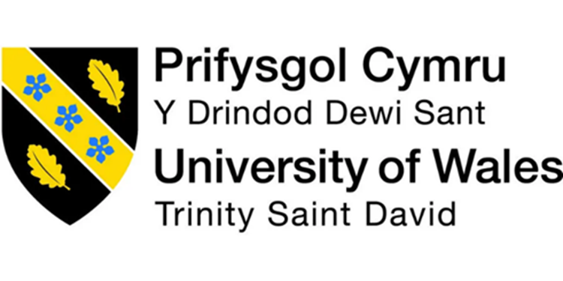

MODERN WORKPLACE
Assessment 1
Organizational Structure & Culture

Module Code: LCBB4003
Submission Date: 24th April 2023
Name of the Lecture: Dr Hoang Dang Nguyen
Words count: 2298.
Student ID: 2132604
Student Name: Marlon Alexander Ortiz Gavilanes

Introduction
This report analyses how Nike UK's organizational structure, culture, and methods for employee motivation help the company achieve its goals. The report begins by giving a general description of Nike UK, including information about its organizational structure and organizational culture. The influence on the organization's performance and how it promotes an environment of responsibility and innovation are next examined. The report concludes by discussing how Nike UK motivates its employees through different motivation theories. Also, it offers insights into how Nike UK may improve organizational performance and keep its position as a top provider of sports gear by looking at these three criteria.
Main body
A worldwide company named Nike is dedicated to developing, manufacturing, and selling sports gear, clothing, and footwear. The business was established in the United States territory of Oregon in 1964, and since then it has expanded to become one of the biggest producers of athletic apparel and shoes internationally (Frisch, 2008).
Nike UK Ltd., a company of Nike, is responsible for operations in the United Kingdom. The business is well-known and active in several cities around the United Kingdom. Including designers, marketing, and retail employees, Nike UK employs nearly 2,000 people (MarketLine, 2022). Sports shoes, clothes, and equipment for a variety of sports, including running, basketball, football, and golf, are available from Nike UK. Moreover, the business works with sportsmen and designers to develop trying to cut goods that satisfy customer demands.
Together with its product line, Nike UK participates in several programmed that advance diversity, sustainability, and community participation. As an illustration, the business has started a number of environmentally friendly programmed, such as using recycled materials in its goods and cutting waste during the manufacturing process. To help underrepresented populations, Nike UK has launched a number of initiatives and is dedicated to encouraging diversity and inclusion in its workforce. Overall, Nike UK's strong brand recognition, innovative products, and dedication to sustainability and social responsibility have helped the firm create a strong position in the UK market and remain competitive in the sporting industry for footwear and sportswear (MarketLine, 2022).
Organizational Structure and Performance
The organizational structure of a company refers to the framework of connections, roles, and channels of communication that it has. (Mullins, 2019). It determines how the work is divided and how the coordination, monitoring, and control systems are formed in order to achieve the organization's goals. The organizational structure may be represented by an organizational chart that displays the hierarchy of positions, reporting relationships, and communication patterns inside the company. It provides a framework for decision-making, resource allocation, and performance evaluation, and it may have a significant impact on an organization's effectiveness and ability to adapt to its environment (Joseph and Gaba, 2020).
Nike Ltd. UK's organizational structure is a key factor in influencing the performance of the business. The organizational structure of Nike was created to support effective internal communication, coordination, and decision-making. Nike Ltd. UK's organizational structure is a key factor in influencing the performance of the business. The organizational structure of Nike was created to support effective internal communication, coordination, and decision-making. Being aware of the many organizational structures available, including the matrix organization, boundaryless organization, project teams, organic structure, and mechanical structure. The organizational structure of Nike has helped the business succeed in a variety of ways (Angeles, 2014).
Employees at Nike are arranged in a matrix structure according to location and product line. With a focus on functional expertise, this structure enables the organization to coordinate its efforts across several geographic areas and product lines. Also, Nike is able to be adaptable and react to market developments because of the matrix structure. The corporation can adjust swiftly to changes in customer tastes and market trends since its product lines are structured around specialized categories, such as footwear, clothes, and equipment. Moreover, the geographic structure of the business enables it to account for regional variations in customer preferences and market circumstances, which is crucial for a global brand like Nike. The organization makes sure that its operations are in line with its strategic goals using a functional organizational structure. Each functional department has distinct duties and goals that are in line with the overarching business plan. This guarantees that everyone inside the firm is working towards the same objectives, which enhances the success of the business as a whole. Also, Nike's organizational structure encourages creativity and innovation. The organization promotes cross-departmental collaboration and new idea generation, and it has an innovative culture. As a result, new goods and technology have been created, which have helped the business succeed.
As a result, Nike's organizational structure has been crucial to the success of the business. The organization's structure has made it possible for it to adapt to market changes, connect activities with strategic objectives, and encourage innovation and creativity across all of its products (Angeles, 2014).

Organizational Culture and Performance
The collective values, beliefs, attitudes, behaviors, and practices that define an organization are referred to as its organizational culture. It is an organization's personality, the culmination of its principles, and the methods used within. Several aspects of an organization, including its history, objective, and vision, as well as its leadership, structure, modes of communication, and working environment, have an impact on its culture. Employee engagement, motivation, and productivity may all be increased because of an effective corporate culture, which can also help to draw and keep talent.
Employees who feel appreciated, respected, and empowered to contribute to the success of the company often work in a collaborative, supportive, and inclusive atmosphere that promotes good culture. A bad culture, on the other hand, might lead to low morale, a high turnover rate, and lower production. The culture of an organization can changes over time and is not static. Both formal rules and procedures and casual interactions and relationships among workers can help to shape and reinforce it. To achieve company goals, develop strong teams, and promote a healthy work environment, it might be crucial to comprehend and manage organizational culture (Epstein et al, 2010)
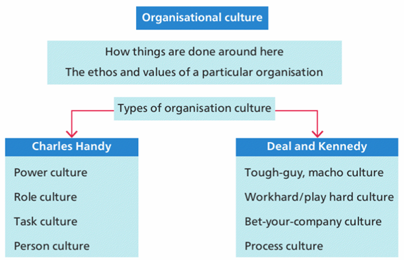
Illustration 1 (Mullins, 2019, p. 564)

The performance of a company, including its profitability, productivity, employee engagement, and customer happiness, may be significantly impacted by organizational culture. In the case of Nike UK, the firm's strong brand and culture of creativity and innovation have contributed to its notable success in the international market. Focusing on performance and perfection, Nike UK's culture is distinguished by a dedication to encouraging its people to be their best selves and produce goods that inspire and motivate athletes.
The innovative and creative culture at Nike UK has led to the creation of ground-breaking goods and innovations like the Fly knit and Air cushioning systems, which have enabled the firm to continue to be a leader in the sportswear sector. The company has developed a favorable image among stakeholders and consumers because of its strong focus on sustainability and ethical business practices. Also, Nike UK's culture of cooperation, diversity, and teamwork has contributed to the development of a strong and enthusiastic staff, which is crucial to the company's success. The business has made significant investments in the employee wellness program, training and development efforts, and other programs that promote empowerment and accountability. Overall, Nike UK's exceptional organizational culture has aided the business in achieving outstanding financial results, such as significant sales growth and profitability, and has allowed it to keep its position as a leader in the cutthroat sportswear sector (Cutlip, 2019).
He concentrates on outlining a few of the cultural kinds employed by Nike UK in this paragraph. Nike UK frequently refers to itself as a family and has a clan culture, sometimes referred to as a process culture, with an emphasis on cooperation, teamwork, and employee involvement. The organization honors employee contributions, recognizes them, and promotes open dialogue and transparency. Adhocracy culture, sometimes referred to as the "work hard culture," is renowned for its inventive and creative approach to product design and development. It is a culture that encourages risk-taking, experimenting, and pushing the limits of what is possible.
Nike UK's emphasis on performance and attaining outcomes is mirrored in its market culture, which is also known as the "best your business culture." The business is very aggressive and focused on achieving results, with a goal of dominating the world sportswear industry. Power or network culture is very collaborative and emphasizes forming connections and alliances. To create cutting-edge goods and technologies that satisfy the demands of its clients, the firm collaborates closely with athletes, coaches, and other stakeholders (Cutlip, 2019).

Employee Motivation
According to Mullins (2019). Employee motivation refers to the internal and external variables that encourage workers to carry out their duties with vigor, devotion, and passion. It is an important factor in determining employee engagement and work satisfaction and may have a big influence on how well a business performs. Employee motivation in the workplace may be affected by a number of variables, including job design, organizational culture, leadership style, remuneration and benefits, and possibilities for professional growth. Good managers recognize the value of employee motivation and strive to provide a workplace that encourages high levels of commitment and drive. Employees that are motivated are more likely to be effective, creative, and dedicated to the objectives of the company. They are also more likely to stay with the company and help it succeed in the long run. Hence, an important part of organizational management and leadership might be figuring out what elements affect employee motivation and coming up with plans to increase it. Also define “The process by which a person’s efforts are energized, directed, and sustained toward attaining a goal” (Robbins and Coulter, 2020).
Psychological theories called content theories of motivation concentrate on the particular wants, desires, and objectives that drive human action. According to these views, motivation comes from a set of fundamental wants or desires, and satisfying these needs is crucial for motivation and psychological health. The following are some of the main content theories of motivation.
Firstly, Maslow’s Hierarchy of needs theory human motivation is based on a hierarchy of wants, starting with the most fundamental ones such as food, water, and shelter and moving up to more complex ones like safety, love, belonging, and self-actualization. This idea holds that before being driven by higher-order demands, people must first satiate their lower-order needs.
Secondly, Herzberg's Two-Factor of needs theory, work satisfaction and discontent are two distinct conceptions that are impacted by many variables. Although they are crucial to preventing unhappiness, hygiene variables like working environment, pay, and job stability may not always result in motivation. Employee motivation and work satisfaction are largely dependent on motivational elements including recognition, success, and growth possibilities.
McClelland's achievement motivation, according to this idea, people have four main needs, the Achievement motivate, the power motivate, the affiliative motivate, the avoidance motivate. People's conduct and motivation at work are influenced by these demands, which are impacted by cultural and socialization factors.
Moreover, there are several process theories. Vroom’s Expectancy theory is a process explanation of motivation that contends that valence, instrumentality, and anticipation are the three main drivers of people's motivation to engage in a certain action. Still, another is the process theory of motivation known as equity theory. It contends that how people see justice and equality in relation to others affects their motivation at work. Moreover, the Goal theory is a process theory of motivation that places a strong emphasis on the value of having clear, difficult goals to boost motivation and productivity. And lastly, job satisfaction relates to a person's general views and sentiments regarding their work or employment, whether they are favorable or bad. It is a crucial component of organizational behavior and is impacted by a range of elements, including possibilities for growth and development, the nature of the job, the workplace, remuneration, and relationships with coworkers and superiors. There are five core dimensions such as skill variety, task identity, task significance, autonomy, and feedback from the job (Mullins, 2019).
Nike engages in a variety of employee motivation techniques. Employees that reach or surpass their performance goals are rewarded with performance-based incentives. Bonuses, stock options, and other financial incentives fall under this category. Employees that go above and above at work are recognized and rewarded through employee appreciation programmed. Awards, certificates, and other kinds of recognition could be part of these initiatives.
Employees are given opportunities for training and development to assist them advance their abilities. These might include official training programmed, on-the-job training, or mentorship schemes. Nike can retain its finest people and make sure that its staff members have the skills and knowledge necessary to function at their peak levels by investing in employee development. Nike has placed a strong emphasis on employee growth and development, and it's possible that they're employing theories like the Goal Theory, which highlights the value of individual autonomy, competence, and mastery. Nike has also publicly stated their dedication to diversity, equality, and inclusion, which raises the possibility that they are utilizing motivational theories like the equity theory, which highlights the value of justice, respect, and social connection in boosting employee motivation (Bice et al, 2016).

Conclusion
In conclusion, the success of Nike is highly correlated with its organizational structure and culture. The corporation can make decisions, solve problems, and innovate more effectively and efficiently because of its matrix organizational structure. The strong company culture encourages creativity, collaboration, and excellence, which raises staff productivity and dedication levels. Nike's employee motivation tactics, such as performance-based rewards, employee recognition programs, and chances for training and development, serve to guarantee that the firm maintains its top talent and empowers its people to achieve at their highest levels. Nike has been effective in accomplishing its organizational goals and maintaining its competitiveness in the global market by utilizing these variables.

References
Angeles, R. (2014). Using the technology-organization-environment framework for analyzing Nike's Considered Index green initiative, a decision support system-driven system. J. Mgmt. & Sustainability, 4, 96.
Bice, M. R., Ball, J. W., & McClaran, S. (2016). Technology and physical activity motivation. International Journal of Sport and Exercise Psychology, 14(4), 295-304.
Cutlip, C. R. (2019). Organizational Culture: Work Arrangements and Strategies for a Sustained High-Performance Culture. Pp. 17 (Accessed: 10 April 2023).
Epstein, M. J., Buhovac, A. R., & Yuthas, K. (2010). Implementing sustainability: The role of leadership and organizational culture. Strategic finance, 91(10), 41.
Frisch, A. (2008) The history of Nike. 1st Ed. United States of America: Creative Education.
Joseph, J., & Gaba, V. (2020). Organizational structure, information processing, and decision-making: A retrospective and road map for research. Academy of Management Annals, 14(1), 267-302.
MarketLine (2022) Footwear Retail in the United Kingdom. MarketLine Industry Profile. Reference code 0183-0619. Pp. 36 (Accessed: 07 April 2023).
Mintzberg, H. (1979). The structuring of organizations: A synthesis of the research Englewood Cliffs, NJ: Prentice-Hall.
Mullins, L. J. (2019) Organizational behavior in the workplace. 12th Ed. Harlow: Pearson Education Limited.
Huczynski, A. and Buchanan, D.A. (2019) Organizational behavior. 10th Ed. Harlow: Pearson
Robbins, S., and Coulter, M. (2020) Management, Global Edition. 15th Ed. Pearson.

