Table of Contact `
1.0 Executive summary 2
2.0 Introduction 4
2.1 Report remit 4
2.2 Background of the organization 4
2.3 Definitions of major concepts 5
2.3.1 Cost leadership 6
2.3.2 Differentiation 6
2.3.3 Focus 6
3.0 Main body 7
3.1 Implementation of the strategy 8
3.2 Advantages & disadvantages of the strategy 8
4.0 Conclusion 9
4.1 Recommendation 9
5.0 Reference 11
6.0 Appendix 13

1.0 Executive summary
This report will analyze Lidl & Co. KG information. And give examples of the conditions and actions required to implement the strategy. It will critically assess the strengths and weaknesses of competitive strategy and make some appropriate recommendations. This report is intended to inform readers of market competition strategies and the actions taken to address them. Let readers understand the advantages and disadvantages of competitive strategy. Through my suggestions, readers can have a comprehensive understanding of the competition strategy.
Lidl Stiftung & Co.KG is located in Neckarsulm, Germany. This is a global chain discount supermarket in Germany. The number has reached 10,000. It has now spread to 29 countries. Lidl offers a limited range of food and non-food items every week. The company also provides online shopping services. Lidl is a fast-growing retailer in Germany. Porter believes that these three strategies are essential to every company. Failure to clarify these strategies may result in the company being in an unfavorable strategic position. The cost leadership strategy refers to companies that reduce operating costs through effective means. This allows companies to gain a competitive advantage strategy at a lower total price. When companies implement cost leadership strategies, differentiated strategies refer to companies that focus on multiple choices of users. The company gives the product one or more qualities and meets the specific needs of the customer. Focusing strategy means that companies focus their operations on a particular target market. The company's business is specific and can do its best in one particular segment of the market. Thus, beyond the competition. All three strategies have achieved a tremendous competitive advantage.
Through the analysis of 7p, we can learn the marketing strategy of life. They are taking advantage of cost leadership strategies and implementing the strategy with incredible efficiency. The company implements a cost leadership strategy. Various measures must be taken to reduce the total operating costs and make the price lower than the competition. Companies rely on low-cost to achieve high profits, which allows companies to take a favorable position in the competition.
About 90% of LIDL's products are owned by their brands. This is the biggest reason for the company's low prices. Therefore, the quality of the product is guaranteed, and the cost is saved, and the middleman is eliminated. The cost of hiring employees is an expense that significantly increases the efficiency of employees, which can reduce the number of employees. The company's pricing is always lower than the market value. It can be profitable through small profits but quick turnover.
This strategy provides organizations with higher profits and increased team market share. This strategy can improve business sustainability and reduce market competition. But it can cause financial cuts in crucial areas that hurt the business. This approach leads to a lack of innovation in the product. It reduces the importance of consumer feedback. It may require a lower quality set of raw materials to create higher profit margins. The advertising or marketing budget may need to be changed. This may reduce the number of new customers acquired. This strategy requires successful mass sales.
All in all, companies need to understand the competitive strategy of their competitors fully. Have a correct analysis and research on their competitive strategy.
Companies need to ensure that essential departments receive financial support. Product diversification and innovation are crucial. Companies should ensure that the quality of each product is in line with standards. When managers choose products, they must consider all the factors of the product. Determine the product's profitability is high.

2.0 Introduction

2.1 Report remit
This report will analyze the Lidl &Co. KG’s information. In a highly competitive market, the company has adopted some competitive strategies to ensure its strategic position. It will give examples and explain the conditions and actions required to implement the strategy. For a competitive strategy, the report will critically evaluate the strengths and weaknesses and make some appropriate suggestions.
The purpose of this report is to give readers an understanding of the competitive strategies in the market and the measures taken for the strategy. Let the reader understand the advantages and limitations of the competitive strategy. Through my suggestions, readers can have a comprehensive understanding of the competitive strategy.

2.2 Background of the organization
Lidl Stiftung & Co.KG is located in Neckarsulm, Germany. This is a German global (Lidl.NI, 2019) discount chain supermarket. Lidl is also known as the supermarket of the poor. It is a private company and currently belongs to Dieter Schwarz Holdings. Lidl is part of the Schwarz Group, the fifth-largest retailer in the world, with sales of £82.4 billion (Lidl.NI, 2019).
In 1930, its prototype was a food wholesaler. In 1977, the company began to focus on discount markets, supermarkets, and cash and goods wholesale markets. The first store opened in the UK in 1994 and has proliferated in the 21st century. It is now spread across 29 countries (Lidl.NI, 2019). Nowadays, the number of Lidl's chain stores has reached 10,000(Lidl.NI, 2019). There are already 450 stores in Germany and the United States, with more than 5,000 (Lidl.NI, 2019) employees.
Lidl offers a limited range of foods and non-food items provided weekly, including household items, sports equipment, electronics, and themed foods. There are bakeries in stores across Europe and a baking area. The company also offers online shopping services (Lidl.NI, 2019).
Lidl is a fast-growing retailer in Germany. Lidl and Aldi drove Wal-Mart out of Germany together, so the company is high reputation.
On 17th April 2019, Lidl promotes sports in Northern Ireland. The company invested £160,000 in local youth sports. The club received new training accessories and equipment. (Appendix 1)
On 22nd January 2019, Lidl is committed to treating fish in a 100% responsible manner. Lidl advocates protecting the ocean. (Appendix 2)

2.3 Definitions of major concepts
In 1980, American scholar Porter (2005) proposed five competitive forces for corporate profitability in his book. Based on a detailed analysis of the competitiveness, Porter further proposed a general strategy that can be applied to enterprise practice.
According to Porter's analysis, the general strategy has three essential points to gain a competitive advantage，, for instance, cost leadership, differentiation, and focus, respectively. Porter calls general strategy.
There are four primary sources of competitive advantage in Porter's Generic Strategies. Such as cost leadership, differentiation, focus cost leadership, and focus differentiation.

Figure 1: Porter’s Genic Strategies

Figure 1: Porter’s Genic Strategies

Porter believes that these three strategies are essential to every company. Failure to clarify these strategies may result in the company being in an unfavorable strategic position. If leaders want to ensure that the company is invincible, then choosing the right competitive strategy is very important. Leaders need to have a good understanding of the content and impact factors of the competitive strategy. (Cao YiFei,2014).

2.3.1 Cost leadership
The cost leadership strategy, also known as the low-cost strategy, refers to companies that reduce operating costs through effective means. This allows companies to gain a competitive advantage strategy at a lower total cost (Katarina, 2019)

Companies can achieve significant competitive advantages when implementing cost leadership strategies. First, when the product is sold at the same price, the cost of the company is lower than other companies in the same industry. So, companies can get higher profits if the company maintains the industry's average profitability. Products sold at lower prices can increase the competitiveness of their products. Second, relative to the higher cost, companies can force suppliers to maintain the original estimate through a cost leadership strategy. The cost leadership strategy allows companies to achieve more gross profit. Third, cost leaders can constitute barriers to entry. New competitors are subject to many limitations, such as technology, management, and experience. New competitors cannot get low-cost participation in the competition. Cost leaders sell products at lower prices when they encounter new competitors, which can devastate new competitors (JiSheng,2014).

2.3.2 Differentiation
The differentiation strategy is also called the characteristic advantage strategy, which means that the enterprise pays attention to the multiple choices of customers. The company gives the product one or more qualities and meets the specific needs of the customer. Differentiation strategies are divided into four types, namely product differentiation strategy, service differentiation strategy, personnel differentiation strategy, and image differentiation strategy (Kokemuller, 2019).
Enterprises can gain a sizeable competitive advantage when implementing differentiation strategies. First, companies can gain more loyal customers through differentiation strategies. Second, in the face of the threat of alternatives, the differentiation strategy can effectively increase the competitiveness of enterprises(Whiting, 2018). Third, the differentiation strategy makes the purchaser lack comparable products and weakens the buyer's sensitivity to price.

2.3.3 Focus
The focus strategy, also known as the centralized strategy, refers to the focus of the company's operations on a specific target market. The business is single-minded and can do its best in a particular market segment (Zaware, 2016). Thus, beyond the competition.
Companies can gain a significant competitive advantage when implementing focused strategies. First of all, because the company's focus is concentrated, resulting in a narrow market, companies can better understand the market and customers. They are thereby providing better products and services. Second, the focus strategy has adapted to the characteristics of limited enterprise resources. Companies can focus on providing the best service to a particular target market. Third, management is simply because of the centralized management objectives (Gaille, 2018). Finally, this strategy can reduce business operating costs. This will help to concentrate on the use of resources and achieve specialization.

3.0 Main body
First, on the product side, Lidl is one of the cheapest supermarket retailers in the industry. Lidl sells products that are very similar to other companies in the same industry, such as Tesco. Second, in terms of price, Lidl's pricing strategy is one of the company's main competitive advantages. Lidl sells goods at low prices. Third, in terms of location, Lidl has a large number of stores and distribution centers. Fourth, in terms of promotions, Lidl often launches promotions that are attractive enough. Fifth, in terms of employees, Lidl's employees are highly paid, but they must work hard. Sixth, in terms of processes, Lidl's primary operation is to buy and sell more goods on a low-cost basis. Seventh, in terms of physics, most of the products are arranged in a very linear and traditional way.
It is soon possible to clearly understand what strategy Lidl is currently adopting. Lidl has been selling quality products at the lowest price (Brown, 2015). This shows that they are taking advantage of the cost leadership strategy and implementing the strategy with incredible efficiency.

The company implements a cost leadership strategy. First, companies must have advanced equipment and production facilities. And companies can improve equipment utilization. Secondly, enterprises should use management experience to strengthen the control of costs and management costs. Companies need to go all out to reduce costs. Finally, minimize expenses for research and development, marketing, advertising, and services. In short, various measures must be taken to reduce total operating costs. Making costs lower than competitors and relying on low-cost to obtain high profits, so that enterprises occupy a favorable position in the competition (Dolgui, 2014).

According to Porter's thinking, the cost leadership strategy is reflected in lower prices. But it is not blindly lowering the price. Instead, let companies turn costs into controllable cost leadership. In other words, companies need to find a source of sustainability before they can achieve a low-cost strategy. This will prevent competitors from imitating(Moschetti, 2016). This cheap advantage will last long.

3.1 Implementation of the strategy
First, about 90% of Lidl's products belong to their brands. This is the biggest reason for the company's low prices. Every product has undergone a lot of tests, such as checking quality, taste, and feeling of use. They work with local and regional farms. Each Lidl product passes quality testing and a carefully selected process. Therefore, the quality of the product is guaranteed, and the cost is saved, and the middleman is eliminated (Bhasin, 2019)
Second, the cost of hiring employees is an expense. If you can significantly improve the efficiency of your employees, you can reduce the number of employees. So, Lidl has a limited number of employees in each store, but every employee must be responsible. Therefore, a large amount of cost can be saved. Thereby further reducing the price of the product.
Third, the company's pricing is always lower than the market value. It can profit from small profits but quick turnover, reduce the profit per product, and sell more products. It is attracting more customers at an affordable price. For example, according to a recent survey of 20 items, Lidl was found to be 9% cheaper than Wal-Mart in the United States.

3.2 Advantages & disadvantages of the strategy
There are some advantages to the cost leadership strategy.
First, this strategy provides organizations with higher profits. The focus of the strategy is to operate at a low cost in the market and within the industry. By reducing development and production costs, it is possible to achieve higher profit margins if you can offer a competitive price and get a higher profit than other companies.
Second, this strategy can increase the market share of the team. Not only can higher profit margins be achieved, but they can also increase market share over time. If the company's goods or services cost the lowest, and the price is acceptable, then the business goods will be given priority to purchase. (Ruddick, 2015).
Third, this strategy can improve the sustainability of the business. When the cost of the company is low, the financial threat of bankruptcy of the organization is even less. This sustainability will be a considerable advantage when the economic situation gets worse. When a price war or trade war occurs, the company with the lowest operating cost has the highest chance of survival (2018, p. 456)
Fourth, this strategy reduces market competition. Companies that can achieve this strategy have also succeeded in bringing their future advantages. Because they can offer their consumers a more affordable price. Therefore, new competition in the market has been limited. Because competitors may have difficulty achieving the same price. This can control the market over time. (Online Abertillery,2019)

There are some disadvantages to the cost leadership strategy.
First, it could cause financial cuts in critical areas that could hurt the business.
Some cost owners may want to reduce the cost of crucial areas of the company, such as their customer service department.
Second, this approach leads to a lack of innovation in the product. For many leaders, R&D seems to be an extra expense. The result of cutting money here is that fewer new products or services are entering the market (Lidl, 2015).
Third, it reduces the importance of consumer feedback. If you only focus on maintaining services or products and reducing their costs. Some customers will spend more money on competitive products because they can better meet their needs.
Fourth, it may require a lower quality set of raw materials to create higher profit margins. The advertising or marketing budget may need to be changed. This may reduce the number of new customers acquired.
Fifth, this strategy requires successful mass sales. Cost leadership is most successful when it can generate a lot of sales. This is how the organization maintains overall profitability. (Online Abertillery,2019)

The strengths and weaknesses of cost leadership style show us that this process can be used to create unique competitive advantages. It will also slow down the organization's ability to adapt to changing environments. For function effectively, cost leadership must be carefully managed to generate possible profits. There is a significant risk (2017, p.5).

4.0 Conclusion
All in all, if companies want to be invincible in the fierce market competition, they need a competitive strategy for competitors. Have a correct analysis and research on their competitive strategy. Only in this way can we grasp the development direction of the enterprise and continue to grow in the development to obtain a broader profit and growth space for the enterprise.

4.1 Recommendations
First, when companies are implementing cost leadership strategies, they need to ensure that essential departments receive financial support. For the customer service department, this department seriously affects customer loyalty. If you ignore this link, the company may lose a lot of customers (2014, p. 631).
Then, product diversification and innovation are essential. The company should pay attention to the upgrading of products while saving as much as possible.
Second, it does not reduce the quality of the product while saving costs. It cannot blindly lessen the quality of raw materials to lower prices. Companies should ensure that the quality of each product is in line with standards.
Finally, because the cost leadership strategy must be successful in the case of massive sales, so, when managers choose products, they must consider all the factors of the product. It is determined that the profitability of the product is high before it can be bought and sold.

5.0 References
1. Online Abertillery (2019) Available at: https://corporate.lidl-ni.co.uk/about-lidl/history (Accessed: November 16, 2019).

2. Michael, E. (2005) Competition Strategy: a handbook of theory and practice. Basingstoke: Huaxia Press.

3. Cao, YiFei. (2014) ‘The brand positioning analysis of JiangSu satellite TV based on porter's three general strategies’, China Academic Journal Electronic Publishing House. All rights reserved. [Online]. Available at: http://www.cnki.net (Accessed: 16 November 16, 2019).

4. Ye, JiSheng. (2014) ‘The content and necessary condition analysis of enterprise general competition strategy’, Fazhiyujingji,293(11), pp.79-80.

5. Kanika Katarina. (2019) Cost Leadership – Definition, Examples, & Strategies. Available at: https://www.feedough.com/cost-leadership-definition-examples-strategies/ (Accessed: 16 November 16, 2019).

6. Brianna Whiting. (2018) Differentiation Strategy: Definition & Examples. Available at: https://study.com/academy/lesson/differentiation-strategy-definition-examples.html (Accessed: 16 November 16, 2019).

7.Neil Kokemuller. (2019) Differentiated Business Strategies. Available at: https://smallbusiness.chron.com/differentiated-business-strategies-20638.html (Accessed: 16 November 16, 2019).

8. Nitin Zaware. (2016) Focus strategy. Available at: https://www.slideshare.net/drnitinzaware/focus-strategy (Accessed: 16 November 16, 2019).

9. Brandon Gaille. (2018) 15 Focus Strategy Advantages and Disadvantages. Available at: https://brandongaille.com/15-focus-strategy-advantages-and-disadvantages/ (Accessed: 16 November 16, 2019).

11. Brown, G. (2015). Giant Lidl distribution hub to create 500 West Midlands jobs. Available at: http://www.birminghampost.co.uk/business/business-news/giant-lidl-distribution-hub-create-888311 (Accessed 16 November 2019).

12. Dolgui, A. & Proth, J. M. (2014). ‘Pricing strategies and models’. Annual Reviews in Control, 34(1), pp. 101-110.

13. Morschett, D., Swoboda, B. & Schramm-Klein, H. (2016). ‘Porter outlines four generic strategies; differentiation, cost leadership, differentiation focus and cost focus’. Journal of Retailing and Consumer Services, 13(4), pp. 275-287.

14. Hitesh Bhasin. (2019). Marketing Strategy of LIDL – LIDL Marketing Strategy. Available at: https://www.marketing91.com/marketing-strategy-of-lidl/ (Accessed 16 November 2019).

15. Ruddick, G. (2015). Supermarkets could increase prices to pay for living wage. Available at: http://www.telegraph.co.uk/finance/newsbysector/retailandconsumer/11736662/Supermarkets-could-increase-prices-to-pay-for-living-wage.html (Accessed 16 November 2019).

16. Siro, I. Kapolna, E. Kapolna, B. & Lugasi, A. (2018). ‘Functional food. Product development’. marketing and consumer acceptance—A review. Appetite, 51(3), pp. 456-467.

17. Online Abertillery (2019) Available at: https://futureofworking.com/14-advantages-and-disadvantages-of-cost-leadership-styles/ (Accessed: November 16, 2019).

18. Lidl, (2015). Customer orientated expansion. Available at: http://property.lidl.co.uk/cps/rde/xchg/lidl_uk/hs.xsl/5187.htm (Accessed: November 16, 2019).

19. Lusch, R. F., Vargo, S. L. & O’Brien, M. (2017). ‘Competing through service: Insights from service-dominant logic’. Journal of Retailing, 83(1), pp. 5-18.

20. Dyson, R. G. (2014). ‘Strategic development and SWOT analysis at the University of Warwick’. European Journal of Operational Research, Volume 152, pp. 631-640.

Appendix
Appendix 1：
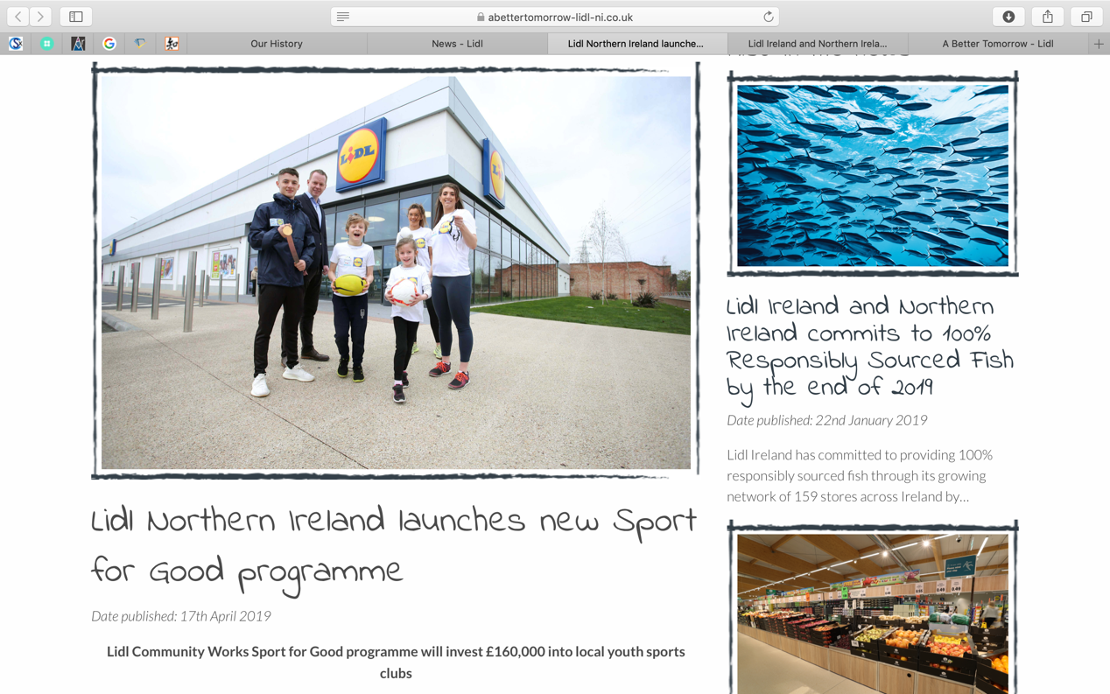
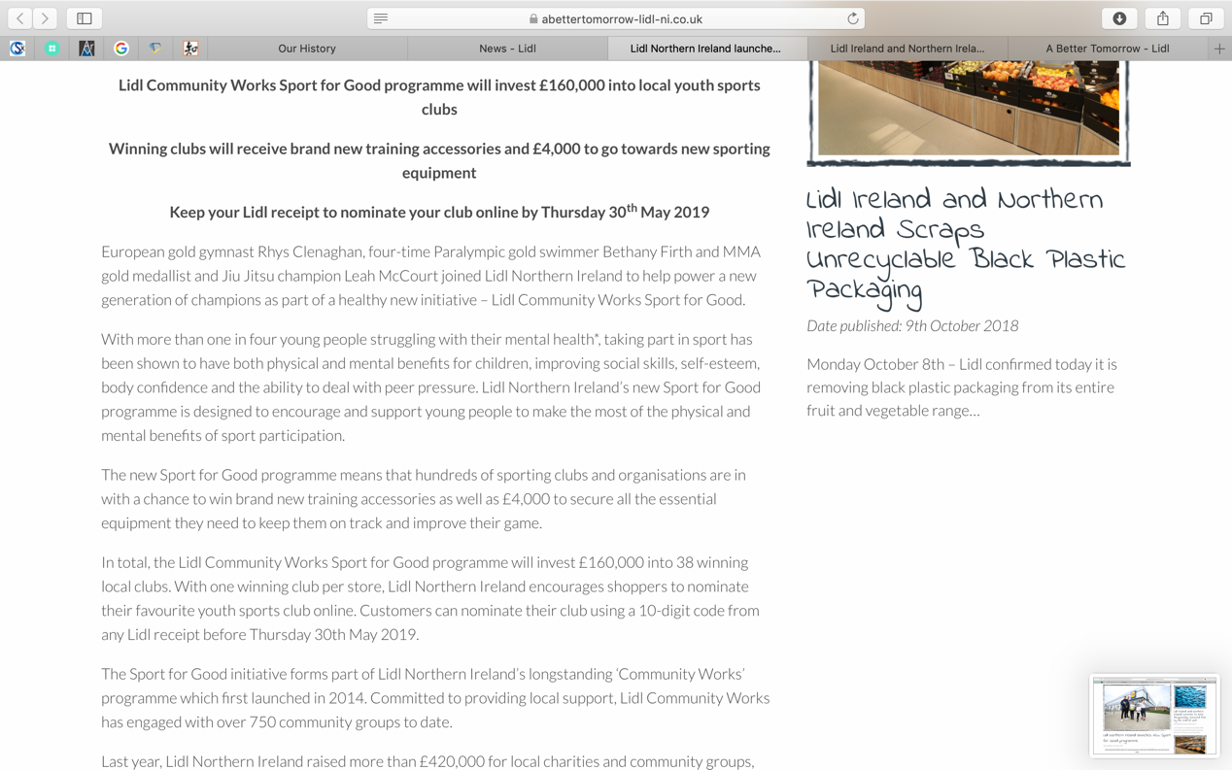

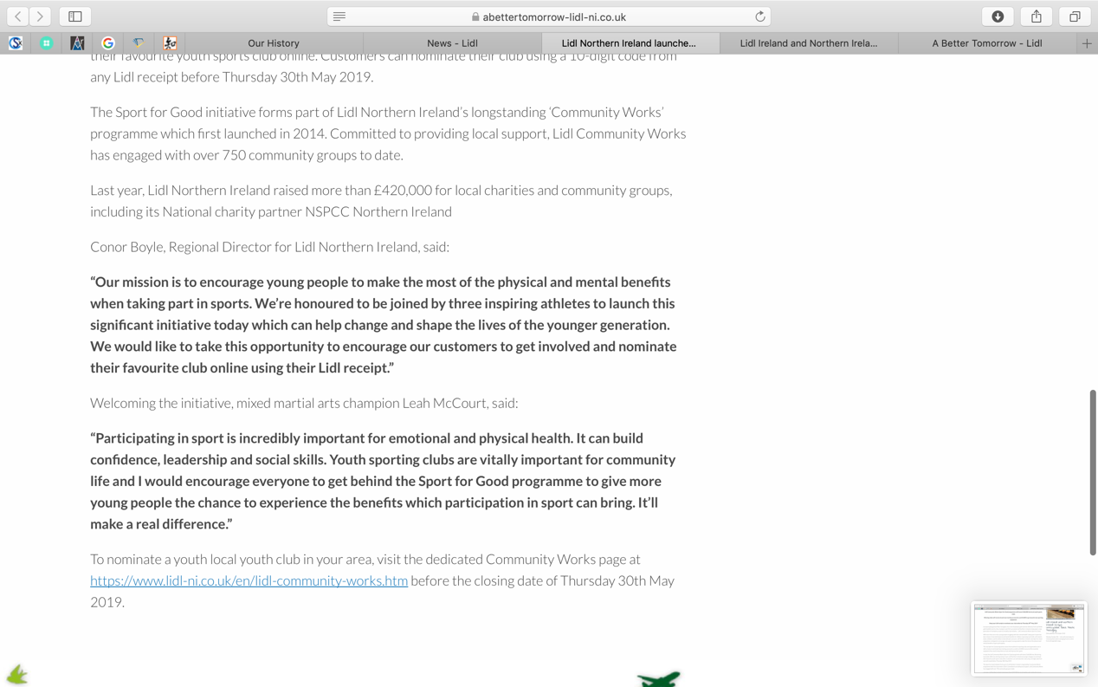
（reference：https://www.abettertomorrow-lidl-ni.co.uk/news/lidl-northern-ireland-launches-new-sport-for-good-programme/ ）

Appendix 2：
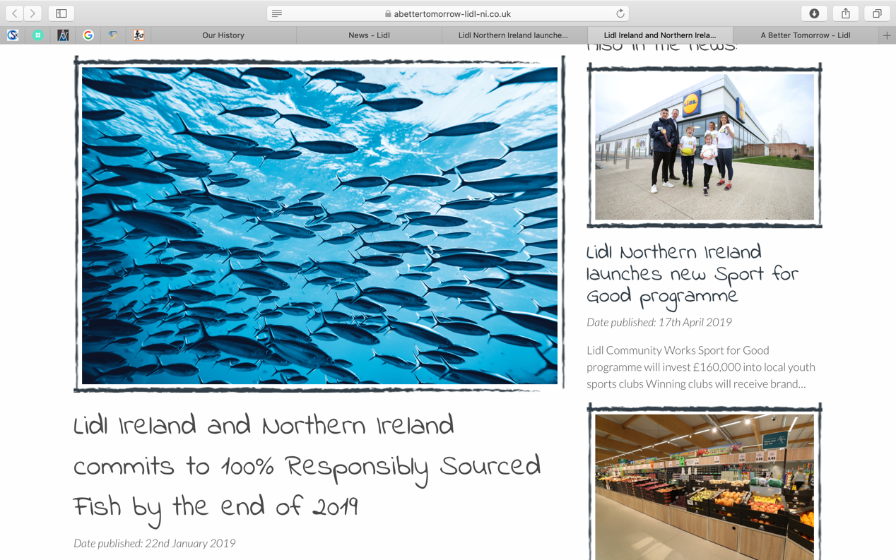
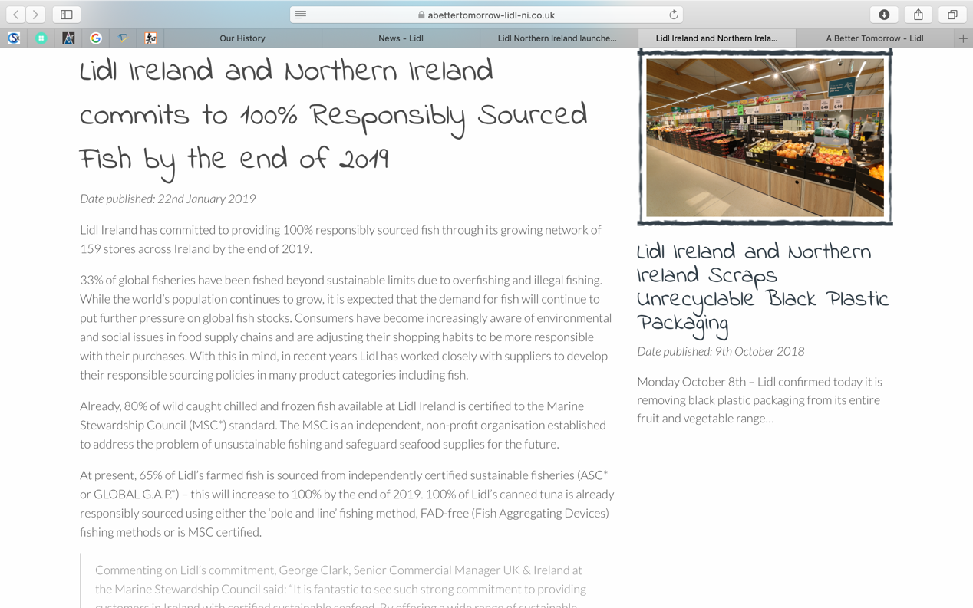

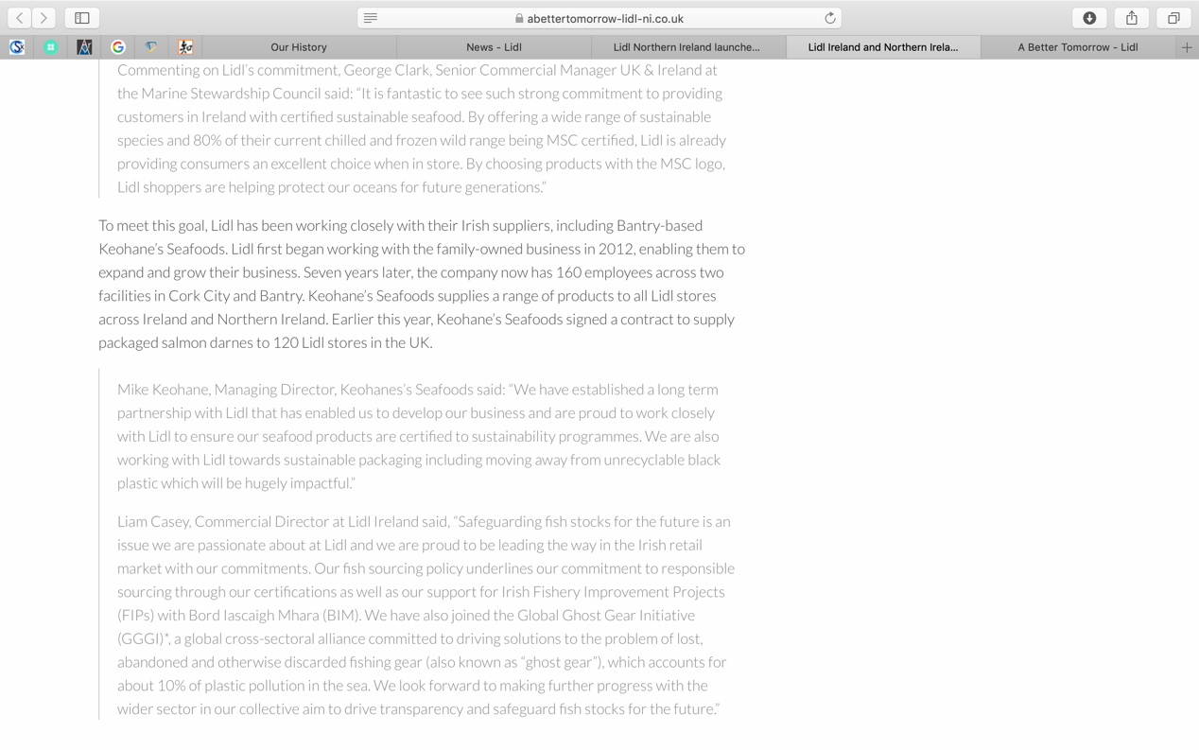
（reference：https://www.abettertomorrow-lidl-ni.co.uk/news/lidl-ireland-commits-to-100-responsibly-sourced-fish/ ）

