
Programme: BA Business Management
Module: Leadership and management, theory and practice
Module code: LCBB6003
Assignment Title: Component 2
Practical: Group Report & Presentation
Student Name: Lachezar Nikolov
Student ID: 1916906

Table of Contents
Task 1-Presentation 3
Task 2-Lessons Learned Report 7
Reference List 9

Task 1-Presentation
Leadership definition
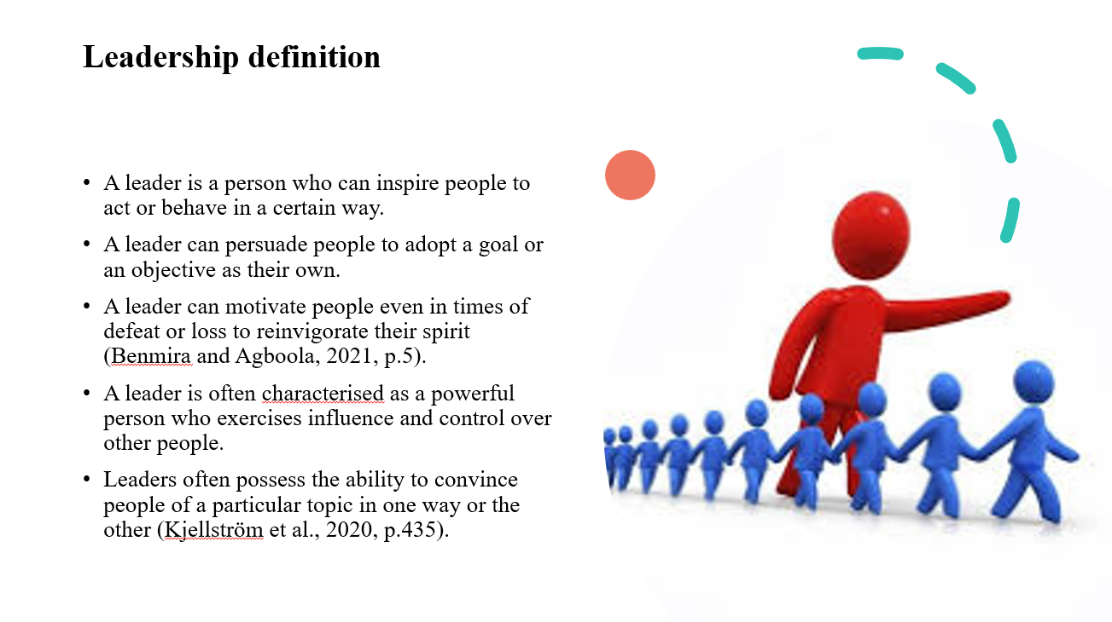
While people tend to seek leaders in the topmost positions of the Multinational Corporations (MNCs) and in the political strata, that may not be necessary. Many people possess leadership abilities and exercise them in their preferred space. For example, the head of a family can be construed as a leader. Even the lower-level members of an organisation can possess significant leadership skills and often showcase them through various activities.
20th century leader: Steve Jobs
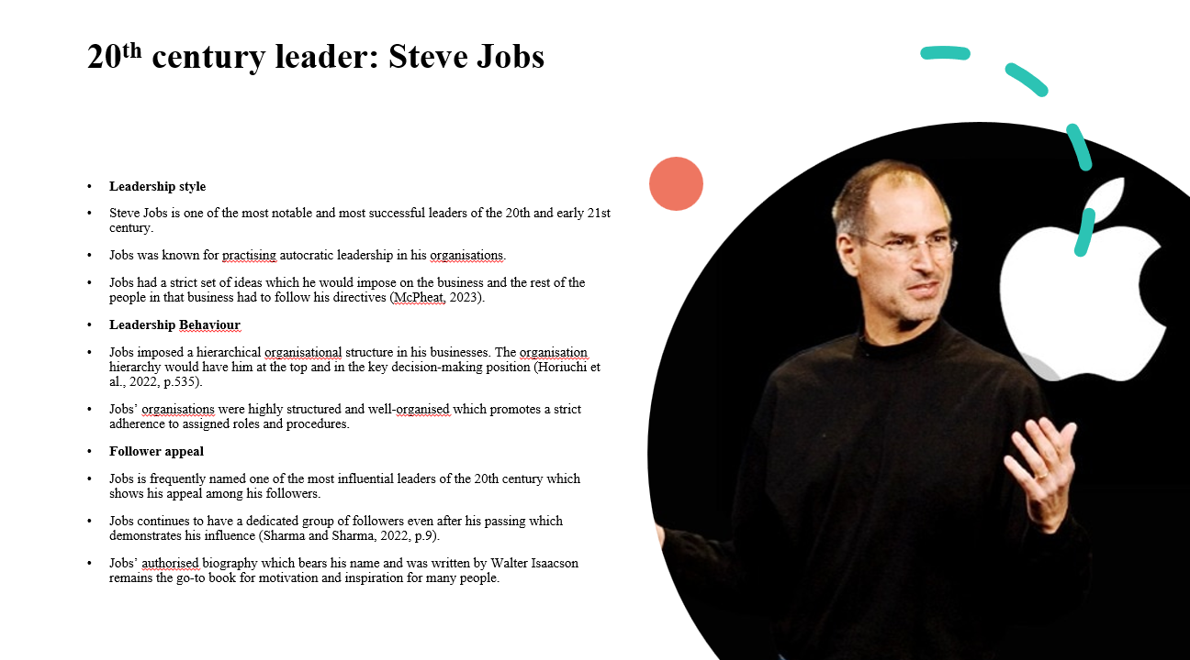
Steve Jobs has become an urban legend in terms of how he would find ways to motivate employees and push them beyond their limitations. Jobs would clearly communicate with the employees how to carry out their tasks and put emphasis on maximising productivity.
21st leader: Jeff Bezos
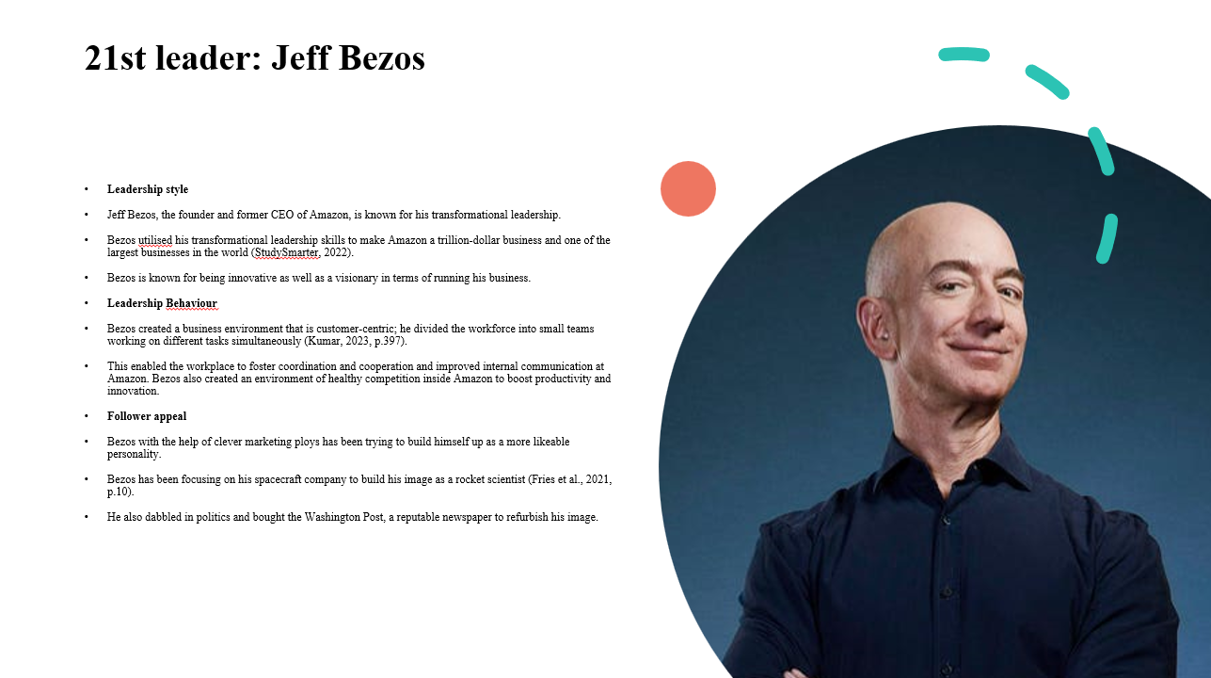
Transformational leaders also tend to have a clear vision of where they want to take the organisation and how they may reach that goal. Transformational leaders are also known for their innovative nature and being open to feedback and ideas put forth by others.
Similarities between Steve Jobs and Jeff Bezos
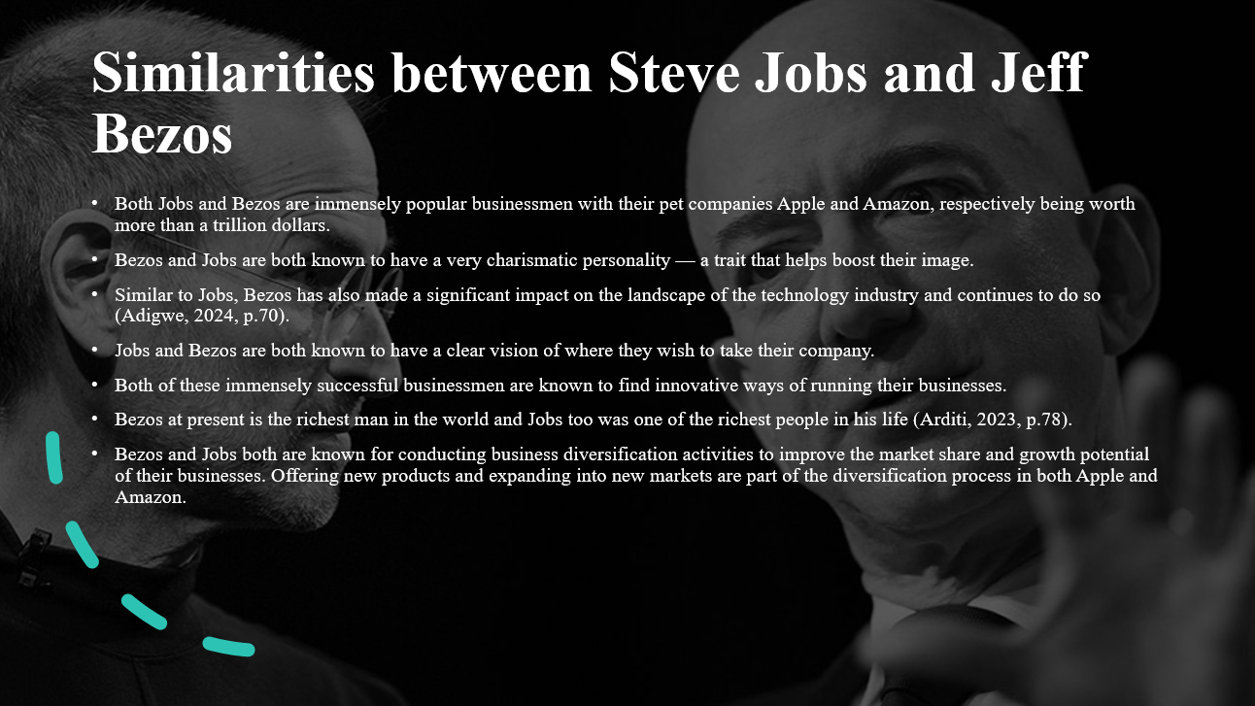
As successful entrepreneurs, Bezos and Jobs were bound to have a fair bit of similarities. Both of them are based in the USA and have become the poster children of the American clan of successful business personnel.
Differences between Steve Jobs and Jeff Bezos
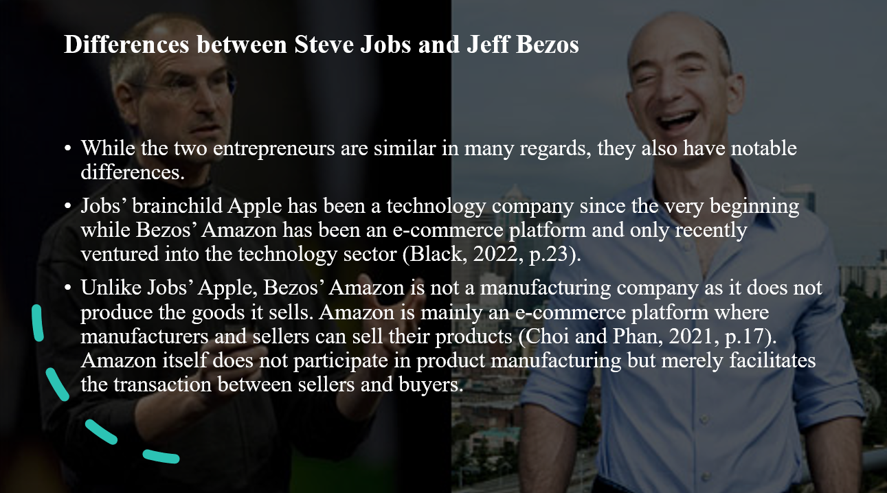
Unlike Jobs, Bezos, despite his success as a businessman, is not nearly as popular. Jobs, even after his death, continues to be a very popular figure in the business community who is widely respected by people who are not even connected with the world of technology. He is often lauded as an innovative thinker, creative genius and a visionary. However, Bezos’ Amazon has been embroiled in controversy around its business practices including mistreatment of the workers, particularly in its warehouses.
Conclusion
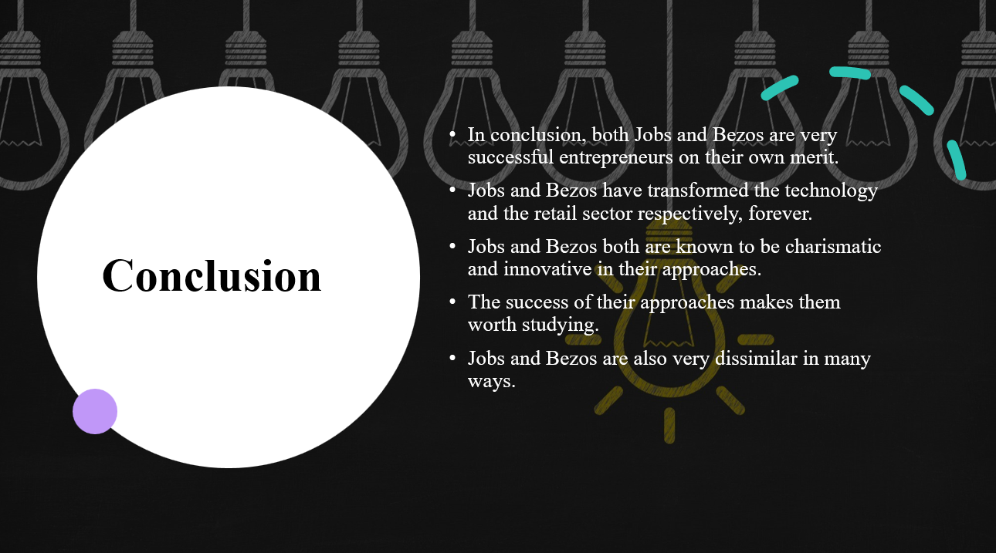
Jobs mainly operated in the technology market while Bezos’ arena is retail and e-commerce. It is only fairly recently that Amazon started venturing into the technology sphere but Apple has seemingly no intention of diverging from its core capabilities.

Task 2-Lessons Learned Report
Involving in preparing this presentation on leadership and management has provided me with the scope of clear my concept regarding leadership by delving into this topic deeply. I have got to know about the leadership styles that match the characteristics of Steve Jobs and Jeff Bezos. In this regard, a Trait theory of leadership can help me to outline my learning outcome regarding the leadership styles of the mentioned leaders. The concept of Trait theory is derived from the Great Man theory of leadership where the qualities of leadership are compared as self-made or in-built (Benmira and Agboola, 2021, p.1). I have found that Steve Jobs follows an autocratic leadership style which highlights the ability of Steve to make decisions on his own without getting influenced by others. It is also noticed that autocratic leaders are good at making decisions quickly to resolve any conflicts (Jaafar et al., 2021, p.1). According to the Trait theory, a wide range of traits are there that should be present in the characteristics of leaders. In the case of Steve Jobs, self-confidence, centralised power, hierarchical structure and high supervision are the traits that have made him a successful leader. I have realised that leadership qualities are developed by leaders through their immense practice and practical implications. This is because the role of leadership is associated with the performance of firms and their employees (Nani and Safitri, 2021, p.208). From the viewpoint of this Trait theory, leaders get some traits by birth which differentiate them from others. Henceforth, I have realised that some of the traits of Steve Jobs might be acquired by birth but some have developed by his continuous practice in the realm of business.
On the other hand, I have also gained knowledge about transformational leadership as Jeff Bezos holds a transformational leadership style. It is known that the transformational leadership style contributes to increasing the turnover intention of the firms (Situmorang and Wardhani, 2022, p.463). In this regard, transformational leadership models can be suitable to illustrate the effectiveness of the transformational leadership style of Jeff Bezos. The transformational leadership model has gained popularity over the last three decades due to its unique characteristics (Deng et al., 2023, p.628). This leadership model outlines the influential personality traits of transformational leaders that motivate the followers to achieve success. I have found the connection between the success of Jeff Bezos and his transformational style of leadership. His legacy is remarkable in the case of the modification of the strategies and culture of Amazon. I have found it effective due to the high standard and long-term thinking straits of Bezos which complements his transformational leadership style. However, the transformational leadership model also appreciates the adaptable approach of transformational leaders that allows them to welcome new changes. I came to know that under the leadership style of Jeff Bezos, Amazon has unlocked immense success through digitalisation. It highlights the adaptable nature of Bezos to stay updated with the latest trends.

Reference List
Adigwe, C.S. (2024) Transformational Leadership: A Comparative Exploration of the Leadership Prowess of Jeff Bezos and Steve Jobs. Asian Journal of Economics, Business and Accounting, 24(3), pp.68-89. https://doi.org/10.9734/ajeba/2024/v24i31242.
Benmira, S. and Agboola, M. (2021) Evolution of leadership theory. BMJ leader, pp.leader-2020. https://bmjleader.bmj.com/content/leader/5/1/3.full.pdf
Benmira, S. and Agboola, M. (2021) Evolution of leadership theory. BMJ leader, pp.leader-2020. https://doi.org/10.1136/leader-2020-000296.
Black, C. (2022) Astro-nots Bezos, Branson, and Musk Compared to NASA and the ESA: Using Twitter to Assess Public Sentiment Differences Between Commercial and Government Space Programs. pp.1-47. https://shareok.org/bitstream/handle/11244/335499/2022_Black_Cheyenne_Thesis.pdf?sequence=6&isAllowed=y.
Choi, Y. and Phan, W.M.J. (2021) Narcissistic leaders: The good, the bad, and recommendations. Organ. Dyn, p.100868. https://scholarworks.calstate.edu/downloads/v979v963w.
Deng, C., Gulseren, D., Isola, C., Grocutt, K. and Turner, N. (2023) Transformational leadership effectiveness: an evidence-based primer. Human Resource Development International, 26(5), pp.627-641. https://www.tandfonline.com/doi/pdf/10.1080/13678868.2022.2135938
Fries, A., Kammerlander, N. and Leitterstorf, M. (2021) Leadership styles and leadership behaviors in family firms: A systematic literature review. Journal of Family Business Strategy, 12(1), p.100374. https://doi.org/10.1016/j.jfbs.2020.100374.
‌Horiuchi, S., Nasser, J.S. and Chung, K.C. (2022) The art of a scientific presentation: tips from Steve Jobs. Plastic and Reconstructive Surgery, 149(3), pp.533-540. DOI:https://doi.org/10.1097/PRS.0000000000008849.
Arditi, D. (2023) Amazon and Baron Bezos. In Digital Feudalism: Creators, Credit, Consumption, and Capitalism (pp. 77-94). Emerald Publishing Limited. https://doi.org/10.1108/978-1-80455-766-220231005.
Jaafar, S.B., Zambi, N.M. and Fathil, N.F. (2021) Leadership style: Is it autocratic, democratic or laissez-faire. ASEAN Journal of Management and Business Studies, 3(1), pp.1-7. DOI: 10.26666/rmp.ajmbs.2021.1.1
Kjellström, S., Stålne, K. and Törnblom, O. (2020) Six ways of understanding leadership development: An exploration of increasing complexity. Leadership, 16(4), pp.434-460. https://doi.org/10.1177/1742715020926731.
Kumar, A. (2023) Jeff Bezos: The Entrepreneur with a Difference. International Journal of Applied Social Science, 10(5), pp.397-401. DOI:https://10.36537/IJASS/10.5&6/397-401.
McPheat, S. (2023) Steve Jobs’ Leadership Style | MTD Training. [online] Leadership and Management Training Courses UK | MTD Training. Available from: https://www.mtdtraining.com/blog/steve-jobs-leadership-style.htm (Accessed 11 July 2023).
Nani, D.A. and Safitri, V.A.D. (2021) Exploring the relationship between formal management control systems, organisational performance and innovation: The role of leadership characteristics. Asian Journal of Business and Accounting, 14(1), pp.207-224. https://doi.org/10.22452/ajba.vol14no1.8
Sharma, S. and Sharma, N.K. (2022) What is Entrepreneurship?. In Entrepreneurship in India (pp. 1-17). Routledge. https://doi.org/10.4324/9781003342281-1.
Situmorang, E.D. and Wardhani, N.K. (2022) The influence of transformational leadership style, workload and job satisfaction on turnover intention. Dinasti International Journal of Management Science, 3(3), pp.463-476. https://doi.org/10.31933/dijms.v3i3
StudySmarter. (2022) Jeff Bezos Leadership Style: Traits & Skills | StudySmarter. [online] StudySmarter UK. Available from: https://www.studysmarter.co.uk/explanations/business-studies/business-case-studies/jeff-bezos-leadership-style/ (Accessed 11 July 2024).

