Powertrain Technology

Engine Dyno Session

Honda Civic Engine
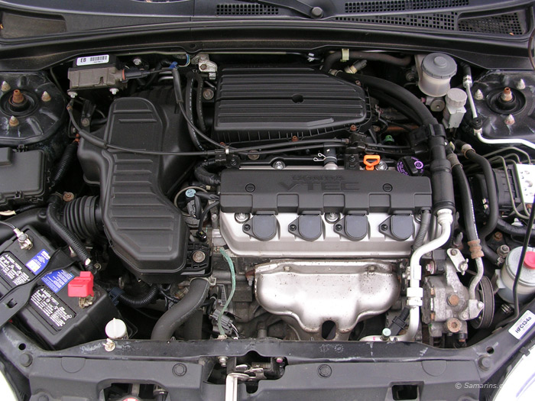

Callum Evans
Bsc/Hnd Engineering
1702660

- Contents

2----------------------------------------------------------------------------------------------------Abstract
3---------------------------------------------------------------------------------------------list of figures
4----------------------------------------------------------------------------------------------Introduction
5-------------------------------------------------------------------------------Experimental procedure
6-----------------------------------------------------------------------------------------Equipment used
7--------------------------------------------------------------------------------------------------Equations
8-----------------------------------------------------------------------------------------------------Results
9-------------------------------------------------------------------------------------------------conclusion
10--------------------------------------------------------------------------------------------further work
11----------------------------------------------------------------------------------------------References

Abstract

This report will be focusing on a dyno session using a Honda civic engine. The dyno was set up and a sweep test was taken and data was collected. Data such as engine speed in rpm, force in newtons, fuel flow rate and ambient temperatures in kelvin. Power curves and torque graphs will be created, compared and analysed.
Using an excel document equations will be used to work out calculations such as brake power, BMEP, SFC, torque and thermal efficiency.
The investigation found out when VETC shift cams engage. Also, how the SFC increases when the throttle is initially increased and what the torque curve of the engine produced.

- List of Figures

Figure 1 Graph to show torque vs engine speed
Figure 2 Graph to show engine power vs engine speed
Figure 3 Graph to show SFC vs engine speed

- Introduction
This investigation will be focusing on an Engine dyno session carried out on a Honda Civic engine. The engine was introduced in the late 80s in a Honda CRX. During the session the engine was put through a step test and a sweep test. Both tests involved increasing the load the engine was under and then taking results. The test will gather raw data such as, engine load, fuel consumption, and engine speed.
With this raw data it will then be possible to work out corrected Power, Torque, BMEP, SFC, and Thermal Efficiency
  - Aims
To create a spreadsheet to show all raw data and researched data such as the specification of the Honda Engine using the manual. Find out information such as Stroke, bore and fuel density. With this information one can work out the area of the piston.
It will also be useful to find out information about the fuel used. Such as its octane rating and its calorific value.
To crate three graphs which include S.F.C, Torque and brake power against engine speed.
Research values for peak power and peak torque then compare it to the data collected from the dyno session. State why differences or similarities occur.

- Experimental Procedure

- Turn on all parts of the dyno, including the exhaust extractor, cooling system, fuel system. Make sure cooling system is working correctly.
- Fit prop shaft to dyno from engine and close the prop case
- Then calibrate the dyno by using weighted arms then making sure the reading is correct on the computer
- Turn on ignition and start engine and allow to idle and allow it to get up to normal temperature
- Set some maximum and minimum RPM and Torque values to ensure the engine doesn’t get damaged from user error.
- Select sweep test or step test.
- The sweep test is preferred because it simulates more realistic driving
- The step test goes up in increments of 50 rpm which isn’t realistic and you miss out some data.
- Try to keep the engine as a steady RPM while increasing the load on the engine and the engine speed at the same time.
- Then let engine run back down to idle speed by slowly degreasing the load and the engine speed.
- This should then give you a power curve and a torque curve

- Equipment used

- Eddy current Brake Dynamometer
- DSG data pro v26xx software
- 2 Load arms= length of 815.775 mm
- Honda d16 1.6 VTEC
- Hook with steel weight = 20.06 k

- Equations

T=W x R

T= Torque (NM)
W= Load (N)
R= Radius (M)
- To find torque, multiply load in newtons by the radius of the torque arm

$$BP=\frac{2πNT}{60}$$
BP= Brake Power (W)
N= Engine Speed (RPM)
T= Torque (NM)
- To find brake power multiply 2 pie by engine speed and torque all over 60
- Your answer will be in watts
- Divide by 1000 to convert to kilo watts

$$\frac{P_{s}}{BP}=\frac{1.01325}{p_{a}}\sqrt{\frac{T_{a}}{293}}$$
Ps= Corrected Power (W)
Pa= Pressure (Pa)
Ta= Temperature (°K)

$$S.F.C=\frac{V×0.72×60}{BP}$$
S.F.C= Specific Fuel Consumption (Kg/Kwhour)
V= Flow Rate (Kg/hour)
BP= Brake Power (W)
- It is important to research the specific gravity of fuel which happens to be 0.72
- Convert S.F.C into kg/min by multiplying by 0.72
- Convert to Kg/hour by multiplying by 60
- Then divide this by brake power in KW this will give you SFC in Kg/KWh
$$A=\frac{πd^{2}}{4}$$
A= Piston area (M^2)
D= Piston diameter (M)
- Area of piston is equal to the piston diameter squared over 4

$$BMEP=\frac{BP(120)}{LxAxNxn}$$
BP= Brake Power (W)
L= Stroke (M)
A= Area (M^2)
N= Engine Speed (RPM)
n= Number of Cylinders

- Plot 3 graphs within the excel document
- Torque vs engine speed
- Power against engine speed
- SFC in Kg/kwh

- Results.

Figure 1

Figure 2

Figure 3
- Conclusion
The findings of this report include, how SFC is substantially increased when the throttle is opened, this is due to the engine over fuelling for a short time before the rpm picks up. The results show how the variable cams are used to protect the engine, the VVT kicks in at 5300 rpm and then gives an increase in engine power. Pulse tuning effect has been made clear and can be seen to be working in figure 1

- Further work
In a perfect world it would have been good to adjust variables such as ambient temperature and fuel octane level. This can be used to see how the engines characteristics such as its brake power and torque values change compared to normal conditions. Things like changing the air filter to a less restricted setup will allow the most air possible, a free-flowing exhaust will be also improving the brake power. As the engine is very old, it would be interesting to see the results after an engine rebuild. Then one could see how much power the engine has lost since it was new.

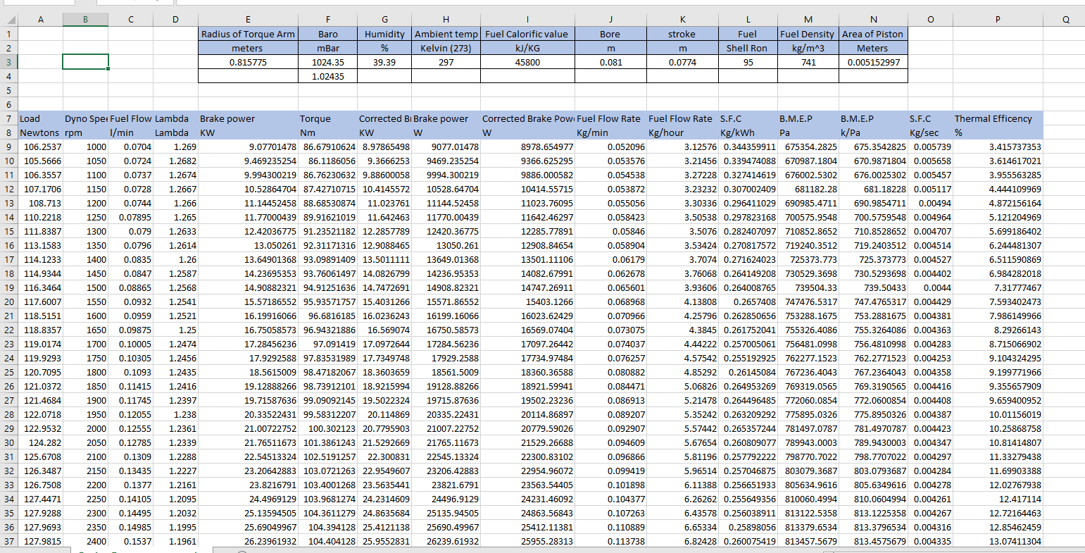

- Analysis

The graph in figure 1 shows a perfect torque curve. At 3500 rpm pulse tuning effect takes place this is where the peak torque can be seen. As the engine revs higher, the torque figure degreases. This can be caused by mainly engine mapping. As the rev range gets towards the redline then the car ECU is programmed to reduce the torque to limit extreme load on the engine and therefore increase reliability.

The graph in figure 2 shows a power curve of the Honda engine. The power steadily increases until 5300 rpm when it slightly degreases before VETC comes in to protect the engine. This is shown by the little bump at the end of the graph. The test didn’t record after the vibrable valve timing comes in because a rpm limit of 5500 was set. The VVT involves the shifting to the bigger lobes on the cam shaft to open the valves further and therefore increase the volume of air in the cylinder.

The graph in figure 3 shows an initial decrease in SFC (specific fuel consumption). This is because the engine electrics are trying to compensate for the demand of the throttle bodies therefore too much fuel is being put into the combustion chamber causing a slight degrease in RPM. Once the fuel has been burnt the rpm then starts to increase.

- References

N/A. (2014). Dust runners . Available: https://dustrunnersauto.com/honda-d16/. Last accessed 18/1/2020.

