

Community Engagement

Student name: Adrian Iulian Susanu
Student id: 2019938
Module code: LCBB4002
LECTURER NAME: Anupam Mazumdar

Table of Contents
Introduction: 3
Describe the difference between both projects, compare, analyse and evaluate the best practices 3
Their community engagement approaches; Reflect on what they do differently and why? 5
Discuss what differences effective communication, active stakeholders’ participation, and inclusion can make in community engagement. 7
how they conduct their research, carry out community mapping, social media engagement, impact analysis, evaluation and justify the best practices 10
Conclusion: 11
Reference List: 12

Introduction
Community engagement is a process of working collaboratively connected by geographically, special interests, and similar situations to eliminate and address some issues affecting their well-being. It is a powerful instrument for bringing out serious problems such as environment, behavioral changes to boost the overall health of the community. Constructive relations between government institutions and public communities lead to more equitable and sustainable public decisions to improve the livability of local citizens (Olteanuet al., 2015). The following discussion will compare the different projects of Tower Hamlet climate engagement event and London climate action week and evaluate their approaches, social media engagement and best practices to measure the effectiveness and success rate.

Main body

Describe the difference between both projects, compare, analyses and evaluate the best practices
Parameters of Comparison | Tower Hamlet Climate engagement event | London climate action week
Date | 17th March, 2021 | 26th June to 4th of July, 2021
Duration | The first virtual event of Tower Hamlet is telecasted for few hours (10 am to 12.45 pm) to accomplish the net zero carbon action plan | The third year of London climate action week has taken place for one week in a virtual way.
Final objective | The objective of this virtual event is to raise awareness about the climate change issues and start the journey to become net zero carbon emitter by the year of 2050 or earlier | This event aims to harness the power and influence of London to impact the shape of global climate change
Speakers | The major names of speakers in the program include mayor John Biggs, Chief executive of Tower Hamlet ‘Will Tuckley’, Hannah Pathak- the director of UK and Europe forum of the future (Mavrodievaet al., 2019). | AminathMaiha Hameed (Air quality management and ministry of environment, Maldives), Barry O'Byrne (CEO of HSBC global banking), Andrew Griffith (UK government business champion), and Andreia Santos (Health Economist)
Partners | The official partners of the first virtual event of Tower hamlets includes Barts, East London business Alliance, London NHS trust, Canary wharf group, queen mary university and other governmental institutions | The headline partner of London climate week is HSBC bank, industrial partner ‘Nationwide building society’, climate software partner ‘Persefoni’, and other strategic partners including Mitsubishi, Ecoact, Carbon trust etc.
Agenda | The simplistic agenda of this event is to build maximum amount of consciousness about global climate change issues and developing the first net zero carbon metropolitan area in London and the UK as a whole | It is the largest multi stakeholder event to implement the green industrial revolution and the breathing space stage where it aims to connect policymakers, finance and innovative leaders to drive the UK’s net zero transition (Li et al., 2017).

Fig: 1 Difference between London climate action week event and Tower Hamlet climate event
(Source: Learner)

Their community engagement approaches; reflect on what they do differently and why?
Tower Hamlet community overview: It is a small portion of the city of London located in the east end and on the north bank of the river Thames. The local community consists of Muslim majority of residents that are mostly established by British Bangladeshi businesses (Martiskainenet al., 2020). The borough has developed different community engagement programmes throughout these years since its foundation. Currently, the local community of 272,890 people offers accommodation-based services, advice and advocacy, daytime opportunities, health & well-being, education and training, transport, and care givers services. Additionally, most of the people in this area are extremely aware of the negative impacts of climate change and consequences. The net zero carbon plan of the council sets out to tackle the climate emergency by the year of 20250 or earlier. For this reason, the local community of Tower Hamlet applies some actions and strategic decisions.
- It has developed sustainable workplace programmes to promote sustainable behaviours, resource efficiency, elimination of plastic cups from buildings, and introducing a food waste collection council to reduce solid wastes and send them to landfills.
- Advancement of local plan policies
- Aims to minimize carbon emissions by 105 tons per year by implementing LED lights, low carbon heating, and retrofit hot water systems (Delannonet al., 2016)
- Review of council assets and design standards for new council development to ensure new hiring can coincide with the declaration of climate emergency
- Since 2019, the council operates in 100% renewable energy and continued delivery of carbon reduction projects
London community overview: The city of London is considered as one of the greatest and oldest cities in the world. The current local community of London is extremely mixed and complex due to the industrialization and globalization characteristics. Over the years, it has become one of the ethnically diverse cities as over 300 languages are spoken in the whole metropolitan area of greater London. With a total population of 8,173,941 out of which 44.9% are white English residents and the rest are born outside of the UK. Generally, the local citizens of London are exceptionally qualified and talented due to their advanced education framework and modern ways of teaching in the world-class prestigious universities (McGregor, 2015). The City of London Corporation has developed a radical climate action strategy in the event. According to the climate action strategy, the goal is to accomplish net zero carbon emissions by 2027. The different actions and decisions of the community are as follows
- Climate resilient landscaping
- Adaptation of buildings and public realm to cope up with higher temperatures
- Public health interventions to high extreme heat stress
- Creation of distinct designs that priorities water conservation (Henry Akintobi et al., 2020)
- Urban greening to absorb rain water in order to minimize flooding
- The community of London provides environmental advocacy and stewardship in the utilization of assets, greening, conservation, and biodiversity
- Massive rate of installation of electrical vehicle charging points to boost the EV market.

Discuss what differences effective communication, active stakeholders’ participation, and inclusion can make in community engagement.
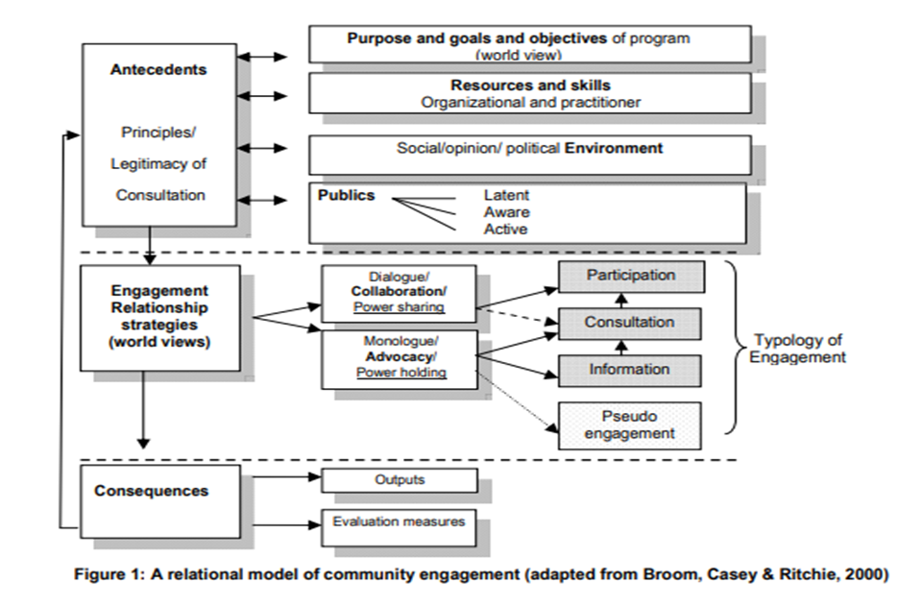

Fig 1: Model of Community Engagement
(Source: Creator)
This model of community engagement broadly focuses on the factors that may affect well-being and health of citizens. According to the above figure, any event is conducted to fulfill a specific purpose or issue related to the growth of human and social communities. In order to effectively engage the members and participants communities require resources and associated skills and encouragement from social and political sources. The model of community engagement employs a range of tools and strategies to ensure its success. This framework is built on the principles that respects the rights, beliefs, and values of all members within the community in such a way that they are effectively informed, supervised, and empowered.

Comparison Parameters | Tower Hamlet Climate engagement event | London climate action week
Effective Communication | The community of Tower Hamlet aims to improve the daily lifestyle, and working conditions in the area with the help of effective communication. In order to develop a strong and consistent identity, the council has recently revised new guidelines. House style guidelines are being produce to support the staff along with the use of common languages to meet the communication requirements of people with disabilities | Nick Mabey, chief executive of an independent think tank related to climate change, has introduced several communication strategies to effectively engage with the ethnic diverse population of London and share the serious consequences of climate change across the world. Therefore, the role of communication is exceptionally important to obtain its main objectives (Guerlain and Campbell, 2016).
Active Stakeholders | The active stakeholders of this event are counted as partnering executive group (PEG), Tower Hamlets college, Tower hamlets interfaith forum and local school representatives, Canary wharf group, Tower Hamlets housing forum etc. The stakeholders focus on four areas such as better education, aspiration and skills for children and young people, better jobs, strong, resilient and safe community, and better health and wellbeing. | The present stakeholders of this event consist of various international, national, and private institutions. The proactive partners of this event includes HSBC bank, Persefoni, University of Cambridge, Euro cities, energy institute, london councils, The prince of Wales, Regen energy, world green building council, Zemo partnership, UKSIF, world cement association, IEMA, EERA, EIC, and Eurosif etc.
Participation | The active stakeholders of this event are normally from the local community as they try to improve the services and outcomes for local residents of Tower Hamlet. The committed participation of members may seem small but their contribution toward shaping, influencing, and advancement is priceless. The participants are challenged to redesign the services and resources to achieve vital results (Wallis et al., 2020) | It is one of the biggest climate change related community engagement events where more than fifty speakers provide their speeches regarding the critical challenges of climate change impacts. The efficient participation of these partners has helped the event to effectively address the key factors and impacts of climate change plus it aids the climate action and breathing space agenda of the community.
Inclusion | The cabinet of the community has approved the revised strategic plan of 2021-24. It is introduced to counter the effects of pandemic, quick recovery from the economic crisis, huge amounts of progress and achievements, relevant information to meet community needs. | The governmental institutions, investors, trade associations, think tanks ,and private finance companies have joined forces to get solutions in the event including more greener investment, international collaborations, and most importantly adaptation and resilience (Haines and Ebi, 2019)
Table 2; Difference of stakeholders and their activities between London climate event and Tower Hamlet climate event
(Source: Learner)

how they conduct their research, carry out community mapping, social media engagement, impact analysis, evaluation and justify the best practices
In the case of London climate action week, it is one of the biggest community engagement events in the world due to its countless stakeholders and active partners. It generally conducts the research through the advanced universities such as Cambridge, Oxford, and queen market along with the research facilities of private firms and research institutes that provides detailed insights of global climate change characteristics. The community mapping is conducted through various online and offl;ine surveys along with government data that clearly shows the ethnicity percentage, language spoken and other cultural activities and events. The event has its own official social media platforms through which it connects with the residents of the globe and interacts to raise awareness by posting environment related contents and stories. The deputy mayor of social integration and community engagement suggests a series of virtual roundtable conversations with community leaders and group members to improve the current economic conditions of post-Covid’19. The event frequently evaluates various solutions regarding different social and cultural communities living within the city (Bunce, 2016). To illustrate, the event embraces various multinational heritages, connections, and experiences to create a distinct global experience. It is all about establishing a progressive and lively climate cluster to tackle the current environmental issue throughout the week and beyond.
In the case of the Tower Hamlet climate event, the council declared a climate emergency in March 2019 based on the investigative information of local research facilities, universities, and online sources. The leaders of Tower Hamlet community have developed various ethnic and improvement legislations as it is one of the fastest growing, youngest and most diverse populations in the UK. The employment rate in the community is below the average national level but it is widely between different groups. The community has its own official website powered by the UK government and other social media channels as well. Nonetheless, the aim of the community is to deliver services and results that reduce negative environmental impacts and help to obtain sustainable protection and growth for the open spaces, climate, urban design, conservation, and heritage (Russell et al., 2017).

Conclusion
From the above discussion, It has been decided that the effectiveness of community engagement depends on the strategies, approaches, and principles. The one day virtual event of Tower Hamlet is executed to raise environmental awareness and make the metropolitan area carbon neutral by the year of 2050. Whereas, the one week long London climate action event focuses on each aspect of climate change and its various consequences on a broad scale. Additionally, the research data and other fundamental resources of the London climate event is far greater than the Tower Hamlet council event thus, the efficiency and success rate of such an event is also greater. Therefore, despite the scale and resources of community engagement as long as there is a realistic issue to solve the usefulness of such events is undoubtedly extremely valuable.

Reference List
Bunce, S., 2016. Pursuing urban commons: Politics and alliances in community land trust activism in East London. Antipode, 48(1), pp.134-150.
Delannon, N., Raufflet, E. and Baba, S., 2016. Corporate community engagement strategies and organizational arrangements: A multiple case study in Canada. Journal of cleaner production, 129, pp.714-723.
Guerlain, M.A. and Campbell, C., 2016. From sanctuaries to prefigurative social change: Creating health-enabling spaces in East London community gardens.
Haines, A. and Ebi, K., 2019. The imperative for climate action to protect health. New England Journal of Medicine, 380(3), pp.263-273.
Henry Akintobi, T., Jacobs, T., Sabbs, D., Holden, K., Braithwaite, R., Johnson, L.N., Dawes, D. and Hoffman, L., 2020. Community engagement of African Americans in the era of COVID-19: considerations, challenges, implications, and recommendations for public health. Preventing chronic disease, 17, p.E83.
Li, S., Juhász-Horváth, L., Harrison, P.A., Pintér, L. and Rounsevell, M.D., 2017. Relating farmer's perceptions of climate change risk to adaptation behaviour in Hungary. Journal of environmental management, 185, pp.21-30.
Martiskainen, M., Axon, S., Sovacool, B.K., Sareen, S., Del Rio, D.F. and Axon, K., 2020. Contextualizing climate justice activism: Knowledge, emotions, motivations, and actions among climate strikers in six cities. Global Environmental Change, 65, p.102180.
Mavrodieva, A.V., Rachman, O.K., Harahap, V.B. and Shaw, R., 2019. Role of social media as a soft power tool in raising public awareness and engagement in addressing climate change. Climate, 7(10), p.122.
McGregor, C., 2015. Direct climate action as public pedagogy: the cultural politics of the Camp for Climate Action. Environmental Politics, 24(3), pp.343-362.
Olteanu, A., Castillo, C., Diakopoulos, N. and Aberer, K., 2015, April. Comparing events coverage in online news and social media: The case of climate change. In Ninth International AAAI Conference on Web and Social Media.
Russell, B., Schlembach, R. and Lear, B., 2017. Carry on camping? The British Camp for Climate Action as a political refrain. Protest camps in international context: Spaces, infrastructures and media of resistance, pp.147-162.
Wallis, G., Siracusa, F., Blank, M., Painter, H., Sanchez, J., Salinas, K., Mamuyac, C., Marudamuthu, C., Wrigley, F., Corrah, T. and Rampling, T., 2020. Experience of a novel community testing programme for COVID-19 in London: lessons learnt. Clinical Medicine, 20(5), p.e165.

