LCMB7001 Assignment 1

Maya Todorova
Student Number:2009851
MBA – LCMB 7001 - 75 %
Lecture name: Tushara Balendran

Table of Contents
Abstract...................................................................................................................................4
Introduction.............................................................................................................................4
Critical analysis and create innovate marketing strategy for raising the brand, managing and evaluating customer journey………………………..……………......…………….……………….…………………..4
Critical analysis of customer journey and customer touch point of the organisation….........11
Conclusion...............................................................................................................................13
Reference................................................................................................................................13
Web links..............................................................................................................................…13

Abstract
The main idea of this research is to explain, analyze, and recognize the customer satisfaction and touchpoint of Nestle’s company, and work on building innovative marketing strategies for raising awareness of the brand. The information will provide important solutions for the issue with a customer’s end–to–end journey” (Neher et al, March 2016). The analyses will be then about how to create innovative marketing strategies for raising the brand. Another subject connected to these analyses is evaluating the customer journey connected to communication channels and appropriate theory. The investigation and providing the information is based on an independent creator.
Introduction
The choice and trust of Nestle’s consumers and many people from all over the world is not only the creator's choice. The choice is done by my own experience using the product of Nestle's company. Here is an important introduction to one of the best companies producing multinational food and drinks. The company was founded by Henri Nestle` in 1866 Switzerland when the Anglo-Swiss condensed milk company opened the first European condensed milk factory. Nestle`s products have high quality, and they include all the types of food: baby food, medical food, bottled water, breakfast cereals, coffee and tea, confectionery, dairy product, ice cream, frozen food, pet foods and hasks. Also, the company has twenty – nine brands and annual sales of over 1 billion. Nestle`s company has 447 factories, operates in 189 countries, and employ all around the world 339 000 people. The company has the chance to grow up in a period of First World War and Second World War. Nestle’s company has few partnership companies which are: Cereal Partners, Worldwide, Coca- Cola Company, Lactails, Colgate-Palmolive, Nestle` Indofood, Snow Brand Milk, Grupo Modelo and Fontera.
From the presented information we will critically analyze how Nestle’ can create innovative marketing strategies for raising awareness of the brand as well as managing and evaluating the customer journey into communication channel, satisfaction and touchpoint. Also, to ensure current and future stakeholders and also the important issue ‘the customer’s end-to-end journey’ (Neher et al.March 2016).
The main base of Nestle’ company and each business and any other organisation is communication between customers and the company. Every communication act of transferring information from place to person or groups. One of the definitions is:” process of passing information and understanding from a person to another”- Keith Davis. There are many definitions, but we will point another one as well: “Communication is a process by which information is passed between individuals and organizations and organizations by means of previously agreed symbols”- Peter Little.

Communication
The good messages send from Nestle’ and employers around the world sometimes include the effect of emotions, the cultural situation, and location. When the message has been sent there is a use of a mixture of world’s and non-verbal communication and is transmitted in the same way of speech or writing. Communication has four different ways to be delivered:
1) Spoken or verbal communication includes face-to face, telephone, radio, and other media.
2) Non–verbal communication - covering body languages, gesture, how we dress or act, how we stand, the tone of voice.
3) Written communication – social media, emails, letters, the internet, and other media.
4) Visualization – map, graphs and communicate messages.
Each message must be encoded into form and transfer to the communication channel and decode the message to understand the meaning and significance. The effective communicator understands their audience and the message has be understood correctly. For effective communication he has to choose an appropriate communication channel, hones their message to this channel, and encodes the message to reduce misunderstanding by the receivers.
Also, we will have feedback from the receivers on how they understood and ensure correct or if is any misunderstanding or confusion to be fixed as soon as possible. Receivers can use techniques such as clarification and reflection as effective ways to ensure that the message sent has been understood correctly. Nestle’ as a successful business uses the model of Shannon and Weaver’s.
We are going to show and give an example with communication model diagram of Claude Shannon and Waren Weaver’s.
Diagram 1: Communication model by Philip Kotler and Kevin Keller ,15th Edition
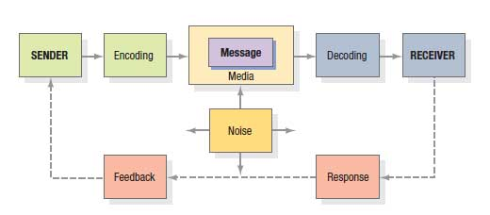

Claude Shannon and Waren Weaver’s use of this model to introduce the standard steps for effective communication. The model shows view of communication where messages are encoded by a source and sent through a channel. Messages are then decoded by a receiver, who sends the source feedback. The factor of fields of experience of the sender and receiver, life experiences which can enhance communication when they overlap.
→ Communication channels help us to the found way how we communicate. The method is used to transmit our message to a recipient or to receive a message from someone else. In this type of message are inclusive face-to–face conversations, telephone calls, text messages, emails, and the internet.
→ Encoding messages - all messages must be encoded and deliver into the communication channel chosen for the message.
→ Decoding messages – when the recipient of the massage is the the recipient, who needs to decode the messages. Vital communication skills are based on successful decoding. The process of successful communications is to understand how the message will be decoded.
→ Feedback - feedback is a final part of communication. To receive and understand the message the recipient lets the sender know that. The recipients of messages are likely to provide feedback on how they understood the messages through verbal and non – verbal reaction.
Many different models, definitions, frameworks, maps, and ways are effective stakeholder strategies. This is a part of a crucial process in effective, efficient project management. The business landscape and context map can be changed from events from internal and external stakeholders. Also, employers fit, and stakeholders bring importance to the growing up of each company and everything starts with ‘free markets’ into ‘stakeholder capitalism’. The positive benefit of analysing the map and model is to bring the company to the best level. The prove is support and fluency boost employee retention and customer satisfaction. Another part is to establish strategic external communication channels and prevent conflicts and respond quickly. Particularly important part is to identify new business development and create markets and build trust and reputation in the industry.
Integrated marketing
When we have all the forms of messages and communication and they are linked together then we can have a view of Integrated marketing. One of the definitions for Integrated marketing is the follows: “Integrated marketing is a strategic approach to integrating communications and interactive experiences targeting defined audiences and individuals which coordinates all aspects of marketing of a brand including:
→ Paid media (offline advertising, direct marketing, and online display and programmatic).
→ Earned media (organic search fuelled by content, marketing, PR, and online influence outreach.
→ Owned media (including social media, on–site UX, customers service and direct messaging through emails and mobile).
Advertising of the company is communication. This type of communication uses paid messages by those who send them and are intended to inform influence people who receive them as detained by the Advertising Association of the UK.
Media include many sectors: Newspapers, magazine, television, radio, cinema, outdoor. Media texts are used to inform, entertain, or promote ideas or products. The Media messages can be in many different formats on a range of platforms. Nestle’ company uses this way also to promote their company and promotions. To achieve consistent messaging customised where possible by channel with present a unified and seamless experience to customers across the customer lifestyle or path to purchase”
Promotions
Nestle is a worldwide company and now use current promotion where is for people who buy products of their company. Also, the customers must have internet access, proof of purchase and registration required. It is important that they keep promotion of cash receipt. The one of the biggest worldwide company Nestle’ believes in customer satisfaction. They also believe the products are” sold, not brought”. They follow the process of personal selling and other sales techniques. Nestle’ tries to understand the economic geographic and social factors. Also, they make their products available at affordable prices. As an example, nestle’ spend a few days in different countries to find out the customer’s needs in their everyday life. They try to produce a product that they need and achieve organization’s goals. Promoting and promotions is a plan of satisfaction of the customer’s demand and products buying. In this way they are sending a message to the customer that ‘If you buy the product you will try new quality”.
Promotion strategy for raising the brand
Nestle’ realise that importance of promotion increases when the distance between the producers and the customers increase as well. Another main idea is to keep the logo and name in the market. According to Armstrong and Kotler” called marketing communications is a mix of all the promotion tools in a perfect blend, which an organisation uses to promote its products”. The sales promotion of Nestle’s company is one of the fastest growing promotional methods known. The winner, who follow the rules, can be granted with cash and with product price. The method includes free samples, money off coupons, extra value offers such as “Buy one get one free” bundling. Nestle’s also offer programmes like every day eating coupon codes, discounts and offers for online shopping on various Nestle’ products. Nestle’ is a well-known brand and continue working on the idea to bring the attention of all customers. The company provides advertising and sales promotions.
Sales promotion
Each organisation that creates a business must use advertising and sales promotion. Here we can analyse the difference between advertising and sales promotion. The sale promotion is a type of marketing strategy to include the products and raise the sales on temporary plan. An advertising strategy is permanent that includes marketing and sales. Generally, advertising is paid messages in the media, while promotion includes paid and free marketing activities like sales or sponsorship. Nestle’ trust both way of keeping the name and standard of the company. The new promotional strategies Nestle’ uses to raise awareness of the brand.
One of the new strategies is product development inclusive new product range for the existing market for future growth. Also, they are using products on the market that are totally unconnected with existing products on the market. An example of diversification of Nestle’s product is pet food which is different from their other products. The strategy also includes developing product lines and customized online and offline marketing strategies. Nestle’ established its” expatriate army” of 700 managers who are experienced in management activities in foreign countries. Another approach is from SBV’s - this is units create high-level strategic decisions on worldwide basis. Another highly successful strategy is through a partnership with other large companies, in which Nestle’ includes different products from a different country. All the strategies are based on the idea of “push and pull”, where:
→ Pull strategy: Nestle’ advertise their products to the customers, offering discount and promotions. For example, the promotional offer and online launch of Maggi with discount prices is one of the highlights in this strategy. Also, this is the way how they deliver the message to the channel.
→ Push strategy: The distribution panthers have obligation to Nestle’ to push the product through to the channel. They offer marketing activities, price discount, advertising partnership.
When a company is on the market for success one of the best ideas is to use both strategies - push and pull. The environment and customers are open to a change because of open to change strategy.
Here we will show the diagram of “Push and Pull” strategy to give more clear explanation.
Diagram 2: Introduction to marketing Push and Pull strategy

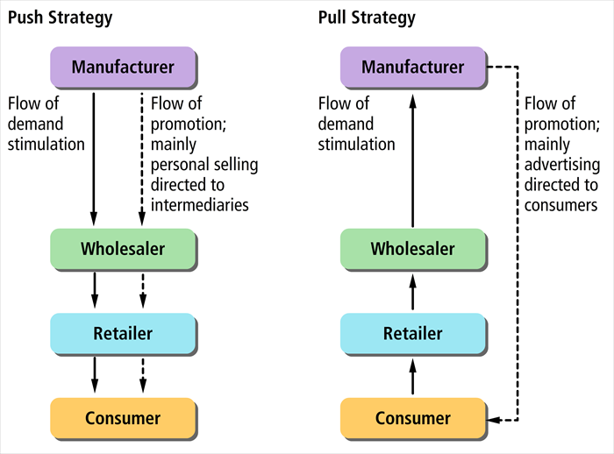
Public Relation
Another important part of the strategy is public relations, which means the result of what you do, what you say and what others say about you. In other words, is called Reputation. The reputation of Nestle’ is based of worldwide popularity and a logo of the best product.
In this process of inclusion, the relationship between customers, suppliers, employees, investors, journalists, and regulations, is vital. That relationship is one of the main drivers’ people to get involved in any decisions, support and ideas. The publicity of Nestle’ company is playing an important part in the launch of every new product, hence in the sale. The process of publicity includes attraction and attention of the public. Attention is given to someone or something by newspapers, magazines, television, and new programs.
The PR of Nestle’ company has the responsibility to deal with the reputation and transferring the messages to the media. Any big or small organisation depends on reputation for survival and success. The role of PR is to build the best relationship with good and winning reputation, communication, and stakeholder.
Sponsorship and Integrated Marketing Communications
Regarding to the increase of popularity and public relationship big businesses use sponsorship. The role of sponsorship is to sponsor events, teams, or brand awareness. Most of the sponsorships have a commercial objective. Nestle’ became main sponsor of the world-wide IAAF Kid’s Athletics Programme. Nestle’ will provide financial support under terms and agreement. Also for popularity, we can use direct marketing. This type of marketing is a form of promotion, where organizations communicate directly to the media using all abilities like messages, phones, websites, online adverts, distributional and promotional letters. Also, another method is digital marketing where they transfer advertising into digital channels such as websites, social media, mobile apps. Nestle’ as a company uses all the possible opportunities to build strong position and uses many communication channels. This procedure is called Integrated Marketing Communication. Many of Nestle’ advertisement channels, such as billboards, television, transports, magazines, newspapers and posters, are effective and appropriate. Integrated marketing communication is a term used to describe a holistic approach to marketing communications. Also, they include online and offline marketing channels.
Diagram 3: Stages in an International Marketing

Define the audience(s) to be targeted
Set the promotional objectives (2)

Set the promotion budget (3)

Design the promotion mix (4)

Evaluate the results (5)

Nestle’ is a company with good reputation in worldwide term. To keep the brand in high position of reputation and rase awareness, they use new strategies. Nestle’ is experienced in different marketing solutions to gain and increase their brand awareness, for example using on-pack promotion and gift with purchase and POS display. The new promotional strategy - POS display, is one of the best examples for multi-tunnel marketing solution. This is a perfect way to gain attention and increase brand awareness.
The brand equity refers to a value premium that the company generates from a product with recognizable name. By using this strategy, they make the brand Nestle’ and their product memorable, easily recognizable and quality reliable.
“Each expert comes up with his or her own definition of a brand or nuance of definition” (Kapferer,2004). All brands should be managed as valuable and long-term corporate assets. The relationship must be built between brand loyalty and brand value needs. Another important part is the logo, and they are using it for complex strategy of brand communication. Also, there is another definition given by Kerr:” name, symbol, logo, word or other graphic that identifies and differentiates the destination”. In both definitions the design, graphic device, or symbol, are key features in the definition by brand (Kerr, 2016, p.277).
The importance of branding in industrial context has increased and is following the model of business–to–business. The study of Keller involves a structure of the brand model. The model has a shape of pyramid with four levels. The levels of the brand enquiry pyramid are as follows: meaning, identity, response, and relationships. To have a strong brand your organisation must build your pyramid solid from the ground.
Keller’s Brand Equity Model
Diagram 4: Introducing Keller’s brand equity model
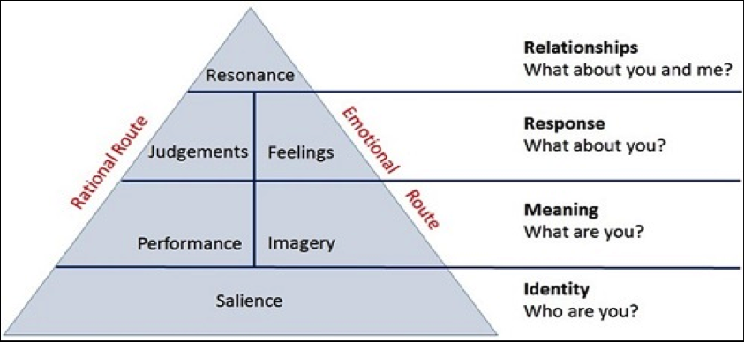
The identity makes your brand and creates the way of communicating and what the brand is about. Everyone must know about your brand but also to get every message in right way. One of the best messages that has been sent by Nestle’ and everyone understand, and quite easy to remember is “GOOD FOOD, GOOD LIFE”. The message sent to all of the world, makes people choose Nestle’ based on the positive vibe, because they believe in the quality of their products, and everything they do.
Another message, that have been sent is: “Launch more foods and beverages that are nutritious, especially for mothers-to-be, new mothers, infants and children”. This message is send especially for group of people mother and children, not for everyone.
Here is also another one:” Increase vegetables, fibre-rich grains, pulses, nuts and seeds in our foods and beverages”. The idea is to be used by everyone who is vegetarian or anyone with special requirements. There are many types of messages in Nestle’ company, but we introduced few and present how important is the message information to be clear and with straightforward meaning. In each send message, we receive a respond from the customers. It is especially important to build positive relationships with customers as this also creates a community for the brand and increase the loyalty within buyers.
CONCLUSION
In 2016 Nestle’ marked their 150th birthday. To build an organisation like Nestle’ with 2000 brands, globally famous with a tremendous value is a quite big challenge. The key for success is an excellent brand managers, creativity, discipline, and consistency. The introduction from the creator and analyses have been there to help other companies for success. Nestle’ is an example for success and prosperity for many years ahead.
Discuss the costumer’s journey and customer’s touchpoints of your organisation.
The successful organisation is based on customer’s experience or customer’s journey, which is also based on customers path via touchpoint, to their decision to purchase an item. Customer journey includes the customer being aware of buying the items and talking about them.
The customer journey “end-to-end” is an experience, where company includes the customer needs and shows understanding. The Nestle’ is build stable on the touchpoint of ensuring that their products are available whenever a customer may need them and may want them. The main strategies of customer journey are awareness, consideration, decision, retention, and advocacy.
→ Awareness
The first stage of customer journey is Awareness, where a potential customer has need or problem, and in a short time to be found solution for the problem.
→ Consideration
The next stage is a consideration level. Here are the analyses between one product of the market to another product of the market.
→ Decision
In this stage customer makes decision based on the market offers, and what type of product would like.
→ Retention
Your best customers do not just buy one product or use your service once. They come back again and again for more. Customer retention increases your customers’ lifetime value and boosts your revenue.
→ Advocacy
Customer advocacy is a specialized form of customer service in which companies focus on what is best for the customer. It is a change in a company's culture that is supported by customer-focused customer service and marketing techniques.
The definition has been given will be proof for customer journey with a model diagram of Nestle’ Egypt report.
Diagram 5: Customer journey Nestle’ - Egypt
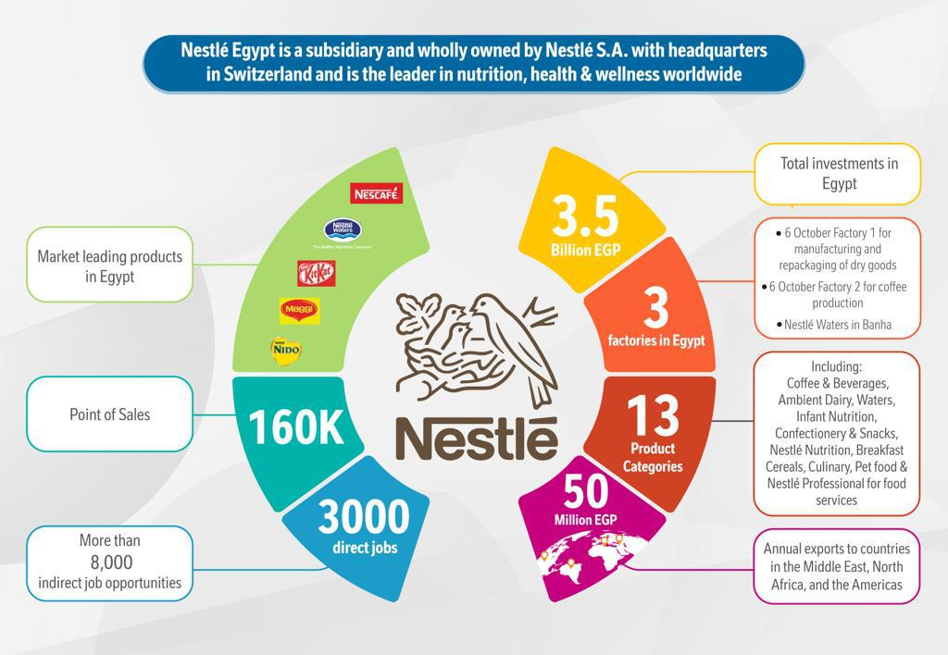

From the diagram we can introduce the investment in Egypt, and in the market product. They show how many factories been producing products and been open. Included are all products and all sponsorship relationship with Nestle’ and Egypt. Also, there is a plan for point sales and job opportunities and introducing the business in many countries.
Customers touch point
The customer touch point is created every time with Nestle brand and service. Customer touch point refer to the point of the interaction between the brand and the customer. Touch point can be any way of inviting customers and introducing the business to them such as social media, online advert, digital marketing context, company event, peer referral.
A touch points before the purchase of a product, or during a purchase are the two ways of where a company keeps in touch with the customers. Before the social media appearance, online advertisement, digital context, company events, the product catalogues, and product reviews, and website points of sale were a touch point after purchase. Customer journey map is also especially important in Nestle’ business. This is the one of the ways for the business to be assessed by the view of customers. Also, to improve the relationship between business and customer’s service. In we see help and point of the side of the customer. The success of Nestle’ business is to deliver to customers when they decide to purchase a product. The products of Nestle’ always have the design and logo of Nestle’ and are with high quality. Behind the brand’ success of who they are, and what they stand for is not only the brand and logo standing. For the business success we have a strategy of engagement model, which is considered a benefit of the present future for the company and includes customer value promotion, customer’s experience, branding. Also, the customer’s experience is combination of a physical and emotional elements of the success of the business. One of the main reasons for successful customers experience is the promotion offer, and the fact they give a chance for many customers to be loyal to the products, and always use this product of the company. To create engagement with customers, Nestle’ always follow the steps and keeps the following model:
1. Develop a unique value proposition based on strong customer insight.
2. It should then communicate this value proposition to customers consistently in its brand advertising.
3. The promise is then ideally delivered by staff that support and understand the strategy and importantly understand their individual role in making it a success.
4. The cultural foundation results in the delivery of a planned customer experience that delivers strongly against the promise made in your advertising.
Diagram 6: Engagement model
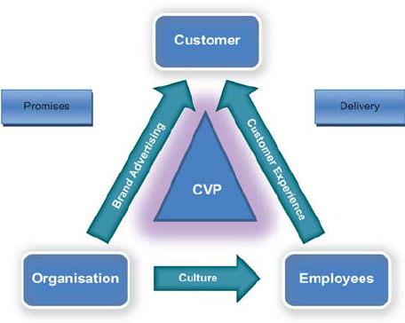

Every business faces some issues and problems sometimes. The Engagement model put everything together into effective system - all activities of the company and plan for customer engagement, including advertising, service, product, and the internal culture. The benefit of the engagement model is a total brand strategy alignment throughout the company: the whole (through integration) is greater than the sum of the parts (of which some may already be good, and some may not be that good, but they may be fragmented). The proposed model is comprehensive and thereby integrates and clearly explains, with emphasis on actionability, how to design and operationalise a growth plan driven by increasing customer engagement. Any organisation looking for a success must follow this model.
Conclusion
The research from the author shows critical analyses for marketing strategies of raising awareness of the brand as well as managing and evaluating the customers journey into communication channel. Also, analyses the satisfaction and touch point and introduces “end–to–end journey”. From the above report the creator shows how can be positively helpful and how the marketing strategies can be used by another businesses. The introduction and the explanation research were reached from online and home study. All the analyses are based on this research.
References:
The mathematical theory of communication by Cloude Shannon and Waren Weaver
Push & Pull strategy Third Edition by Gerardus Blokdyk
Strategic Brand Management by Richard -Elliott, Larry Percy, Professor Simon Pervan
Strategic Brand Management: Building, Measuring, and Managing Brand Equity, Global Edition by Kevin Keller and Vanitha Swaminathan
Stakeholder Engagement Analysis 101: Five Simple Models to Create Your Project / Business Template
Customer Engagement Contemporary Issue And Challenges By Roderick J.Brodie, Linda H. Holleebick And Jodie Conduit

Marketing Strategy and Competitive Positioning, 7th Edition by Graham Hooley

The Customer Success Professional′s Handbook: How to Thrive in One of the World′s Fastest Growing Careers―While Driving Growth for Your Company by Ashvin Vaidyanathan
The brand mapping strategy by Karen Tiber Leland

International Marketing Strategy Analysis, Development and Implementation by Isobel Dool,Robin Lowe , Alexsandra J.Kenyon

Nestlé: The Secrets of Food, Trust and Globalization by Friedhelm Schwarz
Strategic Customer Service by John A . Goodman
Web links:
https://globalriskcommunity.com/profiles/blogs/stop-pushing-and-start-pulling-it-s-more-satisfying
https://michellemathiasfsp.blogspot.com/2018/11/shannon-and-weavers-model-of.html
https://studylib.net/doc/9038546/the-shannon-weaver-model
https://surabhiudas91.wordpress.com/2014/08/17/nestle-slim-milk-distribution/
https://www.smartinsights.com/marketing-planning/marketing-models/push-pull-product-distribution-model/
https://www.mindtools.com/pages/article/keller-brand-equity-model.htm
https://www.chegg.com/learn/business/introduction-to-business/brand-equity-in-introduction-to-business
https://www.salaamgateway.com/story/nestle-egypts-world-exports-record-egp-50m-annually-regional-official
https://www.salaamgateway.com/story/nestle-egypts-world-exports-record-egp-50m-annually-regional-official
https://www.grosvenor.com.au/resources/key-to-effective-stakeholder-engagement/
https://www.ngdata.com/how-to-find-customer-touchpoints/
https://www.tutor2u.net/business/reference/sales-promotion
https://prezi.com/ksxpnnsuwh7g/nestle-growth-strategy/

