ECED7006
2106780
Select and critically discuss, three images which can be seen to perpetuate stereotypical attitudes for a group of your choosing (2,596/ 2,250 words)
Image 1
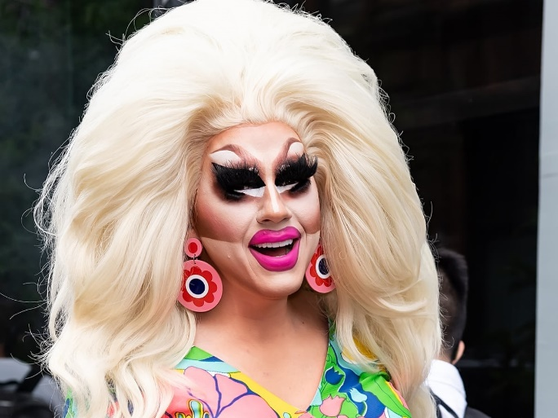
(Carrasquillo, 2021)

Image 2
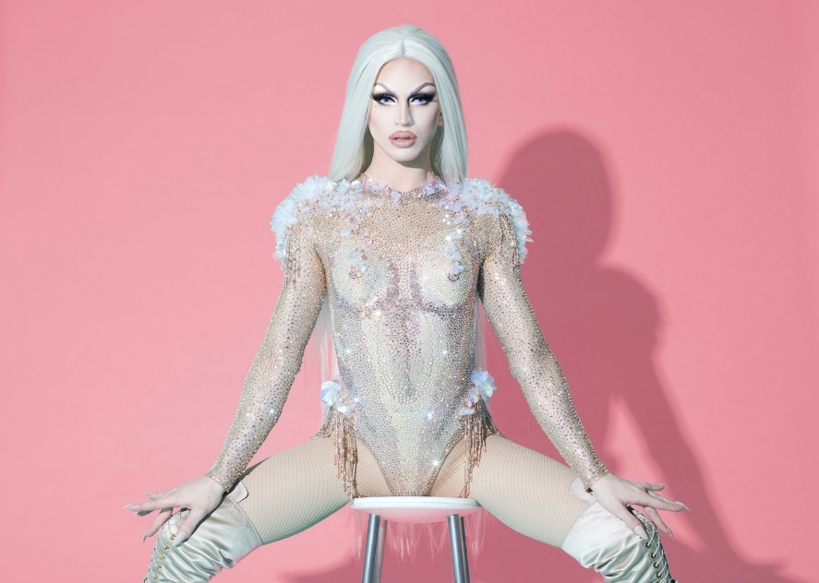
(Photo provided by Aquaria, 2020)

Image 3
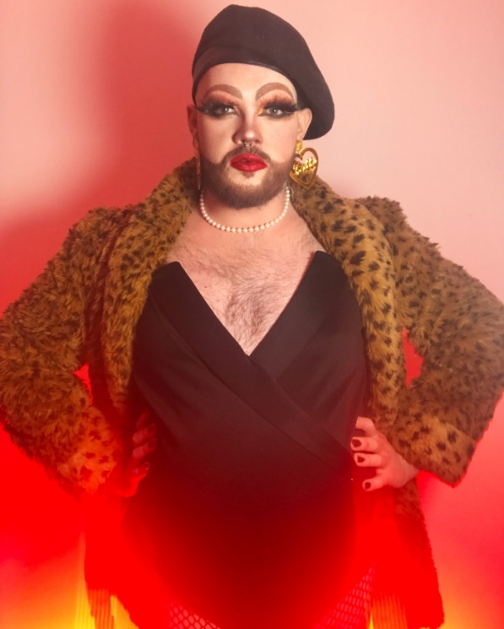

(Mitsis, 2021)

Stereotypes are expectations about members of social groups (Ellemers, 2018; Greenwald and Banaji, 1995; Muntoni et al., 2021), which provide guidance on how to interact with individuals (Schneider, 2004). Fiske and Neuberg (1990) argued that stereotypes are usually negative opinions about groups, often based on rumours (Fiske and Taylor, 1991). Further research has suggested that stereotypes are distinct from discrimination, which is behavioural (Fiske, 1998, 2004; Nelson, 2002; Posthuma and Campion, 2009). Later scholars, however, argued that stereotypes can cause discrimination, as they can reduce impartiality and lead to unfavourable treatment (Carlana, 2019; Glover et al., 2017).
Drag performances have a history as a key part of LGBTQ+ spaces, representing for people whose gender and/or sexuality has left them marginalised in society (Barnett and Johnson, 2013a, 2013b; Newton, 1972). In recent years, drag performances have received increased media attention (Schact and Underwood, 2004; Vidal-Ortiz, 2008; Zervigon, 2009), becoming a widely recognised phenomenon (Barnett and Johnson, 2013a), with shows such as RuPaul’s Drag Race (Simmons, 2014), films including To Wong Foo and popular books (Harris, 2005). As attention has increased, literature on drag queens has also extended, alongside the popularity of queer studies (Greaf, 2016). The majority of mainstream drag performances involve drag queens, rather than drag kings, and due to their increased attention in the public sphere, drag queens will be the focus of this submission (Ellis et al., 2022; Rupp et al., 2010).
As a term, drag queen needs to be defined, as there is little consistency (Schmid and Payam, 2022). Previous terms that have been used include cross-dresser and female impersonator (Barnett and Johnson, 2013a), but drag queen is used throughout this submission, as it is the most recognised marker (Carretta et al., 2019; Holcomb, 2007). Drag can refer to appearing to be a different gender (Barnett and Johnson, 2013a), or changing persona (Greaf, 2016), although Taylor and Rupp (2004) specifically define them as gay men who perform as women, but do not wish to be women (p.115; Rupp et al,. 2010). This definition is problematic, however, as it uses binary gender categories, whereas a variety of gender identities are represented within the drag queen community (Berkowitz et al., 2007). Consequently, Knutson et al’s. (2018) definition of self-identification as a drag queen being the key indicator, is used throughout. Self-identification as a drag queen links to Social Identity Theory (SIT), whereby individuals identify with social groups that are reflective of their characteristics (Ashforth and Mael, 1989). Though SIT has criticisms for being vague (Ashforth and Mael, 1989), its lack of reliance on pre-existing labels, and therefore increased inclusivity of those who self-define as drag queens, makes it suitable for this submission (Schmid and Payam, 2022).
Within this submission, three images will be used which can be seen to perpetuate stereotypes associated with drag queens. The images that have been selected are of Trixie Mattel (Carrasquillo, 2021, image 1) and Aquaria (Photo provided by Aquaria, image 2), American drag queens who have featured on RuPaul’s Drag Race, and Fatt Butcher (Mitsis, 2021, image 3), a British drag queen. The stereotypical attitudes towards drag queens that will be considered within these images are: as caricatures of women, with over-emphasised makeup and wigs (Image 1; Butler, 1988; Carretta et al., 2019; Hyde et al., 2018); as over-sexualised (Image 2; Friedman and Jones, 2011; Fox, 2008; Murnen and Byrne, 1991) and as a mechanism to shock audiences, through challenging gender binaries (Image 3; Knutson et al., 2019; Schmid and Payam, 2022). Although these stereotypical attitudes may appear contradictory, they represent three of the main stereotypes that drag queens face, which demonstrates the mixed reaction to drag queens within society (Berkowitz and Belgrave, 2010; Newton, 1979; Tewksbury, 1994).
The first stereotypical attitude studied, is that drag queens are caricatures, often over-emphasising features such as makeup and hair (Barnett and Johnson, 2013a; Greaf, 2016; Newton, 1972). The image chosen to show the perpetuation of this stereotype is image 1 of Trixie Mattel (Carrasquillo, 2021), with thick makeup, voluptuous hair, bright earrings and a colourful top (Carrasquillo, 2021; Mattel, 2022).
Drag looks can be gendered, centred around another person, usually based on a celebrity, or be a caricature of a social role, such as a housewife (Barnett and Johnson, 2013a; Levitt et al., 2018; Newton, 1972). Knutson et al. (2018) argued that drag is a parody, with further research adding that drag is based on adopting a persona (Butler, 1988; Carretta et al., 2019; Greaf, 2016; Hyde et al., 2018). Barnett and Johnson’s (2013a) research is pertinent here however, as they argued that drag queens are social actors who reconstruct aspects of life to create mass entertainment. This exaggeration is often extreme and not related to the majority of women, as can be seen in image 1 (Ellis et al., 2022; Newton, 1972).
Schmid and Payam’s (2022) research furthered the argument that drag queens often perform as caricature-like women, and utilise this to entertain audiences (Namaste, 2000; Berkowitz et al., 2007). Some of these stereotypical attitudes have come from within the LGBTQ+ community, which has led to drag queens performing these stereotypes, as it is seen to increase audiences (Namaste, 2000). Drag queens have become the jesters of the LGBTQ+ community, with their job only to perform, meaning that their personas are only suitable for the stage (Namaste, 2000). These caricature-like performances can impact on drag queens’ personal lives, as research shows that they often have difficulty finding relationships and can be marginalised within the LGBTQ+ community (Berkowitz and Belgrave, 2010; Berkowitz et al., 2007).
Despite the exaggerated makeup, hair and clothing that drag queens may wear, drag queens are often more masculine than their female caricature appearance may imply, merely using stereotypical facets of femininity to increase status, income and power (Berkowitz and Belgrave, 2010; Schact and Underwood, 2004). This has led to feminist theorists criticising drag queens performing as reinforcing the patriarchy (Connell, 2000), as they will still receive benefits as men (Butler, 1988, 1990; Rupp et al., 2010; Schact and Underwood, 2004; Williams, 1995). Although this may be the case for some drag queens, this not only assumes that all drag queens are cisgender men, in a time when an increasing number of queens identifying as gender diverse (Berkowitz et al., 2007), but also is not inclusive of drag queens who challenge boundaries whilst performing as females, for example the rising presence of Drag Pageants, similar to Beauty Pageants (Greene, 2021; Tewksbury, 1993). Whilst Drag Pageants and Beauty Pageants have some similarities, beauty queens tend to express individual expression within set boundaries (Daems, 2014; Greene, 2021), whilst drag queens perform with creativity and uniqueness, working to challenge what is means to be feminine (Barrett, 2017; Hopkins, 2008; Greene, 2021). This supports feminists and queer theorists aims of redefining femininity, and suggests that drag queens challenge the patriarchy, rather than reinforce it (Barrett, 2017).
In addition to performing as exaggerated, caricature-like females, a further stereotype associated with drag queens are that they dress and behave in a manner that is over-sexualised (Berkowitz and Belgrave, 2010; Berkowitz et al., 2007). This includes being seen as flamboyant and promiscuous, leading to negative associations both inside and outside the LGBTQ+ community (Berkowitz and Belgrave, 2010; Berkowitz et al., 2007).
The image chosen that perpetuates this stereotype is image 2 (Aquaria, 2020), of Aquaria. The image of Aquaria with legs apart, visible breasts and parted lips demonstrates the overt sexuality and hyper femininity that is stereotypically associated with drag queens (Carretta et al., 2019; Friedman and Jones, 2011; Fox, 2008; Murnen and Byrne, 1991). Although drag queens are becoming more diverse, in regards to ethnicity, gender, body shape and age (Daems, 2014; Mayora, 2014), a large number of drag queens still attempt to imitate white, western standards of beauty, such as being young and slim with large breasts (Berkowitz & Belgrave, 2010; Berkowitz et al., 2007; Carretta et al., 2019; Greaf, 2016; Tewksbury, 1993), sometimes even attempting to ‘pass’ to audiences as a cisgender woman (Garber, 1992; Greaf, 2016). Image 2 portrays this image, and all three images chosen are of white drag queens, reflecting the majority of drag queens in western society (Berkowitz & Belgrave, 2010; Berkowitz et al., 2007).
The stereotype of drag queens being sexualised is mainly applied to those who are young (over 20, but under 35) (Carretta et al., 2019) and slender, creating a preference for slimmer bodies, labelling these as ‘appropriately female’ (Darnell and Tabatabai, 2017). Drag queens often experienced being objectified by audiences (Wiseman and Moradi, 2010), including touching and sexualised remarks, which then led to cash tips, which could mean that drag queens perpetuated these stereotypes to continue receiving money (Carretta et al., 2019). Although sometimes this stereotype may be played upon by drag queens for financial gains, it could also lead to them becoming marginalised. An empirical study conducted by Berkowitz and Belgrave (2010, p.169) included a drag queen stating that some people called them ‘freaks or sluts’ and assumed they were trying to seduce straight men.
Carretta et al’s. (2019) study into drag performances show that drag queens act out sexualised shows of femininity that replicate heteronormative ideals. Drag queens not only use wigs, makeup, padding and clothing, but may shave body hair and diet to achieve this. Rupp et al. (2010) have used queer theory to argue that drag queens elicit non-normative sexual responses from their audiences (Marcel, 2014), whilst others suggests that they reinforce heteronormative sexual desire through their portrayal of feminine beauty (Dolan, 1985; Frye, 1983; Gagné and Tewksbury, 1996; Schacht, 1998, 2000, 2002a, 2002b; Tewksbury, 1993, 1994). Greaf’s (2016) study is relevant here, as the drag queens interviewed highlighted heterosexual audience members expressing a sexual attraction towards them, despite knowing that they were male. This is because some drag queens, including Aquaria, use their performances to continue heteronormative male and female gender roles and stereotypes, which aids audience members in constructing their sense of what is real (Johnson, 2004). Drag queens style their wigs, choose feminine clothing and create female, sexualised personas to reflect the images that audiences have consumed from media (Greaf, 2016). This suggests that drag queens are aware of the stereotype of them being sexualised, and continue this in their performances to achieve financial security, even if this leads to them being marginalised.
The final stereotype associated with drag queens that will be considered in this submission is that they use their drag to shock audiences, through their gender presentation. Image 3 (Mitsis, 2021) portrays Fatt Butcher, a British drag queen, who has body hair, but wears full makeup and stereotypically feminine clothing. This challenges heteronormative views on gender (Greaf, 2016) and perpetuates the stereotype that drag queens adopt this persona to shock audiences.
A heteronormative society assumes someone that looks and acts as a man is a man, and that someone who looks and acts like a woman is a woman (Devor, 2002, p. 528; Greaf, 2016), which drag queens and queer theorists challenge. Gender diversity has traditionally been accepted in various cultures, notably the Asian subcontinent (Vincent and Manzano, 2017), but in many Western societies, cross-dressing is viewed as deviant, meaning that drag queen performances interact with social expectations of gender and create stereotypes (Greaf, 2016; Knutson et al., 2019; Rupp et al., 2010; Schechner, 2003; Schmid and Payam, 2022). Rupp et al’s. (2010) research suggested that drag queens are often perceived as being transgender, but Barnett and Johnson (2013a) state that drag queens construct their own gender and portray this to audiences authentically, rather than as a way to play into a stereotype of shocking audiences.
Some have suggested that as drag performance become more mainstream, the shock audiences feel has lessened (Schact and Underwood, 2004; Vidal-Ortiz, 2008), but an element of seeing gender outside of the heteronormative binary may still be shocking, due to fear associated with the criminalisation and pathologisation of same-sex attraction (Ellis et al., 2022). Consequently, drag queens not only shock audiences, but also hold a unique power (Berkowitz and Belgrave, 2010; Rupp et al., 2010), as they demonstrate that gender is a social construct (Greaf, 2016; West & Zimmerman, 1987).
Therefore, despite assertions that drag queens reinforce the patriarchy through performing as females only (Butler, 1988, 1990; Rupp et al., 2010; Schact and Underwood, 2004; Williams, 1995), masculinity, femininity and queerness are all included within drag queen performances (Berkowitz and Belgrave, 2010; Greaf, 2016; Levitt et al., 2018), which questions social systems (Barnett and Johnson, 2013a). Queer theorists also argue that drag queens perform transgressive acts, which challenges heteronormative assumptions and acknowledges minority gender identities (Butler, 1990,1993; Garber, 1992; Lorber, 1994, 1999; Muñoz, 1999; Rupp and Taylor, 2003). Drag queen performances may therefore be described as genderqueer, even if the drag queens themselves do not identify as such. Genderqueer performers may identify as both male and female, or somewhere in between (Beemyn, 2009), contrary to the previous assumptions that drag queens were transgender (Stryker and Whittle, 2006; Valentine, 2007). Symbolic interactionism (SI) is relevant here, as this assumes that people add meaning to their worlds through interacting with others (Berkowitz and Belgrave, 2010; Mead, 1934). SI is relevant to drag queens as it suggests that they give meanings to their world that have been created through an interpretive process (Berkowitz and Belgrave, 2010). This is supported by Simmel’s (1955) research into SI, that states that people have multi-layered identities, with parts of these shown or hidden, depending on the audience (Berkowitz and Belgrave, 2010; Stryker, 1980).
Despite the SI theorist argument that drag queens portraying their gender as part of a multi-layered identity (Barnett and Johnson, 2013a; Corwin, 2009; Garber, 1992), some drag queens may perpetuate this stereotype as a means of political resistance (Barnett and Johnson, 2013a; Corwin, 2009; Nestle et al., 2002; Moloney and Fenstermaker, 2002; Rupp et al., 2010). Genderqueer performances could be viewed as political, as they are ambiguous and challenges traditional binaries (Barnett and Johnson, 2013a). Whilst some scholars argue that drag queens do not display political resistance, and instead mock women (Morrison, 2014), Wilchins (2002) argues that gender was a way to rebel and defy societies norms, and drag queens may perform in this way to continue the history of them fighting for social justice (Berkowitz and Belgrave, 2010; Simmons, 2014; Zervigon, 2009), despite this visible way of challenging heteronormative assumptions potenitally leading to marginalisation, violence and discrimination (Ellis et al., 2022; Stein, 2023). Drag queens have a unique position of portraying entertainment and politics, meaning that they are some of the most visible people within LGBTQ+ communities (Barnett and Johnson, 2013a; Berkowitz and Belgrave, 2010; Buetti et al., 2016). This suggests that although the stereotypical attitude suggested is that drag queen shock audiences, this is an acknowledged part of drag performances that may be an act of political resistance, despite the potential consequences of discrimination.
To conclude, drag queens can face stereotypical attitudes from both inside and outside the LGBTQ+ community (Berkowitz and Belgrave, 2010; Berkowitz et al., 2007; Namaste, 2000). Images 1,2 and 3 have been considered as portraying stereotypical attitudes of drag queens being caricature like females, viewed as over-sexualised and being purposefully shocking towards the audience. It is apparent that these perceptions exist and are often continued by the drag queens themselves to exert power and to be financially secure, despite the potential marginalisation caused by these acts (Berkowitz and Belgrave, 2010; Rupp et al., 2010). The stereotype of drag queens being shocking to audiences, however, may actually be as a purposeful and effective way of political resistance (Barnett and Johnson, 2013a; Corwin, 2009; Nestle et al., 2002).

Reference list
Ashforth, B. E., & Mael, F., (1989), ‘Social identity theory and the organization’, Academy of Management Review, 14 (1), pp.20–39
Barnett, Joshua Trey, and Johnson, Corey W., (2013a), ‘We Are All Royalty: Narrative Comparison of a Drag Queen and King’, Journal of Leisure Research, 45 (5), pp.677-694
Barnett, Joshua Trey, and Johnson, Corey W., (2013b), ‘Our Town’s a drag: Drag queens and queer space in Athens, Georgia’, in K. Schwab and D. Dustin (Eds.), Just Leisure: Things we believe in, Illinois: Sagamore, pp.49-58
Barrett, Rusty, (2017), From Drag Queens to Leathermen: Language, gender and gay male subcultures, Oxford: Oxford University Press
Beemyn, B. G., (2009), ‘Genderqueer’, GLBTQ Arts, 1, pp.1-2
Berkowitz, D.; Belgrave, L., and Halberstein, R. A., (2007), ‘The interaction of drag queens and gay men in public and private spaces’ Journal of homosexuality, 52 (3/4), pp.11-32 Berkowitz, D., and Belgrave, L., (2010), ‘”She works hard for the money”: Drag queens and the management of their contradictory status of celebrity and marginality’, Journal of Contemporary Ethnography, 39 (2), pp.159-186
Buetti, D.; Martinello, N.; Moureau, N.; Lapointe-Harris T., and Ladouceur, P., (2016), ‘Social representations of male homosexuality and their consequences for gay men: An explorative inquiry within the Canadian context’, Culture, Society & Masculinities, 8 (2), pp.155-173
Butler, J., (1988), ‘Performative acts and gender constitution: An essay in phenomenology and feminist theory’, Theatre Journal, 40, pp.519–531
Butler, J., (1990), Gender trouble: Feminism and the subversion of identity, New York: Routledge
Butler, Judith, (1993), Bodies that Matter: On the Discursive Limits of Sex, New York: Routledge
Carlana, Michela, (2019), ‘Implicit Stereotypes’, The Quarterly journal of Economics, 134 (3), pp.1163-1224
Carrasquillo, Gilbert, (2021), Trixie Mattel, accompanies Michael Segalov, ‘Sunday with Trixie Mattel: ‘I refuse to stop – every day is a Monday’, The Guardian, Accessed via: Sunday with Trixie Mattel: ‘I refuse to stop – every day is a Monday’ | Sunday with… | The Guardian, Accessed on: 17/12/22
Carretta, Rachel; Szymanski, Dawn M., and DeVore, Elliott, (2019), ‘Predictors of disordered eating and acceptance of cosmetic surgery among grad queen performers’, Body image, 30, pp.64-74
Connell, R., (1992), Masculinities, Berkeley: University of California Press
Corwin, A. I., (2009), ‘Language and gender variance: Constructing gender beyond the male/female binary’, Electronic Journal of Human Sexuality, 12, pp.1-19
Daems, Jim, (2014), The Makeup of RuPaul’s Drag Race: Essays on the Queen of Reality Shows, North Carolina: McFarland & Company
Darnell, A. L., and Tabatabai, A., (2017), ‘The werk that remains: Drag and the mining of the idealized female form’, In N. Brennan & D. Gudelunas (Eds.), RuPaul’s drag face and the shifting visibility of drag culture, Cham: Springer Nature, pp. 91–101
Devor, H., (2002), ‘Who are “we”? Where sexual orientation meets gender identity’, Journal of Gay & Lesbian Psychotherapy, 6, pp.5–21
Dolan, Jill, (1985), ‘Gender Impersonation Onstage: Destroying or Maintaining the Mirror of Gender Roles?’, Women and Performance: A Journal of Feminist Theory, 2 (2), pp.5–11
Ellemers, Naomi, (2018), ‘Gender stereotypes’, Annual review of psychology, 69 (1), pp.275-298
Ellis, Justin R.; Ashford, Chris and Maine, Alexander, (2022), ‘A Fairy Tale Gone Wrong: Social media, Recursive Hate and the Politicisation of Drag Queen Storytime, Journal of criminal law, 86 (2), pp.94—108
Fiske, S. T., (1998), ‘Stereotyping, prejudice, and discrimination’, In D. T. Gilbert and S. T. Fiske (Eds),Handbook of social psychology(4th ed.), Boston: McGraw-Hill, pp. 357-411
Fiske, S. T., (2004), ‘Intent and ordinary bias: Unintended thought and social motivation create casual prejudice’, Social Justice Research, 17, pp.117-127
Fiske, S. T., and Neuberg, S., (1990), ‘A continuum of impression formation, from category-based to individuation processes: Influences of information and motivation on attention and interpretation’, Advances in Experimental Social Psychology, 23, pp.1-74
Fiske, S. T., and Taylor, S. E., (1991), Social Cognition, New York: McGraw-Hill
Fox, Ragan, (2008), ‘Sober Drag Queens, Digital Forests, and Bloated ‘Lesbians’: Performing Gay Identities Online’, Qualitative Inquiry, 14 )7), pp.1245-1263
Friedman, R. B., and Jones, A., (2011), ‘Corsets, headpieces, and tape: An ethnography of gendered performance’, Cross-Cultural Communication, 7, pp.82–91
Frye, Marilyn, (1983), Politics of Reality, California: Crossing Press
Gagné, Patricia and Tewksbury, Richard, (1996), ‘No “Man’s” Land: Transgenderism and the Stigma of the Feminine Man’, in P. Vasilikie; Marcia Demosand, and Segak Texler (Eds.), Advances in Gender Research Vol. 1, Greenwich: JAI Press, pp.115–55
Garber, Marjorie, (1992), Vested Interests: Cross-Dressing and Cultural Anxiety. New York: Routledge
Glover, Dylan; Amanda Pallais, and Pariente, William, (2017), ‘Discrimination as a Self-Fulfilling Prophecy: Evidence from French Grocery Stores’, Quarterly Journal of Economics, 132, pp.1219–1260
Greaf, Caitlin, (2016), ‘Drag queens and gender identity’, Journal of gender studies, 25 (6), pp.655-665
Greene, Laurie A., (2021), Drag Queens and beauty queens: contesting femininity in the world’s playground, New Brunswick: Rutgers University Press
Greenwald, A. G., and Banaji, M. R., (1995), ‘Implicit social cognition: Attitudes, self-esteem, and stereotypes’, Psychological Review, 102, pp.4–27
Harris, D., (1995), ‘The aesthetic of drag’, Salmagundi, 108, pp.62–74
Harris, D., (2005), Diary of a Drag Queen, New York: Carroll & Graf Publishers
Holcomb, B. D., (2007), ‘Drag queens’ In F. Malti-Douglas (Ed.), Encyclopedia of sex and gender (Vol. 2), Detroit: Macmillan, pp. 415–418
Hopkins, Steven J., (2008), ‘”Let the Drag Race Begin”: The Rewards of Becoming a Drag Queens’, Journal of Homosexuality, 46 (3), pp.135-149
Hyde, J. S.; Bigler, R. S.; Joel, D.; Tate, C. C., and van Anders, S. M., (2018), ‘The future of sex and gender in psychology: Five challenges to the gender binary’, The American Psychologist, 74, pp.171–193
Johnson, A. G., (2004), Patriarchy, the system, Women’s Lives: Multicultural Perspectives, 3, pp.25–32
Knutson, D.; Koch, J. M.; Sneed, J., and Lee, A., (2018), ‘The emotional and psychological experiences of drag performers: A qualitative study’, Journal of LGBT Issues in Counseling, 12 (1), pp.32–50
Levitt, Heidi; Surace, Francisco; Wheeler, Emily E., and Maki, Erik, (2018), ‘Drag Gender: Experiences of Gender for Gay and Queer Men who perform drag’, Sex Roles, 78 (3/4), pp.82-99
Lorber, Judith, (1994), Paradoxes of Gender., New Haven: Yale University Press
Lorber, Judith, (1999), ‘Crossing Borders and Erasing Boundaries: Paradoxes of Identity Politics’, Sociological Focus, 32 (4), pp.355–70
Marcel, Mary, (2014), ‘Representing Gender, Race and Realness: The Television World of America’s Next Drag Superstars’, in Jim Daems (Ed.), (2014), The Makeup of RuPaul’s Drag Race: Essays on the Queen of Reality Shows, North Carolina: McFarland & Company, pp.3-12
Mattel, Trixie, (2022), ‘About Trixie’, Accessed via: About - Trixie Mattel, Accessed on: 18/12/22
Mayora, R. Gabriel, (2014), ‘Coverm Girl: Branding Puerto Rican Drag in 21st-Century U.S. Popular Culture’, in Jim Daems (Ed.), (2014), The Makeup of RuPaul’s Drag Race: Essays on the Queen of Reality Shows, North Carolina: McFarland & Company, pp. 106-123
Mead, G. H., (1934), Mind, self, and society, Chicago: University of Chicago Press
Mitsis, Mario, (2021), Fatt Butcher, accompanies Adam Carver, ‘Adam Carver: Fatt Projects’, Accessed via: FATT BUTCHER – Adam Carver (adamgcarver.com), Accessed on: 17/12/22
Moloney, Molly and Fenstermaker, Sarah, (2002), ‘Performance and Accomplishment: Reconciling Feminist Conceptions of Gender’, in Sarah Fenstermaker and Candace West (Eds.), Doing Gender, Doing Difference, New York: Routledge, pp. 189–204
Morrison, Josh, (2014), ‘”Draguating to Normal: Camp and Homonormative Politics’, in Jim Daems (Ed.), (2014), The Makeup of RuPaul’s Drag Race: Essays on the Queen of Reality Shows, North Carolina: McFarland & Company, pp. 124-147
Muñoz, José Esteban, (1999), Disidentifications: Queers of Color and the Performance of Politics, Minneapolis: University of Minnesota Press
Muntoni, Francesca; Wagner, Jenny and Retelsdorf, Jan, (2021), ‘Beware of Stereotypes: Are Classmates’ Stereotypes Associated with Student Reading Outcomes?’, 92 (1), pp.189-204
Murnen, S. K., and Byrne, D., (1991), ‘Hyperfemininity: Measurement and initial validation of the construct’, The Journal of Sex Research, 28, pp.479–489
Namaste, V., (2000), Invisible lives, Chicago: University of Chicago Press
Nelson, T. D., (2002), The psychology of prejudice, Boston: Allyn & Bacon
Nestle, J.; Wilchins, R., and Howell, C., (2002), Genderqueer: Voices beyond the sexual binary, Los Angeles: Alyson Books
Newton, E., (1972), Mother camp: Female impersonators in America, Chicago: The University of Chicago Press
Photo provided by Aquaria, (2020), Aquaria seated against red background, accompanies Smith, Dakota, ‘It’s still the age of Aquaria: an interview with the Ru Paul’s Drag Race season 10 winner’, Wussy, Accessed via: It’s Still the Age of Aquaria: An Interview With the RuPaul’s Drag Race Season 10 Winner — WUSSY Mag, Accessed on: 17/12/22
Posthuma, Richard A., and Campion, Michael A., (2009), ‘Age Stereotypes in the Workplace: Common Stereotypes, Moderators and Future Research Directions’, Journal of management, 35 (1), pp.158-188
Rupp, L. J., and Taylor, V., (2004), Drag queens at the 801 Cabaret, Chicago: The University of Chicago Press
Rupp, L. J.; Taylor, Verta, and Shapiro, E. L., (2010), ‘Drag Queens and Drag Kings: The Difference Gender Makes’, Sexualities, 2010, 13 (3), pp.275-294
Schacht, Steven P., (1998), ‘The Multiple Genders of the Court: Issues of Identity and Performance in a Drag Setting’, in S. Schacht and D. Ewing (Eds.), Feminism and Men: Reconstructing Gender Relations, New York: New York University Press, pp.202–24
Schacht, Steven P., (2000), ‘Gay Masculinities in a Drag Community: Female Impersonators and the Social Construction of “Other”’, in Peter Nardi (Ed.), Gay Masculinities, California: SAGE, pp.247–68
Schacht, Steven P., (2002a), ‘Four Renditions of Doing Female Drag: Feminine Appearing Conceptual Variations of a Masculine Theme’, in P. Gagné and R. Tewksbury (Eds.), Gendered Sexualities (Advances in Gender Research, vol. 6), New York: JAI Press, pp.157–80
Schacht, Steven P., (2002b), ‘Turnabout: Gay Drag Queens and the Masculine Embodiment of the Feminine’, in N. Tuana (Ed.) Revealing Male Bodies, Bloomington: Indiana University Press, pp. 155–70
Schact, S. P., and Underwood, L., (2004), ‘The absolutely fabulous but flawlessly customary world of female impersonators’, Journal of Homosexuality, 46 (3), pp.1-17
Schechner, R., (2003), Performance studies: An introduction, New York: Routledge
Schmid, Anna Theresa and Payam, Shahin, (2022), ‘”I Don’t Want to Have Sex as a Woman”: A Qualitative Study Exploring Sexuality and Sexual Practices of Drag Queens in Germany’, Journal of Homosexuality, 69 (14), pp.1-21
Schneider, D. J., (2004), The psychology of stereotyping, New York: Guilford
Simmel, G., (1955), Conflict and the web of group-affiliation, New York: Free Press
Simmons, Nathaniel, (2014), ‘Speaking like a Queen in RuPaul’s Drag Race: Towards a Speech Code of American Drag Queens’, Sexuality & culture, 2014, 18 (3), pp.630-648
Stein, Marc, (2023), Rethinking the Gay and Lesbian Movement (second edition), New York: Routledge
Stryker, S., (1980), Symbolic interactionism: A social structural version, California: Benjamin Cummings
Stryker, S., and Whittle, S., (2006), The transgender studies reader, New York: Routledge
Taylor, V., and Rupp, L. J., (2005), ‘When the girls are men: Negotiating gender and sexual dynamics in a study of drag queens’, Signs: Journal of Women in Culture and Society, 30 (4), pp.2115-39
Tewksbury, R., (1993), ‘Gender construction and the female impersonator: The process of transforming “he” to “she”’, Deviant Behavior, 15, pp.27–43
Tewksbury, R., (1994), ‘Men performing as women: Explorations in the world of female impersonators’, Sociological Spectrum, 13, pp.465–486
Valentine, D., (2007), Imagining transgender: An ethnography of category, Durham: Duke University Press
Vidal-Ortiz, S., (2008), ‘Transgender and transsexual studies: Sociology’s influence and future steps’, Sociology Compass, 2 (2), pp.433-450
Vincent, Ben, and Manzano, Ana, (2017), ‘History and Cultural Diversity’, in Christina Richards, Walter Pierre Bouman and Meg-John Barker (Eds.), Genderqueer and non-binary genders, London: Palgrave Macmillan, pp.11-30
West, C., and Zimmerman, D. H., (1987), ‘Doing gender’, Gender & Society, 1, pp.125–151
Williams, C., (1995), Still a man’s world: Men who do “women’s work”, Berkeley: University of California Press
Wiseman, M. C., and Moradi, B., (2010), ‘Body image and eating disorder symptoms in sexual minority men: A test and extension of objectification theory’, Journal of Counseling Psychology, 57, pp.154–166
Zervigon, A. M., (2009), ‘Drag shows: Drag queens and female impersonators’, GLBTQ Arts, 2, pp.1-4

