

Student name AMINA MUSBAH
Student ID: (2133007).

Module name: INTRODUCATION TO HEALTH AND SOCIAL CARE
Module code: LCHS4003
Lecturer name : DOBIJHOUT(MODULE LEAD )
LD :LIZETA DEMETRIOU
AA:AKINSEYE

Content page
Element 1 …………………………………………………………….. page 2
Mental Health Services
1959
NHS’s introduction of The Mental Health Act.
This act allowed people who suffered from mental health problems, for the first time, to be treated as people with physical illnesses would be treated
Vison of NHS
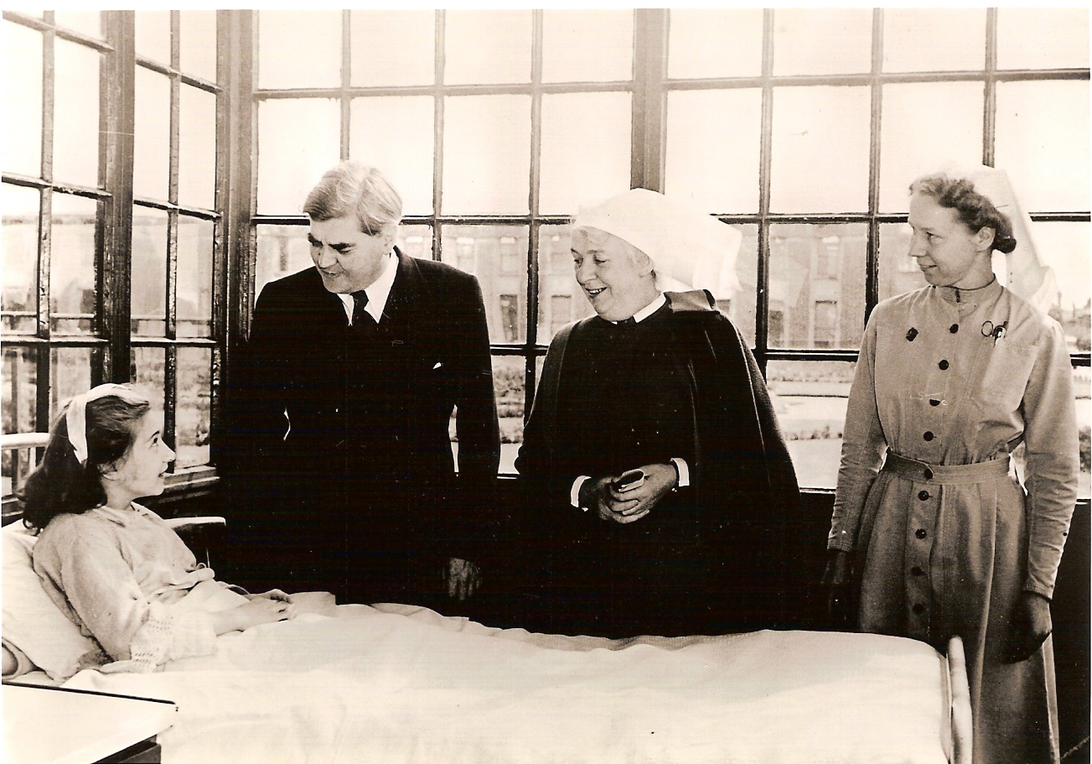
High Quality, Free and Sustainable Healthcare
NHS Expansion & Coverage
1962
Building of hospitals in areas with a population above 125,000.
1978
Louise Brown became the first child to be conceived by In Vitro Fertilisation (IVF).
1994
Organ transplantation. Twelve million people 1998
1998
NHS Direct, a telephone service that provided health information for patients, was introduced
2018
The NHS celebrates their 70th anniversary of providing excellent, and free, healthcare to the public of the United Kingdom

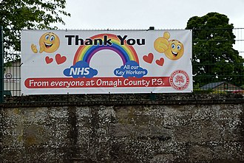
Thank You NHS
Social phenomenon during 2020 and 2021, for part of the COVID-19 pandemic. People and organisations thanking for NHS staff members and other key workers.
Current Challenges
An ageing population
A growing population
Evolving healthcare needs
Medical advancements
Closure of local services
An increase in reliance on privatised services
NHS & Covid-19

The coronavirus pandemic will had huge impacts on the NHS.
Patients placing unprecedented demands on acute care.
Dramatically increase the resources available to NHS hospitals for treating these patient
Forced reorganisation of hospital facilities.
Redeployment of existing staff.
Integrating with Social Care.



History & Aim of NHS
The National Health Service (NHS) was founded 1948.
Foundation Principal stated in 1952 that
“the collective principle asserts that no society can legitimately call itself civilised if a sick person is denied medical aid because of lack of means”. healthcare to all who required it.
Development of NHS
Amina Musbah-CERT in HE - HEALTH AND SOCIAL CARE, aminamusbah@hotmail.co.uk

Element 2

Development of NHS
By the end of World War II, the concept of an integrated, state-funded hospital service had become established and, in 1948. of welfare reforms designed to guarantee basic levels of personal and social security. For the first time, a UK government assumed responsibility for the provision of a comprehensive preventive and curative service for the whole population.
The structure of the new service reflected its disparate origins and artificial divisions between different elements persisted for many years. There were three main strands¹:
- State owned (nationalised) hospitals
- A national network of general practitioners
- Community and domiciliary health services
The 1960s was a decade of fast expansion in new buildings and technology and the health service benefited with a boom in the building of new hospitals. Health planning concentrated on capital schemes. A "Hospital Plan for England and Wales"4 specified 'norms' - number of beds per 1000 population served, using the 14 Regional Health Authorities as a basis for planning and building new hospitals. Although the first signs of a population-based approach to health care provision were now apparent, the following obstacles remained:
· hospital funding was still based on the previous year's expenditures and was not linked to
population size;
· GPs could in theory refer patients anywhere;
· Community services were still managed by Local Authorities.
In order to tackle poor service co-ordination a major reorganisation of the NHS took place in 1974. This followed a long period of research and consultation 7,8,9 initiated by the Conservative Government which was in power in the early 1970s. The Labour Government which took over in 1974 went ahead with the proposals. The 1974 reorganisation tackled two of the NHS's long-standing problems by:
1. Taking the NHS a step population-based funding.
2. Bringing together hospital and community services and the public health function
Two major reallocations of financial resources were under way by the beginning of the
1980s:
· from one geographical area to another to address historical inequalities (RAWP);
· towards non-acute services.
The foundations were being laid for the later move to population-based funding for

hospital and community services. In the meantime, there was work to be done in dismantling the excess bureaucracy of the 1974 reforms12. The first (Conservative) Thatcher government came to power in 1979 with an agenda of radical change in the public sector.

The area tier of management was removed in 1982 and management costs were generally targeted for reduction.
1990s The Internal Market , "Working for Patients" introduced wide-ranging proposals setting out the most radical changes in the NHS since its creation and in the process ending the post-war conse "The new NHS. Modern. Dependable" was published in December 1997. In many
respects it represented an evolution, rather than revolution, in the management of the NHS initiated by "Working for Patient". Despite a rejection of the competitive ethos of the internal market, the fundamental purchaser-provider split, which separated planning of health care from its delivery, is retained, and the move towards a primary care led NHS reinforced. Board responsibilities for financial performance are now complemented by equally explicit board-led responsibilities for the quality of care. A renewed emphasis has been placed on co-operation between the various partners in local health economics rather than competition. Performance management includes an expanded set of indicators and benchmarks.
Six principles underpin the proposals:
1 To renew and improve the NHS as a national service.
2 To make delivery of health care a local responsibility.
3 To focus on quality of care.
4 To work in partnership.
5 To drive efficiency and performance.
6 To rebuild public confidence
NHS, in particular its management, has evolved since its inception. It illustrates the complexity of achieving a uniform level of health care delivery nationally. The NHS developed from an existing, complex and historically determined mixture of health and social services. It has remained at the top of the political agenda throughout its existence and has been subject to repeated reorganisation and financial crises. Expectations of the service have risen exponentially, driven by technological advances and general societal changes that have emphasised individual rights and more consumer-focused services.

Element 3

Name 5 of the 9 protective characteristics from the Equality Act 2010 | Age, Race, Religion or belief, Sex, Sexual orientation.
Who is the current Secretary of State for Health and Social Care? | Steve Barclay was appointed Secretary of State for Health and Social Care on 25 October 2022.
. Name two key pieces of legislation from the SCIE webpage relating to the health and social care sector | Human Rights Act  Health and safety Act

References

Element 1

1. Britain Magazine : https://www.britain-magazine.com/features/history/nhs-history/
2. Bing.com : https://www.bing.com/search?q=NHS+IMGAES&cvid=c72d015816ba45febf0e4aa6301bfe0f&aqs=edge..69i57j0l8.40191j0j4&FORM=ANAB01&PC=DCTS
3. Istockphoto.com: https://www.istockphoto.com/photos/nhs

Element 2

- Asset Publishing Service https://assets.publishing.service.gov.uk/media/57a08d91e5274a31e000192c/The-history-and-development-of-the-UK-NHS.pd
- IFS : https://ifs.org.uk/publications/wider-impacts-coronavirus-pandemic-nhs Local’.gov.uk:
- Gov.uk : https://www.local.gov.uk/equality-act-and-protected-characteristics
- Premier College Group : https://www.premierchoicegroup.com/the-history-of-the-nhs/
- The Medic Portal: https://www.themedicportal.com/application-guide/the-nhs/challenges-facing-the-nhs/
- Wikipedia: https://en.wikipedia.org/wiki/Thank_You_NHS

Element 3:
- https://www.gov.uk/government/ministers/secretary-of-state-for-health-and-social-care

- https://www.scie.org.uk/key-social-care-legislation

