HOTEL HANDBOOK
FESTUS TUMI: 2121888
BMIH 5003
FOREIGN LANGUAGES AND CULTURAL AWARENESS
LECTURER: RODRIGO F. AGUILERA

Hotel Handbook
Contents
Executive Summary 1
Contents 1
Introduction 1
Ghana and France 3
Ghana vs France: The Cultural Dimension 4
Key Points to Remember 6
Conclusion 6
RECOMMENDATIONS 6

Executive Summary

This report will examine the west African country of Ghana vis a vis the growing number of international travellers visiting the country, particularly from France and the Francophone west African countries that surround Ghana’s borders. The very nature of the hotel business through millennia has been to cater for the culinary and accommodation needs of the traveller, but now more than ever hoteliers need to have an understanding of the cultural values that each guest brings. There will be references to Hofstede’s Six Dimensions, and how the report will work on some practical applications to ensure that staff have a basic understanding of the diversity of the guests that the hotel welcomes. The purpose of this report will be to create a handbook that provides essential “dos and don’ts” for the benefit of current and future staff

.

Introduction
As the world becomes smaller through advances in travel and technology hotels across the world are receiving more and more international travellers. The United Nation’s World Travel Organisation (UNWTO) reported in 2015 that there has been an exponential growth since 1950 of international tourists from 25 million to a projected 1.8 billion in 2030 with growth year on year.

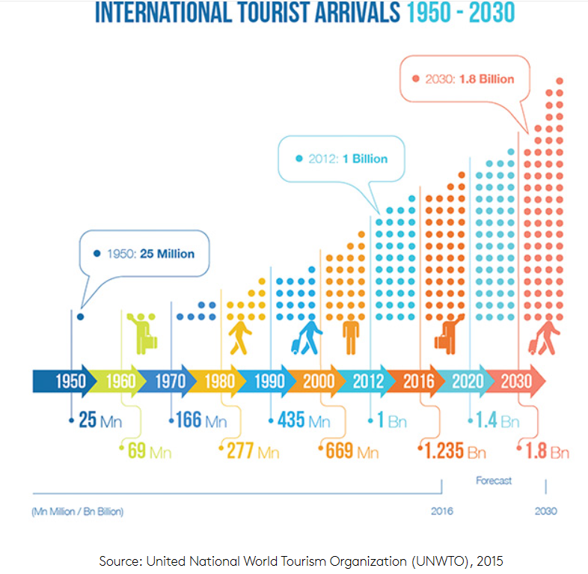
This prediction of year on year growth has been true every year every year except for the COVID years (Varga 2023)
SiteMinder is a major company that “helps hotels attract and acquire…global travellers to view websites in over 20 languages”. It argues that as the needs of travellers increase it is imperative that hotels, if they want to continue to thrive, must work to towards providing personal experiences in a world of standardisation. (SiteMinder, 2023)
The World Bank (2018) describes the development of these digital platforms (Booking.com, Expedia, hotel own websites and others) as “disruptive” but then acknowledge that they also provide opportunities and challenges in countries that are striving to use tourism as a means to encourage national development.

Ghana and France

Ghana is located on the west coast of Africa bordered by Burkina Faso to the north, Cote d’Ivoire to the west and Togo to the east. The Atlantic Ocean makes up its southern border. In the Bradt Travel Guides (2019), Phillip Briggs describes Ghana as “Africa for beginners” and is seen as one of the friendliest, liveliest, and quirkiest countries on the continent. An outwardly religious country the majority Christian believers live harmoniously with Muslim and animist believers. It remains one of Africa’s most politically stable countries which has seen a tourism boom over the past few years.
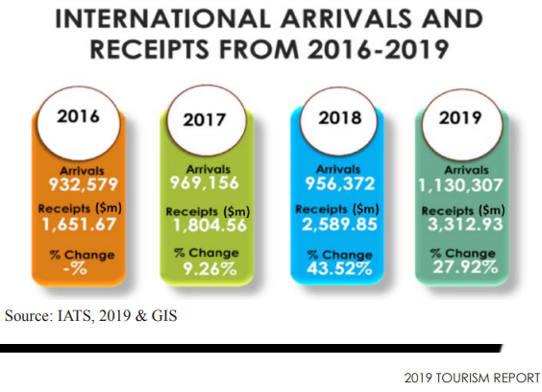

Based on Statista.com (2021) figures, France provides the fourth highest number of tourists to Ghana.
France has had a long and varied history, and has had a very chequered influence in Africa, especially west Africa. Famed for its culinary and artistic flair in Europe, it has had an altogether harder, more paternalistic approach to it’s former colonies. Whereas in France, the French are more liberal they have been far more direct and conservative in Africa.

Ghana vs France: The Cultural Dimension

It is important to have an understanding of the culture of the host country, which can then inform as to how both similarities and diversity of the visitor can be celebrated. This point is echoed by Manoharan, Gross and Sardehmukh (2014) where they advise that hotels should choose an “identity conscious” rather than an “identity blind” approach when managing guests’ expectations.
Geert Hofstede argues in Cultural Dimensions that “culture is more often a source of conflict than of synergy. Cultural differences are a nuisance at best and often a disaster”, and to help combat this his cultural dimensions research can help provide an insight when interacting with other cultures.
Using Hofstede’s Six Dimensions there are very stark cultural variances between the two countries except for in the pillar of masculinity.

  - 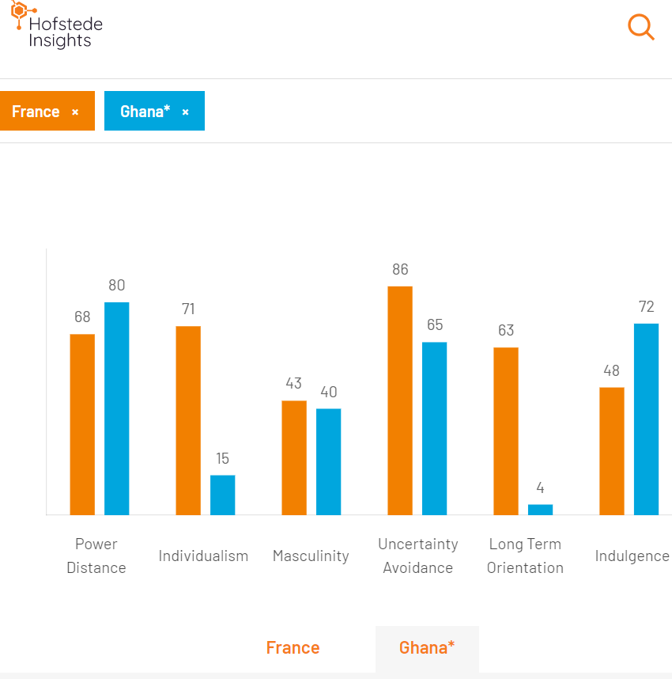

  - The most obvious comparisons are individualism and long term orientation. While Ghana appears as a culture to exercise a great deal of interdependence on each other, it is very much a culture based on the individual in France. The extremely low long term orientation for Ghana reflects the still subsistence mindset and living in the now, while France generally takes a much more longer term view.

Recommendations

To avoid delivering what Ritzer (1993) suggests as a “McDonaldization of the society” a process of standardisation in service delivery in hospitality, the hotel team will need to ensure that they acknowledge cultural difference when developing standard operating procedures.
The following points will need to be followed to ensure that the hotel recognise the norms and customs of a diverse clientele:
- Acknowledge that most French guests will book far in advance of their arrival
- That use of pre arrival information software should be set as soon as the booking has been confirmed.
- European visitors are used to allergen information to be clearly stated on menus and at buffet stations. Staff will need to make sure that all food ingredients are boldly labelled.
- Make direct eye contact with guests
- French guests prefer to be addressed formally as “Madame”, “Monsieur”, and “Mademoiselle”
- Staff will need to ask questions as part of the booking process to become fully aware of their needs. Remember that the hotel is selling experiences not just rooms.
- Staff should gain some knowledge of the visiting culture, accept the differences and where possible adapt to some of them.

Conclusion

As globalisation brings in more standardisation, the paradox is that guests want to be more recognised for their differences. Understanding this diversity can be what keeps an international hotel profitable. Varga (2023b) suggests that to welcome foreign guests in a fashion that celebrates their diversity will need to be learned “if hospitality wishes to follow its future endeavour which is personalising guest’s hospitality experiences.”

REFERENCES

Briggs, P. Bradt Travel Guides (Ghana, 2019). Publisher: Bradt Travel Guides; Eight edition (2019)
Ghana Tourism Report (2019) Available at: https://visitghana.com/wp-content/uploads/2021/04/Ghana-Tourism-Report-2019-min.pdf Accessed 16th May 2023
Manoharan, Gross and Sardeshmukh) Identity-conscious vs identity-blind: Hotel Managers’ use of formal and informal diversity management practices International Journal of Hospitality Management Vol 41, Aug 2014. Available at: https://www.sciencedirect.com/science/article/abs/pii/S0278431914000693 Accessed: 16 May 2023
Sasu, DD. Statista.com (2023) Number of international tourist arrivals in Ghana as of 2021, by country of origin. Available at: https://www.statista.com/statistics/1230306/number-of-inbound-tourists-in-ghana-by-leading-country-of-origin/#:~:text=In%202021%2C%20over%2092%2C000%20tourists,and%2034.1%20thousand%20tourists%2C%20respectively
SiteMinder (2023) “Guest experience in hotels: How to achieve complete customer satisfaction (including COVID-19 tips) Blog Available at: Siteminder.com/r/trends-advice/hotel-guest-experience/guest-experience-hotels-customer-satisfaction/ Accessed 16th May
Varga P. (2023a)“Valuing cultural differences: Why it matters and how to do it right” EHL Insights Blog Available at: Valuing cultural differences: Why it matters and how to do it right (ehl.edu) Accessed 16th May 2023
Varga P. (2023b)“Valuing cultural differences: Why it matters and how to do it right” EHL Insights Blog Available at: Valuing cultural differences: Why it matters and how to do it right (ehl.edu) Accessed 16th May 2023
World Bank Group (2018) Tourism and the sharing economy: Policy and potential of sustainable Peer-to-Peer Accommodation.

.

