

Varying occupational stress and organisational commitment within the university staff of contrasting economies
(Cross-sectional comparative study of middle range public universities in Pakistan and the UK)

A Doctoral Thesis presented by
Adnan ul Haque
to
The University of Wales Trinity Saint David (UWTSD)
in Partial fulfilment of the Requirement for the Degree of
Doctor of Business Administration

in the Subject of
Organizational Behaviour
Supervisor: Dr. John Aston
Director of Studies: Professor Dr. Eugene Kozlovski

UWTSD London, United Kingdom
September 2018

ABSTRACT
This thesis investigates the varying occupational stressors and organisational commitment of the contrasting genders at the teaching and non-teaching (administrative) positions in the contrasting economies of the UK and Pakistan. Whilst the existing literature is focused on individual cases of personal strain and resources, occupational therapists’ role, social support and organisational commitment of employees, this thesis extends the current knowledge with comparative analysis in the context of gender, faculty and economy. The mixed method deployed for this analysis is based on the combination of SEM, Chi-Square and multiple regression informed by the total of 408 survey responses, followed by a qualitative study of 98 interviews.
The results confirmed that overall organisational factors cause higher stress while psychological effects are common in the education sectors of the both economies. Overall stress, as well as organisational commitment, is higher in Pakistan despite higher power, distance and collectivism. Overall, personal factors cause more stress to females and non-teaching staff, while organisational factors often make males and teaching staff stressed. Furthermore, the physical and behavioural effects are higher amongst males and non-teaching staff, while females and teaching staff have higher psychological symptoms. Nevertheless, the causes and consequences of stress, as well as job-related preferences differ for gender, faculty, and economy. The statistical tests confirmed non-significant impact of occupational therapists on the affective commitment (AC), normative commitment (NC), and continuance commitment (CC). All other predictors, to some extent, have a significant effect on OC. Furthermore, males exhibit higher AC, while females often demonstrate NC and CC. Social support and stress management programmes are effective in sustaining human capital and reducing strain. The qualitative findings supported the statistical outcomes. Based on above results, practical implications are recommended to public universities for reducing stress and improving organisational commitment to sustain human capital.
Keywords: Causes of Stress; Consequences of Stress; Comparative Analysis; Organisational Commitment; Public Universities in Contrasting Economies

DECLARATION
This work has not previously been accepted in substance for any degree and is not being concurrently submitted in candidature for any degree.

Adnan ul Haque
Signed ...................................................................... (candidate)
01 July 2018
Date ........................................................................

STATEMENT 1
This thesis is the result of my own investigations, except where otherwise stated. Where correction services have been used the extent and nature of the correction is clearly marked in a footnote(s). Other sources are acknowledged by footnotes giving explicit references. A bibliography is appended.
Adnan ul Haque
Signed ...................................................................... (candidate)
01 July 2018
Date ........................................................................

STATEMENT 2
I hereby give consent for my thesis, if accepted, to be available for photocopying and for inter-library loan, and for the title and summary to be made available to outside organisations.
Adnan ul Haque
Signed ...................................................................... (candidate)
01 July 2018
Date ........................................................................
STATEMENT 3
I hereby give consent for my thesis, if accepted, to be available for deposit in the University’s digital repository.

Adnan ul Haque
Signed ...................................................................... (candidate)
01 July 2018
Date ........................................................................

ACKNOWLEDGEMENTS
I would like to express my gratitude to following:
Dr. John Aston and Professor Dr. Eugene Kozlovski (my supervisory team), for believing in me and guiding me expertly throughout the research journey. There were times where I was feeling low but their support and encouragement kept me going on. Not only they guided me but ensured I continue publishing papers in reputed journals under their expert supervision. They communicated and critically evaluated my progress continuously while allowing me continuing in my own way so I can learn as well as enjoy research process.
Chaman and Faizan ul Haque (my parents) for believing, supporting, and encouraging me during my stressful days. Talking to them made helped me overcoming obstacles. I also thank my brother Irfan ul Haque and sister Riffat Faizan for ensuring my stay in the UK remains comfortable by sharing family responsibilities. They encouraged me towards this Doctorate. Without their moral and emotional support, I wouldn’t have made it so far. My little niece Zuhal and Zaryab for inspiring joy and life in me.
I would also thank my research colleagues and lecturers, especially Dr Akhtar Baloch, Dr Vipin Nadda and Dr Fred Yamoah for communicating and sharing ideas, critical discussions, and circulating surveys and arranging interviews in the UK and Pakistan. Additionally, I also thank all my lecturers and professors for educating me, enhancing my knowledge, and providing opportunity to contribute to workshops, especially Dr Steve Sommerville, Dr Isaiah Oino, Dr Jill Venus and Ravshonbek Otojanov.
All my friends; especially Asphandyar for his IT support from time to time.
I also thank Ms. Marylyn Whaymand for providing professional proof-reading services.
I thank the management of all organisations for giving consent. I also thank respondents for sharing their views, feelings, and experiences. Without their contributions, I wouldn't have been able to complete this research.
Most importantly, Nasreen Zehra for continuously supporting me throughout research phase, critically reviewing my strategies and arranging workshops at MNCs for corporate training.

PUBLICATIONS RESULTING FROM THIS RESEARCH PROJECT
Haque, A. U., Aston, J., and Kozlovski, E. (2018). The impact of stressors on organisational commitment of managerial and non-managerial personnel in contrasting economies: Evidences from Canada and Pakistan. International Journal of Business, 23(2), 152-168
Haque, A. U., Aydin, E., and Uysal, E. (2017). A Comparison of Effectiveness of Global Leaders and Domestic Leaders in Electronic Retail Industry. Global Journal of Management and Business Research (G), 17(3), version 1, 11-20.
Haque, A. U., Faizan, R., and Cockrill, A. (2017). The relationship between female representation at strategic level and firm's competitiveness: evidences from cargo logistic firms of Pakistan and Canada, Polish Journal of Management Studies, 15(2), 69-81.
Haque, A. U., Aston, J., and Kozlovski, E. (2016). Do causes and consequences of stress affect genders differently at operational level? Comparison of the IT sectors in the UK and Pakistan. International Journal of Applied Business, 1(1), 1-7.
Haque, A. U., and Aston, J. (2016). A Relationship between Occupational Stress and Organizational Commitment of I.T Sector's Employees in Contrasting Economies. Polish Journal of Management Studies, 14(1), 95-105.
Haque A. U., and Oino, I. (2017) Sustaining Human Capital by Reducing Stress through Social Support Programme in Contrasting economies. Accepted in Conference Proceedings at 4th European Conference of Behavioural Sciences & Psychology, Brighton, UK.
Faizan, R., and Haque, A. U. (2016). The Relationship between Societal attributes, Feminine Leadership & Management Style: Responses from Pakistan's Urban Region Female-Owned Businesses. European Journal of Business and Management. 8(23). 171-191.
Haque, A. U., Faizan, R., Zehra, N., Baloch, A., Nada, V., and Riaz, F. (2015). Leading Leadership Style to motivate cultural oriented female employees in developing country: I.T staff responses from Pakistan. International Journal of Academic Researches in Business and Social Sciences, 5(9), 280-302.
Faizan, R., and Haque, A. U. (2015). Bullwhip effect phenomenon and mitigation in logistic firm's supply chain: Adaptive approach by Transborder Agency, Canada. International Journal of Supply Chain Management, 4(4), 43-51.

TABLE OF CONTENTS
ABSTRACT ii
DECLARATION iii
ACKNOWLEDGEMENTS v
PUBLICATIONS RESULTING FROM THIS RESEARCH PROJECT vi
TABLE OF CONTENTS vii
LIST OF ABBREVIATIONS xii
LIST OF FIGURES xiv
LIST OF TABLES xvi
CHAPTER ONE: INTRODUCTION 16
1.1 Introduction 16
1.2 Background and Context 16
1.3 Research Problem 26
1.3.1 The Research Agenda 26
1.3.2 Background of research problem 27
1.3.3 Problem statement 28
1.4 Research Questions 29
1.5 Aim 29
1.6 Objectives 30
1.7 Significance of the project 30
1.8 Overview of undertaken methodology 31
1.9 Overview and Structure of the project 35
CHAPTER TWO: LITERATURE REVIEW 38
2.0 Introduction 38
2.1 Stress 38
2.2 Types of Stress 39
2.2.1 Eustress 39
2.2.2 Distress 40
2.2.3 Hyper-Stress 40
2.2.4 Hypo-Stress 40
2.3 Level of Stress 40
2.4 Causes and Effects of Occupational Stress at the Workplace 42
2.5 “General Adaption Syndrome” - the GAS Model of Stress 45
2.6 Interactional and Transactional Theories of Stress 47
2.6.1 Interactional theories 47
2.6.2 Transactional Theories 54
2.7 Perceived Organisational Support 66
2.8 Social support 68
2.9 Job Satisfaction 71
2.10 Organisational Commitment (OC) 72
2.10.1 Dimensions of Organisational Commitment 73
2.11 Role of the occupational therapist in dealing with stress at work 79
2.12 Hofstede Cultural Dimensions 80
2.13 Gaps in Literature 83
2.14 Hypotheses 86
2.15 Summary 87
CHAPTER THREE: CONCEPTUAL FRAMEWORK 88
3.1 Introduction 88
3.2 Variables of interest 88
3.3 Institutional theory and comparative approach 90
3.4 Stressors in an organisational setting 92
3.5 Approaches to investigating occupational stress 95
3.6 Summary 98
CHAPTER FOUR: RESEARCH METHODOLOGY 99
4.1 Introduction 99
4.2 Research 100
4.2.1 Research Paradigm 101
4.2.3 Research Philosophy 107
4.2.4 Axiology 110
4.2.5 Research Type 112
4.2.6 Research Approach 113
4.3 Methodology 114
4.3.1 Research Design 114
4.3.2 Research Process 116
4.3.3 Research Methods for Data Collection 118
4.3.4 Sampling Techniques 122
4.3.5 Population and sample size 128
4.3.6 Research Instrument 130
4.3.7 Pilot Testing 134
4.3.8 Data Collection Procedure 135
4.3.9 Types of Data 137
4.3.10 Data Analysis and Tools 138
4.3.11 Methodological, Thematic and Comparison of two-perspective review 140
4.3.12 Ethics 140
4.3.13 Reliability 141
4.3.14 Validity 142
4.4 Summary: 145
CHAPTER FIVE: RESEARCH FINDINGS AND DISCUSSION 148
5.1 Introduction 148
5.2 Survey Questionnaire - Results, Findings and Discussion 148
5.2.1 Reliability 149
5.2.2 Equal and Normal Distribution 150
5.2.3 Fitness of the model 155
5.2.4 Exploratory Factor Analysis 155
5.2.5 Partially Recursive Model 158
5.2.6 Proportional Analysis 164
5.2.7 Chi-Square Tests 167
5.2.8 Multiple Regression 177
5.2.8.1 Predictors and organisational commitment’s antecedents - Contrasting economies 178
5.2.8.2 Predictors and Organisational commitments’ antecedents - Contrasting Genders 191
5.2.8.3 Predictors and Organisational commitments’ antecedents - Contrasting Faculties 203
5.3 Interview Findings and Discussion 213
5.3.1 Most likely job feature 214
5.3.2 Most disliked job attribute 216
5.3.3 Dislike feature affecting university staff 218
5.3.4 Ways to overcome negative impact 220
5.3.5 Rate and effectiveness of the Occupational Therapist 222
5.3.4 Awareness and effectiveness of Social Support at workplace 224
5.3.5 Type of Support attained from social support at workplace 227
5.3.6 Stress Management Programme effectiveness at workplace 229
5.3.7 Affective Commitment at the Universities 231
5.3.8 Normative Commitment at the Universities 233
5.3.9 Continuance Commitment at the Universities 235
5.3.10 Causes of stress at the Universities 238
5.3.11 Consequences of stress at the Universities 240
5.4 Overall findings in the light of Institutional theory & Hofstede’s cultural dimension Framework 242
5.5 Summary 244
CHAPTER 6: OVERALL CONCLUSION, CONTRIBUTION AND IMPLICATIONS 246
6.1 Introduction 246
6.2 Overall Conclusion 247
6.3 Research Contributions 258
6.4 Research Implications 260
6.5 Research Limitations 263
6.6 Concluding Remarks 265
BIBLIOGRAPHY 266
APPENDIX A 313
APPENDIX B 330
APPENDIX C 335
APPENDIX D 338
APPENDIX E 348
APPENDIX F 349

LIST OF ABBREVIATIONS
Abbreviation | Meaning
AC | Affective commitment
AFGI | Adjusted Goodness-of-Fit Index
AMOS | Analysis of a moment structures
ANOVA | Analysis of Variance
BREXIT | British exit
CAOT | Canadian Association of Occupational Therapists
CC | Continuance Commitment
CFA | Confirmatory Factor Analysis
CFI | Comparative Fit Index
CIPD | Chartered Institute of Personnel Development
C.R | Critical Ratio
CSHS | Centre for Studies on Human Stress
DAB | Demographic, Attitudinal, and Behavioural
DCS | Demand Control Support
DRIVE | Demand Resources and Individual Effect
DSS | Demand-Skill-Support
EFA | Exploratory Factor Analysis
EOP | Effectiveness of Occupational Therapist
ERI | Effort-Reward Imbalance
GAS | General Adaption Syndrome
GDP | Gross Domestic Product
GFI | Goodness-of-Fit Index
GWI | Global Wellness Institute
KMO | Kaiser-Meyer-Olkin
HCEC | Housing Consumer Education Centers
HEFCE | Higher Education Funding Council for England
HEWS | Higher Education Workforce Survey
HDI | Human Development Index
HR | Human Resource
ID | Identity Document
IT | Information Technology
JD-R | Job-Demand Resource
JS | Job Satisfaction
M.E | Margin of Error
MS | Microsoft
NC | Normative Commitment
OC | Organisational Commitment
OST | Organisational Support Theory
PAK | Pakistan
P-E Fit | Person and Environment Fit
PJS | Perceived Job Stress
POS | Perceived organisational support
PR | Personal Resource
PS | Personal Strain
Q-Q | Quantile-quantile
RMSEA | Root Mean Square Error of Approximation
RR | Rate of Representation
SEM | Structural Equation Modeling
SPSS | Statistical Package for the Social Sciences
SS | Social Support
THC | The Health Centre
TWB | The World Bank Report
UK | United Kingdom
UKPS | UK Professional Standards Framework

LIST OF FIGURES
Figure 1. 1: Source – “The Workplace Survey 2016: Results and Analysis” (Grove, 2016) 17
Figure 1. 2: “Increasingly unwell at the workplace” (GWI, 2016) 18
Figure 1. 3: “Increasing unwell at the workplace” (GWI, 2016) 19
Figure 1. 4: “Anxiety Index Study - Global Report 2013” (Tribune, 2013) 19
Figure 1. 5: “Anxiety Index Study - Global Report 2013” (Tribune, 2013) 20
Figure 1. 6: “Government expenditure on the Education in the UK and Pakistan” (The World Bank, 2015) 21
Figure 1. 7: “HDI of the UK and Pakistan” (Human Development Report, 2016) 23
Figure 1. 8: “Comparison of the different attributes of the UK and Pakistan” (HDI Report, 2016) 24

Figure 2. 1: Adapted from Kundaragi and Kadakol (2015) 39
Figure 2. 2: ‘Phases in stress development’ (Oyetimein, 2009) 41
Figure 2. 3: Types of stressors Adapted from Stranks (2005) 43
Figure 2. 4: Types of Stress consequences Adapted from Stranks (2005) 44
Figure 2. 5: ‘General Adaptation Syndrome’ (Stranks, 2005) 45
Figure 2. 6: The Job-demands and Job-control Model (Karasek, 1979) 50
Figure 2. 7: Siegrist’s Effort-and-Reward Model (Söderberg, 2014) 54
Figure 2. 8: The DRIVE Model (Mark and Smith, 2008) 62
Figure 2. 9: ‘Antecedents of Organisational Commitment’ Adapted from Mowday et al., (1979) 73
Figure 2. 10: Comparison of Pakistan and UK (geert-hofstede.com, 2017) 83

Figure 3. 1: Self-constructed framework to demonstrate variables of interest 89
Figure 3. 2: Self-constructed conceptual framework for the present study. 90

Figure 4. 1: Self-constructed framework for “Research” section. 101
Figure 4. 2: Self-constructed thesis research paradigm. 104
Figure 4. 3: “Attributes of Research Paradigm” adapted from Mack (2010). 104
Figure 4. 4: Types of research philosophies (Saunders et al., 2012). 109
Figure 4. 5: Self-constructed thesis research type. 113
Figure 4. 6: Research process (Walliman, 2001). 118
Figure 4. 7: Sampling techniques (Hair et al., 2007). 123
Figure 4. 9: Research flow chart of present thesis 146

Figure 5. 1: Bar diagrams for equal distribution in terms of economy, gender, and faculty 153
Figure 5. 2: Q-Q Plot for normality in the context of Economies 154
Figure 5. 3: Q-Q Plot for determining normality distribution in terms of gender and faculty. 155
Figure 5. 4: Partially Recursive Model demonstrating the relationship. 159
Figure 5. 5: The directional path of direct effect of exogenous variables on endogenous variables. 161
Figure 5. 6: Bar diagram containing proportions of causes of stress. 166
Figure 5. 7: Bar diagram containing proportions of consequences of stress. 167
Figure 5. 8: Multiple regressions on the affective commitment in contrasting economies 181
Figure 5. 9: Multiple regressions on the normative commitment in contrasting economies 185
Figure 5. 10: Multiple regressions on the continuance commitment in contrasting economies 188
Figure 5. 11: Multiple regressions on the affective commitment in contrasting genders. 194
Figure 5. 12: Multiple regressions on the normative commitment in contrasting genders. 197
Figure 5. 13: Multiple regressions on the continuance commitment in contrasting genders. 200
Figure 5. 14: Multiple regressions on the affective commitment in contrasting faculties. 205
Figure 5. 15: Multiple regressions on the normative commitment in contrasting faculties. 207
Figure 5. 16: Multiple regressions on the continuance commitment in contrasting faculties. 210
Figure 5. 17: Frequency of interview respondents in contrasting economies. 214
Figure 5. 18: Most liked job-related feature at the public universities in Pakistan and the UK. 215
Figure 5. 19: Most disliked job-related feature at the public universities in Pakistan and the UK. 217
Figure 5. 20: Dislike feature affecting employees at the public universities. 219
Figure 5. 21: Ways to overcome negative impact. 221
Figure 5. 22: Effectiveness of the Occupational therapist. 223
Figure 5. 23: Social support and effectiveness of the social support. 225
Figure 5. 24: Type of support attained from social support. 228
Figure 5. 25: Stress management effectiveness at workplace. 230
Figure 5. 26: Affective commitment at Universities. 232
Figure 5. 27: Normative commitment at Universities. 234
Figure 5. 28: Continuance commitment at Universities. 236
Figure 5. 29: Causes of stress at the Universities. 239
Figure 5. 30: Consequences of stress at the Universities. 241

LIST OF TABLES
Table 1. 1: Comparison of contrasting economies………………………………………………………...21
Table 4. 1: Current Study Data Collection Procedure. 137
Table 4. 2: Models applied to quantitative and qualitative analysis 147

Table 5. 1: Features of quantitative section 150
Table 5. 2: Case Processing Summary 151
Table 5. 3: Reliability Statistics 151
Table 5. 4: Country Proportion: 1=United Kingdom, 2=Pakistan 153
Table 5. 5: Gender proportion: 1=Male, 2=Females, 3=Prefer not to say 153
Table 5. 6: Faculty: 1=Teaching Staff, 2=Non-teaching Staff 154
Table 5. 7: Test Statistics 156
Table 5. 8: KMO and Bartlett's Test 156
Table 5. 9: Communalities 157
Table 5. 10: Total Variance Explained 158
Table 5. 11: Critical Ratio and standardized path estimates 163
Table 5. 12: Causes of stress 166
Table 5. 13: Consequences of stress 167
Table 5. 14: Causes of Stress – Country 168
Table 5. 15: Chi-Square Tests 168
Table 5. 16: Symmetric Measures 168
Table 5. 17: Consequences of Stress – Country 170
Table 5. 18: Chi-Square Tests 170
Table 5. 19: Symmetric Measures 170
Table 5. 20: Causes of Stress – Gender 171
Table 5. 21: Chi-Square Tests 172
Table 5. 22: Symmetric Measures 172
Table 5. 23: Consequences of Stress – Gender 173
Table 5. 24: Chi-Square Tests 174
Table 5. 25: Symmetric Measures 174
Table 5. 26: Causes of Stress – Faculty 175
Table 5. 27: Chi-Square Tests 175
Table 5. 28: Symmetric Measures 176
Table 5. 29: Consequences of Stress – Faculty 177
Table 5. 30: Chi-Square Tests 177
Table 5. 31: Symmetric Measures 177
Table 5. 32: Model Summary^{a,c} 179
Table 5. 33: ANOVA^{a,b, a' b} 180
Table 5. 34: Coefficients^{a, a,' b} 181
Table 5. 35: Model Summary^{a,c} 183
Table 5. 36: ANOVA^{a,b, a' b} 184
Table 5. 37: Coefficients^{a, a,' b} 185
Table 5. 38: Model Summary^{a,c} 187
Table 5. 39: ANOVA^{a,b, a' b} 187
Table 5. 40: Coefficients^{a, a,' b} 188
Table 5. 41: Group Statistics 190
Table 5. 42: Model Summary^{a,c} 192
Table 5. 43: ANOVA^{a,b, a' b} 193
Table 5. 44: Coefficients^{a, a,' b} 194
Table 5. 45: Model Summary^{a,c} 196
Table 5. 46: ANOVA^{a,b, a' b} 196
Table 5. 47: Coefficients^{a, a,' b} 197
Table 5. 48: Model Summary^{a,c} 199
Table 5. 49: ANOVA^{a,b, a' b} 199
Table 5. 50: Coefficients^{a, a,' b} 200
Table 5. 51: Group Statistics 202
Table 5. 52: Model Summary^{a,c} 204
Table 5. 53: ANOVA^{a,b, a' b} 204
Table 5. 54: Coefficients^{a, a,' b} 205
Table 5. 55: Model Summary^{a,c} 206
Table 5. 56: ANOVA^{a,b, a' b} 207
Table 5. 57: Coefficients^{a, a,' b} 208
Table 5. 58: Model Summary^{a,c} 209
Table 5. 59: ANOVA^{a,b, a' b} 209
Table 5. 60: Coefficients^{a, a,' b} 210
Table 5. 61: Group Statistics 212

Table 6. 1: Research questions and research outcomes 247

CHAPTER ONE: INTRODUCTION

1.1 Introduction
The introductory chapter of the present thesis contains a brief overview of the background and context of stress and its existence in the education sector. After identifying the research agenda, the aims and objectives are stated, followed by the research problem and significance of the study. In addition to that, the chapter contains an overview of the proposed methodology and, finally, an overview and structure of the thesis.

1.2 Background and Context
Stress is evident in an individual’s life at various stages; it is constructive to some while destructive to others (Haque & Aston, 2016). It is an influencer - disturbing the body's natural equilibrium (Stranks, 2005). Selye classified four types of stress, namely: eustress (good stress), distress (bad stress), hyper-stress (too much stress), and hypo-stress (too little stress), (cited from Garg & Rani, 2014). Furthermore, Stranks (2006) argued that from distress, an individual develops either acute stress or chronic stress. The acute leads on to forming hyper-stress, whereas chronic stress builds hypo-stress.
Organisational commitment is another variable of interest that has been the focus of attention among scholars and experts of organisational behaviour. It is a psychological pact between worker and workplace (Buchanan, 1974). Allen & Meyer (1996) defined it as a positive intent exhibited by employees for attaining the organisational goal (cited from Haque & Yamoah, 2014). Affective, normative and continuance commitment are distinguishing antecedents of organisational commitment (Mowday et al., 1982; Haque & Yamoah, 2014).
The education sector is one of the critical sectors of an economy, as it contributes to the improvement of society in more than one way (World Economic Reforms, 2015). The education sector’s contribution is vital for economic growth and development (ibid). Since the sector's significance has been established thus, it is essential to explore the variables of interest from a practical, business perspective. The level of stress experienced by staff working in educational institutions is higher in the developing countries and, thus, they require support programme and technology to ensure that resources are adequately utilised (Fimain & Sontaro, 1983; Terry, 1997). Additionally, the studies of Bhatti et al., (2011) and Yusoff & Khan, (2013) argued that stress has a negative impact upon the performance and job satisfaction of employees in Pakistan’s education sector.
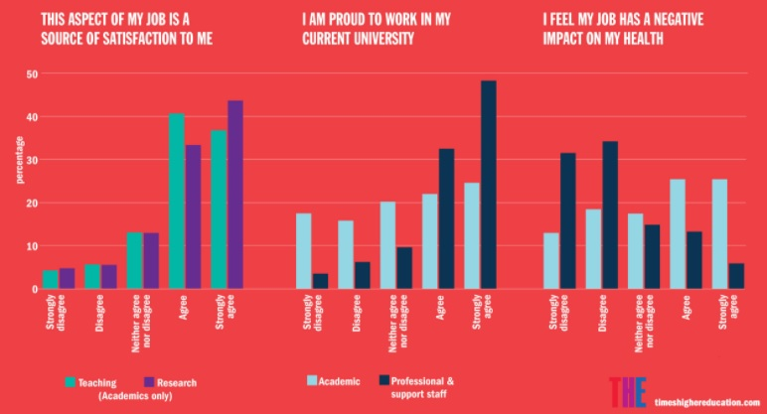
Figure 1. 1: Source – “The Workplace Survey 2016: Results and Analysis” (Grove, 2016)
Interestingly, Grove’s workplace survey of 2016, at more than twenty universities, revealed a variation among the academic and non-academic staff concerning their job satisfaction, commitment and stress, respectively. Overall, academic staff (teaching and research) have higher job satisfaction in the university sector (Grove, 2016). However, according to Grove (2016), the commitment among professional and support staff is higher in contrast to academic staff (41% against 23%). In addition to that, job-related stress, affecting the health of academic staff negatively, is higher in contrast to non-academic staff (ibid). On the other hand, Frith (2017) stated that Robert Half’s UK Survey revealed that two-thirds (63%) of the UK workforce experience stress in their job. Nevertheless, at present, there is no survey available from Pakistan reflecting these attributes affecting academic, non-academic and support staff working in the education sector. Thus, there is a need to investigate the research variables in contrasting economies so that a comprehensive understanding might be developed.
A wide range of literature has confirmed that the wellbeing and performance of employees are affected by stress (Cicei, 2012; Kumasey et al., 2014; Haque & Aston, 2016; Haque et al., 2016; Zehra & Faizan, 2017; Zahid et al., 2017; Zehra et al., 2017). Hence, the researcher examined the Global Wellness Institute’s (GWI) report (2016) to measure the impact of stress on the workforce.
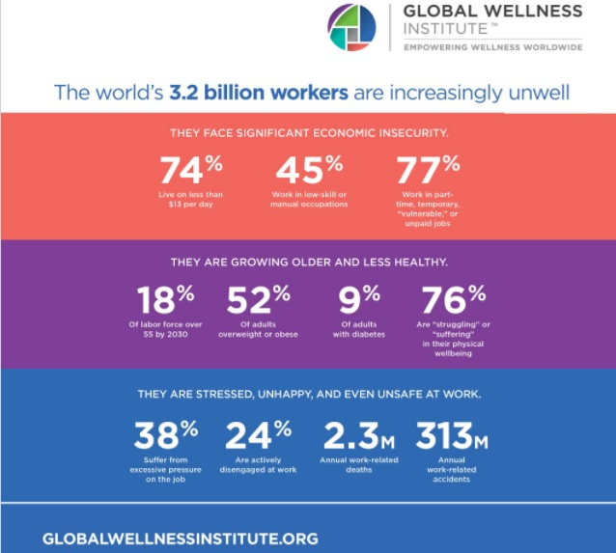
Figure 1. 2: “Increasingly unwell at the workplace” (GWI, 2016)
Interestingly, this report revealed that one of the major causes affecting the wellness of the workforce globally is economic insecurity (77%), followed by health concerns (76%), whereas 38% experienced occupational stress and 24% felt disengaged at work. This report revealed that stress is one of the most significant factors affecting the wellness and, to some extent, the performance of the workforce.
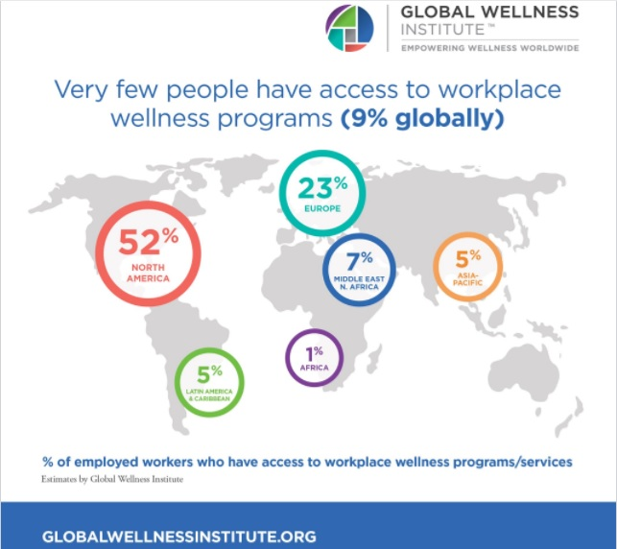
Figure 1. 3: “Increasing unwell at the workplace” (GWI, 2016)
Interestingly, GWI (2016) results revealed that North American employees (52%) have higher access to wellness (social support) programme and services, followed by Europe (23%), whereas Asian employees have low access (5%). Here, the UK is included in Europe and Pakistan is included in Asia. Therefore, the UK workforce has higher access to wellness programmes at a workplace, in contrast to Pakistan.
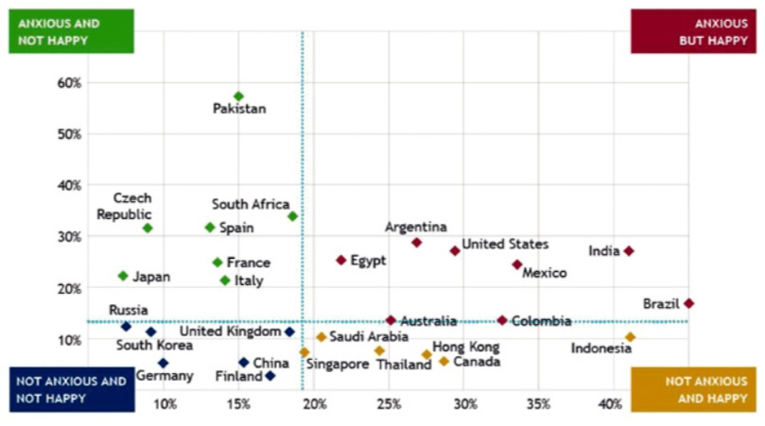
Figure 1. 4: “Anxiety Index Study - Global Report 2013” (Tribune, 2013)
According to the Anxiety Index Study Global Report (2013), Pakistan has a higher number of individuals who are “anxious and not happy” (60%), while, on the other hand, more UK workers are under the “not anxious and not happy” (neutral stage). In other words, anxiety to some extent reflects stress and depression amongst individuals.
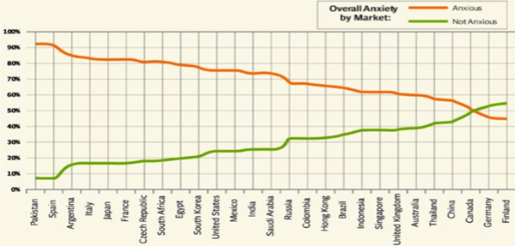
Figure 1. 5: “Anxiety Index Study - Global Report 2013” (Tribune, 2013)
The above graph shows the comparison of Pakistan with some of the other countries. On the scale of “anxious to non-anxious”, Pakistan is the least contented country on the scale, while the UK appears to have a much higher number of happy workers on the scale, reflecting lower anxiety, depression, and stress. Hence, this also confirms that stress is more elevated in Pakistan in contrast to the UK. However, there is no direct report to compare and conclude the relationship between the two countries’ occupational stress and commitment. In other words, there is no conclusive study to confirm the comparative analysis and draw a logical conclusion. Moreover, the study above is carried out in the general perspective, while there is a need for more focused research on occupational stress and organisational commitment in the education sectors of the UK and Pakistan.
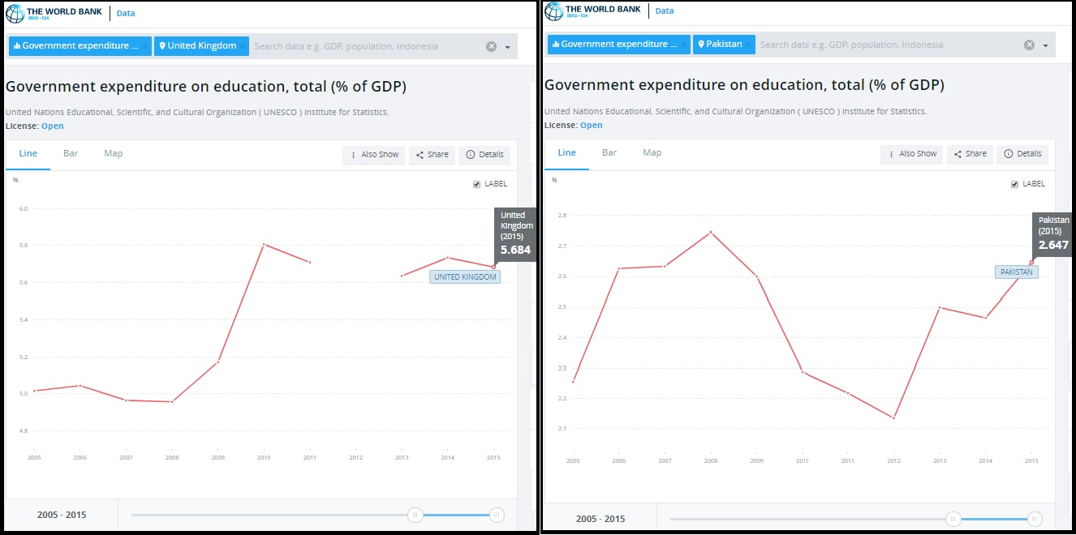
United Kingdom | Pakistan
Figure 1. 6: “Government expenditure on the Education in the UK and Pakistan” (The World Bank, 2015)
The variations within the two countries are presented below:
Table 1. 1: Comparison of contrasting economies
Components | Pakistan | United Kingdom
Human Development Index | 0.59 | 0.90
World Ranking | 147th | 16th
Education | 8.1 | 16.3
Budget spending on Education | 2.6% | 5.68%
Education Sector contribution to GDP | 3.6% | 2.8%
Gender Inequality in the Education sector | 0.38 | 0.83
Employment Vulnerability | 51.0 | 59.3

Currently, the government of Pakistan is spending 2.64% of its budget on the education sector (The World Bank Report, 2015; Higher Education Workforce Survey, 2015), while universities significantly contribute 3.6% to GDP (Ministry of Education, 2015). Conversely, UK government spending on the education sector is 5.68% (TWB Report, 2015), while universities contribute 2.8% to GDP (HEWS, 2015; UKPS, 2016). Interestingly, the government of Pakistan spends less in comparison to the UK government, but the Pakistani education sector’s contribution is higher than the UK's education sector.
Chaudhry (2012) identified that there is a positive relationship between stress and job satisfaction within universities in Pakistan whereas Danish et al., (2015) argued that organisational commitment and job satisfaction results from organisational climate. However, Khan et al., (2015) demonstrated that stress affects the organisational commitment of employees in Pakistan. Nevertheless, the studies mentioned above have only focused on teaching faculty, while the present study attempts to examine the relationship between variables of interest using a multi-dimensional approach. Additionally, the study of Jackson & Rothmann (2006) found a positive relationship between job stress and organisational commitment in the UK education sector. On the other hand, Khatibi et al., (2009) identified a negative relationship between stress and organisational commitment in educational institutions. Hence, there is a need to investigate the phenomenon in more depth, explicitly considering a contrasting approach in order to understand the nature of the relationship in the education sector of both the UK and Pakistan.
Furthermore, the selection of the UK and Pakistan is based on the researcher’s axiological view. Included in this view is the fact that there is a huge difference in the Human Development Index (HDI) of these two countries.
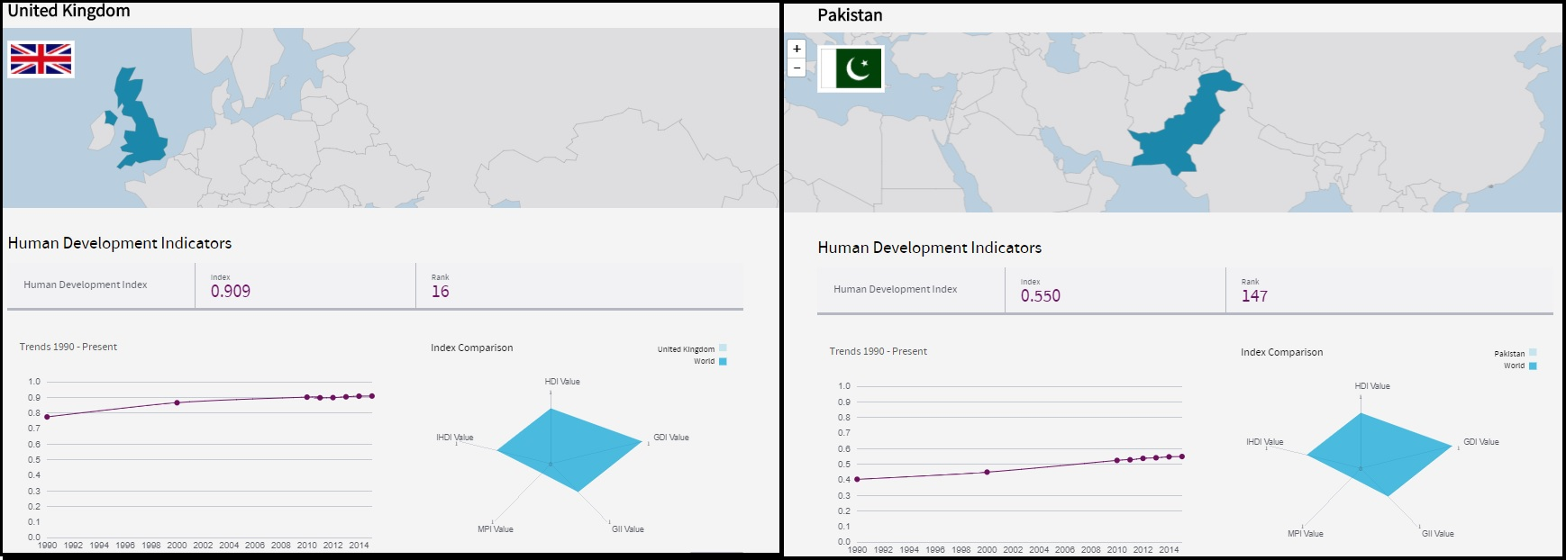
United Kingdom Pakistan
Figure 1. 7: “HDI of the UK and Pakistan” (Human Development Report, 2016)
The above figure reflects that the HDI of the UK is 0.900 whereas Pakistan's HDI is 0.550. It indicates that the UK’s HDI is double that of Pakistan’s. The detailed analysis revealed that although the UK’s HDI is more stable than Pakistan’s HDI but Pakistan experienced inclined at a constant rate during the last half decade. Moreover, the UK is ranked 16th while Pakistan is lying at 147th, which reflects the enormous differences between the two, different economies.

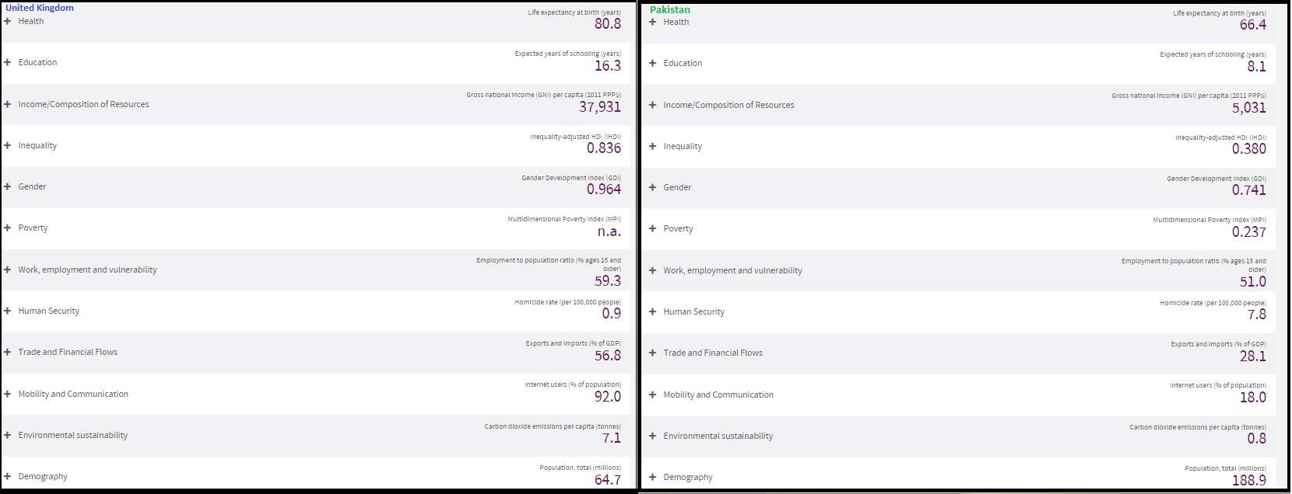
United Kingdom Pakistan

Figure 1. 8: “Comparison of the different attributes of the UK and Pakistan” (HDI Report, 2016)
The above-mentioned comparative figure reflects different attributes of the two distinctive economies. However, in the education sector, there is a massive difference, as the UK has a score of 16.3 while Pakistan has a score of approximately half of the UK (8.1). Interestingly, inequality is higher in the UK at 0.836, while Pakistan scored comparatively lower (0.38). Thus, it is possible that occupational stress and the level of commitment will vary in these different economies. Additionally, work, employment and vulnerability are higher in the UK in contrast to Pakistan (59.3 to 51.0). This is not too significant a difference, but it could affect the performance of the workforce of these contrasting economies. Hence, this study attempts to fill this identified gap. Additionally, despite Pakistan having a lower HDI than the UK, both countries are experiencing higher stress levels and challenges regarding retaining employees in the education sector (Metcalf et al., 2005; CIPD Annual Report, 2007; Haq, 2013; HEWS, 2015, Akhtar et al., 2015; Nasir & Mahmood, 2016; HCEC, 2017).
The researcher has extended the parameters by considering the education sectors of the UK and Pakistan, owing to its reputation of being one of the few sectors to contribute significantly towards GDP during the post global economic recession of 2008 (TWB Report, 2015; HEFCE, 2015). Furthermore, the trends, operations, and structure of education in both countries are similar to a considerable extent (Ramzan, 2015). Additionally, Saleem & Qamar (2017) found that the ratio of employee turnover and low job satisfaction is significantly higher amongst the university staff of Pakistan. On the other hand, Henley et al., (2016) reported that 15% of UK university staff might quit their jobs owing to Brexit. Moreover, Savage (2017) revealed that a 25% of teaching staff had left jobs after 2011 and, in the last five years, the tally has increased to 31%. These arguments reflect the trends, variations and challenges in both countries’ education sectors are similar to large extent and detailed analysis is needed to measure the variations in occupational stress and its effect on the organisational commitment of both academic and non-academic (administrative) staff. Therefore, this project critically examines the relationship between research variables in the education sector of the UK and Pakistan by exploring the variation through gender and faculty.
In order to gain superior knowledge, researchers usually opt for a comparative analysis in two distinct economies because it increases the generalizability of the results to a more considerable extent in contrast to single case (economy) selection, which limits and restricts knowledge to one specific type of economy (Goodrick, 2014; Haque & Aston, 2016; Gustafsson, 2017; Haque, Aston, & Kozlovski, 2018). In other words, rather than limiting the study to the ‘region-specific context’, the researcher attempts to gain superior knowledge through a ‘cross-cultural context’ (Haque et al., 2018). Furthermore, although there are visible differences in various aspects including, anxiety, HDI and cultural context, there are, however, some similar trends and variations in these two distinctive economies (Ramzan, 2015). Interestingly, there is some evidence of comparative analyses of the UK and Pakistan, but the study is either limited to the IT sector (Haque & Aston, 2016; Haque et al., 2016) or government expenditure on the education sector (Ramzan, 2015). Hence, there is no conclusive evidence regarding the relationship between varying occupational stressors and the organisational commitment of academic, non-academic and support staff in a comparative manner from Pakistan and the UK. The personnel operating in the academic and non-academic education sector in the contrasting economies contribute to superior knowledge in contrast to focusing on one country’s education sector. Hence, the comparative analysis in this study enhances the factor of results’ generalizability in the broader context.

1.3 Research Problem

1.3.1 The Research Agenda
Reedy (2009) defines a research agenda as focusing on specific ideas and issues within the broader research field’s subset. Conversely, Hoque et al., (2017) argued that a research agenda is a strategic plan, intently focusing on certain attributes and associated issues, that a person considers to examine and investigate in a particular time duration. Thus, in the light of the above arguments, the researcher concludes that the specific focus of the present study’s research agenda is the relationship between occupational stress and organisational commitment within the universities of the UK and Pakistan. The research primarily focuses on the varying occupational stress affecting the distinctive antecedents of organisational commitment, namely: Affective Commitment (AC), Normative Commitment (NC) and Continuance Commitment (CC) of the teaching and non-teaching, public university staff in the contrasting economies. In addition to that, other variables interlinked in this study include causes and consequences of stress, the role of a social support programme, effectiveness of the professional occupational therapists, perceived job satisfaction and Hofstede’s cultural dimensions. However, following the axiological view, the researcher has narrowed the construct of the research by only focusing on personal stressors, organisational stressors and environmental stressors. Similarly, the consequences of stress included in this study are: physical, cognitive, behavioural and emotional symptoms. Previous researchers have, however, studied mainly personal stressors, organisational stressors and only three types of consequences (physical, behavioural and emotional), while this study focuses in more depth. The focus of this project is multi-dimensional in many aspects and, therefore, it considers gender (male versus female), faculty (teaching versus non-teaching) and contrasting economies (emerging versus developed). In addition to that, the axiological view of the researcher is evident in the preference of the education sector over other sectors. Therefore, the focus of this project is the education sector of the UK and Pakistan and, within the education sector, the targets are mainly individuals working in public universities. Thus, in the present study, the research agenda includes all of the aforementioned identified aspects.
However, the primary theme of this study revolves around the varying occupational stressors affecting the organisational commitment of teaching and non-teaching (administrative) staff in both the UK and Pakistan. Hence, all of the variables in question (indirect and direct variables) are part of the research agenda and, thus, require adequate consideration for critically analysing them within the research process.

1.3.2 Background of research problem
There is mixed evidence from previous empirical studies regarding the nature of the relationship between variables considered in this study. Nevertheless, a wide range of studies in both the UK (developed economy) and Pakistan (emerging economy) have confirmed the existence of a relationship between occupational stress and organisational commitment in the education sector. Furthermore, the role of an occupational therapist is more visible in the West in contrast to the East, but there is limited evidence of the effectiveness of the occupational therapist’s role in relation to variables of interest in the West. Additionally, limited pieces of evidence are present regarding the role of social support programme within the education sector, reducing occupational stress and increasing organisational commitment. Furthermore, previous empirical studies have hinted at investigating the variables of interest through Hofstede’s cultural dimensions; however, there is no conclusive evidence regarding the use of it in the contrasting economies of the UK and Pakistan.
There is a theoretical DRIVE model available but there is no conclusive evidence regarding its adoption to measure the variation and nature of a relationship in a complex environment; therefore, studies are limited to a large extent. At present, there is a need to understand which is the most dominant and which is the least active cause of stress for contrasting genders in teaching and non-teaching (administrative) staff in distinctive economies. Nevertheless, recently Sacky & Sanda (2008), Sacky & Sanda (2011) and Haque & Oino (2017) investigated the role of social support in reducing stress, while Kumasey, Delle and Ofei (2014), Haque & Aston (2016) and Haque et al., (2016) examined the linkage of occupational stress and organisational commitment. At present, however, there is no single combined study that has considered all of the aspects within one construct. Moreover, the variations in the consequences of stress and the role of the occupational therapist regarding organisational commitment required in-depth and practical investigation because there is no conclusive evidence for investigating them within one construct.

1.3.3 Problem statement
After exploring the research agenda and the background of the research problem, the researcher has developed the problem statement given below:
"What is the effect of varying occupational stressors on the organisational commitment of teaching and non-teaching (administrative) staff working in public universities in the UK and Pakistan? Additionally, are professional occupational therapists and social support programme inside the universities effective in reducing stress and/or enhancing organisational commitment? Do the causes and consequences of stress vary for individuals considering their distinctive gender, faculty and economies of interest?
To clarify this problem statement further, the researcher has divided it into separate dimensions so that a comprehensive understanding of it can be developed:
- In what capacity do distinctive stressors affect the antecedents of the organisational commitment of teaching and non-teaching (administrative) university staff in the UK and Pakistan?
- What are the different types of consequences resulting from the occupational stress of teaching and non-teaching (administrative) university staff in the UK and Pakistan and how are these interlinked with the antecedents of organisational commitment?
- How effective are the existing social support programme in reducing occupational stress and/or enhancing the organisational commitment of teaching and non-teaching (administrative) university staff in the UK and Pakistan?
- How effective is the role of the professional occupational therapist in the education sector in reducing the occupational stress and/or enhancing the organisational commitment of teaching and non-teaching (administrative) university staff?
- What is the nature of the relationship between the occupational stress and organisational commitment of teaching and non-teaching (administrative) university staff in the UK and Pakistan?

1.4 Research Questions
Based on the preliminary research investigation and the evidences from the literature, the researcher has identified the research problem and has developed the main research question and sub-questions. Hence, the primary research question of this study is, “Does a relationship exist between the occupational stress and organisational commitment of the teaching and non-teaching (administrative), public university staff in the UK and Pakistan?” The sub-questions are as follows:
- How do the varying stressors, namely: personal, organisational and environmental stressors, affect the affective, normative and continuance commitment of teaching and non-teaching (administrative) university staff in the UK and Pakistan?
- How do the physical, behavioural, cognitive and emotional consequences concerning the distinctive antecedent of organisational commitment, vary within the teaching and non-teaching (administrative) public university staff in the UK and Pakistan?
- Are social support programme effective in sustaining human capital within public universities in the UK and Pakistan?
- To what extent are the visibility and effectiveness of the professional occupational therapist’s roles evident in public universities in the UK and Pakistan?

1.5 Aim
Based on the above problem statement and research questions, the researcher has developed the aim of this project.
This study aims “to investigate the role of social support programme and the effectiveness of the occupational therapist in dealing with the varying occupational stress and sustenance of organisational commitment of the teaching and non-teaching university staff of contrasting economies.”

1.6 Objectives
To attain the aim mentioned above, here are the research objectives:
- To examine the varying occupational stressors affecting the organisational commitment of males and females working at teaching and non-teaching faculties within the public universities of the UK and Pakistan.
- To examine the varying consequences of occupational stress among males and females working at teaching and non-teaching faculties within public universities of the UK and Pakistan.
- To evaluate the potential impact of the effectiveness of the occupational therapist, perceived job stress, personal strain, personal resources and social support for the organisational commitment of public universities’ personnel in the UK and Pakistan.

1.7 Significance of the project
A large amount of managerial literature is available that indicates the varying relationship between occupational stress and organisational commitment (Haque & Aston, 2016; Kumasey et al., 2014; Sacky & Sanda, 2011). However, there is no conclusive evidence regarding a comparative approach undertaken to examine the variables of interest concerning faculty and gender in the education sectors of contrasting economies. Hence, this study is significant in offering a comparative analysis by investigating the research problem in the education sectors of contrasting economies. Furthermore, the focus of the project is the use of social support programme in relation to the research variables, while previously there has been no conclusive study of the role of social support usage in the education sector with regard to stress and organisational commitment.
Historically, the role of an occupational therapist is well-established in developed economies (Stoica& Buicu, 2010). In emerging economies, however, the phenomenon is yet to be explored in further depth. Moreover, there are differing cultural and social norms in the considered economies of interest and, thus, this study is significant in enhancing the body of knowledge by comparing contrasting cultures and social norms in different education sectors, while also exploring the role of the occupational therapist in a developing economy. Additionally, variables of interest have been the focus of organisational behaviour research for a long time. This present project, therefore, explores it through a multi-variant approach. Sustaining human capital has been a philosophy of the organisations; hence, this project efficiently identifies the corrective measures for overcoming the various types of stressors affecting organisational commitment in an adverse manner and catering the consequences through the role of the occupational therapist. Furthermore, although the role of an occupational therapist was established in the West, the effectiveness of this role has not been studied in depth. This study, therefore, is significant in assessing and evaluating the effectiveness of the occupational therapist’s role in the education sector.
This study is also significant as it explores the different types of stressors causing different types of impact upon the contrasting faculties in distinctive economies, as well as the varying consequences for individuals experiencing stress in the education sector. Since the previous studies have mainly adopted a one-dimensional approach whereas the multidimensional approach undertaken by the researcher in this study is effective. The role of the occupational therapist, as a catalyst, is a significant addition to investigation of the variation within the variables of interest. The results significantly contribute towards establishing a standard approach for addressing the global standards required by educational institutions in sustaining human capital through increasing organisational commitment and reducing stress. Additionally, previously the DRIVE model of stress proposed by Mark and Smith (2008) was not used in complex business environments and, thus, this project takes a unique approach by practically testing the DRIVE model of stress in the complex education sectors of contrasting countries that differ historically, socially and culturally, to some extent.

1.8 Overview of undertaken methodology
In this segment, the researcher provides a brief overview of the methods conducted for examining the role of a social support programme in relation to occupational stress and organisational commitment within the teaching and non-teaching staff working in the education sector of the UK and Pakistan. As the present study prefers a comparative analysis to a single case for investigating the research phenomenon, the researcher has, therefore, opted for a comparative case analysis (Bennett, 2004; Haque & Aston, 2016; Bartlett & Vavrus, 2017; Haque, Aston, & Kozlovski, 2018). Moreover, the researcher opted for public universities over private, using a networking, connection-based approach to different public universities in the UK and Pakistan. The researcher used this two-way approach in this study to examine, assess and evaluate variables of interest through a “hypothetico-inductive-deductive” model for literature development and a “hypothetico-deductive-inductive” model for case analysis, proposed by Sekaran and Bougie (2012). These are two distinctive models used by the researchers and applied to different stages of the present research process. These are as follows:
- Hypothetico-inductive-deductive model: Firstly, in the content development stage, the researcher developed a conceptual and theoretical framework of the study by starting with the inductive approach and followed it with the deductive method through deducing irrelevant literature. Hence, the first step was the introduction of theories and models of the research variables and then the reduction of these to ensure that only those which fit with the present research scope were included in the study. The purpose of this approach is to ensure that the research objectives and literature at hand align with the research problem. Thus, this approach helped in both exploring and understanding the research problem in more depth.
- Hypothetico-deductive-inductive model: In the actual case analysis (second) stage, the researcher opted for this model, as by starting with a deductive (quantitative) approach to investigate and numerically express the relationship, and then follow on with an inductive (qualitative) approach. Thus, the deductive approach was preferred primarily because this study attempts to represent the relationship between research variables numerically. In the second stage, the researcher followed it by including interviews as a part of gaining a qualitative, in-depth perspective. In other words, this research undertakes an inductive approach during the latter half of the case analysis in order to explore the nature of variables in further depth.
Opting for cross-sectional research design reflects that the researcher investigated the variables of interest through sub-groups in both countries (Benett, 2004; Sekaran & Bougie, 2012; Haque & Aston, 2016; Haque et al., 2016; Zehra et al., 2017; Bartlett & Vavrus, 2017; Haque et al., 2018). Hence, it enables the research to move in a specific direction by comparing the distinctive variations within the sub-groups, such as gender (male/female), faculty (teaching/non-teaching) and types of economy (emerging/developed). The data collection process followed the strategy of triangulation by mixing various credible techniques throughout the research.
Moreover, in this study, the researcher created the following criteria: inclusion and exclusion. These also reflect the axiological view of the researcher and, hence, as part of the inclusion criteria, the researcher included only the institutions operating in the UK and Pakistan, in particular public universities. Thus, as part of a strategy, public universities in different urban regions were included, while private universities were excluded from this study. Furthermore, the focus of the research remains on the professionals involved in either administrative tasks or teaching and, therefore, all other personnel, such as cleaning staff and so on, were excluded from this study. Additionally, the age limit was taken into account by setting a lower limit (no individual below 18 years of age) and an upper limit (65 years or above) respectively. This was due to preliminary research indicating that a majority of teaching and non-teaching staff were aged 18 years or above, while upper limit was above 65 years. Some retired professionals are aged between 65 and 78 and work on a contractual basis. Thus, the researcher opted for this inclusion criterion. In addition to that, the researcher considered a comparative approach by comparing primary cases with secondary sources (reports, and so on.) by including the sources from the last two and a half decades. This is to ensure that the research covers a wide range, while keeping a higher focus on the most recent reports.
Additionally, the researcher developed a self-administered, semi-structured survey questionnaire on a matrix-based ordinal LIKERT scale. The researcher used a forced approach by eliminating the option of a ‘neutral’ response, while introducing a 6-point scale (1 = Strongly Disagree, 2 = Disagree, 3 = Moderately Disagree, 4 = Moderately Agree, 5 = Agree, and 6 = Strongly Agree) because the option of neutrality reduces the chance of learning about the true nature of a relationship. Moreover, the open-ended, semi-structured interviews undertaken in this study are to gain a qualitative perspective from the education sector respondents (See Appendix A and Appendix D). Using an on-line, GOOGLEDOC survey form, the researcher circulated the research instrument through gatekeepers in the UK and, after reaching a substantial target audience, the same survey was circulated in Pakistan. However, in order to avoid over-reliance on one method, the researcher also personally visited and distributed survey questionnaires amongst the targeted audience. For this project, the researcher used the combination of both probability and non-probability sampling techniques. Stratified - creating strata for gender, faculty and economy, while further classifying through proportionate stratified methods and area cluster sampling., The use of non-probability sampling can be prone to biases; however, in Haque et al., (2018) strategies were used for quantitative research because relying only on probability sampling became impractical and costly, as the access to the informant was limited. Thus, this study adapted the Haque et al., (2018) strategy to reduce bias by stratifying the respondents into major groups, so they could have fair representation. Furthermore, the researcher used the marginal error formula for determining the minimum number of respondents for the present study, following the approach of Rumsey (2002), LeBlanc (2004), and Jamal (2013). The driven formula reflected the total minimum number of respondents for this study as 384.14; therefore, over 384 respondents are sufficient to draw a logical conclusion (See Appendix E). In the present case, 408 is the total sample size. Hence, 204 respondents in both countries; Pakistan and the UK were targeted by the researcher, ensuring that the number of representatives is equal in terms of gender and faculty. Using AMOS and SPSS 23.0, the researcher has achieved a quantitative statistical analysis.
In the second stage, interviews were carried out in order to gain a qualitative aspect. Face-to-face and SKYPE interviews with both the teaching and non-teaching staff started in Pakistan and were later carried out in the UK. There were two rounds, starting first in Pakistan and then in the UK, whereas in the second round, the UK was completed first and later, through SKYPE, interviews were carried out with Pakistani employees. The purpose of holding interviews was to develop statistical significance and explore the phenomenon of the research in depth. The researcher determined the number of interviews through ‘saturation-point’. Hence, after reaching forty-nine (49) interviews, the researcher attained the saturation point (stage of repetitive response occurrence) in Pakistan and to balance the sample precisely forty-nine (49) interviews were held in the UK. Based on the saturation point, a thematic analysis was taken into consideration for the qualitative data analysis.
In addition to that, for validity, reliability, transferability and credibility, the researcher used a triangulation approach. It was to avoid relying heavily on one particular method because this eventually develops limitations and self-biases. Hence, one of the techniques is a ‘cross-check’ with the gatekeeper and HR department of the targeted organisations. Using this technique, the researcher randomly picked 50% of the respondents’ demographic details with the gatekeepers and/or HR officers to ensure information was adequate. This step enabled the researcher to maintain credibility to a large extent. In addition to that, for transferability, the researcher opted for a general framework adoption technique while developing the survey questionnaire. Hence, the researcher used the DAB (demographic, attitudinal, and behavioural) framework. Moreover, the researcher used the same instrument that was previously used by Haque & Aston (2016) and, therefore, the instrument reflected higher transferability aspects. The reliability of the instrument was ensured through Cronbach’s alpha test, whereas content-validity, fitness of the model and exploratory factor analysis (EFA) were used to check and cover the validity aspect. These distinctive mixed techniques and approaches enabled the researcher to ensure the appropriate level of validity and reliability of the respondents, the research instruments and the entire process of the research. Moreover, frequency and Q-Q plots were used for checking equal and normal distribution.
The information shared by the participants remained confidential, as their details were kept anonymous both during and after the research. This step was part of the ethical considerations undertaken by the researcher.

1.9 Overview and Structure of the project
The final section of this chapter gives a brief overview of the structure of this project. Hence, it gives a short review of the remaining chapters in sequential order.
1.9.1 Literature Review - This chapter contains theories and models about stress and organisational commitment. It offers a critical review of the various, interlinked variables including causes and consequences of stress, perceived job satisfaction, Hofstede’s cultural dimensions and the role of the occupational therapist. The chapter also discusses the gaps in the existing literature in order to develop research hypotheses. Lastly, the chapter contains the summary of the chapter, providing concluding thoughts.
1.9.2 Conceptual Framework - This short chapter contains the designed conceptual framework that the researcher has developed from the updated literature review. It identifies and explains the variables of interest, such as independent, dependent and other important variables in question. All of those important attributes discussed in the previous chapter are included here to offer the readers a comprehensive understanding of the research variables. Furthermore, this chapter contains the institutional theory and comparative approach preferred in this study for investigating the identified variables of interest. Hence, the study offers an insight into the attributes of institutional theory, namely regulative, normative and cognitive features. Additionally, the chapter explains the different waves of a comparative approach by underlining the first waves as varying stressors in contrasting economies; the second wave focuses on gender (male and female) in distinctive faculties (teaching and administrative) and the last waves explore the effectiveness of social support and the professional therapist. Lastly, the researcher gives a summary of the chapter’s key aspects.
1.9.3 Research Methodology - The next chapter discusses the actual research methodology undertaken in this study, as well as the justification regarding selected methods, approaches, and techniques. The chapter contains two sections, ‘research’ and ‘methodology’ respectively. In the first section, the researcher provides the overview about key concepts including the research paradigm (ontology, epistemology, and methodology), the research philosophy, the research type and axiological view, as well as the justification of preferred features. The second section, the ‘methodology’, includes the research design, research approach, research process, research instrument, sample size and sampling technique with the justification for each considered attribute. Lastly, the researcher has included a pilot study, methodological review, reliability, validity and ethical considerations.
1.9.4 Findings, Analysis, and Discussions - This chapter contains the actual results and representation of the data based on primary findings. The statistical test of Cronbach’s alpha, Fitness of the data, EFA, and equal and normal distribution (Q-Q) plots are included in the first section of this chapter. The second section contains the quantitative analysis including structural equation modelling through a partially recursive model, a Chi-Square test, and multiple regression for measuring the statistical significance and nature of the relationship between research variables. Furthermore, the research hypotheses developed during the earlier stages this study are tested in this chapter. Later, the findings are discussed in the light of the available literature. The second segment contains qualitative aspects by using thematic analysis for evaluating the interview responses. The main theme of this chapter is confirming or contradicting previous empirical studies through present findings. Lastly, the chapter contains a summary which provides the key highlights of the present study.
1.9.5 Conclusion, Contribution, and Implications - The final chapter of this project contains the overall conclusion by stating the individual objectives and responding to them in the light of primary evidence. The next section contains the contribution of the present study by offering both practical and theoretical contributions towards the existing body of knowledge. Later, the researcher includes the recommendations for both future researchers and university managements in Pakistan and the UK. The recommendations for future researchers are the proposed strategies for overcoming the present limitations. On the other hand, the practical implications for the management of universities are for sustaining human capital and the reduction of occupational stress. It is followed by the research limitations, where the researcher discusses the various limitations associated with this study, despite having adequate and effective use of the resources to reach a logical conclusion. Finally, the chapter contains concluding remarks by answering the research problem in the light of the evidence.

CHAPTER TWO: LITERATURE REVIEW

2.0 Introduction
The theories and models related to the research variables of the present study are discussed in this chapter. The “literature review is an important part of the research process that starts with the identification of the problem and carries on until the conclusion is drawn” (Kumar, 2009, p. 07). Hence, this chapter serves as the foundation for a theoretical framework to investigate the research problem at hand by critically evaluating various, previous, empirical studies. In addition to that, the variables of interest in different types of industries and sectors are examined in order to measure the variation in relation to the education industry in two contrasting economies.

2.1 Stress
“Stress has no single definition because it is a term often not clearly understood by all” (Stranks, 2005). It is considered differently by different individuals according to their understanding. It might be pleasant to some while unpleasant to others, depending upon each individual’s thinking and ability to comprehend (ibid). Seyle (1936) defined stress as a “common response to attack”, while Stranks (2005) argued that "it is an influencer to disturb the natural equilibrium of the human body". Now that the term stress has been explained briefly, it is essential to understand the nature of stress. Various scholars have confirmed that it is intangible, as it can only be experienced rather than touched (Stranks, 2005; Ekundayo, 2014; Kumasey, et al., 2014). Stress is a common phenomenon, visible and occurring at different stages in the professional life of individuals (Smith et al., 2000; Chang & Lu, 2007; Kumasey et al., 2014). Interestingly, studies by Schabracq and Cooper (2000) and Mark and Smith (2008) found that variation in the products and procedures of organisations, technological advancement, globalization and economies fluctuates the operations of those organisations leading to a further increase in the stakes. The above factors cause variations and shifts affecting organisational efficiency in a negative manner. The adverse effect on organisational efficiency may occur because of “stress” and, therefore, the present study focuses upon it.
Mark and Smith (2008) have argued that variation in the nature of an organisation is a reason for an increasingly “stressful” work environment. A number of researchers have also argued that changes in the nature of an organisation create apparent stress for employees and that this is caused by various factors, such as: intense work pressure, job role conflicts, harassment, personality clashes, insufficient holiday entitlement or none at all, a lack of direction or no direction at all, poor promotion prospects, a work-life imbalance, excessive working hours, isolation, job insecurity and improper feedback (Griffiths, 1998; Mark & Smith, 2011; Faizan & Zehra, 2016). On the other hand, there is a school of thought which strongly argues that stress is not always harmful by indicating examples from workplace settings confirming that a little stress is constructive, beneficial and positive in enhancing employees’ performance and commitment, depending upon the situation (Lazarus, 1966; Nelson & Simmons, 2004; Ekundayo, 2014; Haque & Aston, 2016).

2.2 Types of Stress
When considering the above arguments, it is evident that stress is destructive for some individuals, causing organisational inefficiency, while for others it can be a motivator which increases organisational efficiency. Thus, it is essential to explore the various types of stress in order to enhance a further understanding of it. There are four types of stress commonly evident in employees, namely: eustress, distress, hyper-stress and hypo-stress (Kundaragi & Kadakol, 2015).
Stress
Distress
(Bad Stress)
Acute Stress
Hyper-Stress
Chronic Stress
Hypo-Stress
Eustress (good Stress)

Figure 2. 1: Adapted from Kundaragi and Kadakol (2015)

2.2.1 Eustress
Seyle (1936) coined the word “eustress” for positive stress. Later, it was explored by Lazarus in 1966 confirming that stress could be constructive for individuals in organisational settings. Furthermore, Nelson and Simmons (2004) also found that positive stress is beneficial for both employees and organisations. According to Kundaragi and Kadakol (2015), it is a type of stress that makes an individual feel better and thus enables them in demonstrating better or creating solid impact. It activates individuals by increasing their energy, enabling them to perform at their best. However, there is no conclusive evidence regarding when good stress turns into bad stress.

2.2.2 Distress
According to Haque and Aston (2016), the opposite of eustress is distress. Kundaragi and Kadakol (2015) described it as negative stress that may affect the performance and efficiency of an individual by reducing them. Distress is common in the workplace and if continuous over a long period of time, it transforms into chronic stress (The Health Centre, 2006; Batty et al., 2017). It often arises from constant worry (Kundaragi & Kadakol, 2015).

2.2.3 Hyper-Stress
Hyper-stress is a type of stress that is more than manageable for the individual (Kundaragi & Kadakol, 2015). Furthermore, Kundaragi and Kadakol (2015) argued that for individuals in an organisational setting, an excessive workload is often a factor behind hyper-stress. On the other hand, Stranks (2005) argued that money is a prime cause of hyper-stress, affecting the performance of individuals both at home and in the workplace, eventually causing continuous strain. However, this type of stress is still limited. An employee can, therefore, continue managing to work with it (THC, 2006). Hyper-stress is also regarded as a type of acute stress (CSHS, 2010).

2.2.4 Hypo-Stress
This is the opposite of hyper-stress, arising when there is constant stress and leading to the creation of boredom and fatigue (THC, 2006; Kundaragi & Kadakol, 2015). Interestingly, this stress makes an individual feel exhausted and results in creating de-motivation owing to performing a repetitive task (THC, 2006; Kundaragi & Kadakol, 2015). Hence, the inspiration reduces due to excessive stressful work. Interestingly, CSHS (2010) consider hypo-stress as chronic stress.

2.3 Level of Stress
After identifying the different types of stress, it is essential to understand the differing levels of stress because individuals are different from one another and, thus, it is likely possibility of experience stress more or less degree. According to Ekundayo (2014), stress - whether eustress (good stress) or distress (bad stress) - differs from individual to individual. Moreover, stress does not suddenly arise, as it forms gradually and eventually exceeding to the point where it is visible Ekundayo, 2014). At times, stress levels increase and give rise to symptoms of negative impact on the functionality, behaviour and performance of individuals (ibid). Thus, it could be possible that the level or degree of stress may differ between individuals in terms of gender and faculty, negatively affecting them. Since there is no conclusive evidence at present regarding how variation in the levels of stress might be different, the stages of stress, therefore, need to be examined to determine that variation. A number of scholars have identified three stages of stress, namely: the “alarm stage - (acute stress)”, “resistance stage - (prolonged stress)”, and the “exhaustion stage” (Levi, 1972; Oyetimein, 2009; Ekundayo, 2014).
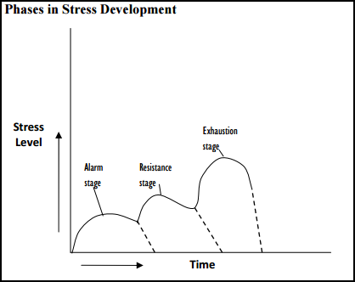
Figure 2. 2: ‘Phases in stress development’ (Oyetimein, 2009)
Interestingly, the exhaustion stage is also viewed as a result of the chronic stage; the alarm stage, by nature, is acute, while resistance is episodic stress (THC, 2006). Ekundayo (2014) explains that in the levels of stress, the first stage is regarded as the “alarm stage”. In this stage, the body produces adrenaline for competing with the stressful situation. Interestingly, at this point, the human body’s organs experience minor changes, such as an increase in pulse rate, the onset of faster breathing, problem in digestion, and/or an increase in blood pressure (Ekundayo, 2014). Different types of medication are used by some individuals in order to try to control these changes and restrict the impact of stress (Oyetimein, 2009). In addition, the consequences resulting from acute stress are counter-attacked, neutralized and reversed through various types of medication (Oyetimein, 2009; Ekundayo, 2014).
Ekundayo (2014) explained that the resistance stage is the second stage where the body decides either to fight or take flight owing to experiencing stress. Numerous types of resources including therapy, meditation and so on, are considered by the human body to deal with the stress and return to a state of equilibrium (ibid). Thus, there is large possibility that a body may return to normal if adequate measures are taken; however, if there is a defense mechanism breakdown because of a complete failure of resistance, then a person will eventually advance to the exhaustion (final) stage (Oyetimein, 2009; Ekundayo, 2014).
According to Ekundayo (2014), exhaustion is the final stage where the human body is unable to bear the stress any longer. In other words, when elastic limits are crossed and normal functionality is not maintained by the body (Oyetimein, 2009; Ekundayo, 2014). Furthermore, chronic stress is evident at this level and, therefore, the consequences are demonstrated through either severe nervousness and psychological or physical breakdown (Oyetimein, 2009). In addition to that, Ekundayo (2014) argued that if the exhaustion stage is continuous over a long period of time, there is the possibility of severe problems including: mental illness, depression, diabetes, ulcer and cardiovascular problems.

2.4 Causes and Effects of Occupational Stress at the Workplace
“Individuals experience different types of stress at a workplace and it causes different types of issues for employees” (Stranks, 2005; p. 12). Moreover, individuals are affected differently by the various types of stressors (Stranks, 2005; Ekundayo, 2014; Haque & Aston, 2016). In the present literature review, Stranks’ (2005) approach is considered for investigating the relationship between variables; these are mainly: individual, organisational and environmental stressors for measuring the impact these factors have on organisational stressors.

Figure 2. 3: Types of stressors Adapted from Stranks (2005)

The study of Ekundayo (2014) revealed that the causes and the consequences of stress differ from person to person, organisation to organisation and industry to industry. Hence, there is no conclusive evidence regarding the variation in causes and consequences for employees within the education sector. Considering the argument of Ekundayo (2014), it can be stated that symptoms vary for individuals. In other words, it is possible that there are different combinations for different employees, such as: high physiological symptoms alongside low behavioural and cognitive symptoms, or low physiological but high behavioural and cognitive symptoms, or any of the three with one being higher or lower in contrast to the other two. It is also possible that some individuals may demonstrate all three types of symptoms at either a high or low level. It indicates that there could be any combination for any individual in the work setting, but these are yet to be measured within one framework, in terms of gender, faculty and economies of interest. However, an attempt has been made recently by Haque and Aston (2016) and Haque et al., (2016) to investigate variation in the consequences of stress but their findings are largely confined to the IT sector of Pakistan, Canada and the United Kingdom, respectively. Moreover, the authors used quantitative methods and, hence, qualitative aspects are not yet explored in relation to the variables of interest. Therefore, there is no conclusive evidence from the managerial literature at hand confirming variation in the effects of stress experienced by employees working in the education sector. Additionally, no convincing evidence is present regarding the examination of the variables, through a pragmatic approach, exploring the relationship in both qualitative and quantitative aspects.

Figure 2. 4: Types of Stress consequences Adapted from Stranks (2005)
Interestingly, the work of Stranks showed that instead of considering the emotional and physical as two separate types of symptoms, they can be viewed as a single effect, namely: “physiological symptoms”. In addition to that, the literature regarding the consequences of stress has also considered them as a single effect. However, in this study, emotional and physical effects are treated as two, separate attributes.
Moreover, the study of Haque, Aston and Kozlovski (2016) found that operational level employees mostly experience stress because of personal stressors, while managerial level employees are affected by organisational stressors. In addition to that, a developing country’s workforce experiences higher levels of stress in contrast to a developed country’s workforce (Haque & Aston, 2016; Haque et al., 2016). However, the aforementioned studies did not identify any specific types of symptoms, demonstrated by distinctive genders, at different levels of management, in different types of economies. Thus, there is a need to investigate the variation in the effects of the stressors on employees with regard to contrasting genders, especially in the education sector. Moreover, there is also a need to measure the impact of stressors on the overall organisational commitment and its distinctive dimensions.
Furthermore, the previous studies included in here are limited in providing conclusive evidence to give an in-depth understanding of the causes and effects of stress in relation to organisational commitment within the education sector of contrasting economies, in both qualitative and quantitative dimensions. Now that the causes and consequences of stress have been identified through the literature, the next step is to evaluate the various models of stress to further enhance understanding of the variables of interest.

2.5 “General Adaption Syndrome” - the GAS Model of Stress
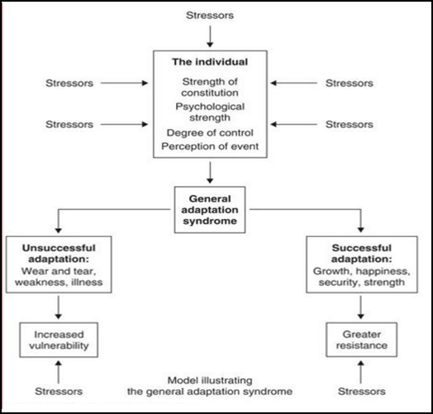
Figure 2. 5: ‘General Adaptation Syndrome’ (Stranks, 2005)

In 1936, Hans Seyle proposed a model of stress known as the GAS model, reflecting responses of stress (Smeltzer & Bare, 2004). The model argued that persistent exposure to stress cause different types of diseases and led to ageing (ibid). Interestingly, the earlier discussed phases of stress by Oyetimein (2009) and Ekundayo (2014), are based on the GAS model, as Seyle (1936) proposed three stages in his model, namely: alarm, resistance and exhaustion (Seyle, (1976; Smelzter & Bare, 2004; Stanks, 2006; Haque & Aston, 2016). Nevertheless, although the GAS model is effective in providing a basic outline, it does not help with comprehensively understanding the stress phenomenon, as it does not offer comprehensive details. The model is useful, however, as it takes into consideration the psychological mechanism and interlinked attributes demonstrated by individuals when experiencing stress. Furthermore, it also highlights the reasons why stress is damaging to a person’s well-being, physical and psychological health. It fails, however, to predict chronic stress complications that result from it (Alice, 2012). Additionally, individuals view, act and react differently to stressful situations and, thus, this model overlooks the notion of an individual’s ability to see different types of stressors (Alice, 2012).
On the other hand, Stranks (2005) argued the GAS model indicates that in the face of stressful situations, people react differently. Moreover, the author also claimed that personal implementation determines the reaction of a person and, hence, adaption of changes in a proper manner will enable a person to handle the stressful situation efficiently or vice versa (ibid). Additionally, unsuccessful adaption to situation could affect health seriously in an adverse manner (ibid). Conversely, successful adaption during a stressful situation indicates higher resistance to stress and, thus, individuals with higher personal growth and greater happiness would be more successful in a stressful situation (ibid). Moreover, Stranks (2006) argued that adequate strategies for coping with the stress at hand, the creation of self-awareness and personal resources are useful for individuals in surviving stressful situations (Haque & Aston, 2016). Hence, the GAS model serves as a constructive foundation for the development of interactional and transactional theories developed over the passage of time. Moreover, in the present study, it offers a starting point for elaborating on the impact of stress on the dimensions of organisational commitment, namely: affective commitment (AC), normative commitment (NC) and continuance commitment (CC) respectively.
From Stranks’ (2006) argument regarding Seyle’s GAS model, a basic understanding is developed about stress. It does offer a primary theme to the present study in understanding the linkage between variables of interest, namely occupational stress and organisational commitment, especially when exploring the positive and negative adaptation to changes undertaken by teaching and non-teaching staff in the education sector. To further investigate the concept, it is essential to examine the interactional and transactional theories and models of stress.

2.6 Interactional and Transactional Theories of Stress
A large number of theories and models related to work-related stress are effective in providing a theoretical framework and practical stance to investigate the stress at organisational setting. In this section, a specific selection of theories and models are taken into account, including those from the past and the present, to further explore the research phenomenon.

2.6.1 Interactional theories
According to Stranks (2005), interactional theories of stress primarily focus upon structural attributes when individuals interact with their respective environment. Interestingly, this school of thought takes into account stress as an emerging phenomenon, which rises when there is an interaction between a person and their environment (Cox & Griffiths, 1995; Stranks, 2005; Haque & Aston; 2016). Lewin (1951) argued that a primary focus of interactional theory are individual attributes of structural pattern in relation to their working environment (Mark & Smith, 2008; Haque & Aston, 2016).

2.6.1.1 Person-Environment Fit Model
In 1982, French, Caplan and Van Harrison proposed a “P-E Fit Model”. Interestingly, according to French et al., (1982), stress occurs when there is no perfect “fit” between a person and the environment (Jovanovic et al., 2005). Additionally, well-being is possibly affected in an adverse manner owing to a lack of “fit”. Interestingly, this theory has two major distinctions: firstly, subjective perceptions and objective reality and secondly, there is a distinction between person variables (P) and environmental variables (E). Thus, the lack in the “fit” situation can occur in four distinctive ways when P x E interact (2 into 2) configuration. Additionally, each of these situations could be challenging for the workers, as stress will be incurred from the environment and affect the health of employees (Jovanovic et al., 2006). Hence, a P-E fit creating stress in both an objective and subjective manner could result due to mismatch. On the other hand, Mark and Smith (2008) argued that the “P-E Fit Model” proposed that good health conditions are affected and occur when an appropriate match is found between individuals and their work environment, and vice versa.
Interestingly, to remain in a healthy state, it is essential for employees to ensure that their respective resources, abilities, skills and attitudes match with the required job attributes and working condition related skills, knowledge and needs (Mark & Smith, 2011). This, therefore reflects that if there is a wide gap or misfit in either an objective sense or subjective manner, it will cause more problems, as there would be a lack of “fit” (Sonnentag & Frese, 2003; Mark & Smith, 2008). Additionally, work-related issues lower productivity, and other health problems are strains resulting from the mismatch between a person and the environment (French et al., 1982; Mark & Smith, 2008). Moreover, Bunnk et al., (1998), argued that in this same model, there exists a “defense mechanism” operating to minimize subjective misfits, particularly reappraisal and denial.
Nevertheless, some of the major limitations of the “P-E fit model” include the unrealistic assumption that the interaction taking place between the person and his/her respective environment is stable and static in nature. This indicates, therefore, that there is higher stability in the operating dynamics when interactions are taking place, whereas in an actual scenario, the environment is continuously changing, mainly indicating that interactions may be subject to variation, from a lower to a higher level. Moreover, there is limited empirical evidence regarding the “P-E Fit model” (Buunk et al., 1998; Mark & Smith, 2008). Stress is treated as an external attribute to a large extent under the “P-E Fit Model” (Haque & Aston, 2016).

2.6.1.2 The Job Characteristics Model
The Job Characteristics Model is another model of “interactional theories” developed by Hackman and Oldham (1980). It concentrates on the significance of attributes of the job including: autonomy, a variety of skills, task importance, task identity and response (Hackman & Oldham, 1980; Mark & Smith, 2008). Interestingly, critical psychological states are approached by these attributes, indicating outcomes in the shape of knowledge, experience and responsibilities (Cox & Griffiths, 1995; Mark & Smith, 2008). Hence, this model suggests that a specific type of mental state is given rise to by job-related attributes of a positive or negative nature, eventually leading to the resulting behavioural and cognitive types; for instance, absenteeism, satisfaction, motivation and so on (Hackman & Oldham, 1980; Cox & Griffiths, 1995; Mark & Smith, 2008). Interestingly, this model is more practical for testing in organisational settings because it includes various job-related characteristics. Additionally, Kompier (2003) argued that there is sufficient and impressive literature at hand regarding job-related attributes and resulting variables (Kompier, 2003; Mark & Smith, 2008). Nevertheless, although this model is very practical in terms of conducting Job Diagnostic Survey, it only contributes to the psychological state in a limited manner and offers very little variety regarding core job attributes (Mark & Smith, 2008).

2.6.1.3 The Vitamin Model
Warr (1987) proposed an extension to the earlier model of Job Characteristics by proposing the “Vitamin Model” (Mark & Smith, 2008). The author argued that specific types of job attributes could affect the mental health of individuals in a similar way to vitamins. Most commonly, some job attributes have "constant effects" on individuals by working linearly with an enhanced “dose” to a certain level, after which there is no constructive or deductive effect (Buunk et al., 1998). Task significance, security and salary are some of the inclusions (Buunk et al., 1998). On the other hand, van Veldhoven et al., (2002) argued that when there is a moderate level of stress, an “additional decrement” or curvilinear effect might be productively experienced by some.
However, the negative impact on health could be too high or too low depending on the ability of a person to cope with the stress in the job context, specifically social support, task feedback, skill variety, skill utilisation, autonomy, and job demands (van Veldhoven et al., 2002; Mark & Smith, 2008). Interestingly, in this model, it is demonstrated that health is affected by job-related attributes in a moderate manner by exploring the well-being of individuals in three distinctive dimensions (Buunk et al., 1998). “Depressed-pleased”, “anxious-comfortable” and “discontent-content” are the three dimensions along with the individual attributes that might affect health (Buunk et al., 1998; Mark & Smith, 2008). However, although this model appears to be an interesting development in the context of interactional theories of stress, it is evident that the model is inconclusive to a large extent (Buunk et al., 1998; Sonnentag & Frese, 2003). Furthermore, van Veldhoven et al., (2005) argued that like the DCS model, the Vitamin Model also lacks empirical evidence.

2.6.1.4 Demand Control Model
In 1979, the Demands-Control Model was conceived by Karasek (Kompier, 2003). According to Kompier (2003), this model is highly influential for investigating stress at a workplace (Mark & Smith, 2008). Interestingly, the original model considers job demands and job control that are by nature psychological attributes of a job (Mark & Smith, 2008). Karasek (1979) referred to job control as “latitude” formed of skill discretion (likely through competencies and learnt skills) and decision authority (control over a situation while working in the organisation) (Karasek, 1979; Jovanovic et al., 2006; Mark & Smith, 2011; Haque & Aston, 2016). Although the model considers psychological features, it focuses on the structural attributes of a person’s interaction with the operating environment (contrary to the process of occurrence during the interaction (Cox & Griffiths, 1995).

Figure 2. 6: The Job-demands and Job-control Model (Karasek, 1979)
Interestingly, the JDC model of Karasek (1979) above found that mortality, cardiovascular disease, fatigue and a higher level of depression are likely to be more prominent and visible when there is disproportion between a low level of job control and high level of demand. Nevertheless, in challenging situations, despite having moderate or higher demands, some individuals demonstrated a lower level of illness (Karasek 1979; Cox & Griffiths, 1995). Hence, a high strain was predicted by Karasek (1979), when low control and high demand interacts, while higher control would shield the outcomes from adverse effects. Interestingly, Johnson and Hall (1988) extended the model by including a social support dimension, thus forming the DCS model in order to support the notion that in situations of high demand, social support would work as a buffer (Karasek & Theorell, 1990; Lim 1996; Cooper, Dewe, & O'Driscoll, 2001; Mark & Smith, 2008). Van der Doef and Maes (1999) argued that support, demands and controls have been largely associated with the high number of people with health outcomes.
Additionally, Warr (1990) argued that demands and controls are affected interactively by mixed support, which to a great extent are additive in nature. However, although the extension of social support is a good development, still model has only considered limited job-related attributes and, therefore, might not comprehensively explain the nature of the modern workplace, where the environment is dynamic and multi-stressors are in operation. At the macro-level, the predictive validity of the model is good, but it does not consider the vulnerability of individual attributes and differences to stressors (Perrewe & Zellars, 1999; Mark & Smith, 2008; Haque & Aston, 2016). Moreover, the model does not offer a rational explanation regarding two individuals having a similar level of demands and control giving rise to distinctive health or behavioural outcomes (Perrewe & Zellars, 1999) (For further details, See Appendix F).

Interactional Theories of Stress
Model | Main Concept | Advantages | Limitations | Reference
Person-Environment fit model | Stress incurs in the absence of fit or mismatch between person and environment. | - Introduces two major distinctions; (a) subjective perceptions and objective reality, and (b) personal and environmental variables.  - Scenario based analysis to find explain stress. | - Unrealistic assumption that interaction between person and environment is static and stable.  - Treats stress as only external attributes.  - Limited empirical evidence to support P-E Fit model.  - It does not consider job related characteristics (task identity, task response, task importance, autonomy, etc). | (French, Caplan, & Van Harrison, 1982; Jovanovic, et al., 2006; Mark & Smith, 2008)
The Job Characteristics model | Job characteristics affect mental state of individual leading to show behavioural and cognitive symptoms. | - Considers job characteristic as significant feature to explore stress.  - Treats psychological stress resulting from job related attributes leading to explain cognitive and behavioural symptoms.  - Testing this model is practically viable.  - Job characteristics are supported by vast empirical literature. | - Stress phenomenon is not comprehensively elaborated.  - Does not predict the complications of chronic stress resulting from causes of stress.  - Individual’s ability of viewing and reacting to different types of stressors are not considered.  - More emphasis on the psychological state while limited insight is given about core job characteristics. | (Hackman & Oldman, 1980; Cox & Griffiths, 1995; Mark & Smith, 2008)
The Vitamin model | Only specific types of job characteristics affect the mental health of employees. | - Treats job characteristics to have “constant effect”, reflecting individual’s ability to cope with it.  - Addition of three dimensions, ‘discontent-content’, ‘depressed-pleased’, and ‘anxious-comfortable’. | - The model has inconsistent and mixed results.  - Does not have empirical evidence to support findings. | (Warr, 1987; Van Veldhoven et al., 2002; Mark & Smith, 2008)
Demand Control model | Job demand and job control are structural psychological features. | - Considers psychological attributes while maintaining focus on structural attributes.  - Includes a new dimension "social support" working as a buffer in stressful situation. | - Despite having social support, the considered job features are limited hence fail to explain multi-stressors impact in dynamic environment.  - Does not give rational explanation regarding different health and behavioural outcomes demonstrated by two individuals experiencing stress from same job-related attributes.  - Complexity of stress model is not clearly explained.  - Environment’s subjective perception is ignored. | (Karasek, 1979; Jovanovic et al., 2006; Mark & Smith, 2011)

2.6.2 Transactional Theories
Another school of thought regarding stress theories is transactional theories and model. Cox & Griffiths (1995) argued that there is a main difference between interactional (structural) approaches and transactional (process) models of stress (Mark & Smith, 2008). It is evident that interactional models mainly consider structural attributes, reflecting types of stressors leading to demonstrate the kind of outcome, particularly more in a physiological aspect in contrast to psychological ones (Mark & Smith, 2008). On the other hand, transactional models focus on the cognitive aspects and dynamic linkage taking place between individuals and environment, specifically emotional and mental process (Cox et al., 2000; Mark & Smith, 2008; Haque & Aston, 2016). The environment’s subjective perceptions and its role are the main focus of transactional models. Moreover, it takes into consideration the locus of control, personality, appraisal, coping and so on, as features affected by individual differences (Cox et al., 2000). Below are some of the transactional models for examining the variables of interest:

2.6.2.1 The Effort-Reward Imbalance Model
- Job Insecurity
- Low aspects of promotions
- Lack of esteem from management
- Inadequatesalary

- Interruptions & disturbance
- Overtime
- Responsibilities
- Time pressure
- High workload

Figure 2. 7: Siegrist’s Effort-and-Reward Model (Söderberg, 2014)
Siegrist (1996) proposed the Effort-Reward Imbalance (ERI) Model to examine workplace stress by focusing on cardiovascular disease; this is similar to the DCS model (Mark & Smith, 2008). The environment’s subjective perception is a fundamental feature of this model. Despite that, in this model, internal process explications and the role of individual differences are not as comprehensively developed as in Folkman and Lazarus (1980) and Cox (1987). Interestingly, these two comparative models are made earlier than Siegrist’s (1996) model. However, “reciprocity” is a key concept of this approach, where a theme is based on the notion that mismatches between efforts-and-rewards would cause stressful experiences (Peter & Siegrist, 1999). Additionally, security, career opportunities, self-esteem and money are termed as “rewards” while extrinsic and intrinsic efforts are other two significant components (Peter & Seigrist, 1999; Mark & Smith, 2008). Extrinsic efforts or pressures, including workload, are similar to the DCS model’s job demands, while intrinsic effort comes from personal motivation, reflecting control features, subject to the rationality of goals (Kompier, 2003).
The studies of Siegrist et al., (1990) and Bosma et al., (1998) have supported the ERI model by indicating the situation of low reward in return for high effort is likely to escalate the risk of heart disease (Mark & Smith, 2008). Additionally, the findings of Van Vegchel et al., (2002) showed that exhaustion and psychosomatic complaints are affected by rewards in a significant manner, particularly when considering job security and self-esteem (Cox et al., 2000; Mark & Smith, 2008). Nevertheless, ERI provides a new dimension to the DCS model with predictive validity, but the dimension of intrinsic effort is explored only in a limited manner through individual differences. Additionally, the inability of the model to propose the mechanism through which stress perception process could be affected by the individual differences is another shortcoming. In addition to that, Kompier (2003) argued that, in a similar way to the DCS model, this model takes into account general intended principles rather than offering a comprehensively redesigned theory. Having said that, although there are limitations, the combination of both the DCS and ERI model are effective in offering scope regarding variations in physical and emotional health outcomes (de Jonge et al., 2000).

2.6.2.2 The Cognitive Theory of Psychological Stress and Coping
This theory proposed by Lazarus and Folkman (1980) is also regarded as a “Cognitive-Relational Approach” and is considered to be one of the most influential transactional theories from a theoretical perspective. Interestingly, it considers the co-existence of both individuals and their environment taking place dynamically, reflecting that stress is an internal attribute emerging from an emotional and psychological state, as the stressful transaction takes place (Folkman et al., 1986). Coping and appraisal are the two significant themes in the process of transaction (Cox et al., 2000). Additionally, in the appraisal process, a primary appraisal is one key stage where potential risk is evidently at stake when evaluated in a subjective manner (Folkman et al., 1986 cited from Perrewe and Zellars, 1999). Since the nature of stress is taken into account as individual-specific, these assessments do affect individual differences (Park & Folkman, 1997). Interestingly, the events are given meaning by individuals in the context of their belief, resulting from global meaning (Park & Folkman, 1997; cited from Mark and Smith, 2008). However, the notion of Park and Folkman, if examined from an institutional theory perspective would appear to be one dimensional only, conveying the perception of global belief, as it is known that individual differences are subject to variation owing to an individual’s experiences (Haque & Aston, 2016).
Another notion that is identified in the study of Park and Folkman (1997) is “situational meaning”. It could be more directly associated with the Person-Environment transactional process, thus indicating that appraisal and a coping process could result from events, so a secondary appraisal might occur when a situation is assessed as potentially stressful (Mark & Smith, 2008). Hence, an individual may perceive a situation according to their own set of beliefs or even through their experience reflecting that the context could be a highly significant consideration (Park & Folkman, 1997). Interestingly, there could be a massive possibility of crediting oneself or blaming situations for outcomes. Thus, under this model, coping strategies are proposed as potential actions taken to deal with stress and include personal resources, personality and previous experiences (Folkman & Lazarus, 1980). Moreover, emotional-focused and problem-focused are two major coping responses identified by Folkman and Lazarus (Mark & Smith, 2008). A rational problem-solving approach is used in a problem-focused response, while the emotional-oriented approach is a pattern of the emotional-problem. However, both types of responses depend upon the situation (Folkman & Lazarus, 1980; cited from Mark and Smith, 2008).
Based on Folkman and Lazurus’ work, Vitaliano et al., (1985) argued that categorizing responses are essential as avoidance, wishful thinking, blamed self and seeking social support are aspects requiring problem-focused coping. On the other hand, Falkum, Olff and Aasland (1997) found that defense, self-blame, seeking support, positive thinking and accommodation require action-oriented coping. However, this model is a significant development, but it is difficult to evaluate coping responses empirically, specifically in contrasting cultures, owing to the complexity of the model. For instance, organisational culture and a country’s culture differ, reflecting the outlook of individuals towards events, norms, traditions, history, and sense of value and proportions. Hence, there is a possibility that it would not be simple to deal with stressful situations. Furthermore, Cox and Ferguson (1991) and Cooper et al., (2001) argued that it is relatively difficult to define the term “coping” concerning the different aspects, such as specific situation, stable trait, behaviour and process (Mark & Smith, 2008). Another criticism posed by Briner et al., (2004) is that the anticipated future and history of the individuals are not considered by this model, as it only takes a simplistic approach to explain appraisal concepts. Additionally, Cox (1987) criticized the model's process as being irrational, to some extent, in relation to transactional theories of stress.

2.6.2.3 Cox’s Transactional Model
To investigate occupational stress from the transactional perspective, Cox developed and modified his transactional model at different times (Cox 1978; Cox & Mackay, 1981; and Cox et al., 2000). Interestingly, some of its features and stages are similar to the model proposed by Folkman and Lazarus, particularly the first two stages, but the essential distinguishing feature is a huge concentration on individual differences and occupational health, along with drawing a clear structure (Cox & Ferguson, 1991; Mark & Smith, 2008). According to Cox et al., (2000), under this model, stress is taken into consideration as a “psychological state” resulting from a mismatch between an ability to cope with a situation and the perception of demands (Cox et al., 2000). Additionally, support from others, resources and the ability to cope, along with the demand experienced from internal and external sources, affect the primary appraisal process (Cox & Ferguson, 1991). Moreover, similar to Folkman and Lazarus’ model, coping and secondary appraisal are involved in the third stage of Cox’s model; they are linked with stress and cause changes in the physical and mental aspects (Cox et al., 2000). Individuals undergoing stress exhibit psychological changes by showing features such as depression, tension, anxiety, mood swings, emotional disturbance and so on (Cox & Ferguson, 1991; Mark & Smith, 2008). Hence, negative health results appear when, despite having awareness of the stressful problem, individuals are unable to adjust to the situation and remain in the cycle of behaviours (Mark & Smith, 2008). Furthermore, coping consequences are evident at the fourth stage of the model while feedback regarding all the prior stages is a key feature of the last stage (Cox et al., 2000).
Although this model is vital in providing a clear indication about individual difference, too much focus remains upon the variations in coping resources, hardiness and locus of control. Mediating attributes, such as appraisal have, therefore, taken over too much control in determining the final health outcome (Mark & Smith, 2008). Moreover, the feedback stage and a clear structure of the model make it more appealing than previous models, but in reality, Cox himself has argued that in stressful situations, the problem-solving process is highly unlikely to be rational (Cox, 1987). Mark and Smith (2008) argued that conscious evaluation might not be easily attained under the appraisal and coping process and chances of bias are likely to occur, as well as a lack of sufficient information, a limited frequency of solutions, and based on past learning experience, little or no attention being given to adequate feedback. Nevertheless, one could argue that in the determination of successful and unsuccessful events of problem-solving, the above-mentioned issues could be significant in creating a difference (Mark & Smith, 2008). Overall, this model has supporting evidence similar to Folkman and Lazarus’ model, but the role offered by mediating and moderating variables conveys no conclusive evidence (Parkes, 1994; Cooper et al., 2001; Spector, 2003; Mark & Smith, 2008). In addition to that, and similarly to the “cognitive-relational approach”, this model is also complex and, therefore, it is very difficult to capture evidence in an empirical manner in contrast to simple models, such as: Karasek (1979) and Siegrists (1996).

2.6.2.4 Demand-Skill-Support (DSS) Model
In a series of stress models, this is relatively new, yet it is significant in many aspects as it takes into account existing models’ key attributes and creates them in a unique manner (Mark & Smith, 2008). This model is more closely built upon the Karasek and Theorell’s (1990) DCS model by van Veldhoven et al., (2005). Its main theme was to reduce the number of factors by taking only key factors into consideration that can affect the occupations in various types of situations. For this reason, a primary practical study was conducted by van Veldhoven et al., (2005) in four branches of industry targeting 37,000 Dutch employees by exploring the association between organisational commitment and work-related attributes, such as: task satisfaction, job security, job-related fatigue affecting health outcomes, relationship quality with supervisors, peers and colleagues, task autonomy, skills-utilization, physical effort, and amount and pace of work (Mark & Smith, 2008). Interesting findings of the study include: quality of social relationships with skills-utilization, time demands and physical effort, whereas job security and task autonomy do not play a vital role in predicting health outcomes when considered with the above-mentioned attributes (van Veldhoven et al., 2005).
van Veldhoven et al., (2005) based on their findings, proposed that demands of both qualitative and quantitative types are likely to be associated with strain and health outcomes, whilst wellbeing and attitudinal outcomes are more likely to be associated with social support and skills-utilization. This model is significant in finding the attributes in a wide range of occupational situations; there are, however, limited job attributes that were taken into consideration. It is a good starting point for researchers interested in exploring occupational stress related to job-related features. However, the model does not give full consideration to the individual differences affecting the stress process (Mark & Smith, 2008). Furthermore, job demands’ subjective perceptions are given a very little recognition in this model (Mark & Smith, 2008). Nevertheless, the developers of the model had stated beforehand that the aim is to take the minimum factors for capturing aspects of the stressful environments of this parsimonious model. The model does reflect the view that various stressors exist in organisational settings. On the other hand, a large number of authors have criticized this model by stating that it does not take stress into consideration by viewing it from a transactional process, subjective and relative in appearance (Dewe, 1991; Florio, Donnelly, & Zevon, 1998; Perrewe & Zellars, 1999; Frese & Zapf, 1994; Spector& Fox, 2003; Dewe & Trenberth, 2004). Further benefit might be attained from stress-related studies by including other job characteristics to test their relevance to stress affecting the health outcomes from psychological aspects.

2.6.2.5 Demand Induced Strain Compensation Model
The study findings of de Jonge et al., (2000) and Rydstedt, Devereaux, and Sverke (2007) showed that the ERI and DCS models’ sub-attributes had cumulative, independent consequences in forecasting physical and psychosomatic health complaints, job satisfaction and emotional exhaustion. Thus, these studies concluded that future researchers should consider combining and refining these two models, DCS and ERI respectively, to investigate stress at the workplace. Based on the suggestion, the Demand Induced Strain Compensation model was developed by combining both the ERI and DCS models (de Jonge & Dormann, 2003). Interestingly, the stress of service jobs was the prime focus for which this model was formed. The model’s main assumption is that if the demands and resources of different types are present, then the match would result in healthy outcomes (Mark & Smith, 2008). Cognitive resource compensates for cognitive demands and emotional resource compensates for emotional demands, while physical resources do cater for physical demands (van Veldhoven et al., 2005). In addition to that, van Vegchel et al., (2005) argued that certain types of affective or emotional outcomes result from the interactions and qualitative dimensions matching with demands and resources.
For instance, adverse outcomes will emerge affecting health when there is a mismatch of any type, such as: low cognitive resources for higher cognitive demands, low emotional resources for higher emotional demands and low behavioural resources for higher behavioural demands. On the other hand, results are likely to be positive and constructive by having high growth, learning and motivation when each type of demand meets higher resources. Interestingly, de Jonge and Dormann (2003) called this scenario a “triple match principle” (Mark & Smith, 2008). Furthermore, this model undertakes the demands and resources from the earlier mentioned two models and works on the principles of reciprocity and balance (Mark & Smith, 2008). Despite having some key features, still more research on this model is required, specifically exploring the types of resources that could best compensate for the demands in a similar domain or complex environment. Nevertheless, the findings of de Jonge and Dormann (2003) and Van Vegchel et al., (2005) have been of vital importance and indicate a positive move towards exploring stress at work.

2.6.2.6 The Job-Demand Resource (JD-R) Model
Another interesting approach has been developed, in recent times, by Demerouti et al., (2001). Interestingly, it combines several approaches from the past by categorizing different psychological attributes into job-demands and job-resources global categories to measure their impact on organisational commitment and the illness of individuals (Llorens et al., 2006). Since the present study also aims to explore organisational commitment with stressors, it therefore provides a deeper understanding for exploring the variables of interest. As with this model, it treats the social and physical dimensions of the effort required by a job. Therefore, against the efforts, there are both mental and physical costs. Moreover, resources at the workplace facilitate and stimulate growth and development in individuals (Mark & Smith, 2008). Motivation and health impairments are key processes that are affected by job conditions resulting from the available demands and resources (Lloren et al., 2006; Mark & Smith, 2008). Additionally, Lloren et al., (2006) argued that health-related consequences occur because of the opposition to psychological states by work engagement and burnout. For instance, the motivation process leads to enhanced organisational commitment if there is high engagement, while the health impairment process might affect the organisational commitment of employees negatively owing to burnout.
The detailed analysis revealed that the JD-R model of Llorens et al., (2006) appears to be an overarching and heuristic model, indicating that it is feasible to apply it to all types of occupational settings, irrespective of the involved specific types of resources or demands (Mark & Smith, 2008). In fact, the JD-R model is an extension of the DCS model, as it takes in various types of resources that could shield the impact of various types of demands on stress-related outcomes (Bakker, Demerouti, & Euwema, 2005). Interestingly, various studies have supported this model’s aspects, for instance, the findings of Bakker et al., (2005) confirmed that demands and resources interact in a unique proportion leading to a demonstration of cynicism and exhaustion outcomes in variances. On the other hand, Llorns et al., (2006) found that between resources and organisational commitment, a mediating role is played by engagement, while between job demands and organisational commitment, a negative relationship is mediated by burnout. However, investigations have supported the JD-R model, but the roots of this model are based upon the traditional model of Karasek’s (1979) “demands-control model”, thus indicating that the work environment’s related various characteristics are the prime focus of this model (Xanthopoulou et al., 2007).
Hence, personal resources such as optimism, organisational based self-esteem (OBSE), general self-efficacy, resiliency and so on, are added by Xanthopoulou et al., (2007) to the JD-R model. Furthermore, the authors argued that the outcomes and the environment’s relationship should be mediated and moderated by types of personal resources (Xanthopoulou et al., 2007). Additionally, Xanthopoulou et al., (2007) have explained the moderating role offered by optimism, self-esteem and efficacy on the outcomes from previous research including (Van Yperen & Snijders, 2000; Mäkikangas & Kinnunen, 2003; Pierce & Gardner, 2004). Nevertheless, personal resources offering a moderating role are not evident in the study of Xanthopoulou et al., 2007). Evidence in their research was found, however, regarding a mediating role offered by personal resources between exhaustion, work engagement and job resources respectively. Although the role of personal resources has mixed support, there is no denying the fact that the JD-R model offers a significant development in theoretical aspect to further extend the JDC and DSS models. Moreover, for future researchers, it could be instrumental in offering direction through “personal factors” within the JD-R model.

2.6.2.7 The DRIVE Model
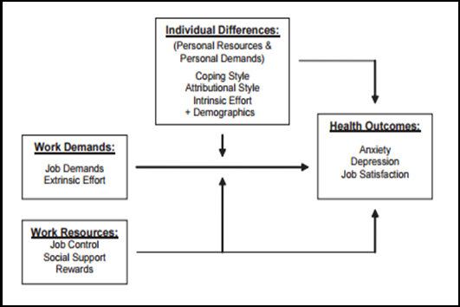
Figure 2. 8: The DRIVE Model (Mark and Smith, 2008)
After assessing and evaluating different types of models from both interactional and transactional theories of stress, Mark and Smith, in 2008, developed a model based on the limitations of earlier effective models related to stress at a workplace (Haque & Aston, 2016; Haque et al., 2016). This model is regarded as Mark and Smith’s (2008) Simple DRIVE Model, containing the "demands", “resources” and “individual effects”, thus constituting DRIVE word (Haque & Aston, 2016: Haque et al., 2016). Moreover, it contained explanatory variables, namely: demographic variables (age, gender, and so on), individual differences and job features’ frequencies (to predict depression, job satisfaction, anxiety, and so on) (Mark & Smith, 2008). Furthermore, from the DCM model, key features are taken as independent variables, such as job demands, social support, decisions, authority and skills, while from the ERI Model, for dealing with behavioural coping, the efforts of both intrinsic and extrinsic types are included in the DRIVE model (Mark & Smith, 2008). Although Mark and Smith’s (2008) model is far more adequate and comprehensive in contrast to previous models in exploring work-related stress, it appears to be slightly simple in its outlook, particularly as the work-setting has a higher degree of complexity, context, and connectedness. Still the most appealing feature of this model is the inclusion of “perceived job stress”, as it is a significant mediator in exploring the association between “demands and outcomes” and “resources at a workplace” (Mark & Smith, 2011).
Interestingly, the model was tested by Haque and Aston (2016), in the IT sectors of both Pakistan and the UK, to investigate the relationship between occupational stress and organisational commitment. It indicated that the model has the validity and feasibility to be tested in a complex business environment. Furthermore, “perceived job stress” is a significant mediator in investigating the relationship (Haque et al., 2016). Nevertheless, DRIVE is the most updated model, but there is limited evidence regarding its use in cross-cultural studies. Additionally, from the literature, it is evident that the authors have used it while either following purely qualitative methods or purely quantitative methods. Hence, there is no conclusive evidence regarding the use of this model by adopting a ‘pragmatic method’. Moreover, Haque and Oino (2017) included “social support” as another mediating variable to examine the relationship between variables of interest. Thus, using the same approach, “perceived job stress” and “social support” are adopted in the present study to further investigate the relationship between occupational stress and organisational commitment in the education sector of contrasting economies.
After a detailed analysis of the different theories and models of stress, the next step, before evaluating the dependent variable “organisational commitment”, is to examine other significant “variables in question” because of their significance in relation to main variables.

Transactional Theories of Stress
Model | Main Concept | Advantages | Limitations | Reference
The Effort-Reward Imbalance model | Stressful experience is caused by mismatch | - Considers subjective perception of environment as core aspect for stress.  - Includes reciprocity concept; stress caused by mismatch between efforts-and-rewards. | - Internal process explications are not explored.  - Works on general intended principles rather than comprehensive design theory.  - Ineffective unless combined with any other model. | (Siegrist, 1996; Mark & Smith, 2008)
The Cognitive Theory of Psychological Stress and Coping | Emotional and psychological state forms internal stress. | - Treats stress as internal attribute.  - Introduces appraisal and copping as essential theme of transaction process.  - Considers individual differences. | - Lacks practical viability in evaluating coping response in contrasting culture.  - The model is too complex in nature.  - Lacks rational-processing method explaining stress. | (Lazarus & Folkman, 1980; Haque & Aston, 2016)
Cox's transactional model | Clear structure for investigating stress through individual differences. | - Focuses more on individual differences.  - Considers internal and external sources.  - Includes ‘feedback’ stage. | - Excessive focus on the variations in resources, hardiness, and locus of control.  - Difficult to gain conscious evaluation due to chances of biased and manipulated responses. | (Cox et al., 2000; Cooper et al., 2001; Mark & Smith, 2008)
Demand-Skill-Support model | Only key organisational factors affecting job creates stress. | - Focuses on specific occupational factors.  - It is relatively simple in comparison to previous transactional stress models. | - Only test and considers limited job-related features, thus it is not comprehensive.  - It does not consider individual differences | (van Veldhoven et al., 2005)
Demand Induced Strain Compensation model | Specific emotional outcomes are driven from qualitative dimensions match | - Considers demands and resources to measure the stress through cognitive demands and resources, emotional demands and resources, and physical demands and resources  - Introduces "triple match principle" to measure the stress and coping aspects. | - It is not practically viable in complex environment.  - It does not have empirical evidence to support findings in cross-cultural studies.  - Does not consider categorization of psychological features into job related demands and resources. | (de Jonge et al., 2000; Rydstedt et al., 2007; Mark & Smith, 2008)
The Job-Demand Resource model | Stress explored in social and physical dimensions. | - Categorizes psychological features into job-demand and job-resources for measuring the impact on the organisational commitment.  - Supported by various empirical researches. | - Follows traditional pattern by focusing more on environment related different features.  - Mediating variable ‘personal resources’ has inconsistent support from the empirical researches. | (Demerouti et al., 2001; Xanthopoulou et al., 2007)
The DRIVE model | Stress examined through demand, resource, and individual effects using explanatory variables and perceived job stress. | - Most comprehensive model by including the important features of previous models.  - Simplistic in nature.  - Contains explanatory variables, job-related characteristics, and individual differences  - Considers demands, resources, and individual effects at explore stress at workplace. | - Limited empirical evidence to be tested in cross-cultural aspect.  - Despite having feasibility and validity, there is little evidence of this model used in exploring stress in the complex business environment.  - Model is not new but adoption of various attributes from other transactional and interactional models. | (Mark & Smith, 2008; Haque & Aston, 2016; Haque et al., 2016)

2.7 Perceived Organisational Support
Before joining organisation, employees do have some perceptions regarding organisational support programmes. According to Haque and Yamoah (2014), it is possible for different types of organisational commitment to result from the actual organisational support or these perceptions. Eisenberger, Huntington, Huthinson and Sowa (1986), formed the “Organisational Support Theory” (OST) by suggesting that firms value and care about the contributions and well-being of their employees by meeting their socio-emotional needs; they do so by offering them a range of benefits at the workplace (Haque & Yamoah, 2014). In return, a general perception is developed among the employees that the organisation values them for their efforts at work (ibid).
POS is a concept that has been the focus of researchers from the psychology and management discipline in recent times (Fuller et al., 2003; Stamper et al., 2003; Aube et al., 2007; Allen et al., 2008). However, it is defined in different ways by scholars from distinctive fields. One of the earliest definitions is by Eisenberger et al., (1986): “perceived organisational support (POS) is a degree of employees’ belief, taking care of their well-being and their contributions being valued by the organisation under global beliefs” (p. 504; cited from Haque & Yamoah, 2014). On the other hand, Allen et al., (2008) explained POS as a degree or extent by which organisations value their employees’ contribution and, therefore, demonstrate that they cater for employees’ concerns by having organisational support at the workplace. The important theme here is that individual understanding is a vital element because the evaluation of the behaviour of the organisation’s agents is based on the treatment received by these individuals and their respective ability to understand. Thus, it indicates that there is no unanimous criterion regarding perceived and actual organisational support, as it may likely vary from person to person, organisation to organisation, sector to sector and even industry to industry (Haque & Yamoah, 2014). Hence, POS could be argued to vary for different individuals. It could also be argued that some individuals might view it as an organisation’s willingness to provide them all with the required instruments, equipment and other particulars for completion of assigned tasks (Haque & Yamoah, 2014). Nevertheless, some individuals might view POS as an intangible aspect, such as the willingness of members of an organisation to be adequately trained in specific tasks, so that their future career growth opportunities are further enhanced (ibid).
Organisational support theory argued that an employee’s abilities for attaining desired outcomes through organisational support are restricted by the constraints of the organisation and environment because they are vulnerable to such constraints (Eisenberger et al., 1986; cited from Haque & Yamoah, 2014). Hence, to further explore the notion, the POS concerning organisational commitment is evaluated in different sectors. The evidence from the education sector is that LaMastro (1999) found that teachers’ experiences vary to a large extent. Conversely, the work of Uchenna et al., (2013) revealed that in the teaching sector, POS significantly affects the organisational commitment and performance of both teaching and non-teaching employees. Interestingly, there is no connection in these studies between stress and organisational commitment, considering the mediating or moderating effect of POS amongst teaching and non-teaching faculty (for further details, See Appendix F).
Although different studies focused on different sectors, there is still no conclusive evidence from the education sector, particularly in a comparative analysis using institutional theory to explain whether organisational support is more closely perceived and associated with job satisfaction or employee engagement. Moreover, there is limited evidence in a comparative manner regarding the mediating and moderating role played by organisational support in occupational stress and organisational commitment.
POS is considered to result from not only job conditions and facilities but also the various HR practices that shape an employee’s attitude and behaviour in a positive way (Colakoglu & Culha, 2010). Rhoades and Eisenberber (2002) found that favourable job conditions, fairness and unbiased treatment, supervisory support, reward and appreciation are linked with POS. However, the earlier findings of Eisenberger et al., (1986) reflected that POS is more to do with the personal efforts of the employees rather than the support given at a workplace for attaining organisational goals. Interestingly, Aselage and Eisenberger (2003) argued that according to the OST, an organisation facilitates employees with a higher level of support at the workplace enabling them to attain organisational goals and objectives. Additionally, the study of Haque et al., (2015) argued that organisation aligns individual goals and organisational goals in such a manner that organisational support programme provides a beneficial situation for both employer and employees. Nevertheless, Faizan and Zehra (2016) found that although a good quality working life has a significant role in the creation of organisational commitment, leadership is still more essential in contrast to social support, in determining the organisational commitment of employees in the IT sector.
From the above discussion, the key theme developed is that the perceived organisational support programme is a significant attribute within an organisation; however, its connection to different features varies, such as; organisational commitment, job satisfaction, employee engagement and employee performance. Moreover, there is limited evidence at hand regarding the variable in question from the education sector in a comparative manner. Nevertheless, from different studies, it is evident that individuals work is effectively linked with the organisational commitment and attainment of organisational and personal objectives. However, there is a relationship between job satisfaction and organisational commitment, where organisational support plays a mediating and moderating role; this notion is supported by a large number of researchers (Rhodes & Eisenberger, 2002; Aube et al., 2007; Riggle et al., 2009). Nevertheless, before exploring job satisfaction, a key type of organisational support, i.e. social support, is taken into consideration in order to establish its role in the relationship between variables.

2.8 Social support
According to Haque and Oino (2017), it is an intangible type of organisational support that prevails in the shape of moral and emotional support within an organisation. Conversely, Sackey and Sanda (2011) define this as support at the workplace from colleagues, peers and supervisors to make individuals feel part of the organisation. Interestingly, social support evidently has a significant relationship with job satisfaction, job performance and job stress (House, 1981; Hurlbert, 1991; Park et al., 2004; Sackey & Sanda, 2011; Kumasey et al., 2014; Haque & Oino, 2017). Hence, these studies reflect that social support is linked with the job satisfaction as well as occupational stress. The study of Schwarzer and Leppin (1991) found that in public organisations, the wellbeing and health of employees tends to improve with the presence of social support inside organisations, mainly when employees are performing repetitive tasks on a daily basis (Sackey & Sanda, 2011). Furthermore, different studies have confirmed that social support within an organisation tends to create a relaxing and comfortable environment for employees by reducing their workplace-related stress; thus, social support works as environmental copping resource (LaRocco, House & French 1980, House, 1981; Cohen & Wills 1985; Moos & Schaefer 1993; Brotheridge 2001; McGuire, 2007; Sanda & Sackey, 2010; Sackey & Sanda, 2011). Interestingly, all of these studies treated social support as a moderating factor in different types of sectors. Now that there is evidence from previous empirical studies regarding the variable of interest, the next step is to explore it from a gender perspective.
Considering support from the perspective of gender, Sackey and Sanda (2011) found that females use social support programme effectively, in contrast to males in public organisations, to deal with stressors such as anxiety, depression and frustration. Moreover, Haque and Oino (2017) also support these above-mentioned findings in the logistic sector of contrasting economies. Interestingly, both studies, Sackey and Sanda (2011) and Haque and Oino (2017), confirmed that social support has a mediating effect on organisational commitment and job stress. In addition to that, social support is perceived and received by females more constructively than males in both public organisations (Sackey & Sanda, 2011) and private organisations (Haque & Oino, 2017). Furthermore, social support enables a workforce to develop an “adaptive response” when they perceived and received social support and used it constructively in dealing with occupational stress (Brannon & Feist, 1992; Sackey & Sanda, 2011; Haque & Oino, 2017). Interestingly, the study of Haque and Oino (2017) confirmed that females demonstrate an adaptive response more frequently in contrast to males. However, the study was carried out in the IT sectors of Pakistan and Canada and, thus, it is likely that the results may vary in the education sector because the job description and type of support is altogether different.
After gaining a general understanding of organisational support, the literature extracts the connection between occupational stress and social support at a workplace. Kumasey et al., (2014) argued that an employee’s performance tends to be enhanced in cases where there is a decline in occupational stress. Conversely, the findings of Sackey and Sanda (2011) showed that an employee’s performance increases because of social support programme as they are effective in retaining human capital and reducing environmental stress (Haque & Oino, 2017). Nevertheless, the above-mentioned contrasting studies have limitations because they explored the research variables only in a quantitative way. Based on this limitation, Haque and Oino (2017) carried out qualitative research. This study was carried out in the logistic sector, while the earlier ones were from banking and public organisations. Interestingly, Haque and Oino (2017) used a comparative approach to enhance understanding of the variables of interest. Kumasey et al., (2014) found that, in contrast to males, females are more vulnerable to stress at the workplace, whereas the study of Haque, Aston and Kozlovski (2016) found that males are more vulnerable to stress than females. Interestingly, Kumasey et al’s., (2014) research was focused on a developing country, while Haque et al., (2016) found the evidence in both developed and the developing country. Moreover, one researched sector was banking, while the other was IT and, thus, there is no conclusive evidence from the education sectors of either Pakistan or the UK.
Nevertheless, Sackey and Sanda (2011) found that work, workers and the workplace are equally affected by stress at all layers of management. In addition to that, Kahn and Byosiere (1990) revealed that at all levels of management, a psychological reaction is commonly demonstrated by workers experiencing stress including: depression, anxiety, wellbeing disturbance and health deterioration (cited from Sackey & Sanda, 2011). Furthermore, the studies of Lim and Teo (1996) and Kumasey et al., (2014) demonstrated that organisational politics is a common type of stressor for females at a workplace. In addition, Kumasey et al., (2014) have argued that non-managerial level employees demonstrate lower stress than managerial level employees, whereas Haque and Aston (2016) found contradictory evidence, as their results showed that non-managerial level employees are more vulnerable to stress in contrast to managerial level employees. Similar findings are evident in the study of Virk et al., (2001) in the healthcare sector.
Interestingly, the study of Sackey and Sanda (2008) argued that within the different layers of management, there is evidence of variation among the differing genders in stressful situations. The females operating at a lower level have higher POS and use social support more effectively in comparison to other levels in public organisations (Sackey & Sanda, 2008). Moreover, irrespective of the layers of management, females use social support programme more effectively than their counterparts due to their perceiving ability (Parry & Shapiro, 1986; Sackey & Sanda, 2011; Haque & Oino, 2017). These studies indicate that females use social support in a constructive way to deal with occupational stress. Additionally, another investigation of Sackey and Sanda (2010) revealed that effective social support at a workplace could lead an increase in an employee’s performance and engagement, health, commitment and well-being. On the other hand, Kets de Vries et al., (2009) found that organisational trends and the prevailing culture inside an organisation is a significant factor and, thus, it is not necessary that specific types of gender will be affected more or less by stress; this depends on the actual nature of the work.
Hence, from the literature at hand, there are mixed responses, which thus reflect there is no conclusive evidence that higher stress is experienced more by a particular layer or gender. Additionally, from the education sector, there are no definitive results to show the variation in stress considering social support as a mediating factor. Interestingly, the previous studies of Haque and Aston (2016); Haque et al., (2016); and Haque and Oino (2017) have considered comparative analysis by comparing gender, layers of management and economies but these studies are mostly focussed on the IT sector in particular and, thus, it is likely that the findings cannot be applied to the education sector unless there are rigorous tests to support those earlier studies. The significant point, however, is that from these three studies, two are quantitative, while the other is a qualitative study. It would be interesting to consider a pragmatic approach to institutional theory in order to investigate the variables of interest at higher level educational institutions.

2.9 Job Satisfaction
Colakoglu and Culha (2010) considered job satisfaction (JS) to be an “affective-laden attitude” in organisational and management behaviour studies despite it being one of the complex phenomena. Interestingly, Ivancevich and Matteson (2002) considered it to be the individual's attitude and feelings resulting from the perfect match between their perception and real experience by him/her at work. Conversely, the simplest definition is offered by Robin and Judge (2009) by explaining it as “an additional variable, inside the organisational setting, used for the assessment of individuals’ feelings arising from work and workplace environment” (p. 65). On the other hand, Locke (1977) explains it as the employees’ emotional state demonstrate content due to appraisal or job experience. Nevertheless, Sempane et al., (2002) sum up that with the job, the evaluation and perception of the employees based on their values, needs and expectations are driving their feelings, and if they are happy about work, then feelings will be regarded as job satisfaction. Hence, JS tends to escalate because of the employees’ positive perceptions and evaluations.
Exploring job satisfaction, in relation to the variable of interest in different sectors, is a step to develop a comprehensive understanding of it. Since, JS is already established, as a positive perception and evaluation, it is, therefore, examined in relation to organisational commitment (OC). As JS is established, before going further, a brief insight into organisational commitment is provided. Organisational commitment is a positive intent developed by the employees towards their organisation to ensure that organisational goals are valued and attained (Haque & Aston, 2016). Affective commitment (AC), normative commitment (NC), and continuance commitment (CC) are three antecedents of organisational commitment (Mowday et al., 1979; Allen & Meyer, 2001; Porter et al., 2005; Haque & Yamoah, 2014; Haque et al., 2015; Haque & Aston, 2016; Haque et al., 2016; Haque & Oino, 2017). The connection between JS and the antecedents of OC in various sectors is evident in the previous empirical studies (for further details, See Appendix F). Hence, the critical evaluation of OC and its dimensions is an essential aspect in this research.

2.10 Organisational Commitment (OC)
After exploring the significant attributes interlinked with the variables of interest, here the dependent variable is discussed at length. Haque and Yamoah (2014) have argued that this is terminology that is explained by a large number of researchers from the behavioural science disciplines. Sheldon (1971) explained OC as positive intent that employees at the workplace demonstrate by ensuring that organisational goals are accomplished. On the other hand, Buchanan (1974) treats it as a “psychological pact” between the workers and their respective organisations. These were earlier definitions based on the Becker’s “Side-Bet” theory (1960). According to Side-Bet theory, “when the person and his performed activities are in a steady line, it creates a side-bet, as the interest of a person develops towards the assigned activities, reflecting commitment” (Becker, 1960; p.32). Although, the roots of commitment are driven from Becker’s side-bet theory, it is heavily criticized by theorists because model only showed the individual’s behaviour, while commitment is treated as a trade exchange between the workers and organisations against payment or rewards (Sheldon, 1971; Buchanan, 1974; cited from Porter, Steers, & Mowday, 2005).However, these theorists failed to explain commitment in a comprehensive manner.
Bateman and Strasser (1984) explained it as a worker’s desire to be associated and affiliated with their respective organisations and to do so, they demonstrate efforts to achieve organisational goals and remain loyal. Nevertheless, the first comprehensive definition was offered by Porter et al., (1974) by stating that organisational commitment is a commitment shown by individuals towards the same organisation by ensuring their voluntary efforts. Additionally, they accept the norms of the organisation, while exhibiting the willingness to continue with the same organisation. Based on the explanation of Porter et al., (1974), Mowday et al., (1979) termed three distinctive attributes of organisational commitment (OC) by naming them: affective commitment (AC), normative commitment (NC) and continuance commitment (CC) (Haque & Yamoah, 2014). Furthermore, affective commitment is when employees offer voluntary efforts for the attainment of organisational goals because they treat the organisational goals and targets as their own goals and targets (Mowday et al., 1979; cited from Haque & Yamoah, 2014). The employees demonstrate normative commitment by showing their consent and acceptance of organisational values and, thus, reflecting that the values and beliefs of those organisations are taken as a norm by the employees (Mowday et al., 1979; cited from Haque & Yamoah, 2014). Lastly, continuance commitment is demonstrated by the employee through their willingness to be affiliated and associated with the same organisation, as this reflects that a person wants to continue working for the same organisation (Mowday et al., 1979; cited from Haque & Yamoah, 2014).

2.10.1 Dimensions of Organisational Commitment

Organisational Commitment (OC)
Figure 2. 9: ‘Antecedents of Organisational Commitment’ Adapted from Mowday et al., (1979)
A large number of researchers have confirmed that AC is actual involvement, NC is recognition and CC is the attachment of employees to organisations and that these are the three distinct dimensions of organisational commitment (Allen & Meyer, 1996; Karrasch, 2003; Bartlett & Kang, 2004; Greenberg, 2005; Turner & Chelladurai, 2005; Boehman, 2006; Canipe, 2006; Haque & Yamoah, 2014). Additionally, the above researchers’ explanation is based on the earlier definition of organisational commitment by Porter et al., (1974), as the previous study concluded that the desire and feelings of employees encouraged them to stay with same organisation because of their belief, desire and willingness to do so would be fruitful for career growth. Furthermore, such feelings and intent indicate that employees consider organisational goals as their own goals (Haque & Yamoah, 2014). Interestingly, Haque and Yamoah (2014) explain that NC is an obligatory feeling of employees towards an organisation; that AC is remaining attached to the work, while CC is feeling that they want to stay with the same organisation.
Interestingly, Jans (1989) further constructed the concept of organisational commitment by explaining that employees develop feelings by valuing organisational goals in a specific manner through accepting, internalizing and perceiving them. From the wide range of studies, it can be concluded that an “individual considering the mission and goals of the organisation as his/her own is reflecting the affective commitment.” Through mutual concern, the individual demonstrating dedication to an organisational goal reflects normative commitment, while the individual demonstrates continuance commitment by expressing a deep desire to serve an organisation with the intent of continuity (Mowday et al., 1982; Jans 1989; Hunt & Morgan, 1994; Robbins & Coulter, 2003; Haque & Yamoah, 2014).
However, from the earlier scholars, all of these dimensions are explained through approaches. Continuance commitment is viewed as a cost-benefit approach, as employees ideally see staying with the same organisation as a benefit, while seeing leaving an organisation as a cost (Kanter, 1968). Buchanan (1974) explained affective commitment from a value approach perspective. Additionally, he argued that employees value organisational goals and objectives by considering them as their own. Later, Wiener (1982) explained normative commitment as an internalized pressure approach. According to this approach, the aims and goals of an organisation are taken as a norm and an obligation because of the internalized pressures of the organisation (Wiener, 1982). In order to explain this in the context of the present study: (a) affective commitment is shown by university staff when they willingly accept and consider an institution’s goal and values without objecting to them; (b) normative commitment is shown by university staff in a demonstration of their efforts via a prompt willingness to ensure that the rules, procedures and standards of the university are adhered to, and (c) university staff demonstrate continuance commitment by showing their intent of working for the same institution or by being affiliated to the same university’s membership.
Interestingly, distinctive types of relationship are demonstrated by the different dimensions of organisational commitment (Angle & Perry, 1981; Mathieu & Zajac, 1990; Steers, 1997; Haque & Yamaoh, 2014). In the banking sector, normative commitment is lower among employees, as it is evident that they have a moderate negative relationship with job satisfaction, while a positive association is found between job satisfaction and affective and normative commitment (Madi et al., 2012). Furthermore, Hassan et al., (2013) found that bank employees, who have appropriate organisational support, demonstrate a higher level of organisational commitment and tend to perform better, irrespective of whether the bank is a public or private institution.
In the IT sector, it is evident that an employee’s performance is enhanced because of non-financial rewards (Tan & Lau, 2012). This indicates that organisational commitment and job satisfaction have a positive relationship, as both tend to be enhanced when there are non-financial rewards for employees. Nevertheless, in the healthcare sector, it is evident that in the public sector there is high continuance commitment and low affective and normative commitment in comparison to private healthcare organisations, where employees have low continuance commitment but high affective and normative commitment because of the presence of an organisational support system (Halepota & Irani, 2010). Additionally, organisational support is provided in the form of rewards and recognition, procedural justice, job training and so on (Halepota & Irani, 2010). Interestingly, in the hospitality sector, it is evident that job satisfaction tends to increase for all types of organisational commitment, namely: AC, NC and CC, as all of these dimensions are direct and positively associated with POS (Hemdi, 2009). Interestingly, in the healthcare sector, it is clear that POS is linked more closely with AC and NC, while highly associated with CC in the private sector, and vice versa in the public sector.
Steers (1977) found that commitment and attendance have a positive connection in the education sector, whereas Mathieu and Zajac (1990) found that actual performance has an insignificant or little impact on the commitment of employees in the education sector. This indicates that affective commitment has inconsistent findings in the education sector. Furthermore, Ryes and Pounder (1993) found that teachers, who value organisational goals and objectives, demonstrate a high level of organisational commitment. This reflects that normative commitment prevails in the education sector. Interestingly, the study of Malik et al. (2010) on the education sector revealed that teachers in the public sector show higher continuance commitment, as there is high job satisfaction. The study also concluded that a strong positive relationship exists between organisational commitment and job satisfaction. Thus, in the education sector, all three types of organisational commitment: AC, NC and CC are evident. POS with AC, NC and CC is evident in the various sectors (for further details, See Appendix F).

2.10.1.2 Dimensions of Organisational Commitment and Occupational Stress
Cicei (2012) argued that there is a wide range of managerial literature available, indicating the relationship between organisational commitment and occupational stress. Different types of stressors are associated with psychological and organisational outcomes (Cicei, 2012). Furthermore, organisational commitment is a predictor of an employee’s withdrawal behavioural (Glazer & Kruse, 2008). The same study also argued that the reasons for a reduction in organisational commitment are mainly the role of stressors, anxiety and depression. Conversely, the individual’s intention to stay or leave an organisation is largely predicted by organisational commitment (Cicei, 2012). In addition to that, Fairbrother and Warn (2003) and Cicei (2012), in their respective studies, found that occupational stress and its effects are common at the workplace in almost all types of professions. Moreover, job stress leads to the development of negative physical and emotional responses that affect not only the mindset of the workers but also their performance and commitment (NIOSE, 1999; Cicei, 2012; Haque & Aston, 2016). Furthermore, Chraif (2010) found that occupation stress negatively affects an employee’s work-related behaviour. Interestingly, a large number of studies confirmed that occupational stress tends to decrease working efficiency and overall organisational performance (Chraif, 2008; Pitariu & Chraif, 2009; Pitariu et al., 2009; Cicei, 2012; Haque & Aston, 2016). Therefore, the various empirical and exploratory studies indicate that occupational stress tends to affect the organisational commitment of employees.
In the vast scientific literature, occupational stress is evident; not only are organisational efficiency and commitment affected but also the functionality, performance and commitment of workers (Fairbrother & Warn, 2003; Chraif, 2008; Pitariu & Chraif, 2009; Pitariu et al., 2009; Cicei, 2012; Haque & Aston, 2016). Interestingly, studies found that in the presence of anxiety, depression, tiredness, lack of motivation, and so on, stress affects the emotional and psychological level in a relatively complex way in the organisational settings (Stranks, 2005; Cicei, 2012; and Haque and Aston, 2016). Nevertheless, Stranks (2005) also argued that behavioural and cognitive effects are driven by stress and effects include: indecisiveness, eating too much or too little, high level of alcohol consumption, irritability, smoking, errors leading to accidents, poor relationships with other workers and so on. Moreover, it is clear that the physical health of the workers is affected by stress at the workplace, as there are physical symptoms demonstrated by employees under stress such as: dizziness, continuous headaches, aching and muscular pain and so on (Stranks, 2005; Cicei, 2012; Haque & Aston, 2016). Additionally, occupational stress affects the workers’ organisational commitment and job satisfaction (Fairbrother & Warn, 2003; Chraif & Anitei, 2011; Cicei, 2012; Haque & Aston, 2016). Therefore, the relationship between occupational stress and both job satisfaction and organisational commitment has been established in the literature.
Interestingly, under the Social Exchange theory, there is a negative relationship between occupational stress and organisational commitment (Lee, 2007). Under the Casual Model framework, the results are further confirmed by Lambert and Paoline (2009). In addition to that, when using a structural model, similar results were found by Boyas and Wind (2009). Nevertheless, in the public sector, the same nature of the relationship was evidenced by Omolara (2008). On the other hand, a positive relationship between occupational stress and organisational commitment was established by Wells et al., (2009). However, although the overall relationship was positive, the same study found that occupational stress negatively affects an employee’s continuance commitment. It is interesting to note that similar findings are evident in the work of Somers (2009), reflecting a positive relationship between occupational stress and affective commitment, and occupational stress and normative commitment, while there is a negative relationship between occupational stress and continuance commitment.
However, the study of Yaghoubi et al., (2008) found that occupational stress has no relationship with organisational commitment in all three dimensions. Conversely, occupational stress has a moderate relationship with normative commitment, while it negatively affects affective and continuance commitment (Cicei, 2012). Furthermore, the nature of a relationship between variables of interest results from the organisational culture (ibid). Interestingly, AC is primarily affected negatively by pressure of responsibility and workload (Cicei, 2012). On the other hand, in sports equipment organisations Khatibi et al., (2009) found that organisational commitment is likely to be high among employees who have good health. Hence, it reflects that those employees who are free from different types of destructive stress demonstrate high organisational commitment and tend to perform better. Interestingly, with distinctive models and frameworks, there is evidence of the varying nature of the relationship between variables of interest in different types of organisational settings.
Fields (2002) and Chraif and Stefan (2010) found that from all three types of organisational commitment, affective commitment is relatively more linked to job-stress. Stress-free employees at work are likely to have high involvement with assigned tasks and, because of good health, they perform better (Fields, 2002; Chraif & Stefan, 2010). On the other hand, Fields (2002) argued that NC reflects the obligatory feelings of employees that is, to some extent, affected by job stress, whereas CC is a cost against leaving an organisation and this type of commitment decreases because of a job’s excessive workload. Chraif and AniĠei (2011) confirmed that health and peace of mind are significant enough for employees to make an optimal personnel selection, thus increasing their work-related performance. However, Cicei (2012) found that organisational commitment highly depends upon occupational stress, as when stress rises, all three antecedents of organisational commitment tend to be affected negatively. Performance and commitment start to decline with an increase in stress levels that goes beyond control. Moreover, Cicei (2012) also supports the previous work of Fields (2002), and Chraif and Stefan (2010) in that AC, from all three types of OC, is the most closely linked to occupational stress. Additionally, absenteeism, anxiety, depression, personal and professional stress, work-family conflicts and so on, at the workplace negatively affect AC, whilst favourable attendance and organisational citizenship behaviour positively affect AC. Interestingly, the study of Haque and Aston (2016) found that CC is highly affected by occupational stress in the IT sectors of both developed and developing economies. Additionally, the same study indicated that occupational stress affects the organisational commitment of a developing country’s workforce more, in contrast to that of a developed country. Moreover, females have high AC and CC, while males have high NC in both types of economies and females are less vulnerable to stress in contrast to their counterparts because of the effective use of organisational support at the workplace (Haque & Aston, 2016; Haque et al., 2016; Haque & Oino, 2017). Despite all of these findings, there is still no conclusive evidence from the education sector of how the varying stressors affect AC, NC and CC of teaching and non-teaching staff in contrasting economies.
Chaudhry (2012) identified that there is a positive relationship between stress and job satisfaction at the universities of Pakistan, whereas Danish et al., (2015) argued that organisational commitment and job satisfaction result from organisational climate. However, Khan et al., (2015) demonstrated that stress affects the organisational commitment of employees in Pakistan. Nevertheless, the studies above have only focused on the teaching faculty, while the present study attempts to examine the relationship between variables of interest using a multi-dimensional approach. Additionally, the study of Jackson and Rothmann (2006) found a positive relationship between job stress and organisational commitment in the UK education sector. On the other hand, Khatibi et al., (2009) identified a negative relationship between stress and organisational commitment in educational institutions.
Interestingly, from the private sector, it is evident that occupational stress has a positive relationship with CC and other organisational factors including: opportunities of career development, job design, management practices and social stressors. The physical environment, however, has no relationship with stress at a workplace (Velnampy & Aravinthan, 2013). Interestingly, the same study found no relationship between occupational stress, AC and NC. It indicates that the findings are contradictory to those of earlier studies regarding the nature and relationship between occupational stress and antecedents of organisational commitment. Additionally, the studies of Haque and Aston (2016), Haque et al., (2016) and Haque and Oino (2017) were all carried out in a complex environment, while considering a multi-dimensional approach to investigate the relationship between variables; this, however, was in the IT sector and there is still no conclusive evidence from the education sector using a multi-dimensional approach with comparative analysis to investigate the relationship between occupational stress and organisational commitment. Interestingly, another important dimension to the present study is exploring the role of the professional occupational therapist in dealing with occupational stress in organisational settings. Since organisational commitment tends to be affected by occupational stress, employees can, therefore, benefit from the presence of a professional occupational therapist within an organisation to ensure that an employee’s job-related stress is managed efficiently and effectively (Haque & Aston, 2016). Thus, the literature explores the role and effectiveness of a professional occupational therapist in dealing with stress at the workplace.

2.11 Role of the occupational therapist in dealing with stress at work
Interestingly, stress has gained the attention of authors and scholars of the organisational behaviour discipline since the mid-1980s (Stoica & Buicu, 2010). Furthermore, Stoica (2007) argued that a professional stress management programme is now often used in organisational settings to address the issues creating stress for employees working at different levels. Interestingly, Wisenthal (2004) argued that a professional occupational therapist functions as a bridge between workers and work at the workplace. Additionally, professional occupational therapists and stress management programme provide solutions for organisations by offering counselling, nutrition and wellness, work-pressure handling skills training, workplace and health safety, ergonomics and pain management to manage stress (Watson, 2000; CAOT, 2010; Haque & Aston, 2016). Hence, these findings indicate that workplace stress is reduced through the effective role offered by the professional occupational therapist. Additionally, examining the literature ranging from Allen and Meyer (1996) to Haque and Oino (2017) has shown that employees with good health have a higher level of productivity and performance by demonstrating organisational commitment. Moreover, recent studies have shown that a professional occupational therapist inside an organisation is significant in managing the stress of employees (Watson, 2000; Stoica, 2007; CAOT, 2010; Stoica & Buicu, 2010; Haque & Aston, 2016; Haque et al., 2016; Haque & Oino, 2017).
Moreover, a union representative, health and safety personnel and insurer to act as a catalyst between workers and management, so that the needs and requirements of both employees and employers are properly addressed; these are roles offered by occupational therapists (Watson, 2000; CAOT, 2010; Haque & Aston, 2016). Additionally, a professional occupational therapist provides quality assurance in performance and cost-effective solutions to an organisation by ensuring an inter-relationship between workers and their occupations, so that a smooth atmosphere develops between work, the workers and the workplace (Watson, 2000; CAOT, 2010; Haque & Aston, 2016) (for further details, See Appendix F).

2.12 Hofstede Cultural Dimensions
In cross-cultural studies, Hofstede’s cultural dimension theory provides a framework, as it depicts the values of members and their value-related behaviour affected by their society’s culture (Gelade, Dobson, & Auer, 2008). When examining Hofstede’s cultural dimension, it is significant to understand culture as a general term and later to understand it in the context of the organisation. Hofstede (2011) defines culture as the “mind’s collective programming which differentiates the members of one type of category or group from others” (p. 02). Although, it is often viewed as a collective phenomenon, culture can be linked with various collectives and individual varieties (Hofstede, 2011). Interestingly, the term culture is not limited to ethnic groups but can also be applied to social classes, generations or genders. Nevertheless, the development in organisational cultural studies, particularly the changes in aggregation studies, have led to changes in the concept of culture (ibid). The gender, national, and societal culture varies, yet it is deep-rooted, for instance, occupational and organisational culture is acquired at a job because of organisational environment (ibid).
Social psychology and cross-cultural studies are influenced in a broader aspect by national culture, as per Hofstede’s model (1980) (Gelade et al., 2008). Interestingly, Hofstede’s study is frequently used by social scientists to observe behavioural variations among people from distinctive countries and cultures (Ning, 2006; Gelade et al., 2008; Afaneh et al., 2014). Nevertheless, Hofstede’s findings and their implications are yet to be confirmed empirically by evaluating them in the context of different nation’s sources of organisational commitment. Gelade et al., (2008) argued that it is important that the practices of a culturally diversified workforce should follow the local culture in order to sustain their organisational commitment, as it is generally supposed that the workforce’s high-valuing priorities are addressed to a certain extent by the organisational practices’ effectiveness. Bartlett and Ghoshal (2000) stated that organisation’s operations and assets are not limited to a certain region but disperse into globe whereas Reade (2001) argued that firm’s ability to motivate and engage the diversified workforce in determining the competitiveness of the firm. Thus, in multinational and cross-cultural context, the adequate formation of organisational commitment becomes a significantly vital aspect of strategy.
Although there are organisational behaviour studies in both Eastern and Western Countries but more in the west in comparison to eastern countries. There is however, no conclusive evidence regarding a comparative study to investigate organisational commitment in differing countries via Hofstede’s cultural dimension. Moreover, previous empirical researchers including: Palich, Hom, and Griffeth (1995); Buchko, Weinzimmer, and Sergeyev (1998); Meyer et al., (2002); and Adolšek and Štebe (2004) confirmed that the sources of commitment vary from nation to nation. Nevertheless, these studies present no evidence of sources of commitment in association with cultural values.
Interestingly, based on a previous limited evidence, Ning (2006) and Gelade et al., (2008) carried out research to examine organisational commitment from the lens of cultural values and found that it plays an essential role in its development, as it can be effective in the construction of management systems ensuring that in different cultures, the sources of commitment are prioritized.
Aggregation at an individual level, as well as at a national level, can differ in differing cultures. Schwartz (1999) argued that social power at the national level has a positive association, while having a negative impact at an individual level. Fiske (2002) explained that at the individual level cultural measures cannot be conceived. Furthermore, Steele and Ones (2002) state that personality traits form a meaningful construct at the national level. One of the Hofstede's cultural dimensions is ‘power distance’, reflecting the level to which members of a society or organisation agree and expect power to be concentrated or stratified at a higher level of the organisation (Ning, 2006). Interestingly, the study of Mitic et al., (2016) found that high ‘power distance’ negatively affects the affective commitment of employees. Moreover, it is evident that higher ‘power distance’ affects the normative commitment and continuance commitment of private university employees (Afaneh et al., 2014). Furthermore, Ning (2006) found that affective commitment is comparatively lower among Chinese compared to Dutch employees and it is negatively affected by higher ‘power distance’.
Individualism versus collectivism is another cultural dimension in which Hofstede measures cross-cultural variation. However, aggregation at both the national and individual levels can be accredited to individualistic societies or organisations versus collectivist societies or organisations (Gelade et al., 2008). Members of an organisation or society focusing on individual achievements by exhibiting self-interest and initiative are reflecting individualism, whilst preference for teamwork, community and public interest is a key feature of collectivism. Interestingly, the study of Afaneh et al., (2014) found that individualism significantly affects organisational commitment. However, the study does not explain which dimension of organisational commitment is affected, more or less. Nevertheless, affective commitment in relation to collectivist values is not evident (Gelade, Dobson and Gilbert, 2006). On the other hand, Ning (2006) found that the commitment of Chinese and Dutch employees does not significantly vary, despite that one is collectivist while the other is individualistic. Hence, this means that both individualism and collectivism affect commitment in a significant manner. On the other hand, Gelade et al., (2008) found that in an individualistic culture, there is a higher preference for ‘job characteristic’, as it leads to satisfaction. With the increase in individualism, the effect of job satisfaction decreases in a collectivist culture (Gelade et al., 2008).
According to Hofstede (2001), “masculine and feminine are the degree to which differentiation is made between the social gender roles as in masculine societies, men are tough, assertive and supposed to primarily focus on material success, while women are tender, modest and exhibit a concern with the quality of life. On the other hand, feminine societies view both men and women as tender, modest and concerned with the quality of life” (p. 297). Interestingly, Afaneh et al., (2014) found that a positive linkage between masculinity and organisational commitment exists. On the other hand, Ning (2006) compared Chinese and Dutch employees in order to measure the impact of masculinity on organisational commitment. The study showed that masculinity negatively affects overall affective commitment; however, the Dutch have a higher AC in contrast to Chinese employees in the presence of masculinity. Interestingly, in a masculine culture, a higher value is given to satisfaction with job attributes, as this type of culture positively influences commitment at a national level (Gelade et al., 2008).
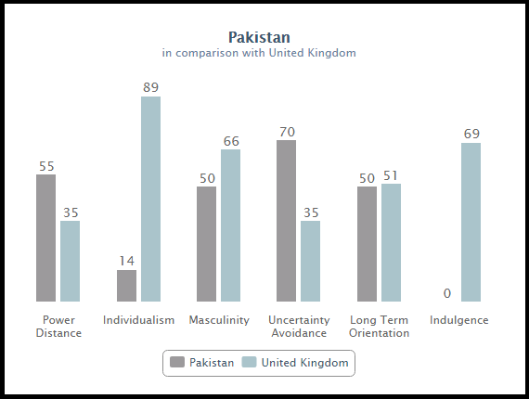
Figure 2. 10: Comparison of Pakistan and UK (geert-hofstede.com, 2017)
Interestingly, based on Hofstede’s study, the comparison of Pakistan and the UK revealed that Pakistan has a high level of ‘power distance’ in contrast to the UK (55 against 35). In other words, the preference for ‘power distance’ is low in the UK, while it is relatively high in Pakistan. Furthermore, Pakistan scores lower in ‘individualism’ than the UK (14 against 89). Hence, it reflects that Pakistan is more collectivist than the UK, whereas the UK is more individualist than Pakistan. Thus, in Pakistan, the long-term close commitment to the group or organisation is higher in contrast to the UK. Masculinity is evident in both countries but in comparison to Pakistan, the UK scores high (50 against 66). However, it cannot be said with certainty whether the preference is higher for masculinity or femininity in Pakistan. The above comparisons and arguments of various social scientists serve as a platform to assess and evaluate the contrasting economies with distinctive cultural dimensional variations. These are to be explored further so that the body of knowledge is enhanced regarding the relationship between occupational stress and organisational commitment in a cross-cultural study.

2.13 Gaps in Literature
The literature at hand was critically analysed in detail and gaps were found at different stages. Previous empirical studies were mostly single dimension in that they either explored the relationship between variables of interest in specific types of economies or types of employees (faculty or layers of management, etc) or from a general perspective. However, there is limited evidence regarding a comparative approach, taken by researchers in recent times, considering multi-dimensions, such as contrasting genders (males and females), types of faculty (teaching and non-teaching staff) and economies (developed and developing country). Moreover, there is limited evidence from the education sector in considering comparative analysis for investigating variables through a pragmatic approach.
Additionally, there is no conclusive evidence regarding the role of the professional occupational therapist in the education sector in two contrasting economies. The analysis also revealed that previous models, such as structural, causal and so on, had been used while the DRIVE model, which is relatively comprehensive, was not being used in the education sector to investigate the relationship between occupational stress and organisational commitment. There is limited evidence in recent studies indicating the consideration of the DRIVE model in the complex business environment; those studies, however, are limited to the IT sector where the role of a professional occupational therapist is included but its effectiveness is still not explored in depth. Hence, the role of the occupational therapist in the past is viewed in western organisations but its effectiveness is yet to be measured in a detailed manner, while in eastern organisations there is little or no evidence regarding either the role of the occupational therapist or its effectiveness.
Additionally, the causes and consequences of stress affecting organisational commitment vary in terms of gender, as the literature has identified, but from the education sector, there is no conclusive evidence. Moreover, comparative analysis is limited to the gender perspective, explaining the varying types of stressors causing stress; the varying consequences it can have on employees are only from the IT sector. Hence, there is the likely possibility that stress, commitment, stressors and its impact, vary from individual to individual and sector to sector. In addition to that, social support and other types of organisational support programme, evident in the literature, are used in a different manner. However, limited evidence is present from previous empirical studies; in particular, there is no conclusive evidence from the education sector to explain the effectiveness of these support programme in terms of gender, faculty and economies. Since the culture of the country and organisation varies from the East to the West, the complexities in the environment and their functionality differs and the DRIVE model, as a way to measure the relationship by taking other identified variables such as organisational commitment, stress, causes and consequences, organisational support programme in the literature need to be studied under one framework. Additionally, role of the professional occupational therapist is yet to be explored in the contrasting economies’ education sectors.
The present theoretical and conceptual framework is comprehensive in contrast to previous studies by taking into account the context, complexities and connectedness existing in the environment. Furthermore, limited evidence is present regarding the nature of AC, NC and CC and is affected by varying stressors in the contrasting economies. Nevertheless, to expand the knowledge further by exploring the variables of interest in more depth, the comparative analysis is carried out in the contrasting economies’ education sectors. It will be effective in filling the gap, to some extent, as no conclusive evidence is present from the education sector. Additionally, the inclusion of resources, demands and the workplace outcome is relatively limited in previous studies, particularly as they only consider the IT sector to investigate the role of the occupational therapist; this study is, thus, an attempt to fill the gap to a certain level by including ‘perceived job stress’ and ‘social support’ with the above-identified variables, to measure the role, as well as the effectiveness of the professional occupational therapist in reducing the degree of stress experienced by both teaching and non-teaching staff.
Historically, the role of the occupational therapist is well-established in developed economies (Stoica, 2010). In developing economies, however, the phenomenon is yet to be explored in more depth. Moreover, there are differing cultural and social norms in the considered economies of interest and, thus, attempt is significant in enhancing the body of knowledge by comparing contrasting cultures and social norms in the contrasting education sectors. Additionally, variables of interest have been the focus of researchers from the organisational behaviour discipline for a long period of time and, thus, it could be significant to explore them through a multi-variation approach. The sustenance of human capital has been a philosophy of the organisations and, hence, it could be useful in finding the correct measure to overcome various types of stressors affecting organisational commitment in an adverse manner and how the consequences could be ideally catered for through the role of the occupational therapist. The study explores the different types of stressors causing different types of impact on the contrasting faculties in distinctive economies and the varying consequences for individuals experiencing stress in the education sector. Since previous researchers have mainly adopted a one-dimensional approach, a multidimensional approach is taken here to explore effectiveness. The role of the occupational therapist, as a catalyst, is a significant addition to investigating the variation between variables of interest. Hence, this study is significant in contributing towards establishing a standard approach to address the global standards required by educational institutions to sustain human capital through increasing organisational commitment and reduction of stress.
Furthermore, this study undertakes the institutional approach to examine the relationship, while previously, organisational commitment has been explored mainly through social networking theory and occupational stress has been evidenced through grounded theory or engaged theory with conjectural analysis. However, over the last three decades, there has been an increase in research using ‘institutional theory’ to investigate the variables of interest in the organisational behaviour discipline (Aldrich, 1994; Suchman, 1995; Peng & Heath, 1996; Dacin, 1997; Lawrence, Winn, & Jennings, 2001; Sherer & Lee 2002; Aten & Howard-Grenville, 2012; Zilber, 2012; Palthe, 2014; Ozeren & Aydin, 2016). There is still limited evidence regarding how organisational commitment and other inter-related attributes are affected by the institutional approach. Interestingly, Ozeren and Aydin (2016) used institutional theory to compare systems affecting the equality of minorities in organisations in Turkey and the United Kingdom (UK). Thus, a similar comparative approach is taken in this study by using institutional theory to examine how the pillars of institutional theory (systems and supports in the education sector) affect the organisational commitment of employees.

2.14 Hypotheses
Based on the identified ‘gaps’ in the literature review, the conceptual framework was designed and the following hypotheses were developed for this study:
Hoa: The causes of stress do not vary significantly for the different genders of teaching and non-teaching faculty at UK and Pakistan’s public universities.
Hoa': The causes of stress vary significantly for the different genders of teaching and non-teaching faculty at UK and Pakistan’s public universities.
Hob: The effects of stress do not vary significantly for the different genders of teaching and non-teaching faculty at UK and Pakistan’s public universities.
Hob': The effects of stress vary significantly for the different genders of teaching and non-teaching faculty at UK and Pakistan’s public universities.
Hoc: There is no significant impact of the role of the occupational therapist, social support programme, personal strain, personal resources and perceived job stress upon reducing occupational stress amongst the different genders of teaching and non-teaching faculty of UK and Pakistan’s public universities.
Hoc': There is a significant impact of the role of occupational therapist, social support programme, personal strain, personal resources and perceived job stress upon reducing occupational stress amongst the different genders of teaching and non-teaching faculty at UK and Pakistan’s public universities.

2.15 Summary
In this chapter, a wide range of literature is critically evaluated to examine the key variables of the research. From the GAS model to the DRIVE model, it is confirmed from the literature that the health and wellbeing of people are vital for organisational effectiveness. Additionally, personal resources and the ability to cope with stress varies from person to person. There is also evidence from the literature to demonstrate that no two employees will show the same type of consequences of stress in similar situations. Stress is more about internal attributes that transact when there is a mismatch between the effects of demands, resources and imbalance. On the other hand, the literature shows that organisational commitment varies not only in gender but also among the types of employees, such as private or public-sector workers and so on. Social support and organisational support systems are also not efficiently used by all types of employees, in all kinds of sectors, in different types of economies. After reviewing interactional and transactional theories of stress, the latest DRIVE model is included to examine occupational stress. However, the model is not used in the contrasting education sectors for understanding the relationship between stress and organisational commitment in a complex business environment. Organisational commitment and its antecedents along with the types, causes and consequences of stress are explored in depth.
The literature has indicated that a little stress is not bad at the workplace. Chronic stress, however, can be destructive for an employee’s well-being, health, performance and organisational efficiencies. Occupational stress and organisational commitment are aspects that could ideally be explored adequately from a psychological perspective. The relationship between occupational stress and organisational commitment is examined in different types of organisational settings, but the findings from the education sector are inconsistent. Additionally, the role of the occupational therapist is established in the West, while it is not very visible in the East. Furthermore, although the role is established, there is limited evidence regarding its effectiveness. Moreover, the use of institutional theory to compare the relationship in a comparative manner by considering gender, faculty and economies of interest is not yet evident from the literature to hand. Hence, the present study attempts to fill the gaps identified in the literature by enhancing the body of knowledge.

CHAPTER THREE: CONCEPTUAL FRAMEWORK

3.1 Introduction
This chapter contains the conceptual framework designed from the literature review. The independent, dependent and other vital variables in question are identified from the literature. This is presented separately below so that variables of interest are clearly identified for the present study.
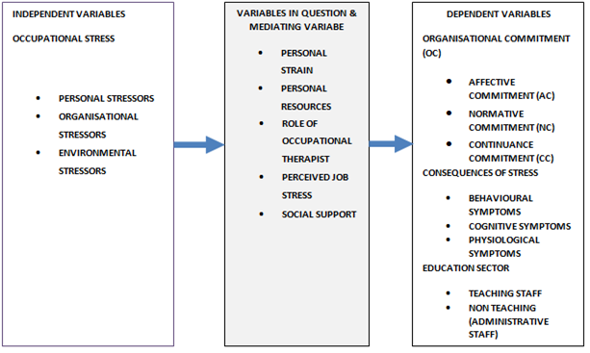
Figure 3. 1: Self-constructed framework to demonstrate variables of interest

3.2 Variables of interest
In the above figure, the ‘independent variables’ are on the left-hand side. Here in this study, ‘occupational stress’ is the main independent variable. Additionally, following the work of Stranks (2005), this study also uses three types of stressors which cause occupational stress, namely: personal stressors (personality, family problems and financial problems), organisational stressors (task demand, role demand, life cycle of the organisation, organisational leadership, interpersonal demand and organisational structure), and environmental stressors (political uncertainty, technological uncertainty and economic uncertainty). On the right-hand side, ‘dependent variables’ are demonstrated. In this study, the main dependent variable is ‘organisational commitment’. The impact of stress, however, is not only measured by overall organisational commitment alone but also by its individual dimensions, mainly affective commitment, normative commitment and continuance commitment. Furthermore, the consequences of occupational stress are treated as dependent variables in this study. In Stranks (2005), the effects of occupational stress are considered, namely: cognitive symptoms, behavioural symptoms and physiological symptoms. Since the impact of occupational stress on teaching and non-teaching (administrative staff) are discussed in this study, education sector employees, therefore, are considered as other dependent variables.
In addition, in this study, the variables in question are included, as it is considered that there are other variables interlinked with independent and dependent variables. Perceived job stress, the effective role of the professional occupational therapist, the role of a social support programme, personal strain and personal resources are the predictors that are identified through preliminary research and subsequent investigation. Hence, these are the variables in question that are closely interlinked in this study. Furthermore, the impact of these attributes is investigated in this study to enhance understanding of each attribute that exists in the education sector.
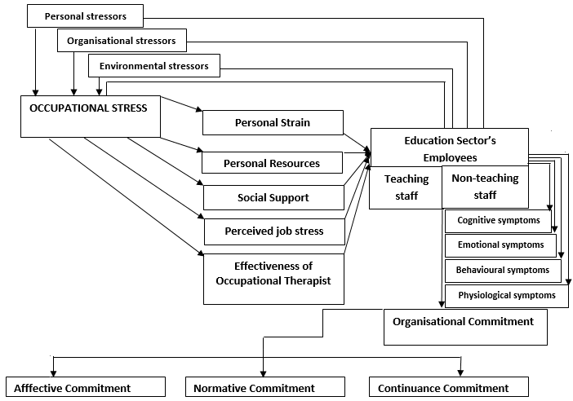
Figure 3. 2: Self-constructed conceptual framework for the present study.
The above figure is the conceptual framework reflecting the critical variables of interest in this study.

3.3 Institutional theory and comparative approach
After identifying the variables of interest, this study uses institutional theory to examine variables in a more detailed manner. Interestingly, there are few examples available of studies that consider the role of institutional process transformation and professional associations (Greenwood, Suddaby & Hinnings, 2002). Additionally, a number of studies including: Huy (2001), Heracleous and Barrett (2001), and Delibridge and Edwards (2013) have stressed the significance of institutional change, cognitive and regulative pressure drive work and organisational performance. On the other hand, Ozeren and Aydin (2016) argued that through institutional theory, comparative analysis can be made to scrutinize and understand the agenda in two distinctive locations. A similar approach is taken in the present study to examine the variables of interest.
However, the relationship between occupational stress and organisational commitment through organisational performance and effectiveness is still not evaluated through regulative, normative and cognitive pressure. Moreover, the role of the occupational therapist from the perspective of the institutional system (regulative, normative, and cognitive institutional attributes). and how these institutional elements affect their function and effectiveness. is explored in this study. In general, institutional theory is not perceived as a theory of organisational commitment but, in the past, it has been used to define the similarity and stability within an organisation in a traditional manner (Palthe, 2014). Additionally, the cultural norms differ in both Pakistan and the UK’s education sectors. Despite higher spending in the UK, the contribution of the UK’s education sector to GDP is 2.8%, while government spending on it is 11% (UKPS Framework, 2016). On the other hand, the Pakistani government spends less (7.8%), but the contribution of the higher education sector is 3.6% (Ministry of Education Pakistan, 2015). Moreover, there are similar inconsistent results regarding the relationship between variables of interest from the two selected countries’ education sectors. Therefore, this needs to be explored.
Interestingly, there is a similarity in the Pakistan and UK's geographical aptitude results, considering the education sector (69.6 against 66.6) (Saeed, 2007; Ramzan, 2015). Additionally, in both Pakistan and the UK, the minimum duration for a PhD and routes for MPhil in a relevant discipline are equal (three years). Interestingly, the gap in comparative performance regarding gender (males and females) is a similar feature in both Pakistan and the UK (Ramzan, 2015). Moreover, at all levels of education in both countries; the UK and Pakistan there is similar summative and formative assessment style are used (Saeed, 2007; Ramazan, 2015). However, the UK has more developed and structured approach than Pakistan whereas Pakistan follows the same pattern and has a similarly structured approach adopted from the UK (Ramazan, 2015). Interestingly, the gap between the education systems of the two countries has reduced relatively with recent changes and the adoption of fixing minimum standards. With the new reforms, the structured mentoring of teachers has started in Pakistan, which again is similar to the UK’s approach. Despite having similarities in the institutional system, one is an emerging economy (Pakistan), while other is a developed economy (UK). Thus, the choice of selecting these two contrasting economies is based on their sharing similar trends. Hence, this study undertakes the same approach to Greenwood and Hinings (1996) and Palthe (2014) by considering institutional theory as a framework to examine the relationship between occupational stress and organisational commitment, as it indicates the contextual dynamics related to exploring the phenomenon in a comparative manner.
Three components of the institutional theory reflect three different waves. Since the context of these two countries’ education sectors is discussed above in order to explain the selection of these countries as a choice for study, now the agenda’s first wave addresses the varying stressors directly affecting the contrasting types of employees within the institution and how institutions face employees’ vulnerability to acute and chronic stress. The next wave of the theory is to take into consideration that the contrasting employees (male and female) working in contrasting faculties (teaching and non-teaching) are given adequate support through institutional policies and procedures to effectively address different types of challenges in a somewhat inclusive environment. The last wave of the institutional theory undertakes “how the educational institutions have addressed the stressors and the effective use of a professional occupational therapist at the workplace to ensure institutional efficiency remains a priority.” Hence, this last wave examines the institutional system and the environment in a legal context, while the first two focused on comparison through concentrating on the regulative and cognitive pressures. Through an institutional perspective, the context, connectedness and complexities in the contrasting countries’ education sectors are considered in this study.
The social construction of reality is used for attaining the legitimacy of the organisation via an institutional approach, reflecting the practices, programmes and structure of the organisation (Palthe, 2014). Additionally, Scott (1981) argued that the social process demonstrates institutionalism because employees accept the reality of process activities that are similar in meaning to all of them despite being repetitive. Moreover, the institutions are complex and dynamic and, thus, there is the possibility of variation of variables affecting individuals’ performance and commitment in a distinctive manner. Furthermore, exploring the rational aspect, all of the organisational members express the different values of institutions explicitly (Palthe, 2014). For instance, educational values guide the functioning and operations of the universities. The effects of the institutions are evident in both the environment and the organisation, as they reflect that adequate organisational behaviour could be understood by studying the relationship between variables.
The three aspects of institutional theory include: regulative, normative and cognitive (Palthe, 2015; Ozeren & Aydin, 2016). In the present study, work rules, policies and procedures, organisational factors, environmental factors and supportive workplace are taken as regulative. Normative includes working norms, cultural norms, personal resources and habits, while cognitive includes beliefs, values and personal factors. Hence, institutional theory and assumptions match with the present study. After explaining the rationale behind the adoption of institutional theory and a comparative approach to examine the research problem at hand, it becomes essential to describe briefly the conceptual framework developed through identifying the varying stressors at a workplace.

3.4 Stressors in an organisational setting
The UK Health and Safety Executive produced the “management standard framework” in relation to stress-related health issues. Job role, organisational change, job demands, support functions and control systems are some of the issues affecting health and are part of this strategic framework (HSE, 2007; Mark & Smith, 2008; Haque & Aston, 2016). Interestingly, a large number of studies identified the above-mentioned issues as “psychological stressors”, leading to physical or psychological problems, such as fatigue, gastrointestinal problems, heart disease, depression, musculoskeletal disorders, work-family conflict, absence, burnout, substance misuse, accidents and so on (Cox & Griffiths, 1995; Gianakos, 2002; HSE, 2007; Mark & Smith, 2008 and 2011; Haque & Aston, 2016). These different attributes lead to serious consequences, such as an increase in absenteeism, higher employee turnover, an increase in the number of strikes, reduction in productivity and low morale are evident in the organisational setting (Mark & Smith, 2008 and 2011).
An employee’s work-related attitude and efficiency are affected by stress. This has been one reason why it has been a centre of attraction for organisational researchers and, therefore, has been studied during last few decades with high enthusiasm (Jamal, 1990; Kumasey et al., 2014). In addition to that, organisational commitment is evidently affected by organisational support and/or stress and, thus, researchers from the organisational behaviour and human resource management discipline are interested in evaluating the variation in organisational commitment because of these variables (ibid). However, there is no conclusive evidence to measure the variations in the causes and consequences from the perspective of gender, faculty and economies of interest. There are some traces from recent literature where different types of stressors including: personal, organisational and personal factors are identified as affecting distinctive kinds of employees (Haque & Aston, 2016; Haque, Aston, & Kozlovski, 2016; Haque, Aston, & Kozlovski, 2018). However, these studies were carried out in the IT and Logistic sectors, whereas there is still no conclusive evidence from the education sector of the different economies. Moreover, the same studies concluded that there is no variation in the consequences of stress in contrasting genders, working at distinctive layers of management, in developed and developing economies. However, there is a need to investigate research problem in the education sector to confirm if the causes and consequences vary from sector to sector. Another important aspect is considering the work of Haque & Aston (2016) that confirmed task demand as most visible organisational stressor affecting male employees, while personality clash (personal factor) affects female employees. It makes the HR and top leadership role more significant in the management of varying types of stressors among distinctive genders.
Since HR serves an essential role in shaping organisational commitment and enhancing individual and collective information, it is necessary, from the management and HR’s perspective, to examine the relationship between variables of interest in the contrasting economies’ educational sectors. Specifically, measuring the variation of stress in order to understand the impact it has on the effectiveness and performance of employees working in the educational sector. Interestingly, the role of the occupational therapist is not studied in a comparative manner to provide insight into the research problem, whereas a number of scholars argued that in order to deal with the issue of employees’ stress, modern-day firms consider the role of the professional occupational therapist (Chang & Lu, 2007; CAOT, 2010; Mark & Smith, 2011; Haque & Aston, 2016). Again, this is another important aspect that contributes towards conceptual underpinning, as presently there is limited evidence from the education sector to assess the representation and effectiveness of the professional occupational therapist.
Numerous scholars found that smooth operations and organisational efficiency are affected mainly by job stress in modern professional life (Chang & Lu, 2007; Mark & Smith, 2011; Kumasey et al., 2014; Haque & Aston, 2016; Haque, Aston, & Kozlovski, 2016).
Interestingly, studies have shown that the workers’ productivity, attitude, behaviour, and performance are negatively affected by stress at the workplace (Ofoegbu & Nwadiani, 2006; Kumasey et al., 2014). However, these studies mentioned above do not examine variation in the causes and consequences. On the other hand, the recent work of Haque and Aston (2016); Haque, Aston, and Kozlovski (2016) examined, through quantitative analysis, the different types of stressors affecting the performance, productivity, efficiency and behaviour of employees within the organisation. Interestingly, their findings reflect that causes vary for males and females but only in quantitative aspects. Males are more likely to be stressed because of organisational factors, while females are negatively affected by personal factors (Haque et al., 2016; Haque & Aston, 2016; Haque & Oino, 2017). Interestingly, the same studies showed that employees’ organisational commitment at the operational level is negatively affected by stressors, while the commitment of managerial level employees is positively influenced by stress (ibid). However, the studies were conducted in the IT sector; therefore, the findings cannot be generalized to the education sector. In addition to that, teaching and non-teaching staff are different to managers and non-managers; therefore, there is a possibility that causes as well as consequences may vary for education sector employees.
Hart and Cooper (2001) argued that not only individual but also collective performances of employees within an organisation are influenced by stress and, thus, for employees, the work-related cost is significantly higher. A large number of studies have supported the notion that stress negatively affects the performance and efficiency of organisations in a highly complex environment (Dua, 1994; Brown & Uehara, 2008; Reskin, 2008; Kehsavarz & Mohammadi, 2011; Kumasey et al., 2014; Haque & Aston, 2016). However, whether stressors negatively or positively affect the performance and efficiency of the educational sector’s employees, especially from a faculty and gender perspective, is yet not examined in a comparative manner.
Now that the level of stress is known, and a brief overview is provided about stress, particularly stressors in the organisational setting, the causes and consequences need further exploration. In particular, there is a need to explore the magnitude of the impact of stressors on the overall and individual dimensions of organisational commitment. According to Ekundayo (2014) stressors lead to dissatisfaction, conflicts, overwhelm, and threats. On the other hand, Haque and Aston (2016) argued that stressors themselves cause stress rather than acting as mediators. Ekundayo (2014) argued that the researchers’ and medical practitioners’ view is that prolonged stress can result in an ulcer, cardiac disease and so on, and is destructive to the functioning of the human mind and body. On the other hand, Haque and Aston (2016) argued that chronic stress tends to reduce not only an individual’s physical functionality but also their well-being, overall spirituality and mental abilities. Hence, stressors do not only affect the physical being but also the psychological being of individuals.
Interestingly, the recent study of Mark & Smith (2018) examined the stress of university staff. A high level of stress is evident in university teaching staff in the UK (Mark & Smith, 2018). In addition to that, a high workload, job insecurity, family conflicts, sleep problems, long working hours and low control are some of the reasons for the high stress of university staff in the UK (ibid). Interestingly, physical and psychological consequences are evident among the university staff because of work stress (Mark & Smith, 2018). Moreover, talking to colleagues (informal social support) is a way of dealing with stress among university staff in the UK. Another important notion identified by Mark & Smith (2018) is that more highly experienced, university staff deal better with stress. Additionally, the communication is considered as a key to resolve stress at university (ibid). Lastly, the same study found that despite having stress, university staff view stress in the education sector as not above that in other sectors (ibid).
The study of Ekundayo (2014) argued that anxiety, the frequent occurrence of negative vibes, high depression, fear, an upset stomach, a disturbed sleep pattern and loss of appetite are common symptoms for stressed individuals. Moreover, work, workers and workplace efficiency are reduced because of excessive stress (Ekundayo, 2014). Nevertheless, researchers have used different approaches to assess occupational stress. It is, therefore, essential to examine distinctive approaches before considering the one that is best-aligned with the present study.

3.5 Approaches to investigating occupational stress
Under an engineering approach, occupational stress is viewed as the work environment’s avoidance or harmful characteristic (Jovanovic, Lazaridis, & Stefanovic, 2006). Additionally, when using this approach in organisational studies, environmental factors causing ill health are treated as independent variables (Jovanovic et al., 2006). Thus, this approach looks into circumstances and causes of stress explored through the structural attempt. The physiological approach is another approach that undertakes and explains stress in a physiological manner. Furthermore, this approach reveals the physiological response demonstrated by an individual when encountering a threatening or dangerous situation, reflecting stress as a “dependent variable” (ibid). The psychological approach is the third type that conveys the theme of work stress emerging as a result of continually changing the interaction between individuals and their respective working environment (ibid). Interestingly, under this approach, the main argument is that stress could be measured by taking into account the emotional reactions and cognitive processes underpinning the interactions taking place between individuals and environment or inferring challenging person-environment interactions, reflecting the psychological dimensions interlinked with the stress phenomenon (ibid).
Moreover, concerning the conceptual and empirical aspects, there are certain criticisms. Firstly, with the existing data, both engineering and physiological approaches do not appropriately comprehend the stress phenomenon. For instance, noise and disturbance affecting an individual’s comfort and working performance under the engineering model is one example. Interestingly, here the adverse effect of noise on working efficiency or performance is not evaluated from the aspect of its frequency or volume but is examined by considering its nature and the contextual effect it might have on individual difference (Jovanovic et al., 2006). According to Broadbent (1981), in case tiredness and fatigue is higher among the subjects then there is a likely chance that even normally disruptive level of noise might be very destructive in task performance maintenance.
On the other hand, in situations of social gathering or leisure, some individuals might consider a high level of music (noise) (Broadbent, 1981; Jovanovic et al., 2006). Thus, this means that noise is not the main disturbance causing stress but the context, individual capability of handling it and individual preference are. and, therefore, the engineering approach is not a comprehensive approach to large extent, as it ignores various likely occurring possibilities. Additionally, Scott and Howard (1970) stated that certain specific types of events or situations could prove to be problematic to some individuals owing to the degree of impact that these situations have on them, however, although the degree of impact might not turn out to be severe in nature for others. This statement reflects that the situation could be viewed as highly serious or problematic but does not have to be seen and similarly viewed by all. It could be due to personal differences, outlook and the abilities of individuals. Additionally, the situational context and a strong cognitive ability to mitigate the situation might change the consequences of stress for different types of individuals. Hence, at present, there is no conclusive evidence from the literature at hand for how stimuli differ and the coping ability of teaching and non-teaching staff regarding gender, faculty and contrasting economies of interest.
In addition to that, Douglas (1992) argued that the perception of an individual is also significant in assessing events as stressful or not. With the engineering approach, such behaviours and related perceptions are not explained in an appropriate and detailed manner. Notably, there is no comprehensive explanation regarding the actual nature of risk, and cultural and group biases that are likely determining factors in creating stress. Additionally, Jovanovic et al., (2006) argued that stress is not always destructive because a little stress is positively associated with good health and good performance in the organisational settings. However, under an engineering approach, management practices of poor quality are justified on various occasions by indicating that there is an existence of most favourable levels of stress. Another serious lack of the engineering approach is that there is no rationale present under this model for the above notion. Similarly, another approach, which is equally highly criticised, is the “physiological approach”. Selye’s argument and explanation are in contradiction to the physiological approach because this approach considered the noxious events and unpleasant elements which show a specific type of physiological response; in the course of time, however, and the non-specificity, it is likely that responses would vary. Interestingly, with this approach, the physiological response is very different to the one explained by Selye’s (1976) findings (Jovanovic et al., 2006). Additionally, with regard to totality, stress responses are not always produced by harmful, physical situations. Specifically, heat was considered by Douglas (1992) as an example of what would not lead to a stressful response of an extreme nature among some of the individuals.
Moreover, the findings of Lacey (1967) showed that there is an inconsistency between the various physiological attributes of stress and the idea of particular response set of symptoms. Not sure what you mean here) (cited from Jovanovic et al., 2006). In addition to that, the relationship between variables mentioned above is clearly relatively low (ibid). Furthermore, it is somewhat difficult to differentiate between physiological changes appearing at times of stress and those that occur when there is no stress; specifically, the latter might be separate from stressors in different timeframes (ibid). Nevertheless, there has been a gradual increase in research over time indicating that if a “stress response syndrome” exists, then it is not of a general nature. Interestingly, the overall response pattern slightly differentiates one from another. However, it is a significant notion that the pattern differs to some extent. The major criticism of the engineering and physiological approaches of stress is that they conceptualize to be within specified “stimulus-response” paradigm, which is relatively simple in nature, having only a particular set of responses, while largely ignoring individual differences of a psychological nature, along with underpinning cognitive and perceptual patterns (Cox & Griffiths, 1995; Jovanovic et al., 2006).
Additionally, both earlier models do not treat individuals as an active medium but consider them as a passive vehicle for converting the environment’s stimulus attributes into physiological and, more importantly, psychological response limits (Cox & Griffiths, 1995; Jovanovic et al., 2006). Furthermore, earlier models did not take situational factors and interactions taking place between individuals and their different environments into consideration; the composite of an integral part of “systems-based approaches” interlinked with the psychology, behaviour, and biology (Cox & Griffiths, 1995; Jovanovic et al., 2006). Furthermore, work-related stress, specifically in the context of the organisation and psychological aspects are ignored by these approaches. Today, perhaps the most widely conceptualized viewpoint is exploring stress from a “psychological” perspective. After assessing all three approaches, it can be concluded that the psychological approach is more associated with modern and contemporary theories of stress, while physiological and engineering approaches are more linked with earlier theories of stress. Hence, in this study, the psychological perspective is used to investigate the research variables.

3.6 Summary
This chapter confirms that the existence of stressors at a workplace formulate a conceptual framework for investigating the variables of interest. In the present study, the latest approach, the “psychological approach”, is used to examine the variables of interest. Based on the literature so far, the independent variables identified for this study include: ‘occupational stress’ with three types of stressors, personal stressors, organisational stressors and environmental stressors respectively; these will be evaluated by using institutional theory. The variables in question are personal strain, personal resources, job role stress, social support, the role of a professional occupational therapist and perceived job satisfaction categorized largely into the regulative, normative and cultural norms. The dependent variables in this study include: organisational commitment (AC, NC, and CC) and the education sector (teaching and non-teaching staff).

CHAPTER FOUR: RESEARCH METHODOLOGY

4.1 Introduction
This chapter contains the details, choices and justification of the methods and methodology undertaken in this study. Research methods and methodology are an integral part of the research process and, therefore, it is essential to develop a comprehensive understanding of them and present a justification of the choices selected. In order to proceed further, it is important to define research. According to Sekaran and Bougie (2012) “it is a systematic (step-by-step) process followed by researchers through adoption of a particular pattern for investigating the research problem at hand” (P. 05). Thus, it reflects that the research process follows a specific sequence or order to investigate a research problem. In other words, research does not follow a disorganized and haphazard pattern but is properly channelled in a particular manner for attaining the research outcome.
Furthermore, Creswell (2013) explained that a ‘research methodology’ is a formation of two distinctive words: research and methodology, respectively. A sequential process for investigating a research problem is “research”, whereas “methodology” includes procedure and pattern followed in due process to investigate problem (Creswell et al., 2009). Moreover, the authors explained the combined term in more depth by stating that research philosophy, type and approach constitute research, whilst the research process, data collection process, sampling technique, research design, sample set and population, research instrument and ethical consideration form the methodology (ibid). Nevertheless, MacKenzie and Knipe (2009) argued that it is essential for researchers to determine the choices exhibited under specific research paradigm, as they convey the set of the belief and intentions of researchers, which encourages them to work in a specific manner.
As MacKenzie and Knipe’s approach is used in this study, the present chapter, therefore, is categorized in two parts: ‘research’ and ‘methodology’ respectively. In the first part of this chapter, the research paradigm, research philosophy, axiology, research type and research approach form the ‘research’ section. This is followed by the ‘methodology’ part containing research design, research process, sample size and population, sampling technique, research process, data collection, and methodical review. A later section contains validity, reliability, credibility, ethical consideration, limitations of research and brief summary.

4.2 Research
From the earlier definition of research, it is clear that the researcher follows a gradual, systematic procedure for investigating the research problem. Thus, one can comprehend that in order to explore the research problem in depth, rather than width, the researcher follows a sequential process. In addition to that, following a particular research process enables researchers to decide upon a direct or indirect approach, identification, exploration, endorsement, examining and pursuing various well-thought processes for research variables. Hence, understanding the research paradigm is essential to gain a better understanding before deciding upon the suitable aspects of research, along with the context. Additionally, rather than offering only a general outline, it enables researchers to explain their respective choices.

Applied
Basic
Research
Research Paradigm
Ontology
Epistemology
Methodology
Axiology
Research Types
Qualitative
Quantitative
Pragmatic
Research Approach
Inductive
Deductive

Figure 4. 1: Self-constructed framework for “Research” section.

The above figure represents all aspects of the ‘research’ section considered in this study (for further details, See Appendix F).

4.2.1 Research Paradigm
According to Easterby-Smith, Thorpe and Jackson (2015), the research paradigm is a set pattern or a belief that the researcher follows to commence research. On the other hand, Atieno (2009) argued that it is a theoretical framework considering real and perceived knowledge with a specific technique to investigate a research problem. Nevertheless, MacKenzie & Knipe (2009) argued that it is a theoretical framework for developing, analysing and interpreting knowledge in a rational manner. It has three main components: ontology (reality), epistemology (perceived reality) and methodology (procedure), respectively (Mack, 2010). Interestingly, MacKenzie and Knipe (2006) further divided the research paradigm into two main types “positivist or scientific paradigm” and “socio-anthropological paradigm” respectively and both paradigms have these three components. Hence, it is essential to differentiate between types of research paradigms.
The current thesis falls in between both research paradigms but, to a large extent, it falls into a scientific/positivist paradigm, while, to a lesser extent, uses some aspects of the socio-anthropological paradigm. Nevertheless, this thesis cannot entirely be categorized as falling into one particular research paradigm; it can be said, however, that features of a positivist paradigm is higher whereas, to some extent, a socio-anthropological paradigm’s aspects are also undertaken. In other words, in this study, both quantitative methods and qualitative methods are combined for investigating variables of interest. Nevertheless, a higher emphasis, in this study, is placed on the extraction of a relationship between research variables following a deductive approach for testing hypotheses, in order to attain numerical significance. Hence, a key attempt of this study is to generalise the results in a broader perspective with numeric expression. The usage of statistical tools AMOS and SPSS 23.0 in this study indicates that it comes under a positivist paradigm by exploring and interpreting results with numeric expressions in order to understand the relationship between variables. In addition to that, the adoption of hypotheses testing and use of a deductive approach for measuring the relationship between variables of interest also indicates that this scientific/positivist paradigm is a major one in this study.
Interestingly, within a specific type of research paradigm, there is further sub-categorization. In this study, although a positivist research paradigm is a broader categorization, a further sub-category of this research is “quantitative-qualitative continuum”. This indicates that the research combines both qualitative methods and quantitative methods. Interestingly, Vine’s (2009) argument is that there is no single “right paradigm” and, therefore, in order to attain a comprehensive understanding about the research problem, researchers combine qualitative and quantitative methods. Based on this notion, Vince proposed a “quantitative-qualitative continuum” research paradigm (ibid). Interestingly, it is significant for research, as it explores the variables in more depth (Onwuegbuzie, 2000; Niglas, 2007; Vince, 2009). Thus, this research follows a “quantitative-qualitative-continuum” so that, after gaining numerical expression through interviews, the research phenomenon can be further explored in-depth. The research variables in both qualitative and quantitative dimensions, therefore, are assessed, evaluated and explored in this study. In other words, within the scientific paradigm, this study falls under a pragmatic paradigm because a mixed methodology is used by combining qualitative instruments such as interviews and a survey questionnaire which are considered as quantitative instruments. The use of different research instruments, in this study, reflects the aim of gaining both numerical significance and in-depth understanding in order to explore the relationship between variables of interest. In other words, the quantitative aspect is explored through a matrix-based, semi-structured survey questionnaire in order to attain a numerical expression of the relationship between variables, while open-ended, semi-structured interviews are used to gain an in-depth understanding of the research phenomenon
The movement from a broader perspective to a more specific one is for drawing a comprehensive conclusion and, thus, sub-categorization is essential, particularly in determining and justifying choices. In addition to that, it reflects a ‘wheel within the wheel’ approach. This means that within a scientific/positivist paradigm, further division is drawn by considering a ‘quantitative-qualitative continuum’, in order to reflect that neither one type of method is ignored at the expense of the other. However, within above-mentioned sub-categorized research paradigm, a higher focus is placed on the attainment of numerical significance by testing hypotheses through a deductive approach. Nevertheless, a mixed methodology is undertaken in the present study in order to explore the phenomenon at hand in more depth by having statistical results based on hypotheses testing and in-depth, qualitative interviews. Having said that, owing to broader categorization, a high emphasis remains on numerical expression and, hence, the paradigm is largely ‘quantitative’ because higher focus remains on establishing a relationship in a quantitative manner.

Figure 4. 2: Self-constructed thesis research paradigm.

As stated earlier, this study has considered the definition of Mack (2010) because it appeared most comprehensive and updated and, therefore, further exploration of a research paradigm is done through attributes of the paradigm namely: ontology, epistemology and methodology.
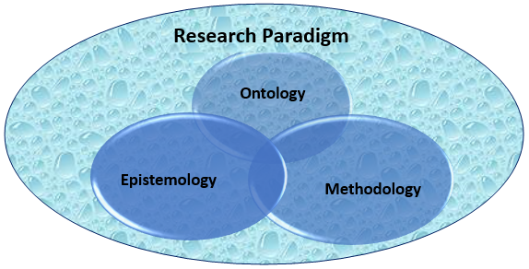
Figure 4. 3: “Attributes of Research Paradigm” adapted from Mack (2010).

4.2.1.1 Ontology
Guba (1990) introduced the sentence, “What is reality?”. This was later used by de Gialdino (2009) for explaining ontology by stating that it is a reality. Interestingly, Mack (2010) argued that owing to distinctive dimensions, there is variation in the reality. To support his argument, he introduced different dimensions of ontology, namely: realism, critical realism and relativism, respectively. On the other hand, Guba (1990) explained that ontological stance determination is likely visible if the laws of nature were comprehended in the right manner because reality varies from person to person (cited from de Gialdino, 2009). For instance, some individuals may view reality as realism, while others may view it as relativism or critical realism (de Gialdino, 2009; Mack, 2010).
According to Mack (2010), a large number of researchers follow relativism’s ontological stance, particularly for explaining social reality through individual interpretations. Conversely, de Gialdino (2009) stated that critical realism and realism ontological stance could explain social realities and, thus, determination of the context is significantly important. Interestingly, MacKenzie and Knipe (2006) and Mack (2010) argued that relativist ontology is often used for exploring the relationship between variables and reflecting social realities, while critical realism ontology explores social reality with numerical expression to show the relationship. Since, in this study, a relationship between variables of interest are assessed and evaluated in order to understand the existing social reality in contrasting economies and numerical expressions are used to measure the relationship, the ontological stance here is, therefore, “critical realism”.

4.2.1.2 Epistemology
Guba (1990) explained epistemology, “it is discovering knowledge-relationship in a pattern as an individual perceives it” (P. 33). Additionally, de Gialdino (2009) explained epistemology as a sub-categorization of philosophy, interlinked with exploring perceived knowledge. On the other hand, Bryman (2003) argued that perceiving the reality of knowledge is the main aspect of epistemology. Moreover, Mack (2010) argued that understanding and explaining the reality of knowledge is not simple and straightforward because only viewing it will not convey an actual sense of perceived reality. Furthermore, Bryman (2003) proposed a notion of internal mode versus external mode for viewing and exploring a knowledge relationship in an actual and perceived manner. Thus, an explanation and determination of epistemology objectively and subjectively is a pattern for understanding and exploring a knowledge relationship’s perceived reality. This also reflects that a knowledge relationship is explored by a researcher through being an insider or outsider. In other words, Guba (1990) and Bryman (2003) argued that the relationship of knowledge is investigated by the researcher through either an objectivist epistemological stance (investigating in direct mode) or a subjectivist ontological stance (investigating in indirect mode).
From the above argument, it is clear that, in the research process, when interaction takes place between researchers and subjects, the determination of an epistemological stance becomes significantly more important, while keeping ontological assumptions. Therefore, with the ontological assumption “laws of nature” for enhancing knowledge, the approach of a research investigation becomes largely objective owing to the mapping of the social context for constructing positivist science. Nevertheless, researchers attempting to enhance knowledge, while considering individual’s interpretations and perceptions, indicate a consideration of the contextual field of information with an ontological assumption that reality is a social construction. This demonstrates a subjective epistemological stance taken into consideration during the process of research. Hence, in the appropriate selection of epistemology, an important requirement is to have a comprehensive understanding of the concept of epistemology. This study uses objective epistemology after establishing a critical realism ontological stance. Additionally, through a positivist approach, the information gained from subjects in an objective manner, in order to determine the relationship between variables of interest in a numeric form, is an attempt made in this study. Moreover, the present study considers experiences, perceptions and opinions of subjects for attainment of true knowledge. Therefore, various distinctive organisational attributes, examined in this study as a part of a process to understand, might play a role or affect, to some extent, the organisational commitment of teaching and non-teaching (administrative) staff of the universities. This also reflects that the apparent interpretation of true knowledge of variables of interest varies from person to person, because of a subject’s view of reality and perceived reality.
In addition to that, an objectivist epistemological stance is evident through the adoption of combined methods, both qualitative and quantitative. The body of knowledge enhanced by gaining a qualitative perspective (in-depth exploration of a research phenomenon) and quantitative aspect (numerical significance), to a large extent, reflects objectivism in the present study. Moreover, using both an inductive and deductive approach for the extraction of knowledge from the subjects in a direct manner, reflects objectivist approach. Furthermore, Mack (2010) argued that the main feature of an objectivist epistemological stance is exploring earlier literature for constructing a linkage between variables resulting from the assumption that a relationship exists between them. However, there is no definite answer about the relationship existing across the world is alike because there is a large tendency that it may vary from region to region (ibid). Thus, a comparative analysis is considered in this study to effectively measure the relationship’s strength in distinctive types of economies. Furthermore, the objective epistemological stance is evident in the present study as it takes into consideration the various interlinked aspects, such as: personal stressors, personal resources, the role of professional occupational therapists, perceived job satisfaction and social support programmes existing in the education sector of developed and developing countries (for further details, See Appendix F).

4.2.1.3 Methodology
The methodology here represents the third most important attribute of a research paradigm. Interestingly, there is no agreed definition, as various authors defined it according to their own understanding (Easterby-Smith et al., 2015). Methodology is defined as the “tools and techniques of different types combined and used by researchers for investigating, examining and exploring variables in distinctive organisational settings” (ibid). Conversely, Sekaran and Bougie (2012) argued that approaches undertaken for commencing research are a vital aspect for determining research methods. To support their argument, the authors state that the adoption of an inductive approach or deductive approach for attaining conclusion requires different types of methodologies (Sekaran and Bougie, 2012). On the other hand, Creswell (2013) explained that a major categorization of the undertaken approach, such as a qualitative perspective and a quantitative perspective determines the adopted methodology. Interestingly, idiographic and nomothetic are the two main types of research approaches which determine a methodology (Brown, 2010).
The earlier discussion showed that “positivist” is the main research paradigm in this study, resulting from positivist realism philosophy. Additionally, the pragmatic approach undertaken in this study reflects the aim to attain quantitative, as well as qualitative, aspects using both an inductive and deductive approach. Furthermore, a numerical expression attained through quantitative methods and, therefore, a semi-structured, matrix-based LIKERT scale is used in this study. On the other hand, an in-depth exploration of the research phenomenon through semi-structured interviews, to ensure qualitative aspects, is attained. Therefore, throughout this study, an objective stance is maintained by following a pragmatic approach for the attainment of both qualitative and quantitative perspectives. From a narrow perspective, this study uses a hypothetico-deductive-inductive approach to measure the relationship between research variables. Thus, this study follows a “pragmatic or mixed methodology”. The main component of this methodology is constructed by maintaining an objectivist epistemological stance, while following a critical realistic ontology to advance by considering features of an idiographic and nonomethic approach. This led to the development of a model for this study, a “hypothetico-deductive-inductive” model, for understanding the relationship between research variables in the education sectors of Pakistan and the United Kingdom.
The next step in this chapter is to explain the philosophical stance in the present, study along with the justifications behind the selection.

4.2.3 Research Philosophy
One school of thought treats research philosophy and the research paradigm as one, while the other treats the two as separate domains. This means that some authors use the two terms interchangeably, while others consider them as two distinctive concepts. As the research paradigm has been explored previously, research philosophy now requires an in-depth elaboration. Interestingly, Bandaranayake (2012) explained the distinction between the two terms by stating that a research paradigm is a set of beliefs and patterns, whereas research philosophy is arching aim through development, attainment and nature of knowledge. On the other hand, Easterby-Smith et al., (2006) argued that there is not a huge difference between two terms. Research philosophy reflects the thinking patterns of the researcher and is a significant component of the research paradigm (Easterby-Smith et al., 2006). Nevertheless, the present thesis considers the argument posed by Bandarnayake (2012) and, therefore, treats the two terms as separate entities. The research paradigm defines and determines the research philosophy (Kasi, 2009) (for further details, See Appendix F).

Figure 4. 4: Types of research philosophies (Saunders et al., 2012).

As per Saunders et al., (2012), researchers follow positivist philosophy in order to ensure that research variables are measured through testing hypotheses against existing knowledge. Moreover, with this type of philosophy, the relationship of research variables is measured in a quantitative manner by the researchers following natural laws (Jupp, 2006; Matthews& Ross, 2010). Hence, numerical significance is attained through usage of statistical tools by analysing the relationship by means of a deductive approach. Conversely, interpretivism is a research philosophy undertaken for measuring the relationship between variables of interest through interpretation of an individual’s perspective (Bryman, 2002; May, 2011; Sekaran & Bougie, 2012; Saunders et al., 2012; Creswell, 2013). Thus, with this type of research philosophy, the research phenomenon is explored in a qualitative manner following an inductive approach (for further details, See Appendix F).
Another two types of research philosophies include “realism” and “pragmatism”; these are commonly used in social science research. Interestingly, some authors consider them as the same, while others argue that both have distinctive features (Zwieniecki, 2013). Interestingly, Saunders et al., (2013) argued that although both look similar, to a large extent, because both philosophies combine aspects of positivism and interpretivism. Realism, however, is based on “factual truth”, whereas pragmatism follows the theme of “useful truth” (Saunders et al., 2013; Zwieniecki, 2013). On the other hand, Lipscomb (2011) argued that realism and pragmatism overlap each other and, thus, the theoretical assumption of the two being different is rejected. A realist philosophical stance is common when a researcher operates as an independent individual examining a process with the belief that social realities and scientific attempts could be combined (Brace, 2008; Riemer et al., 2012). Thus, to a greater extent, this philosophical stance resembles positivist philosophy by considering scientific tools to be the correct tools for measuring relationships. However, it does not limit its approach to scientific methods but recommends a follow-up pattern by considering the interpretation of results for gaining qualitative aspects (Matthews& Ross, 2010; Sekaran & Bougie, 2012). Interestingly, pragmatist philosophy also combines positivist and interpretivist philosophy, in order to gain both a qualitative and quantitative perspective. However, the main difference is that realism follows physical existence to define factual truth, while pragmatic philosophy uses useful truth (Saunders et al., 2013; Zwieniecki, 2013).
In other words, imperfections exist when the researcher aims to be too scientific and, therefore, after attaining numerical significance by means of a deductive approach; the researcher can explore the phenomenon further through an inductive approach for the attainment of qualitative aspects. Similarly, the researcher could start with an inductive approach and later follow it up with a deductive approach with a realist and pragmatist philosophical stance (Mathew & Ross; 2010; Sekaran & Bougie, 2012); although realism heavily relies upon truth based on facts and perceiving "reality" in an exact manner, whereas pragmatism follows practical consequences resulting from “useful truth” (Saunders et al., 2013). Neither of these philosophies have a perfect pattern but incorporate a combination of qualitative and quantitative methods used in order to attain deeper understanding of the relationship between variables. Thus, researchers take both positivist and interpretivist philosophies into consideration (for Further details See Appendix F).
After considering a ‘positivist/scientific’ research paradigm, this study follows a pragmatist research philosophy because it deals with human aspects and, therefore, considers the assumption that perceived reality and knowledge prevail in the contrasting countries’ education sectors; there is, thus, a need for examining the relationship in a qualitative manner after attaining numerical significance. In other words, this is social science research and, therefore, rather than extracting “factual truth”, here is an attempt to gain “useful truth” about practical consequences. Moreover, attainment of both a quantitative and qualitative perspective through a pragmatic approach is for exploring a research problem and, thus, using a pragmatic philosophical stance data is gathered through an inductive and deductive approach. The benefit of a pragmatic philosophical stance is that elements of both positivism and interpretivism are included; when one is considered over another, the benefit gained is at the expense of the other. In other words, attaining a qualitative perspective at the expense of a quantitative one, or vice versa, could be limiting, to an extent. Hence, by following pragmatism philosophy researcher is able to attain the aim and objectives through exploring both quantitative and qualitative perspective.
Interpretivist philosophy is effective in exploring qualitative aspects, whereas positivist philosophy is invaluable in attaining a quantitative perspective; however, the research philosophy “pragmatism”, in social science research, uses both a quantitative aspect through a deductive approach and a qualitative perspective via an inductive approach (Denzin & Lincoln, 2003; Hatch & Cunliffe, 2006). Realism is most appropriate when truth is explored through a physical aspect, while pragmatism uses the practical consequences of exploring “useful truth” (Zwieniecki, 2013). Hence, a pragmatic philosophical stance is the most appropriate and is suitable for this study because it enables exploration of the research problem in depth rather than width. The next step is determining an axiological view of the present research.

4.2.4 Axiology
Axiology is considering particular type of philosophy, attributes and aspects as vital determinants in the research process (Hogue, 2011). Furthermore, the outcome of research highly depends upon an individual’s special consideration and value of certain characteristics (Hogue, 2011). For instance, it reflects a researcher’s position, as some features, patterns and aspects are preferred over others during different phases of the research. Furthermore, an axiological view takes place owing to the background affiliation of a researcher that drives them to explore research variables through the adoption of certain patterns and preference of certain features of interest in a specific context. Interestingly, investigating variables in a particular type of setting is a personal choice because the researcher often belongs or have had working experience in a type of economy, which drives them to investigate phenomenon there. In the present research context, the axiological view could be explained by the example of the researcher having a working affiliation with the education sector in Pakistan and the UK as well as interest, which developed higher preference for examining the variables of interest there. In other words, the preference results from an interest in and value of these two countries’ education sectors. Moreover, the working experience and cultural awareness of these economies’ education sectors have played their part in forming an axiological stance. In other words, personal experience and familiarity with the existing culture of the education sector has played a vital role in selecting these two contrasting economies’ education sectors for investigating the research variables (for further details, See Appendix F).
In the present thesis, axiological stance is visible by giving preference to certain aspects over others. For instance, the inclusion of literature from the last five decades rather than back dates, preferences of cross-sectional research design over longitudinal design and consideration of studies from different sectors exploring the relationship between occupational stress and organisational commitment. Additionally, the preference of one education sector over others, the preference of comparative analysis over a single case study, the inclusion of the role of the professional occupational therapist and the preference of a pragmatic method over qualitative or quantitative methods reflects the axiological view. Moreover, in this study, special preference is given to “meta-analysis”, as both quantitative and qualitative studies are included to explore the research variables in a systematic manner. In addition to that, exploratory and explanatory studies are preferred over descriptive studies and are included in the literature to form a conceptual and theoretical framework as part of axiological stance.
Furthermore, the inclusion of the causes and consequences of stress, the role of the professional occupational therapist, personal resources, perceived job stress and job role are distinctive features used to examine the relationship between occupational stress and the organisational commitment of teaching and non-teaching employees in the education sector of Pakistan and the UK, and reflect valuing these attributes. They are included for the attainment of knowledge in a comparative manner. In addition to that, the inclusion of a deductive-inductive approach, a critical realism ontological stance, an objectivist epistemological stance, pragmatist philosophy and a scientific research paradigm also reflect the axiological stance by preferring and valuing them over other choices. Moreover, the axiological view of comparing two contrasting economies over a specific type of economy is in order to gain superior knowledge by having global comparative knowledge rather than region-specific knowledge. This also increases the generalization of findings, to a certain extent, as it contributes to comparative literature.

4.2.5 Research Type
Various authors have classified research into different types of categories. Sekaran and Bougie (2012) classified research into two types, namely: basic and applied research. In a broader perspective, these are two main types where basic research is for further expansion of the existing body of knowledge, while applied research is to enhance understanding of a unique research problem that has never been explored before (ibid). Nevertheless, Bryman (2012) argued that theoretical research and practical research are types of research. On the other hand, Brace (2008) categorized research into three distinctive types, namely: quantitative research, qualitative research and pragmatic (mixed) research. Thus, different authors have termed and categorized research differently. The important theme of basic research is expanding existing knowledge and, therefore, research is based on an existing research problem, whereas applied research is for investigating a unique problem (a problem never experienced before). A situation is unfamiliar and the research undertaken, in due course, is to understand a research problem. Hence, the present study is basic research because it is an attempt to enhance the existing body of knowledge of a research phenomenon. Additionally, a practical dimension is taken in the present study by investigating the research phenomenon in a practical sense and, hence, it is practical research. Furthermore, the study does not aim to propose a new theory but considers an existing theory and tests it in practical settings. Moreover, this is pragmatic research as it uses both quantitative and qualitative methods for exploring the research phenomenon.
Practical Research
Pragmatic Perspective
Basic Research
Figure 4. 5: Self-constructed thesis research type.

The present study falls under Sekaran and Bougie’s (2012) categorized “basic research” because it follows a pragmatist philosophy and pragmatic approach within the positivist paradigm for enhancing existing knowledge of the relationship between occupational stress and organisational commitment in the education sectors of Pakistan and the UK. Hence, this study is an expansion of existing knowledge. Furthermore, this study is practical research within basic research because it is an attempt to test existing theories in a practical setting. Additionally, this study is pragmatic research within a practical setting because the research phenomenon is explored in both quantitative and qualitative dimensions. According to May (2011), practical research within the social sciences examines, assesses and evaluates human aspects in a qualitative manner while quantifying it. Social science research increases the confidence of the researcher when there is numeric expression (ibid). Hence, both a qualitative and quantitative perspective is essential in social science research and, therefore, this study is pragmatic research because it undertakes both.

4.2.6 Research Approach
Inductive and deductive are two types of research approaches driven by specific types of research philosophies (Saunders et al., 2007). The facts and figures induced and gathered in research follow an inductive approach for developing a theory, while an attempt to reach a specific conclusion by deducing both irrelevant and required facts and information for testing a theory, reflects a deductive approach (Sekaran & Bougie, 2010). Additionally, a deductive approach is used for testing hypotheses, whereas testing hypotheses is not a major aspect of an inductive approach (Sekaran & Bougie, 2012). Thus, the arguments above suggest that these two approaches are contrasting in nature. One continues by deducing data, while the other continues by inducing the data to reach a conclusion. In other words, the researcher continues deducing the high volume of information at hand, in order to reach to a stage where a particular theory or hypotheses is generated; this reflects a deductive approach. On the other hand, starting from a single point, the researcher continues to include and collect information to explore the research phenomenon in depth in order to develop a new theory; this reflects an inductive approach. Additionally, Robson (1993) explained the difference between an inductive and deductive as follows: hypotheses development is a significant feature in a deductive approach, while it is not mandatory in an inductive approach.
In the present research, Sekaran and Bougie’s (2012) proposed “hypothetico-deductive-inductive” model is used, starting with a deductive approach, followed by an inductive approach to analyse the primary findings. Hence, quantitative method is used first to test the hypotheses so that numerical significance is attained; this is later followed by an inductive approach in order to attain a qualitative perspective by exploring the research phenomenon via human interpretations. This model suits the present study, as it enables in attaining research aim by exploring the research phenomenon in both a qualitative and quantitative manner, so that the variations of the research variables are investigated in the two distinctive economies. Hence, Sekaran and Bougie (2012) proposed the model undertaken in this study by following a systematic pattern in order to collect and analyse data via a methodological framework. Additionally, it is suitable because the research phenomenon can be explored in detail to attain a qualitative aspect, while quantitative perspective attained through gaining numerical significance. In addition to that, the present study undertakes an objectivist epistemology and, therefore, direct contact with the subjects is made in an attempt to gain numerical significance; however, this alone is not sufficient and so the experiences, views and ideas of human interpreted in order to gain a qualitative aspect. This helps in accomplishing the aim of the study in more depth because both qualitative and quantitative aspects are equally important. Hence, through this model the inductive and deductive approaches combined are effective in attaining the research aim because these suits the nature of the research.

4.3 Methodology
This section contains the methodology and all of the related important elements, along with justification for the choices. The key aspects in this section include: the research design, research process, research instruments, sample size, sampling technique, pilot study, data collection process, reliability, validity, credibility, ethical consideration and research limitations.

4.3.1 Research Design
According to Sekaran and Bougie (2012), the research design plays a significantly important role in articulating the process of data collection. On the other hand, Creswell (2013) argued that it enables researchers to collect data within a specific time duration. Nevertheless, it is a structure followed by researchers in order to gather data within a particular timeframe and, thus, it is effective in determining the types of tools and techniques for extraction of facts and findings from reliable sources (Sekaran & Bougie, 2007). However, there is no restriction of the selection of techniques and tools used for data collection, within a specific type of research design, in the social sciences. Thus, it is significant to justify the selection made regarding research design and answer why one is preferred to others. Before that, however, it is vital to provide an insight to the types of research design often used in social science research.
In social science research, a large number of studies follow a cross-sectional research design because it is widely used for collecting data, only once, from the participants (Kendra, 2015). Furthermore, observation of the variables is a common element in cross-sectional research design (ibid). On the other hand, Moser (2015) argued that during the research collection process, the subjects are observed or studied only once by gaining information from them about cause-and-effect relationship. In other words, once information is taken from the respondent, there is no second attempt to collect information again from the same respondent; this is a key feature of cross-sectional design, whereas in longitudinal research design, one respondent participates twice in a study at different time intervals (Sekaran & Bougie, 2010). However, McBurney and White (2010) argued that features of both longitudinal and cross-sectional research design combine within cross-sequential research design. Interestingly, the benefit of using a cross-sequential research design is that it facilitates researchers in finishing within a defined timeframe without compromising on sacrificing key aspects (McBurney & White, 2010). Sekaran and Bougie (2012) proposed an argument that any study’s data collection process that goes beyond one year is a longitudinal study, while any study finishing within one year is a cross-sectional study. Moreover, respondents and events studied more than once at different intervals of time is longitudinal, while respondents and events studied only once is said to be cross-sectional study. In other words, repetition of the same sample is common feature of a longitudinal study, while a cross-sectional study has no repetition. Furthermore, the comparison of groups or participants at one point-of-time is also a prominent feature of a cross-sectional study (ibid). Haque, et al., (2018) and Haque et al., (2017) adapted a cross-sectional research design to measure variation within the sub-groups.
After detailed analysis, this study undertakes a cross-sectional research design because sample respondents are studied only once in a given time interval. Additionally, the present study forms groups and compares them, such as a developed versus a developing economy, teaching versus non-teaching and males versus females. Hence, the stance of Haque et al., (2018) and Haque et al., (2017) is adopted by considering cross-sectional design to investigate variations within sub-groups. Moreover, within a one-year timeframe, the study aims to investigate the causal-effect relationship between occupational stress and organisational commitment. The objective of the study is to find variation between the gender, faculty and economies of interest rather than variation taking place in a different time zone. Thus, a cross-sectional design is suitable because it serves the purpose of the study. Additionally, the considered research paradigm, the philosophical stance, research approach and methodological stance support this study’s completion within the allotted timeframe and, hence, it is preferred over a longitudinal and cross-sequential research design.

4.3.2 Research Process
The research process starts with the identification of the research problem and continues until the results are attained (Walliman, 2001). Samuels (2004) defined it as set of well-established activities undertaken for accomplishing research outcomes. Nevertheless, Sekaran and Bougie (2012) provide a comprehensive definition by stating that it is a process beginning with identification of the research problem, followed by development of the objectives and aim in order to provide answers to the unknown phenomenon. This process continues in a systematic pattern until the final research outcome is achieved. Hence, it reflects that with the extraction of a relevant literature leads to construction of research objectives, and the process continues until answers are achieved for the research questions. Moreover, the research takes adequate direction, owing to the development of the theoretical framework and adoption of particular research methods (Walliman, 2001). The selection of correct type of research instruments and methods, and valid literature, provide an appropriate platform for drawing conclusions by comparing the gathered data with the available literature. Hence, the entire research process is a significant aspect of the research. Bryman (2012) states that transparency of research is an essential consideration throughout the research phase in order to ensure that attainment of the research aim takes place in an adequate manner. Nevertheless, Walliman (2001) argued there are no definite research process steps but that often the process cycle begins with stating the situation (research problem) and is completed with reaching the conclusion. In the present thesis, Walliman’s (2001) proposed research process is used.
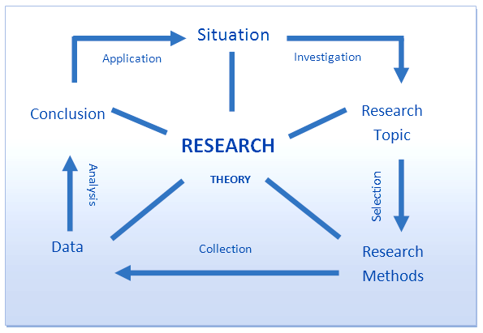
Figure 4. 6: Research process (Walliman, 2001).

The figure above explains the process of research undertaken in this study. At an early stage, the “situation” research problem stated: Is varying occupational stress affecting the organisational commitment of teaching and non-teaching staff at universities in Pakistan and the UK in a similar manner?? In order to develop the conceptual and theoretical framework to both assess and evaluate the relationship between variables of interest, an attempt is made to examine the relationship between occupational stress and organisational commitment in the education sectors of the contrasting economies. Furthermore, after explaining the situation, the above-mentioned relationship is a theme formed under “topic”. The topic is the abstract form of the research question. After this step, an in-depth analysis is performed in order to understand the theoretical and empirical forms of the research variables. An axiological stance is maintained during the extraction of the literature review by preferring a particular type of literature for the conceptual and theoretical framework’s development; this is followed by assessing and examining the relationship between variables of interest by explaining the research methodology. Moreover, the determination of a specific research paradigm and philosophical stance is part of the research process and provides an accurate dimension for the present research. The selection of the research design and research instruments results from keeping a specific axiological stance.
In addition to the above, a triangulation approach, including validity, reliability, and credibility) is adopted for ensuring that the research remains free from bias, specifically in relation to the selection of research instruments and participants. After ensuring the validity, reliability, credibility and transferability of instruments, a data gathering stage followed where information was taken from the targeted audience (sample size) in Pakistan and the UK. Additionally, for the purpose of gaining both quantitative and qualitative aspects, a deductive-inductive approach is part of this research process. Lastly, the logical conclusion is drawn from the interpretation and testing of results. This provided research implications for the education sectors of the comparative economies. Hence, by following Walliman’s (2001) steps, the research process for this study is complete.

4.3.3 Research Methods for Data Collection
The nature and approach of the data collection techniques are significant in the methods of data collection (Sekaran & Bougie, 2012). Quantitative, qualitative and pragmatic methods are commonly used data collection techniques in social science research (ibid). Interestingly, experimental and descriptive research often follows quantitative methods because of the nature of this research (Babbie, 2010). Furthermore, experimental patterns and treatment are common in experimental research whereas in descriptive research studies subjects’ measurement take place in descriptive manner due to descriptive nature (Brian et al., 2010). On the other hand, McNabb (2008) argued that that a quantitative descriptive method mainly investigates the relationship between research variables, while causality is the major development of a quantitative experimental study. Moreover, Singh (2007) explained that in quantitative studies, the correlation between research variables with numerical expression is the key feature. Furthermore, Creswell (2013) stated that with quantitative methods, an objective stance along with numerical significance are features for drawing logical conclusions. Additionally, numbers are an important element in determining that relations and focus remain numeric reasoning that does not change in quantitative studies.
However, the biggest drawback of quantitative methods is expressing human aspects in numeric terms (Babbie, 2010). In other words, quantitative methods are an attempt to quantify various human related aspects rather than exploring the relationship in depth to attain a qualitative aspect. Since humans are unpredictable species, there is, therefore, no certainty or confirmation of their behaving similarly in different settings. Additionally, humans are subject to change; their experiences, expressions, ideas and views’ quantification in all cases, cannot be right (ibid). Hence, the above notion indicates that an explanation of the expression of some of the human related attributes, in fractions and numeric cannot explain it adequately. For instance, various human aspects such as experience, knowledge, ideas and perceptions could be understood better in a qualitative manner rather than expressing them through numeric. On the other hand, McNabb (2008) argued that an objective approach undertaken by quantitative studies mainly provides statistical significance to variables through numeric expression that is important for creating a better understanding of variables. Furthermore, Sekaran and Bougie (2010) argued that in social science research, a deductive approach used in quantitative studies is for gaining statistical significance, so that the development of generalization and measurements takes place.
Scientific investigations are not only associated and confined to quantitative studies because a large range of social science disciplines, fields and subjects have used qualitative methods for scientific investigations (Denzin & Lincoln, 2000). Additionally, Malterud (2001) explained the importance of qualitative methods in social disciplines by stating that the exploration of the perspective of the participants in a dynamic environment is effective through qualitative methods, as it enables researchers to create in-depth understanding of the operating variables in a complex social process. Various researchers confirmed that qualitative methods are useful in exploring and examining the values and beliefs of human behaviour by providing deeper insight; this works as a motivator for researchers to opt for qualitative methods in research (Inui, 1996; Berkwits & Inui, 1998; Bradley et al., 2006). In addition to that, a large number of researchers supported the use of an inductive-approach in qualitative studies by focusing on observations leading to the development of hypotheses (Glaser & Strauss, 1967; Pope & May, 1995; Soafer, 1999; Crabtree & Miller, 1999; Patton, 2002; Soafer & Firminger, 2005; Creswell & Piano, 2007; Sekaran & Bougie, 2012; Creswell, 2013). On the other hand, quantitative methods have a deductive approach in order to have hypotheses leading to observation (Glaser & Strauss, 1967; Pope & May, 1995; Crabtree & Miller, 1999; Patton, 2002; Creswell & Piano, 2007; Sekaran & Bougie, 2012; Creswell, 2013).
There is a significant difference between qualitative and quantitative methods, considering the various dimensions. Nevertheless, numerical significance and fractional representation are major, prominent, differential features that separate quantitative methods from qualitative methods (Sekaran & Bougie, 2012). On the other hand, the breadth, range and complexity of phenomena remain the focus of qualitative methods (ibid). The use of statistical tools for testing hypotheses is an essential feature of quantitative methods, while qualitative methods use non-fractional expressions to observe the occurrence and development of hypotheses (ibid). The advantages of one method are the disadvantages of others and, hence, there is a wide range of research that combines both qualitative and quantitative methods, which are referred to as mixed (pragmatic) methods.
“Mixed (pragmatic) methods strengthen the approach of research by combining the best elements of quantitative methods and qualitative methods. Hence, pragmatic methods enable researchers in the process of exploring research variables in both dimensions rather than moving in one dimension” (Jick, 1967; Creswell, 2003; Curry et al., 2006; Sekaran & Bougie, 2012). Moreover, the gaining of a deeper insight, along with the numerical significance of the research phenomenon in pragmatic methods because it offers a comprehensive data collection (Morgan, 2006; Creswell & Piano, 2007; Creswell, 2014). Conversely, the researcher’s axiological stance plays a significant role in the selection of pragmatic (mixed) methods and, because of it, the determination of the consequences of research take place accordingly (Morgan, 2006). However, it depends on the researcher’s preference within the pragmatic approach which method is used (qualitative or quantitative) more or less in research process (Morgan, 2006; Creswell & Piano, 2007). In other words, the drift towards either approach (qualitative or quantitative) depends on researchers while using mixed methods.
Creswell (2013) argued that in the data collection process, researchers must ensure a right balance is kept between quantitative and qualitative methods. On the other hand, Sekaran and Bougie (2012) argued that often researchers use mixed methods by starting with a qualitative approach at the preliminary stage, observation leading into development of hypotheses and later follow this with a quantitative approach. Additionally, same authors have also argued that researchers sometimes start with a quantitative approach but find inconsistency in the results which leads to in-depth observation and, therefore, conduct interviews in order to gain a qualitative perspective. Hence, mixed methods have a flexible style where the researcher may start with one approach but follow it with another. Morse et al., (2006) explained that within a mixed methodology, perhaps researchers, in relation to addressing any type of aspect, can state any methodological assumption and undertake a complementary strategy for supporting the findings at hand. Additionally, the benefit of using pragmatic (mixed) methods in research is that such type of method is open to all types of situation for using any type of approach in addressing and answering the research question by exempting the idea of sacrificing one particular method at the expense of others (Jick, 1967; Creswell & Piano, 2006).
The present thesis requires both numerical significance and in-depth exploration of research variables; hence pragmatic (mixed) methods are an appropriate choice for the data collection and for understanding the relationship between occupational stress and organisational commitment. Without sacrificing either qualitative methods or quantitative methods, here both are combined to investigate the research variables. This gives flexibility in opting for the appropriate approach to the situation at hand. In other words, it keeps the options and dimensions wide and open for the research in the data collection process. As earlier mentioned, this study follows a hypothetico-deductive-inductive model and, thus, the research starts with quantitative methods and is followed by qualitative methods. The survey questionnaire circulation is part of the quantitative approach and is performed in order to gather data for the statistical test, so that quantification of the data offers numerical significance. Following this with in-depth interviews, however, reflects the qualitative methods for gaining qualitative aspects regarding research variables. This, therefore, reflects pragmatic methods for data collection. Moreover, this data collection method is effective in attaining the research outcome, while following the earlier defined philosophical stance and research paradigm.
As a pragmatist philosophical stance is defined in the early stages, a pragmatic (mixed) method is effective for the attainment of both qualitative and quantitative data. Sekaran and Bougie (2007) argued that often the use of a survey questionnaire is for gaining quantitative aspects by a statistical test, while interviews are commonly used for exploring the phenomenon in qualitative ways. In this study, both the “survey questionnaire” and “interviews” are key instruments for the data collection and, thus, reflect the use of pragmatic methods for creating deeper understanding of the expressions, experiences, opinions, views and ideas, while running statistical tests to gain numerical significance. Interestingly, Tashakori and Teddlie (2003) argued that the responses gathered from survey questionnaires are largely quantifiable, while interviews enable gaining non-numeric data. Hence, an attempt is made to investigate the research problem in a pragmatic manner through combining both methods in this study.

4.3.4 Sampling Techniques
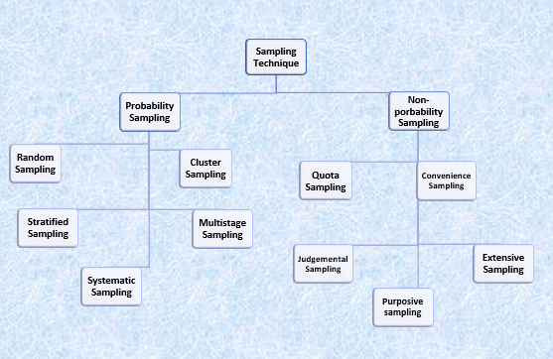

Figure 4. 7: Sampling techniques (Hair et al., 2007).

Before extracting the population and sampling technique, it is significant to enhance understanding of different sampling techniques. Various types of sampling techniques are common in both natural and social science research. In this study, however, Hair et al.’s (2007) identified sampling techniques are considered. Hair et al., (2007) broadly categorized sampling techniques into probability and non-probability. Furthermore, Sekaran and Bougie (2010) explained that the distinction between the two is based on the assumption of equality. The equal chance of selection for all events is a probability-sampling technique, whereas a non-probability sampling technique follows the approach of selecting events on unequal chances (Gingery, 2009). Similarly, Sekaran and Bougie (2012) argued that “events/elements do not have known or predetermined chances of selection in non-probability sampling, whereas probability sampling considers events/elements that have some known chances of selection as a sample” (p. 286). In addition to that, Sekaran and Bougie (2012) explained that probability sampling is effective when researchers are looking for wider generalization, whereas non-probability sampling is useful when time and other factors become more critical than generalization.
Different sampling strategies (probability and non-probability) are designs undertaken by researchers and selection depends on the desire for generalization, purpose of the research, and demands of time and other interlinked resources (Sekaran & Bougie, 2012).“Quota sampling, convenience sampling, extensive sampling and judgemental (purposive) sampling are types of non-probability sampling techniques as there are unequal chances for selection of events, while stratified sampling, systematic sampling, random sampling, multistage sampling and cluster sampling techniques fall into probability sampling techniques because all events have an equal chance for selection in the study” (Hair et al., 2007). Interestingly, Sekaran and Bougie (2012) has further categorized types of stratified sampling techniques into proportionate and disproportionate sampling technique. Furthermore, within cluster sampling, a technique considering specific locality or area is known as “area sampling” (Sekaran & Bougie, 2012). Thus, before considering and justifying the types of sampling techniques in this study, it is significant to provide a brief overview of all types of sampling techniques. Both probability and non-probability sampling techniques have certain advantages and limitations. As per Sekaran and Bougie (2012), the biggest advantage of using probability sampling is that it offers a higher level of accuracy in selection, thus reducing response bias, but it is relatively expensive and difficult to use without having complete information about the sample frame. On other hand, non-probability is cost-effective but arguably vulnerable to bias unless adequate means and strategies are developed during selection of the sample size (Sekaran & Bougie, 2012).
Stratified (probability) sampling enables researchers to estimate the parameters of the population by sub-grouping it (Hair et al., 2007; Haque, 2007; Sekaran & Bougie, 2012). Additionally, Sekaran and Bougie (2012) explained that stratified sampling follows the pattern of sub dividing the population into strata (mutually exclusive groups), such as gender (male and female), education (high school, college, university), management layer (top, middle and lower level of management), and so on. Similarly, the strata of teaching and non-teaching staff are a sub-group of the targeted population (university education sector). Moreover, Haque (2007) argued that proportionate and disproportionate are two types of stratified sampling techniques (Haque, 2007; Hair et al., 2007; Sekaran & Bougie, 2012).
Haque (2007) defined proportionate sampling as, “the known attributes are a main factor for considering the proportion drawn for the sample by viewing the homogeneity among the sub-population of each stratum” (P. 02). Hence, it indicates the reduction of sampling error as a major advantage when opting for a proportionate stratified sampling technique by determining the sample size through required attributes. Conversely, disproportionate sampling intakes equal consideration but each unit or strata is not significantly important in the determination and selection process of events (Haque, 2007). Therefore, in this type of technique alone, homogeneity is not the major criterion (Proctor, 2003; Haque, 2007). Nevertheless, Haque (2007) argued that homogeneity not being only criteria is advantageous but it gives rise to the possibility of preference being given to a particular type of stratum which could lead to the generation of bias in results.
Sekaran and Bougie (2012) explained cluster sampling as a technique for use in selecting the chunk of elements or groups within the population through heterogeneity. It is opposite to systematic and random sampling because it considers intergroup homogeneity forming a cluster of heterogeneous interest. On the other hand, Haque (2007) explains it as, “taking the group of elements, rather than considering individual elements, as the sample unit is a method regarded as a cluster probability sampling technique” (P. 03). Moreover, it is a cost-effective sampling technique but there is a possibility of a lower precession level (ibid). Conversely, Agresti and Finlay (2008) argued that instead of opting for cluster sampling techniques, the researcher should, at times, use multistage sampling, especially when there is smaller sample size. Nevertheless, it is more complex in contrast to cluster sampling (Agresti & Finlay, 2008). Additionally, it follows a random basis pattern where the focus remains on considering distinctive stages to study the cluster rather than specific attributes of the cluster (ibid). Although, it is complex, it offers a deeper insight to investigate the research problem by studying the same sample at different stages (ibid).
According to Sekaran and Bougie (2012), geographical clusters are area sampling used by researchers when particular geographic features, such as blocks, cities, counties or other localities serve as a boundary for selection of respondents. Hence, it reflects the formation of a cluster within a particular area (ibid). The location for selecting specific types of organisations having similar features could be a sample for the study to measure how they behave and operate in a certain locality. Interestingly, it is a relatively less expensive probability sampling technique and does not force the researcher to depend on a sample frame population. The other types of probability sampling techniques include: simple random sampling and systematic sampling techniques (for further details, See Appendix F).
After evaluating the probability sampling technique, a researcher explores non-probability sampling techniques by looking into their advantages and disadvantages. According to Sekaran and Bougie (2012), some of the non-probability sampling techniques are more dependable than others and, hence, provide valuable information about a population. Hence, it is essential to extract types of non-probability sampling techniques. Purposive, convenience, snowball and judgemental sampling are types of non-probability sampling techniques (ibid). Convenience sampling is most widely used in research. It is the easiest way to select participants and is a cost-effective technique because it saves time, money and energy (ibid). Additionally, in convenience sampling, the convenience of participants is an essential aspect (Hair et al., 2007; Sekaran & Bougie, 2012). It requires the respondents to be the representatives of the population based on their own convenience especially when the population is too big, and it is significantly difficult to include all representatives (Sekaran & Bougie, 2012). Interestingly, it is the quickest and most inexpensive technique for reaching a targeted audience in a short timeframe (ibid). However, the major drawback of this technique is that findings gathered do not offer higher generalization (ibid).
Quota sampling is another non-probability sampling technique used in research where particular events form a quota (Brown, 2006; Sekaran & Bougie, 2012). Interestingly, Sekaran and Bougie (2012) explained that gender, age, education and so on are some of the attributes for the formation of a quota. Once, the attributes are finalized, a specific percentage is taken from the group forming the quota (ibid). The key aspect that differentiates a quota from stratified sampling is the criterion of equal chances for selection (Haque, 2007). Stratified sampling intakes equal chances whereas a quota considers a certain decided percentage of the group to be representative of the sample.
Often snowball sampling is also referred to as referral sampling, chain sampling or chain-referral sampling (Morgan, 2008). “It is a technique of having small pool informants at the initial stage nominating, directing or referring to the next participant. Through a social network or connections, participants are targeted who meet the criterion of eligibility and contribute towards the purpose of the study. Since, it gradually increases with the rolling of downhill therefore regarded as snowball sampling technique” (Morgan, 2008). Snowball sampling is effective in identifying and reaching hidden populations (Atkinson & Flint, 2004; Morgan, 2008). Additionally, it does not require complex planning and can be used in both complementary and alternative research methodologies (Atkinson & Flint, 2004; Morgan, 2008). However, the drawback is that it is impossible to find the total size of a whole population (Cohen & Ariel, 2011). Furthermore, community biases can occur, as the first participant will have a significant impact upon the determination of events of the sample size (Voicu, 2011). Hence, one incorrect choice or inexact selection can lead to inaccurate results.
Similar to convenience sampling is another technique, “self-selection sampling”, where participants are selected on volunteer participation in the study through informing them about the purpose of the research (Colman, 2014). Often self-selection sampling is referred to as purposive sampling (Colman, 2014). Interestingly, in convenience sampling, the researcher has to approach the participants personally, whereas in self-selection, the researcher conveys the purpose of the research to a group asking them for voluntary participation as per their own accord and ease (ibid). Nevertheless, this type of sampling is open to self-selection bias and errors. There is a large possibility that people who are not required may also participate in the research (Colman, 2014). Moreover, people who do not have knowledge of the nature of the variables, if they participate in the research, may have little to contribute (ibid). In contrast to purposive sampling, snowball sampling is more effective, as it helps the researcher in reaching out to knowledgeable people from the specific field through referrals and connections (Colman, 2014). Interestingly, the combination of purposive and snowball sampling could be effective because by using purposive sampling, particular identified experts can be approached whereas snowball sampling could help in inclusion of knowledgeable respondents in this study.
Judgemental sampling is another type of purposive sampling (Sekaran & Bougie, 2012). It takes in particular attributes of the respondents that might serve the purpose of the study and, therefore, selection of the respondents is highly based on the judgement, knowledge, skills, and abilities of the researcher (ibid). Interestingly, the experiences, skills, opinions and knowledge of the participants play a vital role in the identification of the respondents, as these prominent attributes serve the purpose of the research; hence it is an essential aspect of purposive sampling (Bajbai, 2008). Those events viewed and perceived as significant by the researcher are included in purposive, as well as judgemental sampling. Nevertheless, both purposive and judgemental sampling have a higher risk of sampling error (Sekaran & Bougie, 2010). According to Wijnhoven, Ehrenhard & Kuhn (2015), purposive sampling is often open to bias and compromise with regard to research validity. Nevertheless, it can be adopted for data collection in inferential statistics through ensuring appropriate safeguarding against bias (de Munnik, Dupuis, and Illing, 2009; Wijnhoven et al., 2015; Haque et al., 2018). In addition to that, convenient and purposive sampling methods are used for data collection when probability sampling alone would be an impractical, as well as a costly procedure because of the limited access to informants, lower response rates or other factors complicating randomisation (Wijnhoven et al., 2015; Haque et al., 2018). Often, fair representation of the respondents in stratified groups minimises bias (Haque et al., 2018). The other type of non-probability sampling technique is extensive sampling, (for further details, See Appendix F).
After detailed analysis of the various types of sampling techniques, their determination is explained in this section of the present study. In this research, both probability and non-probability sampling techniques are combined for selection of the respondents and extraction of information from these participants. From the probability sampling technique, stratified sampling is used by forming strata from categorizing and determining the strata of types of economies; (Pakistan is a developing economy, whereas the UK is a developed economy. In addition to that, strata formed by considering gender (Male and Female) and faculty (teaching and non-teaching (administrative) staff) are developed by using the proportionate, stratified sampling method. Moreover, an element of area cluster sampling is also used in this study for the selection of the educational institution. The geographical area is taken into consideration when selecting the educational institutions in Pakistan and the UK. The reason for opting for these above-mentioned sampling techniques is to ensure the risk of sampling errors is significantly reduced and selection is, to some extent, on an equal basis. Moreover, it is not mandatory to know the names of the entire population when adopting an area-cluster sampling technique. Furthermore, a non-probability sampling technique is used in this study and includes: convenience, snowball, purposive and quota sampling techniques following the theme and argument of Haque et al., (2018), while ensuring that biases are minimized through fair representation of the respondents in major groups.
In this study, the introduction of a snowball sampling technique, in the early stage, is to ensure that knowledgeable participants (hidden population) are included. By approaching one knowledgeable contact at the targeted institutions, such as HR departments, a Registrar, an Operations Head, a Vice Chancellor or a Dean, the researcher has used the snowball sampling technique to develop a chain of referrals to reach a hidden population through these points-of-contact (gatekeepers). In other words, these gatekeepers served as a point-of-contact for the introduction and referral to another knowledgeable contact, out of the direct reach of the researcher. Additionally, purposive sampling was taken into account by contacting administration, gatekeepers and the HR departments by informing them of the purpose of the study and seeking their formal consent and help in the data collection process. The formal email to them contained a brief overview of the purpose of the research, the total time for completion of survey and interview sessions, a choice of leaving if the participant felt the need to opt out and information about the research instruments.
The voluntary participation, with no monetary reward, explained its essential feature - the purposive sampling approach. Moreover, the formation of quotas, by looking at the percentage from all types of the targeted sub-groups, is a quota-sampling technique and is used in this study for reaching targeted participants by ensuring an equal percentage of the respondents in major groups. Additionally, a snowball-sampling technique is effective because it enabled the researcher to reach knowledgeable participants through referral and a networking technique for interviews. In addition to that, the use of convenient sampling was to ensure that participants could participate at their own convenience. The above-mentioned techniques are effective in gaining responses, while keeping to time and taking other resources into account. The consideration of different types of sampling techniques enabled the researcher to reduce sampling error, increase higher generalizability and accomplish the purpose of the research through drawing logical conclusions in a cost-effective manner. In addition to ensuring the reduction of selection biases, the researcher opted for the DeMoivre-Laplace Theorem (DLT) as a strategy. This is an effective measure taken for equal and normal distribution of the data, while using the non-probability sampling technique.

4.3.5 Population and sample size
A better understanding of differentiation between population and sample is effective for justifying the selection of events and elements related to the research problem in this study. According to Sekaran and Bougie (2012), in statistics, a population is an entire set of events, whereas a sample is a subset (representative) of a population. It is difficult, costly practice to study all the events of the population and, therefore, suitable representatives known as the sample size are approached and studied by extracting findings from them so that results can be generalized across the entire population. Additionally, a census is a method of studying all events in the population; however, it is a time consuming and costly process and, therefore, sampling is used by researchers (Hair et al., 2007). Conversely, Haque (2007) stated that the extraction of a significant portion of events from the entire population by researchers is termed as the “sample”, which is a population’s true representative. Nevertheless, sampling in contrast to census is a technique of studying some units for generalizing the findings of an entire population (Hair et al., 2007). Moreover, sampling has an advantage over census in being cost effective, as it saves time, money and energy (Sekaran & Bougie, 2010).
In the current thesis, the universities in Pakistan and the UK formed the population. Additionally, the middle range universities are the sub-categorization in these two countries. Moreover, the researcher specifically targeted the universities offering business and management courses. Interestingly, the researcher only targeted public or semi-private universities in order to narrow down the specific types of the universities or business schools. Furthermore, the official government reports from an authentic website list of universities was undertaken for determining the population and deciding upon the sample size. Thus, an area-clustering sampling technique was used effectively for the selection of these institutes, while keeping intact the theme of business and management schools at universities form sample size. Further, the strata formed in this study for selecting both teaching and non-teaching staff was implemented through gatekeepers by briefing them to ensure that both types of employees were targeted by including all inside the organisation. In addition to that, LeBlanc (2004) argued that the scientific discipline, at times, under general consensus, allowed ±3 “margin of error” only when the researcher had control over the confidence level and sample size. Nevertheless, to a large extent, researchers do not have control over the parameters of population ‘P’ that affects the value of ‘p̂’, and hence the probable estimation of population is likely through the formula of M.E (Margin of Error) M.E= $\frac{z\sqrt{\overset{^}{p}\left(1-\overset{^}{p}\right)}}{n}$(Rumsey, 2002; LeBlanc, 2004; Jamal, 2013). On the other hand, Rumsey (2002) and Jamal (2013) argued that the margin of error in social science research can be up to ±4. Since, this study is related to the social science discipline using a scientific approach, the M.E is thus 0.04 for measuring the sample size with z =1.96 for 95% confidence interval, p̂ = prior judgement of the correct value of p. Thus, the formula for determining the sample size in this study is n=$\frac{z\sqrt{\overset{^}{p}\left(1-\overset{^}{p}\right)}}{M.E}$. Through this formula, the minimum required sample in this study is 384.2 (See Appendix E).
Interestingly, Sekaran and Bougie (2012) argued that the researcher always makes a trade-off between precision and confidence when determining the sample size. Moreover, the researcher should not only look at statistical significance but also consider the practical significance of the sample size. In other words, practical utility should be meaningful rather than simply having statistical significance (ibid). In addition to that, Roscoe (1975), as a rule-of-thumb for determining an appropriate sample size, proposed that any sample size should have more than 30 and less than 500 respondents (cited from Sekaran & Bougie, 2012). Additionally, sub-sample groups, such as female/males, teaching/non-teaching, and so on, should have a minimum of 30 from each category and a sample size of preferably 10 or more times higher, considering the number of variables in the research (Roscoe, 1975 cited from Sekaran & Bougie, 2012). Hence, using the formula and the above arguments, the researcher found that 384 or above respondents are significant for drawing logical conclusions. Interestingly, in the present study, the researcher received 408 completed survey questionnaires. Moreover, by using purposive and quota sampling, it was ensured that the representation of the respondents in major groups remained equal.
Similarly, in the interviews, 98 participated (49 each in terms of economy, gender and faculty). Additionally, the “saturation-point” was attained in the research after reaching 98 participants. According to Morse et al., (2006), the sample size of 30 or above is sufficient in reaching the point-of saturation (cited from Haque et al., 2018). On the other hand, Creswell (2013) stated that in a comparative analysis, 30-50 interviews are sufficient for reaching saturation point. Since, this is a comparative analysis and the sample is not only equal in terms of the major groups but also higher than the suggested benchmark of Creswell (2013), it is, thus, an acceptable sample size. The sample size could have been improved further by increasing the number of participants to 50 for each group, giving a total of 100 respondents. However, the saturation point was attained at 98 and, thus, the responses became repetitive and the addition of two respondents would not have affected the outcome proportion indifferently. Therefore, it was decided that the sample size was sufficient to draw logical conclusions. Hence, in both quantitative and qualitative aspects, the sample size was sufficient for drawing logical conclusions.

4.3.6 Research Instrument
A semi-structured, matrix-based survey questionnaire and semi-structured, open interview questions are two research instruments used in this study. The use of the survey questionnaire is to gain quantitative aspects, whereas in-depth interviews are conducted to gain a qualitative perspective. Thus, distinct instruments enabled the researcher to gain both perspectives. Often the over reliance on one type of instrument limits accessibility to extract and gather different information and, thus, in this study the researcher opted for two distinctive instruments so that the range in the data collection process would remain wider. Nevertheless, the survey questionnaire remained the main instrument, while interviews were a supporting tool for gaining a deeper understanding about the variables of interest. In other words, the quantitative aspects were provided by the questionnaire for statistical analysis, while exploration of the research phenomenon was performed via interviews for attaining qualitative aspects.

4.3.6.1 Self-constructed and Online Survey Questionnaire
As mentioned earlier, the main instrument for collection of information, in this study has been the "survey questionnaire". In order to explore the variables of interest, the researcher followed a DAB (demographic, attitudinal, and behavioural) strategy. A matrix-based, semi-structured questionnaire contained multiple choice questions and a rating scale. Interestingly, the LIKERT scale with six-points (Strongly Disagree=1, Disagree=2, 3=Moderately Disagree, 4=Moderately Agree, 5=Agree, 6=Strongly Agree) was used in this questionnaire for variables related to occupational stress and organisational commitment. The researcher intentionally did not keep the option of ‘neutral’, as researcher wanted the participants to state their opinion rather than remaining undecided, which would lead to nullifying the relationship, whereas this study is an attempt to establish the relationship. Nevertheless, some questions had a rating from low to high (0-to-10), specifically for representation of the occupational therapist in the education sector. Through “GOOGLEDOC”, the researcher developed this online survey questionnaire. The survey questionnaire link was forwarded to gatekeepers in targeted universities with a request to share with teaching and non-teaching (administrative) staff. The researcher could have met with the employees in person when circulating the questionnaires but preference was given to online so that no direct contact took place. This was a precautionary measure taken by the researcher, as some respondents might be vulnerable to stress and may have harmed the researcher or themselves; thus, it helped in avoiding such a situation.
Gender, age, education, experience and faculty formed the demographic variables. The researcher ensured that through demographic questions, the respondent’s background could be verified. Hence, it increases the reliability of the findings, if respondents are genuine and knowledgeable. In other words, the researcher checked that the research participants had knowledge regarding the research variables. Attitudinal and behavioural questions followed demographic questions by first checking the rate of representation of professional occupational therapists at Universities in the UK and Pakistan. Additionally, for measuring the degree of the responses, the researcher used questions developed on an ordinal scale. Furthermore, the researcher used bar diagrams for explaining response frequencies in a graphical manner because this is the easiest, simplest and most attractive way. For this purpose, the researcher used the MS Excel 2013 integrated package. The bar diagram preferred over other types of graphs is based on both a rational and personal preference. Since the researcher kept more than six options in some of the demographic variables, the bar diagram was more effective in presenting each separately, whereas a pie chart would have made it congested. Hence, by using a bar diagram, it is easier and simpler for readers to understand and comprehend. In other words, a pie chart would split the options into various portions of items while a bar diagram represents each segment separately.
In order to ensure reliability, validity, credibility and transferability remained intact in this study, the researcher used a triangulation approach. One of the steps included establishing a point-of-contact and selecting a gatekeeper inside the organisations. If the link was shared on any social format, there would have been a chance that people from different segments participated, whereas sharing a link with a gatekeeper and asking them to act on behalf of the researcher was to ensure that there were no biased, manipulated or unknowledgeable respondents in the survey. This increased the reliability and validity of the sample. Moreover, an online survey questionnaire also provided safety for the respondents in that there was no direct, face-to-face contact with them. Thus, they did not hesitate to share and express their honest responses. Moreover, the gatekeeper sent a link to the email IDs of the targeted audience and, thus, there was no duplication in responses. Furthermore, the researcher also kept a check on settings so that each respondent, when completing the questionnaire could not submit another one from the same ID. In addition, the survey questionnaire description stated that there would be no monetary reward for participation as this was on a voluntary basis. No direct contact was put in place to enhance the confidence of the respondents and their responses remained confidential; the researcher also mentioned the times, details and surety of confidentiality in the description of the survey questionnaire.

4.3.6.2 In-depth face-to-face and SKYPE Interviews
As part of a pragmatic approach, a semi-structured, open-ended interview is another research instrument in this study. The researcher retained more flexibility in commencing interviews with the participants. The points-of-contact (Gatekeepers) were informed of participants’ voluntary participation. Additionally, it was the gatekeepers’ task to arrange interview days and times. The option of participating either via Skype sessions or face-to-face was given to the participants. They had to decide themselves, which was more suitable for their convenience and comfort. In order to ensure those participants selected for interviews had not participated in a survey questionnaire, the researcher used a snowball-sampling technique. Thus, the different approaches used in this study are as follows: firstly, inside the universities, the “point-of-contact” was given the responsibility of circulating the details of voluntary interview participants? and ensuring that those who had already participated in the survey were not included in the interview segment. Moreover, the "gatekeepers" inside the universities emailed the link of the survey questionnaire and informed the participants that either they could complete it or participate in an interview; one could not participate in both. Secondly, the chain-referral formed through the professional network LinkedIn. Immediate contacts worked as ‘gatekeepers’, according to their own wishes, in arranging knowledgeable participants for the interview while interviewed participants referred the new participants forming a chain-referral.
In both face-to-face and Skype interviews, the researcher informed participants about the research purpose, expected time duration, and option to leave the interview at any time if they felt that they wanted to opt out. In addition to that, the researcher assured all participants before the actual interview that all personal details and expressed opinions would remain confidential. The researcher began with general questions, such as age, experience, qualification and faculty. Then warm up questions from the participants were asked, followed by attitudinal and behavioural questions, in order to develop a deeper understanding of the research variables. Since the researcher himself has background experience in the education sector, all professional connections were used in order to reach a knowledgeable, hidden population. The interviews continued for a total of four months (November, 2017 - February, 2018). For LinkedIn, the researcher relied heavily on the snowball-sampling technique because expert connections introduced directly the knowledgeable participants. Additionally, for face-to-face interviews, convenient, quota and area-cluster sampling techniques were combined in the interview process. The researcher kept the option of the respondent’s convenience at the top, while ensuring that the geographic area-cluster was maintained in selection of the universities. Additionally, gatekeepers and point-of-contacts were requested to arrange a fifty-fifty (50%) quota in terms of gender and faculty. The time duration for each interview in this study was 7 to 12 minutes with an average duration 8 minutes and 33 seconds.
The researcher ensured that after every week of interviews there was an in-depth analysis regarding the interview findings. After a total of 98 interviews, findings showed that interviews had reached the “saturation point”. The saturation point reflects that commenced interviews have reached a point where no new information is obtainable and there is a continuous repetition of answers from the respondents. Interestingly, the determination of a saturation point incurs when the range of interviews crosses 30 participants (Morse, 2000). Hence, this reflects that 30 is a sufficient number of interviews to reaching the saturation point. On the other hand, Creswell (2013) argued that, in comparative studies, researchers reach the saturation point at 30-50 interviews.
In the present study, 98 participants took part, which reflects the “saturation point” and that the number of interviews is sufficient to draw logical conclusions from the findings and information at hand. The researcher approached a total of 42 universities but only 14 agreed to participate in this study, reflecting a 33.3% response rate in terms of university participation. The interview findings were put manually into an MS Excel spreadsheet. The researcher ensured that the answers were transferred from paper to excel spreadsheet in a correct manner and, thus, each set of responses was checked twice. For each question, the researcher developed a new sheet. Moreover, the researcher used codes and developed themes as part of the thematic analysis. Hence, this study followed Attride-Stirling’s (2001) thematic network analysis framework. In this study, the verbatim data were split into meaningful and manageable parts through coding and proportional analysis. Furthermore, the researcher ensured that frequencies developed in this study separately reflected the responses in the contrasting gender, faculty and economies of interest.

4.3.7 Pilot Testing
In this thesis, the pilot testing undertaken was for ensuring that the instruments were credible, reliable and feasible for the collection of the data. Hence, the researcher personally circulated the online survey questionnaire in the education sectors of Canada and Malaysia; in these two countries, the researcher has links and connections and, therefore, personally requested that the universities to participate in pilot study. The idea was to ensure the feasibility of the instrument and, for that, only participants from the education sector were required. The pilot study was carried out with people who shared similar attributes to the actual target respondents and, in this case, participants from the education sector served the purpose. The pilot testing took place for 1 month (May, 2017). Language usage was one of the reasons for pilot testing; the researcher wanted to ensure that actual participants understood and could use the English language. In pilot testing, for both survey questionnaires and interviews, the researcher used convenience sampling but in the actual study, the sampling technique was improved by combining both. The researcher had 4 completed interviews, while 12 respondents completed survey questionnaires. Interestingly, it enabled the researcher to fine-tune and adjust the flow of some questions. Moreover, few of the difficult phrases and words were replaced with simpler expressions, so that respondents could understand them in the right way. To a greater extent, the research instruments used in this study were aligned with the objectives of the research, thus reflecting that the instruments used were credible, transparent, reliable and feasible.

4.3.8 Data Collection Procedure
After the pilot study and modification of research instruments, the researcher circulated the survey questionnaires, followed by conducting the interviews for attaining the primary data. Additionally, the researcher set the criterion of “Inclusion and exclusion” for recruiting participants for this research, according to the axiological view and the requirements of the study. According to the inclusion criterion, the minimum age bracket was set for participants working in the universities of Pakistan and the UK. The minimum age required, specifically for the non-teaching (administrative) tasks is 18 years or above and, hence, in this study, ‘18 or above’ comes under inclusion, whereas below 18 years falls under exclusion. Interestingly, in Pakistan, a minimum of 35 years’ service is allowed but teaching staff can have a work contract even after they have 35 years of service. Therefore, above the 66 years old age bracket is undertaken, as there is no age restriction for working at a university in both countries. Additionally, the researcher did not exclude new employees or those who were still in their probationary period. Hence, the option of 'less than a year’s' experience was kept in this study. The formal approach and using a point-of-contact in the targeted institutions are part of the inclusion criterion. The online-survey is another inclusion criterion because it assists the researcher in avoiding another’s manipulation of the results. Automatically responses were updated once the targeted audience filled the questionnaire online. A participant could participate in either the survey or the interview but could not simultaneously participate in both. This reflects that inclusion in one is directly exclusion from the other. Furthermore, the pattern of data collection was a survey circulated first in the UK and then in Pakistan. In addition to that, the researcher followed the reverse pattern in the interview process by starting with Pakistan and followed by the UK.

Table 4. 1: Current Study Data Collection Procedure.
Research Method | Research Instrument | Number of respondents |  |  | Participating technique | Sampling Technique | Approach to reach respondents | Determination of Sample size
Quantitative Methods | Survey Questionnaire  (Matrix based 6 points rating, 1= Strongly Disagree, 2= Disagree, 3=Moderately Disagree, 4=Moderately Agree, 5=Agree, and 6=Strongly Agree) | Total 408 |  |  | Online survey formed through Googledoc. The link was shared with the Gatekeepers to email it to the teaching and administrative staff in target organisations | Proportionate stratified, area cluster sampling, convenience and purposive sampling | Circulated via Gatekeeper in all targeted universities | Formula of Marginal Error by LeBlanc (2004) and Jamal (2013)  M.E= $\frac{z\sqrt{\overset{^}{p}\left(1-\overset{^}{p}\right)}}{n}$ , required minimum sample size = 384.2. Total respondents 408. Hence, acceptable sample size for drawing logical conclusion.
Quantitative Methods |  | Dimensions | Description | No. of Respondents
Quantitative Methods |  | Economies | Pakistan | 204
Quantitative Methods |  | Economies | United Kingdom | 204
Quantitative Methods |  | Genders | Male | 204
Quantitative Methods |  | Genders | Female | 202
Quantitative Methods |  | Genders | Undisclosed Gender | 2
Quantitative Methods |  | Faculties | Teaching Staff | 204
Quantitative Methods |  | Faculties | Non-teaching (administrative) staff | 204
Qualitative Methods | Interviews  (Open ended, semi-structured questions) | Total 98 |  |  | One-on-One (Face to face and SKYPE) | Quota sampling, snowball, convenience and purposive sampling | Network, connections and referrals | Point-of-Saturation to determine the number of respondents. Using Haque et al., (2018) and Creswell (2013) strategy.
Qualitative Methods | Interviews  (Open ended, semi-structured questions) | Dimensions | Description | No. of Respondents
Qualitative Methods | Interviews  (Open ended, semi-structured questions) | Economies | Pakistan | 49
Qualitative Methods | Interviews  (Open ended, semi-structured questions) | Economies | United Kingdom | 49
Qualitative Methods | Interviews  (Open ended, semi-structured questions) | Genders | Male | 49
Qualitative Methods | Interviews  (Open ended, semi-structured questions) | Genders | Female | 49
Qualitative Methods | Interviews  (Open ended, semi-structured questions) | Faculties | Teaching Staff | 49
Qualitative Methods | Interviews  (Open ended, semi-structured questions) | Faculties | Non-teaching (administrative) staff | 49

4.3.9 Types of Data
According to Stimson (2004), in social science research both primary and secondary data are significant; however, primary data is the biggest challenge in comparison to secondary data because the former requires time, money and energy used in an extensive manner, while the latter is less time consuming and inexpensive. In the present study, for investigating the research problem, both types of data were used by the researcher. Secondary data was used mainly in the development of a conceptual and theoretical framework, whereas primary data was used in the actual research commencement phase of this study. The choices and justification for the types of data used in this study are as follows:

4.3.9.1 Primary Data
In present study, the researcher used survey questionnaires and interviews as the main research instruments for extracting information from the primary sources. These two instruments played a pivotal role in the direct extraction of the information from the sources regarding the variable of interest. The self-constructed, on-line survey questionnaire and in-depth, semi-structured, open-ended interviews are instruments used as a direct approach to both avoid and minimize external influences in the extraction of information between researcher and primary source.

4.3.9.2 Secondary Data
Sekaran and Bougie (2012) defined secondary data as the extraction of information from the sources in an indirect mode. Moreover, the authors also argued that there is no question about the importance of primary data collection but secondary data is also vital for research, as it provides a unique insight into and foundation of research variables. Furthermore, secondary data often offers a foundation for attainment of primary data (ibid). For example, secondary data provides a deeper insight into the research problem during the formation of literature, which enables the researcher to develop research instruments for collecting primary data. On the other hand, Kumar (2009) stated that secondary data is a collection of information from various sources in an indirect mode. Interestingly, in contrast to primary data collection, it is relatively easy and inexpensive but the authenticity and credibility of secondary data, to a large extent, remains a subject matter (Samuels, 2004).
Nevertheless, secondary data plays a pivotal role in research and, thus, at no cost, it can be ignored in the research investigation because it offers insight regarding key concepts, for example, the development of hypotheses and forming a theoretical framework (Stimson, 2004; Sekaran & Bougie, 2012). Therefore, the researcher has, as a significant part of the research process, employed various secondary sources, such as whitepapers, news articles, books, annual reports and journals regarding the variables of interest used in this study. Interestingly, stress and organisational commitment related theories and models, along with other important variables existing in the various sectors and economies used in this study, are secondary data.

4.3.10 Data Analysis and Tools
According to Thorne (2000), data analysis poses one of the biggest challenges to the researcher, especially analysis of the qualitative data. Nevertheless, it does not mean that analysis of the quantitative data analysis is easy. However, quantitative analysis is comparatively simpler and more straightforward than qualitative analysis because manual development of proportions through coding and labelling requires an extensive ability for accurate processing. On the other hand, Sekaran and Bougie (2012) explained that, irrespective of the type of analysis, the overall processing of data analysis is a complex and delicate procedure requiring appropriate, detailed and thoughtful consideration. Thus, quantitative and qualitative analysis techniques and tools require thoughtful data examination owing to the complexities of the research process.
The current study comes under the positivist research paradigm and, hence, higher emphasis remained on the quantitative analysis. For this purpose, the researcher used AMOS and IMBM SPSS 23.1 for the results quantification and measuring the relationship between variables of interest. The equal and normal distribution is presented through Q-Q plots and graphs. Interestingly, Tukey (1977) advocated that graphical methods are significant in assessing normal distribution of data (cited from Totton & White, 2011). In addition to that, (when number of observations exceeds then graph and Q-Q plots shall be taken into consideration because a statistical test like Shapiro-Wilk reflects significant value despite normal distribution (Haque, Faizan & Cockrill, 2017). Thus, the Q-Q plot and graph are used for determining the equal and normal distribution of data because the number of respondents are higher. Later, the fitness of the model is measured using AGFI, AIC, CFI and RMSEA. Based on the findings, it is confirmed that the model is a good fit. Furthermore, explanatory factor analysis is considered by using KMO and Bartlett Test, communalities and total variance cumulative percentages. Test results confirmed that factors are adequate for explaining the data. The use of “structural equation modeling” is undertaken in this study to measure the total size effect of the predictors on the dependent variables. The partially recursive model is used because all causal effects are correlated and multi-dimensional but no direct effect among the predictors is measured. It is followed by a proportional analysis before using a Chi-Square test for causes and consequences of stress (categorical data). Moreover, multiple regression is considered for measuring the impact of variables on the antecedents of organisational commitment in contrasting economies, genders and faculties. This is followed by group statistics to measure the visibility aspect.
The appropriate interpretation of the discussion is essential for the quantification of qualitative data (Thorne, 2000). Furthermore, qualitative analysis is not the easiest by any means because incorrect coding, theme development, labelling and frequency distribution can alter the proportion and, therefore, it requires adequate measures for expressing the data in a manageable and meaningful way (ibid). Additionally, by considering an appropriate process, the researcher transforms the knowledge from qualitative data by assessing and evaluating it in the right manner (ibid). Nevertheless, a complication for readers might arise in the qualitative analysis because of the adaption of the language used in the study (ibid). Bryman (2013) argued that a commonly used approach is a “phenomenological approach”, in social science research, for exploring qualitative aspects. Interestingly, “constant comparative analysis” is one of the significant approaches for analysing research variables in a qualitative manner (Creswell, 2013). On the other hand, Thorne (2000) argued that cross-comparison is an effective approach for exploring the phenomenon in a detailed manner but systematic and reflective qualitative analysis is also significant method (Thorne, 2000). Moreover, for testing the existing theory, researchers often use a comparative technique for enhancing the body of knowledge regarding the research phenomenon.
In this thesis, the researcher combined a cross-comparative and phenomenological analysis technique for gaining a detailed understanding of the research variables. The researcher has since explored the variables of interest in a cross (contrasting) comparative manner and, hence, has measured the variation in distinctive types of economies, gender and faculty. Moreover, the objective epistemological stance with pragmatist philosophy has been undertaken in this study and, therefore, the participants’ experiences, opinions, ideas and views are explored in an objective way. In addition, the new knowledge tested with the existing theory is a key consideration of a “phenomenological approach”. Furthermore, the use of interview techniques is reflected in the ‘narrative approach’ undertaken by the researcher for exploring the participants’ views in the discussion section and is part of the phenomenological approach. Therefore, under this phenomenological approach, coding and labelling used in the discussion interviews is to explore the phenomenon by giving meaningful expression to the concepts. In addition to that, the meaningful expressions are converted into frequencies, followed by expressing the percentages and proportions.

4.3.11 Methodological, Thematic and Comparison of two-perspective review
In this study, the researcher has ensured that all three review patterns are followed. The procedures, methods and research design employed reflect a methodological review (Johnston, 2007). Interestingly, adequate steps were taken in the study to ensure that the data was transformed into meaningful forms (Luton, 2010). On the other hand, the thematic review reflects a significant step taken for ensuring that the objectives were attained in a correct manner (Johnston, 2007). It also helps in identifying the risks, strengths and weaknesses of approach in order to take right steps (ibid). The comparison of two-perspectives provides a comprehensive understanding of the distinctive disciplines (Johnston, 2007). Interestingly, all of these are significant in determining the reliability and validity of the data collection process. Therefore, the researcher ensured that all of the information collected from participants was saved in an MS Excel spreadsheet.
Thus, all of the information gathered from the respondents has been entered manually in the MS Excel spreadsheet and has been checked twice by the researcher by following a downward-upward approach. This was part of a methodical and thematic review for ensuring that no element in inserting and sorting the data was missed. Furthermore, the frequency tabulation check was continued for re-assessing; individual checking is part of the thematic reviewing process. Additionally, for the survey findings, the researcher used an automatic GOOGLEDOC form so that the responses were automatically updated. In addition, the researcher ensured that one candidate only submitted a response and has, thus, used an option of restricting the candidates’ response. Thus, duplication of responses was avoided by imposing a check-limit. Moreover, pilot testing is part of the review process for ensuring that, in the collection of data, instruments are reliable, valid, credible, consistent and correct. In addition to that, comparison of a two-perspective review is a step for ensuring that the distinctive aspects in terms of gender, economies and faculty are correctly addressed.

4.3.12 Ethics
Resnik (2015) defines ethics as, “norms for conduct that distinguish between acceptable and unacceptable behaviour”. Dantzker and Hunter (2012) argued that in the commencement of research it is essential to ensure that researcher is doing legally and morally right things (for further details, See Appendix F).
In this study, the researcher took various steps for ensuring that ethical considerations, procedures and guidelines were followed in an adequate and appropriate manner. As part of the ethical considerations, in the description section, all respondents were informed about the research purpose, surety of confidentiality regarding shared opinions, expressions, ideas and personal information, expected time duration for participating in and completion of the survey and interview section, permission required from the participants regarding observation, and it was clearly stated that they could quit participation at any stage. In addition to the above, surety was given to the point-of-contact as well as participants that personal and professional data would only be used for academic purposes and would not be used for any personal gain. Moreover, the researcher clearly informed respondents and point-of-contact (gatekeepers) of the voluntary participation of respondents; no reward was offered for participation or any activity arranged by the researcher. Furthermore, following ethical procedures and guidelines, the researcher approached all targeted educational institutions in a formal manner by sending an email using official university ID to the administration/HR department/Registrar Office/ or any other concerned point-of-contact inside the targeted universities.
Moreover, the researcher also used the professional networking website, ‘LinkedIn’, for reaching connections. This reflects the formal approach taken for reaching a targeted audience and avoided taking out-of-way pattern in order to ensure ethical standards are maintained. The researcher sent copies of the research instruments, the official university letter confirming the researcher’s programme details and a covering letter containing details and ethical considerations for commencement of the research. Hence, in this study, the researcher included only those institutions (universities) that gave formal consent for participation.

4.3.13 Reliability
Consistency is one of the elements for ensuring reliability (Healy & Perry, 2000). In fact, consistency reflects the concept of being rigorous. In other words, the consistency by the above-mentioned various authors reflects the transformation of raw data into a meaningful form so that similar findings might emerge indicating an element of consistency in the results. Hence, consistency within the obtained findings reflects reliability. As the present research contains a mixed methodology having both qualitative and quantitative approaches, mixed techniques are, therefore, used by the researcher for checking aspects of reliability. Interestingly, the researcher has previously used the same research instruments in three pieces of research and, therefore, this reflects the “test re-test reliability” technique by adopting a pattern of a well-established research instrument. In addition, the use of questions is driven from the work of Allen and Meyer (1997); Sanda and Sackey (2008); and Haque and Aston (2016) and, therefore, reflects that the instrument is consistent and the researcher has used the ‘test re-test reliability’ effectively to a large extent. Moreover, the researcher also considered the “Inter-Rater reliability” technique by observing, evaluating and assessing the two distinctive types of participants, within a similar setting, expressing, sharing and stating their respective opinions, views and ideas about the same research phenomenon.
Furthermore, “Cronbach’s alpha” is another technique used in this study for testing reliability. This is a used reliability test for measuring the internal consistency of all items on the scale (Tavakol & Dennick, 2011). In other words, the objective of this reliability test is ensuring the items’ alignment on the scale. In this study, the “Cronbach’s alpha” value obtained is 0.815, reflecting that the items on the scale are aligned, as the value obtained has higher internal consistency. According to Tavakol and Dennick (2011), a value greater than 0.70 obtained through “Cronbach’s alpha” technique reflects that the instrument is reliable. In this study, the obtained value confirms that the consistency is good. In addition to that, the “parallel-forms reliability” is another technique used in this study. The researcher created subsets of the large questions, asking one question in two different ways and administered the responses in order to ensure consistency. Although this was a difficult task, owing to the wide range of variables in this study, it was important to perform it and, therefore, the researcher continued with it despite considerable time consumption. This was an effective measure taken for ensuring reliability.
In qualitative studies, reliability and validity increase trustworthiness (Seale, 1999). The present study includes qualitative aspects demonstrating that trustworthiness was another important requirement for ensuring the quality of research. Thus, the researcher checked the backgrounds of the respondents to ensure that the responses could be trusted. This increases rigour, as the researcher can trust the respondents’ responses if the background check shows that participants have sufficient knowledge and experience of the university settings. Hence, in this study, the researcher ensured reliability through demographic variables, as part of maintaining the quality of the research. In addition to that, a pilot study is another measure taken in this study for ensuring that instruments are reliable for the process of extracting correct information from the participants.

4.3.14 Validity
According to Patton (2001), a researcher ensures that the research is not only reliable but also valid. The considerations are subject to question if the researcher ensures reliability but fails to confirm validity in the research process (ibid). The tools, procedures and processes used in the study should meet the scientific methods and reflect validity (ibid). A large number of researchers have argued that accuracy in the research reflects the validity of the measurements and concepts (Punch, 1998; Roberts & Traynor, 2006; Sekaran & Bougie, 2012; LoBiondo-Wood & Haber, 2014). In addition, there are two types of validity: internal and external. (Punch, 1998; Roberts & Traynor, 2006). Internal validity indicates that the reasons addressed could affect the probable, accurate outcome and enables the researcher to minimize unanticipated occurrence by means of construct, content and criterion validity (Punch, 1998; Roberts & Traynor, 2006). Conversely, external validity reflects confidence addressed in order to ensure that the outcomes of the current research are applicable in other situations with different set of people (Punch, 1998: Roberts & Traynor, 2006). Interestingly, Sekaran and Bougie (2012) argued that there is a trade-off between precision and confidence in the research. In other words, to increase one, the other has to be reduced to some extent.
Nevertheless, Trochim (2006) explained that in qualitative studies, credibility, transferability, dependability and conformability are significant aspects of validity. Dependability reflects that findings are dependable and conformability indicates findings of similar type will emerge when particular types of research methods are used (ibid). In addition to that, credibility indicates data extraction sources and considered research instruments are credible, whereas transferability shows the obtained findings from one setting can be transferred to another (ibid). In other words, validity is ensuring that the process, methods, procedures and tools undertaken in the study are believable and accurate, and thus, the findings can be trusted. Validity helps in reducing response biases and improving goodness fit for data.
In the present thesis, the researcher took all precautionary measures to ensure that response biases are reduced to a large extent and possibly avoided. Hence, the researcher offered no monetary rewards, appreciation tokens or incentives, at any stage, to the participants and points-of-contacts, so that no issues of biased responses could arise. Furthermore, the subject and purpose of this study does not require any prior training and, therefore, it was not offered and there was no direct contact made with respondents before the commencement of the actual data collection process. In addition to that, construct validity is evident in the design of the research instruments. In order to ensure that response bias is avoided to a greater extent, no double-barrelled, leading or manipulating questions were asked. This reflects the validity of the research instruments. Moreover, in the data collection process, the researcher kept all aspects of credibility, conformability, dependability, transferability and accuracy.
Therefore, in the present study, the researcher used pragmatic approaches for ensuring validity. The careful consideration during the designing, development and use of a research design, along with the thoughtful pilot testing, enabled the researcher to ensure that external validity was retained within this research. In the pilot study, the researcher used a small group of the respondents as a predictor for strategizing the process, tools and techniques in the actual research. The accuracy of the instruments enhanced. Interestingly researcher found that the responses predicted by the pilot testing sample remained consistent with the final outcomes (for further details, See Appendix F). Additionally, the use of a statistical test, including fitness of the model (AGFI, AGI, CFI, GFI, and RMSEA), is to ensure the validity purpose. Moreover, the use of an explanatory factor analysis is included to further confirm the validity of the research.

4.4 Summary:
The researcher has presented a research flow chart, which shows the steps of the present research.
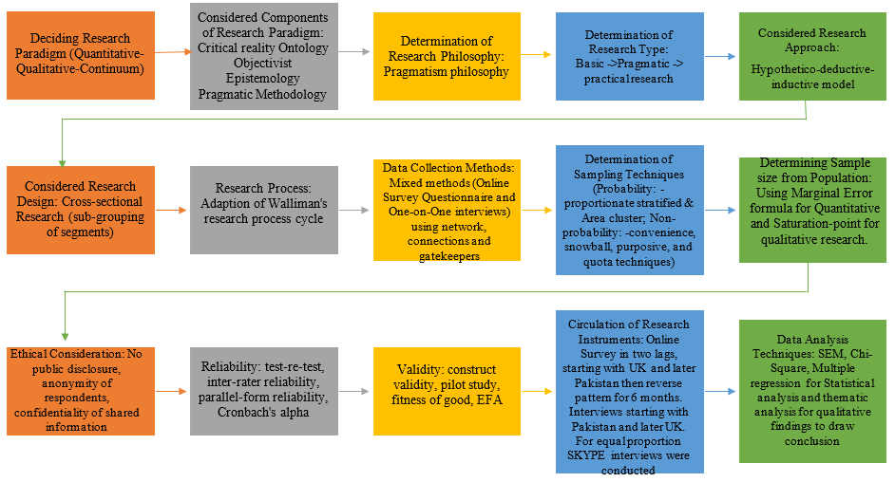

Figure 4. 9: Research flow chart of present thesis

The aforementioned steps showed the entire process of research undertaken in this study. After determining the ontological and epistemological stance in research, the pragmatic phlisophy was undertaken to ensure that useful truth is explored using both quantitative and qualitative methods. Since, the research is categorized as basic pragmatic research because it aims to attempt the existing body of knowledge. Thus, hypothetico-deductive-inductive cross-sectional research design by forming sub-groups within the segments, such as gender, faculty, and economy while following Walliman's research cycle. The data collection methods included survey questionnaire and one-on-one interviews with the participants using network, connections and gatekeepers. Hence, to determine the sample size, researcher followed marginal error formula and saturation-point by combining proportionate statefied, area cluster, purposive, quota, convenience and referral sampling technique to draw logical conclusion. As part of ethical consdirations, the participants were informed about the purpsoe of research and ensured about their anonymity and confidentialy. Moreover, the research instruments' validity and reliability were ensured through triangulation approach including pilot testing, demographic check, Cronbach's alpha, fitness of good and EFA. Survey was completed in two lags by starting with the UK and then Pakistan, later reversing the sequence to ensure equal proportion. It followed interviews by ensuring equal proportion. Later statistical techniques including SEM, Chi-Square and multiple regression was used while for qualitative findings researcher adopted thematic analysis.
Table 4. 2: Models applied to quantitative and qualitative analysis
Components | Techniques | Rationale | References
Reliability Test | Cronbach’s alpha | Statistic used in social science for measuring the items are aligned on the scale, reflecting the research instrument adopted for research is fit for purpose. The threshold value of 0.7 or above research instrument is acceptable. | Sekaran & Bougie, (2012), Haque & Aston (2016) and Taber (2017)
Equal and Normal Distribution | Proportional analysis and Q-Q Plots | Proportional analysis is to ensure data is equally distributed among the considered sub-groups namely; gender, faculty and economy. Shapiro-Wilk test has a limitation in satisfying normality assumption when the number of respondents is excess to 300, thus, Q-Q plots are used for determining the normality of data distribution. | Altman & Bland (1995), Ghaesmi & Zahediasl (2012), Haque, Faizan and Cockrill (2017)
Fitness of the Model (Validity Test) | AGFI, CFI, GFI and RMSEA | For ensuring the SEM model's fitness, the explanatory power of Adjusted Goodness-of-Fit Index (AGFI) and Goodness-of-Fit Index (GFI) above 0.9 reflects good fit. Similarly, the value of Root Mean Square Error of Approximation (RMSEA) index less than 0.10 reflects the amount of freedoms divergence between the actual and estimated distribution of the model is acceptable whereas Comparative Fit Index (CFI) reflecting lower value indicates model is a good fit for the research project. | Shigeno (2017)
Exploratory Factor Analysis (Validity test) | KMO & Bartlett Test, communalities and Total Variance Explained | The dimension reduction option of SPSS is used to measure the validity of construct and a threshold value of 0.7 in KMO & Bartlett reflects acceptable construct. The communalities extraction helps in checking the maximum likelihood whereas measuring of total variance explained is to assess the items on the scale explaining the validity of construct. | Gaskin & Happell (2014)
Partially Recursive Model | Structural Equation Modeling | This model is considered because independent variables arel multi-directional and correlated with causal effects but endogenous variables among themselves have no direct effect. The model is effective in determining the total size effect of exogenous variables on endogenous variables. | Gaskin & Happell (2014) and Shigeno (2017)
Proportional Analysis | Bar diagram and proportional representation of Causes and Consequences of stress | Representing the causes and consequences of stress in diagram and percentages in order to have holistic outlook regarding the variation within the sub-attributes of stressors and symptoms. | Faizan & Haque (2015), Haque et al., (2017) and Zehra & Faizan (2017).
Categorical Data Statistical Analysis | Chi-Square Test | For non-continuous (categorical) data, Chi-Square Test is used for measuring the statistical significance of variables of interest. | Pallant (2014)
Statistical Test for measuring the impact of variables of interest | Multiple regression and Group Statistics | For continuous data, in the presence of sub-groups, within an interval variable through the variance predictor the multiple regression determines the relationship between dependent and independent variables more effectively. | Cleophas et al., (2000), Kariminalayer & Anuar (2012)
Qualitative Approach | Thematic Analysis using coding, labelling, frequency and proportions | Using thematic analysis for the interview findings by generating codes for themes and labelling responses. Later transforming it to frequency by using COUNTIF formula and generating the percentages to show the responses of sub-groups. | Zehra & Faizan (2017) and Haque et al., (2018)

The above table reflects the application of statistical models and qualitative approach used in this research.

CHAPTER FIVE: RESEARCH FINDINGS AND DISCUSSION

5.1 Introduction
This chapter contains the results, findings and discussion, based on the primary data attained from a target audience at universities in the UK and Pakistan, for determining the impact of varying, occupational stressors affecting the organisational commitment of teaching and non-teaching (administrative) staff. The chapter is divided into two parts, namely: (a) survey results, and discussion findings and (b) interview findings and discussion. Since, this study falls more within a positivist paradigm, a higher focus, therefore, remains on the quantitative findings to gain numerical significance, which is the reason for discussing it in the first section. Nevertheless, the qualitative part is also given equal consideration. The qualitative findings are discussed to explore the phenomenon in more depth, using an institutional approach. Lastly, the overall findings are discussed through Hofstede’s cultural dimensions before summarizing the key aspects of the chapter.

5.2 Survey Questionnaire - Results, Findings and Discussion
The survey questionnaire adapted Haque & Aston’s (2016) “DAB (demographic, attitudinal, and behavioural) strategy” by placing demographic variables (gender, age, faculty and experience) first and asking warm-up, attitudinal questions later; this is followed by behavioural questions. The following are the aspects covered in this section:

Table 5. 1: Features of quantitative section
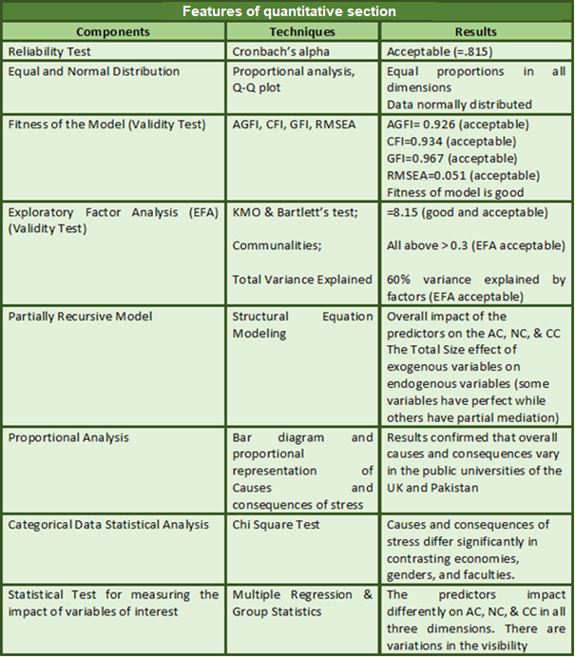
Before proceeding with the statistical test for the obtained data, the key considerations, including a reliability test and normality of data distribution, are explained below:

5.2.1 Reliability
One of the essential aspects of the research is to ensure that the data is reliable, consistent and the test is free from measurement errors (De Bruin, 2010). In other words, reliability indicates replicability and consistency over time (ibid). Additionally, various scholars have stated that tests which have a higher measurement error are less reliable and, therefore, reliability test is viewed as the degree to which a test is free from measurement errors (Moss, 2004; McMillan & Schumacher, 2006; Fraenkel & Wallen, 2009; De Bruin, 2010; Neuman, 2011). According to Sekran & Bougie (2010) and Hinton, McMurray & Brownlow (2014), there are several ways of examining reliability; however, the most popular of all is Cronbach’s coefficient alpha. It reflects the internal consistency among the items on a scale (Sekaran & Bougie, 2010; Hinton et al., 2014; Haque et al., 2017). A number of researchers have agreed that 0.7 is acceptable, 0.8 is good, while 0.9 is excellent (Hinton, et al., 2014; Sekaran & Bougie, 2010; Wieland et al., 2017). Hence, in this study, Cronbach’s alpha test is considered for examining the reliability aspect.
Table 5. 2: Case Processing Summary
 |  | N | %
Cases | Valid | 404 | 99.0
Cases | Excludedª | 4 | 1.0
Cases | Total | 408 | 100.0
a. Listwise deletion based on all variables in the procedure.

Table 5. 3: Reliability Statistics
Cronbach's Alpha | Cronbach's Alpha Based on Standardized Items | N of Items
.807 | .815 | 24

The above results showed that Cronbach’s alpha derived value is 0.807, which is good and above that which is a generally acceptable (0.807 > 0.7) value in social science research. Since, the Cronbach’s alpha coefficient is 0.8, which compared to the guidelines of 0.7 indicates that the dimensions (internal consistency of the dimensions) explain the large segment of the variance (Nunnally & Bernstein, 1994). Therefore, in this research the degree of ‘free from measurement error’ is good and higher than the generally acceptable one.

5.2.2 Equal and Normal Distribution
According to Curran-Everett & Benos (2004), the most common statistical error cited in 50% of published scientific literature it is essential that the data normal distribution assumption is satisfied in order to use parametric tests such as correlation, regression, t tests and analysis of variance (cited from Ghasemi & Zahediasl, 2012). Although it is fine to consider normality and other assumptions to draw an accurate and reliable conclusion, with a large sample size, if the normality assumption is violated, it still should not be a major cause of concern (Pallant, 2007; Ghaesmi & Zahediasl, 2012). Moreover, Elliott & Woodward (2007) argued that parametric procedures can be used despite data not being normally distributed. Moreover, Altman & Bland (1995) argued that when the sample contains hundreds of observations, then the researcher can ignore the normality assumption. Interestingly, Elliott & Woodward (2007), suggested that despite the fact that the Central Limit Theorem itself suggests that a sample set, having 30 or higher observations, tends to be normal irrespective of the data shape, true normality is a myth and, therefore, normal Q-Q plots (visual normality) should be considered to ensure that data does not have serious deviations from normality (cited from Ghasemi & Zahediasl, 2012). Interestingly, Haque et al., (2017) have used Q-Q Plots for checking the normality assumption instead of relying on Shapiro-Wilk test, as the observations were in hundreds. Since the present data has 408 observations, thus Haque et al.’s (2017) approach of Q-Q plots is used for determining the data normality distribution.
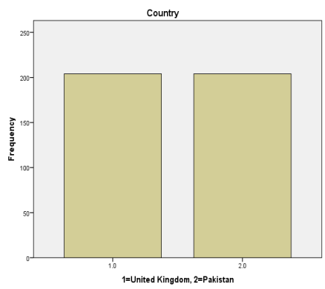
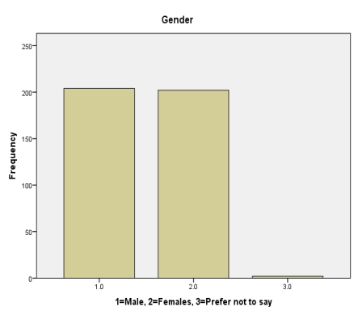 | 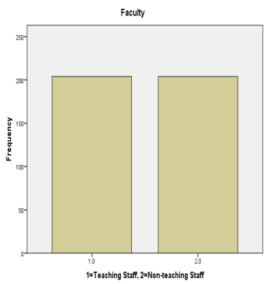

Figure 5. 1: Bar diagrams for equal distribution in terms of economy, gender, and faculty

Table 5. 4: Country Proportion: 1=United Kingdom, 2=Pakistan
 |  | Frequency | Percent | Valid Percent | Cumulative Percent
Valid | 1.0 | 204 | 50.0 | 50.0 | 50.0
Valid | 2.0 | 204 | 50.0 | 50.0 | 100.0
Valid | Total | 408 | 100.0 | 100.0

The above figure contains the bar diagrams reflecting all three main dimensions for considering the equal distribution of the population. “Country” is the first aspect in which equal normal distribution is targeted and, according to the selection strategy, included 50% of the respondents from the UK and 50% from Pakistan. Additionally, the above table revealed an attainment of equal frequency and percentages in each country (See table 5.4).

Table 5. 5: Gender proportion: 1=Male, 2=Females, 3=Prefer not to say
 |  | Frequency | Percent | Valid Percent | Cumulative Percent
Valid | 1.0 | 204 | 50.0 | 50.0 | 50.0
Valid | 2.0 | 202 | 49.5 | 49.5 | 99.5
Valid | 3.0 | 2 | .5 | .5 | 100.0
Valid | Total | 408 | 100.0 | 100.0

The second aspect in the figure is “gender” in both countries. There is almost an equal split between males and females. Interestingly, the table above also confirmed that the percentages in terms of gender are almost equal (Males=50% and Females=49.5%) (See table 5.5).
Table 5. 6: Faculty: 1=Teaching Staff, 2=Non-teaching Staff
 |  | Frequency | Percent | Valid Percent | Cumulative Percent
Valid | 1.0 | 204 | 50.0 | 50.0 | 50.0
Valid | 2.0 | 204 | 50.0 | 50.0 | 100.0
Valid | Total | 408 | 100.0 | 100.0

Third dimension is “faculty” in this study. The bar diagram reflects that there is an equal split (50% each) in teaching and non-teaching faculty. Additionally, the above table reflects that the frequency and percentage for both teaching and non-teaching staff are equally distributed (See table 5.6).
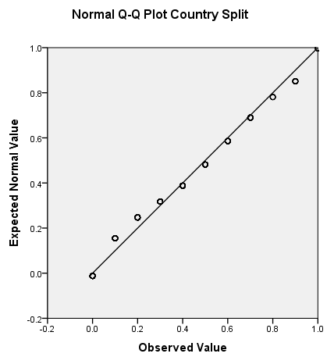

Figure 5. 2: Q-Q Plot for normality in the context of Economies
From the above Q-Q plot, it is evident that the observed values are almost on the same line. There are some traces of small deviation but largely they are aligned. Thus, this shows that the present data satisfies the assumption of normal distribution. In other words, considering countries, the data is normally distributed (See figure 5.2).

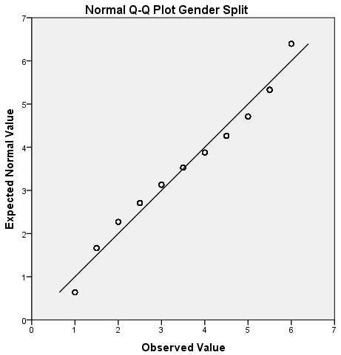 | 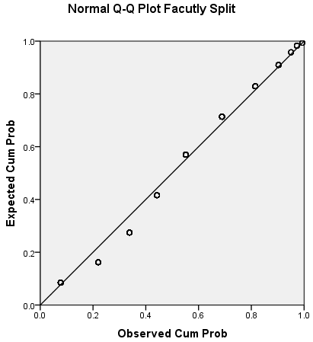

Figure 5. 3: Q-Q Plot for determining normality distribution in terms of gender and faculty.
Similarly, the Q-Q plot for gender and faculty was used to examine the normal distribution. As shown in the above figure, the observations are close to the line (See figure 5.2). Thus, the Q-Q plots of gender and faculty both indicate that the present data satisfy the normality distribution assumption (See figure 5.3).
After determining the normality assumption, the next step is determining the fitness of the model for Structural Equation Modeling (SEM). The two most powerful, statistical techniques are Confirmatory Factor Analysis (CFA) and Exploratory Factor Analysis (EFA) (Child, 1990; Kline, 1998). CFA is the first step to confirm that the factors developed through the measurement instrument are adequate (Child, 1990). In case the CFA technique does not confirm the factor structure, then EFA is the next step, as it enables the researchers to determine the factor structure in accordance with the responses of the participants (ibid). Interestingly, Gaskin (2012) argued that both CFA and EFA could be used for ensuring adequacy of measurement items. Hence, EFA is significant in determining the underlying construct for a set of measured items/variables (ibid). In SEM, different statistical tests are carried out for CFA in order to determine the adequacy of data model fit, namely: CFI, Chi-Square Test, RMSEA and so on (ibid).

5.2.3 Fitness of the model
Table 5. 7: Test Statistics
χ^{2 value} | Degree of Freedom | P value | AGFI | AIC | CFI | GFI | RMSEA
135.918 | 4 | 0.000 | 0.926 | 368.248 | 0.934 | 0.967 | 0.051

The above table demonstrates the fitness of the SEM model through the explanatory power of AGFI (Adjusted Goodness-of-Fit Index) and GFI (Goodness-of-Fit Index), as the value of both (AGFI=0.926 and GFI=0.967) are above 0.9, indicating that the model is a good fit because the indicating criteria is that the explanatory power should lie between 0 and 1 (Shigeno, 2017). In the present thesis, the explanatory power is close to 1 and, therefore, the model is adequate. Additionally, the RMSEA (Root Mean Square Error of Approximation) index shows the amount of freedoms divergence between the actual and estimated distribution of the model (Shigeno, 2017). The incurred value is 0.051. Since, the value of 0.10 or less is judged as good fitness thus, the result satisfies the RMSEA condition for good fit. Furthermore, the CFI (Comparative Fit Index) explains goodness-of-fit of the model, while assuming if there is no correlation among the observed variables then how much model has developed and got better in comparison with the estimated independent model (Shigeno, 2017). Again, the indicating criteria is a value between the 0 and 1 for being good fit and, in this case, the CFI derived value is 0.934 and, therefore, it reflects that model is a good fit.

5.2.4 Exploratory Factor Analysis
Table 5. 8: KMO and Bartlett's Test
Kaiser-Meyer-Olkin Measure of Sampling Adequacy. |  | .813
Bartlett's Test of Sphericity | Approx. Chi-Square | 5926.718
Bartlett's Test of Sphericity | Df | 231
Bartlett's Test of Sphericity | Sig. | .000

Using the dimension reduction option through SPSS, the items on the scale were checked to ensure the underlying construct for a set of measured variables. The obtained KMO value is 0.813, which is greater than 0.7, reflecting good sampling adequacy. Furthermore, the extractions of communalities through maximum likelihood were checked as the second step in the process. According to Gaskin & Happell (2014), the extraction values above 0.3 indicate a good likelihood, whereas the aggregate of matrix patterns for each factor scoring over 0.7 indicate the adequacy and reliability towards goodness-of-fit.

Table 5. 9: Communalities
 | Initial | Extraction
Rate Occupational Therapist Representation | .761 | .784
Rate Occupational Therapist Representation at University | .853 | .943
Impact of Occupational Therapist in Sustenance of Human Capital | .831 | .862
Occupational therapist offers solutions to improves working efficiency | .876 | .957
Occupational therapist address concerns to improve organisational commitment] | .847 | .869
Occupational therapist counselling is effective in reducing different types of stress | .785 | .798
Personal Strain – I | .610 | .531
Personal Strain II | .499 | .541
Personal Strain III | .547 | .589
Perceived Job Stress I | .586 | .553
Perceived Job Stress II | .523 | .453
Perceived Job Stress III | .582 | .633
Affective Commitment – I | .638 | .776
Affective Commitment II | .545 | .547
Normative Commitment I | .488 | .488
Normative Commitment II | .543 | .675
Continuance Commitment I | .510 | .579
Continuance Commitment II | .512 | .477
Personal Resources I | .624 | .664
Personal Resources II | .621 | .694
Social Support I | .588 | .649
Social Support II | .546 | .420
Extraction Method: Maximum Likelihood.

Since all of the extractive values are over 0.3, this therefore reflects that under the communalities’ aspect, the measurement variables have met the likelihood criteria. The next step is assessing the cumulative percentage of the extracted items in order to measure the total variance explained by how many items are considered on the scale.

Table 5. 10: Total Variance Explained
Factor | Initial Eigenvalues |  |  | Extraction Sums of Squared Loadings |  |  | Rotation Sums of Squared Loadingsª
Factor | Total | % of Variance | Cumulative % | Total | % of Variance | Cumulative % | Total
1 | 5.351 | 24.324 | 24.324 | 4.718 | 21.446 | 21.446 | 3.480
2 | 4.331 | 19.687 | 44.011 | 1.241 | 5.641 | 27.087 | 3.565
3 | 2.654 | 12.065 | 56.076 | 3.790 | 17.226 | 44.313 | 3.656
4 | 1.627 | 7.394 | 63.470 | 2.711 | 12.323 | 56.636 | 3.812
5 | 1.328 | 6.036 | 69.506 | 1.297 | 5.898 | 62.534 | 2.944
6 | 1.114 | 5.066 | 74.572 | .726 | 3.300 | 65.834 | 2.635
7 | .899 | 4.086 | 78.658
8 | .639 | 2.904 | 81.562
9 | .608 | 2.765 | 84.327
10 | .517 | 2.348 | 86.675
11 | .462 | 2.102 | 88.777
12 | .362 | 1.645 | 90.421
13 | .339 | 1.543 | 91.964
14 | .301 | 1.368 | 93.332
15 | .264 | 1.202 | 94.534
16 | .254 | 1.157 | 95.690
17 | .229 | 1.042 | 96.732
18 | .211 | .960 | 97.693
19 | .182 | .827 | 98.520
20 | .155 | .706 | 99.227
21 | .092 | .418 | 99.644
22 | .078 | .356 | 100.000
Extraction Method: Maximum Likelihood.
a. When factors are correlated, sums of squared loadings cannot be added to obtain a total variance.

The above table reflects that the cumulative percentage for six items indicates 65% of the items. According to Gaskin & Happell (2014), 50% is the minimum required to confirm that the items on the scale are explaining the factors. As evident, the above table reflects 65.83% and, therefore, this indicates that the total variance is explained by the items on the scale. Additionally, the correlation table reflects that the non-redundant residuals for 22 items are 4.0% (0.04), which is less than 0.05 (See Appendix C). Therefore, the reproduced correlation is well within the adequacy requirements. Lastly, the pattern matrix was evaluated and the results revealed that the sum of each considered factor scored over 0.7 and, thus, this indicates that the factors are adequate in explaining the variance (See Appendix C).

5.2.5 Partially Recursive Model
The endogenous (dependent) variables in this study are the dimensions of the organisational commitment: affective commitment, normative commitment and continuance commitment, whereas the exogenous variables in questions are: personal strain, personal resources, perceived job stress, social support and role/effectiveness of the occupational therapist. The reason that the present model is categorized as a partially recursive model is because all of the causal effects are multi-directional and correlated but there is no direct effect among the endogenous variables. In other words, the independent variables have covariance, as well as having directional path, but there is no direct effect of one dependent variable on the other dependent variables. Below is the model drawn by using AMOS SPSS:
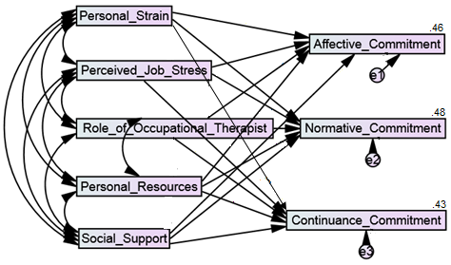
Figure 5. 4: Partially Recursive Model demonstrating the relationship.
The above figure represents the causal effect of the multivariable on the antecedents of organisational commitment (affective, normative and continuance commitment). In other words, it is the multiple linear regressions with different “variables in question” affect the dependent variables. Moreover, the variables in question have a direct impact on each other and cause an indirect effect on the dependent variables. For instance, personal strain has a direct effect on perceived job stress, the role of occupational therapist, personal resources and social support, while through these all of the variables in question have an indirect effect on affective commitment, normative commitment and continuance commitment. Similarly, all other variables have a direct effect on the other “variables in question” and an indirect affect through “variables in question” on the dependent variables (AC, NC and CC). The above figure also reflects that a 46% variability in affective commitment is explained by the variability in the number of exogenous variables (R²₌0.46). Moreover, the variability/differences explained by the model through exogenous variables for the variability in the normative commitment is 48% (R²₌0.48), whereas the 43% variability in continuance commitment is explained by the differences in the model (R²₌0.43).
In order to assess the total effect of each exogenous variable on the individual endogenous variables, the following formula is used for the calculation:
Y1n = βa + (βb X βc)
Thus, below the formula for one exogenous variable, “personal strain”, is stated to explain the calculation, whereas the rest of the formulae are presented in Appendix B.
Total Effect of Personal Strain on AC through perceived job stress: Y1a₁= β1 + (β2 X β3)
Total Effect of Personal Strain on AC through role of OT: Y1b₁= β1 + (β4 X β5)
Total Effect of Personal Strain on AC through personal resources: Y1c₁= β1 + (β6 X β7)
Total Effect of Personal Strain on AC through social support: Y1d₁= β1 + (β8 X β9)
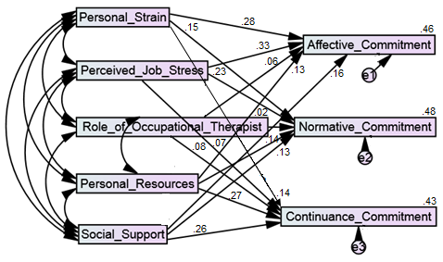

Figure 5. 5: The directional path of direct effect of exogenous variables on endogenous variables.
The above figure reflects the regression of the exogenous variables on the endogenous variables. As evidenced, the personal strain has 0.28 regression on the AC, which is a direct effect (β1=0.28) but personal strain is interlinked with other exogenous variables too, indicating that personal strain has 0.68 direct effect on perceived job stress (β2=0.68) and perceived job stress also has a 0.33 direct effect on affective commitment (β3=0.33). Hence, the indirect effect of personal strain on affective commitment is 0.22 (β2 X β3). Considering only personal strain, the total effect on the affective commitment is 0.50. [Y1a₁=β1+ (β2 X β3)]. However, the indirect effect of personal strain via the role of the occupational therapist is 0.016 (β4 X β5), while the total effect of personal strain through the role of the occupational therapist on affective commitment is 0.29 [β1 + (β4 X β5), See Appendix B for further details]. The indirect effect of personal strain via personal resources is 0.049 (β6 X β7) and the total effect via personal resources is 0.32 [β1 + (β6 X β7), See Appendix B]. Lastly, the indirect effect of personal strain through social support is 0.014, while the total effect via it is 0.29 [β1 + (β8 X β9), See Appendix B]. Hence, the sum of the standardized total effect of personal strain on the AC is 0.288, which is also evident in the table 10 as a standardized estimate (See Appendix B).
Personal strain also has a direct and indirect effect on normative commitment. The direct effect is 0.15 on NC, while the indirect effect is 0.156 and total direct effect is 0.30 via perceived job stress (See Appendix B). Moreover, personal strain’s indirect effect on NC via the role of the occupational therapist is 0.005 and the total effect is 0.155 (See Appendix B). The indirect effect via personal resources is 0.05 and the direct effect is 0.20 (See Appendix B). Lastly, via social support, personal strain effects indirectly NC 0.011 and the total effect is 0.16 (See Appendix B). Thus, the standardized total effect of personal strain on NC is 0.148. Similarly, personal strain has both a direct and indirect effect on continuance commitment. The direct effect on CC is 0.047, while via perceived job stress it is 0.16 and, therefore, the total effect of personal strain on CC is 0.18 (See Appendix B). Through the role of the occupational therapist, the indirect effect of personal strain on CC is 0.02, while the total direct effect is 0.166 (See Appendix B). Furthermore, via personal resources, the indirect effect of personal strain on CC is 0.102 and the total direct effect is 0.24 (See Appendix B). Moreover, through social support, the indirect effect is 0.024 and the total direct effect of personal strain on continuance commitment is 0.16, whereas the standardized total effect of personal strain on CC is 0.146 (See Appendix B).
In a similar manner, the direct, indirect and total effect of all of the exogenous variables (personal strain, perceived job stress, role of occupational therapist, personal resources and social support) on AC, NC and CC has been determined in the partially recursive model and results showed that the range of these variables’ standardized total effect lies between 0.03 to 0.267 (See Appendix B). These values are also shown under the standardized estimates in table 5.10. Thus, considering the totality aspect, all of the variables in question affect the endogenous variables to some extent. Interestingly, in this model, some of the exogenous variables are predictors, as well as the outcome, indicating a mediating role. Hence, mediation is also determined in this research. Interestingly, the total effect of the predictors is higher on AC in comparison to NC and CC. The majority of the variables β_{n,} after inclusion of the error (e_{n}), become non-significant, which reflects partial mediation. Some of such variables are personal strain via perceived job stress and the role of the occupational therapist in relation to AC, while perfect mediation is evident for personal strain via personal resources and social support in relation to AC (See Appendix B). Nevertheless, both partial and perfect mediation being among the variables indicates that the considered partially recursive model confirms previous empirical research to a certain extent, such as House, 1981; Hurlbert, 1991; Schwarzer and Leppin (1991); Park et al., 2004; Mark & Smith (2008), Sackey & Sanda, 2011; Kumasey et al., 2014; Haque & Yamoah (2014), Haque & Aston (2016); Haque et al., (2016), Haque & Oino (2017), and Haque et al., (2018) by confirming that there is correlation, as well as a total effect of exogenous variables on the endogenous variables.
Table 5. 11: Critical Ratio and standardized path estimates
 |  |  | Estimate | S.E. | C.R | P
Affective Commitment | <--- | Personal Strain | .228 | .070 | 3.257 | ***
Affective Commitment | <--- | Perceived Job Stress | .267 | .070 | 3.814 | ***
Affective Commitment | <--- | Role of Occupational Therapist | .071 | .042 | 1.690 | .293
Affective Commitment | <--- | Personal Resources | .137 | .065 | 2.107 | .017
Affective Commitment | <--- | Social Support | .146 | .066 | 2.215 | .039
Normative Commitment | <--- | Personal Strain | .148 | .059 | 2.508 | .011
Normative Commitment | <--- | Perceived Job Stress | .224 | .059 | 3.796 | ***
Normative Commitment | <--- | Role of Occupational Therapist | .033 | .036 | .691 | .909
Normative Commitment | <--- | Personal Resources | .157 | .055 | 2.854 | .018
Normative Commitment | <--- | Social Support | .124 | .056 | 2.214 | ***
Continuance Commitment | <--- | Personal Strain | .146 | .057 | 2.587 | .030
Continuance Commitment | <--- | Perceived Job Stress | .066 | .051 | 1.294 | .126
Continuance Commitment | <--- | Role of Occupational Therapist | .098 | .069 | 1.420 | .194
Continuance Commitment | <--- | Personal Resources | .224 | .060 | 3.733 | ***
Continuance Commitment | <--- | Social Support | .256 | .061 | 4.196 | ***
*p<0.05

The next step was the extraction of the model by viewing the standardized and unstandardized results of the exogenous variables in relation to the endogenous variables. Since, AMOS gives two separate tables by giving the standardized estimates separately, while the unstandardized estimates with the standard error (S.E), critical ratio (C.R) and P-value, the researcher, therefore, replaced the standardized estimates with the unstandardized ones in order to explain the results from one table. The t-value is 1.96 is a cut-off value and using Gaskin’s (2012) steps, the researcher explained the derived value by dividing the standard estimates by the standard error (S.E.) in order to obtain the critical ratio (C.R). A critical value greater than 1.96 reflects a significant relationship between the variables of interest (Gaskin, 2012). Personal strain highly significantly affects overall affective commitment (p-value =0.0000 < 0.05, p < α; Table 5.11). Moreover, personal strain has a significant impact on overall normative commitment (=0.011, p < α; Table 5.11) and continuance commitment (=0.030, p < α; Table 5.11). Since the critical ratio for all three antecedents of organisational commitment are positive and greater than the t-value, there is, therefore, a positive link between the variables of interest (C.R_{A} > t-value, 3.257 > 1.96, C.R_{B} = 2.508 > 1.96, and C.R_{C} =2.587 > 1.96; Table 5.11). Thus, this study confirms the earlier work of Haque & Aston (2016) that personal strain affects the organisational commitment of employees, whereas it partially supports the notion of Brannon & Fiest (1992) and Sackey & Sanda (2011) that personal strain exists in organisational settings affecting the commitment of the employees in a varying manner.
Perceived job stress is another variable in relation to the antecedents of organisational commitment considered in this research. The results revealed that, statistically, it has a highly significant effect on the affective commitment (=0.0000, p < α; Table 5.11) and normative commitment (=0.030, p < α) while non-significant impact on the continuance commitment of the university staff (=0.126, p > α). Furthermore, the critical ratio for AC (C.R_{D} > t-value, 3.814 > 1.96) and NC (C.R_{E} > t-value, 3.796 > 1.96; Table 5.11) hence these antecedents have positive linkage with perceived job stress. Interestingly, present findings indicate that the continuance commitment is not affected by the perceived job stress hence this has strikingly different from the recent work of Gok, Akgunduz, & Alkan (2017). Conversely, the present findings support the work of van Zyl et al., (2013), in terms of affective commitment, and Zehra et al., (2017) when considering normative commitment. Nevertheless, both the aforementioned studies were carried out in the healthcare sector, while the present findings offer the same evidences from the education sector in contrasting economies.
The effect of the role of the occupational therapist on the dimensions of organisational commitment in the public universities of Pakistan and the UK was examined in this study. Interestingly, the results revealed that it has no statistically significant impact on AC (=0.1690, p > α; Table 5.11), NC (=0.691, p > α; Table 5.11), and CC (=0.194, p > α; Table 5.11). Thus, this study partially opposes the work of Haque & Aston (2016) which states that the role of the occupational therapist is significant in determining the organisational commitment of employees. Nonetheless, the work of Haque & Aston (2016) was related to the IT sector, whereas present findings are from the education sector. Additionally, the present findings support the work of Haque & Aston (2016) and Haque et al., (2016) to a large extent in that there are low traces of the effectiveness and use of the professional occupational therapist from developing economies in contrast to developed ones.
Personal resources interlinked with organisational commitment, were examined in this study and results revealed that, it has highly statistically significant effect on the CC (=0.000, p < α; Table 5.11), whereas it has a significant positive effect on the AC (=0.017, p < α; Table 5.11) and NC (=0.018, p < α; Table 5.11). Furthermore, the critical ratio of the three distinctive attributes of organisational commitment is again shown to be positive and greater than the t-value (C.R_{J} > t-value, 2.107 > 1.96, C.R_{K} = 2.854 > 1.96, and C.R_{L} =3.733 > 1.96). Therefore, the results confirm that there is a positive linkage between the considered variables. The present findings partially support the work of Schwarzer & Leppin (1991) and Sackey & Sanda (2011). Interestingly, the findings support the work of Haque & Aston (2016) in terms of personal resources significantly affecting normative and continuance commitment but differ from the authors’ finding of personal resources having no significant role in improving the affective commitment of the employees.
The results revealed that social support affects the antecedents of organisational commitment of university staff in the UK and Pakistan in a significant manner. As evident, social support significantly affects AC (=0.039, p < α; Table 5.11), whereas highly statistically significant affects NC (=0.0000, p < α; Table 5.10), and CC (=0.000, p < α; Table 5.11). Additionally, the results also revealed that the critical ratio for the respective dimensions of organisational commitment, namely: AC, NC and CC are positive, as well as greater than the t-value and, thus, it shows that there is a positive linkage between the variables of interest (C.R_{M} > t-value, 2.215 > 1.96, C.R_{N} = 2.214 > 1.96, and C.R_{O} =4.196 > 1.96; Table 5.11). The present findings support, to a large extent, the work of Haque & Aston (2016), Haque et al., (2017), Zehra et al., (2017), Zehra & Faizan (2017), Haque & Oino (2017), Haque et al., (2018), while partially supporting the work of Sackey & Sanda (2011), Cicei (2012), and Kumasay et al., (2014).
However, the above partially recursive model and SEM provided significant findings about the multivariate but the present study is relatively complex in nature, as it also contains categorical data and distinctive dimensions, such as economy, gender, faculty, types of stressors causing stress and types of consequences because of those stressors. For this reason, the researcher, instead of relying on one technique, has used several different tools and techniques to investigate the variables of interest. The above test did not reflect the causes and consequences of stress, while which is also one of the most important objectives of this research to be evaluated. Hence, a different approach is used by the researcher.

5.2.6 Proportional Analysis
The causes and consequences of stress identified earlier by Stranks (2005) and later explored by Haque & Aston (2016), Haque et al., (2017), Nair et al., (2017), Zehra & Faizan (2017), and Haque et al., (2018), were examined and presented through proportional analysis (bar diagram and percentages) to give an overall outlook.
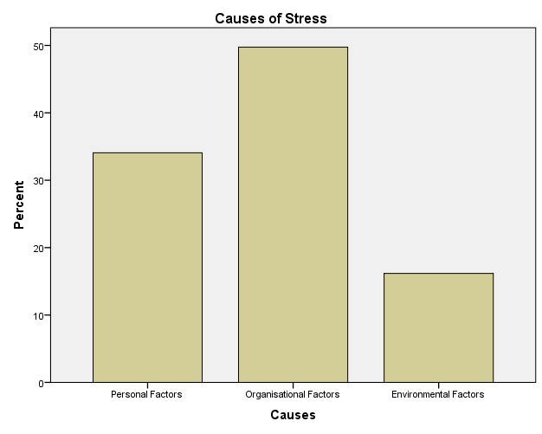
Figure 5. 6: Bar diagram containing proportions of causes of stress.

Table 5. 12: Causes of stress
 |  | Frequency | Percent | Valid Percent | Cumulative Percent
Valid | Personal Factors | 139 | 34.1 | 34.1 | 34.1
Valid | Organisational Factors | 203 | 49.8 | 49.8 | 83.8
Valid | Environmental Factors | 66 | 16.2 | 16.2 | 100.0
Valid | Total | 408 | 100.0 | 100.0

The above figure and table reflect that, overall, organisational factors most frequently cause stress to university staff in both the UK and Pakistan. As is demonstrated above, an overall 49.8% of the total number of respondents identified organisational stressors, followed by personal stressors and lastly environmental factors as causes of stress (See table 5.12). Thus, this study supports the work of Haque et al., (2018) to a certain extent.

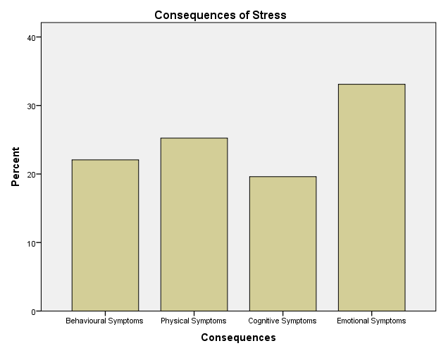

Figure 5. 7: Bar diagram containing proportions of consequences of stress.

Table 5. 13: Consequences of stress
 |  | Frequency | Percent | Valid Percent | Cumulative Percent
Valid | Behavioural Symptoms | 90 | 22.1 | 22.1 | 22.1
Valid | Physical Symptoms | 103 | 25.2 | 25.2 | 47.3
Valid | Cognitive Symptoms | 80 | 19.6 | 19.6 | 66.9
Valid | Emotional Symptoms | 135 | 33.1 | 33.1 | 100.0
Valid | Total | 408 | 100.0 | 100.0

From the above figure and table, it is evident that the most frequently occurring symptoms experienced by university staff of the UK and Pakistan, when experiencing stress, are emotional symptoms. Hence, it is clear that emotional consequences are the highest (33.1%), followed by physical symptoms (25.2%), behavioural symptoms (22.1%) and, finally, cognitive symptoms (19.6%) (See table 5.13). However, the above analysis conveyed the general idea about the commonly causing stressor and type of consequences, but it does not reflect the variation in terms of considered dimensions. Thus, the chi-square test is used as the next step in this research.

5.2.7 Chi-Square Tests
In this section, the chi-square test explains the categorical data presented above, via proportional analysis, by considering three aspects, namely: economy, gender and faculty, in order to attain numerical significance regarding each distinctive attribute of the causes and consequences of stress.
Table 5. 14: Causes of Stress – Country
 |  |  | Causes of Stress |  |  | Total
 |  |  | Personal Factors | Organisational Factors | Environmental Factors | Total
Country | United Kingdom | Count | 61 | 114 | 29 | 204
Country | United Kingdom | Expected Count | 69.5 | 101.5 | 33.0 | 204.0
Country | United Kingdom | % within Country | 29.9% | 55.9% | 14.2% | 100.0%
Country | Pakistan | Count | 78 | 89 | 37 | 204
Country | Pakistan | Expected Count | 69.5 | 101.5 | 33.0 | 204.0
Country | Pakistan | % within Country | 38.2% | 43.6% | 18.1% | 100.0%
Total |  | Count | 139 | 203 | 66 | 408
 |  | Expected Count | 139.0 | 203.0 | 66.0 | 408.0
 |  | % within Country | 34.1% | 49.8% | 16.2% | 100.0%

Table 5. 15: Chi-Square Tests
 | Value | Df | Asymp. Sig. (2-sided)
Pearson Chi-Square | 6.128 | 2 | .047
Likelihood Ratio | 6.143 | 2 | .046
Linear-by-Linear Association | .421 | 1 | .516
N of Valid Cases | 408
a. 0 cells (0.0%) have expected count less than 5. The minimum expected count is 33.00.

Table 5. 16: Symmetric Measures
 |  | Value | Approx. Sig.
Nominal by Nominal | Phi | .123 | .047
Nominal by Nominal | Cramer's V | .123 | .047
N of Valid Cases |  | 408

According to Pallant (2016), above 20% expected count violates the assumption and researchers should consider a ‘Likelihood Ratio - sig-value’ to determine results, whereas 20% or below reflects that the assumption is not violated and a Pearson Chi-Square sig-value should be considered for testing the hypothesis. Since 0% cells have less than 5 expected counts, the assumption, therefore, is not violated (See table 5.15). The Pearson Chi-square sig value is less than alpha (=.047 < 0.05, p < α), which indicates that results are statistically significant. In other words, the null hypothesis is rejected as there is no significant relationship between contrasting economies and types of stressors. Moreover, the types of stressors are dependent on the type of economies. In addition to that, Pallant (2016) explained that criteria for considering Symmetric Measures depend on the number of items; for 2X2 researchers should consider the Phi Value, whereas for 2X3 or above, Cramer’s V should be taken into consideration. Since, in this study it is 2X3, Cramer’s V is, therefore, considered to explain the effect. Hence, 0.123 indicates that contrasting economies have a small to moderate effect on the types of causes and the effect is significant (=.047 < 0.05, p < α) (See table 5.16). Thus, the present findings support the work of Haque & Aston (2016) that there is a significant difference in the types of stressors affecting employees in contrasting economies.
Additionally, table 5.14 contains the proportion, which indicates that in the UK, organisational factors have scored higher than the expected counts (114 against 101.5), reflecting 55.9% in contrast to two other factors (personal factors=29.9% and environmental factors=14.2%) (See table 5.14). Similarly, in Pakistan, organisational factors have a high proportion (43.6%), followed by personal factors (38.2%) and environmental factors (18.1%) (See table 5.14). Nevertheless, organisational factors are a high cause of stress in the UK in contrast to Pakistan (55.9% against 43.6%). Conversely, Pakistan, in contrast to the UK, has higher personal factors (38.2% against 29.9%) and environmental factors (18.1% against 14.2%). Thus, to some extent, these findings support the work of Haque & Aston (2016) and Haque et al., (2018) but their findings were from the IT sector of Pakistan and the UK, whereas the present results confirmed similar findings from the education sector of the two contrasting economies. Overall, organisational factors cause more stress to university employees; however, the types of stressors significantly differ for the two distinctive economies. Since, the present findings confirmed that organisational factors cause more stress to the employees in contrast to personal and environmental factors, this study, therefore, confirms the work of Haque et al., (2016), while it opposes the work of Cicei (2012) and Fairbrother and Warn (2003) to a large extent. Nonetheless, the present findings confirmed that all these types of stressors exist and affect both teaching and non-teaching (administrative) staff, which means that the study supports the work of Stranks (2005) that differing stressors affect employees in an organisational setting.
Table 5. 17: Consequences of Stress – Country
 |  |  | Consequences of Stress |  |  |  | Total
 |  |  | Behavioural | Physical | Cognitive | Emotional | Total
Country | United Kingdom | Count | 44 | 61 | 29 | 70 | 204
Country | United Kingdom | Expected Count | 45.0 | 51.5 | 40.0 | 67.5 | 204.0
Country | United Kingdom | % within Country | 21.6% | 29.9% | 14.2% | 34.3% | 100.0%
Country | Pakistan | Count | 46 | 42 | 51 | 65 | 204
Country | Pakistan | Expected Count | 45.0 | 51.5 | 40.0 | 67.5 | 204.0
Country | Pakistan | % within Country | 22.5% | 20.6% | 25.0% | 31.9% | 100.0%
Total |  | Count | 90 | 103 | 80 | 135 | 408
 |  | Expected Count | 90.0 | 103.0 | 80.0 | 135.0 | 408.0
 |  | % within Country | 22.1% | 25.2% | 19.6% | 33.1% | 100.0%

Table 5. 18: Chi-Square Tests
 | Value | Df | Asymp. Sig. (2-sided)
Pearson Chi-Square | 9.784 | 3 | .020
Likelihood Ratio | 9.883 | 3 | .020
Linear-by-Linear Association | .183 | 1 | .669
N of Valid Cases | 408
a. 0 cells (0.0%) have expected count less than 5. The minimum expected count is 40.00.

Table 5. 19: Symmetric Measures
 |  | Value | Approx. Sig.
Nominal by Nominal | Phi | .155 | .020
Nominal by Nominal | Cramer's V | .155 | .020
N of Valid Cases |  | 408

Following Pallant’s (2016) criteria of validity assumption, the consequences of stress in contrasting economies are examined above. Again, 0% cells have less than 5 expected counts and, thus, the assumption is not violated; thus, the Pearson Chi-Square is taken into consideration instead of a Likelihood Ratio for testing the hypothesis (See table 5.18). The sig-value of the Pearson Chi-square is less than alpha and, therefore, the results are statistically significant (=.020 < 0.05, p < α). Based on the evidence, a null hypothesis is rejected, as a significant relationship is established between differing consequences of stress in contrasting economies. Cramer’s V confirmed a small to moderate effect of the contrasting economies on varying consequences of stress (=0.156). Additionally, the effect is significant (=.020 < 0.05, p < α). Therefore, the present findings demonstrate a striking difference to the findings of Haque et al., (2016) and Haque et al., (2018) because here it is evident that there is a statistically significant difference in the consequences faced by the employees in Pakistan and the UK.
Interestingly, in the UK, the expected count is less than that observed for emotional symptoms but the proportion is relatively high compared to the other symptoms, namely: physical, behavioural and cognitive (34.3% > 29.9% > 21.6% > 14.2%). On the other hand, the observed count for emotional symptoms is less than the expected count in Pakistan but the proportion (31.9%) is greater than the cognitive, behavioural and physical symptoms (25% > 22.5% > 20.6%). Overall, the emotional symptoms are high in both countries (33.1%), followed by physical symptoms (25.2%), behavioural symptoms (22.5%) and, lastly, cognitive symptoms (19.6%). Since, emotional symptoms, as well as physical symptoms, are the two most frequently occurring symptoms, to some extent, the present findings have a striking difference to the work of Haque et al., (2016) and Haque et al., (2018) in this regard, while they partially support the work of Mark & Smith (2018). However, all consequences in this study have been confirmed, to some extent, which means that the work of Stranks (2005) is supported by the present findings.

Table 5. 20: Causes of Stress – Gender
 |  |  | Causes of Stress |  |  | Total
 |  |  | Personal Factors | Organisational Factors | Environmental Factors | Total
Category | Male | Count | 41 | 118 | 45 | 204
Category | Male | Expected Count | 69.5 | 101.5 | 33.0 | 204.0
Category | Male | % | 20.1% | 57.8% | 22.1% | 100.0%
Category | Female | Count | 98 | 83 | 21 | 202
Category | Female | Expected Count | 68.8 | 100.5 | 32.7 | 202.0
Category | Female | % | 48.5% | 41.1% | 10.4% | 100.0%
Category | Prefer not to say | Count | 0 | 2 | 0 | 2
Category | Prefer not to say | Expected Count | .7 | 1.0 | .3 | 2.0
Category | Prefer not to say | % | 0.0% | 100.0% | 0.0% | 100.0%
Total |  | Count | 139 | 203 | 66 | 408
 |  | Expected Count | 139.0 | 203.0 | 66.0 | 408.0
 |  | % | 34.1% | 49.8% | 16.2% | 100.0%

Table 5. 21: Chi-Square Tests
 | Value | Df | Asymp. Sig. (2-sided)
Pearson Chi-Square | 40.348 | 4 | .000
Likelihood Ratio | 41.926 | 4 | .000
Linear-by-Linear Association | 32.238 | 1 | .000
N of Valid Cases | 408
a. 3 cells (33.3%) have expected count less than 5. The minimum expected count is .32.

Table 5. 22: Symmetric Measures
 |  | Value | Approx. Sig.
Nominal by Nominal | Phi | .314 | .000
Nominal by Nominal | Cramer's V | .222 | .000
N of Valid Cases |  | 408
Since, the expected count is higher than 20%, the assumption is violated and, as a result, the likelihood ratio is considered instead of the Person Chi-Square for hypothesis testing (See table 5.21). In terms of gender, the likelihood ratio is statistically significant (=0.000 < 0.05, p < α); hence, it indicates that there is strong evidence against a null hypothesis, as the results confirmed that the types of stressors vary for the contrasting genders. Cramer’s V value reflects that the contrasting genders have a small to moderate effect on the types of stressors in the universities in both Pakistan and the UK (=0.22) (See table 5.22). Moreover, the effect of gender is statistically highly significant (=.000 < 0.05, p < α). Thus, this study confirms the previous work of Haque & Aston (2016) and Haque et al., (2016) in that the causes of stress differ for males and females.
Interestingly, overall organisational factors have a high effect on the contrasting genders in comparison to personal and environmental factors (49.8% > 34.1% > 16.2%). However, the proportional analysis revealed that organisational stressors cause more stress to males in contrast to females (57% against 41%), whereas females, in contrast to their counterparts, confirmed that personal factors cause them higher stress (48.5% against 20.1%) (See table 5.19). Since the study found that females are not highly stressed because of organisational factors, the findings of this study, therefore, oppose the work of Kumasay et al., (2014) and Fairbrother & Warn (2003). Additionally, the present findings support the work of Haque & Aston (2016) and Haque et al., (2016), while have a striking difference to the findings of Cicei (2012) and Fairbrother and Warn (2003), in terms of the contrasting genders experiencing varying stress from different stressors. Nevertheless, the existence of all types of stressors is confirmed in the university environment, which affect employees and, therefore, the work of Stranks (2005) is confirmed by this study.

Table 5. 23: Consequences of Stress – Gender
 |  |  | Consequences of Stress |  |  |  | Total
 |  |  | Behavioural | Physical | Cognitive | Emotional | Total
Category | Male | Count | 72 | 77 | 18 | 37 | 204
Category | Male | Expected Count | 45.0 | 51.5 | 40.0 | 67.5 | 204.0
Category | Male | % | 35.3% | 37.7% | 8.8% | 18.1% | 100.0%
Category | Female | Count | 18 | 25 | 61 | 98 | 202
Category | Female | Expected Count | 44.6 | 51.0 | 39.6 | 66.8 | 202.0
Category | Female | % | 8.9% | 12.4% | 30.2% | 48.5% | 100.0%
Category | Prefer not to say | Count | 0 | 1 | 1 | 0 | 2
Category | Prefer not to say | Expected Count | .4 | .5 | .4 | .7 | 2.0
Category | Prefer not to say | % | 0.0% | 50.0% | 50.0% | 0.0% | 100.0%
Total |  | Count | 90 | 103 | 80 | 135 | 408
 |  | Expected Count | 90.0 | 103.0 | 80.0 | 135.0 | 408.0
 |  | % | 22.1% | 25.2% | 19.6% | 33.1% | 100.0%

Table 5. 24: Chi-Square Tests
 | Value | Df | Asymp. Sig. (2-sided)
Pearson Chi-Square | 112.402ª | 6 | .000
Likelihood Ratio | 119.045 | 6 | .000
Linear-by-Linear Association | 84.937 | 1 | .000
N of Valid Cases | 408
a. 4 cells (33.3%) have expected count less than 5. The minimum expected count is .39.

Table 5. 25: Symmetric Measures
 |  | Value | Approx. Sig.
Nominal by Nominal | Phi | .525 | .000
Nominal by Nominal | Cramer's V | .371 | .000
N of Valid Cases |  | 408

The Chi-Square tests revealed that the assumption is violated and, thus, Pallant’s (2016) argument is considered by taking the Likelihood ratio into consideration for testing the hypothesis because the expected count has exceeded 20% (See table 5.24). The sig-value is less than the alpha and, therefore, statistically there is strong evidence against a null hypothesis (=0.000 < 0.05, p < α). The consequences of stress thus differ for males and females working at the universities of Pakistan and the UK. Hence, the present findings oppose the work of Haque & Aston (2016), Haque et al., (2016) and Haque et al., (2018) that suggested the consequences of stress do not vary for males and females in contrasting economies. Additionally, Cramer’s V value indicates that gender has a small to moderate effect on the consequences of stress (=0.371). Moreover, the sig-value is lower than the alpha value and, hence, it is confirmed that the effect is significant (=0.000 < 0.05, p < α).
It is evident that males show a high level of physical symptoms (37.7%) and behavioural symptoms (35.3%) because of stress, while females exhibit emotional (48.5%) and cognitive (30.2%) symptoms. Taking into account each symptom, it is evident that males, in contrast to females, exhibit a higher level of physical symptoms (37.7% against 12.4%) and behavioural symptoms (35.3% against 8.8%), whereas they exhibit lower emotional symptoms (18.1% against 48.5%) and cognitive symptoms (8.8% against 30.2%). Overall, both the physical and psychological effects of stress are evident in this study and, thus, it supports the work of Stranks (2005), Haque & Aston (2016), Haque et al., (2016), Haque et al., (2018) and Mark & Smith (2018).
Table 5. 26: Causes of Stress – Faculty
 |  |  | Causes of Stress |  |  | Total
 |  |  | Personal Factors | Organisational Factors | Environmental Factors | Total
Category | Teaching | Count | 58 | 128 | 18 | 204
Category | Teaching | Expected Count | 69.5 | 101.5 | 33.0 | 204.0
Category | Teaching | % | 28.4% | 62.7% | 8.8% | 100.0%
Category | Non-teaching | Count | 81 | 75 | 48 | 204
Category | Non-teaching | Expected Count | 69.5 | 101.5 | 33.0 | 204.0
Category | Non-teaching | % | 39.7% | 36.8% | 23.5% | 100.0%
Total |  | Count | 139 | 203 | 66 | 408
 |  | Expected Count | 139.0 | 203.0 | 66.0 | 408.0
 |  | % | 34.1% | 49.8% | 16.2% | 100.0%

Table 5. 27: Chi-Square Tests
 | Value | Df | Asymp. Sig. (2-sided)
Pearson Chi-Square | 31.280ª | 2 | .000
Likelihood Ratio | 31.972 | 2 | .000
Linear-by-Linear Association | .255 | 1 | .614
N of Valid Cases | 408
a. 0 cells (0.0%) have expected count less than 5. The minimum expected count is 33.00.

Table 5. 28: Symmetric Measures
 |  | Value | Approx. Sig.
Nominal by Nominal | Phi | .277 | .000
Nominal by Nominal | Cramer's V | .277 | .000
N of Valid Cases |  | 408

Table 5.26 revealed that the expected count is less than 20% and, hence, the assumption is met, and the Pearson Chi-Square will be considered for testing the analysis. The sig-value is less than the alpha value and, therefore, there is statistically strong evidence against a null hypothesis (=0.000 < 0.05, p < α). In other words, the causes of stress vary for teaching and non-teaching (administrative) staff. Moreover, Cramer’s V value showed that. Hence, it indicates that there is strong evidence against a null hypothesis, as the results confirmed that the types of stressors vary for the contrasting genders. Cramer’s V value reflects that a small to moderate effect is confirmed among the variables of interest (=0.27) and the effect is statistically significant (=.000 < 0.05, p < α). Although this is a new finding, with regard to the two different layers of faculty, this study to some extent supports the work of Sackey & Sanda (2008), Sackey & Sanda (2011), Haque & Aston (2016), Haque et al., (2016), and Haque et al., (2018).
Moreover, a detailed analysis was carried out to assess the variation of stressors in the proportions within the contrasting faculties. Table 5.26 revealed that teaching staff, in contrast to non-teaching (administrative) staff, are most frequently affected by organisational stressors (62.7% against 36.8%). On the other hand, personal factors cause higher stress to non-teaching (administrative) staff (39.7%). Interestingly, non-teaching staff, in comparison to teaching staff, have been highly affected by environmental factors (23.5% against 8.8%). However, there is no conclusive evidence from previous studies that evaluated the differing causes of stress among teaching and non-teaching staff; however, when considering the two parallel faculties (one involved more conceptual aspects, while the other involved more operational tasks), the study, to some extent, supports the work of Sackey & Sanda (2008), Sackey & Sanda (2011), Haque & Aston (2016), Haque et al., (2016), Haque & Oino (2017), Haque et al., (2018). Since, organisational factors are clearly the main stressors for teaching staff, while personal and environmental factors cause higher stress to non-teaching (administrative) staff, to a certain extent, therefore, all types of stressors are evident operating in the universities. Therefore, the study, to a certain extent, also confirms the work of Kumasey et al., (2014), Stranks (2005), and Fairbrother & Warn (2003), in that different types of stressors exist within the organisational setting that affects the employees.

Table 5. 29: Consequences of Stress – Faculty
 |  |  | Consequences of Stress |  |  |  | Total
 |  |  | Behavioural | Physical | Cognitive | Emotional | Total
Categories | Teaching | Count | 53 | 36 | 42 | 73 | 204
Categories | Teaching | Expected Count | 45.0 | 51.5 | 40.0 | 67.5 | 204.0
Categories | Teaching | % | 26.0% | 17.6% | 20.6% | 35.8% | 100.0%
Categories | Non-teaching | Count | 37 | 67 | 38 | 62 | 204
Categories | Non-teaching | Expected Count | 45.0 | 51.5 | 40.0 | 67.5 | 204.0
Categories | Non-teaching | % | 18.1% | 32.8% | 18.6% | 30.4% | 100.0%
Total |  | Count | 90 | 103 | 80 | 135 | 408
 |  | Expected Count | 90.0 | 103.0 | 80.0 | 135.0 | 408.0
 |  | % | 22.1% | 25.2% | 19.6% | 33.1% | 100.0%

Table 5. 30: Chi-Square Tests
 | Value | Df | Asymp. Sig. (2-sided)
Pearson Chi-Square | 13.271ª | 3 | .004
Likelihood Ratio | 13.433 | 3 | .004
Linear-by-Linear Association | .183 | 1 | .669
N of Valid Cases | 408
a. 0 cells (.0%) have expected count less than 5. The minimum expected count is 40.00.

Table 5. 31: Symmetric Measures
 |  | Value | Approx. Sig.
Nominal by Nominal | Phi | .180 | .004
Nominal by Nominal | Cramer's V | .180 | .004
N of Valid Cases |  | 408

As the expected count is less than 20%, the Pearson Chi-Square is considered for testing the hypothesis instead of a Likelihood Ratio. Interestingly, the sig-value is less than the alpha (=0.004 < 0.05, p < α, Table 5.30). Thus, there is strong evidence against the null hypotheses that consequences of stress do not differ for teaching and non-teaching (administrative) staff in contrasting economies. Additionally, Cramer’s V value revealed that the effect is small to medium (=0.18) and it is significant (=0.004 < 0.05, p < α). Hence, the consequences of stress vary for teaching and non-teaching staff working at the universities in Pakistan and the UK. Again, there is no direct evidence regarding the differing consequences for teaching and non-teaching staff but considering the distinctive faculties, the types of effect differ and, thus, in this aspect, the present findings confirm the work of Haque & Aston (2016), Haque et al., (2016), Haque & Oino (2017) and Haque et al., (2018).
Moreover, the consequences of stress vary for teaching and non-teaching staff (See table 5.28). It is evident that emotional symptoms are slightly higher among the teaching staff in contrast to non-teaching (administrative) staff (35.8% against 30.4%). Interestingly, the non-teaching staff, in contrast to teaching staff, have higher physical symptoms (32.8% against 17.6%). Moreover, behavioural symptoms, as well as cognitive symptoms are higher among teaching staff, in contrast to non-teaching (administrative) staff (26.0% against 18.1%) and (20.6% against 18.8%). Overall, emotional symptoms are higher than the other symptoms. Nevertheless, psychological, as well as physiological symptoms, are evident in this study and, therefore, this research supports the work of Stranks (2005) and Mark & Smith (2018).
Interestingly, when considering all three dimensions for causes and consequences of stress, the present study found that, statistically, the causes of stress are marginally significantly different in the contrasting economies, whereas they are highly significantly different for contrasting genders and faculties. On the other hand, it is evident that the consequences of stress are statistically significant, but they are highly statistically significant in terms of gender, while statistically significant in terms of considered economies and faculties.

5.2.8 Multiple Regression
According to Nachtigall et al., (2003), latent variables are additional benefit of the SEM for the researchers from the field of psychology when investigating individual subjects, but the major issue is that estimation contains severe problems, such as factor scores might have incurred in an ambiguous way. In addition to that, various authors argued that in the comparisons of standing on factor score, the model does not offer more than factor score estimates (Jöreskog, 2001; Raykov and Penev, 2002; Nachtigall et al., 2003). Interestingly, Kariminalayer and Anuar (2012) argued that multiple regressions are one of the finest approaches for determining the relationship between dependent (X) and independent variables (Y) through a variance predictor in an interval variable. Furthermore, more than one explanatory variable reflects multiple regression (ibid). On the other hand, one of the few drawbacks of SEM is that it neglects substantive background, complexity of theory and application, risk of producing models post hoc and has a higher focus on the size effect (Nachtigall et al., 2003). Additionally, in SEM, the significance of parameters is not the main interest; effect size is given more consideration such as 200 is the minimum sample size for lower bound to attain results (ibid). On the other hand, Cleophas et al., (2000) argued that multiple regressions are highly effective for sub-groups to measure the impact of dependent variables on an independent variable.
Since, in this research, sub-groups were formed in terms of economy, faculty and gender, the size of the total sample reduces, which indicates that the lower bound is over 200 but variations in predictors within sub-groups may vary and, thus, the multiple regression is considered in this study to further evaluation. In other words, the SEM gave the overall holistic picture, but the further sub-group divisions required using another technique for measuring the impact of the variables in question on the dependent variables.

5.2.8.1 Predictors and organisational commitment’s antecedents - Contrasting economies
For the purpose of analysis, the tables are combined so that the comparison is present in an adequate sequential manner. The variables of interest in relation to AC, NC and CC are examined in the contrasting economies first.
Table 5. 32: Model Summary^{a,c}
Model | R | R Square | Adjusted R Square | Std. Error of the Estimate
1 | .441^{b} | .394 | .374 | 1.38056
2 | .517 ^{b} | .467 | .449 | 1.41858
a. Country: 1=UK and 2=PAK
b. Predictors: (Constant), Social Support, Personal Strain, Role of Occupational Therapist, Perceived Job Stress, Personal Resources
c. Dependent Variable: Affective Commitment

The above table reflects R-Square and Adjusted R-Square. The adjusted R² is considered where the number of predictors varies for the dependent variable, while R² is used if the number of predictors remains same (Cleophas et al., 2000). In the present case, R² is used as the number of predictors is constant. R² for the UK is 0.394 reflecting 39.4% variation in affective commitment is measured by the variations in the predictors, while 0.449 for Pakistan indicates 44.9% variation of the model explained by the predictors (Table 5.32). This is acceptable as in either country one-third is explained by the model. Hence, the model is a good fit for the data.

Table 5. 33: ANOVA^{a,b, a' b}
Model |  | Sum of Squares | Df | Mean Square | F | Sig.
1 | Regression | 190.891 | 5 | 38.178 | 36.272 | .000^{c}
1 | Residual | 377.377 | 199 | 1.896
1 | Total | 568.268 | 204
2 | Regression  Residual  Total | 195.449 | 5  199  204 | 39.090  2.012 | 37.078 | .000^{c}
2 | Regression  Residual  Total | 398.447
2 | Regression  Residual  Total | 593.896
a. Country = 1.0 – UK
a'. Country = 2.0 – PAK
b. Dependent Variable: Affective Commitment
c. Predictors: (Constant), Social Support, Personal Strain, Role of Occupational Therapist, Perceived Job Stress, Personal Resources
The ANOVA reflects that the F-Statistics scored 36.27 for the UK and 37.07 for Pakistan. Hence, this indicates that the explanatory power of the UK table is 36.27% and 37.07% for Pakistan. Therefore, this model is acceptable, as it has a one-third proportion of explanatory power. In addition to that, the sig-value is significant and, hence, the model is acceptable (=0.000 < 0.05, p < α; 0.000 < 0.05, p < α; Table 5.33). The figure below shows the multiple regressions of variables on the affective commitment of employees in Pakistan and the UK.

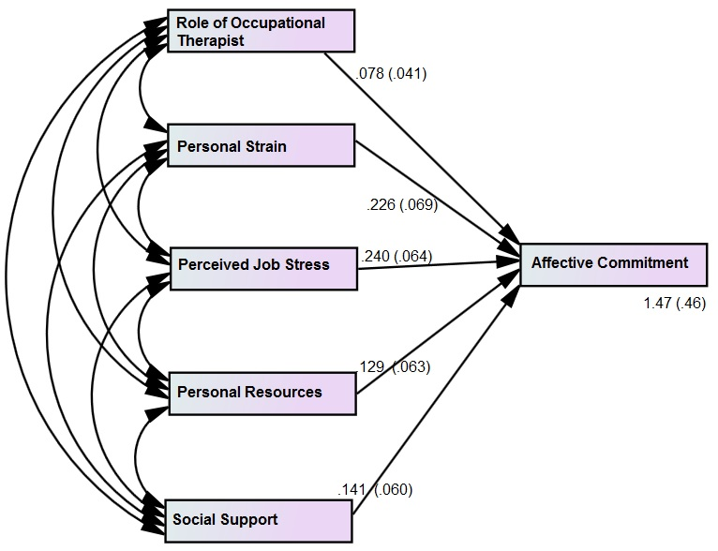United Kingdom | 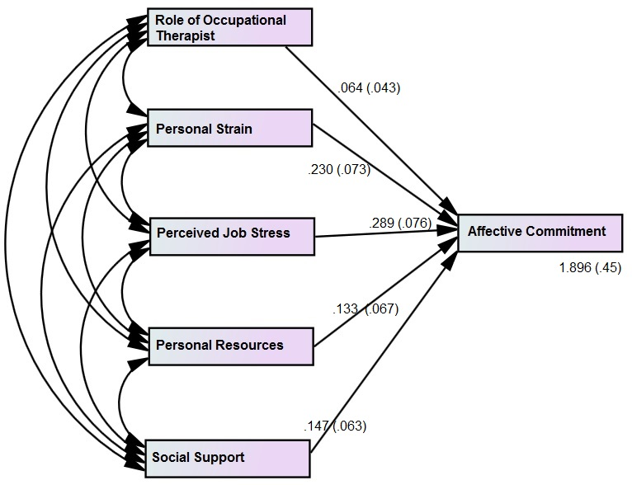  Pakistan

Figure 5. 8: Multiple regressions on the affective commitment in contrasting economies
Table 5. 34: Coefficients^{a, a,' b}
Model |  | Unstandardized Coefficients |  | Standardized Coefficients | T | Sig.
 |  | B | Std. Error | Beta | T | Sig.
 | (Constant) | 1.470 | .465 |  | 3.159 | .002
UK | Role of Occupational Therapist | .078 | .041 | .069 | 1.903 | .616
PAK | Role of Occupational Therapist | .064 | .043 | .041 | 1.488 | .070
UK | Personal Strain | .226 | .069 | .220 | 3.855 | .023
PAK | Personal Strain | .230 | .073 | .227 | 3.150 | .000
UK | Perceived Job Stress | .240 | .064 | .238 | 3.750 | .000
PAK | Perceived Job Stress | .289 | .076 | .281 | 3.802 | .002
UK | Personal Resources | .129 | .063 | .118 | 2.047 | .016
PAK | Personal Resources | .133 | .067 | .132 | 1.985 | .031
UK | Social Support | .141 | .060 | .138 | 2.350 | .011
PAK | Social Support | .147 | .063 | .139 | 2.333 | .004
a. Country = 1.0 – UK
a'. Country = 2.0 – PAK
b. Dependent Variable: Affective Commitment

The statistical test showed that the role of the occupational therapist is non-significant in determining the affective commitment of university staff in the UK and Pakistan (=0.616 > 0.05, p > α; =0.070 > 0.05, p > α; Table 5.34). Thus, this indicates that the effectiveness of the occupational therapist in relation to the affective commitment of the university staff is not statistically significant. In other words, the affective commitment of university employees is not significantly affected by the role of occupational therapist. Hence, there is no strong evidence against a null hypothesis and, therefore, fails to reject it. The present findings differ partially from the earlier work of Haque & Aston (2016), as the role of the occupational therapist is shown to be non-significant in the contrasting economies, whereas their work suggested otherwise. In addition to that, personal strain is shown to have a statistically significant impact on the affective commitment of employees in both Pakistan and the UK (=0.023 < 0.05, p < α; 0.000 < 0.05, p < α; Table 5.34). Additionally, the t-value is greater than 1.96; and, therefore, the incurred value lies in the critical region. Therefore, there is a statistically significant impact of personal strain on the AC of university staff of both Pakistan and the UK. Interestingly, the standardized coefficient β reflects the variation caused by the predictors when there is single unit deviation from the standard. In the present case, the variation is higher in Pakistan in contrast to the UK (Table 5.34). In other words, the impact of personal strain affecting the AC of university staff in Pakistan is higher than the UK. In the light of the present evidence, the findings support the earlier work of Ruiller & van der Heijden (2014) in that personal strain is significant in affecting the affective commitment of employees. However, the statistical evidence does not confirm the work of Coyle-Shapiro & Kessler (2000) in that the impact is largely negative.
Furthermore, perceived job stress is statistically significant in affecting the AC of university staff in Pakistan and the UK, as the sig-value is less than the alpha (=0.000 < 0.05, p < α; =0.002 < 0.05, p < α; Table 5.34). Hence, there is strong evidence against a null hypothesis and it is, therefore rejected. In other words, perceived job stress is highly significant in determining the affective commitment of teaching and non-teaching staff in Pakistan and the UK. In addition to that, the increase by 1 standard deviation in perceived job stress will affect approximately 0.2 AC in a directly proportional manner (UK β =.23, PAK β =.28; Table 5.34). Thus, the present findings support the work of Mark & Smith (2008) to the extent that perceived job stress has a direct impact on employees, while have striking difference with the work of Haque & Aston (2016) in that the impact does not differ in the contrasting economies.
The results confirmed that personal resources have a statistically significant impact on the affective commitment of university employees in the contrasting economies (=0.016 < 0.05, p < α; 0.031 < 0.05, p < α; Table 5.34). Hence, there is strong, statistically significant evidence against a null hypothesis. In other words, personal resources play a significant role in shaping the affective commitment of employees in a certain manner. Interestingly, the in-depth analysis revealed that the variation is higher in Pakistan in contrast to the UK, as the increase of 1 standard deviation leads to personal resources affecting AC 0.132 positively in Pakistan and 0.118 in the UK (Table 5.34). The findings of Zehra, et al., (2017a) are confirmed, to some extent, in that personal resources significantly affect AC. Moreover, from the contrasting economies’ perspective, this study is aligned with the work of Haque & Aston (2016). Additionally, Folkman & Lazarus’ (1980) model, used by Mark & Smith (2008), is supported through the present findings, as personal resources are an essential and effective aspect at the workplace in determining employees’ commitment and attitude. Moreover, the work of Xanthopoulou et al., (2007) confirmed that personal resources have a mediating role at the workplace.
Social support has a statistically significant impact on the affective commitment of university staff employees in both the UK and Pakistan (=0.011 < 0.05, p < α; 0.003 < 0.05, p < α; Table 5.34). The results indicate that social support has a vital role in affecting the affective commitment in public universities of the contrasting economies. Therefore, in the light of statistical evidence, a null hypothesis is rejected. In addition to that, 1 standard deviation increase will cause social support to positively affect the AC of university staff in Pakistan and the UK by 0.13 (Table 5.34). This partially differs with the work of Faizan & Zehra (2016) in that social support is not highly significant in affecting the organisational commitment of employees, while it supports the findings of Haque et al., (2018), Haque and Oino (2017), Haque & Aston (2016), Haque et al., (2016), and Sackey & Sanda (2011).
Table 5. 35: Model Summary^{a,c}
Model | R | R Square | Adjusted R Square | Std. Error of the Estimate
1 | .671^{b} | .491 | .413 | 1.24286
2 | .689 ^{b} | .473 | .462 | 1.12853
a. Country: 1=UK and 2=PAK
b. Predictors: (Constant), Social Support, Personal Strain, Role of Occupational Therapist, Perceived Job Stress, Personal Resources
c. Dependent Variable: Normative Commitment

Table 5. 36: ANOVA^{a,b, a' b}
Model |  | Sum of Squares | Df | Mean Square | F | Sig.
1 | Regression | 197.158 | 5 | 39.432 | 37.887 | .000^{c}
1 | Residual | 305.851 | 199 | 1.545
1 | Total | 503.010 | 204
2 | Regression  Residual  Total | 180.750 | 5  199  204 | 36.150  1.274 | 35.876 | .000^{c}
2 | Regression  Residual  Total | 252.172
2 | Regression  Residual  Total | 432.922
a. Country = 1.0 – UK
a'. Country = 2.0 – PAK
b. Dependent Variable: Normative Commitment
c. Predictors: (Constant), Social Support, Personal Strain, Role of Occupational Therapist, Perceived Job Stress, Personal Resources
Table 5.34 showed that the R² is 0.491 in the UK, reflecting 49.1% and 0.473 in Pakistan confirming 47.3%. Therefore, in both countries, an above 45% variation in normative commitment is explained by the variations in the predictors (Table 5.35). In addition to that, an F-test revealed that the table has over 35% explanatory power. Since the sig-value is significant, the model is thus a good fit for data (=0.000 < 0.05, p < α; 0.000 < 0.05, p < α; Table 5.36). Additionally, the figure below reflects the unstandardardized coefficient and standard error of each predictor on the normative commitment of university staff in the UK and Pakistan.
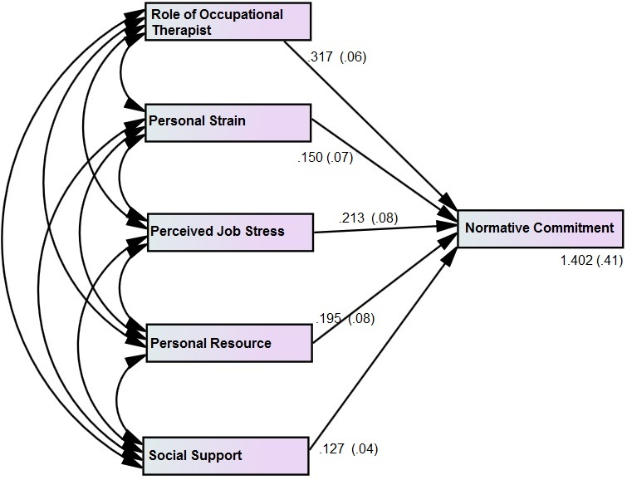  United Kingdom | 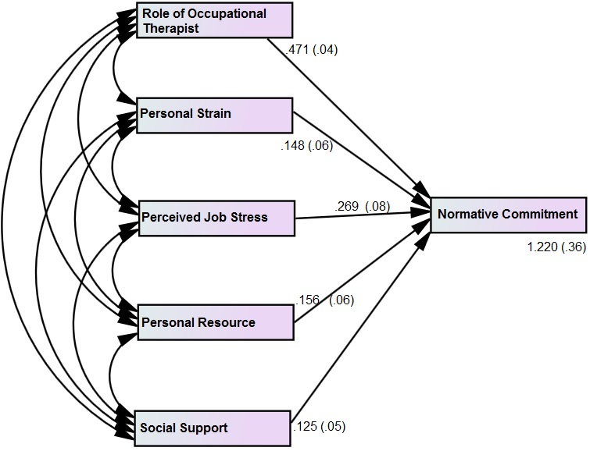  Pakistan

Figure 5. 9: Multiple regressions on the normative commitment in contrasting economies

Table 5. 37: Coefficients^{a, a,' b}
Model |  | Unstandardized Coefficients |  | Standardized Coefficients | T | Sig.
 |  | B | Std. Error | Beta | T | Sig.
 | (Constant) | 1.402 | .419 |  | 3.348 | .001
UK | Role of Occupational Therapist | .317 | .621 | .312 | .510 | .784
PAK | Role of Occupational Therapist | .471 | .43 | .408 | 1.095 | .986
UK | Personal Strain | .150 | .70 | .145 | 2.142 | .011
PAK | Personal Strain | .148 | .068 | .145 | 2.176 | .020
UK | Perceived Job Stress | .213 | .085 | .207 | 2.505 | .000
PAK | Perceived Job Stress | .269 | .083 | .251 | 3.240 | .000
UK | Personal Resources | .195 | .080 | .221 | 2.437 | .018
PAK | Personal Resources | .156 | .068 | .152 | 2.294 | .016
UK | Social Support | .127 | .040 | .117 | 3.175 | .000
PAK | Social Support | .125 | .057 | .119 | 2.192 | .032
a. Country = 1.0 – UK
a'. Country = 2.0 – PAK
b. Dependent Variable: Normative Commitment

The statistical test showed that the role of the occupational therapist is not statistically significant regarding the normative commitment of university employees in the UK and Pakistan (=0.784 > 0.05, p > α; =0.986 > 0.05, p > α; Table 5.37). Thus, a null hypothesis cannot be rejected, as there is no significant evidence against it. The finding has a striking difference with the study of Haque & Aston (2016) in that the effectiveness of the occupational therapist is significant in affecting the normative commitment of employees in the contrasting economies, as there is non-significant affect evident in the contrasting economies. Additionally, the statistical results confirmed that personal strain has a significant role in determining the normative commitment of university (teaching and administrative) staff in Pakistan and the UK (=0.020 < 0.05, p < α; 0.011 < 0.05, p < α; Table 5.37). In addition to that, the t-score is higher than 1.96, confirming that normative commitment is significantly affected by employees’ personal strain. Interestingly, an increase of 1 standard deviation will lead to personal strain positively affecting the normative commitment of university staff of the UK and Pakistan by 0.145 (Table 5.37). In this aspect, the present study confirms the earlier work of Zehra et al., (2017a) and Haque et al., (2016), whereas it differs with the findings of Zehra et al., (2017b) by confirming a statistically significant impact of personal strain on normative commitment.
Interestingly, the results showed that, statistically, perceived job stress extremely statistically significantly affects normative commitment in the contrasting economies (=0.000 < 0.05, p < α; 0.000 < 0.05, p < α; Table 5.37). There is strong evidence against a null hypothesis and, therefore, it is rejected. The results indicate that perceived job stress has a significant impact on the NC; the results also showed that the impact is higher in Pakistan in contrast to the UK as 1 standard deviation increases the NC and is affected by it up to 0.251 in Pakistan, while in the UK it is affected by it up to 0.207 (Table 5.37). The current findings support the work of Haque & Aston (2016), while oppose the work of Zehra et al., (2017b) in this regard.
Statistically, personal resources statistically significantly affect the normative commitment of teaching and non-teaching, university staff in the contrasting economies (=0.018 < 0.05, p < α; 0.016 < 0.05, p < α; Table 5.37). The results showed that the incurred value lie in the critical region and, hence, there is strong evidence against a null hypothesis. Thus, a null hypothesis is rejected. The role of personal resources is higher in the UK, as an increase of 1 standard deviation reflects over 0.221 direct variations in normative commitment, while in Pakistan it is 0.152 (Table 5.37). Thus, the work of Haque et al., (2018), Haque & Aston (2016) and Haque et al., (2016) is supported while, to some extent, the findings of Yilmaz, Özer & Günlük (2014) are contradicted by the present findings. he normative commitment of teaching and non-teaching (administrative) staff is statistically significantly affected by social support in the UK and Pakistan (=0.000 < 0.05, p < α; 0.032 < 0.05, p < α; Table 5.37). Additionally, the t-score is higher than 1.96, indicating that the impact is statistically significant. A null hypothesis is rejected owing to strong, statistical evidence against it. Furthermore, social support positively affects normative commitment by over 0.11 with an increase of 1 unit of standard deviation. Thus, this study supports the work of Haque et al., (2018), Haque & Aston (2016) to a large extent and indirectly supports the work of Sackey & Sanda (2008) in that social support at a workplace is vital for employees to be committed to their respective organisations.
Table 5. 38: Model Summary^{a,c}
Model | R | R Square | Adjusted R Square | Std. Error of the Estimate
1 | .479^{b} | .443 | .373 | 1.30505
2 | .563 ^{b} | .417 | .390 | 1.28090
a. Country: 1=UK and 2=PAK
b. Predictors: (Constant), Social Support, Personal Strain, Role of Occupational Therapist, Perceived Job Stress, Personal Resources
c. Dependent Variable: Continuance Commitment
Table 5. 39: ANOVA^{a,b, a' b}
Model |  | Sum of Squares | Df | Mean Square | F | Sig.
1 | Regression | 180.702 | 5 | 36.140 | 34.437 | .000^{c}
1 | Residual | 337.225 | 199 | 1.703
1 | Total | 517.926 | 204
2 | Regression  Residual  Total | 181.068 | 5  199  204 | 36.214  1.641 | 36.573 | .000^{c}
2 | Regression  Residual  Total | 324.859
2 | Regression  Residual  Total | 505.926
a. Country = 1.0 – UK
a'. Country = 2.0 – PAK
b. Dependent Variable: Continuance Commitment
c. Predictors: (Constant), Social Support, Personal Strain, Role of Occupational Therapist, Perceived Job Stress, Personal Resources
The 44.3% variation in continuance commitment in the UK is explained by the predictors considered in this study, while the same predictors explained a 41.7% variation in continuance commitment in Pakistan (Table 5.38). Additionally, the F-score for the UK is 34.4, reflecting a 34.4% explanatory power of the model, while in Pakistan the explanatory power is 36.5%. In addition to that, the sig-value is significant for both models, confirming that the model is acceptable, as these are a good fit for the data (=0.000 < 0.05, p < α; 0.000 < 0.05, p < α; Table 5.39).
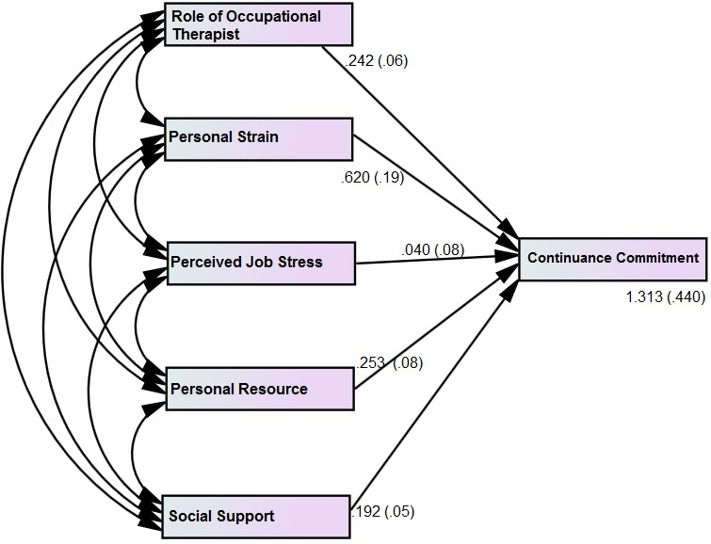  United Kingdom | 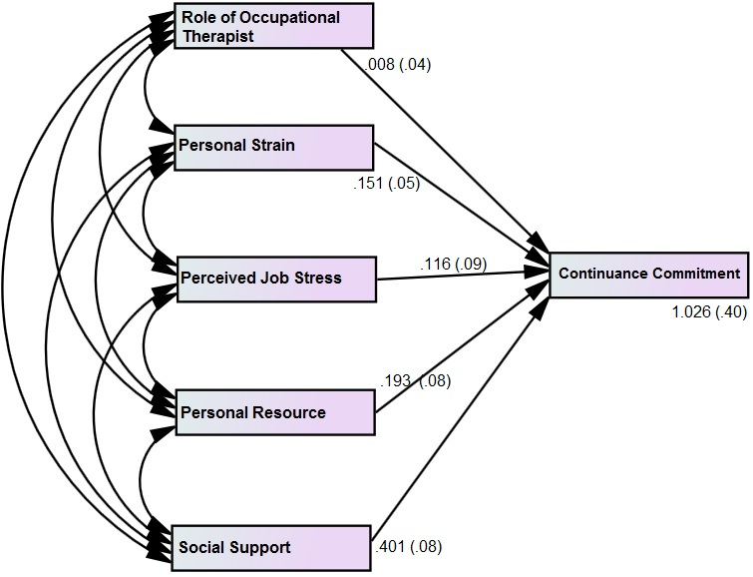  Pakistan
Figure 5. 10: Multiple regressions on the continuance commitment in contrasting economies

Table 5. 40: Coefficients^{a, a,' b}
Model |  | Unstandardized Coefficients |  | Standardized Coefficients | T | Sig.
 |  | B | Std. Error | Beta | T | Sig.
 | (Constant) | 1.313 | .440 |  | 2.986 | .003
UK | Role of Occupational Therapist | .242 | .065 | .232 | 1.406 | .180
PAK | Role of Occupational Therapist | .008 | .048 | .010 | .161 | .872
UK | Personal Strain | .620 | .193 | .553 | 3.212 | .030
PAK | Personal Strain | .151 | .053 | .136 | 2.849 | .021
UK | Perceived Job Stress | .040 | .089 | .037 | .445 | .136
PAK | Perceived Job Stress | .116 | .094 | .090 | 1.229 | .220
UK | Personal Resources | .253 | .084 | .241 | 3.011 | .000
PAK | Personal Resources | .193 | .086 | .182 | 2.248 | .026
UK | Social Support | .192 | .056 | .087 | 3.428 | .000
PAK | Social Support | .401 | .081 | .404 | 4.930 | .000
a. Country = 1.0 – UK
a'. Country = 2.0 – PAK
b. Dependent Variable: Continuance Commitment

The role of the occupational therapist is non-significant in relation to the continuance commitment of employees in the contrasting economies (=0.18 > 0.05, p > α; =0.872 > 0.05, p > α; Table 5.40). In other words, the continuance commitment of university staff in the UK and Pakistan is not statistically significantly determined by the role of the occupational therapist. Hence, a null hypothesis cannot be rejected. This finding, therefore, differs from the earlier work of Haque & Aston (2016) in terms of contrasting economies. Thus, statistically the effectiveness of the occupational therapist cannot be established in determining the continuance commitment of employees working at public universities in the UK and Pakistan. Interestingly, personal strain is statistically significant in affecting the continuance commitment of employees in both countries (=0.030 < 0.05, p < α; 0.021 < 0.05, p < α; Table 5. 40). Hence, the findings support the work of Haque et al., (2018), Haque & Oino (2017), and Haque & Aston (2016) in the contrasting economies perspective but differs with the work of Zehra et al., (2017b) on general grounds.
In addition to that, the impact varies in the contrasting economies as evident that 0.553 direct effect of personal strain on the CC of university staff in the UK, while 0.136 in Pakistan with an increase of 1 standard deviation (Table 5. 40). Perceived job stress has a non-significant impact on the continuance commitment of university staff in the contrasting economies (=0.136 > 0.05, p > α; 0.220 > 0.05, p > α; Table 5. 40). In other words, perceived job stress does not affect the continuance commitment of the employees in the contrasting economies in a significant manner. A null hypothesis cannot be rejected, as there is no significant evidence against it. Therefore, the work of Haque & Aston (2016) is opposed by the results of this research, while the findings of Zehra et al., (2017b) are supported. Moreover, personal resources are statistically significantly interlinked with the continuance commitment of university staff in the UK and Pakistan (=0.000 < 0.05, p < α; =0.026 < 0.05, p < α; Table 5. 40). In other words, personal resources have a significant impact on CC. Thus, a null hypothesis is rejected, as there is strong evidence against it. Personal resources affect CC by 0.241 in the UK, while in Pakistan they affect CC by 0.182 with the increase in the standard deviation by 1 unit. This indicates that the role is highly statistically significant. Therefore, the findings are aligned with the work of Haque et al., (2018), Zehra, et al., (2017a) and Haque & Aston (2016). Social support has an extremely significant impact on the continuance commitment of university staff in both the UK and Pakistan. A null hypothesis is rejected owing to strong statistical evidence (=0.000 < 0.05, p < α; 0.000 < 0.05, p < α; Table 5. 40). Hence, in this regard, the present findings are aligned with the work of Haque et al., (2018), Haque & Oino (2017), Haque & Aston (2016), while it differs with the work of Faizan & Zehra (2017). Nevertheless, the statistical results showed different aspects but still there is a need to examine the visibility of the contrasting attributes in the contrasting economies.
Table 5. 41: Group Statistics
 | Country | N | Mean | Std. Deviation | Variance
Representation of Occupational Therapist | United Kingdom | 204 | .3040 | .21869 | .074
Representation of Occupational Therapist | Pakistan | 204 | .3984 | .27161 | .048
Effectiveness of Occupational Therapist | United Kingdom | 204 | 3.2467 | 1.4987 | 3.85
Effectiveness of Occupational Therapist | Pakistan | 204 | 3.5964 | 1.9620 | 2.24
Personal Strain | United Kingdom | 204 | 3.8529 | 1.2603 | 1.64
Personal Strain | Pakistan | 204 | 3.7761 | 1.2812 | 1.58
Perceived Job Stress | United Kingdom | 204 | 3.8799 | 1.1954 | 1.77
Perceived Job Stress | Pakistan | 204 | 3.6732 | 1.3312 | 1.42
Personal Resources | United Kingdom | 204  204 | 3.5906  3.4436 | 1.4376  1.4948 | 2.23  2.06
Personal Resources | Pakistan
Social Support | United Kingdom | 204  204 | 3.7426  3.6765 | 1.5412  1.3585 | 1.84  2.37
Social Support | Pakistan
Affective Commitment | United Kingdom | 204 | 3.9583 | 1.5188 | 1.51
 | Pakistan | 204 | 3.6103 | 1.6368 | 1.63
Normative Commitment | United Kingdom | 204 | 3.9804 | 1.3187 | 1.31
 | Pakistan | 204 | 3.4510 | 1.2806 | 1.28
Continuance Commitment | United Kingdom | 204 | 3.6324 | 1.4348 | 1.43
Continuance Commitment | Pakistan | 204 | 3.3676 | 1.5311 | 1.53

The results showed that the rate of occupational therapist representation in the UK is higher in contrast to Pakistan, as the mean value is relatively lower (=0.3040 < 0.3984, Table 5.41). In other words, rate of representation of the occupational therapist is higher at universities in the UK (developed economy) in contrast to Pakistan (emerging economy). In addition to that, the effectiveness of the occupational therapist was evaluated in the universities of the contrasting economies. Results revealed that the mean value for the UK is lower than that of Pakistan and, hence, the visibility of effectiveness is higher in the UK, in contrast to Pakistan, despite the overall evidence showing that it is not highly effective, to a large extent (=3.2467 < 3.5964, Table 5.41). Moreover, personal strain is more visible in the university staff of Pakistan (emerging economy), in contrast to the UK (developed economy), as the mean score is lower (=3.7761 < 3.85929, Table 5.41). Nevertheless, there is only fractional difference of personal strain in the two contrasting economies. Similarly, perceived job stress is higher in Pakistan, in contrast to UK (3.6732 < 3.8799, Table 5.41). Hence, perceived job stress among the university staff of Pakistan is more visible, in contrast to the UK.
Personal resources are more visible in Pakistan than in the UK (=3.4436 < 3.5906, Table 5.41). This indicates that personal resources are used more by both teaching and non-teaching staff in Pakistan, in contrast to the UK. In addition, social support at the universities in Pakistan is significantly visible, in contrast to the UK (=3.6756 < 3.7426, Table 5.41). Thus, social support is used more constructively by employees in the Pakistani universities, in contrast to the UK. Furthermore, the organisational commitment’s antecedents were examined in terms of visibility in the contrasting economies. Results showed that continuance commitment is highly visible, in contrast to affective and normative commitment, in Pakistan because it is the lowest of the three (CC=3.3676 < NC=3.4510 < AC=3.6103, Table 5.41). Moreover, the dimensions of organisational commitment are more visible in Pakistan than in the UK (AC=3.6103 < 3.9583, NC=3.4510 < 3.9804, CC=3.3676 < 3.6324, Table 5.41). Thus, in this regard and to a certain extent, the present findings support the work of Haque & Aston (2016), while differ from the work of Haque et al., (2018), as the AC is higher in the developing country, in contrast to the developed country.
In addition, considering the presence of all types of commitment despite stress, present findings to some extent opposed the work of Danish et al., (2015) and Khatibi et al., (2009) while support the work of Chaudhry (2012) and Jackson & Rothman (2006). Nevertheless, regarding all three dimensions of OC, this study differs from the work of Haque & Aston (2016) in that the UK has a higher AC, NC and CC than Pakistan. However, that study mostly covered the IT sector, whereas the present findings are from the education sector. Moreover, the IT sector was mostly privately owned, while the education sector is a public sector. Hence, it is concluded that the antecedents’ visibility and degree vary from sector to sector in terms of nature and type. In other words, the dynamics of the sector have a role in creating variation in overall organisational commitment. Another important notion is that the study of Haque & Aston (2016) has higher responses from inexperienced graduates, while here the majority of the respondents were experienced and in the 40 to 60 years age bracket.

5.2.8.2 Predictors and Organisational commitments’ antecedents - Contrasting Genders
Table 5. 42: Model Summary^{a,c}
Model | R | R Square | Adjusted R Square | Std. Error of the Estimate
1 | .501^{b} | .451 | .419 | 1.27687
2 | .488^{b} | .436 | .402 | 1.33841
a. Gender: 1=Male and 2=Female
b. Predictors: (Constant), Social Support, Personal Strain, Role of Occupational Therapist, Perceived Job Stress, Personal Resources
c. Dependent Variable: Affective Commitment

Table 5. 43: ANOVA^{a,b, a' b}
Model |  | Sum of Squares | Df | Mean Square | F | Sig.
1 | Regression | 108.069 | 5 | 21.614 | 19.257 | .000^{c}
1 | Residual | 332.817 | 199 | 1.630
1 | Total | 430.886 | 204
2 | Regression  Residual  Total | 95.254 | 5  197  202 | 19.051  1.791 | 17.260 | .000^{c}
2 | Regression  Residual  Total | 352.827
2 | Regression  Residual  Total | 448.081
a. Gender = 1.0 – Male
a'. Gender = 2.0 – Female
b. Dependent Variable: Affective Commitment
c. Predictors: (Constant), Social Support, Personal Strain, Role of Occupational Therapist, Perceived Job Stress, Personal Resources
In the above tables, the option of ‘preferred not to say’ is discarded because only those responses with an identified gender are considered for exploring the perspective in terms of gender. The R² is over 40% for both male and female, reflecting that the predictors explain 40% variation in the dependent variable in both genders (Table 5.42). In addition to that, the F-score reflects over 15% explanatory power for males and females, while the sig-value is statistically significant and, therefore, the model is a good fit for the data (Table 5.43).
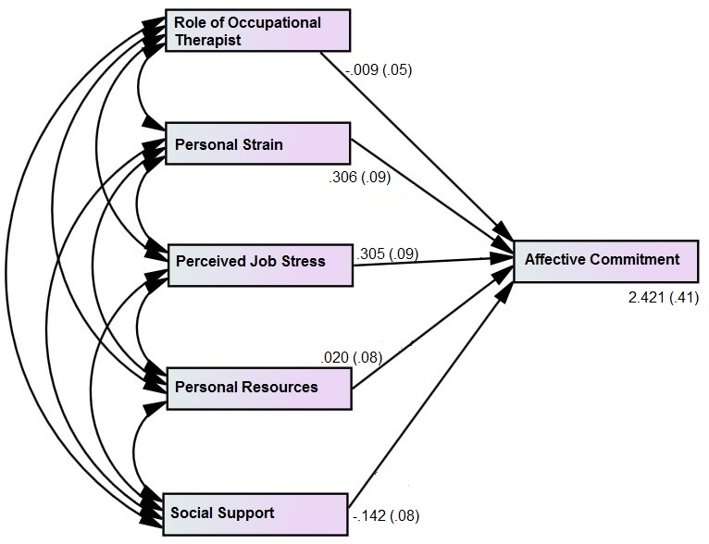Male | 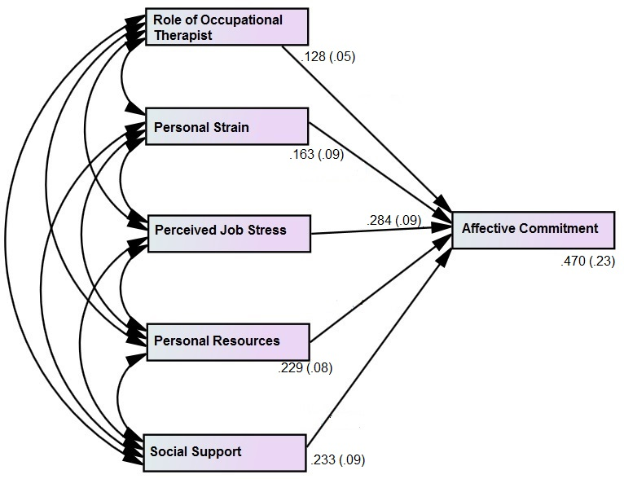Female

Figure 5. 11: Multiple regressions on the affective commitment in contrasting genders.
Table 5. 44: Coefficients^{a, a,' b}
Model |  | Unstandardized Coefficients |  | Standardized Coefficients | T | Sig.
 |  | B | Std. Error | Beta | T | Sig.
 | (Constant) | 2.421 | .415 |  | 5.832 | .000
Male | Role of Occupational Therapist | -.009 | .055 | -.011 | -.158 | .875
Female | Role of Occupational Therapist | .128 | .057 | .150 | 2.247 | .026
Male | Personal Strain | .306 | .091 | .273 | 3.360 | .001
Female | Personal Strain | .163 | .098 | .136 | 1.671 | .096
Male | Perceived Job Stress | .305 | .096 | .257 | 3.186 | .002
Female | Perceived Job Stress | .284 | .092 | .250 | 3.080 | .002
Male | Personal Resources | .020 | .087 | .020 | .227 | .821
Female | Personal Resources | .229 | .086 | .223 | 2.538 | .001
Male | Social Support | .242 | .085 | .239 | 2.847 | .009
Female | Social Support | .233 | .091 | .230 | 2.560 | .001
a. Gender = 1.0 – Male
a'. Gender = 2.0 – Female
b. Dependent Variable: Affective Commitment

The results showed that effectiveness of the occupational therapist significantly affects the affective commitment of the females, while it is non-significant for males (=0.025 < 0.05, p < α; =0.875 > 0.05, p > α; Table 5.44). Hence, this indicates that effectiveness of the occupational therapist affects the AC of females to a significant level but does not have any significant role in determining it for males. In this aspect, the study supports the work of Haque et al., (2016) in that females use the occupational therapist’s counselling in a more effective manner, in contrast to their counterparts. Interestingly, the perceived strain is statistically significant in affecting the AC of males, while it is non-significant for females (=0.001 < 0.05, p < α; =0.096 > 0.05, p > α; Table 5.44). A null hypothesis cannot be rejected. This study, therefore, supports the work of Haque et al., (2016), while it differs from the notion of Sackey & Sanda (2011) and Brannon & Fiest (1992) that males deal with personal strain more effectively than females, owing to adaptive response. In other words, females are more effective in ensuring that personal strain does not affect their emotional attachment to an organisation.
Moreover, it is evident that perceived job stress has a statistically significant impact on the AC of the contrasting genders (=0.002 < 0.05, p < α; =0.002 < 0.05, p < α; Table 5.44). Hence, a null hypothesis is rejected. Interestingly, the present findings contradict the work of Sackey & Sanda (2011), Kumasey et al., (2014), Haque et al., (2016) and Haque et al., (2018) by confirming that perceived job stress affects the AC of male and female university staff in the contrasting economies. The statistical tests also revealed that personal resources affect the females’ AC, while they do not affect males’ AC in a significant manner (=0.001 < 0.05, p < α; =0.821 > 0.05, p > α; Table 5.44). Hence, a null hypothesis cannot be rejected because personal resources have a significant role in determining the females’ AC, in contrast to males. In other words, females use personal resources in a more constructive manner, in contrast to their counterparts at a public university. Thus, this study supports, to a large extent, the work of Haque et al., (2016) and Sackey & Sanda (2011), while it differs from the work of Kumasay et al., (2014) in that the AC of males and females are similarly affected, owing to personal resources. Social support plays a statistically significantly role in affecting the AC of males and females (=0.009 < 0.05, p < α; 0.001 < 0.05, p < α; Table 5.44). Hence, there is strong evidence against a null hypothesis. Since the obtained value for females is lower than that for males, this indicates that social support is more constructively used by females, in contrast to their counterparts, in shaping AC. Hence, this study supports the work of Haque et al., (2018), Haque et al., (2016), Haque & Aston (2016) and Sackey & Sanda (2011), while it differs from the work of Kumasey et al., (2014).
Table 5. 45: Model Summary^{a,c}
Model | R | R Square | Adjusted R Square | Std. Error of the Estimate
1 | .479^{b} | .423 | .411 | 1.18239
2 | .442^{b} | .420 | .375 | 1.18336
a. Gender: 1=Male and 2=Female
b. Predictors: (Constant), Social Support, Personal Strain, Role of Occupational Therapist, Perceived Job Stress, Personal Resources
c. Dependent Variable: Normative Commitment

Table 5. 46: ANOVA^{a,b, a' b}
Model |  | Sum of Squares | Df | Mean Square | F | Sig.
1 | Regression | 82.67 | 5 | 16.521 | 15.124 | .000^{c}
1 | Residual | 276.815 | 199 | 1.398
1 | Total | 359.422 | 204
2 | Regression  Residual  Total | 67.361 | 5  197  202 | 16.472  1.412 | 15.060 | .000^{c}
2 | Regression  Residual  Total | 275.792
2 | Regression  Residual  Total | 342.153
a. Gender = 1.0 – Male
a'. Gender = 2.0 – Female
b. Dependent Variable: Normative Commitment
c. Predictors: (Constant), Social Support, Personal Strain, Role of Occupational Therapist, Perceived Job Stress, Personal Resources
The model summary revealed that over 40% of the variations in the NC of the contrasting genders is explained by the variation in the predictors (Table 5.45). Additionally, the F-test revealed that a 15% acceptable explanatory power of the model is significant, reflecting that the model is a good fit for data (Table 5.46).
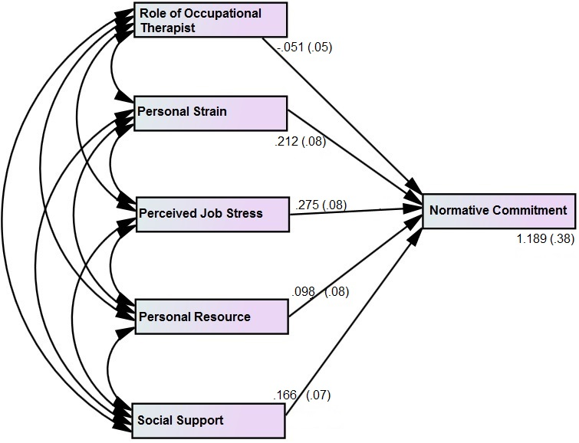  Male | 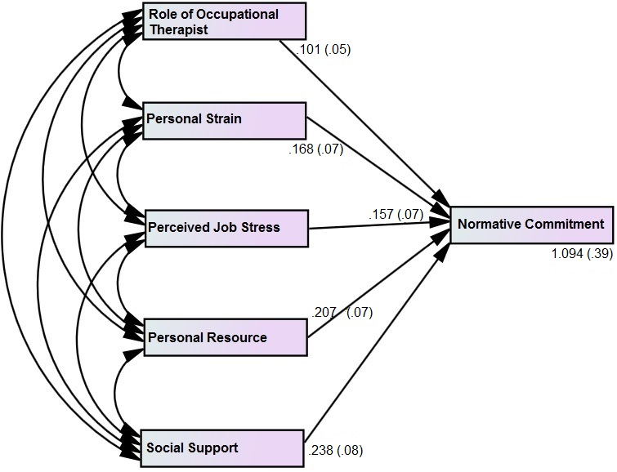  Female

Figure 5. 12: Multiple regressions on the normative commitment in contrasting genders.
Table 5. 47: Coefficients^{a, a,' b}
Model |  | Unstandardized Coefficients |  | Standardized Coefficients | T | Sig.
 |  | B | Std. Error | Beta | T | Sig.
 | (Constant) | 1.189 | .384 |  | 3.094 | .002
Male | Role of Occupational Therapist | -.051 | .051 | -.068 | -1.001 | .318
Female | Role of Occupational Therapist | .101 | .050 | .133 | 2.003 | .047
Male | Personal Strain | .212 | .084 | .208 | 2.515 | .013
Female | Personal Strain | .168 | .079 | .064 | 2.127 | .031
Male | Perceived Job Stress | .275 | .089 | .253 | 3.100 | .002
Female | Perceived Job Stress | .157 | .078 | .155 | 2.013 | .046
Male | Personal Resources | .098 | .081 | .108 | 1.206 | .229
Female | Personal Resources | .207 | .076 | .222 | 2.732 | .007
Male | Social Support | .166 | .078 | .186 | 2.121 | .035
Female | Social Support | .238 | .081 | .139 | 2.938 | .002
a. Gender = 1.0 – Male
a'. Gender = 2.0 – Female
b. Dependent Variable: Normative Commitment

Statistical tests revealed that the role of the occupational therapist is statistically significant in affecting females’ normative commitment, while it is non-significant for their counterparts (=0.047 < 0.05, p < α; =0.318 > 0.05, p > α; Table 5.47). This indicates that a null hypothesis is rejected in the light of the contrasting findings. Moreover, the females find the role of occupational therapist more effective, in contrast to males. Hence, the study supports the work of Haque et al., (2016). In addition, personal strain is statistically significantly affecting NC of the contrasting genders. In other words, personal strain affects the normative commitment of males and females in a significant manner. A null hypothesis is rejected owing to strong evidence against it (=0.013 < 0.05, p < α; =0.031 < 0.05, p < α; Table 5.47). Nevertheless, the NC of males is fractionally higher in significance than that of the females. Hence, in this regard, the present study supports the work of Haque et al., (2016), Sackey & Sanda (2011) and Brannon & Fiest (1992).
Interestingly, the perceived job stress is evident to statistically significantly affecting the normative commitment of males and females working at the public university (=0.002 < 0.05, p < α; =0.046 < 0.05, p < α; Table 5.47). Hence, in light of the statistical results, a null hypothesis is rejected. In other words, perceived job stress has a statistically significant role in determining the normative commitment of the contrasting genders. Thus, the present findings are strikingly different to the work of Haque et al., (2018), Haque et al., (2016), Kumasey et al., (2014), and Sackey & Sanda (2011). Personal resources have a statistically significant role in shaping the normative commitment of females but have a non-significant impact on male employees working at the universities. Thus, a null hypothesis cannot be rejected (=0.007 < 0.05, p < α; =0.229 > 0.05, p > α, Table 5.47). The contrasting results indicate that the present findings differ from the work of Kumasey et al., (2014) but are aligned with the findings of Sackey & Sanda (2011), to a large extent. Moreover, the results confirmed that social support has a statistically significant role in affecting the normative commitment of the contrasting genders working in the universities of the UK and Pakistan. There is strong evidence against a null hypothesis and, therefore, it is rejected (=0.035 < 0.05, p < α; =0.002 < 0.05, p < α; Table 5.47). Partially, the study supports the earlier work of Sackey & Sanda (2011) but differs from the work of Haque et al., (2016) and Kumasey et al., (2014).

Table 5. 48: Model Summary^{a,c}
Model | R | R Square | Adjusted R Square | Std. Error of the Estimate
1 | .538^{b} | .429 | .372 | 1.25888
2 | .658^{b} | .434 | .411 | 1.29533
a. Gender: 1=Male and 2=Female
b. Predictors: (Constant), Social Support, Personal Strain, Role of Occupational Therapist, Perceived Job Stress, Personal Resources
c. Dependent Variable: Continuance Commitment

Table 5. 49: ANOVA^{a,b, a' b}
Model |  | Sum of Squares | Df | Mean Square | F | Sig.
1 | Regression | 127.885 | 5 | 25.577 | 23.992 | .000^{c}
1 | Residual | 315.415 | 199 | 1.585
1 | Total | 443.300 | 204
2 | Regression  Residual  Total | 88.620 | 5  197  202 | 17.724  1.232 | 16.492 | .000^{c}
2 | Regression  Residual  Total | 242.704
2 | Regression  Residual  Total | 331.324
a. Gender = 1.0 – Male
a'. Gender = 2.0 – Female
b. Dependent Variable: Continuance Commitment
c. Predictors: (Constant), Social Support, Personal Strain, Role of Occupational Therapist, Perceived Job Stress, Personal Resources

The model summary reflects that the mode is a good fit for the data, as over 40% of the variations in the dependent variable are explained by the variations in the predictors (Table 5.48). Moreover, the explanatory power is acceptable for the contrasting genders and the model is statistically significant (Table 5.49).
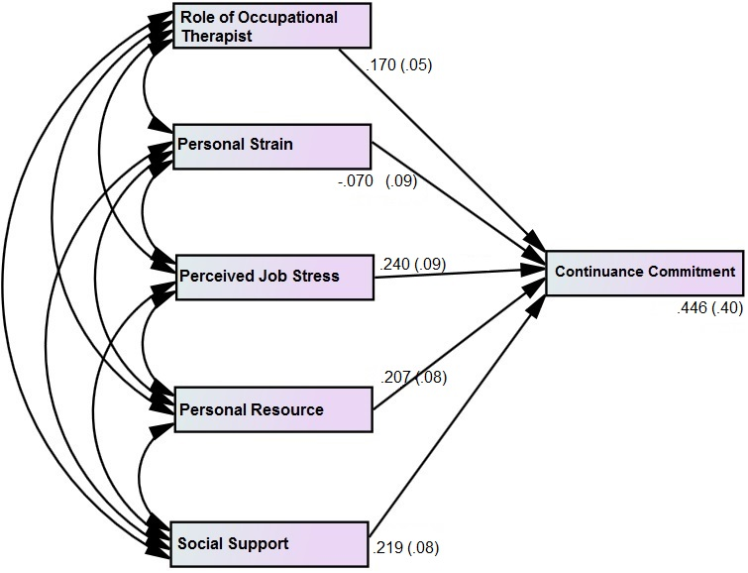  Male | 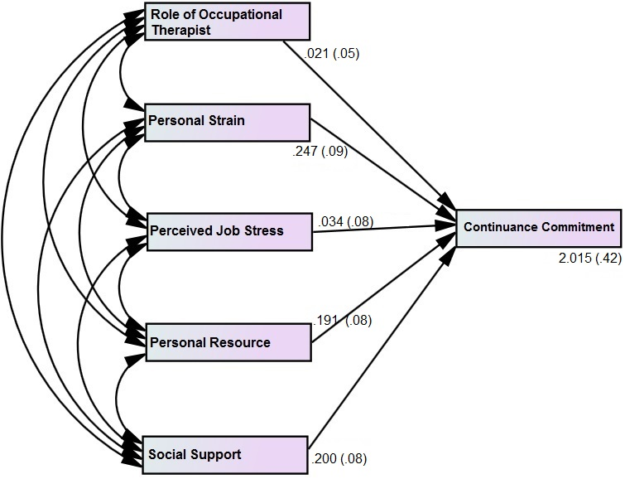  Female

Figure 5. 13: Multiple regressions on the continuance commitment in contrasting genders.
Table 5. 50: Coefficients^{a, a,' b}
Model |  | Unstandardized Coefficients |  | Standardized Coefficients | T | Sig.
 |  | B | Std. Error | Beta | T | Sig.
 | (Constant) | .446 | .409 |  | 1.089 | .277
Male | Role of Occupational Therapist | .170 | .054 | .206 | 3.153 | .002
Female | Role of Occupational Therapist | .021 | .055 | .026 | .380 | .704
Male | Personal Strain | -.070 | .090 | -.062 | -.782 | .435
Female | Personal Strain | .247 | .094 | .241 | 2.627 | .002
Male | Perceived Job Stress | .240 | .095 | .199 | 2.534 | .012
Female | Perceived Job Stress | .034 | .089 | .032 | .386 | .700
Male | Personal Resources | .207 | .086 | .207 | 2.404 | .017
Female | Personal Resources | .191 | .083 | .195 | 2.313 | .022
Male | Social Support | .219 | .083 | .222 | 2.632 | .009
Female | Social Support | .200 | .088 | .191 | 2.265 | .025
a. Gender = 1.0 – Male
a'. Gender = 2.0 – Female
b. Dependent Variable: Continuance Commitment

The statistical results showed that the continuance commitment of male employees is significantly affected by the role of the occupational therapist, while females’ CC is not significantly affected. Hence, there is strong evidence to suggest that the effectiveness of the occupational therapist is higher for males’ CC, in contrast to their counterparts (=0.002 < 0.05, p < α; =0.704 > 0.05, p > α; Table 5.50). This finding, therefore, differs from the previous work of Haque et al., (2018), Haque et al., (2016) and Haque & Aston (2016) who argued that females find occupational therapists more effective, which improves their continuance commitment. In addition to that, personal strain statistically significant affect the females’ continuance commitment, while it has a non-significant effect on males’ CC (=0.002 < 0.05, p < α; =0.435 > 0.05, p > α; Table 5.50). In other words, personal strain differs in its effect on the continuance commitment of males and females. This indicates that its impact is significant in determining females’ CC. Hence, in this regard, this study partially differs from the work of Haque & Aston (2016) by confirming that females experiencing higher personal strain affect their continuance commitment in contrast to males.
Additionally, perceived job stress has a statistically significant effect on males’ CC, while it has a non-significant impact on females’ CC (=0.012 < 0.05, p < α; =0.700 > 0.05, p > α; Table 5.50). Hence, it reflects that there is no evidence against a null hypothesis. This also reflects that perceived job stress causes males CC to decline, while females’ CC does not. Therefore, this study supports the work of Haque & Yamoah (2014), Haque & Aston (2016), Haque et al., (2016) and Haque et al., (2018), while it differs from the work of Hemdi (2009) and Kumasey et al., (2014). Interestingly, personal resources are evident to statistically significantly affect the continuance commitment of the contrasting genders. A null hypothesis is rejected owing to strong evidence against it (=0.017 < 0.05, p < α; =0.022 < 0.05, p < α; Table 5.50). In other words, personal resources affect the continuance commitment of the contrasting genders in a significant manner. The present finding supports the work of Haque & Aston (2016), while it differs from the work of Kumasey et al., (2014). Moreover, social support has a statistically significant effect on the continuance commitment of the contrasting genders (=0.009 < 0.05, p < α; =0.025 < 0.05, p < α; Table 5.50). Hence, in the light of the evidence, a null hypothesis is rejected. In other words, social support significantly affects the continuance commitment of male and female employees in a distinctive manner. Therefore, the present study supports the work of Haque & Aston (2016), Haque et al., (2016) and Haque et al., (2018), while it partially differs from the work of Kumasey et al., (2014).
Since, two respondents did not disclose their gender, these are, therefore, excluded by only considering male and female responses to measure the visibility of the predictors.
Table 5. 51: Group Statistics
 | Gender | N | Mean | Std. Deviation | Variance
Representation of Occupational Therapist | Male | 204 | .3284 | .25249 | .064
Representation of Occupational Therapist | Female | 202 | .2486 | .24865 | .062
Effectiveness of Occupational Therapist | Male | 204 | 3.5264 | 1.7872 | 3.19
Effectiveness of Occupational Therapist | Female | 202 | 3.3203 | 1.7215 | 2.96
Personal Strain | Male | 204 | 3.9853 | 1.3023 | 1.69
Personal Strain | Female | 202 | 3.6403 | 1.2206 | 1.49
Perceived Job Stress | Male | 204 | 3.9330 | 1.224 | 1.49
Perceived Job Stress | Female | 202 | 3.6196 | 1.2897 | 1.66
Personal Resources | Male | 204  202 | 3.9985  3.8391 | 1.4725  1.3085 | 2.16  1.95
Personal Resources | Female
Social Support | Male | 204  202 | 3.3284  3.0842 | 1.4896  1.3983 | 2.21  1.71
Social Support | Female
Affective Commitment | Male | 204 | 3.1708 | 1.4569 | 2.12
 | Female | 202 | 4.4044 | 1.4649 | 2.14
Normative Commitment | Male | 204 | 3.8137 | 1.3306 | 1.71
 | Female | 202 | 3.6287 | 1.3085 | 1.71
Continuance Commitment | Male | 204 | 3.9356 | 1.4750 | 2.17
Continuance Commitment | Female | 202 | 3.0637 | 1.3743 | 1.88

The results revealed that the rate of representation of the occupational therapist is more preferred by females, in contrast to males (=0.2486 < 0.3284, Table 5.51). Moreover, the effectiveness of the occupational therapist in the education sector is more evident among females, in contrast to males (=3.3203 < 3.5264, Table 5.51). The mean difference is significant and, thus, reflects that the visibility of the professional occupational therapists’ effectiveness is more evident among female university staff, in contrast to males. Interestingly, personal strain is more evident among female employees, in contrast to males (=3.6403 < 3.9585, Table 5.51). Thus, the findings revealed that personal strain is higher in females, in contrast to organisational strain. The earlier chi-square results also revealed that personal strain is higher in females. In addition to that, perceived job stress is also evident highly among female employees, in contrast to male workers, irrespective of the types of faculty and economy (=3.6196 < 3.9985, Table 5.51).
Interestingly, the test revealed that females make more effective use of personal resources than males (=3.8391 < 3.9985, Table 5.51). In other words, females working in universities are using personal resources more frequently in order to deal with different types of stressors, in contrast to males. Moreover, the mean difference is significant between males and females regarding the effective use of social support at the workplace (=3.0842 < 3.3284, Table 5.51). Therefore, there is statistical evidence to confirm that preference, usage and visibility of social support is higher among female employees, in contrast to male employees, at universities. Considering the antecedents of organisational commitment, the statistical analysis revealed that affective commitment is highly visible among males (=3.1708 < 4.4044, Table 5.51), whereas normative commitment and continuance commitment is higher among female employees, in contrast to their counterparts (NC=3.6287 < 3.8137, CC=3.0637 < 3.9356, Table 5.51). Hence, the types of organisational commitment vary among the contrasting genders, as NC and CC are highly visible among females, while AC is higher in male employees. The present findings support the work of Haque & Yamoah (2014) in that AC is higher among males, while NC and CC are higher among females and, thus, these results differ from the work of Haque & Aston (2016) and Haque et al., (2016).

5.2.8.3 Predictors and Organisational commitments’ antecedents - Contrasting Faculties
Table 5. 52: Model Summary^{a,c}
Model | R | R Square | Adjusted R Square | Std. Error of the Estimate
1 | .517^{b} | .427 | .382 | 1.30200
2 | .448^{b} | .420 | .381 | 1.49870
a. Faculty: 1=Teaching and 2=Non-teaching (administrative)
b. Predictors: (Constant), Social Support, Personal Strain, Role of Occupational Therapist, Perceived Job Stress, Personal Resources
c. Dependent Variable: Affective Commitment

Table 5. 53: ANOVA^{a,b, a' b}
Model |  | Sum of Squares | Df | Mean Square | F | Sig.
1 | Regression | 122.145 | 5 | 24.429 | 14.41.992 | .000^{c}
1 | Residual | 337.305 | 199 | 1.695
1 | Total | 459.450 | 204
2 | Regression  Residual  Total | 111.957 | 5  199  204 | 22.391  2.246 | 9.969 | .000^{c}
2 | Regression  Residual  Total | 446.954
2 | Regression  Residual  Total | 558.911
a. Faculty = 1.0 – Teaching
a'. Faculty = 2.0 - Non-teaching (administrative)
b. Dependent Variable: Affective Commitment
c. Predictors: (Constant), Social Support, Personal Strain, Role of Occupational Therapist, Perceived Job Stress, Personal Resources

The model summary reflects that 42% of the variation in the dependent variables is explained by variations in the predictors (Table 5.52). Moreover, the explanatory power is acceptable, as the value is statistically significant (Table 5.53).
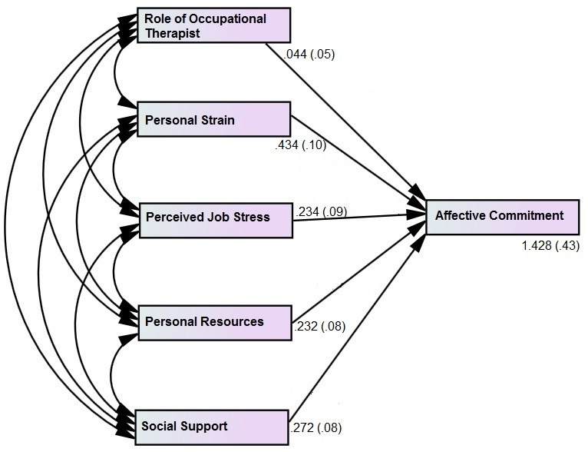  Teaching | 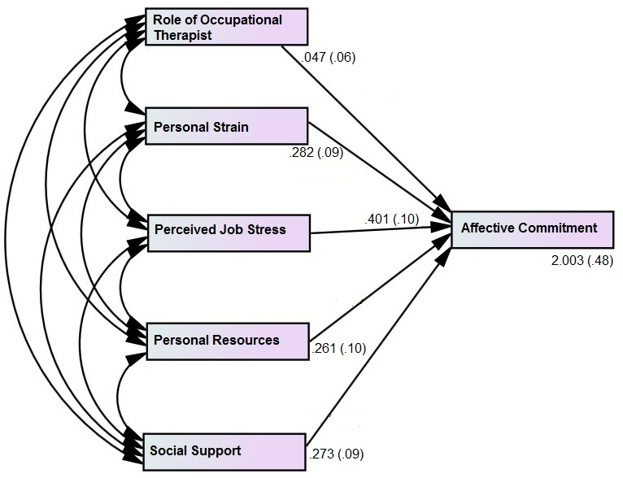  Non-teaching (Administrative)

Figure 5. 14: Multiple regressions on the affective commitment in contrasting faculties.

Table 5. 54: Coefficients^{a, a,' b}
Model |  | Unstandardized Coefficients |  | Standardized Coefficients | T | Sig.
 |  | B | Std. Error | Beta | T | Sig.
 | (Constant) | 1.428 | .437 |  | 3.268 | .001
Teaching | Role of Occupational Therapist | .044 | .055 | .050 | .789 | .431
Non-teaching | Role of Occupational Therapist | .047 | .066 | .048 | .715 | .475
Teaching | Personal Strain | .434 | .100 | .355 | 4.354 | .000
Non-teaching | Personal Strain | .282 | .097 | .244 | 2.907 | .002
Teaching | Perceived Job Stress | .234 | .095 | .200 | 2.452 | .015
Non-teaching | Perceived Job Stress | .401 | .102 | .303 | 3.933 | .000
Teaching | Personal Resources | .232 | .083 | .290 | 2.795 | .007
Non-teaching | Personal Resources | .261 | .100 | .254 | 2.612 | .041
Teaching | Social Support | .272 | .087 | .217 | 3.126 | .004
Non-teaching | Social Support | .273 | .099 | .245 | 2.756 | .006
a. Faculty = 1.0 – Teaching
a'. Faculty = 2.0 - Non-teaching (administrative)
b. Dependent Variable: Affective Commitment

The statistical tests confirmed that the affective commitment of the teaching and non-teaching (administrative) staff is not statistically significantly affected by the role of occupational therapist. There is no evidence against a null hypothesis and, therefore, it cannot be rejected (=0.431 > 0.05, p > α; =0.475 > 0.05, p > α; Table 5.54). This is a new development, as there is no previous study that has explored this dimension. However, considering the non-teaching as operational layer, this study indirectly supports the work of Haque & Aston (2016). Personal strain has a statistically significant effect on the contrasting faculty staff working at the public universities. There is strong evidence against a null hypothesis and, therefore, it is rejected (=0.000 < 0.05, p < α; =0.002 < 0.05, p < α; Table 5.54). In other words, personal strain is a significant determinant in relation to the affective commitment of the teaching and non-teaching staff. Interestingly, personal strain has a high statistically significant effect, on the AC of teaching staff, while personal strain has a relatively significant effect on the AC of non-teaching staff. This again is a new development, however, when considering the administrative as operational layer, this study partially supports the work of Haque & Yamoah (2014) and Haque & Aston (2016). Additionally, perceived job stress, personal resources and social support are evident to be statistically significant in determining the affective commitment of the teaching and non-teaching (administrative) staff (PJS=0.015 < 0.05, p < α; =0.000 < 0.05, p < α; PR=0.007 < 0.05, p < α; =0.041 < 0.05, p < α; SS=0.004 < 0.05, p < α; =0.006 < 0.05, p < α; Table 5.54). These are all new developments of the present study.
Table 5. 55: Model Summary^{a,c}
Model | R | R Square | Adjusted R Square | Std. Error of the Estimate
1 | .437^{b} | .419 | .371 | 1.18602
2 | .450^{b} | .420 | .382 | 1.20737
a. Faculty: 1=Teaching and 2=Non-teaching (administrative)
b. Predictors: (Constant), Social Support, Personal Strain, Role of Occupational Therapist, Perceived Job Stress, Personal Resources
c. Dependent Variable: Normative Commitment

Table 5. 56: ANOVA^{a,b, a' b}
Model |  | Sum of Squares | Df | Mean Square | F | Sig.
1 | Regression | 65.861 | 5 | 13.172 | 9.364 | .000^{c}
1 | Residual | 279.993 | 199 | 1.407
1 | Total | 345.854 | 204
2 | Regression  Residual  Total | 73.263 | 5  199  204 | 14.653  1.458 | 10.052 | .000^{c}
2 | Regression  Residual  Total | 290.142
2 | Regression  Residual  Total | 363.405
a. Faculty = 1.0 – Teaching
a'. Faculty = 2.0 - Non-teaching (administrative)
b. Dependent Variable: Normative Commitment
c. Predictors: (Constant), Social Support, Personal Strain, Role of Occupational Therapist, Perceived Job Stress, Personal Resources
The model summary confirmed that a variation over 40% in normative commitment is predicted by the variables of interest through this model (Table 5.55). In addition, the F-score reflects an acceptable explanatory power, as the significance value is statistically significant.
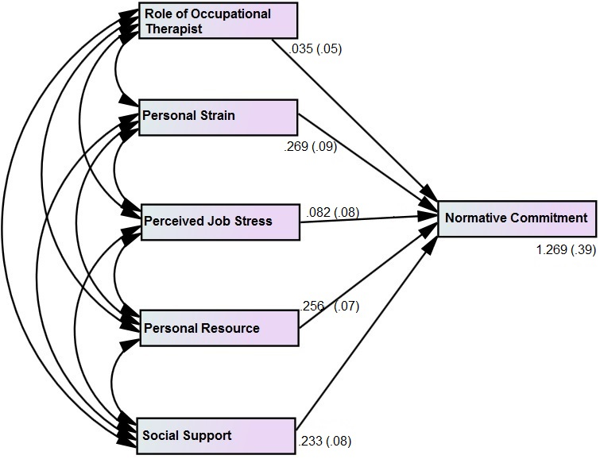  Teaching | 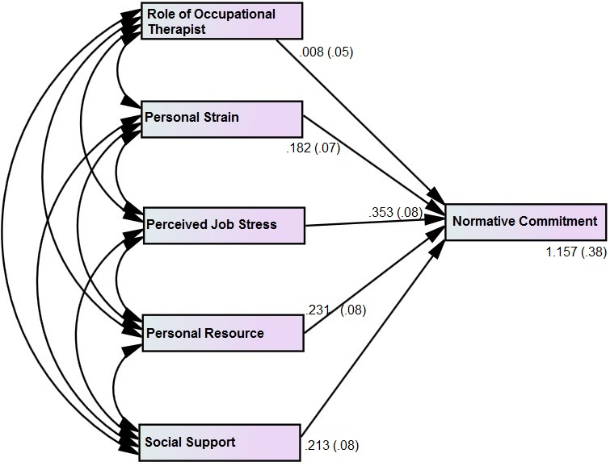  Non-teaching (administrative)

Figure 5. 15: Multiple regressions on the normative commitment in contrasting faculties.

Table 5. 57: Coefficients^{a, a,' b}
Model |  | Unstandardized Coefficients |  | Standardized Coefficients | T | Sig.
 |  | B | Std. Error | Beta | T | Sig.
 | (Constant) | 1.269 | .398 |  | 3.190 | .002
Teaching | Role of Occupational Therapist | .035 | .050 | .046 | .697 | .487
Non-teaching | Role of Occupational Therapist | .008 | .053 | .010 | .153 | .878
Teaching | Personal Strain | .269 | .091 | .254 | 2.963 | .003
Non-teaching | Personal Strain | .182 | .078 | .181 | 2.333 | .003
Teaching | Perceived Job Stress | .082 | .087 | .081 | .948 | .344
Non-teaching | Perceived Job Stress | .353 | .082 | .331 | 4.299 | .000
Teaching | Personal Resources | .256 | .076 | .263 | 3.368 | .000
Non-teaching | Personal Resources | .231 | .080 | .253 | 2.872 | .005
Teaching | Social Support | .233 | .080 | .246 | 2.927 | .004
Non-teaching | Social Support | .213 | .080 | .215 | 2.663 | .002
a. Faculty = 1.0 – Teaching
a'. Faculty = 2.0 - Non-teaching (administrative)
b. Dependent Variable: Normative Commitment

The statistical test confirmed that there is no statistically significant role played by the occupational therapist in determining the normative commitment of teaching and non-teaching staff at university level. Hence, there is no significant evidence against a null hypothesis (=0.487 > 0.05, p > α; =0.878 > 0.05, p > α; Table 5.57). This is a new development, as there is no evidence of this in previous research. Perceived job stress is evident to be statistically significant for non-teaching (administrative) staff, whereas it is non-significant for teaching staff (=0.000 < 0.05, p < α; =0.344 > 0.05, p > α; Table 5.57). Hence, this reflects that perceived job stress is highly significant in affecting the normative commitment of non-teaching staff, while it has no role in determining the NC of teaching staff. Again, there is no evidence regarding it, but the study partially contradicts the work of Haque & Aston (2016) in that the commitment of operational level employees is significantly affected by perceived job stress. Interestingly, personal strain, personal resources and social support have a statistically significant impact on the normative commitment of teaching and administrative staff at public universities (Teaching staff: PS=.003 < 0.05, p < α; PR=0.000 < 0.05, p < α; SS=.004 < 0.05, p < α; Non-teaching staff: PS=.003 < 0.05, p < α; PR=.005 < 0.05, p < α; SS=.002 < 0.05, p < α; Table 5.57). Thus, there is strong evidence against a considered null hypothesis and, therefore, it is rejected. There is no evidence from empirical research about this and, therefore, it is a new development. Nevertheless, the work of Haque & Aston (2016) is partially confirmed regarding taking administrative staff as operational level employees.
Table 5. 58: Model Summary^{a,c}
Model | R | R Square | Adjusted R Square | Std. Error of the Estimate
1 | .445^{b} | .420 | .378 | 1.29170
2 | .522^{b} | .472 | .454 | 1.33356
a. Faculty: 1=Teaching and 2=Non-teaching (administrative)
b. Predictors: (Constant), Social Support, Personal Strain, Role of Occupational Therapist, Perceived Job Stress, Personal Resources
c. Dependent Variable: Continuance Commitment

Table 5. 59: ANOVA^{a,b, a' b}
Model |  | Sum of Squares | Df | Mean Square | F | Sig.
1 | Regression | 81.5446 | 5 | 16.309 | 9.774 | .000^{c}
1 | Residual | 332.132 | 199 | 1.669
1 | Total | 413.676 | 204
2 | Regression  Residual  Total | 131.787 | 5  199  204 | 24.357  1.778 | 14.821 | .000^{c}
2 | Regression  Residual  Total | 353.822
2 | Regression  Residual  Total | 485.609
a. Faculty = 1.0 – Teaching
a'. Faculty = 2.0 - Non-teaching (administrative)
b. Dependent Variable: Continuance Commitment
c. Predictors: (Constant), Social Support, Personal Strain, Role of Occupational Therapist, Perceived Job Stress, Personal Resources

Approximately over 40% variations in continuance commitment are explained by the predictors in this model (Table 5.58). Moreover, the explanatory power is acceptable because the sig-value is less than alpha, reflecting statistical significance. In other words, the model is a good fit for the data (Table 5.59).
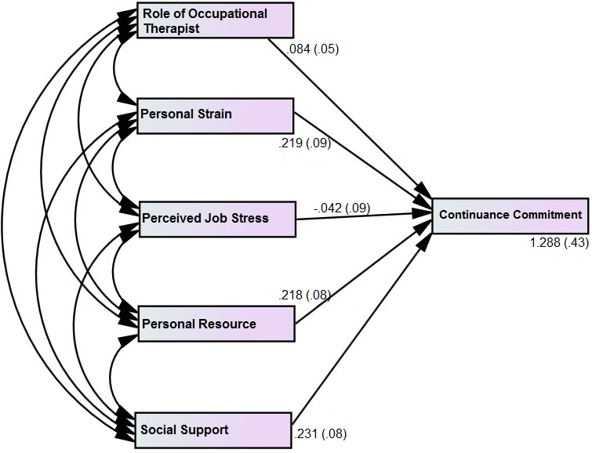  Teaching | 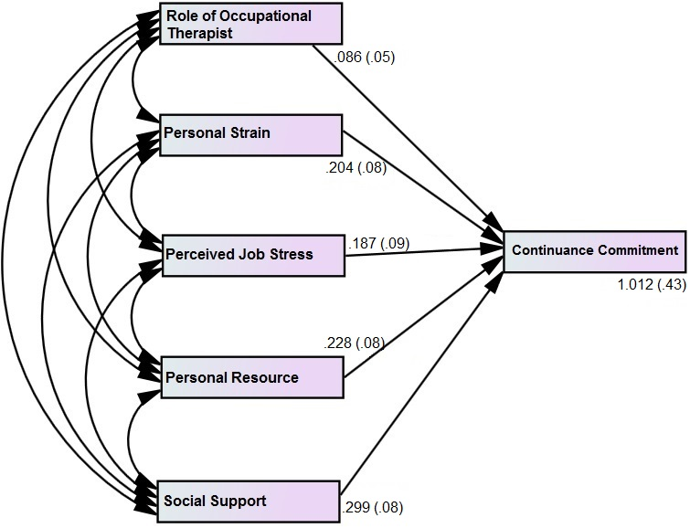  Non-teaching (administrative)

Figure 5. 16: Multiple regressions on the continuance commitment in contrasting faculties.

Table 5. 60: Coefficients^{a, a,' b}
Model |  | Unstandardized Coefficients |  | Standardized Coefficients | T | Sig.
 |  | B | Std. Error | Beta | T | Sig.
 | (Constant) | 1.288 | .433 |  | 2.972 | .003
Teaching | Role of Occupational Therapist | .084 | .055 | .101 | 1.535 | .126
Non-teaching | Role of Occupational Therapist | .086 | .059 | .095 | 1.465 | .144
Teaching | Personal Strain | .219 | .099 | .210 | 2.212 | .002
Non-teaching | Personal Strain | .204 | .087 | .119 | 2.345 | .002
Teaching | Perceived Job Stress | -.042 | .095 | -.038 | -.446 | .656
Non-teaching | Perceived Job Stress | .187 | .091 | .152 | 2.064 | .040
Teaching | Personal Resources | .218 | .083 | .224 | 2.631 | .009
Non-teaching | Personal Resources | .228 | .089 | .216 | 2.569 | .011
Teaching | Social Support | .231 | .087 | .223 | 2.659 | .008
Non-teaching | Social Support | .299 | .088 | .287 | 3.381 | .001
a. Faculty = 1.0 – Teaching
a'. Faculty = 2.0 - Non-teaching (administrative)
b. Dependent Variable: Continuance Commitment

The results showed that the role of the occupational therapist does not have a statistically significant effect on the continuance commitment of teaching and administrative staff at public universities in the UK and Pakistan (=0.126 > 0.05, p > α; =0.144 > 0.05, p > α; Table 5.60). Hence, a null hypothesis cannot be rejected. This is again a new development. However, when considering administrative employees as an operational layer of management, the present findings support the work of Haque & Aston (2016). Perceived job stress has a statistically significant effect on the continuance commitment of non-teaching staff but has a non-significant impact on the teaching staff’s CC (=.040 < 0.05, p < α; =.656 < 0.05, p > α; Table 5. 60). Personal strain, personal resources and social support are evident to have a statistically significant role in determining the continuance commitment of the contrasting faculties. Thus, null hypotheses are rejected (Teaching staff: PS=.002 < 0.05, p < α; PR=0.009 < 0.05, p < α; SS=.008 < 0.05, p < α; Non-teaching staff: PS=.002 < 0.05, p < α; PR=.011 < 0.05, p < α; SS=.001 < 0.05, p < α; Table 5. 60). This is a new development, but it partially supports the work of Haque & Aston (2016).

Table 5. 61: Group Statistics
 | Faculty | N | Mean | Std. Deviation | Variance
Representation of Occupational Therapist | Teaching | 204 | .3645 | .26694 | .071
Representation of Occupational Therapist | Non-teaching | 202 | .3379 | .23335 | .054
Effectiveness of Occupational Therapist | Teaching | 204 | 3.8350 | 1.7123 | 2.93
Effectiveness of Occupational Therapist | Non-teaching | 202 | 3.0082 | 1.6975 | 2.88
Personal Strain | Teaching | 204 | 3.7810 | 1.2298 | 1.51
Personal Strain | Non-teaching | 202 | 3.8480 | 1.3106 | 1.71
Perceived Job Stress | Teaching | 204 | 3.7525 | 1.2875 | 1.69
Perceived Job Stress | Non-teaching | 202 | 3.8007 | 1.2505 | 1.56
Personal Resources | Teaching | 204  202 | 3.6569  3.3775 | 1.4621  1.4612 | 2.13  2.13
Personal Resources | Non-teaching
Social Support | Teaching | 204  202 | 3.9583  3.4608 | 1.3760  1.4850 | 1.89  2.20
Social Support | Non-teaching
Affective Commitment | Teaching | 204 | 3.6275 | 1.6559 | 2.74
 | Non-teaching | 202 | 3.9412 | 1.5017 | 2.25
Normative Commitment | Teaching | 204 | 3.5735 | 1.3351 | 1.78
 | Non-teaching | 202 | 3.8578 | 1.3024 | 1.69
Continuance Commitment | Teaching | 204 | 3.6127 | 1.4244 | 2.02
Continuance Commitment | Non-teaching | 202 | 3.3873 | 1.5439 | 2.38

The third dimension is faculty where visibility, preference and usage are examined in this research. Teaching and non-teaching (administrative) staff from the UK and Pakistan were targeted. The results revealed that the rate of representation of the occupational therapist at university is highly visible among non-teaching (administrative) staff, in contrast to teaching staff (=3.379 < .3645, Table 5.61). In addition, the effectiveness of the occupational therapist is highly evident among non-teaching staff in comparison to teaching staff, as the mean value is significantly lower reflecting a higher visibility of effectiveness (=3.0082 < 3.8350, Table 5.61). The mean difference is also significant, reflecting the comparison in terms of visibility is higher. Interestingly, personal strain and perceived job stress are higher among teaching staff, in contrast to non-teaching (administrative) staff.
The results showed that a higher level of personal strain is visible among teaching staff (=3.7810 < 3.8480, Table 5.61). In addition, perceived job stress is also highly visible among teaching staff in comparison to administrative staff (=3.7575 < 3.8007, Table 5.61). Personal resource and social support are higher among non-teaching staff. This further confirms that the ability to cope effectively with personal strain and job-related stress is very much dealt with by use of personal resources and social support at workplace by non-teaching (administrative) staff. The usage of personal resources among non-teaching staff is highly visible, in contrast to teaching staff (=3.3775 < 3.6569, Table 5.61). Furthermore, social support is also effectively used at the workplace by non-teaching staff, in comparison to teaching staff (=3.4608 < 3.9583, Table 5.61). Moreover, organisational commitment was examined within the contrasting faculties and results showed that overall organisational commitment is higher among non-teaching (administrative) staff, in contrast to teaching staff. Interestingly, AC and NC are highly visible in teaching staff, whereas CC is higher among non-teaching staff. A further, detailed analysis revealed that continuance commitment is highly visible, followed by normative and affective commitment (teaching-CC=3.3873 < 3.6127, non-teaching-NC=3.5735 < 3.578, non-teaching-AC=3.6275 < 3.9412, Table 5.61).
After attaining numerical expression for the variables of interest, the researcher explored the research phenomenon in a qualitative way. Below are the interview findings and discussion.

5.3 Interview Findings and Discussion
 | PAKISTAN |  | UNITED KINGDOM
 | Male | Female | Male | Female | Total
Teaching | 13 | 12 | 12 | 12 | 49
Non-teaching | 12 | 12 | 12 | 13 | 49
Total | 25 | 24 | 24 | 25 | 98

Figure 5. 17: Frequency of interview respondents in contrasting economies.
A total of 98 respondents participated in the qualitative interviews. It was ensured that 50% in terms of economies, gender and faculty are targeted. The above figure reflects the frequency of responses, equal in terms of economies (Pakistan and the UK), gender (males and females), and faculties (teaching and non-teaching staff). The in-depth analysis revealed that the teaching staff of the UK were more experienced in contrast to the teaching staff of Pakistan, whereas the non-teaching staff had a higher number of fresh (inexperienced) employees, in contrast to the teaching staff. In addition, female respondents had less (3-5 years) experience and were in their mid 30s to early 40s, whereas males had higher (9-12 years) experience and were in their 40s to mid-50s.
As part of the attitudinal questions, the respondents were asked about their feelings regarding their jobs. Results showed that an overall majority were satisfied (82%). However, the teaching staff were more satisfied about their job role, in contrast to non-teaching staff (88% against 76%). Females were more satisfied in contrast to males (89% against 76%). However, when considering the variation within the contrasting economies, it was revealed that in Pakistan teaching staff were more satisfied than non-teaching (92% against 75%) while in terms of gender there is not much variation between males and female’s satisfaction (88% against 89%). On the other hand, in the UK, there is no significant difference between teaching and non-teaching staff (76% against 75%) whereas males were more satisfied regarding their job role, in contrast to their counterparts (87% against 64%).

5.3.1 Most likely job feature

Figure 5. 18: Most liked job-related feature at the public universities in Pakistan and the UK.

Pakistani (teaching staff) respondent 1: “Course structure. It is set pattern. I like such stable routine” (See Appendix A)
UK (teaching staff) respondent 1: “Interacting with people. It does not stop you at one point in life. It keeps you going as you have opportunities to grow. Help others in careers” (See Appendix A)
Pakistani (teaching staff) respondent 2: “Flexible Style and Social Environment. It gives me a peace of mind” (See Appendix A)
UK (teaching staff) respondent 2: “It’s really about interacting by helping students to achieve goals. Sort of enhancing their careers” (See Appendix A)
Pakistani (non-teaching - administrative staff) respondent 1: “Flexible environment. There is no pressure. We work as a team” (See Appendix A)
UK (non-teaching - administrative staff) respondent 1: “Interacting with students. That’s is what I am here for and I enjoy it” (See Appendix A)
Pakistani (non-teaching - administrative staff) respondent 2: “Healthy Environment. There is no work pressure” (See Appendix A)
UK (non-teaching - administrative staff) respondent 2: “Dealing with students. I am into customer services for long and I like to communicate with students” (See Appendix A)
Pakistani male: “Structural work. Changes usually irritate me” (See Appendix A)
UK male: “Intellectual activities. Sharing Knowledge” (See Appendix A)
Pakistani female: “Interacting with students. Opportunity to communicate ideas. Ideas are communicated. This position offers me a chance to interact and learn more” (See Appendix A)
UK female: “I like when any student achieves something great. I talk to my students. Since I give knowledge to students and support them become better” (See Appendix A)
The respondents were asked about the most liked job feature and, overall, the responses showed that the majority stated, “interacting and communicating” (26%), followed by “structural pattern” (24%) and “expanding knowledge and learning” (19%) were the most liked. In terms of faculty, teaching staff very much liked “expanding knowledge and learning” (33%), while non-teaching staff preferred “structural pattern” (41%). Additionally, when considering gender, the results revealed that females liked “interacting and communicating” (27%), while males preferred “structural pattern” (29%). Nevertheless, from the perspective of the contrasting economies, it was revealed that in Pakistan, “structural pattern” (37%), followed by “flexible environment” (24%) and “interacting and communicating” (18%) were the most liked job features. Interestingly, teaching staff stated that “interacting and communicating” was their most liked job feature (32%), while non-teaching (administrative) staff preferred “structural pattern” (58%). Moreover, females preferred “flexible environment” and “structural pattern” equally (30% each), while males preferred “flexible environment” (44%). On the other hand, in the UK, the overall preference was for “interacting and communication” (33%), followed by “expanding knowledge and learning” (29%) and “structural pattern” (12%). Teaching staff attributed “expanding knowledge and learning” (54%), whereas non-teaching staff preferred “interacting and communicating” (44%). Additionally, both males and females identified “expanding knowledge and learning” (28% against 29%), followed by “interacting and communicating” (33% against 32%).

5.3.2 Most disliked job attribute

Figure 5. 19: Most disliked job-related feature at the public universities in Pakistan and the UK.

Pakistani (teaching staff) respondent 1: “Lack of practical exposure for students. Following traditional text book is not good idea” (See Appendix A)
UK (teaching staff) respondent 1: “Office Politics. I don’t feel comfortable in such situations. Came here to making human beings better but this way it is not possible” (See Appendix A)
Pakistani (teaching staff) respondent 2: “Unnecessary rigid structure. Same modules, same way of assessing. I want practical based learning for my students” (See Appendix A)
UK (teaching staff) respondent 2: “Marking scripts... structuring reports. I can’t read writing, especially international students’ writing” (See Appendix A)
Pakistani (non-teaching - administrative staff) respondent 1: “Its casual type. I don’t like unreliable environment. There is uncertainty. When they need you they involve you else not ask you” (See Appendix A)
UK (non-teaching - administrative staff) respondent 1: “Making everyone happy. There is politics most of the time” (See Appendix A)
Pakistani (non-teaching - administrative staff) respondent 2: “Rigid policies. High dependence on others for small things” (See Appendix A)
UK (non-teaching - administrative staff) respondent 2: “Too much other factors like coming from far away” (See Appendix A)
Pakistani male: “Many things but mostly orthodox way of teaching. High restrictions on trying different things” (See Appendix A)
UK male: “I think moving to online. Making too much severe... Less paper work. I am a person who likes to have paper rather than looking at screen at the time. Even the travel from Kent to make it is another factor” (See Appendix A)
Pakistani female: “Structural and traditional pattern. I want experimentation, so I and students do not get bored” (See Appendix A)
UK female: “Changes, Pressure from government. The policies of the government are changing and more people are moving so participation is getting lower” (See Appendix A)
Respondents were asked about their most disliked job feature and their overall responses showed that “long working hours” (22%), followed by “conventional structure” (21%) and “workload” (20%) were the most disliked. In addition, teaching staff very much disliked “long working hours”, while non-teaching staff identified “workload” as the most disliked (24% and 22%). Interestingly, males considered “long working hours” (24%), whereas females stated that “conventional structure” and “long working hours” were their most disliked job features (20% each). In depth-analysis revealed that, in Pakistan, “conventional structure” is a highly disliked job attribute (27%). However, the teaching staff identified “conventional structure” (32%) and “Long working hours” as their most disliked job attributes, whereas non-teaching staff identified “workload” (25%). Interestingly, males found “long working hours” and “conventional structure” as equally disliked features (28%), followed by “changes” and “workload” (16%), whereas females identified “conventional structure” (25%). Interestingly, females, especially in the teaching faculty, stated “nothing” (21%), reflecting that females, in contrast to males are less dissatisfied. On the other hand, in the UK, “external factors” are the most disliked job-related feature (29%). Teaching staff considered “workload” (29%), followed by “external factors” and “long working hours” (25%) as their most disliked job-related features, while non-teaching staff identified “external factors” (32%). Males, in contrast to females, scored higher in identifying “external factors” (29% against 28%). Hence, this study partially supports the work of Mark & Smith (2018), Haque et al., (2018) and Haque & Aston (2016) because all attributes are evident to some extent, to build up stress.

5.3.3 Dislike feature affecting university staff

Figure 5. 20: Dislike feature affecting employees at the public universities.

Pakistani (teaching staff) respondent 1: “Emotional disbalance at times” (See Appendix A)
UK (teaching staff) respondent 1: “De-motivated. At times pessimistic thoughts occur” (See Appendix A)
Pakistani (teaching staff) respondent 2: “I think efficiency declines. My mind is disturbed” (See Appendix A)
UK (teaching staff) respondent 2: “Yes, if I can’t read English of poor structure I feel agitated” (See Appendix A)
Pakistani (non-teaching - administrative staff) respondent 1: “I have irritation. Sometimes I am moody” (See Appendix A)
UK (non-teaching - administrative staff) respondent 1: “All the time feel worrying about things” (See Appendix A)
Pakistani (non-teaching - administrative staff) respondent 2: “Efficiency comes down. I have disturbed sleep pattern. My mood is affected” (See Appendix A)
UK (non-teaching - administrative staff) respondent 2: “Yes, efficiency affects. It is mostly fatigue” (See Appendix A)
Pakistani male: “Feel irritation. Mood swings” (See Appendix A)
UK male:“It certainly does, especially when systems doesn’t work. I often feel angry and it is demoralizing when system stops working. I lash out on others. It’s not good thin later when I realize my mistake I say sorry to people I misbehaved with” (See Appendix A)
Pakistani female: “I have psychological depression. I feel stress negatively affects me” (See Appendix A)
UK female: “Yes, I get upset. Become moody” (See Appendix A)
After identifying the disliked job feature, participants were asked about its impact on their working pattern. Interestingly, the results showed that overall, as well as in contrasting economies, the disliked job feature leaves a negative psychological impact on the majority of the public university personnel (37%). Furthermore, this is followed by negative behavioural impact (29%). The negative behavioural impact is higher in Pakistan, in contrast to the UK (31% against 27%). Additionally, overall, teaching staff demonstrated a higher negative psychological impact, whereas non-teaching staff exhibited a negative physiological impact (53% against 33%). Interestingly, the majority of females stated a negative psychological impact (47%), whereas males exhibited behavioural impact (31%). The detailed analysis of the contrasting economies revealed that negative psychological impact is higher in both Pakistan and the UK but the UK teaching staff scored higher than those in Pakistan (54% against 52%), followed by negative behavioural impact (29% against 36%). Interestingly, the majority of non-teaching staff in Pakistan exhibited negative physiological impact, in contrast to the UK (38% against 28%). Interestingly, the results show that non-teaching staff in Pakistan have stated “negative behavioural impact” as second most occurrences (25%), whereas in the UK, “nothing” is confirmed by non-teaching staff (28%). Additionally, females in the UK had a higher negative psychological impact score than those in Pakistan (48% against 46%); this was followed by negative behavioural impact, which is evidently higher among Pakistani females, in contrast to the UK (29% against 24%). On the other hand, in Pakistan the results demonstrate that the majority of males stated equally “negative physiological impact” and “negative behavioural impact” equally (32%), while in the UK, the majority of males confirmed negative behavioural 29% while psychological and physiological equally evident (25%).
Thus, there are variations in terms of gender and faculty, as psychological impact is higher in teaching, while higher physiological and behavioural impacts are demonstrated by non-teaching. The males have higher negative behavioural and physiological impacts, while females demonstrate higher negative psychological impact. Interestingly, the study showed that since the work of non-teaching (administrative) staff is more related to desk work, there is, therefore, higher physiological impacts, while teaching staff are more engaged in mental work and, therefore, there is a higher psychological impact. Nevertheless, the present findings support, to some extent, the work of Haque & Aston (2016). Interestingly, the physical and psychological impact is evident in the UK too and, thus, this study supports the work of Mark & Smith (2018).

5.3.4 Ways to overcome negative impact

Figure 5. 21: Ways to overcome negative impact.

Pakistani (teaching staff) respondent 1: “Yes, I talk to my friends, it helps me feel relaxed” (See Appendix A)
UK (teaching staff) respondent 1: “I have sporting background. Sometimes I go for run, gym, exercise etc” (See Appendix A)
Pakistani (teaching staff) respondent 2: “I discuss my issues with my close ones. Being social helps me overcome it” (See Appendix A)
UK (teaching staff) respondent 2: “Personally I do all to keep stable mind. I don’t have colleagues to talk but I do sport etc” (See Appendix A)
Pakistani (non-teaching - administrative staff) respondent 1: “I go out for a break. I know I can’t do much. I told you I am helpless to object” (See Appendix A)
UK (non-teaching - administrative staff) respondent 1: “We talk to others. All are in same boat. Structuring it to see if we come over it” (See Appendix A)
Pakistani (non-teaching - administrative staff) respondent 2: “I take medication. I regularly take co-renetic so my BP remains stable” (See Appendix A)
UK (non-teaching - administrative staff) respondent 2: “I take break. I have backache issue” (See Appendix A)
Pakistani male: “I go to therapist once every 15th day. Physiotherapy is effective, especially in growing age” (See Appendix A)
UK male: “You can chat with colleagues. Stress release due to social chat” (See Appendix A)
Pakistani female: “The best way of getting out of my depression is talk to someone. It helps in releasing stress” (See Appendix A)
UK female: “I talk to my close ones. It just helps me” (See Appendix A)
Overall, the majority of university staff do nothing to overcome negative behavioural, psychological and physiological impacts (29%). The proportion further increased in Pakistan (35%). However, there is evidence of social support, breaks, meditation and immediate measures, to some extent. The comparative analysis revealed that in the UK, social support, breaks and meditation are more evident, in contrast to Pakistan, (27% against 22%; 27% against 18%; and 16% against 13%). Interestingly, overall, non-teaching staff use social support and breaks more often than teaching staff (29% against 20%; and 27% against 18%), whereas self-meditation is higher among teaching staff, in contrast to non-teaching staff (18% against 8%). In terms of gender, overall social support is highly regarded by females, in contrast to their counterparts (31% against 18%). Similarly, breaks and self-meditation are higher among females than males (24% against 20%; and 16% against 10%). Interestingly, the proportion of males stating “nothing” is higher (35% against 22%) and immediate measures such as medicines, direct dialogues, requests and so on are higher among males in contrast to females (14% against 6%). Nevertheless, earlier, this study identified that males had a higher score in negative behavioural and physiological impacts and now the use of less social support and a higher ratio of doing ‘nothing’ further confirms that females demonstrate less negative behavioural and physiological symptoms than males, owing to the effective use of social support. Thus, this study, to large extent, supports the work of Haque et al., (2018), Haque et al., (2016) and Haque & Aston (2016), while partially supporting the work of Mark & Smith (2018).
The variations are further examined in the distinctive economies. In Pakistan, social support is effectively used by teaching staff, in contrast to non-teaching staff, (24% against 21%). On the other hand, breaks and immediate measures are clearly higher among non-teaching staff, in contrast to teaching staff (21% against 16%; and 21% against 4%). Additionally, Pakistani females use social support and breaks more, in contrast to their counterparts, in dealing with the negative impacts of disliked job attribute (33% against 12%; and 25% against 12%). In contrast, males often take immediate measures to deal with this (20% against 4%). On the other hand, within the UK, non-teaching staff are using social support more effectively to overcome the negative impacts of disliked job attribute, in contrast to teaching staff (36% against 17%) followed by breaks (32% against 21%). On the other hand, self-meditation, such as yoga, exercise, listening to music, engaging oneself in something and so on, are more common among teaching staff than non-teaching staff (21% against 12%). Moreover, females use social support and self-meditation more effectively than their counterparts (28% against 25%; and 20% against 13%). On the other hand, males often regularly take breaks in order to deal with the negative impact of job related attributes, in contrast to females (29% against 24%). The findings are interesting, as the faculty in the contrasting economies vary at length but in terms of gender, it is confirmed that social support is more effectively used by the females in dealing with the stressors. Thus, this study largely supports the work of Haque et al., (2018), Haque et al., (2016) and Haque & Aston (2016).

5.3.5 Rate and effectiveness of the Occupational Therapist

Figure 5. 22: Effectiveness of the Occupational therapist.

Pakistani (teaching staff) respondent 1: “To some extent” (See Appendix A)
UK (teaching staff) respondent 1: “I believe to some extent. I find it effective. Helps you overcome issues” (See Appendix A)
Pakistani (teaching staff) respondent 2: “To some extent. It much brings positive dependent in workers” (See Appendix A)
UK (teaching staff) respondent 2: “It’s Ok. Low but for time being it should be effective in helping people to some extent” (See Appendix A)
Pakistani (non-teaching - administrative staff) respondent 1: “No. its personal ability to overcome your ongoing stress” (See Appendix A)
UK (non-teaching - administrative staff) respondent 1: “I don’t think these occupational therapists can help at all. It’s yourself that you will find solution to your problem” (See Appendix A)
Pakistani (non-teaching - administrative staff) respondent 2: “A very little but not much because I think only change in setup can help” (See Appendix A)
UK (non-teaching - administrative staff) respondent 2: “No. It is not effective at all” (See Appendix A)
Pakistani male: “No. If it was, I wouldn’t have used pills. They just sit to talk” (See Appendix A)
UK male: “In order to be effective, it has to be communicated. Like tell us and at present, it is not communicated well. Depends on type of person, extrovert might open and find it effective. I won’t easily open I don’t think it is going to be effective” (See Appendix A)
Pakistani female: “Certainly can be effective. Professionals always help professionals to better” (See Appendix A)
UK female: “Yes, I have used in another institution and it’s very useful. It provides immediate solution” (See Appendix A)
In this study, the respondents were asked about the rate of representation of professional occupational therapists at the university; overall, there are traces that to some extent, it is evident in both countries but the proportion is higher in the UK (developed economy) in contrast to Pakistan (developing economy). Additionally, it is also evident that “no representation” of the professional occupational therapist is higher at the universities in Pakistan, in contrast to the UK (37% against 12%). In addition, in this regard, the qualitative findings support the earlier quantitative findings. Hence, the study is aligned with the work of Haque & Aston (2016) in that the rate of representation of occupational therapist is relatively low in the emerging economy, in contrast to the developed economy. However, their work was carried out in the private IT sector and now the same findings have been confirmed in the public education sector. This is a new development of the present study. Non-teaching staff had a higher score than teaching staff regarding no representation (27% against 22%). Moreover, males had a higher score in contrast to females (29% against 20%). Nevertheless, traces of the rate of representation of occupational therapist are evident, to a certain extent, in contrasting economies.
Since, the rate of representation is evident, to a certain extent thus, the effectiveness is measured. It is evident that an overall majority of the respondents confirmed the effectiveness of the professional occupational therapist (29%); however, the UK (developed economy) had a higher score than Pakistan (emerging economy). Nevertheless, overall, teaching staff found the role of the occupational therapist more effective, in contrast to non-teaching staff (31% against 22%), whereas males, in contrast to females, found it ineffective in reducing stressors (27% against 6%). Thus, overall, to some extent occupational therapist role is effective but females found it more effective than males. Since, the teaching staff earlier identified negative psychological impact higher while negative behavioural and physiological impacts were identified by non-teaching. Same was evident in case of gender as males stated latter two and females attributed psychological thus the effectiveness is also higher for females and teaching staff because the professional therapist is mainly involved in improving the psychological aspects. In other words, the employees, having psychological symptoms found the role of the occupational therapist more effective, while employees with behavioural and physiological symptoms found it less effective.

5.3.4 Awareness and effectiveness of Social Support at workplace

Figure 5. 23: Social support and effectiveness of the social support.

Pakistani (teaching staff) respondent 1: “Yes. Social orientation and support to improve well-being. Yes. Yes. When I am unable to come I do get support from faculty. They understand my concerns. Yes” (See Appendix A)
UK (teaching staff) respondent 1: “Yes, I am familiar with it. There is technical support formally and peer support informally. Yes, it is very useful. I have used it and found it very effective” (See Appendix A)
Pakistani (teaching staff) respondent 2: “Yes. Help and support from university. Yes. Yes. It was excellent. Everyone helps you. You don’t feel alone in crunch situations. Yes, it helps you very much” (See Appendix A)
UK (teaching staff) respondent 2: “Yes, its environment of cooperation. Informally Yes, I have used. One I can’t come for exams so asked colleague to cover me. Very very effective” (See Appendix A)
Pakistani (non-teaching - administrative staff) respondent 1: “Friendly and supportive environment. Yes, we have and we all use it. Very effective” (See Appendix A)
UK (non-teaching - administrative staff) respondent 1: “Yes, I know we have support system for all. We care about each other. Yes, I do use it frequently. We cover each other. Yes, very effective” (See Appendix A)
Pakistani (non-teaching - administrative staff) respondent 2: “Yes. I can’t define but I have idea. Social, technological, emotional etc support from authorities to ensure you are not left by your own. Yes. Yes. Very effective. Yes” (See Appendix A)
UK (non-teaching - administrative staff) respondent 2: “Yes. I have used it at times. Very useful” (See Appendix A)
Pakistani male: “Yes I am aware but can’t explain. Yes, I have used. It is present here and its good experience. Very useful” (See Appendix A)
UK male: “Physical, technical, and people support at desk. Yes, we informally have and I do use it. I find it effective for myself” (See Appendix A)
Pakistani female: “Not just heard I actively use it. I don’t know how to explain it, Social being at department. Yes. Yes. Great... Any time I need any help. My fellow colleagues help me. Indeed” (See Appendix A)
UK female: “Yes, support from others around you. A lot of having opportunities, workshops, etc to resolve issues. Yes, its effective” (See Appendix A)
The awareness of social support at the workplace was explored and results showed that the majority of the respondents had knowledge and awareness of both formal and informal social support. The second step was measuring the effectiveness of the social support and results revealed that, overall, 28% of employees considered it highly effective, whereas 50% found it effective. Interestingly, the comparative analysis revealed that Pakistan scored higher, in contrast to the UK, in finding social support effective to a certain extent (82% against 73%). Again, the qualitative findings are aligned with the quantitative findings. Earlier, the visibility of social support was evidently higher in the emerging economy, in contrast to the developed economy, and now effectiveness is also found in the country with higher visibility. Hence, in this regard, the present study supports the work of Haque et al., (2018), Williams et al., (2017), Haque et al., (2016), and Haque & Aston (2016), to a large extent, in that social support is clearly more effective in the emerging economies, in contrast to the developed economy. Interestingly, overall, the effectiveness, to a certain extent, is evident in both teaching and non-teaching staff but the teaching staff scored fractionally higher (84% against 71%).
The detailed analysis revealed that social support is often received in an informal manner to reduce stress and, hence, these findings support the work of Mark & Smith (2018). Interestingly, the quantitative findings revealed higher visibility in non-teaching staff but the detailed analysis confirmed that, despite higher visibility, effective use is made by teaching staff. This is a new development, as previously there was no conclusive evidence regarding the variation in the effectiveness of social support for contrasting faculties. Nevertheless, the phenomenon was explored through the funnel approach and results again showed that experienced teaching staff, in the age bracket of 40 and above, use social support more constructively. Again, Mark & Smith (2018) found that in the UK, experienced staff use social support more effectively for dealing with stress and, therefore, this study supports their findings. Additionally, their findings are evident in the UK but with the present findings the notion is also confirmed in Pakistan (emerging economy).
Interestingly, overall, in contrast to their counterparts, males scored higher in finding social support effective at the workplace (84% against 72%). Hence, in this aspect, the present study differs with the work of Haque et al., (2018), Haque et al., (2016), Haque & Aston (2016), and Sackey & Sanda (2011). In Pakistan as well as in the UK, teaching staff scored higher than non-teaching (administrative) staff (88% against 75%; and 79% against 68%). Moreover, males, in contrast to females in both Pakistan and the UK, found social support more effective (84% against 79%; and 83% against 69%). Thus, the findings differ from the previous work of Haque et al., (2018), Haque et al., (2016), Haque & Aston (2016) and Sackey & Sanda (2011). It is interesting that although females use more social support than males, effectiveness is more evident among males. This led to examining the working experience of the employees by using funnel approach, and, it is evident that overall, employees with 7 or more years’ experience in the education sector found social support more constructive and effective in contrast to young and less experienced employees.

5.3.5 Type of Support attained from social support at workplace

Figure 5. 24: Type of support attained from social support.

Pakistani (teaching staff) respondent 1: “Only moral support” (See Appendix A)
UK (teaching staff) respondent 1: “Not at all. I think organisation doesn’t care how I feel” (See Appendix A)
Pakistani (teaching staff) respondent 2: “Emotional support” (See Appendix A)
UK (teaching staff) respondent 2: “Nothing” (See Appendix A)
Pakistani (non-teaching - administrative staff) respondent 1: “Moral support” (See Appendix A)
UK (non-teaching - administrative staff) respondent 1: “Combination of both” (See Appendix A)
Pakistani (non-teaching - administrative staff) respondent 2: “Yes, I have gained moral support” (See Appendix A)
UK (non-teaching - administrative staff) respondent 2: “From my team moral support” (See Appendix A)
Pakistani male: “Moral support” (See Appendix A)
UK male: “Moral and only moral” (See Appendix A)
Pakistani female: “Emotional support definitely” (See Appendix A)
UK female: “Yes, I have comfort and received emotional support but not sure if I will get it again or not” (See Appendix A)
After establishing the effectiveness of social support, the respondents were asked about the type of support they received frequently through social support and, interestingly, results showed that overall “moral support” is attained by the majority of public university staff (36%). Interestingly, emotional support is also received by public university staff (27%). Nevertheless, the comparative analysis revealed that Pakistan has a higher score than the UK with regard to moral support and emotional support at the workplace (45% against 27% and 31% against 22%). Additionally, there is also evidence that ‘no support at all’ is higher in the UK, in contrast to Pakistan (27% against 6%). Hence, to a large extent, the present findings are aligned with the work of Haque & Aston (2016) in that employees within the developing economies receive a higher level of emotional and moral support, in contrast to the developed economies. Furthermore, overall, the teaching staff receive a higher level of emotional support, while non-teaching (administrative) staff confirmed that they receive “moral support” (37% and 41%). Additionally, females received a higher level of emotional support (41%), whereas males often received moral support (47%).
In Pakistan, the majority of the teaching staff confirmed emotional support (40%) while non-teaching staff stated moral support (54%). On the other hand, in the UK, teaching staff received emotional support (33%) but an equal proportion of teaching staff stated that they received “no support at all”. Non-teaching staff confirmed that both types of support were received (36%) but moral support was higher in contrast to emotional support in non-teaching staff (32% against 12%). In terms of gender, the majority of males in Pakistan and the UK stated that they received moral support (64% and 29%), while females in Pakistan and the UK confirmed that they received emotional support (46% and 36%). Interestingly, the ratio of ‘no support at all’ is higher in the UK among males in contrast to their counterparts (33% against 20%). This reflects that social support is less effective in providing emotional and moral support in the UK (developed economy) in comparison to Pakistan (emerging economy). Nevertheless, the present finding supports the earlier work of Haque et al., (2018), Haque et al., (2016) and Haque & Aston (2016), to a larger extent, as the present findings confirmed that a high level of emotional support is received by females, while moral support is received by males from the existing social support. Again, the funnel approach revealed that employees with higher experience, who stay with the same organisation, receive emotional, as well as moral support more often, while employees in the early stages of their career seek higher emotional support from their peers at the workplace.

5.3.6 Stress Management Programme effectiveness at workplace

Figure 5. 25: Stress management effectiveness at workplace.

Pakistani (teaching staff) respondent 1: “Yes but very little. Yes, a bit. Little but effective” (See Appendix A)
UK (teaching staff) respondent 1: “Somewhat useful” (See Appendix A)
Pakistani (teaching staff) respondent 2: “I have some sessions and I feel it’s quite effective” (See Appendix A)
UK (teaching staff) respondent 2: “At that time it was effective” (See Appendix A)
Pakistani (non-teaching - administrative staff) respondent 1: “Yes, I have used but not effective” (See Appendix A)
UK (non-teaching - administrative staff) respondent 1:"Yes, they offer stress training program and even helps you if you are feeling any stress. I have used it and its effective" (See Appendix A)
Pakistani (non-teaching - administrative staff) respondent 2: “Yes. Yes. Of course, reduces my immediate stress” (See Appendix A)
UK (non-teaching - administrative staff) respondent 2: “It’s effective” (See Appendix A)
Pakistani male: “Yes. Yes. A lot” (See Appendix A)
UK male: “Useful” (See Appendix A)
Pakistani female: “Great help. Too much helpful” (See Appendix A)
UK female: “Somewhat effective” (See Appendix A)
The respondents were asked about the use and effectiveness of the stress management programme within the university and results showed that the overall proportion of the employees who have used it and found it effective, to a certain extent, is higher than those who found it ineffective (35% against 9%). Interestingly, the majority of the participants who hadn’t used it found it more effective than those who perceived it as ineffective (28% against 9%). Overall, the teaching staff viewed it as more effective in contrast to non-teaching staff (40% against 30%; and 29% against 27%). Moreover, females in contrast to males found it more effective (43% against 28%), as well as perceiving it to be better than their counterparts (29% against 27%). Overall, it is evident that the stress management programme is effective in dealing with the stress of employees (53%). Interestingly, the proportion further increases in the UK (developed economy) in contrast to Pakistan (emerging economy) (57% against 50%). Additionally, in Pakistan the proportion of employees who hadn’t used it is evident significantly higher (27% against 10%). Moreover, considering overall grounds for faculty aspect, teaching staff scored higher than non-teaching staff in finding it effective (60% against 46%). Interestingly, overall, males scored fractionally higher than females in finding the stress management programme effective (55% against 53%). Since it is evident that the stress management programme is effective, this study is thus aligned with the work of Watson (2000) and CAOT (2010) survey.
An in-depth comparative analysis revealed that in both Pakistan and the UK, teaching staff scored higher than non-teaching staff in finding stress management programme effective (64% against 39%; 59% against 56%). Additionally, the results showed that in the UK, males found it more effective than their counterparts (63% against 52%), whereas in Pakistan, females found it more effective than males (54% against 48%). Hence, this is a new development in that there is a variation in gender in the contrasting economies with males scoring higher than their counterparts. The funnel approach was used to examine the causes and results demonstrated that UK males have higher experience (7 to 20 years plus) in contrast to females, whereas in Pakistan, males have less experience and females have higher use of a social support system that helped them in dealing with stress more effectively. Interestingly, the funnel approach revealed that social support and stress management programme are preferred more by public universities’ personnel rather than the services of the professional occupational therapist for dealing with stress in both countries, irrespective of gender and faculty.

5.3.7 Affective Commitment at the Universities

Figure 5. 26: Affective commitment at Universities.

Pakistani (teaching staff) respondent 1: “My biggest concern. I feel unrest if there is any such issues” (See Appendix A)
UK (teaching staff) respondent 1: “Things are never casting in stone. If there is new development, we normally face it and see how to face it. And find way around it. Do not expect workplace remaining stable. Change will come and you have to adopt it” (See Appendix A)
Pakistani (teaching staff) respondent 2: “No second thought. Its priority and I will do all to resolve it” (See Appendix A)
UK (teaching staff) respondent 2: “Things can’t be perfect. I convince my mind that you will come across. It will make me better. If challenge is there why not?” (See Appendix A)
Pakistani (non-teaching - administrative staff) respondent 1: “My own problem. I will do anything to solve it” (See Appendix A)
UK (non-teaching - administrative staff) respondent 1: “It depends on what it is. We are all here for some work so if it’s related to my area I will do it” (See Appendix A)
Pakistani (non-teaching - administrative staff) respondent 2: “Extra load. I won’t say I will be happy to do it but not unhappy if asked to do it” (See Appendix A)
UK (non-teaching - administrative staff) respondent 2: “I try to be positive and work out a way” (See Appendix A)
Pakistani male: “My most important task. I will ensure I do it in best possible manner” (See Appendix A)
UK male: “I will solve it. I like such challenges which forces me to do more” (See Appendix A)
Pakistani female: “I feel very annoyed. If any additional problems are imposed on me I just want to stick to my assigned template” (See Appendix A)
UK female: “If it’s in my department and if it touches me I will do it. I will accept it as challenge then” (See Appendix A)
One of the three important antecedents of organisational commitment is “affective commitment”. In the present study, the visibility of affective commitment within the universities of the UK and Pakistan is highly evident. Hence, this is a new development, as previously there was no conclusive evidence from a comparative perspective. Nevertheless, an in-depth analysis revealed that it is higher in Pakistan in contrast to the UK. There is, however, only a minor difference (67% against 65%). Thus, this study supports the work of Haque & Aston (2016), while it differs with work of Haque et al., (2018) in terms of AC in contrasting economies. Overall, teaching staff demonstrated higher affective commitment compared to non-teaching staff (69% against 65%). Interestingly, overall, males have higher affective commitment than their counterparts (79% against 52%). Hence, this study differs from the work of Haque et al., (2016), which found that females, in contrast to males, have higher affective commitment. On the other hand, the present findings support the earlier work of Haque & Yamoah (2014), Tan & Lau (2012) and Mathieu & Zajac (1990), since the qualitative findings showed that AC is evidently higher among males; the qualitative findings, therefore, confirmed the earlier quantitative findings in this regard.
Considering the contrasting economies, in Pakistan, affective commitment is almost equally evident in both teaching and non-teaching staff (68% against 67%) but it is higher in males in contrast to females (86% against 47%). On the other hand, in the UK teaching staff have higher affective commitment in contrast to non-teaching staff (71% against 60%). Since, as evident it is higher in teaching staff in contrast to non-teaching staff and, therefore, the qualitative and quantitative findings are aligned. Similar to Pakistan, the males in the UK demonstrated higher AC in contrast to females (71% against 60%). This is a significant development. Interestingly, AC was examined previously in different sectors, such as the IT Sector (Haque & Yamoah, 2014; Haque & Aston, 2016; Haque et al., 2016) and Cargo Logistics (Haque et al., 2018), while the present findings are from the education sector. However, overall, when considering organisational commitment, the findings support the work of Chaudhry (2012), and Jackson and Rothman (2006) in that organisational commitment is higher in the education sector. Another important development is that the detailed analysis revealed that in earlier research, the majority of the respondents were from the young age brackets (20s to early 30s), with relatively low experience, while in this study, the majority of the respondents have more experience.

5.3.8 Normative Commitment at the Universities

Figure 5. 27: Normative commitment at Universities.

Pakistani (teaching staff) respondent 1: “Being loyal and true to yourself. Yes, to some level. To some extent, I suppose” (See Appendix A)
UK (teaching staff) respondent 1: “Yes, it is very important to have loyalty to subject not to institution. Yes, I have seen it inside and its medium visibility” (See Appendix A)
Pakistani (teaching staff) respondent 2: “Important but depends on how are treated. Not much inside. Very low” (See Appendix A)
UK (teaching staff) respondent 2: “Very important. If you think it’s not my job, it’s bad attitude. I see it inside here. 60% are loyal” (See Appendix A)
Pakistani (non-teaching - administrative staff) respondent 1: “Job loyalty is like a person remaining loyal to given tasks. Sometimes... very low, 30%” (See Appendix A)
UK (non-teaching - administrative staff) respondent 1: “Yes, definitely important. Yes, people enjoy here, stay late. It shows loyalty is high” (See Appendix A)
Pakistani (non-teaching - administrative staff) respondent 2: “Very important. Yes. Highly visible” (See Appendix A)
UK (non-teaching - administrative staff) respondent 2: “I think loyalty is earned. It’s not right to expect from employees or any department. Organizations have to earn it by caring about their people. Yes, a lot of people have been working since very long. I would say it’s very visible” (See Appendix A)
Pakistani male: “Indeed important. I can see it. 90% are loyal” (See Appendix A)
UK male: “It’s very specific. Some are more loyal in some industries. You have to be less loyal in some industries. It’s give and take. Yes, I can see here. People are loyal very much” (See Appendix A)
Pakistani female: “Very very important. Yes, most are loyal. See I have been here since 15 years. Most are still here. I will say very visible” (See Appendix A)
UK female: "Very important. Both ways shall work. People should be loyal and organisation should also look after them. Quite highly visible, 60 to 80%” (See Appendix A)
The second dimension of organisational commitment is also evident in the public universities of the UK and Pakistan. Overall, the majority of respondents confirmed visibility of “normative commitment” (85%). Interestingly, the absence of NC is higher in the UK in contrast to Pakistan (22% against 8%), reflecting that it is highly evident in an emerging economy rather than a developed economy. Again, the qualitative findings support the quantitative findings in that visibility is higher in the emerging economy. Since the employees from the emerging economy have higher NC, this study differs from the work of Haque & Aston (2016). Furthermore, overall NC is higher among non-teaching staff in contrast to teaching staff (88% against 82%). Interestingly, the visibility through quantitative revealed higher among teaching staff but a detailed analysis confirmed that non-teaching staff demonstrate higher NC in contrast to teaching staff. Moreover, females, in contrast to males, have higher NC (86% against 84%). Hence, the qualitative findings are aligned with the quantitative findings, as the NC is higher among females in contrast to males. In other words, visibility and the actual demonstration of the normative commitment is higher among females, as they feel that fulfilling the assigned tasks is a moral obligation. Hence, this study supports the findings of Haque & Yamoah (2014), while it contradicts the work of Haque & Aston (2016) in terms of gender demonstrating normative commitment.
In Pakistan, total NC is highly evident among teaching staff in contrast to non-teaching staff (96% against 83%). However, a further, in-depth analysis revealed that NC is more visible in non-teaching staff, while lower visibility is mostly evident in teaching staff. Hence, regarding the split (higher-moderate-lower visibility) aspect non-teaching staff have higher NC than teaching staff. Nevertheless, overall visibility is present in both teaching and non-teaching staff. Moreover, the females have higher total NC in contrast to males (96% against 87%). On the other hand, in the UK, total NC is higher in the non-teaching staff in contrast to teaching staff (88% against 67%). Additionally, total NC visibility is higher in females in contrast to males (80% against 75%). Hence, there is not much variation in the contrasting economies regarding gender and faculty. This is a new development. Interestingly, in the work of Haque & Yamoah (2014) even though the majority of employees were young with little experience, and here the majority of respondents were experienced, the present findings are consistent with the earlier work. Thus, the findings of NC in terms of gender are similar in the contrasting sectors with distinguish job-related attributes including experience, age, field related skills, and so on.

5.3.9 Continuance Commitment at the Universities

Figure 5. 28: Continuance commitment at Universities.

Pakistani (teaching staff) respondent 1: “Depends on how good is post. Recently a colleague got offer of Vice Chancellor from private university. Option was good. Something like that if comes I will also try” (See Appendix A)
UK (teaching staff) respondent 1: “See it all depends. I might go and I might stay. It all depends on offer” (See Appendix A)
Pakistani (teaching staff) respondent 2: “I will not go. It’s a government job” (See Appendix A)
UK (teaching staff) respondent 2: “Depends on opportunity. I like to move. Politics in organisation cause all such pressure. I want to go” (See Appendix A)
Pakistani (non-teaching - administrative staff) respondent 1: “No, I am fine. Long career here and doing well” (See Appendix A)
UK (non-teaching - administrative staff) respondent 1: “I would be happy to go. If it’s good for my career I will go” (See Appendix A)
Pakistani (non-teaching - administrative staff) respondent 2: “No, I am happy here. This university has given me everything I desired for. I am satisfied here” (See Appendix A)
UK (non-teaching - administrative staff) respondent 2: “At the moment I am happy here. Couldn’t be much better” (See Appendix A)
Pakistani male: “I am somewhat happy for time being here” (See Appendix A)
UK male: “I will be more than happy to go. I am bored here” (See Appendix A)
Pakistani female: “A little disappointed to leave because its long time I worked here but it will take time to overcome it” (See Appendix A)
UK female: “It depends on the type of organisation. What are the opportunities? At the moment, where I am I feel I am fine here” (See Appendix A)
Overall “continuance commitment” is visible among the majority of public university personnel (63% against 28%). However, the comparative analysis revealed that in Pakistan, continuance commitment is higher in contrast to the UK (69% against 56%). Hence, this study opposes the work of Haque & Aston (2016) in terms of contrasting economies. However, the earlier work was from the IT sector, while the present findings are from the education sector. In addition, the type of sectors is also different as these findings are from the public sector, whereas earlier findings were from the private sector. Moreover, CC is higher among teaching staff in contrast to non-teaching staff (73% against 51%). This is a new development, as there is no conclusive evidence regarding the CC of teaching and non-teaching staff from the literature at hand. Furthermore, females, in contrast to their counterparts, scored higher (67% against 58%). This study, therefore, supports the work of Haque & Yamoah (2016) and Haque & Aston (2016), as earlier studies confirmed a higher of CC among females in contrast to males. The findings from the contrasting sectors still showed similar findings in this aspect, which means that, largely, females have a higher level of CC than their male counterparts in the organisational settings, irrespective of the types and nature of the sector. Hence, in all three dimensions, the qualitative findings support the quantitative findings, as visibility and actual demonstration are exhibited by Pakistan rather than by the UK (an emerging economy compared to a developed economy), teaching rather than non-teaching (contrasting faculties) and females rather than the males (contrasting gender). Interestingly, the present findings partially support the work of Haque & Aston (2016) with regard to the gender aspect but, at the same time, contradict it in terms of types of economies, because their work revealed higher AC, NC and CC in the UK (developed economy) in contrast to Pakistan (emerging economy), whereas the present findings found the opposite. In other words, all three dimensions of the OC are highly demonstrated by Pakistan in contrast to the UK.
Moreover, the phenomenon is further explored and results show that, within Pakistan, non-teaching staff, in contrast to teaching staff, have higher continuance commitment (71% against 64%), whereas females demonstrate higher CC than males (79% against 60%). On the other hand, within the UK, teaching staff demonstrate higher CC than the non-teaching staff (84% against 32%). Interestingly, 64% of the non-teaching staff have ‘no visibility at all’, reflecting the absence of CC to a large extent. In addition to that, males in contrast to females have a higher absence of CC (42% against 36%). This indicates that females have a higher CC than males at public universities in the UK and Pakistan. Hence, the present findings support the work of Haque & Yamoah (2014), Haque & Aston (2016), and Haque et al., (2016).
Interestingly, the funnel approach revealed that AC, NC and CC are higher among university personnel who have a higher level of experience, irrespective of their gender and faculty, in the contrasting economies.

5.3.10 Causes of stress at the Universities

Figure 5. 29: Causes of stress at the Universities.

Pakistani (teaching staff) respondent 1: “Environmental factors like any mishap, strike, etc” (See Appendix A)
UK (teaching staff) respondent 1: “I think the political climate inside this organization. Environmental factors too but t I see too much politics insider this university lobbies” (See Appendix A)
Pakistani (teaching staff) respondent 2: “Organisational factors because personal are only temporary” (See Appendix A)
UK (teaching staff) respondent 2: “Organisational factors” (See Appendix A)
Pakistani (non-teaching - administrative staff) respondent 1: “Political uncertainty is a major issue” (See Appendix A)
UK (non-teaching - administrative staff) respondent 1: “Organisational factors. Workload” (See Appendix A)
Pakistani (non-teaching - administrative staff) respondent 2: “Organisational factors” (See Appendix A)
UK (non-teaching - administrative staff) respondent 2: “Organisational politics” (See Appendix A)
Pakistani male: “Organisational factors” (See Appendix A)
UK male: “Organisational factors” (See Appendix A)
Pakistani female: “Family issues cause me stress. Personal factors” (See Appendix A)
UK female: “Personal life. My family. I can’t give them time” (See Appendix A)
Overall, all three types of stressors, namely: personal, organisational and environmental factors are evidenced. Nevertheless, personal and organisational factors are equally high stressors affecting the universities’ personnel (37%), followed by environmental factors (22%). However, the comparative analysis revealed that both personal and organisational factors are higher in the UK in contrast to Pakistan (39% against 35%; and 39% against 35%). However, environmental factors are higher in Pakistan than in the UK (29% against 16%). Interestingly, overall, teaching staff considered organisational factors as being higher than personal and environmental factors (41% > 37% > 18%). On the other hand, non-teaching staff attributed personal factors as the highest, followed by organisational and environmental factors (37% > 33% > 27%). Overall, considering gender, males found organisational factors higher in contrast to environmental and personal factors (53% against 35% and 8%), whereas females have accredited personal factors as being higher than organisational and environmental factors (65% against 20% and 10%). Thus, it is confirmed that personal factors are more common stressors for females, while organisational factors cause higher stress in males. Therefore, the present findings are consistent with the work of Haque & Aston (2016), Haque et al., (2016), and Haque et al., (2018) because the same variations are confirmed in this study. Additionally, the qualitative findings support the quantitative results evidenced above. Thus, the numeric expression is further confirmed by in-depth, qualitative exploration.
Interestingly, the detailed analysis found that organisational politics is a common stressor at UK universities. It has been identified as a frequent contributor towards stress. This is a new development from the present study. Furthermore, the funnel approach revealed that within personal factors, females in Pakistan have identified family and financial problems as the major stressors, whereas in the UK, personality clashes and family issues cause stress. On the other hand, task demands (organisational factors) cause stress to males. Hence, the work of Stranks (2005) is largely confirmed, while the work of Haque & Aston (2016) is supported in that, within the types of stressors, the attributes vary for females in the contrasting economies.

5.3.11 Consequences of stress at the Universities

Figure 5. 30: Consequences of stress at the Universities.

Pakistani (teaching staff) respondent 1: “Behavioural issues do occur due to stress” (See Appendix A)
UK (teaching staff) respondent 1: “All of these affects but psychological stays longer” (See Appendix A)
Pakistani (teaching staff) respondent 2: “Physiological” (See Appendix A)
UK (teaching staff) respondent 2: “If stress I eat more. Behavioural. I had headache too, my health deteriorates but its more behavioural deficiency” (See Appendix A)
Pakistani (non-teaching - administrative staff) respondent 1: “I feel depress. My mood swings” (See Appendix A)
UK (non-teaching - administrative staff) respondent 1: “Physical pain. I sleep to get better. The key is rest. I make sure I have rest at weekend and go with life” (See Appendix A)
Pakistani (non-teaching - administrative staff) respondent 2: “I do have aching and pain. Even sometimes I feel like my heartrate has rapidly increased. Heart burning and chest pain starts too then I go to doctor. It’s due to uncertain environment and long travel distance” (See Appendix A)
UK (non-teaching - administrative staff) respondent 2: “Emotionally affected” (See Appendix A)
Pakistani male: “Usually behavioural things happen due to it but that’s for time being” (See Appendix A)
UK male: “Psychological. I can be more closed and angry but nothing physical” (See Appendix A)
Pakistani female: “Physical most of the times” (See Appendix A)
UK female: “Agitation, anxiety. More emotional things” (See Appendix A)
Overall, the results showed that “psychological symptoms” are the highest among all the consequences of stress (36%), followed by behavioural (29%), physiological (20%), and cognitive symptoms (10%), whereas only 5% stated that there was ‘no impact of stress’. In this study, psychological symptoms are considered as emotional symptoms by separating them from cognitive symptoms. The comparative analysis revealed that psychological (emotional) and cognitive symptoms are higher in the UK than Pakistan (37% against 35%; and 12% against 8%). However, behavioural and physiological symptoms are higher in Pakistan than in the UK (33% against 24%; and 22% against 18%). Thus, this study contradicts the work of Haque et al., (2016) and Haque et al., (2018), as the consequences of stress evidently vary in contrasting types of economies. In terms of faculty, overall, the teaching and non-teaching staff exhibited higher psychological symptoms but teaching staff scored higher (39% against 33%), followed by scoring equally in behavioural symptoms (29%), whereas non-teaching staff demonstrated higher physiological symptoms in contrast to teaching staff (27% against 14%). Although, there is no conclusive evidence from the literature that directly explains the consequences for the contrasting faculties, the work of Haque et al., (2018) is the closest, in this regard, by considering non-teaching as operational level (a layer of management).
However, the study is partially rejected, as the consequences clearly vary for the employees working in the contrasting economies. In terms of gender, the consequences vary for males and females. The results showed that females exhibited a high level of psychological symptoms (43%), followed by physiological (18%), behavioural (16%) and cognitive symptoms (14%), while 8% stated no impact. On the other hand, male personnel exhibited a high level of behavioural symptoms (41%), followed by physiological (22%), psychological (22%) and cognitive symptoms (6%); finally, only 2% stated no impact. Thus, this reflects a variation in the types of stressors within contrasting genders. Hence, this study opposes the work of Haque et al., (2018) by confirming variations in the stressors within the contrasting genders. Interestingly, the study of Haque et al., (2018) was conducted in the IT sector, while the present findings are from the education sector. This, therefore, is a new development. Nevertheless, the qualitative findings support the earlier quantitative findings.
The funnel approach revealed that higher behavioural and physiological symptoms are exhibited by personnel in the higher age bracket (late 40s and above), especially males, whereas psychological and cognitive symptoms are higher among employees within the early 30s to mid-40s age bracket. In addition to that, stress and anxiety are evident, as a negative outcome from job disliked features. Thus, this study supports the work of Williams, Thomas, & Smith (2017) in that the DRIVE model is effective in determining a negative outcome. It is evident, in this study, that an imbalance in demands and resources create stress and anxiety. Moreover, the funnel approach revealed that overall acute (hyper-stress) is more common among females, while chronic (acute) stress is higher among males. Thus, this study supports the work of Stranks (2005) in identifying that different types of stress exist in the professional workplace. Considering the various aspects, it is evident that despite stress, the level of organisational commitment is above par in both countries and, therefore, this study supports the earlier work of Jackson & Rothman (2006), Chaudhry (2012), and Mark & Smith (2018), while it contradicts the work of Danish et al., (2015), Khan et al., (2015), and Khatibi et al., (2009). Nevertheless, it is evident that a number of respondents in both the UK and Pakistan hinted at “situational commitment”, especially in the UK. There is evidence, because of BREXIT, that changing policies have made the majority of the workforce reconsider their priorities and commitment to universities. On the other hand, in Pakistan, better opportunities for attaining higher administrative positions in the private sector have driven personnel to leave. Thus, this reflects that, to a certain extent, the organisational commitment of public universities’ personnel depends on the situation. Hence, this study supports the work of Haque & Yamoah (2014) in that situation alters and determines the level of organisational commitment.

5.4 Overall findings in the light of Institutional theory & Hofstede’s cultural dimension Framework
In the light of the institutional approach, the first wave addressed the varying stressors affecting the contrasting types of employees, along with the institution’s vulnerability towards hyper-stress and hypo-stress. It is evident that both acute (hyper-stress) and chronic (hypo-stress) are evident in personnel at public universities. It is also evident that the employees of an emerging economy have higher acute and chronic stress despite informal use of social support. Moreover, it is evident that the rate of representation and effectiveness of the occupational therapist is significantly lower. The behavioural and physiological symptoms are higher in Pakistan but, overall, public-sector employees are suffering from organisational factors and demonstrating higher psychological consequences.
Another wave examined the use of social support, personal and other institutional resources for contrasting employees at contrasting faculties in different economies. Results confirmed that support is mostly informal and personal resources are used to deal with stress-related issues. Both workload and long working hours have caused higher stress in Pakistan and the UK, but despite that, organisational commitment is evident in both countries. Nevertheless, institutional efficiency is relatively weaker, as the rate of representation and effectiveness of the occupational therapist is not highly significant in improving the wellbeing of employees and reduction of stress. In short, the three aspects of institutional theory are regulative, normative and cognitive, and in this study organisational factors, environmental factors, policies and procedures are not effective regulators, while a supportive workplace, to some extent, is the only regulator that works in favour of public university personnel. Personal resources, and working and cultural norms are normative, while personal factors, belief and values are cognitive components that to some extent help in reducing the stress of employees.
Since affective commitment is evidently high in both economies, this study, therefore, contradicts the work of Mitic et al., (2016) in that power distance is higher in the emerging economies and negatively affects AC. Since, Pakistan has higher power distance but AC is highly visible among employees, this study, therefore, contradicts the work of Mitic et al., (2016). In addition to that, despite individualism being higher in the UK, in contrast to Pakistan (89 against 14), organisational commitment is higher in Pakistan. Thus, this study contradicts the findings of Afaneh et al., (2014). Moreover, Afaneh et al.’s (2014) study did not explain any particular dimension, whereas in this study, all three dimensions, namely: AC, NC and CC are evidently higher in the country with low individualism. In addition to that, Pakistan is a country with high collectivism but AC is evident there and, thus, this study opposes the work of Gelade et al., (2006), while it supports the work of Ning (2006) that organisational commitment is significantly affected by both: higher individualism and collectivism. Moreover, the nature of job in the public sector because of the collectivist culture does not reduce employees’ job satisfaction. Thus, this study opposes the work of Gelade et al., (2008). In addition to that, this study opposes the work of Afaneh et al., (2014) in their claim that higher masculinity positively affects organisational commitment because Pakistan has lower masculinity but the level of commitment is higher. Hence, this cross-cultural study offers new insights by providing new traces from public universities of contrasting economies.

5.5 Summary
From the primary investigation, it is evident that the causes and consequences of stress vary for public university staff in terms of gender, faculty and types of economy. The results for this variation are statistically significant and the qualitative findings also further confirm that organisational factors cause higher stress to males, whereas females are highly stressed by personal factors. Moreover, teaching staff confirmed personal stressors causing stress while non-teaching staff attributed stress to organisational and environmental factors. Overall, organisational stressors caused higher stress to the majority of public university personnel. Nevertheless, to a certain extent, all types of stressors are evident in contrasting economies. Similarly, the consequences of stress for males are usually behavioural and physiological, whereas psychological and cognitive consequences for females in Pakistan and the UK. Overall, psychological consequences are higher for teaching and non-teaching staff in the contrasting economies. Moreover, social support is evidently effectively used by the personnel in the emerging economy in contrast to the developed economy. Overall, both teaching and non-teaching staff use it in an effective manner.
Moreover, males in contrast to their counterparts, use social support more effectively at public universities, despite using it less frequently. In addition, the experienced personnel use it more effectively to deal with different stressors, in contrast to new employees. Overall, moral support is higher in contrast to emotional support. Furthermore, considering distinctive economies, Pakistan scored higher in contrast to the UK in both types of support. In terms of faculty, teaching staff often receive higher emotional support, whereas higher moral support received by non-teaching staff. Similarly, females receive higher emotional support, while males receive higher moral support. Another important development is that acute stress is higher among females, while chronic stress higher among their counterparts.
Interestingly, the representation of the occupational therapist is higher in the UK (developed economy) but the effectiveness in the both developed and developing economy is non-significant. Moreover, the role of perceived job stress has no-significant impact on organisational commitment (AC, NC, and CC) of public university personnel in both countries. Additionally, personal strain, personal resources and social support have a significant impact on AC, NC, and CC. Interestingly, the total effect of predictors is higher for AC. Furthermore, AC is higher among males, while NC and CC are higher among females. Interestingly, teaching staff exhibit higher AC and CC, whereas NC is higher in non-teaching staff. In addition to that, AC and CC are higher in the emerging economy, while NC is higher in the developed economy. Nevertheless, there is evidence that organisational commitment tends to alter according to changing situations.

CHAPTER 6: OVERALL CONCLUSION, CONTRIBUTION AND IMPLICATIONS

6.1 Introduction
The last chapter of this thesis contains the overall conclusion, the contribution of the project, managerial implications, suggestions for the future researchers and research limitations. The overall conclusion is given by stating each objective presented in chapter 1. The section on the contribution contains the actual contribution of this project towards enhancing the body of knowledge. The research limitation briefly states the aspects that could not be covered in this study. It is followed by the practical implications of the project findings for sustaining human capital by improving organisational commitment and reducing the stress of public universities' personnel in the UK and Pakistan. After that, future researchers are given suggestions to consider (the following aspects in order to attain further in-depth understanding of the research problem. Lastly, the concluding remarks are stated.
Table 6. 1: Research questions and research outcomes
Research Questions | Research Outcome
- How do the varying stressors, namely: personal, organisational and environmental stressors, affect the affective, normative and continuance commitment of teaching and non-teaching (administrative) university staff in the UK and Pakistan? | Varying stressors affect differently the teaching and non-teaching (administrative) university staff in the UK and Pakistan. Statistical test and qualitative findings confirmed organisational factors are higher in the UK than Pakistan, therefore, affective, normative and continuance commitment is higher in Pakistan. Additionally, organisational factors cause higher stress to males while personal factors cause more stress to females. As a result, males exhibit higher affective commitment but not normative and continuance commitment, which are highly evident in the females. In terms of faculties, organisational stressors affect teaching staff more whereas personal and environmental factors often influence non-teaching (administrative) staff. Moreover, the affective and continuance commitment is higher among teaching staff while non-teaching (administrative) staff demonstrate higher normative commitment.
- How do the physical, behavioural, cognitive and emotional consequences concerning the distinctive antecedent of organisational commitment, vary within the teaching and non-teaching (administrative) public university staff in the UK and Pakistan? | Through statistical test and qualitative findings, it is confirmed that overall, emotional (psychological) consequences are commonly evident among the public university personnel in both the UK and Pakistan. Nevertheless, after emotional, physical and behavioural are consequences common in Pakistan while cognitive consequences are higher in the UK. Moreover, females exhibit higher emotional and cognitive symptoms whereas males have demonstrated higher physical and behavioural symptoms, irrespective of the type of economies. Lastly, emotional consequences are higher in the teaching staff while higher physical symptoms are exhibited by non-teaching (administrative) staff in both the UK and Pakistan. Hence, the organisational commitment of the teaching and non-teaching (administrative) personnel differ because of the varying consequences of stress experienced. Moreover, stress is higher among the young and less experienced university personnel often demonstrating emotional and cognitive symptoms.
- Are social support programme effective in sustaining human capital within public universities in the UK and Pakistan? | The visibility and effectiveness of the social support programme is higher in Pakistan than the UK. It helps in sustaining human capital to large extent as both teaching and non-teaching (administrative) staff using it have demonstrated higher organisational commitment towards their respective universities. Interestingly, informal social support has been productive in reducing stress, especially the matured workforce uses it more frequently for reducing different types of stressors in contrast to young personnel. Females use it more frequently, but males find it more productive for stress reduction. Considering faculties, teaching staff use it effectively in contrast to non-teaching (administrative) staff. Social support programme is effective in offering emotional and moral support to the public university personnel, which enables them to demonstrate higher level of organisational commitment. Females commonly receive emotional support while males attain moral support through it. However, nevertheless, both types of support prove significantly effective in strengthening the antecedents of the organisational commitment.
- To what extent are the visibility and effectiveness of the professional occupational therapist’s roles evident in public universities in the UK and Pakistan? | The rate of representation of the professional occupational therapist is relatively lower reflecting lower visibility. Nevertheless, the visibility as well as effectiveness is higher in the UK (developed economy) in contrast to Pakistan (emerging economy). Hence, in contrast to developed economy, emerging economy has low visibility and less effectiveness of professional occupational therapist in reducing stress. Furthermore, the teaching staff view it more visible and effective than the non-teaching (administrative) staff. In addition to that, the visibility and effectiveness is more evident among females in contrast to males. Overall, the visibility and effectiveness of the role of professional occupational therapist is limited in reducing stress of the university personnel in the UK and Pakistan.

6.2 Overall Conclusion
Objective 1: “To examine the varying occupational stressors affecting the organisational commitment of males and females working at teaching and non-teaching faculties within the public universities of the UK and Pakistan.”
It is evident from the statistical analysis that the Pearson Chi-Square sig value is less than alpha (=.047 < 0.05, p < α), reflecting that statistically, the causes of stress differ significantly in the UK and Pakistan. Furthermore, it is concluded that overall organisational factors are the most common stressors at the public universities of the UK and Pakistan. The next most common stressors are personal and environmental factors. The statistical test confirmed that organisational factors are higher in the UK in contrast to Pakistan (55.9% against 43.6%). However, personal factors and environmental factors are higher in Pakistan than the UK (38.2% against 29.9%; 18.1% against 14.2%). Hence, in this regard, to a certain extent, the research findings of Haque & Aston (2016) and Haque et al., (2018) are confirmed by the present study. Furthermore, considering gender, the likelihood ratio is highly statistically significant (=0.000 < 0.05, p < α), confirming that the causes of stress significantly differ for the different genders. The detailed analysis revealed that overall, again organisational factors affect the contrasting genders higher, followed by personal and environmental factors (49.8% > 34.1% > 16.2%). Furthermore, organisational factors cause higher stress to males (57%), while personal factors often cause stress to females (48.5%). In this aspect, the present findings oppose the work of Kumasey et al., (2014) and Cicei (2012), while supporting the findings of Haque & Aston (2016) and Haque et al., (2016).
Lastly, considering the contrasting faculty, the Pearson Chi-Square sig-value is less than alpha (=0.000 < 0.05, p < α), which means that statistically, the causes of stress highly significantly differ for teaching and non-teaching (administrative) staff. The detailed analysis revealed that, overall, organisational stressors affect teaching staff more, while personal factors and environmental factors influence non-teaching staff more frequently (62.7% against 39.7% and 23.5%). It is a new development, when considering the two distinctive faculties as two distinctive levels, this study supports, to some extent, the work of Sackey & Sanda (2011) and Haque & Aston (2016) in that personnel with a different set of jobs are affected by different types of stressors. The Crammer V value confirmed a small to moderate, but statistically significant, effect of varying stressors on all three dimensions: gender, faculty and type of economy.
The qualitative findings further confirmed that public university staff are affected by organisational, personal and environmental factors. Moreover, organisational and personal factors are equally evident in both the UK and Pakistan (39% against 35%; and 39% against 35%). However, environmental factors are higher in Pakistan. Furthermore, organisational factors are higher than personal and environmental factors in causing stress to teaching staff (41% > 37% > 18%), whereas personal factors are higher than organisational and environmental factors (37% > 33% > 27%). Lastly, overall males stated that organisational factors affect them more than environmental and personal factors (53% against 35% and 8%), while females stated that personal factors, rather than organisational and environmental factors, affect them more (65% against 20% and 10%). Hence, at public universities in the UK and Pakistan, organisational factors cause higher stress to males, while their counterparts are more frequently affected by personal factors. It means that the qualitative findings are aligned with the quantitative results. Therefore, the work of Sackey & Sanda (2011), Haque & Aston (2016), Haque et al. (2016), and Haque et al. (2018) are supported, while the work of Kumasey et al. (2014) and Cicei (2012) is, to a certain extent, contradicted. Nevertheless, all three types of stressors are evident in public universities of the UK and Pakistan, which means that the study supports the work of Stranks (2005). Interestingly, the analysis revealed that long working hours, conventional structures, lack of control and workload are commonly disliked, job-related features creating stress. In this regard, the present study supports, to some extent, the work of Mark & Smith (2018).
The qualitative findings found that, overall, “interacting and communicating”, followed by “structural pattern” and “expanding knowledge” are the most liked job-related attributes (26% > 24% > 19%). Nevertheless, teaching staff prefer highly “expanding knowledge”, while non-teaching staff prefer “structural pattern” (33% against 41%). Males like “structural pattern”, while females preferred "interacting and communicating" (29% against 27%). Within the contrasting economies, variations are evident among the different genders and faculty. On the other hand, overall long working hours, conventional structure and the workload are disliked job-attributes at public universities in the UK and Pakistan (22% > 21% > 20%). Teaching staff highly attributed long working hours, while non-teaching staff stated workload as disliked job-related features (24% against 22%). Interestingly, males stated long working hours as a disliked job-attribute, while females added conventional structure (24% against 20%). Thus, to a large extent, the findings are consistent with the work of Haque et al., (2018), Mark & Smith (2018) and Haque & Aston (2016).
Interestingly, organisational politics is a stressor that is evident in the UK, which is a new development. Additionally, within personal factors, family problems and personality clashes affect UK females higher, while family and financial issues cause stress to Pakistani females; males in both countries are affected highly by task demands (organisational factors).
Objective 2: “To examine the varying consequences of occupational stress among males and females working at teaching and non-teaching faculties within public universities of the UK and Pakistan.”
From the statistical test, it is evident that the consequences of stress differ in the UK and Pakistan, as the sig-value of the Pearson Chi-square is less than alpha (=.020 < 0.05, p < α), reflecting that the effects of stress are statistically significantly different in the contrasting economies. Overall, public university personnel demonstrate a high level of emotional (psychological) symptoms in both the UK and Pakistan (33.1%). However, after emotional symptoms, behavioural and physical symptoms are higher in Pakistan (22.5% and 20.6%), while cognitive symptoms are higher in the UK (29.9%). Nevertheless, emotional and physical symptoms are the most common consequences of stressors in the UK and Pakistan. This study differs from the work of Haque et al., (2016) and Haque et al., (2018), while it supports the work of Mark & Smith (2018), to a certain extent. With regard to the different genders, the Likelihood ratio sig-value is less than the alpha (=0.000 < 0.05, p < α), reflecting that the consequences of stress differ highly statistically significant for males and females working at public universities. The detailed analysis revealed that female personnel, in contrast to male staff, demonstrate higher emotional symptoms (48.5% against 18.1%) and cognitive symptoms (30.2% against 8.8%), whereas males, in comparison to females, exhibited higher physical symptoms (37.7% against 12.4%) and behavioural symptoms (35.3% against 8.8%). Nevertheless, a higher degree of both physical and psychological effects of stress are evident among public university staff in both the UK and Pakistan. Thus, largely, this study supports the work of Mark & Smith (2018).
Lastly, the Pearson Chi-Square sig value confirmed that that the consequences of stress are statistically significantly different for the teaching and non-teaching (administrative) staff in the contrasting economies (=0.004 < 0.05, p < α). The detailed analysis revealed that teaching staff demonstrated higher emotional effects (35.8%), whereas non-teaching staff exhibited a high level of physical symptoms (32.8%). However, there are also traces of behavioural and cognitive symptoms among public university personnel in the UK and Pakistan. Since the findings confirmed that psychological and physiological symptoms are higher among public university personnel in the contrasting economies, this study, therefore, supports the work of Mark & Smith (2018) and Stranks (2006), while it opposes the earlier work of Haque & Aston (2016), Haque et al., (2016), and Haque et al., (2018). Moreover, the Crammer’s V value confirmed that the effect is small to moderate but is statistically significant for all three dimensions: gender, faculty and types of economy.
The qualitative findings further confirmed that overall psychological (emotional) consequences are highly exhibited by the employees of public universities in the UK and Pakistan (36%). The comparative analysis showed that, in the UK, emotional and cognitive symptoms are higher than in Pakistan (37% against 35%; and 12% against 8%), whereas behavioural and physical consequences are demonstrated more by the university staff of Pakistan in contrast to the UK (33% against 24%; and 22% against 18%). Furthermore, overall, teaching staff exhibited higher psychological symptoms (39%), whereas non-teaching staff exhibited higher behavioural (29%) and physiological effects of stress (27%). In addition to that, with regard to gender, psychological symptoms are higher in females (43%), while behavioural, physiological and psychological symptoms are higher among males (41% > 22% > 22%). Nevertheless, both psychological and physiological symptoms are confirmed through the qualitative findings. It means that the present results are aligned with the work of Stranks (2006) and Mark & Smith (2018). The varying consequences, in terms of economies, gender and faculty, confirmed that this study has a striking difference from the work of Haque & Aston (2016), Haque et al., (2016) and Haque et al., (2018).
Interestingly, the funnel approach revealed that young employees with relatively low experience are more stressed, in contrast to experienced and older personnel. Moreover, the majority of young employees demonstrate higher psychological symptoms, whereas experienced employees showed higher physical and behavioural symptoms at public universities in the UK and Pakistan. Another important development emanating from this study is that acute stress (hyper-stress) is more evident among female personnel, whereas higher chronic stress (hypo-stress) is more prevalent in males.
Objective 3: “To evaluate the potential impact of the effectiveness of the occupational therapist, perceived job stress, personal strain, personal resources and social support for the organisational commitment of public universities’ personnel in the UK and Pakistan.”
From the quantitative investigation, it is evident that personal strain, personal resources and social support, to a large extent affect organisational commitment, while to some extent perceived job stress affects overall organisational commitment and the role (effectiveness) of a professional occupational therapist is non-significant. Through a partially recursive model, it is confirmed that personal strain has a statistically significant impact on all three antecedents of organisational commitment. However, its impact is highly statistically significant on affective commitment, while just statistically significant regarding the normative commitment and continuance commitment of public university personnel (p-value=0.0000 < 0.05, p < α; =0.011, p < α; =0.030, p < α). In this regard, the present findings confirmed, to a certain extent, the earlier work of Brannon & Fiest (1992), Sackey & Sanda (2011) and Haque & Aston (2016) in that personal strain is interlinked with organisational commitment. However, considering the dimensions: gender, faculty, and type of economy, the research findings showed that statistically, personal strain is highly significantly affecting AC in Pakistan, while only having a significant effect on AC in the UK (=.000 < 0.05, p < α; =.023 < 0.05, p < α). Furthermore, personal strain is shown to have a statistically significant impact on normative commitment of university personnel in the UK and Pakistan (=.011 < 0.05, p < α; =.020 < 0.05, p < α). Hence, this study differs from the work of Zehra et al., (2017b), to some extent. In addition, it is evident that it has a significant impact on continuance commitment in the UK and Pakistan (=.030 < 0.05, p < α =.021 < 0.05, p < α). Nevertheless, to some extent, it has a high effect on the dimensions of organisational commitment in Pakistan rather than in the UK but, overall, the impact is statistically significant. The group statistics further confirmed that personal strain is more visible in the UK than in Pakistan (=1.2603 < 1.2812).
Considering the gender dimension, personal strain is statistically significant in affecting the male's AC, while it is non-significant for females’ AC in public universities of the contrasting economies (=.001 < 0.05, p < α =.096 > 0.05, p > α). Hence, in this regard, the present study’s findings oppose the work of Sackey & Sanda (2011) and Brannon & Fiest (1992), while they are aligned with the work of Haque et al. (2016) in that females’ AC is not significantly affected by personal strain, in contrast to their counterparts. Furthermore, the results showed that personal strain significantly affects the NC of both male and female personnel (=0.013 < 0.05, p < α; =0.031 < 0.05, p < α). Interestingly, the evidence showed that males are more significantly affected than females, which means that personal strain, in contrast to females, affects males’ NC more. Nevertheless, overall, both gender’s NC is affected significantly by personal strain. Hence, this study supports the work of Brannon & Fiest (1992), Sackey & Sanda (2011) and Haque et al., (2016). Lastly, females’ continuance commitment is evident to be statistically significantly affected by personal strain, whereas males’ CC is not significantly affected by it (=0.002 < 0.05, p < α; =0.435 > 0.05). This reflects that the CC of males and females differs, as personal strain has a non-significant impact on males’ CC, while it has a significant impact on females’ CC. Therefore, in this respect, the present study differs from the work of Haque et al., (2016). Moreover, group statistics revealed that, overall, personal strain is highly visible among females, in contrast to males (=3.6403 < 3.9853).
In terms of the contrasting faculties, personal strain statistically significantly affects the AC of teaching and non-teaching (administrative) staff (=0.000 < 0.05, p < α; =0.002 < 0.05, p < α). This is a new development but when considering the faculties as distinctive layers, this study partially supports the work of Haque & Yamaoh (2014) and Haque & Aston (2016). In addition, personal strain is highly visible among teaching staff, in contrast to non-teaching (administrative) staff (=1.2298 < 1.3106).
The statistical results showed that perceived job stress has a highly significantly effect upon AC and NC but has a non-significant impact on CC. In terms of contrasting economies, it statistically significantly affects the affective commitment of university personnel in the UK and Pakistan (=0.002 < 0.05, p < α; =0.000 < 0.05, p < α). Therefore, the findings support the work of Mark & Smith (2008), to some extent, while they differ from the work of Haque & Aston (2016) regarding the contrasting economies. Furthermore, normative commitment statistically, in both countries is highly significantly affected by perceived job stress (=0.000 <0.05, p < α; 0.000 < 0.05, p < α). In this regard, the present study supports the work of Haque & Aston (2016) and Zehra et al., (2017b). Interestingly, continuance commitment is non-significantly affected by perceived job stress in the contrasting economies (=0.136 > 0.05, p > α; 0.220 > 0.05, p > α). Thus, this reflects that perceived job stress has no significant role in determining the CC of employees in the UK and Pakistan. Hence, this study supports the work of Zehra et al., (2017b), while it opposes work of Haque & Aston (2016).
In terms of gender, AC is statistically significantly affected by perceived job stress (=0.002 < 0.05, p < α; =0.002 < 0.05, p < α). This means that perceived job stress has a significantly different effect on males and females' AC. Thus, largely, the present findings differ from the work of Haque et al., (2016), Kumasey et al., (2014) and Sackey & Sanda (2011). Moreover, ‘perceived job stress’ statistically significantly affects the contrasting genders’ NC (=0.002 < 0.05, p < α; =0.046 < 0.05, p < α). Thus, this indicates that males and females’ NC is affected differently by perceived job stress. Again, the findings differ with the authors mentioned above. Lastly, the statistical results confirmed that the continuance commitment of males is significantly affected by perceived job stress, whereas females’ CC is non-significantly affected by it (=0.012 < 0.05, p < α; =0.700 > 0.05, p > α). This indicates, therefore, that males’ CC is significantly reduced owing to perceived job stress, whereas it does not affect females’ CC. Therefore, the findings contradict the work of Hemdi (2009) and Kumasey et al., (2014), whereas they are aligned with the findings of Haque & Yamoah (2014), Haque & Aston (2016), Haque et al., (2016) and Haque et al., (2018).
Considering the contrasting faculties, perceived job stress significantly affects the affective commitment of teaching staff, whereas it highly significantly affects the AC of non-teaching staffs (=0.015 < 0.05, p < α; =0.000 < 0.05). This is a new development brought about by this study. Interestingly, the normative commitment of non-teaching (administrative) staff is highly statistically significantly affected by perceived job stress but it has no significant impact on the NC of teaching staff (=0.000 < 0.05, p < α; =0.344 > 0.05, p > α). Again, this is a new development. Moreover, perceived job stress statistically significantly affects the continuance commitment of non-teaching staff but has a non-significant impact on the CC of teaching staff (=.040 < 0.05, p < α; =.656 < 0.05, p > α). Similarly, with AC and NC, this is also a new development. Nevertheless, there is no conclusive evidence from the literature at hand but regarding the two distinctive layers, this study partially supports the work of Haque & Aston (2016). The group statistics confirmed that perceived job stress has higher visibility in the UK than in Pakistan (=3.6732 < 3.8799). In terms of gender, it is more visible in males, in contrast to females (3.6196 < 3.9330). Similarly, it is highly visible in teaching staff, in contrast to non-teaching (administrative) staff (=3.7575 < 3.8007).
The role and effectiveness of the occupational therapist clearly has a non-significant impact on the affective, normative and continuance commitment of public universities' personnel. In terms of economies, the statistical results confirmed that it has no significant impact on the AC of public universities in the UK and Pakistan (AC=0.616 > 0.05, p > α; AC=0.070 > 0.05, p > α; (NC=0.784 > 0.05, p > α; NC=0.986 > 0.05, p > α; (CC=0.18 > 0.05, p > α; CC=0.872 > 0.05, p > α). Thus, the findings differ partially with the work of Haque & Aston (2016). However, the rate of representation and effectiveness is more visible in the UK, in contrast to Pakistan (RR=0.3040 < 0.3984; EOP=3.2467 < 3.5964). Similarly, in terms of faculty, the impact is non-significant for the AC, NC and CC of teaching, as well as non-teaching (administrative) staff (Teaching: AC=0.431 > 0.05, p > α; NC=0.487 > 0.05, p > α; CC=0.126 > 0.05, p > α; Non-teaching: AC=0.475 > 0.05, p > α; NC=0.878 > 0.05, p > α; CC=0.144 > 0.05). Nevertheless, the rate of representation and effectiveness is more visible among non-teaching personnel, in contrast to teaching personnel (RR=.3379 < .3645; EOP=3.0082 < 3.8350). In terms of gender, females’ AC and NC are affected significantly; while males’ AC and CC are non-significantly affected by effectiveness of occupational therapist. Moreover, it affects females’ CC in a non-significant manner, while it significantly affects males’ CC (Female: AC=0.025 < 0.05, p < α; NC=0.047 < 0.05, p < α; Male: AC=0.875 > 0.05, p > α; CC=0.704 > 0.05, p > α; Male: NC=0.318 > 0.05, p > α; CC=0.002 < 0.05, p < α). Thus, the findings are aligned with the work of Haque et al., (2016). Interestingly, the visibility of the rate of representation and effectiveness is higher among females, in contrast to their counterparts (RR=0.2486 < 0.3284; EOP=3.3203 < 3.5264). Moreover, the qualitative findings also confirmed that the rate of representation and effectiveness is higher in the UK, in contrast to Pakistan (29%). Effectiveness is higher among non-teaching staff (31%), whereas it is higher in males, in contrast to females, who confirmed that they did not find the occupational therapist effective in reducing stress (27% against 6%).
Another predictor considered in this study is personal resources and results showed that, overall, it has a statistically significant impact on AC and NC, whereas it has a highly significant impact on the CC of public universities’ personnel. In terms of economies, AC, NC and CC are statistically significantly affected by personal resources in the UK and Pakistan (UK: AC=0.016 < 0.05, p < α; NC=0.018 < 0.05, p < α; CC=0.000 < 0.05, p < α; Pakistan: AC=0.031 < 0.05, p < α; NC=0.016 < 0.05, p < α; CC=0.026 < 0.05, p < α). Hence, to a certain extent, the present findings support the work of Haque et al. (2018), Zehra et al., (2017a), Haque & Aston (2016), Haque et al., (2016) and Mark & Smith (2008), while they contradict Yilmaz, et al.’s (2014) findings, to some extent. Interestingly, the group statistics confirmed that personal resources are more visible in Pakistan than in the UK (=3.4436 < 3.5906).
In terms of gender, personal resources affect the CC of both male and female personnel in a significant manner (=0.017 < 0.05, p < α; =0.022 < 0.05, p < α); males’ AC and females’ NC are also affected significantly by personal resources (Male: AC=0.001 < 0.05, p < α; Female: NC=0.007 < 0.05, p < α), while they have no significant impact on the AC of females and NC of males (Female: AC=0.821 > 0.05, p > α; Male: NC=0.229 > 0.05, p > α). Thus, this study differs from the work of Kumasey et al., (2014) but is aligned with the work of Haque & Aston (2016), Haque et al., (2016) and Sackey & Sanda (2011). Group statistics revealed that the visibility of the effective use of personal resources is higher among females than males (=3.8391 < 3.9985).
Considering contrasting faculties, it is evident that personal resources affects the AC, NC, and CC of teaching staff in a highly statistically significant manner, while they significantly affect non-teaching (administrative) staff (Teaching: AC=0.007 < 0.05, p < α; NC=0.000 < 0.05, p < α; CC=0.009 < 0.05, p < α; Non-teaching: AC=0.041 < 0.05, p < α; NC=.005 < 0.05, p < α; CC=.011 < 0.05, p < α). This is a new development brought about by the present findings. Moreover, group statistics revealed that personal resources’ usage is highest among non-teaching staff. (=3.3775 < 3.6569). Through qualitative studies, the stress management programme is clearly effective in dealing with stress (35%). However, it is more commonly used by employees in the UK rather than those in Pakistan (57% against 50%). Overall, teaching staff consider it more effective than non-teaching staff (40% against 30%) and females had a higher score than males (43% against 20%).
Lastly, overall social support is found to have a statistically significant impact on affective commitment, while it has a highly statistically significant impact on normative and continuance commitment of public university personnel. In terms of economies, it is evident that social support has a statistically significant impact on AC and NC, whereas it has a highly significant impact on the CC of public university personnel in the UK and Pakistan (UK: AC=0.011 < 0.05, p < α; NC=0.000 < 0.05, p < α; CC=0.000 < 0.05, p < α; PAK: AC=0.003 < 0.05, p < α; NC=0.032 < 0.05 p < α; CC=0.000 < 0.05, p < α). Thus, the present study supports the work of Haque et al., (2018), Haque & Aston (2016), Haque et al., (2016) and Sackey & Sanda (2011), whereas it partially differs from the work of Zehra & Faizan (2017). In addition, group statistics confirmed that social support is more visible in Pakistan than in the UK (=3.6756 < 3.7426). In terms of gender, social support has a statistically significant role in determining organisational commitment at public universities (Male: AC=0.009 < 0.05, p < α; NC=0.035 < 0.05, p < α; CC=0.009 < 0.05, p < α; Female: 0.001 < 0.05, p < α; NC=0.002 < 0.05 p < α; CC=0.025 < 0.05, p < α). Females have higher visibility than males regarding the effective use of social support (=3.0842 < 3.3284). In terms of faculty, all three dimensions of organisational commitment are evident to statistically significantly affected by social support at the workplace (Teaching: AC=0.004 < 0.05, p < α; NC=.004 < 0.05, p < α; CC=.008 < 0.05, p < α; Non-teaching: AC=0.006 < 0.05, p < α; NC=.002 < 0.05, p < α; CC=.001 < 0.05, p < α). This is a new development. Moreover, the group statistics revealed that non-teaching staff have higher visibility regarding use of social support, in contrast to teaching staff (=3.4608 < 3.9583).
The qualitative results confirmed that, overall, 28% of university personnel find social support highly effective, whereas 50% considered it effective. Interestingly, the qualitative findings support the statistical results in that Pakistan has higher preference, usage and effectiveness of social support (82%). Teaching and non-teaching staff considered that informal social support is effective (84% against 71%). However, the quantitative findings showed higher visibility among non-teaching staff, but higher effective usage among teaching staff. Similarly, social support was found to have higher visibility among females, but the qualitative findings showed that, overall, males used social support more efficiently than females in both Pakistan and the UK (84% against 79%; and 83% against 69%). This means, therefore, that although social support is more visible among females, it is largely used effectively by males. The funnel approach confirmed that experienced employees (age bracket 40 or above with 7 or more years’ experience) use social support constructively. Hence, this study partially supports the work of Mark & Smith (2018), whereas it has a striking difference from the work of Haque et al., (2018), Haque et al., (2016) and Haque & Aston (2016). Overall, the majority of university personnel received higher moral support than emotional support (36% against 27%). Nevertheless, moral and emotional support are highly evident in Pakistan rather than in the UK (45% against 27%; and 31% against 22%). Interestingly, teaching staff received higher emotional support, whereas non-teaching staff stated moral support (37% against 41%). Males commonly received moral support (47%), whereas females frequently received emotional support (41%). In this regard, the study supports the work of Haque et al., (2018), Haque et al., (2016) and Haque & Aston (2016).
Interestingly, regarding the contrasting economies, all three antecedents of organisational commitment are evident higher in Pakistan than in the UK (AC=3.6103 < 3.9583, NC=3.4510 < 3.9804, CC=3.3676 < 3.6324). Furthermore, the qualitative findings confirmed that all three dimensions are higher in Pakistan than the UK (AC= 67% against 65%; NC=92% against 78%; CC= 69% against 56%). Hence, this study supports, to a large extent, the work of Haque & Aston (2016), while it partially differs from the work of Haque et al., (2018). Nevertheless, those studies were from conducted in the IT and Cargo logistic sectors, whereas the present findings are from the education sector of the contrasting economies. Thus, it is confirmed that the dimensions of OC are higher in Pakistan’s (emerging economy) education sector than in the UK (developed economy).
In terms of gender, group statistics revealed that AC is highly visible among males, whereas NC and CC are higher among females (Male: AC=3.1708 < 4.4044; Female: NC=3.6287 < 3.8137, CC=3.0637 < 3.9356). Moreover, the findings are further confirmed by qualitative findings, as AC is clearly higher among males, in contrast to females (79% against 52%). In this regard, this study supports the work of Haque & Yamoah (2014), Tan & Lau (2012) and Mathieu & Zajac (1990), whereas it differs from the work of Haque et al., (2016). Additionally, the qualitative findings confirmed that NC and CC are higher among females, in contrast to males (NC=86% against 84%; CC=67% against 58%). Hence, considering NC, the present findings differ from the work of Haque & Aston (2016) but CC is clearly higher among females, which means that the present findings support the work of Haque & Aston (2016), as well as Haque & Yamaoh (2016). In terms of the contrasting faculties, group statistics revealed that AC and NC are more visible among non-teaching staff, while CC is highly visible among teaching staff (teaching: CC=3.3873 < 3.6127, non-teaching: NC=3.5735 < 3.578, non-teaching: AC=3.6275 < 3.9412). Interestingly, the qualitative findings further confirmed that AC and NC are higher among non-teaching (administrative) staff than teaching staff (AC=69% against 65%; NC=88% against 82%), whereas teaching staff have higher CC than non-teaching (administrative) staff (73% against 51%). These are new findings but considering the overall higher presence of organisational commitment in the education sector of Pakistan and the UK, the present findings are aligned with the work of Chaudhry (2012) and Jackson & Rothman (2006). Moreover, despite higher power distance and collectivism, organisational commitment is higher in Pakistan, in contrast to the UK. Nonetheless, there is evidence regarding variations that exists within gender and faculty of the two contrasting economies. Interestingly, the findings confirmed that employees with higher experience have higher AC, NC, and CC. Some traces of “situational commitment” are also evident in the education sector, reflecting that the commitment of public university personnel varies owing to changing situations in their operational dynamics. Moreover, social support and stress management programme are more effective in sustaining human capital rather than the professional occupational therapist’s services.

6.3 Research Contributions
This project contributes towards the expansion of the body of knowledge in several ways. Firstly, it is practical research that tests the DRIVE model in the education sector using multi-dimensions, namely: gender, faculty and types of economy. Previously, this model has not been used in a complex, multi-dimensional approach; thus, this study has provided practical knowledge of the usage of the considered model in the education sector of the UK and Pakistan. Moreover, the same model was used in relation to organisational commitment by adding new dimensions to it. Therefore, the model was given new dimensions to measure the variables of interest in a practical way and reflects that this research has higher practical implications for examining the relationship between varying occupational stress and antecedents of organisational commitment in a comparative manner. Additionally, the previous studies included in this project considered Hofstede’s cultural dimensions in other sectors, whereas there was no conclusive evidence regarding the comparison of the cultural dimensions in the education sector of developed and emerging economies. Moreover, this thesis contributes to the body of knowledge through using institutional theory, which was previously used for research in the public sectors but limited to single case study, whereas in this research it has been adapted through comparative analysis.
Through this research, practical contributions are made as previously researchers heavily relied on a single dimensional-approach, whereas this study overcomes the limitations by including multi-dimensions within one construct. Hence, this research offers a new insight into gender-related, comparative studies by examining the variations in distinctive genders, operating at different faculties, within the contrasting economies. Therefore, further in-depth knowledge is attained through widening the paradigm of research in the related area. Previously there were traces of comparative analysis but researchers either used pure quantitative or qualitative analysis, whereas this study used a pragmatic approach, which presents a new practical stance for researchers to examine similar “variables of interest”. Hence, it has been shown practically how the continuum of quantitative-cum-qualitative research paradigm can be used for examining the same variables of interest. Moreover, this study practically found that social support and stress management programme are effective methods for reducing stress and sustaining human capital; therefore, this research offers practical implications for public universities and their policymakers to develop national and global standards for dealing with stress-related issues in complex business environments.
Furthermore, the methodology for investigating the same variables is robust, to a large extent. Additionally, this research adopted structural equation modeling for the overall relationship and total size effect but later considered multiple regression for investigating the variations within the contrasting genders, faculties and types of economies. Moreover, for the categorical data, a Chi-square test was also included. However, previously, for similar variables of interest, researchers relied on SEM, Chi-Square or simple regression, whereas this study considered multiple regression along with previously used techniques to further robust the methodology for investigation of the research problem. Furthermore, the use of Q-Q plots for explaining the normality assumption, by discarding over-reliance on the statistical test alone, is another attempt at strengthening the methodology. However, some researchers have adopted this stance but there is no conclusive evidence from behavioural studies, related to stress and commitment in a cross-sectional manner. Hence, this is another significant development in this research.
Since this research confirmed, as well as contradicted, various, previous empirical studies; thus, it has extended research in the area of interest. In other words, it has updated the literature related to organisational commitment, occupational stress and social support with its recent findings. Interestingly, previously there was no comparative study from the education sector regarding the research problem; this study, therefore, contributes to the literature by providing a comparative aspect in the three dimensions, namely: gender, faculty and economy, respectively. In other words, the new theoretical dimension is contributed by including different variables within one construct that were previously studied separately. Moreover, this study found that despite the lack of an occupational therapists’ presence, the level of organisational commitment is higher in the emerging economy than in the developed economy. Furthermore, the use of social support in sustaining human capital is established. Hence, this study gives a new dimension to the literature in that representation and effectiveness are still underdeveloped in the developed economy, whereas without proper resources and higher strain, organisational commitment is higher in the country with lower individualism and higher power distance and collectivism. Thus, this study contributes to new knowledge in the cultural aspect. Interestingly, the study also found that age and experience have a definite role in dealing with stress and improved commitment, which adds the new knowledge to the research area, as previously this was not confirmed.
Lastly, the use of both the “hypothetico-deductive-inductive” and “hypothetico-inductive-deductive” approaches, within one construct contribute towards theoretical perspective as previously there was no conclusive evidence of combining two distinctive approaches to investigate the relationship between occupational stress and organisational commitment. In other words, this has opened up a new passage for future researchers to combine and use two distinctive approaches for investigating practically the “variables of interest” in a complex environment.

6.4 Research Implications
This section is divided into two parts. The first part contains the research suggestions for future researchers, while the second part offers practical implications to public universities for sustaining human capital and reducing occupational stress.
Future researchers shall consider the option of using controlled variables in future studies to explore further an in-depth understanding of variations in the research variables. The present research has opened up the pathway for future researchers to expand knowledge further in a controlled variables’ dimension using the same research framework. In addition, future researchers could consider the use of focus group interviews with experts in order to gain a deeper understanding of the research variables. It will be interesting if future researchers use both individual interviews with university personnel and group interviews with experts from the education sector in order to explore research variables in more depth. Perhaps, this might lead to having a more comprehensive understanding of the research phenomenon. Moreover, future researchers shall consider a larger sample size in order to gain statistical significance. The population of this study is relatively acceptable, but an increase in the sample size, by including other lower and upper range universities, perhaps may increase the factor of generalization, to a further extent.
Future researchers shall consider a longitudinal panel research design to investigate the same variables of interest. This will provide an opportunity to measure the variations in responses using a different time interval. Perhaps, there is a possibility that there are either variations or confirmation of the findings in a different timeframe. In addition, future researchers shall consider the categorization of the respondents based on their work contract. In this study, no distinction was made, but perhaps future researchers could categorize employees as “full-time and part-time” and “permanent and contractual”. There is a possibility that there are variations in the responses of employees having different work status. If there is, then it will open up a new dimension; however, if there isn’t, then there will be concrete evidence about the majority confirming certain aspects.
The above-considered suggestions would further enhance the chances of future researchers exploring the research variables in more depth, with more concrete evidence. In the next section, suggestions are made to the public universities for sustaining human capital and reducing occupational stress among the teaching and non-teaching (administrative) staff.
Public universities shall introduce a formal, social support programme because it is evident that it has been the most appropriate support for dealing with the stress-related issues of university personnel. However, it is mostly present in an informal manner. Despite that, its effectiveness is high, so it reflects that, if informal support is effective, to a large extent, then it is likely that a formal and structural presence will further improve the chances of dealing with stress-related issues. In addition to that, it is evident that there is very low representation of the professional occupational therapist in the education sector of the considered contrasting economies, especially in Pakistan. On the other hand, the effectiveness of the occupational therapist is relatively low regarding improving organisational commitment. The interviews findings identified that the majority of university personnel did not have the appropriate information about the role of and need for the occupational therapist. Therefore, they were reluctant to use occupational therapist’s services. Thus, there is a need for communicating the role of the professional occupational therapist in an adequate manner. It is advised that there should be regular workshops to inform employees of the importance of attending counselling sessions with experts in stress-release. The effectiveness of the occupational therapist can only be made possible when it is properly communicated, and personnel are informed and educated about using an occupational therapist’s services.
Furthermore, it is evident that females have higher acute (hyper) stress, while males exhibited higher chronic (hypo) stress. These are the reasons for the higher psychological, physical and behavioural consequences among university personnel. Thus, the following should be noted by the management of the universities: long working hours, workload and conventional structure lead to depression, anxiety, high blood pressure, disturbed sleep or eating patterns, fatigue, mood swings and so on. Hence, there is a need to introduce a balanced approach by finding the mixed and match methods in teaching practices as well as administrative operations. Repetitive tasks, a higher structural approach, a low chance of experimenting and fewer chances of showing creativity increases the types of stress and their adverse effects. Thus, job-features should be made more flexible; a rotation policy should be used where possible, and the workload should be distributed so that there is a lower level of distress. Jobs should be made more exciting and enjoyable, so that employees’ stress is reduced and commitment further improves. In the UK, organisational politics is clearly a stressor and the management at universities should consider a way to ensure that lobbies are not created where specific individuals work closely against others. Instead, networking and teamwork should be promoted. The management should consider a policy of rotating personnel, especially administrative staff in the offices, from time-to-time, whereas the teaching staff should be given group tasks with other teachers, in order to collaborate in workshops and seminars, so that instead of lobbying, there is networking and teamwork.
Lastly, it is evident that young employees have higher levels of stress and lower organisational commitment. Interestingly, the use of a stress management programme is evident to be effective in dealing with immediate stress. Hence, it is suggested that university management should arrange frequent stress management sessions for employees, especially young employees, in order to improve their organisational commitment and reduce occupational stress. It is also evident that social support is useful for stress reduction and sustenance of human capital. Hence, university management should use the social support programme by ensuring that young employees work in close collaboration with experienced personnel. Mentoring inexperienced staff would improve both aspects (stress reduction and increased organisational commitment). Often, it is said that there is no substitute for experience and, thus, training given by experienced personnel will reduce employee turnover, stress reduction and the development of human capital for universities. In other words, the employees, as the most valuable asset, would be retained, which will increase the competitiveness of the universities and their ability to survive and thrive further in the complex business environment.

6.5 Research Limitations
Although it was ensured that adequate, appropriate and correct strategies, tools and methods were followed during this research, there are always limitations. In other words, there is still room for improvement. When a person prefers one option over another, there is always an opportunity cost because the second-best alternative is sacrificed in due course. Nevertheless, these limitations serve as a foundation for future researchers to consider and include in their future research. Similarly, limitations are attached to this study, but by any standard, it does not mean that there is an error in the research outcome or overall process.
The research design used in this study is one of the limitations. Perhaps, the use of a longitudinal design for measuring the same respondents' opinion in two different time lags or intervals might have been very interesting. Since this study followed a cross-sectional design, it was adequate for attaining the research aim and objectives. The intent here was to study the responses only once in the given timeframe, but there is a possibility that some interesting variations might have occurred in different time intervals. Hence, in this regard research is limited.
This research focused on the comparative analysis while considering multi-dimensions. However, the job-related attributes of both teaching and non-teaching (administrative) staffs were not controlled in this study. Perhaps, there is a possibility that using controlled variables for respondents, especially their job-related features, such as style of work, nature of work, temperament, experience and so on, might have shed light on some interesting variations. Nonetheless, this study had the objectives of finding the causes, consequences and predictors affecting the antecedents of the dimensions and, therefore, focused on those aspects; it would be very intriguing, however, to explore the research phenomenon through controlled variables.
In addition, although in this study, considering the practical significance has been attained through fairly sufficient sample size but when considering the size of the education sector in the UK and Pakistan, this is relatively small. Having said that, the present sample size is not, by any means, an unacceptable representative but it is relatively small when compared with the actual population of the two distinctive economies. Still, the generalization of the results may further improve with an increased sample size.
Moreover, this study considered comparative analysis to measure the variation in distinctive sets of economies. The selection of these case studies remained a direct resultant of an axiological stance and various sampling techniques. Thus, only public universities were included in this study, but there is a chance that the level of commitment and stress might be different for private institutions. It would have been interesting to compare the findings from public and private universities. In other words, public institutions versus private institutions might have offered some interesting insight into the research phenomenon. Nevertheless, this could be a way for future researchers to move forward. Perhaps, it might have also been very interesting to compare the research variables that occur in middle range universities against the top and lower ranked universities.
Since there was no funding for the commencement and completion of this research, a self-funding approach was used at various stages. This is the reason that not all universities were visited personally because that would have increased the cost of the study, to a large extent. However, effective alternative strategies were developed to overcome this limitation. The use of online-survey questionnaires was a replacement strategy, but again it served the purpose of the research, while also ensuring there was no direct contact, so that respondents could share their views without any pressure or second thoughts. Not all interviewed participants were observed in order to learn about the research variables and responses from their body language, but wherever it was possible, the researcher made the most of the opportunity at hand.
Additionally, the use of SKYPE interview sessions, in the second part, is a constructive approach to overcoming the limitations mentioned above. Nevertheless, expert panel interviews were not considered because of the difficulty in gathering all of the experts together at one time, owing to the personal constraints of the experts. Thus, a Delphi technique was not used to form a focus group of experts. Perhaps, it might have been very interesting to have a panel of experts, on a single platform, sharing their expertise and views about the topic so this is also a limitation. Owing to the above-mentioned, various research limitations, the generalization of the present findings is limited to the education industry, specifically, middle-range, public universities of Pakistan and the UK. Nevertheless, despite all of those limitations, it was ensured that the ethical guidelines, methodological reviews and procedures used in this study enabled the extraction of findings from credible sources, with no compromise to the validity and reliability of instruments, methods and procedures.

6.6 Concluding Remarks
In the light of the primary evidence, it is concluded that the varying types of occupational stress (personal, organisational and environmental factors) affect the contrasting genders at the teaching and non-teaching (administrative) faculties in the UK and Pakistan in a significant manner. Therefore, the consequences of stress (behavioural, physical, emotional and cognitive) also vary for university personnel. The most frequent stressor is the “organisational stressor”, while “emotional symptoms” are a common effect in the contrasting economies. The effectiveness of the occupational therapist is non-significant, but personal strain, perceived job stress and personal resources significantly affect the antecedents of organisational commitment: affective commitment, normative commitment, and continuance commitment. Nevertheless, social support and stress management is most effective in reducing occupational stress and increasing organisational commitment.

BIBLIOGRAPHY
Ader, H. J., Mellenbergh, G. J., and Hand, D. J. (2008). Advising on Research Methods: a Consultant's companion. Huizen, Netherlands: Johannes Van Kessel Publishing.
Adolšek, D. M., and Štebe, J. (2004). Multinational Perspectives on Work Values and Commitment, International Journal of Cross-Cultural Management, 4(2), 181-209.
Afaneh, J. A. Khaireddin, M. A., Sanjuq, G. M., and Qaddoumi, J. B. (2014). Impact of cultural dimensions according to Hofstede model on organizational commitment of the middle management at Jordanian private universities, European Journal of Business and Social Sciences, 3(9), 129-146.
Agresti, A., and Finlay, B. (2008). Statistical Options for the Social Sciences, 4th edition. Upper Saddle River, NJ: Prentice Hall.
Ahmad, K. Z. and Bakar, R.A. (2003). The association between training and organizational commitment among white-collar workers in Malaysia, International Journal of Training and Development, 7(3), 166-185.
Ahmad, Z. A., and Yekta, Z. A. (2010). Relationship between perceived organizational support, leadership behavior, and job satisfaction: An empirical study in Iran, Intangible Capital, 6(2), 160-185.
Ahsan, N., Abdullah, Z., Fie, D. Y. G., and Alam, S. S. (2009). A Study of Job Stress on Job Satisfaction among University Staff in Malaysia: Empirical Study, European Journal of Social Science, 8(1), 121-131.
Akhtar, C. S., Aamir, A., Khurshid, M. A., Abro, M. M. Q., and Hussain, J. (2015). Total Rewards and Retention: Case Study of Higher Education Institutions in Pakistan, Procedia - Social and Behavioral Sciences, 210, 251-259.
Aksu, A. A. and Aktas, A. (2005). Job satisfaction of managers in tourism: Cases in the Antalya region of Turkey, Managerial Auditing Journal, 20(5), 479-488.
Aldrich, H. E., and Fiol, C. M. (1994). Fools rush in? The institutional context of industry creation, Academy of Management Review, 19, 645-670.
Alice, H. (2012). General Adaption Syndrome. Miss Orrin's Psychology Blog. Available at: https://missorrinpsychology.wordpress.com/2012/09/07/general-adaptation-syndrome/. Last accessed: 8th February 2017.
Allen, J. N. and Meyer, P. J. (1990). The measurement and antecedents of affective, continuance and normative commitment to the organization, Journal of Occupational Psychology, 63, 1-18.
Allen, N. J., and Meyer, J. P. (1996). Affective, continuance, and normative commitment to the organization: an examination of construct validity, Journal of Vocational Behavior, 49(3), 252-76.
Allen, M. W., Armstrong, D. J., Reid, M. F. and Riemenschneider, C. K. (2008). Factors impacting the perceived organizational support of IT employees, Information & Management, 45, 556-563.
Altman, D. G., and Bland, J. M. (1995). Statistics notes: the normal distribution, British Medical Journal, 310(6975), 298.
Alvi, A. K., and Abbasi, A. S. (2012). Impact of Organizational Justice on Employee Engagement in Banking Sector of Pakistan, Middle-East Journal of Scientific Research, 12(5), 643-649. Available at: http://www.idosi.org/mejsr/mejsr12(5)12/10.pdf.. Last accessed: 5th November 2016.
Andolšek, D. M., and Štebe, J. (2004). Multinational perspectives on work values and commitment, International Journal of Cross-Cultural Management, 4, 181-209.
Angle, H. L., and Perry, J. L. (1981). An Empirical Assessment of Organizational Commitment and Organizational Effectiveness, Administrative Science Quarterly, 26(1), 1-14.
Appell, G. N. (1978). Ethical dilemmas in anthropological inquiry: a case book. Waltham Mass, USA: Crossroads Press. xii, pp.292.
Aselage J. and Eisenberger, R. (2003). Perceived organizational support and psychological contracts: a theoretical integration, Journal of Organizational Behaviour, 24, 490-505.
Aten, K., and Howard-Grenville, J. (2012). Encouraging trade at the boundary of organizational culture and institutional theory, Journal of Management Inquiry, 21(1), 114-117. Available at: http://dx.doi.org/10.1177/1056492611419803. Last accessed: 21st February 2017.
Atieno, O. P. (2009). An Analysis of Strengths and Limitation of Qualitative and Quantitative Research Paradigms, Problems of Education in the 21st Century, 13, 13-18.
Atkinson, R., and Flint, J. (2004). Encyclopaedia of Social Science Research Methods. New York, USA: SAGE Publications Inc. pp. 1044–1045.
Attride-Stirling, J. (2001). Thematic Networks: An Analytic Tool for Qualitative Research, Qualitative Research, 1(3), 385–405.
Aube, C., Rousseau, V., and Morin, M. E. (2007). Perceived organizational support and organizational commitment: The moderating effect of locus of control and work autonomy, Journal of Managerial Psychology, 22(5), 479-495.
Babbie, E. R. (2010). The Practice of Social Research. 12th ed. Belmont, CA: Wadsworth.
Bajpai, N. (2010). Business Statistics, New Delhi, India: Pearson Education.
Baker, T. L. (1994). Doing Social research. 2nd Edition. New York, USA: McGraw-Hill Inc.
Banaraayake, T. (2012). Understanding Research Philosophies. Slideshare. Available at: http://www.slideshare.net/thusharabandaranayake/understanding-research-philosophies. Last accessed: 25th November 2017.
Barnes, J. A. (1984). Ethical and political compromises in social research, Wisconsin Sociologist, 21, 100–111.
Bartlett, C. A., & Ghoshal, S. (2000). Transnational management: Text, cases, and readings in cross-border management, (3rd ed.). Boston, USA: Irwin/McGraw Hill.
Bartlett, R. K. (2001). The relationship between training and organizational commitment: A study in the health care field, Human Resource Development Quarterly, 12(4), 335-352.
Bartlett, K. R., and Kang, D. S. (2004). Training in organizational commitment in response to industry and organizational change in New Zealand and the United States, Human Resource Development International, 7(4), 423-440.
Bartlett, L., and Vavrus, F. (2017). Rethinking Case Study Research: A Comparative Approach. New York, USA: Routledge.
Bateman, T. and Strasser, S. (1984). A longitudinal analysis of the antecedents of organizational commitment, Academy of Management Journal, 21, 95.
Batty, D., Russ, T. C., Stamatakis, E., and Kivimäki, M. (2017). Psychological distress in relation to cite specific cancer mortality: pooling of unpublished data from 16 prospective cohort studies, British Medical Journal, 356(108). Available at: http://www.bmj.com/content/356/bmj.j108. Last accessed: 12th March 2017.
Becker H.S. (1960). Notes on the concept of commitment, American Journal of Sociology, 66, 32-40.
Bennett, A. (2004). Case study methods: Design use and comparative advantages. In Models, numbers, and cases: Methods for studying international relations, eds. Detlef F Sprinz and Yael Wolinsky-Nahmias, 19–55. Ann Arbor, MI: University of Michigan Press.
Berkwits M., and Inui, T. S. (1998). Making use of qualitative research techniques, Journal of General International Medical, 13, 195–199.
Bhatti, W. A., Khan, M. N., Ahmad, A., Hussain, N., and Rehman, K. (2011). Sustaining Competitive Advantage through effective knowledge management. African Journal of Business Management, 5(8), 3297-3301.
Black, K. (2010) Business Statistics: Contemporary Decision Making. 6th Edition. USA: John Wiley & Sons.
Black, K. (2004). Business Statistics for Contemporary Decision Making. 4th Edition. Wiley Student Edition for India. India: Wiley-India.
Boehman, R. (2006). Affective, Continuance, and Normative Commitment among Student Affairs Professionals. Unpublished Doctoral Dissertation, North Carolina State University, Raleigh, NC.
Bolon, D.S. (1993). Organizational Citizenship Behaviour Among Hospital Employees: A Multidimensional Analysis Involving Job Satisfaction and Organizational Commitment, Hospital & Health Services Administration, 42(2), 221-241.
Boyas, J., and Wind, L. H. (2009). Employment-based social capital, job stress and employee burnout: A public child welfare employee Structural Model, Children and Youth Services Review Journal, 32(3), 380-388.
Bozeman, D. P., and Perrewe, P. L. 2001. The effects of item content overlap on Organizational Commitment Questionnaire-turnover cognitions relationships, Journal of Applied Psychology, 86, 161–173.
Brace, I. (2008) Questionnaire design: how to plan, structure and write survey material for effective market research. London: Kogan Page. Available as an e-book via the Library catalogue: http://prism.talis.com/derby-ac/. Last accessed: 25th November 2017.
Bradley, E. H., Curry, L. A., Wbster, T. R., Mattera, J. A., Roumanis, S. A., Radford, M. J., McNamara, R. L., Barton, B. A., Berg, D. N., and Krumholz, H. M. (2006). Achieving rapid door-to-balloon times: How top hospitals improve complex clinical systems, Circulation, 113, 1079-1085.
Brannon, L., and Fiest, J. (1992). Instructor's Manual for Health Psychology: An Introduction to Behavior and Health, CA, USA: Wadsworth Publishing Company.
Brians, C. L., Willnat, L., Manheim, J., and Rick, R. (2010). Empirical Political Analysis, 8th Edition. Oxford, UK: Routledge.
Briner, R. B., Harris, C., and Daniels, K. (2004). How do work stress and coping work? Toward a fundamental theoretical reappraisal, British Journal of Guidance and Counselling, 32(2). 223-234.
Broadbent, D. E. (1981). Decision and Stress. Academic Press, New York, 13-39.
Brown, R. B, (2006). Doing Your Dissertation in Business and Management: The Reality of Research and Writing, Sage Publications.
Brown, Z. A., and Uehara, D. L. (2008). Coping with teacher stress: A research synthesis for Pacific education. Available at: http://www.prel.org/products/. Last accessed: 1stMarch 2017.
Brown, Z. A., and Uehara, D. L. (2008). Coping with teacher stress: A research synthesis for Pacific education. Available at: http://www.prel.org/products/. Last accessed: 16th April 2016.
Bryman, A. (2012). Social Research Methods. 4th Edition. Oxford, UK: Oxford University Press.
Buchanan, B.II. (1974). Building organizational commitment: The socialization of managers in work organizations, Administrative Science Quarterly, 19(4), 533-546".
Buchko, A. A., Weinzimmer, L. G., and Sergeyev, A. V. (1998). Effects of cultural context on the antecedents, correlates, and consequences of organizational commitment: A study of Russian workers, Journal of Business Research, 43, 109-116.
Buunk, B. P., de Jonge, J., Ybema, J. F., and de Wolff, C. J. (1991). Psychosocial Aspects of Occupational Stress. In P.J.D. Drenth, H. Thierry & C.J. de Wolff (Eds.), Handbook of Work and Organizational Psychology, UK: Routledge, 145-182.
Canipe, J. S. (2006). Relationships among Trust, Organizational Commitment, Perceived Organizational Support, and Turnover Intentions, Unpublished Doctoral Dissertation.
CAOT (2010). Occupational Therapy Solutions to Common Workplace Issues. A Manual to Enhance Workforce Management.Ottawa, CA: Canadian Association of Occupational Therapists. Available at: https://www.caot.ca/pdfs/Insurance%20lobby/OT%20Solutions.pdf. Last accessed: 22nd February 2017.
Carayon, P. (1993). Effect of electronic performance monitoring on job design and worker stress: Review of the literature and conceptual model, Human Factors, 35, 385-95.
Carroll. S. (2013). Types of Research you can use for your Dissertation. Available at: http://www.dissertation-statistics.com/research-designs.html. Last accessed: 22nd April 2018.
Chance, B. L. (1997). Experiences with Authentic Assessment Techniques in an Introductory Statistics Course, Journal of Statistics Education [Online], 5(3). Available at: www.amstat.org/publications/jse/v5n3/chance.html. Last accessed: 22nd April 2018.
Chang, K., and Lu, L. (2007). Characteristics of organizational culture, stressors and wellbeing: The case of Taiwanese organizations, Journal of Managerial Psychology, 22, 549-568.
Chaudhry, A. Q. (2012). The Relationship between Occupational Stress and Job Satisfaction: The Case of Pakistani Universities, International Education Studies, 5(3), 212-221.
Chen, Y. J. (2007). Relationship among service orientation, job satisfaction, and organizational commitment in the international tourist hotel industry, Journal of American Academy of Business, 11(2), 71-82.
Chen, Z. X., Aryee, S. and Lee, C. (2005). Test of a mediation model of perceived organizational support, Journal of Vocational Behavior, 66(3), 457-470.
Child, D. (1990). The essentials of factor analysis, 2nd edition. London: Cassel Educational Limited.
"Chraif, M. and AniĠei, M. (2011). The impact of economic crisis on occupational stress and counterproductive behavior in a food and beverage restaurant chain from Romania, 2nd World Conference on Psychology, Counselling and Guidance, Procedia - Social and Behavioral Sciences, 30, 2644-2650".
"Chraif, M. and Stefan, C. (2010). A practical model for the development of public servants’ competitiveness and professional performance, Romanian Journal of Applied Experimental Psychology, 1(1), 44-57.
Chraif, M. (2010). Counterproductive behavior at work place, Bucharest: Universitară.
Chraif, M. (2008). Predicting counterproductive work behavior in fast-food organizations, in the volume of the International Conference with international participation, Bucharest: Publisher House University.
Christmann, E. P., and Badgett, J. L. (2008). Interpreting Assessment Data. Arlington, USA: NTSA Press.
Cicei, C. C. (2012). Occupational stress and organizational commitment in Romanian public organizations, Procedia - Social and Behavioral Sciences. 33, 1077–1081".
CIPD Annual Report (2007). Recruitment, retention and turnover, Chartered Institute of Personnel and Development, 1-45. Available at: http://www2.cipd.co.uk/NR/rdonlyres/746F1183-3941-4E6A-9EF6-135C29AE22C9/0/recruitretntsurv07.pdf. Last accessed: Last accessed: 2nd May 2017.
Cleophas, T. J., Zwinderman, A. H., Cleophas, T. F., and Cleophas, E. F. (2000). Statistics Applied to Clinical Trials, Dordrecht, Netherlands: Springer.
Clont, J. G. (1992). The concept of reliability as it pertains to data from qualitative studies. Paper Presented at the annual meeting of the South West Educational Research Association. Houston, TX.
Cobb, G. (1992). Teaching Statistics.In Heeding the Call for Change: Suggestions for Curricular Action, ed. L. A. Steen, Washington, DC: Mathematical Association of America, 3-43.
Cohen, L., Manion, L., and Morrison, K. (2007). Research methods in education. 6th edition. London: Routledge.
Cohen, N., and Tamar, A. (2011). Field research in conflict environments: Methodological challenges and snowball sampling, Journal of Peace Research, 48(4), 423–435.
Colakglu, U., and Culha, O. (2010). The Effects of Perceived Organisational Support on Employees' Affective Outcomes: Evidence from hotel Industry, Tourism and Hospitality Management, 16(2), 125-150.
Colman, A. M. (2014). A Dictionary of Psychology. 3rd Edition. UK: Oxford University Press.
Cooper, C. L., Dewe, P. J., and O'Driscoll, M. P. (2001). Organizational Stress: A Review and Critique of Theory, Research, and Applications, Gender, Work & Organization, 10(1), 130-131.
Cooper, D.R. and Schindler, P.S. (2006). Business Research Method, 9th Edition. Boston: McGraw-Hill Irwin.
Cox, T. (1987). Stress, coping and problem solving, Work & Stress, 1, 5-14".
Cox, T. and Griffiths, A. (1995). The nature and measurement of work stress: theory and practice. In J.R. Wilson & E.N. Corlett (Eds.), Evaluation of human work: a practical ergonomics methodology, London: Taylor & Francis.
Cox, T., Griffiths, A. and Rial-Gonzalez, E. (2000). Research on Work-Related Stress.Luxembourg: Office for Official Publications of the European Communities.
Cox, T., Houdmont, J., and Griffiths, A. (2006). Rail passenger crowding, stress, health and safety in Britain, Transportation Research Part A: Policy & Practice, 40(3), 244-258.
Cox, T. and Mackay, C.J. (1981). A Transactional approach to occupational stress. In E.N. Corlett and J. Richardson (Eds.), Stress, Work Design and Productivity. Chichester: Wiley & Sons.
Coyle-Shapiro, J.A-M., and Kessler, I. (2000). Consequences of the psychological contract for the employment relationship: A large scale survey, Journal of Management Studies, 37, 903-930.
Crabtree, B., and Miller, W. eds. (1999). Doing Qualitative Research. 2nd ed. Newbury Park, California: SAGE.
Craig, G., Corden, A. and Thornton, P. (2001). A Code of Safety for Social Researchers, London: SRA.
Creswell, J. W. (2013). Research Design: Qualitative, Quantitative, and Mixed Methods Approaches. 4th Edition. London, UK: SAGE.
Creswell, J. W. (2012). Educational research: Planning, conducting, and evaluating quantitative and qualitative research. Upper Saddle River, NJ: Prentice Hall.
Creswell, J. W. (2007). Qualitative inquiry and research design: Choosing among five approaches. (2nd ed.). Thousand Oaks, CA: Sage.
Creswell, J., (2003). Research Design: Qualitative, Quantitative and Mixed Methods Approaches. 2nd ed. Thousand Oaks, California: SAGE.
Creswell, J., Clark, P. V., Gutman, and Hanson, W. (2009). Advanced mixed methods research designs. In: Tashakkori, A., Teddlie, C. (eds.) Handbook of mixed methods in social & behavioral research, Thousand Oaks, CA: SAGE. 209-240.
Creswell, J. W., and Piano, C. V. (2007). Designing and Conducting Mixed Methods Research. Thousand Oaks, California: SAGE.
CSHS (2010). Acute vs. chronic stress. [Centre for Studies on Human Stress]. Available at: http://www.humanstress.ca/stress/understand-your-stress/acute-vs-chronic-stress.html. Last accessed: 2ndMay 2017.
Culha, O. (2008).A research on determination of the relationship between in-service training and organizational commitment. Unpublished Master Thesis. Izmir: Dokuz Eylül University Institute of Social Sciences Department of Tourism Management.
Curran-Everett, D., and Benos, D. J. (2004). Guidelines for reporting statistics in journals published by the American Physiological Society, American Journal of Physiology-Endocrinology and Metabolism, 287, 189–191.
Currivan, D.B. (1999). The causal order of job satisfaction and organizational commitment in models of employee turnover, Human Resource Management Review, 9(4), 495-524.
Curry, L., Shield, R., and Wetle, T. eds (2006). Improving Aging and Public Health Research: Qualitative and Mixed Methods. Washington, DC: American Public Health Association and Gerontological Society of America.
Dacin, M. T. (1997). Isomorphism in context: The power and prescription of institutional norms, Academy of Management Journal, 40(1), 46-81.
Danish, R. Q., Draz, U., and Ali, H. Y. (2015). Impact of Organizational Climate on Job Satisfaction and Organizational Commitment in Education Sector of Pakistan, American Journal of Mobile Systems, Applications and Services, 1(2), 102-109.
Dantzker, M. L., and Hunter, R. D. (2012). Research Methods for Criminology and Criminal Justice, 3rd Edition, Massachusetts, USA: Jones & Bartlett Learning Publish.
De Bruin, II. (2010). Chapter 3 - Validity and Reliability. University of Pretoria. Available at: https://repository.up.ac.za/bitstream/handle/2263/25218/02chapter3-4.pdf?sequence=3. Last accessed: 21st February 2017.
de Gialdino, I. V. (2009). Ontological and Epistemological Foundations of Qualitative Research, Forum: Qualitative Social Research, 10(2).
De Munnik, D., Dupuis, D., and Illing, M. (2009). “Computing the Accuracy of Complex Non-Random Sampling Methods: The Case of the Bank of Canada’s Business Outlook Survey.” Working Paper/Document de travail 2009-10, CA: Bank of Canada.
de Jonge, J., Bosma, H., Peter, R. and Siegrist, J. (2000). Job strain, effort-reward imbalance and employee well-being: a large-scale cross-sectional study, Social Science and Medicine, 50, 1317-1327".
Delbridge, R., and Edwards, T. (2013). Inhabiting institutions: Critical realist refinements to understanding institutional complexity and change, Organization Studies, 34(7), 927-947.
Demerouti, E., Bakker, A. B., Vardakou, I., and Kantas, A. (2001). The convergent validity of two burnout measurement instruments in a Greet population. NY: Cengage Publications.
Denzin, N. K., and Lincoln, Y. S. (2005). Introduction: The discipline and practice of qualitative research. In N. K. Denzin & Y. S. Lincoln (Eds.). The SAGE handbook of qualitative research. 3rd edition. Thousand Oaks, California: SAGE. pp. 1–32.
Denzin, N. K, and Lincoln, Y. S. (2000). Handbook of Qualitative Research. 2nd ed. Thousand Oaks, California: SAGE.
Dewe, P. (1991). Primary appraisal, secondary appraisal and coping: Their role in stressful work encounters, Journal of Occupational Psychology banner, 64(4), 331-351.
Dewe, P., and Trenberth, L. (2004). Work stress and coping: Drawing together research and practice, British Journal of Guidance & Counselling, 32(2), 143-156.
De Vaus, D. A. (1993). Surveys in Social Research. 3rd edition. London. UK: UCL Press.
Diener, E. and Crandall, R. (1978). Ethics in social and behavioural research. Chicago, USA: University of Chicago Press. pp. 266.
Douglas, M. (1992). Risk and Blame. London: Routledge.pp. 45-54.
Dua, J. K. (1994). Job stressors and their effects on physical health, emotional health and job satisfaction in a University, Journal of Educational Administration, 32(1), 59-78.
EASHW (n.k). E-Facts 31. Prevention of work-related stress in the education sector. Available at: https://osha.europa.eu/en/tools-and-publications/publications/e-facts/efact31. Last accessed: 18th Nov 2016.
Easterby-Smith, M., Thorpe, R., and Jackson, P. R. (2015). Management and Business Research. 5th Ed. London: SAGE.
Eisenberger, R., Stinglhamber, F., Vandenberghe, C. Sucharski, I. L. and Rhoades, L. (2001). Perceived supervisor support: Contributions to perceived organizational support and employee retention, Journal of Applied Psychology, 87(3), 565-573.
Eisenberger, R. Cummings, J. Armeli, S. and Lynch, P. (1997). Perceived organizational support, discretionary treatment, and job satisfaction, Journal of Applied Psychology, 82(5), 800-825.
Eisenberger, R., Huntington, R., Hutchison, S. and Sowa, D. (1986). Perceived organizational support, Journal of Applied Psychology, 71(3), 1-5.
Ekundayo, J. A. (2014). Occupational Stress and Employees Productivity in the Workplace, International Journal of Scientific Research in Education, 7(2), 157-165.
Elliott, A. C., and Woodward, W. A. (2007). Statistical analysis quick reference guidebook with SPSS examples. 1st ed. London: SAGE.
Eriksson, P., and Kovalainen, A. (2008). Qualitative Methods in Business Research. Business & Economics. London: SAGE.
Eroglu, A. (2008). Faktör Analizi.In Kalaycı, S. (Ed.), SPSS Uygulamalı Çok Degiskenli statistik Teknikleri, Ankara: Asil Yayın Dagıtım. pp. 321-331.
Europe, A. (2013). The Four main Approaches - Types of Research. Available at: http://www.alzheimer-europe.org/Research/Understanding-dementia-research/Types-of-research/The-four-main-approaches. Last accessed: 21th December, 2016
Etzioni, A., and Gross, E. (1985). Organizations in society. Englewood Cliffs, NJ: Prentice-Hall.
Faizan, R., and Haque, A. U. (2015), Bullwhip effect phenomenon and mitigation in logistic firm's supply chain: Adaptive approach by Transborder Agency, Canada. International Journal of Supply Chain Management, 4(4), 43-51.
Fairbrother, K., and Warn, J. (2003). Workplace dimensions, stress and job satisfaction, Journal of Managerial Psychology, 18, 8-21.
Faizan, R. and Zehra, N. (2016). Quality Work-Life as predictor to Organisational Commitment under contrasting Leadership Styles: I.T Responses from Pakistan's private software houses, Global Journal of Management and Administration, 16(6), 9-23.
Falkum, E., Olff, M., and Aasland, O. G. (1997). Revisiting the factor structure of the Ways of Coping Checklist: A three-dimensional view of the Problem-Focused Coping Scale. A study among Norwegian physicians, Personality and Individual Differences, 22, 257–267.
Fields, D. (2002). Taking the measure of work: a guide to validated scales for organizational research and diagnosis. Thousand Oaks: California: SAGE.
Fimian, M. J., and Santoro, T. M. (1983). Sources and manifestations of occupational stress as reported by full-time special education teachers, Exceptional Children, 49(6), 540-530.
Fiske, A. P. (2002). Using individualism and collectivism to compare cultures—A critique of the validity and measurement of the constructs: Comment on Oyserman et al. (2002), Psychological Bulletin, 128, 78-88.
Fletcher, B. C. (1988). The epidemiology of occupational stress. In: Cooper CL & Payne R. (eds). Causes, Coping and Consequences of Stress at Work. Chichester: Wiley & Sons.pp.57-81.
Florio, G. A., Donnelly, J. P., and Zevon, M. A. (1998). The Structure of work-related stress and coping among oncology nurses in high-stress medical settings: a transactional analysis, Journal of Occupational Health Psychology, 3, 227-242.
Folkman, S., and Lazarus, R.S. (1980). An Analysis of coping in a Middle-Aged Community sample, Journal of Health and Social Behaviour, 21, 219-239.
Fraenkel, J. R., and Wallen, N. E. (2009). How to Design and Evaluate Research in Education, (7th ed). New York, USA: McGraw-hill.
Frankey, J. R., and Wallen, N. E. (2009). How to design and evaluate research in education, 7th Edition, New York, USA: McGraw-Hill.
Frederick J. S., Orife, J. N., and Anderson, F. P., (2010). Effects of Commitment to Corporate Vision on Employee Satisfaction with Their Organization: An Empirical Study in the United States, International Journal of Management, 27(3).
French, J. R. P., Jr, Caplan, R. D., and Harrison, R. V. (1982). The mechanisms of job stress and strain. London: John Wiley& Sons.
Frese, M., and Zapf, D. (1994). Action as the core of work psychology: A German approach. In H. C. Triandis, M. D. Dunnette, & L. M. Hough (Eds.), Handbook of industrial and organizational psychology (Second ed., Vol. 4, pp. 271-340). Palo Alto, CA: Consulting Psychologists Press.
Frith, B. (2017). Stress affecting employee engagement, HR Magazine, Available at: http://www.hrmagazine.co.uk/article-details/stress-affecting-employee-engagement. Last accessed: 12th March 2017.
Frith, B. (2016). Younger employees more affected by workplace stress, HR Magazine, Available at: http://hrmagazine.co.uk/article-details/younger-employees-more-affected-by-workplace-stress. Last accessed: 12th March 2017.
Fuller, J.B., Barnett, T., Hester, K. and Relyea, C. (2003). A social identity perspective on the relationship between perceived organizational support and organizational commitment, The Journal of Social Psychology, 143(6), 789-791.
Gaertner, S. (1999). Structural determinants of job satisfaction and organizational commitment in turnover models, Human Resource Management Review, 9(4), 479-493.
Gal, I. (ed.), (2000), Adult Numeracy Development: Theory, Research, Practice, Cresskill, NJ: Hampton Press.
Garg, D., and Rani, K. (2014). An Analytical Study of Occupational Stress in Education Sector, International Journal of Research, 1(9), 640-648.
Garfield, J. (1999). Thinking about Statistical Reasoning, Thinking, and Literacy. Paper presented at First Annual Roundtable on Statistical Thinking, Reasoning, and Literacy (STRL-1).
Garland, B.E., Mccarty, W. P., and Zhao, R. (2009). Job Satisfaction and organizational commitment in prisons, An Examination of Psychological Staff Teachers and Unit management staff, Criminal Justice and Behavior, 36(2), 163-183".
Gaskin, C. J. (2012). Confirmatory Factor Analysis. Available at: http://statwiki.kolobkreations.com/wiki/Confirmatory_Factor_Analysis. Last accessed: 12thMarch 2017.
Gaskin, C. J. (2012). Structural Equation Modelling, Gaskination's Statiki. Avaiable at: http://statwiki.kolobkreations.com. Last accessed: 12thMarch 2017.
Gaskin, C. J. and Happell, B. (2014). On exploratory factor analysis: a review of recent evidence, an assessment of current practice, and recommendations for future use, International Journal of Nursing Studies, 51(3), 511-521.
Geert Hostede (2017). Pakistan in comparison with United Kingdom. Available at: https://geert-hofstede.com/pakistan.html. Last accessed: 12thMarch 2017.
Gelade, G. A., Dobson, P., and Gilbert, P. (2006). National Differences in Organizational Commitment Effect of Economy, Product of Personality, or Consequences of Culture?, Journal of Cross-Cultural Psychology, 37(5), 542-556.
Gelade, G. A., Dobson, P., and Auer, K. (2008). Individualism, Masculinity, and the Source of Organizational Commitment, Journal of Cross-Cultural Psychology, 39(5), 599-617.
Ghasemi, A., and Zahediasl, S. (2012). Normal Tests for Statistical Analysis: A Guide for Non-Statisticians, International Journal of Endocrinology and Metabolism, 10(2), 486-489.
Gianakos, I. (2002). Predictors of Coping with Work Stress: The Influences of sex, gender role, social desirability, and locus of control, Sex Roles, 46, 149-158.
Gingery, T. (2009). Communicating the Use of Results and Respondent Data. Available at: http://survey.cvent.com/blog/research-questionnaire/page/31.Last accessed: 11thFebruary 2017.
Glaser, B.G. and Strauss, A.L. (1967). The Discovery of Grounded Theory: Strategies for Qualitative Research. Chicago, USA: Aldine Publication Company.
Glazer, S., and Kruse, B. (2008). The Role of Organizational Commitment in Occupational Stress Models, International Journal of Stress Management, 15, 329–344.
Gliner, J. A., and Morgan, G. A. (2000). Research Methods in Applied Settings: An integrated Approach to Design and Analysis. London, UK: Lawrence Erlbaum Associates.
Gok, O. A., Akgunduz, Y., and Alkan, C. (2017). The Effects of Job Stress and Perceived Organizational Support on Turnover Intentions of Hotel Employees, Journal of Tourismology, 3(2), 23-32.
Gokul. A (2012). The study on work engagement, perceived organizational support and affective commitment among employees of a petrochemical industry. Unpublished MBA project dissertation, University of Madras, India
Golafshani, N. (2003). Understanding Reliability and Validity in Qualitative Research, The Qualitative Report, 8(4), 597-607.
Goodrick, D. (2014). Comparative Case Studies. Methodological Briefs: Impact Evaluation 9, Florence, Italy: UNICEF Office of Research.
GoP (2015). Highlights - Pakistan Economic Survey 2014-15. Economic Adviser's Wing, Finance Division, Government of Pakistan, Islamabad. Available at: http://www.finance.gov.pk/survey/chapters_15/Highlights.pdf.Last accessed: 17thFebruary 2017.
Greenberg, J. (2005). Managing Behaviour in Organizations. 4th ed., EnglewoodCliffs, NJ: Prentice-Hall.
Greenwood, R., and Hinings, C. R. (1996). Understanding radical organizational change: Bringing together the old and the new institutionalism, Academy of Management Review, 21(4), 1022-1054.
Greenwood, R., Suddaby, R., and Hinings, C. R. (2002). Theorizing change: The role of professional associations in the transformation of institutionalized fields, Academy of Management Journal, 45(1), 58-80.
Griffiths, A. (1998). The psychosocial work environment. In R. C. McCaig and M. J. Harrington (Eds.) The changing nature of occupational health, 213-232.
Griffiths, R. W., Hom, P. W., and Gaertner, S. (2000). A meta-analysis of antecedents and correlates of employee turnover: Update, moderator tests, and research implications for the next millennium, Journal of Management, 26, 463–488.
Grove, J. (2016). THE University Workplace Survey 2106: Results and Analysis, [Times Higher Education]. Available at: https://www.timeshighereducation.com/features/university-workplace-survey-2016-results-and-analysis Last accessed: 21th October, 2017.
Gu, Z. and Siu, R.C.S. (2009), Drivers of job satisfaction as related to work performance in Macao casino hotels: An investigation based on employee survey, International Journal of Contemporary Hospitality Management, 21(5), 561-578.
Gustafsson, J. (2017). Single case studies vs. multiple case studies: A comparative study, Academy of Business, Engineering and Science, Halmstad University, Halmstad, Sweden, 12/1.
Guillemin, M., and Gillan, L. (2004). Ethics, Reflexivity, and “Ethically Important Moments” in Research. Qualitative Inquiry, 10(2), 261-280.
Gunlu, E., Aksaraylı, M., and Perçin, N.S. (2000). Job satisfaction and organizational commitment of hotel managers in Turkey, International Journal of Contemporary Hospitality Management, 22(5), 693-717.
Gunlu, E., Aksaraylı, M. and Perçin, N.S. (2010). Job satisfaction and organizational commitment of hotel managers in Turkey, International Journal of Contemporary Hospitality Management, 22(5), 693-717.
GWI (2016). Global Wellness Institute Releases Report and Survey on ‘The Future of Wellness at Work’, Available at: https://globalwellnessinstitute.org/press-room/press-releases/global-wellness-institute-releases-report-and-survey-on-the-future-of-wellness-at-work/. Last accessed: 21th October, 2016
"Hackman, J. R., and Oldham, G. R. (1980). Work Redesign, Reading, MA: Addison-Wesley.
Hair, J. F., Babin, B., Money, A. H. and Samouel, P. (2007), Research Methods for Business, New York, USA: John Wiley and Sons.
Hair, J. F., Black, W. C., Babin, B. J., and Anderson, R. E. (2010). Multivariate data analysis: A global perspective. Upper Saddle River, New Jersey: Pearson Education.
Halepota, J. A., and Irani, Z. (2010). The Impact of Organisational Antecedents on Employee Job Satisfaction. An empirical Evaluation of Public Sector Employees in Pakistan. European, Mediterranean and Middle Eastern Conference on Information Systems 2010 (EMCIS2010). Available at: http://202.154.59.182/ejournal/files/C103.pdf.Last accessed: 18th November, 2016.
Haq, A. U. M. (2013). Human Resource Development in Pakistan: Evolution, trends and challenges, Human Resource Development International, 18(1), 97-104.
Haque, M. (2007). Sampling Methods in Social Research. Available at: http://www.grmgrlaranya.com/Journals/SAMPLING%20METHODS%20IN%20SOCIAL%20RESEARCH.pdf. Last accessed: 18th November, 2016.
Haque, A. U., and Aston, J. (2016). A Relationship between Occupational Stress and Organizational Commitment of I.T Sector's Employees in Contrasting Economies, Polish Journal of Management Studies, 14(1), 95-105.
Haque, A. U., Aston, J., and Kozlovski, E. (2018). The Impact of Stressors on Organizational Commitment of Managerial and Non-Managerial Personnel in Contrasting Economies, International Journal Business, 23(2), 166-182.
Haque, A. U., Aston, J., and Kozlovski, E. (2016). Do causes and consequences of stress affect genders differently at operational level? Comparison of the IT sectors in the UK and Pakistan, International Journal of Applied Business and Management Studies, 1(1), 1-7.
Haque, A. U., Faizan, R., and Cockrill, A. (2017). The relationship between female representation at strategic level and firm's competitiveness: evidences from cargo logistic firms of Pakistan and Canada, Polish Journal of Management Studies, 15(2), 69-81.
Haque, A. U., Faizan, R., Zehra, N., Baloch, A., Nadda, V., and Riaz, F. (2015). Leading Leadership Style to Motivate Cultural-Oriented Female Employees in the Developing Country: I.T Responses from Pakistan, International Journal of Academic Research in Business and Social Sciences, 5(9), 280-302.
Haque A. U., and Oino, I. (2017) Sustaining Human Capital by Reducing Stress through Social Support Programme in Contrasting economies. Accepted in Conference Proceedings at 4th European Conference of Behavioural Sciences & Psychology, Brighton, UK.
Haque, A.U., and Yamoah, F. (2014). Gender Employment Longevity: I.T Staff Response to Organizational Support in Pakistan, International Journal of Academic Research in Business and Social Sciences, 4(12), 324-347.
Hart, P.M. and Cooper, C. (2001). Occupational Stress: Toward a More Integrated Framework, Handbook of Industrial, Work and Organizational Psychology, 2, 93-114.
Hassan, S., Hassan, M. U., and Shoaib. M. (2014). Measuring the Impact of Perceived Organization Support, Psychological Empowerment and Rewards on Employees’ Satisfaction: Testing the Mediating Impact of Employee Engagement. World Applied Sciences Journal, 30(5), 652-660. Available at: http://www.idosi.org/wasj/wasj30(5)14/20.pdf. Last accessed: 30th October, 2016.
Hassan, M. U., Bano. T., Shaukat, S., and Nawaz, M. S. (2013). Antecedents of Organizational Commitment: A Case of Banking Sector of Pakistan. World Applied Sciences Journal, 24(12), 1621-1628. Available at: http://www.idosi.org/wasj/wasj24(12)13/11.pdf. Last accessed: 13th October, 2016.
Hatch, M. J., and Cunliffe, A. L. (2006). Organization Theory. 2nd ed, Oxford University Press, Oxford.
Hazer, J. T., and Williams, L. J. (1986). Antecedents and consequences of satisfaction and commitment in turnover models: a re-analysis using talent variable structural equation methods, Journal of Applied Psychology, 72(1), 215-235.
HCEC (2017). Recruitment and retention of teachers, Fifth Report of Session 2016–17.
Healy, C.M., and McKay, M. F. (2000). Nursing stress: The effects of coping strategies and job satisfaction in a sample of Australian, Journal of Advanced Nursing, 31, 681-688".
Healy, M., & Perry, C. (2000). Comprehensive criteria to judge validity and reliability of qualitative research within the realism paradigm, Qualitative Market Research, 3(3), 118-126.
Heckathorn, D. D. (1997). "Respondent-Driven Sampling: A New Approach to the Study of Hidden Populations" (PDF). Social Problems.
Hemdi, M. A. (2009). Investigating Hotel Employees' Organisational Commitment: The Influence of Human Resource Management Practices and Perceived Organizational Support, Journal of Tourism, Hospitality and Culinary Arts, 1(3), 1-20.
Henley, J., Kirchgaessner, S., & Oltermann, P. (2016). Brexit fears may see 15% of UK university staff leave, group warns. [The Guardian]. Available at: https://www.theguardian.com/education/2016/sep/25/brexit-may-force-15-of-staff-at-uk-universities-to-leave-warns-group. Last accessed: 15th February 2017.
Heracleous, L., and Barrett, M. (2001). Organizational change as discourse: Communicative actions and deep structures in the context of information technology implementation, Academy of Management Journal, 44(4), 697-713. Available at: http://dx.doi.org/10.2307/3069414. Last accessed: 15th February 2017.
HEFCE (2015). HEFCE allocates £3.97 billion to universities and colleges in England for 2015-16, Available at: http://www.hefce.ac.uk/news/newsarchive/2015/Name,103785,en.html. Last accessed: Last accessed: 15th February 2017.
HEWS (2015). Higher Education Workforce Survey 2015, Universities & Colleges Employers Association (UCEA), Woburn House, London: UK. Available at: file:///C:/Users/Adnan/Downloads/higher_education_workforce_survey_2015.pdf. Last accessed: 15th February 2017.
Hinton, P. R., McMurray, I., and Brownlow, C. (2014). SPSS Explained. 2nd Edition, New York: Routledge.
Hofstede, G. (2001). Cultures consequences: Comparing values, behaviours, institutions and organizations across nations, (2nd ed.). Thousand Oaks, CA: Sage.
Hogue, R. J. (2011). A design research approach to mobile learning. 10th World Conference on Mobile and Contextual Learning. Beijing, China.
Hogue, R. J. (2011). Axiology - What do you value in Research? Available at: https://rjh.goingeast.ca/2011/11/17/axiology-what-do-you-value-in-research/ Last accessed: 15th February 2017.
House, J. S. (1981). Work Stress and Social Support. Reading, Mass: Addison-Wesley.
HSE (2007). Managing the risk factors of work-related stress in Home Office headquarters and the Border and Immigration Agency. Available at: http://www.homeoffice.gov.uk/hons/white-hon/hon041-2007.pdf?view=Binary. Last accessed: 25th February 2017.
HSE (2007). HSE Management standards indicator tool. Available at: http://www.hse.gov.uk/stress/standards/pdfs/indicatortool.pdf. Last accessed: 28th February 2017.
Huang, L. H. (2000), “The Perceived Leadership Behaviour and Organizational Commitment at CPA Firms”, DBA, Nova Southeastern University, Publication Number: AAT 9954698.
Hulbert, D. F. (1991). The role of assertiveness in female sexuality: A comparative study between sexually assertive and sexually non-assertive women, Journal of Sex and Marital Therapy, 17, 183-190.
Hunt, J., and Morgan, P. (1994). Organizational Commitment: One of Many Commitments or Key Mediating Construct, The Academy of Management Journal, 37(6), 1568-1587.
Huy, Q. N. (2001). Time, temporal capability, and planned change, Academy of Management Review, 26(4), 601-623. Available at: http://dx.doi.org/10.2307/3560244. Last accessed: 15thFebruary 2017.
Inui, T. S. (1996). The Virtue of qualitative and quantitative research, Annual International Medicine, 125, P. 770-7701.
Islam, T., Khan, S. R., Alia, G., Ahmed, I., and Bowrad, Z. A. (2014) Turnover Intentions: The Influence of Perceived Organizational Support and Organizational Commitment. 103, 1238–1242.
Ivancevich, J. M., and Matteson, M. T. (2002). Organizational Behavior and Management. 6th Ed. New York. McGraw-Hill Companies. Pp. 20-75.
Jackson, D.W., and Sirianni N.J. (2009). Building the bottom line by developing the frontline: Career development for service employees, Business Horizons, 52, 279-287.
Jackson, L., and Rothmann, S. (2006). Occupational Stress, Organisational Commitment, and ill-health of Educators in the North West Province, South African Journal of Education, 26(1), 75-95.
Jamal. S. (2013). Statistics Problems and Practice Edition 2013 for B.Com. Ahmed Academy. PAK: Karachi.
Jamal, M. (1990). Relationship of job stress and Type-A behavior to employees‟ job satisfaction, organizational commitment, psychosomatic health problems, and turnover motivation, Human Relations, 43, 727-38.
Janis, N. A. (1989). Organizational commitment, career factors and career/life stage, Journal of Organizational Behavior, 10, 247-266.
Jick, T. (1967). Mixing qualitative and quantitative methods: triangulation in action, Administrative Science Quarterly, 602–610.
Johnson, J.V., Hall, E.M. (1988). Job strain, workplace social support and cardiovascular disease: a cross-sectional study of a random sample of Swedish working population, American Journal of Public Health, 78, 1336-1342".
Johnston, B. (2007). Methodological Review: Mapping the Literature in Relation to the Challenges for the Non-participation Project. Working Paper 4. NPinHE Project.
Jöreskog, K. G. (2001). Analysis of Ordinal Variables 2. Available at: http://www.ssicentral.com/lisrel/ord2.pdf. Last accessed: 15thApril, 2018.
Jovanovic, J., Lazaridis, K., and Stefanovic. V. (2006). Theoretical Approaches to Problem of Occupational Stress, ACTA FAC MED NAISS. 23(3), 163-169. Available at: http://publisher.medfak.ni.ac.rs/AFMN/2006/3-broj/THEORETICAL%20APPROACHES%20TO%20PROBLEM%20OF%20OCCUPATIONAL%20STRESS.pdf. Last accessed: 8thFebruary 2017.
Judeh, M. (2014). Mediating Effects of Organisational commitment on the relationship between perceived organisational support and job satisfaction. Presented in Business-Related-Scientific-Research Conference Press.
Jupp, V. (2006). The Sage dictionary of social research methods. London: Sage. Available as an e-book via the Library catalogue: http://prism.talis.com/derby-ac/. Last accessed: 8thFebruary 2017.
Kanter, R. M. (1968). Commitment and social organizations: A study of commitment mechanisms in Utopian communities, American Sociological Review, 33(4), 499-517.
Karasek, R. (1979). Job demands, job decision latitude and mental strain: Implications for job redesign, Administrative Science Quarterly, 24, 285-306.
Karasek, R. and Theorell, T. (1990). Healthy work: Stress, productivity and the reconstruction of working life, New York: Basic Books.
Karatepe, M.O. and Uludag, O. (2007). Conflict, exhaustion, and motivation: A study of frontline employees in Northern Cyprus hotels, International Journal of Hospitality Management, 26(3), 645-665.
Karimimalayer, A. A. M., and Anuar, M. K. (2012). Structural equation modeling VS multiple regression, IRACST – Engineering Science and Technology: An International Journal (ESTIJ), Vol. 2(2), 326-329.
Karrasch, R. (2003). Antecedents and Consequences of Organizational Commitment, Military Psychology, 15(3), 225-236.
Kasi, P. (2009). Research: What, Why and How? A Treatise from Researchers to Researchers, 1st Edition. Bloomington: AuthorHouse.
Kelly, U., McNicoll, I., and White, J. (2011). The Impact of Universities on the UK Economy. Available at: http://www.universitiesuk.ac.uk/policy-and-analysis/reports/Documents/2014/the-impact-of-universities-on-the-uk-economy.pdf. Last accessed: 17thNovember 2016.
Kendra, C. (2015). What is a Longitudinal Study? Available at: https://www.verywell.com/what-is-longitudinal-research-2795335. Last accessed: 27thNovember 2017.
Keshavarz, M., and Mohammadi, R. (2011). Occupational stress and Organizational performance, Case study: Iran. Procedia - Social and Behavioral Sciences. 2nd World Conference on Psychology, Counselling and Guidance, 30(1), 390-394".
Khan, I., Nawaz, A., and Khan, M. S. (2013). Determining the Organizational Commitment of Academicians in Public Sector Universities of Developing Countries like Pakistan, International Journal of Academic Research in Accounting, Finance, and Management Sciences, 3(1), 280-289.
Khan, S., and Jan, F. (2015). The Study of Organization Commitment and Job Satisfaction among Hospital Nurses. A Survey of District Hospitals of Dera Ismail Khan, Global Journal of Management and Business Research, 15, 16-18.
Khatibi, A., Asadi, H., and Hamidi, M. (2009). The Relationship Between Job Stress and Organizational Commitment in National Olympic and Paralympic Academy, World Journal of Sport Sciences, 2(4), 272-278.
Kuhn, T. (1962). The structure of scientific revolution. Chicago: University of Chicago Press.
Kline, R. B. (1998). Principles and Practice of Structural Equation Modeling. New York: The Guilford Press.
Kompier, M. (2003). Job Design and Well-being. In M. Schabracq, J. Winnubst and C.L. Cooper, (Eds.), Handbook of Work and Health Psychology, 429-454.
Kralj A. L., and Solnet, D. J. (2011). The influence of perceived organizational support on engagement: a cross-generational investigation in the hospitality industry. 2011 ICHRIE Conference. Available at: http://scholarworks.umass.edu/cgi/viewcontent.cgi?article=1811&context=refereed. Last accessed: 19th October, 2016.
Kariminalayer, A. M., and Anuar, M. K. (2012). Structural equation modeling VS multiple regression, IRACST - Engineering Science and Technology: An International Journal (ESTIJ), 2(2), 326-329.
Kumasey, S. A., Delle, E. and Ofei, B. S. (2014) Occupational Stress and Organisational Commitment: Does Sex and Managerial Status Matter? International Journal of Business and Social Research (IJBSR), 4, 173-182.
Kumar, R. (2009). Research Methodology: A Step-by-Step Guide for Beginners. SAGE Publications, 330-332.
Kundaragi, P. B., & Kadakol, A. M. (2015). Employee Work Stress: A Literature Review, International Journal of Humanities and Social Science Research, 1(1), 4-7.
Lacey, J. I. (1967). Somatic response patterning and stress: some revisions of activation theory. In: Appley M. H. & Trumbull R. (eds). Psychological Stress. Appleton- CenturyCrofts, New York, 5-15.
LaMastro, V. (2008), Commitment and perceived organizational support, National Forum, 19(1), 1-3.
"Lambert, E. and Hogan, N. (2009). The Importance of Job Satisfaction and Organizational Commitment in Shaping Turnover Intent A Test of a Causal Model, Criminal Justice Review, (34)1, 96-118".
LaRocco, J. M., House, J. S., and French, J. R. P (1980). Social Support, Occupational Stress, and Health, Journal of Health and Social Behavior, 21(3), 202-218.
Lam, T. and Zhang, H.Q. (2003). Job satisfaction and organizational commitment in the Hong Kong fast food industry, International Journal of Contemporary Hospitality Management, 15(4), 214-220.
Lawrence, T. B., Winn, M. I., and Jennings, P. D. (2001). The temporal dynamics of institutionalization, Academy of Management Review, 26(4), 624-644.
"Lazarus, R.S. (1991). Psychological Stress in the Workplace. In P.L. Perrewe (Ed.). Handbook on job stress, Journal of Social Behavior and Personality, 6, 1-13.
"Lazarus, R. S. (1966). Psychological Stress and the Coping Process. New York, Toronto, London: McGraw-Hill Book Co.
Lazarus, R.S. and Folkman, S. (1984). Stress, appraisal, and coping. New York: Springer".
Leblanc, D. C. (2004). Statistics: Concepts and Applications for Science, volume 2, Jones and Bartlett Publisher, Sudbury: UK.
Lee, J.A., (2007). Organizational justice: A mediated model from individual well-being and social exchange theory perspectives, A dissertation for the degree of Doctor of Philosophy, TOURO University International".
Lee, R. (1995). Dangerous Fieldwork, Qualitative Research Methods Series, Vol. 34, London: Sage Publications.
Lee, R. M. (2000). Unobtrusive Methods in Social Research, Open University Press, Buckingham: UK.
Lee-Treweek, G., and Linkogle, S. (2000). Danger in the Field: Risk and ethics in social research, London and New York: Routledge.
Levi, L. (Ed). (1972). Stress and distress in response to psychosocial stimuli. New York: McGraw-Hill.
Lewin, K. (1951). Field theory in social science; selected theoretical papers. New York: Harper & Row.
Lincoln, Y. S., and Guba, E. G. (1985). Naturalistic inquiry. Beverly Hills, CA: Sage.
Lio, K. (1995). Professional orientation and organizational commitment among public employees: an empirical study of detention workers, Journal of Public Administration Research and Theory, 5, 240-241.
Lipscomb, M. (2011). Critical realism and realist pragmatism in mixed methods: Problematics of event identity and abductive inference (evolving paradigms in mixed methods research) - Paper kindly presented on Dr Lipscomb’s behalf. In: American Educational Research Association Annual Meeting, 2011, New Orleans, Louisiana, USA. Available from: http://eprints.uwe.ac.uk/14188. Last accessed: 22nd November 2017.
LoBiondo-Wood, G., and Haber, J. (2014). Nursing Research - E-Book: Methods and Critical Appraisal for Evidence-Based Practices, 8th Edition, Elsevier, UK.
Locke, E. A. (1977). The nature and causes of job satisfaction, In Dunnette, M.D. (Ed.), Handbook of Industrial and Organizational Psychology, McGraw-Hill, New York, pp. 1297-1349.
Lok, P. and Crawford, J. (2001). Antecedents of organizational commitment and the mediating role of job satisfaction, Journal of Managerial Psychology, 16(8), 594-613.
Llorens, S., Bakker, A.B., Schaufeli, W.B., and Salanova, M. (2006). Testing the robustness of the job demands-resources model, International Journal of Stress Management, 13, 378-391.
Lucas, S. R. (2014a). Beyond the Existence Proof: Ontological Conditions, Epistemological Implications, and In-Depth Interview Research, Quality & Quantity, 48, 387-408. doi:10.1007/s11135-012-9775-3.
Lucas, S R. (2014b). An Inconvenient Dataset: Bias and Inappropriate Inference in the Multilevel Model, Quality & Quantity, 48, 1619-1649. doi:10.1007/s11135-013-9865-x.
Luton, L. S. (2010). Qualitative Research Approaches for public Administration, M. E. Sharpe, New York: USA.
Mack, L. (2010). The Philosophical Underpinnings of Educational Research. Polyglossia, 19, 1-10.
Mackenzie, N., and Knipe, S. (2006). Research dilemmas: Paradigms, methods and methodology, Issues in Educational Research, 16(2), 193-205.
Madi M., and Jarad, I. S. (2012). Employees’ Perception and Organizational Commitment: A Study on the Banking Sector in Gaza, Palestine, International Journal of Business and Social Science, 3(16), [Special Issue – August 2012]. Available at: http://ijbssnet.com/journals/Vol_3_No_16_Special_Issue_August_2012/32.pdf. 22nd February2017.
Makanjee C. R., Hartzer Y. F., and Uys I. L. (2006). The effect of perceived organizational support on organizational commitment of diagnostic imaging radiographers, Radiography, 12(2), 118-126.
Mäkikangas, A., and Kinnunen, U. (2003). Psychosocial work stressors and well-being: Self-esteem and optimism as moderators in a one-year longitudinal sample, Personality and Individual Differences, 35(3), 537-557.
Malik, M. E., Dr. Nawab, S., Naeem, B., and Danish, R. Q. (2010). Job Satisfaction and Organizational Commitment of University Teachers in Public Sector of Pakistan, International Journal of Business and Management, 5(6), June 2010. Available at: http://www.ccsenet.org/journal/index.php/ijbm/article/viewFile/5204/4901. 22nd February 2017.
Mallows, C. (1998). 1997 Fisher Memorial Lecture: The Zeroth Problem, The American Statistician, 52, 1-9.
Malterud, K. (2001). The art and science of clinical knowledge: evidence beyond measures and numbers, Lancet, 358: 397–400.
Marczyk, G. R., DeMatteo, D. & Festinger, D. (2005) Essentials of research design and methodology. Hoboken: Wiley. Available as an e-book via the Library catalogue: http://prism.talis.com/derby-ac/. Last accessed: 14th January 2018.
Mark, G. and Smith, A. P. (2011). Occupational stress, job characteristics, coping, and the mental health of nurses, British Journal of Health Psychology, 17(3), 505-521.
Mark, G. M., and Smith, A. P. (2011). Effects of occupational stress, job characteristics, coping, and attributional style on the mental health and job satisfaction of university employees, Anxiety, Stress and Coping, 25, 1–16.
Mark, G. M., and Smith A. P. (2018). A Qualitative Study of Stress in University Staff, Advances in Social Sciences Research Journal, 5(2). 238-247.
Mark, G. M., and Smith, A. P. (2008). Stress models: a review and suggested new direction. In: Houdmont, J. and Leka, S. eds. Occupational Health Psychology, European Perspectives on Research, Education and Practice, 3(1). Nottingham: Nottingham University Press, 111-144.
Markovits, Y., Davis, A. J., and Dick, R., (2007). Organizational Commitment Profiles and Job Satisfaction among Greek Private and Public-Sector Employees, International Journal of Cross Cultural Management, 7(1), 77-99.
Martins, N., and Coetzee, M. (2007). Organisational culture, employee satisfaction, perceived leader emotional competency and personality type: An exploratory study of a South African engineering company, SA Journal for Human Resource Management, 5(2), 20–32.
Matthews, B., and Ross, L. (2010). Research methods: a practical guide for the social sciences. Harlow: Longman. Available as an e-book via the Library catalogue: http://prism.talis.com/derby-ac/. Last accessed: 14th January 2018.
Mathieu, J. E., and Zajac, D. M., (1990). A review and meta-analysis of the antecedents, correlates and consequences of organizational commitment, Psychological Bulletin, Vol. 108(2), 171-194.
Maxwell, G, and Steele, G. (2003). Organisational commitment: a study of managers in hotels, International Journal of Contemporary Hospitality Management, 15(7), 362 -369.
May, T. (2011) Social research: issues, methods and process. 4th ed. Maidenhead: Open University Press. Available as an e-book via the Library catalogue: http://prism.talis.com/derby-ac/. Last accessed: 14th January 2018.
McBurney, D. H., and White, T. L. (2010). Research Methods. 8th Edition. Wadsworth Cegage Learning Inc. New York. USA.
McDonald, G. M. (2000). Cross-sectional Methodological Issues in Ethical Research, Journal of Business Ethics, 27, 89-104.
McMillan, J. H., and Schumacker, S. (2006). Research in education: Evidence-based inquiry, 6th Edition, Boston: Pearson Education.
McNabb, D. E. (2008). Research Methods in Public Administration and Non-profit Management: Quantitative and Qualitative Approaches, M.E. Sharpe Incorporated, University of Michigan, USA.
Meng, X. (2013). "Scalable Simple Random Sampling and Stratified Sampling" (PDF). Proceedings of the 30th International Conference on Machine Learning (ICML-13), 531–539.
Metcalf, H., Rolfe, H., Stevens, P., and Weale, M. (2005). Recruitment and Retention of Academic Staff in Higher Education, National Institute of Economic and Social Research, Research Report RR658, Available at: http://webarchive.nationalarchives.gov.uk/20130323033821/https://www.education.gov.uk/publications/eOrderingDownload/RR658.pdf. Last accessed: 14th January 2018.
Meyer, J. P., and Allen, N. J. (1997), Commitment in the Workplace: Theory, Research and Application, Sage Publishes, London.
Meyer, J. P., Stanley, D. J., Herscovitch, L., and Topolnytsky, L. (2002). Affective, Continuance, and Normative Commitment to the Organisation: A Meta-analysis of Antecedents, Correlates, and Consequences. Available at: http://www.sciencedirect.com/science/article/pii/S0001879101918421. Last accessed: 22ndFebruary 2017.
Miarkolaei, H., and Miarkolaei, H. (2014). An investigation on relationship between employees’ job satisfaction and organizational commitment. Management Science Letters, 4(4), 669-678.
Ministry of Education (2015). Pakistan: Education for All 2015 National Review Report. Available at: http://unesdoc.unesco.org/images/0022/002297/229718E.pdf. 22ndFebruary 2017.
Ministry of Education Pakistan (2015). Federal Budget 2016-2017. Budget in Brief, Finance Division, Islamabad, Available at: http://www.finance.gov.pk/budget/Budget_in_Brief_2016_17.pdf. Last accessed:22nd February 2017.
Mishra, D., Kapse, S., and Bavad, D. (2013). Employee Engagement at Banks in Kutch, International Journal of Application or Innovation in Engineering & Management (IJAIEM). Volume 2 (7), Available at: http://www.ijaiem.org/volume2issue7/IJAIEM-2013-07-25-088.pdf. Last accessed: 4th October, 2017.
Mitic, S., Vukonjanski, J., Terek, E., Gligorovic, B., and Zoric, K. (2016). Organizational Culture and Organizational Commitment: Serbian Case, Journal of Engineering Management and Competitiveness, 6(1), 21-27.
Miyazaki, A. D. and Taylor, K. A. (2008). Researcher Interaction Biases and Business Ethics Research: Respondent Reactions to Researcher Characteristics, Journal of Business Ethics, 81: 779-795.
Morgan, D. L. (2008). The SAGE Encyclopaedia of Qualitative Research Methods. SAGE Publications, Inc. 816–817.
Morgan, D. L. (2006). Connected contributions as a motivation for combining qualitative and quantitative methods. In: Curry L, Shield R, Wetle T, eds. Improving Aging and Public Health Research: Qualitative and Mixed Methods. Washington, DC: American Public Health Association and Gerontological Society of America; 53–63.
Morse, J., Wolfe, R., and Niehaus, L. (2006). Principles and procedures of maintaining validity for mixed-method design. In: Curry L, Shield R, Wetle T, eds. Improving Aging and Public Health Research: Qualitative and Mixed Methods. Washington, DC: American Public Health Association and Gerontological Society of America. 65–78.
Moser, C. (2015). At Work. Uyen Vu (editor). Institute for Work and Health. Issue. 81. Summer. Available at: https://www.iwh.on.ca/system/files/at-work/at_work_81.pdf. Last accessed: 4th October, 2017.
Moss, P. A. (2004). The Meaning and Consequences of "Reliability", Journal of Educational and Behavioral Statistics, 29(2), 245-249.
Mowday, R. T., Steers, R. M., and Porter, L. W. (1982). Employee-Organizational Linkages: The Psychology of Commitment, Turnover, and Absenteeism, New York: Academic Press.
Mowday, R. T., Steers, R. M. and Porter, L. W. (1979). The measurement of organizational commitment, Journal of Vocational Behavior, 14, 224-247.
Muaz, J. M. (2013). Practical Guidelines for conducting research. Summarising good research practice in line with the DCED Standard.
Nachtigall, C., Kroehne, U., Fune, F., and Steyer, R. (2003). (Why) Should We Use SEM? Pross and Cons of Structural Equation Modelling, Methods of Psychological Research Online, 8(2), 1-22.
Nasir, S. Z., and Mahmood, N. (2016). Determinants of Employee Retention: An Evidence from Pakistan, International Journal of Academic Research in Business and Social Sciences, 6(9), 182-194.
National Institute for Occupational Safety & Health (1999). Stress…at Work. Centers for Disease Control and Prevention, U. S. Department of Health and Human Services. Publication no. 99-101.
Nelson, D. L., and Simmons, B. L. (2004). Eustress: An Elusive Construct an Engaging Pursuit. P. L. Perrewé, D. C. Ganster (ed). First ed. Oxford, UK: Elsevier Jai.
Neuman, W. L. (2011). Social research methods: qualitative and quantitative approaches, 7th Edition, London: Pearson Education.
Niglas, K. (2007). Media Review: Microsoft Office Excel Spreadsheet Software, Journal of Mixed Methods Research, 1(3).
Ning, Y. (2006). Examination of Influences of Cultural Dimensions on Three Components of Career Commitment in Dutch and Chinese Cultures. Unpublished Master's Thesis, University of Twente. Available at: http://essay.utwente.nl/57853/1/scriptie_Ning.pdf. Last accessed: 12th March 2017.
Nunnally, J. C., and Bernstein, I. H. (1994). Psychometric theory, (3rd ed.). McGraw-Hill, Inc. New York: USA.
Obico, J. (2011). Research Process - Objective & Hypothesis. (Lec 2). Available at: http://www.slideshare.net/jasperidium/research-process-objective-hypothesis-lec2. 22nd February 2017.
Ofoegbu, F. and Nwandiani, M. (2006). Level of perceived stress among lecturers in Nigerian Universities, Journal of instructional psychology, 33(1), 66-74.
Omolara, B. E. (2008). Influence of Work Related Stress on Organizational Commitment at Olabisi Onabanjo University Ago Iwoye Ogun State Nigeria, EABR and TLC Conferences Proceedings Rothenburg, Germany.
Ostroff, C. (1993). Relationships between Person-Environment Congruence and Organizational Effectiveness, Group & Organization Management, 18(1), 103-122.
"Oyetimein, C. F. (2009). Executive Stress Management: A Contemporary Approach. 2nd edition. Ibafo, Premium Management: Training and Consultancy Services.
Ozeren, E., and Aydin, E. (2016). What does being LGBT mean in the workplace? A comparison of LGBT equality in Turkey and the UK. In Research Handbook of International and Comparative Perspectives on Diversity of Management. SAGE Publication. London.
Palich, L. E., Hom, P. W., & Griffeth, R. W. (1995). Managing in the international context: Testing cultural generality of sources of commitment to multinational enterprises, Journal of Management, 21, 671-690.
Pallant, J. (2016). SPSS Survival Manual. A Step by Step Guide to Data Analysis Using SPSS, 23rd edn. Maidenhead: Open University Press.
Pallant, J. (2007). SPSS survival manual, a step by step guide to data analysis using SPSS for windows. 3ed. Sydney: McGraw Hill. 179–200.
Palthe, J. (2014). Regulative, Normative, and Cognitive Elements of Organizations: Implications for Managing Change, Management and Organizational Studies, 1(2), 59-66.
Pasch, J. R. (2008). Organizational Commitment in a Technology-focused Organization: An investigation of Military, Government Service, and Contracted Personnel. Capella University, ProQuest Dissertations Publishing.
Patton, M. Q. (2002). Qualitative Research and Evaluation Methods. 3rd ed. Thousand Oaks, Calif: Sage Publication Inc.
Peng, M. W., & Heath, P. S. (1996). The growth of the firm in planned economies in transition: Institutions, organizations, and strategic choice, Academy of Management Review, 21(2), 492-528.
Perrewe, P. L., and Zellars, K. L. (1999). An examination of attributions and emotions in the transactional approach to the organizational stress process, Journal of Organizational Behavior, 20, 739-752.
Perry, J. (1997). Antecedents of Public Service Motivation, Journal of Public Administration Research and Theory, 7(2), 181-197.
Pierce, J. L., and Gardner, D. G. (2004). Self-Esteem Within the Work and Organizational Context: A Review of the Organization-Based Self-Esteem Literature, Journal of Management, 30(5), 591-622.
Pitariu, H. D., Radu I., and Chraif M. (2009). Selection and psychological evaluation of personnel, Supplement for The Journal of Human Resources Psychology, Cluj: Editura AsociaĠiei de ùtiinĠe Cognitive.
Pitariu, H. D., and Chraif, M. (2009). Assessing professional performance, Supplement for The Journal of Human Resources Psychology, Cluj: Editura AsociaĠiei de ùtiinĠe Cognitive".
Polit, D. F., Beck, C. T., and Hungler, B. P. (2001). Essentials of Nursing Research: Methods, Appraisal and Utilization. 5th Ed. Lippincott Williams & Wilkins. Philadelphia. USA.
Pope, C., and Mays, N. (1995). Reaching the parts other methods cannot reach: an introduction to qualitative methods in health and health services research, British Medical Journal, 311, 42–45.
Porter, L. W., Steers, M. R., Mowday, T. R. and Boulian, V. P. (1974). Organizational commitment, job satisfaction, and turnover among psychiatric technicians, Journal of Applied Psychology, 59(5), 603-609.
Power, C., and Elliott, J. (2006). Cohort Profile: 1958 British Cohort Study, International Journal of Epidemiology, 35(1), 34-41.
Proctor, T. (2003). “Essentials of Marketing Research”, 3rd edition, Prentice Hall.
Punch, K. F. (1998). Introduction to Social Research, Sage, London.
Ramzan, S. (2015). A comparison between education in Pakistan and UK. Available at: https://es.slideshare.net/sheroz_ramzan/a-comparison-between-education-in-pakistan-and-uk. Last accessed: 17th February 2017.
Randall, M. L., Cropanzano, R., Bormann, C. A., Birjulin, A. (1999). Organizational politics and organizational support as predictors of work attitudes, job performance, and organizational citizenship behavior, Journal of Organizational Behavior, 20(2), 159-174.
Raykov, T., and Penev, S. (2002). Exploring structural equation model misspecifications via latent individual residuals. In G. A. Marcoulides & I. Moustaki (Eds.), Latent variable and latent structure models (pp. 121-134). Mahwah, NJ: Lawrence Erlbaum.
Razali, No., and Wah, Y. B. (2011). "Power comparisons of Shapiro–Wilk, Kolmogorov–Smirnov, Lilliefors and Anderson–Darling tests" (PDF), Journal of Statistical Modelling and Analytics, 2(1), 21–33.
Reade, C. (2001). Dual identification in multinational corporations: Local managers, and their psychological attachment to the subsidiary versus the global organization, International Journal of Human Resource Management, 12, 405-424.
Reed, S. A., Kratchman, S. H. and Strawser, R. H. (1994). Job satisfaction, organizational commitment, and turnover intentions of United States accountants: The impact of locus of control and gender, Accounting, Auditing & Accountability Journal, 7(1), 31-58.
Reedy, J. (2009). Creating a research agenda. Available at: https://www.insidehighered.com/advice/mentor/reedy. Last accessed: 22nd February 2017.
Reichers, A. (1985). A review and reconceptialitzion of organizational commitment, The Academy of Management Review¸ 10(3), 465-476.
Reskin, A. (2008). Podcast Transcript for Working with Stress. SAGE Publication. UK. Available at: http://www.cdc.gov/niosh/docs/video/pdfs/WorkingwithStress.pdf. 22nd February 2017.
Resnik, D. B. (2011). What is ethics in research and why is it important? National Institute of Environmental Health Sciences. Available at: http://www.niehs.nih.gov/research/resources/bioethics/whatis. 22nd February 2017.
Reynolds, P. D. (1975). Value dilemmas in the professional conduct of social science, International Social Science Journal, 27, 563–611.
Reyes, P., and Pounder, D. G. (1993). Organizational orientation in public and private elementary schools, The Journal of Educational Research, 87, 86-93.
Rhoades, L., Eisenberger, R., and Armeli, S. (2001). Affective commitment to the organization: The contribution of perceived organizational support, Journal of Applied Psychology, 86, 825–836.
Rhoades, L. and Eisenberger, R. (2003). Perceived organizational support: A review of the literature, Journal of Applied Psychology, 87(4), 698-714.
Rhoades, L., Eisenberger, R. and Armeli, S. (2002). Affective commitment to the organization: The contribution of perceived organizational support, Journal of Applied Psychology, 86(5), 825-836.
Riggle, R. J., Edmondson, D. R. and Hansen, J. D. (2009). A meta-analysis of the relationship between perceived organizational support and job outcomes: 20 years of research, Journal of Business Research, 62(10), 1027-1030.
Riemer, F. J., Lapan, S. D. and Quartaroli, M. T. (2012) Qualitative research: an introduction to methods and designs. San Francisco: Jossey-Bass. Available as an e-book via the Library catalogue: http://prism.talis.com/derby-ac/. 22nd February 2017.
Rizzo, J., House, R., and Lirtzman, S. (1971). Role conflict and ambiguity in complex organizations, Administrative Science Quarterly, 15, 150-163.
Robbins P., and Coulter, M. R. (2003), “Management”, 7th ed., EnglewoodCliffs, NJ: Prentice-Hall.
Roberts, P., & Traynor, M. (2006). Reliability and Validity in Research, Nursing Standard, Vol. 20 (44). 41045. Available at: http://journals.rcni.com/doi/pdfplus/10.7748/ns.20.44.41.s56. Last accessed: 21st December 2017.
Robins, S. P. and Judge, T. A. (2009), Organizational Behavior, Englewood Cliffs, NJ: Prentice Hall. pp. 65.
Robson, C. (1993), Real World Research: A Resource for Social Scientists and Practitioners-Researchers, Oxford: Blackwell.
Roscoe, J.T. (1975). Fundamental Research Statistics for the Behavioural Sciences, 2nd edition. New York: Holt Rinehart & Winston.
Ross, S. (2016). What are the advantages and disadvantages of using systematic sampling? Available at: http://www.investopedia.com/ask/answers/042415/what-are-advantages-and-disadvantages-using-systematic-sampling.asp. Last accessed: 12th November 2017.
Ruiller, C., and van der Heijden, B. (2014). Socio-emotional support at work: effects on French nurses' job strain and affective commitment, Applied Nursing Research, 29, 229-236.
Rumsey, D. J. (2002). Statistical literacy as a goal for introductory statistics courses, Journal of Statistics Education, 10(3). Available at: http://www.amstat.org/publications/jse/v10n3/rumsey2.html Last accessed: 12th November 2017.
Rutherford, B., Boles, J. S., Hamwi, G. A., and Rutherford, L. G. (2010). Perceived organizational support and the seven facets of salesperson job satisfaction, Journal of Selling & Major Account Management. Winter Edition. Available at: http://www.cob.niu.edu/jsmam/archive/10-01-01article.pdf. Last accessed: 12th November 2017.
Rydstedt, L. W., Devereux, J., and Sverke, M. (2007). Comparing and combining the demand-control-support model and the effort reward imbalance model to predict long-term mental strain, European Journal of Work and Organizational Psychology, 16(3), 261-278.
Saari, L. M., and Judge, T. A. (2004). Employee Attitudes and Job Satisfaction, Human Resource Management, 43(4), 395–407.
Sackey, J., and Sanda, M.A. (2011). Sustenance of Human Capital: Social Support as a Managerial Stress Reliever for Women in Developing Economies, Research and Practice in Human Resource Management, 19(2), 1-23.
Sackey, M., and Sanda, J. (2011). Sustenance of Human Capital: Social Support as a Managerial Stress Reliever for Women in Developing Economies, Research and Practice in Human Resource Management, 19(2), 1-23.
Saeed, M. (2007). Education System of Pakistan and the UK: Comparisons in Context to Inter-provincial and Inter-countries Reflections, Bulletin of Education & Research. 29(2), 43-57.
Saleem, S., and Qamar, B. (2017). An investigation of the antecedents of turnover intentions and job hopping behavior: An empirical study of universities in Pakistan, South Asian Journal of Business Studies, 6(2), 161-176.
Samuels, T. (2004). Qualitative methods in social researches. NY, USA: SAGE.
Sanda, M. A., and Sackey, J. (2010). Unmasking the socio-cultural constraints to career growth of married women in Ghanaian organisations, Advancing Women in Leadership Journal, 32(20), 1-19.
Saunders, M., Lewis, P., and Thornhill, A. (2012). Research Methods for Business Students. 6th ed, Harlow: Prentice Hall Financial Times.
Saunders, M., Lewis, P., and Thornhill, A. (2009). Research Methods for Business Students, 6th ed, Harlow: Prentice Hall Financial Times.
Saunders, M., Lewis, P., and Thornhill, A. (2007). Research methods for business students, 4th Edition. London: Prentice HallFinancial Times.
Saunders, M., Lewis, P., and Thornhill, A. (2003). Research Methods for Business Students, 2nd ed, Harlow: Prentice Hall Financial Times.
Savage, M. (2017). Almost a quarter of teachers who have qualified since 2011 have left profession. [The Guardian]. Available at: https://www.theguardian.com/education/2017/jul/08/almost-a-quarter-of-teachers-who-have-qualified-since-2011-have-left-profession. Last accessed: 22nd February 2017.
Schabracq, M. J. and Cooper, C. L. (2000). The changing nature of work and stress, Journal of Managerial Psychology, 3, 227-241.
Schwartz, S. H. (1999). A theory of cultural values and some implications for work, Applied Psychology: An International Review, 48, 23-47.
Schwarzer, R., and Leppin, A. (1991). Social support and health: A theoretical and empirical overview, Journal of Social and Personal Relationships, 8, 99-127.
Schwepker, C.H. (2001). Ethical climate’s relationship to job satisfaction, organizational commitment, and turnover intention in the sales-force, Journal of Business Research, 54, 39-52.
Scott, R., and Howard, A. (1970). Models of stress. In: Levine S. & Scotch N. (eds). Social Stress. Chicago: Aldine, pp. 9-19.
Seale, C. (1999). Quality in qualitative research, Qualitative Inquiry, 5(4), 465-478.
Seidu, P. A., and Boache-Mansah, F. O., (2012). Employees’ Perception of Performance Appraisal System: A Case Study: Educational Sector, International Journal of Business and Management, Vol. 7 (2), January 2012. Available at: http://www.ccsenet.org/journal/index.php/ijbm/article/viewFile/12311/9885.Last accessed: February 22, 2017.
Sekaran, U., and Bougie, R. (2012). Research methods for business: A skill building approach. (6th ed.). West Sussex, UK: John Wiley & Sons.
Sekaran, U., and Bougie, R. (2010). Research methods for business: A skill building approach (5th ed.). West Sussex, UK: John Wiley & Sons.
Selye, H. (1931). Stress without distress. Philadelphia: J.B. Lippincott Company. 171.
Selye H. (1936). A syndrome produced by diverse nocuous agents, Nature, 138, 32.
Selye, H. (1976). The Stress of Life (rev. edn.). New York, USA: McGraw-Hill.
Selye, H. (1976). Stress in health and disease. Reading, MA: Butterworth.
Sempane, M. E., Rieger, H. S. and Roodt, G. (2002). Job satisfaction in relation to organisational culture, South African Journal of Industrial Psychology, 28(2), 23–30.
Shadish, W. R., Cook, T. D., and Campbell, D. T. (2002). Experimental and Quasi-Experimental designs for Generalized Causal Inference. 2nd Edition. Boston, USA: Hoghtom Mifflin Company. pp. 267.
Shaukat, M. Z., Dr. Senin, A. A., and Ahmed, I. (2012). An exchange perspective of job satisfaction: A study of banking sector of Pakistan, Business Management Dynamics. 1(2), 59-65. Available at: http://bmdynamics.com/issue_pdf/bmd110220-%2059-65.pdf. Last accessed: 22nd February 2017.
Shapiro, S. S., and Wilk, M. B. (1965). An analysis of variance test for normality (complete samples), Biometrika, 52 (3–4): 591–611.
Sheldon, M. (1971). Investments and involvements as mechanisms producing commitment to the organization, Administrative Science Quarterly, 16, 143-150.
Sherer, P. D., and Lee, K. (2002). Institutional change in large law firms: A resource dependency and institutional perspective, Academy of Management Journal, 45(1), 102-119.
Shigeno, H. (2017). Empirical Analysis of the Innovation Process of SMEs by Structural Equation Modeling (SEM), Doctoral Dissertation. Japan: Graduate School of Applied Informatics, University of Hyogo.
Siegrist, J. (1996). Adverse health effects of high-effort/low-reward conditions, Journal of Occupational Health Psychology, 1, 27-41.
Silva, P. (2006). Effects of disposition on hospitality employee job satisfaction and commitment, International Journal of Contemporary Hospitality Management, 18(4), 317-328.
Singh, K. (2007). Quantitative Social Research Methods. Los Angeles, CA, USA: Sage.
Singh, Y.K. and Bajpai, R.B. (2008). Research methodology: techniques and trends. New Delhi, India: APH publishing Corporation.
Smeltzer, S. C., and Bare, B. G. (2004). Brunner and Suddarth's Textbook of Medical-Surgical Nursing. 10th edition. Philadelphia, USA: Lippincott Williams & Wilkins.
Smith, A., Johal, S. S., Wadsworth, E., Davey Smith, G., and Peters, T. (2000). The Scale of Occupational Stress: the Bristol Stress and Health at Work Study. HSE Books. Report 265/2000.
Snell, L. (1999). Using Chance media to Promote Statistical Literacy. Paper presented at the 1999 Joint Statistical Meetings, Dallas, TX.
Snell, L., and Finn, J. (1992). A Course Called Chance, Chance, 5, 12-16.
Söderberg, M. (2014), Psychosocial Work Conditions - Cardiovascular Disease, Perceptions and Reactive Behaviour. [Researchgate]. Available at: https://www.researchgate.net/publication/275016457_Psychosocial_Work_Conditions_-_Cardiovascular_Disease_Perceptions_and_Reactive_Behaviour. Last accessed: 22nd February 2017.
Sofaer, S., and Firminger, K. (2005). Patient perceptions of the quality of health services, Annual review Public Health, 26, 513-559.
Sofaer S. (1999). Qualitative methods: what are they and why use them? Health Survey Research, 34(2), 1101-1118.
Somers M. J., (2009). The combined influence of affective, continuance and normative commitment on employee withdrawal, Journal of Vocational Behavior, 74, 75-81.
Sonnentag, S., and Frese, M. (2003). Stress in organizations. In W. C. Borman, D. R. Ilgen, & R. J. Klimoski (Eds.), Comprehensive handbook of psychology (Vol. 12: Industrial and organizational psychology, pp. 453– 491). Hoboken, NJ: Wiley.
Spector, P.E. (2003). Individual differences in health and well-being in organisations, In D.A. Hoffman L.E. Tetrick (eds). Health and Safety in Organisations: A Multilevel Perspective. in the Society of Industrial and Organizational Psychology. San Francisco, CA: Jossey- Bass, Inc.
Spector, P. E., and Fox, S. (2003). Reducing subjectivity in the assessment of the job environment: development of the Factual Autonomy Scale (FAS), Journal of Organizational Behavior, 24(4), 417-432.
Stamper, C. L. and Johlke, M. C. (2003). The impact of perceived organizational support on the relationship between boundary spanner role stress and work outcomes, Journal of Management, 29(4), 569-588.
Steele, P., & Ones, D. S. (2002). Personality and happiness: A national-level analysis, Journal of Personality and Social Psychology, 83, 767–781.
Steers, R. M. (1977). Antecedents and outcomes of organizational commitment, Administrative Science Quarterly, 22(1), 46-56.
Stenbacka, C. (2001). Qualitative research requires quality concepts of its own, Management Decision, 39(7), 551-555.
Stimson S. (2004). Types of data. In Republican Ascendancy in Southern U.S. House Elections by Seth C. McKee, New York, USA: Westviews Press, Routledge.
Stoica, M., and Buicu, F. (2010). Occupational Stress Management, Management in Health, 14(2).7-9.
Stoica, M. (2007). Stress Management for Occupational Stress, Management in Health. 3(5).
Stranks, J. (2005). Stress at Work: Management and Prevention. Oxford: Elsevier Butterworth-Heinemann.
Suchman, M. C. (1995). Managing legitimacy: Strategic and institutional approaches, Academy of Management Review, 20(3), 571-610.
Suleiman W. (2013). A Study of Causes of Poor Attitude to Work among workers of both Public and Private Sectors Organizations, International Journal of Academic Research in Business and Social Sciences. 3(7). Available at: http://hrmars.com/hrmars_papers/A_Study_of_Causes_of_Poor_Attitude_to_Work_among_workers_of_both_Public_and_Private_Sectors_Organizations_in_Bauchi_State-Nigeria._2.pdf. Last accessed: 22nd February 2017.
Susskind, A. M., Borchgrevink, C. P., Kacmar, K. M. and Brymer, R. A. (2000). Customer service employees’ behavioral intentions and attitudes: An examination of construct validity and a path model, International Journal of Hospitality Management, 19(1), 53-77.
Sveinsdo, H., Biering, P., and Ramel, A. (2006). Occupational Stress, Job Satisfaction and working environment among Icelandic nurses: A cross-sectional questionnaire survey, International Journal of Nursing Studies, 43, 875-889.
Taber, K. S. (2017). The Use of Cronbach’s Alpha When Developing and Reporting Research Instruments in Science Education, Research in Science Education, 1–24.
Tamar, A. (2009). Israeli-Palestinian border enterprises revisited, Journal of Borderlands Studies, 24(2), 1–14.
Tan, S. L. C., and Lau, C. M. (2012). The Impact of Performance Measures on Employee Fairness Perceptions, Job Satisfaction and Organisational Commitment, JMAR, 10(2). Available at: http://www.cmawebline.org/joomla4/images/stories/JAMAR_2012_Summer/JAMARv10.2-Performance_Measures.pdf. Last accessed: 22nd February 2017.
Tansky, W. J., and Cohen, J. D. (2001). The relationship between organizational support, employee development, and organizational commitment: An empirical study, Human Resource Development Quarterly, 12(3), 285-300.
Tashakori, A., and Teddlie, C. (2003). Handbook of mixed-methods in social and behavioural research (pp. ix-xv). Thousand Oaks, California, USA: SAGE.
Tashakkori, A., and Teddlie, C. (1998). Mixed Methodology: Combining Qualitative & Quantitative Approaches, London: SAGE.
Tavakol, M., and Dennick, R. (2011). Making sense of Cronbach's alpha, International Journal of Medical Education, 2, 53-55.
Teijlingen van, E., Rennie, A.M., Hundley, V., and Graham, W. (2001). The importance of conducting and reporting pilot studies: the example of the Scottish Births Survey, Journal of Advanced Nursing, 34, 289-295.
Terry, P. M. (1997, April). Teacher burnout: Is it real? Can we prevent it? Paper presented at the annual meeting of the North Central Association of Colleges and Schools, Chicago, IL. (ERIC Document Reproduction Service No. ED 408 258).
THC (2006). Types of Stress, [The Health Centre], Available at: https://digital.nhs.uk/data-and-information/publications/statistical/health-survey-for-england/health-survey-for-england-2006-cvd-and-risk-factors-for-adults-obesity-and-risk-factors-for-children. Last accessed: 22nd February 2017.
The World Bank (2015). The World Bank Annual Report 2015, Available at: http://www.worldbank.org/en/about/annual-report-2015. Last accessed: 22nd February 2017.
Thorne, S. (2000). Data Analysis in Qualitative Research, Evidence Based Nursing Journal, 3(3), 68-70.
Thorpe, R., and Jackson, P. R. (2015). Management and Business Research. 5th Ed. London: SAGE.
Totton, N., and White, P. (2011). The Ubiquitous Mythical Normal Distribution. Research & Innovation, University of the West of England. Available at: https://www.nbt.nhs.uk/sites/default/files/attachments/Normal%20Distribution.pdf. Last accessed: 22nd February 2017.
Townsend, E. A., and Polatajko, H. J. (2007), Enabling Occupation II: Advancing an Occupational Therapy Vision for Health, Well-Being, & Justice through Occupation. Ottawa, ON: CAOT Publications ACE.
Tribune, (2013). Nine in every 10 Pakistanis are anxious: Survey. Available at: https://tribune.com.pk/story/594483/nine-in-every-10-pakistanis-are-anxious-survey/. Last accessed: 22nd February 2017.
Trochim, W., and Donnelly, J. (2006). The Research Methods Knowledge Base. 3rd. Edition. Mason. USA: Atomic dog Publishing Inc.
Trochim, W. M. K. (2006). The Research Methods Knowledge Base. Social Science Research Methods. Qualitative Validity and Reliability. Available at: http://www.socialresearchmethods.net/kb/contents.php. Last accessed: 22nd February 2017.
Tukey, J. W. (1977). Exploratory Data Analysis, 1st Edition, London, UK: Pearson.
Turner, B., and Chelladurai, P. (2005). Organizational and Occupational Commitment, Intention to Leave, and Perceived Performance of Intercollegiate Coaches, Journal of Sport Management, 19, 193-211.
Ucar, D., and Utken, A. B. (2010). Perceived Organizational Support and Organizational Commitment: The Mediating Role of Organization Based Self-Esteem. 25(2). Available at: http://iibf.deu.edu.tr/deuj/index.php/cilt1-sayi1/article/viewFile/277/pdf_257. Last accessed: 6th November 2016.
Uchenna, O. C., Tolulope, A, and Ayeerun, O. T., (2013). Perceived Organizational Support and Some Demographic Variables Predicting Organizational Commitment of Non-Teaching Employees in a State-Owned Nigerian, 21(1). fe Psychologia. Available at: http://www.questia.com/read/1P3-2922991141/perceived-organizational-support-and-some-demographic. Last accessed: 22nd February 2017.
UKPS (2016). UK Public Spending on Education Sector. Available at: http://www.ukpublicspending.co.uk/. Last accessed: 22nd February 2017.
Utts, J. (1996), Seeing Through Statistics, Belmont, CA: Duxbury Press.
Van der Doef, M., and Maes, S. (1999). The Job Demand-Control(-Support) Model and psychological wellbeing: a review of 20 years of empirical research, Work and Stress, 13, 87-114.
van Vegchel, N., de Jonge, J., and Landsbergis, P. A. (2005). Occupational stress in (inter)action: The interplay between job demands and job resources, Journal of Organizational Behavior, 26, 535–560.
Van Yperen, N. W., and Snijders, T. A. B. (2000). A multilevel analysis of the demands–control model: Is stress at work determined by factors at the group level or the individual level? Journal of Occupational Health Psychology, 5(1), 182-190.
van Zyl, L. E., Eeden, C. V., and Rothmann, S. (2013). Job insecurity, job stress, organisational commitment and coping in private health care institutions, South African Journal of Business Management, 14(1), 75-86.
Vaz, S., Falkmer, T., Passmore, A. E., Parsons, R., and Andreou, P. (2013). The Case for Using the Repeatability Coefficient When Calculating Test–Retest Reliability, PloS One, 8(9).
Veldhoven, M. van., Taris, T. W., Jonge, J. de and Broersen, S. (2005). The relationship between work characteristics and employee health and well-being: how much complexity do we really need? International Journal of Stress Management, 12, 3-28.
Velnampy, T., and Aravinthan, S. A. (2013). Occupational Stress and Organizational Commitment in Private Banks: A Sri Lankan Experience, European Journal of Business and Management, 5(7), 254-267.
Vitaliano, P. P., Russo, J., Carr. J. E., Maiuro, R. D., and Becker, J. (1985). The Ways of Coping Checklist: Revision and Psychometric Properties, Multivariate behavioral Research, 20(1), 3-26.
Voicu, M.C. (2011). Using the Snowball Method in Marketing Research on Hidden Populations, Challenges of the Knowledge Society, 1, 1341–1351.
Wallace, T. (2015). Budget 2015 summary and highlights: Everything you need to know, [The Telegraph]. Available at: http://www.telegraph.co.uk/finance/budget/11724370/key-points-summer.html. Last accessed: 22nd February 2017.
Walliman, N. (2001). Your Research Project: a step-by-step guide for the first-time researcher. London: SAGE. pp. 194.
Waqas, M., Qureshi, T. M., Anwar, F., and Haroon, S. (2012). Job Satisfaction of Educationists: An important Antecedent for Enhancing Service Quality in Education Sector of Pakistan, Arabian Journal of Business and Management Review (OMAN Chapter) 2(2); Sep 2012 Available at: http://www.arabianjbmr.com/pdfs/OM_VOL_2_(2)/3.pdf. Last accessed: 22nd February 2017.
Warr, P.B. (1987). Work, unemployment, and mental health. Oxford, UK: Clarendon Press.
Warr, P.B. (1990). Decision latitude, job demands, and employee wellbeing, Work and Stress, 4, 285–294.
Watson, D. E. (2000). Evaluating Costs and Outcomes, Demonstrating the Value of Rehabilitation Services.Bethesda, MD:The American Occupational Therapy Association Inc.
Watson, J. (1997). Assessing Statistical Thinking Using the Media.In the Assessment Challenge in Statistics Education, eds. I. Gal and J. Garfield, Amsterdam: IOS Press and International Statistical Institute.
Weiner, Y. (1982). Commitment in Organization: A Normative View, Academy of Management Review, 7, 418-428.
Wells, J. B., Minor, K., Anger, E., Matz, A., and Amato, N. (2009). Predictors of job stress among staff in juvenile correctional facilities, Criminal Justice and Behavior, 36(3), 245-258.
Wickramasinghe, D., and Wickramasinghe, V. (2012). Effects of perceived organisational support on participation in decision making, affective commitment and job satisfaction in lean production in Sri Lanka, Journal of Manufacturing Technology Management, 23(2), 157-177.
Wieland, A., Durach, C. F., Kembro, J., and Treiblmaier, H. (2017). Statistical and judgmental criteria for scale purification, Supply Chain Management: An International Journal, 22(4), 321-328.
Wijnhoven, F., Ehrenhard, M., and Kuhn, J. (2015). Open Government Objectives and Participation Motivations, Government Information Quarterly, 32, 30-42.
Williams, G., Thomas, K., and Smith, A. P. (2017). Stress and Well-Being of University Staff: An Investigation Using the Demands-Resources- Individual Effects (DRIVE) Model and Well-Being Process Questionnaire (WPQ), Psychology, 8(12), 1919-1940.
Wisenthal, A. (2004). Occupational therapy provides the bridge back to work, Occupational Therapy Now, 6(4), Available at: http://www.caot.ca//default.asp?pageid=1185. Last accessed: 22nd February 2017.
World Economic Reforms (2015). Why Education is the Key to Development. World Economic Forum. Available at: https://www.weforum.org/agenda/2015/07/why-education-is-the-key-to-development/. Last accessed: 22nd February 2017.
Xanthopoulou D., Bakker A. B., Demerouti E., Schaufeli W. B. (2009). Work engagement and financial returns: a diary study on the role of job and personal resources, Journal of Occupational and Organisational Psychology, 82, 183-200.
Yaghoubi, M., Yarmohammadian, M. H., and Javidi, M. (2008). The relation between organizational commitment and job stress between educational hospital managers from Esfahan University, Health Management Journal, 11, 63-68.
Yanez, B. C., and Figueroa, A. J. (2011). Psychological well-being, perceived organizational support and job satisfaction amongst Chilean prison employees. 13, 91-99. Available at: http://scielo.isciii.es/pdf/sanipe/v13n3/en_04_original3.pdf. Last accessed: 22nd February 2017.
Yang, J. T. (2010)/ Antecedents and consequences of job satisfaction in the hotel industry, International Journal of Hospitality Management, 29(4), 609-619.
Yates, D. S., Moore, D. S., and Starnes, D. S. (2008). The Practice of Statistics, 3rd Ed. NY, USA: Freeman.
Yilmaz, E., Özer, G., and Günlük, M. (2014). Do organizational policies and organizational commitment affect budgetary slack creation in public organizations? 10th International Strategic Management Conferences, Procedia - Social and Behavioral Sciences, 150, 241-250.
Yoon, J., and Thye, S. R. (2002). A dual process model of organizational commitment: Job satisfaction and organizational support, Work and Occupations, 29(1), 97-124.
Yusufzai, A. (2016). Budget 2016-17: Rs. 84 Bln for Education, Rs. 79.5 Bln for Higher Education, Available at: https://propakistani.pk/2016/06/03/budget-2016-17-rs-84-bln-for-education-rs-79-5-bln-for-higher-education/ Last accessed: 22nd February 2017.
Yusoff, R. M., and Khan, F. (2013). Stress and Burnout in the Higher Education Sector in Pakistan: A Systematic Review of Literature, Research Journal of Recent Sciences, 2(11), 90-98. Available at: http://www.isca.in/rjrs/archive/v2/i11/13.ISCA-RJRS-2013-213.pdf. Last accessed: 22nd February 2017.
Zahid, M., Shaikh, T., and Zehra, S. Z. (2017). Impact of Organizational Culture on the Pakistani Hotels Workforce's Job Satisfaction: Qualitative Report, International Journal of Applied Business and Management Studies, 2(1), 37-46.
Zehra, N., and Faizan, R. (2017). The Impact of Occupational Stress on Employees at Project Based Organizations (PBOs) in Pakistan, International Journal of Applied Business and Management Studies, 2(1), 1-9.
Zehra, S. Z., Ather, M., and Zehra, B. (2017). A Correlation between Workplace Stress and Organizational Commitment: Doctors response from Public and Private Hospitals in Karachi, Pakistan, IMPACT: International Journal of Research in Business Management, 5(5), 41-52.
Zilber, T. B. (2008). The work and meanings in institutional processes and thinking. In R. Greenwood, C. Oliver, K. Sahlin, and R. Suddaby (Eds.), The SAGE Handbook of Organizational Institutionalism. London, U.K: SAGE, 151-169. Available at: http://dx.doi.org/10.4135/9781849200387.n6. Last accessed: 22nd February 2017.
Zilber, T. B. (2012). The relevance of institutional theory for the study of organizational culture, Journal of Management Inquiry, 21(1), 88-93.
Zwieniecki, K. (2013). What is the difference between Realism and Pragmatism? QUORA. Available at: https://www.quora.com/What-is-the-difference-between-Realism-and-Pragmatism. Last accessed: 22nd February 2017.

APPENDIX A
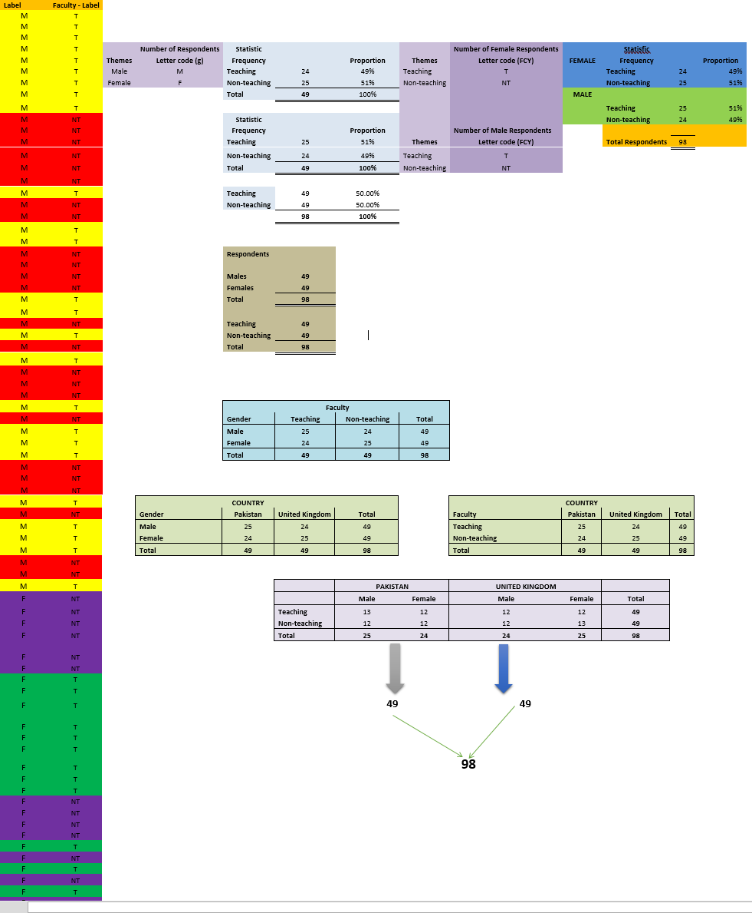
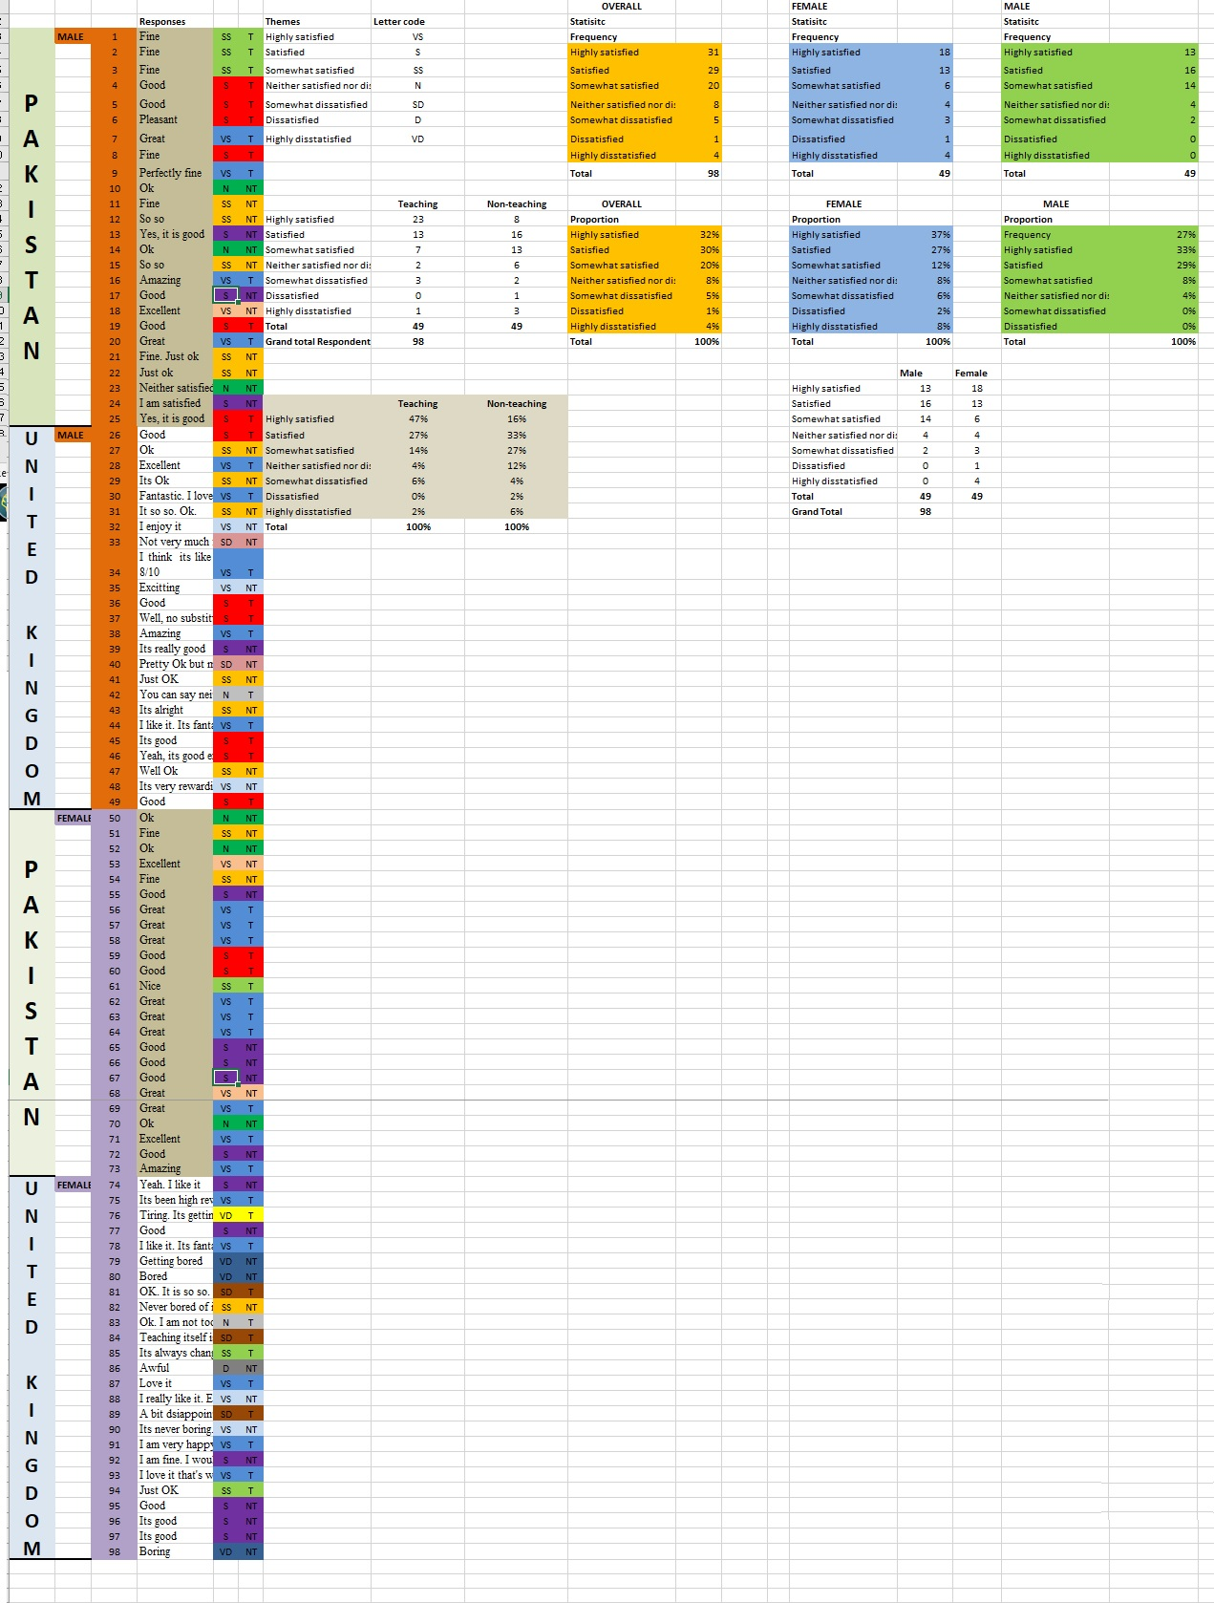
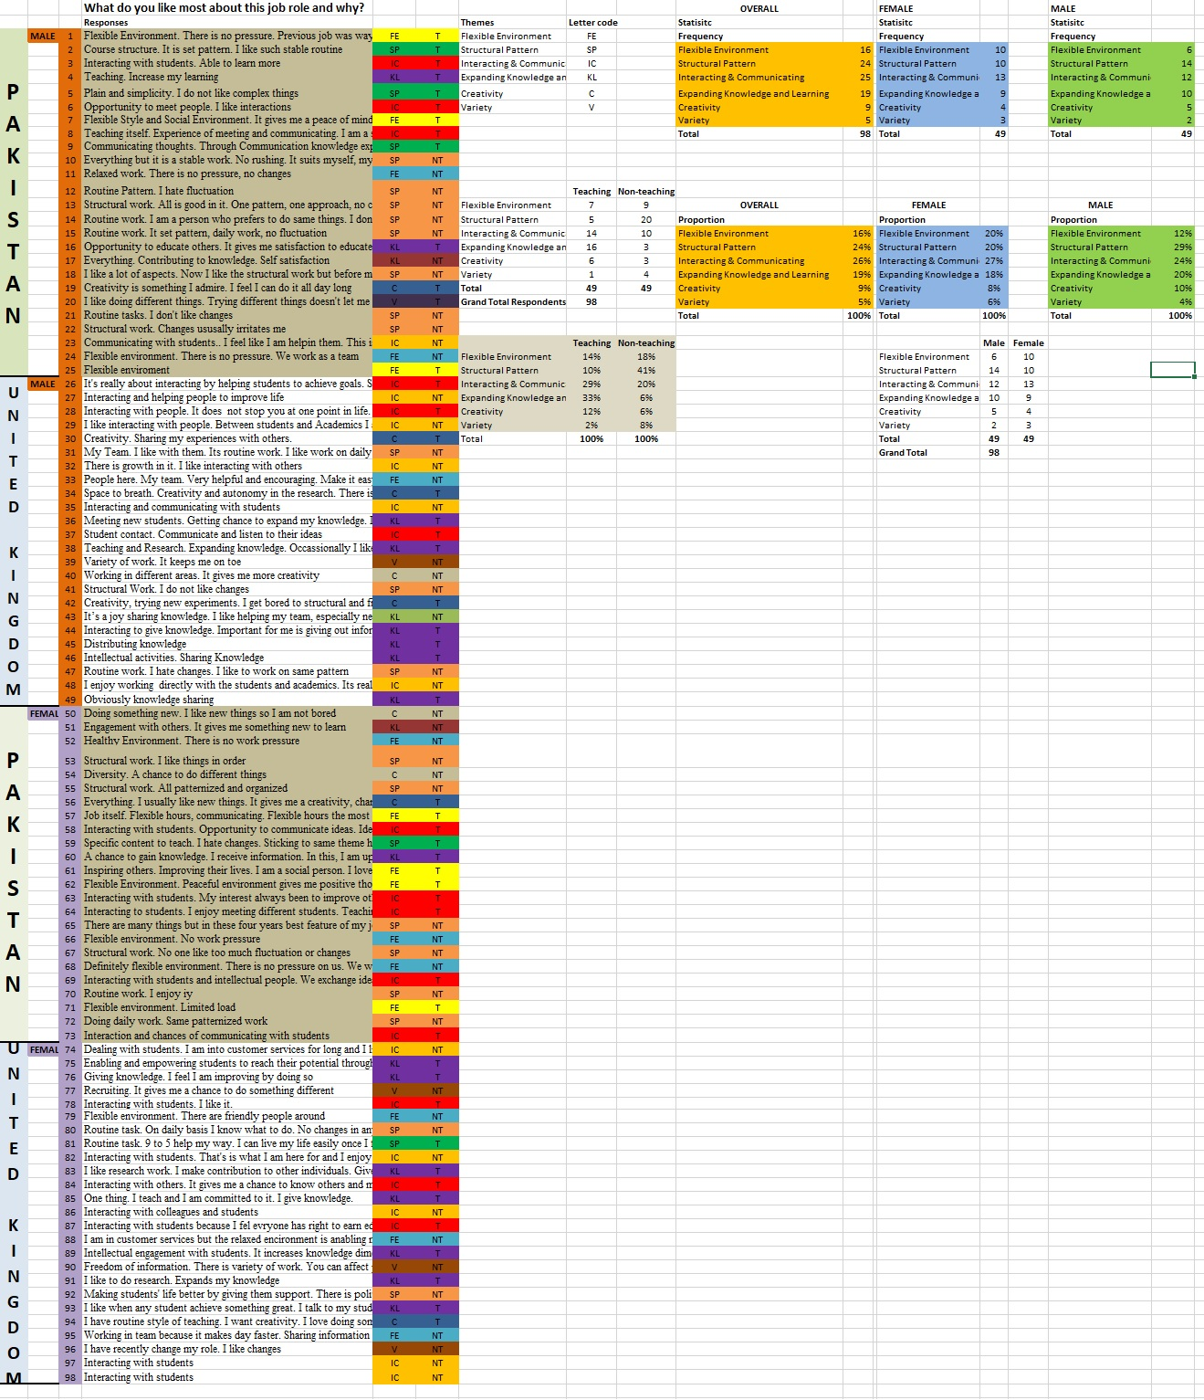
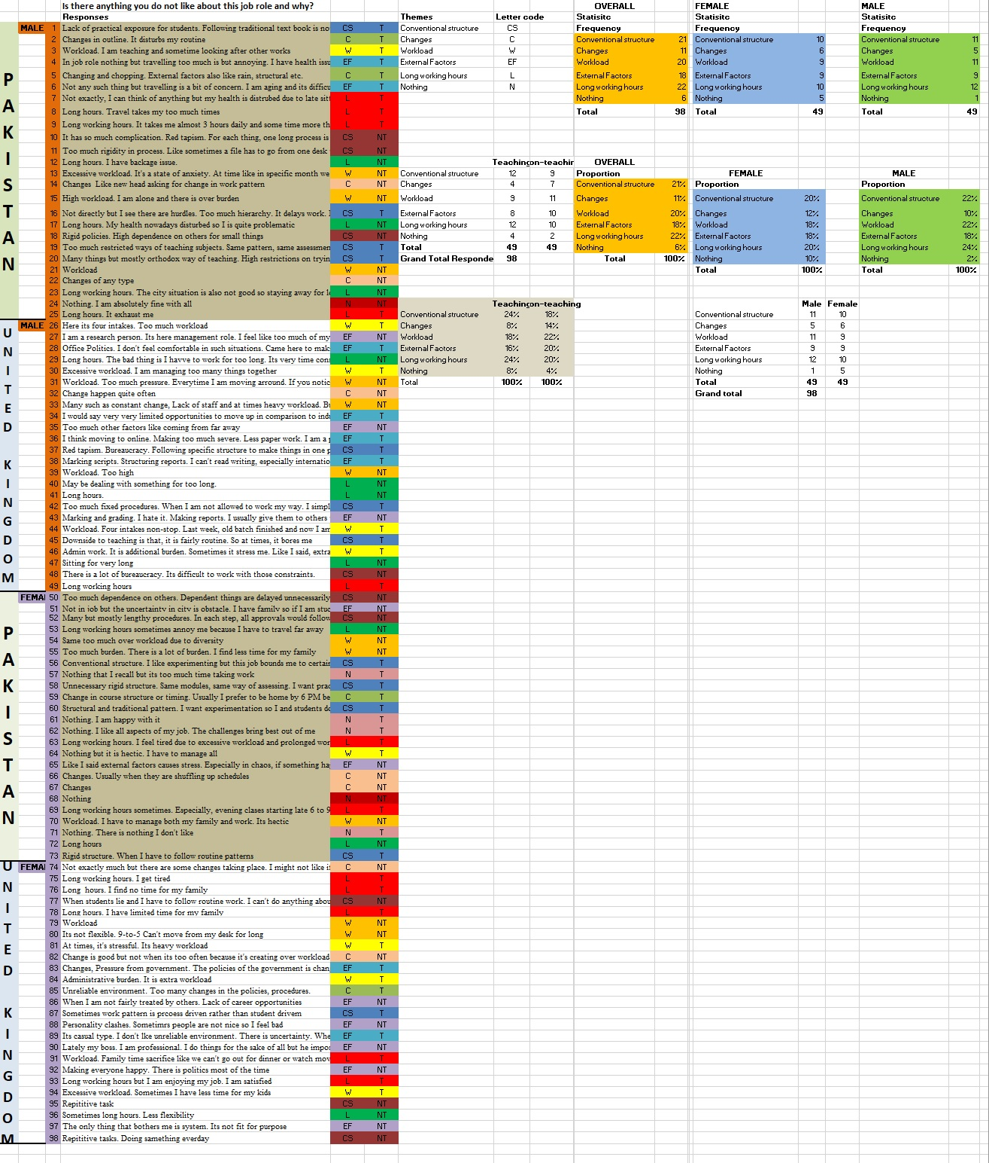
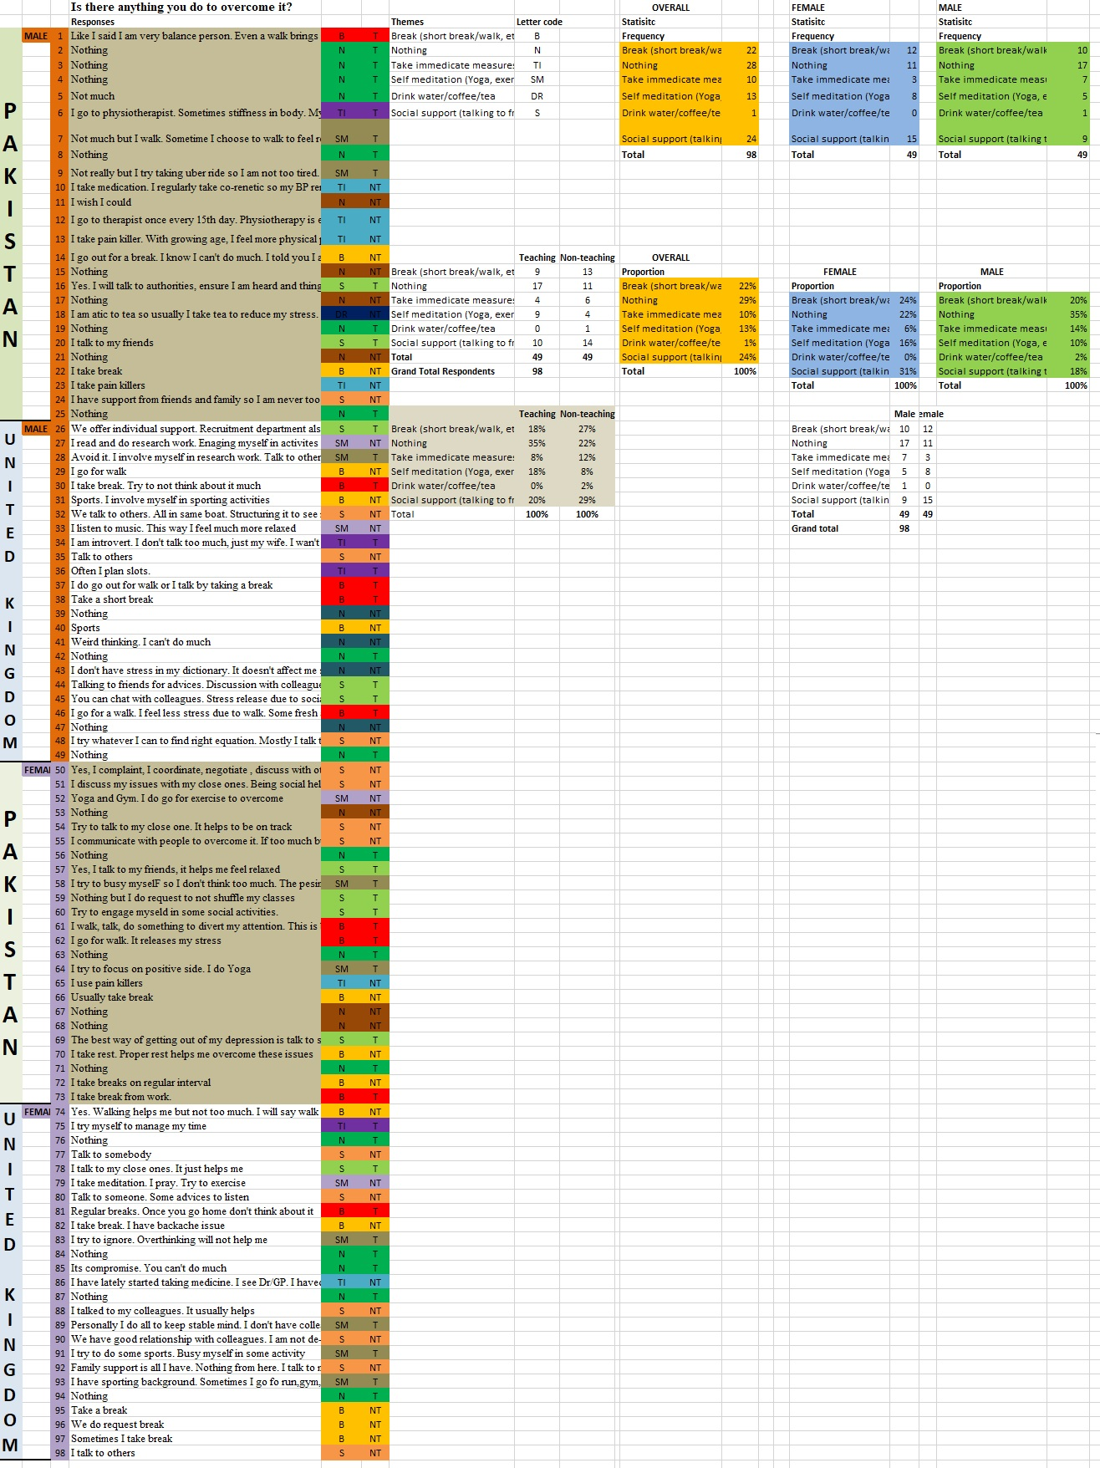
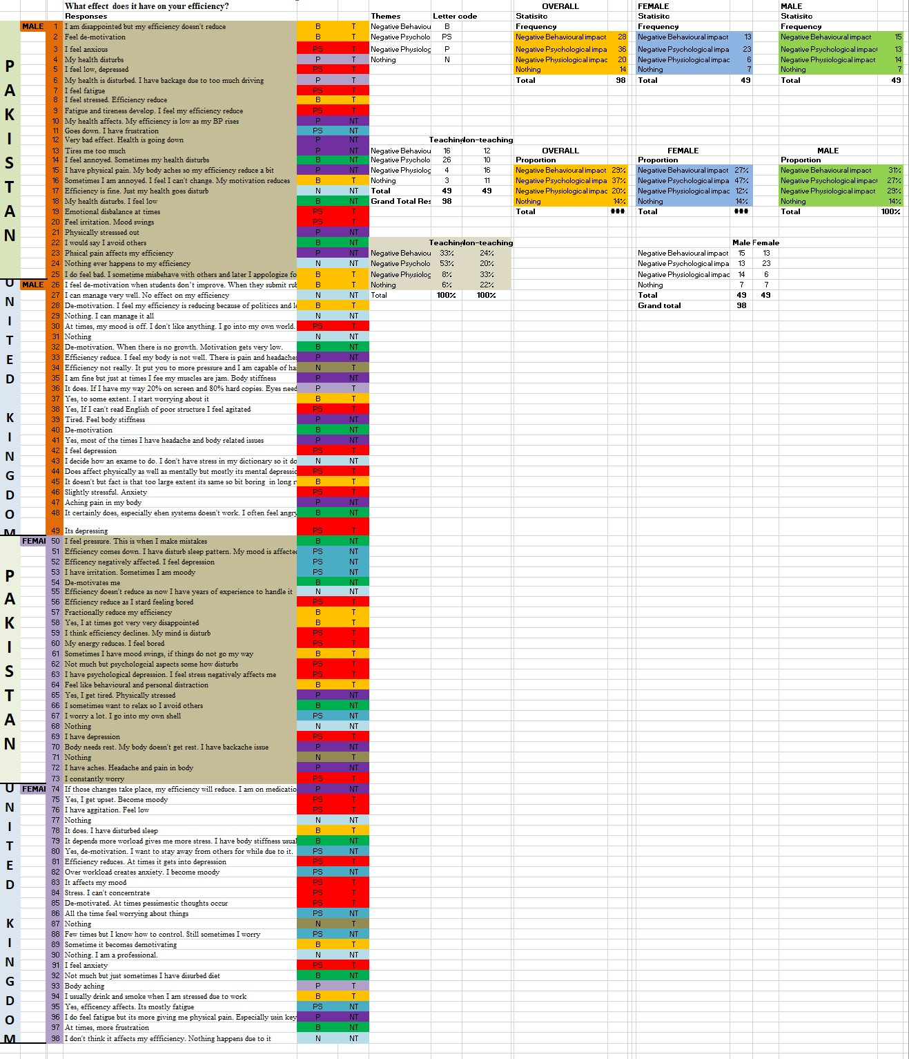
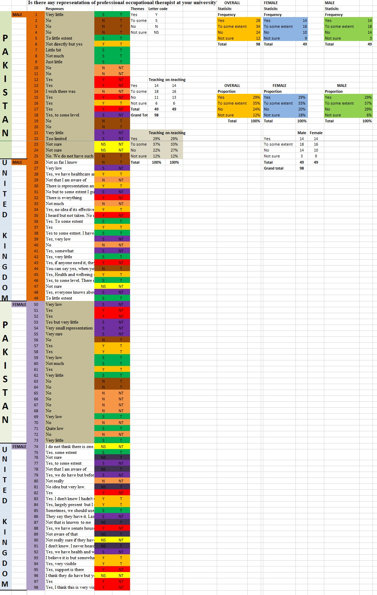
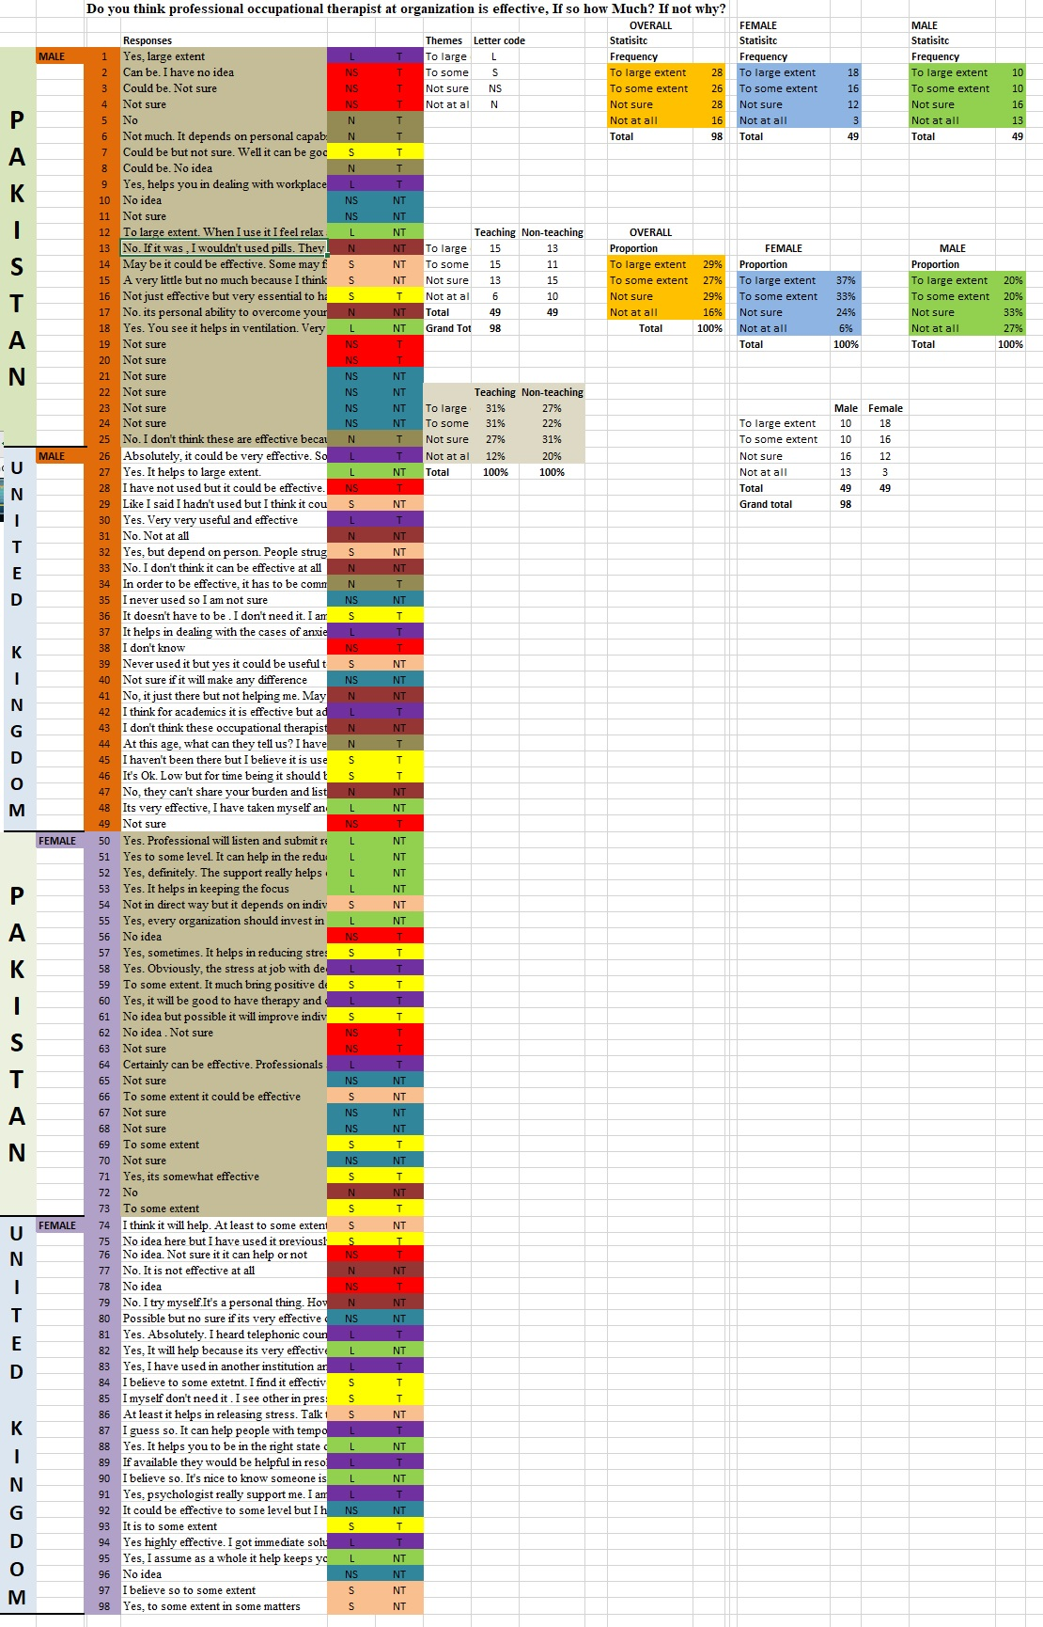
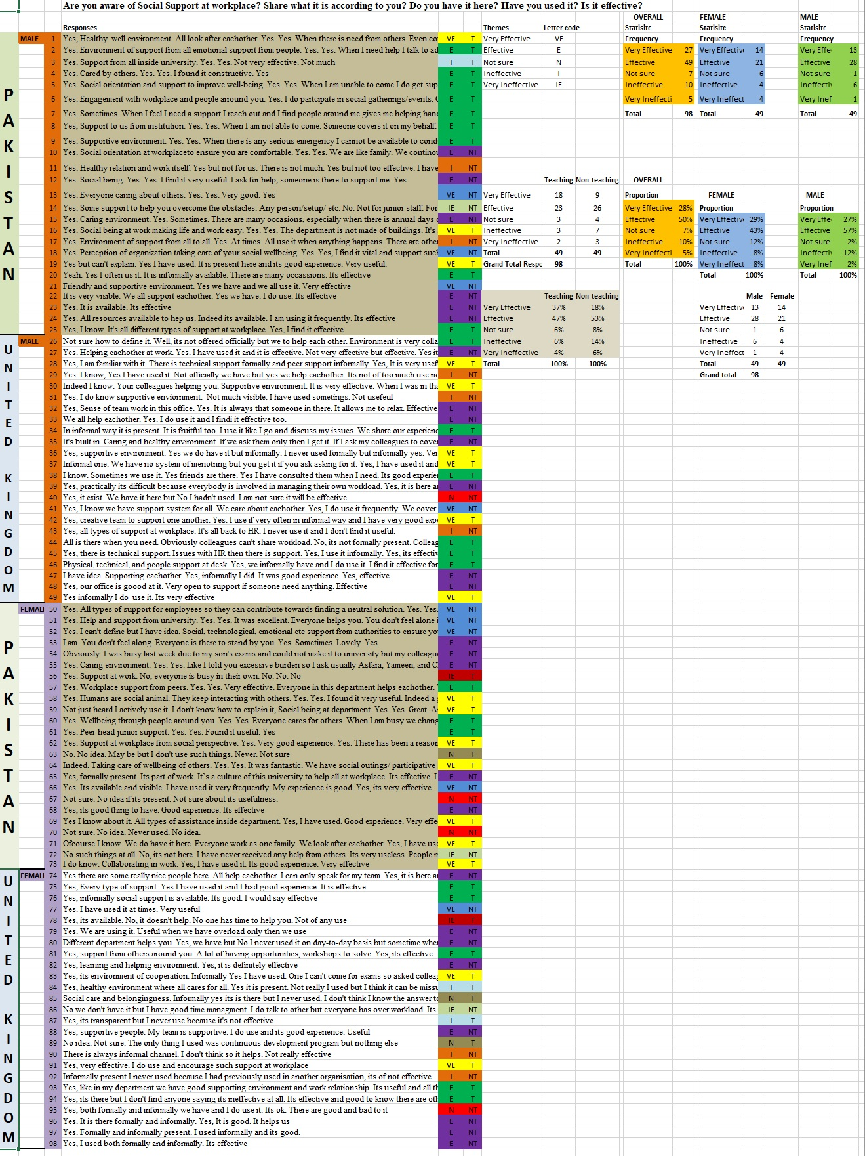
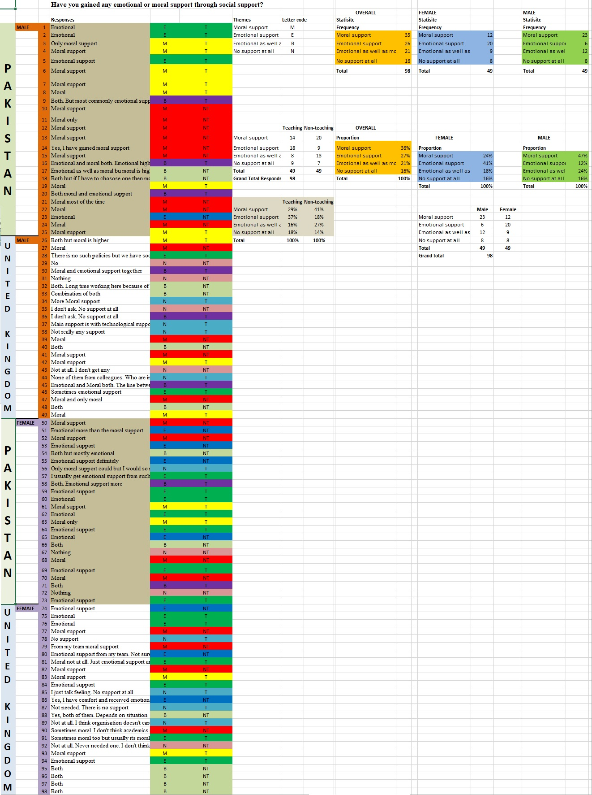
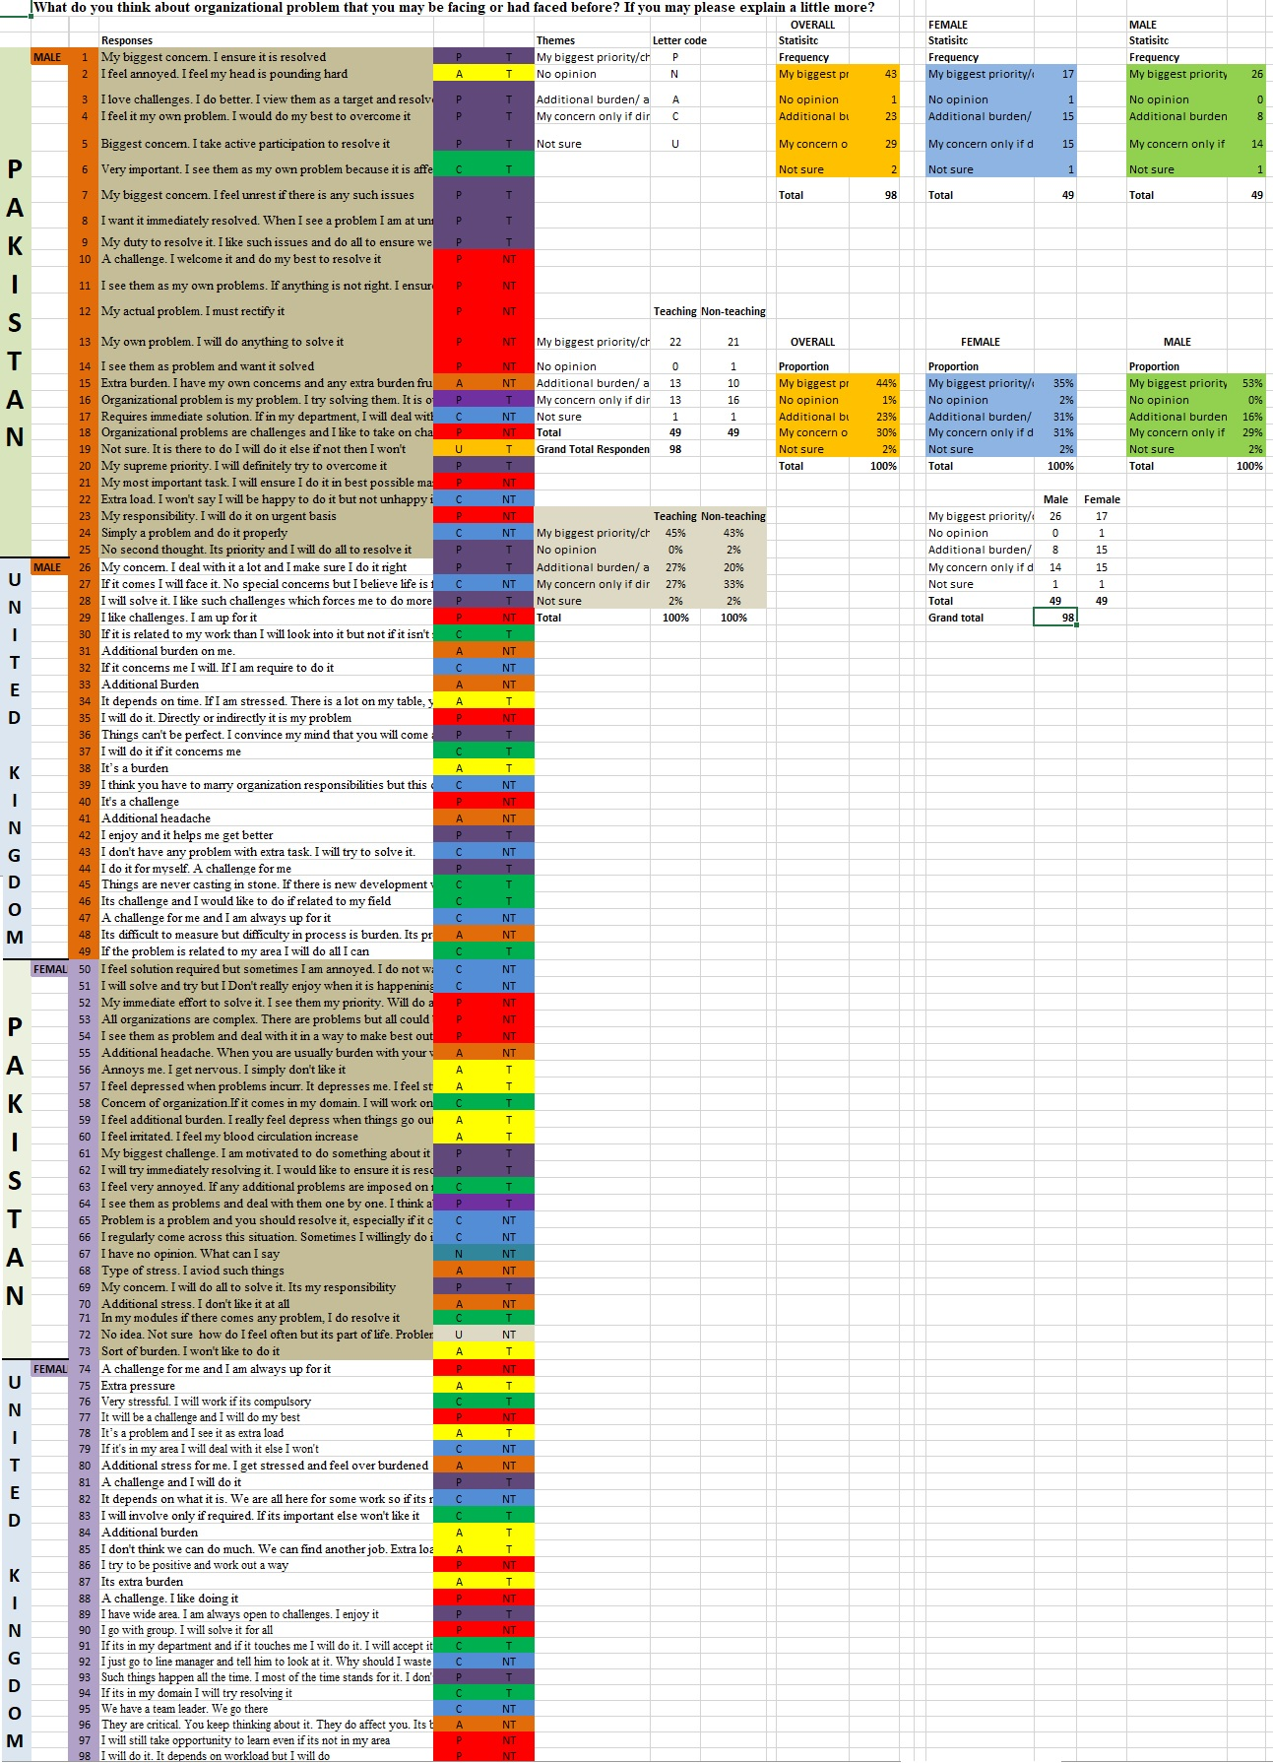
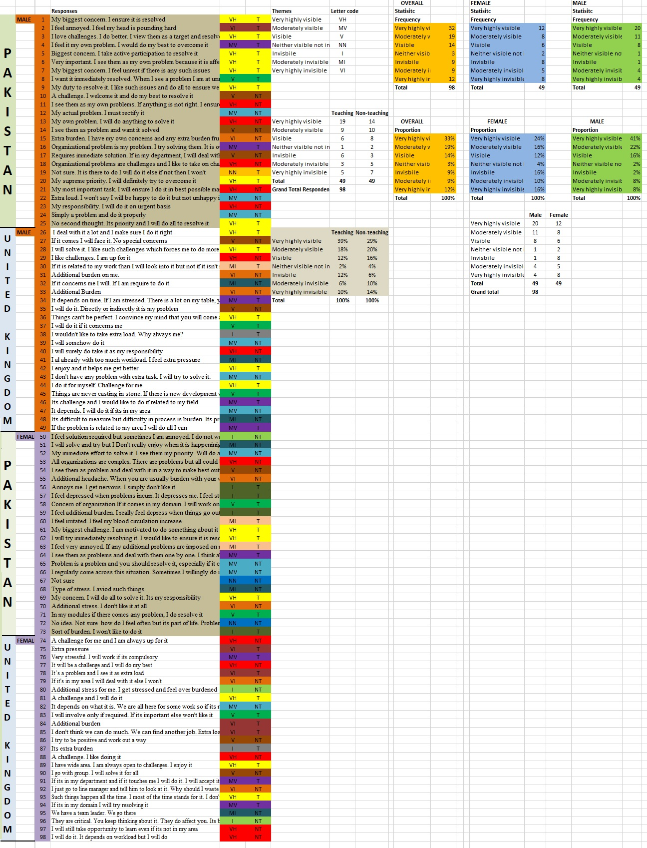
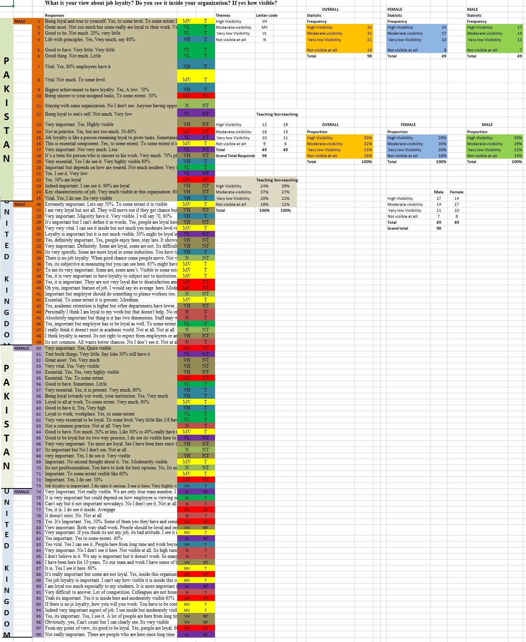

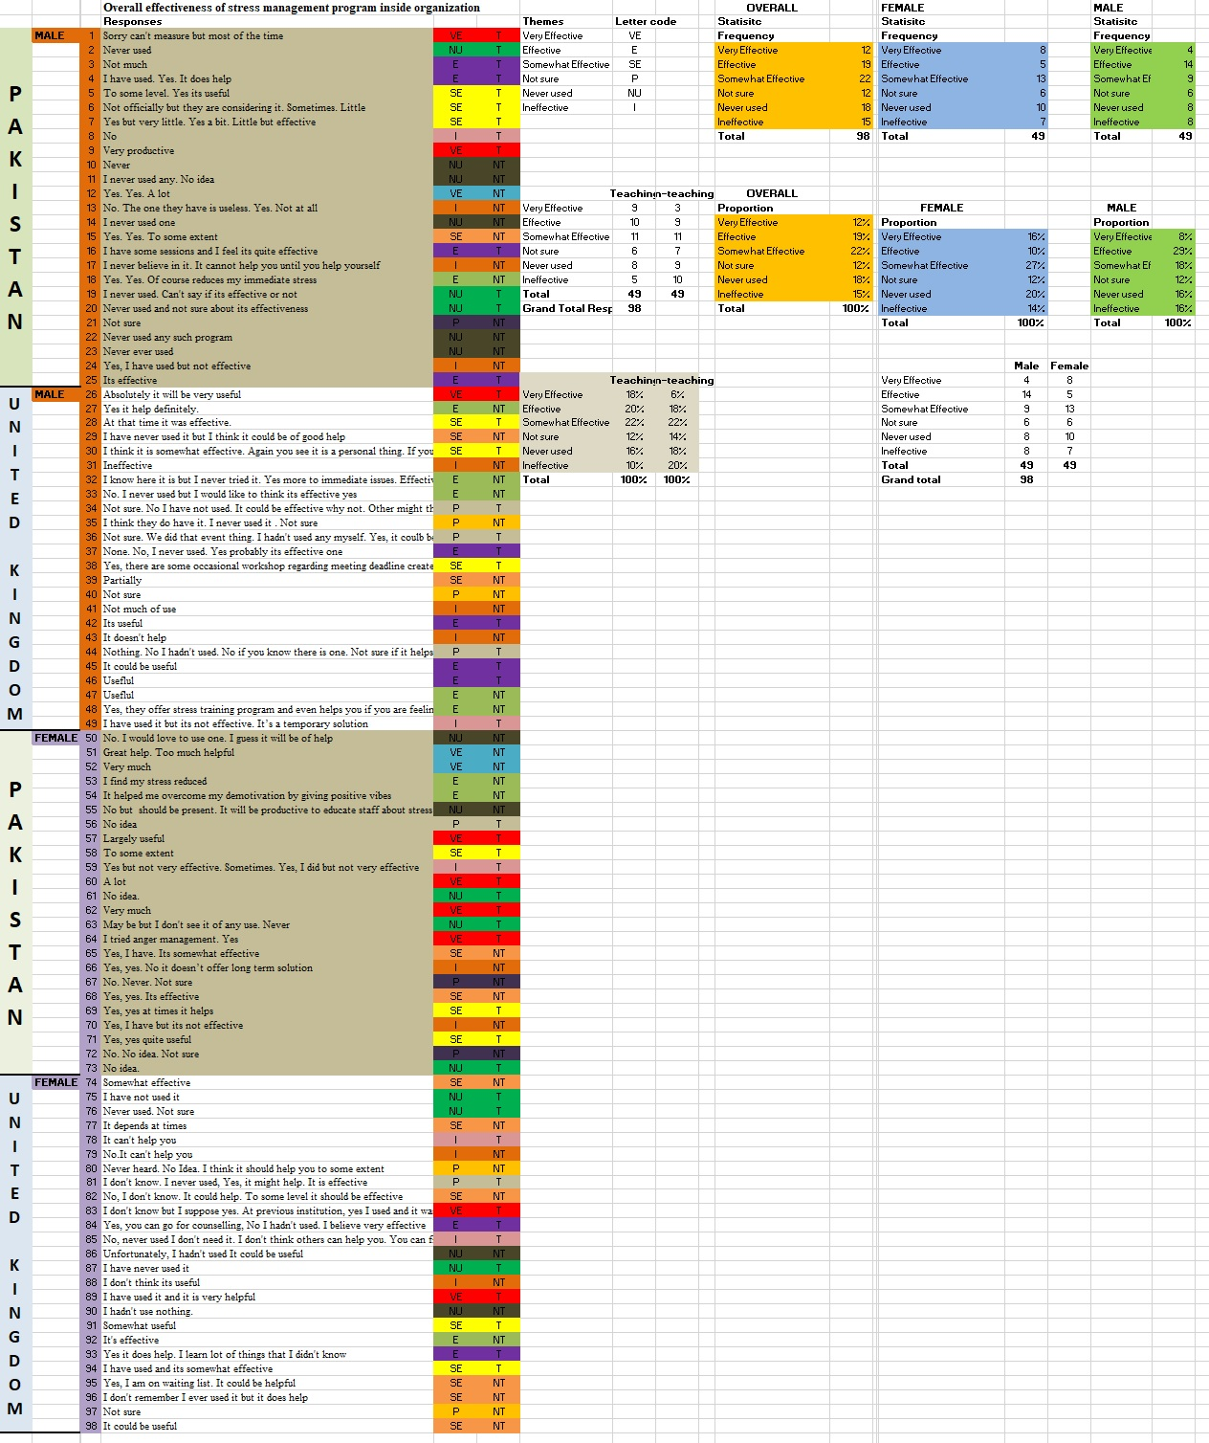

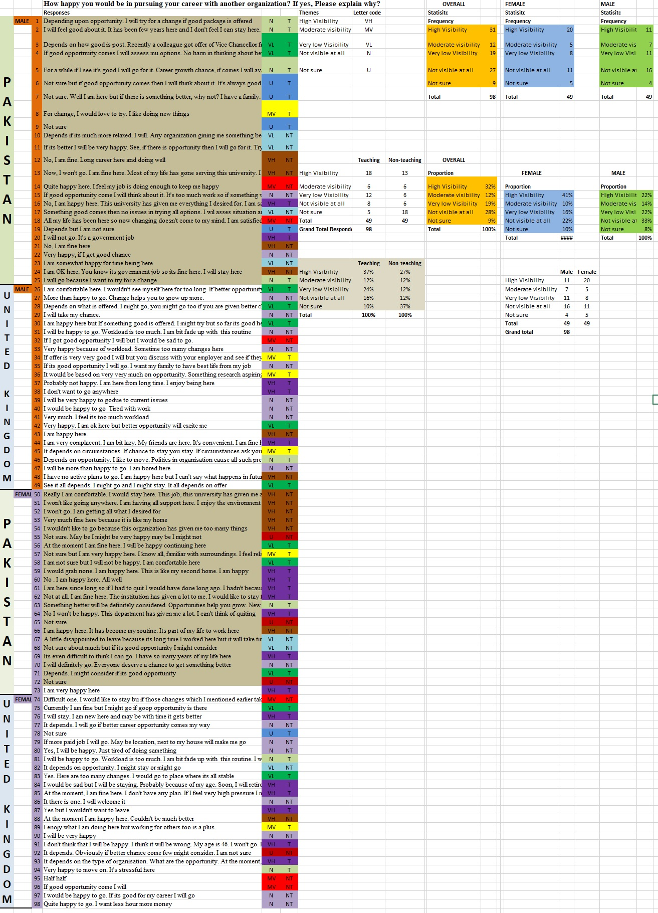

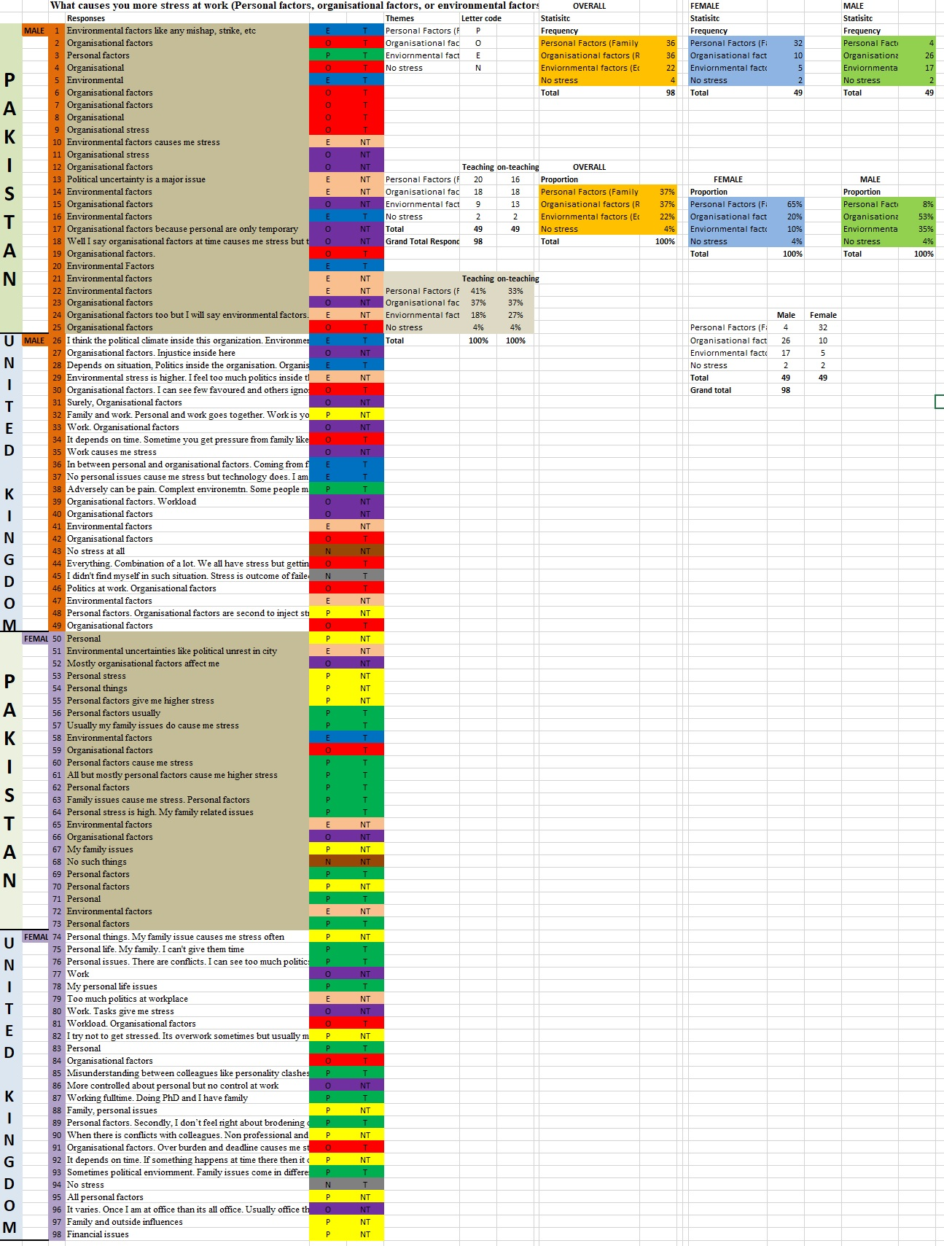

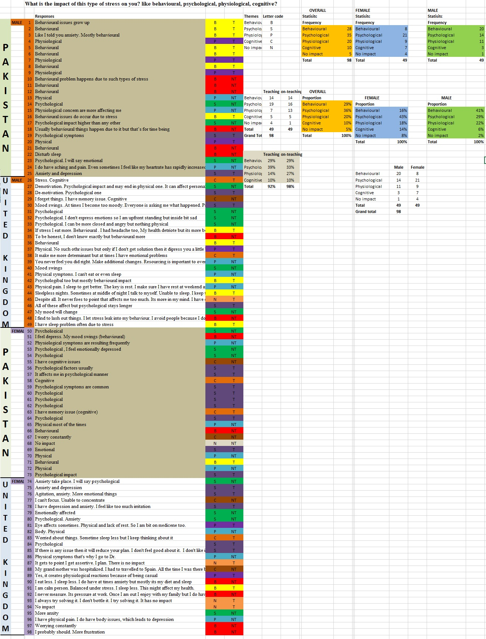

APPENDIX B
AC  Personal strain via Perceived Job Stress  0.68 X 0.33 = .22  0.28 + 0.22 = .5 | AC  Perceived job stress via personal strain  0.68 X 0.28 = .19  0.33 + 0.19 = .52 | AC  Role of Occ Therapist via personal strain  0.27 X 0.28 = .016  0.06 + = .296 | AC  Personal Resources via Personal Strain  0.38 X 0.28 = .106  0.13 + 0.1604 = .23 | AC  Personal Strain  0.09 X 0.28 = .025  0.16 + 0.025 = .18
AC  Role of Occupational Therapist  0.27 X 0.06 = .016  0.28 + 0.016 = .296 | AC  Role of Occupational Therapist  0.25 X 0.06 = .015  0.33 + 0.015 = .34 | AC  via Perceived job stress  0.25 X 0.33 = .082  0.06 + 0.082 = .14 | AC  Perceived Job Stress  0.31 X 0.33 = .042  0.13 + 0.042 = .17 | AC  Perceived Job Stress  0.12 X 0.33 = .039  0.16 + = .19
AC  Personal Resources  0.38 X 0.13 = .049  0.28 + 0.049 = .32 | AC  Personal Resources  0.31 X 0.13 = .04  0.33 + 0.04 = .37 | AC  Personal Resources  0.29 X 0.13 = .0377  0.06 + 0.037 = .097 | AC  Role of Occ therapist  0.29 X 0.06 = .017  0.13 + 0.037 = .147 | AC  Role of Occ therapist  0.13 X 0.06 = .007  0.16 + 0.007 = .167
AC  Social support  0.09 X 0.16 = .014  0.28 + 0.014 = .29 | AC  Social support  0.12 X 0.16 = .019  0.33 + 0.019 = .34 | AC  Social support  0.13 X 0.16 = .020  0.06 + 0.020 = .08 | AC  Social support  0.15 X 0.16 = .024  0.13 + 0.024 = .15 | AC  Social support  0.15 X 0.13 = .019  0.16 + 0.0195 = .17

NC  Personal strain via Perceived Job Stress  0.68 X 0.23 = 0.156  0.15 + 0.156 = .306 | NC  Perceived Job Stress via personal strain  0.68 X 0.15 = 0.102  0.23 + 0.102 = .332 | NC  Role of occupational therapist via personal strain  0.27 X 0.15 = 0.405  0.02 + 0.405 = 0.06 | NC  Personal Resources via Personal Strain  0.38 X 0.15 = .057  0.14 + 0.057 = .19 | NC  Social support via Personal Strain  0.09 X 0.15 =.011  0.13 + = 0.16
NC  Role of Occupational Therapist  0.27 X 0.02 = .005  0.15 + 0.005 = 0.15 | NC  Via Role of Occupational Therapist  0.25 X 0.02 = .005  0.23 + 0.005 = 0.235 | NC  Via Perceived Job Stress  0.25 X 0.23 = .0575  0.02 + 0.0575 = 0.0775 | NC  Via Perceived Job Stress  0.31 X 0.23 = .0713  0.14 + 0.0713 = .21 | NC  Via Perceived Job Stress  0.12 X 0.23 = .027  0.13 + = .14
NC  Personal Resources  0.38 X 0.14 = .05  0.15 + 0.05 = .20 | NC  Personal Resources  0.31 X 0.14 = .0434  0.23 + 0.0434 = .27 | NC  Personal Resources  0.29 X 0.14 = .0406  0.02 + 0.0406 = .06 | NC  Via Occ. Therapist  0.29 X 0.02 = .005  0.14 + 0.005 = .145 | NC  Via Occupational Therapist  0.13 X 0.02 = .002  0.13 + 0.002 = .13
NC  Social Support  0.09 X 0.13 =.011  0.15 + 0.011 = 0.16 | NC  Social Support  0.12 X 0.13 = .015  0.23 + 0.011 = .24 | NC  Social Support  0.13 X 0.13 = .0195  0.02 + 0.0195 = .039 | NC  Social Support  0.15 X 0.13 = .023  0.02 + 0.23 = .043 | NC  Via Personal Resources  0.15 X 0.02 = .023  0.13 + 0.23 = .033

CC  Personal strain via Perceived Job Stress  0.68 X 0.07 = .047  0.14 + 0.047 = .18 | CC  Perceived Job Stress via personal strain  0.68 X 0.14 = .095  0.07 + 0.095 = .16 | CC  Occ Therapist Via Personal Strain  0.27 X 0.14 = .037  0.08 + 0.037 = .11 | CC  Personal Resources via Personal strain  0.38 X 0.14 = .053  0.27 + 0.053 = .19 | CC  Social Support via Personal Strain  0.09 X 0.14 = .012  0.26 + 0.012 = .27
CC  Via Role of Occupational Therapist  0.27 X 0.08 = .02  0.14 + 0.02 = 0.166 | CC  Via Role of Occ Therapist  0.25 X 0.08 = .02  0.07 + 0.02 = .09 | CC  Via Perceived Stress  0.25 X 0.07 = .017  0.08 + 0.017 = .09 | CC  Via Perceived Job Stress  0.31 X 0.07 = .021  0.27 + 0.021 = .29 | CC  Via Perceived Job Stress  0.12 X 0.07 = .008  0.26 + 0.008 = .268
CC  Via Personal Resources  0.38 X 0.27 =0.102  0.14 + 0.10 = .24 | CC  Via Personal Resources  0.31 X 0.27 =0.095  0.07 + 0.095 = .16 | CC  Via Personal Resources  0.29 X 0.27 = .078  0.08 + 0.078 = .15 | CC  Via Occ therapist  0.29 X 0.08 = .023  0.27 + 0.023 = .292 | CC  Via Occ Therapist  0.13 X 0.08 = .010  0.26 + 0.010 = .27
CC  Via Social support  0.09 X 0.26 = 0.024  0.14 + 0.024 = 0.164 | CC  Via Social support  0.12 X 0.26 = 0.034  0.07 + 0.034 = 0.102 | CC  Via Social Support  0.13 X 0.26 = .033  0.08 + 0.033 = .13 | CC  Via Social Support  0.15 X 0.26 = .039  0.27+ 0.039 = .30 | CC  Via personal Resources  0.15 X 0.27 = .04  .0.26 + 0.04 = .30

Total Effect of Personal Strain on NC through perceived job stress: Y1a₂ = β1 + (β2 X β3)
Total Effect of Personal Strain on NC through role of OT: Y1b₂ = β1 + (β4 X β5)
Total Effect of Personal Strain on NC through personal resources: Y1c₂ = β1 + (β6 X β7)
Total Effect of Personal Strain on NC through social support: Y1d₂ = β1 + (β8 X β9)

β1 | β2 | β3 | Β4 | Β5 | β6 | Β7 | Β8 | Β9 | β10 | β11 | β12 | β13 | β14 | β15 | β16 | β17 | β18 | β19 | β20 | β21 | β22 | β23 | β24 | β25 | β26
.28 | ǁ | ǁ | ǁ | ǁ | ǁ | ǁ | ǁ | ǁ | ǁ | ǁ | ǁ | ǁ | ǁ | ǁ | ǁ | ǁ | ǁ | ǁ | ǁ | ǁ | ǁ | ǁ | ǁ | ǁ | ǁ
ǁ | .68 | ǁ | ǁ | ǁ | ǁ | ǁ | ǁ | ǁ | ǁ | ǁ | ǁ | ǁ | ǁ | ǁ | ǁ | ǁ | ǁ | ǁ | ǁ | ǁ | ǁ | ǁ | ǁ | ǁ | ǁ
ǁ | ǁ | .33 | ǁ | ǁ | ǁ | ǁ | ǁ | ǁ | ǁ | ǁ | ǁ | ǁ | ǁ | ǁ | ǁ | ǁ | ǁ | ǁ | ǁ | ǁ | ǁ | ǁ | ǁ | ǁ | ǁ
ǁ | ǁ | ǁ | .27 | ǁ | ǁ | ǁ | ǁ | ǁ | ǁ | ǁ | ǁ | ǁ | ǁ | ǁ | ǁ | ǁ | ǁ | ǁ | ǁ | ǁ | ǁ | ǁ | ǁ | ǁ | ǁ
ǁ | ǁ | ǁ | ǁ | .06 | ǁ | ǁ | ǁ | ǁ | ǁ | ǁ | ǁ | ǁ | ǁ | ǁ | ǁ | ǁ | ǁ | ǁ | ǁ | ǁ | ǁ | ǁ | ǁ | ǁ | ǁ
ǁ | ǁ | ǁ | ǁ | ǁ | .38 | ǁ | ǁ | ǁ | ǁ | ǁ | ǁ | ǁ | ǁ | ǁ | ǁ | ǁ | ǁ | ǁ | ǁ | ǁ | ǁ | ǁ | ǁ | ǁ | ǁ
ǁ | ǁ | ǁ | ǁ | ǁ | ǁ | .13 | ǁ | ǁ | ǁ | ǁ | ǁ | ǁ | ǁ | ǁ | ǁ | ǁ | ǁ | ǁ | ǁ | ǁ | ǁ | ǁ | ǁ | ǁ | ǁ
ǁ | ǁ | ǁ | ǁ | ǁ | ǁ | ǁ | .09 | ǁ | ǁ | ǁ | ǁ | ǁ | ǁ | ǁ | ǁ | ǁ | ǁ | ǁ | ǁ | ǁ | ǁ | ǁ | ǁ | ǁ | ǁ
ǁ | ǁ | ǁ | ǁ | ǁ | ǁ | ǁ | ǁ | .16 | ǁ | ǁ | ǁ | ǁ | ǁ | ǁ | ǁ | ǁ | ǁ | ǁ | ǁ | ǁ | ǁ | ǁ | ǁ | ǁ | ǁ
ǁ | ǁ | ǁ | ǁ | ǁ | ǁ | ǁ | ǁ | ǁ | .25 | ǁ | ǁ | ǁ | ǁ | ǁ | ǁ | ǁ | ǁ | ǁ | ǁ | ǁ | ǁ | ǁ | ǁ | ǁ | ǁ
ǁ | ǁ | ǁ | ǁ | ǁ | ǁ | ǁ | ǁ | ǁ | ǁ | .06 | ǁ | ǁ | ǁ | ǁ | ǁ | ǁ | ǁ | ǁ | ǁ | ǁ | ǁ | ǁ | ǁ | ǁ | ǁ
ǁ | ǁ | ǁ | ǁ | ǁ | ǁ | ǁ | ǁ | ǁ | ǁ | ǁ | .31 | ǁ | ǁ | ǁ | ǁ | ǁ | ǁ | ǁ | ǁ | ǁ | ǁ | ǁ | ǁ | ǁ | ǁ
ǁ | ǁ | ǁ | ǁ | ǁ | ǁ | ǁ | ǁ | ǁ | ǁ | ǁ | ǁ | .13 | ǁ | ǁ | ǁ | ǁ | ǁ | ǁ | ǁ | ǁ | ǁ | ǁ | ǁ | ǁ | ǁ
ǁ | ǁ | ǁ | ǁ | ǁ | ǁ | ǁ | ǁ | ǁ | ǁ | ǁ | ǁ | ǁ | .12 | ǁ | ǁ | ǁ | ǁ | ǁ | ǁ | ǁ | ǁ | ǁ | ǁ | ǁ | ǁ
ǁ | ǁ | ǁ | ǁ | ǁ | ǁ | ǁ | ǁ | ǁ | ǁ | ǁ | ǁ | ǁ | ǁ | ǁ | ǁ | ǁ | ǁ | ǁ | ǁ | ǁ | ǁ | ǁ | ǁ | ǁ | ǁ
ǁ | ǁ | ǁ | ǁ | ǁ | ǁ | ǁ | ǁ | ǁ | ǁ | ǁ | ǁ | ǁ | ǁ | ǁ | .13 | ǁ | ǁ | ǁ | ǁ | ǁ | ǁ | ǁ | ǁ | ǁ | ǁ
ǁ | ǁ | ǁ | ǁ | ǁ | ǁ | ǁ | ǁ | ǁ | ǁ | ǁ | ǁ | ǁ | ǁ | ǁ | ǁ | .15 | ǁ | ǁ | ǁ | ǁ | ǁ | ǁ | ǁ | ǁ | ǁ
ǁ | ǁ | ǁ | ǁ | ǁ | ǁ | ǁ | ǁ | ǁ | ǁ | ǁ | ǁ | ǁ | ǁ | ǁ | ǁ | ǁ | .23 | ǁ | ǁ | ǁ | ǁ | ǁ | ǁ | ǁ | ǁ
ǁ | ǁ | ǁ | ǁ | ǁ | ǁ | ǁ | ǁ | ǁ | ǁ | ǁ | ǁ | ǁ | ǁ | ǁ | ǁ | ǁ | ǁ | .02 | ǁ | ǁ | ǁ | ǁ | ǁ | ǁ | ǁ
ǁ | ǁ | ǁ | ǁ | ǁ | ǁ | ǁ | ǁ | ǁ | ǁ | ǁ | ǁ | ǁ | ǁ | ǁ | ǁ | ǁ | ǁ | ǁ | .14 | ǁ | ǁ | ǁ | ǁ | ǁ | ǁ
ǁ | ǁ | ǁ | ǁ | ǁ | ǁ | ǁ | ǁ | ǁ | ǁ | ǁ | ǁ | ǁ | ǁ | ǁ | ǁ | ǁ | ǁ | ǁ | ǁ | .13 | ǁ | ǁ | ǁ | ǁ | ǁ
ǁ | ǁ | ǁ | ǁ | ǁ | ǁ | ǁ | ǁ | ǁ | ǁ | ǁ | ǁ | ǁ | ǁ | ǁ | ǁ | ǁ | ǁ | ǁ | ǁ | ǁ | .14 | ǁ | ǁ | ǁ | ǁ
ǁ | ǁ | ǁ | ǁ | ǁ | ǁ | ǁ | ǁ | ǁ | ǁ | ǁ | ǁ | ǁ | ǁ | ǁ | ǁ | ǁ | ǁ | ǁ | ǁ | ǁ | ǁ | .07 | ǁ | ǁ | ǁ
ǁ | ǁ | ǁ | ǁ | ǁ | ǁ | ǁ | ǁ | ǁ | ǁ | ǁ | ǁ | ǁ | ǁ | ǁ | ǁ | ǁ | ǁ | ǁ | ǁ | ǁ | ǁ | ǁ | .08 | ǁ | ǁ
ǁ | ǁ | ǁ | ǁ | ǁ | ǁ | ǁ | ǁ | ǁ | ǁ | ǁ | ǁ | ǁ | ǁ | ǁ | ǁ | ǁ | ǁ | ǁ | ǁ | ǁ | ǁ | ǁ | ǁ | .27 | ǁ
ǁ | ǁ | ǁ | ǁ | ǁ | ǁ | ǁ | ǁ | ǁ | ǁ | ǁ | ǁ | ǁ | ǁ | ǁ | ǁ | ǁ | ǁ | ǁ | ǁ | ǁ | ǁ | ǁ | ǁ | ǁ | .26

APPENDIX C
KMO and Bartlett's Test
Kaiser-Meyer-Olkin Measure of Sampling Adequacy. |  | .813
Bartlett's Test of Sphericity | Approx. Chi-Square | 5926.718
Bartlett's Test of Sphericity | Df | 231
Bartlett's Test of Sphericity | Sig. | .000

Communalities
 | Initial | Extraction
Rate Occupational Therapist Representation | .761 | .784
Rate Occupational Therapist Representation at University | .853 | .943
Impact of Occupational Therapist in Sustenance of Human Capital | .831 | .862
Occupational therapist offers solutions to improves working efficiency | .876 | .957
Occupational therapist address concerns to improve organisational commitment] | .847 | .869
Occupational therapist counselling is effective in reducing different types of stress | .785 | .798
Personal Strain – I | .610 | .531
Personal Strain II | .499 | .541
Personal Strain III | .547 | .589
Perceived Job Stress I | .586 | .553
Perceived Job Stress II | .523 | .453
Perceived Job Stress III | .582 | .633
Affective Commitment – I | .638 | .776
Affective Commitment II | .545 | .547
Normative Commitment I | .488 | .488
Normative Commitment II | .543 | .675
Continuance Commitment I | .510 | .579
Continuance Commitment II | .512 | .477
Personal Resources I | .624 | .664
Personal Resources II | .621 | .694
Social Support I | .588 | .649
Social Support II | .546 | .420
Extraction Method: Maximum Likelihood.

Total Variance Explained
Factor | Initial Eigenvalues |  |  | Extraction Sums of Squared Loadings |  |  | Rotation Sums of Squared Loadingsª
Factor | Total | % of Variance | Cumulative % | Total | % of Variance | Cumulative % | Total
1 | 5.351 | 24.324 | 24.324 | 4.718 | 21.446 | 21.446 | 3.480
2 | 4.331 | 19.687 | 44.011 | 1.241 | 5.641 | 27.087 | 3.565
3 | 2.654 | 12.065 | 56.076 | 3.790 | 17.226 | 44.313 | 3.656
4 | 1.627 | 7.394 | 63.470 | 2.711 | 12.323 | 56.636 | 3.812
5 | 1.328 | 6.036 | 69.506 | 1.297 | 5.898 | 62.534 | 2.944
6 | 1.114 | 5.066 | 74.572 | .726 | 3.300 | 65.834 | 2.635
7 | .899 | 4.086 | 78.658
8 | .639 | 2.904 | 81.562
9 | .608 | 2.765 | 84.327
10 | .517 | 2.348 | 86.675
11 | .462 | 2.102 | 88.777
12 | .362 | 1.645 | 90.421
13 | .339 | 1.543 | 91.964
14 | .301 | 1.368 | 93.332
15 | .264 | 1.202 | 94.534
16 | .254 | 1.157 | 95.690
17 | .229 | 1.042 | 96.732
18 | .211 | .960 | 97.693
19 | .182 | .827 | 98.520
20 | .155 | .706 | 99.227
21 | .092 | .418 | 99.644
22 | .078 | .356 | 100.000
Extraction Method: Maximum Likelihood.
a. When factors are correlated, sums of squared loadings cannot be added to obtain a total variance.

Pattern Matrixª
 | Factor
 | 1 | 2 | 3 | 4 | 5 | 6
The representation of professional occupational therapist in Education sector |  |  | .835
The representation of professional occupational therapist at your institution |  |  | .991
The impact of professional occupational therapist in the sustaining human capital in your institute |  |  | .884
Occupational therapist offers advices/solutions that improves working efficiency |  |  |  | .987
Occupational therapist address concerns that improve organisational commitment |  |  |  | .903
Occupational therapist counselling is effective in reducing different types of stress |  |  |  | .839
I work under tight time deadlines. | .707
I frequently make mistakes in my work. | .731
Lately, I respond badly in situations that normally wouldn't bother me. | .795
While relaxing I frequently think about work | .689
I by myself usually find solution for my problems at work. | .556
I really feel as if this university’s problems are my own |  |  |  |  | .724
I would be very happy to spend the rest of my career with this organization |  |  |  |  | .832
I feel a moral obligation to pursue my career path with this university because loyalty is more important for me |  |  |  |  | .716
One of the reasons behind working here is I receive emotional and moral support. |  |  |  |  | .558 | .411
Right now, staying with my organization is a matter of necessity as much as desire |  |  |  |  |  | .802
I am not afraid of what might happen if I quit my job without having another one lined up. |  |  |  |  |  | .716
When I need suggestions on how to deal with a personal problem, I know someone at university I can turn to. |  | .654
There is someone I could turn to for advice about making career plans or flexible hours. |  | .798
I get a social support from my peers and other members. |  | .846
There is at least one person in this university who listen to my problems. |  | .798
I am expected to do many different tasks in too little time. |  | .763
Extraction Method: Maximum Likelihood.
Rotation Method: Promax with Kaiser Normalization.ª
a. Rotation converged in 7 iterations.

APPENDIX D
Survey Questionnaire:
This survey is to examine the relationship between occupational stress and organisational commitment in Education sector of UK and Pakistan. The participants are teaching (lecturers) and non-teaching (administrative) staff of universities. The findings will be used only for academic purpose. All information and details shared by participants will be will be kept confidential. If you may decide to opt out at any stage of survey, you are allowed to do so. It will take approximately 3-to-5 minutes to answer all questions.
A) Demographic information:
1. Gender(Please tick the appropriate option)
Male | ☐
Female | ☐
Prefer not to say | ☐

2. Age Bracket(Please tick the appropriate option)
18-25 | ☐
26-35 | ☐
36-45 | ☐
46-55 | ☐
56-65 | ☐
66 or Above | ☐

3. Education(Please tick the appropriate option)
High School | ☐
College | ☐
Vocational Training | ☐
Bachelors | ☐
Masters | ☐
Doctorate/PhD | ☐
Other, Please specify | __________________

4. Year of Experience in Education Sector(Please tick the appropriate option)
Less than a year | ☐
1-2 years | ☐
3-5 years | ☐
6-8 yaers | ☐
9-12 years | ☐
13-15 years | ☐
16 or Above | ☐

5. Faculty(Please tick the option best describe you)
Teaching Staff | ☐
Non-teaching Staff | ☐

B. Attitudinal and Behavioural questions:
I. Rate the following statements:
(0=0, 0.1=10%.........................................................................................................1.0=100%).
Low _ _ _ _ _ _ _ _ _ _ _ _ __ _ _ _ _ _ _ _ _ _ _ __ _ _ _ __ _ _ _ _High
 | 0 | 0.1 | 0.2 | 0.3 | 0.4 | 0.5 | 0.6 | 0.7 | 0.8 | 0.9 | 1.0
The representation of professional occupational therapist in Education sector | ☐ | ☐ | ☐ | ☐ | ☐ | ☐ | ☐ | ☐ | ☐ | ☐ | ☐
The representation of professional occupational therapist at your institution | ☐ | ☐ | ☐ | ☐ | ☐ | ☐ | ☐ | ☐ | ☐ | ☐ | ☐
The impact of professional occupational therapist in the sustaining human capital in your institute | ☐ | ☐ | ☐ | ☐ | ☐ | ☐ | ☐ | ☐ | ☐ | ☐ | ☐

II. Rate the following statements:  (Strongly Disagree=1, Disagree= 2, 3= Moderately Disagree, 4 = Moderately Agree, 5 = Agree, 6= Strongly Agree) | 1 | 2 | 3 | 4 | 5 | 6 | N/A
Occupational therapist counselling is effective in reducing different types of stress | ☐ | ☐ | ☐ | ☐ | ☐ | ☐ | ☐
Occupational therapist offers advices/solutions that improves working efficiency | ☐ | ☐ | ☐ | ☐ | ☐ | ☐ | ☐
Occupational therapist address concerns that improve organisational commitment | ☐ | ☐ | ☐ | ☐ | ☐ | ☐ | ☐

III (A). Rate the following statements:  (Strongly Disagree=1, Disagree= 2, 3= Moderately Disagree, 4 = Moderately Agree, 5 = Agree, 6= Strongly Agree) | 1 | 2 | 3 | 4 | 5 | 6
I am expected to do many different tasks in too little time. | ☐ | ☐ | ☐ | ☐ | ☐ | ☐
I work under tight time deadlines. | ☐ | ☐ | ☐ | ☐ | ☐ | ☐
(B).
I frequently make mistakes in my work. | ☐ | ☐ | ☐ | ☐ | ☐ | ☐
Lately, I respond badly in situations that normally wouldn't bother me. | ☐ | ☐ | ☐ | ☐ | ☐ | ☐
(C).
While relaxing I frequently think about work | ☐ | ☐ | ☐ | ☐ | ☐ | ☐
I by myself usually find solution for my problems at work. | ☐ | ☐ | ☐ | ☐ | ☐ | ☐

IV (A). Rate the following statements:  (Strongly Disagree=1, Disagree= 2, 3= Moderately Disagree, 4 = Moderately Agree, 5 = Agree, 6= Strongly Agree) | 1 | 2 | 3 | 4 | 5 | 6
I really feel as if this university’s problems are my own | ☐ | ☐ | ☐ | ☐ | ☐ | ☐
I would be very happy to spend the rest of my career with this organization | ☐ | ☐ | ☐ | ☐ | ☐ | ☐
(B).
I feel a moral obligation to pursue my career path with this university because loyalty is more important for me | ☐ | ☐ | ☐ | ☐ | ☐ | ☐
One of the reasons behind working here is I receive emotional and moral support. | ☐ | ☐ | ☐ | ☐ | ☐ | ☐
(C).
Right now, staying with my organization is a matter of necessity as much as desire | ☐ | ☐ | ☐ | ☐ | ☐ | ☐
I am not afraid of what might happen if I quit my job without having another one lined up. | ☐ | ☐ | ☐ | ☐ | ☐ | ☐

V (A). Rate the following statements:  (Strongly Disagree=1, Disagree= 2, 3= Moderately Disagree, 4 = Moderately Agree, 5 = Agree, 6= Strongly Agree) | 1 | 2 | 3 | 4 | 5 | 6
When I need suggestions on how to deal with a personal problem, I know someone at university I can turn to. | ☐ | ☐ | ☐ | ☐ | ☐ | ☐
There is someone I could turn to for advice about making career plans or flexible hours. | ☐ | ☐ | ☐ | ☐ | ☐ | ☐
I get a social support from my peers and other members. | ☐ | ☐ | ☐ | ☐ | ☐ | ☐
There is at least one person in this university who listen to my problems. | ☐ | ☐ | ☐ | ☐ | ☐ | ☐

VI (A).Tick one of the following options that could be a prime reason for your stress at workplace:
Personal Factors (Family problem, financial problem, personality) |  |  |  |  |  |  |  | ☐
Organisational Factors (Role Demand, Task Demand, Organisational Structure, leadership, interpersonal relationship, Life-cycle of the organisation) |  |  |  |  |  |  |  | ☐
Environmental Factors (Economic uncertainty, Political uncertainty, Technological uncertainty) |  |  |  |  |  |  |  | ☐
VI (B). Based on your above section, tick one of the following option
Personal Factors
Family Problems ☐ |  |  | Financial Problems ☐ |  |  | Personality Clashes ☐
Organisational Factors
Role Demand ☐ | Task Demand ☐ | Organisational Structure ☐ |  | Leadership ☐ | Interpersonal relationship ☐ |  | Life-cycle of the organisation ☐
Environmental Factors
Economic Uncertainty ☐ |  |  | Political Uncertainty ☐ |  |  | Technological Uncertainty ☐

VII.Tick one of the following options that could be a prime effect of your stress at workplace:
Behavioural (Disturb eating habit, Disturb sleep, procrastinating or responsibilities, Using alcohol or cigarettes to relax, Nervous habits (e.g. nail biting, pacing)) | ☐
Physical (Aches and pains, Constipation, Nausea, dizziness, Chest pain, Rapid heart rate, Frequent colds or flu) | ☐
Cognitive (Memory problems, Inability to concentrate, Seeing only the negative, Anxious thoughts, Constant worrying) | ☐
Emotional (Depression, Anxiety, Moodiness, irritability or anger, Feeling overwhelmed, Loneliness and isolation, Other emotional health problems) | ☐

Thank you for your feedback

Interview Questions:
This interview is to is to examine the relationship between occupational stress and organisational commitment in Education sector of UK and Pakistan. The participants are teaching (lecturers) and non-teaching (administrative) staff of universities. The findings will be used only for academic purpose. All information and details shared by participants will be will be kept confidential. If you may decide to opt out at any stage of interview, you are allowed to do so. It will take approximately 7-to-10 minutes to answer all questions.
Q1: Do you know the purpose of research?
_____________________________________________________________________________

Q2: I would like to inform you that you may leave this interview at anytime if you feel to opt out
_____________________________________________________________________________
_____________________________________________________________________________
_____________________________________________________________________________
Q3: Tell me about your job role (teaching or non-teaching)?
_____________________________________________________________________________
_____________________________________________________________________________
_____________________________________________________________________________
Q4: How many years of experience you have in Education sector?
_____________________________________________________________________________
_____________________________________________________________________________
_____________________________________________________________________________
Q5: How do feel about it?
_____________________________________________________________________________
_____________________________________________________________________________
_____________________________________________________________________________
Q6: What do you like most about this job role?
__________________________________________________________________________________________________________________________________________________________
_____________________________________________________________________________
and why?
_____________________________________________________________________________
______________________________________________________________________________
______________________________________________________________________________
Q7: Is there anything that you do not like about this job?
_____________________________________________________________________________
_____________________________________________________________________________
Why?
_____________________________________________________________________________
_____________________________________________________________________________
Q8: What effect does it have on your efficiency? (question from who disliked anything about their job role)
_____________________________________________________________________________
_____________________________________________________________________________
_____________________________________________________________________________Q9: Is there anything you do to overcome It?
_____________________________________________________________________________
_____________________________________________________________________________
If Yes, will you please share it?
_____________________________________________________________________________
_____________________________________________________________________________
_____________________________________________________________________________
Q10: Is there any representation of professional occupational therapist at your university?
_____________________________________________________________________________
_____________________________________________________________________________
If Yes, will you please share like the rate of representation such as 10%, 20%,...100%?
_____________________________________________________________________________
_____________________________________________________________________________
Q11: Do you think professional occupational therapist at organisation is effective?
__________________________________________________________________________________________________________________________________________________________
_____________________________________________________________________________
If yes, How?
_______________________________________________________________________________________________________________________________________________________________________________________________________________________________________
If not, Why?
_______________________________________________________________________________________________________________________________________________________________________________________________________________________________________
Q12: Have you ever used professional occupational therapist services?
__________________________________________________________________________________________________________________________________________________________
If yes, Did you find it useful?
_______________________________________________________________________________________________________________________________________________________________________________________________________________________________________
Q13: Are you aware of social support at workplace?
_______________________________________________________________________________________________________________________________________________________________________________________________________________________________________
If yes, will you please share according to you what it is?
_______________________________________________________________________________________________________________________________________________________________________________________________________________________________________
Q14: Do you have it here?
_______________________________________________________________________________________________________________________________________________________________________________________________________________________________________
If yes, Have you ever used it?
_______________________________________________________________________________________________________________________________________________________________________________________________________________________________________
If you may please share your experience
_______________________________________________________________________________________________________________________________________________________________________________________________________________________________________
Q15: Is it of any use?
_______________________________________________________________________________________________________________________________________________________________________________________________________________________________________
Have you gain any emotional or moral support through it?
_______________________________________________________________________________________________________________________________________________________________________________________________________________________________________
Q16: What do you think about organisational problem that you may be facing or had faced before?
_______________________________________________________________________________________________________________________________________________________________________________________________________________________________________
If you may please explain a little more
_______________________________________________________________________________________________________________________________________________________________________________________________________________________________________
Q17: What is your view about job loyalty.
_______________________________________________________________________________________________________________________________________________________________________________________________________________________________________
Do you see it inside your organisation?
_______________________________________________________________________________________________________________________________________________________________________________________________________________________________________
If yes, how visible?
_______________________________________________________________________________________________________________________________________________________________________________________________________________________________________
Q18: Is there any organisational stress management programme inside your organisation?
_______________________________________________________________________________________________________________________________________________________________________________________________________________________________________
If yes, have you ever used it?
_______________________________________________________________________________________________________________________________________________________________________________________________________________________________________
If yes, did it help you? If yes, how much?
_______________________________________________________________________________________________________________________________________________________________________________________________________________________________________
Q19: How happy you would be in pursuing your career with another organisation? _______________________________________________________________________________________________________________________________________________________________________________________________________________________________________
If yes, Please explain why?
_______________________________________________________________________________________________________________________________________________________________________________________________________________________________________
Thank you for your cooperation

APPENDIX E
Determining Sample Size:
M.E= $\frac{z\sqrt{\hat{p}\left(1 - \hat{p}\right)}}{n}$
z =1.96 with 95% confidence
M.E= ±4% (0.04)
n= Sample Size
p̂ = prior judgement of the correct value of p (Probability to have more than 20% of population)
M.E= $\frac{z\sqrt{\hat{p}\left(1 - \hat{p}\right)}}{n}$
n= $\frac{z\sqrt{\hat{p}\left(1 - \hat{p}\right)}}{M.E}$
$$n=\frac{\hat{p}\left(\begin{aligned}1-p\end{aligned}\right)z^{2}}{M⋅E^{2}}$$
$$n=\frac{0.2 \left(\begin{aligned}1-0.2\end{aligned}\right){(1.96)}^{2}}{{(0.04)}^{2}}$$
$$n=\frac{\left(0.2 X 0.8\right)X (1.96 X 1.96)}{0.04 X 0.04 }$$
$$n=\frac{0.16 X 3.8414}{0.0016 }$$
$$n=\frac{0.614624}{0.0016 }$$
$$n=384.14$$
Thus, using Jamal's marginal error formula, minimum sample size is 384 respondents to draw logical conclusion.

APPENDIX F
Demand Control Model
"Oversimplification assumption" could be accredited as a reason for this variation because it is likely possible those environmental demands are given higher preference (Payne, Jick, & Burke, 1982). Furthermore, environmental demands could be a reason for a change in the differences in the outcome as not all individuals are affected by the events in a similar manner (Payne et al., 1982). Another criticism is posed by Carayon (1993) that multi-dimensional constructs are broader aspects whereas the control conceptualization is a rather small indicator. Moreover, Cox et al., (2000) found that instead of the other types of demands, the demands' definition is based on workload under the DCS model. Furthermore, a desirable state is assumed to be when there is high control under this model, taking into account that negative demands' positive moderator whereas it is likely possible that some people may not fin job control to be a desirable aspect thus might find stressful. For instance, self-efficacy's lower sense being demonstrated (Mark & Smith, 2008). Hence, the stress process' complexity is not clearly catered by this model however it could be effective if combined with other models of stress.
Perceived Organisational Support
According to Eisenberger et al., (1986), the OST argues that organisations are assigned to have human-like attributes by employees thus tends to promote the development of perceived organisational support (POS) (Haque & Yamoah, 2014). Interestingly, Levinson (1965) argued that instead of personal motives, the agents operating on organisation's behalf are often viewed and perceived as working on intentions of the organisation. Additionally, organisation's personification further inclines due to its financial, moral, and legal responsibilities for its respective agent's actions through organisational culture, norms, and policies. Moreover, these elements tend to offer continuation and stipulation of role behaviours along with the organisational power agent has over other individuals within the organisation. It leads to developing a perception among the employees towards their respective organisations as of how they are, or the organisation will be treating them.
The evidence from hospitality and tourism sector also showed that POS has a significant important role in the determination of the organisational commitment (Colakglu & Culha, 2010). Thus, it indicates that the higher is the personal attachment of employee towards the organisation; the better will be his/her performance because POS work as a defining factor. Nevertheless, the study findings of Kralj and Sonet (2011) reflect that not all employees in the hospitality sector is equally affected by the POS due to the age factor. Interestingly, the study found that old generation employees have higher POS in contrast to younger employees therefore older employees are more committed and engaged in their tasks in contrast to younger ones, having low level of commitment and engagement (Kralj & Sonet, 2011).
It is reflected from the above discussion that employee engagement is one essential development that leads to increase organisational commitment. Hence, it could be argued that there exists a relationship between employee engagement and POS. To further elaborate this linkage, different sectors are taken into account. For instance, from the banking sector, the findings of Hassan et al., (2014) showed that employees receiving higher organisational support demonstrate higher engagement towards routine task and have higher job satisfaction. Furthermore, work of Mishra et al., (2013) found that in both public and private banking sector, organisational support system is a driving force in creating employee engagement which is also the most critical factor for the business success. Thus, it reflects that irrespective of the type of bank, the association between variables of interest is confirmed. Additionally, Alvi and Abbasi (2012) argued that in developing country such as Pakistan, employee engagement is evident to be increased among the banking sectors' employees through organisational support programme.
However, large number of studies has shown more drift towards finding job satisfaction in relation to organisational support rather than employee engagement. For instance, Wickramasinghe and Wickramasinghe (2012) in lean manufacturing industry and Judeh (2014) from the textile and clothing sector confirmed that organisational support programme is effective in increasing job satisfaction and higher performances at workplace. Thus, this study supports the notion of Eisenberger et al., (1997).
Additionally, to briefly support the argument it can be stated that AC and POS has strong relationship in engineering and petrochemical sector. However, moving from private to public sector, the relationship becomes moderate or negative. Not only is the nature but there also inconsistent results regarding the visibility of the all antecedents equally. For instance, literature revealed that NC is less visible in the banking sector while AC and CC are more prominently visible. Interestingly, the variation is highly evident in the IT sector as non-financial rewards tend to increase JS while in the healthcare sector organisational support system leads to increase AC. Moreover, from the banking, insurance, pharmaceutical, and telecommunication sector, a strong and positive relationship is evident between NC and POS. Having said that, from the financial sector NC is not significantly linked with POS but AC and CC is significantly associated with POS. In addition to that, the CC is highly visible in the public sector due to POS while NC is lower. However, some studies showed no linkage of NC with JS or POS. Conversely, in the education sector, all three antecedents are found to some extent to be linked with JS and POS however in public sector it is relatively higher than private sector's employees. Furthermore, POS and OC have significant relationship which is exactly opposite in the hotel sector. Despite that, organisational support system has a positive relationship with OC in textile and lean manufacturing sectors.
Although, it can be argued that the literature at hand has only limited studies to establish the relationship between variables of interest in comparative economies. There is likely possibility that in the education sector of developed and developing countries may vary. Interestingly, now that OC and its antecedents are established with POS and JS in various types of sectors thus the study moves into the direction of examining the OC and its dimensions with occupational stress.
Job Satisfaction and Organisational commitment in various sectors
From information technology (IT) sector, evidence is presented by Martins and Coetzee (2007) confirming that when there is little or no JS then there are likely chances of low organisational commitment. Moreover, the study also showed that in the absence of JS, there is high employee turnover. Thus, it can be comprehended from the above evidence that in the absence of JS, there is a decline in the employees' continuance commitment. Additionally, the study of Shaukat et al., (2012) in the banking sector found that OC increases due to JS, especially when organisations provide adequate organisational support and supervision to its workforce. This above study finding indicates that all three types of commitment; AC, NC, and CC is positively associated with the JS in the banking sector. However, the study of Waqas et al., (2012) carried out in the education sector showed that job satisfaction among the teachers is higher due to organisational support at workplace and the JS leads to enhance the quality of services provided by these lecturers enhance at the university level. This is a significant study however; the study has only focused on the teaching faculty. There is a likely chance that the JS in relation to OC may vary to certain degree among the non-teaching (administrative) faculty at university level. Moreover, as previously the literature review has indicated that stress may vary for persons in different types of job so this is likely possible that JS in relation to OC might vary significantly due to various stress for contrasting types of employees in contrasting economies.
Rothman and Coetzer's model (2002) showed that job satisfaction is significantly vital in the determination of the job's reaction. Moreover, the authors also stated that in the situation of appropriate organisational support's presence and provision to the employees the JS work as a mediator in the determination of organisational effectiveness. Thus, it reflects that the organisational effectiveness does rely to some extent upon the employee's content. Interestingly, Saar and Judge (2004) stated "the most productive employees are those who are happy with their work and organisations". Hence, it reflects that organisations are able to accomplish their goals and targets through employees' job satisfaction. Thus, it could be argued that organisational commitment is enhanced through various organisational support systems such as social support at workplace, proper training and development programme, work-life balance, provision of equipment and tools, provision of healthy and safe working environment, fair and transparent managerial practices, etc as these attributes leads to increase employees' job satisfaction (Haque & Yamoah, 2014). The evidence from textile industry is found from the study of Miarkolae and Mirkolae (2014) that has confirmed that above mentioned organisational support features play constructive role in the creation of positive relationship between JS and OC. Conversely, in the household sector, most of the attributes of organisational support programmes are not effective at all; particularly provision of healthy and safe environment as there is negative relationship evident from the study of Rutherford et al., (2010) among the salespersons working on commission bases.
Moreover, Robin (1993) argued that attitude towards the job is vital in the determination of job related satisfaction or dissatisfaction as those who exhibit positive attitude towards job are satisfied while those who show negative attitude towards job tasks are not satisfied. However, there is no conclusive evidence whether the attitude determines job satisfaction or satisfaction leads to develop a certain type of attitude among the workers. Nevertheless, there are large number of empirical researches regarding job satisfaction's key attributes are present but interestingly, one of the most significant attributes that predicts job satisfaction is organisational support programme (Randal et al., 1999; Rhodes & Eisenberger, 2001; Stamper and Jholke, 2003; Haque & Yamoah, 2014). Interestingly, Haque and Yamoah (2014) considered JS as a mediator for enhancing organisational commitment. Additionally, number of researches carried out after year 2000 confirmed that JS and OC are positively associated in the different types of organisational settings (Lam and Zhang, 2003; Karatepe and Uludag, 2007; Yang, 2010; Gulnu et al., 2010; Haque & Yamoah, 2014). However, there is also the study in recent times as Ahmed and Yekta (2010) carried out a study in the cement factory which showed that there is no significant relationship between JS and POS.
Since, the present study focuses on the relationship between occupational stresses (OS) and organisational commitment (OC) therefore the linkage of JS with OC cannot be ignored during the investigation process. The inclusion of different types of personal variables was added to investigate the variables of interests. From GAS Model and psychological approach, a foundation was built but mainly the DRIVE model was taken into consideration with extension from Haque's different studies carried out on the topic to measure the impact of varying occupational stress on the distinctive antecedents of OC in complex environment; AC, NC, and CC respectively. Interestingly, a range of studies showed that occupational stress (OS)/ job stress and job satisfaction are negatively linked (Healy & Mackay, 2000; Sveinsdo, Biering, Ramel, 2006; Ahsan et al., 2009; Khatibi, Asadi, & Hamidi, 2009; Haque & Oino, 2017). On the other hand, organisational commitment and job satisfaction are positively associated (Markovitz, Davis, & Dick, 2007; Lambert & Hogan, 2009; Garland, Mccarty, & Zhao, 2009; Khatibi et al., 2009; Haque & Oino, 2017). Thus, there is no conclusive evidence regarding the nature of relationship between JS and OC and JS and OS within one framework within the education sector while focusing on contrasting gender, faculty, and economies. Moreover, Khatibi et al., (2009) argued that there is no confirm evidence regarding nature of JS to be consistent with OC in all types of sectors, particularly sectors providing services. Additionally, at present there is no conformity about the job satisfaction's nature with OS and all types of OC; AC, NC, and CC.
POS and AC
Organisational commitment is viewed by Allen and Meyer (1990) as a psychological bond between employees and their respective organisations. Affective commitment is the one of the three dimensions of OC. According to Allen and Meyer (1990), "AC indicates the employees' emotional attachment towards their organisation and they enjoy to be affiliated with their organisation. Additionally, AC also demonstrates the individual's desire for staying with the same organisation" (p. 02). Interestingly, Eisenberger et al., (1986) in the context of social exchange framework explained that high level of perceived organisational support (POS) enhances the AC among the employees.
From the petrochemical industry, it is evident that employees' affective commitment tends to increase due to the presence of perceived organisational support (POS) (Gukol et al., 2012). On the other hand, from the engineering firm, it is found that POS is strongly associated with the employees' willingness to stay with the same organisations (Porter et al., 1974). Furthermore, from the diary cooperatives, Driscoll and Randall (1999) reported that organisational support system prevailing and the belief of employees in it leads to enhance employees' attachment towards the organisations. However, the work of Hemdi (2009) from the IT sector showed that there is no significant relationship between POS and AC whereas as the findings of Eisenberger, et al., (2001) revealed that in the presence of a social identification with the organisation developed the positive relationship between AC and POS. Interestingly, Haque & Aston (2016) in the IT sector, found that AC and social support and AC and POS varies between males and females in the contrasting economies. Thus, this indicates that there are mix findings regarding the relationship. Interestingly, the recent studies of Haque et al., (2016) concluded that occupational stress affects the AC of males and females differently in different economies.
However, there is limited evidence from the education sector regarding POS and AC, particularly in the presence of occupational stress.
POS and NC
Bolon (1993) argued that normative commitment (NC) is obligatory feelings towards the norms of the organisations. Interestingly, Weiner (1982) explained it as the loyalty towards assign tasks and norms of the organisation whereas Meyer and Allen (1991) considered it as “a feeling of obligation”. Nevertheless, Wiener (1982) argued that NC is resulting from the societal norms operating in the societies as family, marriage, religions etc are the attributes of societies to which individuals are drawn and therefore develops the normative commitment (cited from Haque & Yamoah, 2014). In the same manner, the different attributes of the society have influenced the organisational commitment of employees as the workforce of organisations are constitute of the people from the society therefore at times some employees show more while other may show low or no moral obligation towards their organisations, depending upon their individual differences (Haque & Yamaoh, 2014).
Hence, through norms' mutuality, the relationship between NC and POS could be further explained. Inducement and returning back of an individual are resultant of normative commitment. Therefore, in the due process of inducement-and-returning-back, there is likely possibility that employees experiencing specific types of experiences will be acting and reacting according to their experiences. For example, the obligatory feelings among the employees develop when the view that organisation is treating them in a fair manner or they are rewarded for demonstrating efforts and it leads to develop the feelings of returning back the favour to the organisation. Such feelings indicate that they are by nature merely obligatory (Haque & Yamoah, 2014). Therefore, it can be argued that employees feel they are obliged towards their respective organisations when they perceive that organisations' treatment is fair and good. Hence, it develops the feeling that being treated well needs to be returned by the individuals through showing that the tasks assigned to them by the organisation must be fulfilled by all means (Haque & Yamaoh, 2014). Interestingly, Haque and Yamoah (2014) argued that in the presence of high NC, the employees do not think much about doing a certain thing is morally right or not, but they simply follow the procedures as obligation upon them.
Interestingly, out of all three dimensions of the organisational commitment, NC is evident to be studied and explored relatively lower in comparison to AC and CC. Thus, it is still an emerging concept requiring further investigation but from past Meyer and Allen's (1997) research is significant because this is the first conclusive evidence where NC is studied in relationship with POS. According to the study of Meyer and Allen (1997), the psychological contract between employees and organisation engages employees to develop a belief that perceived organisational support at workplace is existing thus in return fulfilling the organisational goals and objectives are due obligation.
Interestingly, a detailed exploratory study of Ucar and Ukten (2010) found the relationship between POS and NC to be positively linked in various sectors including; telecommunication, chemical, insurance, pharmaceutical, and banking sectors respectively. However, from the financial sector, Meyer et al., (2002) reported that although NC does prove significant in attaining the desired organisational goals but in comparison to AC and CC, its relationship is relatively low with POS. Additionally, Ahmed and Yekta (2010) in the cement industry found that job satisfaction and employees' performances are not significantly affected by the NC as there is no relationship between POS and NC.
Etzioni and Gross (1985) argued that in order to ensure that employees' behaviours and attitudes are positively controlled by the organisations, they adopt different types of approaches. However, it depends upon the types of the organisations as there can be affective organisations and on the other hand normative organisations (Etzioni & Gross, 1985). One of the ways used by affective organisations to control the behaviour and attitude of employees uses increment in salary as an approach whereas recognition of employees and the special opportunities for the employee engagement and development are the approaches undertaken by normative organisations (ibid). Interestingly the study of Ostroff (1993) found that teachers are more effective in their performances when there is POS as it affects their NC and JS in positive manner. Additionally, Reyes and Pounder (1993) found that in comparison to utilitarian value approach, teachers having higher NC along with higher job satisfaction due to organisational support. Furthermore, LaMastro (1999) found that teachers working at the university demonstrate highly professionalized commitment due to normative commitment. Interestingly, the normative view is argued by LaMastro's (1999) study as "teachers show 'sense of calling' by showing that it is a moral obligation to serve the institution, resulting from the effective organisational support programme" (p. 04).
POS and CC
According to Allen and Meyer (1997), a desire and willingness shown by the individual to continue with the same organisation is organisational commitment known as continuance commitment (CC). Interestingly, Haque and Yamoah (2014) consider staying with the same organisation is viewed by employees as long-term "non-transferable" investment. Additionally, the non-transferable investment is considered to be healthy relationship of employees with the peers and other employees thus leading to long term stay (Reichers, 1985). Due to healthy relationship with others at the organisation makes it significantly difficult for the employees to leave organisation (Allen & Meyer, 1997). The two main concepts of continuance commitment include; alternatives and investments. Interestingly, the study of Fredrick et al., (2010) found that both argue that alternatives and investments are interlinked with the perceived organisational support. Moreover, the organisational support at workplace leads to develop the organisational culture that enhances CC. Furthermore, in the absence of alternatives and AC, there are likely chances of employees quitting the organisations.
Interestingly, the study of Perry (1997) and Allen and Meyer (1997) showed that in comparison to private sector, the employees of public sector shows higher CC. Interestingly, Lio (1995) argued that job security is the main factor behind the employees’ higher continuance commitment in the public sector. Furthermore, from the banking sector also it is evident that public sector's employees have higher CC in comparison to private banking sector (Suleiman, 2013). On the other hand, from the healthcare sector, the CC is evident in both private and public sector and it is positively associated with POS and Job satisfaction (Halepota & Irani, 2010). Additionally, same study showed that organisational support programme is positively associated with CC in public sector. On the other hand, a study conducted by Yanez and Figueroa (2011) revealed that in the public organisations (prisons) employees have higher CC due to JS due to presence of POS however, men demonstrate higher continuance commitment in comparison to women employees. Similarly, from the education sector, we found high level of continuance commitment is shown by employees of private institutions in contrast to private (Seidu & Boache-Mansah, 2012). Furthermore, males have higher CC than their counterparts (ibid).
From the various sectors relationship between POS, JS, and organisational commitment is established. Additionally, from education sector, these relationships are established (Ostroff, 1993; Reyes and Pounder; 1993; LaMastro, 1999; Malik et al., 2010; Seidu & Boache-Mansah, 2012). However, the nature of relationship is inconsistent among the variables of interest. Nevertheless, one significant notion identified from the literature at hand is that organisational commitment itself is evident to be multivariate in all types of the sectors including education sector as largely it a result of job satisfaction. Furthermore, the antecedents of the organisational commitment are explored in association with the job satisfaction and actual and perceived organisational support programme in various sectors. It can be concluded that not all these three antecedents have consistent relationship with JS or POS in any one particular dimension.
Role of Occupational Therapists:
Interestingly, CAOT (2010) stated that occupational therapist recognizes the employees' health and working environment by taking into account the various interacting factors. Interestingly, the choices, performances, organisational commitment, and job-related content is evident to increase due to the presence of occupational therapists at workplace to develop a linkage between workers and workplace (ibid). Furthermore, the work-related issues are addressed by the occupational therapist through their own professional approach as they consider the needs of the work, workers, and workplace all together (Townsend & Polatajko, 2007; CAOT, 2010; Haque & Aston, 2016). Therefore, it indicates towards the vital role played by the professional occupational therapist in reducing the occupational stress and improving the organisational commitment of the employees through looking after their wellbeing and health at the organisation. However, the analysis revealed that large number of studies that has considered the professional occupational therapist role inside the organisation in the developed countries. There is only limited evidence from the literature about role of therapist from developing countries. Interestingly, the comparative analysis regarding it in terms of economies is not sufficient. Nevertheless, studies have shown that although the role in western part is established but the effectiveness of role is still not explored to large extent while in eastern part the role is not very visible. Thus, there is a need of studies to explore it further.
Research Paradigm
Ontology, epistemology, and methodology are elements of research paradigm. Axiology represents the theme and aspects given preference over other. Two fundamental types of research include; 'applied' and 'basic' research whereas qualitative, quantitative, and pragmatic (mixed) methods are sub-categorization of research types. In addition to that, inductive and deductive are two types of research approach.
Kuhn (1962) used research paradigm word for the first time in his book "The Structure of Scientific Revolution" for defining theoretical framework (de Gialdino, 2009; MacKenzie & Knipe, 2009; Mack, 2010). Moreover, MacKenzie and Knipe (2009) argued that theoretical framework (research paradigm) reflects development, analysis, and interpretation of knowledge in a rational way. On the other hand, research paradigm contains three important elements namely; ontology (reality); epistemology (perceived reality); and methodology (procedure) respectively (Mack, 2010). Additionally, Mack (2010) state that knowledge's reality is determine as ontological stance and knowledge's perceived reality is epistemological stance whereas technique or pattern undertaken during research is methodology. Together all these three components make research paradigm.
Before explaining the components of research paradigm, it is significant to understand the meaning and nature of research paradigm. Interestingly, Atieno (2009) also emphasized on the significance of understanding the nature of research in order to determine selection of research paradigm. Interestingly as oppose to Mackenzie and Knipe's (2006) types of research paradigm, Atieno (2009) argued that research paradigm includes; positivist, interpretive or constructivist, and critical paradigm. In addition to that, selection of these paradigm types depends upon the nature of research (Atieno, 2009). Nevertheless, Easterby-Smith et al., (2015) concluded that scientific and socio-anthropological research paradigm are main types with all other types of research paradigm such as positivist, constructivist, etc are resultant of one of the two main types of research paradigm.
Epistemology
In addition to that, previous empirical researches reflect existence of relationship between research variables to some degree however there is higher degree of variation due to interpretation of results as per own understanding and limitation of commencement of study to context specific region. Therefore, through this epistemological stance, present research attains aim of assessing and evaluating the variation in the variables in comparative manner, considering distinctive economies. In addition to that, managerial literature at hand reflected knowledge explored in critical realistic manner in relation to the nature of association between research variable thus, present study undertakes critical realism ontological stance with objective epistemology by constructing theoretical and conceptual framework in an attempt to address research problem at hand.
Research Philosophy
Saunders, Lewis, and Thornhill (2013) proposed 'research onion' for explaining distinctive significant aspects of research methodology in separate layers. Interestingly, Saunders et al., (2013) considered "research philosophy" important outer layer in research onion reflecting the theme enabling researchers in process of identifying the nature and development of background knowledge. On the other hand, Sekaran and Bougie (2010) defined research philosophy as integral part in the research process because it reflects the knowledge and belief of a researcher. Furthermore, Cohen et al., (2007) explained research philosophy by stating that it is undertaken to conceived knowledge in a narrow construct, reflecting researchers' preference for specific type of ideology and belief in carrying out research process. Interestingly, research philosophy provides guidance to the researchers in research process (Cooper & Shindler, 2006). Thus, it indicates that philosophy is part of research paradigm. Hence, research philosophy is a component of research paradigm that offers a theme or foundation for researchers to construct research process.
However, Gliner and Morgan (2000) found similar attributes between research philosophy and research paradigm. To support argument, authors stated perception, beliefs in accordance with reality, and model of individual observations respectively. Therefore, these authors emphasized on the notion that philosophy and paradigm is same concept with different names. Present study considers two terms as separate entities therefore considers Saunders et al., (2013) "research onion" as vital concept to support argument. Interestingly, various scholars have criticised research onion by declaring it not vital however in social science discipline, it is effective in establishing gradual and systematic process for investigating research variables.
Interestingly, Marczyk et al., (2005) argued that researchers undertake realism philosophical stance in an attempt of ensuring various distinctive theories opted so it could be tested meanwhile continue with development of new knowledge by expanding the realities in pragmatic manner. Conversely, Bryman (2012) explained that pragmatism philosophical stance is undertaken when researcher attempts to use and mix different techniques and tools in order to ensure results are valid and reliable. Hence, it indicates that triangulation process undertaken for exploring facts and findings in an attempt to attain valid and reliable conclusion is major theme under pragmatism and realism philosophical stance.
Bandaranayake (2012) stated that positivism philosophy follows laws of nature and reality while under interpretivism philosophical stance humans treated as social actors. Furthermore, realism and pragmatism philosophical stance core theme remains to be "independent of knowledge exist objects" therefore investigating research problem through combining interpretive and positivist philosophical stance. Additionally, realism and pragmatism to greater extent are similar because both use triangulation approach for exploring facts from different sources. In other words, realism philosophical stance serves foundation for pragmatism approach. Thus, study follows pragmatism philosophy by taking into account both quantitative and qualitative tools and techniques with an attempt to extract "useful truth". Nevertheless, philosophy largely drifts more towards positivism, but it does not discard completely interpretivism. In actual, research starts with positivist stance while later support it with interpretivism. The investigation of research problem starts with exploring facts and findings from multiple valid and reliable sources so that quantitative and qualitative perspective attainment takes place. However, to larger extent positivist philosophical stance remains but in actual this research follows pragmatism philosophy.
Moreover, higher emphasis remains on the cultural and social experiences for drawing conclusion in qualitative manner (Marczyk et al., 2005; Riemer et al., 2012; Sekaran & Bougie, 2012; Saunders et al., 2012). Therefore, the relationship explores for attaining qualitative aspect hence results examined by viewing individual experiences and perceived realities. Additionally, Mathew and Ross (2010) argued that there are various different types of cultures existing in the World and under interpretivism philosophy could be understood better because different perceptions, values, ideas, and experiences provide significant meaning through interpretation rather than statistical testing. Hence, the researchers aiming to explore phenomenon through interpretation rather than attaining numerical significance commonly undertake this type of philosophical stance.
Type of Research
Additionally, Hogue (2011) explained that when an individual observes a certain phenomenon on consistent bases by being part of workplace setting then it works as a motivation because he/she views certain features on regular intervals. Thus, this motivation enables researcher in constructing conceptual framework in a particular manner by defining axiological stance. Furthermore, human satisfaction interlinked to keenness and curiosity hence search and explores the aspects to find answers to the questions that keep them at unrest (Hogue, 2011). On the other hand, Hogue (2011) explained that interest plays significant role in shaping axiological stance particularly in the extraction of literature researchers considers the types of past studies and empirical researches that they personally find attractive and similar to their liking. This way particular type of literature receives preference over others. For instance, some researchers aiming to conduct exploratory research prefer usage of descriptive surveys, reflecting their axiological stance. Nevertheless, humans cannot live in vacuum forever a universal truth as at some stage of their lives they do interact with other humans and things. These interactions lead to form intrinsic and extrinsic motivation for particular types of features, aspects, factors, etc. Internal value system affects the perceptions of the researchers and human values have strong linkage with formation of axiological view (Creswell et al., 2009).
Advantages and disadvantages of Research Design
For instance, in true experimental research designs there is strong casual assessment and higher internal validity but slower in procedure whereas quasi experiment is speedy in comparison to true experiment but relatively lower internal validity (Trochin & Donnelly, 2006). On the other hand, casual assessment and lower internal validity evident in non-experimental research design but it is the quickest of all three (ibid).
Research Design
Interestingly, Mauz (2013) argued that researcher's axiological stance plays significant role in determining the type of research design. Additionally, consideration of any particular or mixed research design for investigating research problem depends on the axiological stance of researcher. Moreover, research variables in social science researches explored commonly through co-relational research design, meta-analytic, semi-experimental, descriptive, and experimental (ibid). On the other hand, Bryman (2012) argued that cohort, cross-sectional, cross-sequential, and longitudinal are types of research designs commonly considered in social science researches. Interestingly, Creswell (2012) argued that participant's grouping, respondent's selection, and construction of hypotheses are significantly important in considering specific types of research design. Nevertheless, Sekaran and Bougie (2007) stated that participant's availability, participant's attributes, timeframe, and measurement analysis techniques are important determinants of selection of research design. Moreover, Ader et al., (2008) explained that purpose of research is vital aspect according to which fixed or flexible research designs often used in social science researches. Furthermore, Ader et al., (2008) explained that experimental and non-experimental researches follow fixed research designs whereas case studies, grounded theory, and ethnographic studies follow flexible research designs.
In social science researches, panel approach undertaken for quasi-experimental studies (Power & Elliot, 2006). Interestingly, cohort studies are also known as quasi-experimental studies (ibid). Quasi-experimental design is most suitable when a researcher is aiming investigation of research variables in different time intervals in order to measure the variations by observing in different times lags (ibid). Interestingly, Sekaran and Bougie (2012) gave similar explanation for longitudinal research design. Thus, quasi-experimental is longitudinal research design. However, Shadish et al., (2002) argued that true experimental research design is in actual longitudinal research design. Interestingly, Kendra (2015) posed an argument that when a researcher carries on for investigating research variables for number of years then he/she follows co-relational research design. Hence, co-relational and true experimental research design is also known as longitudinal research. Additionally, Christmann and Badgett (2008) and Kendra (2015) argued that longitudinal research design is to examine the variations taking place in different time intervals. Conversely, researchers aiming for investigating participants only once in a given time interval follows cross-sectional research design because it is for shorter time and only studies the events once.
Sampling Techniques
Simple random sampling is unrestricted sampling technique that offers higher generalization with least biases (Sekaran & Bougie, 2012). Nevertheless, Hair et al., (2007) argued that although higher accuracy in selection pattern is key strength but the attribute of biasness is interlinked with this sampling technique (ibid). Interestingly, various authors argued that the sampling errors chances tend to reduce if the sample size is small but studying the events twice is not possible (Procter, 2003; Yates et al., 2008; Sekaran & Bougie, 2012; Meng, 2013). In order to improve the efficiency of probability of sampling, researchers often prefer the usage of complex probability sampling to simple random sampling (Sekaran & Bougie, 2012). "Systematic sampling, stratified sampling, cluster sampling, area sampling, and double sampling are types of complex probability sampling" (ibid).
Systematic sampling follows the pattern of generating and drawing "nth" element in study design from the population through random selection (Sekaran & Bougie, 2012). However, systematic biases can incur in this technique as the selection follows randomly generated nth number and thus it is likely possible that some events may miss out in due course (ibid). Interestingly, Rose (2016) states that for the purpose of statistical analysis, it is the straightforward and simplistic probability sampling technique for determining sample size. Hence, in comparison to random sampling it is significantly simpler. However, number of authors confirmed that the generating procedure of "Nth" number and setting up of the intervals between two nodes are resultant of personal choice (Bajpai, 2010; Black, 2010; Sekaran & Bougie, 2012). Interestingly, Bajpai (2010) and Black (2010) argued that for using systematic sampling technique, it is essential to know the sample framework but knowing the entire list of the population is not mandatory in all types of researches. Furthermore, there is also a likely possibility of subjective limitation associated with this method as there may be under or over representation incurring when following specific list of population (Black, 2004; Ross, 2016). For instance, considering one organisation having more than 5000 employee whereas another may only have less than 50 employees hence "Nth" frequency can create a situation of over representation for large organisations while under representation for small organisations.
Extensive sampling is also a non-probability sampling that follows the pattern of census (Singh &Bajbai, 2010). Interestingly, it intakes only specific types of subjects that researcher is interested in and exclude those not relevant to the type of the study (ibid). Moreover, Black (2010) argued that it is highly effective but consume too much time because researcher is only focusing on the key aspects thus requires to include only those subjects that has knowledge about the variables of interest.
Pilot Study
Any error in the instrument can cause the research in more than one way because research process is delicate, time consuming, and costly process thus pilot study helps in improving the quality of questions. Hence, through pilot testing the researcher ensured there is no double barrel or leading questions that confuse the respondents. Interestingly, Teijlingen van et al., (2001) argued that often funding bodies invest large investment in researches therefore credibility of instruments is essential determinant and pilot testing helps in convincing funding bodies. Thus, the accuracy and feasibility of instrument improve by following specific required protocols. In addition to that, researcher learns about the way to develop realistic attempt in collecting the data from the sample size as it also helps in determining appropriate sample size (Teijlingen van et al., 2001).
In addition to that, attitudinal strategies development becomes significantly appropriate and likely due to pilot studies (Teijlingen van et al., 2001). For instance, researcher begins with either quantitative or qualitative methods and runs a trial version (pilot study) prior to the actual research on a larger scale. Through pilot testing, researcher may learn that selected method alone cannot bring effective results and there might be a need for inclusion of another method(s). Hence, research develops alternative approach at times due to running a trial version (Tashakkori & Teddlie, 1998). Hence, it is very significant attribute in selection and settling on the specific actual or/and additional instruments. Nevertheless, Teijlingen van et al., (2001) argued that researchers sometimes use pilot testing as a meant to gather data and those gathered data facilitate researcher in structuring and designing the flow of the questions in an appropriate manner.
Ethical Consideration
There shall be no compromise on the ethical grounds in the research (Sekaran & Bougie 2012). On the other hand, Barnes (1984) argued that in the social enquiries often a situation arises where ethical compromise is unavoidable. Nevertheless, Resnik (2015) stated that perspective, procedure, or methods undertaken for operating and analyzing complex issues and problems specifically involving humans is regarded as ethics. For researchers the ethical consideration is one of the important and mandatory aspects in the research commencement (Sekaran & Bougie, 2012). At any stage, there is a possibility of ethical dilemma arising due to tricky situations (ibid). Interestingly, professional, ethical, emotional, and physical dangers might arise in research (Lee-Treweek & Linkogle, 2000). Furthermore, danger and risk mitigation in the designing and planning stage of research enables researcher in developing risk analysis strategy, which effectively reduces potential risk (Lee, 1995; Craig et al., 2001). Moreover, Appell (1978) argued that communicating ethical principles help researcher in addressing ethical issues. On the other hand, Reynolds (1975) suggests researcher shall maintain confidence in research to keep a balance between impartial objectives and valuing respondents' views whereas Diener and Crandall (1978) stated that reviewing and exposing findings and methods to the participants is effective obligatory measure taken by researchers as part of ethical consideration.
Various types of potential risks such as physical, psychological, and emotional risk may arise to researcher, respondents, and research itself. Hence, researcher shall follow and adopt appropriate guidelines and procedures in order to avoid and mitigate adverse effects or serious mishap on different stages of research through carefully planned ethical consideration (Guillemin & Gillan, 2004). Additionally, researchers in the research investigation process do encounter situations of ethical concerns and dilemma (ibid). In other words, researchers in social science researcher do come across situation having ethical dilemma. Furthermore, during qualitative or/and quantitative researches researcher comes directly or indirectly in contact with humans thus following adequate ethical procedures and guidelines are significant for researcher (Guillemin & Gillan, 2004). In addition to that, one of the prime principles of ethical consideration is maintaining confidentiality regarding information shared by the participants (ibid). Nevertheless, Guillemin and Gillan (2004) argued that any information must be disclosed to concern authorities if it may lead to self-injury or injury to anyone else.
Reliability
Therefore, the logical conclusion is resulting from the findings, which is reliable and repeatable in given setting. Moreover, Eisner (1991) argued that in both qualitative and quantitative researches require adequate approach for ensuring situational analysis, research instruments, and data analysis process are correct so that any type of confusion could be avoided. The researcher must maintain 'principles of reliability' throughout the process by stating clearly the research purpose and develop measures that similar findings will incur when measured over the time (Stenbacka, 2001). One could argue that reliability leads to generating and developing comprehensive understanding. Nevertheless, the concept of reliability is often misleading and confusing in the qualitative researches hence researchers are required to ensure adequate means develop for keeping reliability in the research process (ibid). Furthermore, Patton (2002) argued that quality of the study is likely to improve with the higher level of validity and reliability.
Interestingly, Healy and Perry (2000) proposed argument, "the research quality retain and maintain by researchers through following credibility, neutrality, and conformability in the quantitative paradigm". However, Lincoln and Guba (1985) argued that for maintaining the quality researchers use reliability by developing consistency, transferability, and dependability in the process. Interestingly, consistency and dependability considered as factors of reliability by some of the authors for maintaining the quality of the research (Lincoln & Guba, 1985; Clont, 1992; Seale, 1999; Golfishani, 2003).
Validity
Additionally, the set of variables and the arrangement of questions were significant in exploring the research variables in depth rather than width. Moreover, for internal validity researcher used content and criterion validity. The precision and confidence in the research instrument increased through criterion validity as it was ensured that the instruments are accurate in measuring the research phenomenon and the actual concepts. Additionally, the alignment between segments of the questions in a questionnaire and intended respondents so that construct validity increases because the haphazard questions, double barrel questions, or leading questions create bias responses. Hence, researcher ensured there is no such question in the instrument. This reflects the construct validity. Moreover, the use of a literature for developing conceptual and theoretical framework and asking the questions to explore the knowledge of the participants are part of content validity in this study. In addition to that, automatic self-updating survey questionnaire and use of a direct mode (self-reporting) approach in the interviews are reflecting the qualitative validity in this study.
Nevertheless, if not to larger extent but to some limited extent there is a likely possibility of biasness in the research process hence it is vital for the researcher to that that biasness is reduced to maximum level or ideally avoided. According to Mizayaki and Taylor (2008), the chances of biasness in responses arise when researcher and participants interact. Additionally, Robert and Traynor (2006) stated that at times when a researcher offers any monetary rewards or incentives to the respondents for participation in the research process there is a possibility that biased responses will emerge because in order to please researcher, participants alter their opinion under the impression that they are returning the favour against received incentives. Nevertheless, sometimes it happens unintentionally but it is very serious threat to the actual findings and the research process. On the other hand, McDonald (2000) stated that some researches require prior training of the participants before actual participation in the research. As a result, the researcher comes in direct contact with the respondents even before the actual research commencement process. However, this could also increase the response biasness. Thus, validity is vital for the research purpose.

