A report focussing on:

Case Study Audit- Library Building

Prepared for:
Dr Juan A Ferriz-Papi
juan.ferriz-papi@uwtsd.ac.uk
Created by:
K. Jones

Date completed:
4th January 2019



List of Contents

Introduction………………………………………………………………….…………….…………3
Introduction………………………………………………..……………….…………………….……3

Method…………………………………..…………….……………………….……………………..3
Risk Assessment………………………..……………………………….….……………….……….3
Existing Measures …………………………………………..…………………………………..…...4
Legislation and Guidance…………………………………………………………………………….4
Fault Tree Analysis….……..……….……………………………………..……………….…………4
Recommendations for further action....……………. ………………………………………………5
Review Date……………...………………………………………………………………….……......6

Conclusion…………………………………………………………………………………….……..6
Conclusion…………………..…………………………………………………………………….…..6

References………………………….………………………………..………………………………7

Appendices…………………….…………………………………………………………………….8

Introduction
The Health and Safety at Work Act 1974 (HSE, 1974). requires employers to provide and maintain working conditions that are safe and without risk to the health of employees, so far as is reasonably practicable.
This report will identify the main Health, Safety and Welfare challenges related to the library building and highlights best practices and statutory requirements to ensure safe working practises.
The purpose of carrying out this risk assessment is to enable the UWTSD to take the necessary measures for the health and safety protection of staff, students and contractors. This report will focus on the library building of the newly constructed SA1 campus. The building is used for by staff and students to access books, meeting rooms and computers.
Method
The area was visited, walked around and hazards were identified, anything that had the potential to cause harm, making consideration as to who the harm may occur to. Once this was done the risks were evaluated by using a likelihood and severity method.
Risk Assessment
The likelihood was assessed by determining the chances of harm being caused from a potential hazard. Considering the frequently of the hazard occurring, how and who would be exposed to the hazard and whether certain groups of people where more susceptible to this hazard.
This scale to determine the likelihood

1 Very Unlikely- May occur only in exceptional circumstances
2 Unlikely- Could occur at some time
3 Likely- Will probably occur at some time
4 Very Likely- Expected to occur in most circumstances
5 Certainty- Will happen

The severity was then assessed by deciding the amount of damage or harm the hazard could create.

Again a similar scale was used

1 Nuisance- No real injury but may cause some discomfort
2 Minor- minor injury/ first aid required
3 Medical Treatment- injury sustained requiring medical treatment.
4 Major- Major injury/ hospitalisation
5 Fatal- death of one or more persons

By multiplying the Likelihood x Severity gave me a number between 1 and 25 which is the “Risk Level”. Using these scores I then categorised them into either “low” “medium” or “high”.
1-5 = LOW Risk
6-11 MEDIUM Risk
12-25 HIGH Risk

Existing Measures
I investigated what existing control measures where in place by visiting the premises with Cherie Coughlan, a Health and Safety Advisor for the university. During the visit I interviewed Cherie to determine gain an understanding of the existing control measures questioning risk assessments, policies, maintenance, foreseeable issues. I interviewed library staff to understand if they had any concerns with the building as they were main users of the building. I took pictures and collected existing risk and COSHH assessments. After reviewing these documents I followed the same process of using the risk matrix to score the hazards with these control measures in place. A telephone interview was undertaken with Steven Jones to understand the existing measures in place for testing the fire alarms. The prevention of legionnaires was also discussed.
Before conducting these interviews I ensured that my course tutor was aware of them and I sought informed consent from the interviewees. I explained why I was interviewing them and what their responses would be used for, which was for the purpose of this assignment and my research would be independent and impartial.
Legislation and Guidance
Then investigated what legislation, guidance from the HSE and recommendations of best practise there were for this particular area. These included:
- BS 5839-1:2017 Fire detection and fire alarm systems for buildings
- BS 5266 Parts 1 to 10 Code of practice for emergency lighting
- Legionnaires' disease. The control of legionella bacteria in water systems "Approved Code of Practice and guidance"
- User manuals
- Mobile elevating work platforms (MEWPs) HSE website
- Isolation and permits to work HSE website
- The Waste and Resources Action Programme (WRAP)

Fault Tree Analysis

However reliable a system is made it is likely to experience a failure of some kind during its life cycle. The main objectives of the analysis procedure are to determine the possible causes of a specified system failure mode and then assess if the risk of failure is small enough to achieve an acceptable level of safety. A fault tree is a diagram that displays the logical interrelationship between the basic causes of the hazard. Emergency light failure is a high risk to the university and should be tested monthly as recommended in BS 5266 (BSI, 1998).

A fault tree analysis on a no functioning emergency light has been carried out below in the appendix.

Recommendations for further action for this report were achieved by considering what more could reasonably be implemented to reduce the risk level of an accident happening.

Recommendations for further action.

I found some risks with no existing control measures at all, these are the areas I would recommend urgent action. Other risk which have existing control measures require improvements. Research was carried out via various sources, these included manufactures instructions, HSE website, WRAP etc. guidance from these sources formed the recommendations for further action.

Risks like working patterns, working environment can be easily fixed through education. For example a comfortable working environment could easily be achieved if staff were educated on how to control the air exchange system. Similar to the working patterns risk, the layout of the ground floor could be improved and the controlled entry could be turned on with minimal cost.
Although there are adequate control measures in place for COSHH there was evidence that these were not being followed, again education and supervision could rectify this issue. There was also evidence of poor housekeeping with items being stored in inappropriate places. Pictures 3, 11 and 12.

There is currently no waste management in place for the campus. The Bin Store area outside of building is a potential risk to arson and the bins blowing in the wind. A recommendation would be that the area is fenced in and locked. Waste management plan to be produced following guidance from (WRAP, 2009).

Some of the high risk areas would benefit hugely from outsourcing the work to specialist contractors to manage including cleaning of PV, cleaning guttering, replacing the air handling filters. It was clear from the interview Health and Safety advisor for the University that the staff were not in place to manage the building effectively and the University would benefit from employing facilities management company to undertake the maintenance of the building.

Weekly testing of fire alarms should be undertaken by a competent persons as per BS5839. The servicing should be carried out by a competent person. The period between successive inspection and servicing visits should not exceed six month.

Permit to work systems should be introduced which is written system that controls certain types of work that are potentially hazardous. Like maintenance to the plant room, changing the air handling units etc. to prevent danger from the mechanical, electrical and other hazards that may be exposed. It would specify the work to be undertaken and the precautions needed. They would allow work to start only after safe procedures have been defined and they provide a clear record that all foreseeable hazards have been considered. Permits should be issued, checked and signed off as being completed by someone competent to do so, and who is not involved in undertaking the work.
(HSE, 2018).

A full list of the recommendations for further action are included in the risk assessment which can be found in the appendix of this report.
Review Date
I would recommend a further review is carried out once the recommendations for further action have been carried out. Subsequent reviews of the risk assessment should be carried out if circumstances have changed or new activates are being undertaken in or around the building. An annual review should be carried out following the latest review.

Conclusion
After visits, interviews and researching existing control measures were carried out a comprehensive risk assessment was done on the area, this highlighted that although there are existing control measures on place for many of the risks associated with the library there are some where no control are in place. These should be addressed urgently to avoid students, staff and contractors being exposed to unnecessary risks. An external facilities Management Company who employ specialist contractor should be strongly considered by the University for the higher risk actives including cleaning of PV, cleaning guttering, replacing the air handling filters. A permit to work system should be introduced for activities like
A safer more comfortable working environment could be easily achieved with little more than education and slight change in processes. These could be implemented quickly with little or no cost to the university.

References
BSI (1998) Emergency lighting Part 2. Code of practice for electrical low mounted way guidance systems for emergency use. London: British Standards Institution
BSI (2017) Fire detection and fire alarm systems for buildings Part 1: Code of practice for design, installation, commissioning and maintenance of systems in non-domestic premises London: British Standards Institution
HSE. (1974). Health and Safety at Work Act 1974 . Available: http://www.hse.gov.uk/legislation/hswa.htm. Last accessed 18th Dec 2018.
HSE. (2018). Isolation and permits to work. Available: http://www.hse.gov.uk/safemaintenance/permits.htm. Last accessed 17th Dec 2018.
WRAP (2009) Guidance on operational waste management: Waste management in office buildings Available at: http://www.wrap.org.uk/sites/files/wrap/Operational%20Waste%20Guidance.pdf (Accessed: 17th Dec 2018)

Appendix

Risk Assessment
Excel Spreadsheet attached (too big to insert here, emailed to Juan)

Interviews
Before conducting these interviews I ensured that my course tutor was aware of them and I sought informed consent from the interviewees. I explained why I was interviewing them and what their responses would be used for, which was for the purpose of this assignment and my research would be independent and impartial.
Cherie Coughlan- Health and Safety Advisor UWTSD
Cherie is a Health and Safety Advisor for the university who over sees health and safety at the university site. An onsite interview was undertaken with Cherie Coughlan. Questions were asked about existing control measures.
I asked Cherie about working patterns, emergency situations, issues with building services, COSHH, waste, access etc
A full list of responses can be found in the Risk Assessment under “existing control measures.
Steven Jones- Ancillary Staff UWTSD
Steven is in charge of the Ancillary staff running maintenance at the new university site. A telephone interview was carried out with Steven to determine what existing control measures were in place for fire alarm and legionella.
Steven was asked when the fire alarms were tested and at what frequency. Also what measures were in place to prevent legionnaire’s disease?
Steve informed me that the fire alarm is tested weekly on a Friday morning. An existing control measure for the risk of legionella is that the ancillary staff run taps which they deem to be of “low use”.
- brief intro and objective of the interview
- ethics considerations
- questions
- summary of responses

COSHH
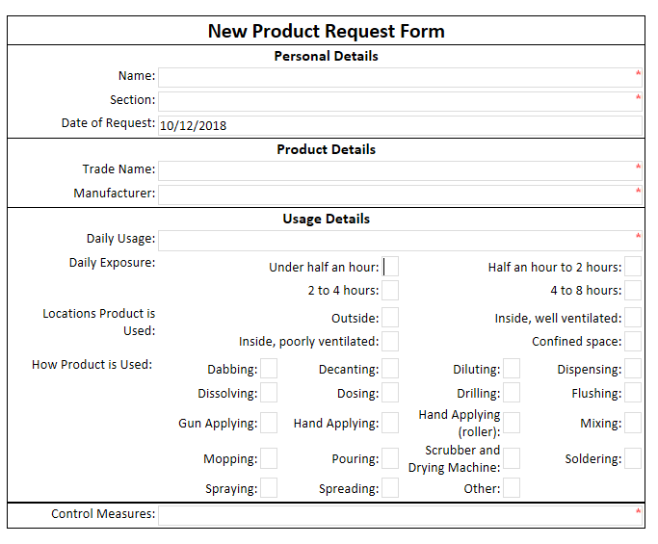

User Manual for Back Up Generator

Emergency light not working fault tree analysis

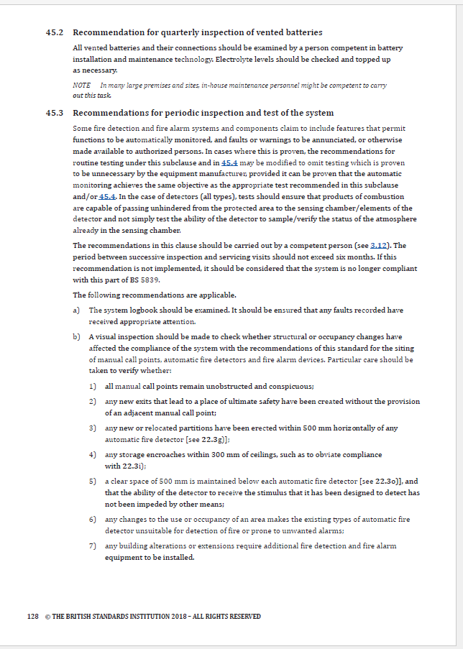
Recommendations for periodic inspection and testing of fire alarms BS5839 p.129

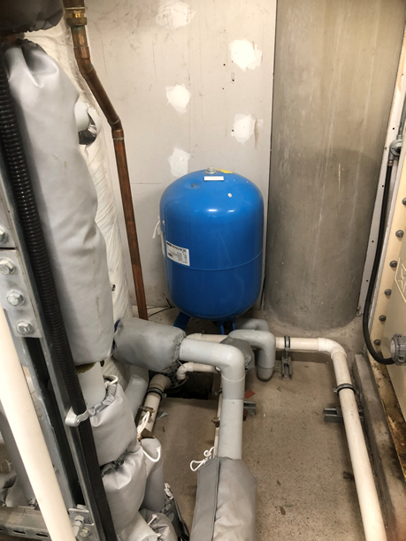
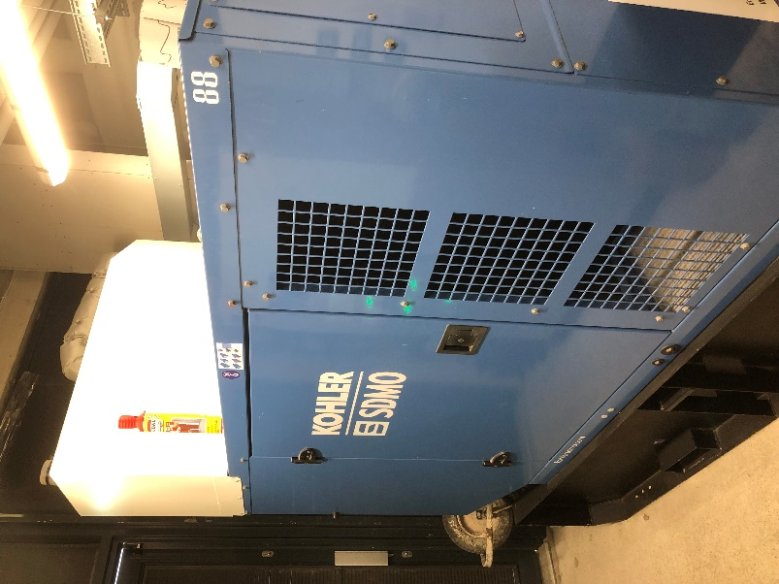
Picture 1- Generator Picture 2- Expansion Vessel

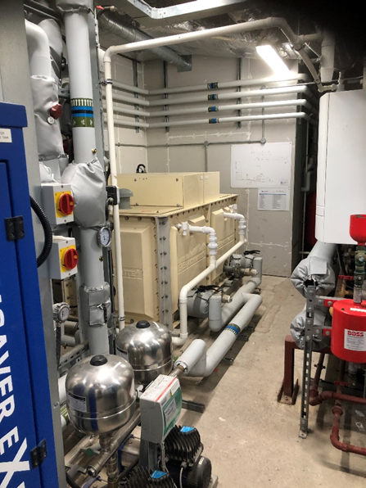
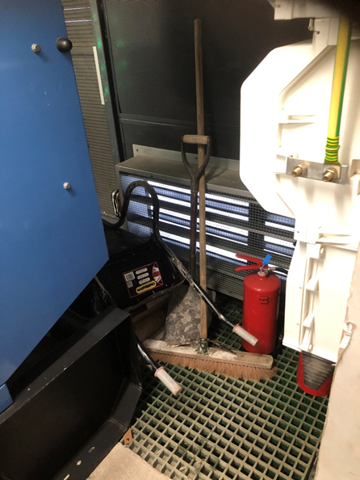

Picture 3- Storage of prohibited Items Picture 4- restricted access to services

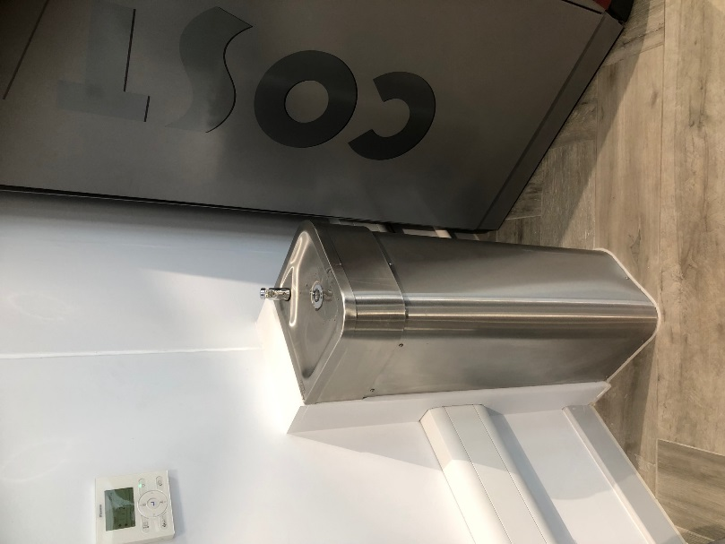
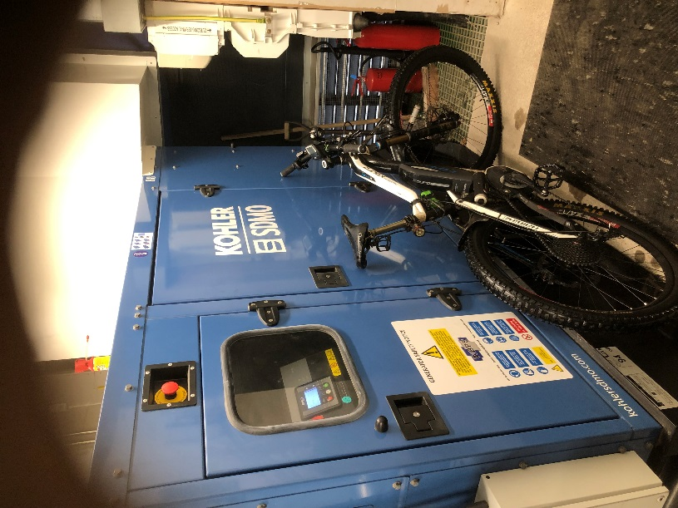

Picture 5- Storage of prohibited Items Picture 6- Water fountain

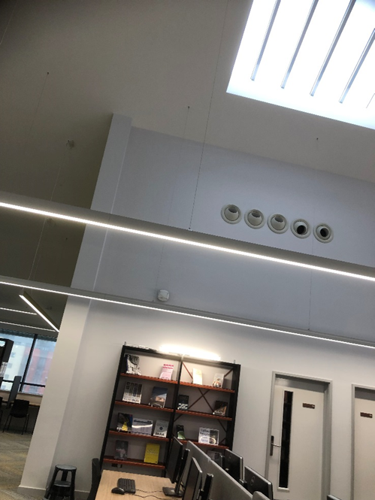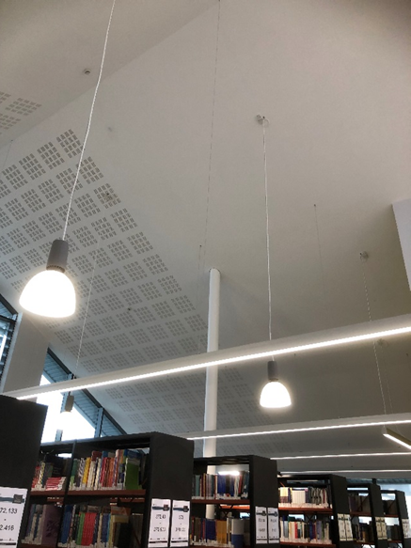
Picture 7- Access to services in a public area Picture 8- Access to services in a public area

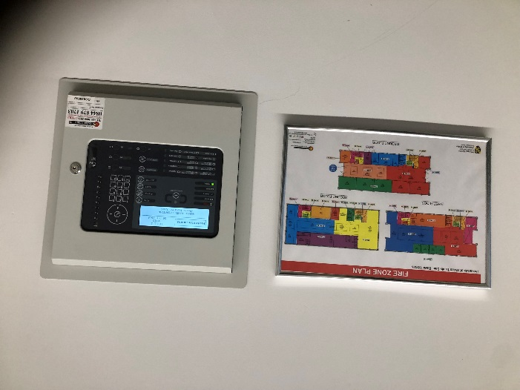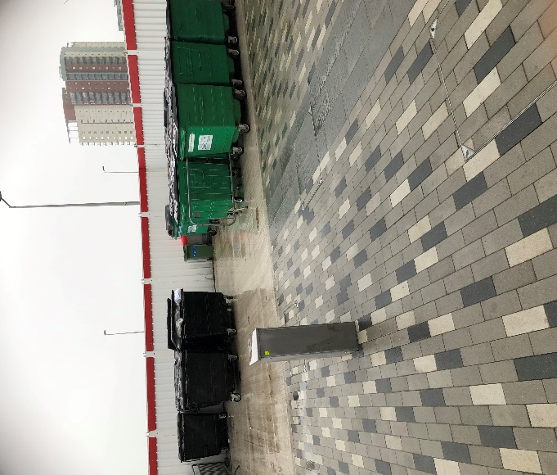
Picture 9- Fire alarm panel Picture 10- Waste disposal area

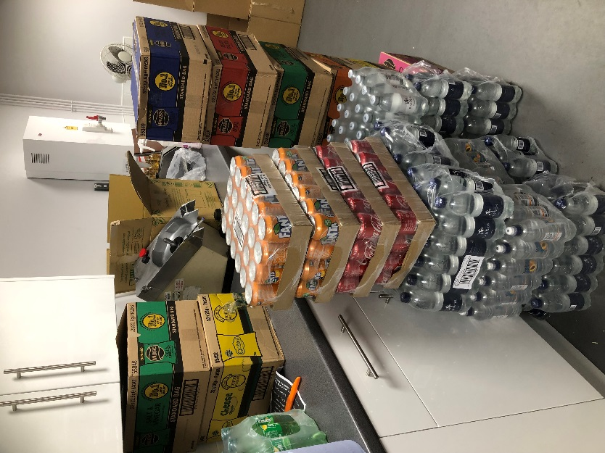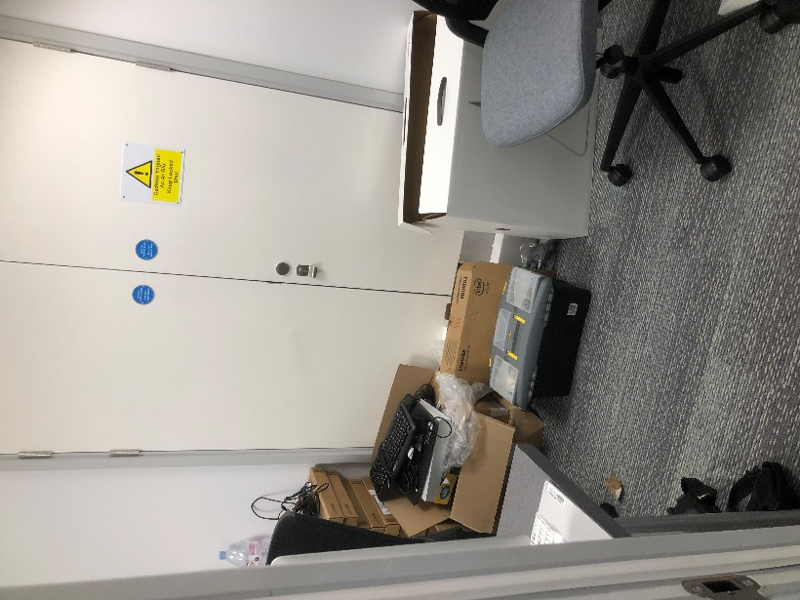
Picture 11- Poor housekeeping Picture 12- Poor housekeeping

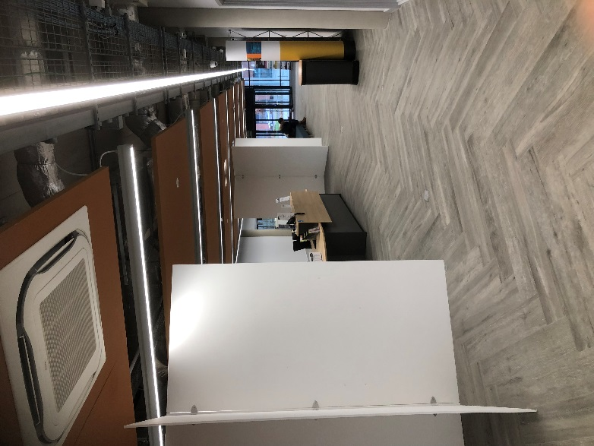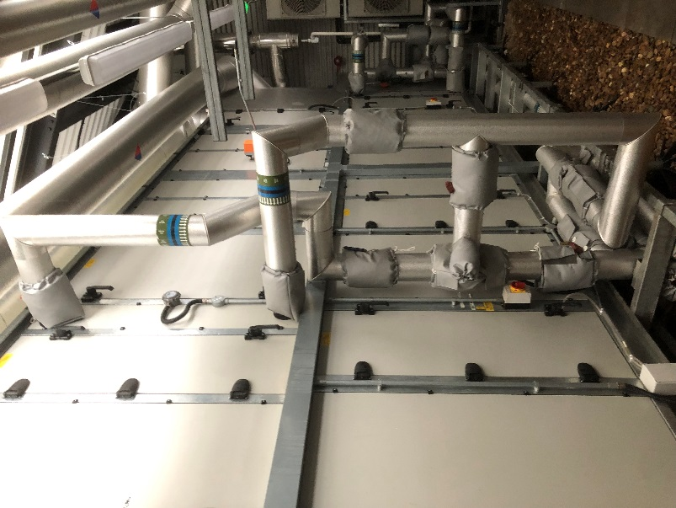
Picture 13- Reception area Picture 14- Air handling units

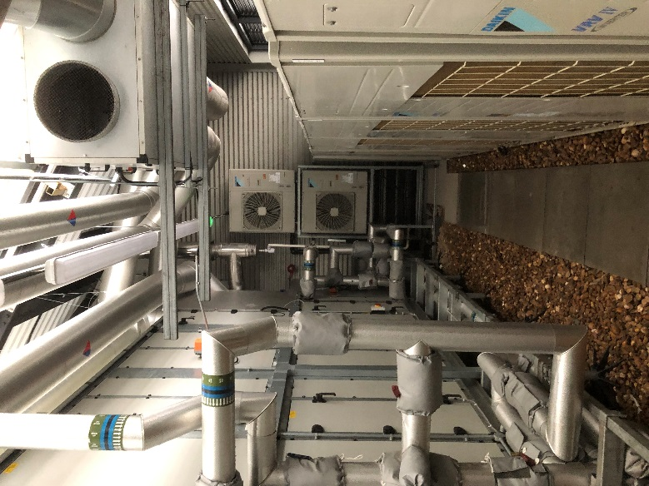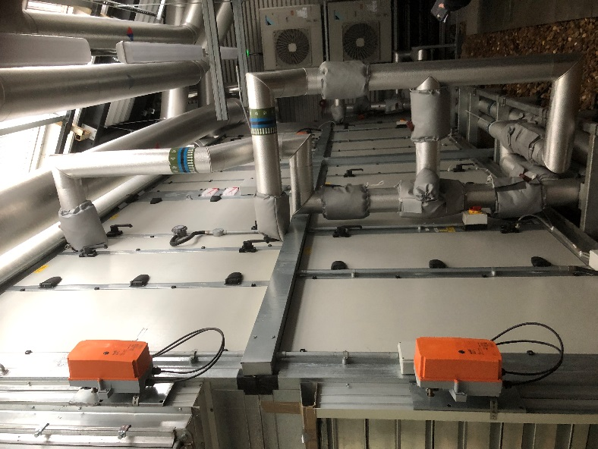
Picture 15- Air handling units Picture 16- Air handling units

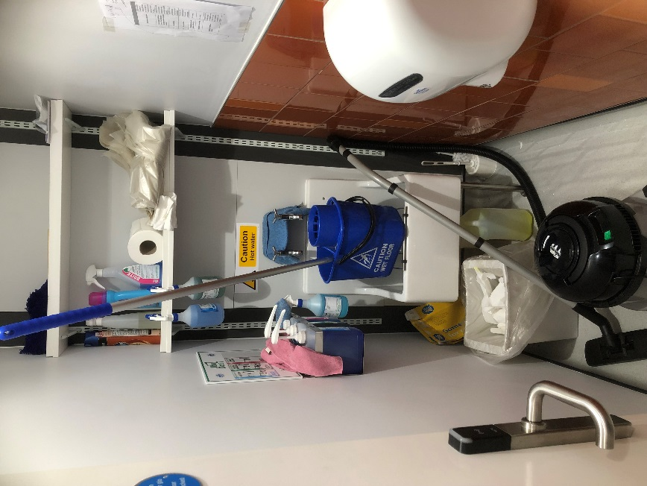
Picture 17- Items which haven’t been COSHH assessed

