3/24/2025
University of Wales Trinity Saint David
London campus
E-Portfolio Link: https://25089838.wixsite.com/e-portfolio/task-1-a-1
Module Name: Learning In the Digital Era
Module Code: ACCA 4025

Student Name: Zaid Khan
Student ID: 2508983
Group: 1

Lecturer’s Name: Koushik Modak

LDE Assignment 1
E-Portfolio
Table of Contents
Introduction 2
Main Body 2
Task 1: Essential Academic and Employment Skills for the future career Path 2
Task 1 (a): Report on Essential Academic and Employment Skills 2
Task 1 (b): Evaluation of Task 1 (a) based on Similarity report 2
Task 2: Collaborative Mind Map and Individual Poster 2
Mind Map (Collaborative) 2
Poster (Individual) 2
Task 3: Virtual Collaboration and RefWorks 2
Report on Virtual Collaboration 2
Step-by-step process of using RefWorks with visuals 2
Task 4: E-Portfolio Creation and Evaluation 2
Task 4 (a): E-Portfolio Creation 2
Task 4 (b): Illustrative Review of E-Portfolio tool Selection 2
Conclusion 2
References 2
Task 1 References: 2
Task 3 References: 2

TASK 1 (a)

Essential Skills For Study and Employment

Getting individuals especially the future workforce prepared for success within contemporary jobs is ever more important as traditional career tracks lose traction, jobs become increasingly competitive, and entry level positions shrink in pay. The changing labour market demands agility, continuous learning, and new education and employment preparedness measures [1].
After decades of oppression, a newly independent country is faced with rapid change, forcing citizens to adapt to new political, economic, and social realities. It is driven by the needs of individuals, emphasizing lifelong learning, learner autonomy, multiple opportunities, and equal respect for knowledge, preparing citizens to thrive in a changing, competitive world [2].

As we act, we tend to generate ideas and connect new information with the things we already know, making sense and the ability to respond to new situations. We test the viability of our knowledge with action, generating new meaning from consequences. While most of this is done automatically, entering new situations requires sensitivity regarding our learning process so that we can improve how we learn and adapt successfully [3].
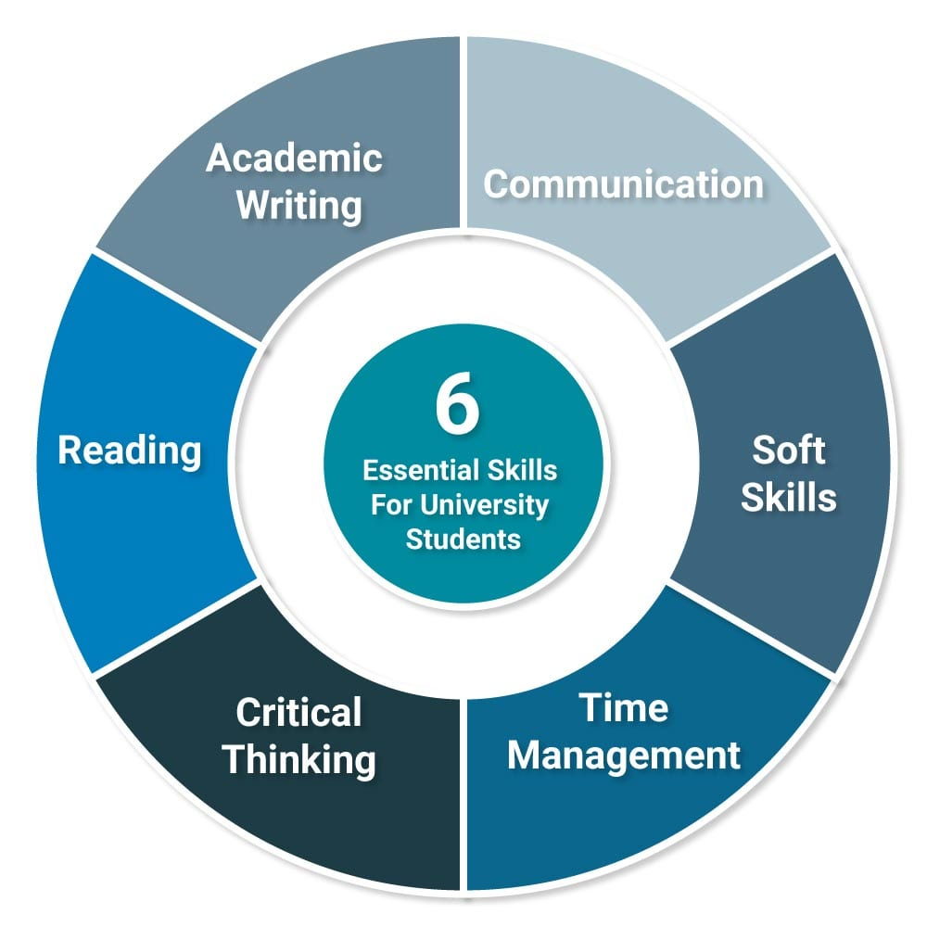

Figure 1 (Essential skills for study). [4].
Social skills are essential to the ability to be employable, but work-specific social skills have been researched sparingly in recent decades. One piece of research replicated previous research by surveying secondary school teachers nationally regarding the use of social skills at work and the amount of teaching provided. Teachers’ most essential skills were thought to be explaining directions, punctuality, appropriate physical boundaries, completion of important tasks first, seeking assistance, receiving criticism, and handling clients. However, these critical competencies were all too often those most typically schooled, even while they recognized a mismatch between learning and work demands [5].
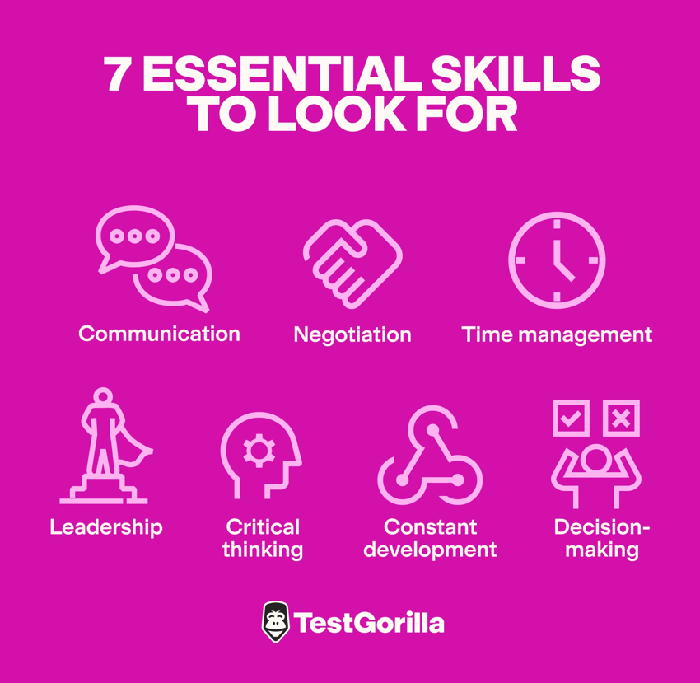

Figure 2 (essential skills for employment). [6].

References

[1] | J. F. Coates, "Skills required for twenty-first century employment," employment relations, no. Wiley Online LIbrary, fall 1995.
[2] | Z. Jelenc, The Learning Society, Routledge, 1999.
[3] | B. c. L. I. L. p. Kathy turner, Essential Academic skills, Oxford University Press, 2008.
[4] | R. Needlemen, "Uniadmissions,co,uk," [Online]. Available: https://www.uniadmissions.co.uk/application-guides/6-essential-skills-for-university-students/.
[5] | S. C. L. M. R. C. Agran M., "Expectancy effects in social validation methodology," Washington D.C, 1991.
[6] | "Testgorilla," [Online]. Available: https://www.testgorilla.com/blog/employee-skills/.

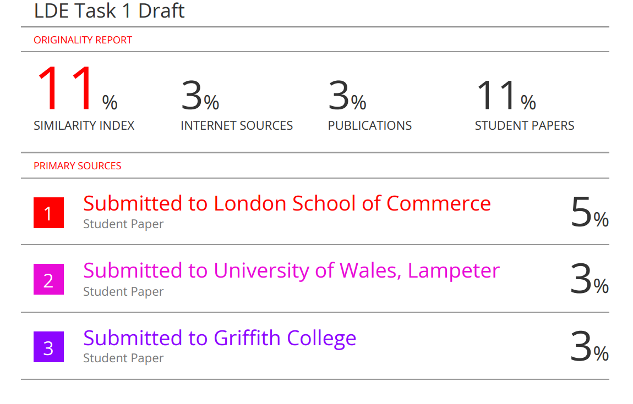
TASK 1 (b)

Next time, I can improve my assignment by creating smoother transitions between paragraphs and connecting the graphics more effectively to my discussion. I will use clearer academic language, ensure proper IEEE referencing, and focus more on analysis rather than simple description. I also plan to include recent research, real world examples and a concise conclusion to strengthen the overall quality and coherence.

would give myself around 65 out of 100 for this work. I believe I did well in presenting key ideas and using proper references, but there’s still room for improvement in linking visuals, enhancing flow, and providing deeper analysis and critical reflection.

TASK 2 (a)
POSTER’S LINK
https://www.canva.com/design/DAG2-fuag9U/izs_wdz-fDOSbBU9TTlEiQ/edit?utm_content=DAG2-fuag9U&utm_campaign=designshare&utm_medium=link2&utm_source=sharebutton
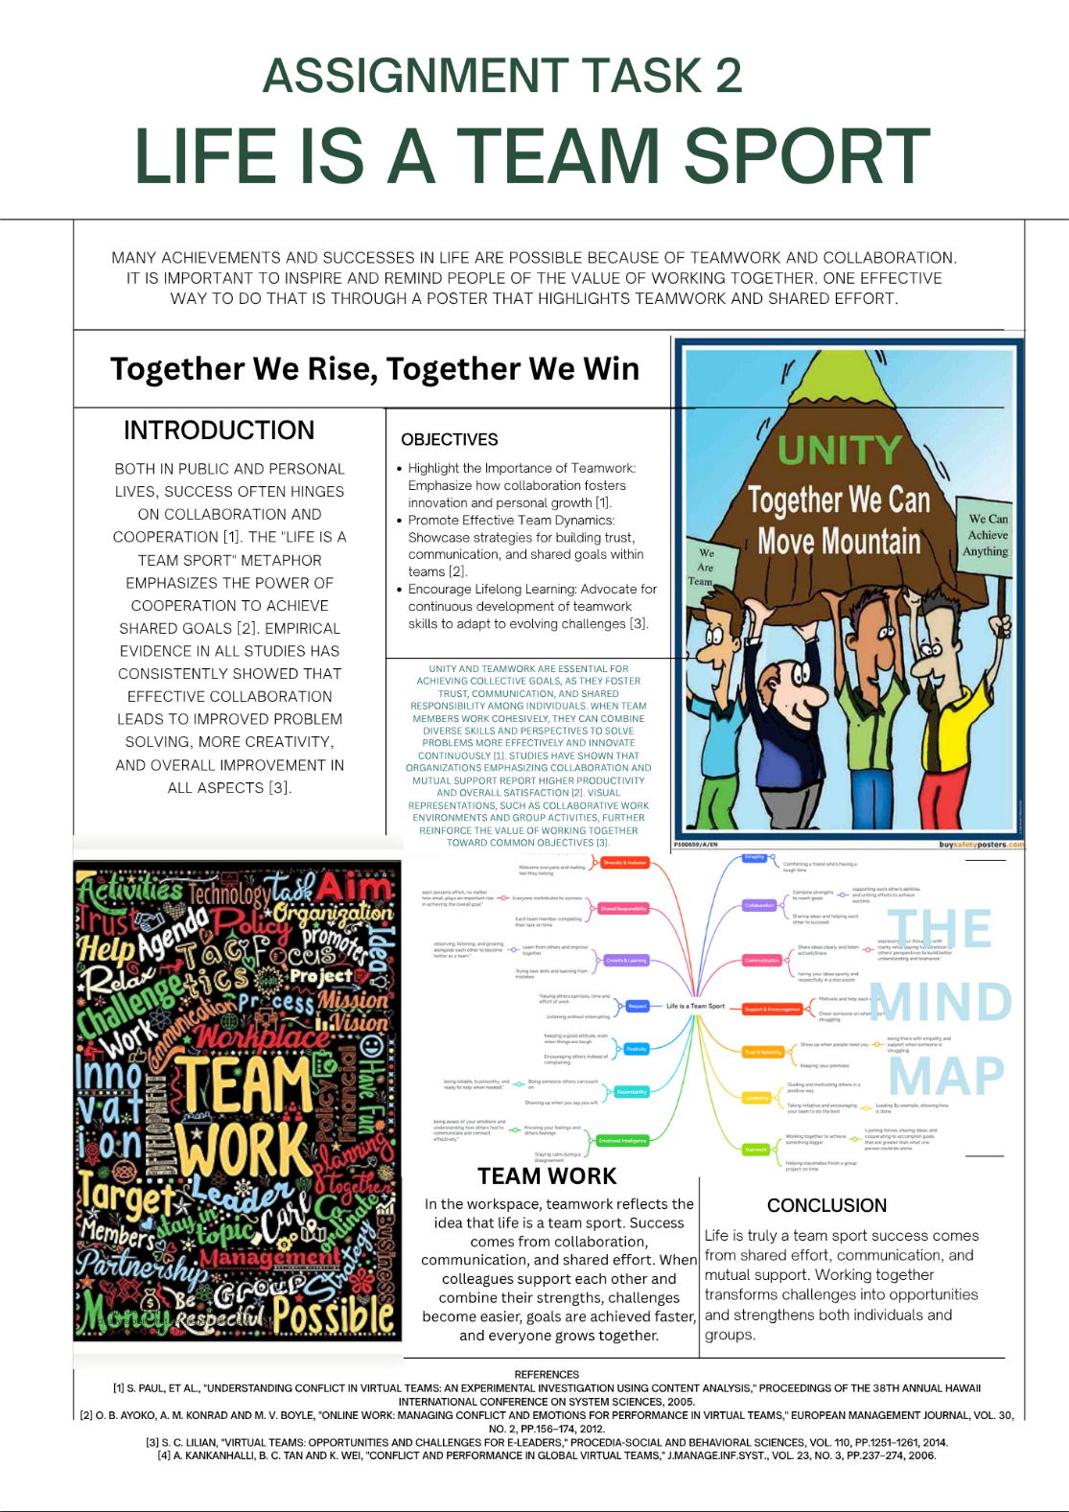

TASK 2 (b)
MINDMAP’S LINK
https://www.mindmeister.com/app/map/3844874658
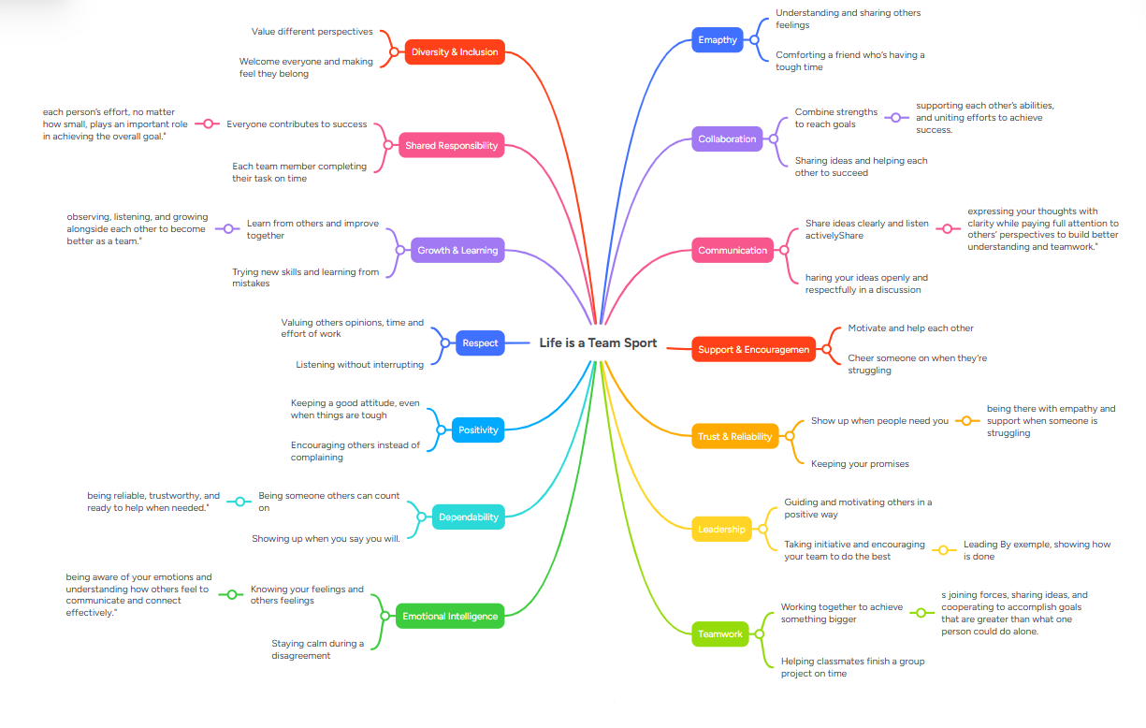

TASK 3 (a)
VIRTUAL COLLABRATION
(RIDING THE STORM)

Virtual collaboration can be defined as teams working together remotely due to the availability of digital tools and technologies. A team may be situated or distributed across different locations, time zones, and cultures. It allows for flexibility in communication and access to talent from all over the world, but it also gives birth to problems such as miscommunication, delays, reduced social connectedness, and a heightened likelihood of misunderstandings or conflict, which influence team efficiency and performances.
In this paper, the authors present a study on conflict in global virtual teams that have emerged through globalization and communication technology. It identifies cultural and functional diversity, electronic communication, and delays in feedback as sources of conflict. Such factors as task complexity, interdependence, and conflict resolution approaches would determine team performance. A model has been suggested to direct further research and management in GVT[1].
Diverse disagreement triggers and the development of negative emotions impact conflict and emotional dynamics in virtual teams. Tensions can rise as a result of things like asynchronous interactions, cultural differences, and poor communication. Affective conflict can be kept from getting worse by using techniques like structured communication, feedback-seeking, and emotional regulation. A thorough model is created to direct the management of emotional responses, improve collaboration, and boost overall performance in virtual team settings by combining affective events theory, emotional regulation theory, and workplace conflict frameworks. This model provides useful insights for both team leaders and team members[2].
Virtual teams are becoming increasingly common, relying on technology to support collaboration across large geographical distances. This literature review draws on 255 studies to identify challenges of collaboration and mitigation strategies by focusing on technology use. Challenges identified include geographical distance, temporal distance, perceived distance, team configuration, and workforce diversity, underpinning cognitive, social, and emotional impacts. The review also points out the gaps in current research that need to be tackled, such as the impact of tightly coupled work and temporal dispersion on coordination. The findings provide insight into opportunities for the design of groupware that better supports collaboration and improves virtual team performance[3].
Conflict and emotional dynamics are pivotal to understanding how virtual teams work as members collaborate across distance, cultures, and time. Factors such as miscommunication, cultural differences, misunderstandings, and lag time while collaborating asynchronously can escalate conflict and increased negative emotions that can [should] damage team performance. Techniques for exercising emotional regulation, engaging in active feedback seeking, and promoting a structured communication practice are necessary to curb affective conflict [the experience of negative feelings/conflict-based emotion] and maintain team cohesion [shared trust and confidence in the group]. Building from affective events theory
emotional regulation theory workplace conflict, and workplace conflict theoretical perspectives, a comprehensive model is developed that provides team members and leaders with insights to collude with team members to manage and intervene in emotional experience in virtual environments. Aspects of the model include proactive observations, the timing of interventions, and supportive team behavior to foster collaborative virtual team environments. Overall, team members, work teams, and leaders use the model to improve communication, reduce tension, use tacit knowledge, and foster synergies to improve performance, team resilience, and performance[4].

References
[1] S. Paul, et al., "Understanding conflict in virtual teams: An experimental investigation using content analysis," Proceedings of the 38th Annual Hawaii International Conference on System Sciences, 2005.
[2] O. B. Ayoko, A. M. Konrad and M. V. Boyle, "Online work: Managing conflict and emotions for performance in virtual teams," European Management Journal, vol. 30, no. 2, pp.156–174, 2012.
[3] S. C. Lilian, "Virtual teams: Opportunities and challenges for e-leaders," Procedia-Social and Behavioral Sciences, vol. 110, pp.1251–1261, 2014.
[4] A. Kankanhalli, B. C. Tan and K. Wei, "Conflict and performance in

TASK 3 (b)
Providing all the Screenshots of the RefWorks
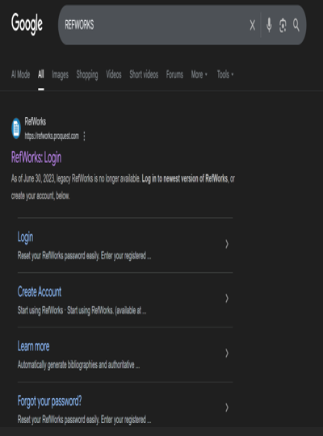

To Do this task first we have to search for the RefWorks.

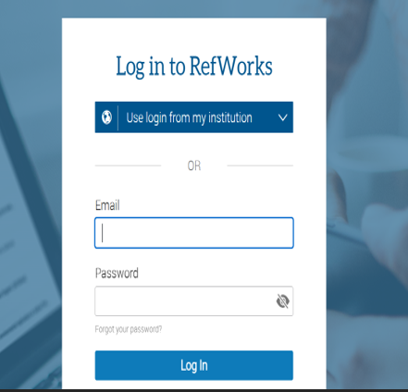

Once you are in login with your student email ID

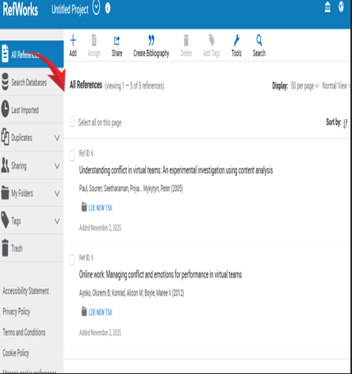

You will get to this page once you area signed in.



Go back to Google and search for Google Scholar.

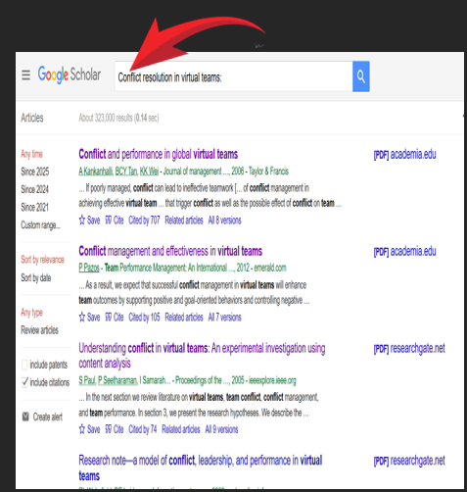

Then search for the Topic you are looking for the References

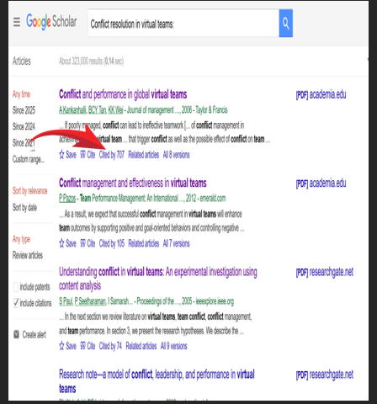
Look for “CITE” on the page

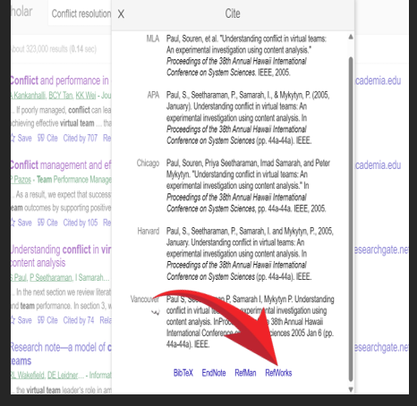

Click the “RefWorks” option on the page

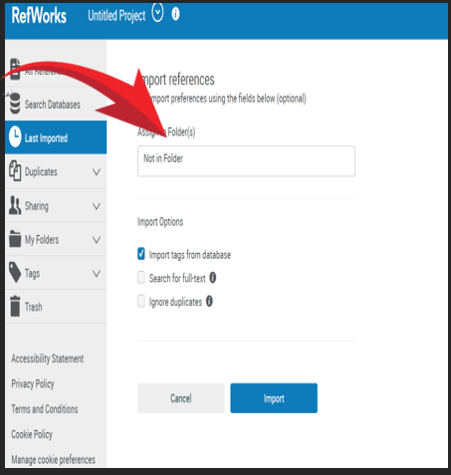

Choose the Folder you want to put your reference in the refworks.

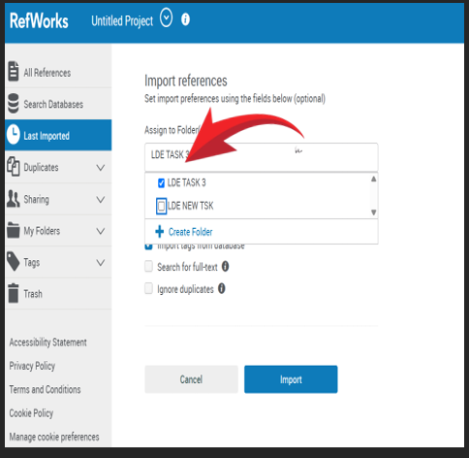

Choose your Folder as shown in the figure above.

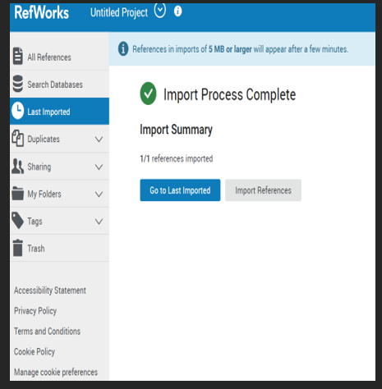
Your references will be imported as shown.

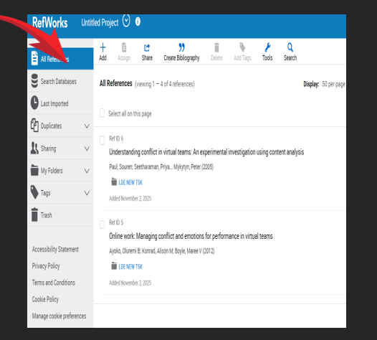

Go back to the home page again.

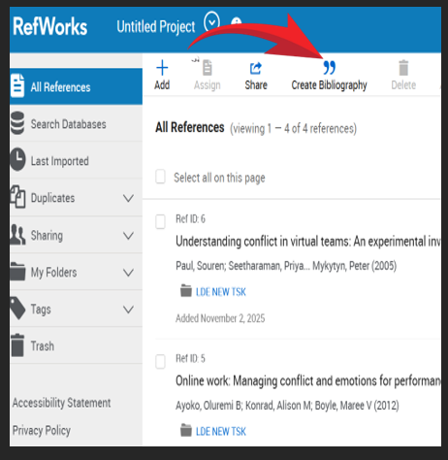

Choose “Create Bibliography”

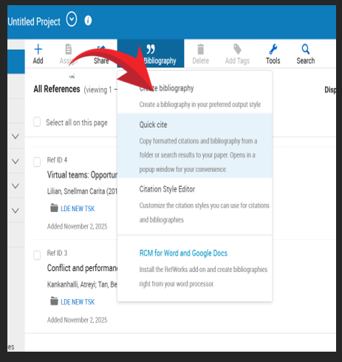
Click on “Create Bibliography”

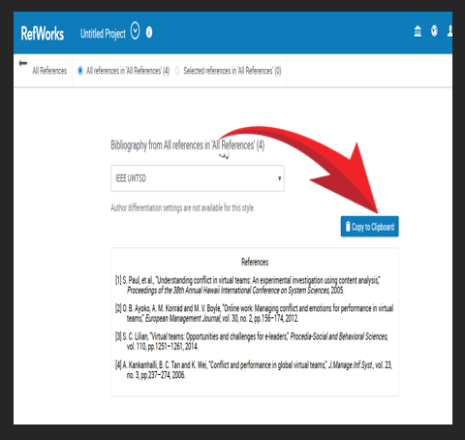

Once your references are imported. Click “Copy to Clipb
Oard” and copy your references

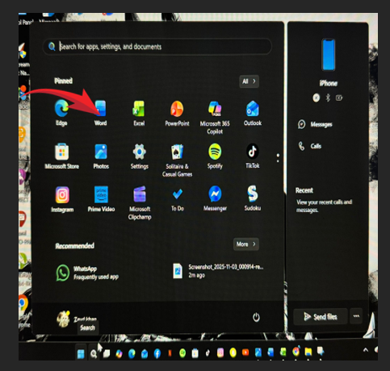
Open your Word Document

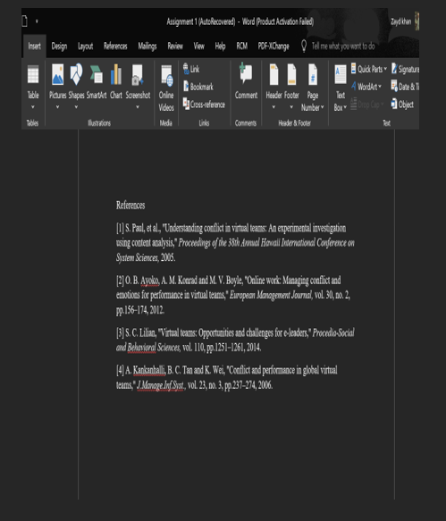

Paste your References to the word

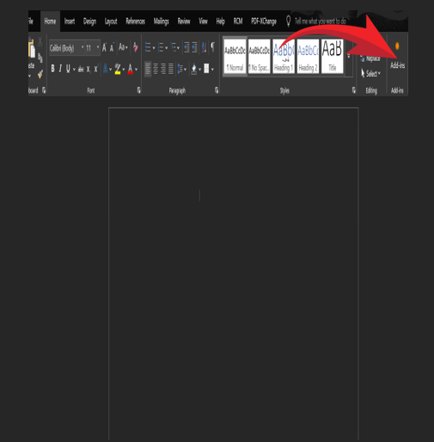

Click on the “Add Ins” Option

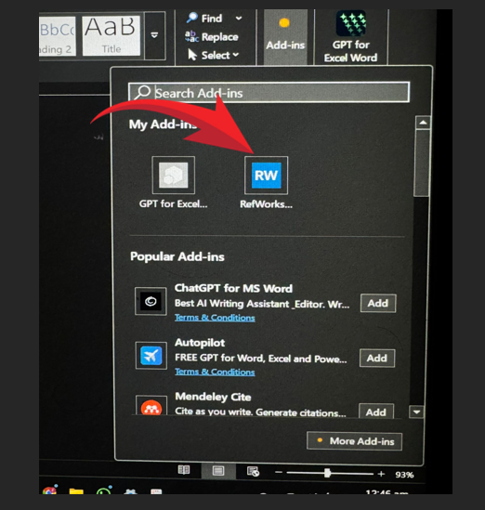

Connect your Refworks to your word as shown in the picture

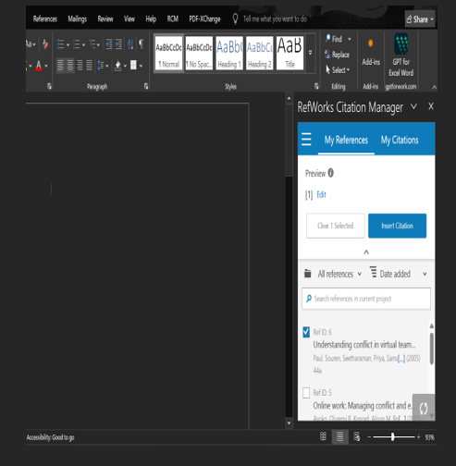

Choose your references and insert them

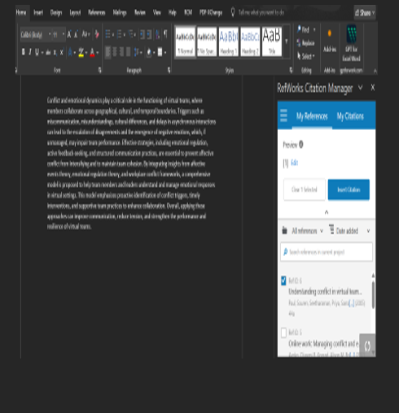

Click on “ Insert Citations” to add your Reference to your written Text

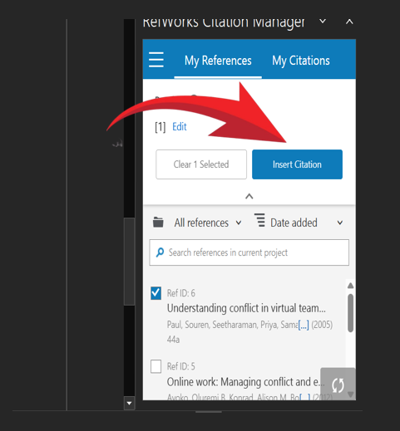
Click on “Insert Citation” as shown in the figure

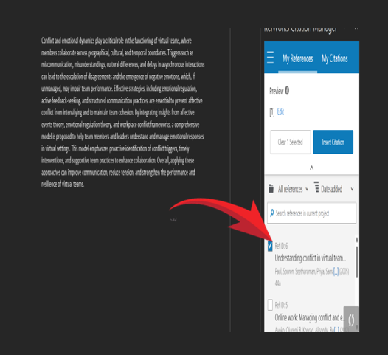

Choose your Reference according to your written paragraph

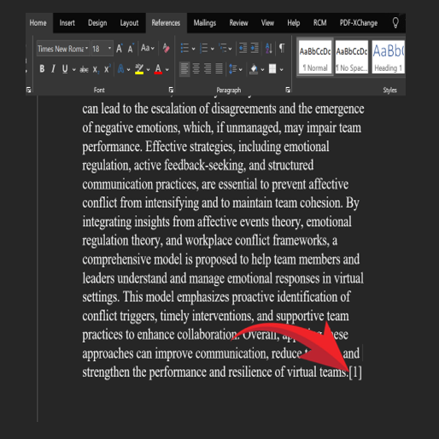
You can see the Citation has been added through the Refworks

Overall Conclusion

On the whole, I can rate myself 70 out of 100 because I feel that, for the most part, I did really well during the course of the project. I was able to do things I have never done, challenge myself, and better learn my strong and weak points. Though there is always more I could have done, I am satisfied that I approached each of the tasks with focused effort and an eagerness to learn. Every step in the process helped me to create a better foundation and understand how I could improve my work in the future.
Equipped with RefWorks, IEEE Referencing, Canva, Mind Meister, Microsoft Word, and other research tools including Google Scholar, I am confident of performing better in the future. In fact, these tools have enhanced my technical capabilities and helped me in being more organized and efficient with regard to academic work. This knowledge motivates me to continue improving and work on better quality projects amidst growth in studies and professional life.



