
3/22/2018
Mohammad Fahad (1303749)

Estate Agent Android Application by Mohammad Fahad
Student No: 1303749
Supervisor: Renuga Jayakumar

Declaration of Originality

I, ......Mohammad...Fahad....… declare that I am the sole author of this Project; that all references cited have been consulted; that I have conducted all work of which this is a record, and that the finished work lies within the prescribed word limits.

This work has not previously been accepted as part of any other degree submission.

Signed: .........Fahad....................................

Date: ....22-03-2018.............................................

FORM OF CONSENT

I, .............Mohammad…Fahad……….. hereby consent that my Project, submitted in candidature for the B.Sc.(Hons) Cloud Computing degree, if successful, may be made available for inter-library loan or photocopying (subject to the law of copyright), and that the title and abstract may be made available to outside organisations.

Signed: .........fahad....................................

Date: .....22/03/2018............................................

Copyright Acknowledgement
I acknowledge that the copyright of this project report, and any product developed as part of the project, belong to University of Wales Trinity Saint David, Swansea.
Table of Content
Chapter 1 Introduction: 6
Chapter 2 Aim: 6
Chapter 3 Objectives: 6
Chapter 4 Structure of the project: 7
Chapter 2 – Review of Literature: 8
Mobile Application: 8
Type of Application: 8
Smart Application: 8
Android platform: 8
iOS application: 9
Benefit of smart application: 9
Purpose of choosing android application: 9
Tools required: 10
Android Application: 10
Application Fundamentals: 10
Chapter 3 -- Research & Development Methodology: 11
Waterfall Model: 11
Requirements Phase: 12
Design Phase: 13
Implementation Phase: 13
Testing Phase: 13
Maintenance Phase: 13
Advantage of Waterfall model: 13
Disadvantage of waterfall model: 14
Chapter 4 - Analysis: 14
Requirement Analysis: 14
Functional Requirement: 15
Application features: 15
Non-Functional requirement: 16
System Requirements: 17
Client requirement: 17
Server requirement: 17
Hardware requirements: 17
Chapter 5:- Risk Analysis: 17
Chapter: -6 Design 18
Chapter: 7 Testing 20
Reference List 25
Appendix: 26
27

Introduction:

This project focuses on the development of an android application which helps buyer and sellers of house owner to deal each other. The name of application “Home search” is featured on performances of delivering property search and an effective communication method between customers and agent. Currently, there are number of similar application developed on property search due to high demand on the market. The development of such apps has consistently growing faster for the most common characteristics of widespread use of android devices. In comparison, Apps purchasing, downloading and releases have increased significantly more than any other mobile platform. Clearly, Google developed android operating system which is the highest market share of open source mobile platform. According to recent statistic, more than 1.5 million applications are published on android market and continuously growing at aggressive rate. [3] However, the challenges of large volume of code which combined with java program and XML creates critical concern about the quality of successful development on android studio. [1] A recent study of VisionMobile reported that the average skilled level of app developers is falling in mobile application development as population grows day by day. [2]
The housing market in Britain is continuously rising trending alone in London ratio rose from 6.9 to 12.88 in 2002 and 2016 respectively. [4] There estate agency companies around the UK including most popular Foxton, Zoopla, Purple-brick and Rightmove invest huge money on development of android and IOS application for the flexibility of customer service. Therefore, the application of Home search I have chosen from the early year of 2017 and this application is designed to be collaborating with estate company specially an agent, buyer and seller. This study will explain not only resulting performance of Home search application but also literature review, design of development, analysis and risk management including relevant information of android application. This report will include basic knowledge of java and android studio starting from the beginner lesson to a complete project.

Aim:
This project will demonstrate the development of a property search android application based on android studio.

Objectives:
- Implementation of android application in android studio
- Analysis suitable development tools, methodologies and establishment.
- Design and develop a simple complete prototype
- Research on various estate property already developed on the market
- To learn professional development skills
- To compare the performance of IOS vs android operating system
- An overview of future career on this project

Structure of the project:
The following study focuses on four parts mainly which are separated into five chapters. The 1st part includes an overview and background research of the project which are discussed already in the introduction, aim and objective above. The 2nd part explains the literature review and development methodology which are the experiment of android studio and development model utilized throughout the project. An analysis and risk management will be provided on the 3rd part of the project. Moreover, the final part will conclude with future aspect and a short summery of this project. The content of all chapters is following.

- Chapter 2 – The Literature Review: The literature review explains the object-oriented paradigm in the key knowledge of android application, identifies the previous research relating to property search and compare into current design patterns and framework, finalizing with summery and conclusion.
- Chapter 3 – Research & Development Methodology: This chapter will provide the research approach and systematic plan conducted including rules and steps to develop the project in discipline manner.
- Chapter 4 – Design and analysis: This chapter will discuss the design precisely an early phase, key features and structure of the framework in android studio and analyse the results alone with final solution of any problem.
- Chapter 6 – Risk Management: This chapter evaluates the assessment of implementation and identifies the risk to make sure the project achieves its objective. Risk management also involves effective management, planning of completion of the project on time and solution of any potential problem.
- Chapter 7– Conclusions and Recommendations: This chapter gives an overall review in a short summery that is achieved in the project as well as if any further research in future is required to do so.
- Chapter 8 – Reflections: This chapter explains a personal commend and reflection of the experience gained during this project management and the knowledge has been learnt.
- Chapter 9 – References: A list documents, sources and references.

Chapter 2 – Review of Literature:

This section evaluates the fundamental knowledge of smart application, android studio, including most common features and behaviour of application framework. This will also include differences and comparison between IOS and android operating system. Finally, there will be a review of current similar application available in the market and a comparison between them.

Mobile Application:
In recent year, the number of mobile devices has increased dramatically in the way of usage and people access to the internet, specially smartphone and tablet changed the characteristic of services. In addition to using the internet, smart devices have access services in either mobile apps or web browsers. [7] Over the past years, there is an increasing amount of time people spend on mobile app which causes a tremendous growth in mobile app market.

Type of Application:
Mobile apps can be divided into three categories which are native, hybrid and web-based. The most popular Native applications that run on an existing operating system on the device and adaptable to use in different devices. A web browser is required to use on Web-based apps. Hybrid apps are mixed approach using JavaScript framework, ‘native-wrapped’ web apps. [8] In this project we are mainly interested in developing a native mobile application utilizing device’s features such as sensors, camera, geolocation and accelerometer.

Smart Application:
Mobile apps are just application running on a mobile operating system. In order to develop an application, the first decision requires to make is the platform on where the application will run for the services. [9] There are several platforms released at different time including most popular of them are following-

Android platform:
The application has simple delivery mechanism for IOS, App store and for Android Play store where users download and install the application from. Developer of both ios and android have to pay a fee to publish the app into the store. For android app, there is a one-time fee of $25 on Google play store and for Apple store it costs $99/year and fee reduces when sale gets higher. [10]
A typical Android application project contains all the files necessary to build the software, namely source code (primarily Java code in src/ ) and resource files (e.g., images, layout descriptions, and string values in res/ ). Android SDK tools compile the code, and package any data and resources into an Android package. User interface elements in an Android application are built using View and ViewGroup objects. A View is an object that draws the controls on a screen with which a user can interact. A ViewGroup holds other View or ViewGroup objects to define the layout of the user interface There are two ways to define a user interface in Android: programmatically in Java code or declaratively in XMLbased layout resource files (in res/layout). For this paper, we consider the analysis and migration of user interfaces de- fined by these resource files.

iOS application:
An iOS application is designed by the XCode IDE to implement a structure which separates user interface, data and handles duties of views, corresponding model and controller objects. Data is accessed by a controller object to display a view objects from model object. Moreover, It also corresponds to user input linking with a view object as well as responds changes to a model object. A view object that communicates with animating and drawing itself. Furthermore, a view object manages and contains views of other layout can contain and manage the layout of other views. The Objective-C programming language is type of native application of ios.

Benefit of smart application:
The technology of smart application has brought a new avenue of hand-held gadget to many people in their daily life. Even a business, medical service and learning tool have begun acknowledging many advantages offering utilization of such application. The most convenient option which are mobility, touch screen and screen size makes more user friendly and perfect choice of today’s world. The effective features of business communication, transaction social networking made the whole lifecycle better in advertising strategies. The increasing number of mobile phone applications that are becoming most popular in use on all operating systems for user to spend more time on their phones (Garg and Telang, 2013). The availability of apps is increasing which are now 1.6 million android apps available for download for and another 1.5 million ios apps available for user to download from Apple's App Store (Statista, 2016a). [12]

Purpose of choosing android application:
Android is a mobile operating system which offer most unified approach to develop the application. One of the reason of choosing android application is the simple development model which means developers use android platform such as android studio, eclipse etc makes them develop an app easily in short time. As android is hugely successful product interested by many vendor, hardware manufacturers like Samsung, LG, HTC, Sony Xperia are fully dependant to power the smartphone. [13] Moreover, It was my long passion to learn and discover such phenomenon product in my project.

Tools required:
Firebase is a platform of mobile as well as web application development which was developed by Firebase in 2011. Google purchased it in 2014 for an undisclosed amount and developed to application building for the perspective of marketing. The cross-platform that the firebase is used for developing application in Android, iOS and web platform. The foundation which is to develop maintaining back-end services and contribute to the overall quality of the application development including the help of developer grow and base of the application user that makes money by advertising in-app. The most flexible and scalable database which is offered by firebase is Realtime database to store and synchronise data in the basis of NoSQL cloud database. It is automatically synchronised among all client and users in realtime which makes available during app is offline. During the development of cross-platform apps in either Android or iOS, JavaScript SDKs it becomes easy to share any update all in one Realtime Database instance automatically with the latest update. [16]

Android Application:
Android is the most popular mobile operating system which is a new, next-generation java-based language platform runs on the Linux 2.6 Kernel. It was first developed by a start-up company named Android, Inc founded by Andy Rubin. Google purchased the company for at least $50 million in July 2005 and took over the strategy of development works. [5][6] Since then Google has been developing Android and wanted to be free and open source Apache license for anyone wants to use it by getting full Android source code. Furthermore, the hardware manufacturers can add customize proprietary extension to android to make the product more usable. Such development model simplifies to develop android application and makes attractive to many vendors. [6]

Application Fundamentals:
Android applications are written in Java programming language is the fundamental core of Android application. However, it is important to remember that without using the standard Java Virtual Machine (JVM) android applications cannot be executed. Instead, Google has created a custom VM called Dalvik. Dalvik is responsible for transforming and also for launching Java byte code. All recursive Java classes are necessary to convert into a Dalvik compatible instruction to put before being executed into an Android operating system. Android is a software stack for mobile gadget that contains an operating system, also a middleware and key application. The Android SDK provide the tools and APIs which are necessary to develop application on the platform of Android technology using the java programming language. Android based on Linux version 2.6.

Chapter 3 -- Research & Development Methodology:

Development methodologies are the process of building computer software and information systems which refers to the framework of planning, managing and controlling the development of approach. Alternatively, it is also known as Software development life cycle that term used in many industrial field for instance software engineering, system engineering, computer science. The development methodology has been studied by many practitioners all around the world and there are different types of models have been found which each has its weaknesses and strengths acknowledgement. The Waterfall, agile software development, rapid prototype, rapid application development and spiral are the most successful models to mention in development methodologies. They all consist of life cycle which means a sequence of phases to step forward that a system designer or developer must follow in order to deliver final result. [14]

Waterfall Model:
The Waterfall model is a process of sequential software development that is regarded as increasingly flowing downwards to a list of phases and steps which must be executed in order to build a successfully mobile and computer software. Originally, the Waterfall model was studied by Winston W. Royce in the year of 1970 to explain a possible software engineering practice. The Waterfall model refers to several consecutive phases which a developer must be completed sequence of one after another and going to the next phase during the preceding phase is successfully completed. However, establishing the appropriate number of resources which each phase of the Waterfall model required including people, time, effort, process equipment and budget was a dilemma for a project manager and designer to achieve the highest productivity using less number of expenses, hours and workers. [15]
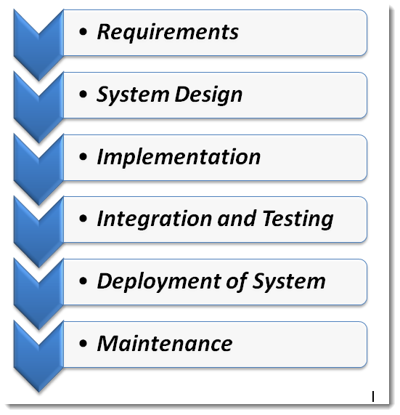
http://20tvni1sjxyh352kld2lslvc.wpengine.netdna-cdn.com/wp-content/uploads/2016/04/WaterFall-Model.png

Requirements Phase: The phase which analysis is called often as Software Requirements Specification (SRS) that is a comprehensive description complete and of the behaviour to be developed of the software. It conveys directly with the system and business analysts to mean of functioning or requirement of non-functional. In general, it is defined of functional requirements by means of use cases that explains the users’ interactions and influences with the software. The requirements which include such as software attributes, perspective, purpose, scope, functions, interface requirements, user characteristics, functionalities specifications, and database requirements. On the other hand, the non-functional requirements describe to the various criteria, limitations, constraints and such requirements that are imposed on the development, design and operation of the software compared to only a behaviour. It also comprises such properties as scalability, reliability, testability, maintainability, availability, performance as well as quality standards. [15]
Design Phase: A software solution which is the process of solving a problem and planning of implementation. It simplifies software developers and software designers to understand the plan of a solution that includes software architecture design, design of logical diagram, algorithm design, database conceptual schema and concept design, design of graphical user interface, and the concept of data structure definition.
Implementation Phase: It defines to the requirements of realization of business and specifications design into a strong executable database, program, website, and software component including the performance of programming and deployment. The implementation phase is the concrete design to what the real code is structured, written and compiled in process of doing it into an operational application that the text as well as database files are created in order. In other words, the whole requirements and blueprints are the process of converting into a production environment.
Testing Phase: Verification and validation is also known as testing phase that is a process to check a software solution satisfies the requirements and specifications of development to which it proceeds of its intended purpose. In general, verification and testing process evaluates the software to ensure whether the development products of a given phase meets the conditions which imposed at the beginning of phase; However, validation process of evaluating software determines specified requirements during or at the end of the development process. Moreover, the testing phase is the process to perform debugging to fix bugs and system glitches which are corrected, found and defined accordingly.
Maintenance Phase: The process of modifying a software and designing to a solution during deployment and delivering to improve performance, refine output, quality assurance and correct errors. Alternative maintenance activities such as accommodating new user requirements can be performed in this phase which also includes adapting software to its environment and increasing software reliability. [15]

Advantage of Waterfall model:
It is the most popular version of development model for software engineering which is the systems development life cycle often considered as structural approach. The purpose of choosing waterfall model as for my application to be many advantages which are following. it is the linear and sequential model which has distinct goals for each phase to develop my application. To develop an app with waterfall model is simple for less amount of resources to implement and also the required minimal effort. In this model, the result of development is generated when each stage is completely accomplished therefore high visibility focuses on every phase. There is considerable progress to manage the client, developer and project manager gets a feel to implement the project on time. Due to clear visible outputs, it is easy for project management each phase both at internal level and client's level. The completion of each phase can be set for deadline and evaluation is made from time to time to reach per milestones of project. This life cycle development methodology is significantly better compared to the haphazard approach to develop application and software. It also includes a sample template into the methods of design, analysis, maintenance, coding and testing can be placed. [17]

Disadvantage of waterfall model:
In recent times, the Waterfall life cycle model has reacted its fair share of criticism to the project development. Imagine a waterfall on a steep mountain on the cliff has flowed over the edge which falling begun down the side of the mountain and there is no turn back. Waterfall development is the same with the downward cliff mountain. As soon as a phase is finished the progress of development proceeds afterwards to the next phase where no turning back of the previous phase. The most notable objection comes as disadvantages which the clients are not fully aware of articular goals that they want a project developer progresses over the lifecycle. The implementation of real project follows rarely what the sequential flow and linear iterations of this model can be managed indirectly in each stage which causes confusion as the project proceeds forward. Customer requirements is often a major concern to get explicitly that specifications sometimes can't be frozen. Baseline approach can be followed If that case arises, therefore output of a development phase is continued forwarding to next phase. For instance, requirements cannot be frozen even if design is not well defined. In other word, in waterfall model, the developer freezes hardware and software when technology keep changing at a rapid pace such long-term projects is not advisable. This method where the client is not IT-literate especially bad in case getting specifications of a person who is tough for the project. Any small change made in previous stage could cause complicated and arises big problem on subsequent steps for all phases are equally dependent on each-other and could also be costly to go back to one or two phases above. [17]

Chapter 4 - Analysis:

Requirement Analysis:
Requirements are explanation of the services which is a software system should include the constraints of operation in which it must operate the application. The analysis of an application requirements is built in features and constrains functionalities of application system. This kind of requirements carried out the expectations of user operation on application behaviour from the software product. It can also be obvious to be known or unknown, hidden expected or unexpected outline from customer’s point of view. [18] A good quality software needs to be able to develop in according to the requirements of user. Therefore, the first step of requirements elicitation phase is to process the software development life cycle (SDLC) with the challenge of capturing all the explicit requirements of stakeholders. the problem of perception and assumptions which communicates between developers and users could create misunderstanding for actual requirements to mention so that the validate technique could be implemented earlier. Moreover, it can range the level of abstract statement from high-level of system that provide functional specifications and non-functional specifications. [19]

Functional Requirement:
The application must meet a means of describing functionality and representing system services. The requirement of functionality explains the type of application, behaviour of app including features and activities. The “Home Search” App which is going to develop for estate agent will represent the latest features for both clients and sellers. There are many apps for searching the properties across London available for sale and buy. A property app is very useful for agent and buyer to communicate each other, request enquire and rating the rank of use. This mobile app for estate agents is very convenient way of giving the edge marketing and advertising over competitors. It can help agents in most effective tool for customer retention. The convenience of viewing properties, latest update, notification of information, paying rent and set up direct debit make customer’s satisfaction easily. The viewing feature within the app reduces the time of appointment nearby quickly as well as easily determines customer in either they would schedule in particular date of a property in a particular area. This app for estate agents can increase popularity of selling in the market directly to the customers with integrating up to date services and the latest news by blog and social media. The features also include push message system which customers will discover the latest property offer and any communication deal between them. In this app will help to view list of properties in detailed property information including maps indication, location icon and notification of new properties added on current location. [20] My home is a tab of sign up/sign in which keeps record of search, favourite selection in case of preview in future.

Application features:
The best challenge of developing app in the view of customer in the marketing is to integrate convenient features for customer. There are two types of users in this app who are normal users buyer or seller and admin or controller of properties. Users who want to sell their properties can make private deal and communication with agent through secure sign in gateway where seller will find agent address, contact details. Once a deal or price is established between agent and seller, this property is ready to advertise in app for sale. The controller/ an agent of the app will explain in details about house such as types of property, number of bedrooms, images, price and location. Estate agent company will sell the property according to the client interest
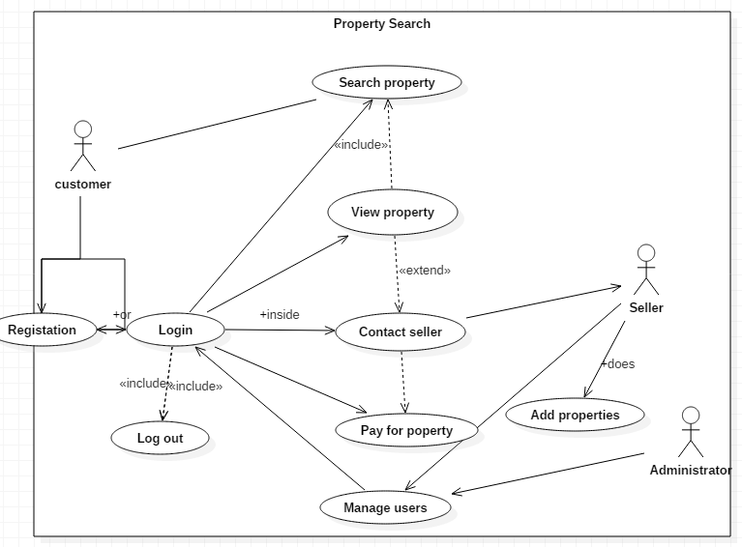
The above UML diagram provides a clear view of the app working for customer, seller and administrator. A customer can search properties in either by registering and signing in to the application and manage directly with secure messaging and payment gateway.

Non-Functional requirement:
The non-functional requirement defines characteristic of the system performance are sometimes relates to the terms of metrics of measuring to make them clear and more tangible. Non-functional requirements may also explain aspects of implementing system which does not associate to it's execution, However, it's evolution speeds over time. The type of requirements are more important than any other requirement functional. This are such specifies criteria of its requirement which can be used to decide the operation of system not relates to the specific behaviours of application.
Non-functional requirements are the form of an overall property of function and the system calls it as "system shall be ", that means of not being specific function but a particular aspect. The difference of the system's overall properties that mark between a successful project is whether has succeeded or failed. There are two types of Non-functional requirements can be categorised which are Execution qualities, for instance usability and security that observes during run time. Evolution qualities, for instance maintainability, testability, scalability, extensibility that are embodied in the software system of the static structure. The restrictions are placed on Non-functional requirements to develop the product, to specify external constraints and the development process that product must meet. [21]

System Requirements:
Operating system is the soul of computer which means the better and powerful processor is makes easier to develop Android using it. However, it is not mandatory of need a highly customized machine rather the basic system requirements should be followed to develop android app.
There are following the ideal system requirements which are for developing Android Apps

Client requirement:
- To have active Internet connection
- Android smart device running minimum OS version 4.1.1
- It needs at least 200MHz processor
- Minimum storage is 100MB required
- Minimum 32MB RAM required

Server requirement:
- To have active Internet connection
- Server running smoothly
- To place the file to host it
- Firebase management console for administration.

Hardware requirements:
- Installing android studio
- 3GB RAM on the PC for the software
- 2GB Hardware storage space
- Windows, Linux or Mac platforms
- Minimum Monitor resolution 1280x800

Chapter 5:- Risk Analysis:

Software system has been increasing significantly and the increasing number of software indicates that overcoming such amount makes chronic problems of development project, for instance project delays, cost overruns as well as unmet user requirements which are not only highly constant desirable but also economically priorities. According to research studies, it is estimated that around 85% of all projects come end in failure. Moreover, it is also indicated that 31.1% of projects is cancelled before they completed over time. Application development gives an abstract and diverse nature that offers challenges and risks. The risk management program which could take an organised and structured way to evaluate risks and analysis the development process. A general model of risk management framework includes identifying the risk and analyzing the task to a project that monitoring and implementing measures needs to be reduced. [22] The risk measurement identifies the level of risk such as High/Low or medium and how mitigation can be implemented in such occurrence. There are some common factors which may cause lose of work for instance Crash of storage, PC stolen, error of internet connection and forgetting to save update latest data.

Chapter: -6 Design
Sign up activity:
mAuth.createUserWithEmailAndPassword(email, password).addOnCompleteListener(this, new OnCompleteListener<AuthResult>() {
@Override
public void onComplete(@NonNull Task<AuthResult> task) {
progressBar.setVisibility(View.GONE);
if (task.isSuccessful()){
finish();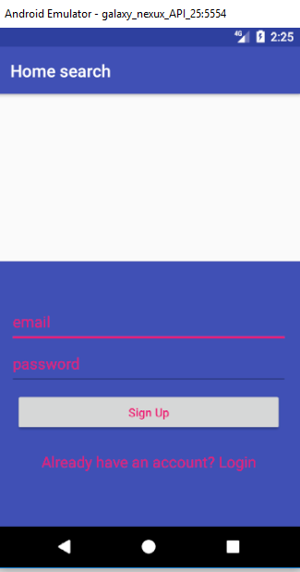

Sign in Activity:
progressBar.setVisibility(View.VISIBLE);
mAuth.signInWithEmailAndPassword(email, password).addOnCompleteListener(new OnCompleteListener<AuthResult>() {
@Override
public void onComplete(@NonNull Task<AuthResult> task) {
if (task.isSuccessful()){
//To stop back button to go login screen
finish();
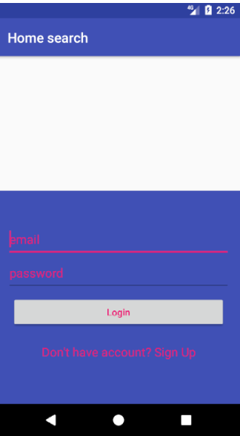

Chapter: 7 Testing
Invalid data impute in registration and login

Input | output | result
Registration | Valid email address and password minimum 6 characters | Unsuccessful
Login | Registered email address only | Unsuccessful
Price search

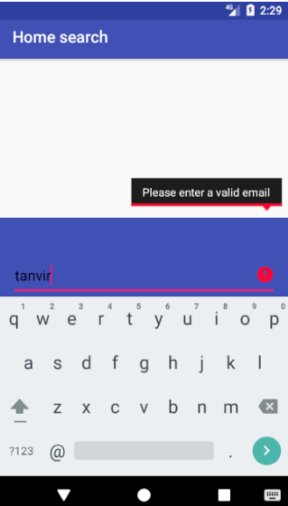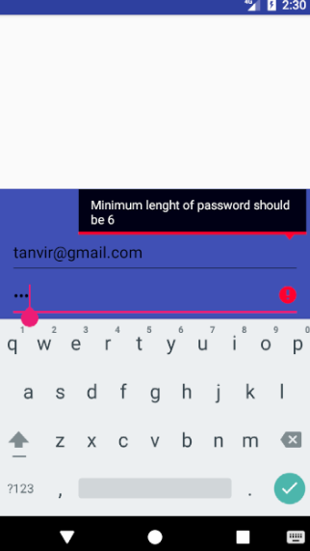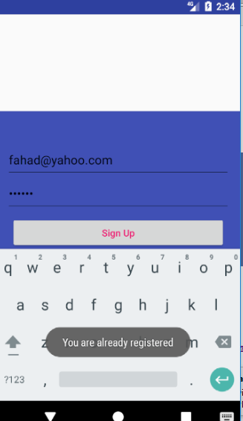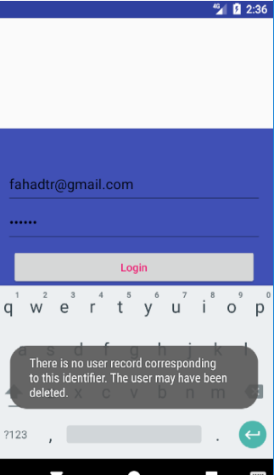
Chapter: 8 Reflection
As experiment of research project has gone so far about development of an estate agent android application is recommended that I have required better effort and further study to complete this project. To help improve this project a strong knowledge of android app development is essential while the knowledge has been insufficient enough to produce standard model of working app due to lack of technical understanding of coding, time management, planning and sick. I have been sick and could not cure in short time for bad weather condition which was an impact of incomplete project. On the other hand, There was no knowledge of previous work about developing any app on android studio before and gradually I start learning tools and design in android studio. To build a complete app is never been easy for the first time and need plenty of time. I learn to build android app by watching Youtube videos and some helpful online course on udemy and coursera and familiar to basic coding of an application.

Reference List

- DENG, L., OFFUTT, J., AMMANN, P. and MIRZAEI, N., 2017. Mutation operators for testing Android apps. In Information and Software Technology, Volume 81, 2017, Pages 154-168, ISSN 0950-5849 [online]Available at: http://www.sciencedirect.com/science/article/pii/S0950584916300684
- "State of developer nation q1 2016 (developer economics 2016)", VisionMobile, 2016.
- A.M. Muharum, V.T. Joyejob, V. Hurbungs, Y. Beeharry, Enersave API: Android-based power-saving framework for mobile devices, In Future Computing and Informatics Journal, Volume 2, Issue 1, 2017, Pages 48-64, ISSN 2314-7288, [online] available at: http://www.sciencedirect.com/science/article/pii/S2314728816300411

- Elliott, L. (2017) The UK housing market's perfect storm, and five steps to avoid it [online] Available at: https://www.theguardian.com/business/2017/oct/08/the-uk-housing-markets-perfect-storm-and-five-steps-to-avoid-it [Accessed 1 Dec. 2017].

- Owen Thomas (2010) Google exec: Android was “best deal ever” [Online] Available at:
https://venturebeat.com/2010/10/27/google-exec-android-was-best-deal-ever/

- WEI-MENG LEE., 2012. Beginning Android 4 Application Development. US: Wrox Press Ltd. Available at: https://www.dawsonera.com:443/abstract/9781118228241

- Tongaonkar, Alok. "A Look at the Mobile App Identification Landscape." IEEE Internet Computing 20, no. 4 (2016): pp.9-15.

- Joorabchi, Mona Erfani, Ali Mesbah, and Philippe Kruchten. "Real challenges in mobile app development." In Empirical Software Engineering and Measurement, 2013 ACM/IEEE International Symposium on, pp. 15-24. IEEE, 2013.

- Tracy, Kim W. "Mobile application development experiences on Apple’s iOS and Android OS." Ieee Potentials 31, no. 4 (2012): 30-34.

- Viennot, Nicolas, Edward Garcia, and Jason Nieh. "A measurement study of google play." In ACM SIGMETRICS Performance Evaluation Review, vol. 42, no. 1, pp. 221-233. ACM, 2014.

- Fan, Xiaochao, and Kenny Wong. "Migrating user interfaces in native mobile applications: android to iOS." In Proceedings of the International Workshop on Mobile Software Engineering and Systems, pp. 210-213. ACM, 2016.

- Alnawas, Ibrahim, and Faisal Aburub. "The effect of benefits generated from interacting with branded mobile apps on consumer satisfaction and purchase intentions." Journal of Retailing and Consumer Services 31 (2016): 313-322.

- Wei-Meng Lee. Wei-Meng Lee. Beginning Android 4 Application Development Beginning Android 4 Application Development 2012.

- Adenowo, Adetokunbo AA, and Basirat A. Adenowo. "Software Engineering Methodologies: A Review of the Waterfall Model and Object-Oriented Approach." International Journal of Scientific and Engineering Research 4, no. 7 (2013): 427-434.

- Bassil, Youssef. "A simulation model for the waterfall software development life cycle." arXiv preprint arXiv:1205.6904(2012).

- Firebase Realtime Database, Firebase. [Online]. Available:
https://firebase.google.com/docs/database/
- Penna Sparrow, “Waterfall Model: Advantages and Disadvantages of Waterfall Model”, [Online] Available at: http://www.ianswer4u.com/2011/11/advantages-and-disadvantages-of.html#axzz59a5GnTJv
- Software Requirements, "CS2 Software Engineering note 2" Autumn 2004 Available at: http://www.inf.ed.ac.uk/teaching/courses/cs2/LectureNotes/CS2Ah/SoftEng/se02.pdf
- Trisnadoli, Anggy, and Indah Lestari. "Software requirement analysis of “family tracking mobile application” on cross platform with hybrid approach." In Data and Software Engineering (ICoDSE), 2017 International Conference on, pp. 1-6. IEEE, 2017.
- Eazi Apps, "MOBILE APPS FOR ESTATE AGENTS" Available at:https://eazi-apps.co.uk/mobile-apps-for-estate-agents/
- Petter L. H. Eide, "Quantification and Traceability of Requirements" 2005, Available at: http://www.idi.ntnu.no/grupper/su/fordypningsprosjekt-2005/eide-fordyp05.pdf
- Feng, Nan, Minqiang Li, Jing Xie, and Deying Fang. "A data-driven model for software development risk analysis using Bayesian networks." In Advanced Management of Information for Globalized Enterprises, 2008. AMIGE 2008. IEEE Symposium on, pp. 1-5. IEEE, 2008.

Appendix:



