

Managing Enterprise in the 21st Century

Business Plan
Brothers Maintenance Solution Ltd
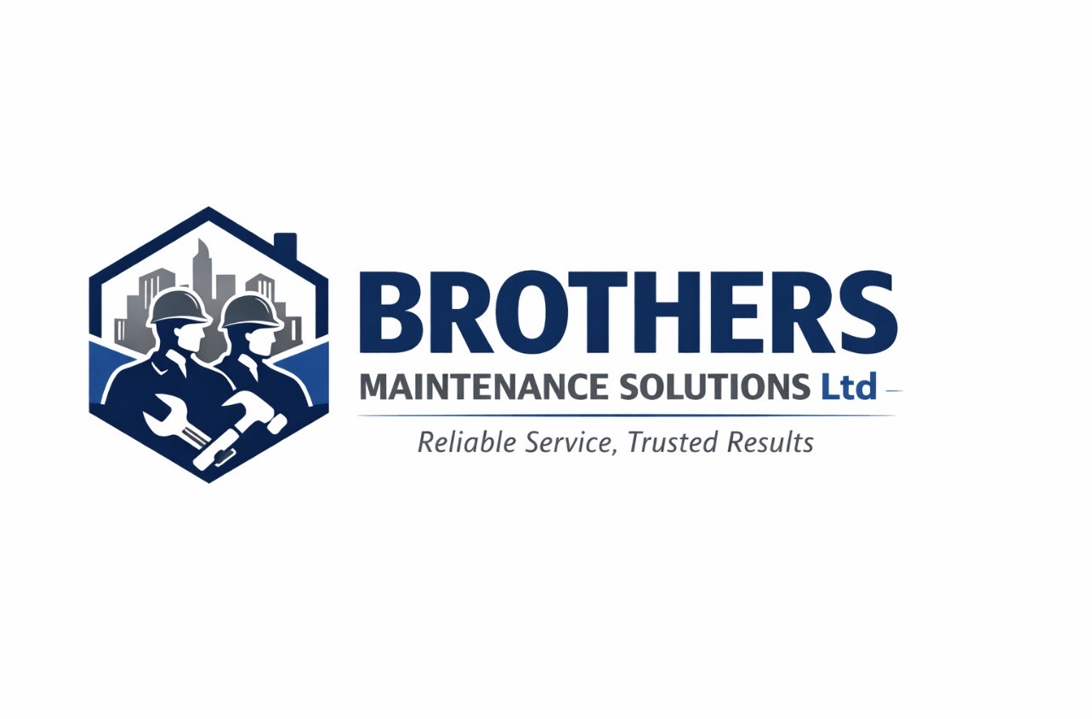

Yaroslav Zhenchuk
(2514092)

Submission Date: 27.07.2026
Lecturer: Mohammad Rahman

Table of Contents
Executive Summary 3
Business Concept 4
Business Description 4
Product Description 4
Business Objectives (SMART Objectives) 5
Short-Term Objectives (less than a year) 5
Long-Term Objectives (More than a year) 5
Market Analysis and Marketing Plan 5
Market Analysis (Competitors, Customers, Target Groups) 5
PESTEL Analysis 6
SWOT Analysis 7
Marketing Mix (4Ps) 7
Management Team 8
Management Team and Their Background 8
Organisational Chart 8
Key Milestones 9
Financial Plan (One Year) 9
Sources of Finance 9
Cash Flow Forecast 10
Sales Forecast 10
Cost of Production Forecast 10
Break Even Analysis 11
Operations and Management Plan 11
Production of Good and Service 11
Technology Plan 11
Human Resource Plan 12
Expansion Plan 12
Reference List 13
Appendices: 14

Executive Summary

Brothers Maintenance Solution Ltd is a company that will provide comprehensive maintenance and repair services for residential and commercial properties in the UK. The main office business is to provide customers with high quality, reliable and affordable maintenance services for houses, apartments, offices and commercial premises.
The company offers a wide range of services, including minor repairs, plumbing and electrical work, painting, carpentry, garden inspection, post lease property maintenance and emergency calls. The main competitive advantage will be a comprehensive approach, when the client can receive all the necessary services in one place.
The company pays special attention to the principles of sustainable development. To perform the work, environmentally friendly materials, energy-efficient equipment and modern methods of recycling construction waste will be used (Burns, 2020). Brothers Maintenance Solution Ltd also plans to cooperate with local suppliers, create jobs for community residents and participate in social initiatives.
Approximately £35000 of start-up capital is required to start a business. The funds will be used to purchase a professional tool, a company car, insurance, marketing compensation, and cover initial operating costs.
The aim of the company is to become one of the most reliable providers of property maintenance services in your region within the first three years.

Business Concept

Business Description
Brothers Maintenance Solution Ltd is a company specializing in comprehensive maintenance, repair and support of residential and commercial real estate. The business will operate in the form of a Private Limited Company (Ltd), which ensures limited liability of the owners, increases customer trust and creates opportunities for further development (Barrow, Barrow and Brown, 2021)
The main idea of the company is to provide customers with a wide range of repair and services through the company. Instead of looking for individual craftsmen for plumbing, electrical installation or painting works, the client will be able to order comprehensive services from Brothers Maintenance Solution Ltd. This will save time, ensure high quality of work and simplify communication.
The company will work with both private owners of houses and apartments and corporate clients, including offices, shops, real estate agencies and companies that manage real estate objects.
Main Services:
- Maintenance of residential real estate;
- Handyman services (minor repairs)
- Plumbing works;
- Electrical maintenance (by certified specialists);
- Painting and decorating of premises;
- Carpentry;
- Maintenance of the surrounding area;
- Repairs after the end of the lease (end-of-tenancy maintenance)
- Emergency repairs.
Sustainability and Community Support
In line with the demands of the modern market, the company will integrate the principles of sustainable development into its operations (British Standards Institution, 2022). It is planned to use energy-efficient materials, sort construction waste, minimize the use of single-use plastics and cooperate with local suppliers.
In addition, Brothers Maintenance Solution Ltd will support the local community by creating new jobs, attracting young professionals to internships and providing discounts to the elderly and charitable organizations.

Business Objectives (SMART Objectives)

Short-Term Objectives (less than a year)

- To officially register the company and start operating within the first three months;
- To attract at least 80 regular customers;
- To conclude at least 10 long-term contracts with corporate clients;
- To achieve a customer satisfaction level of over 90%;
- To create a professional website with the ability to book services online.

Long-Term Objectives (More than a year)

- To expand into neighbouring regions of the UK;
- To increase the team to 20 employees;
- To become one of the leading local property services providers;
- To increase the share of corporate clients to 50% of total revenue;
- To invest in electric company transport and energy-efficient equipment.
These objectives follow the SMART framework, ensuring they are specific, measurable, achievable, relevant and time-bound (Burns, 2020)

Market Analysis and Marketing Plan

Market Analysis
The property maintenance market in the UK is growing due to the increase in the number of residential and commercial properties, as well as the demand for professional repair services. Many property owners, tenants and businesses prefer specialist companies that can quickly and efficiently carry out other types of repair work.
Demand for property maintenance services continuous to increase due to the growth of residential and commercial properties (British Chambers of Commerce, 2024)
Brothers Maintenance Solution Ltd.’s main competitors are local handymen, independent craftsmen and large property management companies. Most of them specialise in only certain types of work, so the company gains the competitive advantage due to its integrated approach, which allows customers to receive several services from one place.
The company’s main customers will be owners of apartments and flats, landlords, estate agents, small businesses and office centres. For these customers, the quality of work, speed of response, reliability and transparent pricing.
The company’s market segmentation and positioning strategy is based on marketing principles described by Kotler and Armstrong.

PESTEL Analysis
Factor | Impact on Business
POLITICAL | State safety standards and building codes determine the requirements for performing renovation work.
ECONOMIC | The increase in the costs, but the demand for repairs and maintenance of real estate remains stable.
SOCIAL | The aging housing stock and active rental market increase the need for professional renovation services.
TECHNOLOGICAL | The use of modern equipment, digital booking systems and CRM increases the efficiency of the company’s work.
ENVIRONMENTAL | The use of environmentally friendly materials and proper disposal of construction waste are consistent with the principles of sustainable development and customer expectations.
LEGAL | The company must comply with legislation on occupational health and safety, liability insurance, consumer protection and requirements for performing certain types of renovation work

The PESTEL analysis demonstrates how external environmental factors may influence the business (Burns, 2020)

SWOT Analysis

Strength | Weaknesses
Comprehensive list of services | New brand without reputation
Qualified employees | Limited start-up budget
Flexible work schedule | Dependence on local market

Opportunities | Threats
Growing demand for repair services | High competition
Cooperation with real estate’s agencies | Rising prices for materials
Expansion of the corporate segment | Economic instability

SWOT analysis helps identify the company’s internal strengths and weaknesses as well as external opportunities and threats (Barrow, Barrow and Brown, 2021)

Marketing Mix (4Ps)

Product.
The company offers comprehensive repair and maintenance services for residential and commercial properties, including plumbing, electrical, carpentry and painting.
Price.
A competitive strategy will be used with transparent rates, individual estimates and discounts for regular customers and long- term contracts.
Place.
Services will be provided directly at customer sites. Orders can be placed via website, phone or social media.
Promotion.
The main promotion channels will be a professional website, Google Business Profile, Facebook, Instagram, local advertising, partnerships with real estate agencies and a referral program for regular customers.
The marketing strategy is based on the 4Ps marketing framework development by Kotler and Armstrong., 2021.

Management Team

Management Team and Their Background
The success of Brothers Maintenance Solution Ltd largely depends on a professional management team and a clear division of responsibilities. At the initial stage, the company has a compact organizational structure that ensures effective management and quick decision-making.
The Managing Director is responsible for the strategic management of the company, financial planning, business development, drafting contracts with customers and quality control of the services provided. The director also makes decision on investments, company development and expansion.
The Operation Manager organizes the daily work of the company, will draw up the schedule for the execution of orders, control the use of materials and equipment, and coordinate the work of technical personnel.
The Marketing and Customer Relation Coordinator is responsible for promoting the company, maintaining a social network, website support, communicating with customers, accepting orders and collecting feedback. This will help attract new customers and maintain a high level of satisfaction with the service.
Maintenance Technicians perform repairs and service work to professional standards. All employees are trained in occupational health and safety before starting work, using a modern equipment and customer service standards.

Organisational Chart

Managing Director

Operations Manager Marketing & Customer Relationship Coordinator

Maintenance Technicians

Key Milestones

Period | Key Objectives
Month 1 | Company registration and equipment purchase.
Months 2-3 | Hire staff, launch website and start marketing campaign.
Months 4-6 | Attract first regular clients and conclude contracts with real estate agencies.
Months 7-12 | Expand client base, increase revenue and hire additional specialists.
Years 2-3 | Expand activities to new regions of the UK and increase the number of corporate clients.

A clear organisational structure supports effective decision-making and business performance (Scarborough and Cornwall, 2019)

Financial Plan (One Year)

Sources of Finance
The establish Brothers Maintenance Solution Ltd, an estimated £35,000 of start-up capital is required. This funding will cover the purchase of professional tools and equipment, a company vehicle, insurance, marketing activities, office supplies, and initial operating expenses.
Source of funding | Amount (£)
Founders’ Own Funds | 20,000
Bank Loan | 10,000
Investment/Grant | 5,000
Total | 35,000

Using multiple sources of financial risk and improves financial stability (British Business Bank, 2024)

Cash Flow Forecast
During the first months, the company will invest significant funds in starting the business, so the net cash flow will be negative. It is expected that after the formation of a permanent customer base, the company will achieve a stable positive cash flow.
Metric | Amount (£)
Expected revenue | 140,000
Operating costs | 112,000
Expected net profit | 28,000

Sales Forecast
The company predicts a gradual growth in sales due to an increase in the number of regular customers and the conclusion of long-term contracts.
Period | Forecast Revenue (£)
1st Quarter | 28,000
2nd Quarter | 33,000
3rd Quarter | 38,000
4th Quarter | 41,000
Total of the Year | 140,000

Cost of Production Forecast
The company’s main expenses will be:
- Staff salaries;
- Purchase of materials and spare parts;
- Fuel and maintenance of the company car;
- Insurance;
- Marketing and advertising;
- Administrative expenses.
The company will regularly monitor costs and review prices for services in accordance with the market.

Break Even Analysis

To reach the break event point, a company must cover its fixed costs through regular order fulfilment. According to preliminary calculations, Brothers Maintenance Solution Ltd plans to break even in approximately 6 months of operation. This is planned to be achieved through an active marketing campaign, high quality services, and long-term contracts with property owners, agencies, and corporate clients.
Financial forecasting enables businesses to evaluate profitability and support strategic decision – making (Barrow, Barrow and Brown, 2021)

Operations and Management Plan

Production of Good and Service
Brothers Maintenance Solution Ltd will provide a wide range of property maintenance and repair services for residential and commercial customers. The service process will begin with receiving customer inquiries through the company website, telephone, or social media platforms. After confirming the clients’ requirements, an appointment will be scheduled, and the appropriate maintenance team will be assigned.
Technicians will arrive at the customer’s property with the necessary tools and materials to complete the work efficiently and safely. Upon completion, all work will be inspected to ensure it meets the company’s quality standards. Customer feedback will be collected to improve service quality and build long-term relationships.

Technology Plan

The company will use technology to improve operational efficiency and customer satisfaction. An online booking system and Customer Relationship Management (CMR) software will be used to manage appointments, customer records, quotations, and invoices. Digital payment options will provide secure and convenient payment options, while social media platforms and Google Business Profile will support marketing activities and customer communication.
The use of digital technology improves operational efficiency and customer relationship management (Federation of Small Businesses, 2024)

Human Resource Plan

During the first year, Brothers Maintenance Solutions Ltd plans to employ one Managing Director, one Operation Manager, one Marketing and Customer Relationships Coordinator and four Maintenance Technicians. As the business grows, additional qualified technicians will be recruited to meet increasing customer demand.
All employees will receive regular training in health and safety, customer service, technical skills and the use of professional equipment. The company will also implement a performance review system and reward employees based on the quality of their work and customer satisfaction.
Continuous staff training contributes to higher service quality and improved customer satisfaction (Health and Safety Executive, 2024)

Expansion Plan

The company aims to expand its operations within three to five years by increasing its workforce, investing in additional service vehicles, and extending its services to neighbouring regions. Brothers Maintenance Solutions Ltd also plans to establish long-term contracts with property management companies, housing associations and commercial businesses. Continuous investment in employee development and sustainable technologies will support long0term growth and strengthen the company’s competitive position in the UK property maintenance industry.
Business growth should be supported through strategic planning and continuous investment in people and technology (Department for Business and Trade, 2024)

Reference List

Barrow, C., Barrow, P. and Brown, R. (2021) The Business Plan Workbook. 9th edn. London: Kogan Page.
British Business Bank (2024) Finance Hub for Smaller Businesses. Available at: https://www.british-business-bank.co.uk (Accessed: 26 July 2026)
British Champers of Commerce (2024) Business support and Advice. Available at: https://www.britishchampers.org.uk. (Accessed:26 July2026)
British Standards Institutions (2022) Facilities Management- Management Systems. Available at: https://www.bsigroup.com (Accessed: 26 July 2026)
Burns, P. (2020) Entrepreneurship and Small Business: Start-up, Growth and Maturity. 5th edn. London: Red Globe Press.
Department of Business and Trade (2024) Business Guidance and Support. Available at: https://www.gov.uk/business (Accessed: 26 July 2026)
Federation of Small Businesses (2024) Starting and Growing a Business. Available at: https://www.fsb.org.uk (Accessed: 26 July 2026)
Health and Safety Executive (2024) Health and Safety in Construction and Maintenance. Available at: https://www.hse.gov.uk (Accessed: 26 July 2026)
Kotler, P. and Armstrong, G. (2021) Principles of Marketing. 18th edn. Harlow: Pearson.
Scarborough, N.M. and Cornwall, J.R. (2019) Essentials of Entrepreneurship and Small Business Management. 9th edn. Harlow: Pearson.

Appendices:

