Task 1: Identify the and Correct the Citations

Recent research suggests that small and medium-sized enterprises (SMEs) are increasingly adopting and utilising digital tools to improve their operational efficiency and customer engagement ____________________________________________. According to recent data sets, SMEs have increased their investment in digital technologies in the past two years; for example,_______________________________ reports that 71% of SMEs have adopted CRM system. This transition reflects a broader trend in the UK economy, where digital capability is becoming a key determinant of business resilience, competitiveness and success.
Beyond industry specific data, further research from academic spheres supports this trend; for example, ________________________________________________emphasises that within the Fourth Industrial Revolution, the adoption of digital technology is now a core driver of competition and present opportunities for small businesses to adapt, particularly due the customer expectations changing rapidly. In addition,________________________further illustrates that the use of AI is changing the way business operate, and highlights that AI can impact productivity, customer retention, and decision-making. In a similar vein, findings from _______________________________note that customers are increasingly prioritising convenience and valuing fast and personalised service delivery. Based upon the findings these findings, businesses who fail to adapt to these expectations run the risk of loosing revenue compared to competitors who are digitally more mature.
Although consumer-driven pressures are considerably important to address, there are external factors which are influencing small businesses to adopt digital infrastructure. _________________________________emphasises that digital skills shortages remain a major barrier to growth, particularly for micro-businesses. The report highlights that many SMEs identify digital and technology-related skills as among the key areas where recruitment and upskilling challenges persist, reflecting ongoing skills gaps affecting business productivity and growth plans. Despite these challenges, government initiatives such as the Skills for Life helps to support SMEs in addressing the skill shortages.
Another important factor shaping SME behaviour is the post-pandemic shift towards hybrid working. __________________________________________indicates that flexible working arrangements have required businesses the change the way they operate, with 71% of UK organisations having hybrid working conditions in place, therefore placing increased demand for collaboration platforms and secure remote-access systems. SMEs that have embraced hybrid models report improvements in employee satisfaction and retention, although concerns remain regarding cybersecurity and data protection.
Overall, the evidence suggests that digital capability is becoming essential for long-term sustainability in the SME sector. Businesses that invest strategically in digital tools, workforce skills, and customer-focused technologies are better positioned to navigate market uncertainty and capitalise on emerging opportunities.

Task 2: Identify and Correct the Reference List

- ______________________________________________________________________________________________________________________________________________________
- ______________________________________________________________________________________________________________________________________________________
- ______________________________________________________________________________________________________________________________________________________
- ___________________________________________________________________________
- ______________________________________________________________________________________________________________________________________________________
- ______________________________________________________________________________________________________________________________________________________
- ______________________________________________________________________________________________________________________________________________________

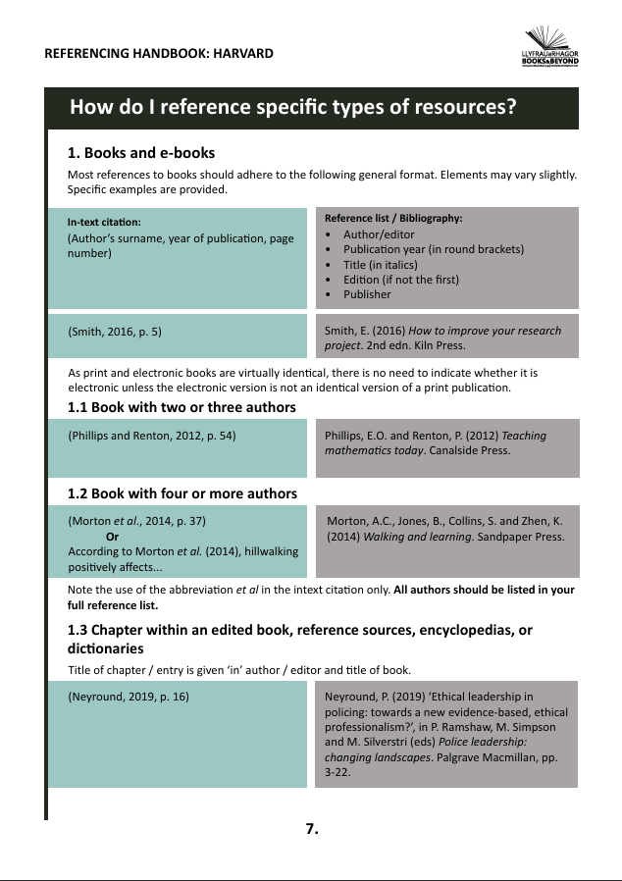
Referencing Guide


