BMTP6016 Strategic Tourism, Events, and Leisure Management
Strategic Case Study Review Report on Airbnb

Executive Summary
From the following report, this paper analyses Airbnb’s strategic leadership in the tourism and events industry with reference to market forces, regulation, and customers. Analyses like SWOT and Porter’s Five Force are used to do a thorough examination of the internal and external environment report anticipate the company to be in. The results examine Airbnb’s planning techniques success in financial sustainability, improving customer experience and promoting long-term operational success. Some proposals are offered to enhance the strategic firm’s manoeuvrability and sustain a competitive edge.

Table of Contents
Executive Summary 2
Introduction 4
Findings 5
SWOT Analysis of Airbnb 5
Porter’s Five Forces Analysis 6
Evaluation of Airbnb’s Current Strategies 8
Critical Factors That Affect Effort 9
Market Analysis (External Factors) 9
Conclusion and Recommendations 11
Conclusion 11
Recommendations 11
Reference list 13
Appendix 15
Appendix 1: Detailed SWOT Analysis Table 15
Appendix 2: Porter’s Five Forces Diagram 16
Appendix 3: Examples of Regulatory Challenges 16
Appendix 4: Airbnb’s Sustainability Initiatives 16
Appendix 5: Key Market Trends Supporting Airbnb Strategy 17

Introduction
Airbnb, an online marketplace and hospitality service, was launched in August 2008 and quickly changed the rules of the tourism and hospitality business by promoting the sharing economy model involving home-sharing. Hosts can offer guest rooms and experiences in their homes through the platform, which is different from hotels. Existing in over 220 countries and territories, the company is now one of the major players in the tourism and events industry (Boswijk, 2017). Using information technology and peer-to-peer business models Airbnb has revolutionised the traditional hospitality industry and comes up with a sustainable but scalable solution that can attract a wide market. However, as the company grows, there are major issues such as the regulatory environment, competition and the changing customer needs which makes the business environment more challenging for a company as it grows (Aaker, 2019).
It can be therefore said that these challenges will determine whether Airbnb can effectively respond to them while attaining maximal profitability of newly emerged opportunities. Some cities around the globe have restricted operations of short-term letting over issues concerning housing supply and disruption to movement (Qiu et al., 2020). Competitors like Booking.com and Vrbo, alongside hotels, have escalated their activities to grab the market by leveraging technology-advanced customer solutions. Analysis of the marketing opportunities shows that the increase in the number of eco-conscious travellers presents Airbnb with an opportunity to categorise itself as an environmentally friendly company with accommodations available for travellers.
In this report, the author intends to critically discuss the suitability of the current strategic leadership and business strategies of Airbnb. It learns how Airbnb solves regular sector problems and captures opportunities for organic development. The assessment uses tools like the SWOT analysis and the Five Force industry model to analyse Airbnb’s internal and external environments systematically.

Findings

SWOT Analysis of Airbnb
Strengths
Brand Recognition and Market Leadership: In reference to Appendix 1, Airbnb occupies one of the leading positions in the sharing economy market. This is also anchored on its strong brand image which is well established in over 220 countries and regions, making it a close contest (Boswijk, 2017). The company has positioned itself uniquely in the market because it offers innovative and affordable means of travelling (Aaker, 2019).
Diverse Offerings: Unlike typical rivals, the company provides a broad number of rooms that range from cheap apartments to expensive villas, as well as other distinct types of residing places, such as tree houses and castles. This diversity comes with a larger clientèle base with different needs and a potential to spend (Okumus et al., 2010).
Scalable and Flexible Business Model: Airbnb does not own any of the assets it deals in due to which, it can expand operations without having to invest heavily. It therefore engages the communities through peer-to-peer hence giving a peculiar value addition proposition (Evans, 2015).
Technological Innovation: Airbnb organises its supply and demand sides by using sophisticated digital technologies from machine learning and artificial intelligence to supply tailored suggestions and preferable search methods. Its mobile application and customer-oriented design also reinforce its market dominance (Johnson et al., 2015).
Weaknesses
Regulatory Challenges: Most cities and towns around the world have applied severe measures to regulate short-term rentals with shortages of housing, high rents, and social disruption. In reference to Appendix 1, These policies concern Airbnb directly and restrict its opportunities to enter major markets (Qiu et al., 2020).
Dependence on Host Compliance: Airbnb has decentralised many of its operations to individual guests who then list and rent properties, leaving it up to hosts to manage the cleaning and ensure compliance with local laws. They also make the following points: Compliance performance and host performance variability are potential threats to the reputation of the company (Boswijk, 2017).
Negative Public Perception: In some cities, Airbnb is regarded as a source of gentrification, housing scarcity, and high charges for rent, and therefore attracts hostility from the public (Okumus et al., 2010).
Opportunities
Emerging Markets: The markets that have the greatest unexplored growth opportunities are in Asia, Africa and Latin America. In reference to Appendix 1, Future advancements in internet connectivity together with conducive economic conditions in these areas also offer a great market for Airbnb expansion (Dileep, 2019).
Sustainability Trends: Consumer interest in sustainable travel represents a potential for Airbnb to take a stand on responsible tourism or, at least, advertise a select number of experiences or destinations that meet environmental and cultural tourism standards (Evans, 2015).
Partnerships and Diversification: The company should pursue partnerships with the local governments hosting tourism agencies, and travel service providers would assist in managing the policies that are likely to inhibit the services provided (Cameron and Green, 2015).
Threats
Intense Competition: Traditional accommodation providers such as Vrbo and Booking.com among others have shifted their coping mechanisms and strategies that were employed in this category and some traditional hotel chains to counter Airbnb (Porter, 2004).
Economic Volatility: In reference to Appendix 1, Market forces such as a pandemic or a global economic downturn affect the corresponding spending on tours and leisure especially where the current pandemic is concerned.
Regulatory Restrictions: One of the biggest risks for the business is the growing regulatory pressure in key cities such as New York, Paris, and Barcelona (Qiu et al., 2020).

Porter’s Five Forces Analysis
Threat of New Entrants – Moderate
In reference to Appendix 2, The low entry barriers depict that new players can enter the sharing economy market easily. However, it achieved a critical market share point and established brand image which is a great hindrance to new entrants. However, building a platform that has an international scope and which is reinforcing customer confidence requires a significant amount of time and capital (Porter, 2004).
Bargaining Power of Suppliers – Low to Moderate
Airbnb’s laid down suppliers whom it relies heavily on are people who open up their homes to these travellers. In reference to Appendix 2, Even if hosts have some degree of power following their ability to advertise approximately an equivalent of their offerings on additional platforms, the volume of participants in Airbnb is far more significant than on any of its competitors. Airbnb too provides guidance and earns a commission on the bookings while retaining a measure of management (Boswijk 2017).
Bargaining Power of Buyers – High
A customer has so many options ranging from hotels to other rented apartment platforms. The volume of product, price elasticity of demand, and aspects that enable the turnover of one supplier with another put buyers in a powerful position to dictate the price. To this effect, there is value through differentiation and price leadership by Airbnb as pointed out by Okumus et al. (2010).
Threat of Substitutes – High
In reference to Appendix 2, Chain hotels, motels, hostels, and vacation rentals are able to substitute Airbnb effectively. Furthermore, changes in lifestyle and or movement towards conventional renting during periods of crises like pandemics is a pull factor that may pull down Airbnb (Johnson et al., 2015).
Industry Rivalry – High
The industry of tourism and hospitality is highly CRS rtive. There is undoubtedly intense competition in the online accommodation market, where key players such as Booking.com, Expedia and Vrbo co-compete with small and medium-sized providers of boutique accommodations. Pricing is a major motivation for competitive rivalry, as well as innovation and customer retention (Porter, 2004).

Evaluation of Airbnb’s Current Strategies
Response to regulatory challenges
In reference to Appendix 3, Airbnb has tried to solve the problems connected with regulation by partnering with local authorities and using self-regulation mechanisms like accumulating tourist taxes. Despite these, some risks have been managed, although regulations are fragmented by region and have not been totally effective (Qiu et al.; 2020).
Focus on Customer Experience
A popular example of strategic implementation of AI is technology investments aimed at improving guest experiences like recommendations, checkout and reviews of hosts. Iodo has also been compounded by efforts to increase customer retention as well as decrease churn levels (Johnson et al., 2015).
Sustainability Initiatives
Airbnb has formulated strategies of sustainable stays and experiences to respond to changes in customer demand for green tourism. However, such efforts have not yet attained full-grown status; thus, solid frameworks are required to produce better significant changes (Evans, 2015).
Diversification of Offerings
The extension of the company into offering experiences like tourism and art, for example, has provided value to its service. This strategy increases income sources and portrays the brand as the stop travel solution provider (Boswijk, 2017).
Competitive Strategies
In reference to Appendix 3, Airbnb has continued to ace competitors by constantly coming up with new viable strategies and policies that were adopted amid the COVID-19 crisis like the cancellation policies as well as the long-term rental offers. However, for an organisation to be able to sustain the identified competitive differentiation it will need to innovate constantly (Aaker 2019).

Critical Factors That Affect Effort
Regulatory Compliance: Airbnb’s organisation structure of renting homes, adds challenge to meeting various local legal provisions resulting in risks such as fines, bans or operating limitations in the key geographies.
Host and Customer Trust: In reference to Appendix 4, It will remain essential to guarantee the level of trust prevailing between the hosts and the guests. This paper has pointed out that Airbnb has over time implemented several steps toward verifying hosts and properties in a bid to eliminate fake listings though such measures require additional fine-tuning (Boswijk, 2017).
Sustainability Gaps: Despite the fact that Airbnb claims it is an eco-friendly company, it does not provide sustainability indicators and relevant accreditation (Evans, 2015).
Dependence on Travel Trends: As observed epidemics such as COVID-19, or changes in the economic climate dramatically affect the financials of Airbnb, making it easy to detect critical weaknesses in its value proposition (Aaker, 2019).

Market Analysis (External Factors)
Technological Advancements
AI and blockchain could rapidly transform Airbnb; for instance, by using AI to automate most processes of finding tenants and managing property. To illustrate this, blockchain was said to enhance security and openness in any deal (Okumus et al., 2010).
Economic Factors
In reference to Appendix 5, A decline in discretionary travel may occur due to global inflation trends for travel products and services or due to uncertain world economy. But one of the biggest advantages Airbnb has over traditional hotel chains is the solution it offers during difficult economic times (Sloman et al., 2016).
Social Trends
Slow travel and focus on cultural experience is a direction that corresponds with Airbnb’s positioning. Secondly, there is a trend in which people do not select hotel accommodations when they travel but instead, they opt for specialised experiences (Dileep, 2019).
Environmental Concerns
High customer concern about the environmental footprint is both a threat and a potential in the Airbnb business model. An increase in the company’s effort towards promoting sustainable tourism could also improve its brand appeal to travellers with a conscience (Evans, 2015).
Legal and Political Factors
Short-term renting laws greatly differ from one another thereby significantly affecting Airbnb’s capacity to standardise operations. In reference to Appendix 5, The political environment, especially for places that are experiencing a shortage of housing in urban areas, makes its environment of operations even more charged (Qiu et al., 2020).
Finally, this comprehensive analysis establishes that Airbnb has efficiently exploited its strengths and minimised its weaknesses as well as having adjusted to pressures outside of the firm. The study focuses on the implications of realistic strategic leadership to enhance sustainable development. The next section of this study will discuss these findings and will also present some practical implications for the senior management of the company.

Conclusion and Recommendations

Conclusion
Airbnb could be acknowledged as the market leader of the sharing economy by making use of the P2P platform, worldwide presence and targeting non-standard accommodation services. Through the examination of its business model, competitors and strategies in certain markets, some of the organisation’s major opportunities that have been identified include secured brand, technological advancement and accommodation of changing consumer preferences.
The data presented in the SWOT analysis once again emphasises Airbnb’s strengths in identifying and seizing opportunities in new markets, as well as following the tendencies of sustainability and joining partnerships; threats are the critical overreliance on hosts’ cooperation, together with legal issues. Porter’s Five Forces can also be used to show how the industry is highly competitive and how important is to introduce innovation and customer-oriented strategies.
Last but not least, Airbnb with its strategic initiatives has unlocked a path for sustainable growth, however, the changes in the market regulation, consumers’ behaviour and gross economic environment suggest the need for a continuous strategic outlook. Overcoming these challenges demands a delicate treatment of compliance, business sustainability, innovation and stakeholder management.

Recommendations
Improve the rules and legislation: The Company should increase its relations with local governments and communities in order to overcome the regulation issues. This may involve developing relationships with local government for tax issues, zoning and environmental concerns. It will also allow the company to keep hosts informed about local laws and regulations in a bid to avoid cases which may dent the punctuated Airbnb reputation.
Sustainability and Responsible Tourism: For Airbnb also there is an important consideration for sustainability in the context of its strategic plan which is to promote the green aspects among the hosts like any host should provide energy-conservative properties. It may increase the attractiveness point of environmentally conscious travellers to ambient the concept of responsible tourism into Airbnb.
Improve Business Sales and Customer Loyalty: Technology has to be adopted by Airbnb to provide a more targeted recommendation and to boost the customer’s experience. Improved post-stay follow-ups and verification procedures can help customers understand the value of safety and build lasting relationships with them by enticing them to make repeat reservations.
Support Agenda for Competition: Airbnb can shift operations into new markets and venture into new services or combine the hospitality service with healthcare, or support services for pets, among others. Adopting such technologies as virtual reality property tours and blockchain payments/imaging will create value, as well as boost the security of your platform.
Mitigate Economic Risks: To reduce the effect of economic fluctuations, Airbnb should offer “best-rate”, fluctuating tariffs, and low prices. This will assist in sustaining such positions of the organisations during periods of financial instability.
Promote Corporate Social Responsibility (CSR): Airbnb needs to dedicate resources to more and better CSR programmes, some of which range from disaster recovery, to support for local communities. They will also improve Airbnb’s brand perception, bringing about the most out of tourism, and improving the social issues surrounding housing.

Reference list
Aaker, D., 2019. Winning in the sharing economy: Six keys to Airbnb’s success. Journal of Brand Strategy, 7(4), pp.310-317.
Boswijk, A., 2017. Transforming business value through digitalized networks: A case study on the value drivers of Airbnb. Journal of Creating Value, 3(1), pp.104-114.
Cameron, E. and Green, M. 2015. Making Sense of Change Management: A Complete Guide to the Models, Tools and Techniques of Organisational Change, 4th edition, London: Kogan Page
Dileep, M. 2019. Tourism, Transport and Travel Management, Abingdon: Routledge
Evans, N. 2015. Strategic Management for Tourism, Hospitality and Events, 3rd ed, Abingdon: Routledge
Hayes, J. 2014. The Theory and Practice of Change Management, 4th edition, Basingstoke: Palgrave Macmillan
Johnson, G, Scholes, K and Whittington, R. 2015. Exploring Corporate Strategy: Text and Cases, London: Prentice Hall
Johnston, M.W. and Marshall, G.W., 2020. Sales force management: Leadership, innovation, technology. Routledge.
Kouzes, T.K. and Posner, B.Z., 2019. Influence of managers’ mindset on leadership behavior. Leadership and Organization Development Journal, 40(8), pp.829-844.
Kriger, M., Zhovtobryukh, Y., Kriger, M. and Zhovtobryukh, Y., 2016. Advice for strategic leaders in turbulent times. Strategic Leadership for Turbulent Times, pp.137-149.
Morrison, J. 2016. The Global Business Environment. 4th ed. Palgrave
Okumus, F Altinay, L and Chathoth, K. 2010. Strategic Management for Hospitality and Tourism, Abingdon: Routledge
Porter, M. 2004. Competitive Advantage – Creating and Sustaining Superior Performance, London: Harper Collins
Qiu, D., Lin, P.M., Feng, S.Y., Peng, K.L. and Fan, D., 2020. The future of Airbnb in China: industry perspective from hospitality leaders. Tourism Review, 75(4), pp.609-624.
Sloman, J, Garratt, D, Guest, J and Jones, E. 2016. Economics for Business. 7th ed. Harlow: Pearson

Appendix

Appendix 1: Detailed SWOT Analysis Table
Strengths | Weaknesses
Strong brand recognition and leadership in the sharing economy. | Regulatory challenges in key cities.
Diverse accommodation offerings (from budget to luxury). | Dependence on hosts for compliance and service quality.
Scalable, asset-light business model. | Negative public perception
Opportunities | Threats
Expansion into emerging markets. | Intense competition from Booking.com, Vrbo, traditional hotels.
Alignment with sustainability and eco-tourism trends. | Economic volatility affecting travel spending.
Partnerships with local authorities and service providers. | Increasing regulatory restrictions in major cities.

Appendix 2: Porter’s Five Forces Diagram
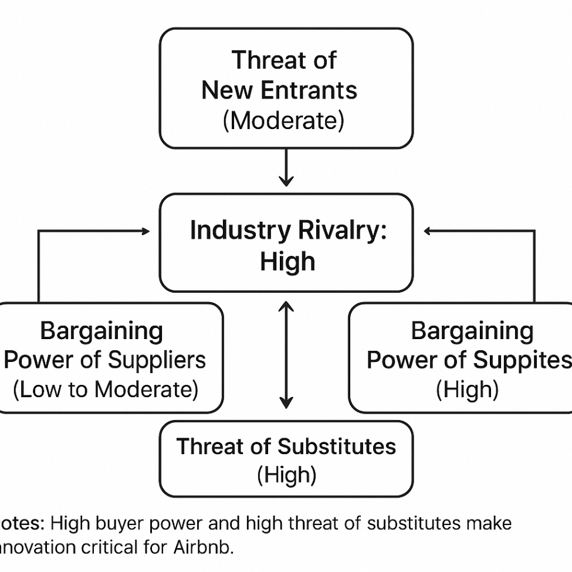

Appendix 3: Examples of Regulatory Challenges
City | Regulation | Impact on Airbnb
New York City | Strict registration requirements for hosts. | Reduces available listings
Paris | Limits on the number of rental days | Host compliance monitoring needed.
Barcelona | Licensing requirements for tourist rentals. | Limits expansion
Amsterdam | Cap on 30 nights per year for rentals. | Reduces host activity and supply.

Appendix 4: Airbnb’s Sustainability Initiatives
Initiative | Description
Sustainable Stays | Energy efficient certifications for green homes.
Community Tourism Programmes | Working with hosts in order to help cultural tourism and minimise the negative effect.
Disaster Relief Housing | Relief measures such as comping or offering affordable homes for the victims and relief givers.
Carbon Offset Options | Offset travel related carbon during booking process.

Appendix 5: Key Market Trends Supporting Airbnb Strategy
Trend | Relevance to Airbnb
Rise in Eco-conscious Travel | Supports sustainability branding.
Growth in Remote Work ("Workations") | Longer-term rental opportunities.
Desire for Authentic Cultural Experiences | Enhances Airbnb’s philosophies of local and authentic experiences.
Digital Transformation (AI, Blockchain) | Support of utilising technology in enhancing personalization and trust features.

