Website Analysis

10.07.2020

Digital Skills and Research Methods

Dragos Sculeac

1913775

Login details: User 1913775DS@gmail.com
Password: Sculeac1

Introduction

Following the results from my primary research, I have started developing the website where I will be looking to sell personalized fishing gear. The website will contain an online shop divided into several categories to distinguish between custom made fishing lure, rods, tackle, but also personalized gifts and clothing.
The customers will also have the option to create an account where they can track their order, view order history, manage payments and arrange returns.
The finished website will contain several pages and a wide variety of products, but for now I have submitted an analysis of the content within the first three pages.

Home page

When designing the website, an important aspect was to make it mobile friendly, as this increases the chances for customers to make purchases and return (Statista, 2020).
For the home page I wanted a simple layout with little writing, but enough visual items to attract the potential buyers.
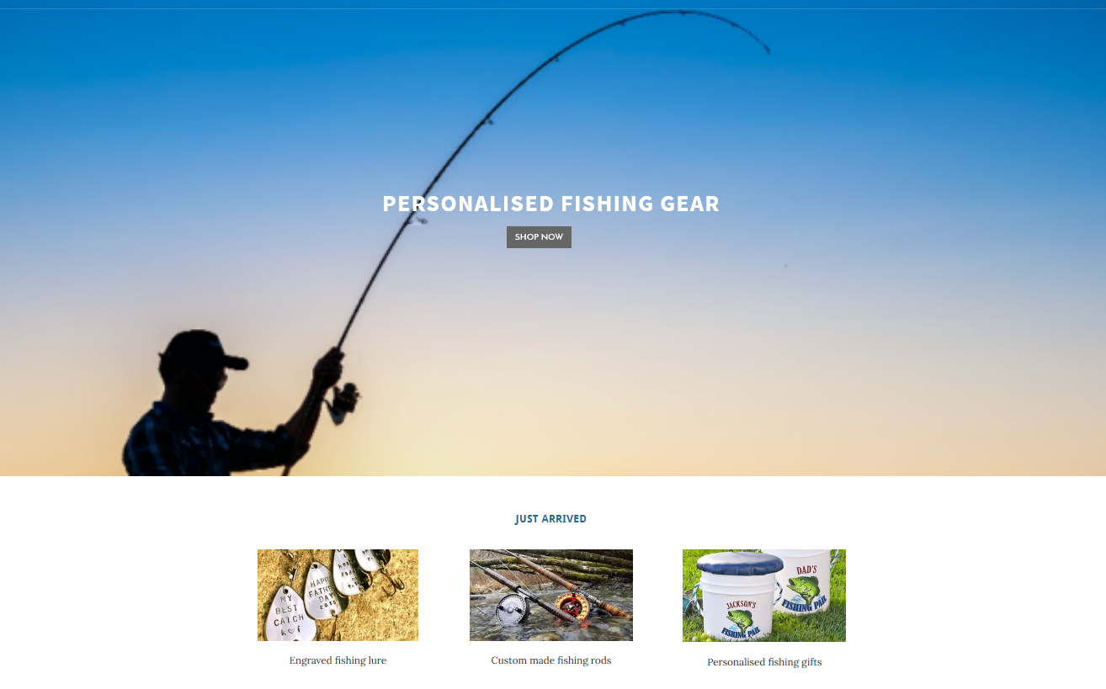
The home page opens with a background picture showing a man fishing in the sea and in the middle the title describes the content of this website along with a SHOP NOW button, which links to a Product page.
Below I have added a gallery that links to new launches, where I have included three of the main product categories.
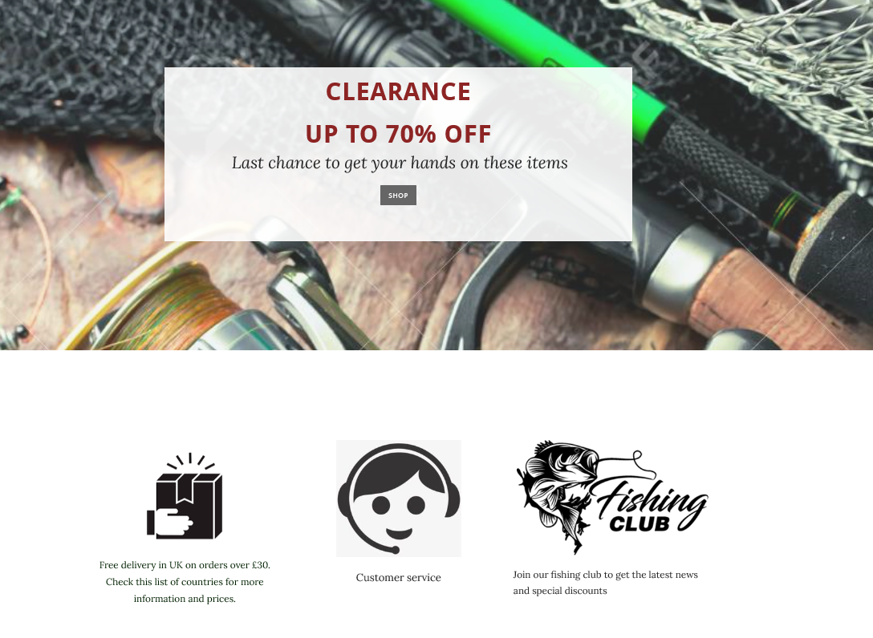
The second part of this page has a banner and a SHOP button that leads to a Clearance page. The customer is made aware of the high discounts they can benefit from.
At the bottom of the page I have added three vectors that link to important information for the potential customer. The customers are made aware they can have the products delivered worldwide, the Customer service icon is linked to build trust and show transparency and by inviting people to join the Fishing club, I can build a community and collect leads.

About page
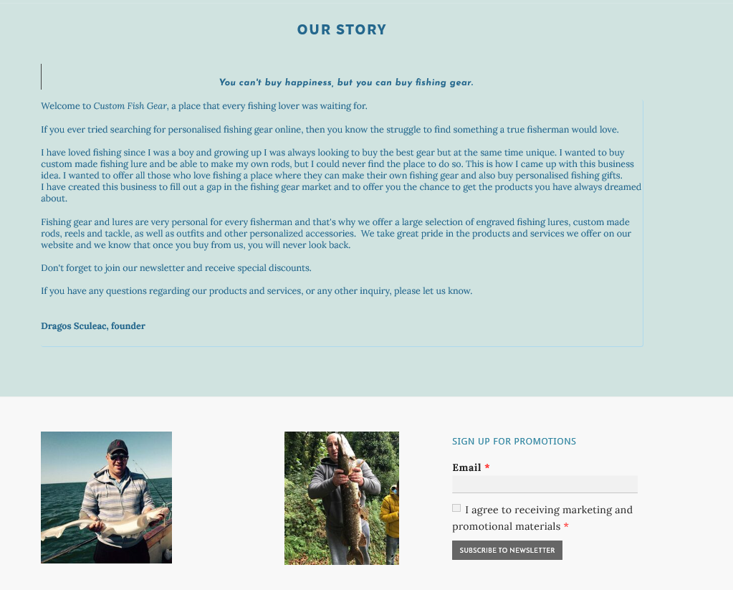

For this second page I chose a simple layout, with no background image, just a plain turquoise color. At the top I attached a short quote to start on a positive note.
I have written a short story about how I came up with this business idea and I give a brief description of what the potential customer can find in my online shop.
At the bottom of the page I inserted two pictures with myself, one whilst I was sea fishing and the other when I went freshwater fishing. I included these pictures to show people I share the same passion as them and to build trust.
Next to the photo gallery I have attached a newsletter form. In the About section I have invited the readers to join the newsletter to receive special discounts and I have reminded them about it at the bottom of this page.

Contact page

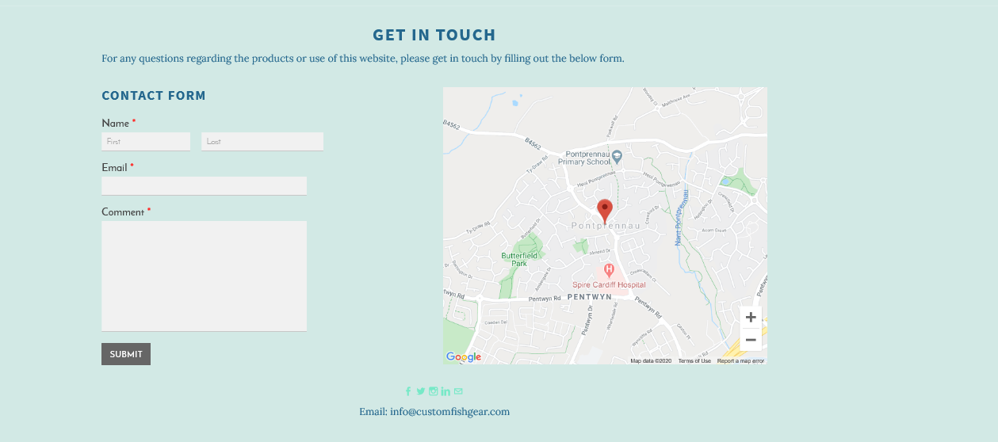

For this page I kept the same background color to create a symmetry and to avoid overcrowding.
I have included a contact form, a map finder and at the bottom of the page I attached social media icons and an email address for the business.
At the top of the page I have invited the customers to use the contact form to get in touch with us if they have any questions regarding use of website or the products.
The use of the social media icons is very important as this is how people connect with business nowadays. According to recent studies (Facebook, 2018) 66% of the people in UK who have messaged a business through social media said they feel more confident about that brand.

References

- Statista 2020, Mobile commerce in the United Kingdom (UK) - Statistics and Facts https://www.statista.com/topics/5888/mobile-commerce-in-the-uk/
(accessed on 09.07.2020)
- Facebook IQ 2018, Why Messaging Businesses is the New Normal https://www.facebook.com/business/news/insights/why-messaging-businesses-is-the-new-normal (accessed on 09.07.2020)

