L4 Principles of Systems Engineering
George Goddard
Abstract
This project designed a new fixture to machine gap test samples. The machining of gap test samples is done using a 5-axis mill, this fixture enables the samples to me machined on a lathe. This enables the mills to be utilised better for program critical work.

Contents
Table of figures 2
Introduction 3
Scope 3
Gap test 3
V model 5
Stake holders 6
Systems requirement review 7
Key customer requirements 8
Concept design 9
Options review 11
Detailed design review 14
Manufacture 16
Initial prototype prove out 16
Machinist feed back 16
Design rework loop 17
Inert prove out 17
Live manufacture 18
Conclusion 18
References 19

Table of figures

Figure A technical drawing of a gap test sample 1 [1] 4
Figure 2 A 3D reprsentation of a gap test sample [1] 4
Figure 3 The V model created for this project [3] 5
Figure 4 The QFD completed at the SRR [4] 8
Figure 5 A concept design drawn by T.Hartnell [5] 10
Figure 6 A concept design drawn by S.Bartholomew [6] 10
Figure 7 A gap test concept drawn by myself 11
Figure 8 - Design 1 Modelled by J.Chapman [1] 12
Figure 9 - Design 2 Modelled by T.Hartnell [5] 13
Figure 10 - Design 3 modelled by myself 13
Figure 11 [7] 14
Figure 12 FMEA [2] 15

Introduction

This project will use a holistic systems engineering approach to solve a production issue. This report will use needs analysis to identify the problem, customer needs and constraints will be assessed, different ideas will be discussed and developed, and risks will be assessed and managed.

Scope

The aim of this project is to develop a fixture for the manufacture of gap test samples for explosive trials and tests. Currently gap tests are manufactured on 5 axis milling machines. The total time for machining gap tests on the mill is over eight hours. When gap tests are being manufactured the machine cannot be used for program critical work. Lathes within the facility are underutilised and removing this sample from the mill will increase throughput of more important components. It will do this by reducing set up time, removing the machining and packaging time. Moving this component to the lathe will not only increase productivity on the mill but also utilise the lathes which are often left idle with no planned work.

Gap test

A gap test is a small-scale explosive sample the is used in the verification and validation of major explosive components. Figure 1 is the technical drawing for the gap test, Figure 2 is a model of the finished component.

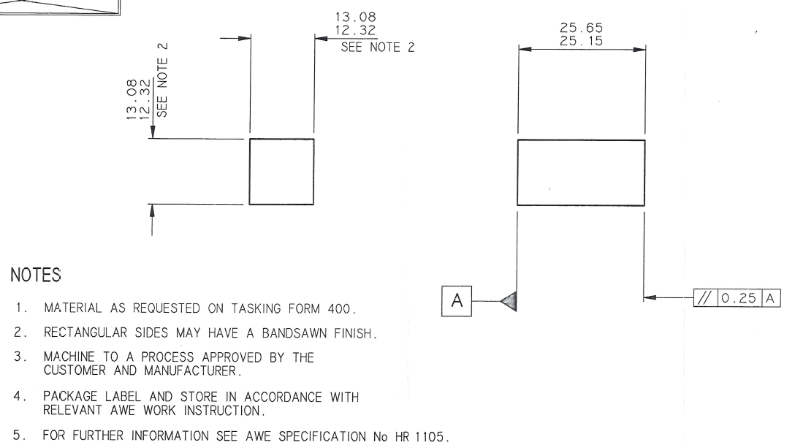
Figure A technical drawing of a gap test sample 1 [1]

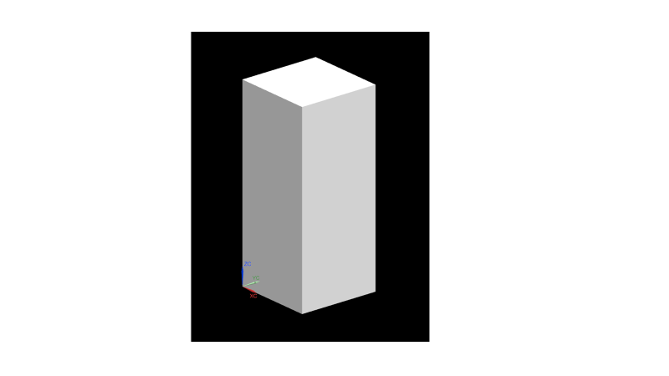

Figure 2 A 3D reprsentation of a gap test sample [1]

V model

This project will follow the V model detailed below. This takes the tool from customer requirements all the way to the manufacture and use of the tool. Each stage on the V model will be attended by various stake holders detailed below, each section will require different stakeholders with some stages only requiring two or three and others mandatory for all stakeholders.
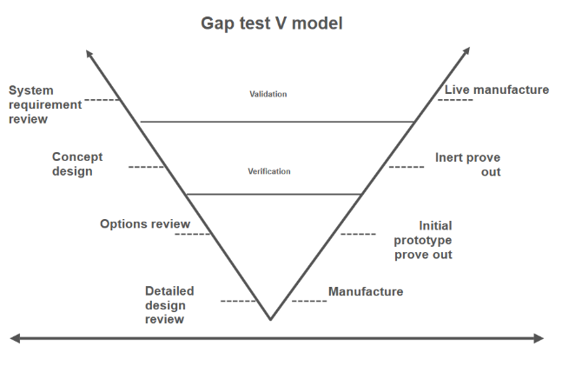
Figure 3 The V model created for this project [3]

Stake holders

- Manufacturing engineer
- Design manager
- Engineering
- Tooling engineer
- Production execution
- Safety
- Quality
- Facility
- Operations (high explosive machinist)
- Technical authority

From the list of stake holders above there are key stakeholders that will take greater responsibility within the project. The manufacturing engineer will take the lead on the project and will chair and minute all meetings. Safety, Quality and Facility personnel will have more of a backseat role and are present to ensure that the product meets their areas of expertise. The machinist will have a large part to play as they will be the end user of the tool. If the machinist isn’t involved from the start it can cause problems when the tool goes into operation.

Systems requirement review

This is the first step on the V model. At this meeting all stakeholders are present and discuss the background of the project the aim of the project, and collectively decide on the system requirements. These requirements are a list of what the customer wants the tool to do, and how it will function. Some of these are key deliverables and other are nice to have. To decide which are the most important a QFD (quality function deployment) is used to put the customer requirements against functional requirements. Figure 4 is the QFD that was created and shows that the most important characteristic is that the sample overhangs the front and the rear of the fixture.

Customer requirements

- The fixture is to locate and ideally hold 24 gap test samples
- The fixture shall be mounted directly to the lath adaptor plate
- The fixture shall have a diameter that can be used to clock the fixture concentric to the lathe spindle
- The fixture is required to hold the components horizontally, parallel to the axis of rotation on the samples band sawn face
- The samples may be clamped in place or use vacuum holding
- If clamping the clamping force must not exceed 60N
- If using vacuum, the vacuum is supplied via the lathe spindle adaptor plate
- If using vacuum, the vacuum must be set between 130mBar and 230mBar

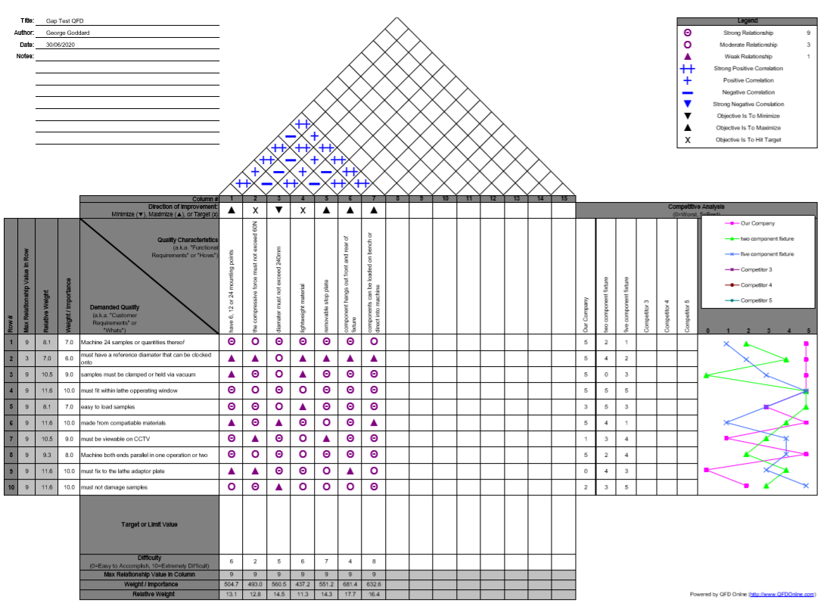
Figure 4 The QFD completed at the SRR [4]

Key customer requirements

High explosives can be a challenging material to work with, there are certain ways of work holding that can and cannot be used for safety and production reasons. In conventional manufacture metal vices and clamps are used to hold the job to be machined. To clamp explosives, it must be clamped between metal and rubber or foam to avoid crushing the material. Ensuring this clamping force is correct is highly important as too much force could damage the sample, and too little force could cause the same to work loose during machining.

All explosive machining is done remotely, therefore being able to view the process is critical. The lathe is fitted with two pan tilt zoom (PTZ) CCTV cameras and one moveable golf ball camera. Due to the fixed positioning of the PTZ cameras and the quality of the golf ball camera, certain areas cannot be seen or are seen with a false view. Therefore, it is important that the fixture can be viewed without obstruction. This can be achieved by having the fixture directly under the CCTV camera. Being able to see the fixture and explosive and fixture is very important to ensure there is no collision between the lathe and fixture or explosive.

Concept design

At this stage of the project only key stake holders were invited to the concept design meeting. The idea of this meeting was to hand sketch ideas that could be used in the final design. The following figures show some of the sketches drawn by the key stake holders. The stakeholders present were:
- Manufacturing engineer
- Tooling engineer
- Machinist
- Design engineer

The Concept design meeting was a great opportunity to discuss ideas and bounce suggestions off other engineers. At the end of the meeting several sketches were chosen to be 3D modelled. Some of the concept ideas are shown in Figure 5 - Figure 7.

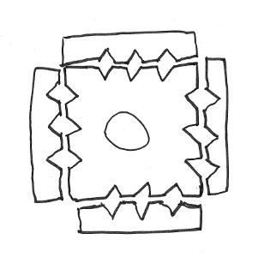
Figure 5 A concept design drawn by T.Hartnell [5]

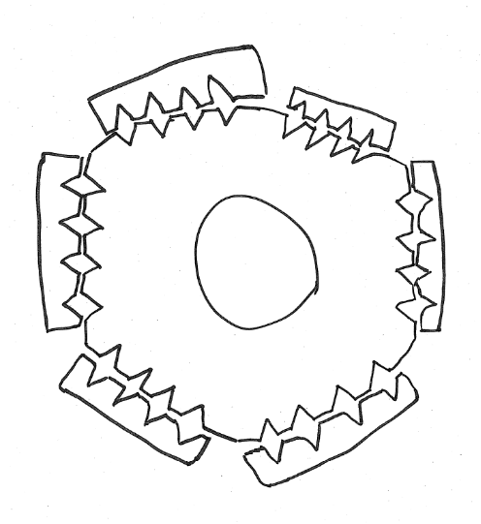
Figure 6 A concept design drawn by S.Bartholomew [6]

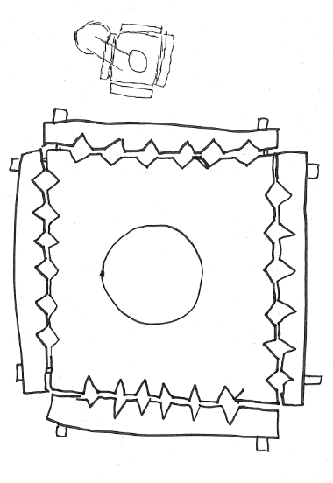
Figure 7 A gap test concept drawn by myself

Options review

The three designs that were modelled were brought to the table for review. Each design was analysed for its individual advantages and disadvantages.

Design one had the stakeholders excited due to its eccentric design, it holds 24 samples and has a clocking face. The design also allowed for different adaptor plates to be fitted giving the fixture the ability to sit in different places. The fixture has a unique way of holding the samples, using a plunger that retracts a sprung loaded clamp. However explosive safety did not like the idea of having exposed springs within a fixture. The clamping force from the springs could not be accurately measured and therefore there was a concern that the sample could be crushed in the fixture.

The second design was the most favourable among the stakeholders. This design has a removable stop plate to aid the set up. The plate is bolted to the front face of the fixture and the samples are butted against it to give an even hang out the front and back of the fixture. Once the samples are clamped in place the plate would be removed prior to machining. Although only holding 12 samples not 24 this was favourable as it means the fixture fits within the lathes operating window. The fixture has been designed to sit directly under the CCTV camera ensuring a good view of the front and rear of the fixture at all times. A clocking face to aid set up meets customer requirements. The small foam tubes ensure that the correct clamping force is applied by compressing the rubber when the clamp is bolted down. The precise dimensions of the mating and clamping faces apply the correct force without damaging the sample, a problem that has occurred with the previous fixture.

Design three is like design two however it holds 24 samples, this reduces the explosive handling and machining time and the program only needs to be run once not twice. This design also enables the samples to be loaded on the workbench and then the clamped units bolted to the fixture. However, because the fixture can hold 24 samples it sits outside the lathes operating window.

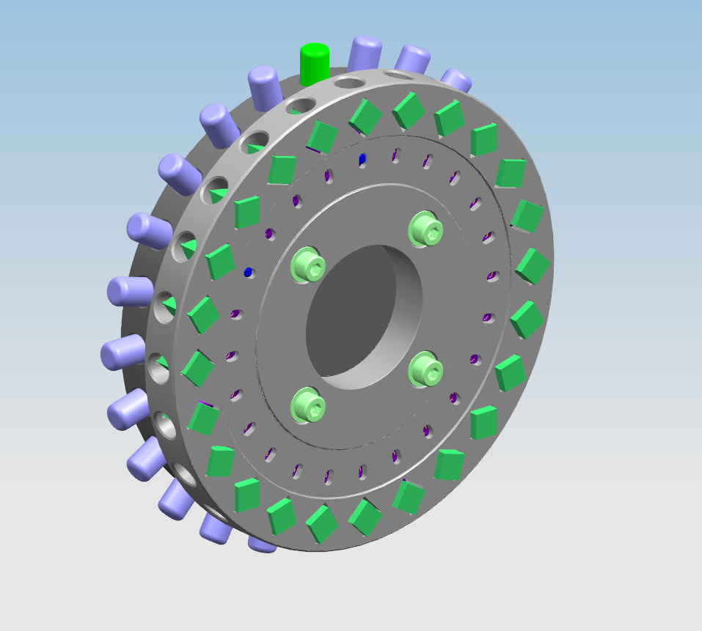
Figure 8 - Design 1 Modelled by J.Chapman [1]

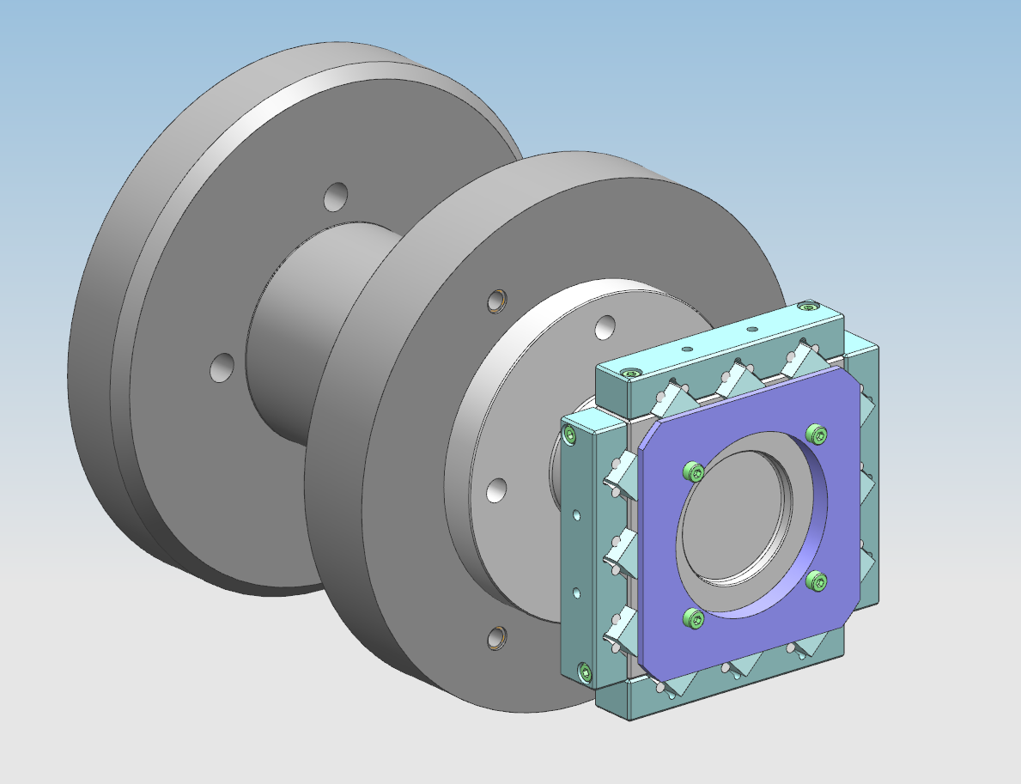

Figure 9 - Design 2 Modelled by T.Hartnell [5]
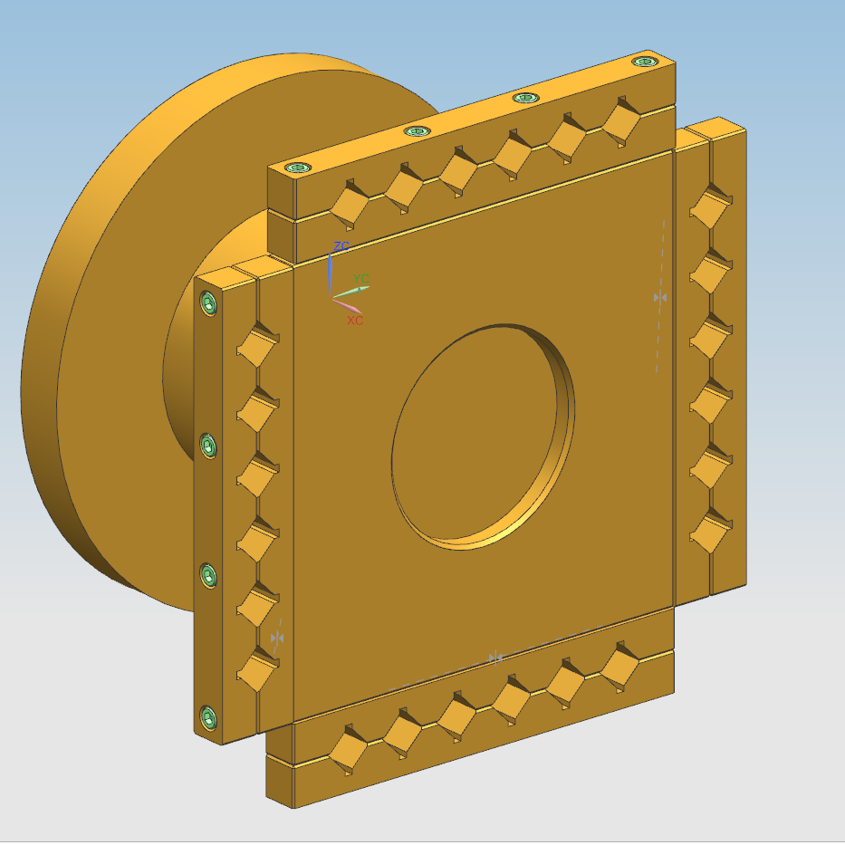

Figure 10 - Design 3 modelled by myself
A decision matrix was used to decide which design would be taken forward to the detailed design review. The matric was filled with requirements and weighted as to customer importance. As can be seen in Figure 11 design two best meets the customer requirements.

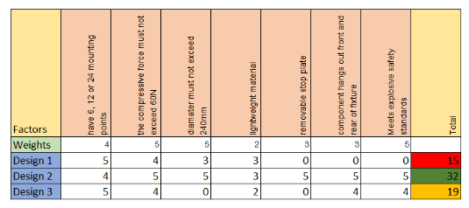
Figure 11 [7]

Detailed design review

All key stakeholders were present at this meeting to finalise the drawings for the fixture and to complete a FMEA (failure mode and effect analysis). The FMEA was written by the lead manufacturing engineer with input from all stakeholders on possible failure modes. As the fixture will hold high explosive several of the failure modes had a high severity, this is because a failure can result in death. However, measures are already in place and measures can be taken to reduce the RPN. Initially the highest RPN (risk priority number) value was the machinist running the incorrect machine part program, this could cause the machine to collide with the fixture potentially damaging the fixture. To solve this issue a two-person check will be used to ensure the correct program is being executed.

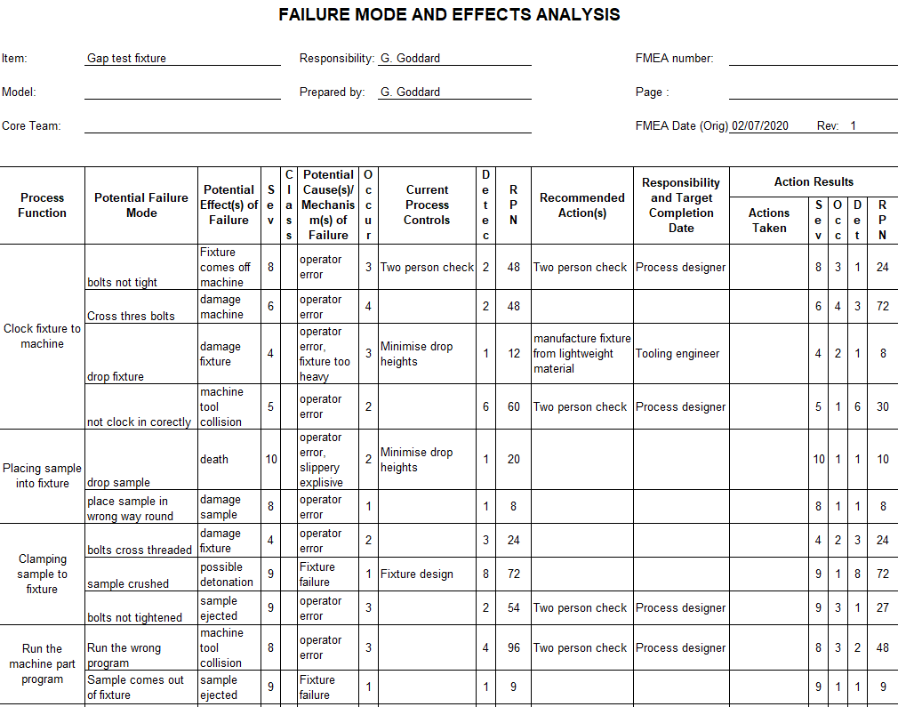
Figure 12 FMEA [2]

Once all stakeholders were happy with the FMEA the drawings were checked for any errors before being sent to the 3D printing production area ready for manufacture.

Manufacture
Having completed the detailed design review the fixture was 3D printed using a laser sintering 3D printer. This fixture was printed quickly and cheaply. The purpose of the prototype enabled the machinist to fit the fixture to the machine and get a hands on look at it.

Initial prototype prove out

This prototype stage enables the user check over the fixture and see it full size for the first time. Having a physical fixture that can be fitted to the machine gives the end user a chance to give feedback on several areas. The key areas the machinist is looking at are:

- The size of the fixture, does it fit within the lathes operating window?
- How easy is it to clock the fixture up?
- How easy is it to load the explosives into the fixture?
- Can the fixture be seen clearly on the CCTV?
- Does the machine part program run without collision?
- Can the entire tool path be seen on the CCTV?

Machinist feed back

The following was written by the machinist having fitted the fixture to the machine and run the machine part program. Although no explosive or inert simulant samples were used this prototype gave the user a feel for the fixture and how it will be used.

The overall design of the fixture is good and the process of setting the fixture up was straight forward. The setting ring will be useful for ensuring that the sample hangs evenly out the front and the rear of the fixture. Once set up the fixture was observed from the remote-control station and the rear of the fixture could not be seen. The fixture needs to be slightly longer to enable this view, without being able to see the rear face the program cannot be run.

Design rework loop

Having taken the machinist feedback into consideration the tooling engineers were tasked with lengthening the fixture to sit it under the CCTV. The change was a simple change of dimension within the modelling software. Because a 3D printed prototype was used this problem was found at an early stage before the fixture had been manufactured out of aluminium, a lengthy and expensive process.

Inert prove out

Once the fixture design had been signed off the drawings were sent off for manufacture. The full fixture with all clamps and rubbers was manufactured from aluminium and shipped to the manufacturing engineer ready for inert prove out.

An inert prove out is carried out for a few reasons. The first is safety, safety has two aspects, personal safety and explosive safety. A member from the ESH (environment safety & health) team has been present at all key meeting to ensure that the fixture isn’t going to cause injury to the user. The safety of the explosives is very important, this prove out uses an inert simulant which has similar properties to live explosive but will not explode. By using this simulant if there is a problem the worst outcome will be damage to the fixture if the machine collides. If live material was used and there was a problem the explosive could detonate and destroy the facility and possibly kill the machinist and people in the vicinity of the facility.

As one of the key requirements of the fixture was the clamping force this prove out will give the customer confidence that those forces are being met. Using the old fixture samples were occasionally snapped due to a higher than specified force being applied.

In this prove out 24 samples were machined, and none were crushed by the fixture. All 24 samples were dimensionally and geometrically correct to the drawing.

Live manufacture

The last milestone in the project is live sample manufacture. This involves using the fixture for a production run using high explosives. The machinist, second machinist and manufacturing engineer were present for this final prove out. The machinist loaded the fixture with 2 samples using the setting plate and clamped them in place. Two samples were machined to check the machine geometry is correct, thus reducing scrap components if an offset is incorrect. A full run of 12 samples were machined followed by the last 10.

No issues were discovered during the live manufacture, none of the samples were cracked or distorted, and none were ejected from the fixture. This result was expected as the fixture passed inert prove out however high explosives can behave differently to the inert simulant.

Conclusion

This project was set up to reduce the workload on two machines within a high explosive production facility. The ability to manufacture gap test samples on the lathe will save the production facility over two weeks a year in production time, enabling the 5 axis milling machines to be better utilised on higher priority jobs.
The V model was followed from the initial project concept through to a full production. The continuous validation and verification of the V model made sure the fixture was correct before a costly mistake was made. The 3D printing of a fixture like this had never been done before but was a useful aid in the design process.

References

[1] | J. Chapmon, Gap test sample, Reading: AWE, 1993.
[2] | T. p. b. R.Morgan, FMEA, R.Morgan, 2020.
[3] | S. draw, “V model template,” Smart draw, [Online]. Available: https://www.smartdraw.com/v-model/examples/v-diagram-09/. [Accessed 02 07 2020].
[4] | Q. online, “QFD template,” QFD online, [Online]. Available: http://www.qfdonline.com/templates/. [Accessed 28 06 2020].
[5] | T.Hartnell, Gap test concept, Reading, 2020.
[6] | S.Bartholomew, Gap test concept, Reading, 2020.
[7] | m. tools, “decision matrix,” mind tools, 2020. [Online]. Available: https://www.mindtools.com/pages/article/newTED_03.htm. [Accessed 05 07 2020].

