University of Wales Trinity Saint David
Wales Institute of Science & Art



Use of applications Portfolio
Software & Apps for Business (ACCA4031)

Jacek Traczewski
2022703
April 2021
Currently, the use of electronic office tools is a must have for every, even the smallest organization. The most popular and well-known tools include Word, Excel, Power Point and the Outlook mailbox. For several years, companies from around the world have been investing more and more resources in cloud solutions that enable work on any device, which also supports remote operation. Such a service is, among others Office 365, which is the successor to Microsoft Office. How to quickly and efficiently switch from traditional offline software to a cloud full of new possibilities?
Office 365 implementation - where to start?
It is worth starting the implementation of Office 365 in the company by configuring each member of the organization with an individual account connected to an e-mail address in the company's domain, Outlook e-mail box and other services of the package. Thanks to this configuration, each user will have access to the entire Office 365 suite with a single login.
Cloud storage space
Office 365 offers each user 1TB of space on the OneDrive cloud drive. This allows you to conveniently view, store and share documents and files in electronic form. Office 365 also allows you to create an Intranet, which is an internal space only for use by the users of the organization.
How to use Office 365? - using the suite's tools
In addition to the tools well-known from the basic version of Office, Office 365 provides additional functionalities and tools tailored to business needs that support everyday work. SharePoint is used to create document libraries that can then be viewed and shared with members of the organization. OneDrive is a virtual space for storing files in the cloud. Teams is an advanced messaging app with video conferencing and a corporate organizer in one. Using SharePoint and Teams, users can use the functionality of creating, sharing and editing documents without the need to exchange e-mail messages with the new version of attachments.
Microsoft Teams - messenger for business
Microsoft Teams is a chat, audio and video conferencing tool. Thanks to this messenger, you will keep in touch with your colleagues, quickly exchange messages and send files. You can use Microsoft Teams on a computer, smartphone (the application is available for iOS and Android) and in a browser.

Table of Contents
Introduction - 5 -
Communication - 6 -
Video meeting - 6 -
E-mail - 7 -
Cloud storage data - 8 -
Microsoft Office - 9 -
Word Processing - 10 -
Spreadsheets - 11 -
Presentation software - 12 -
Conclusion - 13 -
Bibliography - 14 -

Table of Figures
Figure 1: Example Microsoft Teams interface - 6 -
Figure 2:Example Microsoft Outlook interface - 7 -
Figure 3: Example OneDrive interface - 8 -
Figure 4: Microsoft Office 365 interface - 9 -
Figure 5: Microsoft Word interface - 10 -
Figure 6:Microsoft Excel interface and stored data example - 11 -
Figure 7: Example Microsoft PowerPoint interface - 12 -

Introduction
This report will show how we can work together as students in a pandemic period when our university is closed. We all need to stay home and not spread virus to protect the NHS in its fight against COVID19. These are hard times for everyone. Our life is changing. We students cannot physically attend lectures. My school University of Wales Trinity Saint David give for students access to tools withs is give us opportunity to attendant class. All students have their on-line accounts thanks to them we can use the software in the browser version, and we can download and use the desktop versions. We use a suite of programs that allows us to study remotely Microsoft Office 365 is the most popular. Various alternatives are available on the market.

Communication

Video meeting
Communication is not only the basis of remote work. One of the best instant messaging services available on the market is Microsoft Teams. It is available in a paid version as part of the Office 365 service and in a free version. The latter allows you to send unlimited text messages, make video calls, collaborate on Office documents, transfer files, access 250 applications and services, and share screen. The paid variants of the Microsoft Teams service offer many more possibilities, making it a real combine for efficient and effective remote teamwork. The service is available via a browser and applications for Windows, Android and iOS. Due to the threat from the coronavirus, Microsoft decided to make an interesting move and made Teams available for free for six months to all interested users.
The most important functions:
- Collaborate with colleagues and internal experts in real time.
- Quickly share important information with the entire team to allow everyone to fully participate in the project.
- Easily access content and tools in a secure, centralized repository.
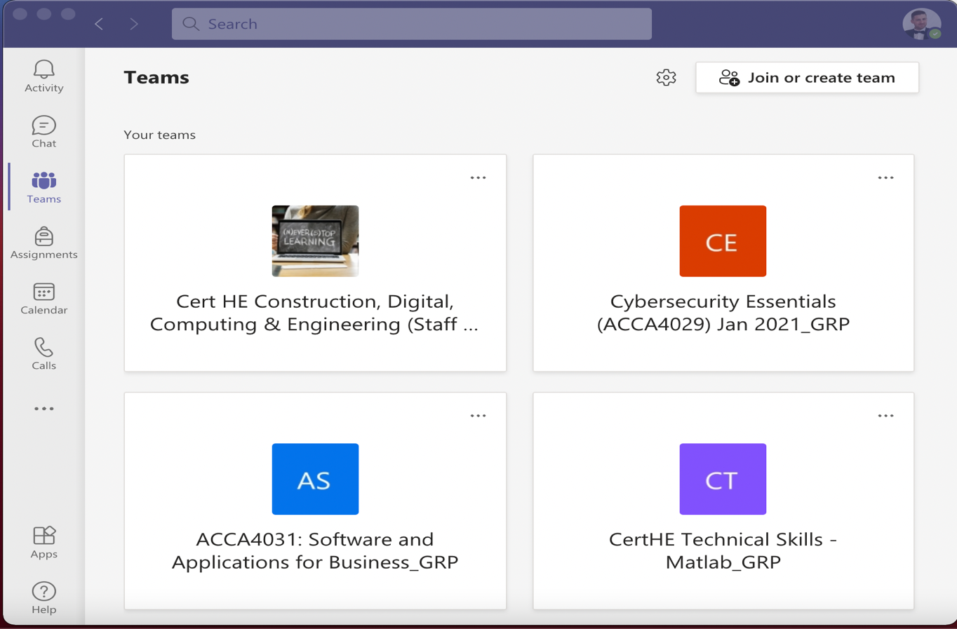
Figure 1: Example Microsoft Teams interface
Alternative for Microsoft Teams:

- Skype
- ZOOM
- GOOGLE HANG OUTS
- Messenger
- Slack

E-mail
Outlook organizes your e-mail messages, calendars, contacts, tasks, and to-do lists in one place. This organization's starting point is an email account. You can use it to start working with emails, turn them into tasks and appointments, and store information about the people you communicate with in your contacts, so you don't have to remember their email addresses or phone numbers.
The most important functions:
- Receive notifications about important contacts.
- Simple scheduling and inviting to meetings.
- Quickly find the information you need and prioritize.
- Create a rule for automatic sorting, flagging, and tasks.
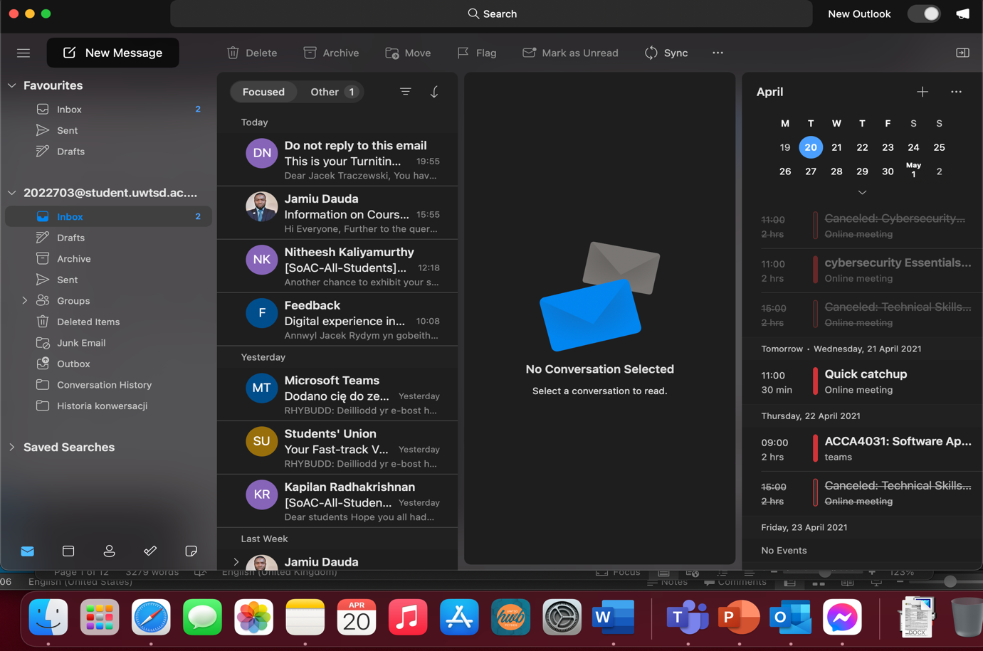
Figure 2:Example Microsoft Outlook interface
Alternative for Microsoft Outlook:
- Gmail
- Thunderbird
- Windows Mail

Cloud storage data
OneDrive is an online drive that offers 5 GB of free Microsoft cloud storage. It allows you to synchronize documents, photos and other files between devices, it also allows you to use the free, browser version of Microsoft Office applications (Word, Excel, PowerPoint, OneNote). We have options for sharing files, folders and photos, as well as easy finding photos thanks to automatic tagging. Data stored in OneDrive is encrypted using SSL. OneDrive can be used in a browser window and through an application installed on a computer or on a mobile device.
The most important functions:
- Editing and viewing work results offline, synchronizing documents on your devices.
- Securely share information with colleagues and supervisors, such as when on the go.
- Users can work from anywhere, on any device.
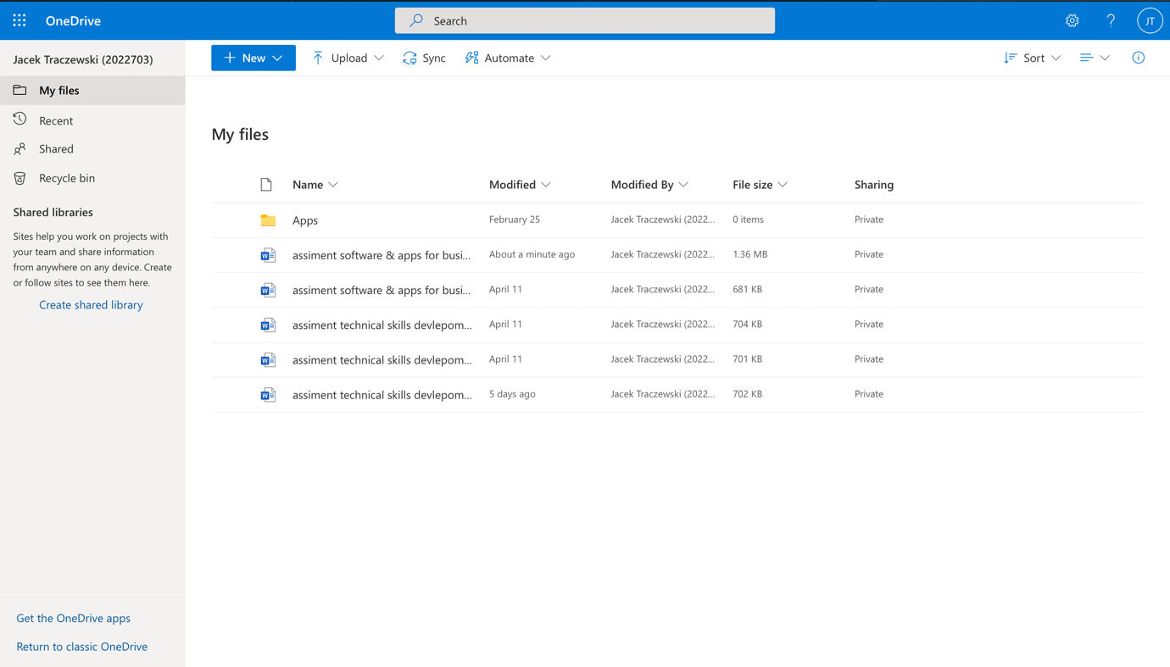
Figure 3: Example OneDrive interface
Alternative for OneDrive:
- GOOGLE DRIVE
- Dropbox

Microsoft Office
Microsoft: Word, Excel, PowerPoint are traditional online programs. They enable us to continue work that is saved, for example, at a university, and then continue it at home. At the same time, we can collaborate on documents with other colleagues on an ongoing basis.
The most important functions:
- Editing one document together with others.
- Store and share drafts using a central location.
- Better data collection and sharing.
- Decide faster with easy-to-understand data tables and charts.
- Present complex data in a visual format that is easy to understand.
- PowerPoint templates provide visual appeal and consistency.
- A professional and effective way of presenting data, e.g., regarding sales or marketing activities.
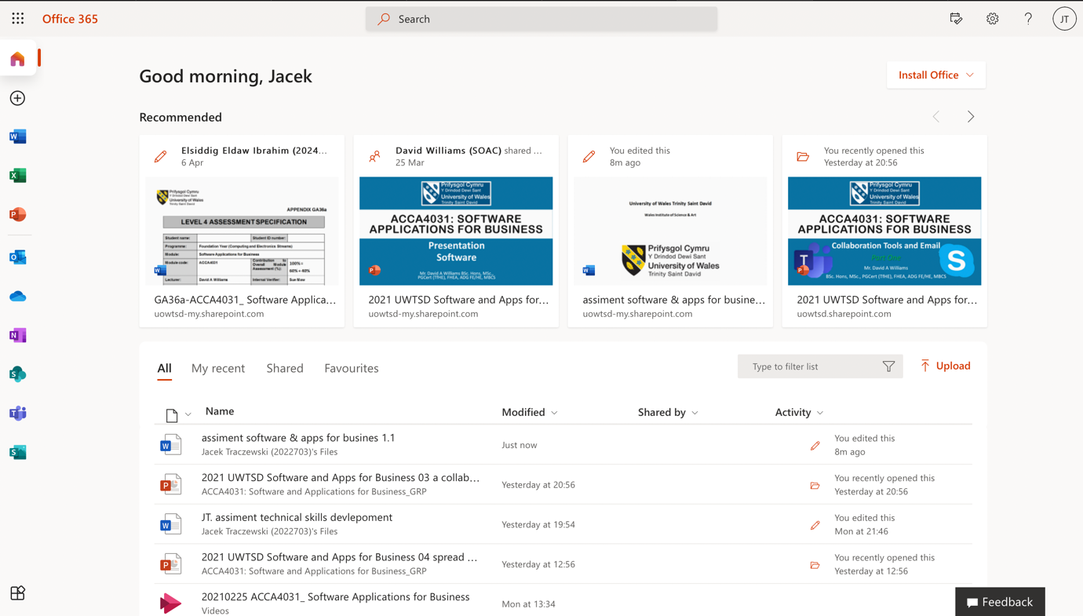
Figure 4: Microsoft Office 365 interface
Alternative for Microsoft Office:
- Open Office
- Google Workplace

Word Processing
A word processor is software that allows you to create, store and print documents. The most popular is the Microsoft word we use at the university. It helps us to write the reports.
“A word processor should not be confused with a text editor, such as Notepad, that only allows editing and creating plain text documents.” (Hope, 2020)
Microsoft Word allows as to:
- Create a new document
- Print the document
- Edit the document
- Convert the document to other file types
- Share document
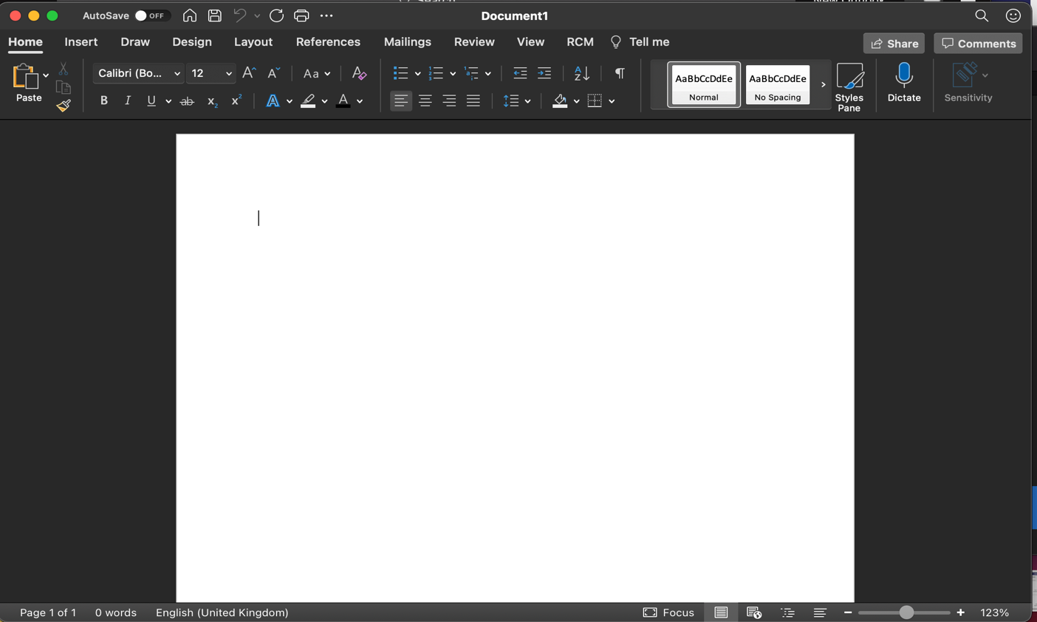
Figure 5: Microsoft Word interface

Spreadsheets
What is spreadsheet?
“A spreadsheet is a file that exists of cells in rows and columns and can help arrange, calculate and sort data. Data in a spreadsheet can be numeric values, as well as text, formulas, references and functions.” (PerfectXL, 2020)
Most popular spreadsheet is Microsoft Excel we us them in university to presentation of research results, data comparisons and calculations. Can also be used as a database.

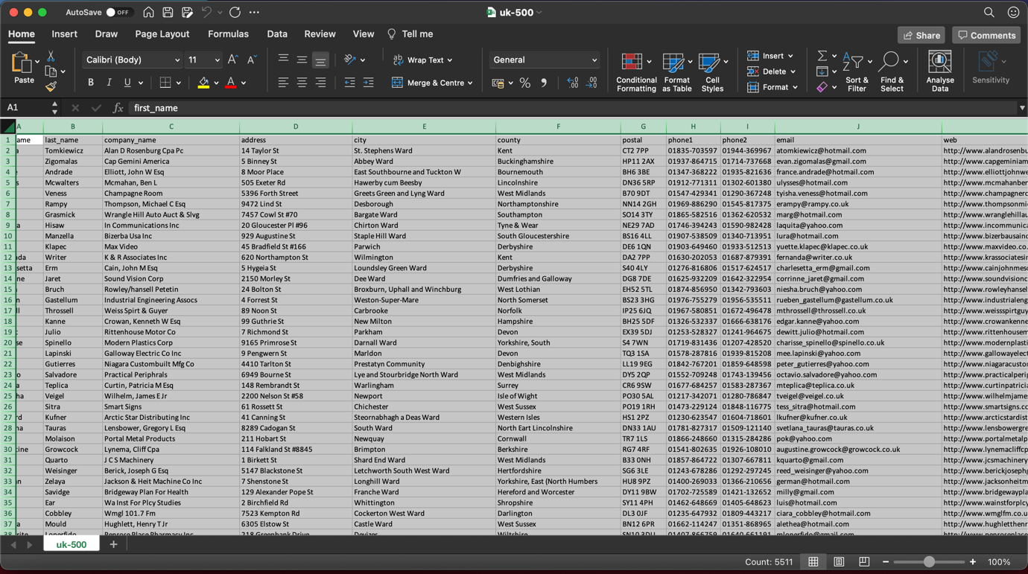
Figure 6:Microsoft Excel interface and stored data example

Presentation software
Here, Microsoft PowerPoint is irreplaceable without this program, it was hard to organize a lecture, each class is based on the presentation of the material for which the lecturer uses Microsoft PowerPoint.
Microsoft PowerPoint can:
- Create presentations from scratch or based on a template.
- add text, images, graphics and video clips.
- choose a professional design using PowerPoint Designer.
- Add transitions, animations and movie motion.Save files to OneDrive to access your presentation from a computer, tablet, or phone.
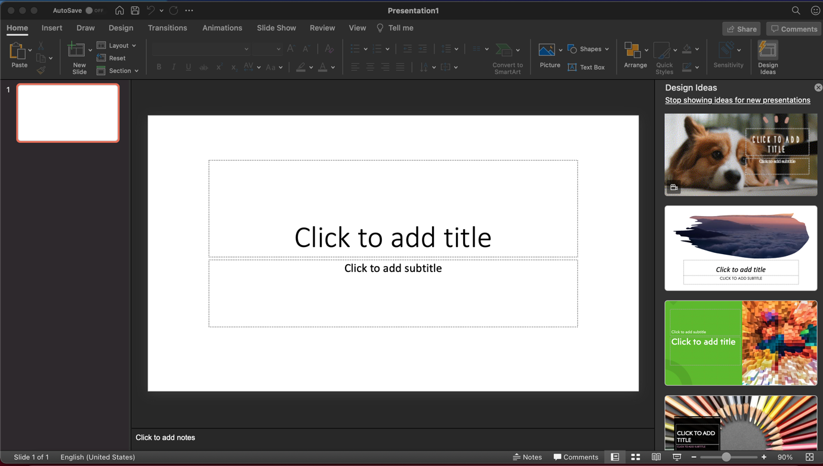
Figure 7: Example Microsoft PowerPoint interface

Conclusion
You probably know Microsoft Office applications because you have them on your computer at work and at home.

Word, Excel and PowerPoint in Office are now available online (including access to Office desktop applications). In the stationary version only, the so-called you do not have this option, and the work of many people on the same document at the same time is simply impossible. Other important applications in the package are OneDrive, Outlook, Teams - formerly Skype. The above-mentioned applications are the basic online tools that enable remote work and constant contact with colleagues.
Teams is a groupware application. It allows the exchange of individual messages, phone calls and videoconferences with the possibility of desktop sharing. It is a file repository and can be expanded with a number of applications built into Office365. Such as, for example, Planner, which allows you to manage tasks, or Stream and Video applications to share recorded calls or video meetings with third parties.
OneDrive, thanks to it, we have files always at hand, regardless of the device we use, and access to them is always safe. We can quickly share files that are on OneDrive with other people inside and outside the organization. There are two sharing options, for viewing or editing. This streamlines the work on the prepared documentation. You have full control over who you share the file with and for how long.
The Microsoft Office 365 service package allows you to easily transfer stationary work in the company beyond its walls. The only obstacle may be internet access. Without it, it will not be possible to launch the browser and get to your personal account. Of course, with the desktop version installed on your computer, you will still be able to work with your offline documents. Current joint work with other users in this case will be impossible.
The biggest advantage of using the Office 365 suite of services is that we know most of the programs / applications. We can also synchronize documents between computers, smartphones and tablets. Additional applications such as Teams are very intuitive and using their capabilities is not difficult. It takes several hours to "click through" it with other colleagues.

Bibliography
Hope, C. (2020, 11 30). Computer Hope. Retrieved from www.computerhope.com: https://www.computerhope.com/jargon/w/word-processor.htm
PerfectXL. (2020). Retrieved from https://www.perfectxl.com/excel-glossary/what-is-a-spreadsheet/

https://www.computerhope.com/jargon/w/word-processor.htm
https://www.perfectxl.com/excel-glossary/what-is-a-spreadsheet/

