Utilising the Entrecomp Framework, critically evaluate your own creativity and enterprise skills and consider how you might be able to develop the creative and enterprising skills of primary learners through your own pedagogy. Word Count: 5500 (+/- 10%)
Within Wales, there is a demand for young people to improve their wider skill set, especially in regards to creativity, which is currently recognised as a high-order skill often acknowledged as entrepreneurship (Donaldson, 2015). Evidently, with emphasis upon the “demand” for young people to enhance their creativity implies an importance and definite requirement within Wales suggesting something ought to change within the curriculum as it has been recommended the Welsh government enhance the present curriculum to incorporate creativity alongside numeracy and literacy as a core theme across learning areas (Smith, 2013). However, numeracy and literacy have continuously been an important aspect within education as they contribute to an array of employment outcomes strengthening employability standards as employers admire high levels of understanding within these academic subjects (Rothman and Mcmillan, 2003; Bynner, 2002; Dench, 1997). Therefore, it is questionable why both Donaldson (2015) and Smith (2013) “demand” and “recommend” creativity becomes equally as important to literacy and numeracy, requiring young people to strengthen their creative skills within the impending curriculum. This may be due to the gap between the skills young people learn and the skills young people need within the twenty-first century and these are becoming more apparent (Soffel, 2016) as traditional means of education is becoming out-dated and ultimately within the majority of schools visited in 2018, teachers are teaching the identical subject matter taught in 1918, including reading, writing, mathematics, science, history and foreign languages (Boyce, 2019; Partovi, 2018). This implies schools are not teaching children the skills needed for a modern society. Teachers need to support and consider education in terms of the unknown as 65% of today’s children will find themselves in jobs that do not exist yet (Balt, 2018; Perkins, 2017) thus suggesting education needs to address the future, reformulating a foundational education to keep abreast with the evolution of skills necessary to innovate, solve problems and succeed thus can question what exactly are the skills needed for the twenty-first century. According to the World Economic Forum (2015) there are sixteen skills students require within the modern society shown in appendix-1, one competence being solely creativity, conveying its importance as it is a lone competence due to the fact skilled jobs are more centred on solving unstructured problems and effectively analysing information, which creativity can support (WEF, 2015). This correlates with Donaldson’s (2015) views regarding the forthcoming curriculum in creating enterprising, creative contributors ready to play a full part in life and work thus demonstrating Wales’ understanding of utilising creativity within education, with the main goal being to prepare young people for future jobs providing a greater balance between the emphasis of academic subjects and the creative competence. However, there is much debate regarding the definitions behind creativity disputing whether it is a general capacity that influences a person’s performance (Baer, 1993) advocating creativity as a natural intrinsic skill which supports a person’s development concerning a creative outcome, or whether creativity is unnatural to the brain (DeBono, 1993) implying learners must be educated and provided with opportunities to learn how to become creative, enduring scaffolded opportunities to enhance their creative development. Research suggests, creativity is identified by an assortment of personality traits and characteristics, which include endurance and intellectual curiosity, in particular an individual’s nature and cognitive manner (Craft, 2001; Smillie and Antinori, 2017), therefore is a natural innate skill derived from an individual’s personality thus suggesting creativity cannot be taught. On the contrary, theories and research suggest creativity can be developed and enhanced through education as creativity is defined by the process of creation through creative solutions and products, which are skills that can be taught through instruction and once these skills are achieved, they should be fostered (Craft, Jeffrey and Leibling, 2001; Sternberg and Lubart, 1999; Donaldson, 2015). Research advocates 81% of primary school teachers believe creativity can be enhanced within the regular classroom (Aljughaiman, and Mowrer-reynolds, 2005) implying creativity is a skill that can be developed, and does not have to arise naturally as ultimately, everyone possesses the ability to produce an idea (Moriarty, 1983) portraying creativity is a skill that must be enhanced. Although, it is contended creativity cannot be interpreted as one single component, process or characteristic as it can be classified in accordance with processes, people and products (Rhodes, 1961; Fisher and Williams, 2004). Fisher and Williams (2004) elaborate proposing creativity is determined by the understanding of skills the individual employs and the outcomes they individually create. The definitions discussed convey a range of debates and definitions regarding creativity, although for the intention of this essay, creativity will be defined as a natural competence that can be encouraged through creative approaches (Baer, 1993; Craft, 2001; Smillie and Antinori, 2017).

It has been acknowledged in recent years teachers have exerted their professional artistry, desiring to teach more creatively attempting to enhance children’s creativity to strengthen children’s persistence and collaboration skills (Jeffrey and Woods, 2003; Saad, 2019, Burnage, 2018). The National Advisory Committee on Creative and Cultural Education (NACCCE, 1999) and Woods (1990) have determined two approaches which can produce a creative environment for students that simultaneously strengthen children’s creativity, which is creative teaching and teaching for creativity. This can assess children’s innovation, control, ownership and relevance, and if these are evident within education, the greater the chance of creative learning (Woods, 1990). However, this implies teachers require engagement with their own creativity and enterprise in order to develop learner’s creativity (Lamb-Sinclair, 2018). This suggests teacher’s pedagogical insight regarding creativity is necessary as teacher subject knowledge is important for successful education to occur as high-quality teaching rests on teachers’ understanding of the subjects they teach (Barnes, 2011; Willingham, 2009) implying the knowledge and understanding of creativity teacher’s must possess is crucial in developing students’ innovation and their own. Although, Aljughaiman and Mowrer-Reynolds (2005) doubt the effectiveness of initial teacher training as it does not enhance teachers’ creative pedagogical insight, understanding or skills thus can question how educators will teach creatively and teach for creativity when their understanding and possession of these skills is insufficient. Nevertheless, Joubert (2001:p.21) proposes creative teaching is an art, and one cannot teach teachers didactically how to be creative as there is no recipe or routine conveying it is in ones nature whether they possess creative qualities or not, consequently a challenge for teachers as if they are not creative, it is questionable how they will teach creatively. Although, Torrance (1963) advocates it is students’ responsibility to think creatively and is essential they become independent in creative judgement, therefore implying perhaps teacher’s insight and subject knowledge is not essential. However, creative teachers do develop creative learners (Esquivel, 1995; Cremin and Barnes, 2018) therefore teachers who engage personally and creatively possessing sound knowledge of enterprise education within the classroom can assist learners in assessing their current creativity level enabling them to identify their next steps (Aljughaiman and Mowrer-Reynolds, 2005). Despite this, research suggests creativity diminishes as you mature proven within George Land’s (2011) creativity test evident within appendix-2. This may be because people’s fundamental capabilities are not challenged, as people are locked into jobs or situations they perceive as boring (Christensen, 2015). However, research also suggests schools ‘kill’ creativity as all children are born with tremendous talents and teachers squander them ruthlessly (Robinson, 2007) implying teachers cannot develop students’ creativity successfully as there is a correlation between creativity stages and age, signifying creativity diminishes with age as education suppresses it. Consequently, I will reflect upon my creative skills utilising the EntreComp framework (2016) and propose solutions to strengthen my knowledge regarding creativity and enterprise education. Although, enterprise education and entrepreneurship are not to be confused. Enterprise education is the process of developing learners’ capacity to generate ideas providing them with the skills to make their ideas happen, which has a positive influence on students’ creativity, flexibility and the innovation process (QAA, 2018; Jones, and Lredale, 2010) correlating with theorists who define creativity as a process (Craft, Jeffrey and Leibling, 2001; Sternberg and Lubart, 1999). Whereas, entrepreneurship equips students with the additional knowledge required to begin a business (QAA, 2018). Therefore for present purposes, enterprise will be determined as the process and implementation of creative ideas giving individuals the opportunity to make their ideas happen in real situations (QAA, 2018).

The EntreComp framework (2016) can be acknowledged as the building blocks of entrepreneurship as a competence as it provides differing levels of progression steps enabling both children and teachers to identify their levels of entrepreneurship and how they can develop their skills, a form of assessment for learning (AFL.) AFL has three principles: identifying where the learners are, where they need to go next and how to get them there (Pierson, 2013) which the EntreComp framework achieves as it gives an assessment like rubric to identify skills and what improvements are needed in order to progress. However, the focus is on the entrepreneurship competence, which as discussed above is defined as giving children opportunities to create and operate businesses (QAA, 2018) therefore not specific or relevant at analysing enterprise education or creativity, limiting its validity. Andy Penaluna (2019) coincides stating if he could adapt the EntreComp framework, he would split the rubric into enterprise education and entrepreneurship, as essentially they are totally different commodities. Nevertheless, the EntreComp framework allows for the creative competence to be assessed as you can identify where you are on the rubric, and where you need to go next becoming better learners of creativity (Sambell, McDowell and Montgomery, 2012). The framework defines creativity as developing several ideas and opportunities to create value and find better solutions to new and existing challenges. The competence of creativity is split into different threads including development of curiosity, ideas, design value, innovation and defining problems, correlating with Fisher and William (2004) and Rhodes (1961) who propose creativity cannot be interpreted as one single component, process or characteristic.

The first creative thread I will reflect upon is being curious and open (Bacigalupo, et al.,2016). Essentially, curiosity is what drives creativity and enterprise education as curiosity enables individuals to apply differing ideas across divergent fields (Kim, 2017). Merele (2017) coincides advocating curiosity is just as important as intelligence in order to succeed within our increasingly complex world, enabling us to lean into uncertainty with open positive minds to new ideas and ways of solving problems giving opportunities to triumph within the twenty-first century (Blaschka, 2018; Soffel, 2016). Reflecting upon this thread, I believe I can explore new ways to make use of existing resources (Bacigalupo, et al.,2016) analysing myself at level 2. Exploring new ways of making use of existing resources corresponds with overcoming functional fixedness, which is a mental block against using objects in a new manner that is required to solve a problem, a classic inhibitor to problem-solving (Duncker, 1945; McCaffrey, 2012). Analysing appendix-3, within the Professional Teaching Experience (PTE) I was able to overcome functional fixedness helping children and I to identify marshmallows, cheerio’s and pom-poms as components of blood, utilising alternate uses of objects to enhance problem-solving capabilities as people’s blindness to alternate uses of objects can stifle creativity (Harley, 2017; Amabile, 1998). This correlates to Bob Eberle’s (1972) ‘scamper’ model (appendix-4) achieving the component of ‘put to other purposes’ as I have used objects including marshmallows and cheerio’s in ways they were not intended for thus defeating aspects of functional fixedness simultaneously enhancing discovery as it consists of looking at the same thing as everyone else and thinking something different (Von Oech, 1983). To progress onto level 3, the EntreComp framework (2016) suggests experimentation with skills and competences in new situations, conveying a risk-taking approach improves curiosity. Therefore, to progress I will ensure learning environments encourage risk-taking on the strongest ideas and if the risk does not succeed, I will resolve what worked and what did not, giving myself permission to try again as risk-taking within education is significant, not only because it creates unique successful strategies but also because such innovation models indicate these processes for pupils, whom future innovation depends upon (Harper, 2018; Baird, 2018). However, another rubric of assessment for creativity (appendix-5) splits risk-taking and curiosity conveying they are two separate commodities to assess, rather than merging them together like the EntreComp framework. Therefore to progress my creativity and enterprise education I can utilise the CEA (2018) framework and consider the impact and practicality regarding a range of ideas, testing alternatives to consider potential solutions (CEA, 2018). I can achieve this by utilising all elements of the Scamper Model (appendix-4) before progressing onto more daring risks in the classroom, as it is more meaningful to progress in all areas of curiosity first, learning to fully overcome functional fixedness, rather than advancing onto risk taking immediately as utilising the Scamper Model helps reach the best decisions simultaneously fuelling innovation and creativity (Elmansy, 2015).

Another creative thread is developing ideas (Bacigalupo, et al.,2016) as sampling new ideas enables new ways of thinking and problem-solving to occur, aiding productivity and cognitive abilities providing opportunities to generate various ideas through divergent thinking enhancing creativity and enterprise education (Vanlint, 2017; Sharp, 2004). Reflecting upon the EntreComp (2016) framework, I identify at level 2 as I can develop ideas that create value for others (Bacigalupo, et al.,2016) utilising my elaboration and collaboration skills to enhance my divergent thinking when teaching. This is proven within appendix-6 and 7 as on PTE the teachers “team taught” proving I can collaborate with others and also took individual responsibility producing multiple ideas for enhanced provisions within foundation-phase classrooms, elaborating and embellishing on other ideas. Divergent thinking is the generation, exploration and development of new ideas (Guilford, 1968) consisting of elaboration, fluency, originality and flexibility also acknowledged as the four components of creativity that can be assessed (Torrance, 1970). Although upon reflecting, I have not achieved the creative aspect of ‘fluency’ as appendix-8 portrays that I do not think divergently when pressurised, thus a limitation regarding my creative development when considering new ideas. When asked how many uses for a shoe, research recognises most adults can generate ten to twelve answers yet a good creative, usually youthful thinker can generate one-hundred or more ideas (Brzozowski, 2012; Guilford, 1968) conveying creativity does decline as you mature (appendix-2). Therefore, to ensure I fully achieve level 2 before progressing onto level 3 within the EntreComp framework (2016) I will brainstorm an unedited list of ideas considering certain topics as Perry (2019) proposes brainstorming is the cornerstone to developing divergent thinking, enhancing spontaneous and imaginative cognition which is advantageous to cognitive thinking skills including attention and memory (Madore, Addis&Schacter, 2015).

A third creative thread within the EntreComp framework (2016) is defining problems, which is acknowledged as crucial within creative and enterprise education as according to Seelig (2012) “if anything can go wrong, fix it!” stating this is the mind-set people need to adopt if becoming innovative is their goal. Tanner (2019) coincides proposing defining and reframing problems is a significant tool for encouraging innovation and creativity. Reflecting upon the framework I associate myself with level 4, as I believe I can reshape open-ended problems to fit my skills (Bacigalupo, et al.,2016) fixing problems as a teacher to benefit myself and pupils. This is evident within appendix-9 and appendix-10 where I found AFL and behaviour management difficult within a class of forty-five therefore created engaging solutions which consisted of an AFL strategy of “prove Miss Thomas wrong” utilising adversarial thinking and a team points system to aid my teaching in a creative innovative way, challenging current viewpoints within the classroom introducing new perspectives to behaviour management and assessment, which Rao (2019) advocates as effective problem-solving and innovation. However according to Seelig (2012), solutions must be varied and imaginative, yet after analysing my solutions, they are innovative but not imaginative as other educators have utilised them and I merely utilised two solutions, not acquiring numerous resolutions. Chandler (1998) and Serrat (2017) propose you must look at reframing problems from differing perspectives. Therefore to progress onto level-5 to “describe different approaches to shaping open-ended problems” within the EntreComp (2016) framework, potentially, asking pupils how they want to be assessed and how they would like their behaviour managed may work better to define problems, as essentially children are more creative than adults (Land, 2011) thus should obtain imaginative solutions from the children themselves utilising the voice of the child. This correlates with Seelig’s (2012) innovation engine (appendix-11), which consists of six components of creativity as opposed to EntreComp’s (2016) five components. Seelig (2012) merges reframing problems into the strand of imagination, as this is the catalyst needed for creative combustion, which involves reframing, connecting and combining ideas (Seelig, 2012). This suggests we must achieve these before progressing forwards, which can occur from analysing different perspectives including acknowledging children’s views to obtain more imaginative ideas.

A fourth creative thread advocated by EntreComp (2016) is design value, which is a critical role within thinking and practice in education as it fosters future productivity and community since design is becoming more valued by governments and international organisations as a device to promote innovation and development (Wright, Davis&Bucolo, 2013;Patrcino&Bolton, 2011) conveying its importance within creativity and enterprise education. Reflecting upon the EntreComp framework (2016), I believe I can assemble, test and progressively refine prototypes, stimulating the value I want to create analysing myself at level 4. This level corresponds with prototyping and trial and error which is an important phase during the development of innovative solutions as it makes the abstract concrete, guiding individuals thoughts to refine ideas helping them move forward (Noyes, 2018;Leonardi, 2011) evident within appendix-12. I identified my lesson plan as a prototype, quickly refining and adapting it when it did not go to plan to create value for the children correlating with Costa and Kallick’s (2000) habit of mind of creating, imagining and innovating as I refined the lesson trying it out in a different way. Although regarding progression, from analysing the EntreComp framework (2016) I feel I have already achieved level 5 as “I can create products or services that solve my problems and needs” through achieving level 4 as they possess similarities thus proving the EntreComp (2016) framework is confusing and repetitive coinciding with Penaluna (2019). As a result, another creativity rubric more focused on assessing prototyping, thus more effective is shown in appendix-13 where I can achieve level 4. Therefore to progress, I can utilise Von Oech’s (1990) (appendix-14) ‘whack pack’ cards, specifically employing the ‘judge’ card as this will help me to evaluate my idea or prototype, deciphering what to do with it, as these cards are the catalyst for creativity replete with suggestions to stimulate generation of ideas and solutions (Rutstein, 1996; Gundry&Kickul, 1996).

The fifth thread of creativity within the EntreComp (2016) framework is innovation. Innovation is essentially completing things in a new way, which requires producing an approach, process, product or strategy (Esdal, 2017). This is important within enterprise education as professionals should be able to look for solutions when faced with new problems, thus becoming innovative, improving education as it compels both teachers and students to use a higher-order level of thinking to solve these problems (Paniagua, 2018; Seelig, 2012). Therefore analysing the EntreComp framework (2016) I believe I can achieve level 4 as I can judge if an idea, product or process is innovative or just new to me indicated within appendix-15 as I considered solutions to problems within the classroom therefore utilised differing software programmes in an innovative manner and proposed a new behaviour management approach within the classroom, which was original and engaging. Although, the behaviour management strategy did not address the needs of all individual students, recognised as another longstanding complication within education is the one-size fits all approach (McKinney, 2019;Thomas, 2019) thus limiting my innovative approach within the classroom environment. Ideally, innovation consists of collaboration, ideation, implementation and value (Cowan, Haralson&Weekly, 2009) yet my collaboration skills have not been achieved regarding innovation, as I did not solve what all learners needed consequently, the value of my innovative solution is affected. Therefore to progress onto level 5 which is describing how innovations diffuse in society, culture and the market (Bacigalupo, et al.,2016) I must enhance my collaboration and communication skills therefore will review my own practice to identify and better align my creative personal capacity to enhance my understanding of innovative pedagogies and children’s needs. This process of self-reflection is crucial as it enhances innovative and cognitive awareness skills, possessing generic competencies that can be further strengthened by social elements (Jones, Machpherson& Jayawarna,2014) thus utilising these techniques will provide better innovation for myself and within the classroom.

Nevertheless, the creative competence within the EntreComp framework (2016) is not the only competence that reinforces creative skills; another could be the motivation and perseverance competence. According to Craft (2001) and Smillie and Antinori (2017) the traits of a creative person are an assortment of personality traits including perseverance and strong motivation. Both Craft (2001) and Smillie and Antinori (2017) emphasise motivation should be “strong” implying this mind-set is crucial for a person to become creative. However Dacey, Lennon and Lubart (2000) state determination and perseverance are the core attributes to a successful teacher, not solely a creative person, suggesting teachers should already possess these creative characteristics. Analysing the EntreComp framework (2016) I can evaluate myself at level 5 as I can drive my effort by using my desire for achievement and belief in my ability to achieve, evidenced within appendix-16, as I remained motivated to ensure all children succeeded within this lesson. According to the NACCCE (1999), Saeed and Zyngier (2012) young people’s creative abilities are most likely to be developed in an atmosphere in which the teacher’s creative capabilities, like motivation, are properly engaged conveying if the learning environment and teacher promotes motivation, children will learn from it. Therefore to progress onto level 6 to “coach others to stay motivated, encouraging them to commit to what they want to achieve” (Bacigalupo, et al.,2016) I could use incentives to increase motivation as these are designed to strengthen thinking skills and accelerate creativity (Erat and Gneezy, 2015). However, according to Pink (2009), Festinger and Carlsmith (1959) too many teachers rely on rewards and incentives, which can block creativity and dull thinking opposing to Freud’s notion that man is motivated by mere instincts. Consequently, another approach for progression could be to utilise Costa and Kallick’s (2000) habits of mind, which provides guidelines specifically to improving motivation and perseverance, performed in response to questions and problems that are not immediately understood, leading to an increase in motivation within the learning environment without utilising incentives.

Assessing creativity utilising rubrics including the EntreComp (2016) and the CEA (2018) frameworks help to progress a deep knowledge base continually working towards learning new things (Brookhart, 2013). Although, it is argued creativity does not need to be measured as this stalls the creative process (Rogers, 2005). Robson (2019) coincides proposing individuals should not feel limited by their own creativity, as life is difficult enough without questioning yourself, therefore the ultimate focus should be to have the confidence to lead education.

Creativity integrated with an enterprising attitude ensures young people learn, succeed and face challenges confidently throughout life helping them to achieve skills for the twenty-first century (NPFS, 2017;Donaldson, 2015; WEF, 2015). Creative experiences encourage children’s mental growth by providing opportunities for testing new ideas, methods of thinking and solving problems (Bates, 2019). This simultaneously enhances cognitive brain development as creativity stimulates communication between differing sections of the brain strengthening an individuals ability to synthesize new ideas, behaving as a self-organising neural network (Cavdarbasha&Kurczek, 2017;DeBono 1993). However, challenges for children regarding creativity are inevitable as Robinson (2007) proposes schools suppress creativity suggesting the education system predominantly encourages intellectual conformity, thus standardized teaching approaches rarely leave opportunities for alternate solutions (Cox, 2018). This implies children begin to conform, disregarding their creative characteristics due to the environment they have to endure. This proves educators need to produce creative learning environments, since individuals do not fulfil their creative potential when encircled within environments where creativity is not fostered, stimulated or encouraged (Seelig, 2012) conveying environments must encompass creativity to promote enterprise education.

Runco and Acar (2012) advocate divergent thinking elicits original ideas; one of the four components for successful creativity proposed by Guilford (1950) implying enhancing individuals’ divergent thinking can support their creative growth. According to De Bono (1993) there was previous belief that intelligence and thinking were the same, consequently educators believed nothing needed to be done for highly intelligent students, as they will automatically be good thinkers, which is not true. Nevertheless, Donaldson (2015) defines creativity and innovation as the exploration of ideas, which associates with the process of divergent thinking, conveying his modern viewpoint supporting the need for development regarding it. Children’s divergent thinking can be enhanced utilising Edward DeBono’s (1993) six thinking hats. This aids children in exploring different perspectives towards complex situations in order to reach creative and innovative solutions achieving cognitive flexibility, fluency, productivity, originality and elaboration, also recognised as the components of creativity (Guilford,1950;Runco&Acar, 2012) as children can seek various solutions to problems by wearing different hats that challenge problems providing thoughts for solutions. This strategy to help divergent thinking is recognised by Estyn (2015) within Mynydd Cynffig primary as a good strategy formation to aid the complex decision-making process, where children created many solutions to one problem correlating with Penaluna (2019) who advocates teachers should not let students fall into the trap of producing one idea, as it is unrealistic to let children believe that problems have one solution. However, while several aspects can enhance divergent thinking including De Bono’s (1993) thinking hats, other elements within everyday life can hinder divergent thinking including insufficient rest and lack of sleep thus dampening innovation and creativity (Grigonis, 2019). Research advocates one night of sleep loss affects divergent thinking (Horne, 1988;Harrison and Horne, 1999) and two-thirds of British children cannot concentrate or think flexibly within school due to sleep deprivation (Innes, 2013), conveying children’s divergent thinking is limited, with or without help from DeBono’s (1993) thinking hats. Therefore, a recommendation could be to create a calm environment before utilising DeBono’s (1993) hats within a problem-solving lesson that does not immediately demand thoughts and ideas as Ford (2018), Huang and Szente (2014) propose teachers should ensure the classroom environment is calm since relaxing environments aid reverie and free-thinking. This could be accomplished by employing open-monitored meditation using breathing exercises as a catalyst to release and calm the mind, enabling various thoughts to arise, as ‘being open’ is a fundamental notion to divergent thinking simultaneously helping to prompt a control state allowing the generation of various new ideas (Colzato, Ozturk and Hommel, 2012). This coincides with Estyn (2018) and Slagter et al (2007) who propose calm environments, breathing exercises and mediation heighten cognitive processes, including the allocation of new thoughts within attention-demanding tasks simultaneously aiding children’s positive mind-sets. Although, Stanlake (2017) and Barr (2019) propose children need to be taught how to perform breathing exercises and meditation for these to work effectively to enhance divergent thinking, conveying children need training before utilising this approach, which ultimately prolongs the process of developing children’s divergent thinking and creativity. Nevertheless, in order to develop children’s divergent thinking without prolonging the process, there are other approaches such as walking to strengthen children’s creative minds as essentially individuals do not think of an idea, they find an idea (OKgo, 2017). From observations and PTE, it is evident when children endure meditation or use DeBono’s (1993) thinking hats it usually results in the children sitting within the classroom. However when students sit still, the creative learning process is hindered rather than enhanced as ultimately sitting does not equal learning (Strauss, 2019;Pica, 2016). Oppezzo and Schwartz (2014) propose walking increases 81% of an individual’s creativity with their experiments indicating individuals were better at thinking and providing new ideas when walking, in comparison to sitting. Therefore, a recommendation could be to utilise DeBono’s (1993) thinking hats and open-monitored meditation to improve children’s divergent thinking, but it is essential teachers take children out of the classroom environment to walk as when children associate and connect with the natural environment, it provides a calming effect simultaneously enhancing the brain’s knowledge retention and openness to think divergently as when the brain processes movement, it also processes learning (Strauss, 2019). Although, Oppezzo and Schwartz (2014) advocate within their research that there was no significant difference to walking outside than it was to walk inside, as it is the action of walking itself rather than the environment. This conveys all teachers can let their children walk within their classrooms or outside and the same results will occur, suggesting there is no excuse not to enhance pupils’ divergent and creative thinking through walking. Creative thinking aspects are evident within the Art and Design Key Stage 2 framework as “learners need to develop their thinking across the curriculum through the processes of planning, developing and reflecting” (DCELLS, 2008) therefore the teacher can contribute to this process by taking them on walks inside or outside of the classroom, utilising DeBono’s (1993) thinking hats or demonstrate breathing and meditation exercises to aid the creative process, simultaneously enhancing divergent thinking.

According to German and Defeyter (2000) functional fixedness is something that children need to overcome from the age of six years old. Their research advocates that six to seven year olds are considerably slower than five year olds, who German and Defeyter (2000) have deemed as immune to functional fixedness within Duncker’s (1945) infamous candle problem, conveying individuals from six years old lack an understanding that objects can have many different purposes. Robinson (2007) suggests young children similar to the five-year olds within German and Defeyter’s (2000) experiment are not frightened of being wrong. However, it is clear education has stigmatised mistakes educating people out of their creative capabilities and fear of being wrong by the time children reach the age of six. This conveys children will never produce anything original if they are not prepared to be wrong. This insinuates that schools have in fact killed creativity. Although, Allen (2017) and Milton (2018) advocate overthinking and fear affect the prefrontal cortex within the brain, which is central to creativity, implying with age comes overthinking and fear suggesting it is not solely schools that hinder creativity and enterprise education, it merely comes with age also proven within Land’s (2011) creativity test portraying that creativity diminishes when individuals mature. Regardless of what kills creativity, it is important educators attempt to strengthen it for children to achieve twenty-first century skills, overcoming functional fixedness becoming innovative and creative (WEF, 2015). To develop children’s functional fixedness, Rube Goldberg machines could be utilised and put into both foundation phase and Key Stage Two enhanced provision areas for children to independently create a machine utilising objects and materials for a different purpose without teacher intervention. This is supported by Piaget (1955) and Russ (1996) who propose teacher intervention can hinder creative opportunities by becoming too instructive limiting creativity by discouraging fantasy and original ideas therefore children should work as ‘lone scientists.’ Although, Bruner (1985) and Runco (1993) disagree arguing teacher intervention is important and should work alongside children encouraging them to establish their own unique interpretation of knowledge. Therefore, if children find overcoming functional fixedness difficult without teacher intervention they could be taught how to use Bob Eberle’s (1972) Scamper Model (appendix-4) as this encourages creativity without placing boundaries, assisting and helping children to overcome their obstacles and generate new ideas (Dam&Teo, 2017). Although, for the Scamper Model to become effective, the correct environment must be created otherwise, the Scamper Model is susceptible to weaknesses (Writing, 2017). When children use this model and overcome functional fixedness within activities like creating Rube Goldberg machines, both the environment and teachers should avoid ridicule, encouraging children to make mistakes and fail (Carter,2008) as this is preparing children to overcome mistakes and therefore produce original products becoming creative, as Robinson (2007) advocates, no one will produce anything original if they are not prepared to be wrong.

The World Economic Forum (2015) and Robinson (2018) propose creativity is one of the most important skills for the future regarding employment, as there will be an increase in technological jobs as our future becomes increasingly online and connected. Therefore concluding, it is evident children need to fulfil twenty-first century skills including innovation, collaboration, critical thinking and problem-solving (WEF,2015) to fulfil these needs. However, children can only achieve this if teacher’s creative pedagogical insight is sufficient, although Aljughaiman and Mowrer-Reynolds (2005) doubt the effectiveness of initial teacher training as it does not enhance teachers’ understanding or skills regarding creativity. Therefore, utilising approaches including DeBono’s thinking hats, the Scamper Model and walking can aid both teachers’ and children’s creativity. A recommendation for assessment could be to utilise the EntreComp (2016) framework to identify how to progress creatively, however assessment can stifle creativity (Robson, 2019) therefore the ultimate focus should be to have the confidence to lead education, concurrently enhancing children’s creativity through various approaches.

Reference List

Aljughaiman, A. and Mowrer-Reynolds, E. (2005). Teachers' conceptions of creativity and creative students. The Journal of Creative Behavior, 39(1), pp.17-34.

Allen, D.A. (2017). How Overthinking Kills Creativity. Visions Applied. [online] Available at: https://visionsapplied.com/overthinking-kills-creativity/ (Accessed: January 8th 2020).

Amabile, T.M. (1998). How to kill creativity (Vol. 87). Boston, MA: Harvard Business School Publishing.

Andy Penaluna. (2019). Developing Creativity Through Learning: What Works and Why. University of Wales Trinity St David: Yr Egin.
Bacigalupo, M., Kampylis, P., Punie, Y., Van den Brande, G. (2016). EntreComp: The Entrepreneur- ship Competence Framework. Luxembourg: Publication Office of the European Union; EUR 27939 EN; doi:10.2791/593884
Baer, J. (1993). Divergent thinking and creativity: A task-specific approach. Hillsdale, NJ: Lawrence Erlbaum Associates.

Baird, R. (2018). Pupils 'remember risk-taking teachers. Tes. [online] Available at: https://www.tes.com/news/pupils-remember-risk-taking-teachers (Accessed: January 6th 2020).

Balt, M. (2018). 65% of primary school children will end up working in jobs that don't exist today. Bonus. [online]. Available at: https://bonus.usbeketrica.com/article/65-of-primary-school-children-will-end-up-working-in-jobs-that-don-t-exist-today (Accessed: December 29th 2019).

Barnes, J. (2011). Cross-Curricular Learning 3-14. 2nd Ed. London: Sage.

Barr, S. (2019). Children to be Taught Mindfulness As Mental Health Trials Launch in 370 English Schools. Independent [online] Available at:https://www.independent.co.uk/life-style/health-and-families/mental-health-schools-mindfulness-relaxation-breathing-children-pupils-a8761801.html (Accessed: January 8th 2020).
Bates, N. (2019). Would You Rather… The TLC Counselling Hub. [online] Available at: http://tlccounsellinghub.co.uk/2019/08/10/would-you-rather/ (Accessed: January 8th 2020).

Boyce, P. (2019). Schools Are Outdated. It's Time For Reform. Foundation for Economic Education. [online]. Available at: https://fee.org/articles/schools-are-outdated-its-time-for-reform/ (Accessed: January 3rd 2020)
Brookhart, S.M. (2013). Assessing creativity. Educational leadership, 70(5), pp.28-34.

Brzozowski, L. (2012). How many uses are there for a shoe? Divergent thinking @ work. [online] Available at: https://xavierleadershipcenter.com/articles/how-many-uses-for-a-shoe/ (Accessed: January 6th 2020).
Bruner, J. S. (1985). Vygotsky: A historical and conceptual perspective. In J. V. Wertsch (Ed.), Culture, communication, and cognition: Vygotskian perspectives (pp. 21–34). Cambridge, England: Cambridge University Press.
Burnage, S. (2018). Creative Teaching, Creative Learning. SecEd. [online] Available at: http://www.sec-ed.co.uk/best-practice/creative-learning-creative-teaching/ (Accessed: December 30th 2019).
Bynner, J. (2002). Literacy, Numeracy and Employability. University of London: London. [online]. Available at: https://files.eric.ed.gov/fulltext/ED473579.pdf (Accessed: January 2nd 2020).
Carter, C. (2008). 7 Ways to Foster Creativity in Your Kids. [online] Available at: https://greatergood.berkeley.edu/article/item/7_ways_to_foster_creativity_in_your_kids (Accessed: January 8th 2020).
Cavdarbasha, D. and Kurczek, J. (2017). Connecting the dots: your brain and creativity. [online] Availavle at: https://kids.frontiersin.org/article/10.3389/frym.2017.00019 (Accessed: January 8th 2020)
CEA. (2018). Rubric For Assessing Being Creative. [online] Available at: http://www.nicurriculum.org.uk/curriculum_microsite/TSPC/doc/2018_resources/rubrics/teacher/RubricForBeingCreative.pdf (Accessed: January 6th 2020).
Chandler, T.A. (1998). Use of reframing as a classroom strategy. Education, 119(2), pp.365-366.

Christensen, T. (2015). The creativity challenge: Design, experiment, test, innovate, build, create, inspire, and unleash your genius. Massachusetts: Simon and Schuster.

Colzato, L.S., Szapora, A. and Hommel, B. (2012). Meditate to create: the impact of focused-attention and open-monitoring training on convergent and divergent thinking. Frontiers in psychology, 3, p.116. [Online] Available at: https://www.frontiersin.org/articles/10.3389/fpsyg.2012.00116/full#B22 (Accessed: January 8th 2020).
Costa, A and Kallick, B (2000). Habits of Mind: A Developmental Series. Alexandria, VA: Association for Supervision and Curriculum Development.
Cowan, KM., Haralson, EL., and Weekly, F. (2009). The Four Key Elements of Innovation: Collaboration, Ideation, Implementation and Value Creation. [online] Available at: https://www.stlouisfed.org/publications/bridges/summer-2009/the-four-key-elements-of-innovation-collaboration-ideation-implementation-and-value-creation (Accessed: January 7th 2020)
Cox, A. (2018). The Current Education System is Failing Our Students. EdSurge Independent. [online] Available at: https://edsurgeindependent.com/the-current-education-system-is-failing-our-students-b35614943541 (Accessed: January 8th 2020).

Craft, A. (2001). An analysis of research and literature on creativity in education. Qualifications and Curriculum Authority, 51(2), pp.1-37. [online] Available at: http://www.creativetallis.com/uploads/2/2/8/7/2287089/creativity_in_education_report.pdf (Accessed: December 29th 2019)

Craft, A., Jeffrey, B. and Leibling, M. eds. (2001). Creativity in education. A&C Black.

Cremin, T. and Barnes, J. (2018). Creativity and creative teaching and learning.

Dacey, J., Lennon, K. and Lubart, T. (2000). Understanding Creativity: Mission Impossible?. Psyccritiques, 45(5), pp.495-497.

Dam, R.F. and Teo Y.S. (2017). Learn How to Use the Best Ideation Methods: SCAMPER. [online] Available at: https://www.interaction-design.org/literature/article/learn-how-to-use-the-best-ideation-methods-scamper (Accessed: January 8th 2020).

De Bono, E. (1993). Serious creativity. Executive Excellence, 10, pp.14-14.

Dench, S. (1997). Changing skill needs: what makes people employable?. Industrial and commercial training, 29(6), pp.190-193.

Department for Children, Education, Lifelong Learning and Skills. (2008). Art and Design in the National Curriculum for Wales. Cardiff: Crown. [online] Available at:
https://hwb.gov.wales/storage/4b10c73d-a7d6-4f29-b163-c2e53bf326b0/art-and-design-in-the-national-curriculum.pdf (Accessed: January 8th 2020). DCELLS.

Donaldson, G. (2015). Successful Futures: Independent Review of Curriculum and Assessment Arrangements in Wales. Wales: Welsh Government.

Duncker, K. (1945). On problem-solving. Psychological Monographs, 58(5, Whole No. 270), 1–113.
Eberle, R. F. (1972). Developing imagination through scamper. The Journal of Creative Behavior, 6(3), 199-203.
Erat, S. and Gneezy, U. (2016). Incentives for creativity. Experimental Economics, 19(2), pp.269-280.

Esdal, L. (2017). Four Dimensions of Innovation in Education. Education Week. [online]. Available at: http://blogs.edweek.org/edweek/rick_hess_straight_up/2017/03/four_dimensions_of_innovation_and_the_strategy_for_scaling_it_up.html (Accessed: January 7th 2020).

Esquivel, G.B. (1995). Teacher behaviors that foster creativity. Educational Psychology Review, 7(2), pp.185-202.

Estyn. (2015). Employing multiple strategies to improve pupils’ thinking skills. [online] Available at: https://www.estyn.gov.wales/effective-practice/employing-multiple-strategies-improve-pupils’-thinking-skills (Accessed: January 8th 2020).

Estyn. (2018). Effective Strategies support the social and emotional wellbeing of pupils. [online]. Available at: https://www.estyn.gov.wales/effective-practice/effective-strategies-support-social-and-emotional-wellbeing-pupils (Accessed: January 8th 2020).
Festinger, L., and Carlsmith, J.M. (1959). Cognitive consequences of forced compliance. Journal o f Abnormal and Social Psychology. 58. 203-210.
Fisher, R. and Williams, M. eds. (2004). Unlocking creativity: Teaching across the curriculum. Routledge.

Ford, L.P. (2018). Designing Educational Spaces To Inspire Divergent Thinking. [online] Available at: https://www.seenmagazine.us/Articles/Article-Detail/ArticleId/6692/Designing-Educational-Spaces-to-Inspire-Divergent-Thinking (Accessed: January 8th 2020).
German, T.P. and Defeyter, M.A. (2000). Immunity to functional fixedness in young children. Psychonomic Bulletin & Review, 7(4), pp.707-712.

Grigonis, H. (2019). The Science of Creativity: What Happens In Your Brain When You Create. CreativeLiveBlog. [online] Available at: https://www.creativelive.com/blog/science-of-creativity/ (Accessed: January 8th 2020).
Guilford, J. P. (1950). Creativity. American Psychologist, 5(9), 444–454.

Guilford, J.P. (1968). Intelligence, creativity and their educational implications: Beyond similarity. Psychological Review, 97, pp.3-18.

Gundry, L.K. and Kickul, J.R. (1996). Flights of imagination: fostering creativity through experiential learning. Simulation & Gaming, 27(3), pp.334-349.

Harley, A. (2017). Functional Fixedness Stops You From Having Innovative Ideas. Nielson Norman Group. [online] Available at: https://www.nngroup.com/articles/functional-fixedness/ (Accessed: January 6th 2020)
Harper, A. (2018). Risk-taking adds value for both educators, students. EducationDive. [online] Available at: https://www.educationdive.com/news/risk-taking-adds-value-for-both-educators-students/517390/ (Accessed: 6th January 2020).

Harrison, Y. and Horne, J.A. (1999). One night of sleep loss impairs innovative thinking and flexible decision making. Organizational behavior and human decision processes, 78(2), pp.128-145. [online] Available at: https://www.sciencedirect.com/science/article/abs/pii/S0749597899928273 (Accessed: January 8th 2020).

Horne, J.A. (1988). Sleep loss and “divergent” thinking ability. Sleep, 11(6), pp.528-536.

Huang, P. and Szente, J. (2014). Helping Chinese Children Become More Creative. Contemporary Issues in Early Childhood, 15(3), pp.297-302. [online] Available at: https://journals.sagepub.com/doi/pdf/10.2304/ciec.2014.15.3.297 (Accessed: January 8th 2020).

Innes, E. (2013). Two Thirds of British children cannot concentrate at school because of sleep deprivation. MailOnline. [online] Available at: https://www.dailymail.co.uk/health/article-2321197/TWO-THIRDS-British-children-concentrate-school-sleep-deprivation.html (Accessed: January 8th 2020).
Jeffrey, B and Woods, P (2003). The creative school: a framework for success, quality and effectiveness. Abingdon: RoutledgeFalmer.
Jones, B. and Lredale, N. (2010). Enterprise education as pedagogy. Education+ training, 52(1), pp.7-19.

Jones, O., Macpherson, A. and Jayawarna, D. (2014). Resourcing the start-up business. 1st ed. Abingdon: Routledge Taylor & Francis Group.

Joubert, M.M. (2001). The art of creative teaching: NACCCE and beyond. Creativity in education, pp.17-34.

Kim , KH. (2017). Curiosity: The Key to Creativity and Innovation. Idea to Value. [online] Available at: https://www.ideatovalue.com/crea/khkim/2017/06/curiosity-key-creativity-innovation/ (Accessed: January 6th 2020)

Lamb-Sinclair, A. (2018). The Need for Teacher Creativity. Education Week-Teacher. [online] Available at: https://www.edweek.org/tm/articles/2018/04/11/the-need-for-teacher-creativity.html (Accessed: January 2nd 2020).

Land, G. (2011). The failure of success: TedxTucson [video]. Available at: https://www.youtube.com/watch?v=ZfKMq-rYtnc (Accessed: 2nd January 2020).
Land, G. and Jarman, B. (1993). Breaking Point and Beyond San Francisco: HarperBusiness.

Leonardi, L. (2011). Early Prototypes Can Hurt a Team’s Creativity. Harvard Business Review. [online] Available at: https://hbr.org/2011/12/early-prototypes-can-hurt-a-teams-creativity (Accessed: January 7th 2020)
Lutz, A., Slagter, H. A., Dunne, J. D., and Davidson, R. J. (2008). Attention regulation and monitoring in meditation. Trends Cogn. Sci. (Regul. Ed.) 12, 163–169.

Madore, K.P., Addis, D.R. and Schacter, D.L. (2015). Creativity and memory: Effects of an episodic-specificity induction on divergent thinking. Psychological science, 26(9), pp.1461-1468.

McCaffrey, T. (2012). Innovation relies on the obscure: A key to overcoming the classic problem of functional fixedness. Psychological science, 23(3), pp.215-218.

Mckinney, P. (2019). Innovation in the Classroom: Why Education Needs to Be More Innovative. [online] Available at: https://philmckinney.com/innovation-classroom-education-needs-innovative/ (Accessed: January 7th 2020).

Merle, A. (2017). Why Curiosity Is The Key To Breakthrough Creativity. HuffPost. [online] Available at: https://www.huffpost.com/entry/why-curiosity-is-the-key-_b_10764428 (Accessed: 6th January 2020).

Milton, C.C. (2018). Fear shrinks your brain and makes you less creative. Forbes. [online] Available at: https://www.forbes.com/sites/carolyncenteno/2018/04/18/fear-shrinks-your-brain-and-makes-you-less-creative/#23b6bee01c6d (Accessed: January 8th 2020).

Moriarty, S.E. (1983). Yes, creativity can be taught—and here are some devices for teaching it. The Journalism Educator, 38(2), pp.13-44.

NACCCE. (1999). All our futures: creativity, culture and education. London: DfEE. [online] Available at: http://sirkenrobinson.com/pdf/allourfutures.pdf (Accessed: 29th December 2019).

Noyes, E. (2018). Teaching entrepreneurial action through prototyping: The prototype-it challenge. Entrepreneurship Education and Pedagogy, 1(1), pp.118-134. https://journals.sagepub.com/doi/10.1177/2515127417737289

OKgo. (2017). How to find a wonderful idea | OK Go. TED. [video] Available at: https://www.youtube.com/watch?v=WyOSqjIABe0 (Accessed: January 8th 2020).

Oppezzo, M. and Schwartz, D.L. (2014). Give your ideas some legs: The positive effect of walking on creative thinking. Journal of experimental psychology: learning, memory, and cognition, 40(4), p.1142. [online] Available at: https://www.apa.org/pubs/journals/releases/xlm-a0036577.pdf (Accessed: January 8th 2020).

Partovi, H. (2018). Why schools should teach the curriculum of the future, not the past. World Economic Forum. [online] Available at: https://www.weforum.org/agenda/2018/09/why-schools-should-teach-the-curriculum-of-the-future-not-the-past/ (Accessed: December 27th 2019).

Patrocinio, G. and Bolton, S. (2011). Comparative Studies on Emerging Issues of National Design Policies. In 1st Cambridge Academic Design Management Conference. Cranfield University.

Perkins, D. (2017). Educating for the Unknown | David Perkins | Conference on Future Education. World Academy of Art and Science. [video] Available at: https://www.youtube.com/watch?v=ymoq_91Qgso (Accessed: December 30th 2019).

Perry, C. (2019). Divergent Thinking: Become a Divergent Thinker. Cognifit. [online] Available at: https://blog.cognifit.com/divergent-thinking/ (Accessed: January 6th 2020).

Piaget, J. (1955). The construction of reality in the child. Journal of Consulting Psychology, 19(1), p.77.

Pica, R. (2016). Debunking the belief that sitting equals learning. [online] Available at: https://www.parenttoolkit.com/academics/news/debunking-the-belief-that-sitting-equals-learning (Accessed: January 8th 2020)

Pierson, R. (2013). Every Kid Needs a Champion: TedTalks. [video]. Available at: https://www.youtube.com/watch?v=SFnMTHhKdkw (Accessed: 5th January 2020).
Pink, D. (2009). The puzzle of motivation. TED. [video] Available at: https://www.youtube.com/watch?v=rrkrvAUbU9Y (Accessed: January 7th 2020).
QAA. (2018). Enterprise and Entrepreneurship Education: Guidance for UK Higher Education Providers. Gloucester: The Quality Assurance Agency for Higher Education. [online] Available at: https://www.qaa.ac.uk/docs/qaa/about-us/enterprise-and-entrpreneurship-education-2018.pdf?sfvrsn=20e2f581_10 (Accessed: 5th January 2020).
Rao, M. (2019). The six components of creativity – and how to make your organisation an innovation engine. [online] Available at: https://yourstory.com/2019/04/creativity-innovation-engine-tina-seelig (Accessed: January 7th 2020).
Rhodes, M., 1961. An analysis of creativity. The Phi Delta Kappan, 42(7), pp.305-310

Robinson, K. (2007). Do Schools Kill Creativity? Sir Ken Robinson. Ted. [video] Available at: https://www.youtube.com/watch?v=iG9CE55wbtY (Accessed: January 4th 2020).

Robinson, R. (2018). Why Creativity Is Key In Educating Our Children For The Future. HuffPost. [online]. Available at: https://www.huffingtonpost.co.uk/entry/why-creativity-is-key-in-educating-our-children-for_uk_5a703c88e4b0c06e6d1bcb89?guccounter=1&guce_referrer=aHR0cHM6Ly93d3cuZ29vZ2xlLmNvbS8&guce_referrer_sig=AQAAALoTFtfrtYrzB-ORkAQW9itMZBCCARvIvONOWDuk5BKetsWMbzFuYmRZ1NxDpW6_mafJVG9HAswVMiLqbvSA3qLOX764C8B1ieS4ncpROnS_APprkfGm3eOGttcdsCudHQGdJVD59KVeWCoLr5Hx4LiYeRZId8ZYbaP5pZGR8W5k (Accessed: January 9th 2020).
Robson, D. (2019). Creativity, Assessment, The Leonardo Effect and the Ynystawe Approach. [Skype]. University of Wales Trinity St David.
Rogers, M. and Fasciato, M. (2005). Can Creativity be assessed? [online] Available at: http://www.leeds.ac.uk/educol/documents/150029.htm (Accessed: January 7th 2020)

Rothman, S. and McMillan, J. (2003). Influences on achievement in literacy and numeracy. LSAY Research Reports, p.40.

Runco, M.A. and Acar, S. (2012). Divergent thinking as an indicator of creative potential. Creativity Research Journal, 24(1), pp.66-75.

Russ, S.W. (1996). Development of Creative Processes in Children. New Directions for Child Development, 72, pp.31-42.

Rutstein, R. (1996). Creative whack pack: success edition, a whack on the side of the head: how you can be more creative, and creative whack pack. Taylor and Francis.

Saad, L. (2019). Teachers Who Promote Creativity See Educational Results. Gallup. [online] Available at:https://news.gallup.com/opinion/gallup/245600/teachers-promote-creativity-educational-results.aspx (Accessed: December 29th 2019).

Saeed, S. and Zyngier, D. (2012). How Motivation Influences Student Engagement: A Qualitative Case Study. Journal of Education and Learning, 1(2), pp.252-267.

Sambell, K., McDowell, L. and Montgomery, C. (2012). Assessment for learning in higher education. London: Routledge.

Seelig, T. (2012). A crash course in creativity: Tina Seelig at TEDxStanford. TEDxTalks. [video] Available at: https://www.youtube.com/watch?v=gyM6rx69iqg (Accessed: January 7th 2020).

Serrat, O. (2017). Knowledge solutions. Springer Singapore.

Sharp, C. (2004). Developing young children's creativity, what can we learn from research. Nfer [online] Available at: https://www.nfer.ac.uk/publications/55502/55502.pdf (Accessed: January 6th 2020).

Smillie, L., and Antinori, A. (2017). People with creative personalities really do see the world differently. The Conversation. [online] Available at: https://theconversation.com/people-with-creative-personalities-really-do-see-the-world-differently-77083 (Accessed: December 29th 2019)

Smith, D. (2013). An independent report for the Welsh Government into Arts in Education in the Schools of Wales. Cardiff: Welsh Government. [online] Available at: https://gov.wales/sites/default/files/publications/2018-04/independent-report-for-the-welsh-government-into-arts-in-education-in-the-schools-of-wales_0.pdf (Accessed: December 28th 2019).

Soffel, J. (2016). What are the 21st-century skills every student needs? World Economic Forum. [online]. Available at: https://www.weforum.org/agenda/2016/03/21st-century-skills-future-jobs-students/ (Accessed: December 27th 2019).

Stanlake, M. (2017). Why Meditation should be taught in schools now. [online] Available at: https://upwellhealth.com.au/why-meditation-should-be-taught-in-schools-now/ (Accessed: January 8th 2020).

Sternberg, R.J. and Lubart, T.I. (1999). The concept of creativity: Prospects and paradigms. Handbook of creativity, 1, pp.3-15.

Strauss, V. (2019). Why students shouldn’t be forced to spend so much time sitting at desks in class. TheWashingtonPost. [online] Available at: https://www.washingtonpost.com/education/2019/02/07/why-students-shouldnt-be-forced-spend-so-much-time-sitting-desks-class/ (Accessed: January 8th 2020).

Tanner, R. (2019). Reframing for Innovative and Creative Problem Solving. [online] Available at: https://managementisajourney.com/reframing-for-innovative-and-creative-problem-solving/ (Accessed: January 7th 2020)
The National Parent Forum of Scotland NPFS. (2017). Creativity, Enterprise and Employability: Skills for Learning, Life and Work. Skills Development Scotland. [online] Available at: https://www.npfs.org.uk/wp-content/uploads/2017/05/creativity_E.pdf (Accessed: January 8th 2020).
Thomas, J. (2019). All Kids Learn Differently. EducationCentral. [online]. Available at: https://educationcentral.co.nz/all-kids-learn-differently/ (Accessed: January 7th 2020).
Torrance, E. P. (1970). Encouraging creativity in the classroom. Michigan: W. C. Brown Co.
Torrance, E., 1963. Education and the creative potential. University of Minnesota Press.

Vanlint, N. (2017). The Positive Benefits of Creativity. LifeLabs. [online] Available at: https://lifelabs.psychologies.co.uk/users/8838-nicola-vanlint/posts/4292-the-positive-benefits-of-creativity (Accessed: January 6th 2020).

Von Oech, R. (1990). Roger Von Oech's Creative Whack Pack. US Games Systems.

Von Oech, R. (1983). A whack on the side of the head: How to unlock your mind for innovation. Warner Books.

Willingham, D. (2009). Why Don’t Students Like School? San Francisco: Jossey-Bass.

Woods, P. (1990). Teacher skills and strategies. London: Falmer.
World Economic Forum. (2015). New Vision for Education: Unlocking the Potential of Technology. British Columbia Teachers’ Federation. [online] Available at: http://www3.weforum.org/docs/WEFUSA_NewVisionforEducation_Report2015.pdf (Accessed: December 30th 2019).
Wright, N., Davis, B. and Bucolo, S. (2013). The creative citizen: understanding the value of design education programs in the knowledge economy. DRS Cumulus Oslo 2013. [online] Available at: https://core.ac.uk/download/pdf/143892136.pdf (Accessed: January 7th 2020).
Writing, A. (2017). What Are the Strengths & Weaknesses of SCAMPER? [online] Available at: https://www.ehow.co.uk/list_7416939_strengths-weaknesses-scamper_.html (Accessed: January 8th 2020).

Appendices

Appendix 1 – World Economic Forum 21st Century Skills.
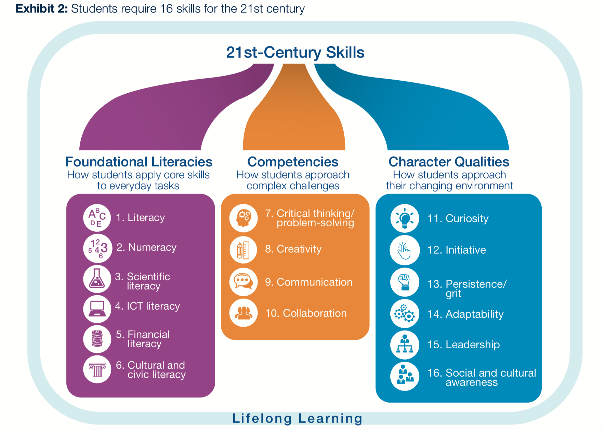
World Economic Forum. (2015) New Vision for Education: Unlocking the Potential of Technology. British Columbia Teachers’ Federation. [online] Available at: http://www3.weforum.org/docs/WEFUSA_NewVisionforEducation_Report2015.pdf (Accessed: December 30th 2019).

Appendix 2- George Land Creativity Test Results
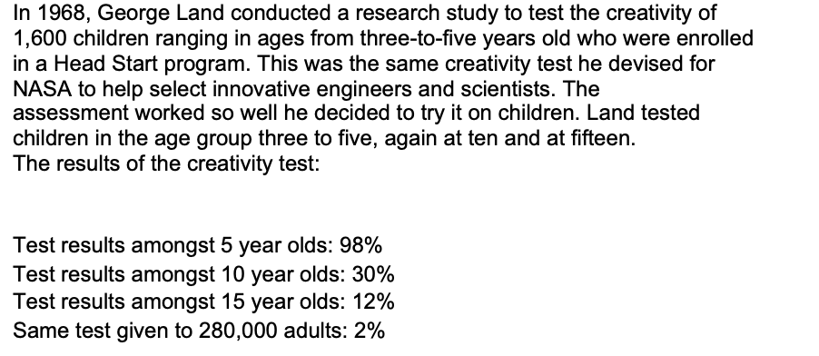
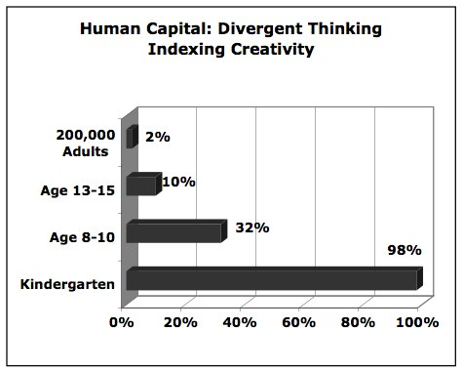
Land, G. (2011) The failure of success: TedxTucson [video]. Available at: https://www.youtube.com/watch?v=ZfKMq-rYtnc (Accessed: 2nd January 2020).

Appendix 3- Creating blood models and overcoming functional fixedness
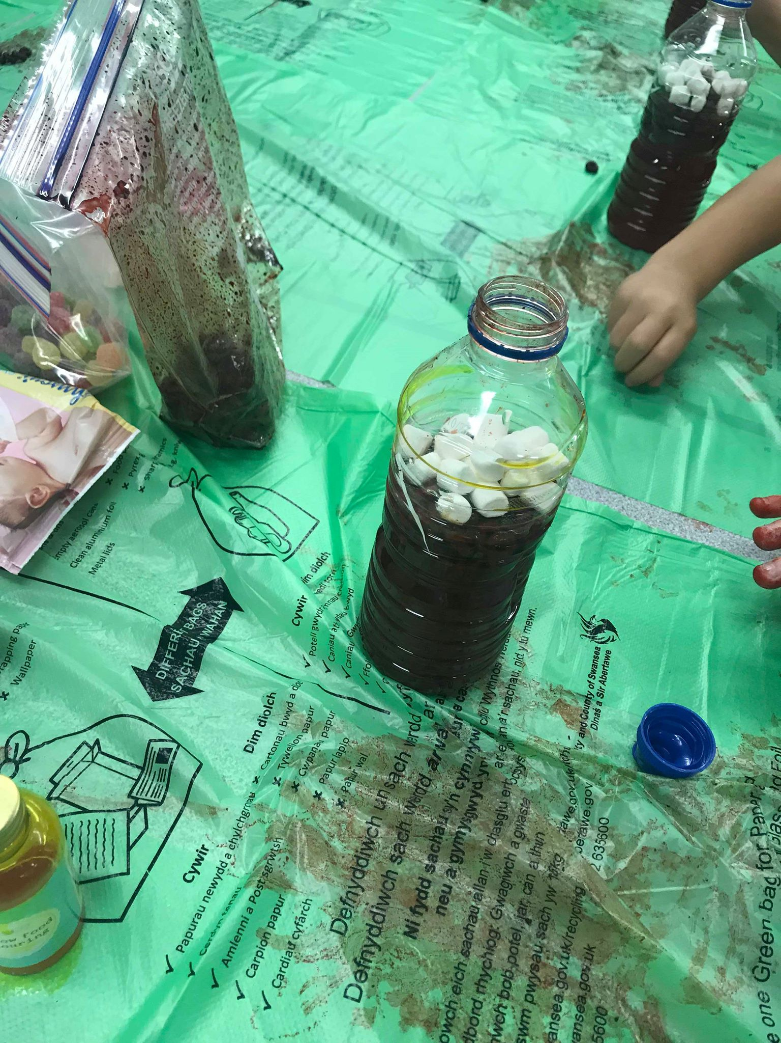
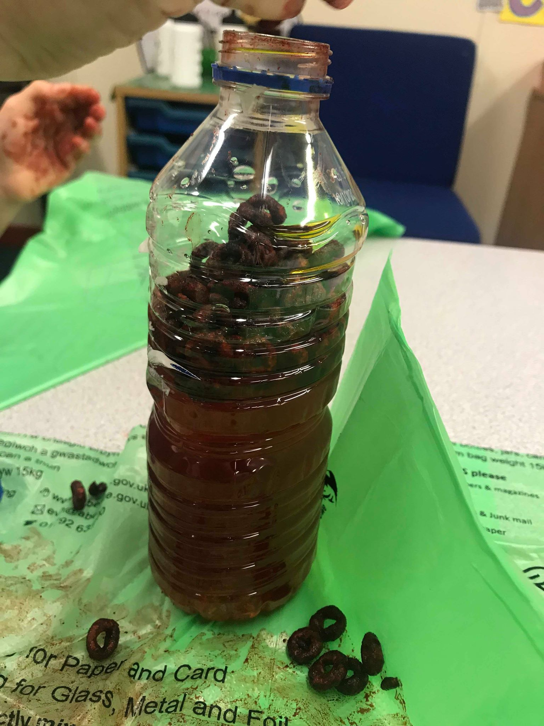
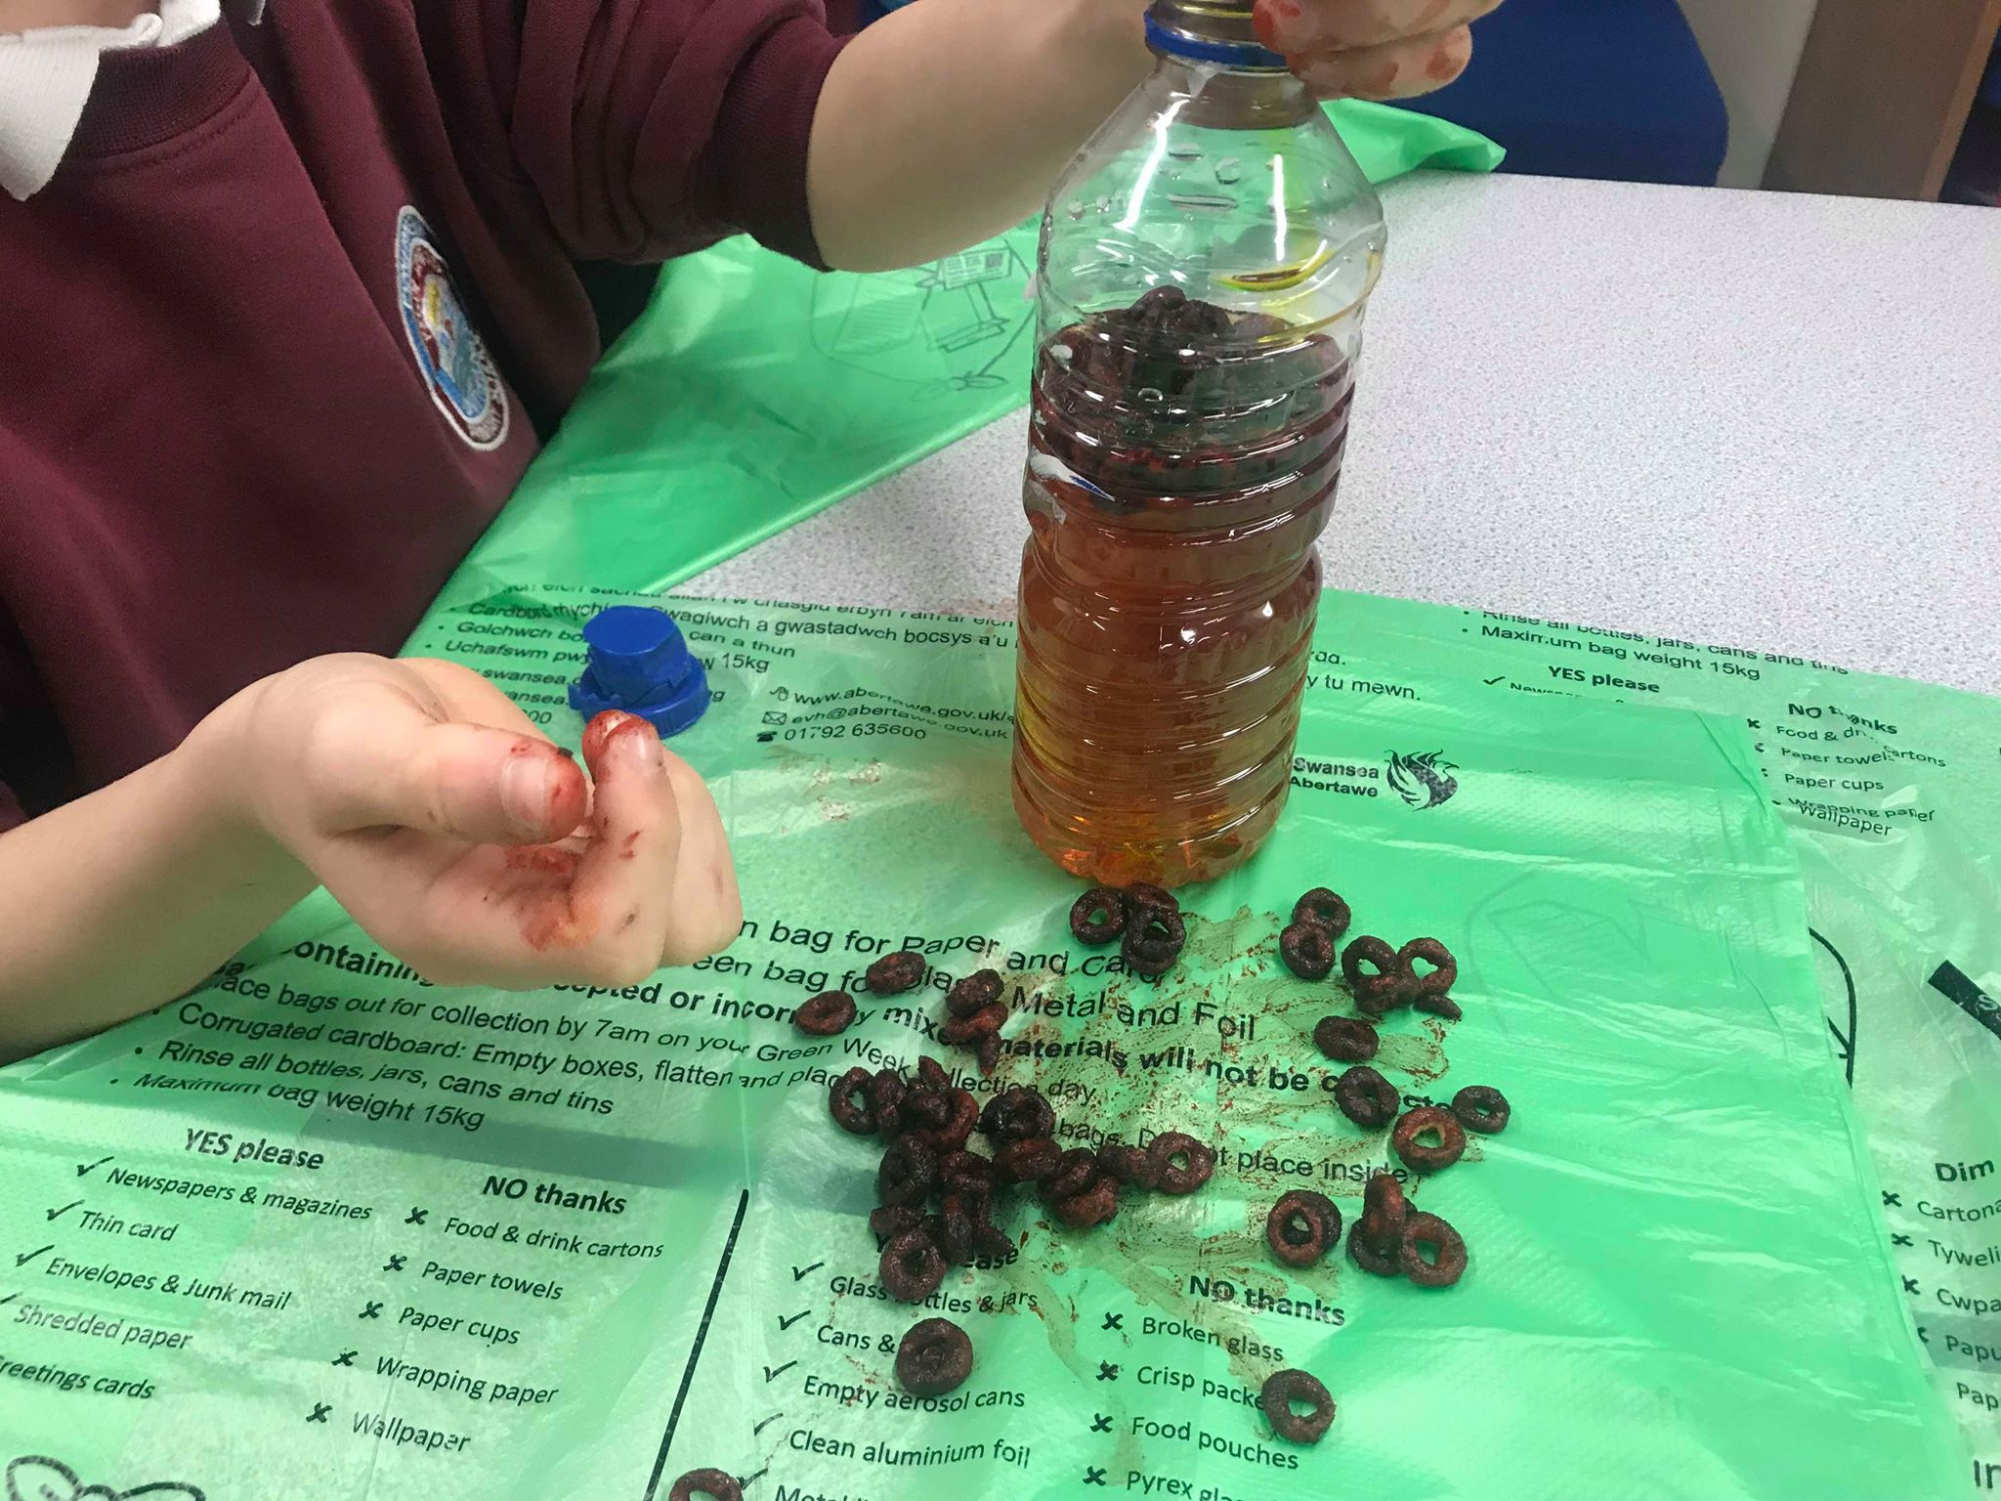
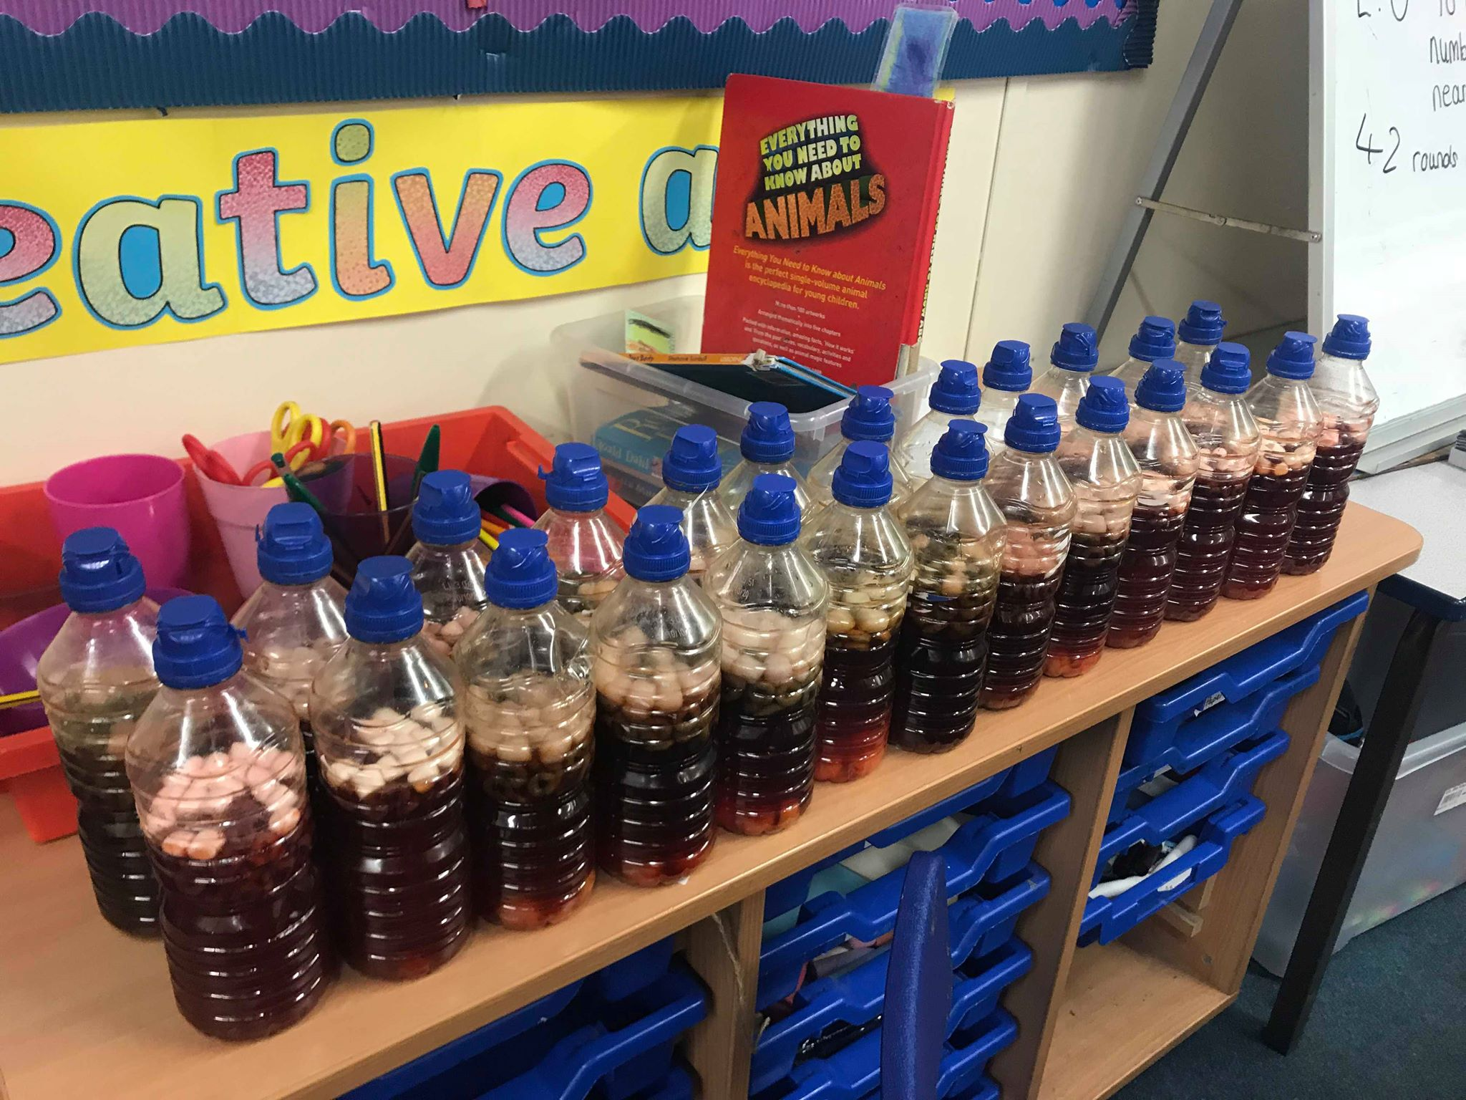

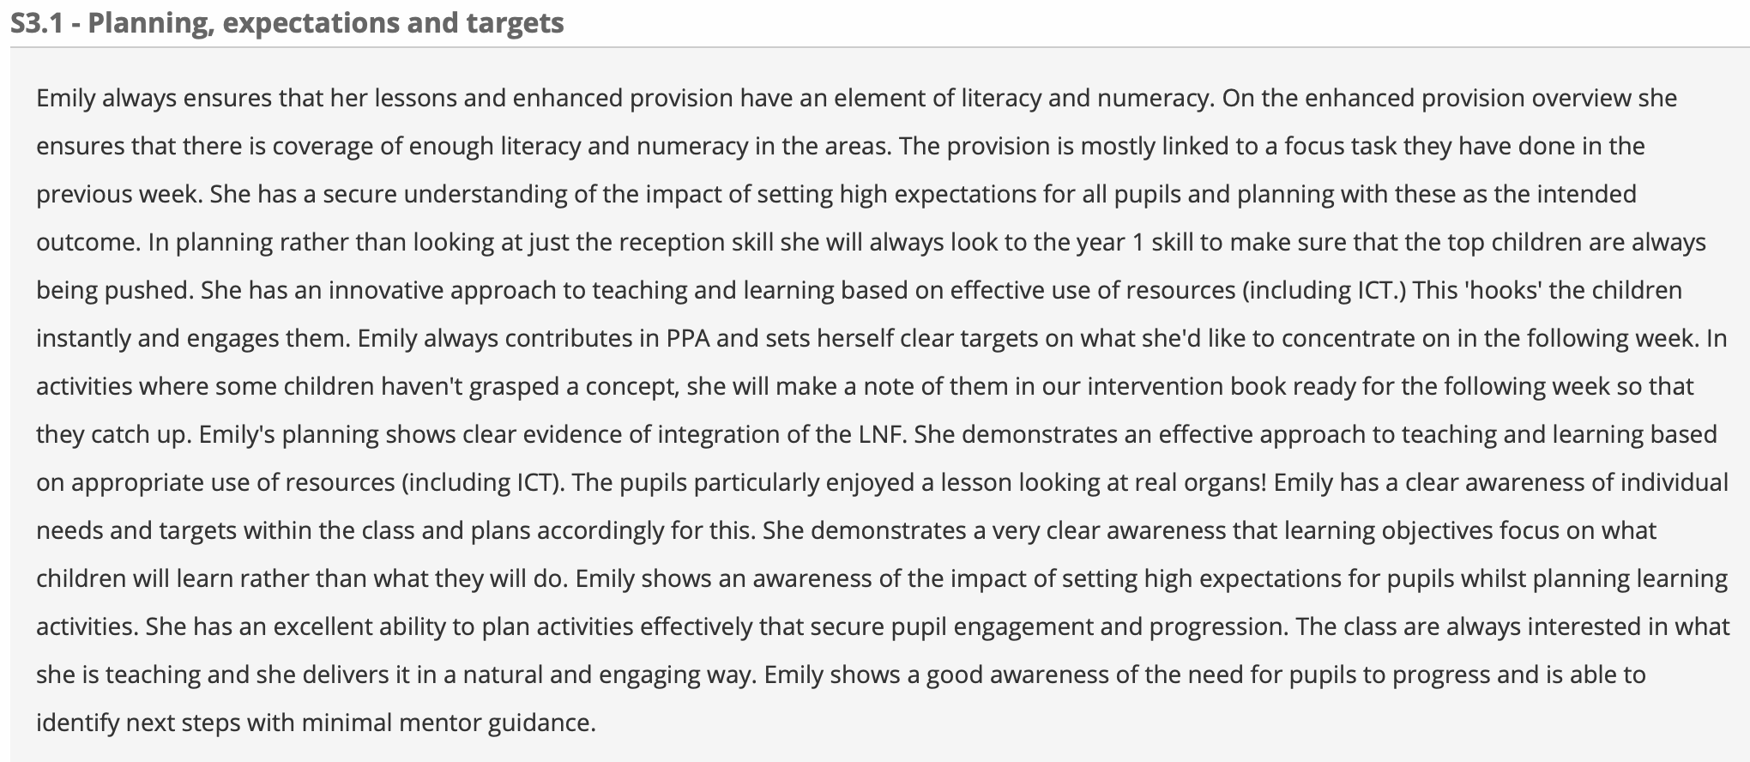
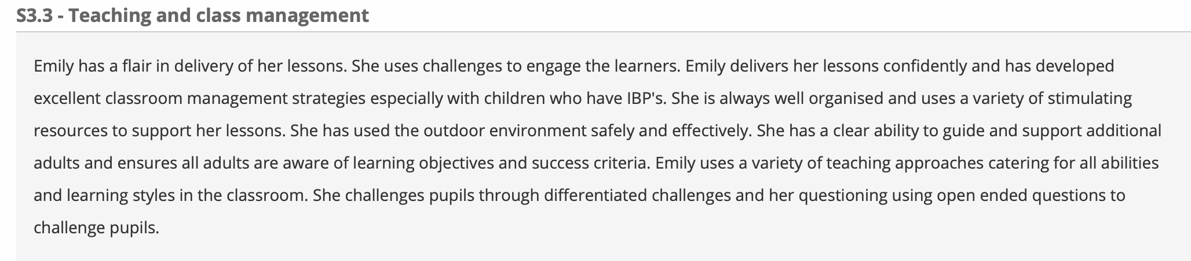
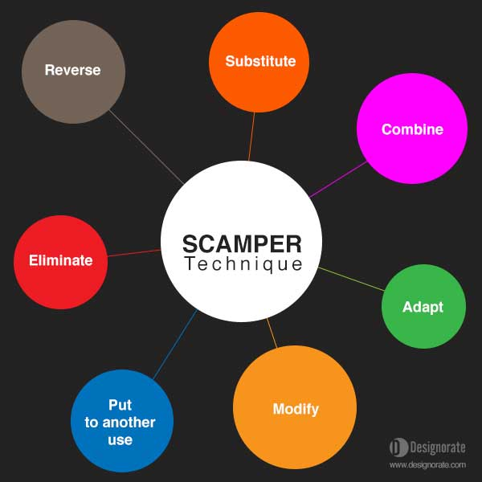
Appendix 4- The Scamper Model

Image taken from: Elmansy, R. (2015). A Guide to the SCAMPER Technique for Creative Thinking. Designorate. [online] Available at: https://www.designorate.com/a-guide-to-the-scamper-technique-for-creative-thinking/ (Accessed: 6th January 2020).
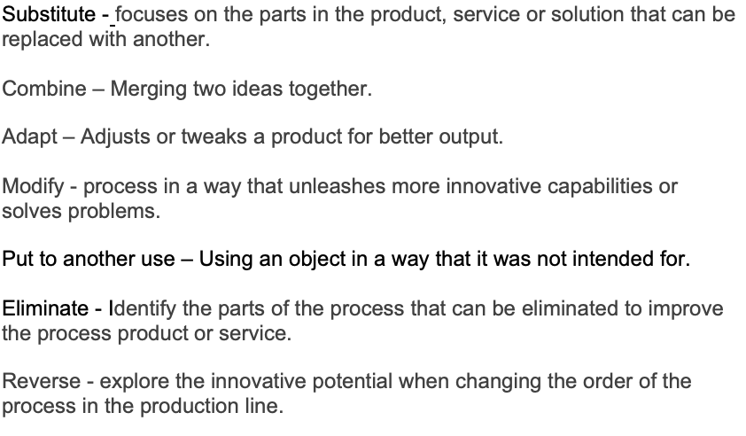

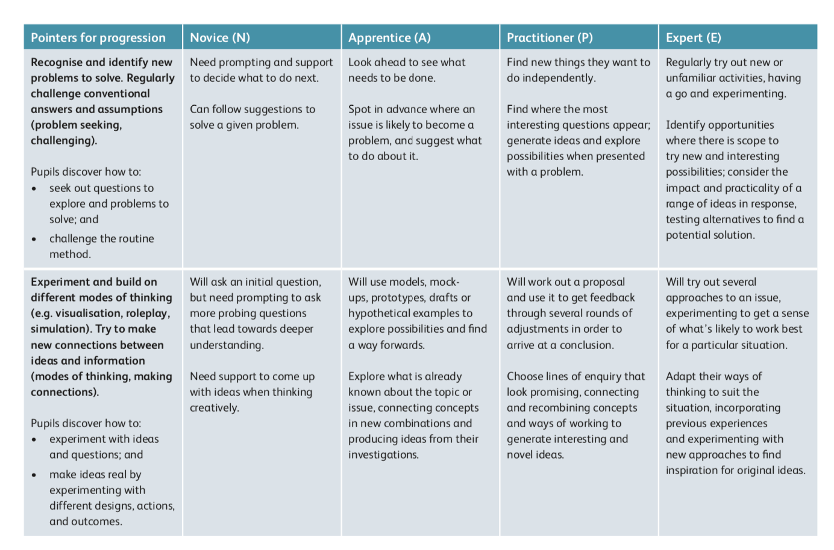
Appendix 5
Curiosity

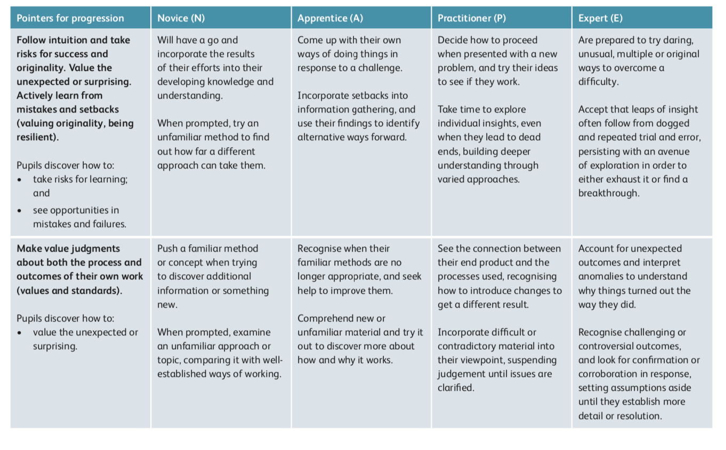
Risk Taking
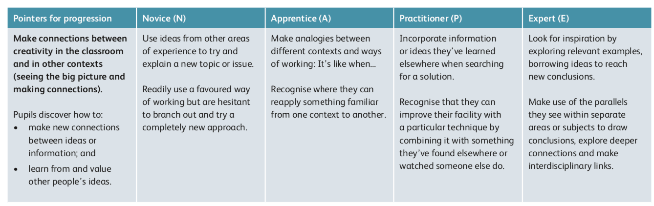
CEA. (2018) Rubric For Assessing Being Creative. [online] Available at: http://www.nicurriculum.org.uk/curriculum_microsite/TSPC/doc/2018_resources/rubrics/teacher/RubricForBeingCreative.pdf (Accessed: January 6th 2020).

Appendix 6 – Placement comments from SWWCTE

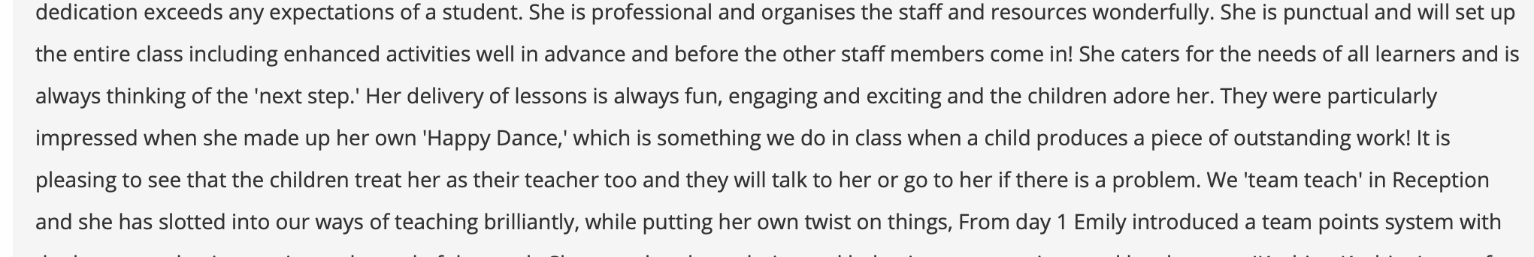
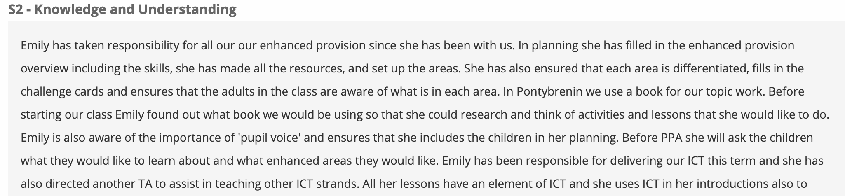

Appendix 7 – Examples of Enhanced Provisions on PTE second year
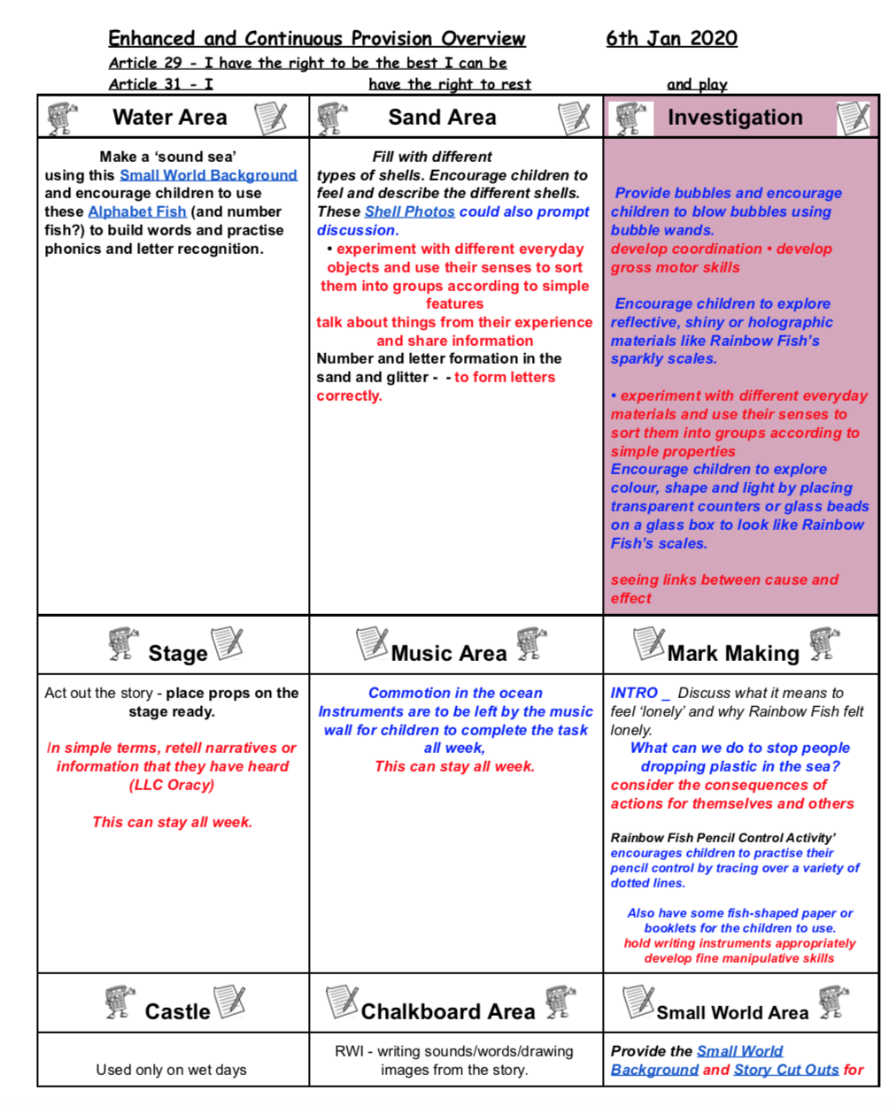
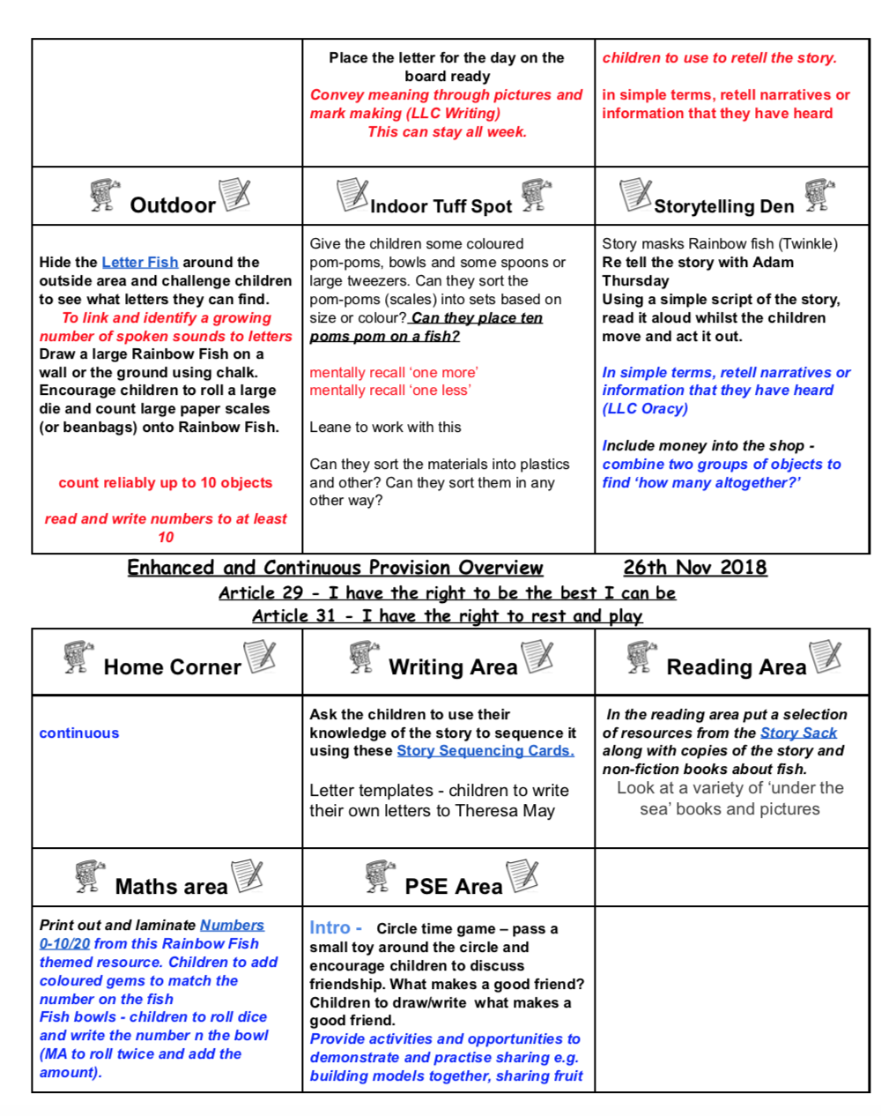

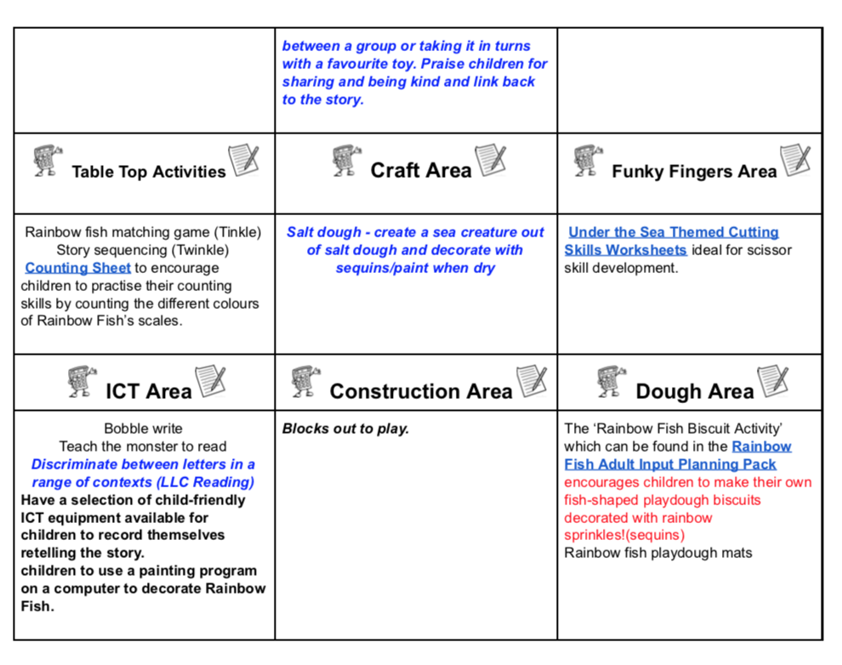

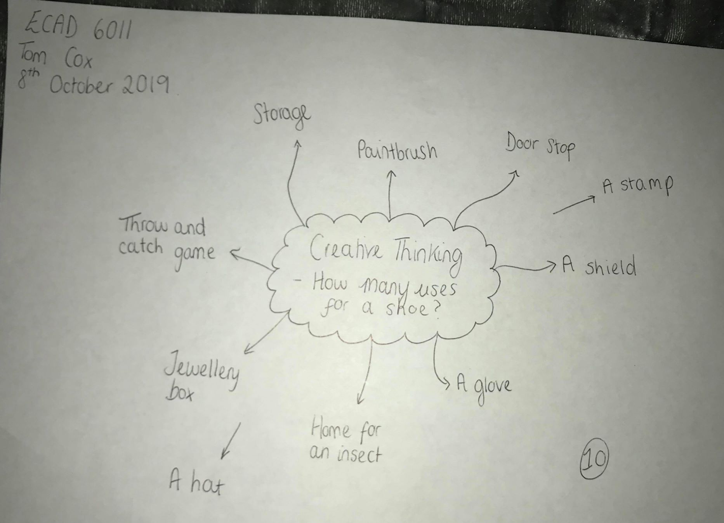
Appendix 8

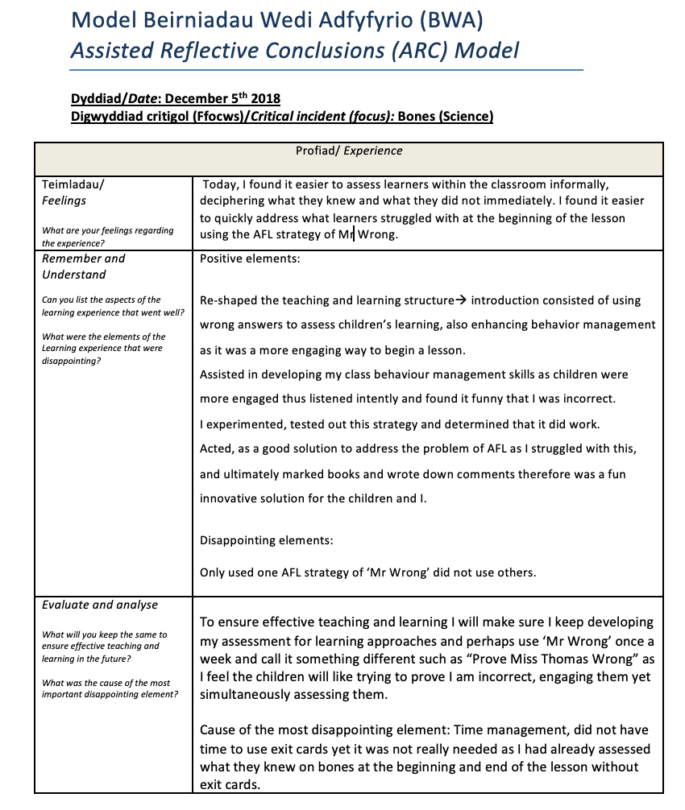
Appendix 9

Appendix 10
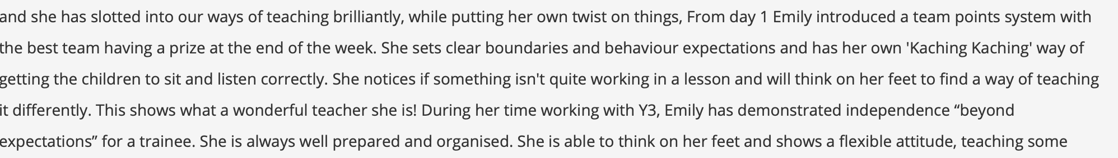
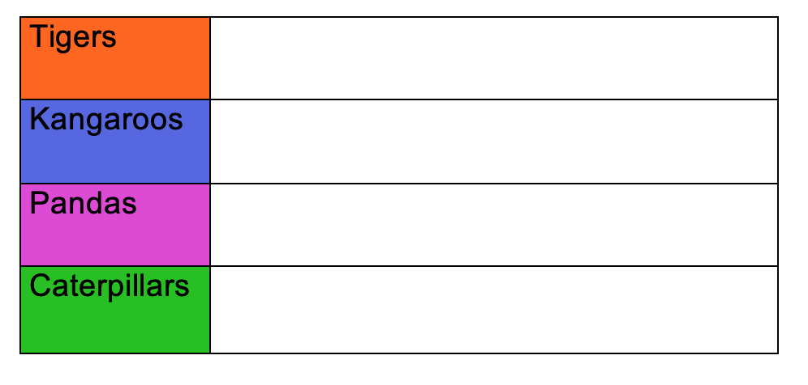

Appendix 11

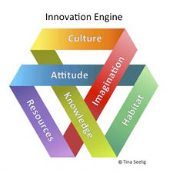

Image taken from: Frenkel, K.A. (2012). Tina Seelig’s Insights On Creativity. [online] Available at: https://www.creativitypost.com/article/tina_seeligs_insights_on_creativity (Accessed: January 8th 2020).

Appendix 12
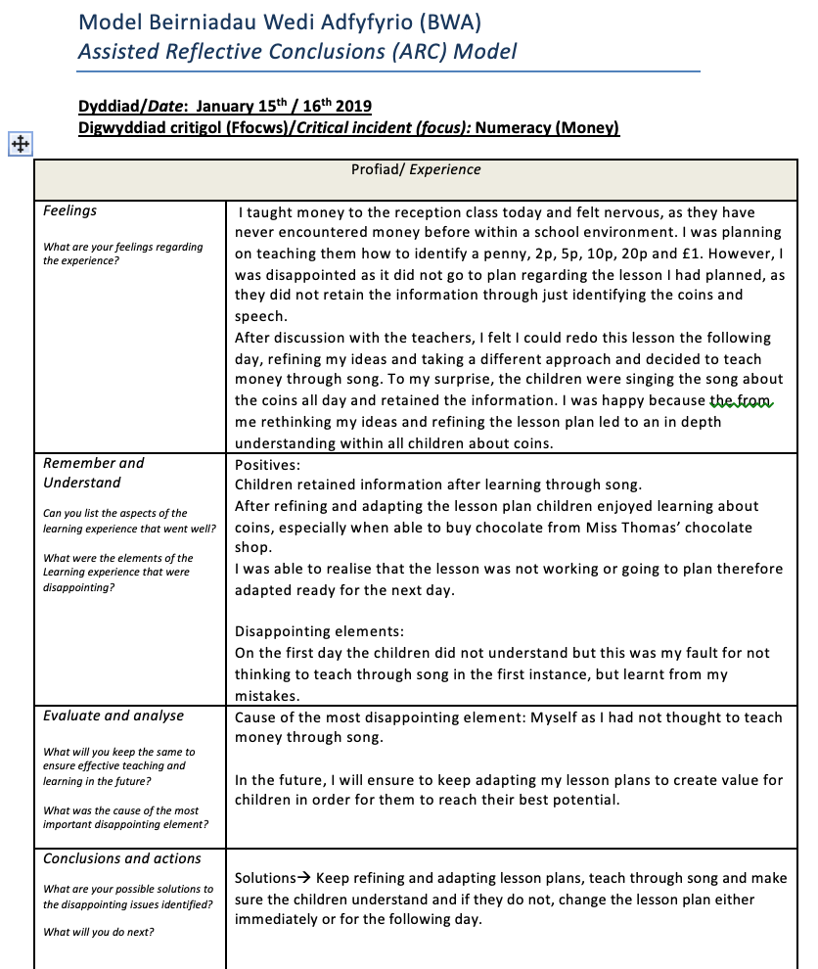

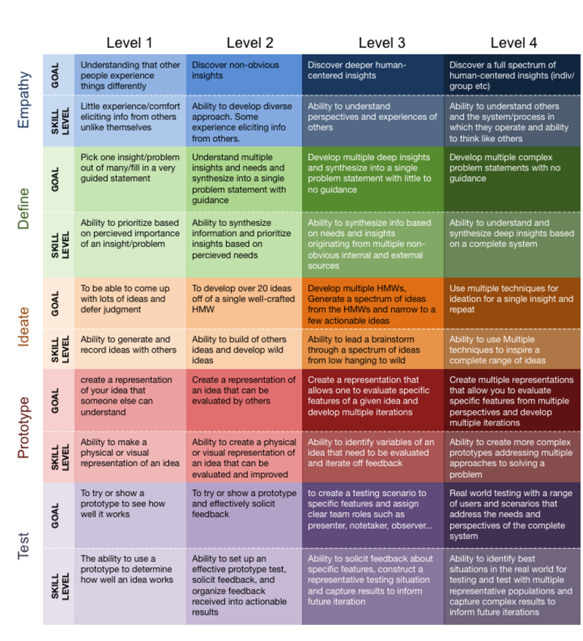
Appendix 13 – Prototyping Rubric
Babuta, D. (2019). Rubric Engineering Design Thinking Competencies. Better Lesson. [online]. Available at: https://betterlesson.com/lesson/627363/school-cafeteria-redesign-summative-assessment (Accessed: January 8th 2020)

Appendix 14 – Examples of Whack Pack Cards

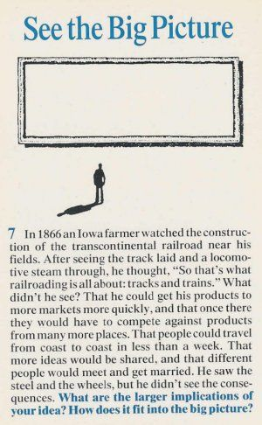
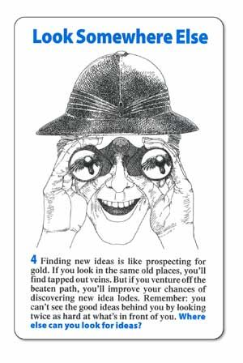
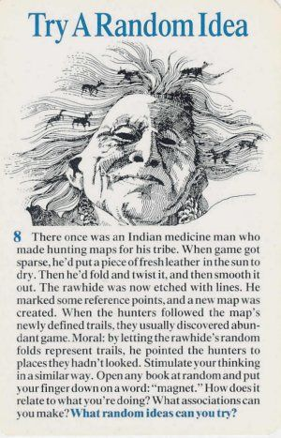
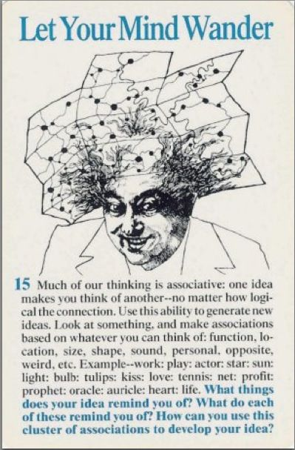

Appendix 15

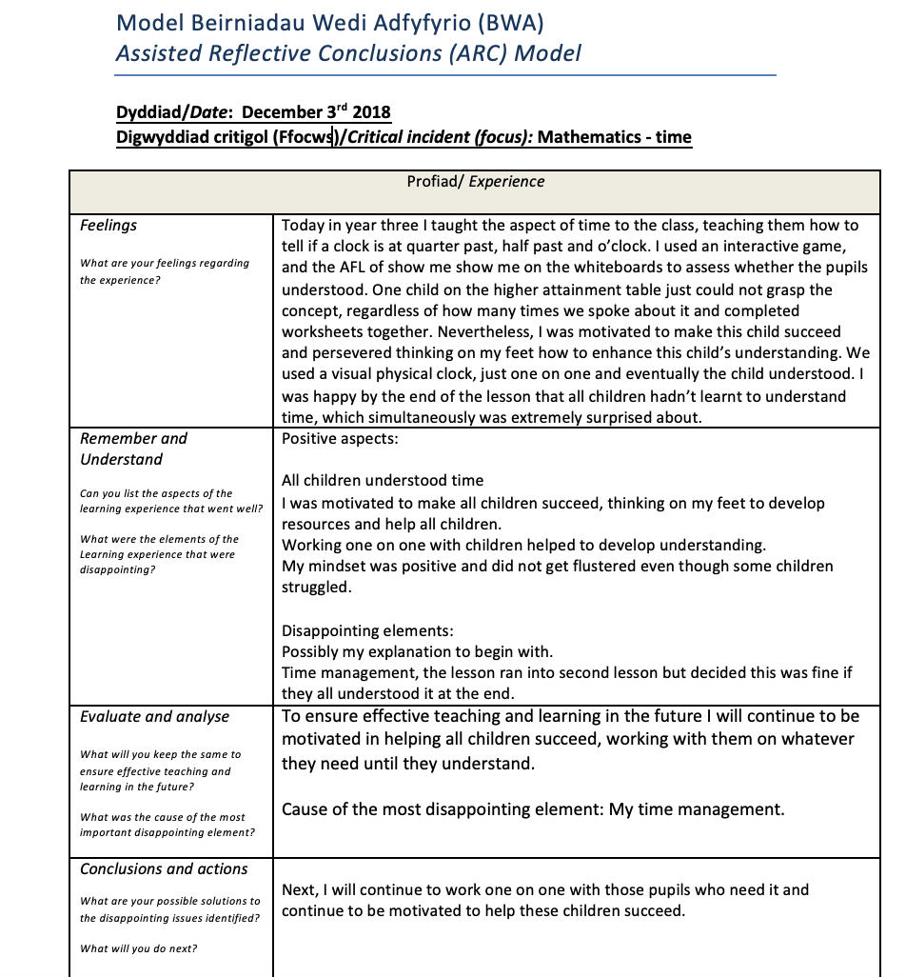
Appendix 16

