Module: Management & Organisational Behaviour
Module code: BMIH5004
Assignment Title: Hotel Organisational Audit
Student ID: 2107558
Student name: Selina Sultana Siddique
Lecturer: Julia Ault

Table of Contents
Introduction 3
Organisational culture, structure and goals of Hilton Hotel Group 3
Change initiatives in Hilton hotels 5
Description of changes 5
Impact of the changes 6
Management of the changes 7
The strategic direction of Hilton Hotel Group and its present business performance 8
Conclusion 9
References 10

Introduction
The hospitality industry is one of the booming sectors across the world with the growing demand for accommodation and hospitality services among travellers and tourists. Hilton belongs among the frontline companies in the hospitality sector around the globe (Guo et al., 2023). With appropriate managerial supervision and business strategies, the company has managed to grow its business by enhancing its brand image and driving its sales and profitability. The following study describes the culture, structure and goals followed by the company along with the changes that have been implemented within the company. Furthermore, the strategic direction as well as the current performance of the company will also be highlighted in the following study.

Organisational culture, structure and goals of Hilton Hotel Group
Organisational culture is significantly important for companies as it shapes the behaviour of employees. On the other hand, it also plays a major role in improving the engagement and participation of employees with the goals and objectives of companies (Metwally et al., 2019). There are different types of organisational cultures which are followed by companies such as clan, adhocracy, market culture and so on. In the case of Hilton, the company follows a market culture which allows the company to analyse the ongoing demands and preferences in the market (Armstrong, 2012). Thus, the management of Hilton can develop appropriate business and organisational strategies to increase its capability of achieving overall business success. In addition to the same, Hilton has largely contributed to the development of a diverse and inclusive organisational culture. The company ensure that the voice of its employees is heard. The inclusive and diverse organisational culture also helps the company to improve the collaboration between employees belonging to different backgrounds and cultures. Hilton leads its culture by being committed to the development of the best place in the world to work (Hilton, 2023).
In addition to the same, the vision of the Hilton Hotel Group is to cover the earth with warmth and light through the delivery of exceptional experiences to its guests through all of its hotels (Olorunsola et al., 2022). Along with the same, the hotel also focuses on personalising its services as per the demands and preferences of its guests to drive their retention and satisfaction. The organisational structure serves as the fundamental system which ensures the efficiency of organisational operations and information flow throughout companies. Determining an appropriate organisational structure helps companies to ensure their productivity and scalability (Mullins and Dosser, 2013). It further helps these companies to drive their capability to address the changing demands and preferences of customers. Thus, companies can enhance their brand image to attract more customers allowing those companies to gain a competitive advantage over their competitors in the market. There are primarily three organisational structures which are followed by companies which are flat, tall and matrix structures. A tall organisational structure consists of a “top to down” approach where the owners and board members are placed at the top of the structure. Hilton follows a tall organisational structure which helps the company to supervise the productivity and efficiency of its employees appropriately (Mullins, 2020). Along with it, the tall organisational structure allows Hilton to maintain multiple levels of management ensuring the efficiency of the overall organisation.
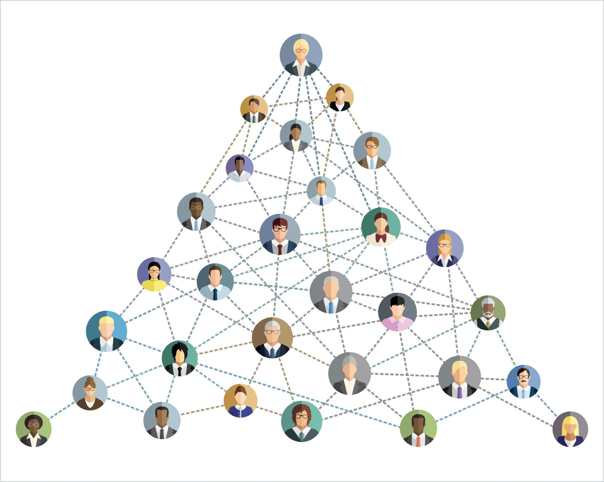
Figure 1: Tall organisational structure
(Source: Mullins, 2020)
The high number of management levels also increases the number of job designations allowing employees to get more opportunities for career progression. It increases the engagement of employees in the company while boosting their contribution towards the achievement of organisational objectives (Boddy, 2014).

Change initiatives in Hilton hotels

Description of changes
The hotel industry around the world has faced a significant impact during the past couple of years. The overall Covid-19 situation has caused a significant downfall o the UK hotel and hospitality industry. The overall impact has also caused Hilton Hotels to implement some major changes in the organisation. The overall changes were implemented by the organisation to help it adapt to the new working situations (Hilton, 2022). The overall market has been influenced in a significant manner.
Hotel design
The overall changes include a change in hotel design. The lack of customers has caused the organisation to implement effective strategies that can help to attract consumers after the re-opening of the hotels in the post-covid situations. The redesigned lobby and reception have helped the organisation to provide better and new experiences. Significant changes in the interior changes in designing have been adopted by the organisation.
Contactless experiences
The overall consumer experience has also been impacted in a significant manner. The organisational changes have been implemented in the organisation in an effective manner. The organisation has utilised advanced technologies to be implemented in its operations. The hospitality company has implemented a number of services with the help of new and advanced technologies. It has helped the organisation to remodel some of the operational processes of the organisation. The contactless experiences provided by the consumers have been implemented by the organisation in this study (Chan et al., 2021). It has effectively helped the organisation to implement significant changes in operations.
Change in hygiene and cleanliness
Organisational hygiene has also been adopted during the present situation. The implementation of changes in cleaning policies and procedures has helped the organisation to adapt to the external changing situations effectively. The organisational change has allowed the organisation to operate in a clean and hygienic manner. The current external situation has caused a significant rise in service requirements and consumer standards have been aimed to be improved in the organisation (Mold, 2022). Such has provided a significant change in organisational operations. Hilton Hotels cleans and disinfect different operational areas such as the pool, playroom and others has been changed by the organisation. Such change initiatives have been considered for helping consumers to feel comfortable and to prevent any spread of infections.
Flexible services
The overall services have also been changed significantly. The changes in the services have been made much more flexible. The organisation is providing hybrid solutions to consumers and event planners. Many organisations utilise Hilton Hotels to hold meetings on a large scale. The implementation of hybrid solutions has enabled the organisation to decrease the threats.
Loyalty program for the customers
For coping with the present situation and market demands the organisation has also introduced new schemes and perks in their loyalty programs. New schemes and parks can now be redeemed by the consumers for avail discounts, offers and additional free services (Lee et al., 2022). The promotional activities and the service-providing process has been changed. The changes in such operational services have allowed the organisation to implement a significant impact on the consumers.

Impact of the changes
The overall changes implemented in Hilton Hotels have provided a significant impact on the organisation. Implementation of changes is aimed at receiving a positive impact on the organisation. The overall organisation has to face different circumstances and influences due to the implementation of the changes.
Improvement in consumer satisfaction
Consumer satisfaction rates have been influenced greatly by the organisation's change management process. Making effective changes in designing the interiors has caused the customers to feel a positive attraction. The improved service quality has attracted an increased number of consumers also. Better quality services have helped customers to receive increased consumer satisfaction rates in a positive manner (Reidhead, 2020). The positive feedback from the customer allows consumer satisfaction rates to get improved. The flexible services have also helped the organisation to improve its customer satisfaction rates. Better customised planning in hospitality services has allowed consumers to receive better satisfaction in the process.
Improvement in revenue
The increasing number of consumers has effectively helped organisations in multiple ways. Improving the physical appearance of the rooms and other services has allowed more consumers to visit the hotels in an effective manner. The increasing number of customers has also been caused by the strict hygiene and cleanliness policies implemented by the organisation. Consumers get attracted significantly. Another significant factor is the increasing discounts and perks provided to existing and new consumers (Statista, 2023). The overall benefits have allowed a number of individuals to seek Hilton Hotels to avail of the services rather than other organisations or service providers. Effective competitive advantages have been gained from such impacts. The overall position of the organisation has also helped the organisation to improve its overall revenue generation process in a positive manner. The organisation generated 8.77 billion USD in 2022, which is a significant increase from 4.31 billion USD in 2020 (Statista, 2023).
Improvement in hygiene
The organisational hygiene and service quality have also been improved in a significant manner. The overall improvements have caused the organisation to increase its overall reputation dn service quality in the market in a positive manner.

Management of the changes
The overall changes in the organisation have been managed in a positive manner. The overall changes that have been made in the organisation have provided positive impacts on the organisation. Increased revenue, market share, customer satisfaction rates and service quality have provided a positive impact on the organisation. All of these have caused Hilton Hotels to grow larger in the market (Ricca, 2019). The overall organisational management process has been conducted effectively as positive feedback from the customers has been received by the organisation. The changes have not provided any negative impact on the consumers. However, the changes in the loyalty program provided by the organisation only focused on these existing consumers in the market. The changes are managed in this aspect with some drawbacks. However, the overall organisation has efficiently managed the changes in operations.

The strategic direction of Hilton Hotel Group and its present business performance
As the pandemic has majorly affected the business of Hilton, the company has focused on the recovery of its business through the implementation of effective changes within the organisation. The company has focused on offering clean and hygienic services and experiences to its guests. As per the current records, Hilton operates in 122 territories and countries along with 19 brands globally. In addition to the same, the company also owns 7,215 properties which can be located throughout the world (Hilton, 2023). The revenue of Hilton was severely affected due to the closure of hospitality and accommodation companies around the globe during the pandemic outbreak. Although the company managed to recover its revenue by implementing the necessary changes to drive guest retention and satisfaction. The revenue generated by the company increased to 8.77 billion US dollars from 5.79 billion US dollars (Statista, 2023).
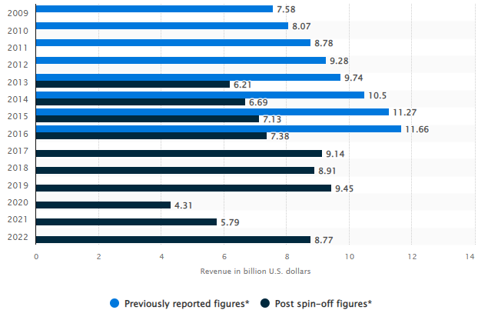
Figure 2: Revenue of Hilton Group
(Source: Statista, 2023)
Hilton has also developed goals to contribute towards ethical and environmental sustainability. The company has carefully curated its organisational culture which allows the company to offer exceptional stays along with extraordinary experiences to its guests which leaves a positive influence in their minds for a longer period of time. Hilton also focuses on the betterment of the lives of its employees and communities which improves the sustainability of the brand (Mullins, 2016). Additionally, Hilton has over one million rooms which can be located throughout the globe allowing the company to stand as one of the largest hotel companies globally. The company emphasises the provision of better services and active contributions to its guests and employees to drive its success in the future. The company has pledged to decrease its carbon intensity by 61% until 2030. Additionally, it has also concentrated on the reduction of the intensity of water usage by 50% until 2030 (Hilton, 2023).

Conclusion
As per the above study, it can be understood that Hilton is one of the largest and most successful hotel companies in the world. The company focuses on the provision of exceptional guest services and accommodation experiences. Hilton follows a tall organisational structure to maintain efficiency. The company has developed a diverse and inclusive organisational culture to maintain collaboration. Furthermore, it has implemented the necessary changes in its operations to improve the satisfaction of its guests to enhance its brand recognition and growth.

References
Armstrong, M., 2012. Armstrong’s Handbook of Management and Leadership (3rd Ed), London: Kogan Page.
Boddy, D., 2014. Management: An Introduction (6th Ed), Harlow, Pearson
Chan, J., Gao, Y.L. and McGinley, S., 2021. Updates in service standards in hotels: how COVID-19 changed operations. International Journal of Contemporary Hospitality Management, 33(5), pp.1668-1687.
Guo, Q., Shen, H., Fan, D.X. and Buhalis, D., 2023. CSR influence on job performance: the roles of psychological needs fulfillment and organizational identification among tourism firms. International Journal of Contemporary Hospitality Management.
Hilton, 2023. Environmental Impact. [Online] Available at:<https://esg.hilton.com/environment/> [Accessed on 3rd June 2023]
Hilton, 2023. OUR CULTURE. [Online] Available at:<https://jobs.hilton.com/us/en/culture> [Accessed on 3rd June 2023]
Hilton, 2023. Welcome TO HILTON. [Online] Available at:<https://www.hilton.com/en/corporate/#:~:text=To%20fill%20the%20earth%20with%20the%20light%20and%20warmth%20of,%2C%20every%20guest%2C%20every%20time.> [Accessed on 3rd June 2023]
Hilton. 2022. Hilton: Many Pandemic Safety Innovations to Remain. [online] Stories From Hilton. Available at: https://stories.hilton.com/corporate-news/hilton-many-pandemic-safety-innovations-to-remain [Accessed 3 Jun. 2023].
Lee, S.H., Deale, C.S. and Lee, J., 2022. Does it pay to book direct?: Customers’ perceptions of online channel distributors, price, and loyalty membership on brand dimensions. Journal of Revenue and Pricing Management, 21(6), pp.657-667.
Metwally, D., Ruiz-Palomino, P., Metwally, M. and Gartzia, L., 2019. How ethical leadership shapes employees’ readiness to change: The mediating role of an organizational culture of effectiveness. Frontiers in psychology, 10, p.2493.
Mold, A., 2022. Food hygiene, public health education and citizenship in Britain, 1948–1967. Medical humanities, 48(1), pp.114-122.
Mullins, L and Dosser, P., 2013. Hospitality Management and Organisational Behaviour (5th Ed) Harlow, Pearson.
Mullins, L., 2016. Management and Organisational Behaviour (11th edition) Harlow: Pearson
Mullins, L., 2020. Organisational Behaviour in the Workplace (12th edition) Harlow:Pearson.
Olorunsola, V.O., Saydam, M.B., Arasli, H. and Sulu, D., 2022. Guest service experience in eco-centric hotels: a content analysis. International Hospitality Review, (ahead-of-print).
Reidhead, C., 2020. Impact of organizational culture on employee satisfaction: A case of Hilton hotel, United Kingdom. Journal of Economics and Business, 3(1).
Ricca, S., 2019. Hilton banks on continued net unit growth.
Statista, 2023. Revenue of Hilton Worldwide Holdings 2009-2022. [Online] Available at:<https://www.statista.com/statistics/297760/revenue-of-hilton-worldwide-holdings-inc/> [Accessed on 3rd June 2023]
Statista. 2023. Hilton Worldwide Holdings Inc.: revenue 2019. [online] Available at: https://www.statista.com/statistics/297760/revenue-of-hilton-worldwide-holdings-inc/ [Accessed 3 Jun. 2023].

