Introduction to Database Concepts Assignment
Author: Kes Sumner (2015409)
L4 - Introduction to Web and Database Concepts (ACCA4023)
School of Applied Computing
Wales Institute of Science and Art
Date and Time of submission: 20/07/2021 1700 (due to EC)
Contents
1 Introduction 3
2 Data Flow Diagrams 4
2.1 Context Diagram 4
2.2 Level 0 Diagram 4
3 Entity Relationship Diagram 6
4 Access Database 7
4.1 Database creation 7
4.2 Forms 8
4.3 Reports 13
5 User guide 15
6 Conclusion 16

Introduction
The task description for the Celtic Caterers assessment centred around the design and implementation activities required to implement a computerised system for the company to replace existing manual processes.
The steps followed were:
- Identifying what was required from the assignment specification, which includes the Celtic Caterers problem task description.
- Use techniques taught in the database concepts lectures to:
  - Identifying requirements from the assignment brief
  - Develop a data flow diagram (DFD) context diagram.
  - Refine the context diagram in to a DFD level 0.
  - Develop an identity relationship diagram.
  - Create DB and table structure in Access from the ERD diagram.
  - Create fields within tables.
  - Set up input masks and lookups.
  - Create relationship diagrams and link primary and foreign keys.
  - Create forms for users to use and navigate the database (add/remove records, run queries etc.)
  - Some macro work required to configure certain buttons (such as the close database and exit button)
This document details the process followed to design and implement an Access database to fulfil the requirements of the problem task.

Data Flow Diagrams

Context Diagram

After examining the task description for the Celtic Caterers current situation and the required system functionality the following data flow diagram (DFD) context diagram was created based on the information supplied. The diagram shows the flow of data between sources and the high-level Celtic Caterers process.
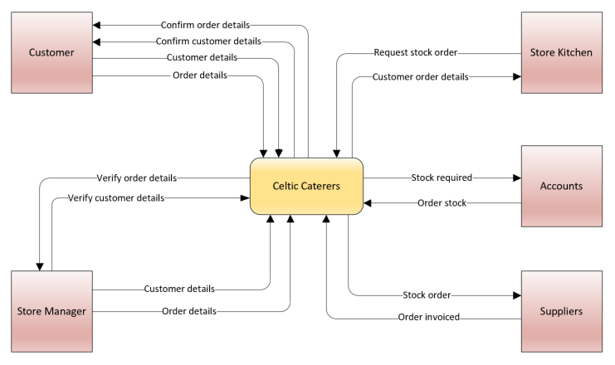
Figure 1: DFD context diagram for Celtic Caterers system.

Level 0 Diagram

From the development of the high level DFD context diagram, the high-level context diagram was refined into a level 0 DFD shown in Figure 2. The diagram shows a finer level of detail by breaking down the ‘Celtic Caterers’ central process from the context diagram into the key sources and processes involved in task description requirements.
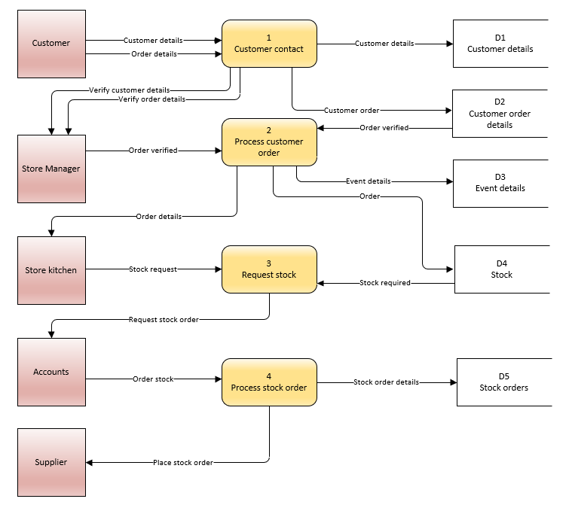
Figure 2: Level 0 data flow diagram for the Celtic Caterers system.
During this process of refinement some of the required data store objects were identified that would be required to facilitate the system functions.

Entity Relationship Diagram

The next stage was to think about and develop and entity relationship diagram (ERD). This was based on the data stores objects identified in the level 0 DFD becoming the entities within the ERD. The contents of each entity were considered and identified within the development of the diagram and can be seen in the ERD diagram below, along with the associated attributes that would be required for the system to function.
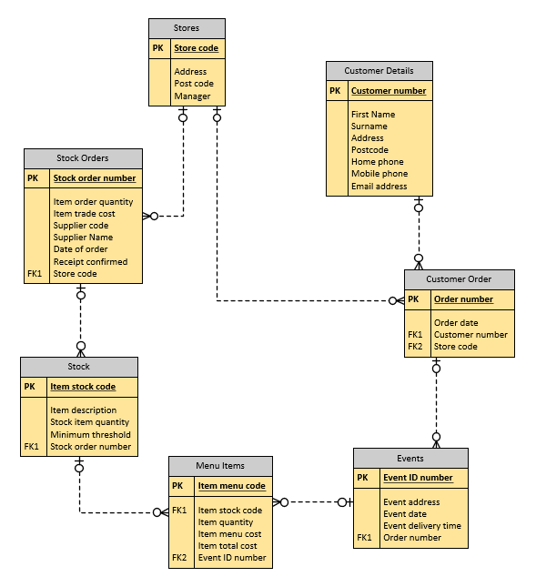
Figure 3: Entity relationship diagram for the Celtic Caterers system.
The diagram also shows the type of relationship between the entities, e.g., one event may have many menu items and is there for a one-to-many relationship from the Events entity to the Menu Items entity. The diagram was created using Microsoft Visio, which has a shapes section specifically for ERD diagrams. Viso automatically created foreign keys based on a match of a primary key in one entity and a non-primary key in another entity.

Access Database

Database creation

The next stage in developing the new system was the creation of the basic database based on the entity and attribute information in the entity relationship diagram.
The empty database was created and the tables, which equate to the ERD entities, were created with the ERD attributes becoming the fields within those associated tables. Named according to best practice with the appropriate prefix.
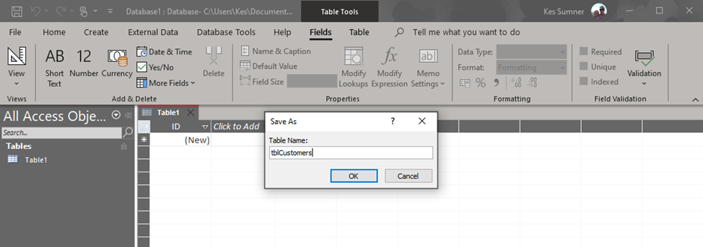
Figure 4: Database and first table creation.

After creating the tables, the fields were created and configured with input masks and lookups, where appropriate.
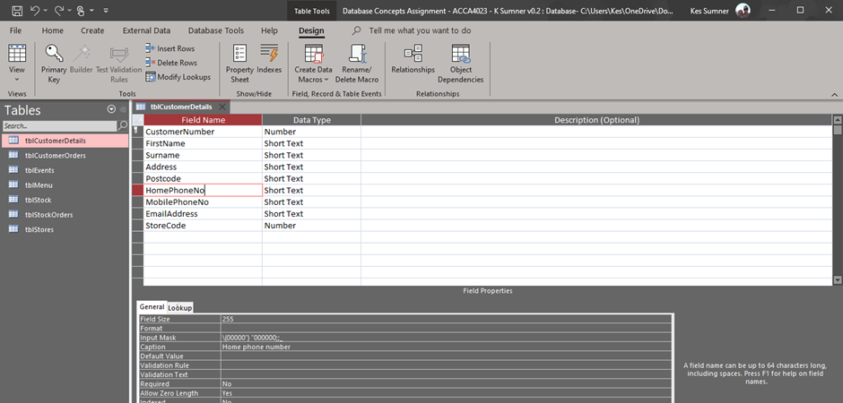
Figure 5: Creation of table fields.
Once all the tables and fields had been created then the table relationships were established.

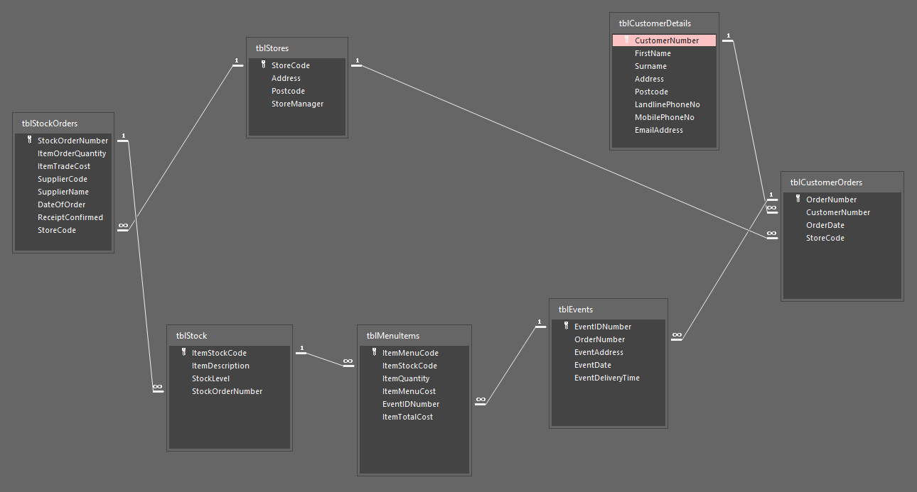
Figure 6: Table relationships showing primary and secondary keys.
The above diagram shows the relationships between the tables and is very close to the entity relationship diagram.

Forms

Once the relationships between the tables were in place then forms were created for users to add/amend/delete data from the system. A selection of the forms created for users to maintain the data are shown below, starting with the main menu which opens automatically when the database is opened. One additional form is also available for users to run and display queries based on any specific event.
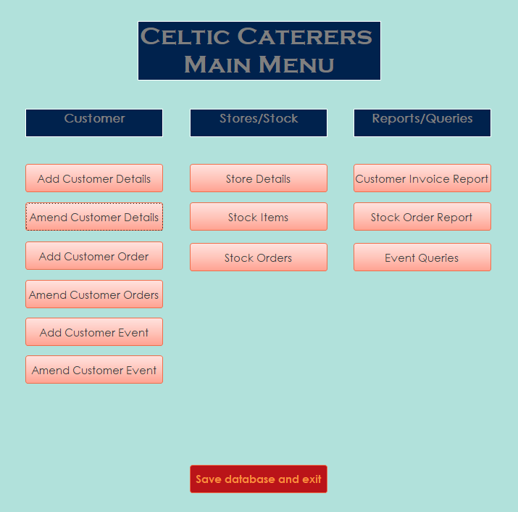
Figure 7: Main menu
From this menu, which appears when the database is opened, users can navigate through the database to add, amend and remove data and to create specific required reports and queries.

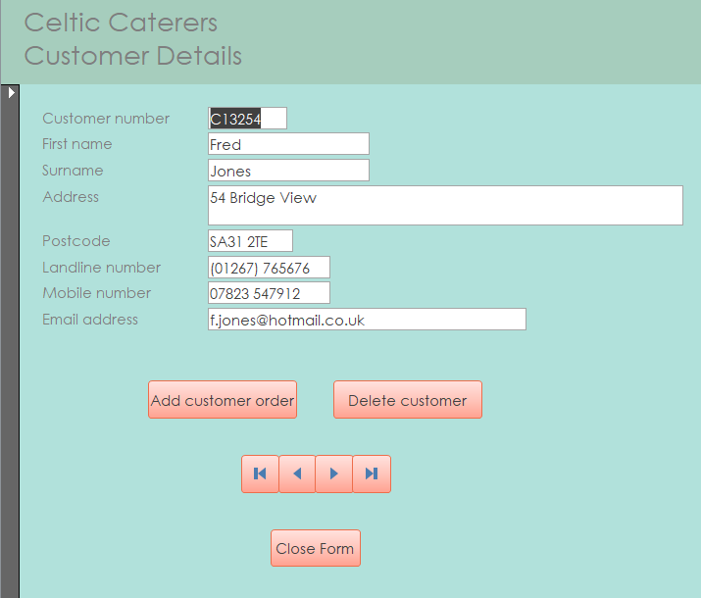
Figure 8: Customer details form
Customer details form for adding, viewing, and removing data for customer details. Includes a button to open the add new order form.
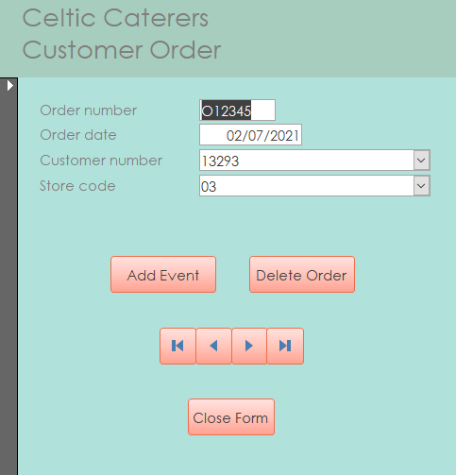
Figure 9: Customer order from
Customer order form with a button to open the add new event form.

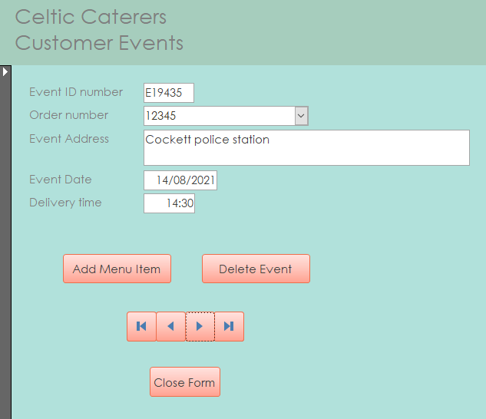
Figure 10: Customer event form
Form for adding or deleting events to a customer order.

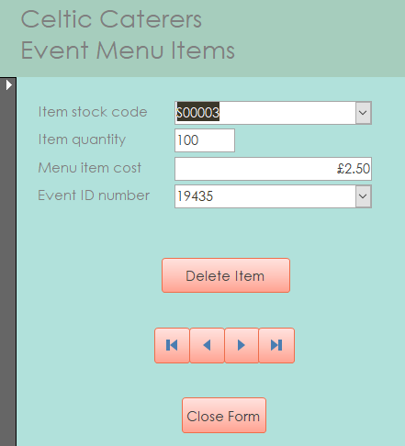
Figure 11: Event menu items form.
Menu items form for adding/deleting one or more menu items to/from an event booking.

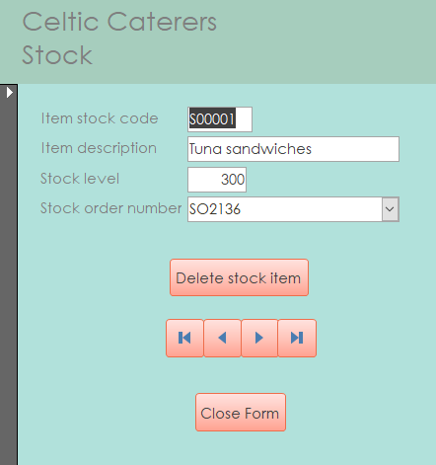
Figure 12: Stock items form
Form for adding/deleting stock items to/from the stock list.
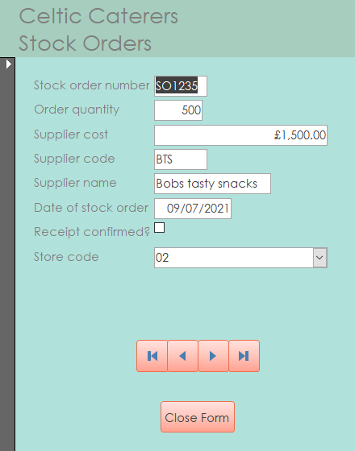
Figure 13: Stock orders form
Form for adding items to stock orders from suppliers.

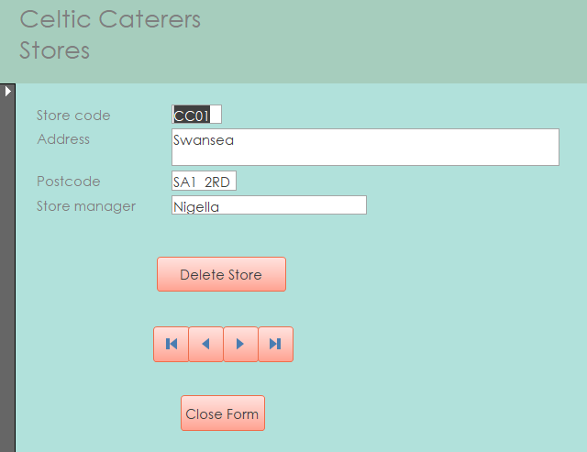
Figure 14: Stores form
Form for adding/deleting store details.
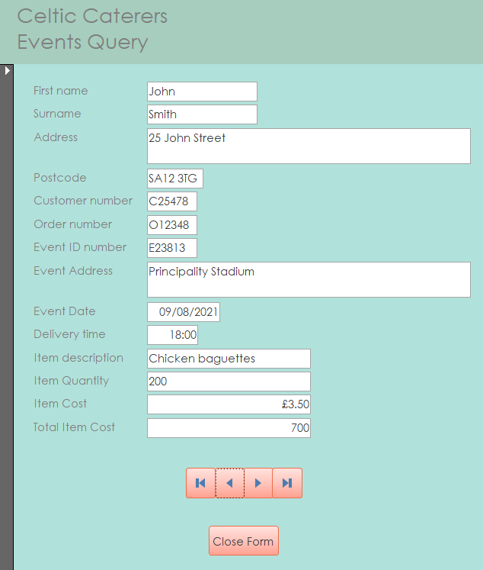
Figure 15: Form for querying events.
The last form differs from the others in that it uses an Access query to display information about any specific event for Celtic Caterers staff to view the details of.

Reports

Two reports have been implemented as required by the task description for the Celtic Caterers system. The first report, shown in figure 16 below, is a record of transactions for stock purchases showing orders placed with from suppliers. Going forward this could be developed further to enable profit/loss reporting capability by adding functionality to the database.

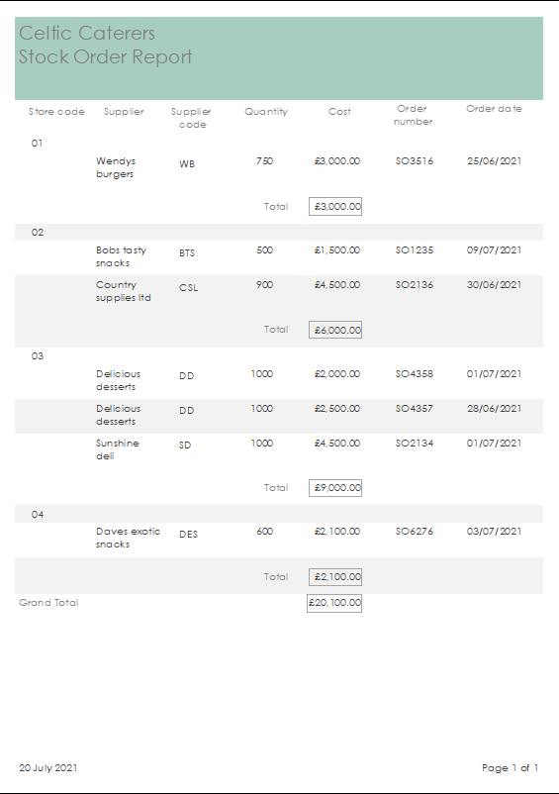
Figure 16: Report of stock acquisitions from product suppliers.

The second form is query-based to enable production of a customer invoice for review and/or printing. When called by the report, the query requests the customer order number from the user and then generates a report-based invoice, as shown below.

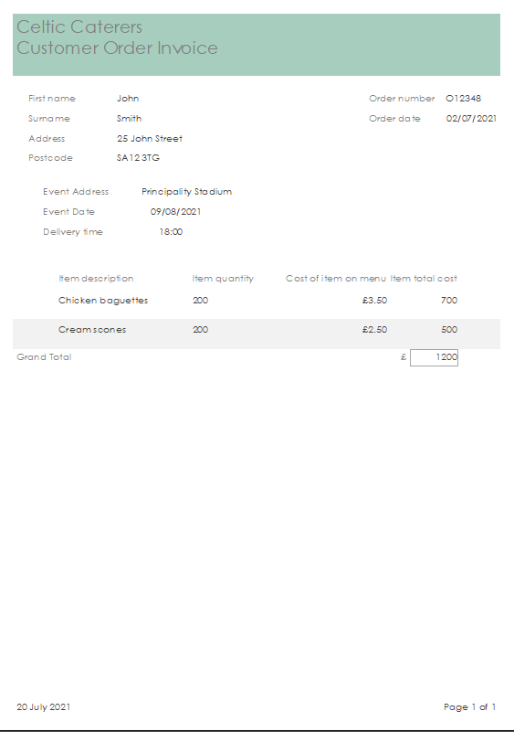
Figure 17: Customer invoice report.

User guide
Below follows a brief user guide on how to use the Celtic Caterers database. The outline structure is quite straightforward and there are links on the relevant forms to that link to dependent tables/forms, such as when creating or viewing a customer record, there is a ‘Add customer order’ button that open the add form function.
When opening the database, the main menu automatically opens displaying the main menu options. There are three columns of buttons, each specific to a particular area:
- Customer: This column is primarily used to enter/review data in a logical order, namely add a new customer, add an order, add an event and add menu items for the event(s).
- Stores/Stock: Allows addition/amendment/deletion of Celtic Caterers store information as well as stock information such as stock items and stock orders.
- Reports/Queries: Allows staff to produce customer invoice reports, stock order reports and run event queries for viewing or printing.

Conclusion

The task was an interesting exercise, and the process was quite detailed, particularly the configuration of the database. Several times I found that I had to remove table relationships in order to change an input mask or add a field in a table and then re-create them after. This demonstrated that the initial design is fundamental to the whole process and needs to be followed and as complete as possible before starting to configure the database in Access. That said, it is inevitable that changes will be required during the configuration as new/different ideas are developed.

