Module code:BMIH5006
Module Name Sustainability Hospitality and Tourism Management
Student Name :Iulia Lazar
Student id:2210859
Tutor name:Scott James

Contents page

Introduction

What do hotels need to do for sustainable accreditation

Benefits of sustainability

Challenges of sustainability

The future of hospitality

In summary

Introduction

This report is going to cover the various efforts that hotels and hospitality providers need to undertake to be granted sustainable accreditation such as the green key certificate, beyond that this report will also look into the benefits and challenges of being associated with sustainability within daily operations, and finally this report will look into what the future will look like for the hospitality industry, and if the industry as a whole is moving into a better future.

What do hotels need to do for sustainable accreditation?

Firstly we need to establish what hotels must do to be considered ‘’sustainable’’ by an awarding body, The foundation for environmental education manages the Green key, it is a non governmental and non profit organisation promoting sustainable development through education. Businesses must comply with different requirements divided into 13 chapters for 13 different areas (Provided below), (Mzembe, 2020)

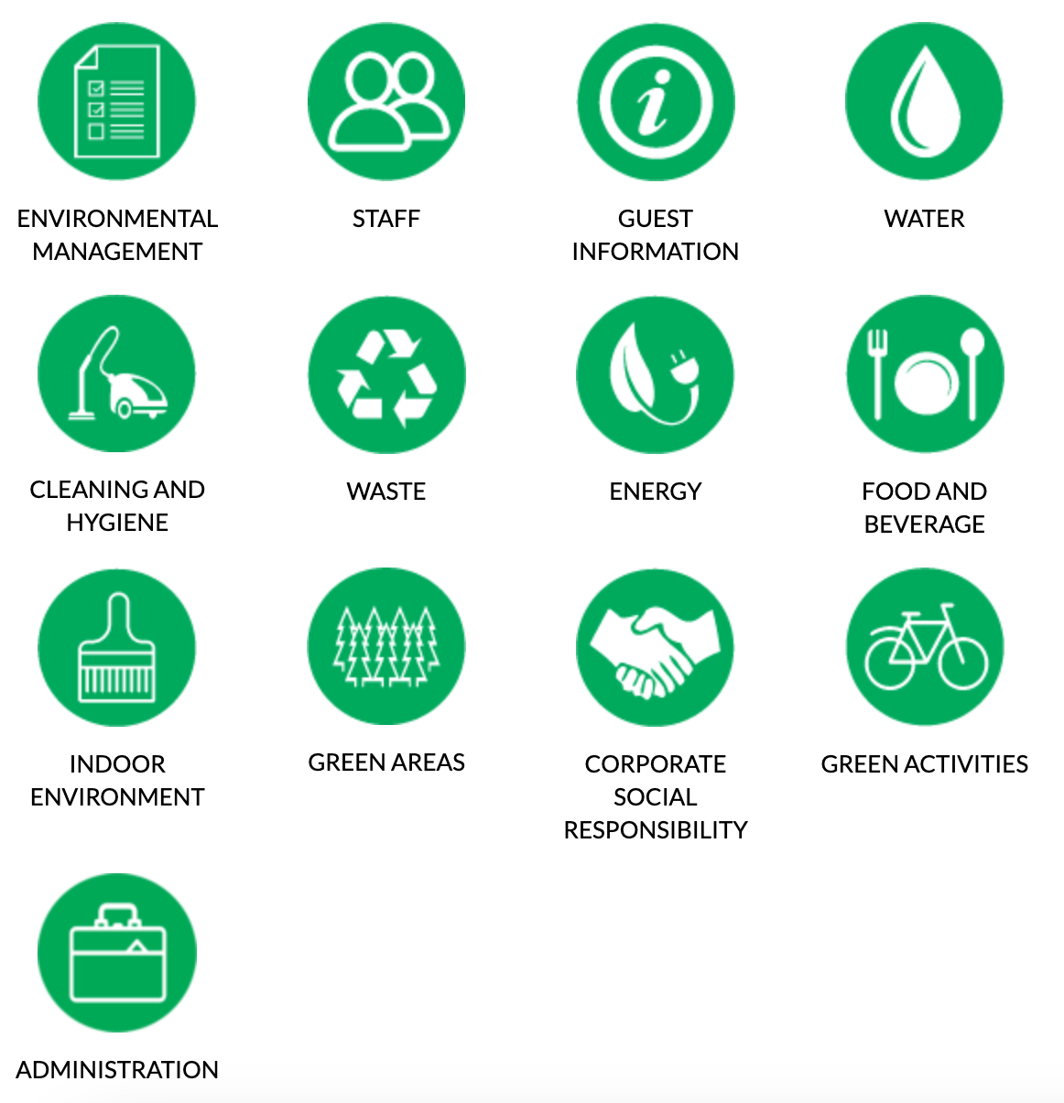

The Criteria is split into imperative and guidelines, meaning that for the imperative criteria the applicant must have met some criterias before even applying, abd the guidelines are something that they must change overtime while being monitored.

And the guidelines for receiving the green key accreditation is the following: Companies need to pick sustainable suppliers committed to sustainability, companies also need to eco-label all printed material or get them form Enviromental management systems, paper use reduction is also a must in this criteria, while the final criteria for supplier engagement is for laundry to be done within 100 kilometres of the hotel. (Huuhka, 2018)

The Green Activities part of the guidelines state that the business must share information on nearby parks and conservation areas, while information on sustainable transport such as bicycle rentals are mandatory alongside with tourist behaviour education.

Next is the CSR guidelines that hotels have to follow, including the adherence to international laws for human rights and non discrimination, along with every employee needing to be insured against workplace injury and ethical practices such as no trading of unprotected species, and animal welfare guidelines. Other guidelines also include accessibility for people with disabilities and support for the unemployed such as giving opportunities. (Castka, 2008)

For biodiversity compliance companies have to avoid chemical pesticides unless no natural alternatives exist, along with eco-friendly equipment such as electric lawnmowers. Water conservation procedures for water efficient gardening are also a necessity. (Mensah, 2019)

Compliance with Indoor air quality is apart of the Green Key accreditation, with smoking policies for staff needing to be put in place, and Non smoking areas for guests with fragile lungs. Along with air quality monitoring and allergy friendly rooms. (Catan, 2019)

Furthermore, sustainable food and beverage practices make up parts of Green key, with the use of organic, eco-labeled and fair trade, locally produced food products needing to be prepared in the kitchen. With the availability of vegan and vegetarian options being offered and vegan milk alternatives. And lastly, local ingredients must make up 50% of the food and beverages being sold, and a plan will be put in place for each applicant to reduce food wastage. (Cozzio, 2018)

Renewable energy is next, meaning hotels need to use efficient systems for heating, ventilation and air conditioning, and monitor their energy usage. Along with the obvious of using renewable energy solutions, and regular energy audits. (Girling, 2015)

Waste management is another key part in obtaining the green key certification, with waste separation such as recyclable and waste, handling hazardous waste properly, and minimisation of single use items, making up parts of the waste management criteria. (Kurdve, 2015)

Lastly, the last notable entry is water conservation, with hotels needing to monitor their water usage, while also installing water saving fixtures and leak detection systems, to ensure no unnecessary wastage happens, and coupled with water recycling systems such as collecting rain water, the green key award can be obtained. (Kurunthachalam, 2014)

Benefits of sustainability

The benefits of green are numerous, with the organisation giving you a comprehensive framework of how to begin to be sustainable, and how to continue to be sustainable, this makes it incredibly easy for hotels to be sustainable, or at least knowledgeable on how to continue being sustainable. (Brentjen, 2018) Which leaks into the next benefit of saving the planet and making sure, that on a human level the future generation have a planet to live with, for a business level this is to ensure the business will continue and will create a dynasty and a legacy to be proud of. (D,amato, 2009)

Other benefits are how eco aware customers will lookout for the green key accreditation, and will most likely choose hotels with such awards to align with their world views, and to better the world, as reports are showing more and more customers are choosing eco-friendly hotels, with ⅔ customers willing to pay more for sustainable products, due to the rise of eco awareness on social media. This directly correlates to increased profit as a benefit of sustainability, and even meaning hotels can increase their prices to justify the expense of increasing sustainable actions. (Shao, 2019) As realistically, hotels chase sustainability mostly for the opportunity to raise more money from stakeholders, both external and internal, although sustainability for internal stakeholders is a much bigger deal, due to investors using various tools to determine what a good investment looks like, one of these tools being the ESG rating set up by Blackrock, which scores businesses from one to one hundred on their environmental and social impacts, with the more sustainable and ‘’better for society’’ businesses, scoring higher. (Unruh, 2016) For hotels with sustainable practices their ESG ratings are considered high, and therefore receive heavy investment from investors, furthering the development of sustainable operations. (Berg, 2022)
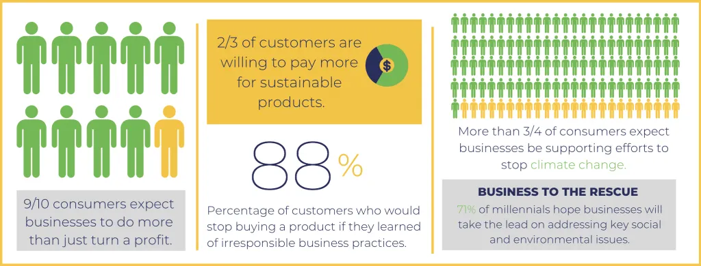

Challenges for sustainability

As for the challenges, the elephant in the room is the cost. Sustainable systems and equipment is still brand new and in development while being produced in small quantities. Meaning the small companies developing this expensive technology are forced to charge a high price due to numerous factors such as the lack of funding, the expensive nature of high quality tech, lack of mainstream demand etc. While the market for sustainability is still growing it remains incredibly more expensive than general technology, for example, the car market proves this point perfectly, with an electric car costing over £20,000, while some diesel fueled cars cost as low as £2000. And the same principle can applied to things like eco-friendly equipment like the electric lawnmower. (Jones, 2016)

Another challenge of integrating sustainability into everyday operations is the time needed to make such changes, big businesses may sometimes take as long as three days to even make the decision of switching their systems to something more sustainable. (Ricaurte,2012) For example, The Sokos Hotel Presidentti changed from oil to electric heating and ventilation, as well as cooling systems, in their renovation. This transformation significantly reduced the hotel’s environmental impact by eliminating the use of fossil fuels for these purposes and replacing them with more sustainable energy sources. This renovation took them two years and 6 months to complete, which is an incredibly long time for any business to wait and invest millions of pounds into an operation before seeing any benefit or return on investment. (Khatter, 2023) And this way for one hotel in the entire Sokos chain, for The Sokos company to implement this new technology across their entire business, it will take tens of millions of pounds and potentially a decade of work before finalised, making the executives question if the change is even worth it.

The final Few challenges come from the stakeholders and their input into the evolution of sustainability, a major roadblock is the lack of low awareness of sustainable tourism, and the disregard some guests have surrounding wastage. (Melissen, 2016) For example, it is typical for guests to assume that just because they are abroad and far from home it is okay to waste water/electricity/gas, just because its ‘’the hotel paying’’ when in fact it is the environment and the planet altogether who’s paying, and the hotels have little control over stopping this apart from spreading information and awareness of sustainable tourism. And I say little control due to the expense of changing every system to technology with limits on natural resources, and even if cost wasn't part of the equation, by limiting customers on services they deliberately pay for inst necessarily a solution as it could come with media backlash, and giving their competition an opportunity to advertise their services as ‘’limitless’’, and in the process losing their customers. (Diaz, 2024)

Stakeholders both internal and external are also not as involved as they could or should be, meaning some companies simply cannot afford to implement sustainable systems due to the lack of funding and attention given to the cause of moving to a more sustainable future, meaning that hotels are forced to delay change, change that could impact the environment in a massive way.

The future of hospitality

The future for hospitality is looking bright and green, with every hotel slowly incorporating sustainable systems and practices into their business. Although the time frame for a fully sustainable hospitality industry being many decades in the future, businesses make do with the funding and resources they currently have, organisations like blackrock and the green key foundation help to push companies into the right direction, and offer heavy rewards for any business that abides. We could see in the near future hotels either having a requirement for staff to come to work in an electric vehicle or loaning out EV’s to their staff to not limit their talent, or how many hotels are moving to a much more efficient electric heating system, and finding better ways to reduce wastage, while simultaneously spreading information around sustainable travelling, and kindly asking their guests to be mindful while staying at their hotels, with some east Asian hotels trying a much simpler solution to limiting usage, and instead opting for reminder’s sent as push notifications to the guests phone. (Malheiro, 2020)

Summary

In summary, Hotels have a huge list of different areas needing to be made more sustainable, before being granted a Green key certificate, with reduction of wastage, renewable energy, and fairly sourced food only making up a small part of the total requirement. However the benefits for abiding to the demands of eco-certifed authorities may potentially make up for the cost, as hotels may be flooded with eco-aware customers who are keen on supporting and even paying extra for eco-friendly products, while internal stakeholders such as investors, may decide to invest into businesses that are forward thinking using tools such as the ESG scores. Although, some investors arent as keen on sustainability, with one of the challenges being the opposite, with some investors hesitant to spend money and vote on sustainable changes as it may be seen as ‘’not profitable’’, or the challenges of getting tourists and guests onboard with being sustainable and caring about the environment. With the future lying in educating the masses on sustainability and more importantly its importance. Although there is hope for sustainability within the hospitality industry, as hotels are using what resources they have to make their operations much more sustainable.

References:

Berg, F., Koelbel, J.F. and Rigobon, R., 2022. Aggregate confusion: The divergence of ESG ratings. Review of Finance, 26(6), pp.1315-1344.
Brentjens, J.M., 2018. Benefits and complication of Green Key Certification in the Hotel. Based on example of the Hotel-en Leisure Group Zuid-Nederland.
Castka, P. and Balzarova, M.A., 2008. Social responsibility standardization: Guidance or reinforcement through certification?. Human systems management, 27(3), pp.231-242.
Catan, M., 2019. Environmental Practices in Hospitality Industry for a more Sustainable Tourism (Case Study-Sheraton Lisboa Hotel & Spa) (Doctoral dissertation).
Cozzio, C., Bullini Orlandi, L. and Zardini, A., 2018. Food sustainability as a strategic value driver in the hotel industry. Sustainability, 10(10), p.3404.
D’amato, A., Henderson, S. and Florence, S., 2009. Corporate social responsibility and sustainable business. A Guide to Leadership tasks and functions, 102.
DIAZ JR, N.B., 2024. Sustainability Practices, Opportunities, and Challenges of Hospitality Industry in the New Normal. Educational Administration: Theory and Practice, 30(4), pp.7748-7763.
Girling, R., Gordy, H. and Lanier, P., 2015. The Good Company: Sustainability in Hospitality, Tourism, and Wine. Business Expert Press.
Huuhka, J., 2018. Green Key-certification application process: Case Hotel Kalliohovi and Hotel Raumanlinna.
Jones, P., Hillier, D. and Comfort, D., 2016. Sustainability in the hospitality industry: Some personal reflections on corporate challenges and research agendas. International Journal of Contemporary Hospitality Management, 28(1), pp.36-67.
Khatter, A., 2023. Challenges and Solutions for Environmental Sustainability in the Hospitality Sector. Sustainability, 15(15), p.11491.
Kurdve, M., Shahbazi, S., Wendin, M., Bengtsson, C. and Wiktorsson, M., 2015. Waste flow mapping to improve sustainability of waste management: a case study approach. Journal of Cleaner Production, 98, pp.304-315.
Kurunthachalam, S.K., 2014. Water conservation and sustainability: an utmost importance. Hydrology: Current Research, 5(2), p.1.
Malheiro, A., Sousa, B.B., Liberato, D. and Liberato, P., 2020, April. Sustainability in tourism and hospitality: Trends and challenges. In 35th IBIMA conference education excellence and innovation management: A 2025 vision to sustain economic development during global challenges(pp. 15545-15555). IBIMA.
Melissen, F., van Ginneken, R. and Wood, R.C., 2016. Sustainability challenges and opportunities arising from the owner-operator split in hotels. International Journal of Hospitality Management, 54, pp.35-42.
Mensah, I., 2019. Environmental management concepts and practices for the hospitality industry. Cambridge scholars publishing.
Mzembe, A.N., Lindgreen, A., Idemudia, U. and Melissen, F., 2020. A club perspective of sustainability certification schemes in the tourism and hospitality industry. Journal of Sustainable Tourism, 28(9), pp.1332-1350.
Ricaurte, E., 2012. The hospitality industry confronts the global challenge of sustainability.
Shao, J. and Ünal, E., 2019. What do consumers value more in green purchasing? Assessing the sustainability practices from demand side of business. Journal of Cleaner Production, 209, pp.1473-1483.
Unruh, G., Kiron, D., Kruschwitz, N., Reeves, M., Rubel, H. and Zum Felde, A.M., 2016. Investing for a sustainable future: Investors care more about sustainability than many executives believe. MIT Sloan Management Review, 57(4).

