

Cover Page

Student Name: Precious Grant Whittaker

Student Number: 2412252

Module Name: Changemakers: Creativity and Value Creation

Module Code: BMHP14

Lecturer Name: Raheela Shaikh

Task 1 – Concept Map
Create a concept map that outlines the relationship between creativity, value creation, and health and social care improvement. Within the concept map explain how these concepts interact in a health and social care context

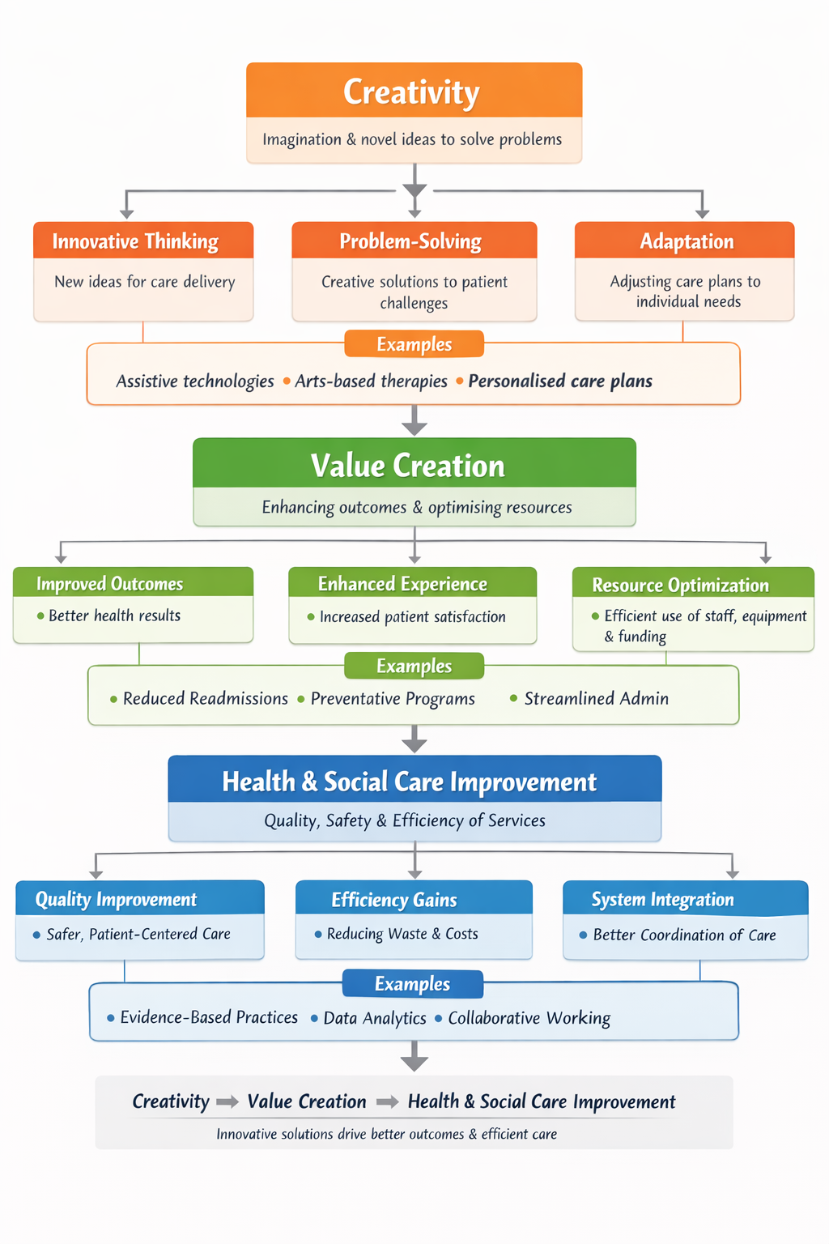
Concept Map: Creativity, Value Creation, and Health & Social Care improvement.
Source: Created with Canva style template
Creativity plays a crucial role in generating value within health and social care because it allows professionals to design new and more effective ways of supporting patients (NHS England, 2019). When practitioners use creative thinking to solve problems, they can refine how services are delivered, adjust interventions to suit individual needs, and make better use of limited resources (West et al., 2015). These improvements directly contribute to value creation by raising the standard of care and enhancing the overall patient experience.
Value creation, in turn, underpins wider service improvement by strengthening the quality, safety, and efficiency of care systems (Porter, 2010). For instance, reimagining how services are organised or how care plans are developed can lead to smarter resource allocation, reducing unnecessary expenditure while still maintaining high-quality support (Department of Health and Social Care, 2021). Creative thinking also enables staff to personalise care more effectively, which is linked to better outcomes and higher levels of patient satisfaction (World Health Organization, 2016).
Creativity additionally supports stronger teamwork. When multidisciplinary groups share ideas and explore different perspectives, they can develop more holistic approaches to care, improving communication, continuity, and patient involvement in decisions (NHS England, 2019). This mindset also encourages ongoing innovation, helping services adapt to shifting population needs, workforce pressures, and financial constraints.
Overall, creativity, value creation, and continuous improvement are closely connected. Together, they help shape health and social care systems that are high-quality, patient-centred, equitable, culturally sensitive, and capable of evolving to meet the needs of diverse communities across different care settings.

Task 2 - Self-Reflection of Group Activity
Complete a self-Reflection on the Convergent/Divergent paperclip thinking class activity using a reflective model

Self-Reflection on Convergent/Divergent Paperclip Activity (Gibbs’ Reflective Cycle)

Description
In Week 2, our group of six took part in a paperclip challenge aimed at helping us experience both divergent and convergent thinking. We began by generating as many creative uses for a paperclip as possible within ten minutes. The emphasis was on open, judgement-free idea generation. I naturally stepped into a facilitative role, encouraging quieter members to speak up and making sure every suggestion was captured.
The second stage required us to narrow down the ideas by assessing their practicality and safety. This part was noticeably more difficult, as people had different views on what counted as “practical” or “safe.” Even so, we eventually reached a shared decision and chose three low-risk options: using a paperclip as a cable organiser, a seed maker, and a temporary fabric stitch holder.

Feelings
During the brainstorming phase, I felt energised and genuinely enjoyed the collaborative creativity in the room. When we moved into evaluation, my feelings shifted. The disagreements slowed us down, and I found myself becoming slightly frustrated. I was also aware of the responsibility I had taken on in guiding the discussion fairly while keeping everyone engaged.

Evaluation
The activity highlighted how essential divergent thinking is for generating fresh ideas, while convergent thinking is equally important for refining those ideas into something workable and safe. My facilitation helped create an inclusive atmosphere, but managing conflicting viewpoints was more challenging than I expected. This made me realise how valuable structured decision-making tools can be when a group needs to move from creativity to clarity.

Conclusion and Action Plan
Overall, the experience reinforced the need to balance imaginative thinking with organised evaluation to work effectively as a team. Gibbs (1998) emphasises that reflection supports ongoing learning, and this exercise certainly did that for me. In future group tasks, I plan to introduce clearer criteria before we begin evaluating ideas and to guide discussions in a more structured way. This should help ensure that everyone’s perspective is heard while keeping the group focused on reaching practical, well-reasoned outcomes.

Task 3 - Case Study of a UK innovation
Write a concise case study analysis of an innovative project or initiative within the NHS or UK social care. Focus on how creativity was used to drive change and the value it created for patients or service users.

Case Study: NHS West Midlands’ Adult Community Rehabilitation Digital Hub

Introduction
The Adult Community Rehabilitation Digital Hub, launched in 2024, was created to support adults recovering from strokes, orthopaedic procedures, and long-term mobility issues. It was introduced in response to ongoing problems in post-discharge care across the West Midlands, such as uneven access to rehabilitation, poor adherence to therapy plans, and high rates of hospital readmission (NHS West Midlands, 2025). These issues often left patients struggling to regain independence and confidence once they returned home.
The initiative brings together several key partners: University Hospitals Birmingham NHS Foundation Trust, community care teams, patients and their families, and the technology provider Teladoc Health (Teladoc Health, 2024). Close collaboration between clinicians and digital specialists ensured that the service was both clinically robust and easy for patients to use, reflecting a genuinely multidisciplinary approach to service innovation.

Creativity and Innovation
The hub showcases creativity by rethinking rehabilitation as something that can extend beyond traditional clinic settings and adapt to the needs of everyone. A central innovation is the adaptive digital platform, which adjusts exercise plans and educational materials to suit each person’s mobility, learning preferences, and daily routines. This system was co-designed with 80 patients and rehabilitation professionals to ensure it was accessible and meaningful (Teladoc Health, 2024).
Another creative element is the use of augmented-reality-supported virtual home visits. Therapists can observe movement, guide exercises, and give immediate feedback without needing to be physically present, which reduces travel demands and helps patients stay consistent with their programmes (NHS West Midlands, 2025). The addition of peer support groups also strengthened the service by giving patients opportunities to share experiences, encourage one another, and build confidence during recovery.
These innovations directly tackled long-standing barriers to rehabilitation. Before the hub was introduced, 60% of patients missed at least one weekly session due to transport or scheduling issues; this dropped to 15% afterwards (NHS West Midlands, 2025). To ensure no one was excluded, the programme also offered tablets, one-to-one digital training, and a dedicated support line for those unfamiliar with technology (Teladoc Health, 2024).

Value Creation
The hub has delivered clear benefits for patients, carers, and healthcare providers. Readmission rates for stroke and orthopaedic patients fell by 28%, and completion of rehabilitation programmes increased by 35% (NHS West Midlands, 2025). These improvements suggest stronger continuity of care and more effective recovery pathways.
Patients also reported feeling more in control of their rehabilitation, with 82% describing increased confidence in managing their recovery compared with 41% before the hub was introduced (Teladoc Health, 2024). Carers experienced benefits too: 76% said they spent less time organising appointments, indicating a meaningful reduction in their workload (NHS West Midlands, 2025).
By combining digital tools, personalised support, and opportunities for peer connection, the hub achieved more than clinical improvements it enhanced patient satisfaction and engagement. Its success has positioned it as a scalable model for community-based rehabilitation across NHS England (Teladoc Health, 2024).

Task 4 - Research Task
Identify a current issue in health and social care (e.g. e.g., mental health stigma, access to care for vulnerable populations). Find two pieces of academic research (journal articles) that explain the reason for this problem. Paraphrase the findings of each article.

Delayed Transfers of Care in the UK
Delayed transfers of care repeatedly described as bed blocking happen when a patient is clinically ready to leave hospital but cannot be discharged because the necessary community support, social care, or suitable accommodation is not yet in place. This situation places additional strain on NHS capacity by reducing the number of available beds (The Health Foundation, 2025).
Smith et al. (2022) investigated how older adults experience these delays through a qualitative study. They found that the causes were rarely isolated; instead, delays tended to stem from a combination of limited social care provision, weak coordination amongst health and social care services, and inconsistent communication among staff, patients, and families. Many participants described feeling anxious and frustrated, as they were eager to return home but were unable to do so. The authors argue that discharge planning should be more person-centred, with clearer communication and greater involvement of patients and carers. Improving these areas could help reduce delays and lead to a more positive discharge experience.
Glasby, Dickinson, and Littlechild (2015) focused on how partnership working between health and social care organisations influences discharge processes. Their research showed that strong collaboration is essential for preventing delays, yet partnerships often struggle due to competing organisational priorities, administrative complexity, and limited shared resources. They suggest that effective joint working relies on strong leadership, clear lines of accountability, and investment in building trusting relationships across agencies. Strengthening these partnerships can help remove structural barriers and ensure that patients receive the support they need without unnecessary waiting.
Taken together, these studies show that delayed transfers of care are shaped by wider system-level issues, particularly poor coordination and weak inter-agency collaboration. Tackling these challenges through integrated, patient-centred approaches and stronger partnership working is crucial for improving patient flow, reducing pressure on hospital beds, and enhancing the overall quality of care across the UK.
Task 5 – Podcast
Record a two-minute Podcast introducing your idea for component 2 using https://www.rev.com/onlinevoicerecorder The MP3 audio must be downloaded and embedded as a file (see guidance video on how to do this here: https://www.youtube.com/watch?v=D21isId0agw) or an accessible OneDrive link if using a chromebook (make accessibility – anybody) before inserting into your portfolio. Check the accessibility of the link before submitting.


Introducing my idea for component 2

my-recording.mp3 <<<< Click the link

Task 6 - NHS Leadership Framework Analysis

Write a short summary explaining the key components of the NHS Leadership Framework. Then, choose one component and describe how a leader might use it to encourage creativity and improve care in the NHS.

NHS Leadership Framework Analysis

Summary of the NHS Leadership Framework
The NHS Leadership Framework delivers a organised guide for developing leadership capability across the workforce, emphasising that leadership is not limited to senior roles but is expected from staff at every level. Created by the NHS Leadership Academy (2011), the framework is organised into seven domains. The first five focus on personal qualities, working effectively with others, managing services, improving them, and setting a clear direction. These areas highlight the behaviours that underpin safe, high-quality care such as self-reflection, integrity, collaborative practice, and responsible use of resources.
The final two domains Creating the Vision and Delivering the Strategy shift towards organisational leadership. They involve shaping long-term goals, influencing others, and ensuring that strategic plans translate into meaningful, sustainable improvements. When these domains are used together, they help build a culture where learning, accountability, and shared responsibility are embedded in everyday practice. Research supports this approach, showing that collective leadership strengthens staff engagement and drives service improvement (West et al., 2015).
Overall, the framework ensures that leadership behaviours remain aligned with NHS values, particularly compassion, high-quality care, and a strong focus on patients.

Applying the Improving Services Domain to Encourage Creativity
The Improving Services domain centres on innovation, critical evaluation, and leading change to enhance patient outcomes (NHS Leadership Academy, 2011). Leaders who apply this domain effectively create an environment where staff feel able to question existing routines, propose new ideas, and work together to refine care processes. Establishing psychological safety is key, as it encourages team members to share creative suggestions without fear of judgement.
Critical evaluation also plays an important role, helping teams identify where current practices are no longer effective and where new approaches might be needed. For instance, a leader might trial a digital feedback tool to involve patients in co-designing services or pilot a new model for discharge planning. Evidence shows that leadership which actively supports innovation is linked to higher staff engagement, better efficiency, and improved patient safety (West et al., 2015).
Embedding creativity within the Improving Services domain ensures that care remains adaptable, forward-thinking, and responsive to the changing needs of patients.

Task 7 - Self-Reflection Journal Entry
Write a short journal entry about what you learned in this module. Focus on how your understanding of creativity and value creation withing H&SC has changed and how it has informed your professional practice.

Self-Reflection Journal Entry
This module has reshaped how I understand creativity and value creation within Health and Social Care. I previously associated innovation mainly with new technologies, but I now see it as the purposeful use of creative thinking to question established practices and improve outcomes for patients and service users.
Learning about divergent and convergent thinking has strengthened my ability to generate a wide range of ideas and then narrow them down into realistic, workable solutions. This approach is especially relevant when considering ongoing NHS pressures such as staffing shortages and financial constraints (Davies, 2019).
Week 9 also highlighted the crucial role of leadership in enabling creativity. As Fullan (2016) argues, effective leaders empower others, encourage experimentation, and create the conditions where collaboration and person-centred care can flourish demonstrating that value is created not only through efficiency but through shared problem-solving.
Using Gibbs’ Reflective Cycle has helped me evaluate my practice more systematically and identify areas for development in line with Care Quality Commission standards (2026). I have also gained a deeper appreciation of how digital tools, including Electronic Health Records, can strengthen communication and support continuity of care.
Looking ahead, I intend to apply leadership principles and structured innovation methods within my practice. By doing so, I hope to contribute to care that is responsive, creative, and consistently aligned with high-quality, person-centred values.

Reference List
Borton, T. (1970) Reach, touch and teach: Student involvement in the learning process. McGraw-Hill, New York. Available at: https://doi.org/10.1037/10006-000 (Accessed: 21 January 2026).
Care Quality Commission (2026). Care Quality Commission. Available at https://www.cqc.org.uk (Accessed: 10 February 2026).
Coccia, M. (2019) ‘Creativity and innovation in health and social care: a systematic review’, Journal of Health Services Research & Policy, 24(4), pp. 211–220. Available at: https://doi.org/10.1177/1355819618816668 (Accessed: 5 February 2026).
Davies, H.T.O., Nutley, S.M. and Mannion, R. (2005) ‘Organizational culture and quality of health care’, Quality and Safety in Health Care, 14(2), pp.111–119. Available at: https://doi.org/10.1136/qshc.2005.015766 (Accessed: 5 February 2026).
Department of Health and Social Care (2021). Integration and innovation: working together to improve health and social care. Available at: https://www.gov.uk/government/publications/working-together-to-improve-health-and-social-care-for-all/integration-and-innovation-working-together-to-improve-health-and-social-care-for-all-html-version (Accessed: 22 February 2026).
Fullan, M. (2016). The New Meaning of Educational Change. 5th Edn. Teachers College press: London.
Gibbs, G. (1988). Learning by Doing: A guide to teaching and learning methods. London: Further Education Unit.

NHS England (2019). The NHS Long Term Plan. Available at: https://webarchive.nationalarchives.gov.uk/ukgwa/20250707103655/https://www.longtermplan.nhs.uk/ (Accessed 22 February 2026).
NHS Leadership Academy (2011). Leadership Framework: A summary. Warwick: NHS Institute for Innovation and Improvement. Available at: https://www.leadershipacademy.nhs.uk/wp-content/uploads/2012/11/Leadership-Framework-A5-Handout.pdf (Accessed 21 February 2026).
NHS England (2022). Framework for innovation in health and social care. NHS England. Available at: https://www.england.nhs.uk/publication/framework-for-innovation/ (Accessed: 13 February 2026).
NHS West Midlands (2025). Adult Rehabilitation Digital Hub: Annual Evaluation Report. Available at: https://www.nhs.uk/westmidlands/health-services/adult-rehabilitation-hub-evaluation (Accessed: 27 January 2026).
Porter, M.E. (2010) ‘What is value in health care?’, New England Journal of Medicine, 363(26), pp. 2477–2481. Available at: https://doi.org/10.1056/nejmp1011024 (Accessed 21 February 2026).
Rolfe, G., Freshwater, D. and Jasper, M. (2001) ‘Critical reflection in nursing and the helping professions: A user’s guide’, Palgrave Macmillan, Basingstoke. Available at: https://doi.org/10.1057/9780230286111 (Accessed: 21 January 2026).

Smith, H., Grindey, C., Hague, I., Newbould, L., Brown, L., Clegg, A., Thompson, C. and Lawton, R. (2022). ‘Reducing delayed transfer of care in older people: A qualitative study of barriers and facilitators to shorter hospital stays’, Health Expectations, (25)6, pp.2628-2644. Available at: https://doi.org/10.1111/hex.13588 (Accessed: 01 February 2026).

Teladoc Health (2024). Innovating Post-Acute Care for Adults: NHS West Midlands Digital Hub Case Study. Available at: https://www.teladochealth.com/uk/case-studies/nhs-west-midlands-rehabilitation (Accessed: 27 January 2026).

The Health Foundation (2025). Delayed Discharges from Hospitals. Available at: https://www.health.org.uk/reports-and-analysis/analysis/delayed-discharges-from-hospital-comparing-performance (Accessed: 26 January 2026).
West, M., Armit, K., Loewenthal, L., Eckert, R., West, T. and Lansar, A. (2015). Leadership and Leadership Development in Healthcare: The Evidence Base London, Faculty of Medical Leadership and Management Kings Fund, pp.36. Available at: https://eprints.soton.ac.uk/439515/ (Accessed: 28 January 2026).
West, M., Eckert, R., Collins, B. and Chowla, R. (2017) ‘Caring to change: How compassionate leadership can stimulate innovation in health care’. London: The King’s Fund. Available at: https://assets.kingsfund.org.uk/f/256914/x/0b76247d02/caring_to_change_2017.pdf (Accessed 21 February 2026)
World Health Organization (2016) Framework on integrated, people-centred health services. Geneva: WHO. Available at: https://apps.who.int/gb/ebwha/pdf_files/wha69/a69_39-en.pdf (Accessed 01 February 2026).
World Health Organization (2021). Innovation for universal health coverage. Available at: https://www.who.int/publications/i/item/9789240037346 (Accessed: 13 February 2026).
Zhou, J. and Shalley, C.E. (2005) ‘Domain-General and Domain-Specific Creative-Thinking Tests: Effects of Gender and Item Content on Test Performance’, Journal of Creative Behaviour: factors, 39(4), pp. 237–257.

