Name: Samad Tawfiq
Student number:
2212531
Module: BMIH6007
International Meetings Management for the Hotel Industry, Level 6
Tutor’s name: Kathrn Flynn
The assignment title: Planning and Delivering an International Meeting/Event.
Word count: 2568

This report provides an analysis of the strategic planning and delivery considerations for Winter Wonderland in Stoke-on-Trent. This event has festive attractions, fairground rides, food stalls, and Christmas market, it is a popular event in the city. This year is going to take place in Trentham Gardens, easily accessible outdoor area in Stoke-on-Trent, transforming it into a winter-themed destination for the holiday season.

This report shows the Winter wonderland’s audience, its economic impact on the local area, and the logistical challenges. Stoke-on-Trent’s strategic location in the Midlands makes it accessible to both regional and local audiences, which increases the importance of efficient planning and performance. Stoke-on-Trent, commonly known as Stoke, is a city in Staffordshire, England, covering 36 square miles. As of 2022, it had an estimated population of 259,965, making it the largest settlement in Staffordshire. (Visitstoke 2024)
Winter Wonderland in Stoke-on-Trent is a winter celebration held between November and January. It attracts families, friends, and tourists looking to enjoy the holiday spirit. It offers activities such as ice skating, Christmas markets, live performances, and carnival rides, all in an outdoor setting. This event is planned to promote community engagement, support local businesses and generate tourism revenue. (Bell 2009)

The event's outdoor venue has lots of challenges and opportunities in terms of layout, accessibility, and weather-related contingencies. The winter season adds complexity to logistics, requiring planning for both guest experience and safety. Effective strategic planning and delivery are crucial to ensuring success of the event. (Getz 2007)

The event cycle
The Event Cycle refers to the of stages involved in planning, executing, and evaluating an event. This cycle ensures thorough preparation, smooth operation, and effective post-event analysis. The Event Cycle includes stages such as concept and feasibility, planning, implementation, the event itself, and evaluation. Each stage requires specific activities and coordination to support the overall goals and objectives of the event. (Allen et al., 2011)
For Winter Wonderland in Stoke-on-Trent, the Event Cycle provides a structured framework to manage this large-scale event. The application of the Event Cycle to Winter Wonderland:

- Objective: Attract residents, families, and tourists; enhance the holiday spirit in Stoke-on-Trent; create a memorable experience.

- Budget overview:

Expenditure:

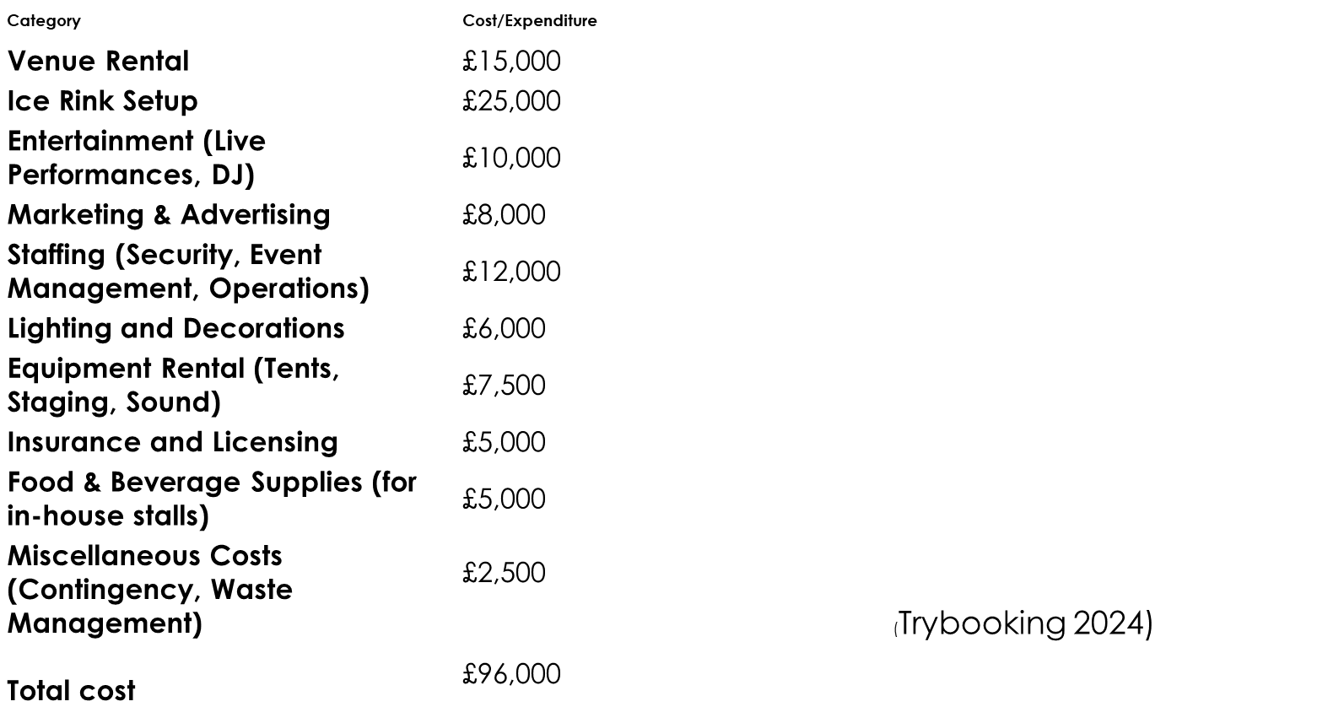

Predicted revenue:
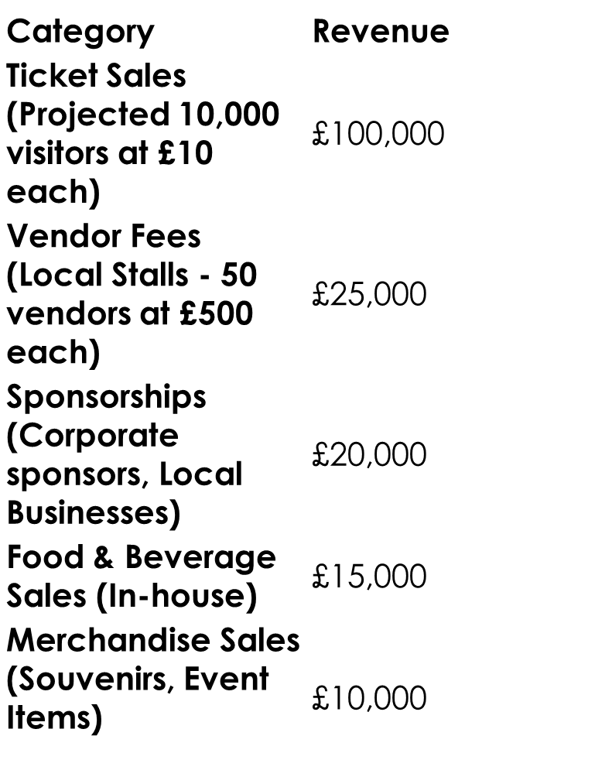
Projected Profit:
Total Revenue: £170,000
Total Expenditure: £96,000
Net Profit: £74,000

- Date and venue: Choosing the right dates for our Winter Wonderland is crucial for maximizing attendance, minimizing operational challenges, and ensuring a positive visitor experience. We have considered the followings: peak holiday season, local school holiday, weather, competitors. Based on the above factors, November 22th to January 6th could be an ideal range for Winter Wonderland in Stoke-on-Trent.
This period includes:
Late November Start: Begins right at the Black Friday shopping weekend, encouraging early holiday excitement.
Christmas and New Year: Operates during the peak holiday season, maximizing attendance opportunities.
First Week of January End: Captures post-holiday family outings and school breaks, for those who prefers quieter experiences. (Mackenzie 2014)

- Search for speakers, sponsors, and performers: Securing the venue, booking vendors and entertainment, developing safety protocols, and design a promotional campaign at this stage is required.

List of potential speakers, entertainers Winter Wonderland in Stoke-on-Trent:
- Local government representator: To open the event, welcome attendees, and speak on the importance of community events for Stoke-on-Trent.
- Celebrities, media personalities: Local radio who are well-known in the community, such as Hits Radio presenters, who can help promote the event through their platforms.
- Holiday themed performers: : Local actors, children’s authors, or performers who can engage children with interactive, festive activities on the daily basis.
- Singers, bands: Live singers, bands every Friday and Saturday evening during the festive season.
- Health ad safety representative: Representatives from local health services or community safety organizations who can provide safety information and peace of mind to attendees.
- Celebrity chef or baker: A local chef or baker who specializes in seasonal cuisine from a notable Stoke-on-Trent restaurant or bakery who can do a live cooking baking show every Sundays during the festive season. (addevent 202)
List of sponsors:

- Loval shopping centres: Intu Potteries, Range, Trantham village. These sponsors benefit from increased traffic during the holiday season and align well with the event’s shopping and gift-giving theme.
- Local and national coffee shops: Costa Coffee, Greggs, Britannia coffee shop. Hot drinks, snacks, and seasonal treats are popular at outdoor winter events, and these brands could sponsor food stalls.
- Local and national charities: British Heart Foundation, Douglas Macmillan Hospice, or Shelter. Partnering with a charity can encourage donations, promote a sense of community. Charity partners could educate visitors about their mission and how they can help.
- Health and wellness brands: Boots, Holland & Barrett, or Bupa Health Clinics. Health-conscious brands could provide hand-warming stations, first aid booths, or sponsor health and wellness initiatives at the event.
- Transportation service: First Bus, uber, Lucky seven taxies. Providing easy access to and from the event can improve attendance. These sponsors could offer discounted fares or dedicated event shuttles.
- Local Craft Breweries: Titanic Brewery or Keele University Brewery. Local breweries can showcase seasonal drinks, adding a festive element to the event’s food and beverage options. They could sponsor an outdoor bar. (Gartner 2024)

- Visualize sales lifecycle:
- Pre-Event Awareness and Early Sales ( 2-3 month before the event): Offering discounts to encourage early sales, campaigns on social media, local radio, and flyers to build awareness.
- Peak Sales (2- 3 weeks before the event): Offering bundled pricing or group discounts, targeting families and schools. Increasing marketing efforts, including paid ads, influencer partnerships, and email campaigns.
- Last minute sales (1-2 weeks before the event- during the event): Offering flash sales or promo codes for specific time slots to boost remaining ticket sales. Using countdowns on social media and email, emphasizing limited availability.
- On site sales during the event: Offering extra activities, such as photos with Santa, ice skating, or carnival games to increase revenue. Setting up stalls for festive merchandise, snacks, and seasonal beverages.
- Post-Event Engagement and Retention: Sharing event highlights, photos, and videos to keep attendees engaged and attract future visitors. Sending surveys to attendees to gather feedback on their experience(Kotler and Keller 2015)

- Track of paperwork: Many activities need some sort of paperwork, including contracts, licenses, and permits. We need to have copies organised to ensure that all of your legal affairs are in order.

- Staffing: Types of Staff Required
- Event Management Team: Oversee the event operations, handle any logistical issues, coordinate with vendors, and manage overall flow.
- Security Personnel: Maintain a safe environment, enforce entry protocols, monitor for safety risks, and respond to emergencies.
- Ticketing and Admissions Staff: Manage entry points, check tickets, sell tickets on-site, and provide information on event activities.
- Guest Services Staff: Assist attendees with directions, event information, accessibility services, and other visitor needs.
- Concessions Staff: Operate food, beverage, and merchandise stalls, handling both sales and inventory management.
- Maintenance and Clean-Up Crew: Regularly clean high-traffic areas, empty trash, and ensure restrooms and facilities are clean.
- Entertainment and Activity Facilitators: Staff for specific attractions like Santa’s Grotto, photo booths, ice skating, or carnival games to enhance guest experience.
- Medical and First Aid Staff: Provide immediate medical assistance for minor injuries or emergencies, given the outdoor and often cold conditions.

- Seamless experience: Using event technology, such as RFID entrance badges and applications that facilitate networking and navigation for participants, can help you control the chaos and provide an incredible experience. Additionally, queues at food stands and merchandise booths can be significantly shortened by using mobile or RFID cashless payments. (Eventbrite 2024)

After the event
- Distribute post-event surveys: post event survey to attendees to find out how much they enjoyed and engaged with your event. We can find out what they would like to see you offer in the future by asking them for suggestions.
- Track our revenue and ROI: calculating our profit and return on investment on our event.
- Compare our budgeting and planning with the result and outcome: recall the objectives we established in the pre-planning stage and contrast the real outcomes with the desired outcome. then examine the areas in which we failed. (Jago and Shaw 2014)

Event concept:
This itinerary is designed to provide a well-rounded experience for guests, combining entertainment, food, shopping, and memorable activities while maintaining a magical and festive atmosphere throughout Winter Wonderland. The event aims to create lasting memories for families, young children, and the local community. (Piratex 2023)

Itinerary 14th December 2024 Saturday
11 am: Event Opens: Arrival and Welcome- Main entrance. Staff will provide maps of the venue and event schedules. A photo booth area with themed props for guests to take a winter wonderland family photo.
  - am: Ice skating opens- Guests can enjoy a scenic ice skating experience on a large outdoor rink, surrounded by glowing winter lights and snow-covered trees.
12.30pm: Visit Santa’s grotto- Guests enter a festive winter wonderland setting, where they meet Santa Claus in a beautifully decorated grotto.
1pm: Main stage life performance- Street performers and roaming entertainers, such as magicians, jugglers, and stilt walkers, will interact with guests.
2pm: Christmas markets-Guests can wander through a traditional Christmas market, filled with local artisans and vendors selling handmade crafts, festive decorations, and unique holiday gifts.
4pm: winter parade- A festive parade featuring dancers, performers, and illuminated floats traveling around the event space
5pm: Winter festive rides- Winter festive rides will provide some exiting experience for children and adult alike.
6pm -9pm: Life music and entertainment- A local band will perform live music, with guests encouraged to sing along to festive songs. A dance floor will be set up for families to dance to Christmas hits. (Shone and Parry 2013)

Aim and Objectives for Winter Wonderland Event

Overarching Aim:
To create an engaging, festive, and memorable experience for families and the local community by delivering a safe, enjoyable, and vibrant Winter Wonderland event in Stoke-on-Trent that promotes holiday spirit, supports local businesses, and attracts a diverse audience. (ThisvsThat 2024)

SMART Objectives:
- Increase Attendance:

Specific: Increase ticket sales by 20% compared to the previous year.
Measurable: Achieve 10,000 ticket sales by the end of the event.
Achievable: Implement targeted marketing campaigns through social media, local partnerships, and early-bird promotions.
Relevant: A higher attendance will improve the event's overall atmosphere and benefit local vendors and sponsors.
Time-bound: Achieve this goal by the end of the event (06.01.2025).

- Enhance Guest Experience:

Specific: Achieve a guest satisfaction rating of 85% or higher through surveys and feedback forms.
Measurable: Distribute surveys to at least 500 attendees and ensure a minimum of 85% satisfaction.
Achievable: Provide quality entertainment, food, and amenities, and ensure staff are trained to engage with guests effectively.
Relevant: High guest satisfaction is critical for encouraging repeat attendance in future years and fostering positive word-of-mouth.
Time-bound: Collect feedback and measure satisfaction during and immediately after the event. (Doran 1981)

Event Management: Skills and Resources for Winter Wonderland Event
Successfully managing an event like Winter Wonderland in Stoke-on-Trent requires a wide array of skills and resources across multiple areas. Here is a detailed breakdown of the key skills and resources needed for each area:

1. Operational Management
Skills Required:
Project Management: Ability to oversee all logistical aspects of the event, ensuring each component is delivered on time and within budget.
Problem-Solving: Quick thinking and decision-making to handle unexpected issues such as weather disruptions or technical problems.
Logistics Coordination: Planning the physical setup of the event (e.g., ice skating rink, Santa’s Grotto, vendor booths) and coordinating the movement of equipment and staff.
Risk Management and Safety: Identifying potential risks (e.g., crowd control, weather conditions) and developing contingency plans.
Staff Management: Supervising event staff and volunteers, assigning tasks, and maintaining high levels of motivation and performance. (Bowdin et al 2010)

2. Planning and Coordination
Skills required:
Time Management: Coordinating the event’s timeline and ensuring all activities are scheduled effectively to avoid overlap or downtime.
Vendor and Supplier Negotiation: Securing contracts with vendors (e.g., food and beverage providers, entertainers) and negotiating favourable terms.
Stakeholder Engagement: Communicating with local authorities, sponsors, and community groups to ensure alignment with the event's objectives.
Marketing and Communications Coordination: Aligning marketing strategies with event schedules and ensuring consistent messaging. (Indeed 2024)

3. Marketing and Promotion
Skills Required:
Marketing Strategy: Ability to develop a comprehensive marketing plan to attract attendees and build excitement before, during, and after the event.
Digital Marketing: Expertise in using social media platforms (Facebook, Instagram, Twitter, TikTok) to promote the event, engage with attendees, and share real-time updates.
Content Creation: Ability to create compelling promotional materials, including posters, videos, and online ads, to highlight the event's features. (Hoyle 2002)

4. Staff and Volunteers
Skills Required:
Customer Service: High-level interpersonal skills to interact with guests and handle inquiries, complaints, or requests in a professional manner.
Training and Development: Ability to train event staff, ensuring they understand their roles, responsibilities, and safety protocols.
Team Leadership: Strong leadership skills to motivate staff and volunteers to work efficiently and provide an excellent guest experience. (Eventbrite 2023)

Industry Trends, Issues, and Impacts in the Meetings and Events Industry
The meetings and events industry is constantly evolving, shaped by societal, technological, and environmental factors. Below are some of the latest trends, issues, and impacts that influence the industry.
Trend: Increasing Demand for Sustainable Events
Winter Wonderland could face increasing expectations from the public and sponsors for sustainability efforts. The event can incorporate green initiatives such as:
- Using recyclable or compostable materials for food packaging.
- Partnering with local, sustainable vendors for food and products.
- Reducing energy consumption by using LED lights and minimizing waste during the event. (Holacon 2024)

Trend: Hybrid and Virtual Events
- Live-streaming key events, such as performances, parades, or special guests, to engage remote audiences.
- Creating virtual tours for those unable to attend, showcasing different attractions and activities at the event.
- Online ticket sales and digital payment systems for a more seamless attendee experience.
- Social media engagement (e.g., Instagram stories, TikTok challenges, or Facebook live events) to increase engagement with a broader audience. (Eventbrite 2024)

Situational and Cultural Considerations for Winter Wonderland in Stoke-on-Trent
When organizing an event like Winter Wonderland in Stoke-on-Trent, it is essential to consider various situational and cultural factors that could influence its success. These factors include the local community’s values, social behaviour, economic conditions, environmental concerns, and political or legal constraints. A PESTEL analysis can be an effective business analysis tool to explore these external factors that may affect the event’s planning and execution. (Jonhson et al. 2008)

Pestle analysis on our event
Political factors:
- Local government regulations
- Government support for the event
- Brexit impact
Economic factors:
- Inflation and cost of living
- Sponsorship and funding
- Stoke on Trent’s local economy
Social factors:
- Understanding the demographic profile of Stoke-on-Trent’s population
- Community Engagement
- Post covid 19 awareness

Technological factors:
- Digital marketing
- Winter Wonderland mobile app
- Virtual engagement

Environmental factors:
- Sustainability awareness
- Weather condition
- Managing the carbon footprint of the event

By being mindful of these situational and cultural considerations, Winter Wonderland can better cooperate itself with the values, preferences, and needs of its audience, resulting in a more successful and impactful event.

References:
Addevent, 2024, https://www.addtoevent.co.uk/listings/childrens-entertainers?ate_adgroup=1151189323579245&ate_campaign=376157101&form=open&msclkid=19890c8b0c1218cd856b6ba7c74c4c07&utm_source=bing&utm_medium=cpc&utm_campaign=Children%27s%20Entertainers%7COrganisers%7CBMM&utm_term=%2Bchildrens%20%2Bparty%20%2Bentertainers&utm_content=childrens%20party%20entertainers [assessed 07.11.2024]
Allen, J., O’Toole, W., McDonnell, I., & Harris, R. (2011). Festival and Special Event Management (5th ed.). Milton, QLD: John Wiley & Sons.
Bell D., 2009, "Winter wonderlands: public outdoor ice rinks, entrepreneurial display and festive socialities in UK cities". Leisure Studies. 28 (1): 3–18. doi:10.1080/02614360802260952
Bowdin, G. A. J., Allen, J., O'Toole, W., Harris, R., & McDonnell, I. (2010). Events Management (3rd ed.).
Doran, G. T. (1981). "There’s a S.M.A.R.T. Way to Write Management’s Goals and Objectives." Management Review, 70(11), 35-36.
Eventbrite 2023, 17 Event Management Skills Every Creator Needs to Succeed, https://www.eventbrite.co.uk/blog/qualities-successful-event-managers-ds00/?msockid=050c067468806d7d1b50157469526cc3 [Accessed 07.11.2024]
Eventbrite, 2024,Event life cycle, https://www.eventbrite.co.uk/blog/event-life-cycle-ds00/ [accessed 06.11.2024]
Holakon, 2024, https://holacon.com/blog/detail/sustainability-in-events-a-guide-to-eco-friendly-planning#:~:text=Sustainable%20event%20practices%20not%20only%20align%20with%20global,in%20the%20success%20and%20reputation%20of%20any%20gathering. [accessed 05.11.2024]
Eventbrite 2024, Events 2024, Management (15th ed.).
Gartner, 2024, https://www.gartner.com/en/conferences/content/exhibiting-opportunities?ef_id=:G:s&utm_source=bing&utm_medium=cpc&utm_campaign=SPEX_GB_2024_GTR_CPC_SEM1_MAINNONBRANDBING&utm_adgroup=1137996229893537&utm_term=event%20sponsorship&ad=71124917753883&matchtype=p&msclkid=6547ce9d527f1a70dde1a9b1956adc75 [accessed 06.11.2024]
Getz, D. (2007). Event Studies: Theory, Research and Policy for Planned Events
Hoyle, L. H. (2002). Event Marketing: How to Successfully Promote Events, Festivals, Conventions, and Expositions.
Indeed, 2024, https://uk.indeed.com/career-advice/career-development/coordination-skills [Accessed 07.11.2024]
Jago, L., & Shaw, R. (2014). Event Management and Marketing: A Case Study Approach.
Johnson, G., Scholes, K., & Whittington, R. (2008). Exploring Corporate Strategy: Text & Cases (8th ed.)
Mackenzie, S. (2014). The Complete Idiot’s Guide to Event Planning.
Shone, A., & Parry, B. (2013). Successful Event Management: A Practical Handbook (4th ed.).
Piratex, 2023, https://piratex.com/blog/event-concept-important/ [accessed 05.11.2024]
ThisvsThat, 2024, https://thisvsthat.io/aims-vs-objectives [accessed 07.11.2024]
Visit stoke, 2024, Visit Stoke - Official Tourism Site [Accessed 10.10.2024]

