Network Programmability
Assessment 2

Daniel Popescu
Student number: 2021265

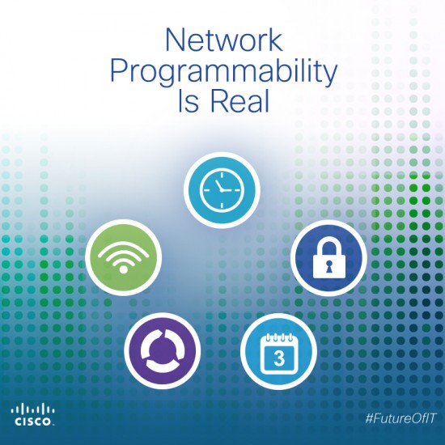

Introduction

Today the digital area where network programmability takes part has emerged in our life as a force shaping the modern network paradigm. This refers to the ability of networks to adapt, self-configure and response to changing demands using automation and application programming interfaces APIs. We will explore network automation, the role of APIs and critically review the automation of security and compliance polices.

A definition of Network automation sound like a way where software automatically configurate and manage devices in a network. Automate repetitive and time-consuming network tasks. It is used to improve efficiency, lower the operability costs, reduce the human errors and network scalability.
Automation Frameworks:
Automation frameworks deliver a service and work to automate repetitive tasks and streamline the software development and testing process. These frameworks offer a set of guidelines, best practices, and reusable components that aid in creating automated scripts and tests. Automation frameworks can be used for various purposes, including functional testing, regression testing, performance testing, and more.
Automation frameworks aim to improve efficiency, maintainability, and scalability of test automation efforts. They often include features like test data management, reporting, error handling, and integration with Continuous Integration/Continuous Deployment (CI/CD) pipelines.
Automation Tools:
Automation tools are software applications designed to carry out specific automation tasks. These tools can be part of an automation framework or standalone solutions that cater to particular needs. Different tools serve various purposes, and they can be categorized into different types based on their functionalities:
Test Automation Tools: These tools are specifically designed to automate the execution of test cases, both for functional and non-functional testing. Examples include Selenium (for web automation), Appium (for mobile app automation), and JUnit/TestNG (for Java-based testing).
Performance Testing Tools: These tools help assess the performance and scalability of applications under various conditions. Examples include JMeter, LoadRunner, and Gatling.
Configuration Management Tools: These tools automate the management of infrastructure and application configurations. Examples include Puppet, Ansible, and Chef.
API Testing Tools: Tools like Postman, SoapUI, and REST Assured are used to test APIs for functionality, performance, and security.
It's important to note that the automation frameworks and tools used can vary based on the specific requirements, programming languages, and technology stacks used in a particular project or organization. Selecting the right tools and frameworks is crucial for the success of an automation effort.
Automation can be integrated in many types of networks such as WAN, data centre, cloud, wireless network.
Most software application today are developed on web browser. For example, Zoom. I often change my computer and when a meeting suddenly arrives find me without application installed. A power tool is Selenium. This works with many browsers, operating systems, programming languages and test frameworks. Another tool is JMeter, used to simulate a heavy load on a server or network. (Wang & Du, 2012)
Important today’s trends are network virtualisation and cloud adoption. Network programmability enables the creation of virtual networks and comply with needs of virtualised and cloud infrastructures.
Internet of things IoT is another subject of trend where devices and edge computing have expanded on the network. There are also challenges in in terms of security and management.
5G and software defined networking is another trend where many APIs achieve their full potential.

There are few types of network automation.

Script based use programming languages to execute tasks. Program languages as Phyton, Ruby and Ansible are more popular now days.
Software based network automation also called intelligent network are integrated in an administrative portal and doe does not need scripts commands manually. These portals usually offer templates on executing tasks based on plain languages polices.
Intend based network automation use AI (artificial Intelligence) and machine learning. Thea learn what user and business is looking for and automatically modify how network policy is applied and on this knowledge. These networks adjust automatically where service level is not met. (Andrew Froehlich, n.d.)

Network APIs
An APIs intermediate the interaction and integration between applications and network devices. Application Programming Interfaces are protocols, routines, tools used to build applications that can interact and communicate on the network. Apis are used also to monetarise services.
APIs could be integrated in and connected with browsers, email clients, messenger applications, games. Some known APIs examples integration are HTTP, DNS, SMTP, IMAP, POP, FTP, TCP, (Jander, 2023)
When coming to build an API we should first plan about what this will do and how it will work. We create a list of needs, who will be useful and what users will do with it.
We search for business requirements, user interactions, testing before lunching and receiving a feedback. This help what features we need to add and what is useless and remove.
An important thing to do is to check if any other similar API already exists.
Also it should comply with the technology Code of practice government data standards and legal requirements.
REST (representational state transfer) is the architectural style commonly used and is compatible with web services. REST are standards used in this industry. (GOV.UK, 2022)
Compared to the old generation of web services, SOAP and XML-RPC, RESTful offer more flexibility
on how developers create web services.

API Security

An API allows other software applications to communicate and connect each other. This is either between clients or servers over public network. Here API Security play an important task to protect from any outside attack. Because these software is in the from line, most used by users it become the first vulnerable target. These vulnerabilities include a wrong programmed authentication and authorization. Therefore a periodically security test must be done regularly. (Kovacic, 2022)
It is very important that APIs to be designed and RESTful developed from the beginning.

API Security is different from general application security.
Below is an illustration:

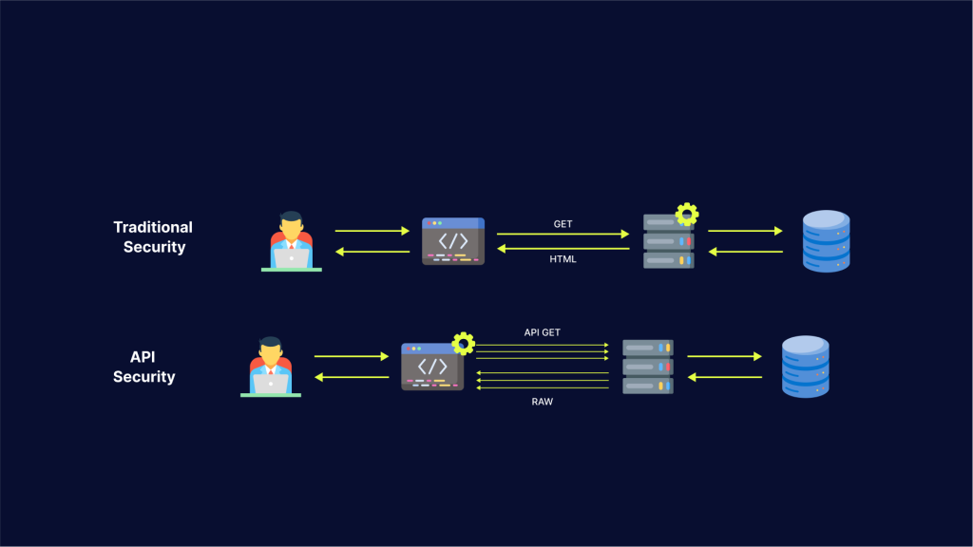

There are two important architecture style developed in `¬APIs
SOAP - support multiple low-level protocols as a highly structured message
REST - usually use JSON format for data transfer trough HTTP /S transport protocol.

The only similarity between these both styles is the HTTP support using Secure Sockets Layer (SSL). Apart from this these offer different security methods. (Kovacic, 2022)

Here's how automation of security and compliance policies using APIs can be accomplished:

API-Enabled Security Tools: Many security and compliance tools provide APIs that allow you to programmatically interact with them. These tools might include vulnerability scanners, intrusion detection systems, antivirus solutions, identity and access management systems, etc. By utilizing these APIs, you can automate various security tasks and policy enforcement.

Configuration Management: APIs can be used to automate the configuration of security settings across various devices and systems. For example, you can use APIs to update firewall rules, set access controls, configure encryption settings, and more, ensuring that all systems are aligned with your security policies.

Continuous Monitoring and Auditing: APIs can be leveraged to collect security-related data and logs from different systems and applications continuously. This enables you to have real-time visibility into your security posture, detect potential threats, and generate audit trails to meet compliance requirements.

Policy Enforcement: APIs allow you to enforce security and compliance policies programmatically. For instance, if a new system is deployed, you can automatically ensure that it meets the required security configurations and complies with relevant regulations.

Incident Response Automation: When a security incident occurs, APIs can help automate incident response workflows. For example, an API can trigger an immediate response when suspicious activity is detected, such as quarantining an affected machine, blocking IP addresses, or sending alerts to security personnel.

User Access Management: APIs can facilitate the automation of user access controls. This includes user provisioning and deprovisioning, role-based access controls, and permissions management, all of which are crucial for maintaining compliance and preventing unauthorized access.

Compliance Reporting: APIs can be used to automate the generation of compliance reports. By collecting data from different systems and tools, you can automatically generate reports that demonstrate compliance with relevant regulations and standards.

Integration with Orchestration Platforms: API-driven security and compliance policies can be integrated into workflow orchestration platforms. This integration allows for more sophisticated automation scenarios and coordination across different systems and processes.

Third-Party Integration: APIs enable seamless integration with third-party services and tools that provide specialized security and compliance capabilities, enhancing your overall security posture.

When implementing automation through APIs for security and compliance, it's essential to ensure proper access controls and authentication mechanisms. API security best practices should be followed to prevent unauthorized access and potential vulnerabilities.

Keep in mind that security and compliance requirements can evolve, so it's crucial to regularly review and update your automated policies to stay current with the latest threats and regulatory changes.

Conclusion:

Network programmability, with its different dimensions such as network automation and APIs, has revolutionized how networks are designed, managed, and secured. Embracing automation and standardizing APIs empowers organizations to optimize network operations, respond rapidly to evolving demands, and fuel innovation in today's dynamic technological landscape. However, it is essential to critically review and address security and privacy challenges to fully realize the potential of network programmability without compromising on safety and compliance. By striking a delicate balance between innovation and protection, network programmability will continue to drive the future of networking.

Below is a general description of terms Sandbox, Code Exchange and Ecosystem Exchange.
Sandbox:
In software development, a "sandbox" typically refers to a restricted and isolated environment where developers can test new code, applications, or changes without affecting the production environment. Sandboxes provide a safe and controlled space to experiment and identify potential issues before deploying the changes to a live system. It's particularly useful for trying out new features, configurations, and plugins without the risk of causing damage to the actual application or system.

Code Exchange:
Code exchange platforms are online repositories where developers can share, discover, and collaborate on code snippets, libraries, and entire projects. These platforms foster a community-driven approach to software development and encourage the open sharing of code to benefit the wider developer community. Popular code exchange platforms include GitHub, GitLab, Bitbucket, and others. Developers can use these platforms to contribute to existing projects, find reusable code solutions, and even showcase their own work.

Ecosystem Exchange:
The term "ecosystem exchange" refer to the exchange of resources, services or integrations between different components within a larger software ecosystem. For example, in the context of an application ecosystem, it could involve the exchange of data, functionalities, or APIs between various applications that are meant to work together seamlessly.
Sandbox is a portal where you can find and use features of Cisco technology. You can use this lab for free and do anything you want with these features.
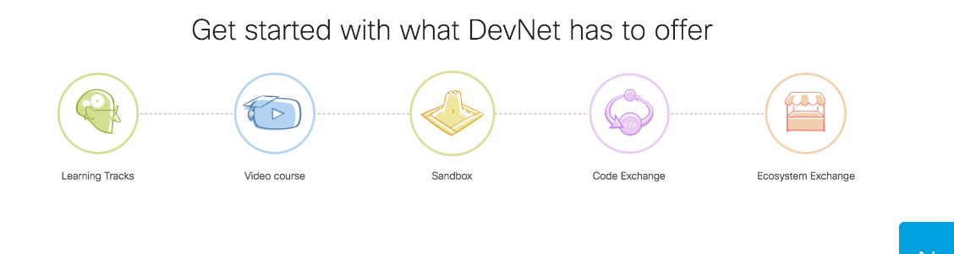
Once logged in you can find the navigation template, multiple links, features and information to familiarize with Sandbox. There are technologies such as Collaboration, Networking, Security. (Developer, n.d.)
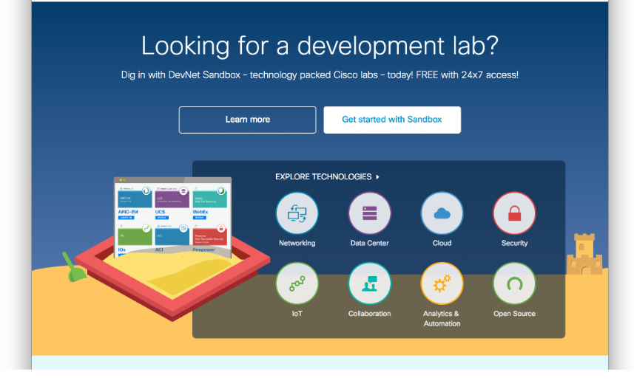

When we say code exchange we can talk about:

GitHub Cloud

GitHub Cloud is in instant notification about repositories changes, This make and easy code collaboration for all developers in the team where they can easy share ideas. (Systems, GitHub Cloud, n.d.)

Connecting to the GitHub Cloud bot for WebEx you receive notifications such as:

Deployment Created or Status Updated
Repository Forked
Commit Pushed, Status Updated, or Comment Added
Branch or Tag Created or Deleted
Collaborator Added or Removed
Issue Created or Updated
Issue Comment Added, Updated or Deleted
Wiki Page Added or Edited
Repository Starred
Release Published
Pull Request Opened or Comment Added
Team Repository Added

GitLab

Same as GitHUb, with GitLab you are always informed about all changes in your repositories.

When Connected with the GitLab bot you receive customizable notifications such as:
New Merge Request Created
New Branch Created
New Todo Created

New Commit Pushed
New Issue Created
Wiki Page Created or Updated (Systems, GitLab, n.d.)
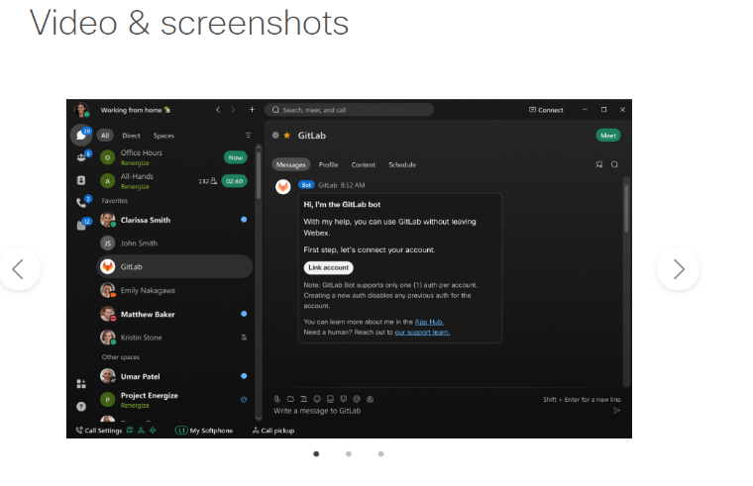

Azure DevOps Services
Instant access to your repositories. With the Azure DevOps Services bot for Webex, you can easily stay on top of the latest changes happening in your team’s repositories.

Only Azure DevOps Services accounts are supported by this bot.
If you connect the Azure DevOps Services bot to your spaces you receive customizable notifications such as:
Pull Request Created, Updated, or Merge Attempted
Release Deployment Started, Completed, or Approval Pending
Work Item Created, Restored, Updated, or Deleted
Work Item Comment Added
Build Completed
Code Checked In
Commit Pushed

Commit Pushed, Status Updated, or Comment Added
Pull Request Opened or Comment Added
Branch or Tag Created or Deleted
Team Repository Added
Collaborator Added or Removed (Systems, Azure DevOps Services, n.d.)
Deployment Created or Status Updated
Release Published
Repository Forked
Issue Created or Updated
Issue Comment Added, Updated or Deleted
Wiki Page Added or Edited
Repository Starred

References
Andrew Froehlich, W. G. (n.d.). Ultimate guide to network management in the enterprise. Retrieved from https://www.techtarget.com/searchnetworking/definition/network-automation
Developer, C. (n.d.). DevNet Sandbox. Retrieved from https://developer.cisco.com/learning/labs/devnet-sandbox/step-2-navigating-to-the-devnet-sandbox/
GOV.UK. (2022, 07 11). API technical and data standards. Retrieved from https://www.gov.uk/guidance/gds-api-technical-and-data-standards
Jander, M. (2023, May 02). WHAT ARE NETWORK APIS? Retrieved from https://www.futuriom.com/articles/news/what-are-network-apis/2023/05
Kovacic, D. (2022, April 04). What Is API security? The Complete Guide. Retrieved from https://brightsec.com/blog/api-security/
Systems, C. (n.d.). Azure DevOps Services. Retrieved from https://developer.cisco.com/ecosystem/webex/apps/azure-devops-80117/
Systems, C. (n.d.). GitHub Cloud. Retrieved from https://developer.cisco.com/ecosystem/webex/apps/github-cloud-99112/
Systems, C. (n.d.). GitLab. Retrieved from https://developer.cisco.com/ecosystem/webex/apps/gitlab-cisco-systems-80617/
Wang, F., & Du, W. (2012). A Test Automation Framework Based on WEB. Retrieved from https://ieeexplore.ieee.org/abstract/document/6211171

