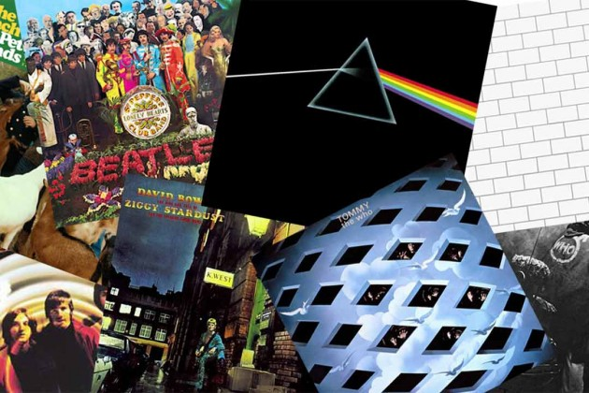

CONCEPT ALBUMS: AN ANALYSIS

LEE HENDRY (P151809)

Submitted in partial fulfilment for the requirements for the degree of
Music Technology B.A. (Hons)
University of Wales Trinity Saint David, Swansea
12th December 2018
Dissertation (M6X01791)
Tutor: Peter Williams
Word Count: 5885

Table of Contents
page
- Summary of topic …………………………………………………………………. 3
- Introduction …………………………………………………………………………. 4
- Chapter 1
  - Definition ………………………………………………………………………... 6
  - Album types & genres…………………………………………………………. 8
- Chapter 2
  - First examples ………………………………………………………………….. 12
  - Rise & experimentation ……………………………………………………….. 15
- Chapter 3
  - ‘Sergeant Pepper’s Lonely-Hearts Club Band’ by The Beatles …………... 20
  - ‘Dark Side of the Moon’ by Pink Floyd ………………………………………. 21
  - Comparison & evaluation …………………………………………………….. 22
- Conclusion …………………………………………………………………………. 28
- Bibliography ………………………………………………………………………… 30
- List of Illustrations ………………………………………………………………….. 34

Summary of topic
The main aims and objectives for my dissertation will be to:
- Attempt to determine the definition of the term ‘concept album’.
- Analyse the ‘concept album’ format from its earliest examples, through its peak in popularity and up to the present day.
- Discuss which types of long-playing records come under the ‘concept album’ category.
- Highlight some of the many variations of the format
- Examine how ‘concept albums’ had a part in shaping the history of popular music.
- Compare and evaluate of two landmark albums that had significant influence on the format’s emergence and subsequent popularity.

Introduction
This dissertation will examine the cult of the ‘concept album’, which has played a major role in shaping the way that western popular music has been written, recorded, presented and listened to over the last fifty or so years.
It is divided into three main chapters and covers a description and history of the ‘concept album’ format, followed by a case study and comparison of two landmark album releases. I will discuss how and why conceptual based records became so popular and will examine the subsequent direction that popular music took due to the influence of these types of albums. I will also look at the issues that become apparent when trying to determine if a musical work can be classed as a ‘concept album’.
This topic especially has an interest for me as I am currently in the process of writing and recording my own ‘concept album’ as part of my degree course. My research has been invaluable in this regard, providing me with more understanding, insight and appreciation of the format. I have also identified a couple of other areas within this realm that could potentially lead on to further research in the future.
The first chapter of my dissertation will analyse the definition of the term ‘concept album’, and how it differentiates from other long-playing records. I will examine the fundamental characteristics of the term and attempt to establish if there are clear boundaries around its definition. My study will also discuss which types of albums can realistically be described as ‘concept albums’ (as well as those that cannot).
In chapter two, I will explore the history of popular music’s conceptual recordings and identify some of the precursors of the genre. I will also chart the development and progress of the ‘concept album’ from its beginnings, through its artistic and commercial golden period, and onward to the new millennium and the present day. This will include a discussion on how the ‘concept album’ helped transform the fortunes of the long-playing record, and why it had an important and unique role in helping to make albums the dominant selling format during an unprecedented period of musical and technological experimentation. I will also look at some the many variations of the ‘concept album’ format and the different ways that artists utilised the L.P. as a form of artistic expression.
Finally, in chapter three my study will focus on two landmark long-playing records which have contributed to the rise in popularity of the ‘concept album’:
- ‘Sergeant Pepper’s Lonely-Hearts Club Band’ by The Beatles (1967)
- ‘Dark Side of the Moon’ by Pink Floyd (1973)
I will analyse both recordings in depth covering all aspects from the music and lyrics, through to the artwork. This will include a comparison to highlight their similarities and differences. To finish, I will attempt to determine their merits as ‘concept albums’ and assess the lasting impact that both records have had on popular music and the ‘concept album’ itself.

Chapter 1
Definition
Shute (2015, p.16) asks “what exactly does the phrase ‘concept album’ refer to?” The Collins online dictionary states that it is “an album that has a unifying theme or that tells a single story” (Collinsonlinedictionary.com, 2018), while Stimeling (2011, p.389) describes ‘concept albums’ as “long-playing records or, more recently, compact discs that are marked by narrative unity and large-scale musical structure.” While these descriptions may at first glance appear to be quite straightforward, when we investigate further then it quickly becomes apparent that they are somewhat vague, and the boundaries are in fact rather blurred. “The concept album was originally defined as a long-player where the songs were based on one dramatic idea – but the term is subjective” (The Independent, 2009).
The phrase ‘concept album’ began to appear in the late 1960s and according to Shute (2015, p.11) “was first used by music journalists to refer to works from the psychedelic era.” Up until this point, the long-playing record was merely a collection of individual songs or instrumental pieces by one or more artist. These songs or instrumentals usually had no connection with each other and were intended as separate, stand-alone pieces. In the ‘concept album’ format however, the songs are typically written with a single, over-arching theme or narrative connecting them all together. This central theme or narrative is usually also extended to the record’s cover and inner-sleeve, providing a visual accompaniment to the music within. Some musicians and bands have taken this idea further by carrying the concepts of their records over to live shows (with stage props and visual/sound effects), music videos and even full film motion pictures.
A major appeal for musicians was that the ‘concept album’ format gave them the scope to expand not only their musical boundaries, but also their lyrical ambitions. There appears to be no limit to the subject matter that can be covered over the course of two, four or six sides of an L.P. and many artists have taken advantage of the freedom that the format allows. From its very early days, the themes and narratives which have provided the basis for ‘concept albums’ have ranged from the simple and straightforward, to the unconventional and downright bizarre. A ‘concept album’ can therefore theoretically be based upon virtually any subject or idea, however basic or complex.
One important point to consider is the difference between the terms ‘theme’ and ‘narrative’. A theme is generally the idea or subject around which the songs of a ‘concept album’ revolve, while a narrative is the story or plot that is told through the songs (either by spoken word passages and/or the song’s lyrics). Within a thematic ‘concept album’, there can seemingly be vague lyrical references to the central idea at some points without it diminishing the overall artistic experience. This is because the thematic ‘centre-point’ is not definitively fixed and often moves around the subject matter. A narrative concept, however, must follow a more rigid structure where each song has its own place in the jigsaw, linking the previous one to the next. The thematic approach therefore does not rely as heavily on lyrics as the narrative one. However, despite these differences, both theme and narrative lay the foundation upon which a ‘concept album’ can be built and from which it is bound together. “Narrative and thematic concept albums do have one thing in common – they both introduce non-musical ideas to structure an album” (Shute 2015, p.16).
Despite the subjective nature of the definition, research suggests that we can simplify the core criteria of the ‘concept album’ down to the following basic elements:
- everything links together around a specific narrative or theme
- all the songs (lyrically and musically) and the accompanying artwork revolve around this narrative or theme
- the record has an intentional cohesive flow from start to finish
Although it appears to be essential for a ‘concept album’ to possess these main characteristics, it is arguably the lyrical element that is the most important. A record can incorporate different musical genres or styles from one track to another and they can still be linked to the theme or narrative via its lyrics. However, if its lyrics are not based around a central conceptual idea, then it matters little if its music is of a similar genre or style – it will not be a ‘concept album’.

Album types & genres
If we consider the above criteria, then closer inspection opens further questions about which types and genres of long-playing record can truly fall under the ‘concept album’ category (and which ones do not). Musicals, movie soundtracks, compilations and live albums could at first glance appear to possess all the prerequisites of the format. However, it soon becomes clear that each of these does not have a strong enough argument for them to be considered as such.
Musical soundtracks have been issued on long-playing records since the early days of the gramophone and have proved to be immensely popular. Some of the most successful albums have come from this genre, selling millions of copies around the world and dominating album charts for many weeks and months. While the musical and lyrical content of these and similar soundtracks are typically focussed around a specific storyline or plot, there are several major distinctions that would preclude them from being classed as ‘concept albums’. For one, the soundtrack is essentially a representation or reproduction of the stage show – and therefore it is a by-product. Secondly, the vocals are traditionally recorded by the actors who appeared in the stage version. Despite having a central narrative or theme, “(t)he key difference is that musicals are written to be performed on the stage, while concept albums are created to be stand-alone musical works.” (Shute 2015, p.11). The same also appears to apply to musicals that were based upon albums, but this is not always clear cut. Written by Andrew Lloyd Webber and Tim Rice, ‘Jesus Christ Superstar’ was a major success as a musical after debuting in the early 1970’s. In this case, the theatre production was based on the music from the album (Fig.1) which was released first in September 1970. This record featured professional singers instead of actors, therefore one could argue that it is a bone-fide ‘concept album’.

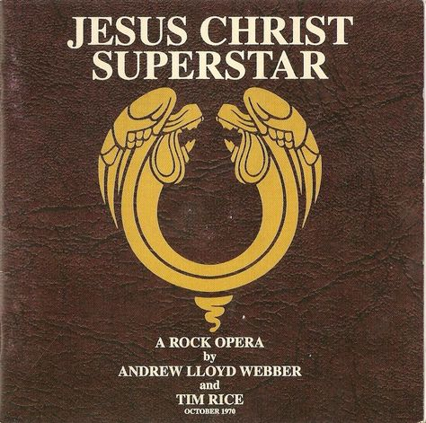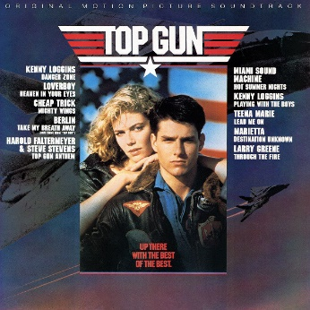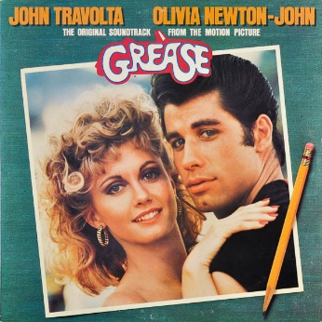
Fig.1: Jesus Christ Superstar
Fig.2: Top Gun: Official Movie Soundtrack
Fig.3: Grease: Official Movie Soundtrack

Like musicals, movie soundtracks have long enjoyed much commercial success and have often proved a lucrative spin-off for film-makers and record companies. Movie blockbusters such as ‘Top Gun’ (1986), ‘Grease’ (1978) and ‘Saturday Night Fever’ (1977) have had their popularity boosted thanks to their accompanying soundtracks (Fig. 2 & 3), many of which have also sold millions of copies worldwide. Movie soundtracks can come in many variations, such as ones that include samples of dialogue and spoken word passages, as well as those that showcase extended versions of orchestral pieces and incidental music from the film. Sometimes they are simply compilations of already popular songs featured in a movie. Just like musicals however, movie soundtracks cannot be seriously regarded as ‘concept albums’. The musical elements would have been predominantly written or incorporated as a counter-point to the movie’s visuals, or to enhance them. For movies that are themselves musicals, such as ‘Mamma Mia’ (2008) or ‘Annie Get Your Gun’ (1950), then their soundtracks also cannot be considered as ‘concept albums’ because the movie is the primary source of the music (as with stage musicals).
Compilation albums usually have a central connecting theme (e.g. love songs) or a genre specific focus (e.g. ‘punk rock’), but again they cannot be placed in the ‘concept album’ category. This is because the selected theme or genre is too broad and subjective. Any number of songs or musical pieces that loosely fit into the stipulated theme/genre could theoretically be included, and there is also no significance in the track order. Indeed, any chosen track could just as easily be replaced by another similar one without changing the overall description of the final product.
Similarly, live albums could include an endless range of unconnected musical material. The only consistent attribute of the music would be that it was recorded ‘live’. This is not enough for live albums to merit consideration for the ‘concept album’ format. The same would be true if the live album was a recording of an already available ‘concept album’, as the original studio version has preceded the live record. Again however, there can be exceptions to the rule. Jackson Browne’s 1977 album ‘Running on Empty’ (Fig.4) is a selection of new songs about a band’s life on the road. These songs were also recorded ‘live’ but it does have a central theme and, crucially, newly recorded material. It is therefore “more a concept album about the road than an actual live album” (AllMusic, 2018).

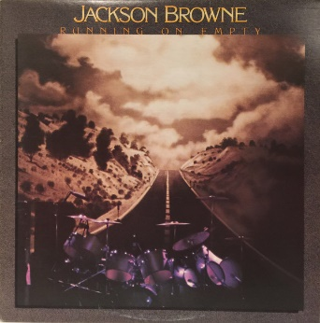
Fig.4: Running on Empty

To summarise, while we have established that ‘concept albums’ do have specific characteristics that enable us to distinguish them from most standard long-playing records or song collections, there is an area of uncertainty and subjectivity around certain individual albums or types of album. The definition of the term ‘concept album’ does not have fixed limitations.

Chapter 2
First examples
Considering the lack of clarity surrounding the ‘concept album’s definition, it is unsurprising that there is much debate as to what was the first ‘concept album’. Before ‘rock and roll’ impacted on popular music in the mid-fifties, it was predominantly singer-songwriters from the folk and country music genres that incorporated storytelling traditions into their works. These artists were usually self-reliant and did not have the restriction of needing to record hit singles. Consequently, they could focus on producing long-playing records, and a few of these began to use themes to group songs together. One of the earliest examples of this is a record released in 1940 by the American folk singer Woody Guthrie. ‘Dust Bowl Ballads’ (Fig.5) tells the story of the mass migration from Oklahoma during the 1930’s dust storms, which threatened the livelihood of the local farmers. Over the course of twelve songs (spread out over three discs), Guthrie sang about the trials and hardships that these farmers faced as they were forced to leave their homes and flee to California. “All the songs were about one topic although the record does not have a main character or storyline that was in every song” (Johnson, 2012).
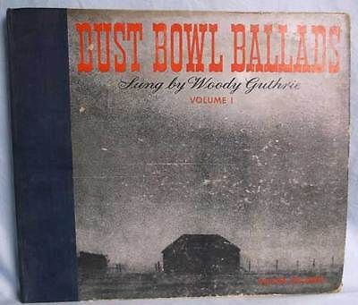
Fig.5: Dust Bowl Ballads

Initially, this theme-based approach did not catch on amongst popular recording artists. One reason for this may have been because the record labels usually employed several specialised songwriters to work on a long-playing record. To create a truly conceptual work would have required a songwriter with a strong thematic vision around which to write and develop the songs, and this would have been difficult if there were other songwriters contributing. They also were inhibited by the lack of space on a typical 78 rpm disc. It wasn’t until the late forties introduction of the vinyl 33 and 1/3 rpm L.P. record that most song collections or classical works could fit onto two sides of a single 10 or 12-inch disc (which also provided a higher fidelity quality reproduction). Another important factor to highlight is that before the mid-fifties, record discs seldom had covers that could incorporate artwork or images. Disc packaging typically consisted of a thin paper or card sleeve, and its main function was to protect the record (which could be easily scratched). If there was any image printed onto the sleeve, then it was more likely to be an advert for the record label, rather than the recording artist (Fig.6, 7 & 8).

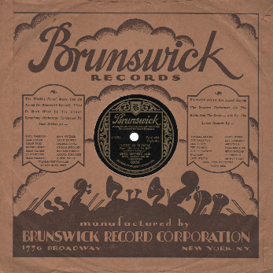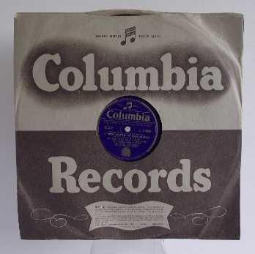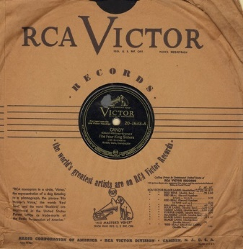
Fig.8: RCA Victor Records
Fig.6: Brunswick Records
Fig.7: Columbia Records

One creditable claim for being an early ‘concept album’ is a 1955 release by Frank Sinatra entitled ‘In the Wee Small Hours’. This record is a collection of jazz ballads which focus on loneliness, lost love and heartache. Sinatra had apparently chosen the 16 songs himself as he intended the album to have a melancholy mood and contemplative feel throughout, and in this he largely succeeded. However, Williams (2007) offers the opinion that “(t)he songs on the album may be thematically linked, but they don't tell a story, so the debate continues”. By now, album covers had evolved from the paper/card sleeve and were beginning to be a more prominent part of the overall product. The image used on the cover of this record had a dark, sombre tone, depicting Sinatra as a lonely figure and perfectly mirroring the songs within (Fig 9). This was an early example of the role that the cover art could play in extending the mood of an album beyond just the music.

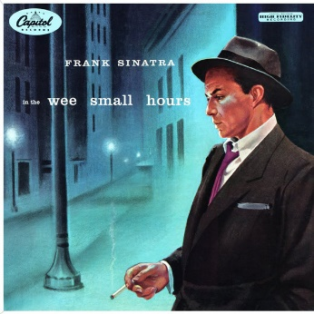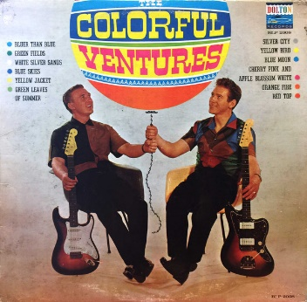
Fig.10: The Colorful Ventures
Fig.9: In the Wee Small Hours

After the advent of ‘rock and roll’, themed albums were still quite rare although a few did come onto the market. One of these was by a popular American band called the Ventures. Their 1961 album ‘The Colorful Ventures’ (Fig.10) was made up of songs with a colour in the title (e.g. ‘Blue Skies’, ‘Red Top’, ‘Orange Fire’, etc).
Although identifying the first true ‘concept album’ is largely down to a matter of opinion, many cite Guthrie’s record as a strong contender. While these early attempts at creating a thematically based L.P. were few and far between, they did illustrate that albums had the potential be more than just a collection of individual tracks.

Rise & experimentation
In the early sixties, most popular music performers were very much controlled by their record companies, who would dictate their musical output. Singles were the primary focus as the 7-inch, 45-rpm disc was by far the most popular selling format. Long playing albums, on the other hand, were considered a poor relation. Only the very successful artists were afforded the opportunity to make an album, which often was used mainly as a promotional tool for the singles included on it. The album’s other tracks were predominantly cover versions of popular old songs or inferior new material (or ‘filler’). It was only after the mid-sixties that artists began to get more creative freedom, and they began to see the long-playing record as the perfect alternative for escaping the confines of the three-minute pop single. This sparked a rivalry between artists which pushed popular music into a new era of rapid growth and change, as (Macdonald 1994, p.189) points out
Since 1965, the major British and American pop acts had been waging a friendly competition to come up with the most extraordinary music, and in 1966-7 this produced a major structural change in the music business.
The advancement in recording technology was an important factor in this new era of experimentation. Innovative audio effects such as artificial double tracking (ADT), repeat echo, tape delay, reverb and flanging were developed around this time while newer, larger recording desks meant that more instruments and voices could be overdubbed onto recordings. The rise of stereo (as opposed to mono) recording was an important milestone, while the introduction of the ‘pan pot’ and other ground-breaking recording techniques allowed for more sonic manipulation. This provided artists and producers with an ever-expanding aural canvas upon which they could create new sounds. The recording studio was beginning to be considered as an instrument itself, within which the audio possibilities were endless.
Record buyers were also changing. With the emergence of the growing ‘counter-culture’ movement, young people were buying records more for listening to rather than for dancing. The increased use of recreational drugs (such as L.S.D.) by both artists and their audience also cannot be overlooked, and this had a far-reaching influence over the way that popular music was being created and consumed around this time. “As the Beatles worked their way through Sgt Pepper’s Lonely Hearts’ Club Band, Martin became more and more aware of the group’s involvement with drugs” (Southall, Vince and Rouse 1997, p.95). This aspect of pop culture is worthy of further research, as it undoubtedly had a big impact.

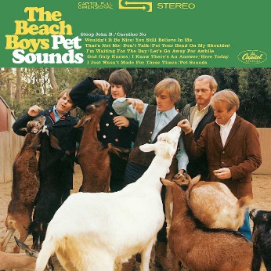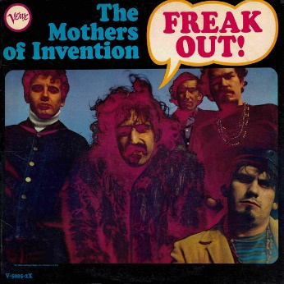
Fig.12: Freak Out!
Fig.11: Pet Sounds

During this early period of experimentation, the idea of the themed album was revisited by acts such as the Beach Boys with ‘Pet Sounds’ (1966) (Fig.11) and Frank Zappa & The Mothers of Invention with ‘Freak Out!’ (1966) (Fig.12). However, it was arguably the release of ‘Sergeant Pepper’s Lonely-Hearts Club Band’ by the Beatles in 1967 that was the catalyst for the emergence of the ‘concept album’ format. It contributed to the shift in focus away from the single and onto the L.P. and highlighted the potential of the new recording studio technology. Southall, Vince and Rouse (1997, p. 99) state that “(t)he Sgt Pepper album not only revolutionised the concept of an album in musical terms it also signalled a breakthrough in recording techniques”. In its wake came a string of interesting albums, many of which centred around a thematic or narrative, and over the next couple of years some of the world’s most successful bands embraced the ‘concept album’ format, which in turn helped increase its popularity further.
Innovative young bands such as Pink Floyd, Yes, King Crimson and Genesis were at the forefront of this new musical movement which was firmly beginning to establish itself by the start of the seventies. However, it was not only their sounds that these bands and artists were developing – it was also the music itself. They were adding more musical complexity to their compositions by introducing classical and jazz elements. Their songs were becoming highly structured, longer, and often moved between different time signatures and musical keys. They were more serious about their music than their pop contemporaries and incorporated free-flowing improvisations and musical interludes into their work. Songs sometimes merged into each other, with repeated musical motifs that connected separate tracks together. It was not uncommon for one track to span the whole side of a long-playing disc, and some works were released as double or even triple albums. Their records were further enhanced by the imaginative use of cover art, which had an important role in conveying the records theme. They used striking and evocative imagery on their album covers, which often gave them an air of mystery and intrigue. This genre of experimental music was described as ‘progressive rock’ (or ‘Prog Rock’) and it took the format of the long-playing record to its zenith.
The cult of the ‘concept album’ was not, however, restricted to the purveyors of ‘Prog Rock’. Many acts from other genres made successful concept albums, which typically focussed on either futuristic or more traditional themes. Interestingly, the messianic (or ‘Jesus’ like) figure was the centre-piece of several popular ‘concept albums’, such as The Who’s ‘Tommy’ (1969) (Fig.13). Over the years, there have been several variations of the ‘concept album’ including:
- Rock Opera – like a musical, where the narrative focuses on a central character
- Interpretational – a re-telling of a popular story or text in musical form
- Observational – describing a specific event or place
- Alter-ego – the artist assumes a new, fictitious identity through which to deliver their music
- Autobiographical/biographical – recounting the life and times of the artist or a fictional character
- Parody – a deliberate and often humorous imitation

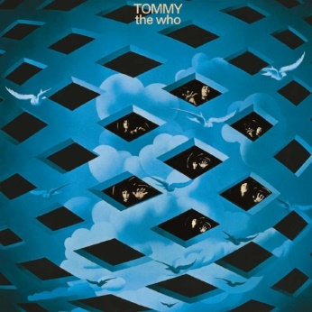
Fig.13: Tommy

With the rise of ‘punk’ music and ‘New Wave’ in the late-seventies, the ‘concept album’ did endure somewhat of a decline which largely continued throughout the next two decades. However, it was still a staple format of the ‘heavy metal’ genre during this period. Although ‘concept albums’ have enjoyed a resurgence in the new millennium, it is without doubt the early to mid-seventies that was its heyday. The advent of the ‘digital download’ era has had a huge impact on the way that albums are now being created, and this is another subject that warrants further research. Whatever the future holds for the ‘concept album’, its longevity suggests that it may well be around as a form of artistic musical expression for some time yet.

Chapter 3
‘Sergeant Pepper’s Lonely-Hearts Club Band’ by The Beatles
By the autumn of 1966, the Beatles had well and truly conquered the pop music world, but they were at a major crossroads in their career. Exhausted (both physically and mentally) by their never-ending workload, at the end of their third tour of the United States they had decided to retire from touring and performing live concerts. After a well-earned break of a couple of months, they returned to the recording studio on 24th November 1966 to begin work on their eighth album. Without the pressures of touring, they could now focus fully on writing and recording without any external distractions. Their continued success ensured that there were no budget restrictions, and their record company allowed them priority access to the studio for as long as they required it. Furthermore, they no longer needed to worry about reproducing their new songs live on stage, meaning they could take their experimenting in the studio to another level. ‘Sergeant Pepper’s Lonely-Hearts Club Band’ (Fig.14) was released in the U.K. on 26th May 1967 and “it was a major cultural event” (Macdonald 1994, p.220). It has since gone on to become one of the biggest selling and most influential albums of all time.
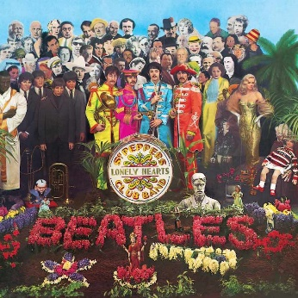
Fig.14: Sergeant Pepper’s Lonely-Hearts Club Band

‘Dark Side of the Moon’ by Pink Floyd
Pink Floyd had started their career as a rhythm and blues outfit in 1964, but they quickly gravitated toward a more experimental form of rock music. Their shows were renowned for their innovative use of lighting and visual effects while their long, improvised musical pieces were founded on a strong sense of melody and rhythm. By the early seventies, they had risen to become one of the forerunners of the ‘progressive rock’ scene and were a very successful recording and touring band. Work began on their eighth album at the end of May 1972 and it took approximately seven months to complete. Though they had played their new songs live on their last tour, they developed them further in the studio using the latest audio equipment. “(T)hey put the whole thing together virtually in the studio and changed it drastically from the version they played live” (Southall, Vince and Rouse 1997, p.119). ‘Dark Side of the Moon’ (Fig.15) was released in the U.K. on 1st March 1973 and according to Weidy (2014) it “takes you through the full life cycle in under 45 minutes, with every song seamlessly segueing into the next”. It is considered by many to be the pinnacle of ‘Prog Rock’.
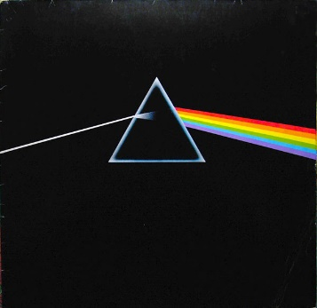
Fig.15: Dark Side of the Moon

Comparison & evaluation
At first glance it may appear that ‘Sgt Pepper’ and ‘Dark Side of the Moon’ have more in common with each other than not. Both were recorded at E.M.I.’s Abbey Road studios in London. Both include tracks which merge from one to another without gaps, and tracks which are reprised. Both have very distinctive covers which are now regarded as iconic. They were also each band’s eighth long-player. Recorded only six years apart, they are considered by many to represent the peak of their respective band’s creative output and both records were massive commercial successes. However, while ‘Dark Side of the Moon’ is generally regarded as a classic ‘concept album’, there has been much debate about whether ‘Sgt Pepper’ can legitimately be considered a ‘concept album’ at all. If we accept that the definition of a ‘concept album’ is one which has an over-arching theme or narrative throughout, then we must examine both record’s conceptual foundation.
In the case of ‘Sgt Pepper’, the Beatles were portrayed on the album under the guise of an alter-ego - a fictional musical ensemble reminiscent of the old Salvation Army brass bands and the more traditional times of the English music hall. This idea was carried over onto the album’s artwork, which showed the band dressed in full military uniform (Fig.16) and included novelty cardboard cut-outs of Sergeant Pepper himself, the band, a clip-on moustache, army stripes and badges (Fig.17). This also marked the first time that an album had the song lyrics printed on the cover (Fig.18). The record was intended to depict a ‘live’ performance by this fictional band (along with an orchestra) in front of an enthusiastic audience.
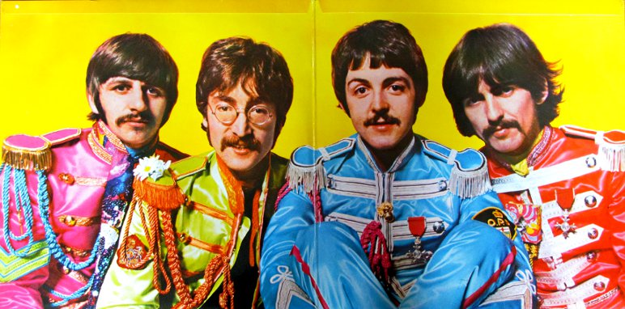
Fig.16: Sgt Pepper (gatefold sleeve)

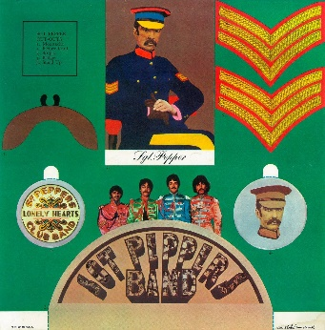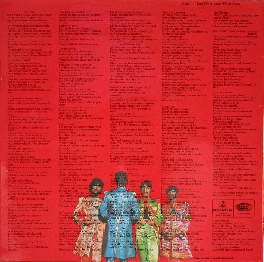
Fig.17: Sgt Pepper (sleeve insert)
Fig.18: Sgt Pepper (back cover)

The main themes for the songs on ‘Dark Side of the Moon’ were the pressures of modern day life. The lyrics for the album were written by Pink Floyd’s bass player, Roger Waters. “Waters described his vision for a piece of music all about the pressures and difficulties and questions that crop up in one’s life and create anxiety” (Blake 2008, p.176). This resulted in a set of songs which cover subjects such as money, religion, madness and death. “Waters used these as a starting point for writing about contemporary society…” (Shute 2015, p.107). The record starts and finishes with the sound of a human heart beating, as if signifying birth and death respectively. The artwork captures the mood of the record perfectly, including the visual representation of the heartbeat that bookends the music. It is dark, mysterious and highly distinctive (Figs.19 – 24). Both these albums therefore appear to have a strong thematic central concept.

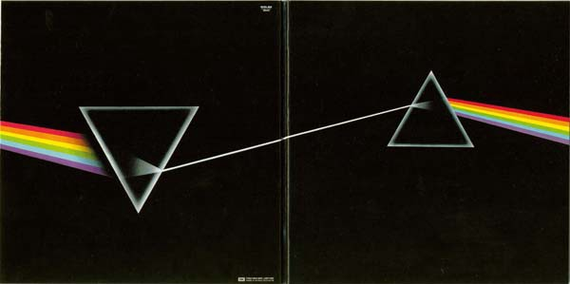
Fig.19: Dark Side of the Moon (front and back cover)
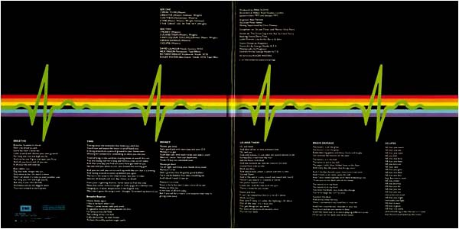
Fig.20: Dark Side of the Moon (gatefold sleeve)
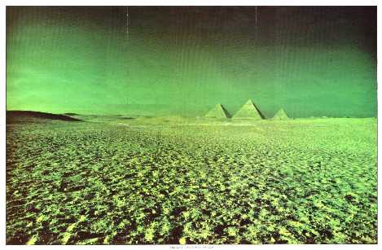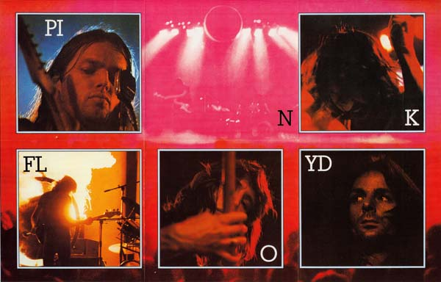
Fig.21: Dark Side of the Moon (poster insert a)
Fig.22: Dark Side of the Moon (poster insert b)

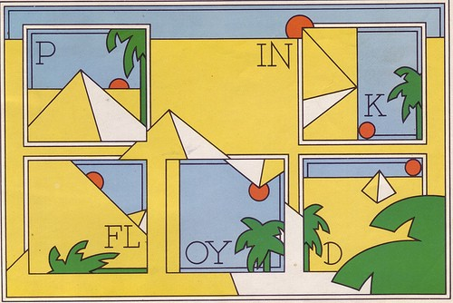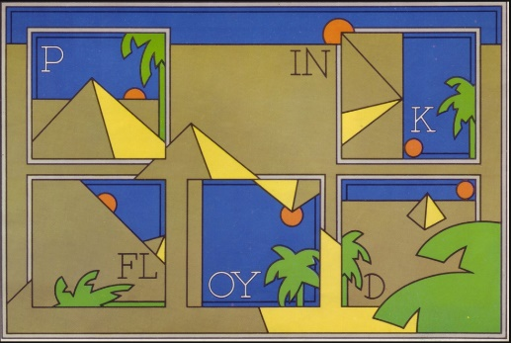
Fig.24: Dark Side of the Moon (sleeve insert b)
Fig.23: Dark Side of the Moon (sleeve insert a)

If we consider the musical elements, then ‘Sgt Pepper’ is more diverse in style and genre than ‘Dark Side of the Moon’. Whereas the latter is underpinned by Pink Floyd’s unique instrumental passages and ‘Prog Rock’ improvisations (albeit more direct and succinct than on their previous albums), the former covers a kaleidoscope of different styles from psychedelic rock and melancholy ballad, to Indian music and whimsical pop. Both records sound inherently English in tone, but at the same time they are markedly different. ‘Sgt Pepper’ is more traditional with shorter songs, while ‘Dark Side of the Moon’ has a futuristic feel and its tracks are longer. Both bands experimented with new and unusual sounds on these records in a way that had not been done before (e.g. the never-ending ‘hidden’ track at the end of side two of ‘Sgt Pepper’ and the inventive use of tape loops, synthesizers and oscillators on ‘Dark Side of the Moon’). These albums both have a musically strong flow and cohesion from beginning to end which are enhanced with the use of sound effects and spoken word phrases which are strategically woven into the music.
However, it is in their lyrics where arguably these albums differ the most when assessing their merits as ‘concept albums’. The theme of ‘Sgt Pepper’ and his band is not evident in the lyrics of every song on the album. Furthermore, if part of its central concept was to portray a fictitious live performance, then this also does not translate throughout the whole record. “On the album, the alter-ego idea is never developed beyond Ringo being introduced as ‘Billy Shears’ as the track segues into ‘With a Little Help from My Friends” (Ingham 2003, p.248). There is only reference to a live audience in the title track and its reprise towards the end of the record. This suggests that the conceptual idea was not at the heart of the song-writing process when the album was written, a fact which is supported by Shute (2015, p.26)
John Lennon later admitted in an interview with Playboy magazine that the album didn’t really deserve to be called a concept album: ‘Sgt Pepper is called the first concept album, but it doesn’t go anywhere. All my contributions to the album have absolutely nothing to do with this idea of Sergeant Pepper and his band’.
Another point which reinforces this is that three individual song-writers contributed tracks to the record, which would have made it very difficult for the Beatles to achieve a lyrical consistency throughout.
In contrast, the central thematic premise of ‘Dark Side of the Moon’ is potent from start to finish and, tellingly, the lyrics were all written by one person. This arguably is the point where these albums diverge when it comes to thinking of them in terms of being ‘concept albums’. One was written by an individual with a strong, preconceived thematic idea in mind, while the other was based around a vague notion, diluted further by it having contributions from more than one lyric writer. This also appears to be a universal trend, as ‘concept albums’ have generally proved to be more authentic and successful when written by one primary lyricist.
Ultimately, ‘Sgt Pepper’s concept is evident in its album artwork and some of its music. Crucially though, it is present in only some of its lyrics. ‘Dark Side of the Moon’, on the other hand, has its concept omnipresent throughout all aspects. Therefore, we can conclude that by the criteria mentioned previously, ‘Sgt Pepper’ should not be regarded as a genuine ‘concept album’. It falls short due to its lack of lyrical consistency and thematic presence (e.g. the ‘live’ Sgt Pepper band performance) in some tracks. While some may debate this, what is not in doubt is that ‘Sgt Pepper’ opened the door for other bands and artists to take up the idea of creating an album around a theme, and it also played a huge role in paving the way for subsequent ‘concept albums’. It influenced the Beatles peers to expand upon the notion of a thematic statement within a long-playing record and as Roger Waters from Pink Floyd stated in his interview in (Slate and Slate, 2017)
Sgt Pepper was a record that revolutionized everything, because that really was the record where from where I was standing – which was next door in Studio Three – it seemed as if the Beatles were giving us permission to talk about our real feelings and our real lives and what was really going on.

Conclusion
While it is evident that the term ‘concept album’ is not rigidly definable and can be open to interpretation, we have established that the essential requirements of the format are that the music, lyrics and artwork are all created and linked together around a pre-determined central theme or narrative. This theme or narrative must be reflected in all the tracks and visuals. The album should also have an intentional cohesive flow from beginning to end. We also cannot realistically consider musicals, movie soundtracks, compilations or live records to be ‘concept albums’.
There is a degree of uncertainty involved when attempting to identify the first true ‘concept album’ as early candidates were restricted by lack of disc space and album artwork. They were also created at a time when recording technology was in its relative infancy. Many point to the Beatles’ 1967 release ‘Sergeant Pepper’s Lonely-Hearts Club Band’ as being the album that opened the door for other musical acts to develop conceptual albums further. Although the absence of the ‘Sgt Pepper’ theme on a lot of its songs suggests that it cannot be classed as a ‘concept album’ in its truest sense, this was the first record that highlighted the potential for the long-player to be used as a tool for artistic expression.
The next few years saw the ‘concept album’ format flourish as many musical artists from all genres began to use the L.P. as either a means for experimentation or simply to tell a story. ‘Progressive Rock’ emerged and became hugely popular, and the ‘concept album’ was at the centre of its rise. Pink Floyd released ‘Dark Side of the Moon’ around this time, and it is considered by many as the quintessential ‘concept album’. It has an underlying theme that is all encompassing, from its lyrics and artwork, to its musical interludes, sound effects and spoken word passages.
Comparing these two albums today reveals that the strength of their conceptual foundations is ultimately determined by their lyrical content. While both the Beatles and Pink Floyd may have conceived them with thematic ideas already in place, it is the record with one lyrical contributor (‘Dark Side of the Moon’) that has the stronger conceptual focus of the two.
‘Concept albums’ ultimately played a unique and vital role in the evolution of the long-playing record. One could argue that without them, the L.P. may not have risen to the heights of popularity and influence that it attained during its heyday of the late sixties and early seventies. ‘Sgt Pepper’ and ‘Dark Side of the Moon’ were both in their own way instrumental in helping to push its boundaries and showcase its potential. In doing so, both paved the way for albums to be much more than just a collection of songs. They could also be perceived as genuine works of art. ‘Concept albums’ demonstrated just how powerful the long-playing record could be as a form of artistic (as well as musical) expression and how it could be used to reflect the world around us.

Bibliography

Reference List
Books
Blake, M. (2011) Pigs Might Fly - The Inside Story of Pink Floyd. London: Aurum Press.
Ingham, C. (2003) The Beatles. London: Rough Guides.
Macdonald, I. (2008) Revolution in the Head. London: Vintage.
Shute, G. (2015) Concept Albums. Investigations Publishing.
Southall, B., Vince, P. and Rouse, A. (1997) Abbey Road. London: Omnibus.

Journals/Newspapers in online collections
Stimeling, T. D. (2011) ‘Phases and Stages, Circles and Cycles: Willie Nelson and the Concept Album’, Popular Music. Cambridge University Press, 30(3), pp. 389–408. ProQuest [Online].Available at: https://search-proquest-com.ezproxy.uwtsd.ac.uk/docview/893253279/abstract/FB73796044C64DE3PQ/1?accountid=130472 [Accessed 3 Nov. 2018].
Weidy, B., (2014). ‘Weighing the Worthiness of Concepts on Concept Albums’, University Wire. ProQuest [Online]. Available at: https://search-proquest-com.ezproxy.uwtsd.ac.uk/docview/1564084748/abstract/53FA6C3CDFEE4504PQ/28?accountid=130472 [Accessed 4 Nov. 2018]
Williams, R. (2007) ‘Every Song Tells a Story’. Winnipeg Free Press, ISSN 08281785: E5., ProQuest [Online]. Available at: https://search-proquest-com.ezproxy.uwtsd.ac.uk/docview/752147208/2084FF17372E40C2PQ/11?accountid=130472 [Accessed 3 Nov. 2018].

Websites
AllMusic. (2018). Running on Empty - Jackson Browne | Songs, Reviews, Credits | AllMusic. [online] Available at: https://www.allmusic.com/album/running-on-empty-mw0000193103 [Accessed 27 Nov. 2018].
Collinsdictionary.com. (2018). Concept Album Definition and Meaning | Collins English Dictionary. [online] Available at: https://www.collinsdictionary.com/dictionary/english/concept-album [Accessed 3 May 2018].
The Independent. (2009). The Return of Concept Album. [online] Available at: https://www.independent.co.uk/arts-entertainment/music/features/the-return-of-concept-album-1796064.html [Accessed 3 May 2018].
Johnson, T. (2012). The Concept Album: A Brief History. [online] The History Rat. Available at: https://historyrat.wordpress.com/2012/06/28/the-concept-album-a-brief-history/ [Accessed 3 May 2018].
Slate, J. and Slate, J. (2017). Roger Waters: The Interview | Rock Cellar Magazine. [online] Rock Cellar Magazine. Available at: https://www.rockcellarmagazine.com/2017/06/12/roger-waters-the-interview-beatles-brexit-trump-abbey-road/ [Accessed 7 Nov. 2018].

Further reading
Books
Burrows, T. (2017) The Art of Sound. London: Thames & Hudson.
Egan, S. (2013) Pink Floyd - Glorious Torment. London: Flame Tree Publishing.
Harris, J. (2005) The Dark Side of the Moon (The Making of the Pink Floyd Masterpiece). 1st Ed. London: Fourth Estate.
Heately, M. (2006) Rock & Pop – the Complete Story. London: Flame Tree Publishing
Hoye, J. (2005) 100 Greatest Albums. New York: Barnes & Noble Books
Morgan, J. & Wardle, B. (2010) The Art of the LP. New York: Sterling
Powell, A. (1994) Classic Album Covers of the 70s. Zurich: Edition Olms
Rose, P. 2015. Roger Waters and Pink Floyd: The Concept Albums. Rowman & Littlefield.
Thompson, D. (2013) Roger Waters - The Man Behind the Wall. Milwaukee, WI: Backbeat Books.

Journals/Newspapers in online collections
Hawaleshka, D., (2003). ‘Long Live the Record’, Maclean's, 116 (24), pp. 68. ProQuest [Online]. Available at: https://search-proquest-com.ezproxy.uwtsd.ac.uk/docview/218523056/abstract/AD5EAE8C6E264033PQ/2?accountid=130472 [Accessed 3 Nov. 2018]
Klein, J., (2004). ‘What a Concept; In an Age of Track-by-Track Downloads, Artists are Responding with Albums that Beg to be Listened to Start to Finish’, Chicago Tribune, 5-7.5. ISSN 10856706. ProQuest [Online]. Available at: https://search-proquest-com.ezproxy.uwtsd.ac.uk/docview/420141406/53FA6C3CDFEE4504PQ/7?accountid=130472 [Accessed 3 Nov. 2018]
Montgomery, D.O., (2002). ‘The Rock Concept Album: Context and Analysis’, University of Toronto (Canada). ProQuest [Online]. Available at: https://search-proquest-com.ezproxy.uwtsd.ac.uk/docview/305486228/abstract/53FA6C3CDFEE4504PQ/2?accountid=130472 [Accessed 4 Nov. 2018]
Rose, A.P., (1995). ‘Which One's Pink? Towards an Analysis of the Concept Albums of Roger Waters and Pink Floyd (Doctoral dissertation)’. Macsphere Mcmaster University Libraries. [online] Available at: http://hdl.handle.net/11375/11030 [Accessed 3 May. 2018]
Hodgkinson, W., (2001). ‘Friday Review: Immaculate Conceptions: In 1967, a Wild British R&B Band Created the World's First Themed LP and Started a Trend That Would Change Pop History. As the Pretty Things Prepare SF Sorrow's Performance Premiere, Will Hodgkinson Asks Them How it All Began - and Selects the 10 Best Concept Albums Ever Written’, The Guardian, 12-FRIDAY.12. ISSN 02613077 ProQuest [Online]. Available at: https://search-proquest-com.ezproxy.uwtsd.ac.uk/docview/245720058/53FA6C3CDFEE4504PQ/15?accountid=130472 [Accessed 3 Nov. 2018]

Websites
Bbc.co.uk. (2016). 10 Concept Albums that Actually Make Sense - BBC Music. [online] Available at: https://www.bbc.co.uk/music/articles/439cb89d-097a-47b4-9195-ecc4e197ff8c [Accessed 6 May 2018].
Vogue. (2018). 45 Years Later, The Dark Side of the Moon Still Rocks. [online] Available at: https://www.vogue.com/article/pink-floyd-dark-side-of-the-moon-anniversary [Accessed 2 May 2018].

Illustration List

Figure 1: Lloyd-Webber, A. & Rice, T., (1970) Jesus Christ Superstar [L.P.] Available at: https://www.pinterest.com/pin/418201515371586165 [Accessed on 7 Dec. 2018]
Figure 2: Various Artists, (1986) Top Gun: Original Motion Picture Soundtrack [L.P.] Available at: https://www.discogs.com/Various-Top-Gun-Original-Motion-Picture-Soundtrack/master/77439 [Accessed on 7 Dec. 2018]
Figure 3: Various Artists, (1978) Grease: Original Motion Picture Soundtrack [L.P.] Available at: https://www.discogs.com/Various-Grease-The-Original-Soundtrack-From-The-Motion-Picture/master/97901 [Accessed on 7 Dec. 2018]
Figure 4: Browne, J., (1977) Running on Empty [L.P.] Available at: https://www.discogs.com/Jackson-Browne-Running-On-Empty/release/1106744 [Accessed on 7 Dec. 2018]
Figure 5: Guthrie, W., (1940) Dust Bowl Ballads [L.P.] Available at: https://www.rootsvinylguide.com/ebay_items/1940-woody-guthrie-dust-bowl-ballads-first-ed-rca-victor-10-78-rpm-3-record-set [Accessed on 7 Dec. 2018]
Figure 6: Brunswick Records., (year unknown) Brunswick Record Label [L.P.] Available at: http://oldtimeblues.net/labels/LabelsBruns.html [Accessed on 7 Dec. 2018]
Figure 7: Columbia Records., (year unknown) Columbia Record Label [L.P.] Available at: https://obsoletemedia.org/12-inch-78rpm-record-front-cover/ [Accessed on 7 Dec. 2018]
Figure 8: RCA Victor Records., (year unknown) RCA Victor Record Label [L.P.] Available at: https://www.vinyl45s.com/Four-King-Sisters--CandySaturday-Night-10-inch-78rpm-record-with-RCA-Victor-company-sleeve--VG6--78-rpm_p_181781.html [Accessed on 7 Dec. 2018]
Figure 9: Sinatra, F., (1955) In the Wee Small Hours [L.P.] Available at: https://www.discogs.com/Frank-Sinatra-In-The-Wee-Small-Hours/master/96471 [Accessed on 7 Dec. 2018]
Figure 10: The Ventures., (1961) The Colorful Ventures [L.P.] Available at: https://www.discogs.com/The-Ventures-The-Colorful-Ventures/release/6219980 [Accessed on 7 Dec. 2018]
Figure 11: The Beach Boys., (1966) Pet Sounds [L.P.] Available at: https://www.udiscovermusic.com/stories/beach-boys-pet-sounds-remains-work-art/ [Accessed on 7 Dec. 2018]
Figure 12: Zappa, F., & The Mothers of Invention., (1966) Freak Out! [L.P.] Available at: https://www.discogs.com/The-Mothers-Of-Invention-Freak-Out/release/7512269 [Accessed on 7 Dec. 2018]
Figure 13: The Who., (1969) Tommy [L.P.] Available at: https://azmusicpro.com/news/2018/2/1/the-greatest-album-covers-of-all-time [Accessed on 7 Dec. 2018]
Figure 14: The Beatles., (1967) Sergeant Pepper’s Lonely-Hearts Club Band [L.P. – front cover] Available at: https://www.udiscovermusic.com/stories/whos-who-on-the-beatles-sgt-peppers-lonely-hearts-club-band-album-cover/ [Accessed on 7 Dec. 2018]
Figure 15: Pink Floyd., (1973) Dark Side of the Moon [L.P. – front cover] Available at: https://www.discogs.com/Pink-Floyd-The-Dark-Side-Of-The-Moon/release/2012286 [Accessed on 7 Dec. 2018]
Figure 16: The Beatles., (1967) Sergeant Pepper’s Lonely-Hearts Club Band [L.P. – gatefold sleeve] http://teachrock.org/resources/image/377-the-beatles-sgt-peppers-lonely-hearts-club-band-inside-cover-1967/ [Accessed on 7 Dec. 2018]
Figure 17: The Beatles., (1967) Sergeant Pepper’s Lonely-Hearts Club Band [L.P. – sleeve insert] https://www.pinterest.com/pin/147211481541330685/ [Accessed on 7 Dec. 2018]
Figure 18: The Beatles., (1967) Sergeant Pepper’s Lonely-Hearts Club Band [L.P. – back cover] https://www.pinterest.com/pin/524176844121001892/ [Accessed on 7 Dec. 2018]
Figure 19: Pink Floyd., (1973) Dark Side of the Moon [L.P. – front & back cover] Available at: https://medium.com/@davidjdeal/pink-floyds-the-dark-side-of-the-moon-how-an-album-cover-became-an-icon-e95bae0bdc32 [Accessed on 7 Dec. 2018]
Figure 20: Pink Floyd., (1973) Dark Side of the Moon [L.P. – gatefold sleeve] Available at: https://medium.com/@davidjdeal/pink-floyds-the-dark-side-of-the-moon-how-an-album-cover-became-an-icon-e95bae0bdc32 [Accessed on 7 Dec. 2018]
Figure 21: Pink Floyd., (1973) Dark Side of the Moon [L.P. – poster insert a] Available at: https://medium.com/@davidjdeal/pink-floyds-the-dark-side-of-the-moon-how-an-album-cover-became-an-icon-e95bae0bdc32 [Accessed on 7 Dec. 2018]
Figure 22: Pink Floyd., (1973) Dark Side of the Moon [L.P. – poster insert b] Available at http://www.feelnumb.com/2011/10/04/pink-floyd-dark-side-of-the-moon-original-album-inserts/ [Accessed on 7 Dec. 2018]
Figure 23: Pink Floyd., (1973) Dark Side of the Moon [L.P. – sleeve insert a] Available at: https://medium.com/@davidjdeal/pink-floyds-the-dark-side-of-the-moon-how-an-album-cover-became-an-icon-e95bae0bdc32 [Accessed on 7 Dec. 2018]
Figure 24: Pink Floyd., (1973) Dark Side of the Moon [L.P. – sleeve insert b] Available at: https://medium.com/@davidjdeal/pink-floyds-the-dark-side-of-the-moon-how-an-album-cover-became-an-icon-e95bae0bdc32 [Accessed on 7 Dec. 2018]

