

EFFECTIVE TEAM WORKING
AND
COMMUNICATION
(task1)
COMMUNICATION OF TECHNOLOGY
Student Name: Diego Torres
Student number: 2133739
Lecturer: Lloyd Beharry

Contents

- Introduction 3
2.0 Models of Communication 4
2.1 Shannon and Weaver (19948/49) 4
2.2 Schramm (1954) 5
2.3 Berlo (1964) 6

3.0 Communication Skills 7
3.1 Verbal 7
3.2 Non-Verbal 7
3.3.0 Listening 7
3.3.1 Active Listening 8
3.3.2 Empathetic listening 9

4.0 The Advantages and Disadvantages of Communication Technology 10,11

5.0 References 12

- Introduction

Communication is important in the world of work because it helps us avoid problems between co-workers or between superiors and employees. Motivation and close ties with employees can be strengthened by holding conversations, thereby increasing productivity, and improving career prospects. To improve internal communication, we must develop an internal communication strategy, and create an internal platform or social network that replaces email and traditional communication tools. All employees will receive feedback to promote internal education, but above all through the use of technological tools, new talents of the new generations are helped in management. The barriers that can affect the message are Linguistic barriers (use of words with multiple meanings, poor expression skills, inappropriate use of non-verbal cues). Psychological (behavior and attitudes, sensory limitations, emotions), Interpersonal (different value judgments, lack of mutual trust, fear of criticism). Cultural (restrictions and behavior, intercultural, general appearance and clothing, greetings from each culture). The consequences that can result from poor communication are strained relationships with workers, inefficient project development and work habits, lack of respect for others or management, gossip, and gossip.

2. Models of Communication
2.1 Shannon and Weaver (1948/1949); identify noise as the cause of poor communication, it is a linear model of a Mathematical Theory of Communication: sender, encoder, channel, noise, decoder, and receiver. The sender sends the information and encodes it, the channel can be the telephone, television, internet, or email, then the information is decoded to be received by the receiver. In this way, he identifies the physical noise as in the case study of María and Pedro, which is the construction noise that interferes with good communication between them, which is why Pedro understands the kitchen instead of chicken. It explains the Barriers to Effective Communication excellent. For example, the model also includes three ‘levels’ where communication can be interrupted. These are technical problems, semantic problems, and effectiveness problems. It breaks down communication into understandable parts, transferable to multiple situations, It’s a Linear Model / there’s insufficient regard for feedback. It is a highly effective communication model that explained the whole communication process from information source to information receiver.

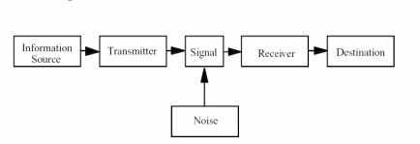

2.2 Schramm Model (1954); It is circular, from sender to receiver-back to sender. Identifies the noise in the same way as in the Shannon and Weaver model but with the difference that it has to do mandatory feedback for effective communication (for example: in the case of Maria and Pedro, the noise is identified as physical noise. Pedro gives back called Maria to ask her if she had told her chicken or the kitchen (this is called feedback and thus the information received by the receiver would be complete.

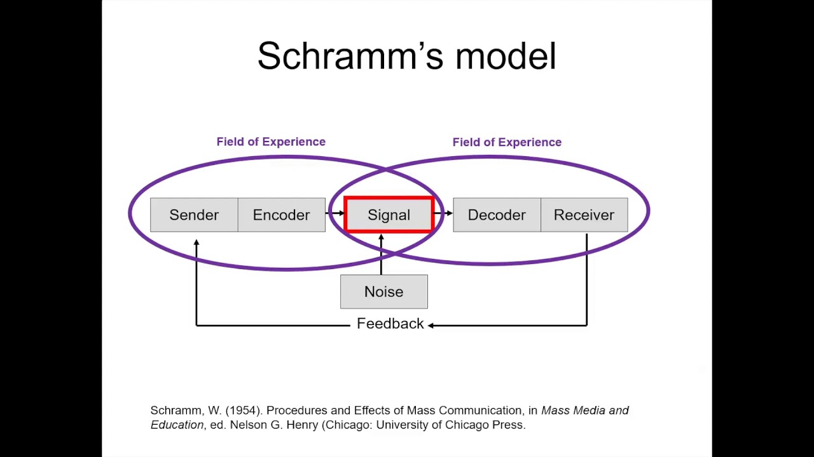

2.3 Berlo´s SMCR model (1964); is similar to the others like Shannon and Weaver, it is linear and without feedback. Here the noise called internal noise is identified but the communication is not complete and received correctly by the receiver (reading, listening, speaking, language, attitude, boring, not listening, assuming things). Example: (in the case of the Professor and the Townspeople) The Professor goes to live in a house on the outskirts of a town where most of the people have no education. One day the Professor lights his pipe, lies down on the sofa, he falls asleep while he drops the pipe on the carpet. When he wakes up and sees that his entire house is on fire, he desperately goes out to ask the townspeople for help and tells them help, my house is in a great "conflagration", instead of using the word "fire" to make the townspeople understood him.

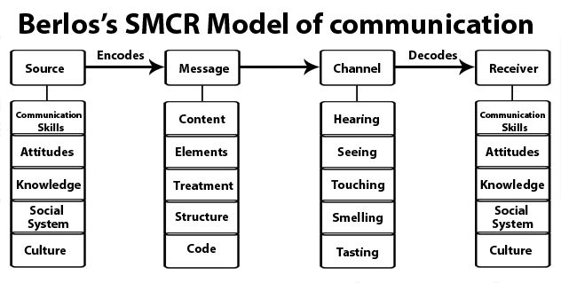

Workplace example of Berlo’s Model
I work as a cleaning supervisor and one day the manager writes to me that a cleaner is not going to work the next day so she tells me to find the person to fill the position, the next day the cleaner appears who was supposedly sick told me why Is there a person here at your job? Why hadn't I asked the Manager before bringing someone to cover the position? What should I have asked first? Raising his voice more and more, until I told him to please control himself and that we are in the workplace. The day before she had texted herself to confirm if she is okay to go back to work but she never got back to me. I continued telling him that it was his responsibility to contact the company to rejoin, but he still did not understand why I lost control of the situation, I raised the tone of my voice and we both distorted the information through the physical noise of the sound waves of our voice.

3.0 Communication Skills
Effective communication involves accurate interpretation of others' verbal messages as meaning is co-created (p. 21) Quintanilla and Wahl, 2020)
3.1 Verbal (oral skills), the communication process that is used to transmit a message through spoken and writing, choice of words, tone, and pitch.
Qualities for Effective Verbal Communication
Clarity: To be clear you have to use simple language, not complicated language (See 'The Professor and the people in the Village' in Class), speak slowly and, choose words that say exactly what you want to say, make sure your body language sends the same message as your words.
Emphaty: Facial expression and tone of voice are important.
Sincerity: Be natural, do not speak ill of people, do not use qualifiers, and respect them. Maintain eye contact: Look at people when you talk to them, this shows that what you are saying is important and that you are telling the truth.
Verbal (Written) It depends on the recipient to use appropriate language and follow grammatical rules.

3.2 Non-verbal
At all times we send messages using our body, our facial expressions, and our way of standing or dressing. Often, we can contradict our corpora language when speaking. We don’t use words to communicate. Verbal and nonverbal communication between group members defines much of team life. Individual goals, team goals, structure, and norms are evident in the communication patterns that develop among members. (of the case A Day with the Chief), overconfidence is the biggest enemy of a person, be careful with body language, always be polite, and do not tell your boss how to do her job. I think Mark didn't properly assess the context because it goes out of context, I shouldn't have told him that the office in London is going badly, and the supervisor who had failed, loosened his tie crossing his legs as if he were Mark the boss. Example: the best thing I should have said I am prepared to meet the objectives set by the company, when you order I get going.

3.3.0 Listening: this is when you focus on sound to grasp its meaning and react appropriately.
Listening

To minimize things that can affect communication, we must first be aware of the:

- Differences in perception: Our past experiences largely determine our views. Differences in age, nationality, culture, education, occupation, sex, and race will have different perceptions and this can be a barrier to communication.
- Jump to the conclusion: We often see what we want to see and hear what we want to hear, so we anticipate before we listen.
- Steorotypes: Treat all people as if they were equal regardless of their differences.
- Lack of Knowledge/language: It is difficult to communicate with someone who has a different academic background than you or who speaks a different language.
- Lack of interest: If someone is talking to you about something that doesn't interest you, it's hard to listen.
3.3.1 Active Listening: You have to pay attention and not do other things like reading your phone, filing your nails, assuming what the other person is going to say, or completing their sentences. It is a skill not learned because we were taught to read, write and speak but not listen for that reason after having heard something, we can only remember 50% of it listening is essential for communication as we have previously explained in our 3 Models. Active listening is the key to accurately understanding what another person is saying. It requires effort and discipline. Chapter 5 (p 98) Communication
3.3.2 Empathetic listening: You have to put yourself in the shoes of the other person. Facial expression and tone of voice are important. Treat others as you would like to be treated. Case studies example; (Max the MULTI-TASKER), it could have been avoided if Max have been honest with Tamara that he had a lot of work to do and thus organized himself by scheduling his appointments to organize and plan the wedding. Tamara did not put herself in Max’s shoes, because if she had put herself in his place, Tamara would have been nicer and she would not have gotten so angry, understanding the difficult situation that she was daring Max.

Overall Barriers – Barry
The Communication challenges in addressing and barriers Barry faces are languages; several potential solutions might be addressed here including posting signs in the employee’s primary language, putting signals with visuals, not just words. time/training, role models, age of workers, different cultures, and emotions that can interfere with effective communication. It will be important for Barry to get his emotions “in check” before starting work. People’s Background language use, disorganized messages, information overall, attitudinal differences, demographic differences, triggers, and filters, physical distance, physical barriers, physical noise, and difficulty hearing clearly.

4.0 The Advantages and Disadvantages of Communication Technology

4.1.0 Advantages

- Access to Information: with just a single click on a dedicated search such as Google and Yahoo, easy access to knowledge.
- Communication: the use of emails, and the internet has enabled faster communication between people in various parts of the world.
- Social Media: the internet has also led to the growth of social media. Through websites like Facebook, Twitter, and Instagram. The students use it to online discuss class topics they search for information in Moodle on the university platform using the internet and a computer or mobile for easy access. People speak to friends, relatives, and co-workers to stay in touch over long distances.
- Commerce: the internet for online businesses by linking potential buyers to sellers with just a computer or smartphone.
- Entertainment: is one of the major advantages of the internet. Users can watch movies, stream live events, play online games, and listen to music.
- Address Mopping: with the help of GPS technology. We can go anywhere just by looking for the address in the browser.
- Creation of Employment: the internet has created thousands of high-paying jobs in the technology sector.

  - Disadvantages

- A poor substitute for face-to-face communication: This has resulted in an increase in bad relationships at work. Although the shy will benefit from this technology, they will also be denied the opportunity to learn how to interact with others.
- Physical and Psychological problems such as depression and anxiety, lack of confidence, eye strain, poor posture
- Students: Very often, students in Britain are caught plagiarism text from the internet or getting essay-writing companies or individuals to do their work. Universities have tools and methods to detect and prevent such fraud.
- Invasion of Privacy: not secure, the database, is exposed to people with wrong intentions inside and outside the organization like hackers.
- Online Bullying: cyberbullies have used this to threaten people anonymously because bullies are able to create fake accounts and go undercover. Cyberbullying is a major threat, especially to young people.

5.0 References

Drew, C. (September 29, 2019). Shannon Weaver Model of Communication – 7 Key Concepts. Available at: Shannon Weaver Model of Communication - 7 Key Concepts (2022) (helpfulprofessor.com) (Accessed: 17th November 2022]
Griffith, Brian A. (2015) Working in teams: moving from high potential to high performance, 1st Edition, Los Angeles: [California] Sage
Juneja, P. (2001:2015). Schramm’s Model of Communication. Available at: Schramm's Model of Communication (managementstudyguide.com) (Accessed: 17th November 2022)
Quintanilla, Kelly M, (2020) Business and professional communication: Keys for workplace excellence, Fourth edition.; International student edition, Los Angeles: Sage
Ramey, K. (2022) Advantages and disadvantages of communication technology in an organization. Available at: Advantages And Disadvantages Of Communication Technology In An Organization - Use Of Technology ( Accessed: 18th November 2022)
Sintellyapp (2021) 5 Advantages and Disadvantages of Technology in the Workplace. Available at: https://sintelly.com/articles/advantages-and-disadvantages-of-technology-in-the-workplace( Accessed: 18th November 2022) (sintellyapp, 2022) (Krumina, 2022)
Surbhi, S. (2018) Difference Between Verbal and Nonverbal Communication. Available at: Difference Between Verbal and Nonverbal Communication (with Comparison Chart) - Key Differences ( Accessed: 18th November 2022]

