
Master of Business Administration

International Business pathway

Assessment : Individual report. Weight: 100%
Module name: International Business Concepts
Module code: LCMB7034
Lecturer name: Jean wang
Company name : The home depot - Japan
Student name: Harsh Hareshkumar Barot
Student ID: 2531265
Word count: 5060
Submission date: 14 Aug 2026

Declaration of AI Acknowledgement
I declare that I have not used any of AI tool, e.g., Claude, ChatGPT] in the preparation of this assignment.
I confirm that:
- The core ideas, analysis, arguments, and conclusions presented in this work are my own.
- Any content generated or assisted by AI has been critically reviewed, verified, and, where necessary, substantially edited by me.
- I take full responsibility for the accuracy, originality, and academic integrity of the submitted work.
- I have used AI in accordance with my institution's academic integrity policy and my course/module guidelines.

Executive Summary
The report provides a critical analysis of the expansion strategy of The Home Depot into the Japanese market. Applying the framework of Bartlett and Ghoshal model, the transnational strategy directly relates to the expansion of The Home Depot which strongly emphasises on acquisitions, regional scale and overall market proximity. This report critically evaluates The Home Depot's proposed entry into Japan through investigating the country's market attractiveness, external environment along with proper market entry strategy. It analyses political, economic, legal and cultural factors leveraging international business frameworks to highlight strategic fit and potential challenges. Application of the Ownership-Location-Internalisation (OLI) framework indicates ownership advantage can be managed due to digital retail capabilities and global brand reputation of Home Depot. Consumer behaviour, regulatory complexity, competitive intensity and local supply integration are key factors determining the success of Home Depot to expand in Japan. The joint venture strategy can be an ideal strategy for the company to expand into Japan since it creates a balance against high domestic market saturation.

Table of Contents
Introduction 5
Section 1 5
1. Organizational Classification and Global Strategy of the Home depot 5
1.1 Strategic Categorization 5
1.2 Global Configuration 6
2. Macro-Environmental Appraisal and Market Attractiveness for the Home depot 6
2.1 Host Country Analysis for the Home depot 6
2.2 Market Entry in the context of The Home depot 10
3. Entry Mode Strategy and Strategic Synthesis for The Home depot 16
3.1 Historical Pattern Recognition for The Home depot 16
3.2 Strategic Fit and Justification for The Home depot 17
3.3 Conclusion and Recommendations 18
Section 2: Reflective Account 20
Conclusion 23
References 25

Introduction
The report aims to cover a market expansion strategy for The Home Depot in the Japanese Market. Key parameters to be covered in the report are organisational classification and global strategy, along with market attractiveness and appraisal of the macro-environment. A recognition of the historical pattern is also to be outlined along with a strategy and its justification. The second section aims to cover a reflective account using a reflective model. It includes covering the learning outcomes of this assignment, challenges encountered and ways through which challenges were mitigated.

Section 1

1. Organisational Classification and Global Strategy of The Home Depot

1.1 Strategic Categorization
The Bartlett and Ghoshal model of international corporate strategy divides the strategy into four distinct types. Those are international strategy, multi-domestic strategy, global strategy and transnational strategy. In regards to international strategy, Home Depot is able to replicate home-country competencies abroad with minimal change along with relying heavily on Relies heavily on parent-company control and exporting. Geopoliticisation in the context of international organisations are making use of the major powers in order to gain competitive advantage (Azzam and Dijkstra, 2026). The global strategy in the context of the framework is higher integration and lower responsiveness by focusing on extreme cost reduction through the help of standardised products.
The transnational strategy strongly relates to the expansion procedure of The Home Depot where the company emphasises on acquisitions, regional scale and overall market proximity. Firms in global markets are able to bring developments to their strategies along with technological advancements (Mahalakshmi, Palanivelu and Kirubakaran, 2026). The transnational strategy for Home Depot is useful in creating a balance on simultaneous demands for global efficiency and local flexibility and sharing knowledge across an integrated network. The multi-domestic strategy has lower integration and higher responsiveness where products can be customised in order to fit distinct local preferences and cultures. In the context of The Home Depot, the company can operate through loose networks of decentralised and local subsidiaries.

1.2 Global Configuration
The Home Depot is able to maintain a global footprint across the entire North American market. Regarding supply chain integration, sourcing on a cross-border basis allows the suppliers of Canada and Mexico to integrate efficiently into the entire U.S distribution network. At the end of the first fiscal quarter, Home Depot was able to operate in around 2,361 retail stores, 1,280 SRS locations and employ more than 47,000 associates (Homedepot, 2026). Past failures and exits from markets such as China, Argentina and Chile taught the firm in prioritising contiguous and culturally aligned regions with speculative distant expansion. US home centre sales and the overall size of the home improvement market is expected to be around $37 billion and $530.6 billion (Statista, 2026). The contribution towards competitive advantage of the firm is replicating its big-box warehouse and pro formats smoothly across any neighbouring countries who have similar consumer habits.
Similarly, diversification within North America also helps cushion in economic downturns or any other regional fluctuations within housing markets. The Home Depot makes use of market development as an intensive growth strategy which provides support to the growth of retail businesses (Panmore, 2026). It helps in establishment of the firm’s presence in newer markets or newer segments in markets.

2. Macro-Environmental Appraisal and Market Attractiveness for The Home Depot

2.1 Host Country Analysis for The Home Depot
Political environment
Political stability along with government support act as strategic enablers for the entry of The Home Depot into Japan. The political stability of Japan is quite strong and it has been reflected by a World Bank estimate score of 0.95 along with the percentile rank of approximately 81.5% (Tradingeconomics, 2024). The specific score indicates Japan strongly in the stable category internationally and this has been supported through long-term demographic governance as well as low-level risk of politically motivated violence. The Home Depot has been operating a capital-intensive business framework that needs consistent substantial investment in regional distribution centres, large stores, long-term supplier partnerships along with integrated logistics. Japan represents a favourable political environment due to its stable democratic governance, robust institutional framework and transparency in policymaking that minimise political uncertainties along with investment risk. The Japanese government promotes foreign direct investment (FDI) actively through initiatives implemented by the Cabinet office and Japan External Trade Organization (JETRO) (JETRO, 2022). Specific initiatives such as regulatory reforms, digitalisation programmes, investment facilitation services shaped for the attractiveness of Japan attract the multinational enterprises. In addition, Japan offers foreign investors with high levels of legal certainties, robust protection for intellectual property and government support (JETRO, 2022). This has been making Japan the most secure destination in Asia for long-term sustainable investment. However, The Home Depot can face significant issues in the aspect of the established retail structure of Japan. In this regard, domestic companies have enhanced long-standing relationships with the suppliers, manufacturers along with local contractors.
The specific type of institutional network can create indirect entry barriers for the foreign retailers in spite of absence of formal restrictions. Hence, The Home Depot needs to identify investment facilities related to political openness, while competitive edge must be achieved through localisation instead of depending on international reputation. For instance, Costco has expanded business through partnerships with Japanese suppliers and adapted product varieties as per local preferences (Yahoo Finance, 2026). The warehouse membership model of Costco remains unchanged, while product localisation such as locally sourced fresh ingredients along with Japanese household goods allow this company to establish robust customer acceptance. This has been indicating that the political environment in Japan supports investments while there is a requirement of strategic localisation in generating sustainable advantage.
Economic environment
High-level purchasing power along with renovation demand provide robust opportunities in business expansion in spite of demographic challenges. The economic conditions play a crucial role in the proposed expansion of the Home Depot as requirement for home enhancement products is directly connected with household income, housing conditions along with consumer expenditure. Japan has been representing innovative infrastructure, a high-income population along with a well-developed retail sector. The nominal GDP in Japan is approximately $4.44 trillion in 2025 and this has made it the fourth largest economy in the world (World Bank, 2025). The economic stability of this country offers a dependable environment for long-term retail investment. According to findings of the International Monetary Fund (IMF), Japan has been continuing to maintain resilient domestic demand supported through wage growth, business investment along with gradual inflation stabilisation (International Monetary Fund, 2026). The IMF also indicates that conditions related to the labour market are quite strong and historically lower unemployment supports the consumer spending capability also. In terms of The Home Depot, market attractiveness is dependable on critical economic performance. The success of this company is dependable on the requirement of home renovation instead of new housing construction.
As Japan has been possessing the world's oldest housing stocks, this has been creating increasing requirements for renovation, modifications for aged individuals and energy-efficient upgrades. The government initiative that promotes sustainable housing, earthquake resilience and energy conversion have stimulated the renovation activities (Naoko Tochibayashi, 2026). This can help in business operations for The Home Depot by leveraging its renovation-oriented product portfolio. However, uncertainties in exchange rates present both opportunities along with risks. Fluctuations in Japanese Yen can increase import costs for the North American products and this has been reinforcing the strategic rationale for sourcing products locally. Developing relationships with the Japanese manufacturers would help in minimising currency exposure, improving supply-chain responsiveness and in enhancing product acceptance using locally sourced offerings.
Legal environment
Regulatory compliance has been observed as the strategic need for the proposed market entry for The Home Depot in Japan. The legal compliance has direct influence on operational efficiency, supply chain resilience along with customer confidence. The home improvement businesses tackle construction materials, electrical products along with environmentally regulated goods that need to comply with strict national safety and quality standards. Hence, the highly developed legal framework in Japan highlights a significant opportunity for establishing customer trusts along with a challenge related to adaptation of notable operations. As per the World Bank Governance Indicators, Japan has been consistently performing well in regulatory quality as 92.45 % in 2023 and that minimises legal uncertainties for multinational investors (Tradingeconomics, 2025). However, the regulatory compliance is quite complex for The Home Depot in comparison with conventional retailers. The building materials, renovation appliances sold in Japan need to comply with legislation such as the Building Standards Act and the Electrical Appliance and Material Safety Act (DENAN) also (METI, 2024). The specific regulations also ensure that products meet robust safety, energy efficiency along with environmental standards before extending business operations in the Japanese market. For example, IKEA Japan initially encountered problems after entering Japan as it transferred various European product specifications along with retail assumptions without adequate localisation (IKEA Museum, 2024). This company has modified its product portfolio by including apartment-friendly designs, safety compliances and established significant relationships with the Japanese suppliers. The specific operational and legal adaptations helped IKEA in expanding their business in Japan. This has been illustrating regulatory compliance needs to be observed as strategic investment while entering in the Japanese market for The Home Depot.
Cultural environment
The business model of The Home Depot is built around a robust Do-It-Yourself (DIY) culture. The Japanese customers basically prefer Do-It-For-Me (DIFM) services, depending on skilled professionals for home renovation along with installation (Kenresearch, 2026). The specific preference has been driven through the aging population in Japan, strong focus on quality, smaller living spaces along with expert craftsmanship. Hence, only transferring the U.S. retail model can impede the market acceptance for The Home Depot. This company needs to combine premium quality home-enhancement products with installation, necessary consultation along with after-sales service also. For instance, Nitori Holdings has achieved market leadership through maintaining focus on product quality, consumer service along with practical solutions instead of price competition (Niotri Holdings, 2025). The continued growth of this company illustrates that adapting towards Japanese cultural expectations creates robust customer loyalty along with a sustainable competitive edge. This has been offering a significant strategic opportunity for the proposed marketing strategy of The Home depot.
Critical analysis of Japan’s market attractiveness
The afore-mentioned external environmental analysis highlights that Japan indicates a strategically attractive and operationally demanding market for The Home Depot. However, the core strategic challenge has been followed in adapting the North American business model to Japanese institutions along with cultural realities. Legal compliance significantly highlights the need for substantial localisation of products. In another direction, supply chains and the cultural preferences mostly favour the professionally offered home-improvement services instead of traditional DIY retailing (METI, 2024). The real life examples including Costco, Nitori and IKEA consistently demonstrate that foreign retailers got success in their business through combining global operational capabilities with extensive local adaptation. Hence, Japan’s attractiveness for The Home Depot relies less on market size rather than on the willingness of the company in reshaping its value proposition regarding professional installation services and sustainable product innovation.

2.2 Market Entry in the context of The Home Depot
Application of eclectic paradigm/ OLI framework
The Ownership-Location-Internalisation (OLI) Framework of Dunning supports evaluation of market expansion strategies of Home Depot in Japan. Ownership, location and Internalisation are three components of the eclectic paradigm or OLI framework (Nasrulddin, 2024). Ownership based, location based and Internalisation advantages need to be focused on by the multinational corporation (MNC) for market entry into the chosen country that is Japan.
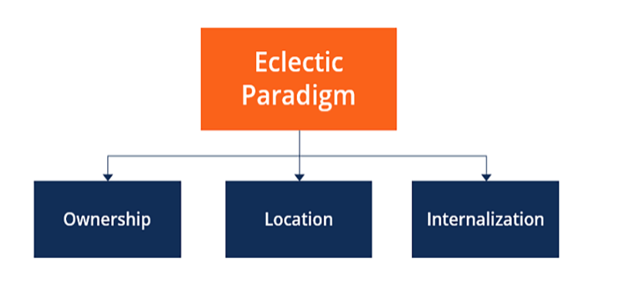
Figure 1: The OLI Framework
(Source: Nasrulddin, 2024)
Ownership
Home Depot has significant ownership-based advantages due to global brand reputation, digital retail capabilities, efficient supply chain system, financial strength and potential of operating in a large-scale home improvement retailing industry. The company-specific assets support competitive advantages that may not be easily imitated by Japanese home improvement retailers. According to Nagy et al. (2024), Omnichannel strategy is important for organisations to implement streamline communication channels for better customer engagement. Home Depot implements Omnichannel strategy that include advanced E-Commerce capability and physical stores inclusion which is important for attracting Japanese consumers and affecting purchasing decisions. However, the ownership advantages are not universally transferable as Home Depot developed the competitive advantage in North America that includes a do-it-yourself (DIY) culture among customers. Japanese customers have greater dependence on small residential spaces, professional renovation services and various customers' purchase behaviour. Hence, Home Depot’s ownership advantages can be valuable in case the strategies are managed to adjust to Japanese market characteristics instead of transferring by not adopting changes.
Location
Japan provides various location based advantages which is important to manage the market entry strategy of Home Depot. The country has one of the largest consumer markets of the world which support strategic logistics infrastructure, customers’ high purchasing power, legal protection to make foreign investment and political stability. Japan is the fourth largest economy after the United States, Germany and China in the world (International Trade Administration, 2025). In addition, the demographic trend of Japan includes renovation expenditure growth, aging housing stock, demand for energy effective housing products and sustainability initiatives which create opportunities for Home Depot’s expansion. On the other hand, structural barriers can create challenges as a highly competitive retail industry includes established domestic businesses which provide products by utilising local knowledge, effective distribution system and loyal customer relationships. Complex regulations,high commercial property expenses and cultural differences can create challenges for Home Depot’s expansion. Henceforth, Japan is an attractive location for market entry that creates long term opportunities by outweighing entry challenges in the short-term.
Internalisation
Home Depot also gets potential benefits of Internalisation advantages which support managing direct control for procurement, supplier management, quality standards, customer service and digital systems to preserve operational consistency. For example, Suppliers of Home Depot need to operate in full compliance by following the regulations of the countries of operations (Home Depot, 2022). In addition, property knowledge protection, risk reduction for contractual dependence, and quality inconsistency can also decrease through Internalisation. In contrast, operational risk and financial exposure also increase due to Internalisation in the unfamiliar institutional environment of Japan. Excessive dependence on wholly controlled operations can negatively influence organisational flexibility during market entry’s initial stage. Hence, Internalisation provides key benefits of market entry and it requires to balance local responsiveness and corporate control for operational adoption.
Critical evaluation of key factors that will impact the success of The Home Depot's 'market entry
Limited DIY culture and consumer behaviour: Success of Home Depot in Japan depends upon compatibility management between Japanese consumer behaviour and the established business model. The competitive advantage of Home Depot is influenced by DIY culture that encourages customers to purchase tools, construction materials and renovation products which affects independence for home improvement. Home Depot offers customer workshops, DIY clinics and one-on-one sessions with consumers (Home Depot, 2026). The behavioural pattern of DIY is quite different in Japan as traditionally households depend upon professional contractors for maintenance and renovation services. However, the cultural difference of consumer behaviour can create challenges to adjust the existing value proposition of the brand and it can lead to failure in adjusting customers' demand. Home Depot's market entry success depends upon modifying North American culture in Japan otherwise it can lead to market expansion and opportunity elimination. As a result, consumer adoption instead of product standardisation is a key factor to influence customers’ behaviour during market entry.
Domestic market leadership and competitive intensity: Home improvement retail industry of Japan includes key characteristics of high competitive rivalry that can be challenging for Home Depot to enter the market. In contrast to Gilbert (2022), lack of technology integration can lead to market competitiveness failure by not satisfying customers. Fragmented competition or institutional weakness can be faced by international retailers during market expansion as Japan includes strong domestic competitors with an effective customer loyalty base and extensive distribution network. As a result, the competitive success of Home Depot depends upon the ability to generate distinctive customer value creation instead of focusing on direct price competition with key Japanese market retailers.
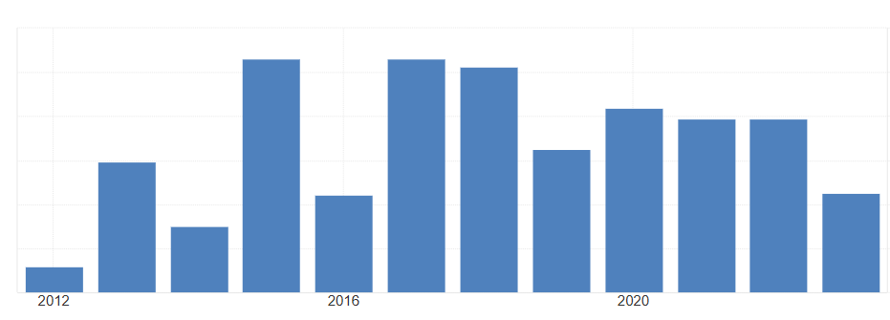
Figure 2: Political Stability and Absence of Violence Percentile Rank of Japan
(Source: Trading Economics, 2026)
Regulatory complexity and institutional environment: Regulatory and institutional environments also influence market entry of Home Depot which provide transparent governance, political stability and legal protection for investors. The market environment of Japan supports political uncertainty reduction during market expansion at international level. Political stability and absence of violence percentile rank of Japan was 80% in 2014 that increased to 81.56% in 2023 (Trading Economics, 2026). However, following construction standards, regulatory requirements and commercial zoning guidelines can be challenging. As a result, institutional stability provides opportunity for market expansion of the company that requires long run strategic commitment and managerial capability for mitigating regulatory complexity.
Local supplier integration and supply chain efficiency: Supply chain management is essential for market expansion of Home Depot in Japan that influences effectiveness in inventory management, procurement and supplier coordination. Japan includes well developed logistic infrastructure which is important for home improvement retail industry operations by managing inventory efficiency and streamline customer services. As claimed by Ghodake et al. (2024), supply chain management is essential for organisations to procure raw materials and provide service delivery effectively. On the other hand, effective infrastructure does not necessarily mean the success of the supply chain system as local suppliers prefer mutual trust and long term relationship instead of short run commercial transactions. As a result, localisation of supplier relationships and extensive global procurement balance is important for managing sourcing strategy.
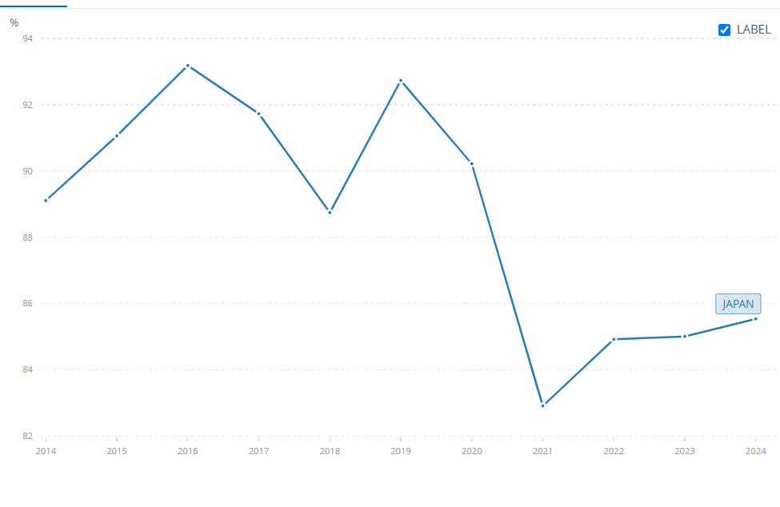
Figure 3: Individuals using the Internet as percentage of population in Japan
(Source: World Bank, 2026)
Omnichannel retailing and digital transformation: Implication of digital retailing services create strategic opportunities for Home Depot to expand in Japan. For example, 83% of the Japanese population used the internet in 2021 which increased to 86% in 2024 (World Bank, 2026). Digital platform utilisation and high internet penetration rate create opportunities for the retail brand to expand in Japan. Sophisticated Omnichannel infrastructure of Home Depot can be beneficial to manage market expansion including inventory visibility, online ordering and click and collect services. Valuable ownership advantage of the company is influenced by the Omnichannel factor which is important for better customer convenience. On the other hand, digital capability dependence only is not sufficient for sustainable competitive advantage as Japanese customers already have advanced digital retail services. Integration of digital platforms with customised services, professional installation support and efficient fulfilment system factors are important to positively influence market expansion strategy in Japan. Hence, Home Depot’s market entry success is dependent upon a combination of local responsiveness and digital transformation for service innovation.

3. Entry Mode Strategy and Strategic Synthesis for The Home Depot

3.1 Historical Pattern Recognition for The Home Depot
Some of the dominant historical international expansion modes adopted by the Home Depot are joint ventures, acquisitions and wholly owned investments. As per the statement of Sestu (2026), for product specific expertise, investors usually pick joint venture strategy. Some benefits of joint venture strategy for The Home Depot are better pro and customer experience by funding early-stage tech companies and helping professional builders in managing bigger projects. In contrast, García-Canal and Guillén (2026) argued that the disruptive nature of global platforms challenges the regulatory frameworks and redefines organisational structures. The challenges of Joint Venture are cultural misalignment, loss of control and differences regarding consumer behavioural aspects.
The benefits of acquisitions for organisations are useful in providing rapid expansion into the market, efficiency and scale, capability enhancement and defines within competitiveness. Adhikari, Sharma and Bikram Panta (2026) stated that mergers and acquisitions (M&A) are motivated based on the benefits of stabilisation of earnings, achievement of market share and cutting down delivery expenses. In the context of The Home Depot, cross-selling synergies involves merging professional supply networks for selling specialised building materials. International acquisitions however, can come with key hurdles such as risks of valuation, regulatory and cultural hurdles. It can also be challenging for The Home Depot in facing rule and legal issues along with conflicting work ethics and different communication styles.
Wholly owned investments in international expansion indicates that a company owns around 100% of the foreign operation. The major benefits that companies can receive from wholly owned investments are 100% of the profits, total operational control and complete protection of the trade secrets. International relations are considered as the study of foreign affairs regarding the roles of inter-governmental organisations, multinational corporations and non-governmental organisations (Ghosh, 2026). In the context of The Home Depot, the parent company can keep all the profits without sharing and maintaining clarity of the brand. However, limitations that can be faced by The Home Depot are higher risks, not receiving local help and incurring higher costs. For instance, if the Japanese market fails, then Home Depot has to incur all the financial losses. Setting or buying a foreign unit can take up a lot of money for The Home Depot while expanding into the Japanese market.

3.2 Strategic Fit and Justification for The Home Depot
The historical mode that can be adopted by The Home Depot is Joint Venture. Maintenance of joint ventures is considered as an optimal way of expanding into the Japanese market by creating a balance against high domestic market saturation. The company is planning to open 12 more stores in the US in the eight states as of 2026 in order to further increase its physical presence (Homedepot, 2026). In terms of political and regulatory risk, Direct acquisition of a home improvement chain in Japan carries higher cultural and operational integration risks which is similar to the challenges faced by the company in China. Therefore, a joint venture strategy can be much more useful in mitigating regulatory friction and gaining insights on consumer behaviour. In terms of financial risks, there can be a direct capital exposure in contrast to a wholly owned subsidiary at a greenfield rollout.
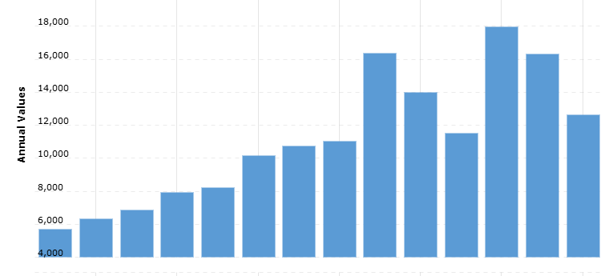
Figure 4: Free cash flow of The Home Depot
(Source: Macrotrends, 2026)
In terms of resource commitment, shared capital expenditure and sharing can help in reducing initial cash outflow. The company’s annual free cash flow in the year 2026 was $12.646 billion which indicates a 22.54% from 2025 (Macrotrends, 2026). Expanding into the Japanese market with the help of Joint Venture Strategy can help the firm in bringing reductions to its overall cash flows. Control versus flexibility includes sacrificing absolute managerial control by avoiding solo failures which the company faced in the past.
Regarding long-term strategic fit, learning about the market can serve as a low-risk testing ground for adapting to the U.S. big-box and the pro model in its ecosystem. This can be shifted towards the higher density urban layouts in Japan’s housing market. The relational exchange theory helps in analysing ways through which strategic relationships are manifested across four significant inter-organisational projects for building strategic relationships (Sandoval et al., 2026). Similarly, synergistic growth is useful in providing a localised foundation for scaling fulfilment purposes without creating a leverage over the balance sheet.

3.3 Conclusion and Recommendations
Conclusion
The report has evaluated The Home Depot's proposed expansion into Japan by analysing Japan's macro-environment, the firm's international strategy, and the suitability of different market entry options. The transparent legal framework, strong economy, political stability, and advanced infrastructure make Japan an attractive destination for foreign investment. However, issues such as limited intense domestic competition, DIY culture and complex supplier relationships can maintain substantial localisation. Therefore, inclusion of the OLI framework demonstrates Home Depot possesses strong ownership and internalisation advantages in Japan that maintain attractive strategies in an operationally demanding market.
Recommendations
Home Depot needs to adopt the joint venture strategy in establishing a Japanese home improvement retailer to manage preferred market entry mode. As inspired by Brüggemann, Martinez and Pauwels (2025), the market entry strategy is a planned method for delivering goods and services into a new target market to maintain supplier networks. This approach can reduce operational and financial risks by providing immediate access to supplier networks, local market knowledge, and customer relationships. The organisation needs to localise its product portfolio for compact home improvement solutions, energy-based products and renovation materials that are suited to Japanese housing characteristics. On the other hand, as stated by Ilyas and Dianti (2025), investment in digital platforms is important to maintain personalised customer service in developing existing omnichannel capabilities. Therefore, Home Depot can establish digital innovation by managing strategic partnerships to strengthen supply chain resilience and emphasise product availability within the Japanese home improvement retail market.

Section 2: Reflective Account
The reflective account based on Gibbs' Reflective Cycle helps me to evaluate the learning process while researching and preparing the international organisational report on The Home Depot's proposed expansion into Japan. This reflects my key understanding of knowledge developed and future improvements to maintain strategic international business analysis.
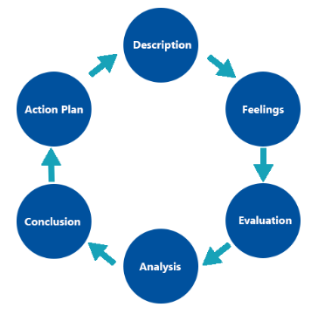
Figure 5: Gibbs reflective cycle
(Source: Created by author)
Description
My assignment requires a comprehensive analysis of The Home Depot's proposed entry into Japan, with analysing the company's international strategy, the key importance of the Japanese market, and an appropriate market entry mode. As inspired by Aquino et al. (2025), individual reflection is important in understanding one's own strengths and weaknesses that further maintain key skills effectively. I have reviewed the key assessment brief to understand the required structure as well as the learning outcome of the study. I have also gathered information from journal articles, reports, as well as others that help to understand key contexts of business situations and their entry in the Japanese market. Inclusion of differences in enabling to understand political stability as well as economic situation when applying international business frameworks, which are effective in managing key entry in the market. Application of organisational theories such as Bartlett and Ghoshal's framework and Dunning's Eclectic Paradigm also helped me to understand the context of business expansion. Further, I also compared Home Depot's historical expansion strategies with Japan's market characteristics to understand a suitable entry mode that helps me to develop practical knowledge.
Feelings
At the beginning level of the assignment, I felt confident in maintaining key research in understanding the international context. However, uncertainty in getting appropriate theories and information at the initial level caused difficulties in managing my research practices. I have realised that postgraduate research skills are required in analysing evidence and maintaining links with the framework directly to support organisational strategic decisions. As stated by Van Oudenhoven et al. (2023), decision-making practices of an individual are effective in managing key research activities and balancing work speed with accuracy. However, I faced challenges in determining market suitability and expansion opportunities in Japan due to a lack of critical thinking skills to evaluate the attractive investment or significant cultural barriers. I have managed my confidence along with taking help from my supervisors and friends, which help to manage my research activity. Application of theories in real organisations, such as The Home Depot, also maintains the learning process more enragedly in evolving complex international business situations.
Evaluation
My assignment work helped to maintain a positive aspect in developing a structured research strategy with a combination of academic literature and industry reports. I have developed the reliability that enabled me to examine Home Depot's expansion strategy from different perspectives. As influenced by Pajić et al. (2024), internationalisation strategies are effective in managing business activity and market entry maintenance, along with managing key preferences of consumers. I have maintained this learning by managing key expansion understanding, which describes the suitability of the business in expanding to Japan with a joint venture mode implication. However, I have faced difficulties throughout the research process, where identifying recent information regarding Home Depot's international operations has been limited by the organisation’s data. I have resolved these issuesalong with managing different source utilisation in understanding the research context. Further, implications of note-taking activity, careful planning and revision enable me to develop the overall quality of the work.
Analysis
Reflecting on my assignment, I have gathered valuable understanding regarding practical business situations and successful multinational corporations that rely on standardisation. The implications of Bartlett and Ghoshal's theory helped me to understand the multinational corporation aspect that needs to balance global integration with local responsiveness. However, I have faced issues of time management that complicate issues in managing research practices. As per views of Oluyisola et al. (2022), time management is a process for planning and controlling tasks to work more efficiently. Academic readings significantly improve my understanding of international business strategy management in demonstrating environmental differences that influence market entry success. Further, this reinforced understanding helps me understand how to integrate political, cultural and economic analysis into strategic decision-making.
Conclusion
The reflection has demonstrated substantial personal and academic improvement throughout the assignment completion. I maintained a stronger understanding of international business strategy and strategic decision-making in applying recognised theoretical frameworks within a multinational organisation. These key experiences maintained my analytical, research, and academic writing skills, as well as other skills to develop my professional skills. Overall, this assignment has developed valuable knowledge, which will support both future academic and professional decision-making skills in international business environments.
Action plan
Area for Development | Action | Expected Outcome | Timeframe
Research skills | Need to develop key practices of taking data or information from more peer-reviewed journal articles and credible international sources, along with taking courses from YouTube. | Develop overall quality and credibility of searching and considering academic evidence. | 6 months
Critical thinking and analysis | Inclusion of a LinkedIn courses program based on these skills development and practice continuously in comparing theories instead of describing concepts. | Strengthen critical thinking to make decisions effectively. | 5 months
Time management | Prepare a weekly research plan as well as consider online courses such as from YouTube with milestones for drafting and revision. | Complete assignments on time, which can help to complete the work in time for sufficient proofreading. | 6 months
Table 1: Action plan
(Source: Created by author)

Conclusion
This report has focused on The Home Depot's proposed entry into Japan by integrating international business theories to maintain contemporary market evidence. The Bartlett and Ghoshal framework is effective in maintaining international corporate strategy, indicating that Home Depot predominantly follows a transnational strategy balancing global operations with local responsiveness. Analysis of political stability, an advanced economy, as well as a supportive investment environment can enhance market differences. Application of the OLI framework can maintain cultural differences, and suitability for using a joint venture can offer balanced activity and local responsiveness in Japan. Therefore, it can be said that sustainable success maintains strategic localisation of The Home Depot in managing effective partnerships and continuous adoption of Japanese consumer preferences.

References
Section 1
Adhikari, N., Sharma, R. and Bikram Panta, S. (2026) ‘Capital regulation-induced mergers and acquisitions: do they improve or impede cost efficiency?.’ Cogent Business&Management, 13(1), p.2632804. Available at: https://doi.org/10.1080/23311975.2026.2632804
Azzam, B. and Dijkstra, H. (2026) ‘The geopoliticisation of international organisations and strategic technologies: Exacerbating global rivalries?.’ Geopolitics, pp.1-25. Available at: https://doi.org/10.1080/14650045.2026.2626267
Brüggemann, P., Martinez, L.F. and Pauwels, K., (2025). ‘Theoretical perspectives and conceptual framework for online grocery shopping: Adapting to environmental circumstances and influencing internal factors’. Electronic Commerce Research, 25(3), pp.2271-2307. Available at: https://doi.org/10.1007/s10660-025-09960-8 (Accessed: 04 August 2026).
García-Canal, E. and Guillén, M.F. (2026) ‘The international expansion of digital platforms: A dynamic setting for challenging and advancing theories of the multinational enterprise.’ BRQ Business Research Quarterly, 29, p.23409444251382952. Available at: https://doi.org/10.1177/23409444251382952
Ghodake, S.P., Malkar, V.R., Santosh, K., Jabasheela, L., Abdufattokhov, S. and Gopi, A., (2024). ‘Enhancing Supply Chain Management Efficiency: A Data-Driven Approach using Predictive Analytics and Machine Learning Algorithms’. International Journal of Advanced Computer Science&Applications, 15(4), p.672. Available at: https://pdfs.semanticscholar.org/2a52/6da7b7b9cf3e185ebf1c02e4727af91e195e.pdf
Ghosh, P. (2026) International relations. PHI Learning Pvt. Ltd..
Gilbert, R.J., (2022) Innovation matters: competition policy for the high-technology economy. MIT press.
Home Depot (2022) Responsible Sourcing Standards. Available at: https://corporate.homedepot.com/sites/default/files/2022-08/THD_0096_2022ResponsibleSourcing-Standards_English.pdf (Accessed: 04 August 2026).
Home Depot (2026) The Home Is Where Our Story Begins. Available at: https://corporate.homedepot.com/page/home-where-our-story-begins (Accessed: 04 August 2026).
Homedepot (2026) The Home Depot Adds 12 New Stores Across Eight States to its U.S. Footprint. Available at: https://corporate.homedepot.com/news/company/home-depot-adds-12-new-stores-across-eight-states-its-us-footprint (Accessed: 3 August 2026).
Homedepot (2026) The Home Depot Announces First Quarter Fiscal 2026 Results; Reaffirms Fiscal 2026 Guidance. Available at: https://ir.homedepot.com/news-releases/2026/05-19-2026-110111934 (Accessed: 4 August 2026).
IKEA Museum (2024) The 1970s failure on the Japanese market, IKEA Museum. Available at: https://ikeamuseum.com/en/explore/the-story-of-ikea/too-big-in-japan/ (Accessed: 04 August 2026).
Ilyas, A. and Dianti, M.R., (2025). ‘Omnichannel Strategy: Its Impact on Customer Satisfaction and Retention’. Jurnal Informatika Ekonomi Bisnis, pp.898-905. Available at: https://doi.org/10.37034/infeb.v7i4.1303 (Accessed: 04 August 2026).
International Monetary Fund (2026) Japan and the IMF, IMF. Available at: https://www.imf.org/en/Countries/JPN (Accessed: 04 August 2026).
International Trade Administration (2025) Japan - Market Overview. Available at: https://www.trade.gov/country-commercial-guides/japan-market-overview (Accessed: 04 August 2026).
JETRO (2022) Investing in Japan | Japan External Trade Organization - JETRO, Www.jetro.go.jp. Available at: https://www.jetro.go.jp/en/invest/(Accessed: 04 August 2026).
Kenresearch (2026) Japan Home Improvement Market | 2019 – 2030 | Ken Research, Kenresearch.com. Available at: https://www.kenresearch.com/japan-home-improvement-market (Accessed: 04 August 2026).
Macrotrends (2026) Home Depot Free Cash Flow 2012-2026. Available at: https://www.macrotrends.net/stocks/charts/HD/home-depot/free-cash-flow (Accessed: 3 August 2026).
Mahalakshmi, K., Palanivelu, V.R. and Kirubakaran, D. (2026) ‘Global Market trends in biomedical sensors: Materials, device engineering, and healthcare applications.’ Biomedical Materials&Devices, 4(2), pp.1628-1646. Available at: https://doi.org/10.1007/s44174-025-00362-w
METI (2024) Electrical Appliances and Materials Safety Act / METI Ministry of Economy, Trade and Industry, Www.meti.go.jp. Available at: https://www.meti.go.jp/english/policy/economy/consumer/pse/index.html (Accessed: 04 August 2026).
Nagy, I.D., Dabija, D.C., Cramarenco, R.E. and Burcă-Voicu, M.I., (2024). ‘The use of digital channels in omni-channel retail—an empirical study’. Journal of Theoretical and Applied Electronic Commerce Research, 19(2), pp.797-817. Available at: https://doi.org/10.3390/jtaer19020042
Naoko Tochibayashi (2026) Here’s how Japan’s green materials sector is thriving, World Economic Forum. Available at: https://www.weforum.org/stories/climate-action/how-japan-is-building-resilience-through-innovation-in-the-green-materials-sector/ (Accessed: 04 August 2026).
Nasrulddin, V., (2024). ‘Prospects of Post-Conflict Foreign Direct Investments in Ukraine Through the Lens of Dunning’s Eclectic Paradigm’. International Journal of Economics and Finance, 16(6), pp.43-61. Available at: https://doi.org/10.5539/ijef.v16n6p43
Niotri Holdings (2025) “Enrich homes of people all over the world,” in Nitori Holdings Integrated Report 2025. Available at: https://www.nitorihd.co.jp/en/pdf/annual.pdf (Accessed: 04 August 2026).
Panmore (2026) Home Depot’s Generic Competitive Strategy&Growth Strategies. Available at: https://panmore.com/home-depot-generic-strategy-intensive-growth-strategies (Accessed: 3 August 2026).
Sandoval, J., Krystallis, I., Whitmore, D. and Huemann, M. (2026) ‘Managing strategic relationships in inter-organisational projects.’ Production Planning&Control, 37(5), pp.463-480. Available at: https://doi.org/10.1080/09537287.2025.2554161
Sestu, M.C. (2026) ‘When Local Partner Knowledge Is Embedded: The Choice Between Greenfield and Acquisitive International Joint Ventures.’ Thunderbird International Business Review. Available at: https://doi.org/10.1002/tie.70138
Statista, (2026). The Home Depot - statistics&facts. Available at: https://www.statista.com/topics/7564/the-home-depot/?srsltid=AfmBOoqzzPNaNoT-9dgS0ipa7pmVB529a8K8CXIbZrBH5D6gSWF-goMz (Accessed: 4 August 2026).
Trading Economics (2026) Japan - Political Stability And Absence Of Violence/Terrorism: Percentile Rank. Available at: https://tradingeconomics.com/japan/political-stability-and-absence-of-violence-terrorism-percentile-rank-wb-data.html (Accessed: 04 August 2026).
Tradingeconomics (2024) Japan - Political Stability And Absence Of Violence/Terrorism: Estimate - 2024 Data 2025 Forecast 1996-2022 Historical, Tradingeconomics.com. Available at: https://tradingeconomics.com/japan/political-stability-and-absence-of-violence-terrorism-estimate-wb-data.html (Accessed: 04 August 2026).
Tradingeconomics (2025) Japan - Regulatory Quality: Percentile Rank - 2025 Data 2026 Forecast 1996-2023 Historical, Tradingeconomics.com. Available at: https://tradingeconomics.com/japan/regulatory-quality-percentile-rank-wb-data.html (Accessed: 04 August 2026).
World Bank (2025) GDP (current US$) - Japan | Data, Worldbank.org. Available at: https://data.worldbank.org/indicator/NY.GDP.MKTP.CD?locations=JP (Accessed: 04 August 2026).
World Bank (2026) Individuals using the Internet (% of population) - Japan. Available at: https://data.worldbank.org/indicator/IT.NET.USER.ZS?end=2024&locations=JP&start=2014 (Accessed: 04 August 2026).
Yahoo Finance (2026) Costco’s Japan Success Highlights Membership Model And Global Growth Potential, Yahoo Finance. Available at: https://finance.yahoo.com/markets/stocks/articles/costco-japan-success-highlights-membership-010925706.html (Accessed: 04 August 2026).
Section 2
Aquino, M.K.A., Bumacod, A.M., Calapine, A.G., Yaco, J.M.T., Dimailig, M.L., Amores, A.P. and Francisco, J., (2025). ‘Interpersonal and intrapersonal leadership competencies: an interpretative phenomenological analysis on effective leadership strategies’. Frontiers in Psychology, 16, p.1553620. Available at: https://doi.org/10.3389/fpsyg.2025.1553620 (Accessed: 04 August 2026).
Oluyisola, O.E., Bhalla, S., Sgarbossa, F. and Strandhagen, J.O., (2022). ‘Designing and developing smart production planning and control systems in the industry 4.0 era: a methodology and case study’. Journal of Intelligent Manufacturing, 33(1), pp.311-332. Available at: https://doi.org/10.1007/s10845-021-01808-w (Accessed: 04 August 2026).
Pajić, V., Andrejić, M., Jolović, M. and Kilibarda, M., (2024). ‘Strategic warehouse location selection in business logistics: A novel approach using imf SWARA–MARCOS—A case study of a Serbian logistics service provider’. Mathematics, 12(5), p.776. Available at: https://doi.org/10.3390/math12050776 (Accessed: 04 August 2026).
Van Oudenhoven, B., Van de Calseyde, P., Basten, R. and Demerouti, E., (2023). ‘Predictive maintenance for industry 5.0: behavioural inquiries from a work system perspective’. International Journal of Production Research, 61(22), pp.7846-7865. Available at: https://doi.org/10.1080/00207543.2022.2154403 (Accessed: 04 August 2026).

