12/17/2025
Network and Cyber Security Essentials


Lecturer’s Name: Dr Kwame Assa-Agyei
Student Name: Yuksel Unlu
Student Number: 2428304

Table of Contents
Cybersecurity Policy Development for First Atlantic Water Company 1
Abstract 1
Introduction 1
Identification of Modern Threats 1
Modern Security Policies 1
Technical Mitigation Measures 1
Proactive Monitoring and Incident Response 2
Continuous Training and Awareness 2
Conclusion 2
References 2
Appendix A: Screenshot of the Board of Directors PowerPoint presentation 3
Appendix B: Screenshot of the Badge 3

Cybersecurity Policy Development for First Atlantic Water Company

Abstract
This report presents a comprehensive cybersecurity policy framework for First Atlantic Water Company, designed to address modern internal and external threats while ensuring resilience, adaptability, and business continuity. The framework identifies emerging risks such as Ransomware-as-a-Service (RaaS), AI-powered social engineering, supply chain compromises, and vulnerabilities associated with cloud adoption and hybrid work. Policies are aligned with the Zero Trust model and best practices from NIST Cybersecurity Framework (CSF) and ISO 27001. Technically, measures, proactive monitoring, incident response strategies, and continuous training programs are proposed to create a general defense system. The recommendations emphasize scalability, usability, and adaptability, ensuring that cybersecurity practices remain effective in dynamic threat environments

Introduction
Organizations increasingly rely on digital infrastructure to support operations, customer engagement, and innovation. This reliance exposes businesses to evolving cyber threats that can disrupt services, compromise sensitive data, and damage reputation. First Atlantic Water Company requires a robust cybersecurity policy framework that integrates modern threat identification, structured policies, technical safeguards, proactive monitoring, and continuous training. This report outlines such a framework, aligning technical and organizational measures with recognized standards to ensure resilience and compliance.

Identification of Modern Threats
Cyber threats are evolving faster and more effectively than ever before worldwide. For critical infrastructure providers like First Atlantic Water Company, these modern threats are by no means abstract risks; rather, they directly target systems that provide safe water to communities and have the potential to have very negative impacts. From ransomware campaigns that can cripple operational technology to sophisticated attacks on industrial control systems, the nature of cybercrime has transformed from isolated incidents to organized, sustained campaigns.
“In today's interconnected digital world, cybersecurity has become a paramount concern for organizations, governments, and individuals alike. As technology continues to advance at an unprecedented rate, the threat landscape evolves in tandem, presenting new and complex challenges that demand vigilant attention and robust defences. This paper aims to provide an in-depth analysis of the emerging threats in cybersecurity, focusing on the modern attack vectors and techniques that are currently posing significant risks to the integrity, confidentiality, and availability of information and systems.” [1]
Today's modern cyber threats are;
Ransomware-as-a-Service (RaaS)
RaaS commoditizes ransomware, enabling attackers with minimal technical expertise to launch sophisticated campaigns.
Threat actors can purchase or rent ransomware kits, increasing attack frequency and scale.
Impact: financial loss, reputational damage, operational disruption.

AI-Powered Social Engineering (Vishing)
Artificial intelligence enables realistic voice phishing attacks using deepfake audio.
Attackers impersonate executives or employees to manipulate victims into revealing sensitive information.
Risk: unauthorized access, financial fraud, insider compromise.

Supply Chain Compromises
Vulnerabilities in third-party software or hardware can be exploited to infiltrate organizations.
Example: SolarWinds breach demonstrated how attackers can compromise trusted vendors.
Risk: widespread exposure across interconnected systems.

Cloud Adoption Risks
Misconfigurations, insecure APIs, and unclear shared responsibility models increase exposure.
Data breaches and unauthorized access are common risks in poorly managed cloud environments.

Hybrid Work Risks
Remote work introduces insecure home networks, personal devices, and insider threats.
Lack of centralized control increases the attack surface.

Modern Security Policies
Modern security policies developed worldwide provide a framework that enables both technology and people to work together to protect critical infrastructure. For First Atlantic Water Company, these policies define how access is controlled, how sensitive customer and operational data is protected, and how incidents are reported and managed. They establish rules for personnel conduct, require strong authentication for remote access, and set standards for third-party suppliers to mitigate supply chain risks. Importantly, modern policies are not just static documents; they are living guidelines that evolve with new threats, incorporate lessons learned from past events, and comply with industry regulations. By adopting and implementing these policies, the company strengthens its resilience, protects customer trust, and ensures compliance with national and international standards.
“Strong security policies deliver three critical outcomes: data protection, business continuity and regulatory compliance. With new regulations like NIS2 imposing significant penalties for non-compliance and the Cyber Resilience Act requiring secure-by-design products, outdated policies create legal and financial risk.
The threat landscape has fundamentally changed as remote work, cloud adoption and increased reliance on third-party vendors have expanded your attack surface. Acting today sets the foundation for long-term resilience and confidence. Your policies must reflect this new reality or leave your organization vulnerable. Effective policies require more than technical specifications and some helpful recommendations include:
- Clear governance structures with defined accountability at the board and executive level
- Risk-based frameworks that align security investments with business priorities
- Vendor risk management protocols that protect your supply chain
- Incident response procedures that minimize business disruption
- Continuous monitoring metrics that provide board-level visibility “ [2]
Today's security policies;
Aligned with Zero Trust and frameworks such as NIST CSF and ISO 27001:
Access Control Policy: Enforce least privilege, role-based access, and mandatory MFA.
Data Protection Policy: Encrypt data at rest and in transit; implement Data Loss Prevention (DLP).
Cloud Security Policy: Adopt Cloud Security Posture Management (CSPM) tools; enforce secure configurations.
Remote Work Policy: Require secure VPNs, endpoint compliance checks, and device management.
Incident Reporting Policy: Establish mandatory reporting channels for suspicious activity.
Compliance Policy: Ensure adherence to GDPR, ISO 27001, and NIST CSF categories (Identify, Protect, Detect, Respond, Recover).

Technical Mitigation Measures
Technical mitigation measures are tangible defenses protecting First Atlantic Water Company’s systems against modern cyber threats. These measures include segmenting networks to separate operational technology from corporate IT, implementing multi-factor authentication for all remote and privileged access, and applying regular patches to close vulnerabilities in legacy systems. Intrusion detection and monitoring tools provide early warning of suspicious activity, while data encryption ensures customer and operational information remains secure even in the event of unauthorized access. Backup and recovery solutions guarantee the rapid restoration of critical services after an incident, minimizing disruption. Together, these technical security measures form a layered defense strategy that reduces risk, strengthens resilience, and enables the company to continue providing uninterrupted safe water services.
These are some Technical Mitigation Measures;
Administrative Measures
Regular audits and compliance checks.
Segregation of duties to prevent insider misuse.
Patch management policies with automated updates.
Multi-Factor Authentication (MFA): Mandatory for privileged accounts.
Security Information and Event Management (SIEM): Centralized log collection and correlation.
Cloud Security Posture Management (CSPM): Automated detection of misconfigurations.
Endpoint Detection and Response (EDR): Continuous monitoring of devices.
Network Segmentation: Prevent lateral movement of attackers.
Backup and Disaster Recovery: Regular encrypted backups with offsite storage

Proactive Monitoring and Incident Response
Proactive monitoring and incident response are crucial for First Atlantic Water Company to detect and respond to cyber threats before they escalate into major disruptions. Proactive monitoring involves continuous oversight of networks, systems, and operational technology using tools such as intrusion detection systems, log analysis, and AI-powered anomaly detection. This constant vigilance enables the company to detect unusual activity early and reduce the risk of undetected breaches. Incident response complements monitoring by providing a structured action plan once threats are identified. Technical teams define clear steps for containment, mitigation, and recovery, assigning responsibilities between management and communications. By combining proactive monitoring with a well-defined incident response framework, the company can minimize downtime, maintain customer trust, ensure regulatory compliance, and ultimately secure the continuity of vital water services.
“
“Service disruptions and system outages represent significant challenges for organizations across industries, impacting customer satisfaction, operational efficiency, and ultimately, revenue. The cyberscurity landscape has evolved dramatically, with service disruptions increasingly linked to sophisticated threat vectors that can compromise multiple systems simultaneously [1]. Traditional approaches to incident management have been largely reactive, with response protocols initiated only after customers report problems. Studies comparing proactive and reactive monitoring approaches have demonstrated that reactive methodologies often result in extended mean time to resolution (MTTR) metrics due to delayed detection and response initiation.” [3]

Here are some Proactive Monitoring work samples;

24/7 monitoring through SIEM integrated with SOAR (Security Orchestration, Automation, and Response).
Automated playbooks for common incidents.
Incident Response Lifecycle
Detection; Identify anomalies through SIEM alerts.
Containment; Isolate affected systems.
Eradication; Remove malicious code and restore integrity.
Recovery; Resume operations with validated systems.
Lessons Learned; Document findings and improve defenses.

How to Read the Flow
24/7 Monitoring (SIEM): Continuous log collection and system oversight.
Threat Detection: Alerts and anomaly detection trigger the next step.
Incident Classification: Severity levels (low, medium, high) guide the response path.
Automated Response (SOAR): Low/medium threats can be handled automatically.
Escalation: High-severity incidents are escalated to the security team.
Resolution & Recovery: Incidents are contained, mitigated, and systems restored.
Continuous Improvement: Lessons learned feed back into monitoring, strengthening defenses.

The following flowchart illustrates a sample description of a cybersecurity protection plan. Proactive Monitoring and Incident Response Flow is shown using standard symbols. This simplified schematic plan will contribute to the overall situation by providing an effective overview.

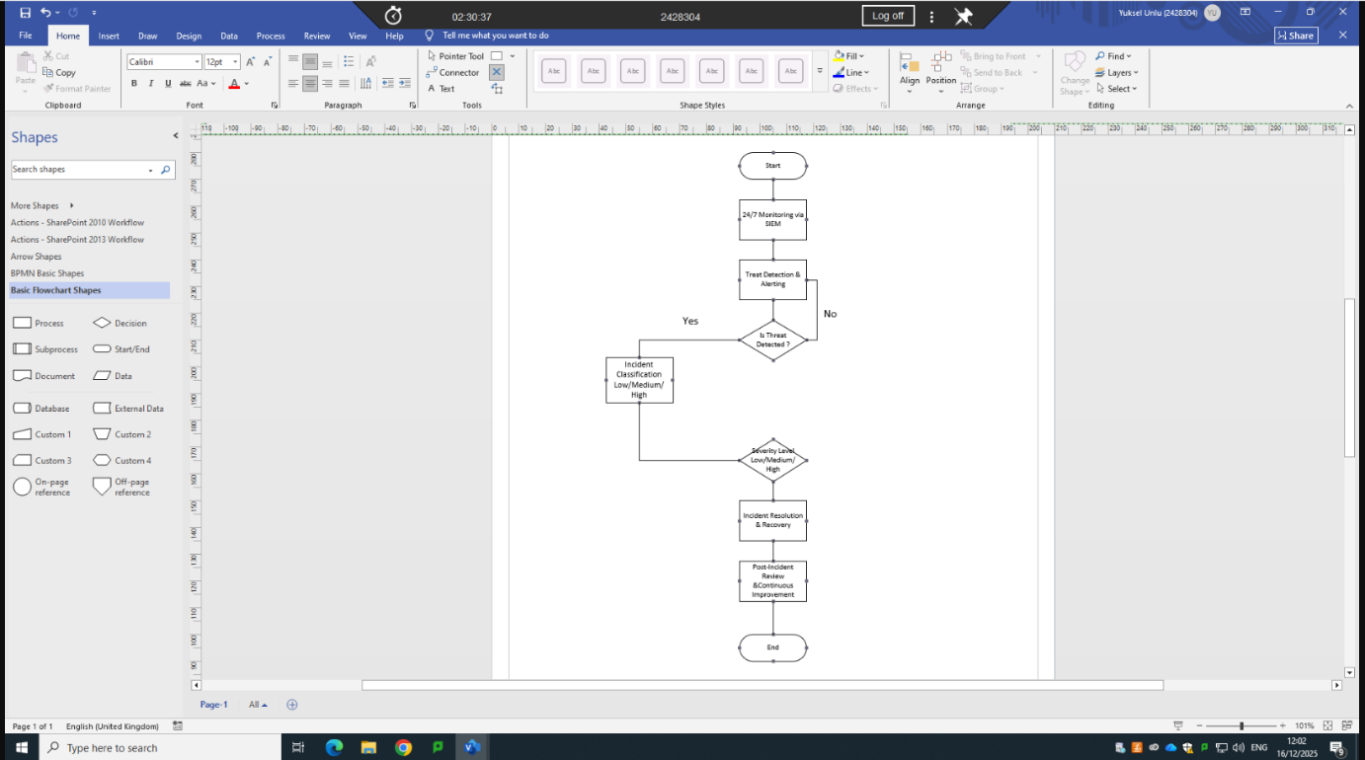

Continuous Training and Awareness
Continuous training and awareness are crucial to building a resilient cybersecurity culture at First Atlantic Water Company. Technology alone cannot protect critical infrastructure if employees are unaware of risks or don't know how to respond. Regular training programs ensure staff understand modern threats such as phishing, ransomware, and social engineering, while awareness campaigns keep cybersecurity at the forefront of daily operations. By simulating real-world scenarios and providing clear guidance, employees become the first line of defense rather than a vulnerability. Continuous training also reinforces compliance with industry regulations and demonstrates the company's commitment to maintaining customer trust. Ultimately, awareness is not a one-off effort, but an ongoing process that evolves with new threats, empowering the workforce to act responsibly and proactively in protecting vital water services.
“Adequate staff training regarding secure online behavior and security counter-measures remains the cornerstone of businesses' cybersecurity strategies as security events continue to increase in frequency, sophistication, and expense. Better security training for staff is suggested to be the optimal cybersecurity investment by Disparte and Furlow [14]. Because of this, businesses need to spend money on cybersecurity awareness training to increase staff readiness and knowledge [12]. Although this is the case, cybersecurity awareness training projects frequently lack funding [15]. In addi-tion, a lot of employees disregard the information security guidelines set forth by their employers [16]. This noncompliance raises concerns about the efficiency of many cybersecurity awareness training projects while also increasing the risk of security and data breaches [17]. Consequently, an effective cybersecurity awareness training pro gram needs to be created in a way that not only expands employees' knowledge but also inspires them to adopt compliant behaviors.” [4]

The importance and seriousness of training on the following key topics will remain constant. First Atlantic Water Company must continually remind itself of the importance of this training. Otherwise, the company's security against cyberattacks will weaken, and it will face periodic difficulties.
Phishing/Vishing Simulations: Quarterly exercises to test employee resilience.
Gamified Training Modules: Interactive scenarios to increase engagement.
Awareness Campaigns: Posters, newsletters, and intranet updates.
Culture of Security: Encourage reporting of suspicious activity; reward proactive behavior.
Annual Refresher Courses: Update staff on evolving threats and compliance requirements.

Conclusion

Cybersecurity policy development for First Atlantic Water Company requires a general approach that integrates modern threat identification, Zero Trust-aligned policies, technical safeguards, proactive monitoring, and continuous training. By addressing RaaS, AI-driven social engineering, supply chain risks, cloud vulnerabilities, and hybrid work challenges, the proposed framework ensures resilience and compliance. Technical measures such as MFA, SIEM, CSPM, and EDR provide robust defenses, while proactive monitoring and incident response ensure rapid containment of threats. Continuous training fosters a culture of security awareness, making employees active participants in defense. Together, these measures align technical decisions with business goals of efficiency, cost reduction, timeliness, and customer satisfaction.

References

[1] | Ashis Dewakar Pandey, Shakil Saiyad, “Emerging threats in cybersecurity: An in-depth analysis of modern attacks.,” 22 April 2024. [Online]. Available: https://www.researchgate.net/publication/380092232_Emerging_Threats_in_Cybersecurity_A_Deep_Analysis_of_Modern_Attack.
[2] | Nick Simmons, Bindu Sundaresan , “From Risk to Resilience: The Power of Modern Security Policies,” Baylor University, 11 December 2025. [Online]. Available: https://hankamer.baylor.edu/news/story/2025/risk-resilience-power-modern-security-policies.
[3] | V. S. Karri, “Proactive Incident Management: Transforming Service Disruption Response Through,” WJAETS, 27 June 2025 . [Online]. Available: https://journalwjaets.com/sites/default/files/fulltext_pdf/WJAETS-2025-1156.pdf.
[4] | H. Taherdoost, “A Critical Review on Cybersecurity Awareness Frameworks and Training Models,” ScienceDirect, [Online]. Available: https://www.sciencedirect.com/science/article/pii/S1877050924008329.

Appendix A: Screenshot of the Board of Directors PowerPoint presentation


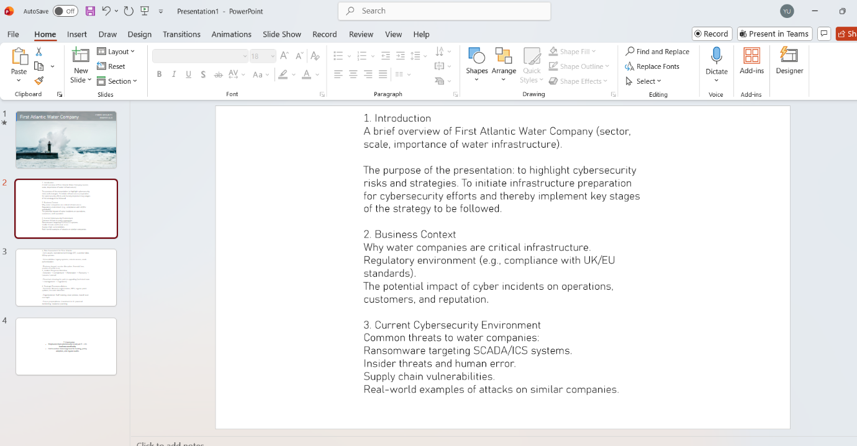
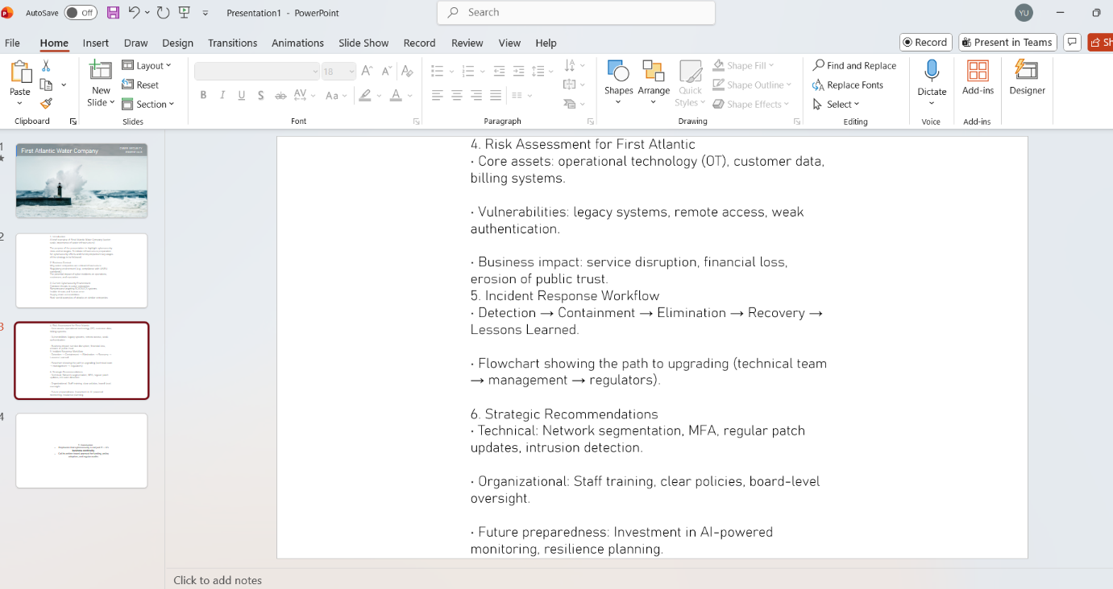
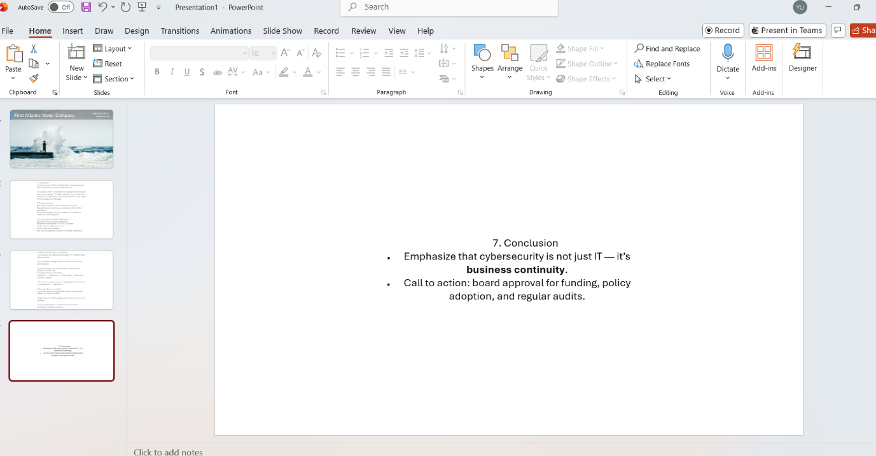

Appendix B: Screenshot of the Badge


