Component 2: Professional Development Portfolio

Student Name: zoya muzaffar
Student Number: 2435513
Module Code & Title: LCHS4009 – Personal and Professional Development
Lecturer: Anika Tahsin Ahmed

Content page

Introduction ....................................................................................... Page 3

Chosen Job Vacancy ......................................................................... Page 4

Task 1: Curriculum Vitae (CV) ........................................................... Page 5&6

Task 2: Personal Statement .............................................................. Page 7

Task 3a: SWOT Analysis .................................................................... Page 8

Task 3b: Personal Development Plan (PDP) ...................................... Page 8

Task 4: Critical Reflection (Gibbs Model) .......................................... Page 9

• Conclusion & Action Plan .............................................................. Page 9

References .......................................................................................... Page 10

Introduction

Choosing a career in midwifery is a decision rooted in my deep-seated passion for women’s health and the desire to provide compassionate support during one of life’s most transformative experiences. From a young age, I have been fascinated by the strength and resilience of women, and I believe that bringing a new life into the world is a profound moment that deserves the highest standard of care, empathy, and advocacy.

My interest in this field grew as I realised that a midwife is much more than a medical professional; they are a protector of a woman's autonomy and a steady guide through a journey that can be both joyful and overwhelming. I am drawn to the philosophy of "woman-centered care," which priorities the physical, emotional, and social needs of the mother. In a world where healthcare can sometimes feel clinical and detached, I want to be the person who ensures that every birthing person feels seen, heard, and respected.

Furthermore, my academic background in Health and Social Care has highlighted the importance of reducing health inequalities within maternity services. I am motivated to work in a profession where I can actively contribute to safer outcomes for mothers and babies from all walks of life. I understand that the role of a midwife is demanding and requires immense responsibility, but I am driven by the reward of building trust with families and making a positive, lasting impact on the start of a new life. I am eager to combine my natural empathy with professional clinical skills to become a dedicated advocate for women in my future career.

Chosen job vacancy

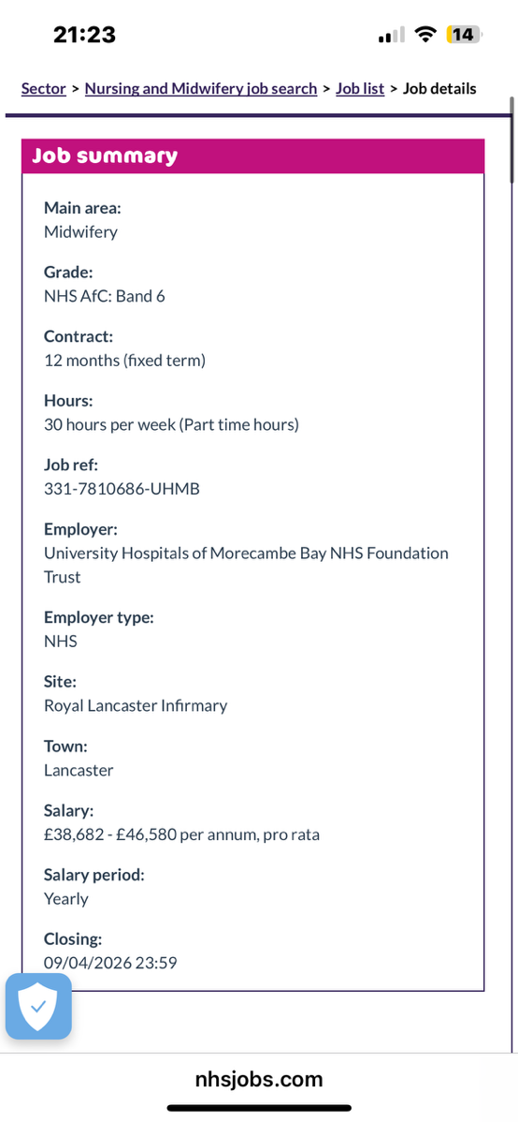

Task 1: Curriculum Vitae (CV)

Zoya Muzaffar

Email: zoya091@icloud.com
Phone: 07593967311
Address: 25 water Orton Road b36 9er

Personal Profile
Personal Profile
I am a highly dedicated and compassionate individual with a deep-rooted ambition to become a registered midwife. My primary goal is to support women and their families through the transformative journey of pregnancy and childbirth, ensuring they feel empowered, safe, and respected at every stage. Through my Health and Social Care studies and practical experience, I have built a robust foundation in person-centered care and developed vital skills in multidisciplinary teamwork and professional communication. I am an empathetic advocate for women’s health, committed to providing evidence-based care and maintaining the highest clinical standards in a high-pressure environment.

Education
Joseph chamberlain college – Health and Social Care (2015–2016)
- Studied key topics including anatomy and physiology, safeguarding, communication, and equality and diversity
- Developed knowledge of professional values and ethical practice within healthcare
- Gained understanding of person-centred approaches and patient safety
Hodge hill girls school GCSEs
Maths | C
English Language | C
Religious Studies | C
Double science | C
Graphics | D
Health and social care | C
History | D

Work Experience / Volunteering
Experience
- Supported individuals with daily living activities while maintaining dignity and respect
- Communicated effectively with service users, families, and staff
- Observed the importance of safeguarding and confidentiality in practice
- Worked as part of a team to deliver safe and effective care

Key Skills
- Excellent communication and interpersonal skills
- Empathy and compassion when supporting individuals
- Ability to work effectively within a team
- Strong time management and organisational skills
- Ability to remain calm under pressure
- Understanding of confidentiality, safeguarding, and professional boundaries

Interests and Hobbies

I have a strong interest in women’s health and enjoy reading about pregnancy, childbirth, and maternal wellbeing. I am also interested in fitness and maintaining a healthy lifestyle, which I believe is important in promoting overall wellbeing. Additionally, I enjoy volunteering and engaging in activities that support my local community.

References

Available upon request

Task 2: Personal Statement
Applying for a career in midwifery is a decision driven by my deep-seated passion for women’s health and a desire to make a meaningful difference during one of life’s most transformative experiences. To me, midwifery is more than just a clinical role; it is a unique blend of medical expertise, emotional strength, and advocacy. I believe that my academic background in Health and Social Care, combined with my natural empathy and dedication, has prepared me well for the challenges and rewards of this vital profession.

My interest in midwifery was significantly strengthened during my studies at Joseph Chamberlain College. Learning about person-centered care taught me that every woman’s journey is unique and deserves a tailored, respectful approach. I understand that pregnancy and childbirth can bring a complex mix of joy and anxiety for families. Therefore, I am committed to becoming a midwife who acts as a steady, reassuring presence, ensuring that the physical and emotional wellbeing of both mother and baby are prioritized at all times. This motivation drives my ambition to pursue a role where I can actively reduce health inequalities and ensure that every birthing person feels seen, heard, and respected.

I am particularly drawn to the vacancy at the University Hospitals of Morecambe Bay NHS Foundation Trust because of the trust’s reputation for providing inclusive, high-quality maternity services at the Royal Lancaster Infirmary. I admire the trust’s commitment to patient choice and safety, and I am eager to contribute to a team that values evidence-based practice. As an aspiring midwife, I recognise the importance of clinical leadership and being a positive role model within the maternity unit. I am ready to bring my strong communication skills to your multidisciplinary team, collaborating effectively with obstetricians and neonatal nurses to ensure seamless and safe patient handovers.

One of my core strengths is my ability to build trusting relationships with individuals from diverse backgrounds. In a maternity setting, where women may feel vulnerable, these interpersonal skills are essential. I am a patient listener who responds sensitively to the needs of others, always maintaining professional boundaries and confidentiality as outlined by the NMC Code. Furthermore, I am highly organised and capable of managing the high-pressure demands of a busy ward. I recognise that the role involves long hours and significant responsibility, but my resilience and determination ensure that I can remain focused and calm during clinical emergencies.

In conclusion, my long-term goal is to become a qualified midwife known for delivering compassionate, safe, and professional care. I am a lifelong learner, dedicated to continuous professional development to ensure my practice remains current with the latest NICE guidelines. I believe I possess the dedication and personal qualities required to succeed in this profession and make a lasting, positive impact on the lives of the women and families within your community.

Task 3

Strengths | Weaknesses
One of my main strengths is my ability to communicate effectively and build relationships with others. I am empathetic, compassionate, and able to understand the needs of individuals. I am also highly motivated and committed to achieving my career goals. Additionally, I am organised and able to manage my time effectively, which is essential in both academic and clinical settings. | A key weakness is that I have no clinical experience in midwifery, which may affect my confidence initially. I can also sometimes feel nervous in high-pressure situations. However, I am actively working on improving my confidence through practice and experience.
Opportunities | Threats
There are many opportunities available to support my career progression, including access to midwifery training programmes, placements, and professional development opportunities within the NHS. I can also develop my skills through volunteering and additional learning. | Midwifery is a highly competitive field, and gaining entry into training programmes can be challenging. Additionally, the academic and emotional demands of the role may be difficult at times. However, with determination and support, these challenges can be overcome.

Personal Development Plan
My goal | What actions will I take? | Target date | How will I monitor success?
Improve public speaking | I will use bullet points on my notes next time | June 2026 | Review teachers feedback
Gain clinical experience | I will apply for a part time HCA role or a volunteer position at a hospital. | Jan 2027 | Tracking my hours in a logbook and writing reflections on my shift
Master newborn baby care | I will complete an online newborn life support module and attend workshops. | March 2028 | Getting a certification

Task 4: Reflective
For my Component 1 assessment, I delivered a 6-minute presentation on the importance of teamwork in healthcare, specifically focusing on the role of nurses. The presentation took place in a classroom with my teacher and a camera recording for assessment purposes. I prepared slides and used a set of detailed notes to ensure I didn't miss any key points. During the talk, I explained how nurses must collaborate with doctors and other staff to keep patients safe. I included real-world examples of how good teamwork among nursing teams leads to better recovery for patients.

Leading up to the presentation, I felt quite a lot of pressure. Knowing that there was a camera recording me made me feel extra nervous and self-conscious. I was worried that I would forget my words or lose my place, which is why I held onto my notes so tightly. During the 6 minutes, I felt relieved that I was getting through the information, but I was also very aware that I was staring at my paper more than looking at my teacher. Once it was over, I felt proud that I had finished it, but I knew my delivery could have been more natural.

There were both good and bad parts to this experience. On the positive side, my teacher’s feedback was really encouraging about the content I chose. She said that I had "some good examples and information on teamwork" and that my research was thorough. This showed that I understood the topic well. However, the main area for improvement was my delivery. My teacher pointed out that I didn't give her much eye contact because I was so focused on reading from my notes. This meant I wasn't fully engaging with my audience.

I used my notes as a safety blanket because I feared making a mistake on camera. According to the Gibbs (1988) model, analysing why this happened is important for my future career. In nursing and midwifery, teamwork relies on clear, face-to-face communication. When a professional is giving a clinical handover or talking to a patient's family, they cannot simply look at a piece of paper; they must make eye contact to build trust and show they are confident. My lack of eye contact during the presentation suggests that I am still building the confidence to speak from the heart rather than from a script. By focusing only on the 'information,' I neglected the 'connection,' which is a huge part of being a professional healthcare provider."

Conclusion
This experience taught me that while having the right information is vital, the way you say it is just as important. I realised that my fear of messing up led me to use my notes as a barrier between me and the teacher. If I had practiced more with just a few bullet points instead of full sentences, I would have felt more comfortable looking up and engaging with the room. This is a major skill I need to work on before I start my clinical placements.

For my next assessment or professional talk, I am going to change how I prepare. Instead of full pages of text, I will use small cue cards with only three or four keywords on each. This will force me to look up and speak more naturally. I also plan to practice my delivery in front of a mirror or a friend so I can get used to keeping eye contact while I talk. By improving my body language and eye contact, I will become a much more confident and professional communicator, which is exactly what a good nurse needs to be.

References

Bick, D. (2019) Midwifery Practice: Core Topics. London: Elsevier.

Gibbs, G. (1988) Learning by Doing: A guide to teaching and learning methods. Oxford: Further Education Unit.

Marshall, J. and Raynor, M. (2020) Myles Textbook for Midwives. 17th edn. London: Elsevier.

NHS (2023) Careers in Midwifery. Available at: https://www.healthcareers.nhs.uk

NMC (2019) Standards of proficiency for midwives. London: Nursing and Midwifery Council.

RCM (2022) Midwifery Practice Guidance. London: Royal College of Midwives.

WHO (2020) Maternal Health Guidelines. Geneva: World Health Organisation.

