Module Name: Managing Enterprise
Module Code: BMSW4011
Assignment Name: Business Plan and Individual Reflection
Student Name: Sebastian Ropel
Student Number: 2423021
Lecturer: Scott James
Deadline: 28/11/2025
Business Plan Wordcount: 1073
Individual Reflection Wordcount: 480

Al Acknowledgement
I confirm that I have not presented any Al generated materials as my own work. I confirm that I have copies of my drafts, notes, and other resources I used, which I may be asked to provide in evidence

Contents
Part 1: Business Plan (1,000 Words) 3
1. Business Plan For Aesthetic Food 3
1. Introduction 3
2. The Story Behind The Idea 3
3. Business Ownership Structure 4
4. Mission Statement, Aim, and SMART Objectives 4
4. Unique Selling Proposition (USP) 5
5. Location and Rationale 5
6. Human Resources 5
7. Marketing Activities 6
8. Market Research 6
9. Financial Resources 6-7
10. SWOT Analysis 7
Part 2: Individual Reflection (500 Words) 8-9
Appendices 9-12
Refference List 13

- Business Plan for Aesthetic Food

Business Name: Aesthetic Food
Business Type: Sole Trader
Business Model: Restaurant & Healthy Dietary Catering
Location: Swansea
Owner: Sebastian & Business Partner

- Introduction
Aesthetic Food is a restaurant and healthy dietary catering service that offers fresh, healthy meals in our restaurant, as well as meal preparation with training program plans included in our premium packages. We also offer a takeaway service, ensuring that healthy eating is easily accessible for everyone in Swansea. All of our meals and products are made from high-quality meats and fresh vegetables, sourced directly from local farms.
We are specifically targeting audiences such as office workers, fitness enthusiasts, students, individuals seeking weight loss or improved health, and anyone with a busy lifestyle who lacks the time or knowledge to plan and prepare healthy meals (Williams, 2022).

- The story behind the idea
The concept for Aesthetic Food was inspired by our personal experiences with health, fitness, and nutrition. Our primary aim is to help people maintain or achieve optimal health by providing convenient services that save time on shopping, cooking, and hiring personal trainers (Barringer & Ireland, 2022).
Aesthetic Food is committed to helping achieve better health, combating obesity, and showing that healthy meals can be both macronutrient-friendly and delicious (Scarborough, 2019).

- Business Ownership Structure
Aesthetic Food will operate as a sole-trader business co-owned by Sebastian and a partner. We will both be personally responsible for the business and make decisions together (WealthFit, 2020). Sole-trader ownership has low legal requirements and also gives us full control to make quick decisions on operations, marketing, and menus (Alvarez, 2018).

- Mission Statement, Aim, and SMART Objectives

Mission Statement
Aesthetic Food’s mission is to help individuals with busy lifestyles improve their health, achieve their fitness goals, and enhance their physical and mental well-being. We do this by providing convenient, healthy meals made to support balanced nutrition (Hisrich et al., 2017).
Business Aim
The aim of Aesthetic Food is to become a leading provider of healthy meals and catering services in Swansea by earning a reputation for quality, great service, and creative meal plans. We aim to meet the growing demand for convenient, healthy food (Neck et al., 2014; Kuratko et al., 2015).
SMART Objectives
- Specific: Open a restaurant with healthy catering service in Swansea by June 2026, offering dine-in and takeaway options.
- Measurable: Serve 550 meals per week, retain 70% of customers in the first year, and achieve at least 80% positive customer feedback on meal quality and service.
- Achievable: Employ chefs, customer service staff and delivery driver. Provide training to ensure high-quality service and customer satisfaction.
- Relevant: Target people who are busy and seek convenient, healthy meals, including students, office workers, and fitness enthusiasts.
- Time-bound: Expand catering services and premium meal packages within 18 months of opening, monitor weekly sales, and track progress through regular performance evaluations.

- Unique Selling Proposition (USP)
Aesthetic Food’s USP is our premium meal packages, which include personalised training plans for monthly subscribers. These packages help customers manage weight, build muscle, or improve fitness without hiring a personal trainer or worrying about meal prep or diet planning.

- Location and Rationale
Aesthetic Food will operate in Swansea city centre. This location will boost our brand presence in a competitive market and provide easy access for dine-in, takeaway, and catering services. Operating in this location will also allow the business to benefit from the high-traffic area, which is surrounded by office workers, students, and local fitness enthusiasts (Johnson et al., 2020). “Please refer to Appendix A for a bird’s-eye view of where Aesthetic food will operate.”

- Human Resources
The business will be managed by the two owners: one will serve as Business Manager and Sales Manager, managing daily operations and making important decisions, while the other will serve as Marketing Lead and Head Chef, responsible for menu development and training kitchen staff. We will employ 2 chefs, 2 customer service staff and 1 part-time delivery driver, working 4 hours daily at minimum wage. During the peak months, we will hire an additional 1 part-time delivery driver and 1 part time kitchen staff on a temporary contract. All team members will receive training to ensure high-quality service (Timmons & Spinelli, 2021; Morris et al., 2019).

Owner (2)
Marketing Lead
&
Head Chef

Owner (1)
Business Manager
&
Sales Manager

_______________________________________|____________________________________
| | | |
Kitchen Staff
38hours/week
Customer Service 38hours/week

Customer Service 38hours/week

Kitchen Staff
38hours/week

|
Delivery Driver
28hours/week

- Marketing Activities
We will use both online and offline marketing. Online advertising will operate on social media platforms. We also plan to distribute leaflets and collaborate with universities and office-based companies to offer free samples, encouraging healthier eating habits, which can improve focus, productivity, and overall well-being. Our marketing message will focus on healthy, convenient meals with premium ingredients for busy customers (Kotler et al., 2021; Morris et al., 2019). “Please refer to Appendix B to see the social media platforms and flyer.”
- Market Research
We conducted an online survey with 50 Swansea locals aged 18–55. Most respondents were students or working professionals who eat out 3–5 times per week and prioritise convenience and healthy nutrition. The main barriers to healthy eating were lack of time. Respondents showed interest in balanced and customisable meal prep options, supporting Aesthetic Food’s offering for busy, health-focused consumers. “Please refer to Appendix C to view the online survey results.”
Secondary research involved reviewing UK industry reports and market data on healthy eating and meal-prep trends. Sources including Mintel (2023) and Statista (2024) show growing demand in the UK for convenient, health-focused food options, especially among young adults.

- Financial Resources
Funding sources:
• Government business start-up grant: £25.000
• Owner contributions: £10.000 (£5.000 each)
• Bank loan: £10.000

Starting Project costs:
• Kitchen equipment: £6.000 (We already have access to an industrial kitchen, but £6.000 is needed for additional equipment)
• Interior design/refurbishment: £15.000
• Rent, deposit, and utilities: £10.000
• Marketing: £2.000
• Initial stock: £2.000
• Legal/admin, licenses, insurance, software/website: £3.000
• Reserved for emergencies/maintenance: Remaining funds
Total projected startup cost: £38.000

Starting Project cash flow:
Salaries:
4 Full time employees (£12.21/hour -35 hours/week) = £7.406/month
1 Part time delivery driver (£12.21/hour - 4 hours/day = 28 hours/week) = £1.486/month
Total =£8.892
Drawings:
2 Owners monthly wage (£2.000 each = £4.000 total per month)
• Monthly income: 550 meals/week × £9 = £19.800/month
• Monthly expenses: Salaries £8.892 + owners £4.000 + rent/utilities £2.500 + marketing £400 + stock £1.875 = £17.667/month
Net cash flow: £19.800 – £17.667 = £2.133 surplus/month, with rent and bills included, expected to grow as sales increase.
Cash flow will be reviewed regularly to ensure financial sustainability and support for business growth (McKeever, 2020; Burns, 2020).

- SWOT Analysis
• Strengths: Premium, natural meals; tailored programs; prime location.
• Weaknesses: Small team and low brand recognition.
• Opportunities: Expanding health-conscious market, potential corporate catering.
• Threats: Competition from other restaurants and meal delivery services, and changes in the economy that affect spending (Johnson et al., 2020; Morris et al., 2019).
Individual Reflection (500 words)
Creating the business plan for Aesthetic Food has been a very helpful experience. I have written business plans before in real life, but creating this one using this structure was very helpful because it covered many details that I had not included in my previous plans. It made me realise how important it is to be more detailed and organised. I can now use this assessment to improve my existing business plan and apply it in real life. It will also help me when applying for grants or funding, as I now understand what kind of information and evidence investors and grant providers expect to see.
Before starting this assignment, I only had a general idea about business planning and things like business ownership structure. I learned about the pros and cons of all types of ownerships. I have also developed my market research skills. I learned how to create a survey, collect responses, and analyse the information to understand the customer needs. This helped me recognise that many people in Swansea prefer healthy meals but struggle because of lack of time and knowledge. I also learned how to use other sources, like information about industry trends, to help me make better decisions.
Another skill that I have developed is financial planning. In my past business experience, I often found financial forecasting difficult and depended on others or on software programs to do most of the calculations for me. I did not really understand how to work out the numbers myself, so I mostly trusted the software to give me the results. Because of that, I didn’t fully understand how the figures were made or what they really meant for the business. In this module I learned how to use Excel for financial planning to calculate expenses, sales, and profit by myself. I gained better understanding of how to count and apply financial data properly.
I also developed better strategic thinking. I have used SWOT analysis and SMART objectives in my current job, so I found it easy to apply them here. However, this time I understood their purpose on a deeper level. The SWOT analysis helped me clearly identify strengths, weaknesses, opportunities, and threats in the business. Writing SMART objectives helped me create realistic and measurable goals that will guide the business as it grows.
This project also helped me improve my time management. Working step by step and breaking down tasks made it easier to stay organised and complete everything on time. I learned to be patient and careful, especially when doing financial calculations and editing the plan.
Overall, this experience gave me confidence and a stronger understanding of how to plan, analyse, and present a business idea professionally. Creating this business plan was not only a learning exercise but also something I can now use and develop further in my real-life business journey.

Appendix A: Location
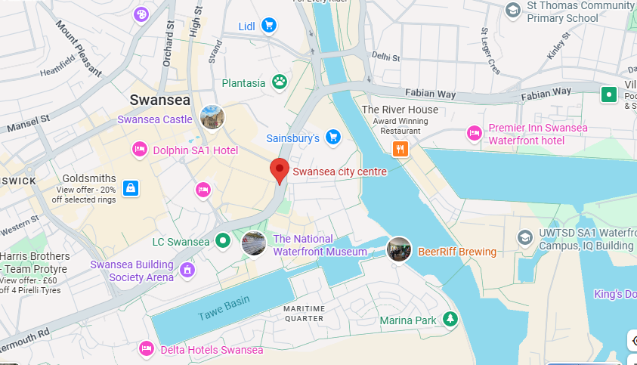

Appendix B: Social media platforms & flyer (Instagram, Canva)
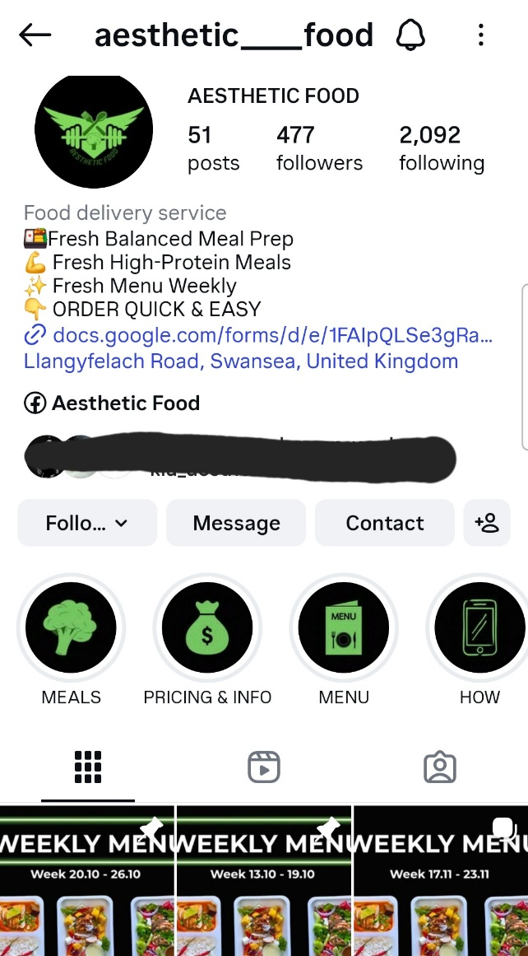
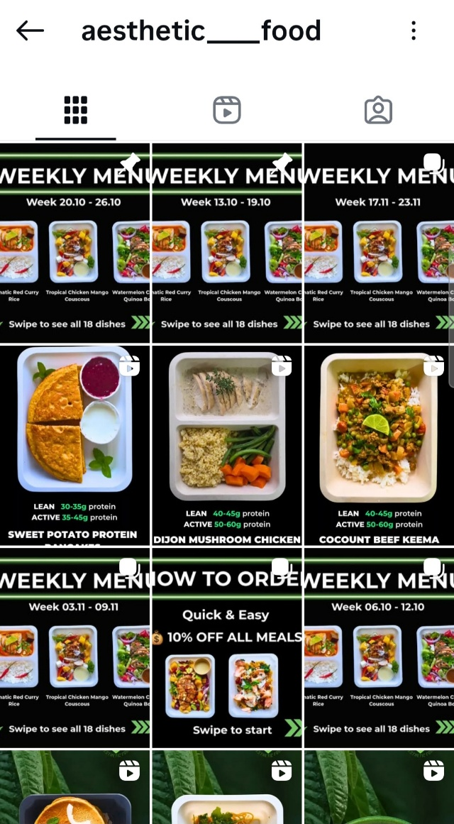

(Instagram)

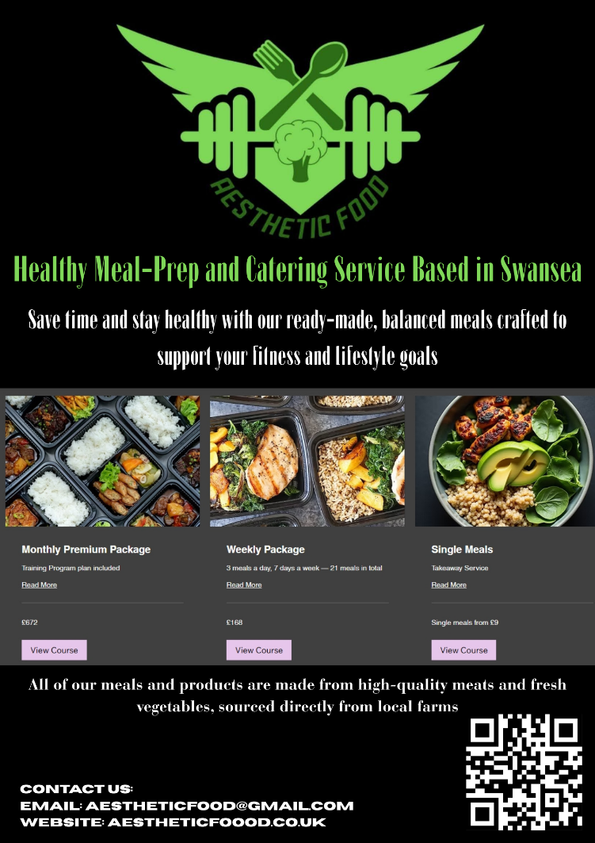

(Canva 2025)

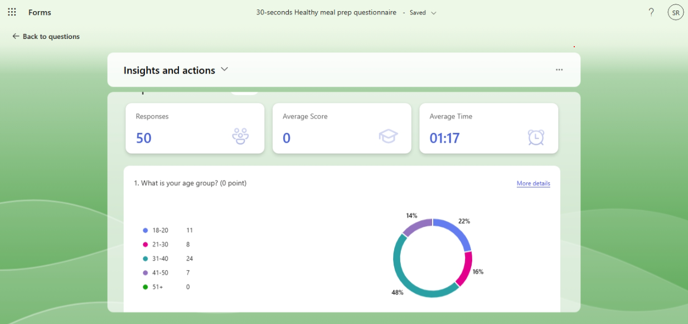
Appendix C: Online survey (Microsoft forms 2025)

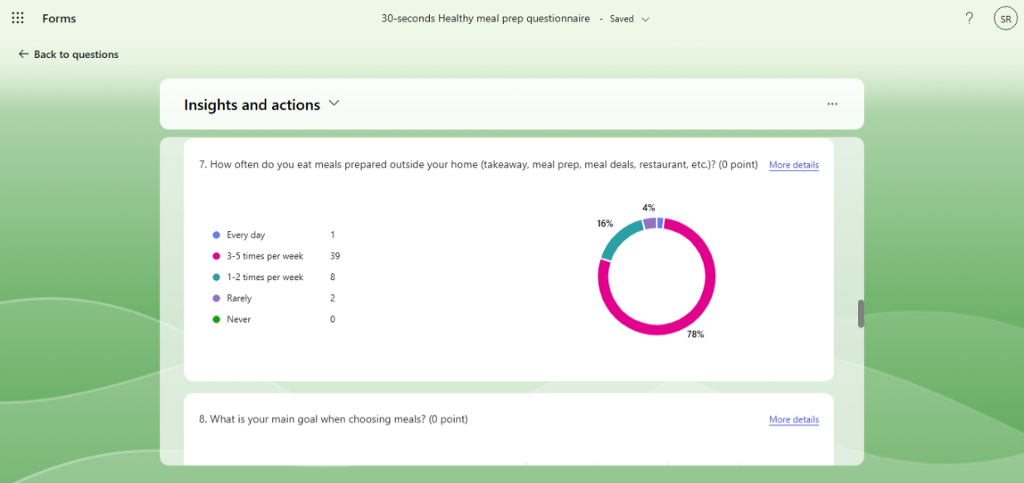

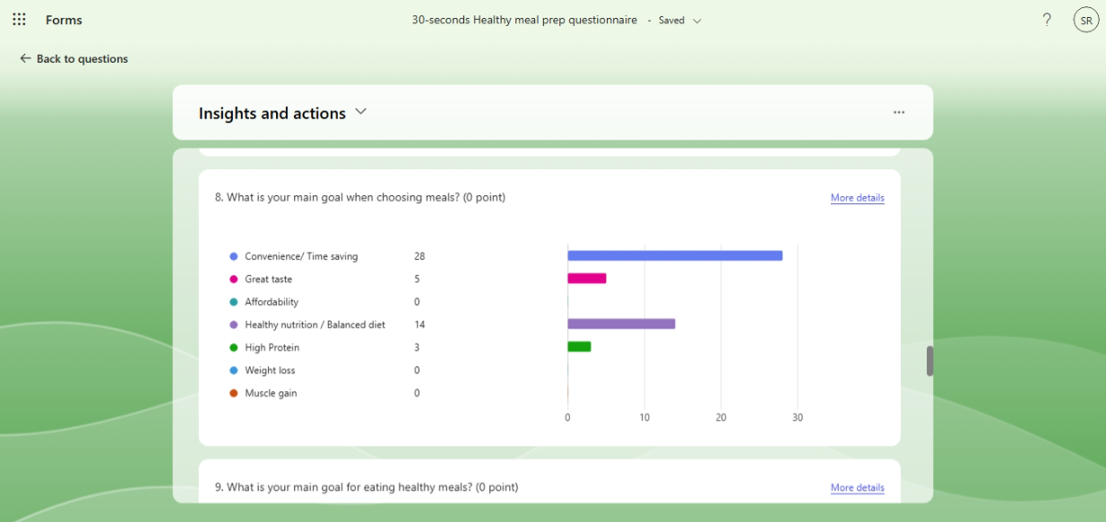

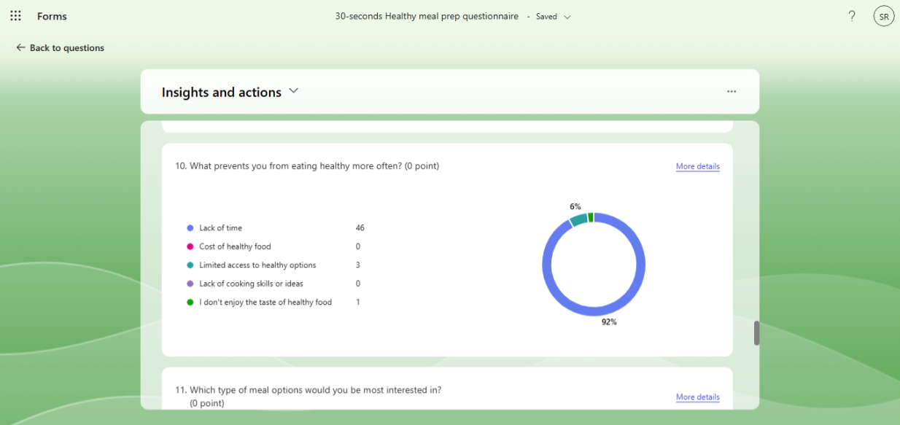

(Microsoft forms 2025)

References

- Barringer, B.R. and Ireland, R.D. (2022) Entrepreneurship: successfully launching new ventures. 6th Global edn. Harlow: Pearson.
- Williams, S. (2022) The Financial Times guide to business start-up 2021/2023. 32nd edn. Harlow: Pearson.
- Scarborough, N.M. (2019) Essentials of entrepreneurship and small business management. 9th edn. Harlow: Pearson.
- Alvarez, S.A. (2018) What entrepreneurs need to know before they start. London: Henry Stewart Talks Ltd.
- WealthFit (2020) The 45-Minute Business Plan. Carpinteria: LinkedIn.com.
- Hisrich, R.D., Peters, M.P. and Shepherd, D.A. (2017) Entrepreneurship. 10th edn. New York: McGraw-Hill Education.
- Kuratko, D.F., Morris, M.H. and Schindehutte, M. (2015) Understanding the dynamics of entrepreneurship through framework approaches. Journal of Small Business Management, 53(4), pp. 1–20.
- Neck, H.M., Meyer, G.D., Cohen, B. and Corbett, A.C. (2014) Entrepreneurship: theory, process, practice. 3rd edn. Boston: Cengage Learning.
- Burns, P. (2020) Entrepreneurship and small business. 4th edn. London: Palgrave.
- Johnson, G., Scholes, K. and Whittington, R. (2020) Exploring strategy: text and cases. 12th edn. Harlow: Pearson.
- Kotler, P., Keller, K.L., Goodman, M. and Hansen, T. (2021) Marketing management. 16th edn. Harlow: Pearson.
- McKeever, M. (2020) How to write a business plan. 11th edn. Boston: Nolo.
- Timmons, J.A. and Spinelli, S. (2021) New venture creation: entrepreneurship for the 21st century. 11th edn. New York: McGraw-Hill.
- Morris, M.H., Kuratko, D.F. and Schindehutte, M. (2019) Framing the entrepreneurial experience. 3rd edn. Boston: Cengage Learning.
- Scarborough, N.M. (2021) Effective small business management. 12th edn. Harlow: Pearson.

