FINAL Project Portfolio

Poster
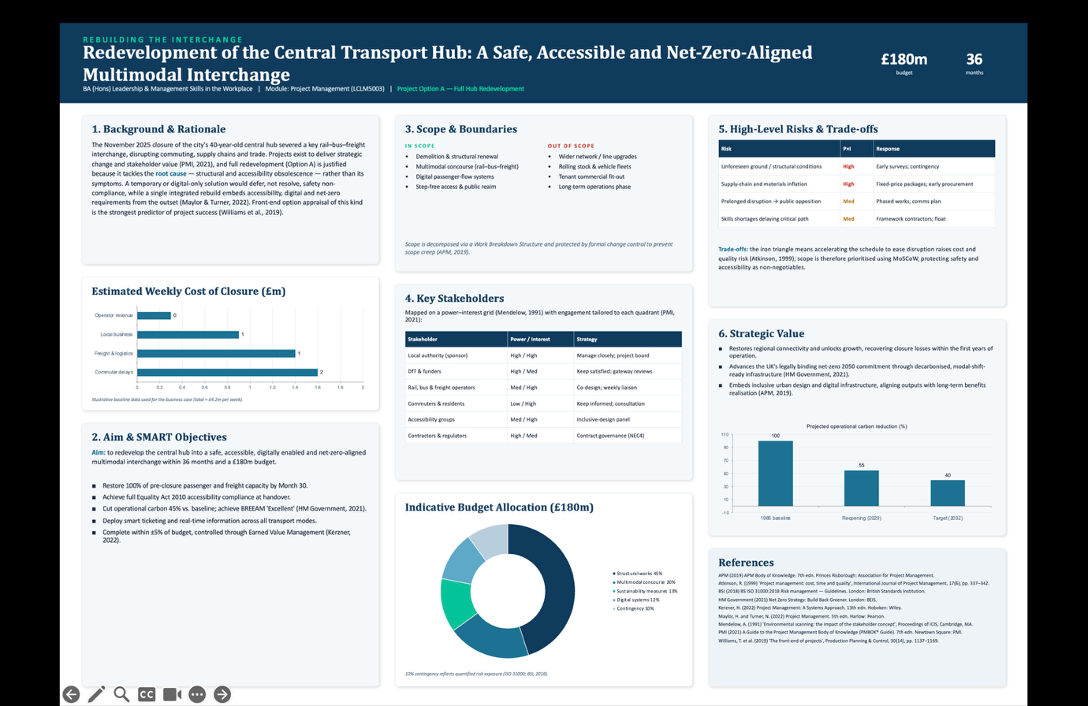

PART B
B-Reflection on tutor feedback
Your tutor, dr. Kareem Sani provided you with very positive and encouraging feedback. He described your poster as successfully addressing all of the Assessment Requirements (ar) for the redevelopment of the central transport hub project, and that it was an outstanding piece of work that fell well within the distinction range.
Strenghts
It appears from dr. Sani's comments that your poster demonstrated a complete and strong understanding of the redevelopment project. He pointed out that your proposal presented a logical structure and included all of the ar for the redevelopment project, including the project rationale, SMART objectives, scope, stakeholder analysis, risks, strategic value, and supporting visuals. It demonstrates that you were able to convert a large and complicated project brief into a clearly organized and fully developed proposal that dealt with all aspects of the ar.
You appear to have used project management methods effectively when dr. Sani said you demonstrated effective application of project management concepts. The specific project management methods he identified were; work breakdown structure, change control, stakeholder power-interest mapping, Earned Value Management, MoSCoW prioritization, and the iron triangle. This informs me that you were able to go past just explaining the frameworks and apply them appropriately to a real-world project environment, providing evidence of an understanding of how they can aid in making decisions. He noted that there was adequate academic and professional reference material cited to indicate that your decisions regarding the content of the poster were based upon credible sources rather than arbitrary choices or based solely on individual opinions. In general, he thought that the good combination of project management methodologies, academic research, and professional communication skills contributed to placing the work in the distinction range.
Weaknesses/recommendations for future development
While most of the comments were positive, dr. Sani mentioned that there were two areas that you could expand upon. First, he indicated that you could possibly shorten certain parts of your poster to enhance its overall readability and aesthetic appeal. What this seems to say is while your poster contained all of the details needed, you may have emphasized the amount of information you had available to include rather than clarity and visual attractiveness of your poster. Therefore, it could limit stakeholders' ability to rapidly see key elements of your poster at first glance.
Second, dr. Sani believed you should enlarge upon the discussion of risks and trade-offs to include a greater critical evaluation of major project decisions and their ramifications. Trade-offs are one of the primary challenges faced by project managers. Thus, adding a more critical evaluation of the consequences associated with choosing one method over another will reflect a higher degree of analytical thinking.
Influence of the feedback upon your final project plan
Based upon dr. Sani's recommendations, i revised my final project management plan in two main respects. As regards concision, i rewrote portions of the document to be shorter and more targeted in their focus and substituted lengthy descriptions with visual aids like Gantt charts, RACI matrices, and risk registers wherever feasible to allow readers to understand information more quickly. Where detailed written explanation was indeed warranted, i maintained only those areas that necessitated additional clarification.
Regarding expanding upon my analysis of risks and trade-offs, i included new sections analyzing ramifications associated with selecting one course of action over another. For instance, i analyzed ramifications associated with adopting a hybrid methodology compared with either a pure predictive or pure agile methodology. Additionally, i examined trade-offs related to allocation of time and money to various stakeholder engagement initiatives relative to other priority items in the project. Lastly, i revisited my risk management plan to ensure that rather than merely listing potential risks, i justified each selected mitigation strategy and described why i chose it as opposed to alternatives.

PROJECT MANAGEMENT PLAN
Implementation of a Cloud-Based Customer Relationship
Management (CRM) System for RetailCo Ltd
Prepared for the Project Board and Programme Stakeholders
Predictive (PMBoK / Waterfall) delivery approach
25 July 2026
Vineta Didzus

Executive Summary
In this case, we have developed a management plan for cloud-based Customer Relationship Management (CRM) system implementation for RetailCo Ltd., one of the mid-sized multi-channel retailers. This project aims at delivering the unified customer data across sales, marketing and service functions replacing fragmented on-premise legacy system with a single Software-as-a-Service platform. It is a predictive, plan-driven approach consistent with Project Management Institute Body of Knowledge, delivering in accordance with a defined scope, work breakdown structure, milestone schedule and formal risk governance.
Budget of GBP 480,000 and a core team of nine full-time equivalents supported by the SaaS vendor over eight-month delivery period (September 2026 - April 2027). It constitutes a plan with scope boundaries, a work breakdown structure of five phases, a quad chart summary, a Gantt schedule updated with three control milestones and additional information by the use of Mendelow-based stakeholder analysis matrix and resource allocation matrix & quantified risk register. These instruments, combined, give the Project Board critical visibility to grant, monitor and control investment and at the same time hold delivery accountable against explicit success criteria.

Contents
Executive Summary 2
1. Introduction 4
2. Project Description 4
3. Scope 5
4. Work Breakdown Structure (WBS) 5
5. Quad Chart 6
6. Gantt Chart 7
7. Stakeholders' Involvement 8
8. Allocation of Resources 9
9. Risk Analysis 10
10. Conclusion 11
References 12
List of Tables
Table 1: Scope inclusions and exclusions 5
Table 2: Stakeholder analysis and engagement strategy 8
Table 3: Resource allocation matrix 9
Table 4: Risk register (summary) 10
List of Figures
Figure 1: Work breakdown structure 6
Figure 2: Project quad chart 7
Figure 3: Gantt chart 8

1. Introduction
Organisations now see customer relationships as a strategic asset and a competitive advantage, and the systems that manage those (CRM) as critical infrastructure. This is the Project Management Plan for implementation of a new cloud-based CRM system for RetailCo Ltd over a time span of 6 weeks. It aims to convert an approved business case into a controlled, deliverable programme of work and convey that intent to stakeholders responsible for funding, governing and using the system. The main integration document defining how a project is executed, monitored and closed before its goal is achieved (Project management Institute, 2021)
It is based on a predictive life cycle, as the requirements are mostly understood, the technology is stable and there are hard commitments from the Project Board on cost and time (Larson & Gray 2021) It includes in this order the project description, project scope, WBS (work breakdown structure), a quad chart, schedule index and stakeholder mapping tool resource assignment and risk management analysis conclusion. Each instrument is one of a number of well-known project management methods known to encourage disciplined planning and provide a benchmark for performance measurement.
The target audience is the Project Board, the sponsor, internal delivery team and the software vendor. Now the document is a living baseline: it is scoped, scheduled and costed and risk positions established — all of which are placed under configuration control — with any material change subject to the following change process. This methodology makes sure that each party is leaning on a singular source of truth and keeping track of decisions across the life cycle (Association for Project Management, 2019).

2. Project Description
Operating 40 stores and a burgeoning e-commerce channel, RetailCo Ltd suffers from customer information spread across both disconnected point-of-sale, email-marketing and spreadsheet systems. Such fragmentation hinders the ability to establish a consistent customer experience, reducing service delivery and limiting marketing intelligence. The project provides a set-up, cloud based Customer Relationship Management (CRM) system unifying customer records; standardising sales and service processes and integrating with current e-commerce, finance and email-marketing systems.
You are trained on Oct 2023 data. In line with the strategic goal to improve customer retention and marketing efficiency by providing staff accurate up-to-date information about customers, The literature has recently evolved a broader view of success where project success is defined not by delivery to time cost and quality but in terms of realised benefits and stakeholder satisfaction (Atkinson, 1999; Cooke-Davies, 2002) Key measurements consist of completion of successful migration for 100 per cent of active customer records, achieving at least 90 per cent user adoption within three months post-go-live and delivering the platform on-budget and in accordance with a maximum eight-month schedule. Choosing a SaaS model moves infrastructure risk from the client to the vendor whilst shortening delivery, and focusing configuration, data quality and adoption in the centre of control effort (Schwalbe, 2018).

3. Scope
Clear scope definition is the foundation of predictive control, because it establishes the boundary against which change, cost and schedule are managed (Burke, 2013). The scope statement below distinguishes what the project will and will not deliver, reducing the ambiguity that commonly drives scope creep. Table 1 summarises the principal inclusions and exclusions agreed with the Project Board.
Table 1: Scope inclusions and exclusions
In scope | Out of scope
Cloud CRM licensing and configuration for sales, marketing and service | Bespoke development of a new e-commerce storefront
Migration and cleansing of active customer records | Migration of inactive records older than seven years
Integration with e-commerce, finance and email-marketing systems | Replacement of the finance or point-of-sale systems
User training and eight weeks of hypercare support | Ongoing marketing campaign design and execution
Project governance, testing and go-live | Physical store hardware upgrades
Anything beyond these borders is done through formal change control, where all additions are reviewed for cost, schedule and risk impacts prior to approval (Kerzner 2022). The acceptance criteria are agreed during the analysis phase and signed off when processes are designed and/or go-live takes place, with successful user acceptance testing + data migration verification. This disciplined boundary management not only protects the baseline, but it allows appropriate response to truly valuable change.

4. Work Breakdown Structure (WBS)
The work breakdown structure decomposes the total scope into progressively smaller, manageable deliverables, providing the basis for estimating, scheduling and assigning responsibility (Project Management Institute, 2021). Figure 1 presents the deliverable-oriented structure for the project, organised into five phases beneath the overall implementation, each subdivided into work packages that become the unit of planning and control.
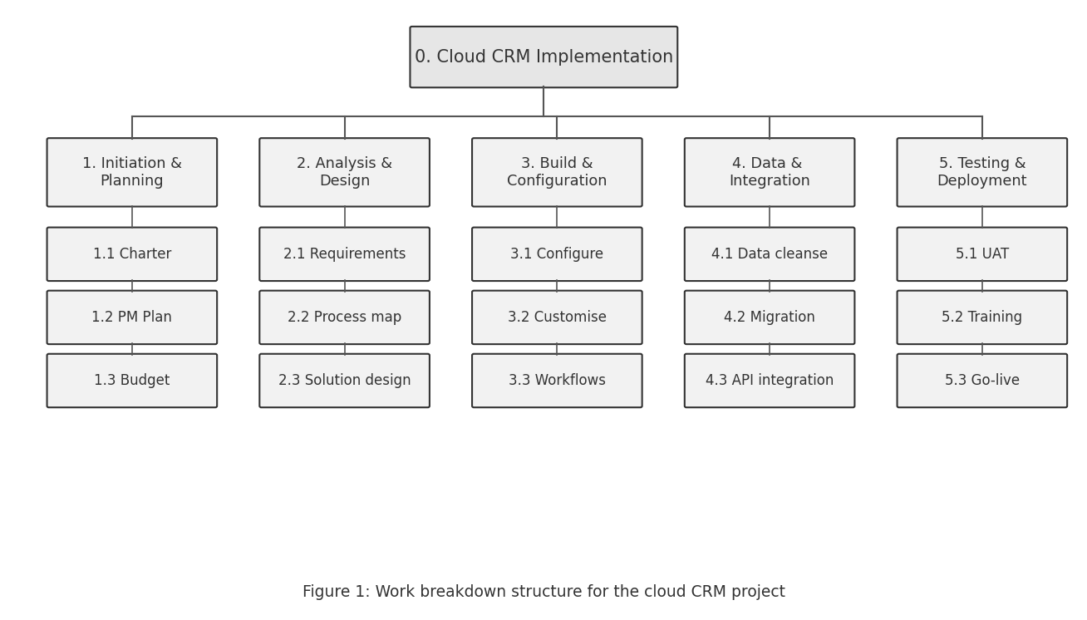
Decomposition adheres to the 100 per cent rule, whereby child work packages collectively identify all the work within each phase and none beyond it (Maylor, 2010) Initiation and planning has charter, plan and budget; analysis and design captures requirements with a solution design; build and configuration is delivery of the working platform; data and integration covers migration and system interfaces; testing and deployment includes user acceptance testing, training at go-live. Each work package has an owner, an estimate and acceptance criteria meaning the schedule and cost baselines can be constructed directly from the structure.
Each work package is identified within the project control account using a specific code (i.e. — Work package ID) ensuring consistency in the tracking of progress, cost and effort across the schedule, resource matrix and risk register. This coding converts the structure from a static diagram into an integrated control backbone and ensures that effort cannot be missed or repeated as the project progresses from planning into delivery (Kerzner, 2022).

5. Quad Chart
A quad chart is a one-page representation of the essential dimensions of a project that facilitates rapid executive review and uniform communication (Meredith, Shafer & Mantel, 2017). Figure 2 depicts a summary outline for the project on four quadrants: goal and description, boundaries and deliverables, schedule and cost as well as main risks The format provides the Project Board with a breezy briefing mechanism aligning sponsors and delivery staff around clear intent and constraint.
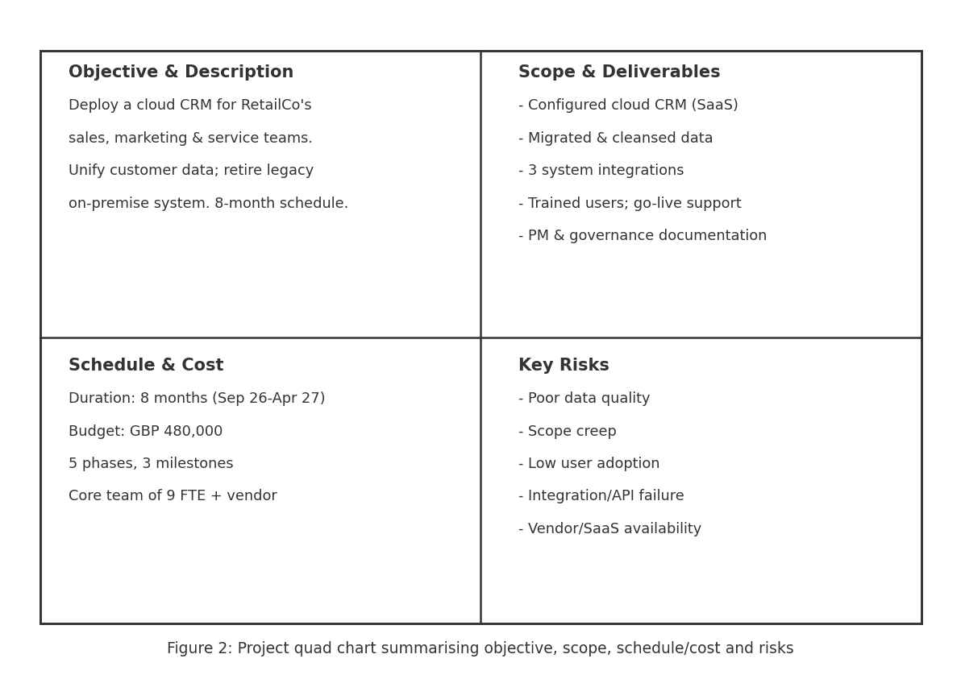
The detailed plan has much more detail than the quad chart, which is not really a replacement for the plan per se, but rather a mechanism for communicating to stakeholders about the elements of a project and its key exposures. It is through the presentation of objective, scope cost, schedule and risk together that they reinforce each other, as well as help decision-makers to evaluate trade-offs when change is proposed (Turner, 2014). It is used at all the Project Board meetings and it remains stable providing a reference point that grounds status reporting and helps to steer discussion towards agreed project priorities.

6. Gantt Chart
The schedule sequences the work packages over the eight-month delivery window and expresses the dependencies between phases. Figure 3 presents the Gantt chart, showing phase durations as horizontal bars against a monthly timeline, with three control milestones marked as diamonds: design sign-off, completion of user acceptance testing, and go-live.
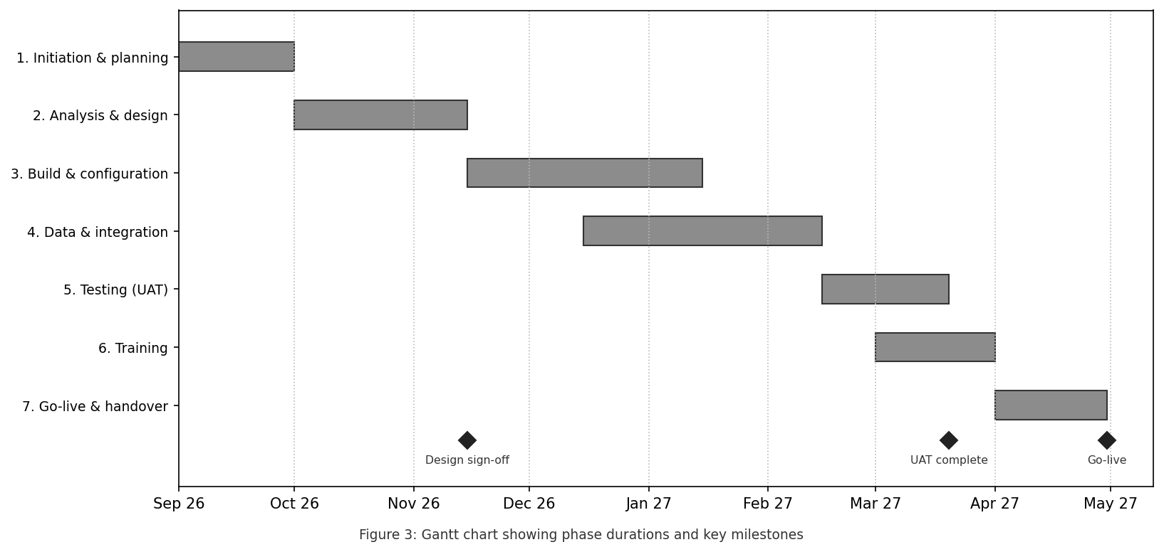
The chart represents an essentially sequential flow with purposeful overlap in places: data and integration start before build is actually finished, and training runs on a trailing parallel to user acceptance testing to establish the immutable go-live date. Analysis, build, integration, testing and go live are where the critical path runs through so any slippage on these activities directly threatens the end date and is closely tracked (Burke 2013). Milestones act as decision gates where the Project Board ensure that entry criteria for the next stage are met, providing a governance and planning function to schedule (Kerzner, 2022). Float on non-critical activities (ex: training) provides minimal flexibility to absorb minor delay, without causing a change in the baseline.

7. Stakeholders' Involvement
Stakeholder is defined as a person or group who has an interest in the project and whose engagement is an acknowledged factor for success (Freeman, 1984; Pinto and Slevin, 1987). Mendelow's power-interest matrix sorts stakeholders to inform engagement strategy based on the level of influence and interest each party has (Mendelow, 1981). The major stakeholders and their interest/ approach are stated in Table 2.
Table 2: Stakeholder analysis and engagement strategy
Stakeholder | Interest / power | Engagement strategy
Project Board / Sponsor | High power, high interest | Manage closely; milestone approvals and monthly reporting
Sales & service staff | Low power, high interest | Keep informed; involve in design, training and UAT
IT department | High power, high interest | Manage closely; joint design and integration ownership
SaaS vendor | High power, high interest | Manage closely; contractual governance and service levels
Finance function | High power, low interest | Keep satisfied; budget reporting and integration sign-off
Customers | Low power, high interest | Keep informed; protect data and service continuity
Close management of high-power, high-interest stakeholders whilst involving low interest groups at appropriate intervals focuses engagement resource in most crucial areas of influence (Johnson, Scholes and Whittington, 2008). A communications plan specifies how often, through which channel and by whom each interaction will be carried out, while a responsibility matrix lists all work packages along the RACI framework (Responsible, Accountable, Consulted and Informed). In order to create real ownership and to support adoption, the long-term success of any CRM project (Müller and Turner, 2007) this is an intentional early and continued involvement with end-users.

8. Allocation of Resources
Resource planning maps the skills and capacity required by the work breakdown structure to available people, technology and budget through the schedule (Larson & Gray, 2021). The core team consists of nine full-time equivalents, with additional input from the vendor's implementation specialists. Table 3 outlines the key roles, includes definitions of their respective accountabilities and illustrates how they might be divided.
Table 3: Resource allocation matrix
Role | Responsibility | Allocation
Project Manager | Planning, control, governance and reporting | 1.0 FTE, full duration
Business Analyst (x2) | Requirements, process mapping, UAT support | 2.0 FTE, months 1-6
CRM Configuration Lead | Configuration, customisation and workflows | 1.0 FTE, months 2-7
Data Migration Specialist | Cleansing, mapping and migration | 1.0 FTE, months 3-6
Integration Developer | API integration with existing systems | 1.0 FTE, months 3-6
Change & Training Lead | Communications, training and adoption | 1.0 FTE, months 5-8
QA / Test Analyst | Test planning and UAT coordination | 1.0 FTE, months 5-7
Vendor implementation team | Platform provisioning and specialist support | As contracted
Levelled resource loading against the Gantt schedule ensures no over-allocation that may happen especially with build, migrate and integration phase overlapping the midpoint of the project (Meredith, Shafer and Mantel, 2017). The main GBP 480,000 budget includes licensing, professional services and internal staff time with ten per cent of the contingency being held by the Project Board to fund approved change and identified risk responses. Earned value measures are used to report cost against the baseline ensuring any variance is detected early, not at phase end (Kerzner, 2022).
Because business analysts and end users are drawn from operational teams their availability is negotiated in advance with line managers and protected within the schedule because conflicting demands for shared resources are almost always a source of delays. In this way, backfills and cross-skilling both minimize the project's reliance on any one person, while an escalation route makes it clear that resource conflict is nothing to worry about as it must be referred to the Project Board before becoming a factor in the critical path (Larson and Gray, 2021).

9. Risk Analysis
Risk management is a process for constantly and systematically identifying, analysing and responding to the uncertainty that might impact on objectives (Hillson, 2009; Association for Project Management, 2019). For each risk, a qualitative score is assigned for both probability and impact, which in turn calculates an exposure rating that ranks the effort needed to respond. Table 4 summarizes the key risks, with their rating and response plans extracted from a risk register which is reviewed at each milestone.
Table 4: Risk register (summary)
Risk | Rating | Response
Poor legacy data quality delays migration | High | Early data profiling and cleansing; phased migration with validation
Scope creep erodes budget and schedule | High | Formal change control; baselined scope and Board authorisation
Low user adoption undermines benefits | High | Early user involvement, training and hypercare; adoption metrics
Integration / API failure with core systems | Medium | Early integration testing; vendor support and fallback interfaces
SaaS availability or vendor performance | Medium | Contractual service levels; escalation and governance meetings
Key resource unavailability | Medium | Cross-skilling, documented handover and contingency reserve
Responses adhere to the accepted strategies of avoidance, transfer, mitigation or acceptance of threats with mitigation being the dominant because of the controllable exposures within this project (Project Management Institute 2021). Data quality, scope creep and user adoption are prioritised over all other aspects of system design because they have the most immediate impact on benefit realisation; a pattern that closely reflects wider evidence on information-systems project failure (Cooke-Davies, 2002). Risk ownership, contingency reserve funding for agreed responses and a register that is an agenda item at all Project Board meetings (to capture emerging risks as well as retire closed risk).
They practice: —Risk management is proactive, not reactive: identification workshops in planning fill the register and each milestone review captures probability/impact re-assessment as understanding grows. Benefits and dangers are captured so that valuable incoming change, e.g. vendor-provided features to minimize configuration effort, is not squandered or ignored. Hillson (2009) states that this cycle of identification, assessment, response and review reinforces effective uncertainty management into the routine governance process of the project rather than treating it as a singular process.

10. Conclusion
This document shows how mature project management techniques can be applied to a specific business change (implementation of a cloud CRM system for RetailCo Ltd). Firm baselines are supplied by a predictive life cycle, and together, the scope statement, work breakdown structure, quad chart, Gantt schedule (more on this later), stakeholder analysis, resource matrix and risk register comprise an integrated system of control. Each instrument reinforces the others: scope drives structure, structure drives schedule and resources, and risk process protects the entire enterprise against uncertainty.
Discipline in your delivery is what moves the needle more, rather than the technology itself: scope management through formal change control, continuous stakeholder engagement, scoping the critical path realistically and treating data quality and adoption as first-class risks. Informed by the milestones and metrics set out here, the project is able to deliver on-time, within budget (GBP 480,000) and with sufficient benefits to justify that investment (Cooke-Davies, 2002).

References
Association for Project Management (2019) APM Body of Knowledge. 7th edn. Princes Risborough: Association for Project Management.
Atkinson, R. (1999) 'Project management: cost, time and quality, two best guesses and a phenomenon, it's time to accept other success criteria', International Journal of Project Management, 17(6), pp. 337-342.
Burke, R. (2013) Project Management: Planning and Control Techniques. 5th edn. Chichester: Wiley.
Cooke-Davies, T. (2002) 'The “real” success factors on projects', International Journal of Project Management, 20(3), pp. 185-190.
Freeman, R.E. (1984) Strategic Management: A Stakeholder Approach. Boston: Pitman.
Hillson, D. (2009) Managing Risk in Projects. Farnham: Gower.
Johnson, G., Scholes, K. and Whittington, R. (2008) Exploring Corporate Strategy. 8th edn. Harlow: Prentice Hall.
Kerzner, H. (2022) Project Management: A Systems Approach to Planning, Scheduling, and Controlling. 13th edn. Hoboken, NJ: Wiley.
Larson, E.W. and Gray, C.F. (2021) Project Management: The Managerial Process. 8th edn. New York: McGraw-Hill.
Maylor, H. (2010) Project Management. 4th edn. Harlow: Pearson.
Mendelow, A.L. (1981) 'Environmental scanning: the acquisition of importance in the organisational context', Proceedings of the 2nd International Conference on Information Systems, Cambridge, MA, pp. 407-418.
Meredith, J.R., Shafer, S.M. and Mantel, S.J. (2017) Project Management: A Strategic Managerial Approach. 10th edn. Hoboken, NJ: Wiley.
Müller, R. and Turner, R. (2007) 'The influence of project managers on project success criteria and project success by type of project', European Management Journal, 25(4), pp. 298-309.
Pinto, J.K. and Slevin, D.P. (1987) 'Critical factors in successful project implementation', IEEE Transactions on Engineering Management, EM-34(1), pp. 22-27.
Project Management Institute (2021) A Guide to the Project Management Body of Knowledge (PMBOK Guide). 7th edn. Newtown Square, PA: Project Management Institute.
Schwalbe, K. (2018) Information Technology Project Management. 9th edn. Boston, MA: Cengage Learning.
Turner, J.R. (2014) The Handbook of Project-Based Management. 4th edn. New York: McGraw-Hill.

