A Report on the Impact of Artificial Intelligence on Recruitment

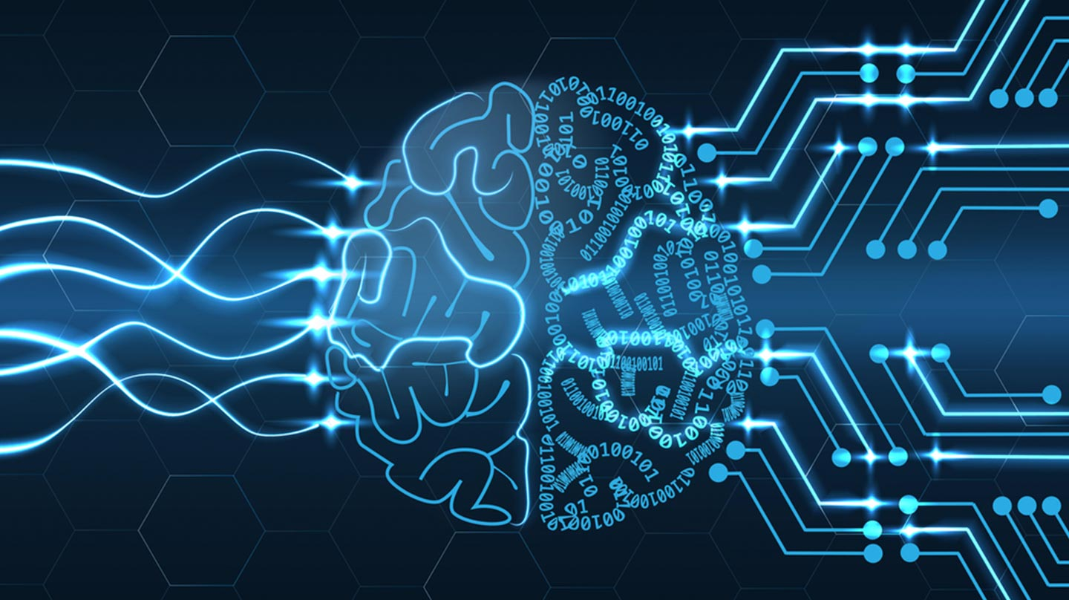
Figure 1: Brain/Artificial Brain image (Karen, 2018)

May 2019

Module Name: Managing People – M5X00856
Report Name: A Report on the Impact of Artificial Intelligence on Recruitment
Name: Shannon Jenkins
Student Number: 1706656

Table of Contents

- Executive Summary – page 4
- Introduction – page 5
  - Report Remit – page 5
  - The Impact of AI on Recruitment – page 6
  - Reasons for Adopting AI as part of the Recruitment Process – page 6
  - How Businesses are already Operating in this way – page 7
  - Recommendations on Making Improvements in this Area – page 8
  - Drawbacks to Recommendations Aforementioned and how to Overcome them – page 9
  - Conclusion – page 9
- References – page 10

List of Figures

Figure 1: Brain/Artificial Brain image (Karen, 2018)
Figure 2: AI Usage Worldwide (Ramaswamy, 2017)

- Executive Summary

Throughout this report, a number of points regarding Artificial Intelligence and the recruitment process will be brought up. For example, the report will discuss whether or not using AI technologies will have any benefit or detrimental value to the current recruitment processes. Following on from this, there will be a variety of advantages and drawbacks of AI technologies mentioned. Furthermore, the reasons for companies adopting Artificial Intelligence technology as a part of their recruitment processes will be discussed in some detail. For example, there are competitive advantages to using the technology in any way possible, especially since it is not limited to only being useful for recruitment purposes. Towards the end of the whole report, there will be a section on recommendations for this company in specific, which will then be followed by a section on any potential drawbacks associated with the recommendations made and how to overcome or remedy them.

- Introduction

Artificial Intelligence, as described by (Copeland, 2019), is the “ability of a digital computer or computer-controlled robot to perform tasks commonly associated with intelligent beings.” The examples of tasks commonly undertaken by AI given in this source include discovering meaning and learning from past experiences, amongst other things. There are a number of ways in which Artificial Intelligence can have an impact on recruitment processes. These include, but are not limited to, picking out keywords in resumes and automated messaging systems which communicate with job candidates. There are a number of reasons why a business may decide to use AI as a part of their recruitment process. For example, the use of AI technology eliminates money being wasted on paying a human to do simple, repetitive tasks. There are a number of companies currently operating in the United Kingdom who have already opted to use AI technology for things including recruiting new staff. I will be making a number of recommendations towards the end of this report on how the company can make important improvements in the use of Artificial Intelligence technology, including ways that the Human Resources team could support any new changes. Following on from this, there will be points made regarding the potential downfalls of the recommendations and how issues could be avoided and, if they were to arise, how they could be rectified.

  - Report Remit

This report seeks to mainly look into the advantages of Artificial intelligence technology and how it is currently used as a part of the recruitment process. A number of ways in which AI can impact recruitment processes will be brought up. Following this, there will be a number of reasons for a company adopting Artificial Intelligence technology will be discussed. Also, there will be a section on how there are companies trading in the U.K. who are using this technology already. Recommendations will be made on how the organisation can improve on how it uses Artificial Intelligence to aide with business processes. Finally, there will be a section on any disadvantages to the recommendations mentioned. This will include how issues may be resolved and will touch upon ethical issues associated with replacing humans with Artificial Intelligence technology.

  - The Impact of AI on Recruitment

Firstly, there are a variety of advantages to using AI as a part of the recruitment process. For example, according to (Anderson, N.N.), Human Resources employees are freed of the time it takes them to go through applicants resumes as Artificial Intelligence is now able to “look for certain skills or previous job titles” along with finding “keywords related to the job profile.” This, in turn allows human employees to focus on the other tasks that they need to carry out.

Having said that, (Deiters, 2018) states that there are “technical problems” with using Artificial Intelligence as a part of the recruitment process. An example of this is the fact that candidates may be wrongly “judged” by AI systems and may be rejected from the job. In turn, the company may lose a valuable candidate who may have filled the vacancy perfectly.

On the one hand, expert systems are eventually going to be in place. Whilst AI technology may be experiencing some technical difficulties at this time, it is hoped that there will eventually be expert systems created. As stated by (Reddy, N.D.), Artificial Intelligence technologies will be able to “display intelligent behaviour, learn, demonstrate, explain and provide users with” good advice. This would be beneficial to companies as they could get advice on recruitment issues amongst other things.

On the other hand, (Tan, 2018) mentions in his blog that Artificial Intelligence can make mistakes based on data collected. For example, data is often “extracted from Facebook profiles, tweets, LinkedIn” and other social platforms. The issue with this is the potential lack of relevant information. For example, if a candidate applies for a marketing position but has never posted anything about marketing, they will automatically be put below another candidate who may have made a post about marketing. This may be incorrect as the candidate with no relevant posts may have more experience but chose not to publically announce it.

  - Reasons for Adopting AI as part of the Recruitment Process

One reason for adopting Artificial Intelligence as a part of the Recruitment Process is the fact that “52% of talent acquisition leaders say the hardest part of recruitment is identifying the right candidates from a large applicant pool” as stated by (Jones, N.D.) For many vacancies, there is a significant talent pool of applicants. This can be an issue throughout recruitment because it is time-consuming to filter all of the applications to find the applicants who have potential in the job. Artificial Intelligence can lessen this burden by doing the initial process of sifting through resumes to search for key words, certain characteristics mentioned, or anything related to the job description.

Furthermore, (Neelie, 2018) states that there are three main reasons why “recruiters and hiring managers should embrace AI” and they are the technology’s ability to reduce human bias, “improve the candidate experience” and to “focus on the human element in HR.” This essentially means that AI can improve the recruitment process because the technology is incapable of being biased in the way that humans can. also, the use of AI technology would allow the humans to concentrate on other aspects of their jobs.

What is more, a specific AI technology is currently being developed. This piece of technology will be designed to be the first point of contact for anyone wishing to apply for a job. If a company employs this technology, it will build a trail of the interactions applicants make with a company. This, according to (Seseri, 2018), will allow a company to see how applicants conduct themselves and whether or not they would be suitable for the job.

  - How Businesses are already Operating in this way

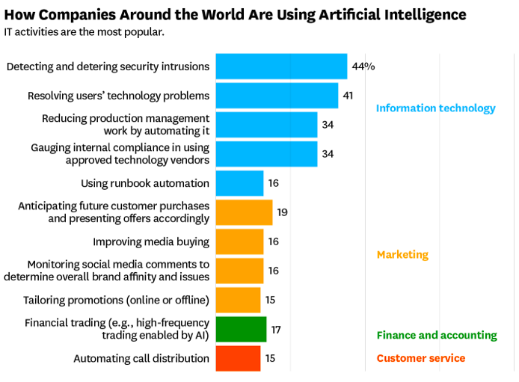
Figure 2: AI Usage Worldwide (Ramaswamy, 2017)

As seen in Figure 2 above, there are already companies using Artificial Intelligence worldwide. Information Technologies are most commonly linked with Artificial Intelligence technology. For this company, Artificial Intelligence could be used to monitor a number of things. We would find that this gives us a competitive advantage as we would be able to have more control over our reputation. We would be able to use the technology to link up with the company’s own social media accounts along with employee accounts. This would be an ideal way to ensure that the company’s reputation is upheld, whilst also being able to easily check on the behaviour of potential new employees.

Following on from this, competitors are currently benefitting from an “optimised recruitment process.” This, according to (Mitchel, 2018), is because many Artificial Intelligence tools “collect data and display it in such a way that it is insightful to you.” This is beneficial for recruitment processes as it would allow you to view all information about candidates in a well-organised documentation. Thus, it would be easier to view everything needed to make an informed decision on who should be hired.

  - Recommendations in making Improvements in this Area

There are a number of recommendations to be made on improving the use of Artificial Intelligence within the company. The first is to thoroughly look into the company’s needs in order to figure out what kind of technology would be the most appropriate for our specific needs. According to (Matskevich, 2018), “AI can provide predictive analytics for your business. It can help you automate tasks.” This means that there is good reason to look into an appropriate AI technology for the company as it can help to eliminate some issues associated with predictive analytics. Automating tasks will allow humans to focus on other tasks which cannot yet be completed by AI technologies.

Additionally, I think it would be beneficial to integrate AI technologies into the recruitment process. Systems can be used to sift through resumes in order to find key words, relevant skills and other things relevant to the job description. This is, in my opinion, something that would be beneficial to the company for a number of reasons. In terms of the company’s overall productivity, there would be a visible increase. People already employed at the job, such as those of us in the Human Resources department, would be able to focus their time on other tasks that are not directly linked to recruitment whilst the initial stages of hiring someone are taking place. They would only need to create the job description and then conduct face-to-face interviews later down the line.

My final recommendation in relation to AI technologies is to train up the staff who will be working on projects alongside AI to deal with the technologies efficiently. They will need to know, to an extent, programming of the device, how to get information from the technologies and how to interpret it.

  - Drawbacks to Recommendations Aforementioned and how to Overcome them

While there are not many drawbacks to looking into which AI technology will be the most appropriate for the organisation, there will be time taken up which may be better spent in other ways. Having said that, I think it is definitely worth looking into AI technologies and how they could have a positive impact on the company.

Moreover, the second recommendation made was to actually integrate AI technologies into the recruitment process. This will be beneficial to the company overall, but may cause a number of issues initially. For example, this can be a costly process. Assets can be liquidated in order to make money which can be put back into the business through the integration of AI technologies.

The final recommendation made was to train up the staff who will be working alongside the technologies. Although this will be beneficial in the long-run, there will be a number of issues in the short-term which can be easily combatted. For example, it will take time to train up the relevant staff. In turn, it will also cost money to pay their wages for the time they spend training and to pay someone to come in specifically to train up staff.

The biggest issue with introducing Artificial Intelligence to the company would be ethical. It would, in my opinion, be unethical to just completely replace human workers with technology. This could be combatted by training up the existing workers so that they are able to work effectively alongside the technologies.

  - Conclusions

To conclude, there are a number of ways in which AI can have an impact on the recruitment process. For example, it can make it more efficient and save existing staff time on the process. There are a number of reasons why the company should adopt AI technology, including competitive advantages and the freeing of existing staff to work on other tasks. As mentioned, there will be a competitive advantage as the company will be able to browse the talent pool and find appropriate job candidates easier. It is recommended that AI be introduced to the company and staff be trained up to work alongside the technology. The issues which may arise with these recommendations can be combatted by liquidising assets to spend money on the technology and training.

- References

Anderson, D. (N.D.), How will Artificial Intelligence Impact the Future of Recruiting?, [online], Available at: https://recruiterbox.com/blog/how-will-artificial-intelligence-impact-the-future-of-recruiting, (accessed: 01-05-2019)

Copeland, B.J. (2019), Artificial Intelligence, [online], Available at: https://www.britannica.com/technology/artificial-intelligence, (accessed: 01-05-2019)

Deiters, C. (2018), Disadvantages of Artifical Intelligence (AI) in Recruitment, [online], Available at: https://www.milchundzucker.com/disadvantages-of-artificial-intelligence-ai-in-recruitment/, (accessed 01-05-2019)

Jones, M. (N.D.), The Big Debate – why use AI in Recruitment?, [online], Available at: http://www.mackenziejones.co.uk/blog/the-big-debate-why-use-ai-in-recruitment, (accessed 01-05-2019)

Karen (2018), How Artificial Intelligence is changing Development, [online], Available at: https://www.surveycto.com/blog/how-artificial-intelligence-is-changing-development/, (accessed: 01-05-2019)

Matskevich, D. (2018), Preparing your Business for the Artificial Intelligence Revolution, [online], Available at: https://www.forbes.com/sites/forbestechcouncil/2018/07/12/preparing-your-business-for-the-artificial-intelligence-revolution/#49e119a57ac8, (accessed 02-05-2019)

Mitchel (2018), 7 Top Benefits of AI in Recruiting, [online], Available at: https://harver.com/blog/benefits-ai-in-recruiting/, (accessed 01-05-2019)

Neelie (2018), 5 Fascinating uses of AI in Recruitment, [online] Available at: https://harver.com/blog/uses-ai-in-recruitment/, (accessed: 01-05-2019)

Ramaswamy, S. (2017), How Companies are already using AI, [online], Available at: https://hbr.org/2017/04/how-companies-are-already-using-ai, (accessed 02-05-2019)

Reddy, K. (N.D.), What is Artificial Intelligence (AI)?, [online], Available at: https://content.wisestep.com/advantages-disadvantages-artificial-intelligence/, (accessed 01-05-2019)

Seseri, R. (2018), How AI is Changing the Game for Recruiting, [online], Available at: https://www.forbes.com/sites/valleyvoices/2018/01/29/how-ai-is-changing-the-game-for-recruiting/#6e002cdd1aa2, (accessed 02-05-2019)

Tan, A. (2018), The Pros and Cons of AI in Recruitment, [online], Available online at: http://adriantan.com.sg/the-pros-and-cons-of-ai-in-recruitment/, (accessed 01-05-2019)

