Name: Andreea Stefania Moldoveanu
Student ID number: 2221408
The module title: Marketing Essentials BMIH4005
Lecturer’s name: Chris Wilkin

Marketing plan
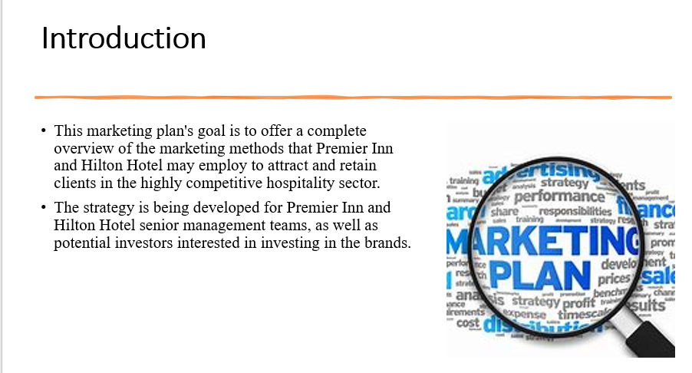
This marketing plan's goal is to offer a complete overview of the marketing methods that Premier Inn and Hilton Hotel may employ to attract and retain clients in the highly competitive hospitality sector. The strategy is being developed for Premier Inn and Hilton Hotel senior management teams, as well as potential investors interested in investing in the brands.
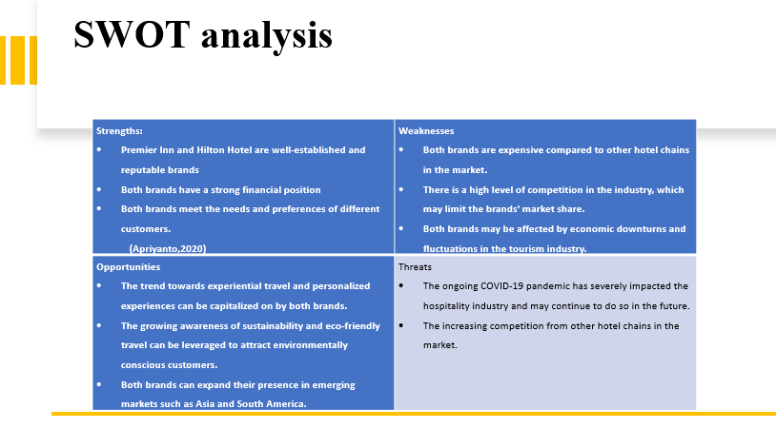 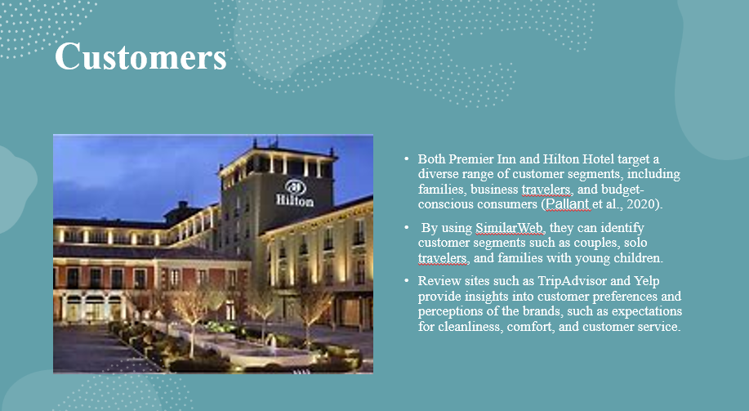Both Premier Inn and Hilton Hotel target a diverse range of customer segments, including families, business travelers, and budget-conscious consumers (Pallant et al., 2020). By using SimilarWeb, they can identify customer segments such as couples, solo travelers, and families with young children. Review sites such as TripAdvisor and Yelp provide insights into customer preferences and perceptions of the brands, such as expectations for cleanliness, comfort, and customer service.
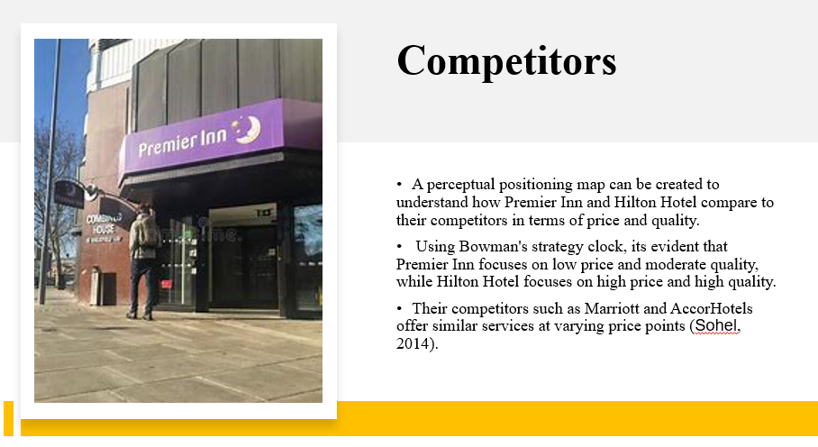A perceptual positioning map can be created to understand how Premier Inn and Hilton Hotel compare to their competitors in terms of price and quality. Using Bowman's strategy clock, its evident that Premier Inn focuses on low price and moderate quality, while Hilton Hotel focuses on high price and high quality. Their competitors such as Marriott and AccorHotels offer similar services at varying price points (Sohel, 2014).
Both Premier Inn and Hilton Hotel have partnerships with various travel companies and booking platforms, such as Expedia and Booking.com. Additionally, they have franchise agreements with independent hotel owners to expand their reach into new market.
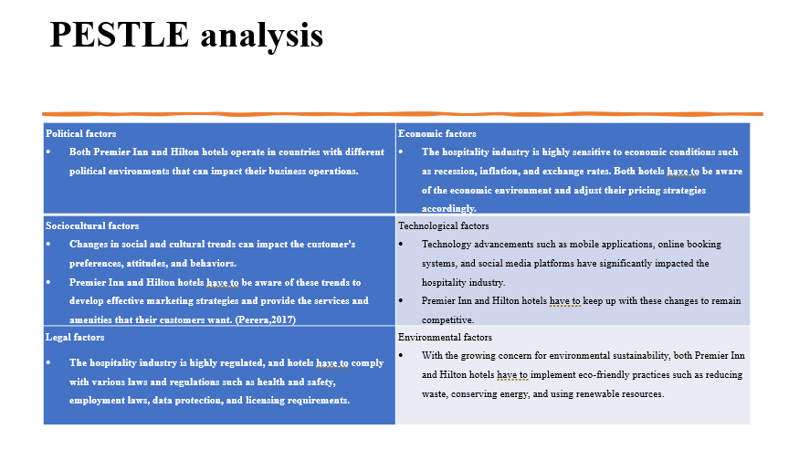

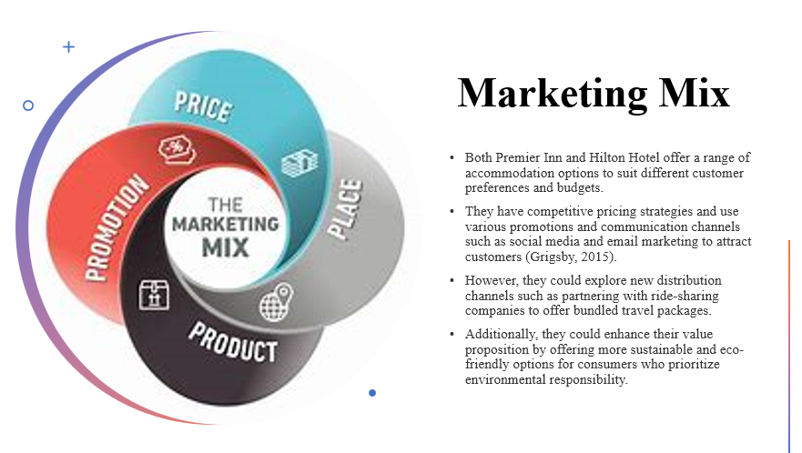Both Premier Inn and Hilton Hotel offer a range of accommodation options to suit different customer preferences and budgets. They have competitive pricing strategies and use various promotions and communication channels such as social media and email marketing to attract customers (Grigsby, 2015). However, they could explore new distribution channels such as partnering with ride-sharing companies to offer bundled travel packages. Additionally, they could enhance their value proposition by offering more sustainable and eco-friendly options for consumers who prioritize environmental responsibility.
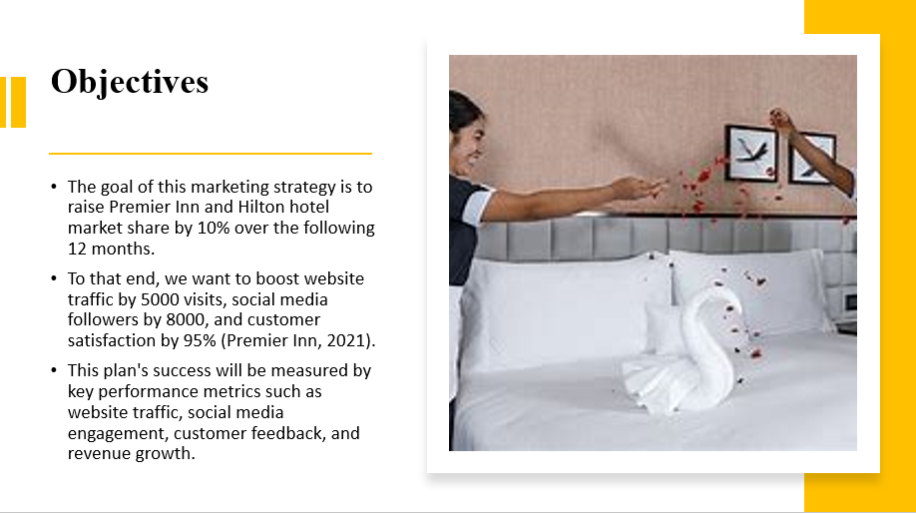The goal of this marketing strategy is to raise Premier Inn and Hilton hotel market share by 10% over the following 12 months. To that end, we want to boost website traffic by 5000 visits, social media followers by 8000, and customer satisfaction by 95% (Premier Inn, 2021). This plan's success will be measured by key performance metrics such as website traffic, social media engagement, customer feedback, and revenue growth. The timeline for meeting these goals is in the next 12 months. The targets are explicit, quantifiable, achievable, relevant, and time-bound, allowing us to measure our progress towards our goals.
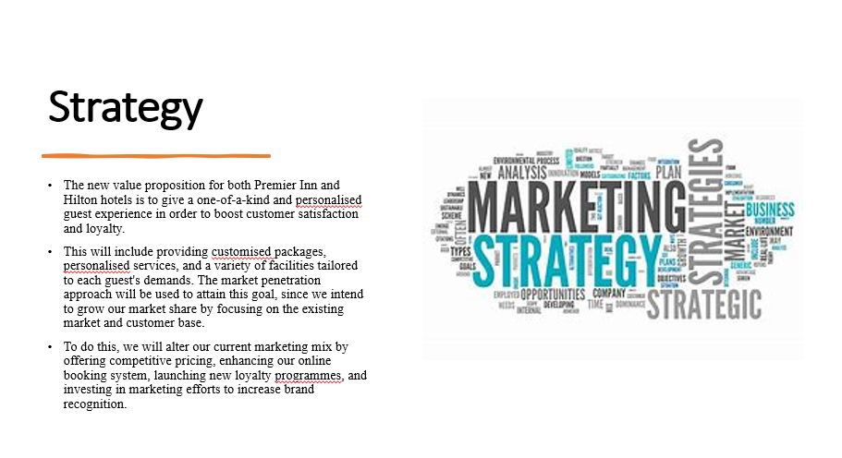The new value proposition for both Premier Inn and Hilton hotels is to give a one-of-a-kind and personalised guest experience in order to boost customer satisfaction and loyalty. This will include providing customised packages, personalised services, and a variety of facilities tailored to each guest's demands. The market penetration approach will be used to attain this goal, since we intend to grow our market share by focusing on the existing market and customer base. To do this, we will alter our current marketing mix by offering competitive pricing, enhancing our online booking system, launching new loyalty programmes, and investing in marketing efforts to increase brand recognition.
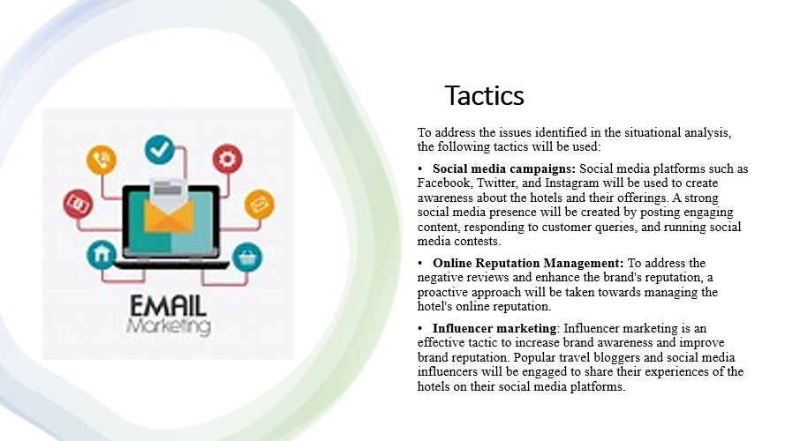To address the issues identified in the situational analysis, the following tactics will be used:
Social media campaigns: Social media platforms such as Facebook, Twitter, and Instagram will be used to create awareness about the hotels and their offerings. A strong social media presence will be created by posting engaging content, responding to customer queries, and running social media contests.
Online Reputation Management: To address the negative reviews and enhance the brand's reputation, a proactive approach will be taken towards managing the hotel's online reputation.
Influencer marketing: Influencer marketing is an effective tactic to increase brand awareness and improve brand reputation. Popular travel bloggers and social media influencers will be engaged to share their experiences of the hotels on their social media platforms.
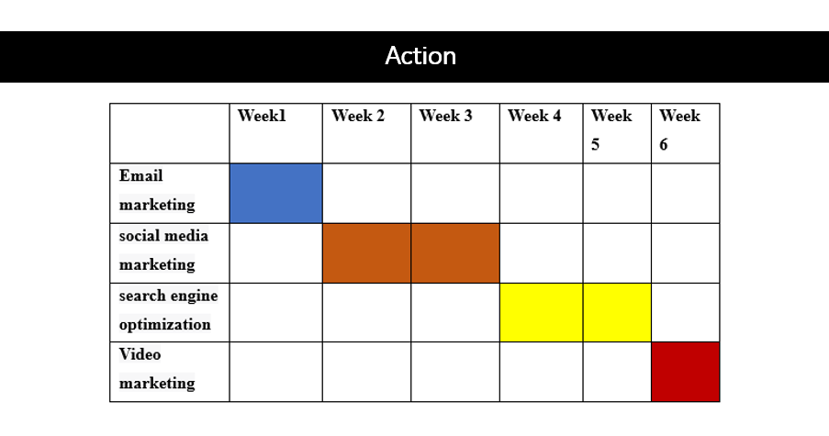

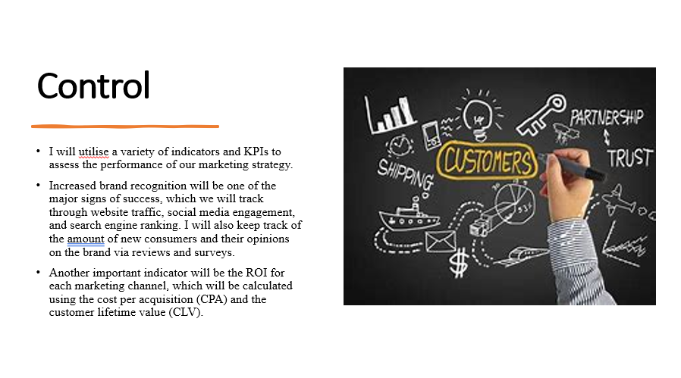I will utilise a variety of indicators and KPIs to assess the performance of our marketing strategy. Increased brand recognition will be one of the major signs of success, which we will track through website traffic, social media engagement, and search engine ranking. I will also keep track of the amount of new consumers and their opinions on the brand via reviews and surveys. Another important indicator will be the ROI for each marketing channel, which will be calculated using the cost per acquisition (CPA) and the customer lifetime value (CLV). I will also monitor conversion rates for each channel, such as email open and click-through rates, social media engagement rates, and website conversion rates. We will be able to assess these parameters by analysing them on a regular basis. By regularly analyzing these metrics, we will be able to evaluate the effectiveness of our marketing strategies and make adjustments as needed to meet our SMART targets.
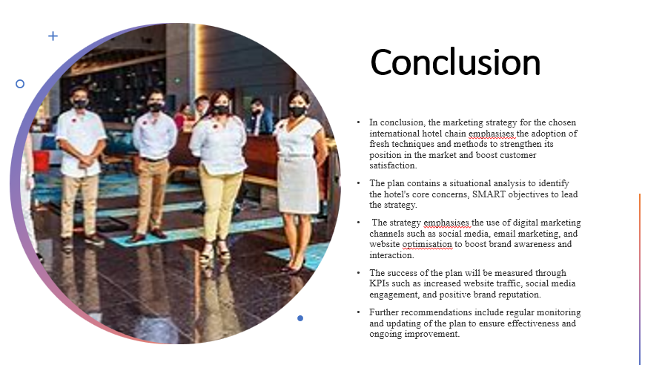In conclusion, the marketing strategy for the chosen international hotel chain emphasises the adoption of fresh techniques and methods to strengthen its position in the market and boost customer satisfaction. The plan contains a situational analysis to identify the hotel's core concerns, SMART objectives to lead the strategy. The strategy emphasises the use of digital marketing channels such as social media, email marketing, and website optimisation to boost brand awareness and interaction. The success of the plan will be measured through KPIs such as increased website traffic, social media engagement, and positive brand reputation. Further recommendations include regular monitoring and updating of the plan to ensure effectiveness and ongoing improvement.

Reference
Apriyanto, M., Marlina, B.F.S., Rifa, A. and Riono, Y., 2021. A SWOT analysis to improve the marketing of young coconut chips. Annals of the Romanian Society for Cell Biology, pp.13232-13240.
Pallant, J., Sands, S. and Karpen, I., 2020. Product customization: A profile of consumer demand. Journal of Retailing and Consumer Services, 54, p.102030.
Perera, R., 2017. The PESTLE analysis. Nerdynaut.
Sohel, S.M., Rahman, A.M.A. and Uddin, M.A., 2014. Competitive profile matrix (CPM) as a competitors’ analysis tool: A theoretical perspective. International Journal of Human Potential Development, 3(3), pp.40-47.

