Europe after the rain

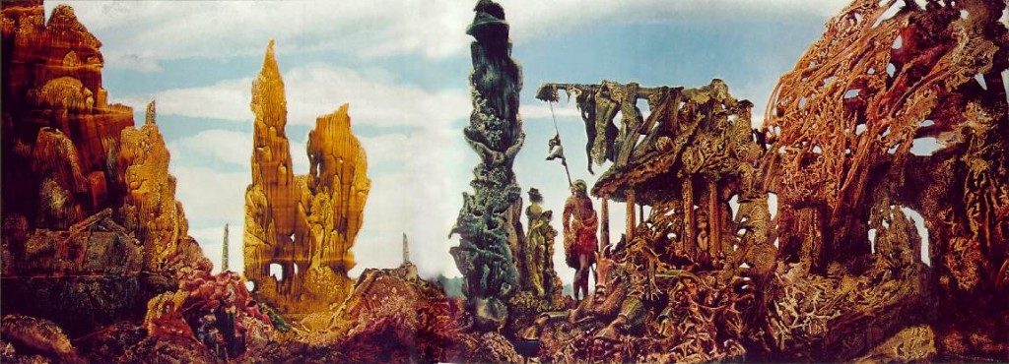

After Max Ernst

Keep down. The cellar’s safer.
The precincts and the tenements
are skewed and buckled
the stacked floors frozen in mid slither.
Melted glass and steel
Have iced and blistered into flesh.
But over there, look,
Among the standing girders’ green and dun
the giant madman in the zany’s hat
and the statuebird
shut wings locked like armour on her flanks
watch and watch whatever there is
beyond them in the square

where a magus saw the stars revolve
where Wales was set upon a spike to rot
where Vesalius flayed the puppet man
where the French sword severed
the adulterous queen’s head
where Regiomontanus tried to set his clock
to which trams ran to time
on which the tired clerk rode home
thinking of light
where we saw Tendulkar’s running one hand catch
where ja outside the Rathaus
Magdeburg’s horses trying to tear apart an idea
ripped their sinews
where somebody nailed a big list to a door
where the Popoli burned the Nobili’s golden book
where the old god waved to the crowd
and death waved back
where authors combed their manes
and gave up roaring
where l’ Empereur set up an obelisk
where they built and then tore down a wall
where the cleanshaven
smashed the shops of the bearded
where victors waved from armoured cars
where Monique slit her Klaus’s throat
pour la patrie
where every year drunks danced in fountains
where they released the doves and the balloons
where they unveiled the great monument
where once a year the great stood silent
where gulls and pigeons limed old murderers’ bronze heads
where the Archduke learnt how soft he was
and gasped

the madman and the statue stare
at the blackened flags,
the scattered bits, the empty space

and nothing has ever been so still
as this:
the figures that could be bits of wall
the blistered walls that could be live
and puncturing the fret of green and rust
the poison rinse of chlorine sky
without a wing alive in it
without a wing alive.

From Christopher Meredith, The Meaning of Flight, Seren, 2005

