Michael Cunniffe (P148021)
Mcunniffe.148021@student.ac.uk

Race engineering
Driver comparison through data analysis

Student of BSc Motorsport Engineering Year 3 .2019



Driver analysis through data analysis.

Student name: Michael Cunniffe (P148021)

Programme: BSc Motorsport

Module: Race engineering

Lecturer: Tim Tudor

Internal verifier: Kerry Tudor
Contents Page

1 Introduction
2 Methodology
3 Data Analysis
3.1 Driver A
3.2 Driver B
3.3 Driver C
3.4 Simulator test 2 Plan
3.5 Davis Vs Tim session 1
3.6 Tim, Tyre temperature
3.7 Davis vs Tim session 2
3.8 GG graph
4 Conclusion
5 References
6 Apendices

1) Introduction

When it comes to performance in motor racing it all comes down to minimizing lap times or to maximise the distance covered in a given time frame. Since race cars don’t drive themselves, the driver plays an important part in the performance of the vehicle. In modern day motor racing, the vehicles are equipped with data logging systems that measure almost every performance parameter of the vehicle and its driver. The data logger records the driver’s inputs such as gear shifts, throttle position, steering position etc.

Due to data acquisition by use of data loggers, the degree of competition in motorsport increases, costs of racing and testing because engineers now needs to know the cars behaviour and how it may be affected by the drivers inputs. This is done by various sensors around the vehicle that transmit data to this electronic memory unit. Because of this there is a greater need for understanding of race car dynamics to educate drivers, develop the vehicle and improve testing efficiency. Before this engineers just made decisions based on theory, intuition and experience. These measurements can be used to examine the effects of setup changes or track conditions, driving style and causes of performance variations or component failures. “An activity that cannot be measured cannot be controlled nor managed” (Sergers .2014). This report covers a thorough analysis of data for three different drivers using Motec i2 software taken from the UWTSD vehicle simulator. The Motec i2 software is used to evaluate how the car/driver combination is performing at a particular location on a racetrack.

2) Methodology

As a class we were organised into groups of 7 people and given a date to take part in a simulator session in the UWTSD campus, each group was given an hour time slot to organise there test time wisely to get the most track time possible as would be the case in a real life on site testing of a race car as time on track is limited. The vehicle we were using is a MCR sports 2000 series car on the universities Base Performance SIMULATOR software. As a group we organised a brief of how we should conduct the test so we began by assigning each other roles. For example we chose the 3 drivers. Driver A (Davis), Driver B (Michael) and Driver C (Tim) aka our tutor. Days before the simulator session we ran through our plan to make sure we would have sufficient time to complete the test with each driver having the same time in the car and the same amount of time being communicated with. Also we had to make sure our drivers were able to complete laps in the MCR. The track we picked for the report was the Brands Hatch Indy Circuit because it’s a short track with a good selection of different corners from slow, medium and fast with elevation changes. The other roles we assigned were to, (Toby) who looked at what he could see visually by watching the monitor when there was a driver in the car and he noted where the driver would spin, lock up, oversteer or understeer etc. Then there was (Oliver) who logged and saved the files from the simulator into files so it would be accessible to everyone in the group. And Finally (Liam) who roles was to communicate with the drivers after each session by showing them the Data and showing them where they could go faster comparing with the fastest drivers times.
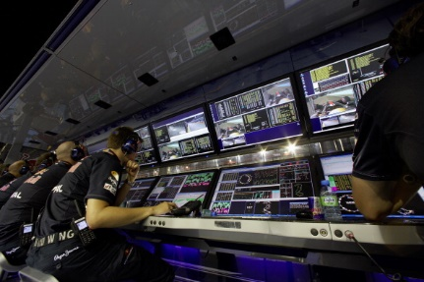
Figure 1- Red bull F1 telemetry engineers on the pitt wall.

3) Data Analysis

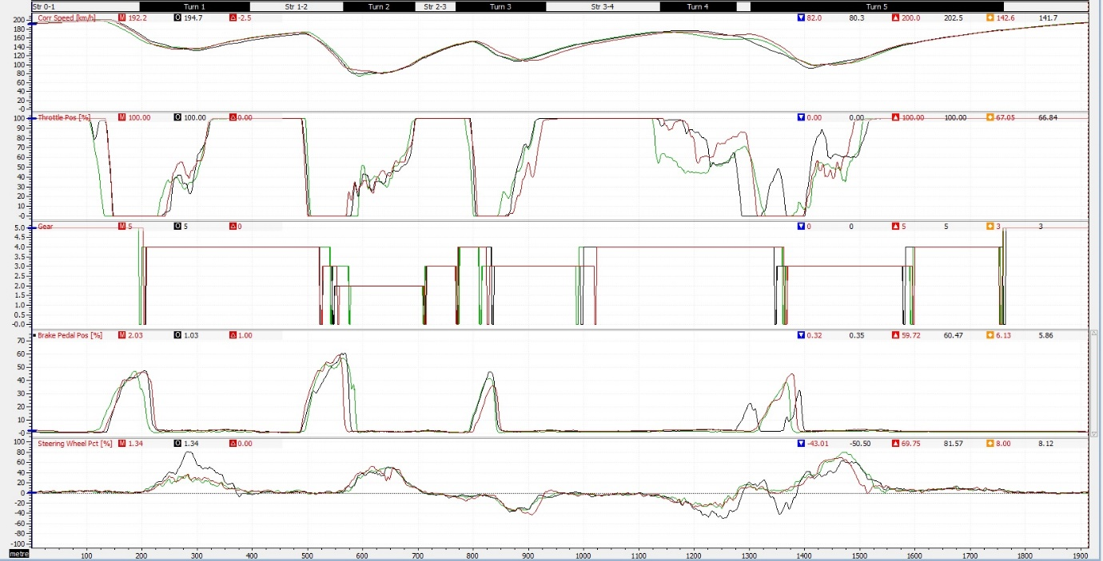
3.1) Driver A. (Davis)
Figure 2- Driver A (Davis), Simulator test 1, 3 fastest laps. Michael Cunniffe .2019

Driver A’s 3rd fastest lap is the Black lap (48.691 secs), 2nd fastest lap is the Green lap (48.392 secs) and fastest lap is the Red lap (48.289 secs). To begin we will look at where the driver could improve from obvious textbook mistakes he is making. The first channel we will look at is the Throttle position of driver A to see how it differs between the 3 laps. Above you can see that in turn 1 on his 2nd fastest lap he has come off the throttle at 30m earlier than his fastest lap and 2 metres earlier than his slowest lap. This shows that he should be on the throttle for 30 metres further therefore he is isn’t utilising the limitations of the track by missing out on increased entry and cornering speed. On the same lap in turn 2 during mid corner driver A applies the throttle to early. This is known in the motorsport fraternity as being to “greedy” and the driver should try being smoother when operating the throttle. Since turn 4 is a high speed left hand entry chicane, on driver A’s green lap he lifts and coasts earlier than his slowest and fastest lap. This means that he isn’t carrying as much speed that the vehicles limits can carry. To improve on this driver A must can stay on the throttle for longer therefore carrying more speed and can get back on the accelerator a little bit earlier too.
Also on driver A’s slowest lap (Black lap) the throttle position shows irregular appliance of the accelerator during mid corner. This is shown in the brief rise in the black lap during turn 1. This greedy throttle application mid corner upsets the balance of the MCR and any race car with stiff dampers and springs which makes the car understeer during that turn in which can be seen in the bottom, steering % channel where the black line shows a much larger percentage of steering being applied. “In simplistic terms an understeer vehicle requires
more steering input into the turn if speed of the vehicle is gently increased on a constant radius path” (Donald F. Tandy .2019). At the entry to turn 5 after the fast turn 4 chicane, driver A applies 50% throttle in the braking zone which is odd. When we observe the steering % channel at this point 1340m along the circuit we see a correction in the steering of the vehicle signifying an event of “oversteer”. “An oversteer vehicle requires the driver to reduce the magnitude of steering as speed increases and therefore lateral acceleration will be increased” (Donald F .Tandy .2015).
On driver A’s fastest lap he makes a large improvement in the tricky turn 4 where he has the smoothest steering input and reduces to 50% throttle therefore not losing as much velocity as before. Driver A applies the accelerator briskly where as in the other inferior laps he lifts off throttle for longer and applies it again gradually therefore not utilising the available lateral grip which will be discussed later on. The vehicle can hold the corner with this rapid throttle application on driver A’s fastest lap because turn 4 is less of a radius corner than turn 1 and the vehicle is carrying less speed into turn 4 than turn 1. Also the rpm is mid-range in the power band of the engine in 4th gear where the torque available isn’t sufficient enough in dry conditions to encourage oversteer. Gear selection isn’t mentioned too much in this section as driver A. upshifts before the rev limit and downshifts at the correct time utilising enough engine braking. “Engine braking is a supplemental addition to foundational friction brakes” (Saggam N .Edke .2019).

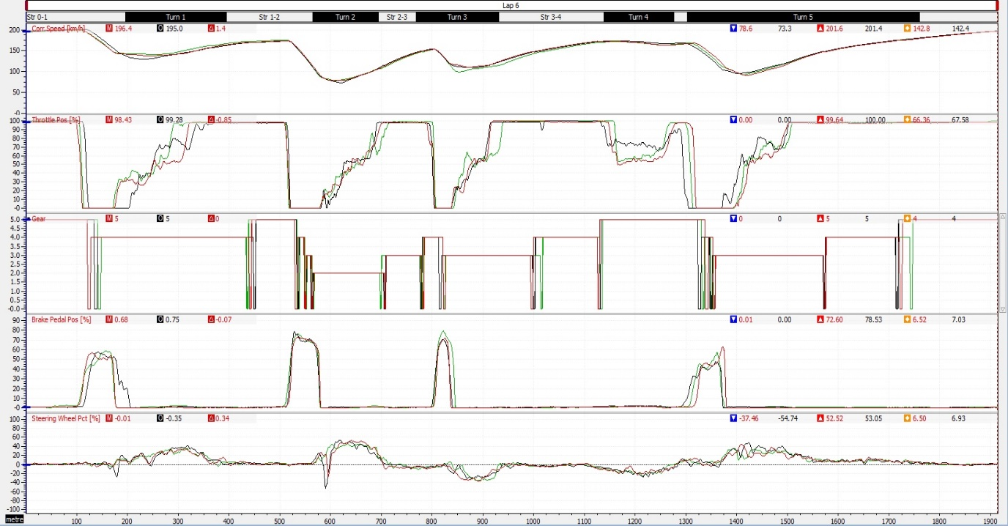
3.2) Driver B. (Michael)
Figure 3- Driver B (Michael), simulator test 1, 3 fastest laps. Michael Cunniffe .2019

Driver B’s layout is the same as before by having the 3rd fastest lap Black lap (48.697 secs), 2nd fastest lap Green lap (48.566 secs) and the fastest lap Red lap (48.424 secs). The first thing that can be noticed from driver B’s channels is that he never is fully on the throttle which we concluded that this was from sitting too far away from the pedals. From observing the data driver B. is 0.150 secs slower than driver A. but is much more consistent by repeating the same braking points every lap within metres of each braking zone. Also driver A. in figure 1 is only reaching 60% pedal position whereas driver B reaches 80% pedal position therefore he can die off the vehicles velocity for tight corners such as in turn 2 which can be seen by the steep gradient of the brake pedal position. A major problem is when he is coming on the throttle as it is too greedy yet again making him come off the power again and unsettling the balance of the car by promoting oversteer as can be seen in an ever so slightly correction having to be made. He is also consistent when he comes off the throttle immediately for every braking zone this can be seen by the steep gradient at 100m, 500m, 800m and 1300m distances around the circuit. Setbacks do occur in his gear shift selection.

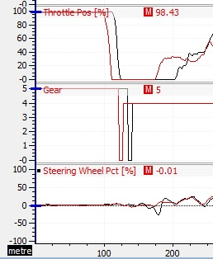
Going up the gearbox is perfect as its redlined every gear but the problems do occur on his downshifts as there far too close together and too early in which promotes wheel lock up when braking going into turn 1. This can be seen in the steering % channel at the bottom 180m distance where driver B turns for the corner but has to immediately correct himself. It doesn’t help that there is a bump on the braking point where driver B is suddenly hitting the brake pedal.

Figure 4: Michael's lift off oversteer moment. Michael Cunniffe .2019

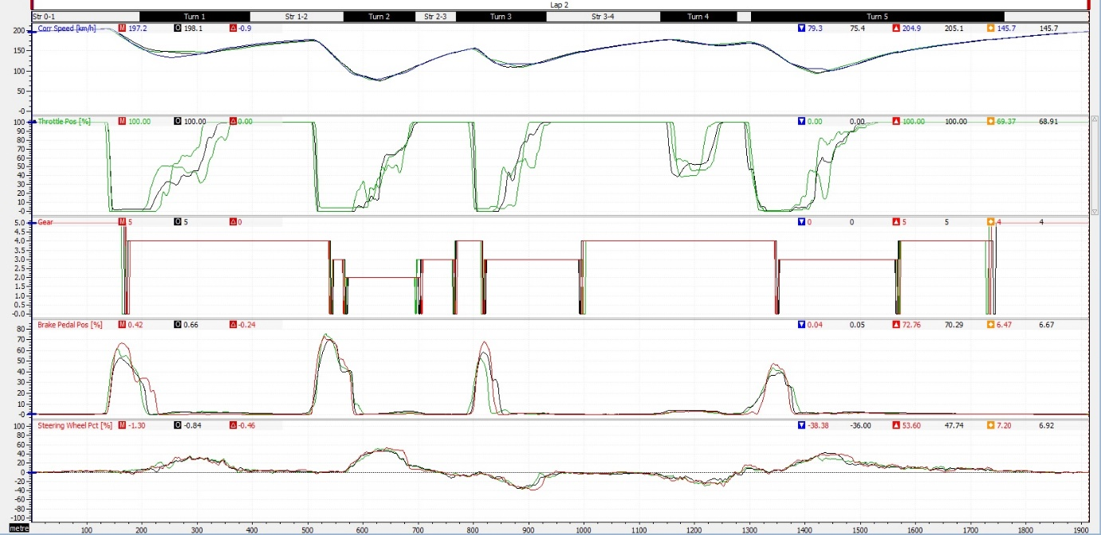
3.3) Driver C. (Tim)
Figure 5-Driver C (Tim), Simulator test 1, 3 fastest laps. Michael Cunniffe .2019.

Driver C’s layout is the same as before by having the 3rd fastest lap Black lap (47.513 secs), 2nd fastest lap Green lap (47.502 secs) and the fastest lap Red lap (47.428 secs). As you can see driver C is the only driver to break into the 47s lap barrier. The Math channels above are very consistent as you can see as there is very little to tell the lap times apart seeing as the fastest lap is less than 0.100 of a second apart. On the first test session driver C was the only driver to carry out a professional style warm up out lap. This benefitted him greatly as he got the tyres, brakes and engine up to operating temperature and could get better efficiency from the tyre before the tyre began to wear and the result of this was he set his fastest lap on lap 2. Since driver C. was much faster than drive A. and B. we used him as a bench mark for improvement for the rest.

3.4) Simulator test 2 Plan

Vehicle: MCR sports 2000
Track: Brands Hatch Indy Circuit
Drivers: Driver A (Davis), Driver B (Michael), Driver C (Tim)
Session length: 1 Hour

Tim Tudor Improvements
- Carry more speed through turn 3
- Apply throttle slightly earlier for turn 2

Davis Watkins Improvements
- Turn 4 lift at corner entry and accelerate before turn 5
- Brake later into turn 2
- Brake harder for turn 3 to allow earlier application of throttle

Michael Cunniffe Improvements
- Turn 4 leave car in 4th gear instead of 5th because the upshift through the corner unsettles the balance of the car for entry of turn 5 and be slightly less throttle positive
- Set peddles closer for session as they were set too far away on test 1.
- At the braking point in turn 1 manage the bump at the crest of the hill where the turn in point is because it keeps unsettling the car making you run wide on the exit.

Session 1: 10 minutes each
Driver A-
- 1 outlap to get heat into tyres and brakes then 4 laps to implement the improvements

Driver B-
- 1 outlap to get heat into tyres and brakes then 4 laps to implement the improvements

Driver C-
- 1 outlap to get heat into tyres and brakes then 4 laps to make minor improvements as driver C is our bench mark driver.

Note: While a driver is on track the other drivers look at their own data to against the data collected in the first session to see if they have improved on their previous time.

Session 2: 10 minutes each
Driver A-
- 1 outlap to get heat into tyres and brakes then 4 laps to implement next improvements

Driver B-
- 1 outlap to get heat into tyres and brakes then 4 laps to implement next improvements

Driver C-
- 1 outlap to get heat into tyres and brakes then 4 laps to implement next improvements

Session 3: 10 minutes each
Driver A-
- 1 outlap to get heat into tyres and brakes then 4 laps to implement next improvements

Driver B-
- 1 outlap to get heat into tyres and brakes then 4 laps to implement next improvements
Driver C-
- 1 outlap to get heat into tyres and brakes then 4 laps to implement next improvements

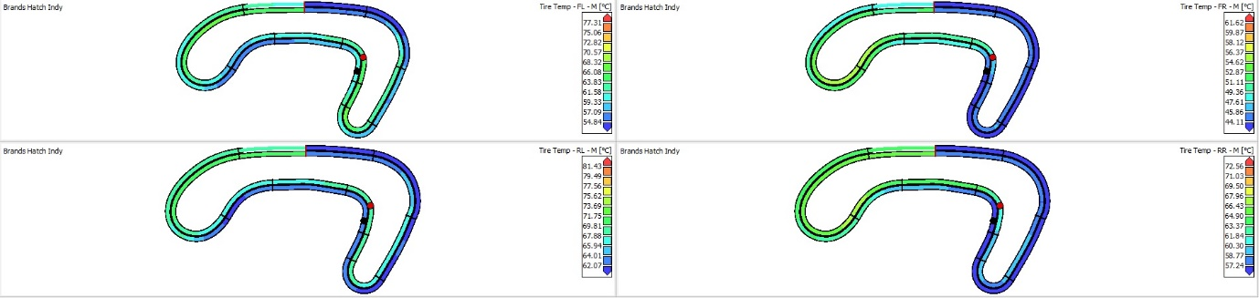
3.5) Driver B. (Davis) fastest lap vs Driver C. (Tim) fastest lap

Figure 6- Driver C (Tim), Tyre temperatures and Camber, Michael Cunniffe .2019

The diagram above is one of monitoring tyre pressures on the first lap of the second testing session just after the outlap. A skid pad and full lap manoeuvres were chosen to simulate steady-state and transient behaviour of the MCR sim vehicle. It is important to this technical report because driver C. set his fastest lap of 47.095s on his 1st lap and driver B. set a 50.302s on his 1st lap. Since there is a large difference in performance on Driver C. and Driver B on the same lap at the same conditions, it would be interesting to try another math channel to monitor tyre temperatures other than looking at the inputs the driver is making on the vehicle. There are many variables that affect the tyres on a race car but largely in is temperature management but for our testing we just wanted to get the car up to temperature and then utilise the time slot we had to fit in the fastest laps the drivers could do. As stated in the study Factors affecting tyre traction “one of the most elusive variables in conducting traction or skid testing is temperature”.

Temperatures effects on tyre traction are not confined to the low temperature range”. The study demonstrates how this increased traction due to heat increases stopping distance on page 7 figure 12. The advantages are proven in our testing as Driver C. is 3 seconds faster from his 1st lap. This is due to the warm up procedure the that driver C. did by slaloming side to side from the pit exit in which transfers the weight across the contact patch of the tyre. Creating this math channel, the front left, front right, rear left, rear right tyre and there inner, middle and outer contact patch had to be selected. The above graph show driver C. as the red dot and with the inner track while driver B. is the black dot on the outer track. It is easily spotted that Driver B. (Black dot) hasn’t done the warm up procedure during the outlap to get optimum heat into his tyres. This is shown at the right hander of turn 2 where the front left and rear left tyre will have more load on them due to the weight transfer but driver B. has roughly 60°C in the front left and 62°C in the left rear whereas Driver C. has roughly 68.32°C in the front left and 69.81°C by just reading from the temperature colour chart.

The superior traction that driver C. (Red dot) has can be seen in the image above where the he is on the power exiting turn 3 whereas Driver B. (black dot) is only entering turn 3. Driver C’s (red dot) tyres are at operating temperature of 52.87°C at the front right and 66.43°C in the right rear by the left hander at turn 4 whereas Driver B’s tyres are at 44.11°C at the front right and 57.24°C at the rears. Coming back onto the start finish straight the “tyres are going to be colder because the being cooled” by air “due to the increased longitudinal accelerations” and not lateral accelerations. (D. Harsh .2019)

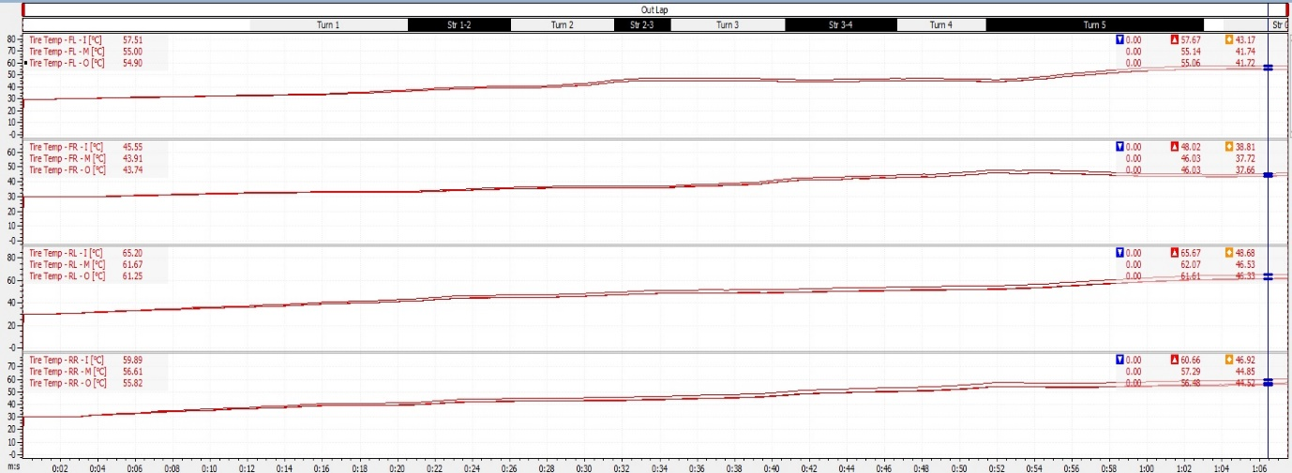
3.6) Driver C. (Tim) Tyre temperatures and Camber
Figure 7- Driver C (Tim), Tyre temperatures and Camber, Michael Cunniffe .2019

The above graph represents each tyres temperatures along driver C’s outlap where he doing his warm up procedure. This is evident as because at the beginning of the run all temperatures are equal but if you look at the tyre temp figures in red on the left of the graph show something interesting. Since MCR is a race car and is set up for the tyre to have maximum contact patch to the asphalt when cornering, this is proven in how the inner part of the tyre heats up quicker than the outer side therefore the wheel has a negative camber. For example the for all the inner (57.51°C) part of the tyre are higher than the middle (55°C) and outer (54.90°C). Although it was mentioned about Driver B. in figure 2 and Driver C. figure 4 were able to reach 80% brake pedal position with steep gradients compared to Driver A. only able to reach 60% brake pedal position in figure 1. This was due to once again the warm up procedure by riding the left foot on the brake pedal during the outlap to get them up to temperature.

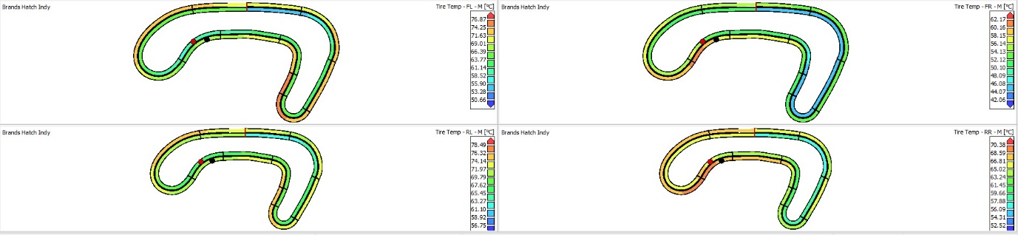
3.7) Driver B. (Davis) fastest lap vs Driver C. (Tim) fastest l

Figure 8- Driver C (Tim), Driver A. (Davis), Tyre temperatures, Michael Cunniffe .2019

The above graph represents the Driver C as the (Red dot) and Driver A as the (Black dot). As stated already Driver C set his fastest lap on his first lap in the second test session and Driver A set his fastest time in test 1 but it was on his 12th lap. Driver A set a 47.095s with fresh tyres just by getting them “scrubbed up” (D .Harsh .2019) on the outlap whereas Driver B didn’t carry out the outlap worm up procedure and therefore paid the price because he took too long to get a fast time logged. This can be seen in figure 7, turn 4 where Driver B’s tyres have done 11 laps with the front right tyre (60.16°C) and rear right (68.59°C) over heating all the while Driver C has fresh tyres on done the outlap and at (54.13°C) for the front right and (63.27°C) which is optimum temperature for that compound according to the colour chart from figure 7. In a real racing scenario drivers must manage their tyres and these simulator tyres in terms of traction seem to go off a cliff when there overheated which shouldn’t happen after 12 laps of a circuit with 5 corners, Maybe a harder compound tyre would be a better choice therefore the drivers get to retain traction for longer so they can string off a set of competitive lap times.

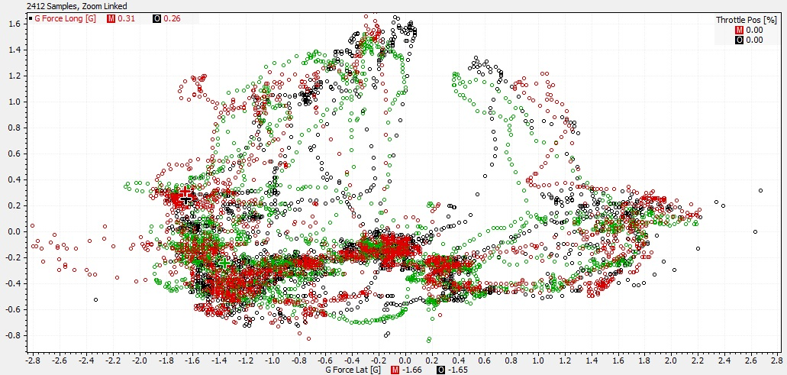
3.8) Driver A. (Davis) Vs Driver B. (Michael) Vs Driver C. (Tim)
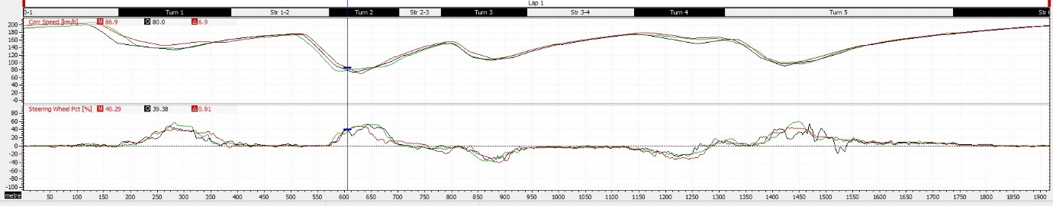
Figure 9- Driver (A, B and C), Longitudinal and Lateral G forces, Michael Cunniffe .2019The above data the G forces that each driver can generate, in the y plane there is the longitudinal and an the x plane represents the Lateral G. Same as before by having the 3rd fastest lap Driver B. Black lap (48.557 secs), 2nd fastest lap Driver A. Green lap (48.284 secs) and the fastest lap Driver C. Red lap (47.095 secs). From observing the GG diagram it is clear the Driver C is utilising the most of the traction circle. As Driver C has is further towards the outer edge without going in to tractive slip he is using the most advailable grip in the corner. The anomalies on the “outside of the tractive circle” which indicates that he has “gone beyond the limit of adhesion” and lost grip. (W F. Milliken .1994). In Layman’s terms it means slip occurs. These anomalies take place in Turn 1 where, Driver C is trying to improve his lap time and was given advice by one of the people in the group and they told him to brake a later and apply the pedal smoother as in session one was too aggressive and it didn’t need to be because it’s a flowing high speed corner. Even though Driver A got a better exit from turn 1 than Driver C but then Driver C brakes harder and later to make up for the ragged driving from the beginning of the lap.

4) Conclusion
Driver C. (Tim) in test session 2 was able to get his tyres and brakes working early to set his fastest time on his first flying lap, to compare that with Driver A. who set his fastest lap on his 12th lap in session one with his tyres overheating as seen in figure 8. Only Driver C made a real improvement in the simulator between test sessions one and 2. Driver B. Made .050 second improvement so really to do faster times hours upon hours of practice would have to must be spent to realistically be able to apply the advice given to achieve a faster lap time.

5) Refernces

W .Bergman, The Basic Nature of Vehicle Understeer – Oversteer, Pub by SAE international, Feb 1st 1965.
- A .Liversey, Advanced Motorsport Engineering, Pub by Routledge, 2011

- William F. Milliken and Douglas L. Milliken, Race Car Vehicle Dynamics (Premiere Series), Pub SAE international, 1994.

- D F .Tandy, J Colborn, Jung C. Bae, Clay Coleman, The True measurement of oversteer and understeer, Pub SAE international, 14th April 2015.

- A W.M.Bonnick, Automotive science and mathematics, Pub by Routledge, 2008

- F .Puhn , How to make your car handle, Pub by HP Books, 1987

- Nikhil Saggam, Pritam Edke, Guruprasath Alagarsamy and Surbhi Kohil, Engine Braking: A Perspective in Terms of Brake Power, Pub SAE International, 9th Jan 2019

- Hans B. Pacejks, Tire Charachteristics and Vehcile Handling and Stability, 3RD ed, Pub 2011

- Rodrigo de Oliveira Santos, A discussion on steady-state lateral weight transfer and how to use it in setup,

John C. Dixon, Tyres, suspension and handling , 2nd ed, Warrendale, Society of automotive engineering INC. pub 1996

- J P .Whitehead, G Howard, D .Bastow, Car Suspension and Handling, 4th ed, Wrrendale, Pub SAE international, pub 2004

- Seger Jorge, Analysis Techniques for race car data acquisition, 2nd Ed, Warrendale, Pub SAE international, 2014.

- Graham Templeman, The Competition Car Data Logging Manual, Pub Veloce Publishing dorchester, 2008

- Buddy Fey, Data Power using racecar data acquisition: a practical guide to selection and setup data interpretation, trackside operation

- Figure 1: Red bull F1 telemetry engineers on the pitt wall, https://redbullracing.redbull.com/gallery/best-test-photo-gallery.

6) Appendices

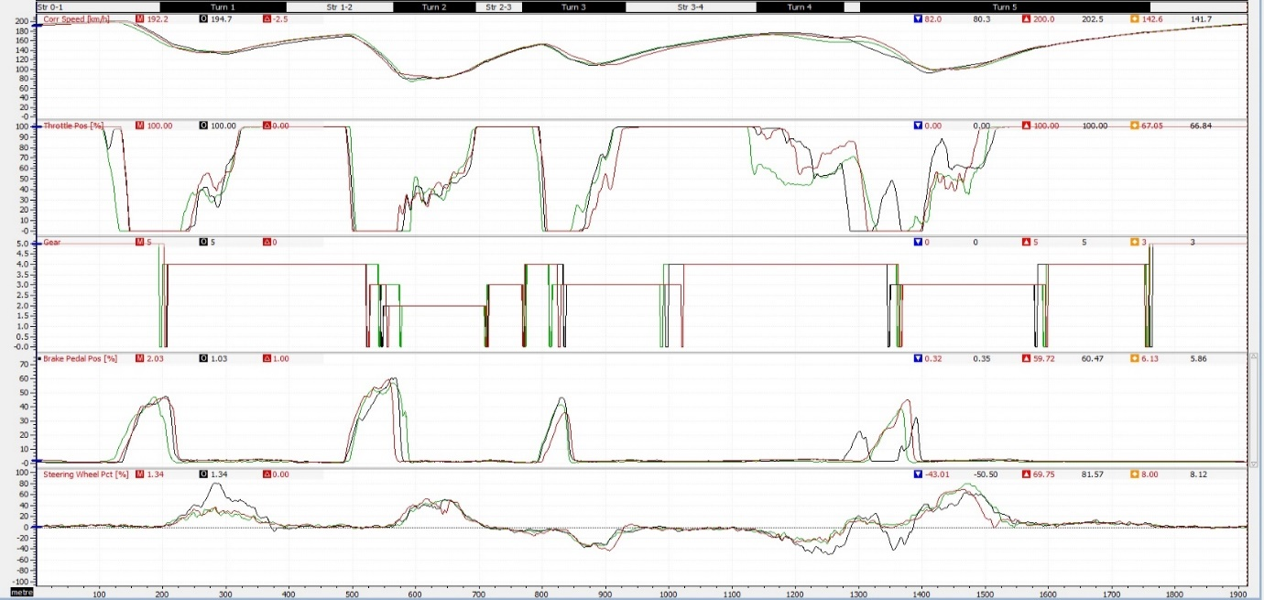
6.1) Appendix
Figure 2- Driver A (Davis), Simulator test 1, 3 fastest laps. Michael Cunniffe .2019

6.2) Appendix
Figure 3- Driver B (Michael), simulator test 1, 3 fastest laps. Michael Cunniffe .2019

6.3) Appendix

Figure 4-Michael's lift off oversteer moment. Michael Cunniffe .2019

6.4) Appendix
Figure 5-Driver C (Tim), Simulator test 1, 3 fastest laps. Michael Cunniffe .2019.
6.5) Appendix

Figure 6- Driver C (Tim), Tyre temperatures and Camber, Michael Cunniffe .2019

6.6) Appendix
Figure 7- Driver C (Tim), Tyre temperatures and Camber, Michael Cunniffe .2019

6.7) Appendix

Figure 8- Driver C (Tim), Driver A. (Davis), Tyre temperatures, Michael Cunniffe .2019

6.8) Appendix
Figure 9- Driver (A, B and C), Longitudinal and Lateral G forces, Michael Cunniffe .2019

