
Skills for the Workplace
Module Assignment Submission
Student Name: | Jenna Stabler
Student Number: | 2107303
Module No: | BMSK4004
Module Title: | Problem Solving and Decision Making

Statement of Confirmation of Authenticity
By the act of making this submission, the student declares that this is the work of the student named above. The work has not, in whole or in part, been knowingly presented elsewhere for assessment, or where assessment has been built on a previous assessment, this has been identified. Where materials have been used from other sources it has been properly acknowledged. If this statement is untrue, the student acknowledges that an assessment offence has been committed.
Attention is drawn to the plagiarism and unfair practice policies of UWTSD.

Table of Contents
Define a complex problem in the workplace, including its scope and impact 3
Analyse information on the identified problem, to help inform the decision making process 3
Propose a range of alternative solutions to the problem 4
Using a decision making technique, evaluate a range of solutions to identify the most appropriate option 4
Develop a detailed plan for implementing the solution 5
Communicate the plan to relevant stakeholders 6
Assess appropriate monitoring and review techniques to ensure successful implementation of solution 6
References 7
Appendix 1 7

Define a complex problem in the workplace, including its scope and impact
Introduction
I will be identifying a challenging issue at my place of employment during this assignment. I'll be examining the size and influence it has, as well as who is impacted and how many individuals. I'll list the causes, justifications, and consequences. I will brainstorm potential solutions for this task, assess them, and choose the most promising ones using a mind map and flowchart. To aid me in doing this, I'll be using a Gantt chart. I'll also create an action plan and track my progress on it.
The issue I have found at work is that there aren't many customers and we're currently quite quiet as a result of the growing cost of living.
Scope and Impact
As a result, team members are suffering, and employee morale is extremely poor. When a significant player does arrive, the team finds it challenging because it has been so quiet during the shift because they tend to switch off and standards have started to slide. Since we are losing money and falling short of our goals, the business is also suffering. If we keep quiet, it also reflects poorly on the company. Customers are also noticing and have started to visit elsewhere.
How it is affecting the business? In order to provide safer gambling, we must ask our customers individualised questions about their finances. Customers don't want to be questioned about their finances when they are gambling, thus this has had a significant impact on the firm. We managers are in a tough situation because of it, but it is a requirement of our licence to ensure safer gambling, and as a result, we risk receiving a hefty fine or perhaps losing our licence. The team members' morale is low as a result of the firm being so quiet, as was already indicated, and they believe that their jobs are in danger as a result.
In order to tackle the problem, myself, as the manager, must work with other members of the management team to find solutions. If we do nothing, the company might close. Alternatively, we could just leave it. I think my issue is an operational one, which means it's medium- to short-term in nature and deals with the allocation of resources to meet specific goals.

Analyse information on the identified problem, to help inform the decision making process
Brainstorming and mind map
A wonderful tool for information organisation and problem-solving is mind mapping. It can also be used to schedule tasks and monitor their completion at work or at home. Due to the fact that a mind map created to solve one problem may frequently be used to solve other problems of a similar nature, mind maps are also a fantastic way to store solutions to difficulties. In order to address my problem, I will use a mind map. Within my management team we brainstormed ideas that we thought would help solve our problem and implemented them into the mind map.
Once a month
Free Bets
Live singers
Every visit counts Stamp card
BOGOF meals

Minimum 6 months
Marketing
Entertainment
Promotions

Competitors
Enrollment system
Slots Tournament
Top 25 party
Very Quiet in work
Self-exclusion

Safer Gambling
Environment

Conversations
EDD Checks
Too warm
Monthly
Aircon broken(heatwave)
Provide proof of income

Flow Chart
To assist me with my issue I have created a flowchart that will outline the crucial phases in resolving the issue. Flowcharting allows for effective analysis, visual clarity, and ease of communication.

Quiet in the Casino

Need to get customers in

Different Promotions

Target Customers

More admissions

Increased Revenue
Root Cause
The 5Ws, 5 Whys, and the Ishikawa diagram will all help me discover potential reasons of the problem and help me find solutions to the problem, and they will all be used to help me pinpoint the root cause of the casino's current quietness. I will be examining the issue's core cause and building on the knowledge I've already obtained by using the five why’s to aid me do this.
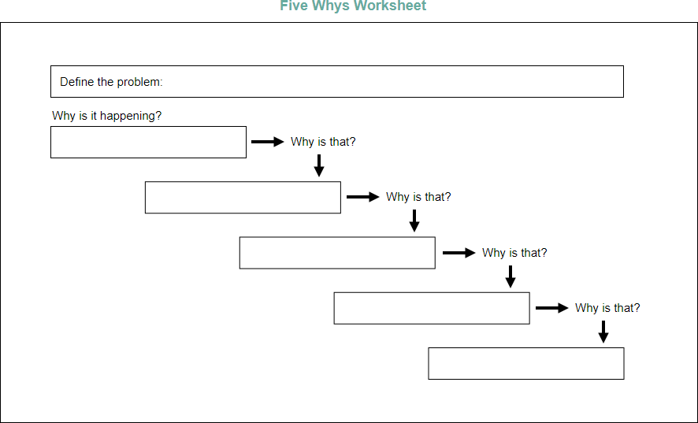
Barring those at risk
Customer interaction
Young and vulnerable protected
Problem Gambling
Safer Gambling

Casino is very quiet at the moment

5W’s
Who?
Casino is struggling to get customers through the door at the moment. Affecting the business.
What?
Customers are being asked personal questions about their finances as part of our safer gambling process that we have to ask customers to protect the young and vulnerable and those at risk.
When?
Since Covid we have been asked to be more cautious as some customers may have lost their job or may not have had furlough pay and due to the increase in cost of living.

Where?
In the Casino when a customer triggers.
Why?
We have to protect our licencing conditions for our licence and its one of the conditions. If we don’t adhere to this we could potentially get a massive fine or lose out licence.

Cause and effect Ishikawa diagram
Ishikawa's cause-and-effect diagram is another technique I have used to break down various causes into more manageable groups. An illustration of several reasons why the casino might be quiet right now is given below.

Customers getting barred for not providing EDD, money laundering, customers getting upset
Disposable income. Cost of living increase
Staff switch off. Morale is low, Staff are bored.

Very quiet in work

Cost cutting. Looking at areas where we can save money.
Competitors- What are they offering
Environment- Aircon not working- boiling hot – people leaving

Propose a range of alternative solutions to the problem

Solutions

Identify

I have identified possible solutions to my problem and listed them in my grid analysis. I will utilise a grid analysis as a helpful decision-making tool to assist me. It works best when you have a wide range of options and important considerations. I have

Options | Cost | Time | Morale/Team | Resources | Total
Weight | 1 | 2 | 5 | 3
EDD Personal information | 1 1 | 2 4 | 3 15 | 5 15 | 11 35
Marketing- Lapsed customers | 2 2 | 2 4 | 3 15 | 4 12 | 11 33
Promotions | 1 1 | 2 4 | 5 25 | 4 12 | 12 42
Environment  (air-conditioning) | 1 1 | 2 4 | 5 25 | 3 9 | 11 39

I created a grid analysis with options and factors that are important for making a decision. The factors I came up with and felt were important were cost- would it by expensive for the company, time- would it take too much time, team morale- would it improve the team morale and resources- what resources would I need. I scored these from 0 (poor) 5 (very good). I then listed a number of variables in the left column and gave each a grid score based on how essential they were to my conclusion. The correct total weight in my selection was then determined by multiplying each score by the importance values. The one that has scored the highest is promotions. I will use a variety of incentives to draw people back into the club.

Using a decision making technique, evaluate a range of solutions to identify the most appropriate option

The process of analysing the costs and advantages of a business action is known as cost benefit analysis. This tool will be used by me to determine whether the plan of action is financially viable. In the first table I will list how much I expect to spend within years 1-5 on promotions.

Cost
Promotions | 1 | 2 | 3 | 4 | 5 | Total
Cost to business  Posters  Training  Net Cost | £2000  £300  £200  £2500 | £1000  £200  £100  £1300 |  | £2000  £300  £200  £2500 |  | £5000  £800  £500  £6300

In an effort to entice customers to visit, I have budgeted £2000 for incentives like cash prizes, buy one get one free meals, and a stamp card that says "every visit counts." Due to the necessity to attempt to bring back clients, I have done this for the first year. Then, I'll spend another £300 on posters to advertise these incentives, bringing the total to £2300. Then, I calculated that I would spend an additional £200 training team members to be able to advertise these, bringing my total to £2500 for the first year. I haven't spent as much on the second year since I think the promotions will increase revenue and attendance, so I don't need to spend as much. It has been difficult since Covid, but I believe it will take 3 years for this to improve therefore I have not utilised any promotions for year 3. I feel like customers will start to return and attendance will be high. To keep attendance strong I have implemented some more promotions for year 4 and left year 5 as I feel by year 5 the business will be well built. My total for the 5 years will be £6300.

The identical process is used in my second table, but this time I've chosen the benefits it will bring to the businesses rather than the costs.

Benefits | 1 | 2 | 3 | 4 | 5 | Total
Attendance  Revenue | 72,800  £20,000 | 91,000  £25,000 | 101,920  £30,000 | 109,200  £10,000 | 112,840  £12,500 | 487,760  £97,500

I believe that by promoting the business it will have many benefits. Attendance will improve and therefore revenue will increase as more customers will be spending money. I have estimated that in year 1 if 200 customers visit a day x that by 7 = 1400 x 52 = 72,800 customers will come through the door increasing revenue by £20,000 by year 1 through promoting the business. By year 2 I have estimated that if we have 250 customers a day x 7 =1750 x 52=91,000 customers through the door increasing revenue by £25,000 as shown in the table above. By year 3 101,920 customers will visits a year increasing revenue by £30,000. By year 4 attendance has increased but revenue has declined this was due to major players winning and having an impact on the business. Same goes for year 5 attendance has increased but revenue has dropped due to major players. By looking at this attendance has increased but revenue can be affected.

I have attached a copy of my cost benefit analysis in my appendix please see below.

I have estimated that if I spend £2300 in the first year I should make that money back from revenue of 20,00 as admissions will be up more customers will be visiting and spending money. Over the 5 years I have estimated the company will make £96,240 in revenue by spending £6300 on promotions. The promotions will be a good solution to my problem and wont cost the company in the long run.

Develop a detailed plan for implementing the solution
I created a Gantt chart (appendix) to help me in the implementation of my plan. It will assist me in estimating how long a project will take to complete, identifying the resources required, and outlining the sequence in which tasks must be completed. It is an effective tool for managing job dependencies. Gantt charts are helpful for tracking the development of a project while it is in process.
I have estimated that it will take 6 weeks for me to roll out any promotions. I'll start by looking at market research and the types of customers I need to target. I'll also be looking at consumers whose profiles have expired because they haven't visited in a while. I will then design posters to promote the promotions, train the team so they are aware of the ongoing promotions, promote these promotions online and in the club, and finally roll out them out. As you can see in my Gantt chart stages of the project are defined by different colours and it is sequential.

Communicate the plan to relevant stakeholders

Identifying Stakeholders

In this section, I will list the groups, companies, and individuals who are stakeholders and analyse their perspectives and areas of interest. Prioritizing the ranking of stakeholders and mapping the relationship between stakeholders and business objectives. I will include a communication plan to help me communicate the objectives to the relevant stakeholders.

Although Grosvenor Casino is a Limited company so what this means is that there is 1 person with significant control. One of the major shareholders of Grosvenor Casinos Limited is Rank Casino holdings limited. There is currently 3 active directors and 1 active secretary.

Stakeholders I have identified are:
- Employees Team
- Employees Families
- Suppliers
- Customers
- Community
- Creditors
- Directors

What contributions do each stakeholder offer?

Employees

Within the organisation, the team will have a significant impact. They assist in both distributing offers to clients and generating revenue for the company. It's crucial to hire the right individual for the job, which is why we conduct interviews when hiring new team members. A six-week training session and a successful probation are prerequisites for joining the gaming team. The team have some influence on decision making we have an ideas box in the staff room which they can write down. They also have the opportunity to implement their decision ideas in the meeting we hold on a monthly basis.

Employees Families

Employees Families don’t have any impact on decision making. But they do contribute by having families with small children they may be the childminder so that the partner can come to work.

Suppliers

Suppliers don’t have any influence on decision making but to do help the everyday running of the business. If we didn’t have suppliers they we wouldn’t be able to sell products to our customers.

Customers

Customers have a significant impact on the company. Without clients, we couldn't generate any revenue. Because we pay attention to feedback and put suggestions into practise to enhance the customer experience, customers have some influence over decision-making.

Community

While casino gambling does have a positive impact on the community's social, economic, and environmental conditions, more has to be done to reduce its unfavourable social and environmental effects. As part of our licensing objectives we have to protect the young and vulnerable and prevent gaming to be a source of crime and disorder. Therefore, the community does influence the business and some of the decisions that are made.

Creditors

Creditors play some part in the decision making. If we wanted to expand the business or make changes then we would need to borrow money. We also do credit checks on our customers before they sign up for responsible gambling reasons.

Directors

As was already said, three of Grosvenor Casino's directors are quite important to the business. For the majority of commercial decisions, we would have to obtain their consent.

Step 3 Prioritise

Employees- These would need to me manged closely, keep them satisfied and they would need to be kept informed as they play a big role within the business.

Employees families - would need to be kept informed.

Suppliers – would need to be monitored to ensure they are providing the service we require, kept informed and satisfied.

Customers – would need to be kept informed and satisfied

Community – Kept informed and satisfied

Creditors – Kept informed and satisfied

Directors – Keep them informed and satisfied engage and consult

To help me map my stakeholders into appropriate engagement levels I will be using the (Mitchell et al. 1997) influence interest matrix below.

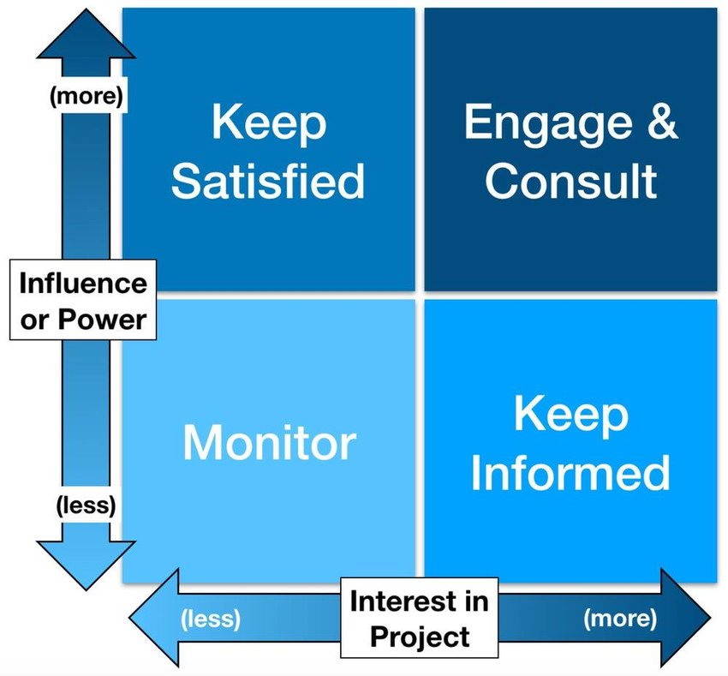

Stakeholders status can change during the course of a project therefore my analysis will need to be regularly updated.

Communication Plan
Providing a communication plan to interact with my stakeholders and gain their support and understanding is the last step in this approach. Here is an illustration of my communication strategy.

What | When | How | Responsible | Sponsor | Project Team | Who?
Promotions | 1/7/22 | Meeting | General Manager/Managers | Approve | Receive | Team members
Agenda minutes | 1/7/22 | Meeting | General Manager/Managers | Approve | Receive | GM/Managers
Huddles | 1/7/22 | Start of shift | Managers/ Supervisors | Approve | Receive | Team members

Assess appropriate monitoring and review techniques to ensure successful implementation of solution

To assist me with my problem and ensure I can monitor it correctly I will be holding monthly meetings to discuss the performance of the business. During this meeting I will be able to see if attendance has improved and if the promotions I am running are helping my problem of the Casino being quiet at the moment through a run on trends report. In work we use a system called Neon this will be able to assist me and I will be able to run reports and see if the attendance has improved and if there is more revenue. I will be using this as a monitoring technique. I will have an agenda as this will allow me and other members of the management team to add to it if they wish. These are the points I will have in my meetings, an example of my agenda will be in my appendix.
- Set Agenda
- Chair person
- Minutes
- Actions
- Records that a meeting took place
To ensure team members are aware of the promotions I will be holding team huddles these are updated on a weekly basis to ensure relevant and up to date information. Huddles will be communicated to the team as they start their shift by the gaming supervisor. These are a good way to communicate to each team member as they start at different times of the day/ evening. The huddles will contain information about what promotions we are offering, when and during what times. I will also be questioning team members and asking them what promotions we have on offer. This is a good way to ensure they understand what promotions are running and when.

References
Luchins, A.S. And Luchins, E.H. (1970) Werbeimer’s Seminar Revisited: Problem Solving and Thinking, Vol. 1, State University of New York Press, Albany, NY.
Mitchel, R.K, Agle, B.R., and Wood . D.J (1997) “Toward a Theory of Stakeholder Identification and Salience: Defining the Principle of Who and What really Counts”
Mendelow A (1991) “Stakeholder Mapping, proceedings of the 2nd International Conference on Information Systems, Cambridge MA
Osborn, Alex F. Applied Imagination: Principles and Procedures of Creative Thinking. New York: Scribner, 1953.
Ishikawa cause and effect fishbone diagram (1960)

Appendix 1

Cost Benefit Analysis
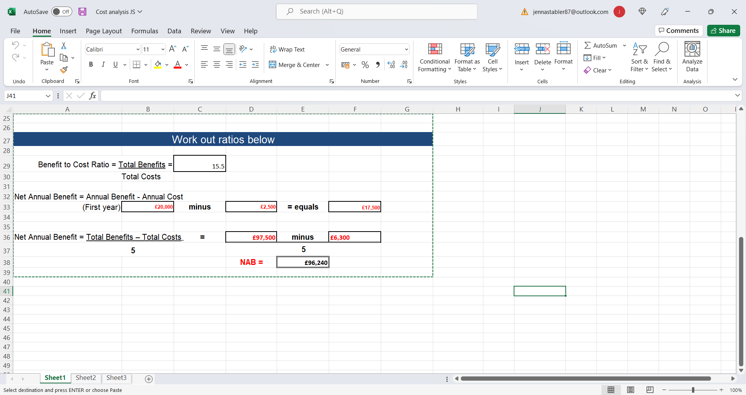

Gantt Chart

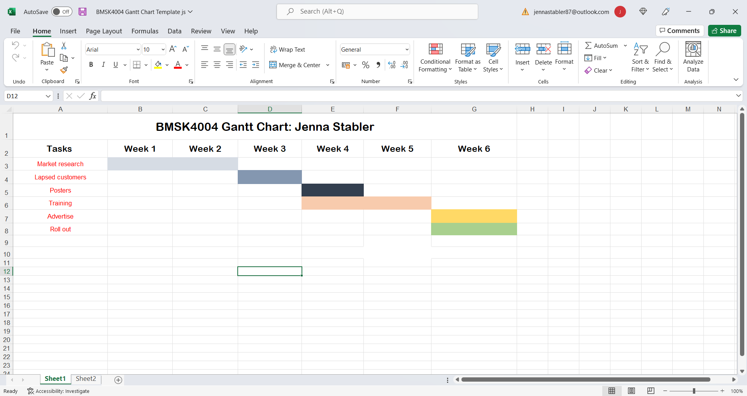

Leadership Meeting June 26th 2022

Attendees Apologies
Vincent Dale
Alex Tizard Varcoe Kirsty Mills
Katy Graham Alun Mills
Sam Boulter
Jenna Stabler

 |  | Action
Trading
P12 a slight improvement from P11
Live gaming handle down 2k from last period 243k down against target. Margin 6.9% impacted from out late night poker players.

ER stake has been problematic all year finishing the period 259k behind holding 31k win 26k short.

Slots had a strong finish 73k income for the period but P10&11 causing us to miss target by 72k on the year.

F&B remains stagnant with a little drop off towards the Q4. YTD 4k average income a week.

Card room has pretty much mirrored F&B, Q4 dropping off but still held on to hit target 4k over YTD

Next year trading

New folder in share drive called Trading 22-23

AS we are going to be a club that losses money this year, there is a close focus on what we are going to do to bring us back into profit next year. A lot of work has been done focusing on savings and also on local promotions.

A promotional Calander will be rolled out shortly, but scope for more local for each department to be rolled out within next 6 weeks.

We also need to look line by line on how we can save money.

Other areas of possible savings, Catering consumables, cleaning consumables,
Please let VD know of any promotional or savings ideas you have.

F&B
EHO visit went really well just waiting on AS to finish remedial work then we will be paying for a revisit.
EDD and SG
Remember that we only need to suspend if there is a real risk to the business, or if they have hit 4 visits without a convo.

RH now suspended
W LI&S LI now signed off

CW brining in documents this week

Updated changes to risk matrix.
PP Update May 22 Final.docx
 | Period: P12  Headline  AR -1%%  BJ 27%  3C 39%  Overall 5%  Underlying  AR 9 %  BJ 27%  3C -57%  Overall 27%  Rolling 3 months  Headline  AR 5.8%  BJ 20.85%  3C 33%  Overall 8.92%  Underlying  AR 12.6 %  BJ 1.2%  3C -28%  Overall 19%  Rolling margins have dropped which normally indicates issues with core delivery  Analytical Underlying Win Calculation P12.xlsx  We have Dave Allens margin report back, mixed comments the big stand out is  Ad hoc CCTV reviews show inconsistency in delivery of basic standards and a lack of urgency to take advantage when the revenue opportunity arises.  Swansea Gaming Review Report - Thursday 23rd June 22.docx  PB meeting after this and will be letting Martin and Moji know expectations moving forward.  As a matter of urgency GS need to ensure that all dealers are dealing to procedure, focus on clean hands, commentary, more bets being controlled with 4 revolutions remaining.  Need all leadership team on this and address with GS if this is not being implemented. | ATV
Slots Update
Last slot party we had 10 customers, next party is on 30th POS arriving today. Can we get EGH to hand out invites.

We will be running slots party's each month dates TBC with VD and KM

ER update
Support office now track tracked drop on live gaming, slots and TBR if we don’t hit target then we are asked to submit an improvement plan.

Latest tracked report
Week 1 220704.xlsx

Poker Update
Looking to replace student night for GUPT until September, recruiting for zero hrs currently no interviews yet.

F&B Update
Keep up the good work on kitchen checks, out of date food found take photos and send to Sam.
New till system coming in September management training in Cardiff team training over teams

Cash Desk Update
- Skyler being trained firstly to be able to cover full shifts and Sam B breaker training.
- Amy notice recieved
- Check to make sure all keys have been signed in and out.
- 2 applicants for CD interviews

Training Update
- Dylan’s apprenticeship paused for 3 months.
- Review of Gaming training standards be undertaken, lots of training practices in place, is this quality training?

Admin Points

Ordering please sanity check (blue roll) only order what we really need

H&S

Please support big push on completing rollout of new fire evac procedures
Alun, Kirsty, Sam, Jenna one evac per month, only needs to be to the front door.
Form needs to be completed and placed in folder, once a month then all uploaded onto prime.
Please read evac procedures and any questions drop an email.

Problem gambling Staff

MP

Failing Audit points
EHO revisit will communicate
Will keep sending audit out please check areas for compliance
AOB
Appraisals time will send out next week please start taking a look and will set dates for completion

