STUDENT NAME: Cristina Tudureanu
STUDENT NUMBER: 1917153
PROGRAMME: Business Management
MODULE NAME: Management Accounting
ASSIGNMENT TITLE: Assessment 2
MODULE CODE: LCBB5002
LECTURER’S NAME: Riaz Bhatti and Zainab Atta

TABLE OF CONTENTS

- Introduction………………………………………………………………………….3
- Part A: Monthly control report, performance report for Amana Ltd. Discussion and recommendations………………………………………………………………4
  - Monthly control report……………………………………………………….4
    - Budget…………………………………………………………………….4
    - Variance…………………………………………………………………..6
  - Performance report………………………………………………………….7
    - Annual revenue…………………………………………………………..7
    - Variable cost……………………………………………………………...8
    - Fixed cost…………………………………………………………………8
    - Contribution Margin……………………………………………………..8
    - Profit………………………………………………………………………8
    - Break-Even Point Analysis…………………………………………….10
  - Discussion and recommendations………………………………………..13
- Part B: Online website or Amazon platform. Analysis, Discussion and recommendations ………………………………………………………………….14
  - Online platform: Website…………………………………………………..14
3.1.1.Performance report………………………………………………….15
3.1.1.1. Calculations and analysis………………………………………..16
  - Amazon platform……………………………………………………………17
3.2.1. Performance report…………………………………………………18
3.2.1.1. Calculations and analysis………………………………………..19
4. Discussion and recommendations…………………………………………………20
5. Conclusion……………………………………………………………………………21
6. References…………………………………………………………………………..22

- INTRODUCTION
Management accounting is the process of collecting, analysing, preparing, interpreting, and transmitting financial data for the purpose of planning, assessing, and controlling an organization's resources. Financial reporting to non-management stakeholders such as shareholders, creditors, regulators, and tax authorities is also included in management accounting (IMA, 2021).
This report has as main focus Amana Ltd company which is a gift-selling tourism firm based in England. The business has other brunches too such as in Brighton, London Bridge, Westminster Bridge, Buckingham Palace, Birmingham, and Manchester. The souvenirs were created by the Amana team and are manufactured by a Chinese company.
The business has 40 years maturity and experience and are familiar with the dynamism of the tourism industry. The Covid-19 pandemic has struck England, imposing severe travel and movement limitations on the country's tourism industry. Summer 2020 sales grew somewhat, but the prolonged lockdown from December 2020 to February 2021 wiped out any additional summer revenue. Previously, Amana Limited conducted business exclusively through brick-and-mortar locations, with a website functioning as a marketing tool. The company wants to operate online as this could decrease the business costs. There are two options that the company wants to take in consideration: a website or Amazon platform. Both options will be discussed and analysed after analysing the Amana’s Ltd actual finances using the management accounting concept in order to take the best decision for the business.
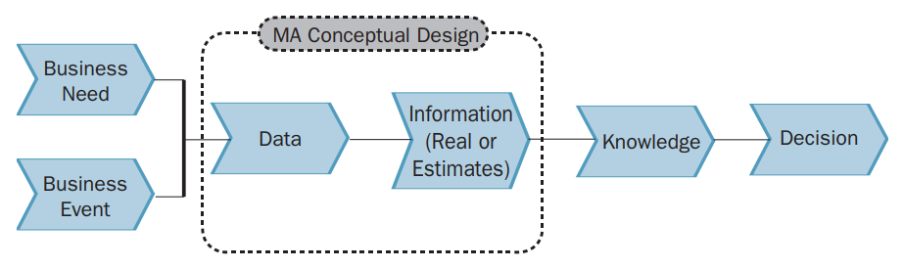
Fig.1: Management accounting concept
Source: IMA, 2021

2. PART A: MONTHLY CONTROL REPORT, PERFORMANCE REPORT FOR AMANA LTD. DISCUSSION AND RECOMMENDATIONS
2.1. MONTHLY CONTROL REPORT
Using monthly control reports, organisations can compare their actual expenditures to their budgeted expenditures. For a given period of time, you establish your budget, and subsequently your budgeting report shows you how much money was actually spent over this period of time (P. Wathman, 2021).
Both the Budgeted Spending and the Actual Spending columns are essential components of any budget report. This basically shows how well the organisation handles funds in comparison to its expectations. It will look a lot like your profit and loss statement. The business net operating income will be displayed first, followed by a list of expenses.

2.1.1. Budget
Budgeting It is the process of allocating the available resources in effective manner for the purpose of optimum utilisation. In addition, revenue and expenditure forecasts are taken into account (Morozov,20113). The budgeting process has numerous advantages for organisations, such as: a better prediction the amount of money the business will need, as well as how much the business will spend, by managing the cash flow
To make decisions, they use the estimates to assemble an effective set of information that they can use. They used this information to make decisions about the use of available funds and to make expenditures in accordance with those decisions (Morozov, 2013).

- Original budget Amana LTD:
 | ORIGINAL BUDGET (£)
Units | 100,000
Selling price | 25
Variable costs: | 25
Materials | 2.50
Labour | 4
Overhead | 1.50
Contribution | 17
Fixed Costs: | 350,000
Warehouse rental | 200,000
Insurance | 100,000
Fulltime warehouse supervisor salary | 50,000
FIG.2: Amana LTD original budget
- Flexed Budget Amana LTD
 | FLEXED BUDGET (£)
Units | 80,000
Selling price | 20
Variable costs: | 840,000
Materials | 280,000
Labour | 440,000
Overhead | 120,000
Contribution | 760,000
Fixed Costs: | 305,000
Warehouse rental | 170,000
Insurance | 100,000
Fulltime warehouse supervisor salary | 35,000
Fig.3: Flexed budget Amana Ltd
2.1.2. Variance
Variance is the difference between expected and actual. Budgeting variances are typical but can occur in any projection. Essentially, every prediction has a positive or negative variance. For example, the company may have a positive budget variance. However, examining the variances reveals that sales exceeded expectations, but materials used above budget. Using this data, can be find new vendors and save money. By monitoring cost accounting variation, can catch anomalies before they become bigger problems (R.B. Gray, 2021).
The variance formula is: < Variance = Forecast – Actual >
Below is calculated the monthly control report for Amana Ltd taking in consideration and calculating all terms discussed above, in order to find the business variance.

Original budget (£) Actual (£) Variances(£)
Units 100,000 80,000 20,000 unfavourable
Selling price 25 20 5 unfavourable
Variable costs: 8 840,000 832,000

Materials 2.50 280,000 279,997.5 unfavourable
Labour 4 440,000 439,000 unfavourable
Overhead 1.50 120,000 119,998.5 unfavourable
Contribution 17 760,000 759,983 unfavourable
Fixed overheads: 350,000 305,000 45,000

Warehouse rental 200,000 170,000 30,000 favourable
Insurance 100,000 100,000 0 favourable
Fulltime warehouse
supervisor salary 50,000 35,000 -15,000 favourable

Fig.4. Monthly control report Amana Ltd
Performing the monthly control report for Amana Ltd there was found favourable and unfavourable variances. The business has registered an unfavourable variance at units sold and the price. Even the business lowered the price, the quantity of units sold was lower with 20,000 units/year. Looking at the variable costs there have grown significantly which is an unfavourable variance for business. On the other hand, the fixed costs registered a favourable variance at warehouse rent registering a 30,000 favourable variance and the supervisor salary who was paid 50,000£ before and in present is paid 35,000£ registering a 15,000£ favourable variance for business.

  - PERFORMANCE REPORT
Performance report is a tool, not a goal in itself. Information is meant to inspire action. The business report thus brings all important facts together in a balanced and objective manner. A excellent report has all the information needed to help the company make decisions. It should prompt the director to ask the correct questions and take actions that will help the company achieve its short- and long-term goals while increasing shareholder value. Finance departments are vital in this setting since their data reflects a company's overall health (CIMA,2022).
Having solid systems for collecting, storing, and analysing financial and non-financial data is critical, but so is maintaining integrity and openness. Information might be twisted on its route up to the board. Relevant information should be supplied that reflects the organization's goals and overall strategy. It must not obscure the overall picture. The company should be able to delve down and access more reports as needed. The information should be sufficient to allow for impartial decision making.
In order to discuss the performance report for Amana Ltd, there needs to be defined all terms used with their formulas.

    - Annual Revenue

Business revenue is the total of all sales revenue for a given accounting period. Annual revenue is the money your company earns in a year.
Revenue comes in two forms: operational and non-operating.
- Operating revenue comes from the core business activities (product sales).
- Non-operating revenue is earned from non-business activity (renting your building to other companies). Calculate annual revenue from both operational and non-operating sources.
The revenue formula used in this report is:
< Revenue = Quantity of Each Product or Service X Sales Price >

    - Variable Cost (VC)
Variable costs are the sum of all labour and materials required to produce the product. The total variable cost is equal to the variable cost per unit, multiplied by the number of units produced. Your average variable cost is equal to your total variable cost, divided by the number of units produced. The variable cost is the amount of labour, materials, and other resources required to produce the business product.
    - Fixed cost (FC)
Monthly fixed costs remain constant. Your production or sales volume has no effect on them. They are the cost of doing business: even if no sales are made, business must pay their fixed costs. The business must also pay property taxes regardless of how many patients your acupuncture business sees. Fixed costs appear on income and balance sheets, but they are predictable (B.Warnes, 2019).
    - Contribution Margin (CM)
The contribution margin shows you how much income is left after variable costs to pay fixed costs and generate profit for the organisation. The company might think of it as the amount of revenue that is used to offset the costs of their fixed assets (A.Gallo, 2017). The contribution formula is:
< Contribution margin = revenue − variable costs >

    - Profit
Profit is the amount of money that a corporation retains after all of its costs have been accounted for. It can be found on the company's financial report. After subtracting expenses from revenue, a corporation is considered to have a profit if the value remaining is positive; if the value is negative, it is said to have a loss (CFI,2022).
There is gross profit, operating profit and net profit as this is illustrated in fig.3 below.
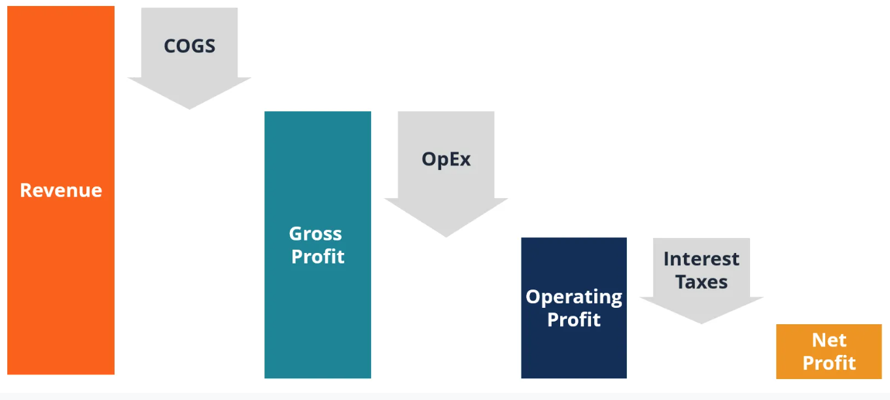
Fig.5. Profit types
Source: CFI,2022
The profit formula used in this report as well is:
< Profit= Contribution- Fixed Cost >

    - Break-even-point analysis

A break-even study can help the business determine when the firm, or a new product or service, will be profitable or not. In other words, it's a financial calculation used to determine how many units or services the business need to sell to break even (Campbell, 2021).
The formula for this analysis calculations is:
< $BEP=\frac{Fixed Costs}{Selling price\left(unit\right)-Variable Cost (unit)}$ >

Amana LTD
Performance Report
2020

Income (£) Cost(£)
Units 80,000
Selling price 20
TOTAL ANNUAL REVENUE 1,600,000

EXPENCES
Total Variable Costs 840,000
Materials 280,000
Labour 440,000
Overhead 120,000
Total fixed Costs 305,000
Warehouse rental 170,000
Insurance 100,000
Fulltime Supervisor salary 35,000
CONTRIBUTION 760,000

TOTAL ANNUAL PROFIT 455,000

Fig.6: Amana LTD Performance report

    - Calculations and analysis
As can be seen the performance report is for year 2020. In 2020 the company registered 80,000 units sold with the selling price 20£. This way can be calculated the total annual revenue.
TR= Units x Price/unit
TR= 80,000 X 20£
TR=1,600,000
In order to find the total variable costs, there where added the materials cost, the labour used and the overhead.
VC=280,000£+440,000£+120,000£
VC=840,000£
The total fixed costs were calculated adding the rent cost, the insurance cost and the supervisor salary cost.
FC= 170,000£ + 100,000£ + 35,000£
FC= 305,000£
The contribution was already given and, in this way, there could be calculated the business profit for year 2020 as requested.
Profit= Contribution- Fixed Cost
Profit= 760,000£ - 305,000£
Profit= 455,000£
As calculated, the profit registered in year 2020, is 455,000£.
Having found the profit of Amana Ltd, before taking any other decision there needs to be calculated the break even point.
$$BEP=\frac{Fixed Costs}{Selling price\left(unit\right)-Variable Cost \left(unit\right)}$$
What is missing from this equation is Variable Cost per unit. This can be found out dividing the Total Variable cost to how many units where sold. In this case we will have this:
VC/unit = 840,000£ / 80,000
VC/unit = 10.5£
Next, we can add our VC/unit in our BEP formula:
$BEP=\frac{305,000£}{20-10,5}$
BEP= 32,105.26£
Having the BEP in terms of sales we can find out the BEP for units that needs to be sold in order to not register loss.
BEP/units = 32,105.25£/ 20£
BEP/units= 1,605.26
There, using Excel we can illustrate all our calculations.
Fig.7: Break-even Point
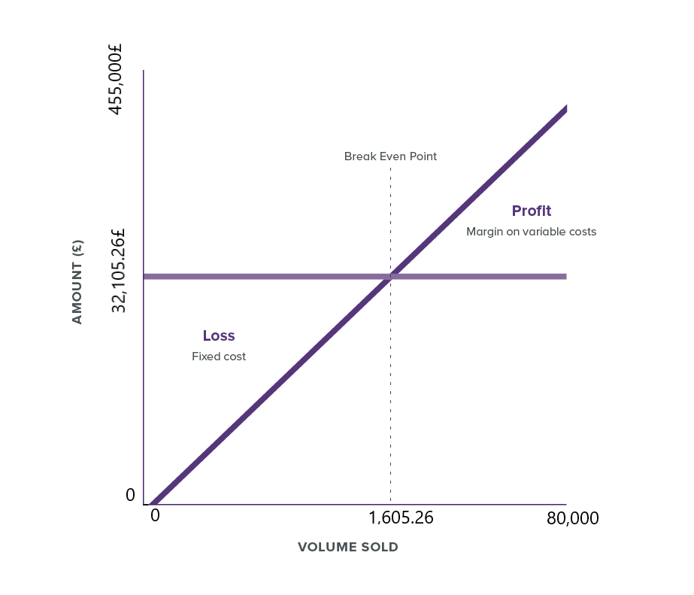
Fig.8: Amana Ltd Break Even Point
  - DISCUSSION AND RECOMMENDATIONS
Amana Ltd actual financial situation has a profit of 455,000£ with a break even point of 1,605.26 products that needs to be sold which will bring a 32,105.26£ revenue. This point being the point “0” of Amana Ltd.
For business to improve the financial situation there can be many options two of them will be discussed in part B, but whatever the decision will be there can be taken in consideration three recommendations which are standard recommendations for every business. Put the price hire, lower the fixed costs and lower the variable costs.

- PART B: ONLINE WEBSITE OR AMAZON PLATFORM. ANALYSIS, DISCUSSION AND RECOMMENDATIONS
  - ONLINE PLATFORM: WEBSITE
The first option for Amana Ltd to lower the fixed and variable costs can be to go online and sell their products on a website. Even this option will reduce the business total cost, there are other costs involved as well that Amana Ltd needs to take in consideration. Delivery network cost-150,000£, website upgrading cost-50,000£ and a salary for a IT programmer will be taken in consideration when designing a performance report for this particular option. What do we know as well is the fact that with this option, Amana Ltd will sell 100,000£ units /year.

    - PERFORMANCE REPORT

To create a website platform performance report, the following factors must be considered: 50% of businesses will be online and 50% will be offline. Small offices or stores with invoices and anything else that needs the business to sell their products will share the overhead (£120,000/2= £60,000) if only half of the business goes online. After sharing the overhead, we'll get 60,000£ plus 50,000£ for website upgrades. 110,000£ neu overhead now. Given that 440,000£ was shared between all locations, we will also split the labour amount in half. The new labour cost is 220,000£. The materials amount will remain the same. The fee for setting up the delivery network will be added to the variable cost. The fixed costs of the firm will change slightly. The warehouse rent cost will stay because it is the most significant aspect of the firm, and the insurance cost will also remain in the calculations. Given that half of the firm is online, an IT programmer is required to ensure that everything runs smoothly at all times. This data may now be used to create a performance report for 50% of Amana LTD sales via the internet.

AMANA LTD
Performance Report
Online platform: Website

Income (£) Cost(£)
Units 100,000
Selling price 20
TOTAL ANNUAL REVENUE 2,000,000

EXPENCES – Total Cost
Total Variable Costs 760,000
Materials 280,000
Labour 220,000
Overhead 110,000
Set up delivery network 150,000
Total fixed overheads 340,000
Warehouse rent 170,000
Insurance 100,000
Supervisor salary (warehouse) 35,000
Fulltime IT 35,000
CONTRIBUTION 1,240,000
TOTAL ANNUAL PROFIT 900,000

Fig.9: Performance report Amana LTD- Online website

      - Calculations and analysis
- Total annual revenue
TR= 100,000£ X 20£
TR=2,000,000£
- Contribution
Contribution = Sales- VC
Contribution= 2,000,000£ - 760,000£
Contribution= 1,240,000£
- Profit
Profit = Contribution – FC
Profit= 1,240,000£- 340,000£
Profit= 925,000£
- Break Even Point
$$BEP=\frac{Fixed Costs}{Selling price\left(unit\right)-Variable Cost \left(unit\right)}$$
VC/unit= $\frac{760,000}{100,000}$ = 7.6

$$BEP=\frac{340,000£}{20-7.6}$$
BEP= 27,419.35£
BEP amount is 27,419.35£ this mean that the company’s BEP units is 1,370.96 units needs to be sold for not going in loss.

  - AMAZON PLATFORM
Another option for Amana Ltd in lower the total cost of the business can be selling their products on Amazon platform. This option is coming with its cost such as: Amazon fee of 50,000£. On the other had there are other characteristics to be taken in consideration too such as losing the control over pricing and return policy and big competition. Furthermore, Amazon guarantees to Amana 65,000 units/year. In order to take a decision regarding this option, there needs to be calculated the performance report and the break-even point.

    - PERFORMANCE REPORT

AMANA LTD
Performance Report
Amazon platform

Income (£) Cost(£)
Units 65,000
Selling price 20
TOTAL ANNUAL REVENUE 1,300,000

EXPENCES
Total Variable Costs 560,000
Materials 280,000
Labour 220,000
Overhead 60,000
Total fixed overheads 355,000
Amazon Fulfilment Fee 50,000
Warehouse rent 170,000
Insurance 100,000
Supervisor salary (warehouse) 35,000
CONTRIBUTION 740,000
TOTAL ANNUAL PROFIT 385,000

Fig.10: Performance Report Amana Ltd- Amazon Platform

      - Calculations and analysis

- Total Revenue
TR = 65,000 X 20
TR= 1,300,000£
- Contribution
C = Sales – VC
C= 1,300,000 – 560,000
C= 740,000£
- Break Even Point
$$BEP=\frac{Fixed Costs}{Selling price\left(unit\right)-Variable Cost \left(unit\right)}$$
VC/unit= $\frac{560,000}{65,000}$ = 8,61£

$$BEP=\frac{355,000}{20-8.61}$$

BEP = 31,167.69£
Calculating the amount of BEP there we can calculate the number of units too dividing the BEP amount to the selling price/unit. The BEP units is 1,558.38.

- DISCUSSION AND RECOMMENDATIONS
According to the data analysed in this report there can be seen that a chance for Amana Ltd could be a good choice.
Online platform became more and more important for business and clients nowadays and a big impact over this change has had Covid19 pandemic limitations. People found comfort in ordering from home any products needed and there is important to specify the fact that Amazon platform became a very big market for business. People are using frequently this platform, and this could be a good option for Amana Ltd, even the fact that the business profit is lower 385,000£/year the business can focus only on lowering the variable cost as for fixed cost there is just the Amazon fee so no insurance, no rent and no supervisor salary. On the other hand, this option is coming with weaknesses as well. On the other had there are other characteristics to be taken in consideration too such as losing the control over pricing and return policy and big competition.
Another option for Amana Ltd is investing in upgrading their website. This option can guarantee the business 100,000 units sold per year with a bigger profit 900,000£. This option is adding to the fixed cost investing a network and an IT programmer salary cost and will add to the Variable costs of the business, specifically, overhead expenses, adding the website upgrading fee 50,000£ to it. Furthermore, the company is allowed to its own pricing and return policy, having it’s own liberty as it has before.
Taking in consideration every aspect of these two options and the actual financial situation for Amana Ltd company, there can be suggested in investing in upgrading their website, maybe focus more on marketing, paying for adds just to make sure that they are always seen from the crowd. This is the best option for them because not only is almost double the business profit bust is cutting from many other costs and burdens that they had before.

5.CONCLUSION
Amana Ltd, a souvenirs company that struggled financially during the pandemic, is the topic of this investigation, which determines the company's true financial position. Due to the fact that online purchases may be more convenient for clients while also saving businesses money, this difficult situation has resulted in numerous changes to the way firms operate. As a result, everyone is increasingly focused on selling items online. I strongly advise Amana Ltd to invest in developing their website and experimenting with new marketing methods in order to differentiate themselves from the competition. Everything will be simpler for Amana and the company as a whole if Amana's costs are decreased.

6. REFERENCES

D. Starovic, (2022), “Performance Reporting to Boards: A Guide to Good Practice”, Chartered Institute of Management Accountants publications.
R.B.Gray, (2021), “Can’t See Into the Future? Don’t Be Surprised If You Have a Variance in Accounting”, Available at: https://www.patriotsoftware.com/blog/accounting/variance-in-accounting/ , Accessed: 20.03.2022.
B.Calzon, (2021), “9 Examples Of Financial Reports You Can Use For Daily, Weekly & Monthly Reports”, Available at: https://www.datapine.com/blog/daily-weekly-monthly-financial-report-examples/#monthly-examples , Accessed: 02.04.2022.
IMA, (2021), “Statements on Management Accounting”, Institute of Management Accountants pubications.
B.Wathman, (2021), “Modern budgeting reports: how to improve budget control”, Available at: https://blog.spendesk.com/en/modern-budgeting-reports , Accessed: 04.04.2022.
J.Kosinski, (2021), “How to Calculate Annual Business Revenue”, Available at: https://www.patriotsoftware.com/blog/accounting/annual-business-revenue/ , Accessed: 05.04.2022.
CFI, (2022), “Profit”, Available at: https://corporatefinanceinstitute.com/resources/knowledge/accounting/profit/ , Accessed: 05.04.2022.
A.Gallo, (2017), “Contribution Margin: What It Is, How to Calculate It, and Why You Need It”, Available at: https://hbr.org/2017/10/contribution-margin-what-it-is-how-to-calculate-it-and-why-you-need-it , Accessed: 05.04.2022.
C.Campbell, (2021), “How to Do Break-Even Analysis (+ Free Template)”, Available at: https://www.shopify.co.uk/blog/break-even-analysis , Accessed:05.04.2022.

