Frances Babbage*

This essay examines how concerns and critiques around stories and storytelling might be used productively to reframe an understanding of theatrical retellings, in performance practice and in adaptation studies. Adaptations in the theatre need not, of course, be narrative-led: its makers might prioritize the formal challenges inherent in the chosen source material, or may be motivated by another agenda—cultural, political, economic—to which “story” becomes subordinate. Equally, the source text might itself entertain the idea of “story” explicitly to resist this, exposing the fractures in its telling, or withholding the anticipated narrative rewards; acknowledging this, adaptations of such a text might strive to preserve in performance precisely these qualities of challenge and critique. However, whilst accepting that old assumptions about linear narrativity have been permanently unsettled in the twentieth and twenty-first century—not least through the development, expansion and impact of new communication technologies—it remains notable how frequently “story” is emphasized within the adaptation process, over and above other factors. Practitioners and playwrights regularly gesture towards story to signal the continued potency of a source text or, by contrast, its rediscovered relevance and timeliness; recurrently, the borrowed work is described as a story that “needed telling.”
The philosopher and literary critic Richard Kearney has argued, deferring to Aristotle, that the art of storytelling is “what gives us a shareable world.” He continues:
It is, in short, only when haphazard happenings are transformed into story, and thus made memorable over time, that we become full agents of our history. . . . Without this transition from nature to narrative, from time suffered to time enacted and enunciated, it is debatable whether a merely biological life (zoe) could be considered a truly human one (bios). (3)
In this light the apparent centrality of story in adaptation is unsurprising. If storytelling is understood, as Kearney suggests, as a practice of articulation that seeks to shape human experience and imagination in purposeful and profoundly interconnected ways, then storytelling through adaptation can in turn be regarded as an adherence to, and perpetuation of, the same desire. For while the appropriative move that adaptation necessarily makes is sometimes perceived as parasitic, a more generous interpretation of the adaptive impulse is precisely to see in this an affirmation of belief in the shareable. Adaptation proposes often unexpected connections between forms, genres, periods, styles, authors, preoccupations, cultures, languages—and in the case of adaptation for the theatre, as Mike Alfreds phrases it, between the “world of the written story and the world of its performance” (138). Such negotiations will of course be marked by tensions as well as opportunities.
Storytelling as Adaptation: Adaptation as Storytelling
Emma Rice, director of the British theatre company Kneehigh, describes the group’s adaptation projects by saying simply, “We tell stories because they matter”; regardless of the style, genre, theme or formal complexity of the material chosen by them, she has found that by “always treating the source as a story, not as a text, the landscape of choices gently alters” (“On Directing”). To regard the literary basis of adaptation primarily as a story, as Rice puts it, might seem to imply, naively, that the formal or contextual attributes of a work are less consequential. In practice, however, it does not follow that such considerations will be neglected. Rather, the privileging of story is a popularizing move that conveys the promise of accessibility, entertainment and engagement. “Story” announces a journey of the imagination, an undertaking to rouse curiosity, stir emotions and feed an appetite for discovery. Crucially, story also stands for a place in which different kinds of audience might come together, a common ground, not because a story means the same to everyone but because anyone can tell, listen, remember and retell a story and in so doing can make it significantly their own. Highlighting the communication of story as the central preoccupation of an adaptation may also indicate a desire to be free from the “trappings” of a text—its associations, expectations and histories of reproduction and reception—and thus clear a space within which it might become possible to tell and/or receive that story as if for the first time. Furthermore, proposing a connection between theatre today and an older performance tradition of oral storytelling acknowledges the distinctive character of traditional tales as widely and immediately comprehensible on the level of surface narrative, yet simultaneously capable of yielding multiple and rich interpretive possibilities for culturally mixed audiences of all ages. Undertaking to “retell” a source text in this way—folk tale or literary fiction, familiar or more obscure—is an inclusive gesture that implicitly probes the borderlines of narratives and leans towards an expansion rather than “fixing” of communicative space.
Evidently, the twin elements of a work of literature and the adaptations it inspires are not straightforwardly the equivalent of a popular folk or fairy tale and the variant forms it assumes over time and across cultures. A novel by an individual and perhaps still living author is not so fully and freely available for adaptation as a popular narrative whose roots are unknown and whose boundaries are uncertain; indeed, the more strongly a text is considered the product of a specific author-creator, the more cumbersome the critical “baggage” attached, at all stages, to the project of adaptation. By contrast, folk and fairy tales already have the quality of fragments: they are “shards of story” and consequently seem to invite and even require intervention in a way that is not equally true of a work originated as literature (Steadman-Jones 28). However, if one accepts even in part Barthes’s notorious claim, first, that any text is “a multidimensional space in which a variety of writings, none of them original, blend and clash,” and second, that ultimately an author’s power is only “to mix writings, to counter the ones with the others, in such a way as never to rest on any one of them,” then the distinction between literary and popular narratives becomes less fundamental (146). From this perspective, any work of literature stands as a contribution to, and intervention in, an ongoing history of textual production and transmission: its covers are not opaque but translucent, its pages already scribbled on in other hands. Just as importantly, accepting a degree of correspondence between these practices—adapting non-dramatic fiction for performance on the one hand, and popular storytelling on the other—can be helpful to us, since the connection draws attention not only to an ancient and still vibrant tradition of narrative (re)circulation that manifests cross-culturally, but one that is directly constructed by the dual and potentially conflicting imperatives of preservation and transformation. The theory and practice of adaptation are self-evidently marked by precisely this tension: inescapably so, since to consider any work in terms of adaptation is immediately to acknowledge an intertextual relationship or dependency.
The American academic Jack Zipes has been one of the most attentive and assiduous commentators on the evolution, dissemination and mutation of the classical fairy tale from its roots in oral storytelling, demonstrating through several studies from the late nineteen-seventies onwards the shifting cultural and political meanings these narratives can serve to reinforce and at times contest.^{[1]} Zipes demonstrates not simply that such tales are malleable, altered by context and open to ideological use and abuse; he argues that transformation is and has always been integral to the storyteller’s task. Since it is impossible to establish the original or authentic version of popular tales, this drive towards reinvention may have arisen more from necessity than choice:
[Storytellers] all have had to build on the past, on tradition, on stories handed down over the ages. They have had to translate from different tongues to facilitate understanding and create meaning. But what distinguishes the great writers and storytellers is that they write and tell with a conscious effort to grab hold of tradition as if it were a piece of clay and to mold it and remold it to see what they can make out of it for the present. . . . Nothing is inanimate in their hands and mouths. They are animators, breathing life into all things and all beings. They don’t worship the past and tradition, but demand that the past and tradition justify themselves in the present. In turn, they ask that their remolding of the past and tradition be questioned. (Zipes 241)
By this account, to undertake “storytelling” is to connect with an existing body or bodies of tales, handed down through and changed by generations; active participation in the telling process requires an almost shamanic act that combines a deep appreciation of the rituals of the past with revivifying creativity in the present. Crucially, Zipes associates the element of tradition as much with the stance of telling as with the stories themselves. When taking on a tale, its new narrator has an obligation to be curious and even actively distrustful, since to pass on any story without questioning what is at stake within it is to betray, rather than uphold, the telling tradition.
How might this representation of the storyteller’s task be used to reframe understanding of adaptation, both in general and within the theatre? First, authentic participation in this tradition requires adapters to approach their sources with a combination of fascination (why else are they drawn to it?) and scepticism; the excitement of reinventing a text in theatrical terms must not blind them to its “faults.” That such a perspective would be adopted might seem axiomatic, given that today, in practice and in theory, adaptations and critics have advanced from a place where what Geoffrey Wagner disparagingly termed mere “transposition” of a source is demanded or even anticipated (222-31). Nonetheless, the depth of critical engagement with story Zipes insists on cannot be assumed to be part of the adaptation process: the implications of accepting a potential equivalence between adaptation and storytelling extend beyond insisting on creative license and, perhaps, defending the legitimacy of changes made. Zipes argues that the telling of a story must be justified in the present, in ideological terms as well as for the fresh creative opportunities it might seem to invite; by extension, the adaptation that is eventually produced in performance must seem to its audience to be pertinent to the moment. To argue this does not, of course, mean seeking out texts that endorse a certain ideological stance; in fact, it more or less suggests the reverse, since responsibility rests with the new tellers to confront the complexities of their text and what it might seem to “say” when reiterated in a context of sometimes profoundly altered circumstances, perceptions and values. Here, perhaps, the advantages and opportunities of a self-conscious intertextuality will be apparent: exposing the ways in which stories of different kinds intersect with one another—old and new, popular and literary, playful and doctrinaire, textual and more broadly cultural—underlines the fictional dimension of all narratives and suggests, in turn, that what seems authoritative can and should be countered and contested. That perception of unlimited narrative possibility is sharpened still further in the context of live performance. Immediacy, creativity, spontaneity, participation in a shared event are all qualities that can be exploited to rouse, however temporarily, something akin to the resistant and utopian spirit that has significantly shaped storytelling tradition.^{[2]} I explore the potential intersections between storytelling and theatrical adaptation in more detail in what follows, through the example of Kneehigh’s twice-mounted staging of Hans Andersen’s fairy tale “The Red Shoes.”
Hans Christian Andersen/Kneehigh Theatre: The Red Shoes
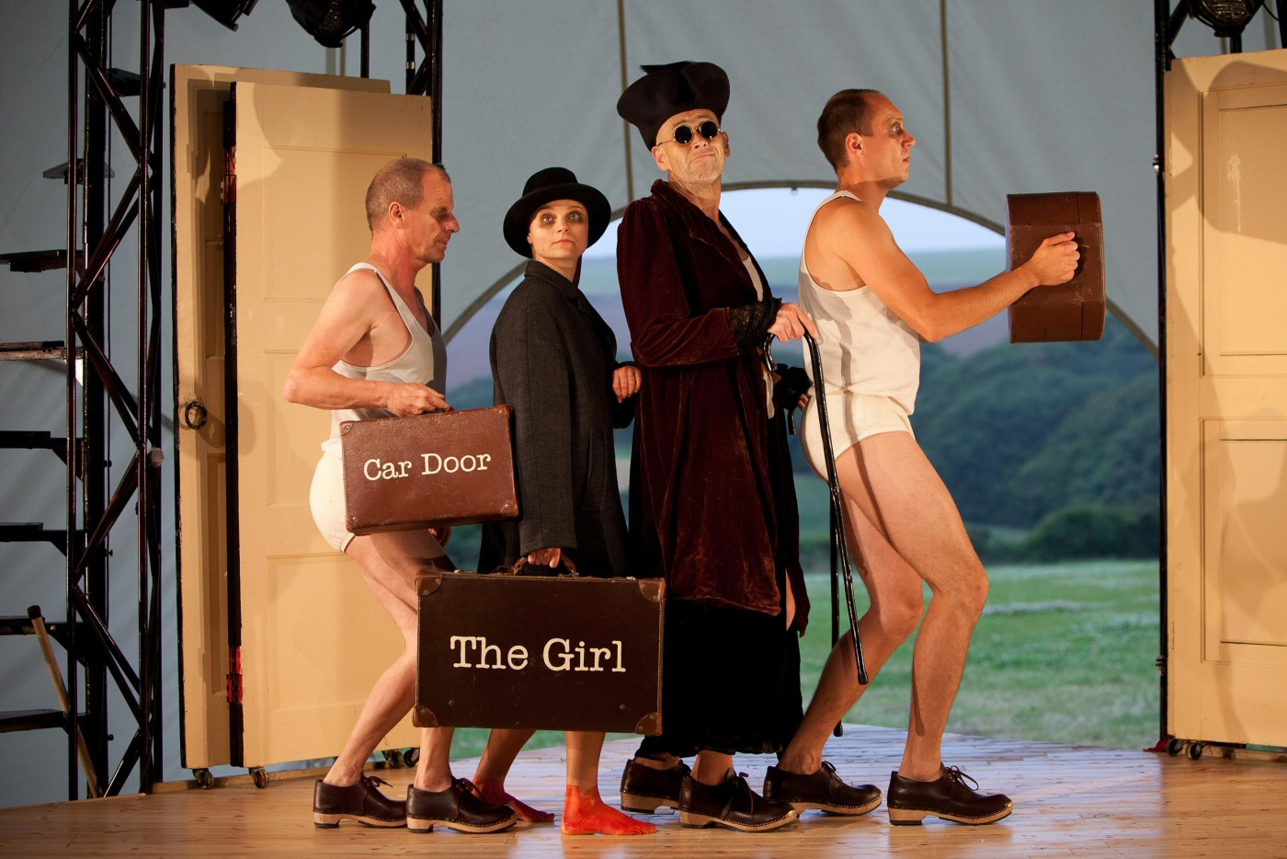Kneehigh Theatre, The Red Shoes. Photo by Steve Tanner.
Kneehigh was founded in 1980, originally as a Theatre-in-Education company. The group built their reputation through colorful, accessible shows influenced by popular performance forms: music, dance, storytelling, puppetry, participation and spectacle have all combined to shape their distinctive aesthetic. But within this mix, storytelling has been emphasized most prominently and consistently as a thread running through all their work and tying together a lengthening list of stage adaptations for which the source might be a novel (Angela Carter’s Nights at the Circus, 2005), classic drama (The Bacchae, 2004; Cymbeline, 2006), film (A Matter of Life and Death, 2007; Brief Encounter, 2008), television series (Steptoe & Son, 2013) or traditional tale (The Red Shoes, 2000; Rapunzel, 2006; The Wild Bride, 2011). As noted previously, director Emma Rice unites these very different orders of text by the simple assertion that the company are telling stories “because they matter.” According to Rice, the process starts with “an itch, a need” that leads her to reach “instinct[ively]” for a story that responds to this (qtd. in Kneehigh 4). When explaining what guides Kneehigh’s selections, she references Bruno Bettelheim: Rice’s experience of the profound rewards storytelling theatre can have for both audience and creators is implicitly supported by the argument made in The Uses of Enchantment that as human beings we turn to stories as a means of explaining our world back to us (Foreword 11). Precisely what “matters” within a chosen story lies somewhere between the itch and the instinct and is discovered, in Kneehigh’s case, through a highly physical, knockabout process that opens up the material and enables it, step by step, to “take on a life of its own” (Rice, “On Directing”).
The Red Shoes, first directed by Rice in 2000 and remounted to critical acclaim at London’s Battersea Arts Centre a decade later, illustrates how a relatively simple popular narrative can be probed and provoked to bring it vital and kicking into the contemporary moment. The 1845 fairy story by Danish author Hans Christian Andersen describes an orphan girl who longs for a pair of red shoes, which she obtains and then wears to church, to the profound disapproval of the community. The shoes are confiscated, but the girl steals them back: when she next puts them on, she can neither stop dancing nor remove them. In desperation, she begs an executioner to chop off her feet with his axe. He does so, carving her a substitute wooden pair on which she hobbles to the church only to find her entrance barred and the chopped off feet in red shoes dancing mockingly beside her. The final section of the story tells of the girl’s bitter repentance and dedication of the rest of her life to the church; eventually, she is shown mercy by an angel, but the joy of this moment causes her heart to burst and she dies, her soul rising to heaven unencumbered.
Andersen’s tales were advocated by his contemporaries for their educational value and on this level “The Red Shoes” describes graphically what will happen to those whose actions and attitudes depart from the normative. Yet arguably, the impact of the story exceeds its didactic purpose: the grotesque imagery lingers in the mind after the precise nature of the protagonist’s “crime” is forgotten. Perceptions of this tale might equally be influenced by some knowledge of Andersen’s life: the son of a cobbler and a washerwoman, he regularly expressed through his fiction a strong degree of sympathy for the underdog or outsider (Bredsdorff 152). From this perspective, “The Red Shoes” could be interpreted as a story about rebelliousness that describes rather than proscribes the harsh penalty exacted. Andersen himself was no rebel, however (“Politics is not for me to dabble in” . . .), and his stated views were distinctly conservative (152-53). Nonetheless, he maintained a fundamentally ambivalent attitude towards the powerful classes whose patronage brought him wealth and fame, and something of this equivocation can be traced through the body of his work and in individual tales.
“The Red Shoes” had been dramatised before, most famously in Powell and Pressburger’s 1948 film of the same name that stars Moira Shearer as an ambitious ballet dancer. Kneehigh’s production likewise seizes on the already theatrical pivotal image of Andersen’s tale and from this pair of scarlet-shod dancing feet extracts both the physical energy that drives the performance and a wealth of connotative meaning. Reviewing Kneehigh’s remounted 2010 production in the Guardian, Elisabeth Mahoney argued that their adaptation could be appreciated on several levels, “as a folk or fairy story about some magic footwear, as a parable about desire, or a spiky tale about women’s lives, or all three together and more.” Mahoney continued:
There are hints of suffragettes, concentration camps, anarchy, wise witches and kind butchers, and the fable as presented here is a blend of brilliantly simple visual richness and a kaleidoscope of ideas. It’s a story about longing, about getting what you want and having to live with that as the delirious, half-crazed passion subsides. Mostly, though, this is intensely charismatic theatre about what it is to be alive and, as the witch says in the epilogue, the fate of “those who dare to dance a different dance.” (2010)
Mahoney’s commentary describes a production that self-consciously stitched political and contemporary versions of difference and resistance into traditional story fabric. In part, such themes were conveyed through the aesthetic of the piece: the appearance of the performers—shaved heads, dirty white vests and briefs—itself spoke of a story stripped back in the telling to expose the absolute harshness at its core. At the same time, this visual signing of victimisation was offset by a flamboyant energy evident throughout, expressed through music, dance and deliberately fumbled magic tricks, and personified in Lady Lydia, a “glamorous and glorious” transvestite compère (Grose, Kneehigh, Morris, Rice, and Murphy 183). The performers wore wooden clogs, shiny black and, in the one case, bright red; this choice referenced folk tradition but also lent the production a certain hard edge, an almost punkish quality intensified by the players’ dark-smudged eyes. Where Andersen’s “The Red Shoes” describes the brutal punishment of specifically feminine vanity, Kneehigh’s retelling conveyed in a more layered and defiantly celebratory way a web of complex sexualities, desires and cross-gender constraints.
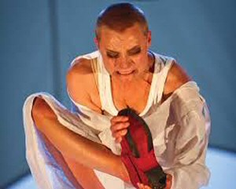The shoes stuck fast. Kneehigh, The Red Shoes. Photo by Steve Tanner.
Kneehigh’s adaptation did not turn “The Red Shoes” into drama in the sense of representational acting: highly visual, physical and musical as it was, the show was still presented consciously as an act of storytelling. The audience watched individual performers (specified “Storytellers” in the cast list) selected as if at random to take on the role of the Girl, the Old Lady, or the Shoemaker. This level of alienation—echoed in the use of battered suitcases that were deployed to establish makeshift settings, or from which items of clothing were unpacked—played with the possibility that characterisation was established temporarily, not psychologically identified; parts could be otherwise assigned, we were invited to suppose, on a different night. This was not true in practice, quite the reverse: indeed, Rice has noted elsewhere how recasting a role—sometimes necessary, at a later stage—“always rips your heart out” (“From the Community to the West End” 104). Nonetheless, the appearance of a ritualised distribution of roles conveyed the impression that the ensemble accepted the responsibility to tell the story collectively. The act of telling was not limited to the words spoken, as writer Anna-Maria Murphy makes clear:
Everything in this company’s work tells the story: the actors, the set, the music, the costume, the props. A living script grows with Emma and the actors, through devising, improvisation and the poems [authored by Murphy]. Each plays an equal part. I say living, as it’s always changing and we all own it. (qtd. in Kneehigh 9)
The claim that any and every aspect of a production has a storytelling function is endorsed by The Red Shoes in overt ways—for instance, when songs were used to communicate plot developments, but it is also more profoundly true of theatre as a form. Zipes’ insistence that the responsible, critically alert storyteller must uncover the resonances of a given tale, both for him or herself and in relation to a changed context of reception, may be addressed in the theatre not simply by rewriting text but—as Brecht knew—through the introduction of music that jars rather than harmonises with the narrative line, or in the proposition that a visual image implicitly extends. In The Red Shoes, the performers’ shaven heads invited spectators to expand their interpretive frame well beyond young girls on their way to church in irreverent shoes; moreover, the multiple connotations in this particular visual symbol—it evoked no single, simple parallel—was designed to keep spectator engagement open and questioning. The image of the shaved head reverberates historically and in the present, signalling exposure, humiliation and punishment, but also standing for the refusal to conform. Kneehigh’s audiences always encompass a wide age range: and while children would not have found in this image precisely the same meanings as their accompanying adults, they would undoubtedly have registered something of these resonances and felt them to be starkly at odds with a story that deals, at least on the surface, with feminine vanity.
As shown, intertextuality was established across the whole fabric of performance in The Red Shoes rather than being confined to verbal allusion. Even in a mid-nineteenth century context, Andersen’s tale can hardly have been thought to describe straightforwardly “immoral” behaviour and its well-deserved punishment; his readers and listeners would have had to negotiate for themselves any lingering unease at the nature and severity of retribution meted out, or look perhaps towards editors and illustrators for comment or critique. By contrast, theatre can embed resistance to the problematic assumptions or moral stance of a text within a production, and without necessarily changing the course of the narrative. Consider this sequence, in which the Old Lady (who is blind) quizzes the Storytellers about the new shoes her adopted daughter has chosen:
OLD LADY: Are they smart?
STORYTELLERS: Yes.
OLD LADY: Are they shiny?
STORYTELLERS: Oh yes.
OLD LADY: Are they black?
Pause.
STORYTELLERS: . . . yes.
By that momentary hesitation, spectators understand that the telling has turned against the tale. Brief as it is, the pause opens up a space of questioning: determination, not vacillation, is implied in this little gap. It marks a point at which actors step back from character and narrative; here, as in the staging of those magic tricks that periodically arrest rather than promote the flow of story, the tellers remind us that sometimes you have to try to resist the tide.
If everything in theatre tells the story, as Murphy says of Kneehigh, it follows therefore that anything can also, if desired, tell against the story. Too often, critique of adaptation in general has emphasised lack: when literature is translated into, especially, visual drama, so much—narrative tone, metaphor, authorial perspective, the rendition of inner states—will (it is said) inevitably be lost. Yet, to consider adaptation in such terms is to ignore the opportunities the new medium allows. Theatre brings more valuable and complex gifts to a telling than the obvious additions of colour, sound, or physicality. Because it is multi-dimensional, theatre enables layering, juxtaposition and provocative formal contradiction. Because it is always participatory, at least to some degree, theatre can choose to exploit the live(ly) and unpredictable qualities of audience engagement. Because it simultaneously presents and represents, the theatrical event is characterised by gaps—between actor and role, place and imagined space, the people and things onstage and what they stand for—and such dislocations can be used productively to disturb, if not altogether overturn, the “order” of the text.
Adapters may decide to contest their material in overt as well as subtler ways and Kneehigh sought to do this in their handling of Andersen’s conclusion. In the fairy tale, the protagonist, Karen, is ultimately shown divine mercy but this comes hand in hand with death:
[B]efore her stood an angel of God in white robes; it was the same one whom she had seen that night at the church-door. He no longer carried the sharp sword, but a beautiful green branch, full of roses; with this he touched the ceiling, which rose up very high, and where he had touched it there shone a golden star. He touched the walls, which opened wide apart, and she saw the organ which was pealing forth; she saw the pictures of the old pastors and their wives, and the congregation sitting in the polished chairs and singing from their hymn-books. The church itself had come to the poor girl in her narrow room, or the room had gone to the church. . . . The bright warm sunshine streamed through the window into the pew where Karen sat, and her heart became so filled with it, so filled with peace and joy, that it broke. Her soul flew on the sunbeams to Heaven, and no one was there who asked after the Red Shoes. (Andersen)
In Kneehigh’s version, by contrast, the girl rejects the forgiveness that is so graciously extended:
ANGEL: It’s over.
Come with me.
Up into the blue.
Heavenward.
LYDIA: It’s over.
Up into the blue.
He leads her away but she falters. It is as if she has remembered something: herself.
She breaks away.
ANGEL: Now come along, your place is booked.
Salvation is yours.
Come along . . . Heaven.
I’m afraid I must insist.
She breaks away again and a vicious fight ensues.
She beats the ANGEL and goes her own way.
(Grose, Kneehigh, Morris, Rice, and Murphy 203)
Here, not just the manner of telling but the tale itself is redirected towards affirmation rather than condemnation of an independent spirit. Kneehigh’s decision to change the ending in this way is instantly comprehensible, given the dated moralising of Andersen’s original; and, as already argued, the idea that storytellers should make a tale their own is both a right and a responsibility actively embraced by the company in their work. To some extent, the combination of Kneehigh’s upbeat energy and the composition of their family audience might seem more or less to enforce some sort of happy ending, yet the sequence cited here is nonetheless not easily celebratory: the “vicious” character of the struggle makes clear that taking an oppositional stance may be difficult and painful.
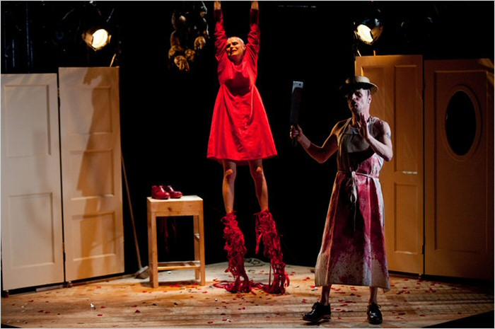The severing of the feet. Kneehigh, The Red Shoes. Photo by Steve Tanner.
However, interventionist or “corrective” telling is not imperative in adaptation—even with the most troubling of texts—and nor will such changes necessarily satisfy its audience. More than one reviewer challenged Kneehigh’s rewriting of Andersen, suggesting that the production’s more optimistic conclusion paradoxically denied its audience the release that the fairy tale, harsh as it is, nonetheless allows; for Miriam Gillinson, for example, the altered turn taken by the adaptation made for “an odd conclusion, which side-steps the threat of comeuppance that glows in the dark underbelly of this story.” Andersen’s “The Red Shoes” remains compelling for contemporary readers and not only as a result of its macabre imagery; it disturbs us because of, and not despite, a complacent resolution in which pardon takes the form of “a final and fatal punishment” (Gillinson 2011). The original author did not write anger and repugnance explicitly into the tale’s ending, but this does not mean that such reactions are disallowed; in some ways, the fact that they are not voiced can stir the reader’s desire to challenge the logic of its closure the more strongly. To argue this is not to suggest, conservatively, that Kneehigh should have left it alone; rather, it is to invite reflection on the ways in which new tellers choose to represent ideologically problematic stories in a contemporary context. We must also ask whether theatre as a medium can close its tellings on so bitter a note, should its creators desire, or whether the very qualities that make performance uniquely suited to popular storytelling—animation, collectivity, spontaneity, participation, connectedness—are also those that make genuinely dark and unsettling conclusions unsustainable.
While Kneehigh’s adaptations typically participate in a recognisable tradition of tale circulation, the perceptual frame explored in this essay can be extended and applied to adaptation practice in the theatre more broadly. The task of the storyteller in preserving yet transforming the source material—inevitably and necessarily—is equally the task of the adapter; re-articulation of a story demands that the teller (has the freedom to) digress from the established path in his or her own way. By embracing this divergence, adaptation opens up the doubled pleasure that its activity already contains in latent form: it exposes the distance between the story of the story, and the story of the telling. Adaptation in the theatre has the potential to exploit the opportunities of this gap still further, by using performance’s inherent multivocality to sustain and interrogate, preserve and transform, the narratives it elects to reframe.

Endnotes
[1] See for example Jack Zipes’ Breaking the Magic Spell: Radical Theories of Folk and Fairy Tales (2002 revised edition) and Fairy Tales and the Art of Subversion (2006 revised edition).
[2] Zipes identifies the utopian impulse in storytelling tradition most forcefully and frequently, but it is a perception shared by other commentators. Thus, Maria Tatar refers to the “utopian moment” within the bleakest story that, for her, reflects not denial of darkness but the fact that “as human beings we just need hope” and the belief “that things can take a better turn” (2013).

Works Cited
Alfreds, Mike. Then What Happens? Storytelling and Adapting for the Theatre. London: Nick Hern Books, 2013. Print.
Andersen, Hans Christian. “The Red Shoes.” 1845. 13 Dec. 2007. Web. 11 July 2013. <http://hca.gilead.org.il/red_shoe.html>.
Barthes, Roland. Image, Music, Text. Trans. Stephen Heath. London: Fontana, 1977. Print.
Bredsdorff, Elias. Hans Christian Andersen: The Story of his Life and Work, 1805-75. London: Phaidon, 1979. Print.
Gillinson, Miriam. “A Recreation, a Reinterpretation—and Certainly Not Magic.” Culture Wars. N.p., 5 Mar. 2011. Web. 12 July 2013.
<http://www.culturewars.org.uk/index.php/site/article/a_recreation_a_reinterpretation_and_certainly_not_magic/>.
Grose, Carl, Kneehigh, Tom Morris, Emma Rice, and Anna Maria Murphy, eds. Kneehigh Anthology: Volume 1: Tristan and Yseult, The Bacchae, The Wooden Frock, The Red Shoes. London: Oberon Books, 2005. Print.
Kearney, Richard. On Stories: Thinking in Action. London: Routledge, 2002. Print.
Kneehigh. Educational Packs: The Red Shoes (2010). Web. 1 July 2013.
<http://www.kneehigh.co.uk/userfiles/files/Kneehigh%20-%20The%20Red%20Shoes%20-%20Memory%20Aid%20for%20Students.pdf>.
Mahoney. Elisabeth. Guardian 3 Aug. 2010. Print.
Rice, Emma. Foreword. Kneehigh Anthology: Volume 1: Tristan and Yseult, The Bacchae, The Wooden Frock, The Red Shoes. London: Oberon Books, 2005. Print.
—. “From the Community to the West End.” The Contemporary Ensemble: Interviews with Theatre-makers. Ed. Duška Radosavljević. Abingdon: Routledge, 2013. 98-108. Print.
—, narr. “On Directing.” The Essay. BBC Radio 3. 14 February 2012. Radio.
Steadman-Jones, Richard. “Odysseus and the Sirens: Archive, Exile, Voices.” Parallax 19.4 (2013): 20-35. Print.
Tatar, Maria. “Transcript for Maria Tatar—The Great Cauldron of Story: Why Fairy Tales Are for Adults Again.” On Being with Krista Tippett. March 14 2013. Web. 10 July 2013.
<http://www.onbeing.org/program/the-great-cauldron-of-story-maria-tatar-on-why-fairy-tales-are-for-adults-again/transcript/5076>.
Wagner, Geoffrey. The Novel and the Cinema. Rutherford, NJ: Fairleigh Dickinson U P, 1975. Print.
Zipes, Jack. Breaking the Magic Spell: Radical Theories of Folk and Fairy Tales. Rev. ed. New York: Palgrave Macmillan, 2002. Print.
—. Fairy Tales and the Art of Subversion. Rev. ed. New York: Routledge, 2006. Print.
—. Why Fairy Tales Stick: The Evolution and Relevance of a Genre. New York: Routledge, 2006. Print.


*Frances Babbage is Reader in Theatre and Performance at the University of Sheffield. She has published widely on theatricality in fiction and on adaptation of non-dramatic literature for performance. Her monograph Re-Visioning Myth: Modern and Contemporary Drama by Women (2011) examined the persistence of classical myths in women’s drama and the potential for feminist theatrical reframing. She is currently writing Adaptation in Contemporary Theatre: Performing Literature for publication by Methuen.
Copyright © 2015 Frances Babbage
Critical Stages/Scènes critiques e-ISSN: 2409-7411

Available at:
https://www.critical-stages.org/12/adaptation-and-storytelling-in-the-theatre/

