Introduction – The Aims and Objectives of the Study
This dissertation explores the importance of the night sky to followers of the Mithras cult in Roman Britain. Beginning with a comprehensive literature review examining the history and breadth of Mithraic scholarship to date, it will then discuss the iconography surrounding the cult, including the presence in Mithraic temples of a multiplicity of deities and cosmological figures and references. Orphic and Neoplatonic elements will also be considered with regard to how these elements may have influenced later Mithraic trends in Roman Britain.
The comparatively recent cross-disciplinary approach promoted by the academic study of archaeoastronomy will be introduced and its potential relevance to the topic will be examined. Using modern computer applications, the night sky as seen from Carrawburgh, one of the best-preserved Mithraic temples on Hadrian’s Wall, will be recreated, with the intention of examining theories connecting Mithraic symbolism and iconography to celestial objects. This data will then be used to interrogate existing theories and seek connections or inconsistencies in current thinking with the intention of either supporting or expressing disagreement with them as appropriate. Comparing and contrasting these findings may well add to the body of work already extant concerning the Roman cult of Mithras in Britain.
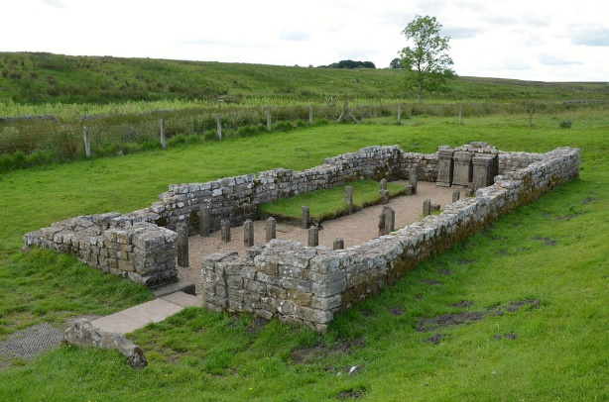
Fig. 1. Temple of Mithras at Carrawburgh, looking north east.
Image ©2017 FollowingHadrian

In modern times, astronomy and astrology are widely different subjects from each other, however this was not the case in the Ancient World; ‘astronomy’ translates as the laws of the stars, ‘astrology’ as the word of the stars, while in the second century CE, Claudius Ptolemy, the Greek scholar, noted two kinds of astronomy – that which dealt with the motions of the stars, and that which was relevant to their actions and effects, and this duality of meaning continued in use for around the next fifteen hundred years before gradually separating into the two different disciplines know today. It is with this concept in mind that the terms have been used herein.

Roman Religion and Mithraic origins
The history and development of Roman religion is complex and inherently problematic, in that accounts of Roman religious practices only really exist from the late Republic and the Empire, making accurate reconstructions dating before the second century BCE something of a challenge. Such impressions as do remain are largely those which the Romans themselves would have held, since it is their voices in which the evidence has survived to provide insight into the Roman mindset and subjective responses to the practices of the time. For Romans, religious and personal identity were intertwined, with worship of the gods of Rome being part of the life of the citizens and their city. The gods themselves were considered as fellow-citizens, and as such were consulted on the life of the city, communicating their wishes and requirements through various forms of divination; the interpretation of the flights of birds, the patterns of lightning in the sky, or though prayer and sacrifice; worshippers communicated with the gods through prayer, by making vows and dedications once their requests had been addressed. The city’s religious life was deeply entwined with its political life, with priests elected from various state departments, and rather than the priesthood becoming an opposing authority to the city state, supporting and upholding civic duty as integral to the religious life of the city. As the Roman empire expanded and encountered other cultures and peoples, it also came into contact with new deities. Since Roman attitudes towards the divine was inclusive rather than exclusive and antagonistic, these new gods were often compared to pre-existing figures in the Roman pantheon in a process known as interpretatio. These deities were then adopted by the Romans and often welcomed to Rome, Greek deities included. Some external divinities, such as Isis, Mithras, and Magna Mater, amongst others, became the focus of their own cults and rituals, which became known as mystery cults or religions, since at the heart of each was a secret which initiates were not permitted to discuss outside the cult.
Such a multiplicity of religious choice was perfectly allowable; as long as Roman citizens offered the appropriate sacrifices and participated in the city’s required religious rituals, they were free to follow whichever deity or cult one chose outside of that. One fundamental difference between the practicalities of public cult and the mystery religions was that civic cultic practice was largely concerned with facilitating the best possible life in the here-and-now with what happened after death considered of secondary importance. The mystery religions, while still concerned with the present bodily existence, also looked beyond the earthbound existence to what might come after, and to a more personal relationship with their deity, made possible by initiation and ritual practice in the cult. Within the practices of the Mithras cult, this relationship manifested in ritual practice intended to prepare the living initiate for their soul’s journey, once deceased, to the stars. Modern scholarship speaks of the Mithras cult by several different names, most often referred to as ‘Mithraism’, although in the ancient world it would have referred to as the ‘Mysteries of Mithras’. This is an important distinction, as the cult of Mithras was more concerned with praxis than with an ideological system.
The Mithraic mysteries were one of the latest of the Roman mystery cults to become popular, but it was also one of the swiftest to spread. Mithra was originally an Iranian sun god connected with the making of alliances. The god was also known from India, Persia and Mesopotamia from the second century BCE. Although the cult as observed by the Romans appears to have been a western innovation, it claimed Persian origins for itself; Porphyry, in ‘On the Cave of the Nymphs’, comments that ‘…the Persians call the place ‘a cave’ where they introduce an initiate… Zoroaster was the first to dedicate a natural cave in honour of Mithras… This cave bore for him the image of the cosmos which Mithras had created…’ This cosmological setting was replicated in Roman Mithraic practice, with small congregations meeting in underground Mithraea which they, too, referred to as caves, particularly in Rome and its environs. These caves were decorated with Mithraic and cosmological imagery; central to which was a depiction of the god killing the primeval bull in the bull-slaying motif, an image known to modern scholars as the tauroctony. Details, however, may have varied from Mithraeum to Mithraeum depending on its individual leadership. The cult was particularly popular among the Roman army, travelling with the militia to Britain, where temples of Mithras are attested at Caernarfon, London, York, and at several points along Hadrian’s Wall, right at the very northern edge of the Roman Empire. Along its journey from Ostia and the Rhinelands, the cult picked up regional and local variations which came to include Orphic symbolism such as the frequent presence of a lion-headed god associated with Aion, the god of time.
Although for some time the Mithras cult was considered to be an ‘Oriental’ religion which grew from Iranian Mazdaism, this theory was later disputed and other ideas emerged, largely as a result of a series of international conferences on the topic. Scholars began to consider whether the key icon of the cult, sometimes known as the tauroctony and which depicts Mithras slaying a bull, is in fact a representation of the night sky, with the bull representing the constellation of Taurus, and Mithras himself identified as one or other of several possible constellations, Orion and Perseus amongst others.
In 2013, Dr Reza Assasi suggested that a group of stars in the northern hemisphere are connected to Mithraic myths and potentially demonstrate early awareness of Earth’s axial precession. This star group, forming the shape of a swastika, is suggested as representing Mithras in his chariot. While mention of this constellation offer a modern perspective on the celestial skyscape relevant to the cult of Mithras, the celestial chariot or quadriga was mentioned in some detail by Cumont, who explored the composition and Iranian understanding of the chariot envisaged in this constellation.
It is with these various and conflicting theories in mind that the orientation of Carrawburgh Mithraeum and the precise positions of the stars in the night sky as they would have been seen from the temple will be examined. The discipline of archaeoastronomy is a comparatively recent one, and a new term – skyscapes – has been coined to express the importance of the sky to ancient societies. Cross-disciplinary in nature – falling somewhere between astronomy and archaeology – but using specific scientific measurements and techniques, this approach may provide additional information on the nature of the Roman Mithras cult in Britain, particularly in the Carrawburgh region of Hadrian’s Wall. Archaeoastronomical methodology will be applied using the most accurate of available established measurements and location details, perhaps throwing new light on the Roman Mithras cult in Britain.

Methodology

The methodological approach chosen here is a combination of literature-based research using both modern and ancient sources, engagement with ancient epigraphical and monumental evidence, and examination of the site of Carrawburgh Mithraeum, utilising existing location and orientation data from a variety of independent sources to assess the precise location and orientation of the site, taking into account the local terrain and any significant geographical features in order to accurately replicate the night sky at the time when the Mithraeum was in use.
In terms of existing literary resources, particularly, the work of Franz Cumont, although now considered outdated, underlies much of modern scholarship, whether supporting his theories or opposing them. But some scholars argue strongly for astronomical and astrological interpretations of mithraic symbolism, and these will be interrogated in connection with the site. The Greek Magical Papyri, translated by Hans Dieter Betz contains a sequence known as ‘The Mithras Liturgy’ and this may also prove useful to the study.
Although best-practice would call for this study to be predicated on fresh location data collected from individually chosen points on-site and with the specific intention of assessing potential lines-of-sight and other locations along particular orientations appropriate to the investigation, and to collect accurate data from which to extrapolate celestial locations at the time when the site was in use, a first-hand examination of the material remains of Carrawburgh Mithraeum has not proved possible and so an alternative methodological approach has been taken. Modern internet resources such as Google Earth provide three-dimensional mapping of the earth using aerial photography, satellite imagery and GIS data which enables the location of specific geographical features with near-pinpoint accuracy. Open-source planetarium software enables the recreation of the heavens at any point in the past, present, or future to image the skies and will be used to reproduce the view from the temple as it would have been for the Mithras cult of Carrawburgh.
By cross-referencing with other sources of data, it is possible to recreate a close approximation to the raw location data which would have been sought. Thus all measurements used will be from pre-existing sources such as original archaeological reports, satellite imagery, and all possible efforts will be made to allow for potential flaws in data. Where these exist, they will be discussed and the parameters of the variation will be stated. Carrawburgh, the site examined in this study, has been chosen largely because a good archaeological report exists in the form of a detailed report by I. A. Richmond, J. P. Gillam and Eric Birley.

Literature Review
In the ancient world, Mithras was variously known as Mihr, Mitra or Mithra, as Mioro or Miiro. The earliest recorded mention of the god dates from the second millennium BCE where, on a 14th century BCE clay tablet found in modern-day Turkey, an agreement between two neighbouring peoples, the Mittani and the Hittites, is recorded and in which the god Mitra is invoked as guarantor. From a very early date, then, Mithras was considered to be a god of oaths and promises and could even be described as the oldest of humankind’s living gods. The earliest evidence of Mithras being linked to the Sun emerges from the older Avesta collection’s yast, which has a probable date of the fifth to fourth century BCE, where this hymn to Mithra speaks of an all-knowing, strong and undeceivable god whose single-wheeled golden chariot is pulled by white steeds, which has been understood to be an allusion to the chariot of the Sun. Comparatively little survives of Mithras in records of the ancient world; this was not a cult with religious books, such as Judaism or its contemporary, Christianity, and tracing a direct line of descent from the Mithra, Mitra or Mithras of Persia, India and Mesopotamia to its Roman incarnation is challenging; for ease of reference and to draw a distinction between the early deity of Indo-European origin with Persian and Hellenistic credentials, and the deity of the mystery-cult known throughout the Roman Empire, the term Mithras will be used henceforth to designate the Roman cult deity.
There are places where Mithras emerges from the silence of recorded history. The god is mentioned in an East Iranian text from the Hellenistic period, written by a Median magus. In dualistic Zoroastrianism, Mithras’ aspect is as the light-bringing force for good, opposed against darkness and putting to flight evil spirits, a foreshadowing of the cult god’s later Roman epithet, Invictus, Unconquered. In Plutarch’s Life of Alexander, Alexander the Great reminds a servant that he has bound himself by swearing by Mithras. The Kingdom of Pontus had six kings who bore the name Mitradates, ‘Gift of Mitra’, the last of whom, Mitradates Eupator, lived between 120-63 BCE. Plutarch is also the source of an account of Cilician pirates, crediting them with initiating secret rituals in honour of Mithras, forming a possible vector for the cult’s arrival in Rome. Commagene had its Mithridates kings; a monument to Antiochus I references Mitra’s association with the Greek solar deity, with Antiochus according Mitra a particular honour in the Commagene pantheon as the only deity to have his own priest. Moreover, Antiochus adopted Mitra’s birthday as his own, and bore the appellation ‘Just God’ – a title given to Mitra himself. A relief showing the king shaking hands with various deities also depicts him doing so with Mitra, and here the deity is depicted wearing Commagene garments, those of the royal house itself.
In terms of origin, Rome itself, or potentially Ostia, are the two most probable places for the Roman mysteries of Mithras to have taken hold, having, to some degree, adopted and incorporated older, Hellenistic and ‘Oriental’ elements, using astrological terms and occasional Persian words such as nama, but their adoption is most likely down to the appeal of the foreign, the esoteric. This, in turn, would serve to enhance the mystery and exotic nature of the cult amongst its initiates. From the ancient world comes the third century CE Neoplatonist Porphyry’s De Antro Nympharumharum, which contains considerable information on Mithraism as Porphyry understood it. The treatise itself is a discussion of the Homeric Cave of the Nymphs, and incorporates several passages which discuss Mithras and his associated cult. After likening the universe to a cave which incorporates two ‘gates’ – ways for souls to come into and to pass out of generation – he goes on to say:
Thus also the Persians, mystically signifying the descent of the soul into the
sublunary regions, and its regression from it, initiate the mystic (or him who
is admitted to the arcane sacred rites) in a place which they denominate a cavern.
For, as Eubulus says, Zoroaster was the first who consecrated in the neighbouring
mountains of Persia, a spontaneously produced cave, florid, and having
fountains, in honour of Mithra, the maker and father of all things; a cave,
according to Zoroaster, bearing a resemblance of the world, which was fabricated
by Mithra...

…Caves, therefore, in the most remote periods of antiquity were
consecrated to the Gods, before temples were erected to them…
But wherever Mithra was known, they propitiated the God in a cavern.

Porphyry situates the two gates for the ascent and descent of souls in Cancer for those descending into generation, and Capricorn for those ascending. Subsequently considering Roman ritual practices, Porphyry examines Roman astronomy, noting that the midwinter festival of Saturnalia is celebrated ‘when the sun is in Capricorn…’ and that Saturn is the house of Capricorn ‘…where they live again and return to the fountain of life…’ He places Mithras in the heavens ‘near to the equinoctial circle’ where he ‘bears the sword of Aries,’ and ‘… is likewise carried in the Bull… for Mithras, as well as the Bull, is the Demiurgus and lord of generation… placed near the equinoctial circle, having the northern parts on his right hand, and the southern, on his left.’
A body of work from Greco-Roman Egypt, known as the Greek Magical Papyri which comprises a variety of spells, charms, formulae and hymns, dates from between the second century and fifth centuries CE. A section therein, referred to as ‘the Mithras Liturgy’, details the ascension of a soul through its various stages of growth and subsequent journey through the heavens, including a ritual for immortality describing a soul journey. This particular passage is the eponymous subject of Albrecht Dietrich’s Albrecht Eine Mithrasliturgie, and the text itself, based on linguistic and paleographical factors, can be dated as extant to the fourth century CE, Dietrich finds sufficient evidence within the text to suggest it had developed and adapted from a source document dating back as early as 150 CE. The text demonstrates a Hellenistic-Egyptian style, with Middle Stoic and Hermetic imagery and referents. Dieterich dedicated Eine Mithrasliturgie to Franz Cumont, a Belgian scholar whom he held in great respect, but whose views on the Mithras cult he nevertheless wished to challenge. Cumont himself had attributed the text to an Egyptian magician with Hermetic interests, while Dieterich saw no reason not to connect the text with Mithras in its own right.
Cumont was, indeed, the breakthrough scholar of the era; his two volumes Textes et Monuments Figures relatifs aux mysteres de Mithra, published in 1896 and 1899 respectively, gathered together a wealth of Mithraic material. While the first volume focussed on recording the existing literary, epigraphical, iconographical and monumental evidence, the second volume offered itself as interpretation and explanation to the first, lending additional weight to its arguments with such comprehensive theories that many of the ideas therein went largely widely unchallenged for decades. Cumont’s primary position was to posit Mithras firmly as a descendant of an Iranian tradition and therefore seated in a dualism of good and evil which lent itself to Cumont’s apparent discovery of ‘… a Mithraic eschatology’. Part of his reasoning was based on his assertion that Mithraism was mostly a theological religion, which led to a minimalizing of the importance of ritual and worship as part of the cult’s identity. This fundamental stance has been concisely summarised in recent scholarship:
Cumont’s…argument was…the name of the god of the cult, Mithras, is the
Latin (and Greek) form of the ancient Iranian god Mithra; in addition, the
Romans believed that their cult was connected with Persia (as the Romans
called Iran); therefore we may assume that Roman Mithraism is nothing
other than the Iranian cult of Mithra transplanted into the Roman Empire.

Cumont’s views resulted in all aspects of the Roman Mithras cult being seen through the lens of early Iranian myths and legends despite several fundamental differences; its essential nature as a mystery cult, requiring initiation and secrecy from its adherents, the way in which its temples and temple architecture which deliberately modelled itself on caves, and the ubiquitous bull-slaying scene, known to modern scholars as the tauroctony, were none of them present in the Iranian antecedents, nor is there any record in Iranian mythology of Mithras as bull-slayer. Rather, in the only variant Cumont could source from the Irananian records concerning the death of the bull, it is the destructive deity Ahriman who performs the killing, and to incorporate this myth satisfactorily into his theory, Cumont theorized a variant which had escaped transmission in which Mithra replaced Ahriman as bull-slayer. Originating in a Zoroastrian text dating from the ninth century BCE, the original story speaks of Ahura Mazda’s creations, a man, and a bull, which were destroyed by Ahriman’s evil forces; with their deaths, all other life sprang forth. Cumont retold the myth with Mithras as reluctant bull-slayer, enabling the release from its carcass a variety of plants and incorporating many of the elements of the tauroctony in the story; Mithras, accompanied by his dog, was, ordered by the Sun, who sent a message by a raven, to kill the beast, which he does, while a scorpion and snake try to attack the dying animal. Although Cumont did find his way around this contradictory interpretation, it does not read easily. Indeed, he himself says ‘We…are apt to be disconcerted by the incoherence… of this body of doctrine…’ Even so, he dismissed differences between the Mazdean Mithra and the Roman Mithras as ‘superficial.’
Cumont noted that Mithras did not make the transition to Rome alone, but was accompanied by other deities from the Mazdean pantheon; while Mithras was Principal Hero, he was not the Supreme God, a position which was occupied by Boundless Time – Aion, also known as Saeculum, Kronos or Saturnus. Ineffable, sexless, nameless and without passion, Aion was depicted as a lion-headed figure carrying the keys to heaven, the bolts and sceptre of divine authority, whose winged body was wrapped in a coiled serpent, representing the sun’s journey along the ecliptic. Bearing zodiacal signs on his body, emblems of the seasons demonstrate time’s passing, Aion is creator and destroyer and master of the four universal elements and holds the powers of all the gods within one form. Perceived as Destiny, primitive light or fire, Aion could be considered as the Stoics’ Supreme Cause. Cumont sees the symbolism of Aion as representing the four components which the ancients understood to comprise the universe, with fire represented by the lion, the cup, water, and the coiled serpent earth, which depicted the struggle of opposing elements in ‘perpetual transmutation…’ that ‘provoked all the phenomena of nature.’ This conflict is represented by the quadriga, Mithras’ chariot which is pulled by four horses, each representing an element and each affecting its adjacent neighbour as they ‘turn… ceaselessly round in a fixed circle…’ until all four have been changed in appearance; this cosmic chariot, Cumont says, has not been included in the ‘sacred iconography’, however, this being ‘reserved for a visible god.’ Besides the elements, the sun and moon, the planets and the signs of the zodiac were also included in Mithraic Mysteries; although the planets were associated with Greek gods, they were here interpreted as Mazdaic deities such as Ahura-Mazda and Zurvan. Altered by time and location, it eventually proved difficult to harmonize this ancient Mazdean tradition with what Cumont saw as essentially Chaldean symbolism, provoking a dual system in which only the ‘elite’ were introduced to the original symbolism and its meanings. Once this secondary non-Mazdean astronomy was incorporated, it expanded to include all things Mithraic with the main focus being on the zodiacal signs, since these were considered to determine peoples’ lives and guided the course of events. Once established within the Mithras cult, astronomy adopted and extended to incorporate all the figures of the Tauroctony which became identified with constellations, resulting in a ‘chimera’.
Mithra, as a god of light – which is borne by air – took the middle zone between Heaven and Hell and so acted as an intermediary and the genius of solar light, is often flanked by two figures known as Cautes and Cautopates, together forming a type of mithraic triad. These two figures, Cautes with a raised torch represents the moment at when, at the beginning of spring, the sun enters Taurus, while Cautopates with torch pointing downwards, represents the time six months later, when the sun enters Scorpio to announce winter. These Torchbearers also represents the opposites of life and death, heat and cold.
Cumont rejected the astronomical nature of the tauroctonous grouping, believing it to be ‘…symbolism more ingenious than rational...’ and as ‘intellectual diversions to amuse the neophytes prior to receiving the revelation of the esoteric doctrines’ drawn from the ‘…Iranian legend of Mithra’ which is now lost and parts only survive in bas-relief. From Mithras’ early roots, he is mediator, and, in terms Cumont specifies as from the philosophy of the times, the Logos which both came from god and shared his omnipotence. As life was a battle, Mithras’ adherents had to fulfil certain precepts in order to be properly rewarded ; purity, ritual ablutions and lustrations, dietary strictures were amongst the strictures as Cumont understood them while the dualism inherent in the system lent itself to encouraging individual effort and human energy, focussing less on mysticism and more on action; the Mithras cult, as a religion of the army, celebrated military virtues. He saw a mixture of ‘cosmogonic fables and… theological speculations… of deliverance and redemption… conscious survival… of the divine essence… within, and in punishments and rewards…’ after death. Souls coming from heaven into mens’ bodies were, after death, subject to judgement, ascending if they had done well, or becoming lodged in the body of an unclean animal or even being dragged down into torment if they had done badly. There were seven heavenly spheres, each symbolically attached to one of the planets in a sort of ladder with eight gates, while all but the final gate were connected to a different metal, and this series of gates indicated the path to the supreme region of the fixed stars; the final gate being guarded by an angel of Ormazd. At each level, the ascending soul stripped away some of its earthly trappings and impurities until it beyond the final gate it reached heaven and the gods with Mithra being the god who judged the soul after death, and who led the worthy on to existence in a spiritual world as ‘…quintessential monads…’, a continued existence which Cumont remarks could have been ‘difficult… for vulgar minds…’ as well as for himself, and his contemporaries.
‘We who have never experienced the Mithraic spirit of grace are apt to be
disconcerted by the incoherence and absurdity of this body of doctrine…
A theology at once naive and artificial here combines primitive myths…
with an astrological system whose logical structure only serves to render its
radical falsity all the more palpable…’

Cumont puts the success of the Mithras cult down to ethics, and to its emphasis on action, its stress on immortality, and its religious expression of the physics and astronomy of the Romans; it ‘satisfied alike both the intelligence of the educated and the hearts of the simple-minded.’
Before the publication of Cumont’s great work, in 1869, a scholar named K.B. Stark had seen astronomical referents in the tauroctony, suggesting its components had not originated from Iranian myths, but were more cohesively explained as celestial figures and were, accordingly, a star map of constellations and celestial objects. He made correlations between the bull and Taurus, the scorpion, Scorpio; the dog, Canis Minor, while the snake equated to Hydra, the raven was Corvus, the lion was Leo, and the cup, Crater. Also, the star Spica – the wheat ear held by Virgo – was present in bull’s tail; the presence of so many constellations, Stark believed, was clear evidence of their importance. However, Cumont favoured a different approach to the tauroctony, and his two volumes comprised such a monumental opus that his scholarship and authority dictated subsequent approaches to the subject for decades.
M. J. Vermaseren’s Mithras, the Secret God largely followed Cumont’s position, although he disputes Cumont’s association of Iranian deities with their Olympian counterparts. Rather, he contends that the Olympic deities were subsumed into the Mithras cult wholesale, resulting in the cult absorbing and adapting to Hellenistic thought. An unidentified leontocephalic figure in a human body wrapped in the coils of a snake is a feature in many temples of Mithras which has been interpreted as Ahriman is more likely to be Aion, the god of time who is depicted in hermetic and gnostic literature, and who is, as Cumont had said, to be associated with Zurvan. Aion has also been depicted bearing Vulcan’s hammer and tongs and representing the element of fire. He is a powerful character, sometimes considered to have ‘…united in himself the might of all the other gods…’ which has led to lending a magical significance to his image. He is known as a god of fire and light, and as Helios – while Helios, in turn, is Mithras. Since there is evidence that different aspects of Aion were connected, it is equally possible for the pagan Great God to equate to the god of the world below, or above, or the be the sun or a subservient power. Astrology from Chaldean priests brought the concept of constellations to the Hellenistic world, where it diffused into the cult of Mithras. In one inscription a Mithraic Father of Fathers was described as a ‘devotee of the heavens and the stars’. The sun and moon both had associations to the bull-slaying scene, and the planets, too, had significance as protectors of the cult’s seven grades. Here, the sun and moon were also important, taking their significance beyond the tauroctony itself and into the protection of the gateways to the seven grades of the cult, the order of which in their symbolic progression is Saturn, Sol, Luna, Jupiter, Mars, Venus and Mercury. These gates formed a progressive journey through which the soul would pass on its way both into birth and through which it returned again after death, absorbing or releasing specific attributes from each of the planets along its trajectory. Astrologically, the entire lifespan of the world was comprised of seven eras, each of which had its own planet; later, these seven periods became twelve, and associated with the zodiac; as with the planets, the zodiacal signs are often found in Mithraic iconography, sometimes in connection with the god’s emergence at birth. The elements, too, were important within the Mithras cult, appearing as symbolic representations; the lion for fire, a bowl for water, a snake for earth and a bird for air. The seasons and the winds are also represented in the iconography, the latter perhaps due to a belief that the wind gods could blow the journeying soul off its course. Vermaseren also makes mention of the Temple of Mithras at Carrawburgh which features below. Having found records of baptismal practice incorporating the elements of fire and water, he cites a rectangular trench close to a hearth located to the south of the Mithraeum which may have connected to ordeals by fire; in the same room was found also a fire-shovel, which may or may not have been used in branding the initiates. Observing, too, that temples were often built on an east-west alignment, he argues that this is deliberate, to capture the first rays of sunlight at dawn. While this was not the case at Carrawburgh, which lies on approximately on a north-west to south-east axis, it certainly was the case at Walbrook, the temple discovered in London in 1954, which was founded around 150 CE – roughly contemporaneous with Carrawburgh, which has been dated by its altars – and situated close to the Walbrook stream.
The Cumontian hiatus lasted generally until the 1970s, when the First International Congress of Mithraic Studies took place in Manchester, in 1971. Two scholars in particular, R.J. Gordon and John Hinnels, levied criticism at Cumont’s arguments that Mithraism was Iranian in origin and expression, citing instances where objective examination of the tauroctony led to other conclusion that Cumont’s. This fundamental re-evaluation opened up a pathway for new scholarship, and by the mid-1970s, other interpretations were under discussion. K. B. Stark’s theory of an astral symbolism behind the tauroctony was revisited; originally, Stark’s argument had been that the tauroctonous figures each have their counterpart in a collection of constellations which were visible together at specific moments during the year, suggesting the choice of figures must therefore have been significant. While the importance of astral symbolism to the cult had never been disputed, some of Stark’s ideas did not hold up under the scrutiny of more modern scholars, with one arguing that while the parallels between astral figures and Mithraic iconography were intriguing, an ‘organising principle’ was lacking. Cumont’s attempts to situate Roman Mithraism firmly within a continuity of cult stretching back to Iran and Persia was largely considered untenable, with scholars setting aside attempts to demonstrate a timeline in favour of putting their energies towards explorations of astrological and astronomical interpretations instead; Manfred Clauss examined the case for continuity and concluded: ‘We cannot account for Roman Mithras in terms borrowed from Persian Mitra’. The Romans themselves, however, considered their interpretation of Mithraism to have Iranian – or, as they termed it – Persian origins; Mithras’ name, clothing, the inclusion of the name Ahriman and the Iranian holy word nama, the Mithraic grade of Persian are all signifiers of this belief.
Michael P Speidel, in Mithras-Orion: Greek Hero and Roman Army God, suggests Mithraism developed from Greek religion, originating in Greek perceptions of the heavens, and the mythology surrounding the constellation of Orion. Observing how the constellations in Mithraic iconography seemed to demonstrate a specific sequence of equatorial constellations, and given Orion’s proximity to Taurus, the bull which he is attacking, Speidel takes this to mean Orion represents Mithras himself. A consideration of the popularity of Mithras amongst the Roman army could include its emphasis on brotherhood, its association with victory in Sol Invictus, the Unconquered Sun, its Iranian dualistic emphasis on the simplicity of good/bad, black/white, with the latter perhaps appealing to ‘…the Roman way of unsparing self-exertion in the face of danger.’ While Speidel considers the Mithraic leap from Asia to the Latin world as happening without the necessity of intermediary stages, he still sees it as fundamentally a Greek religion with surviving Iranian elements, predicated on a Greek cosmic meaning for the cult. To demonstrate this, he concentrates on the night sky as the ancients saw and understood it.
The central Mithraic tauroctony, subject of upwards of five hundred representations has, due to a dearth of written sources, previously been interrogated though the media of Iranian religious literature, Greek and Roman art, and celestial and seasonal symbolism. These three approaches, Speidel asserts, do not adequately explain all the tauroctonous components even when combined. Turning to Greek and Roman astronomy in ancient sources, in De Antro Nympharum, with Mithras carrying the ’sword of Aries’ and riding ‘…on the bull of Venus’, he finds a reference to Taurus. A tauroctony in Sidon connects the tauroctonous scorpion with Scorpio. With evidence of two constellations present in the bull-slaying, Speidel considers whether all the features of the tauroctony represented specific constellations.’ He sets out criteria for considering a ‘predominantly stellar interpretation…’; all tauroctonous elements must be visible in the sky, directly portrayed, any such constellations must fit into a coherent framework, and must have been known in ancient times. With Taurus and Scorpio already established, Speidel identifies Canis Minor as the dog, Crater as the cup, Corvus equates to the raven with Hydra as the snake, while Spica, the bright star in Virgo, represents the ear of wheat and he therefore includes Orion, currently the only icon missing from the tauroctony, as representing Mithras himself. Missing from Speidel’s list of appropriate constellations are the figures of Cautes and Cautopates, which, along with the sun and moon, tend to appear more often outside the frame of the tauroctony proper. Speidel contemplates K.D. Stark’s proposition that the tauroctonous constellations fell between the vernal and the autumnal equinoxes and were close to the ecliptic; this fitted the first of Stark’s criteria, but was both generally vague and failed to account for the absence of Cancer and Gemini from the tauroctony. Instead, the Greek view of the heavens as portrayed by the Hellenistic Atlas Farnese globe, reveals the tauroctonous constellations all present and properly connected to the celestial equator. Moreover, the Atlas Farnese demonstrates that Leo and Crater are considered to belong together, perhaps due to the changing position of the constellations over time, since Leo is rarely found in the tauroctony without association with Crater; Leo and Crater, sitting either side of the celestial equator, indicate to Speidel that they could have been considered as one constellation which, in turn, allows Leo to be included in the collection of tauroctonous constellations. A potential discrepancy is that usually the tauroctony shows three ears of wheat emerging from the bull’s tail, yet the constellation of Virgo shows just one ear of wheat being held in Virgo’s hand; Speidel here accepts the discrepancy since several ancient sources demonstrate that Virgo on occasion was depicted as bearing more than one ear of wheat; he does, however, note that it is ‘remarkable’ that instead of including the well-known constellation of Virgo, only Spica was represented. Speidel also considers Aries to be part of the celestial equator although any connection between Aries and the tauroctony is tenuous citing Aries as ‘…considered the first sign of the Zodiac as well as the first sign of the equator.’ While accepting Aries is not present in the tauroctony, still, he argues for its importance to Mithraists themselves on the evidence of imagery depicted in the Santa Prisca Mithraeum which, while usually considered solely zodiacal, may have relevance to the equator. Speidel therefore considers his criteria fulfilled, Leo’s position away from the strict line of the equator, the differing numbers of ears of wheat, and uncertainties about Aries notwithstanding.
Unless Orion can be satisfactorily proven to equate with Mithras, however, Speidel’s association of the tauroctony with the celestial equator would be impossible; Orion is the last constellation standing between Taurus, and the rest of the equatorial constellations. Speidel quotes from De Antro Nympharum, where Porphyry states that Mithras was positioned on the equinoxes, where he ‘…bears the sword of Aries…’ and ‘…straddles the bull of Venus… like the bull a demiurge and lord of genesis… on the equator with the north to his right and south to his left…’ which Speidel interprets as meaning Mithras is relevant to the celestial equator and that Mithras is on the equator itself. This is also where Orion, which Roman scholars such as Manilaus, Cicero, Aratus and Germanicus place as leading the equatorial constellations, is also positioned. Mithras, then, with his equatorial stance, the north to his right and south to his left side, Speidel believes is Orion; only two equatorial signs are man-shaped – Ophiucus, and Orion; with Orion gesturing northwards with his right arm and southerly with his left as does Porphyry’s depiction of Mithras. While the majority of Mithraic iconography shows Mithras’ right arm lowered as he kills the bull, the depictions of the god in the Greek chiton, show his sword-wielding right arm raised over the bull. This could suggest that, when in the chiton rather than Persian dress, Mithras is being depicted deliberately as a Greek hero and therefore, as Orion. With ancient Roman sources such as Cicero, Germanicus, Vitruvius and Hyginus all describing Orion as standing over a bull which he is raising a club towards, or grasping, Speidel reasons that Orion was fighting Taurus, and that, since Taurus is the bull of the tauroctony, therefore Orion, a prominent equatorial constellation which is so bright it rivals the sun, must be Mithras by another name. Since this is not something that has been specifically recorded, it may have been that within the cult, identifying Mithras as Orion may have denied the god his true name, while the secret nature of mystery cults would have discouraged initiates from spreading this esoteric knowledge beyond the cult.
The tauroctony seems to Speidel to be comprised of Greek and Roman elements, with correspondence between tauroctonous imagery and the constellations on the Atlas Farnese globe; similarity of pose is evident, although artistic licence may have been used to combine all the tauroctonous figures together in a form suited to cultic iconography. Mithras’ position as he kill his sacrifice echoes the stance of other mythological figures engaged in bull-killing or fighting; Nike, or Herakles and the Cretan bull. Demonstrating a Greek origin for the tauroctonous figures is not only significant for understanding the icon, it also contradicts the Cumontian theory of Iranian origins. Rather, the tauroctonous elements relate directly to Greek summer constellations, with Roman Mithraic interpretations following; Mithras’ turning away from the bull here echoes Orion’s glance towards Ursa Major, the Great Bear. Myths of Orion were known to Greek and Roman astronomers such as Eratosthenes, Hyginus and Hipparchus, while Homer, too, knew the constellation. Many of these myths reflect the hero’s hunting prowess; Mithras, too, is a successful hunter, depicted in Germany armed with bow and arrow. The similarity may suggest that tales of Mithras originated in the Orion hunter-myths; both figures are cattle thieves, both fight with the bull.
There is much in the figure of Orion to appeal to the Roman soldiery; his strength and speed, his weapons, his hunting skills and his military belt. His constellation was a harbinger of war, and popular belief held that those born under Orion took on some of his attributes, creating powerful soldiers. Speidel sees the social bias of the Mithras cult reflected in its initiates; besides soldiers, civil servants too may have taken on the hero’s attributes of cleverness and quickness. Mithras was god, not hero, seated on the equator, overseeing the descent and ascent of souls through the Tropic of Cancer and Tropic of Capricorn. Some sources use the term ‘rock born’ and ‘earth-born’ interchangeably for Mithras’ birth, so perhaps the god’s birth from a rock perhaps echoes Orion’s mythological birth from a buried bull’s hide; bees, too, were thought to be born from the hides of bulls, perhaps suggesting how Mithras came to symbolise rebirth and reincarnation – bull-born souls buzz like bees; Speidel wonders if by slaying the bull, Mithras caused the birth of souls and their salvation. He postulates that an acceptance of the tauroctony as depicting the equatorial summer constellations from Taurus to Scorpio would imply that Mithras is therefore Orion, and the astral or heroic myths attached to the Greek hero may have influenced the myths of Mithras himself: ‘Mithras the bull-slayer, the sun god, the rock-born, the hunter and the creator of soldiers and officials…’ which, in turn, suggests Mithraism to be a Greek and Roman religion, and the tauroctony’s astral features, not masking a true meaning, but encoding it in its key iconography. Ultimately, Speidel sees the cult of Mithras as little more than usurping a pre-existing Roman army cult of Orion and the wholesale transfer of many of its traditions into the cult of Mithras and incorporating the importance of the celestial equator and a belief in the journeying of the soul, providing a comprehensive view of the place of man in the cosmos in life and beyond into salvation and immortality.
David Ulansey also considers Cumont’s Iranian hypothesis as flawed; in his 1989 book The Origins of the Mithraic Mysteries; Cosmology and Salvation in the Ancient World, he reconsiders the existing theories before agreeing that the tauroctony is fundamentally astronomical in nature. He disagrees with Speidel’s Mithras-Orion theory on the grounds that it does not adequately incorporate all the equatorial constellations into his theory, instead choosing to omit Aries and Libra, which, in Greco-Roman times, were sat on the equinoctial points and were therefore key constellations. Ulansey’s version of the star differs only from Speidel’s by including Leo, and omitting Orion and he seeks an alternative identity for Mithras. The icon of Mithras as depicted in the tauroctony shows a young male hero clad in flowing cape, tunic and Phrygian cap, resting over the bull, left leg bent across the bull’s back, right leg straight, left hand grasping the bull’s muzzle to raise its head while with a dagger in his right hand, he stabs the animal’s neck; his gaze is frequently averted. Taking Mithras’ stance as a starting point, Ulansey looks to the corresponding place in the heavens, where, directly above Taurus (as Mithras is ’above’ the bull), is the constellation of Perseus, often depicted as a young hero, wearing a Phrygian cap and carrying a dagger. The wearing of this cap signified to the Greeks and Romans a Persian, Anatolian, or generally ‘oriental’ origin, while Perseus wears the Cap of Hades, which renders the wearer invisible and was integral to his killing of the Gorgon Medusa. This is another association which suggests a connection between Mithras and Perseus, since the Romans believed Mithras to have originated in Persia, as they also considered Perseus as having Persian connections.
As Speidel had previously noted, Mithras’ position over the bull resembles the goddess Nike’s posture, but while Nike looks towards the bull, Mithras looks away, ’watching the bear’, but which Ulansey interprets as an echo of how Perseus, on slaying the Gorgon Medusa, looks away for self-preservation. The presence in Mithraea of the lion-headed leontocephaline figure may be associated with the Gorgon, a suggestion which Ulansey uses to further strengthen his argument. Early representations of the Gorgon, such as figure 2, which dates from the sixth century BCE shows striking similarities; the twined snakes, the double set of wings, the human body and snakes emerging from its hair.
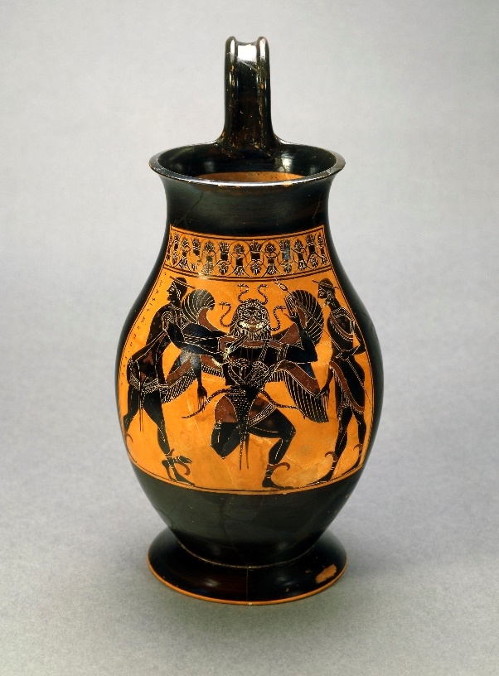

Fig 2. Attic vase showing Perseus beheading the Gorgon, with
Hermes looking on. 6th C BCE. Image © British Museum.

While it is generally accepted that the Gorgon is female, this is not always obvious from the surviving artwork and, indeed, the leontocephaline’s gender is frequently disguised to imply a union of both male and female generative powers present within the figure.
Perseus was born in a cave, and Mithras, the ‘rock-born’ god, is worshipped in temples frequently set up to resemble caves. Mithras has been shown emerging, fully-formed and partially-dressed, from a rock, which Ulansey interprets as Mithras having been born in a cave. A stone relief from Houseteads on Hadrian’s Wall, however, shows the god born emerging from the broken shell of the Cosmic Egg, part of which covers the deity’s head in place of the usual Phrygian cap; the god’s right hand holds a knife, prefiguring its use in the tauroctony, while the left bears a flaming torch depicting Mithras as a bringer of new light. The figure is surrounded by an arching frame depicting astrological imagery and zodiacal signs, suggesting the cosmos. The existence of this relief casts doubt on Ulansey’s claim that Mithras is always rock-born; this particular sculpture is less representative of Perseus than it is of the Orphic deity Phanes, who was hatched from a cosmic egg produced by Chronos. Image CIMRM 695 in the Corpus Inscriptionum et Monumentorum Religionis Mithriacae is an image of Phanes in the Orphic Modena, showing the god emerging from the cosmic egg. Additional support for the conflation with CIMRM 475 is an inscription to ‘Zeus-Helios-Mithras-Phanes’ found at Rome. Moreover, here, astrological symbols encircle the newly-emerging god, rather than framing the tauroctony. The zodiacal frame against which Mithras rests his hands links him to the Greek god Aion, shown in similar iconography; Aion is associated with time, the orb or circle encompassing the universe and the zodiac, and he, too, is a god of the ages. In terms of weaponry, Mithras wields a dagger to slay the bull, and is associated with the harpe, a hooked and bladed weapon symbolic of both the fifth and seventh grades of initiation, that of the Persian and Father respectively. Perseus, Ulansey notes, is frequently shown with a dagger and sometimes with the harpe. Perseus has a strong cultic presence in Tarsus, Cilicia, which he was considered to have founded. Plutarch wrote of the Mithraic rites of the Cilician pirates, and therefore Ulansey explores connections between the cults of Perseus and of Mithras; coins discovered in the region dating from the second or first century BCE bear images and substantiate the widespread importance of Perseus to the region. Apollo was frequently found in Tarsus as a cult deity, often depicted on coins or subservient to Perseus and shown either as an aspect of Perseus, or sacrificing to him. This geographical evidence for the emergence of Mithraism at the same location as cults of both Perseus and Apollo supports Ulansey’s astronomical theories, and suggests Perseus may have been significant in the development of Mithraism.
The constellations present along the line of the celestial equator include those of Aries and Libra, omitted from the tauroctony, which, instead, features Taurus and Scorpio; this double discrepancy aside, all the other tauroctonous constellations are present. In the ancient, geocentric world view, the two imaginary lines of the ecliptic and the celestial equator were known and to some degree understood; Plato, in his Timaeus, speaks of the universe’s construction from ‘two circles joined with a cross’. In Mithraic settings, the leontocephaline is sometimes found standing on a globe with two crossed bands representing the celestial equator and the ecliptic. One explanation for the presence of Taurus and Scorpio in place of Aries and Libra could be due to a phenomenon known as precession; due to the tilt of the earth’s axis, the constellations on the celestial equator do not remain constant; instead, they appear to progress forwards as the earth tilts. Thus every two thousand, one hundred and sixty years, the constellations move backwards by one; while currently the vernal equinox is in Pisces, in Greco-Roman times it was in Aries, while before that, between 4000 BCE and 2000 BCE, it was found in Taurus, raising the possibility that the tauroctony, with its bull and scorpion, could potentially represent the celestial equator as it existed during those years. There is some supplementary support for the importance of the equinoxes in the related figures of Cautes and Cautopates; these the torch-bearing companions of Mithras appear in the majority of tauroctonous sites, often as smaller versions of the cult god, dressed similarly, Cautes with torch held upwards while Cautopates’ points downwards. Their legs are crossed and in different directions, left over right opposing right over left. While generally representative of the tension in opposition of dualism inherent in Mithraism, they may also represent the equinoxes; Cautes for the vernal and Cautopates for the autumnal; Cautes is often depicted with a bull’s head, while Cautopates has a scorpion, thus recalling Taurus and Scorpio, spring and autumn respectively. However, the constellation of Leo, at that time, was not situated on the celestial equator, instead being at the position of the summer solstice; Ulansey argues that since both equinoxes and solstices determine seasonality, they must therefore be connected, while Leo’s antithetical solstitial constellation, Aquarius, may be referenced by the cup, often found paired with Leo and more usually associated with Crater. Spica, however, is not on the ecliptic, nor is it an entire constellation. Usually depicted as one ear of wheat, rather than the three commonly present in the tauroctony; it is Ulansey’s contention that Spica symbolises the annual rebirth of vegetation signalled by the vernal equinox. In antiquity, growing and sprouting wheat is seen as a referent to spring, while for autumn, cut and harvested sheaves are depicted, all of which connects the bull directly to the spring equinox, while the lion represents the summer solstice as it was when the vernal equinox was in Taurus. For this to have relevance to Ulansey’s theory, there must be a connection between Mithras and the celestial equator, which passes above the ecliptic; it is here that Ulansey sees a link, for ‘…directly above the constellation of the bull, the Taurus-equinox celestial equator passed through… Perseus.’
Both in antiquity and current times, the majority of star-maps situate Perseus above the line of the Taurus-equinox celestial equator, with the notable exception of the phaenomena of Aratos, which followed a contemporary of Plato in situating the Pleiades near the left knee of Perseus – which in turn places Perseus kneeling on the Bull’s shoulder in an echo of Mithras’ posture during the bull-slaying. At the time of its creation around 227 BCE and until the end of antiquity, the Phaenomena of Aratos was the best-known iteration of the heavens in the Graeco-Roman world; the depiction was unique, however, with no other sources placing Perseus on the neck of Taurus, both the Salzburg Plaque and the Farnese globe following Hipparchus instead. Aratos’ native city, Soli, was twenty miles from Tarsus in Cilicia, where Perseus was venerated and perhaps Aratos’ fame may have magnified the appreciation of his unique placement of Perseus there while the increased scale of Perseus would have found favour with the populace of Cilicia. The placement of Perseus along the equinox does explain a passage in The Cave of the Nymphs, where Porphyry suggests ‘an astronomical interpretation of Mithraic iconography’, with Mithras as ‘…creator and lord of genesis… ’ positioned ‘…in the region of the celestial equator…’, although Porphyry has already assigned the equinoxes to Aries and Libra, possibly because of a superficial understanding of Mithraism. As Ulansey’s theory requires Libra, not Taurus, to be the autumnal equinoctial sign, he assumes a mistake by Porphyry’s and that these sources have only conveyed a garbled reasoning behind their relevance. Souls coming into incarnation – genesis – according to Porphyry and his middle-Platonic sources, descend to earth through a celestial doorway or gate situated in the constellation of Cancer, and leave earth through another in Capricorn. Mithras, as Lord of Genesis, may therefore control the ascent and descent of souls; the gates for which are present in the Milky Way. Perseus, too, lies along the path of the Milky Way: Aratos refers to Perseus as ‘dust-covered’ which may demonstrate a ‘mythologically significant’ link between Perseus and the Milky way, and therefore have relevance for Mithraists, since the Milky Way is the pathway of souls to and from genesis, an idea developed as early as the fourth century BCE mentioned in Cicero’s Dream of Scipio.
However, there is no apparent reason why the Mithras cult would have been interested in the celestial equator as it would have appeared in preceding millennia. The intellectual community in the city of Tarsus had significant influence on local politics, with Stoicism in particular being popular amongst philosophers with its influence spreading beyond its immediate environs. Aratos, author of the Phaenomena, was also a Stoic and may have encouraged a bias towards Stoic astronomical philosophy in the area; Stoicism interest in astronomy was strong, with three significant Stoics – Zeno, Cleanthes and Chrysippus – all promoting a form of astral religion. Simultaneous to the beginnings of Mithras as a mystery cult, Stoic philosophies concerning astrology and astral religion underwent regeneration; interest in long cycles of time and the influence of stellar motion had led to a belief that the universe underwent period destruction and renewal; each time the planets returned to the same relative positioning as when the cosmos was created, all was destroyed and began again. This Great Year, as it was called, had featured in Persian, Indian and Babylonian mythology as well as in Greek philosophical thought. Calculations for this Great Year were extant in the Greek traditions before the time of Zeno, while Plato’s Timaeus may also reference it. The Stoic tradition of allegorising heroes, gods, and other mythical figures as aspects of natural and cosmic forces led to the conflagration at the end of the Great Year being associated with Phaeton, the son of Helios who borrowed his father’s chariot and almost destroyed the world by fire.
In 128 BCE, or thereabouts, the Greek astronomer Hipparchus discovered the phenomenon of the precession of the equinoxes, which at the time was understood as a slow circling of the Earth by the cosmos taking thirty-six thousand years to fully revolve. This was breakthrough science, new knowledge, particularly as current thought was that the stars influenced events on earth, a revelation which would have had particular significance for the Stoics, who may have seen it as confirming their astral-religious beliefs. Ulansey believes that Aratos’ influence as the author of Phaenomena may have encouraged a particular bias towards Stoic astronomical philosophy in the region of Tarsus; Stoicism’s deep and abiding interest in astronomy, favouring an astral religious interpretation, holding that the cosmos and its attendant heavenly bodies were, in themselves, ‘living, divine beings’. With the exception of a brief hiatus during the leadership of Diogenes and his successor Panaetius, when Posidonus succeeded to leadership of the Stoic school, he reinstated the astral and astrological aspects of the philosophy. In 128 BCE, or thereabouts, the Greek astronomer Hipparchus discovered the phenomenon of the precession of the equinoxes, which was then understood as a slow circling of the Earth by the cosmos taking thirty-six thousand years to fully revolve. At the time this was cutting-edge knowledge, particularly as current thought held that the stars influenced events on earth, a revelation of particular significance for the Stoics, who may have seen the discovery as confirming their astral-religious beliefs.
Given that Stoic philosophy postulated that the gods were everywhere and in everything, and given that Stoic practice saw natural forces as emanating from these gods, the newly-discovered way in which the universe now moved may therefore have signified a new, and particularly powerful, divinity, one capable of moving the sun, the planets, and the entire cosmos and that this divinity was a fitting subject for worship. Stoics in Tarsus, (a city where Perseus was already worshipped) may have interpreted the hero’s constellation to imply a cosmic significance; if Perseus was the power behind precession, which is most visible in the motions of the celestial equator and the equinoxes, then he is the one moving the equatorial constellations; Hipparchus showed that in the age before the Graeco-Roman period, the spring equinox was in Taurus, with that of Aries to follow. The death of the bull, then, became the death of the age brought by precession, Perseus in the sky, placed above Taurus, makes him seems to kill the bull, giving rise to the central image of the tauroctony, while the inclusion of the equatorial constellations, situated beneath Perseus, may have been to honour his rulership. This new cosmic force, perhaps known only to a few at first, with even fewer grasping the religious implications, may have been a sound basis for a mystery religion, knowledge of precession being a powerful secret, revealed only through initiations. Mithraism began at a time when astrological ideas generally were becoming more widespread around the Mediterranean, with a growing belief that the stars influenced the fates of men.
As intriguing as Speidel and Ulansey’s theories may be, there have been other approaches to the importance of the night sky with regard to the cult of Mithras. In 2013, Dr Reza Assasi suggested that a group of stars in the northern hemisphere are connected to Mithraic myths, potentially demonstrating early awareness of Earth’s axial precession. This star group, forming the shape of a swastika, is suggested as representing Mithras in his chariot. While mention of this constellation offers a different perspective on which region of the celestial skyscape was relevant to the Roman cult of Mithras, the cosmic quadriga and its association with the swastika-shaped constellation goes back to the Mihr Yast of Avesta, where Mithras drives a celestial, star-bedecked chariot drawn by four white horses with gold and silver hooves; this reference, and others from the Yast, suggest to Assasi that Mithra in his chariot are present in the sky, near the northern celestial pole, particularly as the constellation of Draco is located in the region of the north ecliptic pole, and although the constellation proper is not swastika-shaped, a star formation of four wings with four associated stars may be discerned, as shown in figure three.
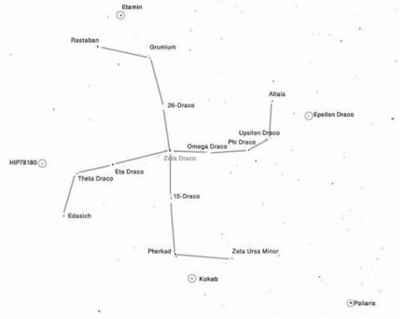
Fig. 3. The celestial quadriga, in Draco. After Assasi.

The star Zeta Draco is near to the north ecliptic pole, and to the centre of the zodiacal constellations; the ecliptic poles also function as the precessional poles; Zeta Draco, because of its situation on the pole, is the only star which appears static as the rest turn clockwise by almost one degree every seventy-two years. This is a phenomenon which Assasi believes may well have been known to ancient civilisations, even if the full relevance of precession was not theorised prior to Hipparchus.
For Assasi, each pair of zodiacal symbols for the age (which occurs every two millennia) is accompanied by a different constellation which simultaneously passes over the celestial equator. His argument seems to be that this information, along with existing awareness of solar, lunar and planetary motion, would have sufficed for the construction of a basic astrolabe, which could have been used to reveal the sign of the age, by rotating it through the thirty degrees of each zodiacal sign; this would show which two signs would be arriving to announce the next age, along with the associated equatorial ‘forerunner’, as Assasi terms it, and which rises just before the arrival of the new age. These precursory constellations, Assasi claims, match those which feature in the tauroctony, with each forerunner, along with the Eastern zodiacal symbol of the age, symbolically overpowers that of the preceding age; Assasi pairs Leo-Aquarius with Corvus, Crater accompanies accompanies Cancer-Capricornus, Hydra pairs Gemini-Sagittarius, Canis Minor, Taurus-Scorpius, while Orion sits with Aries-Libra, the bright star Betelgeuse sitting on the celestial equator to over throw Aldebaran, brightest star in Taurus at the start of the age of Aries. Since Betelgeuse is in Orion, this implies Orion overthrows the bull of Taurus, suggesting an alternative or additional identity for the constellation: Mithras, hero of the age of Aries, incarnated in Orion. Assasi sees this as perhaps originating from eastern astrological ideas being interpreted in Roman and Greek thought, the underlying idea being an awareness of the arrival of the forthcoming age of Pisces-Virgo, which commended around the first year CE at the point where the Pisces edge touched the intersecting ecliptic and equator with Virgo’s bright star Spica rising in the east and touching the celestial equator. The tauroctony, then, may represent the twelve ages of the constellations, beginning around 10,500 BC and following through to Pisces-Virgo, the age to come; this completes the twelve millennia which in Iranian Zurvanite beliefs comprised a Great Year, of which there are six peaceful ages and six evil. Zurvan, as has already been noted above, represents time and may be associated in Roman Mithraic beliefs with Aion, and the leontacephaline, besides holding the position of supreme god, and primordial creator deity in Iranian Zurvanism.
Mithra, as stated above, is associated with a stellar chariot, and depictions of a chariot with its driver marked with swastikas have been found within the Mithras cult; Assasi cites Vermaseren, who noted an anticlockwise swastika on tauroctony in Bulgaria, while in Italy a bronze statue marked with a clockwise swastika, accompanied by two six-rayed stars has been found. Roman artifacts designed as a swastika and comprising four horses’ heads arranged clockwise around the centre suggest the chariot could have been depicted as such a swastika; while other Roman objects depict Mithras as the charioteer, or holding the cosmic sphere while rotating the zodiac in an image reminiscent of Aion, the god of time. Assasi also notes Roman additional objects which envisage the four horse chariot as the swastika constellation, representing the north ecliptic pole, and symbolically serving the Sun, or Helios. Although he then goes on to suggest Mithras is the predecessor of Christ, with a conflation of symbols he finds interesting, and that the birth of Christ may be connected to the beginning of the age of Pisces, there is not scope to discuss this here; more interesting are Assasi’s final thoughts, that Roman Mithraism was aware of the coming of a new age, where a new mythical hero was required, with the god Mithras present in the age of a final conflict; it is ‘…the age of the final battle between good and evil.’
Mithras’ associations with the sun, with Apollo and with Helios, have already been noted, and are not in doubt. Other reasons for the appearance of the swastika in Mithraic contexts are possible; In 2014, Pilar Burillo-Cuadrada and Francisco Burillo-Mozota took a different approach to the celestial swastika. Their paper, ‘The Swastika as Representation of the Sun’, references the appearance of solar and lunar imagery in Mithraic contexts, with the tauroctonous raven as intermediary between the god and the sun, and notes Cautes’ positioning beneath the sun in some settings while Cautopates is beneath the moon. Mithras’ relationship with the sun is a basic feature of Mithraic iconography; during the slaughter of the bull, his gaze is turned on the sun, while in other scenes Helios submits to Mithras, partakes of a meal with him, after which Helios drives Mithras in his chariot. In those scenes where Mithras is identified with the sun, he, Sol and Helios are represented as distinct from each other, while there are many inscriptions referring to Mithras as Sol Invictus, thus asserting his identity as distinct from Helios. Referencing ancient sources such as Plato, Philo and Julian, he explores the philosophical premise of two suns, one within the sphere of fixed stars associated with Helios, and a second, ‘hypercosmic sun’ which is Mithras’ solar identity as the unconquered Sol Invictus. Symbolism also depicts Mithras as ascending through the fixed stars in Helios’ chariot, becoming Aion to reach the fiery sphere beyond the eighth planetary gate in the ladder of ascension. Arguing that, had there been evidence for a constellation shaped like a swastika in the heavens, the ancients would have found it, the authors suggest the revolving sun as the most plausible meaning for the swastika. From the Greek world, the identification of the swastika with the sun, and with Helios, is known, and despite a heavenly swastika constellation being mooted in 1966, and contra Assasi, who superimposes his Mithraic chariot over Draco, the authors reiterate Mithras’ position as a solar deity, as Sol Invicta and the fiery region above the sphere of the fixed stars to conclude that, rather than a constellation, the swastika symbolises the sun.
These theories all have something of worth and all have some problems; there is a strong likelihood that Mithraism did, indeed, derive from Iranian and eastern sources and originated with Mihr or Mitra; Mithras’ identification with Perseus is appealing, but the simplest reason for his Phrygian cap is to identify him as a god from the east rather than identification directly with Perseus; the conflation of Mithras with Orion is appealing in its simplicity, and the constellation is undoubtedly an imposing one in the night sky as well as being positioned amongst many of the key tauroctonous figures – yet that is not without its difficulties too. While Assasi claims the Orion-Mithras identification for his own theories, his stellar swastika, to have avoided notice by the ancients when the symbol appears in the iconography, seems improbable. Of all these suggestions, that of Burrillo-Cudrado and Burrilo-Mozota is the least contentious, and it is with these thoughts in mind that an examination of the site of Carrawburgh Mithraeum and its setting will be explored.

Carrawburgh Mithraeum – The Site and Location

Carrawburgh Mithraeum, the best-preserved temple of Mithras in the North of Britain, is situated in a small, boggy valley which was also the location of a sacred spring of Coventina, close to the adjacent fort of Procolitia. It is less than five miles from Housesteads where the birth of Mithras from the Cosmic Egg was discovered. Carrawburgh’s modern-day GPS location and OS map references are 55°02’02” N, 2°13’39” W, OS map reference NY858710, and it sits on an approximately NW/SE line. Using data generated by selecting the doorway of the Mithraeum in Google Earth, a slightly different location of 55° 02”1.9’ N, 2° 13” 20.81’ W was generated. Since, for the purposes of this investigation, a position from the doorway providing line-of-sight both into the Mithraeum, and out towards the horizon is required, this new location data was used in both heywhatsthat and Stellarium, the better to assess any potential alignments or orientations from that precise spot. While these coordinates differ only slightly from those officially given on maps, it has been important to be as exacting as possible, particularly without the benefit of visiting the site. It should be noted, however, that the website heywhatsthat.com utilises the decimal format of expressing coordinates. The exact expression of the location, in decimal format, is Latitude 55.033863 N Longitude 2.222448 W, which converts to 55° 02”1.9’ N, 2° 13” 20.81’ W.
The temple was built in three distinct phases, and positioned 27. 4 m south of the south-west corner of the fort and on the east bank of the valley, and freestanding rather than dug into the hillside. Its position in the landscape may be seen in figure 4 below.

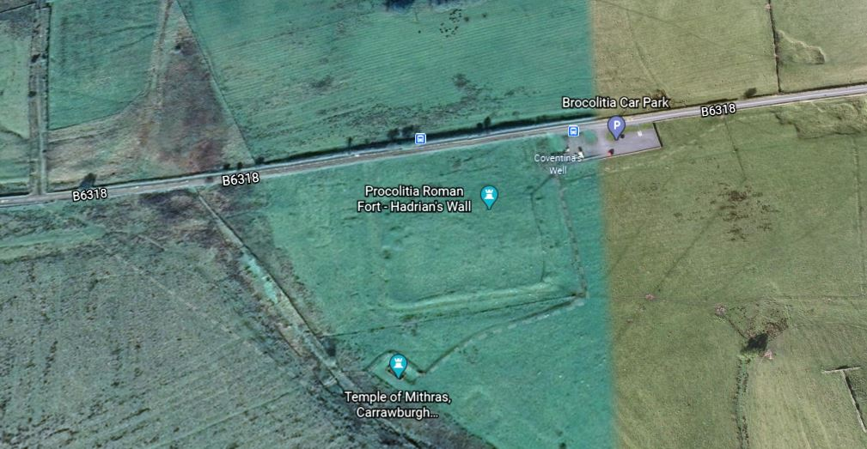
Fig. 4. Aerial image of Carrawburgh Mithraeum with Procolitia Fort to the north
Richmond, Gillam and Birley state that the temple’s location is natural; ‘It faces neither sunrise nor the mid-day sun, nor any cardinal point. Its position appears to be related solely to the natural contour of the hillside.’ Although this was a reasonable supposition on the initial discovery of the temple in 1949, an examination of the site may bring fresh information. Porphyry, in De Antro Nympharum, wrote that most temples were aligned to the east. Vermaseren, writing about the discovery of the temple at Walbrook discovered in 1954 and dating to around 150 CE, stated that the temple’s entrance was to the east. It is therefore possible that the orientation of this particular temple, on an almost south-west to north-east line is perhaps significant itself significant.
The position of the Carrawburgh temple would have placed a small spring to the NW corner, which may have been used for ablutions integral to cult practice, although this spring could only have been in use during the first phase of the temple, since in subsequent phases of use, the spring was flagged over. The first incarnation of the building has been dated by its earliest surviving altar, dated 205-221 CE. Other finds included the remains of timber screens, benches, and timber posts in the north end demarcated a small strip some 61 cm across, in which a pinus pinea fir cone had been placed; figure 5 shows the position of these features in the first stage of the temple’s use.
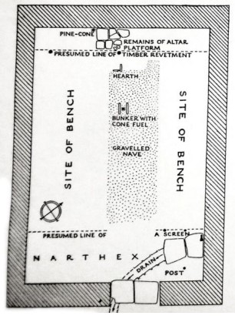
Fig. 5. Carrawburgh Mithraeum, Third Century, stage 1. (after Richmond, Gillam, and Birley, 1951)
Evidence that pine cones had been used in the temple comes from a hearth and bunker with remnants of carbonized pine coal fuel and hazel charcoal. The second phase was an enlargement, extending the temple by 4.3 metres to the north, with an additional 1.8 metres added in the same direction to form an apse. While the stone used was still hammer-dressed, the finish was less accomplished in execution, with additional mistakes of layout creeping in, and the nave placed along the central axis, all of which dates from approximately 222-296 CE, with stone pedestals against the southern end of the benches and faced with plaster to give a unified appearance.
Amongst the finds at Carrawburgh were three altars which refer to the god as invictus – invincible, or unconquered, with RIB 1546 of particular interest as it depicts Mithras, cloaked and crowned, rising from the rock. In his right hand is a whip, symbol of his identification with Sol or Helios. A description of the Mithras taken from the Mithras Liturgy in the Greek Magical Papyri (lines 635-638) compares closely to the god as depicted here, with flaming locks and crown of fire. The central and easternmost of these altars can be dated to between 198 CE and 222 CE, while the date range for the westernmost altar spans between 43-410 CE, although if the similarity of image was taken from knowledge of the Mithras Liturgy, which itself dates from the early fourth century CE, it may well be earlier than 410. Certainly Richmond et al place this altar at some point during the final rebuilding of the temple, or its latter two phases. An absolute date for the destruction or abandonment of the temple is not possible, but it is likely that the temple fell out of use before the end of the fourth century, with the nearby spring of Coventina still in use by 383 CE.
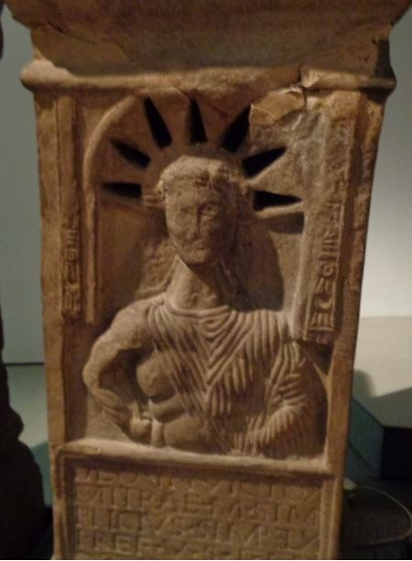

Fig. 6. Altar to Mithras, RIB 1546, showing pierced rays which could have been lit from behind.

Investigation
When one examines satellite imagery of the location of the temple, it appears to lie on a North-East to South-West orientation, with the doorway being in the south western wall and off-centre by 53.3 cm, shifted towards the southeast corner. The temple as it survives today was constructed at some point between 207-305 CE, during the occupation of Hadrian’s Wall. The presence of pine cones used for fuel is interesting as there may be relevance in the association of the leontocephaline which may represent Aion and which has been depicted with a pine cone. Such a link between Carrawburgh, and the god of time who may also represent an aspect of Mithras, recalls the Birth of Mithras found at Housesteads, which also had its Orphic elements.
The actual dimensions of the first rendition of the temple are given as having been 5m 56cm wide, 7m 92.5cm long, with side walls of 48 cm thickness and front and rear walls of 60.9cm. The doorway was located 2m 18.4cm from the southwestern corner, with the doorway being 1m 27cm wide. The first iteration of the nave was asymmetrical, formed by a gravel surface the same width as the doorway and approximately 4.42 metres long, extended from a platform set in the back wall towards the doorway with its long axis lying 38 centimetres east of true, in line with the first doorway. Although at this first stage of construction, the temple was one of the smallest known at the time of excavation, it was later extended by a further 4.3 metres, with the addition of a 1.8 metre apse to give a complete external measurement of 4.57 metres wide by 11 metres.
In 296-297 CE, the temple was destroyed and subsequently rebuilt, with the western edge of the doorway being repositioned to the east, making a narrower door of just over a metre in width. It is this final iteration which has been used in this investigation; while the fields of view and lines-of-sight will differ from those of the first phase of building, without being able to measure the doorway and pinpoint its centre as it stands on the site, the most acceptable solution has been to approximate the centre of the doorway on the satellite imagery available, and use the coordinates generated at that location.

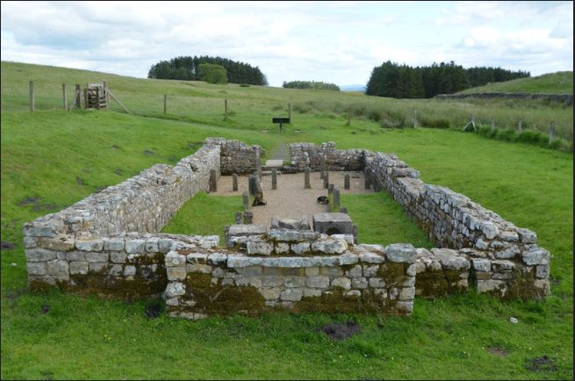
Fig. 7. Temple of Mithras, looking from the apse towards the doorway along the NW-SE axis. Note medial placement of nave which does not align with doorway.
The first-phase axis of the temple taken from the centre of the doorway to a corresponding point at the back of the Mithraeum is suggestive of a deliberate orientation towards winter solstitial sunrise, although this cannot be definitively determined without on-site measurements and observation. As a visit to the site has not proved possible at this time, the use of computer-generated location data will provide historical time referents and topographical information which will provide further information on the likelihood of the alignment’s probability while in situ measurements are not possible. The offset position of the gravelled nave by some 38 cm east of the building’s medial axis ensured it sat in line with the doorway. This would also serve to control the approach of those cult initiates and participants entering the temple, directing their attention deliberately towards the focal point of the tauroctony at the end of the nave. Moreover, (as can be seen in figures 5 and 7) despite later adaptations and alterations, this offset position of the door is retained throughout the successive stages of the Mithraeum, thus suggesting that this was not an accidental positioning, but rather a deliberate choice to maintain its asymmetry. The nave, however, was subsequently moved to lie along the axis of the building and this combination of the offset doorway and the realigned second-phase nave can be seen in Figure 7. One theory for the early asymmetry of the nave was that the space inside the doorway to the left was needed for ceremonies associated with initiation, for which evidence was found for the later building phases; a more symmetrical building would have been cramped. However, since it has been shown that light and its manipulation were important in Mithraic ceremonies, it is important to consider the implications of this offsetting. The alterations which were made later to enlarge the Mithraeum could surely have integrated any required extra space at that point, had the need for more room within the temple been the only reason.
With this in mind, a further examination of the site using heywhatsthat.com was undertaken. The latitude and longitude of the temple, as provided by Google Earth, UKcitymap.com. and Historic England were used as the location for the generation of altitude and line-of-sight images.

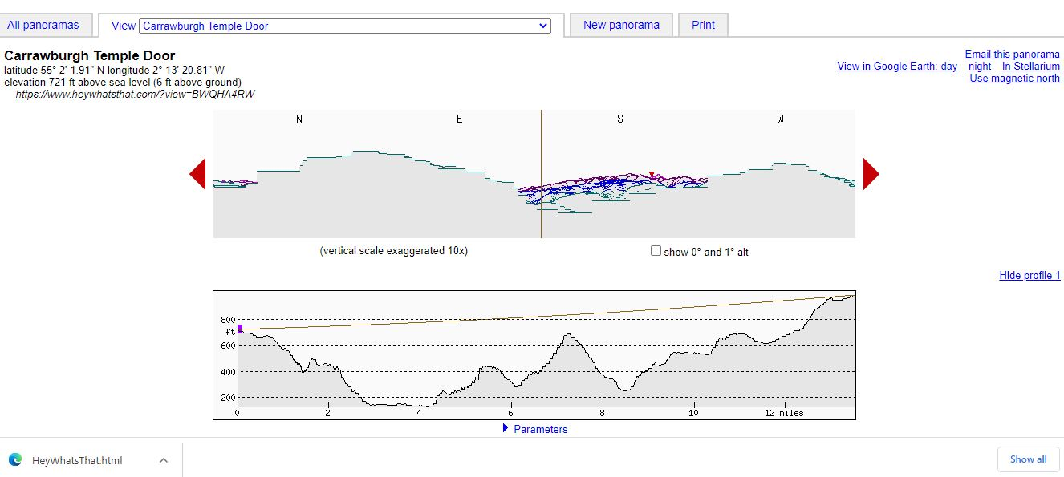
Fig.8. Looking SE from the doorway of the Temple of Mithras
When one looks from the doorway towards the south-east, one’s eyes fall towards a dip in the landscape. In current times, these contours are somewhat wooded, which, of course, may have been the case in Roman times as well. The altitude above sea-level is given at 72 feet, from a height of 6 feet. Looking to the north-west for comparison generates a different profile, shown in figure 9.
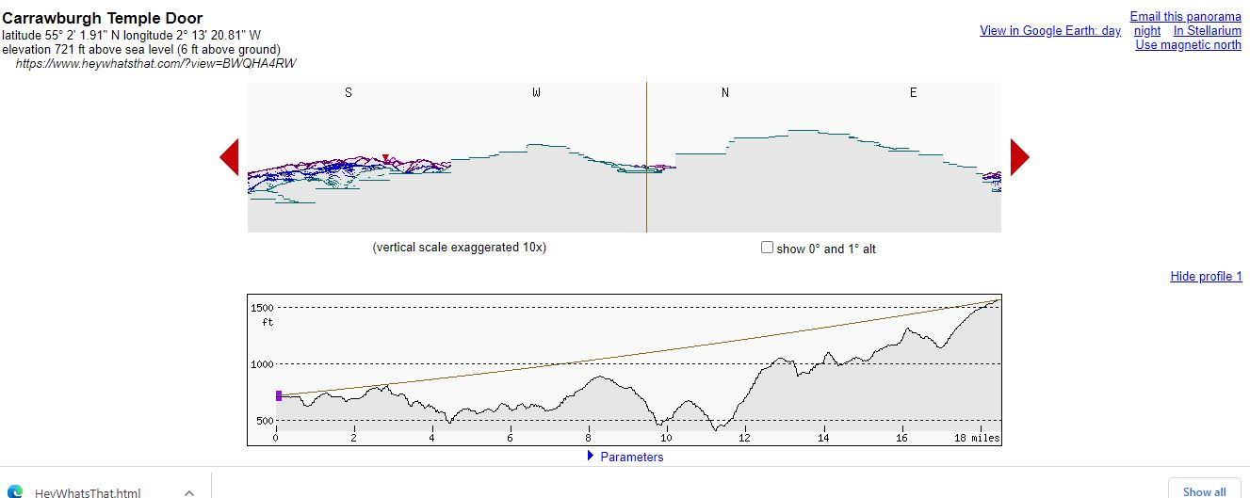
Fig. 9. Carrawburgh Mithraeum looking to the north-west.
Interestingly, although there is a rise in the ground at a comparatively near distance, line-of-sight here extends further than the aspect to the south-east – more than twenty miles, as opposed to twelve along the other axis of the line.
An overhead view of the lines-of-sight from Carrawburgh was also generate by heywhatsthat. (Figure 10). It shows the clear horizon lines marked in blue, while the red areas depict elevated areas of the landscape. The SE-NW sightlines are noteworthy, however an extremely long horizon line to the NNE and another to the SW mat bear investigation.
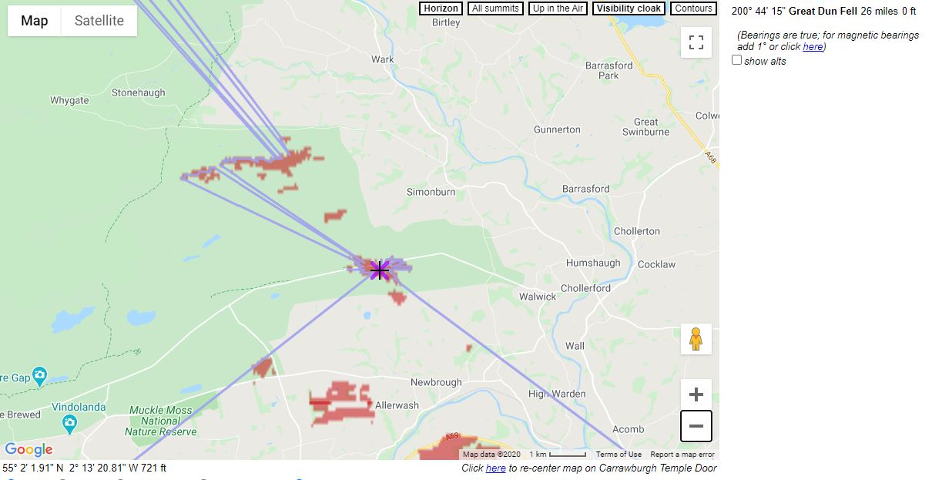
Fig.10. Sightlines radiating from the Temple of Mithras at Carrawburgh.
With these preliminary thoughts in mind, the Stellarium planetarium programme was used to interrogate these findings. The location data from the landscape profiling along the two axes of the central line through the doorway generated were run with a putative date of 150 CE – the earliest date suggested for the temple – and focussing particularly on the dates around the midwinter solstice, since preliminary investigations suggested a potential connection with midwinter solstitial sunrise. Since the date of this can vary by several days, images were taken for the 18th and 22nd of December at the same time, 8.45 am – the approximate time of sunrise. These are shown at Figure 11 using an atmosphere filter for clarity along with constellation lines. A further image was taken for the 25th of December, since that particular date was of relevance to Mithraists as the festival of the god’s birthday.
On all three dates – December 18th , December 22nd, and December 25th in CE 150, the view from the doorway of the temple shows the sun rising to the south east. (Figures 11 and 12.)
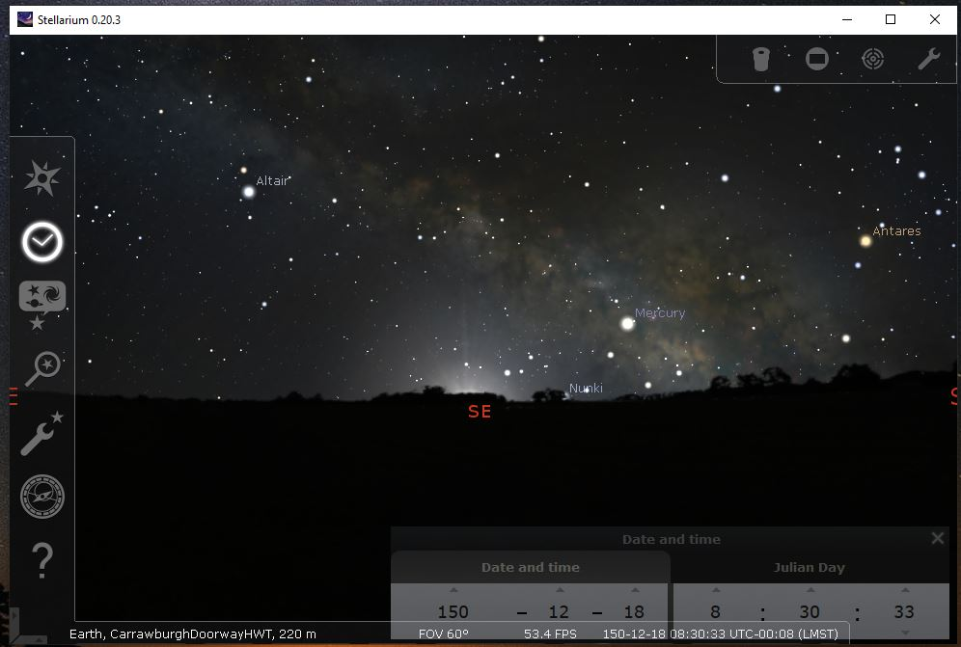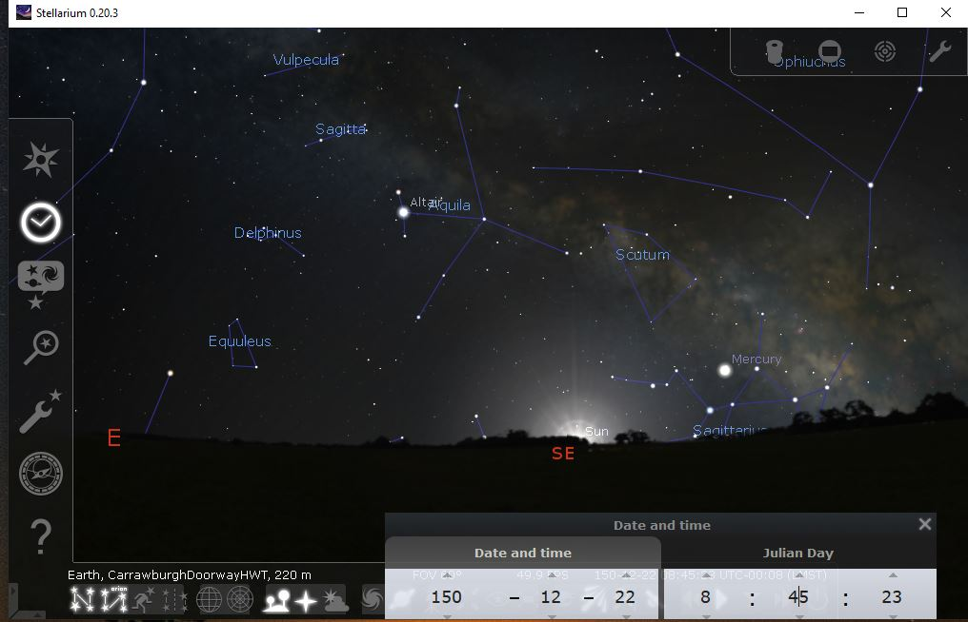
Fig.11. Sunrise on 18th and 22nd December, 150 CE, from the doorway at Carrawburgh Temple.
The sun can be seen rising at approximately 8.45 am on both dates. By December 25th, sunrise took place approximately three minutes later than on the 18th, and so, in Figure 12, the image captured was taken at 8.48 am, and shows a very similar sky with the sun rising to the south-east.
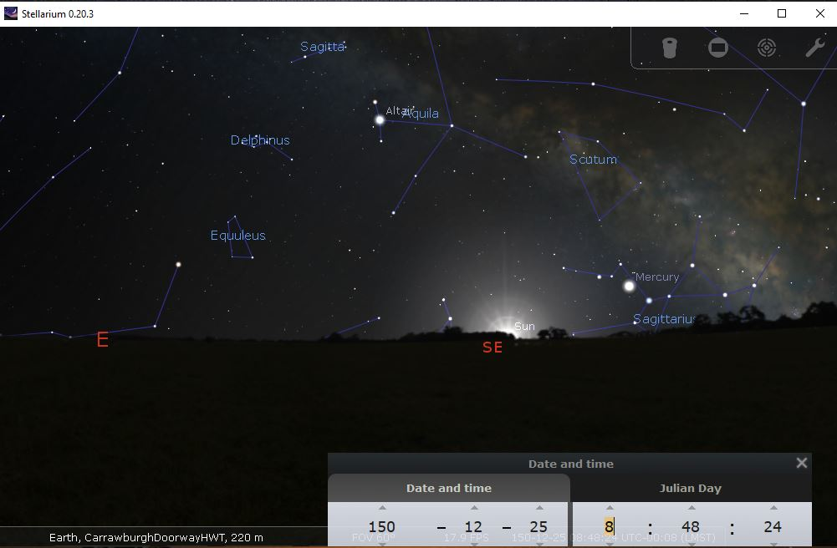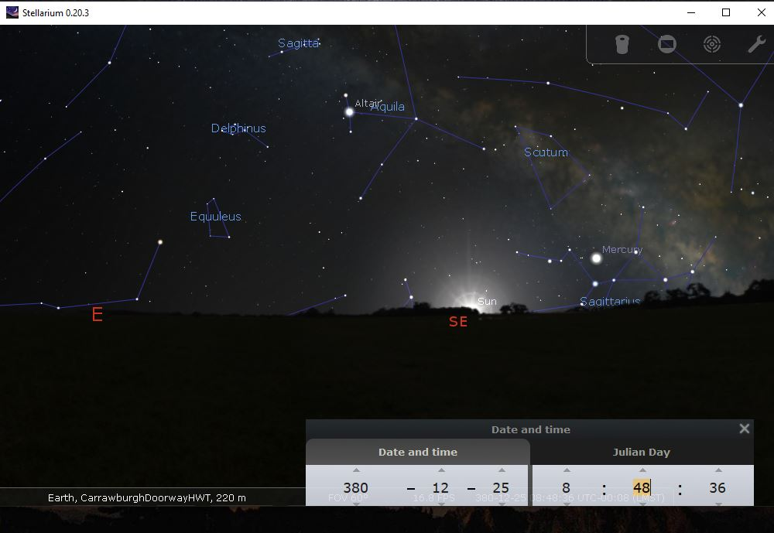
Fig.12. Sunrise, 25th December, Carrawburgh Temple doorway. The left image is 150 CE, while to the right is the same location in 380 CE.
Sample images were also taken for sunrise in 380 CE, keeping to the same dates; the image from 8.48 am, 25th December, 380 CE, is shown alongside for comparison. This suggests that the location of the temple, or at least its doorway, may well have been chosen to align with winter solstitial sunrise.
Earlier in this discussion, mention was made of the constellations of Orion, Perseus, and a theoretical constellation which may have been known to the followers of Zurvan, in ancient Iran, the constellation of the cosmic quadriga which was in the shape of a swastika and composed of stars from the more widely-recognised Draco and so these three constellations, and their relative positions to the temple doorway, have been examined. At the earliest date for the winter solstice in 150 CE, by 18. 45 pm, Orion has risen enough that Rigel, the bright star at Orion’s left foot, is above the south-eastern point and so would have been easily visible from Carrawburgh doorway. So, too, is Aldebaran, the bright star in Taurus, high above the south-east. (Figure 13.)
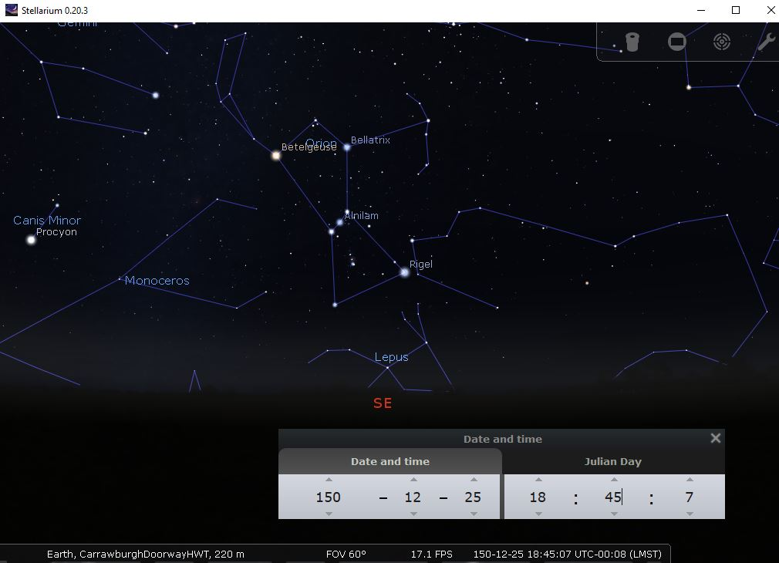
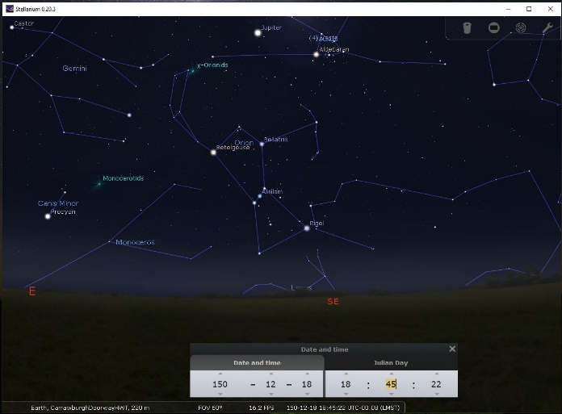
Fig. 13. Orion, 18th and 25th December respectively, at 18.45 pm, from Carrawburgh doorway.
Thus Orion would have been visible from the doorway of the temple for at least a week around the time of the midwinter solstice; 18.45 pm was chosen as being twelve hours on from sunrise at the same position. Perseus, while also visible in the night sky and vertically aligned with the south-eastern point with its bright star, Mirfak, roughly in line with Aldebaran, would have been considerably higher in the sky and so, while visible from outside the temple, a view of Perseus from the doorway seems as if it would have been highly unlikely. (Figure 14.)
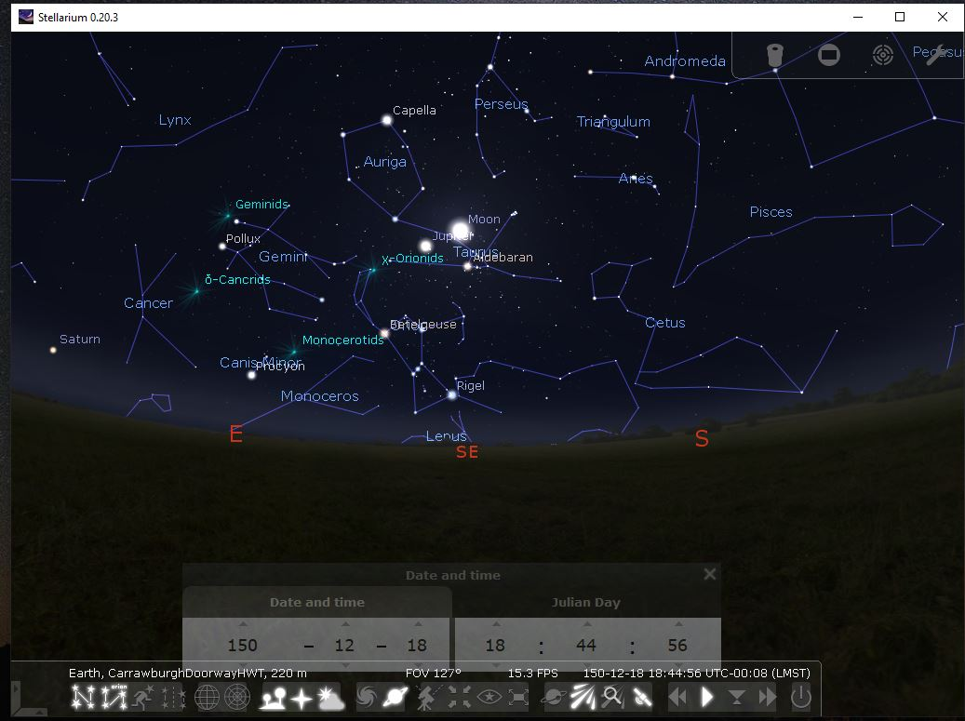
Fig. 14. Orion, Taurus, and Perseus together in the night sky from Carrawburgh Temple.
Assasi’s theoretical celestial quadriga, hiding among the stars of Draco, would have been visible on any clear night from outside the temple, but line-of-sight from the temple doorway would have made it extremely difficult to see due to its position across the north celestial pole, very high overhead. Figure 2, above, shows the putative swastika and Draco side-by-side for comparison. This would suggest that, of the three constellations discussed here, Orion is the most likely to have been the focus of attention of the Mithraists at Carrawburgh if line-of-sight from the doorway was of relevance to their ritual practice and interest in the heavens.
However, when one looks to the north-west, along and beyond the axis of the temple doorway, two constellations are significantly visible in the night sky; Hercules, rising over the northwest cardinal point, and Draco, above Hercules in the sky. The landscape shown in Figure 9 above shows that rising contours may well have placed the horizon above the line of the temple roof, and so Draco, and the celestial swastika, would have been prominent. Figure 15 shows the night sky to the north-west at 18.45 pm on December 25th at the same moment that Taurus and Orion are visible in Figure 13.
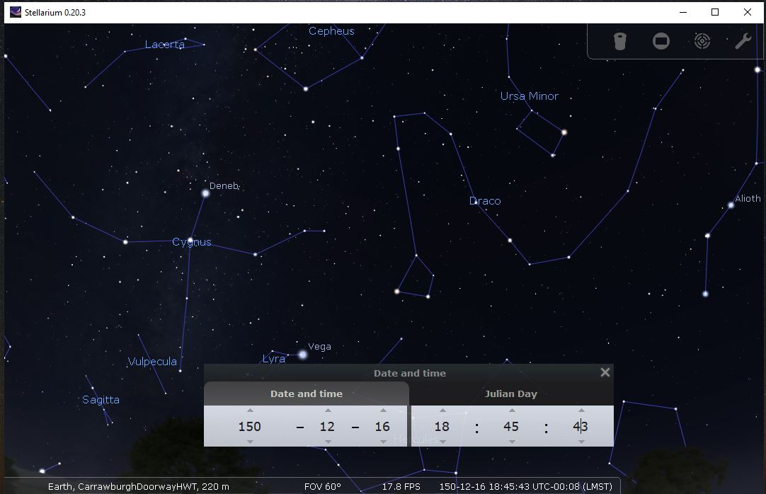
Fig. 15. Position of Draco and celestial quadriga above the Carrawburgh temple.
Leaving this thought for a moment and considering all the theories discussed, Speidel posits both Orion and the celestial equator as important to the cult of Mithras, while Ulansey’s preferred explanation of Mithras’ alternative identity and the tauroctonous symbols requires both the justification of his identification of Perseus with Mithras, and the importance of precession and the celestial equator as it appeared in 2000 BCE to the Mithras cult. This can be seen at Figure 16, with celestial equator marked in red and the ecliptic in yellow. He goes on to suggest that when Taurus is setting at the spring equinox of 2000 BCE, Perseus is above the bull and therefore symbolically ‘killing’ the constellation.
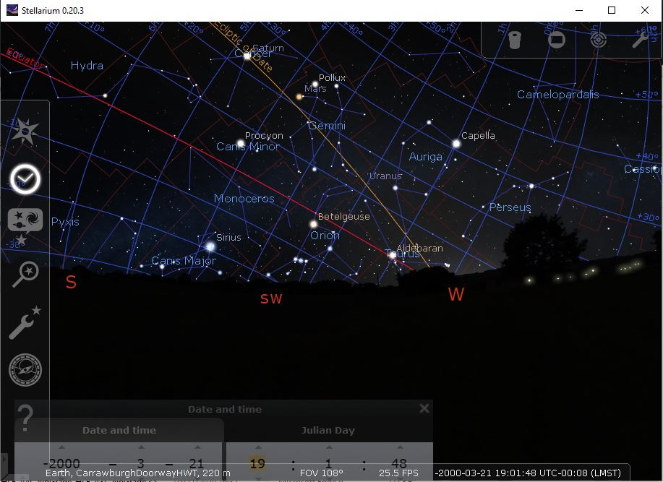
Fig.16. Spring Equinoctial sky 2000 BCE, with Perseus ‘above’ the setting constellation of Taurus
There is also the problem of so much deep Mithraic ritual being conveyed through the medium of a Cilician pirate fleet; however learned the Stoics of Tarsus and the surrounding towns, and although it is undoubtedly the case that Plutarch wrote about rituals known to Cilician pirates ‘…in honour of Mitra’, one scholar points out that this still ‘…proves nothing about the origins of the Roman mystery cult.’ Indeed, the arguments of Speidel and Ulansey both seem to be missing something, with each insisting on exclusions or inclusions to fit their individual theories. But if one follows Ulansey in allowing Leo to be included because its association with Crater causes them to straddle the equator (with Crater replacing the cup in the tauroctony), then one should also include Orion, largest human-like figure on the celestial equator from Speidel’s arguments. The relevance of celestial equator may be problematic, with some of the constellations Speidel includes lying slightly off the equatorial line – but nor is the ecliptic a good match. Moreover, Ulansey’s theory rests on the ancients knowing, understanding, and disseminating the ‘secret knowledge’ of precession within a scant space of time while giving Mithras a whole alter-ego as Perseus as Ulansey claims; Hipparchus’ discovery took place around 128 BCE, which, according to Ulansey, was some sixty years before the earliest attestation of Mithraism, a timeframe which he works out from the date of Plutarch’s Life of Pompey and which he believes to be enough time for the knowledge to spread along with the cult of Mithras. Ultimately, Ulansey only manages to make overall theory work by first drawing attention to Porphyry’s assertion that the seat of Mithras is the celestial equator, and then disregarding it as a misunderstanding on Porphyry’s part to reassign it to a position suiting his theory. Even so, whether or not precession was known and understood by the followers of the Mithras cult at Carrawburgh, there can be no real reason for them to have chosen to site their temple in such a way as to align with the past iteration of precession – the killing of the bull by Perseus – which may be sufficient explanation as to why Perseus is not easily visible from the temple doorway. Nor would it explain why a 2000-year old phenomenon would be celebrated in a deliberate orientation of the temple; indeed, had this been the case, it would have been more likely that the doorway would have lain to the south-western corner of the building, which aligns more closely with the vernal equinox rather than the south-eastern. Orion, however, is visible from the temple doorway, as is Taurus, and, most tellingly, so, too, is winter solstice sunrise when the light of the sun – for which Mithras bears the appellation ‘Sol Invictus’ – crests the horizon and bathes the temple doorway in midwinter sunlight, the angle ensuring the altars and the tauroctony are lit up by natural daylight as the days once more lengthen towards spring. Returning to the celestial swastika while it appears unlikely that an unfamiliar constellation dating back to Zurvanite belief should be appropriated by Roman Mithraists and, while Draco never sets and is visible every clear night, it is unlikely to have been within line-of-sight from the temple doorway due to its high position in the sky, yet figure 15 demonstrates that the celestial swastika could be seen beyond the temple to the north-west. The counter-argument from Burillo and Burillo – that the cosmic quadriga was not a constellation in itself, but a symbol for the sun, and therefore, of Mithras, Sol Invictus, the god of the Unconquered Sun himself, is possible, since a solar interpretation fits legitimates the orientation of the temple and the position of its doorway without the need for a swastika in the sky.

Conclusions
Carrawburgh Mithraeum, placed as it is just five miles from Housesteads to the west and 3.5 miles to Chesters to the east, was within easy reach of other settlements and fortifications along Hadrian’s Wall. The temple of Mithras at Housesteads is no longer available to visit, having been excavated in 1852, but it is interesting for its unique Birth of Mithras. This figure, with its Orphic elements and zodiacal figures, demonstrates a keen awareness of, and interest in, the heavens and the stars. A scant five miles away, Carrawburgh had its own birth of Mithras, but with the god emerging from a rock and clothed and crowned as a young god. The importance of the midwinter sunrise as well sunrise on the 25th of December, the date of the key festival of Mithras’ birth amongst his followers, is apparent in the careful orientation of the temple to enable early daylight to illuminate the tauroctony through the doorway. There is a possibility of the relevance of Assasi’s celestial quadriga, and one could postulate a festival of Mithras, on the 25th of December, which begins with observing the sunrise from the doorway of the temple and which would later culminate with the appearance beyond the orientation of the temple with the celestial swastika emerging from the fading daylight and demonstrating the god in all his glory as a solar deity, driving his star-bedecked chariot endlessly around to symbolise the cycles of time.
It is most unfortunate that during the writing of this paper a visit to the site has not proved possible and so measurements have had to be recreated from alternative resources. While every effort has been made for accuracy, there is still margin for error and a visit, too, would enable a more phenomenological approach to the temple and its relative situation within the landscape.
Preliminary findings have found enough of interest to warrant further exploration at a future date when specific, and relevant data can be collected for future research into the astrological connotations of the temple’s orientation and alignment. While this study may not have conclusively shown that Mithras can be equated directly with any of the constellations interrogated here, it has provided some insight into the importance of the night sky for the initiates of the Mithras cult at Carrawburgh.
Michael Speidel says in the introduction to Mithras-Orion: ‘…the stars will prove whatever one wants them to prove.’ Perhaps, however many constellations are discussed, whatever theories are discussed, it may be that those investigating the mysteries of Mithras will always be left with more mysteries explore.

Nicholas Campion, N. 2008. The Dawn of Astrology. London:Continuum. x
Scheid, J. 1998. An Introduction to Roman Religion. Edinburgh: Edinburgh University Press. 9
North, J. 2007. ‘Rome’ in S. Iles Johnston (ed.) Ancient Religions. Cambridge, Mass. & London England:Belknapp. 228
North, J. 2007. ‘Rome’. 227
North, J. 2007. ‘Rome’. 228
Graf, F. 2007. ‘What is Ancient Mediterranean Religion?’ in S. Iles Johnston (ed.), Ancient Religions. Massachusetts & London: Belknapp Press of Harvard University 9
Iles Johnston, Sarah. 2007. ‘Mysteries’, in S. Iles Johnston (ed.), Ancient Religions. Massachusetts & London: Belknapp Press of Harvard University. 99
Scheid, J. 1998. Introduction to Roman Religion. 19
Iles Johnston, S. 2007. ‘Mysteries’. 99
Campion, N. 2008. Dawn of Astrology.89
Beck, R. 2006. The Religion of The Mithras Cult in the Roman Empire. Oxford: Oxford University Press. 1
Campion, N. 2008. Dawn of Astrology. 347, footnote 2.
Rives, J.B. 2007. Religion in the Roman Empire 141
Iles Johnston, Sarah. 2007. ‘Mysteries’. 103
Campion, N. 2008. Dawn of Astrology. 257
Porph. De Antr. Nymph., 6, Arethusa trans.
Clauss, Manfred, 1990. The Roman Cult of Mithras. Edinburgh: Edinburgh University Press. 42
Green, M.J., 2003 The Gods of Roman Britain 17
Clauss, M., 1990. The Roman Cult of Mithras. 162-165
Clauss, Manfred, 1990. The Roman Cult of Mithras. Edinburgh: Edinburgh University Press. xix-xx
Beck, R. 2006. The Religion Of The Mithras Cult In The Roman Empire. Oxford: Oxford University Press. 35.
Assasi, R. 2013. ‘Swastika: the Forgotten Constellation Representing the Chariot of Mithras’ in Ancient Cosmologies And Modern Prophets: Proceedings of the 20th Conference Of The European Society For Astronomy In Culture. Eds: Ivan Sprajc & Peter Pehani (Eds). Slovene Anthropological Society. Ljubliana. 407.
Cumont, F. 1903.(Trans. T. J. McCormack) The Mysteries of Mithra. Chicago & London. The Open Court Publishing Company & Kegan Paul, Trench, Trubner & Co., Ltd. 116-8
Fabio Silva.2015. ‘The Role And Importance Of The Sky In Archaeology: An Introduction’ in Skyscapes:The Role And Importance Of The Sky In Archaeology’ Fabio Silva & Nicholas Campion( Eds). Oxford & Philadelphia: Oxbow Books. 3
Richmond, I. A. and Gillam, J. P., 1951. The Temple of Mithras at Carrawburgh. Newcastle-Upon-Tyne: Society of Antiquaries of Newcastle-Upon-Tyne
Adrych, P., Bracey, R., Dalglish, D., Lenk, S., Wood, R. 2017 Images of Mithras, Oxford: OUP. 1
Clauss, M. (Trans. R. Gordon). 2000. The Roman Cult Of Mithras: The God And His Mysteries. Edinburgh: Edinburgh University Press. 3
Speidel, Michael. P. 1980. Mithras-Orion: Greek hero and Roman army god. Leiden: E.J.Brill. 1
Clauss, M. 2000. Roman Cult Of Mithras. 3
Clauss, M. 2000. Roman Cult Of Mithras. 3
Clauss, M. 2000. Roman Cult of Mithras. 3
Clauss, M. 2000. Roman Cult of Mithras. 4.
Clauss, M. 2000. Roman Cult of Mithras 4
Clauss, M. 2000. Roman Cult of Mithras 4
Clauss, M. 2000. Roman Cult of Mithras 5
Clauss, M. 2000. Roman Cult of Mithras 5
Clauss, M. 2000. Roman Cult of Mithras 5
Clauss, M. 2000. Roman Cult of Mithras 7-8
De Antro Nympharum
Porphyry, De antr. Nymph. 2
Porphyry, De antr. Nymph. 9
De Antr.11
De Antr.11
De Antr.11
Betz, D. 1996. The Greek Magical Papyri in Translation. Chicago & London: London University Press. xli
Betz, D. 1996. The Greek Magical Papyri in Translation. 48-54
Betz, D. 2003. The Mithras Liturgy. Mohr Siebeck: Tubingen, Germany. 9
Betz, D. 2003. The Mithras Liturgy. Mohr Siebeck: Tubingen, Germany. 9
Betz, D. 2003. The Mithras Liturgy. 1
Betz, D. 2003. The Mithras Liturgy. 1-2
Ulansey, D. 1989. The Origins of the Mithraic Mysteries. Oxford & New York. Oxford University Press 6-8
Claus, M. 2000. Roman Cult of Mithras. xix
Claus, M. 2000. Roman Cult of Mithras. xix
Ulansey, D. 1989. Origins of Mithraic Mysteries. 8
Ulansey, D. 1989. Origins of Mithraic Mysteries. 8-9
Ulansey, D. 1989. Origins of Mithraic Mysteries. 9
Ulansey, D. 1989. Origins of Mithraic Mysteries. 9
Cumont, F. 1903. Mysteries. 135-137
Cumont, F. 1903. Mysteries. 147
Cumont, F. 1903. Mysteries. 104
Cumont, F. 1903. Mysteries. 107
Cumont, F. 1903. Mysteries. 107
Cumont, F. 1903. Mysteries. 109
Cumont, F. 1903. Mysteries. 147
Cumont, F. 1903 Mysteries 116.
Cumont. F. 1903. Mysteries 116-118
Cumont. F. 1903. Mysteries 121
Cumont. F. 1903. Mysteries 118-122
Cumont. F. 1903. Mysteries 123-124
Cumont. F. 1903. Mysteries 125
Cumont. F. 1903. Mysteries 129
Cumont. F. 1903. Mysteries 129-130
Cumont. F. 1903. Mysteries 130
Cumont. F. 1903. Mysteries 131
Cumont. F. 1903. Mysteries 140
Cumont. F. 1903. Mysteries 140-142
Cumont. F. 1903. Mysteries 143
Cumont. F. 1903. Mysteries 144
Cumont. F. 1903. Mysteries 144-145
Cumont. F. 1903. Mysteries 145-146
Cumont. F. 1903. Mysteries 147
Cumont. F. 1903. Mysteries 148-149
Ulansey, D. 1988. The Roman Cult of Mithras 15
Ulansey, D. 1988. The Roman Cult of Mithras 16
Clauss, M. 2000. Roman Cult of Mithras. ix
Vermaseren, M. J., 1963 Mithras, the Secret God. London: Chatto & Windus. 112
Vermaseren, M. J., 1963 Mithras, the Secret God. 112
Vermaseren, M. J., 1963 Mithras, the Secret God. 116-117
Vermaseren, M. J., 1963 Mithras, the Secret God. 112
Vermaseren, M. J. 1963. Mithras, the Secret God. 128
Vermaseren, M. J. 1963. Mithras, the Secret God. 128
Vermaseren, M. J. 1963. Mithras, the Secret God. 128
Vermaseren, M. J. 1963. Mithras, the Secret God. 154
Vermaseren, M. J. 1963. Mithras, the Secret God. 155
Vermaseren, M. J. 1963. Mithras, the Secret God. 156
Vermaseren, M. J. 1963. Mithras, the Secret God. 156-157
Vermaseren, M. J. 1963. Mithras, the Secret God. 157
Vermaseren, M. J. 1963. Mithras, the Secret God. 159-160
Vermaseren, M. J. 1963. Mithras, the Secret God. 158-159
Vermaseren, M. J. 1963. Mithras, the Secret God. 161-162
Vermaseren, M. J. 1963. Mithras, the Secret God. 134-135
Vermaseren, M. J. 1963. Mithras, the Secret God. 67
Vermaseren, M. J., 1963 Mithras, the Secret God. 52-52
Ulansey, D. 1989. Origins of Mithraic Mysteries. 10
Ulansey, D. 1989. Origins of Mithraic Mysteries. 10-11
Ulansey, D. 1989. Origins of Mithraic Mysteries. 12-14
Ulansey, D. 1989. Origins of Mithraic Mysteries. 15-16
Speidel, M. P. 1980. Mithras-Orion: Greek Hero and Roman Army God. Leiden:Brill. 8
Clauss, M. 2000. Roman Cult of Mithras 7
Speidel, M. P. 1980. Mithras-Orion. 2
Speidel, M. P. 1980. Mithras-Orion. viii
Speidel, M. P. 1980. Mithras-Orion. viii
Speidel, M. P. 1980. Mithras-Orion. 2
Speidel, M. P. 1980. Mithras-Orion. 2
Speidel, M. P. 1980. Mithras-Orion. 3
Speidel, M. P. 1980. Mithras-Orion. 5
Speidel, M. P. 1980. Mithras-Orion. 5
Speidel, M.P. 1980. Mithras-Orion. 5
Speidel, M.P. 1980. Mithras-Orion. 5-6
Speidel, M.P. 1980. Mithras-Orion. 7
Speidel, M.P. 1980. Mithras-Orion. 7
Speidel, M.P. 1980. Mithras-Orion. 6
Speidel, M.P. 1980. Mithras-Orion. 8
Speidel, M.P. 1980. Mithras-Orion. 8
Speidel, M.P. 1980. Mithras-Orion. 8
Speidel, M.P. 1980. Mithras-Orion. 11
Speidel, M.P. 1980. Mithras-Orion. 16
Speidel, M.P. 1980. Mithras-Orion. 18
Speidel, M.P. 1980. Mithras-Orion. 14
Speidel, M.P. 1980. Mithras-Orion. 18
Speidel, M.P. 1980. Mithras-Orion. 19
Speidel, M.P. 1980. Mithras-Orion. 20-21
Speidel, M.P. 1980. Mithras-Orion. 22
Speidel, M.P. 1980. Mithras-Orion. 23
Speidel, M.P. 1980. Mithras-Orion. 25
Speidel, M.P. 1980. Mithras-Orion. 25-6
Speidel, M.P. 1980. Mithras-Orion. 26-27
Speidel, M.P. 1980. Mithras-Orion. 28-29
Speidel, M.P. 1980. Mithras-Orion. 28
Speidel, M.P. 1980. Mithras-Orion. 29
Speidel, M.P. 1980. Mithras-Orion. 30
Condos, T. 1997. Star Myths of the Greeks and Romans: a sourcebook Grand Rapids, Michigan:Phanes Press. 150
Speidel, M.P. 1980. Mithras-Orion. 31-2
Speidel, M.P. 1980. Mithras-Orion. 34-35
Speidel, M.P. 1980. Mithras-Orion. 38
Speidel, M.P. 1980. Mithras-Orion. 38-39
Speidel, M.P. 1980. Mithras-Orion. 40-41
Speidel, M.P. 1980. Mithras-Orion. 42-43
Speidel, M.P. 1980. Mithras-Orion. 44-45
Speidel, M.P. 1980. Mithras-Orion. 46
Speidel, M.P. 1980. Mithras-Orion. 47
Ulansey, D. 1989. The Roman Cult of Mithras. Oxford & New York: OUP. 22
Ulansey, D. 1989. The Roman Cult of Mithras. Oxford & New York: OUP. 22
Ulansey, D. 1989. The Roman Cult of Mithras. 24
Ulansey, D. 1989. The Roman Cult of Mithras. 24
Ulansey, D. 1989. The Roman Cult of Mithras. 24-25
Ulansey, D. 1989. The Roman Cult of Mithras. 26-27
Ulansey, D. 1989. The Roman Cult of Mithras. 28-29
Ulansey, D. 1989. The Roman Cult of Mithras. 30
Ulansey, D. 1989. The Roman Cult of Mithras. 32-35
Ulansey, D. 1989. The Roman Cult of Mithras. 32
Ulansey, D. 1989. The Roman Cult of Mithras. 34
Ulansey, D. 1989. The Roman Cult of Mithras. 35
Ulansey, D. 1989. The Roman Cult of Mithras. 35
Vermaseren, M.J., 1951. ‘The Miraculous Birth of Mithras’ in Mnemosyne :Brill
Rives, J. B. 2007. Religion in the Roman Empire Maiden & Oxford:Blackwell 176-7
Ulansey 1989: 120
CIMRM 695
Ulansey 1989: 121
Levi, D. 1944. ‘Aion’ in Hesperia
Clauss, 2000. Roman Cult of Mithras 136-137
Ulansey, D. 1989. The Roman Cult of Mithras. 36-37
Ulansey, D. 1989. The Roman Cult of Mithras. 40
Ulansey, D. 1989. The Roman Cult of Mithras. 42
Ulansey, D. 1989. The Roman Cult of Mithras. 42-43
Ulansey, D. 1989. The Roman Cult of Mithras. 43
Ulansey, D. 1989. The Roman Cult of Mithras. 46-47
Ulansey, D. 1989. The Roman Cult of Mithras. 47
Ulansey, D. 1989. The Roman Cult of Mithras. 47
Ulansey, D. 1989. The Roman Cult of Mithras. 49-50
Ulansey, D. 1989. The Roman Cult of Mithras. 50-51
Ulansey, D. 1980. Roman Cult of Mithras. 62
Ulansey, D. 1998. Roman Cult od Mithras. 51-53
Ulansey, D. 1998. Roman Cult od Mithras. 54
Ulansey, D. 1998. Roman Cult od Mithras. 55
Ulansey, D. 1998. Roman Cult od Mithras. 55
Ulansey, D. 1998. Roman Cult of Mithras. 57
Ulansey, D. 1998. Roman Cult of Mithras. 57
Ulansey, D. 1998. Roman Cult of Mithras. 57
Ulansey, D. 1998. Roman Cult of Mithras. 59
Ulansey, D. 1998. Roman Cult of Mithras. 59
Ulansey, D. 1998. Roman Cult of Mithras. 60
Porphyry, De Antro Nymph.. 22-28
Ulansey, D. 1980. Roman Cult of Mithras. 61-2
Ulansey, D. 1980. Roman Cult of Mithras. 61.
Ulansey, D. 1980. Roman Cult of Mithras. 67
Ulansey, D. 1980. Roman Cult of Mithras. 69
Ulansey, D. 1980. Roman Cult of Mithras. 70-71
Ulansey, D. 1980. Roman Cult of Mithras. 73
Ulansey, D. 1980. Roman Cult of Mithras. 74
Ulansey, D. 1980. Roman Cult of Mithras. 75
Ulansey, D. 1980. Roman Cult of Mithras. 75
Ulansey, D. 1980. Roman Cult of Mithras. 78
Ulansey, D. 1980. Roman Cult of Mithras. 80-81
Ulansey, D. 1980. Roman Cult of Mithras. 70-71
Ulansey, D. 1980. Roman Cult of Mithras. 71-72
Ulansey, D. 1980. Roman Cult of Mithras. 78
Ulansey, D. 1980. Roman Cult of Mithras. 80-81
Ulansey, D. 1980. Roman Cult of Mithras. 82
Ulansey, D. 1980. Roman Cult of Mithras. 83
Ulansey, D. 1980. Roman Cult of Mithras. 83
Ulansey, D. 1980. Roman Cult of Mithras. 84
Ulansey, D. 1980. Roman Cult of Mithras. 84
Assasi, R. 2013. ‘Swastika: The Forgotten Constellation Representing the Chariot of Mithras’ in Ancient Cosmologies and Modern Prophets: Proceedings of the 20th Conference of the European Society for Astronomy in Culture. Eds: Ivan Sprajc & Peter Pehani (Eds). Slovene Anthropological Society. Ljubliana. 407.
Assasi, R. 2013. ‘Swastika: The Forgotten Constellation’, Ancient Cosmologies. 409
Assasi, R. 2013. ‘Swastika: The Forgotten Constellation’ in Ancient Cosmologies and Modern Prophets. 410
Assasi, R. 2013. ‘Swastika: The Forgotten Constellation’ in Ancient Cosmologies and Modern Prophets. 411
Assasi, R. 2013. ‘Swastika: The Forgotten Constellation’ in Ancient Cosmologies and Modern Prophets. 409-410
Assasi, R. 2013. ‘Swastika: The Forgotten Constellation’ in Ancient Cosmologies and Modern Prophets. 411-412
Assasi, R. 2013. ‘Swastika: The Forgotten Constellation’ in Ancient Cosmologies and Modern Prophets. 412
Assasi, R. 2013. ‘Swastika: The Forgotten Constellation’ in Ancient Cosmologies and Modern Prophets. 412
Assasi, R. 2013. ‘Swastika: The Forgotten Constellation’ in Ancient cosmologiess. 412
Assasi, R. 2013. ‘Swastika: The Forgotten Constellation’ in Ancient Cosmologies. 412-413
Assasi, R. 2013. ‘Swastika: The Forgotten Constellation’ in Ancient Cosmologies. 412-413
Assasi, R. 2013. ‘Swastika: The Forgotten Constellation’, Ancient Cosmologies. 410
Assasi, R. 2013. ‘Swastika: The Forgotten Constellation’.416
Assasi, R. 2013. ‘Swastika: The Forgotten Constellation’. 418
Assasi, R. 2013. ‘Swastika: The Forgotten Constellation’. 418
Burillo-Cuardrado, P & F. Burilla-Mozota. 2014. ‘The Swastika as Representation of the Sun of Helios and Mithras’, in Mediterranean Archaeology and Arcaeometry, vol.14 No. 3. Greece:University of Zaragoza 29-36
Burillo-Cuardrado, P et al. 2014. ‘The Swastika as Representation of the Sun’. 32
Burillo-Cuardrado, P et al. 2014. ‘The Swastika as Representation of the Sun’. 31
Burillo-Cuardrado, P et al. 2014. ‘The Swastika as Representation of the Sun’. 32
Burillo-Cuardrado, P et al. 2014. ‘The Swastika as Representation of the Sun’. 33
Burillo-Cuardrado, P et al. 2014. ‘The Swastika as Representation of the Sun’. 34-35
Burillo-Cuardrado, P et al. 2014. ‘The Swastika as Representation of the Sun’. 34-35
Richmond, I. A, J. P. Gillam, and E. Birley. 1951. The Temple of Mithras at Carrawburgh. Newcastle upon Tyne: Society of Antiquities. 1 The Roman fort is sometimes referred to as Brocolitia.
Heywhatsthat. Website accessed 08/12/2020 https://www.heywhatsthat.com/ Stellarium. Website accessed 08/12/2020 www.stellarium.org
Richmond, Gillam & Birley 1951. Temple of Mithras at Carrawburgh. 1
Richmond, Gillam & Birley 1951. Temple of Mithras at Carrawburgh. 1
Porph. De Antro, 1:8
Vermaseren, M. 1955. ‘The New Mithraic Temple in London’ in Numen Fasc. 1/2 (Jan-May 1955) 139-140
Richmond, Gillam & Birley 1951. Temple of Mithras at Carrawburgh. 6
Richmond, Gillam & Birley Temple of Mithras at Carrawburgh. 37
Richmond, Gillam & Birley Temple of Mithras at Carrawburgh. 6
Richmond, Gillam & Birley Temple of Mithras at Carrawburgh. 9
Richmond, Gillam & Birley Temple of Mithras at Carrawburgh. 9-10
RIB 1544, RIB 1545 and RIB 1546
Richmond, Gillam & Birley Temple of Mithras at Carrawburgh. 37
Betz, H. D. 2995. The “Mithras Liturgy”. 54
Richmond, Gillam & Birley Temple of Mithras at Carrawburgh. 37
Richmond, Gillam & Birley Temple of Mithras at Carrawburgh. 44
Richmond, Gillam & Birley. 1951. Temple of Mithras at Carrawburgh. 39
Vermaseren, M.J., 1963. Mithras, the Secret God. 127
Richmond, Gillam & Birley. 1951. Temple of Mithras at Carrawburgh. 4
Richmond, Gillam & Birley. 1951. Temple of Mithras at Carrawburgh. 4
Richmond, Gillam & Birley. 1951. Temple of Mithras at Carrawburgh. 9
Richmond, Gillam & Birley 1951. Temple of Mithras at Carrawburgh. 28
Richmond, Gillam & Birley Temple of Mithras at Carrawburgh. 4
Richmond, Gillam & Birley Temple of Mithras at Carrawburgh. 5
Vermaseren, M. 1963. Mithras, the Secret God. 75.
Ulansey, D. 1989. The Roman Cult of Mithras 93
Clauss, M. 2000. Roman Cult of Mithras 4
Ulansey, D, 1989. The Roman Cult of Mithras 52-53; Speidel, M. 1979. Mithras-Orion 18-19
Ulansey, D. 1989. The Roman Cult of Mithras 77
Ulansey, D. 1989. The Roman Cult of Mithras 17-18
Burillo-Cuardrado, P et al. 2014. ‘The Swastika as Representation of the Sun’. 33-35
English Heritage website. https://www.english-heritage.org.uk/visit/places/housesteads-roman-fort-hadrians-wall/history/mithras-and-eastern-religion/ Accessed 23/01/2021
Speidel, M. 1979. Mithras-Orion. 2

