Title: Student Learning Log

Module: Managing Guest Service Operations(BMIH6003)

Student Name: Hani Rosteenmehr 2118863

Lecturer: Jessica Newport

Contents
Overview of Park Plaza Hotel's Guest Service Operations 3
Section 1: Reflection on Experience and Personal Development 3
Section-2: Critical Analysis of Work-Based Skills and Technical Knowledge 4
Professionalism and work ethics 4
Communication Skills 4
Interpersonal Skills 5
Technical Skills 5
Section-3: Reflection on Organisational Challenges 5
Section 4: Future Action Plan 6
Conclusion 6
References 7
Appendix – A: Park Plaza Vision and Values 9
Appendix – B: Kitchen Display System 10

Overview of Park Plaza Hotel's Guest Service Operations
Due to its reputation for providing exceptional guest service operations, the Park Plaza Hotel is comprised of different departments, including housekeeping, leisure club, front office, and meeting rooms. All these operations are incorporated to provide unpredicted services to guests, guaranteeing a high level of satisfaction. Every department is tasked with a particular responsibility, which contributes to the hotel’s reputation for remarkable services. Following are objectives of this placement:
- To communicate with visitors and co-workers more successfully, practice verbal as well as nonverbal signals.
- Managing operational efficiency, learning teamwork, and offering quality services to guests.
- Polish skills to prioritize tasks and manage time effectively to cater to different responsibilities.
- Gain a technical understanding of the technologies and hospitality management systems utilized in client service operations.

Section 1: Reflection on Experience and Personal Development
During my 10-week placement at the Park Plaza Hotel, I worked as a supervisor in the front office department. My responsibilities in this position are to undertake and participate in daily operations, including check-ins and check-outs, catering guest’s inquiries, and handling requests to provide seamless services (Park Plaza, 2024).
At first, it was overwhelming due to the fast-forward mode environment and the complex details of the tasks. But, with time, I became fully aware of the process, received necessary guidance from senior supervisors, and reclaimed my confidence.
My experience highlighted that work-based skills are important, along with technical know-how. Therefore, effective communication was key to entering guests, as reception staff are the first line of interaction for guests. My technical proficiency with the Property Management System (PMS) was crucial for managing revenue and billing correctly (Berners and Martin, 2022). The ability to function as a team made sure that everything went well, even when things were busy.
This supervisory position has provided me with interesting insights about the role of various skills and areas of development for me. For me, communication skills were paramount to catering to guest inquiries on time, which could potentially impact guest satisfaction levels. As teamwork is required to coordinate with housekeeping, other departments were required to cater to guests preferences efficiently (Ushakov et al., 2020). After that, for me, handling several tasks at once, such as checking visitors in while taking calls and replying to emails, required management of task abilities. Technical proficiency with the PMS allowed for precise reservations and invoicing management, which decreased mistakes and increased operational effectiveness.
My past experience has helped me to know hospital operations in a shorter period of time. My academic courses, including hospitality and organizational behavior, have provided a foundation for theoretical knowledge that I could employ in hands-on practices.

Section-2: Critical Analysis of Work-Based Skills and Technical Knowledge
After placement, I will be assessed on evaluation processes to see my performance during their 10-week placement at the Park Plaza Hotel. Therefore, the combination of these strategies will provide a holistic view of students’ development and their potential contribution to the hotel industry.

Professionalism and work ethics
Punctuality is important, as a timely and regular presence on the job shows someone’s respect for his job (Lukanova and Ilieva, 2019). I tried my best sticking to the hotel’s dress code and maintaining high personal hygiene standards, guaranteeing students present themes suitably and increasing the guest experience.

Communication Skills
In the hospitality sector, effective communication is key to providing satisfactory service to guests (Park et al., 2021). I used verbal communication skills, including their positive interaction with groups and team members, providing clear information, and addressing inquiries based on merit.
After that, written communication was my focused to show my ability to write balance reports, emails, and other correspondence consistently. Further, my listening skills was based on my ability to actively listen to instructions, feedback, and guest concerns, respond with empathy, and make satisfactory arrangements (Datta and Jha, 2015).

Interpersonal Skills
The capability to perform well with other team members is crucial in the hospitality industry (Das, 2020). To matter of fact, I will be assessed based on their collaboration skills, including working closely with colleagues across different departments to achieve common goals. For this conflict resolution, there are key areas where I managed and addressed conflicts with calm without compromising on a harmonious work environment.
Lately, customer service has been crucial to providing high-quality service to guests. This includes responding politely and on time to the requirements and complaints of visitors (Ergashev et al., 2020).

Technical Skills
A better understanding of technical and operational knowledge is key to effective performance in the hospital environment (Gupta, 2024). Therefore, I showed my operational knowledge, including a better understanding of the procedures and protocols of various departmental departments, ensuring efficient and smooth operations (Yang et al., 2018). More technical know-how is important for me so I can fully understand hotel management software and other related technologies.
I have gained experience in task management expertise, as I was supporting the supervisor in preparing a huge convention event, where rigorous preparation and cooperation with numerous departments secured its success and considerably improved my grasp of the complexities of the management of hotels.

Section-3: Reflection on Organisational Challenges
During my placement time at Park Plaza Hospital, I have observed issues with the food and beverage department. This issue was linked to a lack of communication channels between kitchen and serving staff. Due to inconsistent commitment, contributing to a lot of food services, and increasing government compliance with food serving time, this has had a serious impact on departmental performance, affected operations, and the ability to provide quality services.
In order to cater to these issues, a well-designed communication system was required. This was done by the implementation of a digital order management system called Kitchen Display System (Kiran, and Ijaz, 2024) (Appendix B), which not only streamlines communication but also guarantees that orders are transmitted without error and sent to servers in the kitchen. Therefore, regular breakfast and training sessions were also recommended to improve coordination among kitchen and serving staff (Pavia et al., 2014). For this, Herzberg’s Two Factor Theory was employed, increasing job satisfaction levels, decreasing communication hurdles, and supporting a well-coordinated workflow, leading to better and improved guest service.

Section 4: Future Action Plan
In my opinion, my experience related to guest service at Park Plaza Hotel is that my future plan is focused on increasing communication, task management, teamwork, guest services, and personal skills. In order to refine my communication skills, I plan to polish my communication and listening skills in workshops. Moreover, I will participate in role-playing exercises to better cater to guest inquiries. Engaging in leadership responsibilities in collaborative tasks as well as participating in team-building exercises to comprehend different collaboration characteristics and enhance cooperation are two ways to promote teamwork.
In order to improve my task management, I will use management tools like Eisenhower Matrix and participate in seminars on production techniques. To improve my skills, I will seek feedback from supervisors and peers and enrol in professional development courses. For technical skills, I will pursue certification in advanced property management systems (PMS) and link myself with new technologies in the hospitality industry. By emphasizing ongoing education and skill development, this action plan supports both my professional and personal growth objectives. By methodically enhancing these areas, I hope to advance professionally, set myself up for leadership positions in the hospitality sector, and make sure I can provide outstanding customer service.

Conclusion
In my experience at Park Plaza Hotel, I was particularly interested in developing my important work-based skills, technical knowledge, and comprehensive understanding of guest service standards. This highlighted the important role of effective communication, teamwork, and task management to provide unpredicted guest services. My future professional goals in the food and beverage business have been greatly influenced by this experience, along with ongoing professional and personal growth, setting me up for achievements and management positions.

References
Berners, P. and Martin, A., (2022). ‘The practical guide to achieving customer satisfaction in events and hotels.’ Routledge.
Datta, A. and Jha, B., (2015). ‘Industrial training and its consequences on the career perception-A study in context of the hotel management students’ at Jaipur. EPRA International Journal of Economic and Business Review, 3(2), pp.146-152.
Das, B., (2020). ‘An Analysis of Strategic market positioning of Bangladesh Hotel and Hospitality Management: A study on The Palace Luxury Resort.’
Ergashev, T.K. and Berdiev, J.Q., (2020). ‘theoretical and practical aspects of using modern management methods in the hotel industry.’ Theoretical & Applied Science, (4), pp.849-859.
Gupta, R., (2024). ‘Managing hotels: nuts & bolts of hotel management.’ Notion Press.
Kainthola, V.P., (2021. ‘Principles of hotel management.’
Kiran, F. and Ijaz, R., (2024). ‘Comparative Study of Performance Appraisal in Hotels.’ Pakistan Journal of Management and Social Issues, 2(1), pp.28-38.
Lukanova, G. and Ilieva, G., (2019). ‘Robots, artificial intelligence, and service automation in hotels.’ In Robots, artificial intelligence, and service automation in travel, tourism and hospitality (pp. 157-183). Emerald Publishing Limited.
Pavia, N., Grzinic, J. and Floricic, T., (2014). ‘Specialisation as a trend in modern hotel industry.’ In Faculty of Tourism and Hospitality Management in Opatija. Biennial International Congress. Tourism & Hospitality Industry (p. 256). University of Rijeka, Faculty of Tourism & Hospitality Management.
Park, J. and Lee, B.K., (2021). ‘An opinion-driven decision-support framework for benchmarking hotel service.’ Omega, 103, p.102415.
Park Plaza, Online, 2024, Available at: http://www.parkplazacardiff.com/ , Accessed on: 28 May 2024
Ushakov, R.N., Kryukova, E.M., Khetagurova, V.S., Mukhomorova, I.V. and Zelenov, V.V., (2020). ‘Efficiency of hotel management. Training of specialists in hotel industry field.’ Journal of Environmental Management and Tourism, 11(2), pp.388-395.
Yang, Y., Mao, Z. and Tang, J., (2018). ‘Understanding guest satisfaction with urban hotel location.’ Journal of Travel Research, 57(2), pp.243-259.

Appendix – A: Park Plaza Vision and Values

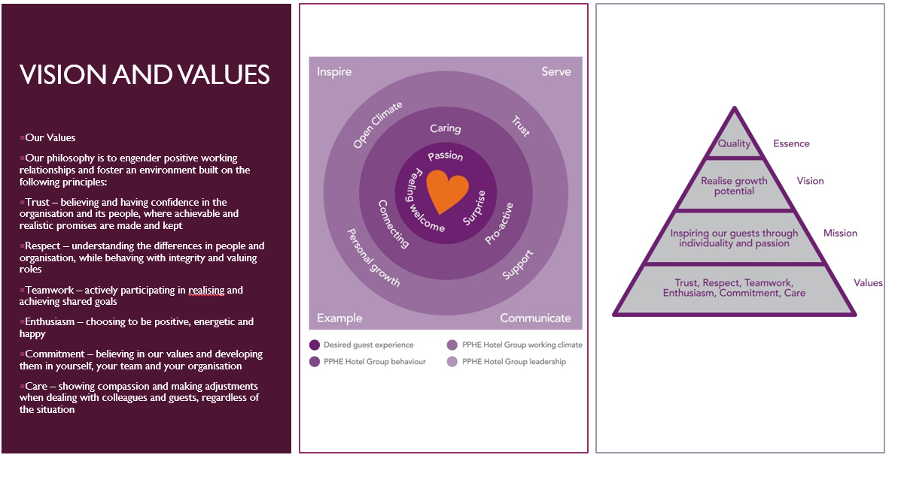
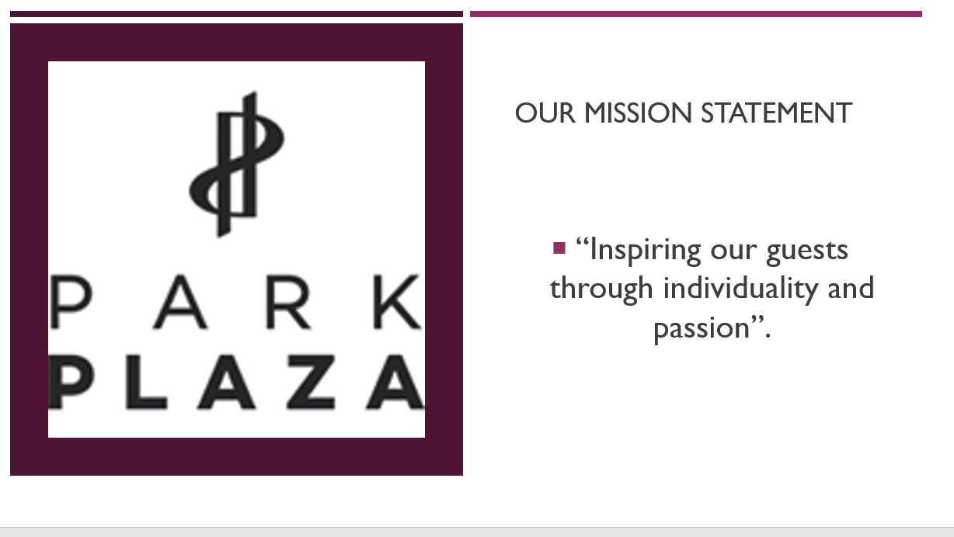

Appendix – B: Kitchen Display System



