

Student name: Binta Drammeh
Student ID: 2317261

Module name: Independent Project
Module code: BMHP6020
Supervisor’s name: Jolly Nwankwo

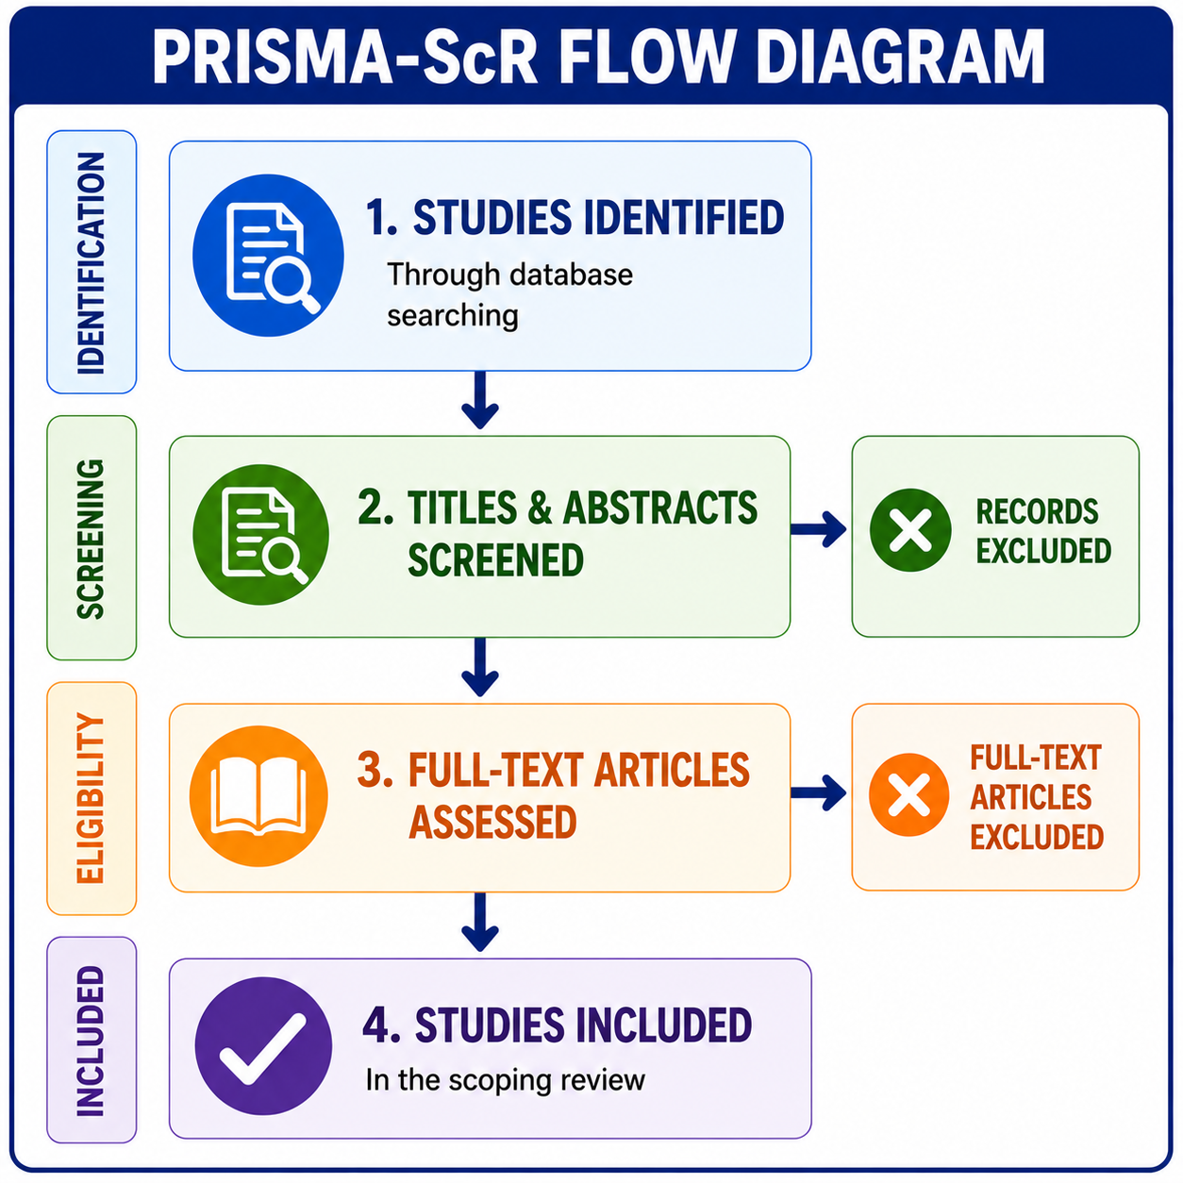 |  | Research Aim  The aim of this study is to explore the effectiveness of digital mental health interventions in improving the mental health and wellbeing of young adults (18–25 years) in the UK. The study also aims to identify the benefits, challenges, and gaps in the current evidence to inform future health and social care practice (National Institute for Health and Care Excellence, 2022). |  | 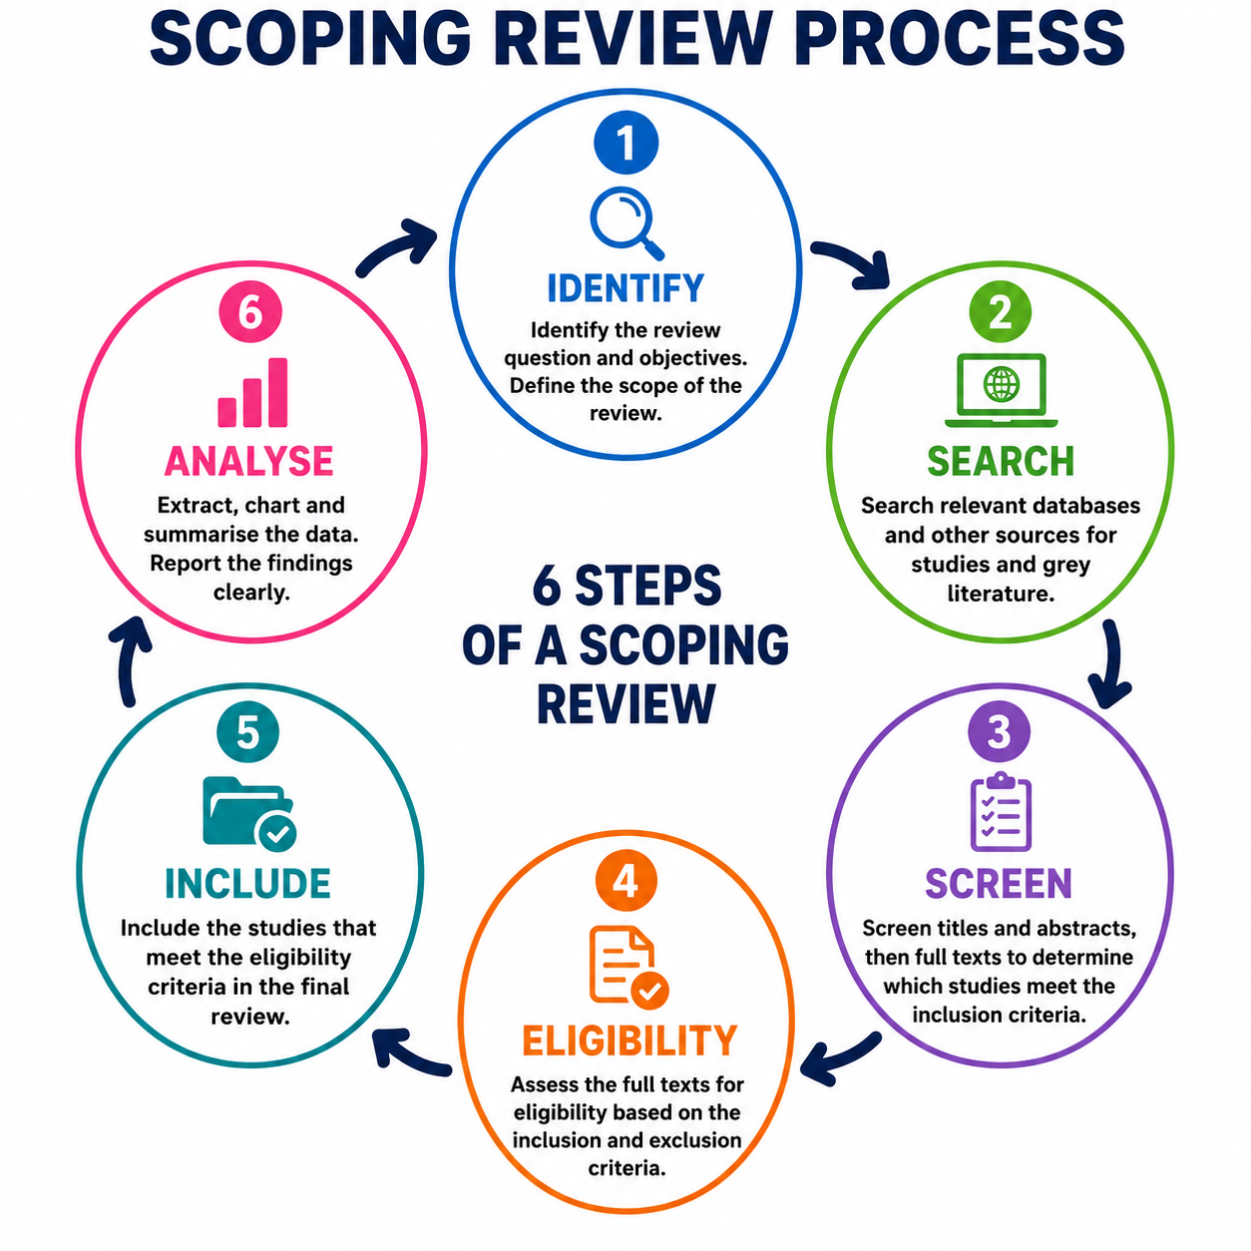
Methodology  This study uses a scoping review methodology. A scoping review was chosen because it is suitable for mapping existing evidence, identifying key concepts, and highlighting gaps in the literature related to digital mental health interventions for young adults in the UK (Arksey and O'Malley, 2005; Hilary Peters et al., 2020). This approach enables a comprehensive review of published research rather than collecting primary data from participants. The selected studies are systematically identified, screened, and analysed to provide an overview of the available evidence and to answer the research aim.  mapping existing evidence, identifying key concepts, and highlighting gaps in literature on a broad research topic (Arksey and O'Malley, 2005; Hilary Peters et al., 2020). |  |  |  | Data Analysis  The data were analysed using thematic analysis, a method used to identify, organise, and interpret patterns across the selected studies. This involved comparing the findings from each article to identify common themes, similarities, differences, and gaps in the existing evidence on digital mental health interventions for young adults in the UK (Virginia Braun & Victoria Clarke, 2006).  Ethical Considerations  As this study is a scoping review, no primary data were collected from human participants. Therefore, formal ethical approval was not required. The study used only published, peer-reviewed literature, and all sources were acknowledged appropriately to maintain academic integrity and avoid plagiarism (Health Research Authority, 2023).
 |  | Data Collection
 |  | Data were collected through a comprehensive search of published literature using electronic databases, including PubMed, CINAHL, PsycINFO, and Google Scholar. Relevant studies published between 2019 and 2026 were identified using keywords such as digital mental health, young adults, online therapy, mobile health, and United Kingdom. Studies were selected based on predefined inclusion and exclusion criteria to ensure that only relevant and high-quality evidence was included in the review (Hilary Peters et al., 2020).

References
Arksey, H. and O'Malley, L. (2005) ‘Scoping studies: Towards a methodological framework’, International Journal of Social Research Methodology, 8(1), pp. 19–32. Available at: https://doi.org/10.1080/1364557032000119616.
Page, M.J. et al. (2021) ‘The PRISMA 2020 statement: An updated guideline for reporting systematic reviews’, The BMJ, 372, n71. Available at: https://doi.org/10.1136/bmj.n71.
Peters, M.D.J. et al. (2020) ‘Updated methodological guidance for the conduct of scoping reviews’, JBI Evidence Synthesis, 18(10), pp. 2119–2126. Available at: https://doi.org/10.11124/JBIES-20-00167.
Pham, M.T., Rajić, A., Greig, J.D., Sargeant, J.M., Papadopoulos, A. and McEwen, S.A. (2014) ‘A scoping review of scoping reviews: Advancing the approach and enhancing the consistency’, Research Synthesis Methods, 5(4), pp. 371–385. Available at: https://doi.org/10.1002/jrsm.1123.
Trico, A.C. et al. (2018) ‘PRISMA Extension for Scoping Reviews (PRISMA-SCRA): Checklist and explanation’, Annals of Internal Medicine, 169(7), pp. 467–473. Available at: https://doi.org/10.7326/M18-0850.

