Course: BSc (Hons) Health and Social Care
Module: Independent Project (BMHP6020_BIRM)

Component 1: Element 1 - Project Proposal

Student ID: 2319163

Student Name: Rozilene Araujo

The Impact of Adverse Childhood Experiences on Long-Term Physical Health Outcomes in Adulthood: A Comprehensive Analysis

1) Aim
This research aims to examine the relationship between adverse childhood experiences (ACEs) and long-term physical health outcomes in adulthood. It will assess how early-life trauma influences the development of chronic illnesses and emphasise the importance of early intervention and trauma-informed care within health and social care practice.

2) Objectives

To achieve this goal, the following research objectives have been established:

- Define adverse childhood experiences (ACEs) and identify common forms of early-life trauma, including abuse, neglect, and household dysfunction.
- Using valid and appropriate current literature, analyse the association between ACEs and adult physical health conditions, such as cardiovascular disease, diabetes, and immune disorders.
- Evaluate existing evidence on the impact of prolonged stress exposure on biological systems and long-term health outcomes, and develop themes through a process of thematic analysis.
- Develop recommendations for health and social care professionals to strengthen early intervention strategies, support services, and trauma-informed approaches to mitigate the long-term effects of ACEs.

3) Background / Rationale

Adverse Childhood Experiences (ACEs) refer to stressful or traumatic events occurring before the age of 18, including abuse, neglect, and household dysfunction (World Health Organisation, 2022; Felitti et al., 1998). Research has consistently demonstrated that ACEs are strongly associated with poorer physical health outcomes later in life, including chronic diseases such as cardiovascular disease, obesity and diabetes (World Health Organisation, 2020; Caglayan et al., 2025). This relationship is often explained through prolonged stress responses, commonly referred to as toxic stress, which can disrupt brain development and alter immune, endocrine and neurological systems (Public Health England, 2020; Burke Harris, 2018; Soares et al., 2021). Furthermore, systematic reviews highlight a dose–response relationship, where exposure to multiple ACEs significantly increases the risk of long-term health problems (Hughes et al., 2017, Silva et al., 2024). This research is particularly important given the increasing burden of chronic disease on healthcare systems such as the NHS ( Hughes et al., 2017). This current study addresses the research gap by analysing how early experiences shape adult health and emphasising the importance of prevention and early intervention strategies.

4) Methods

A systematic search strategy will be employed, utilising keywords such as “adverse childhood experiences,” “chronic illness,” and “physical health outcomes.” The inclusion criteria will focus on peer-reviewed studies published within the last 10 years, while the exclusion criteria will eliminate non-English studies and those deemed irrelevant. This study will take a secondary research approach by analysing existing literature, including peer-reviewed journal articles, government reports, and policy documents accessed through academic databases such as JSTOR, PubMed and Google Scholar (Marzi et al., 2025). The selection criteria will prioritise credible, recent studies related to adverse childhood experiences and physical health outcomes. Data will be analysed using a thematic approach to identify common patterns, relationships, and key findings, with comparisons made between studies to highlight similarities and differences in the evidence (Marzi et al., 2025). Ethical considerations will include accurate referencing, avoidance of plagiarism, and responsible, critical use of all sources.

5) Resources

- Databases: PubMed, JSTOR, Google Scholar (peer‑reviewed research)
- Websites: WHO, NHS, UWTSD library resources
- Tools: MyBib, Refworks (referencing), MS Word, Grammarly (writing),
- Support: Lecturer, library staff, tutor, classmates
- Institutional: Library access, workshops, IT support, NVivo

6) Dissertation Timeline

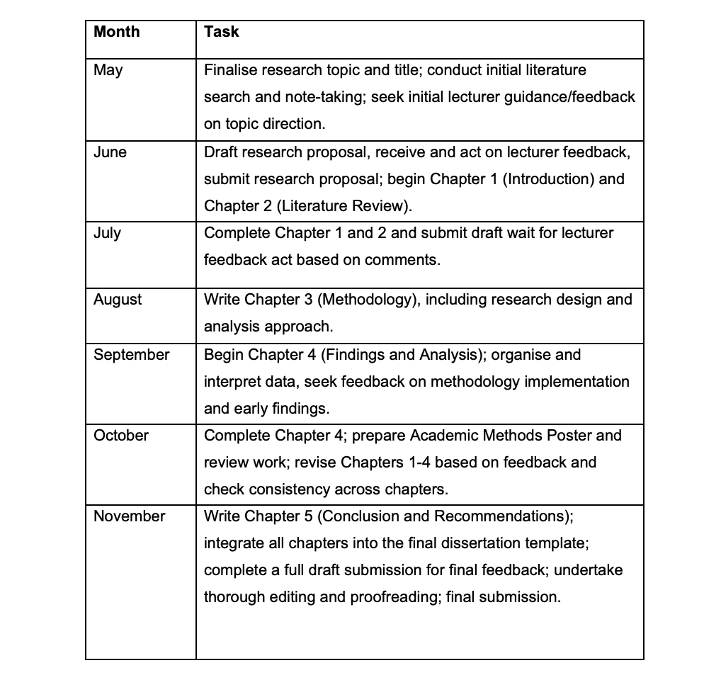

7) Self-Reflection as a Researcher

Throughout my degree journey, I have noticed improvements in my reading, note-taking, and critical review of academic materials. However, I have not carried out research to this extent, so I will seek guidance from sources on how to write a literature review, methodology, analysis, and discussion. I intend to communicate with my support network, lecturers, library staff, tutor, and classmates, and to utilise any feedback to improve my approach to this research and the outcome as best as possible.

Reference:
Caglayan, S., Høye, A., Thimm, J.C., Wang, C.E.A. and Grønli, O.K. (2025) 'Association of adverse childhood experiences with physical illness and self-rated health in the population-based Tromsø study', European Journal of Public Health, 35(3), pp. 498–504. Available at: https://doi.org/10.1093/eurpub/ckae223
Clarke, V. and Braun, V. (2017) 'Thematic analysis', The Journal of Positive Psychology, 12(3), pp. 297–298. Available at: https://doi.org/10.1080/17439760.2016.1262613.
Felitti, V.J., Anda, R.F., Nordenberg, D., Williamson, D.F., Spitz, A.M., Edwards, V., Koss, M.P. and Marks, J.S. (1998) 'Relationship of childhood abuse and household dysfunction to many of the leading causes of death in adults: The Adverse Childhood Experiences (ACE) study', American Journal of Preventive Medicine, 14(4), pp. 245–258. Available at: https://doi.org/10.1016/S0749-3797(98)00017-8
Harris, N.B. (2019) The deepest well: healing the long-term effects of childhood adversity. London: Bluebird.
Hughes, K., Bellis, M.A., Hardcastle, K.A., Sethi, D., Butchart, A., Mikton, C., Jones, L. and Dunne, M.P. (2017) 'The effect of multiple adverse childhood experiences on health: a systematic review and meta-analysis', The Lancet Public Health, 2(8), pp. e356–e367. Available at: https://doi.org/10.1016/S2468-2667(17)30118-4
Marzi, G., Balzano, M., Caputo, A. and Pellegrini, M.M. (2025) 'Guidelines for Bibliometric‐Systematic literature reviews: 10 steps to combine analysis, synthesis and theory development', International Journal of Management Reviews, 27(1), pp. 81–103. Available at: https://doi.org/10.1111/ijmr.12381
Public Health England (2020) No child left behind. A public health informed approach to improving outcomes for vulnerable children. Available at: https://assets.publishing.service.gov.uk/media/5f4e8896d3bf7f0a2d41c511/Public_health_approach_to_vulnerability_in_childhood.pdf (Accessed: 14 June 2026).
Silva, C., Moreira, P., Moreira, D.S., Rafael, F., Rodrigues, A., Leite, Â., Lopes, S. and Moreira, D. (2024) 'Impact of adverse childhood experiences in young adults and adults: a systematic literature review', Pediatric Reports, 16(2), pp. 461–481. Available at: https://doi.org/10.3390/pediatric16020040
Soares, S., Rocha, V., Kelly-Irving, M., Stringhini, S. and Fraga, S. (2021) 'Adverse childhood events and health biomarkers: a systematic review', Frontiers in Public Health, 9, p. 649825. Available at: https://doi.org/10.3389/fpubh.2021.649825
World Health Organization (2020) Adverse Childhood Experiences International Questionnaire (ACE-IQ). Available at: https://www.who.int/publications/m/item/adverse-childhood-experiences-international-questionnaire-%28ace-iq%29 (Accessed: 20 May 2026).
World Health Organization (2022) Preventing maltreatment and other adverse childhood experiences. Available at: https://www.who.int/publications/i/item/9789240049785 (Accessed: 22 May 2026).

