INFORMATION ENGINEERING

Student:
Jitariu Stefan
Teacher:
Suneth Fernando
Course:
Information Engineering

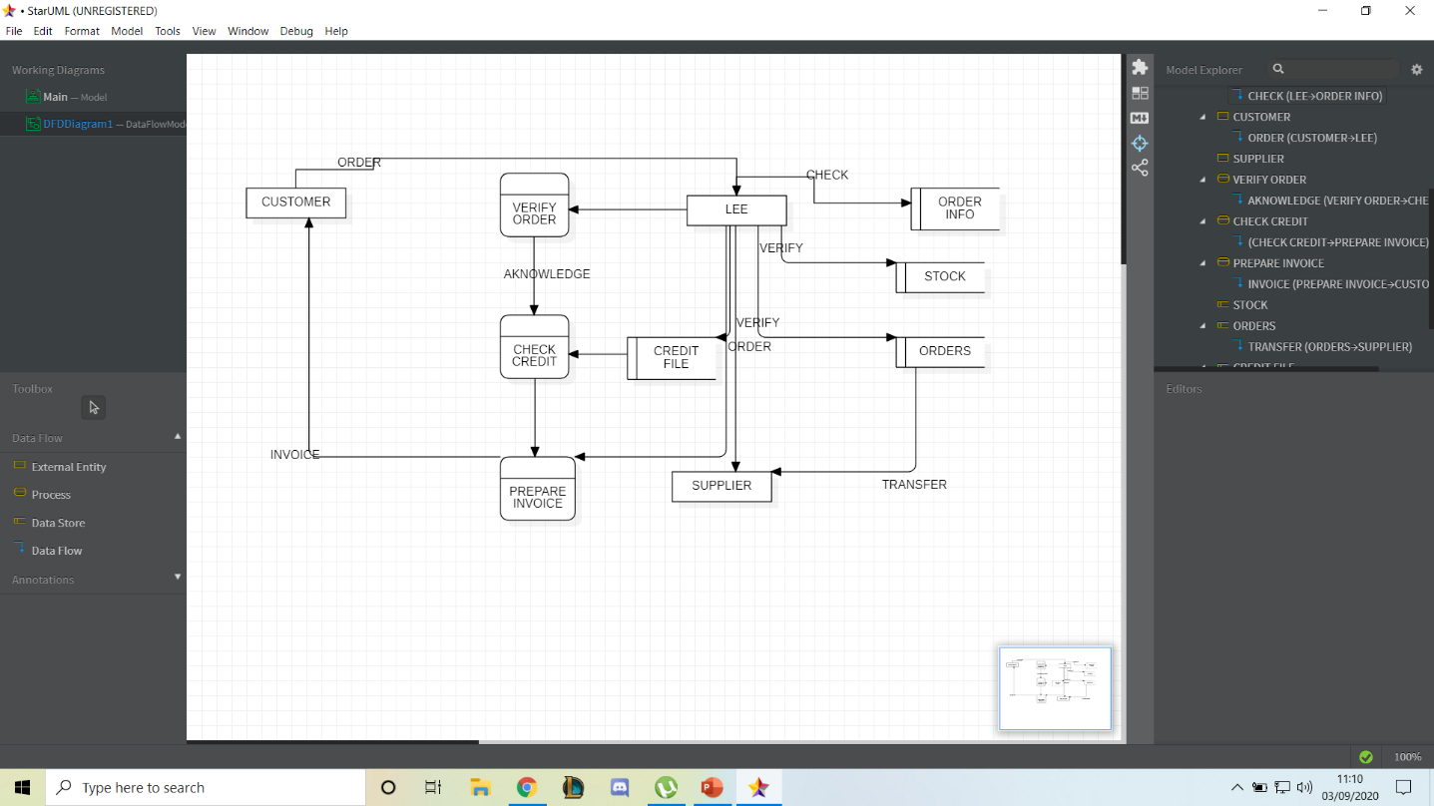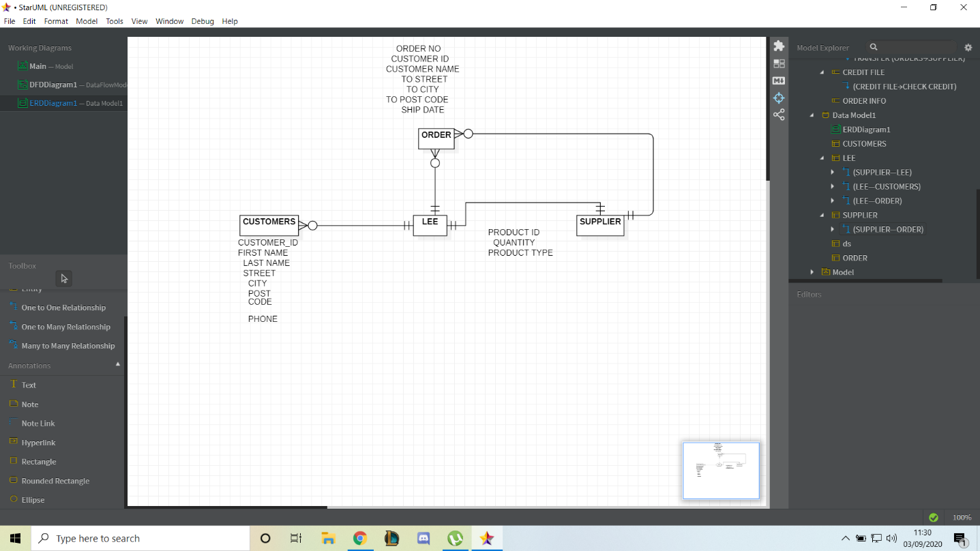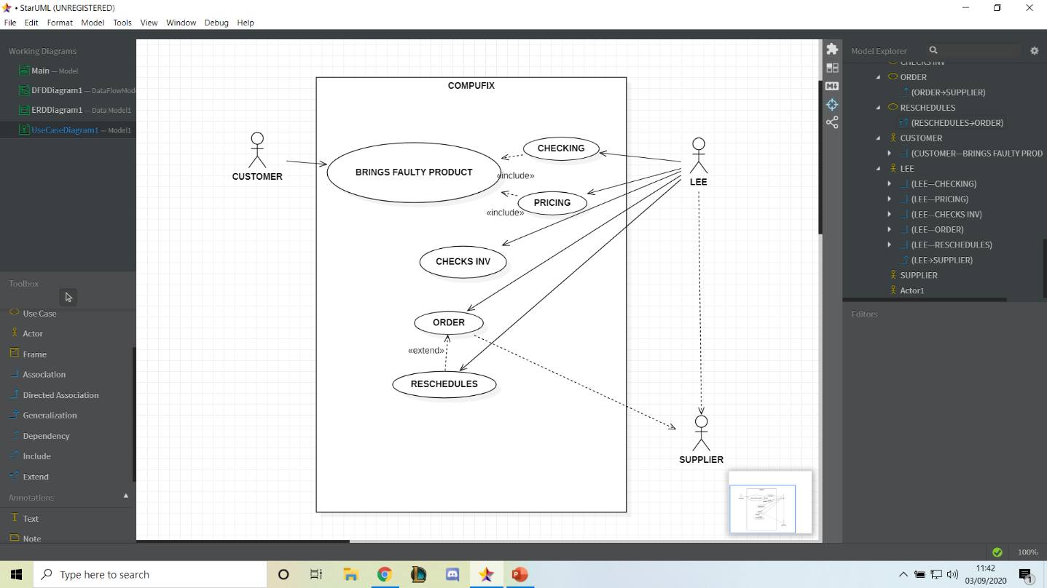

We can clearly see that Lee deals with the customers, having to process their details along with having to sort all of his customer orders. Being the only one, he has to make sure that he has all of the parts he needs. Otherwise, he will procced to order the parts he needs from a supplier and then he will need to reschedule. Pricing is also done by him depending on the faultiness of the product.
In the first diagram (DFD) we can clearly see all of these processes and the correlation between Customer, Lee and Supplier.
In the second diagram (ERD) we can tell that there is a one to many type of relation between Lee and customers, meaning that Lee needs to have more staff.

