Food &Beverage Operations
BMIH4002
Menu Engineering
Student id:2231047
Student name: Sidonia Bianca Mihu
Lecturer name: Ffion Cumberpatch

Table of Contents
1 Part A: Restaurant Concept 3
1.1 Target Audience 3
1.2 Reasoning 3
2 Part B: Menu Design 5
3 References 7

Part A: Restaurant Concept
Hotel Trinity's amazing new restaurant concept, honouring the varied and rich flavours of British food, is the newest addition to the renowned Trinity Hotel Chain, located in the heart of the UK. Visitors are taken on a culinary journey through the classic and contemporary flavours that have created the nation's gastronomic scene through this unique eating experience (Williams et al., 2019). The British Cuisine restaurant at Hotel Trinity delivers an unmatched dining experience that honours the nation's culinary heritage while being surrounded by a chic and welcoming atmosphere. The menu offers a scrumptious assortment of meals that reflect the distinctive regional delicacies found throughout the UK. It is inspired by the wide variety of fresh, local ingredients and time-honoured recipes (Zhang et al., 2019). The menu has been thoughtfully designed to highlight the finest British ingredients, guaranteeing a truly authentic and opulent dining experience. Visitors may experience the spirit of British cuisine through delicacies like luscious roasted meats, tender fish and chips, and aromatic pies rich with flavours, from hearty classics to modern inventions.

Target Audience
The Hotel Trinity and its British Cuisine restaurant serve a variety of target demographics, making sure that everyone has an enjoyable and memorable time there. It attracts sophisticated tourists looking for opulent and convenient lodging in the UK (Kothari, 2015). Business travellers, vacationers, and those attending conferences or events should choose the hotel because of its 4-star rating and convenient city centre location. The British Cuisine restaurant also appeals to food lovers and experts since it provides an upgraded and authentic dining experience that highlights the complex flavours of British gastronomy.

Reasoning
The menu options for the British cuisine restaurant at Hotel Trinity are carefully planned, taking into account both visitor tastes and the popularity of traditional British foods. These famous foods are prominently displayed on the menu in accordance with poll results from 2022, which showed that fish and chips and roast chicken emerged as the most popular British cuisine with high acceptance ratings.
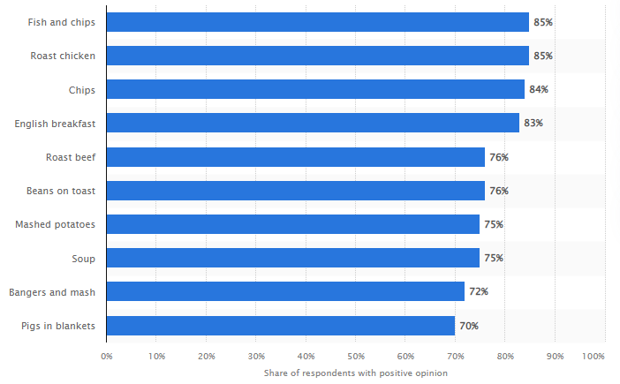
Figure 1: Popular Dishes from British Cuisine
Source: Statista, 2022
The restaurant's objective to offer a true and recognisable British dining experience is reflected in the inclusion of these well-known meals. The menu accommodates the tastes of those who value time-honoured staples by providing premium versions of British cuisine (Business Insider, 2015).

Part B: Menu Design
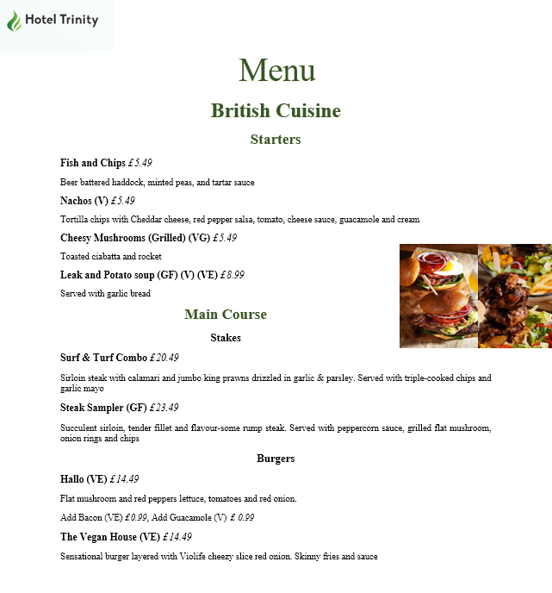
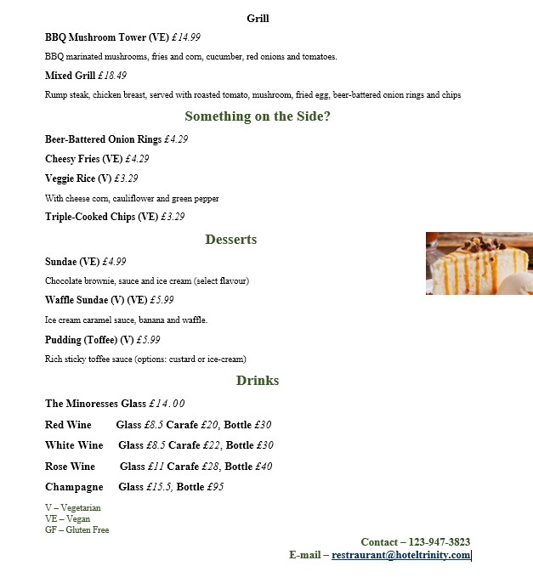

References
All Bar One, 2023. Menus - all our food & drinks menus at all bar one. [online] All Bar One. Available at: [Accessed 3 Jun. 2023].
Beefeater, 2023. What’s on the menu? [online] Beefeater. Available at: [Accessed 3 Jun. 2023].
Business Insider 2015. McDonald's is offering table service and a new menu. [Online] Available at https://www.businessinsider.com/mcdonalds-table-service-new-menu-2015-12 [Accessed on 3 June 2023]
Harrys restaurant, 2023. Nibbles starters steaks - harrys restaurant. [online] Harrys restaurant. Available at: [Accessed 3 Jun. 2023].
Kothari, U., 2015. Reworking colonial imaginaries in post-colonial tourist enclaves. Tourist Studies, 15(3), pp.248-266.
Penny Squares, 2022. Discover our menu. [online] Penny Squares. Available at: [Accessed 3 Jun. 2023].
Spice Village, 2023. every meal has a story. [online] Spice Village. Available at: [Accessed 3 Jun. 2023].
Statista 2022. Most popular British dishes in Great Britain (GB) as of Q3 2022. [Online] Available at https://www.statista.com/statistics/1351787/most-popular-british-dishes-in-great-britain/ [Accessed on 3 June 2023]
Williams, H.A., Yuan, J. and Williams Jr, R.L., 2019. Attributes of memorable gastro-tourists’ experiences. Journal of Hospitality & Tourism Research, 43(3), pp.327-348.
Zhang, T., Chen, J. and Hu, B., 2019. Authenticity, quality, and loyalty: Local food and sustainable tourism experience. Sustainability, 11(12), p.3437.

