Assignment 1

The Mechanics of Soils - Laboratory Testing

Geo-technics and Foundation Technology
ACBA5004

Prepared for

Allan Nantel

Completed by

Benjamin Davies (2012775)

Completed on

24/04/2022

Table of Contents
1.0 | Introduction | Page 3
2.0  2.1  2.2  2.3  2.4 | The Atterberg Limits Test  Introduction  Methodology  Results and Analysis  Conclusions | Page 3-7
3.0  3.1  3.2  3.3  3.4 | Sieve Analysis  Introduction  Methodology  Results and Analysis  Conclusions | Page 8-11
4.0  4.1  4.2  4.3  4.4 | Constant Head Permeability Test  Introduction  Methodology  Results and Analysis  Conclusions | Page 12-15

- Introduction
Soil testing, which has also been referred to as soil investigation or geotechnical investigation, is completed before the start of a build to determine the properties of soil. Civil Engineers will perform this to assist in establishing the soil conditions and whether or not the soil is solid enough to proceed with your construction project. Throughout the academic year we as a group have completed a series of tests to determine the mechanics of different soil. We do this within civil engineering for a number of reasons, like to determine the suitability of the soil and assess whether it can accommodate the requirements of the construction project. We also use it to identify different types of soils on site, we also use tests to determine the soil strength, density, compaction, contamination, organics and sand content which will help assess the soils impact on a construction project. We did many tests like the Atterberg limits test, sieve analysis, and the constant head parameter and the standard proctor test. I will go through some of the tests through this report starting with the Atterberg limit tests, followed by the Sieve Analysis, and finalised by the constant head permeability test.

2.0 Atterberg Limit Tests
2.1 Introduction
Soils intended to support structures, pavements, or other loads must be evaluated by civil engineers to predict their behaviour under applied forces and variable moisture conditions. Within geotechnical laboratories we measure particle size distribution, shear strength, moisture content, and the potential for expansion or shrinkage of cohesive soils. The Atterberg limits test is a classification tests used to determine the moisture content at which fine grained clay and silt soils transition between the different phases. The Atterberg limits are a basic measure of the critical water contents of a fine-grained soil: its shrinkage limit, plastic limit, and liquid limit. Depending on its water content, a soil may appear in one of four states: solid, semi-solid, plastic and liquid.
Atterberg Limits play a crucial role in the early stages of structural design to ensure that the soil performs as expected. Excessive changes in volume caused by moisture swings may cause settling or heaving of the structure.

2.2 Methodology
Equipment
- Wash Bottle to dispense mixing water
- Mortar and Pestle for particle size reduction
- Spatula for mixing forming and smoothing soils
- Aluminium Containers for soil moisture samples
- Liquid limit / Plastic limit set with Casagrande cup
- Weighing Scales
- Grooving tool
- Glass plate to roll out threads of soil
- Evaporating Dishes to mix soil and water
- Drying Laboratory oven

Step by Step Guide for Liquid Limit test
1. Choose, mark and weigh four containers.
2. Record the container weight.
3. Place a soil sample of around 250g in the metal mixing bowl and thoroughly mix with 1-2ml amounts of water by stirring, kneading and chopping with a spatula. Mix thoroughly so as to produce a clay consistency that will require 30-35 drops of the Casagrande apparatus to cause a groove gap closure of 12mm.
4. Test is trial and error until the required consistency is reached.
5. When the right consistency is reached, place a portion of the mixture into the cup bowl, squeezing the clay down with the spatula, and spreading it, as flat as possible, across the base to a depth of 10mm approx. Avoid air bubbles in the sample.
6. Return excess soil to the mixing bowl.
7. From back to front, use the gauging groove tool to cut a groove (in three gentles swipes to avoid side tear) right through the sample to the base of the cup.
8. Zero the drop counter on the cup apparatus.
9. Lift and drop the cup by turning the crank handle at a rate of 2 revolutions per second, until the two halves of the soil close over a distance of 12mm across the slot you made with the gauge tool.
10. Record the number of drops required to close this 12mm gap.
11. Remove a slice of soil the width of a spatula from edge to edge across the sample, cutting through the groove.
12. Place this in your marked container and weigh the wet soil and container together.
13. Repeat for four samples, gradually increasing the moisture content slowly, to reduce the number of blows required to close the gap. The object being to obtain samples that require above and below 25 drops to close the gap, The number of drops should range between 35 and 15
14. Dry the four samples in the oven and weigh the dry sample and the container together to determine moisture contents.
Step By Step Guide for Plastic Limit
1. Choose, mark and weigh three containers.
2. Record the container weight.
3. Thoroughly knead the clay sample. If necessary, mix with water or dried
clay to adjust the moisture content to required limits
4. Mould a small ball of clay between the fingers and roll between the
palms of the hands so that the warmth of the hand dries it slowly.
5. When slight cracks begin to appear on the surface, divide the ball into
three equal parts of about 10g each. Keep them separate.
6. By measuring against the glass rod provided, roll each ball into a thread
on the glass plate of around 6mm in diameter. The thread must be intact
and homogenous.
7. Using steady rolling pressure with the palm of the hand, reduce the
diameter of the thread to around 3mm.
8. Repeat this process until the thread starts to 'crumble' at around the
3mm diameter mark. It is important to maintain uniform rolling pressure
throughout. 'Crumbling' is defined as shearing both longitudinally and
transversally as it is rolled.
9. Crumbling must be due to the reduction of moisture as a result of rolling
directly, and not by mechanical breakdown due to undue pressure from
the hand.
10. The crumbling point is the Plastic Limit moisture content.
11. As the crumbling stage is reached, gather together the crumbs, place
them in your container and weigh the wet soil and container together.
12. Repeat the above for three samples.
13. Dry the three containers with the sample inside in the oven.
14. When dry, calculate the moisture content by weighing the container
and dry soil together. Take the average of all three results to obtain the
moisture content mean.
15. This moisture content mean is the Plastic Limit moisture content
indicator.

2.3 Results and Analysis
 | 1 | 2 | 3 | 4 | 5 | 6 | 7
Type of test | LL | LL | LL | LL | PL | PL | PL
Container Number | 5 | 6 | 7 | 8 | 1 | 2 | 3
Wt of wet soil + cont | 12.7g | 8.6g | 10.51g | 12.44g | 7.03g | 6.67g | 7.29g
Wt of dry soil + cont | 10.53g | 7.79g | 9.22g | 10.55g | 6.66g | 6.31g | 6.88g
Wt of container | 4.73g | 4.69g | 4.73g | 4.71g | 4.67g | 4.69g | 4.72g
Wt of moisture | 2.17g | 0.81g | 1.29g | 1.89g | 0.37g | 0.36g | 0.41g
Wt of dry soil | 5.8g | 3.1g | 4.49g | 5.84g | 1.99g | 1.62g | 2.16
Moisture content | 37.4 | 26.1 | 28.7 | 32.4 | 18.6 | 22.2 | 19
No of blows | 45 | 43 | 26 | 22

Here are my results for the tests which were conducted on Tuesday 30th February 2022, the samples were dried in an oven at 110 degrees C for 24 hours, I conducted the test a few times to ensure a good ideal result. The Plastic Limit (PL) is the moisture content at which a fine-grained soil can no longer be remoulded without cracking. The Liquid Limit (LL) is the moisture content at which a fine-grained soil no longer flows like a liquid
Moisture content = weight of moisture. x 100
Weight of dry soil

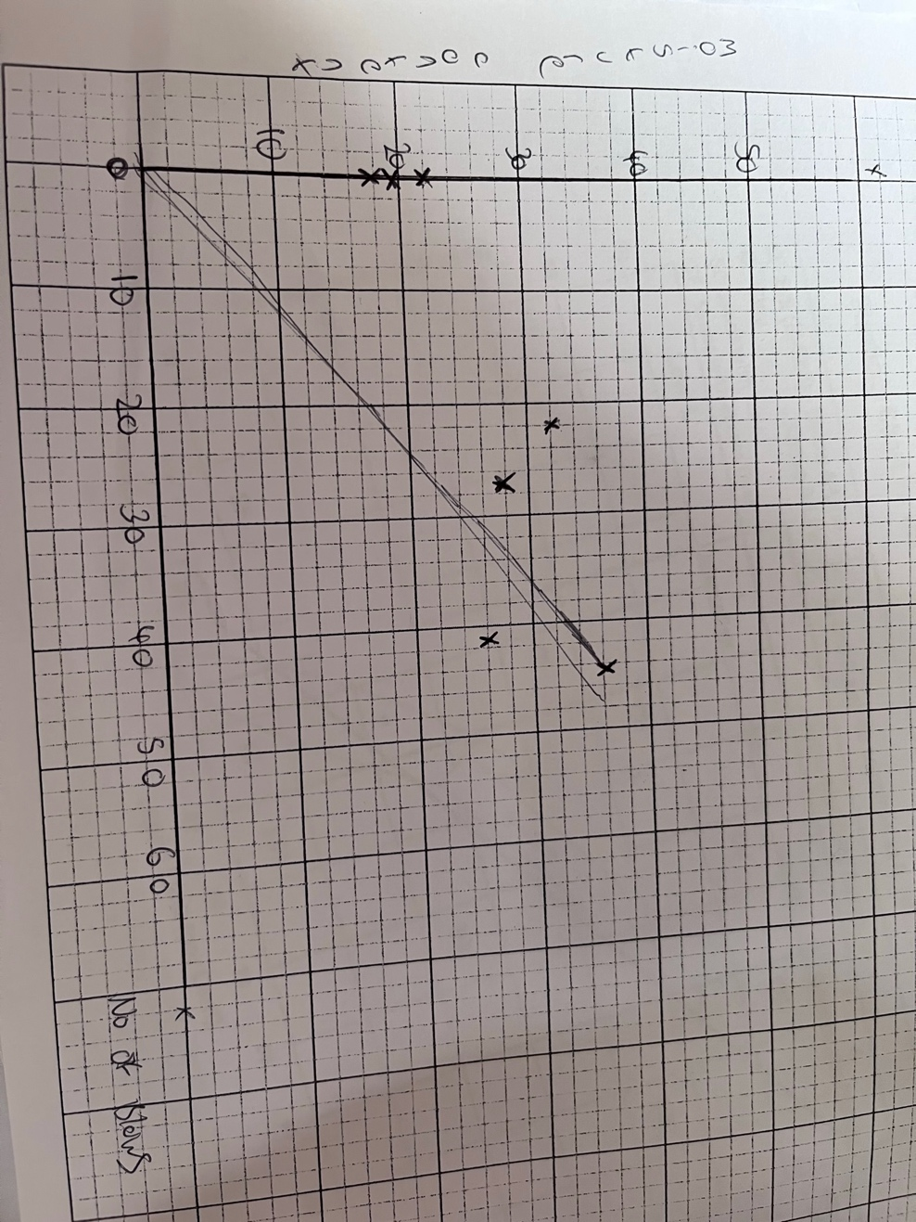
2.4 Conclusion
I believe the tests went well, there were no anomalies of note, I think I learned a lot through this test. Atterberg limits are crucial for classifying fine-grained soils. These few moisture contents allow an engineer to know various properties of the soil and how it will act under the pressure of a structure. Atterberg limits also help engineers know what areas to avoid building in due to poor numbers from sampled soils.

3.0 Sieve Analysis
3.1 Introduction
Sieve analysis test is an analytical technique used to determine the grain size distribution of soils that are greater than 0.075 mm in diameter. The sieve analysis technique involves several layers of sieves with different grades of sieve opening sizes. It is usually performed for sand and gravel but cannot be used as the sole method for determining the grain size distribution of finer soil. The size distribution is often of critical importance to the way the material performs in use. Gradation is usually specified for each engineering application it is used for. For example, foundations might only need coarse aggregates and therefore an open gradation is needed. Sieve analysis determines the particle size distribution of a given soil sample and hence helps in easy identification of a soil's mechanical properties. These properties determine whether a given soil can support the proposed engineering structure.

3.2 Methodology
Equipment
- Bowls
- Electric Vibrating Sieve Machine

Step By Step guide
1. Weigh the scale pan
2. Quarter a sample of soil, use a sample size of around 2kg
3. Accurately weigh the total sample to the nearest 0 1 g
Record this weight
4. Place the set of sieves, with the largest opening on top, onto the pan
stack and pour the aggregate onto the top sieve.
5. Secure the stack onto the vibration machine.
6. Use a mechanical shaker to vibrate the sample for 2 minutes.
After two minutes, stop the machine and remove the lid.
7. One by One, release each sieve carefully.
8. Brush particles clinging to each sieve into the next lower sieve with a bristle brush. Ensure no material is lost.
9. Determine the individual weights to the nearest 0.1 g of aggregate
retained on each sieve and record these weights.
10. Pour the retained aggregate into the tray covered with plastic.
Transfer the aggregate carefully to the pan of the scales. Record the
weight.
11. Repeat this process for the next size sieve
12. Repeat this process until the weight of the material on each sieve has been recorded
13. Report the percentages to the nearest 0.1% for each size of
aggregate retained on each Sieve
14. Take care to prevent loss of material during the sieving operation.
However, if there is a small discrepancy (less than 0.2%) between
the original dry weight of sample and the sum of the weights of the
various sizes, assume the small amount as particles passing the
smallest size sieve and use the original weight, if the discrepancy is
large (greater than 0.2%), check the weights of the various sizes or
rerun the analysis with a new sample to correct the error.
15. Plot sieve size against percentage passing for the sample on the
graph paper provided

3.3 Results and analysis
Sample Size 1500kg

Sieve Size (mm) | Mass (g) | % on sieve | % passing
4mm | 703.41g | 46.91% | 53.09%
2.36mm | 150.77g | 10.05% | 43.04%
1.6mm | 47.88g | 3.19% | 39.85%
600um | 73.72g | 4.91% | 34.94%
300um | 368.19g | 24.55% | 10.39%
160mlc | 121.93g | 8.13% | 2.26%
80mlc | 23.32g | 1.55% | 0.71%
Pan | 6.05g | 0.4% | 0.31%

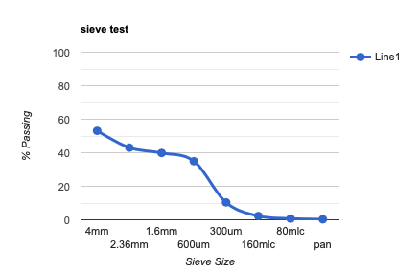

3.4 Conclusions

As a conclusion on my experiment, I can gather that from the data I found, that from sieve size 4mm to 600um it is coarse aggregate, Grains of this size can generally be seen with the naked eye, although a handheld magnifying glass may occasionally be needed to see the smallest of the grains. Gravel and sand are coarse grained soils. Also, from 600um to 160um it is fine soil, Fine-grained soils have 50% or more material passing the sieve, and from 160um to pan it is silt, Silt soil is very fine and feels almost floury to the touch when dry. When wet, it becomes a smooth mud that you can form easily into balls or other shapes in your hand. When silt soil is very wet, it blends seamlessly with water to form fine, runny puddles of mud.

4.0 Constant Head Permeability Test
4.1 Introduction
The constant head permeability test is a common laboratory testing method used to determine the permeability of granular soils like sands and gravels containing little or no silt. This testing method is made for testing reconstituted or disturbed granular soil samples.
The constant head permeability test involves flow of water through a column of cylindrical soil sample under the constant pressure difference. The test is carried out in the permeability cell, or permeameter, which can vary in size depending on the grain size of the tested material. The soil sample has a cylindrical form with its diameter being large enough in order to be representative of the tested soil. As a rule of thumb, the ratio of the cell diameter to the largest grain size diameter should be higher than 12 (Head 1982). The usual size of the cell often used for testing common sands is 75 mm diameter and 260 mm height between perforated plates. The testing apparatus is equipped with a adjustable constant head reservoir and an outlet reservoir which allows maintaining a constant head during the test. Water used for testing is de-aired water at constant temperature. The permeability cell is also equipped with a loading piston that can be used to apply constant axial stress to the sample during the test. Before starting the flow measurements, however, the soil sample is saturated. During the test, the amount of water flowing through the soil column is measured for given time intervals.

4.2 Methodology
Equipment
- Wooden Stand with 3 Manometer Tubes
- Constant Level Water Tank
- Tamping Rod
- Manometer Tubes
- Connection Hoses

Step By Step
- Through the top inlet of the constant head reservoir, the specimen is connected.
- The bottom outlet is opened, and a steady flow is established
- For a particular time, interval, the quantity of flow can be collected.
- Measure the difference of head in levels between the constant head reservoir and the outlet in the base.
- For the same interval, this is repeated three times.
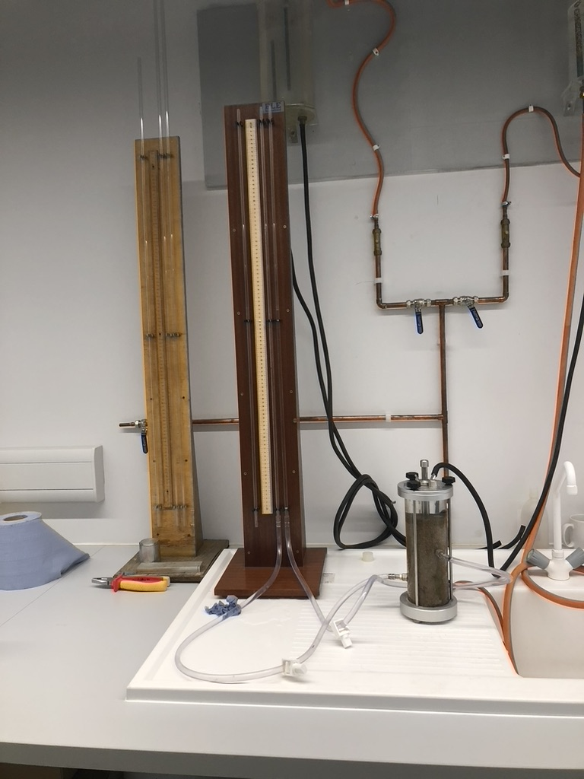

4.3 Results and Analysis
Test 1

Volume of water collected(m³) | 157ml  0.000157m³ | 318ml  0.000318m³ | 440  0.000440m³
Time (s) | 20.09s | 40.09s | 59.9s
Q

T

Height of diff pressure points | 0.592M
Length of the flow line | 0.66m
Cross sectional area | 0.00478m²

H

L

A

K = Q x L.
A x H x T

- K = 0.000157 x 0.66m
0.000478m²x 0.592 x 20.09. = 0.001822695

- K = 0.000318 x 0.66m
0.00478m²x 0.592 x 40.09. = 0.001850058

- K = 0.000440 x 0.66m
0.00478m²x 0.592 x 59.9. = 0.00171324
Average = 0.001795331

Test 2

Volume of water collected(m³) | 380ml  0.0000380³ | 725ml  0.0000725m³ | 1225ML  0.00001225m³
Time (s) | 15s | 30s | 45s
Q

T

Height of diff pressure points | 0.592m  0.14M
Length of the flow line | 0.072m
Cross sectional area | 0.00478m²

H

L

A

K = Q x L.
A x H x T

- K = 0.0000380 x 0.072m
0.000478m²x 0.592 x 20.09. = 0.00064457

2. K = 0.0000725 x 0.072m
0.000478m²x 0.592 x 30. = 0.00061489

3. K = 0.00001225 x 0.072m
0.000478m²x 0.14 x 45. = 0.00029288
Average=0.00045431

4.4 Conclusions

As a conclusion, we get the time is found to be constant at volume of water. The time we get is faster. This is because the permeability of the soil that absorbs the water is low. Therefore, the water diffusion rate is low. From the coefficient of permeability for the given sample of soil value, we can say that the rate of flow the sample has got means the value is higher

