Entrepreneurship in 2021

Student: Marius Ionut Saiz
Student number: 1605685
Module: Entrepreneurship (LCMB7004)
Lecturer: Dr. Nandish Patel

Table of Contents

Introduction.......................................................................................................................................3

Aim of Reports...................................................................................................................................4

Entrepreneur, Entrepreneurship and Enterprise……………………………………………………………….............4

Entrepreneurs Environment and Cluster Theory ………………………………………………………………............5

Law of diffusion of Innovation Model...............................................................................................6

Innovative Theory..............................................................................................................................6

Personality traits Theory....................................................................................................................7

Need for Achievement Theory...........................................................................................................9

Financial Capital / Liquidity Theory...............................................................................................................................................10

Not for Profit Organizations.............................................................................................................11

Leadership trait in Not For-Profit Organization................................................................................11

Role of entrepreneurs in Not-for-Profit Organisation.......................................................................................................................................11

For profit organization.......................................................................................................................11

Leadership traits For-profit Organisation..........................................................................................11

Role of Entrepreneur in For-profit organization.................................................................................12

Conclusion...........................................................................................................................................12

Reference............................................................................................................................................13

Table of Figures
Figure1 —Entrepreneur
Figure2—Entrepreneur, Entrepreneurship & Enterprise
Figure3—Diffusion Model
Figure4—Personality Trait Theory
Figure5—Need for Achievement Theory


Figure 1: Entrepreneur
Source: (Seth, 2019).

The entrepreneur position has been described as identifying outstanding market success and the corresponding introduction of advanced capital investment, usually through establishing a new company (Reynolds, 2005).The entrepreneurship and innovation role entails identifying, evaluating, and designating probabilities such as imported products, facilities, construction methods, modern techniques, administrative structures, and emerging businesses for virtually unlimited commodities and supplies. The entrepreneur potential is an unexploited and undervalued equity fund. Since multiple departments have clear perspectives about the comparative effectiveness of interventions and when properties are converted through the ugh raw material to finished product, entrepreneurship challenges arise. The entrepreneur's theory reflects upon this spectrum of opinions about its importance of capital (Alvarez, 2001).

Aim of Report
This report examines entrepreneur traits that motivate entrepreneurs, their characteristics, and attitudes through the theories and analyse entrepreneurship outcomes. The corresponding studies clarify the relationship between entrepreneur, entrepreneurship and enterprise. The field of entrepreneurship has some exciting and relevant theories underpinned by empirical research evidence.

Entrepreneur, Entrepreneurship, and Enterprise
A business organization built up to produce goods, provided services to the community, and contributed to the national economy by export and import; that establishment is called an enterprise. The enterprise is a business platform in which the individual invests capital, then raised an enterprise and began working with entrepreneurs. The characteristics such as skills, capabilities, threads, and originality help entrepreneurs run enterprises known as entrepreneurship. We can correlate these three terms as the enterprise is the scene, entrepreneurs are actors, and entrepreneurship is the act. When these three works with each other at the time of economic dilemma and make the circle in working order, its evolutionary play is shown by the actor's outcome. The enterprise characterizes the act (Mendel, 2020).
Entrepreneurship is dedicated and autonomous; it integrates harsh judgment and reasonable strategies with threat affinity. They are motivated, persistent, and distinctively optimistic (Kuratko, 2007).
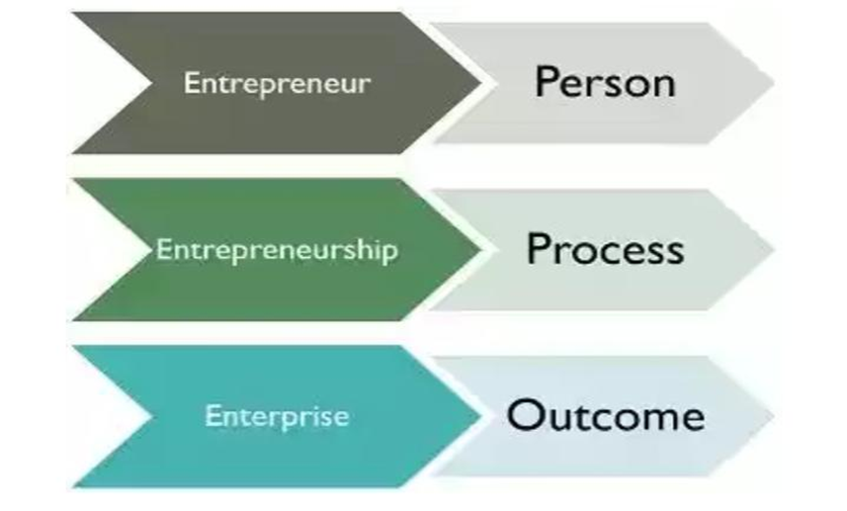
Figure 2: Entrepreneur Strategies
Source: (Mendel, 2020).

Entrepreneurs Environment and Cluster Theory
Cluster theory, introduced by Porter and his co-worker Feldman, states the successful competitive process that enables regional manufacturing regions to perform assets. A responsive industry, exposure to suppliers, organization clusters encourage investment, promote integration and diffusion of quality, and attract innovation are all factors that influence the collaboration among competitiveness, geographical area, and creativity (Sawyer, 2003).
Business people are frequently enmeshed in socioeconomic or national entrepreneurship frameworks. This cultural status will clarify how entrepreneurs originate from native educational institutions, engage targets, and create frameworks that assist them in "spinning off" several significant businesses, eventually forming a cluster. Productive entrepreneurs make adjustments and develop a structure that supports their operations over the period by using the available tools. Diffusion is the term for the emigrants of product creativity like this (Bischoff, 2021).

Law of Diffusion of Innovation Model (DOI)
The law of Diffusion and Innovation is a concept that describes why and how systems are created. Moreover, it is transmitted across societies and cultural structures. This model consists of five steps that help carry on any enterprise's procedure, i.e., confirmation, implementation, decisions, persuasion, knowledge. The social structure officially recognizes and integrates additional benefits (Fetters, 2010).
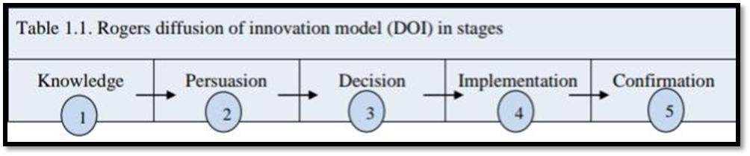
Figure 3: Rogers Diffusion of Innovation Model
Source: (Fetters, 2010).

The interaction between businessman, the invention, and the consumer influences the diffusion model, explaining why technological diffusion may occur. For instance, In Jobs' situation, diffusion involves his market parameters and alliances on the business environment's rising trend (Sayginer, 2020).

Innovative Theory
According to J.A. Schumpeter's theory, a venture capitalist is essentially a designer, and an innovative vendor is someone who brings new configurations. "Innovation begins with creative solutions that are eventually translated into discoveries, facilities, procedures, and methodologies," (Nussbaum, 2005). The key theme of innovative theory is creativity. Then he claims, finds new techniques and technologies. An entrepreneur, on the other hand, uses discoveries and inventions to create new variations. He creates new and improved products with the aid of these various variations. Creative thinking and developing it into implementable channels for new ideas may be the key to creativity and profit margins (Stevenson, 2020).
Example
Jobs' innovative steps at Apple and Pixar resulted in increased profit margin, transformative innovations, and a new norm for pioneering many markets. Apple earned a 24.84% ranking as the most creative organization in several sectors, not only this. The maximum score was given to Apple, with 3M came in second with 11.77 percent, accompanied by Microsoft with 8.53 percent. Apple earned a best rating relying on a reputation for offering excellent customer services with incredible innovations that established business strategies and technological channels (Nussbaum, 2005). This sentence explained how Jobs fuelled Apple's creative and sustainable success. Apple corporation will analyse jobs' management skills in the corresponding domain as possible measures of Apple's business effectiveness.

Evaluation of Scenario
This theory Entities who strictly run a well-established company despite conducting ground-breaking operations are not eligible. The most active form of business is innovative entrepreneurial However, in developing economies, this kind of entrepreneurial is uncommon in progressing countries. It put an excessive amount of focus on novel features. However, it lacks the dimensions of innovation that include taking risks and planning.

Personality Traits Theory
McClelland concluded, a consequence of somebody's culture, in which one's entrepreneurial behaviour was ingrained over one's personality and attitude. Personality traits and attributes of entrepreneurship, who often are described as very well with a range of contexts, are frequently examined by scholars and the school of entrepreneurial (Vandor, 2021).
According to Coon, “personality traits are sustainable attributes that an individual experiences in most circumstances" (Coon, 2004). In the personality traits, a person's instinctual characteristics or possibilities automatically mean he is entrepreneurial. Three components affect entrepreneur productivity:
- perceptions about his profession;
- The adjudicating organizations' task standards, and
- the job's organizational specifications.
The most aggressive acts of behaviours and role perceptions in this situation are a community in general principles.
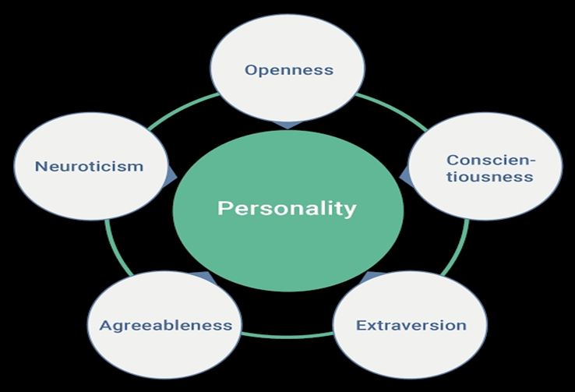
Figure 4: Personality Traits
Source: (Liu, 2021).

Example
Steve job dropout from college in the 1950s, depressed but motivated by a passion for creative technology and design. Jobs began his journey to a familiar guy's machine in a workshop at Cupertino with Wozniak (Jeffrey, 2005). Decades later, Jobs explains how his dedication helped him overcome feelings of displacement preceding, throughout, and then after the successes and disappointments stories that came to be associated with him currently.
Evaluation of Scenario
Its focus on external variables which are included in the theory. Revenue is by far the most potent motivator for entrepreneurs to engage in high-risk conduct. Even the desire for success stems from the profit-making method. It is suggested in the course of accomplishment. Aside from that, an entrepreneur is supposed to take on administrative responsibilities. However, the theory falls short of meeting any of these criteria (Jeffrey, 2005).

Need for Achievement Theory
The theory of achievement has accepted that people must accomplish, fulfil, succeed or accomplish their targets. This theory's feature emphasizes the requirement to implement maintaining innate characteristics and the influence of organisms' expectations on the positive reinforcement of their lives. This desire to achieve and accomplish motivates entrepreneurship. The only persuasive person logical factor relevant to new businesses' formation is empowerment. Mohar, Singh, and Kishore found that taking risks and being inventive and the desire to succeed and the ability to tolerate uncertainty had a positively significant impact on entrepreneurial propensity (Saif, 2020).
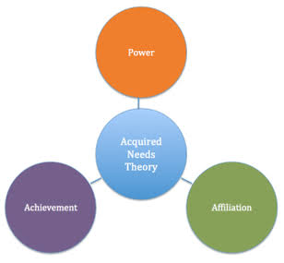
Figure 5: Need of Achievement
Source: (Ndofirepi, 2020).

Example
Steve's job's inspiration to excel and progress despite the perceived effects of being "ideologically, socially, or traditionally displaced from a community" (Kuratko, 2007). In thirty years, Steve has demonstrated his enthusiasm and dedication to creativity by disrupting three businesses: Technology, Music, and Movies. To achieve success needs to have constant optimism encourages a strong sense of self-efficacy and a good understanding of reality and mockery.

Evaluation of Scenario
The base on cognitive skills of entrepreneurial activity revealed that multiple performance alignment enhances entrepreneurial success. However, McClelland's analytical, conceptual instrument is strongly suspected. Still, one wonders whether many of those who are assessed to be highly effective will use it in implementation in developed countries as it is improved (Vandor, 2021).

Financial Capital/Liquidity Theory
According to the Clausen, 2006 this theory implies that persons with a finance centre can more efficiently gain funds and establish a company to take advantage of potential entrepreneurs (Clausen, 2006). Nevertheless, most of the entrepreneurs establish new companies with no funding, and the likelihood of becoming potential investors is not linked to investment assets substantially Recent studies have shown that new companies are established more often when investors have adequate financial resources (Blanchflower, 2001).

Example
A three-year Government currency may pay 2% interest, a 10-year Government currency may pay 4% interest, and a 30-year Government Currency may pay 6% interest. In compensation for deciding to take the money confined for just a long span of duration, the entrepreneur could earn a better interest rate in return for sacrificing liquidity.

Evaluation of Scenario
As per Clausen ,2006 apparent ambiguity arises from the reality that analysis linked to the theory of liquidity restrictions seeks to decide, if a leader's financial liberalization is dictated by the level of money used to launch a new company (Clausen, 2006). According to this theory, entrepreneurs have individual-specific features to recognize exciting challenges and assemble extra capabilities for their small venture (Alvarez & Busenitz, 2001). According to research, some people get better at recognizing and exploiting resources than others because they also have further awareness and expertise (Anderson, 2003).

Not for Profit Organisation

Non-profit organizations (NPOs) are described by Salamon and Anheier (1998) as independent, self-governing organizations, which do not recover income to their shareholders or representatives and rely on voluntary transactions. Entrepreneur creates events in responding to their representatives' demands or the broader community in NPOs (Horvat, 2020).

Role of Entrepreneur in Not-for-Profit Organization
Leadership style is an entrepreneurial endeavours characteristic that relates to "an individual's self - motivated and self-idea to leadership leads moving beyond, what would be officially expected in a specified position" (Frese, 1997). Business people need to show steps to established not-for-profit organizations to find and take advantage of opportunities before others do and constructively handle sensitive circumstances, so attitude and constructive behaviour indicate a significant role. The personal effort has been associated with fundraising and execution activities for volunteers help. Entrepreneurs and non-profit organizations' leadership distinguished themselves by Comparing to others, accommodating, diligent, psychologically secure, and receptive to practice. They also characterized themselves as possessing a high level of self-efficacy, internal motivation, commitment, risk-taking, and accepting responsibility (Rauch, 2010).
Not for profit entrepreneurs who are financially oriented but also have entrepreneurial leadership styles can place funds to good use by establishing independent sources of income in their organizations. Furthermore, the new analysis suggests that people with an "entrepreneurial mindset" are great contenders for entrepreneurial practice since they profit from it. As a result, understanding Not Profit Organisation leaders' characteristics and intentions will guide assessments on who gets access to multiple contents and instructional initiatives (such as charity administration or social skills development) and job placement. Not profit organization is solely concerned with its survival, and entrepreneurs make it possible with their entrepreneurial skills.

For Profit Organization

For-Profit company is one whose primary intention is to create money or profit. For-profit businesses aim to make money from their investors. Entrepreneurs want to make money off of their employees. Selling is the yardstick on which these businesses judge their performance. They also evaluate their performance in terms of benefit (Faulk, 2020).

Role of Entrepreneurs for Profit Organisation
The entrepreneur leadership will regulate profit organization but would look for opportunities using entrepreneurial skills methods. In For-profit organizations, entrepreneurs' main interest is to find opportunity and then focus on developing a business model that will allow them to build innovative structures with certain beliefs. It must involve prior knowledge to build a business model that provides profit to the entrepreneur instead of the economic profit often pursued in large companies. Accounting for the fact development and growth and policy objectives, and predictive maintenance are leadership skills utilized by entrepreneurs for profit organization. For taking a Leadership for profit organization, an analysis of the work line takes place and a functional skill that encompasses an organization and ability to effectively "conduct," control, or direct other people involved in the organizational level. Entrepreneurial leaders accept responsibility for their decisions, which must be constructive rather than responsive. They consider how to attain organizational performance in a novel way, collaborating with a complex community of citizens and assets to profit.
Entrepreneurship is a constructive endeavour that engages organization. For sustaining organization entrepreneurs, coordinating involves inferring the assets essential to improve a specific belief into practice. Entrepreneurs must determine the appliances that are used and the dependability, cost, and variations in market value, limitation, balance sheet, financing decisions, company policies, strategic orientation, and other factors. It will direct, operate, and succeed the organization's outstanding effort at entrepreneurial.

Conclusion
Writing theory-based entrepreneurial activity study is a dramatic shift. As a result, even during the learning experience, the economy has implemented new x. This argument would be that social entrepreneurial manufacturing deserves more recognition, not just because of its relevance to a nation's economy but also because of its effect on members of an organization or local society. Small businesses invest in infrastructure, organizing fun events, contributing to regional growth, and fundraising. Self-efficacy describes whether altering how often a person develops their behaviours in the initial phases of cognitive ability can significantly affect their cognitive states later in life. Self-efficacy is a factor in deciding the consequences of certain activities since it is based on current interactions and consciousness. According to Bandura's theory, those with rising self or belief that they would achieve efficiently are far more inclined to question complex assignments as something to master than something to escape (Bandura, 1995). Encouragement of this type of thought at a young age can boost entrepreneurial activity and aid economic activity. As Steve Job concluded, it's crucial to trust that the dots will interact throughout the future, be passionate about what you're doing, and always do whatever you enjoy.

Bibliography
- Alvarez, S. a. B. L., 2001. The entrepreneurship of resource-based theory.. s.l.:Journal of management, 27(6), pp.755-775.
- Anderson, A. a. M. C., 2003. “Class matters”: Human and social capital in the entrepreneurial process.. s.l.:The journal of socio-economics, 32(1), pp.17-36.
- Bischoff, K., 2021. A study on the perceived strength of sustainable entrepreneurial ecosystems on the dimensions of stakeholder theory and culture. Small Business Economics, 56(3), pp.1121-1140.
- Blanchflower, D. O. A. a. S. A., 2001. Latent entrepreneurship across nations.. s.l.:European Economic Review, 45(4-6), pp.680-691.
- Clausen, T., 2006. Who identifies and exploits entrepreneurial opportunities? Centre for Technology.. s.l.:Innovation and Culture, University of Oslo.
- Faulk, L. P. S. P. S. a. S. K. K., 2020. Donors’ responses to profit incentives in the social sector: The entrepreneurial orientation reward and the profit penalty.. Journal of Policy Analysis and Management, 39(1), pp.218-242.
- Fetters, M. G. P. a. R. M. e., 2010. The development of university-based entrepreneurship ecosystems:. s.l.:Global practices. Edward Elgar Publishing.
- Horvat, T., 2020. Introductory Chapter: Selected Aspects of Non-Profit Organisations. Selected Aspects of Non-Profit Organisations, p.3.
- Jeffrey, Y. a. S. W., 2005. iCon Steve Jobs: The greatest second act in the history of business.
- Kuratko, D. H. J. a. G. M., 2007. . The relationship of stakeholder salience, organizational posture, and entrepreneurial intensity to corporate entrepreneurship.. s.l.:Journal of Leadership & Organizational Studies, 13(4), pp.56-72.
- Liu, H. L. C. C. C. I. C. a. L. C., 2021. Optimizing personality traits and entrepreneurial creativity to boost the precursors of social entrepreneurial intentions: Five studies in Taiwan.. Journal of Social Service Research, 47(1), pp.10-32.
- Mendel, S., 2020. Social innovation, entrepreneurship and enterprise: what nonprofit students need to know. In Teaching nonprofit management. Edward Elgar Publishing.
- Ndofirepi, T., 2020. Relationship between entrepreneurship education and entrepreneurial goal intentions: psychological traits as mediators. Journal of Innovation and Entrepreneurship, 9(1), p.2.
- Nussbaum, B., 2005. A creative corporation toolbox. Business Week, 3945(1 August), pp. 72-74.
- Rauch, A., 2010. Dispositions of entrepreneurs: Exploring entrepreneurs' personality characteristics. s.l.: Entrepreneurship: A Psychological Approach, pp.37-54.
- Reynolds, P., 2005. Understanding business creation: Serendipity and scope in two decades of business creation studies.. s.l.: Small Business Economics, 24(4), pp.359-364.
- Saif, H. a. G. U., 2020. Need for Achievement as a Predictor of Entrepreneurial Behavior: The Mediating Role of Entrepreneurial Passion for Founding and Entrepreneurial Interest. International Review of Management and Marketing, 10(1), pp.40-53.
- Sawyer, R. J.-S. V. C. M. M. S. F. D. G. H. S. R. a. N. J., 2003. Creativity and development. s.l.:Oxford University Press, USA.
- Sayginer, C. a. E. T., 2020. Understanding determinants of cloud computing adoption using an integrated diffusion of innovation (doi)-technological, organizational and environmental (toe) model. Humanities & Social Sciences Reviews, 8(1), pp.91-102.
- Seth, S., 2019. Entrepreneurs.
- Stevenson, R. J. M. M. J. a. S. D., 2020. Organizational and management theorizing using experiment-based entrepreneurship research: Covered terrain and new frontiers. Academy of Management Annals, 14(2), pp.759-796.
- Vandor, P., 2021. Are voluntary international migrants self-selected for entrepreneurship? An analysis of entrepreneurial personality traits. Journal of World Business, 56(2), p.101142.

