
Applied Leadership and Management in the Workplace
Module Assignment Submission
Student Name: | Yasmin Virdee
Student Number: | 2517428
Module No: | BMSK4012
Module Title: | Enterprise and intrapreneurship

Statement of Confirmation of Authenticity
By the act of making this submission, the student declares that this is the work of the student named above. The work has not, in whole or in part, been knowingly presented elsewhere for assessment, or where assessment has been built on a previous assessment, this has been identified. Where materials have been used from other sources it has been properly acknowledged. If this statement is untrue, the student acknowledges that an assessment offence has been committed.
Attention is drawn to the plagiarism and unfair practice policies of both the University and of ILM.


“

Verda Clinic
Owner: Yasmin Virdee
Location: Llansamlet, Swansea

At Verda Clinic, we provide professional and personalised treatments in a welcoming and comfortable environment. Our focus is on helping clients look and feel their best through high-quality skin treatments

Contact Information
📞 Phone: 07974 480332
📧 Email: VerdaClinic@gmail.co.uk
Follow Us on Social Media
📱 Socials: Verda Clinic

Table of Contents

Enterprise and intrapreneurship 1
Table of Contents 3
Executive Summary 4
Introduction and Business Identity 5
Personal Sustainability and Smart Objectives 5
Target Market and Market Size 5
PESTLE Analysis for Verda Clinic- Appendix B 6
PESTLE Analysis Summary 6
SWOT Analysis 6
Implications for Business Decisions 7
Unique Selling Proposition (USP) 8
Marketing and Pricing Strategy 9
Marketing Objectives 9
Marketing Strategy (7Ps) 9
Revenue and Pricing Strategy 10
Operations Plan 11
Financial Information 12
Conclusion 13
References 14
Appendices 15-31

Executive Summary
Verda Clinic is a purpose-built home skin and hair wellness clinic located in Llansamlet, Swansea, owned and operated by Yasmin Virdee. The business will provide a range of professional skin, scalp and wellness treatments, including advanced facials, microneedling, dermaplaning, chemical peels, Japanese Head Spa services and, following further qualifications, laser treatments. The clinic aims to deliver safe, personalised and results-driven treatments while promoting clients' confidence, wellbeing and self-care.
Verda Clinic is targeted at adults seeking specialist skin and scalp treatments, as well as clients looking for relaxing wellness experiences. Operating from a home clinic keeps overhead costs low, allowing competitive pricing and convenient access for clients across Swansea, Neath Port Talbot and the surrounding areas.
My specialist qualifications, industry experience and commitment to continuous professional development position me well to establish and grow the business. Verda Clinic will be funded through £15,000 of personal savings and is forecast to generate a first-year turnover of approximately £44,105, with break-even expected within the first 12 months. The long-term aim is to establish Verda Clinic as a trusted local brand specialising in skin and hair health before expanding its services and team as demand grows.

Introduction and Business Identity
Verda Clinic is a specialised skin and hair wellness clinic in Llansamlet, Swansea. The business idea is to create a professional environment that combines luxury spa experiences with advanced aesthetic treatments, providing clients with personalised solutions to improve skin health, scalp health, and overall wellbeing.
The clinic will offer a range of services including relaxing facials, Japanese Head Spa treatments, and targeted skin and scalp treatments such as microneedling, chemical peels, dermaplaning, laser treatments, and medical-grade treatment courses. These services are designed to address concerns including acne, scaring, pigmentations, ageing, hair thinning, and scalp conditions, while also promoting relaxation and self-care.
Verda Clinic will serve a broad target market. Advanced aesthetic treatments will be available to adults aged 18 and over, while relaxing facial and spa treatments can be adapted to suit clients of all ages.
The business particularly aims to attract individuals seeking professional solutions for specific skin or scalp concerns.
The clinic will be owned and managed by myself Yasmin Virdee and will initially operate as a sole trader.
This legal structure has been chosen because it is simple to establish, involves lower start-up costs, and provides flexibility for a new business. Initially, the clinic will be operated independently, with plans to recruit additional staff and expand the business as the brand develops and demand increases.

Personal Sustainability and Smart Objectives
The long-term success of Verda Clinic will depend on my skills, knowledge and commitment to continuous professional development. I have strong interpersonal and communication skills, enabling me to build trust with clients and deliver a high standard of customer care,my attention to detail and organisational skills support safe treatments and a positive client experience.
I have several years of experience within the hair and beauty industry and continue to expand my knowledge through further training. I hold an NVQ Level 3 in Hairdressing, Level 2 City & Guilds and Ofqual-regulated qualifications in Beauty Therapy, together with specialist qualifications in microneedling, dermaplaning, chemical peels, hydrotherapy, makeup artistry and multiple hair extension methods. I am also currently studying Level 4 Anatomy and Physiology to progress into advanced laser treatments. These qualifications provide me with the skills to assess clients' needs and deliver safe, personalised treatment plans.
As previously stated initially i will operate Verda Clinic as a sole trader, allowing me to maintain high treatment standards while keeping operating costs low. My passion for skin and hair health, together with my ambition to build a trusted local brand, are key strengths. However, I recognise that I have limited experience in financial management and business growth. To address these gaps, I will continue to undertake business training, seek professional guidance and carefully manage my finances.
The SMART objectives shown below will support my personal development and the long-term sustainability of Verda Clinic.

Complete at least two advanced training courses each year to maintain continuous professional development.
Gain a minimum of 20 regular clients within the first six months through social media marketing and referrals.
Achieve break-even within the first 12 months by controlling costs and increasing bookings.
Establish Verda Clinic as a recognised skin and hair wellness brand within three years.
Expand services and recruit staff within five years as customer demand increases.
These objectives will support both my personal development and the long-term sustainability of Verda Clinic.
CVYASMIN VIRDEE – Appendix A

Target Market and Market Size
Verda Clinic will target adults aged 18 years and over across Swansea and the surrounding areas, with females aged 25–54 expected to be the main customer group, reflecting current trends within the UK beauty and aesthetics industry (Mintel, 2025). The clinic will also welcome male clients and offer relaxing treatments, such as facials and Japanese Head Spa services, suitable for a wider range of customers.
The target market includes middle-income individuals who value self-care, skin health and wellbeing. Many customers will be seeking professional treatments for concerns such as acne, ageing, pigmentation, hair thinning or scalp conditions. Research suggests that purchasing decisions are strongly influenced by social media, online reviews and recommendations (Mintel, 2025).
Verda Clinic will operate from a home clinic, providing convenient access for clients across Swansea, Neath Port Talbot and surrounding areas. Swansea has a population of approximately 246,000 (ONS, 2024), offering a substantial local market. The UK beauty industry continues to grow, contributing £30.4 billion to the economy in 2024 (British Beauty Council, 2025). Combined with my market research and competitor analysis, this demonstrates strong demand for specialist skin and scalp treatments.
These can be seen in Appenix D.

PESTLE Analysis for Verda Clinic- Appendix B

PESTLE Analysis Summary
A PESTLE analysis was carried out to assess the external factors that may affect Verda Clinic (see Appendix B). The analysis identified growing demand for skin, scalp and wellness treatments as a key opportunity, while increasing regulations and economic pressures present potential challenges. By maintaining high professional standards, using quality products and operating from a home clinic, Verda Clinic will be well placed to respond to these external influences.

SWOT Analysis
Strengths | Weaknesses
✓ Specialist skin & hair clinic | ✗ New business with no brand recognition
✓ Low overhead costs | ✗ Limited appointment capacity
✓ Wide treatment range | ✗ Limited business management experience
✓ Excellent customer care | ✗ Small marketing budget

Opportunities | Threats
✓ Growing skincare market | ⚠ Strong local competition
✓ Japanese Head Spa trend | ⚠ Industry regulation
✓ Social media marketing | ⚠ Cost-of-living pressures
✓ Future expansion | ⚠ Negative online reviews

Implications for Business Decisions
The SWOT analysis has helped me identify the key areas that will influence my business decisions. My strengths, including offering specialist skin and hair treatments from my own built clinic with lower overhead costs, will allow me to provide a high-quality service while remaining competitively priced.
My weaknesses highlight areas where I need to continue developing my skills, particularly in financial management and marketing. To address these, I plan to undertake additional business training and seek advice from experienced professionals where necessary. As I will initially be working alone, I will also need to manage my time effectively and carefully budget my finances until the business is established.
The opportunities identified encourage me to focus on building my brand through social media, customer referrals and by offering specialist treatments that are in growing demand, such as Japanese Head Spa services. However, I must also be aware of threats including increasing competition, changes in industry regulations and economic conditions. To reduce these risks, I will maintain high professional standards, continue my professional development and regularly review my pricing and marketing strategy to remain competitive.

Competitor Analysis

Competitor | Location | Products/Services | Pricing | Customer Reviews | Marketing Methods | Strengths | Weaknesses

Headspace by Halo | Swansea City Centre | Japanese Head Spa, scalp treatments, luxury wellness experiences | Mid-range (£60–£90) | Excellent reviews (approximately 4.9/5) | Instagram, Facebook, Fresha, before-and-after content | Specialist Japanese Head Spa provider, relaxing environment, strong online presence | Limited advanced skin treatments and medical-grade skincare services

Space for Skin | Swansea City Centre | Specialist facials, microneedling, dermaplaning, chemical peels and skincare | Mid to premium (£70–£120+) | Excellent reviews (5/5 on Fresha) | Instagram, Facebook, Fresha, educational skincare content | Strong reputation, specialist skin knowledge, loyal customer base | Does not offer Japanese Head Spa or specialist scalp treatments

Eleven Eleven Aesthetics & Skin Clinic | Swansea | Facials, microneedling, dermaplaning, aesthetics and skincare treatments | Mid-range (£40–£120) | Excellent customer reviews | Facebook, Instagram and word-of-mouth referrals | Personalised treatments, experienced practitioner and loyal clients | Smaller treatment range and limited focus on advanced skin programmes or wellness treatments

1192 Laser & Beauty Clinic | Swansea.com Stadium, Landore | Laser hair removal, skin rejuvenation, facials, hair restoration and aesthetic treatments | Mid to premium (£50–£200+) | Excellent reviews (approximately 4.6/5 from 160+ Google reviews) | Website, Facebook, Instagram, Google, promotional offers | Award-winning clinic, advanced technology, experienced team and strong reputation | Higher pricing and no Japanese Head Spa or combined wellness treatments

The competitor analysis demonstrates that Swansea has several well-established clinics offering advanced skin treatments or Japanese Head Spa services; however, few businesses combine both within a single clinic. This provides Verda Clinic with an opportunity to differentiate itself by offering advanced medical-grade skin treatments alongside luxury Japanese Head Spa experiences.
As the owner of Verda Clinic, I will compete by using recognised training providers and top grade skincare products to deliver safe, high-quality treatments. Operating from my home clinic will allow me to maintain lower overhead costs than many commercial premises, enabling me to offer better pricing while maintaining professional standards.
The clinic's location in Llansamlet provides convenient access for clients travelling from Swansea, Neath Port Talbot and the surrounding areas with plenty of parking and close to public transport. To build brand awareness, I will primarily use social media platforms such as Instagram, Facebook and TikTok to showcase treatment results, educate potential clients and encourage customer referrals. By combining personalised customer care, specialist treatments and competitive pricing, I aim to establish Verda Clinic as a trusted and sought after provider of skin and hair wellness services within the market.

Unique Selling Proposition (USP)
Verda Clinic offers a unique combination of advanced skin treatments and Japanese Head Spa services, giving clients the opportunity to improve their skin and scalp health while also enjoying a relaxing wellness experience.
I can also provide an easy access location to the M4 corridor.
Keeping my overhead costs low allows me to offer competitive pricing without compromising on quality. I will only use professional-grade products and continue to train with recognised providers to ensure I deliver safe, effective and evidence-based treatments. Every client will receive a personalised consultation and treatment plan, supported by one-to-one customer care and flexible appointments to suit their needs.
As a local business, I want Verda Clinic to become known for its friendly, professional service and specialist knowledge in skin and scalp health. Wherever possible, I will choose professional brands that support ethical and sustainable practices, reflecting the growing consumer demand for responsible beauty businesses (Mintel, 2025).

Marketing and Pricing Strategy

Marketing Objectives
To support the successful launch and growth of Verda Clinic, I have set the following marketing objectives:
Objective | Target | Timescale
Gain at least 300 local followers across Instagram and Facebook. | Increase brand awareness before and after launch. | Within 3 months.
Generate a minimum of 20 customer enquiries through social media and referrals. | Secure bookings before launch and during the first months of trading. | Within 3 months.
Achieve 15 repeat customers through excellent customer service and treatment plans. | Build customer loyalty and recurring income. | By Month 6.
Reach an average of 15–20 treatment bookings per week. | Support financial sustainability and break-even. | Within the first year.
These objectives support the financial forecast by increasing bookings and repeat business, while also supporting operational plans through efficient appointment scheduling and customer retention.

Marketing Strategy (7Ps)
The marketing strategy for Verda Clinic has been developed using findings from my market research, competitor analysis and target market assessment. My survey identified strong demand for advanced skin treatments and Japanese Head Spa services, while competitor analysis highlighted a gap in the local market for a clinic offering both services together (Verda Clinic Market Research Survey, 2026).
The Products offered by Verda Clinic includes advanced facials, microneedling, dermaplaning, chemical peels, laser treatments (following qualification), Japanese Head Spa services and professional skincare products all these come with a skin and scalp analysis using a machine.
Prices will be benchmarked against local competitors, including Headspace by Halo, Space for Skin, Eleven Eleven Aesthetics and 1192 Laser & Beauty Clinic, while remaining affordable through the lower overhead costs of operating from a home-based clinic.
Place is a home clinic build in Llansamlet, providing a convenient location for clients across southwest Wales with close access to the M4.
Promotion will primarily focus on Instagram, Facebook and TikTok through educational content, treatment results, before-and-after photographs, promotional offers and client testimonials. Research shows that social media is one of the main ways consumers discover beauty businesses and influence purchasing decisions (Mintel, 2025).
People are central to the business. Every client will receive a personalised consultation, tailored treatment plan and professional aftercare to encourage repeat bookings and positive customer experiences.
Process includes online booking, consultations, patch testing where required, treatment delivery, aftercare advice and follow-up communication to maintain high standards of customer care.
Physical Evidence will include a clean, professional treatment environment, branded marketing materials, professional uniforms, client reviews and visible treatment results that reinforce the quality of the business.

Revenue and Pricing Strategy
Verda Clinic will use a competitive pricing strategy that reflects both the quality of the treatments and local market conditions. Prices will be comparable with other specialist clinics in Swansea while remaining affordable due to lower operating costs associated with a home clinic. This approach supports my market research, where respondents identified quality, professionalism and value for money as the main factors influencing their choice of clinic. (Verda Clinic Market Research Survey, 2026).
Income will be generated through multiple revenue streams to reduce financial risk and improve business sustainability. The main source of income will come from individual treatments, including Japanese Head Spa services, advanced facials, microneedling, chemical peels, dermaplaning and laser treatments. Additional revenue will be generated through treatment packages, prepaid treatment courses and the sale of professional skincare products. As the business grows, I also plan to introduce seasonal promotions and membership packages to encourage customer loyalty and increase recurring income.
Based on the financial forecast, Verda Clinic is expected to generate approximately £44,105 in sales during its first year of trading. Offering multiple income streams reduces reliance on a single service and supports long-term business sustainability by increasing customer retention and creating consistent revenue throughout the year.
Please see Appendix D for industry and primary research analysis charts.

Operations Plan
Verda Clinic will operate from a home clinic in Llansamlet, Swansea, providing a clean, professional and welcoming environment for clients. Operating from home reduces overhead costs compared with commercial premises, allowing me to offer competitive pricing while maintaining a high standard of service.
The clinic will be fully equipped with professional treatment equipment, including a treatment bed, facial steamer, microneedling device, hydrofacial machine, Japanese Head Spa equipment and, following completion of my Level 4 qualification, laser equipment. Professional-grade products and consumables will be sourced from recognised suppliers to ensure safe, effective treatments and consistent quality. Stock levels will be monitored and replenished regularly to avoid interruptions to services.
Initially, Verda Clinic will operate as a sole trader, with all treatments carried out by myself. This will allow me to provide personalised one-to-one care, maintain high treatment standards and manage costs effectively. As the business grows, I plan to recruit qualified staff and expand the range of services available.
Appointments will be managed using the Faces clinic management system, which enables online booking, secure payments, digital consultation forms and personalised before and aftercare advice. This will improve efficiency and enhance the client experience. Clients will also be able to contact the clinic through social media platforms, including Instagram and Facebook, with cash and card payments accepted.
Health and safety will be a priority, with the business complying with relevant legislation, including the Health and Safety at Work etc. Act 1974, the Data Protection Act 2018 and UK GDPR. Appropriate treatment and public liability insurance will be in place, along with any licences required for advanced treatments. Risk assessments, infection control procedures and secure client records will help ensure safe practice and protect both clients and the business.
To minimise operational risks, I will maintain emergency savings, regularly service equipment and keep sufficient stock of essential products. By combining professional equipment, recognised products, efficient booking systems and high standards of client care, Verda Clinic will be well positioned to deliver the quality service outlined throughout this business plan.

Financial Information
The financial forecasts indicate that Verda Clinic has the potential to become a profitable and sustainable business. The clinic will be funded through £15,000 of personal savings, removing the need for external finance during the first year of trading. This reduces financial risk and allows more income to be reinvested into business growth.
Start-up costs include professional equipment, furniture, treatment machines, stock, training, insurance and marketing. These estimates are based on quotations from professional suppliers, recognised training providers and current market prices. Ongoing running costs include products, utilities, insurance, software subscriptions, marketing and CPD. Operating from a home clinic reduces overhead costs compared with commercial premises, supporting the pricing strategy outlined earlier in this plan.
The sales forecast estimates a first-year turnover of approximately £44,105, based on expected client numbers, treatment prices and retail product sales. Prices have been benchmarked against local competitors while remaining competitive due to lower operating costs. Revenue will also be generated through treatment packages, professional skincare products and prepaid courses, creating several income streams.
The projected Profit and Loss Account shows that Verda Clinic is expected to generate a positive net profit during its first year. The 12-month cash flow forecast indicates that sufficient funds should be available to meet day-to-day operating costs while supporting future growth.
The break-even analysis indicates that Verda Clinic is expected to recover its operating costs within the first year, supporting one of the business's SMART objectives. The forecasts are based on a gradual increase in bookings as the business establishes its client base, supported by market research, competitor analysis and planned marketing activities.
Overall, the financial forecasts suggest that Verda Clinic is financially viable. Low overhead costs, competitive pricing, diverse revenue streams and realistic customer targets provide a strong foundation for future growth.
See Appendix E for the Profit and Loss Account and Cash Flow Forecast.

Conclusion
Verda Clinic is a a realistic and viable business opportunity, supported by market research, competitor analysis and financial forecasts. There is clear demand for specialist skin and scalp treatments within the local area, and my qualifications, experience and commitment to continuous professional development provide a strong foundation for delivering high-quality services. Operating from a purpose-built home clinic offers a cost-effective and practical business model, while the financial forecasts indicate the potential for long-term sustainability. The main risks include increasing competition, changes in consumer spending and regulatory requirements, which will be managed through ongoing training, effective marketing and careful financial planning.

References
British Beauty Council (2025) Value of Beauty 2025: Beauty sector's GDP contribution outpaces UK economy but job growth set to slow in 2025. Available at: https://britishbeautycouncil.com/value-of-beauty-2025/ (Accessed: 23 June 2026).
Department of Health and Social Care (2023) Licensing of non-surgical cosmetic procedures in England. Available at: https://www.gov.uk/government/consultations/licensing-of-non-surgical-cosmetic-procedures-in-england (Accessed: 23 June 2026).
Health and Safety Executive (2024) Health and Safety at Work etc. Act 1974. Available at: https://www.hse.gov.uk/legislation/hswa.htm (Accessed: 23 June 2026).
Information Commissioner's Office (2024) Guide to UK GDPR. Available at: https://ico.org.uk/for-organisations/uk-gdpr-guidance-and-resources/ (Accessed: 23 June 2026).
Kotler, P. and Armstrong, G. (2021) Principles of Marketing. 18th Global edn. Harlow: Pearson.
Mintel (2025) Trends Shaping the Future of the Skincare Industry. Available at: https://www.mintel.com/insights/beauty-and-personal-care/trends-shaping-the-future-of-the-skincare-industry/ (Accessed: 23 June 2026).
Mintel (2025) UK Online Beauty and Personal Care Retailing Market Report 2025. Available at: https://store.mintel.com/report/uk-online-beauty-personal-care-retailing-market-report (Accessed: 23 June 2026).
Office for National Statistics (2024) Population estimates for Swansea. Available at: https://www.ons.gov.uk/ (Accessed: 23 June 2026).
Verda Clinic (2026) Financial Forecasts (Start-up Costs, Sales Forecast, Cash Flow Forecast and Profit and Loss Account). Unpublished business planning document.
Verda Clinic (2026) Market Research Survey (Primary Research). Unpublished survey.

Appendices

Appendix A

CVYASMIN VIRDEE
Advanced Skin Practitioner | Hair & Beauty Specialist | Customer-Focused Professional
Address: 2 Ger y Ffrwd, Llansamlet, Swansea SA7 9XW
Phone: 07974 480332
Email: yasminvirdee@icloud.com
DOB: 29/04/1990

PROFESSIONAL SUMMARY
Motivated and friendly professional with strong communication, customer service, and problem-solving skills. Naturally connects with people and excels in delivering high-quality client experiences. Experienced across beauty, aesthetics, customer support, retail, performing arts, and delivery logistics. Passionate about long-term skin and hair health, continuous learning, and providing exceptional service in every role.

CORE SKILLS
- Excellent Communication
- Customer Service & Client Care
- Time Management
- Multitasking
- Professionalism & Reliability
- Positive Attitude
- Problem Solving
- Organisation & Attention to Detail
- Self-Motivated & Independent
- Adaptable in Fast-Paced Environments

PROFESSIONAL EXPERIENCE

THE SKIN WORKS & CO
Owner / Advanced Skin & Hair Practitioner
Swansea | 07/2025 – Present
- Founded and now manage an advanced skin and hair clinic.
- Deliver luxury facials and conduct detailed skin, scalp, and hair analysis.
- Create personalised treatment plans for each client.
- Oversee all business operations including marketing, bookings, finances, and stock.
- Maintain exceptional hygiene, safety, and treatment quality.
- Provide results-focused treatments aimed at long-term skin and hair health.

AMAZON
Delivery Driver
Swansea | 11/2024 – Present
- Ensure timely and safe delivery of parcels.
- Adapt quickly to road, traffic, and weather conditions.
- Use handheld scanning devices for route management and proof of delivery.
- Complete end-of-route documentation accurately.
- Work independently with strong time management.

SELF-EMPLOYED — Hair & Makeup Artist
Swansea | 04/2022 – Present
- Provide professional makeup and hair styling for weddings, events, and special occasions.
- Conduct detailed consultations and trials.
- Advise clients on skincare routines and product choices.
- Maintain excellent hygiene of tools and workspace.
- Create bespoke hairstyles and makeup looks tailored to individual needs.
- Keep up to date with modern beauty trends and techniques.
- Manage bookings, communication, and scheduling.

SELF-EMPLOYED — Singer & Entertainer
Swansea | 2005 – Present
- Perform at weddings, tribute shows, live venues, and private events.
- Engage audiences with strong vocal ability and stage presence.
- Set up and operate audio equipment for performances.
- Collaborate with musicians when performing as part of a group.
- Manage bookings, client communication, and performance scheduling.
- Continue improving skills and staying updated with music trends.

DVLA
Customer Support Specialist
Swansea | 12/2007 – 12/2008
- Handled high-volume customer enquiries professionally.
- Resolved issues quickly using empathy and clear communication.
- De-escalated challenging situations.
- Used internal systems efficiently to manage cases.
- Ensured compliance with policies and procedures.
- Improved customer satisfaction through accurate information delivery.

NEXT
Retail Assistant
Swansea | 09/2009 – 12/2009
- Assisted customers with queries and product information.
- Replenished stock and maintained a clean, organised sales floor.
- Delivered friendly, helpful customer service.

CUTTING IT HAIR SALON
Hair Assistant
Swansea | 06/2006 – 06/2007
- Assisted stylists with colouring, cutting, shampooing and blow-drying.
- Prepared workstations and sterilised tools.
- Managed bookings and helped with reception work.
- Maintained salon cleanliness and helped manage stock.
- Supported stylists during colour applications and treatments.
- Provided customer hospitality and created a welcoming environment.

EDUCATION & QUALIFICATIONS

Gower College Swansea
- NVQ Level 3 Hairdressing (2023)
- NVQ Level 2 Hairdressing (2022)
- VTCT Level 2 Beauty Therapy (2019)

CPD & Accredited Training
- Hydrafacial
- Chemical Peels
- Microneedling
- Dermaplaning
- Hyaluron Pen (No-Needle Mesotherapy & Dermal Fillers)
- Hair Extensions Specialist (2021)
- Hyaluron Pen & Dermal Fillers – Beauty Institute, Milton Keynes (2019)
- Advanced Skin Training – Jazz Beauty Clinic (2025)

Appendix B
PESTLE Analysis for Verda Clinic
Factor | Impact on Verda Clinic | Opportunity or Threat
Political | Increasing regulation of the aesthetics industry may require practitioners to maintain recognised qualifications, insurance and compliance with health and safety standards. | Threat – Failure to comply could result in legal issues. Opportunity – High standards can increase consumer confidence.
Economic | Cost-of-living pressures may reduce discretionary spending on beauty treatments. However, the UK beauty industry continues to grow and operating from a home-based clinic will minimise overhead costs. | Opportunity – Lower operating costs allow competitive pricing. Threat – Reduced consumer spending may affect demand.
Social | Increased awareness of self-care, wellness and skin health, together with the influence of social media, has increased demand for non-surgical treatments and luxury experiences such as Japanese Head Spa services. | Opportunity – Growing consumer interest supports business growth and market demand.
Technological | Advances in laser technology, skin analysis equipment and digital booking systems improve treatment outcomes and customer experience. Social media platforms provide cost-effective marketing opportunities. | Opportunity – Investment in technology can improve service quality and attract clients.
Legal | The business must comply with legislation including the Health and Safety at Work Act 1974, Data Protection Act 2018 and UK GDPR. Appropriate insurance and record keeping are essential. | Threat – non-compliance could lead to fines and reputational damage. Opportunity – Professional standards enhance trust and credibility.
Environmental | Consumers are becoming increasingly conscious of sustainability, cruelty-free products and environmentally responsible practices. | Opportunity – Adopting sustainable practices can enhance the reputation of Verda Clinic and appeal to environmentally conscious consumers.

Appendix C
Swot Analysis
Strengths | Weaknesses
Specialist focus on skin health, scalp treatments and Japanese Head Spa services, creating a niche within the local market. | As a new business, Verda Clinic has no established customer base or brand recognition.
Home-based clinic reduces overhead costs, allowing competitive pricing and improved profitability. | Initially operated by one person, limiting the number of appointments that can be offered each day.
Wide range of treatments, including relaxing facials, advanced skin treatments and medical-grade skincare programmes, allowing multiple income streams. | Limited experience in financial management and business growth may require additional support and training.
Strong commitment to customer care, continuous professional development and personalised treatment plans. | Initial marketing budget may be limited, making customer acquisition more challenging during the early stages.

Opportunities |  |  |  |  |  |  | Threats
Growing consumer demand for skin health, self-care and wellness treatments within the UK beauty industry. |  |  |  |  |  |  | Strong competition from established skin clinics, beauty salons and aesthetic practitioners within Swansea.
Increasing popularity of Japanese Head Spa treatments provides an opportunity to differentiate the business. |  |  |  |  |  |  | Changes in legislation or increased regulation of the aesthetics industry may increase operating costs.
Social media provides a cost-effective platform for marketing, customer engagement and brand awareness. |  |  |  |  |  |  | Cost-of-living pressures may reduce consumers' willingness to spend on non-essential beauty treatments.
Opportunity to expand services, recruit staff and eventually move into larger commercial premises as demand increases. |  |  |  |  |  |  | Negative online reviews or reputational damage could affect customer trust and future bookings.

Appendix D

Market Research
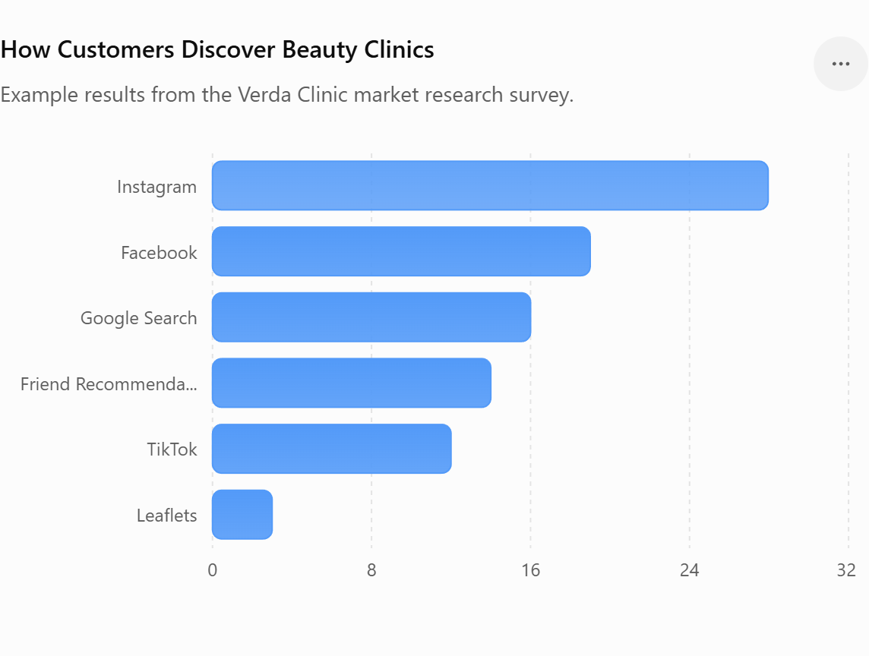
This chart demonstrates that most respondents discover beauty businesses through social media, particularly Instagram and Facebook. This supports my decision to focus my marketing strategy on digital platforms, alongside encouraging customer reviews and referrals.
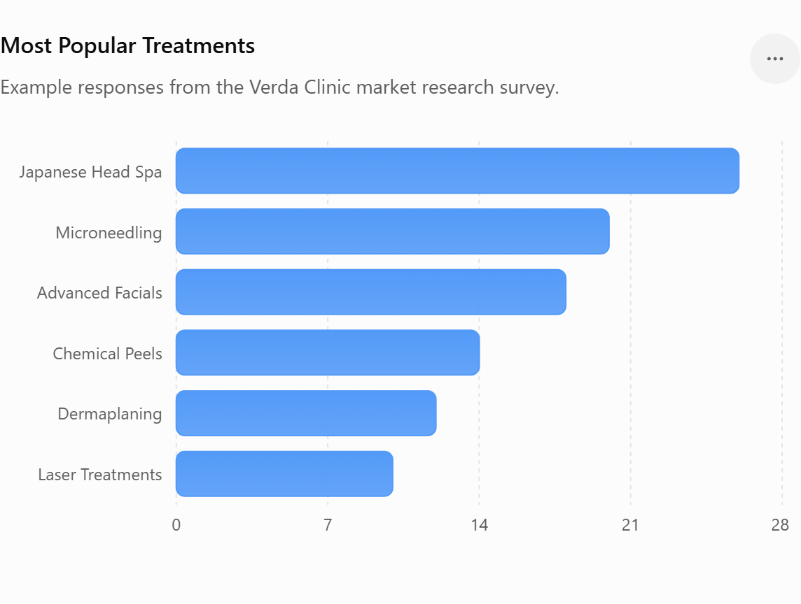
This chart shows that Japanese Head Spa and advanced skin treatments received the highest level of interest. This supports Verda Clinic's decision to specialise in both skin and scalp health rather than offering general beauty treatments.
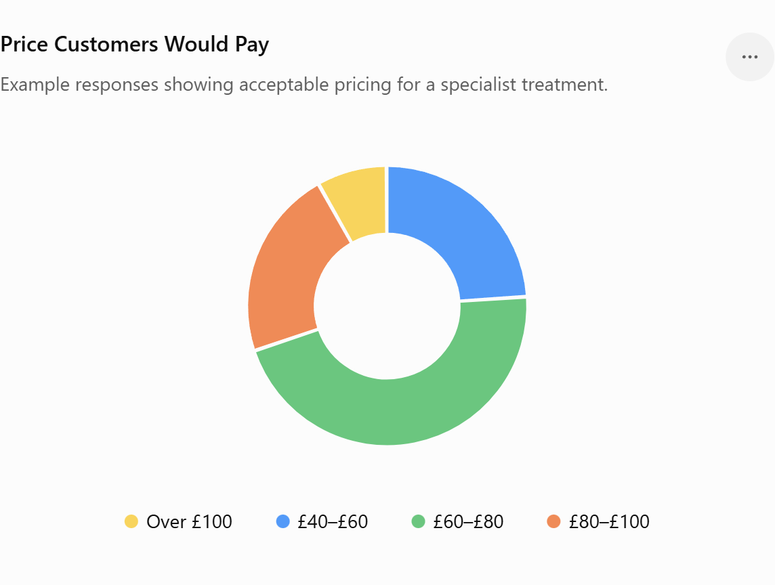
This chart indicates that almost half of respondents would be willing to pay between £60 and £80 for a specialist treatment. This supports my competitive pricing strategy, allowing Verda Clinic to offer high-quality treatments at prices that reflect both customer expectations and the local market.


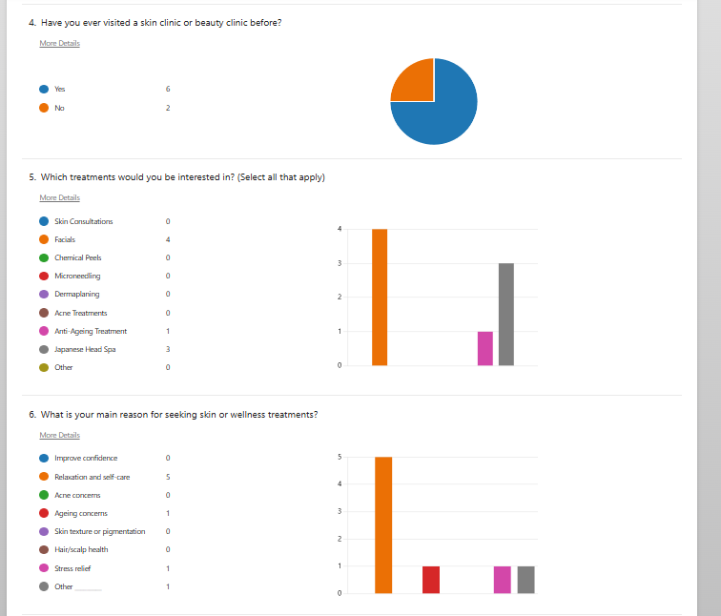

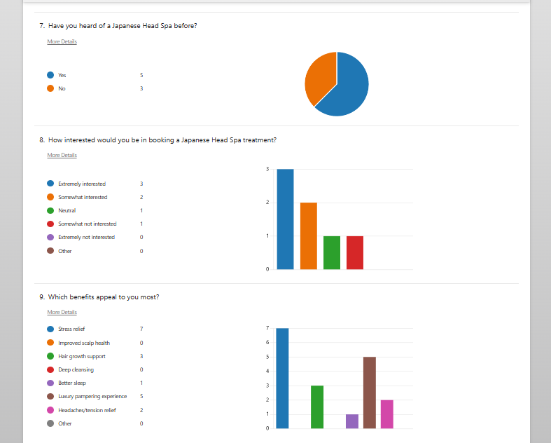

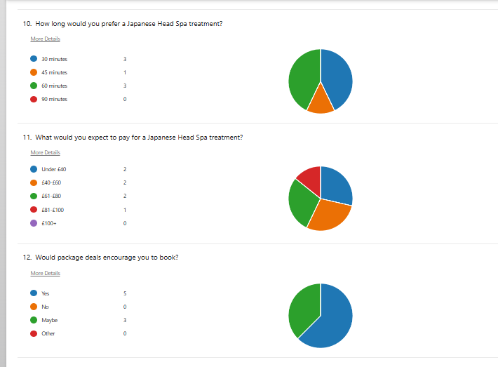

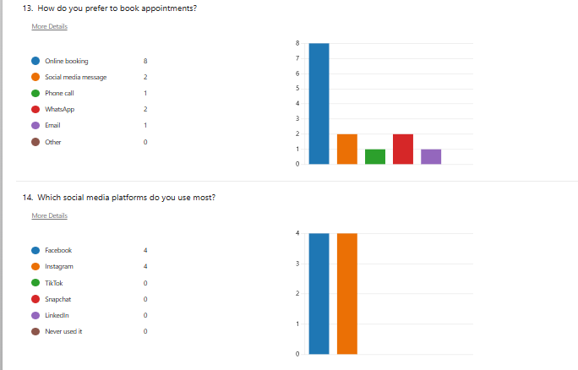
Appendix E

Profit & Loss Account
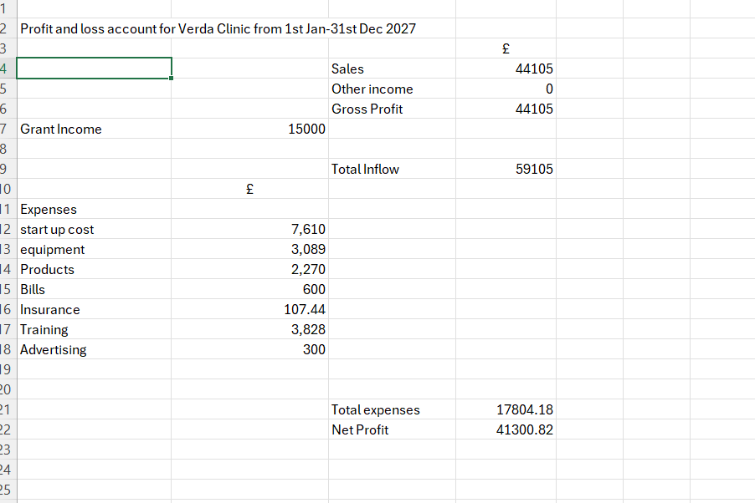

12 months Cashflow Forecast for Verda clinic spreadsheet





