

MODULE NAME: Human Resource Management (7007)
NAME: Rui Chen
STUDENT ID: 2218605
WORD COUNT: 2,352

Executive Summary

The report analyzes the recruitment and selection process of X Technology and provides recommendations to improve the company’s policies and practices. The report starts with an introduction to the importance of recruitment and selection, followed by a description of the methods used to collect data. The report then presents the findings, which indicate that X Technology’s recruitment and selection process is not efficient and effective enough to meet the company’s needs. The report further applies the Harvard HRM model to guide the development of effective recruitment and selection strategies. Recommendations based on the model include defining clear recruitment and selection policies, implementing diversity and inclusion initiatives, using social media and technology, developing a talent management program, and measuring and evaluating recruitment and selection policies. The report concludes by acknowledging the potential challenges of implementing these policies but emphasizes the benefits of a diverse and talented workforce.

Table of Contents
Executive Summary 2
1. Introduction 4
1.1 Organisational profile – X Technology Company 4
1.2 The function of HRM in the company 4
2. Main discussion 6
2.1 The priority of improving the efficiency of recruitment and selection 6
2.2 The negative impact on the performance and effectiveness of the company 7
2.3 The perceived benefits of improving recruitment and selection practices 8
3. Conclusions 10
4. Recommendations 11
4.1 The Harvard HRM Model 11
4.2 The application of Harvard HRM Model in the context of X Technology 12
4.3 The application of Harvard HRM Model in the context of X Technology 13
References 16

1. Introduction

1.1 Organisational profile – X Technology Company
Founded in 2014, X Technology is a Chinese technology company that specializes in smart home security products. They have a diverse workforce, comprised of highly skilled professionals from various backgrounds. With a growing size, X Technology competes with industry giants and remains responsive to market changes.

As an internet-based company, Xiaoyi Technology operates in a fast-paced market and has adapted quickly to changes in the industry. Their innovative products include home security cameras, smart doorbells, security sensors, and driving recorders. The company also offers innovative solutions for smart retail, face capture and assisted driving based on its advanced computer algorithm.

In addition to its home market in China, X Technology has expanded globally, serving customers in the United States, Europe, and Southeast Asia. In 2021 the company was reported to generate revenue of over $1 billion. This success can be attributed to their ability to remain dynamic and adapt quickly to market changes, making them a leader in the smart home security industry.

1.2 The function of HRM in the company
The HR director leads the department and reports directly to the CEO, who expects the HR department to perform various tasks including staff recruitment, team building and employee assessment. However, currently, the HR department mainly focuses on the function of employee recruitment and interviews. This is because the company needs to constantly adapt its products quickly in response to market feedback, which leads to frequent changes in personnel and organizational structure.

2. Main discussion
This section will shed light on the priority area that needs improving in the X company including the explanation of reasons for improvement and the negative impact it had on the organisational performance. Then, in light of the relevant literature on HRM, the perceived benefits of improvement for individuals and the organisation will be presented accordingly.

2.1 The priority of improving the efficiency of recruitment and selection
It is argued that recruitment and selection are essential functions of HRM, involving the identification, attraction, and hiring of qualified candidates for job openings (Armstrong, 2020). Recruitment aims to build a pool of skilled candidates, while selection involves evaluating and choosing the best fit for the job and organization, using methods such as interviews, tests, and assessments (Henderson, 2017).

As mentioned in the introduction section, X Technology Company has a high volume of recruitment needs, yet its current recruitment and selection practices are inefficient and ineffective. The company relies solely on traditional methods, such as posting job vacancies on generic recruitment websites and conducting in-person interviews, which are time-consuming and expensive. Furthermore, the HR department lacks the use of modern technology and data analytics to streamline the recruitment process, resulting in delays in candidate identification and a slow turnaround time. Another issue with the current recruitment and selection process is the lack of diversity in the candidate pool. The company’s reliance on traditional recruitment channels limits its ability to attract a broad range of candidates from different backgrounds and experiences, which makes it difficult to build a diverse and inclusive workforce.

2.2 The negative impact on the performance and effectiveness of the company
The deficiency in recruitment and selection practices has affected the company’s performance and effectiveness. For example, the traditional practice for recruitment has resulted in delays in identifying and hiring qualified candidates for the company, leading to a longer time to hire and increased recruitment costs. According to the statistics, the average time-to-hire for X Technology’s technical roles is currently 60 days, which is longer than the industry average of 45 days. This delay in hiring negatively impacts the company’s ability to innovate and compete in a fast-paced industry.

Additionally, the lack of diversity in the candidate pool limits the company’s ability to attract a broad range of talent, which hinders its innovation and growth. Currently, the Company’s workforce is comprised of only 25% female employees and 10% employees from diverse racial or ethnic backgrounds, which is below industry standards. This lack of diversity is very likely to cause a narrow perspective and potentially result in suboptimal decision-making and innovation (Cook, 2016).

Furthermore, inefficient recruitment and selection processes have resulted in the waste of company resources, such as the time and effort of HR staff and other relevant staff. For example, since the HR department spends a significant amount of time sifting through resumes manually, it leads to a backlog of other HR-related tasks that are left unaddressed such as performance management and employee development.

2.3 The perceived benefits of improving recruitment and selection practices
In light of the literature and the context of the company, improving recruitment and selection practices can have numerous benefits for X Technology Company and its stakeholders. The main benefits have been listed as follows.
a. Benefits for the organisation:
Improved quality of new hires: By implementing more effective recruitment and selection practices, the company can attract and hire candidates with the necessary skills, experience, and cultural fit to succeed in the organisation, leading to improved overall productivity and performance (Picardi, 2019).
Increased diversity: Modern recruitment practices can help the company attract a more diverse range of candidates, leading to a more inclusive and innovative work environment (Slavić Agneš, 2017).
Reduced costs: Streamlining the recruitment and selection process can lead to cost savings in terms of time, resources, and money (Armstrong, 2020).

b. Benefits for the employees:
Improved morale: A more efficient and transparent recruitment and selection process can create a positive impression among job seekers, leading to increased employee satisfaction and motivation (Zeb et al., 2018).
Increased diversity: A more diverse workforce can provide employees with exposure to different perspectives and ideas, leading to greater creativity and innovation.
Career development opportunities: A well-designed recruitment and selection process can help identify talented employees for promotion or development opportunities within the organisation (Henderson, 2017).

c. Benefits for other organisational stakeholders:
Customers: A diverse workforce can help the company better understand and meet the needs of its customers, leading to increased customer satisfaction and loyalty (Gold et al., 2013).
Shareholders: Improved recruitment and selection practices can lead to increased profitability and growth, resulting in higher returns for shareholders.
Society: A more diverse and inclusive workforce can have a positive impact on the broader community, helping to promote social cohesion and reducing discrimination (Laroche and Rutherford, 2007).

3. Conclusions
In conclusion, this report has highlighted the inefficiencies and negative impact of the current recruitment and selection practices at X Technology Company. The company’s reliance on traditional recruitment channels and lack of modern technology and data analytics has resulted in delays in candidate identification and a slow turnaround time. Moreover, the lack of diversity in the candidate pool limits the company’s ability to attract a broad range of talent, hindering its innovation and growth. These deficiencies have affected the company’s performance and effectiveness, resulting in longer time-to-hire, increased recruitment costs, and waste of company resources.

The report has also presented the perceived benefits of improving recruitment and selection practices for the company, employees, and other stakeholders. These benefits include improved quality of new hires, increased diversity, cost savings, improved morale, career development opportunities, a better understanding of customer needs, increased profitability and growth, and a positive impact on society. Therefore, X Technology Company must improve its recruitment and selection practices to remain competitive in the fast-paced industry and build a diverse and inclusive workforce.

4. Recommendations
In this section, feasible recommendations on how to improve the company’s recruitment and selection will be presented based on the above conclusion. Also, to have a holistic perspective and a better understanding of the context, the Harvard HRM Model will be utilised as guidance for analysis.

4.1 The Harvard HRM Model
The Harvard Human Resource Management (HRM) Model is a conceptual framework that elucidates the strategic management of human resources to achieve organizational goals (Bondarouk and Brewster, 2016). The model consists of six components: situational factors, stakeholder interests, HRM policies, HR outcomes, long-term consequences, and feedback mechanisms (Figure 1).
Figure 1 Harvard Model of HRM
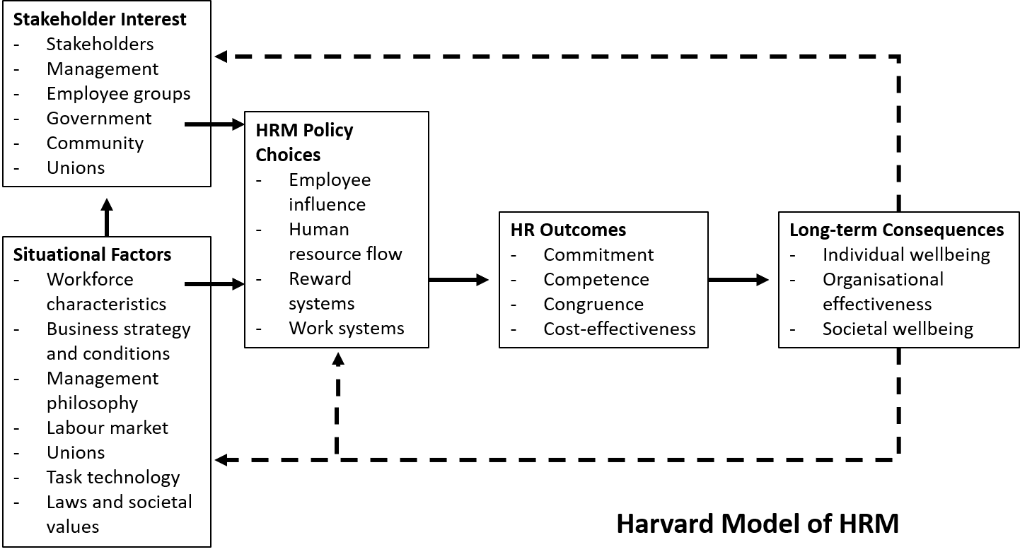

This model accentuates the significance of integrating HR policies and practices with overall organizational strategies while considering the needs and perspectives of employees (Brunetto et al., 2011). In light of this, the Harvard HRM Model requires organisations to adopt a strategic approach that takes into account both the external environment and the internal dynamics. Additionally, the model underscores the importance of treating employees as valuable assets and recognizing their contributions to the success of the organization (Beer, 2015).

In essence, the Harvard HRM Model offers a framework for comprehending how HR management can contribute to organizational success. By aligning HR practices with organizational goals and taking a strategic approach to managing human resources, organizations can enhance performance, foster employee engagement, and achieve a sustainable competitive advantage (Beer et al., 2015).

4.2 The application of Harvard HRM Model in the context of X Technology
In the context of the company’s recruitment and selection process, the Harvard HRM Model can be applied to guide the development of effective strategies to attract and retain talented employees. The analysis will be presented in the following based on the main factors of the model.

In terms of the situational factor in the company, it includes a highly competitive industry, the need for specialized skills and experience, and a desire to increase diversity in the workplace. Regarding the aspect of stakeholder interests, it includes the needs of customers, shareholders, employees, and the wider community, while the HRM policies would involve recruitment, selection, training and development, performance management, and employee relations. As for HR outcomes, they could refer to employee retention, job satisfaction, productivity, and profitability in the current context. Lastly, long-term consequences include the impact of HRM policies on the company’s reputation, brand, and sustainability. Feedback mechanisms are used to evaluate the effectiveness of HRM policies and make improvements where necessary.

4.3 The application of Harvard HRM Model in the context of X Technology
To apply the Harvard HRM Model in the context of the company’s recruitment and selection process, the following recommendations can be made:
- Define recruitment and selection policies: The company should define clear policies for recruitment and selection, including the skills and experience required for each position, the selection criteria, and the interview process. For example, the company may decide to include behavioural interviewing techniques to assess candidates’ ability to handle difficult situations (Armstrong, 2020).
- Implement diversity and inclusion initiatives: To increase diversity in the workplace, the company can implement initiatives such as targeted advertising, unconscious bias training, and diversity recruiting fairs (Cook, 2016). For example, the company could partner with local organizations to reach a more diverse pool of candidates.
- Use social media and the latest technology: To reach a wider audience, the company can use social media and technology to promote job openings and connect with potential candidates (Maria et al., 2020). For example, the company could use LinkedIn, Wechat and other recruitment applications to reach out to potential candidates with the required skills and experience (Gerber, Koch and De Klerk, 2018). Also, the technology of artificial intelligence is more affordable and accessible to organisations and individuals, which might offer novel solutions in the process of recruitment and selection (Baratelli and Colleoni, 2022).
- Develop a talent management program: To retain talented employees, the company can develop a talent management program that includes mentoring, coaching, and career development opportunities (Brewster, Sparrow and Harris, 2005). For example, the company could offer leadership development programs to high-potential employees.
- Measure and evaluate recruitment and selection policies: To ensure the effectiveness of recruitment and selection policies, the company should measure and evaluate the outcomes of these policies. For example, the company could use metrics such as time-to-hire, cost-per-hire, and retention rates to evaluate the success of its recruitment and selection policies.

While the above recommendations would lead to better recruitment and selection practices, there are also perceived disadvantages, risks, and costs that need to be considered. For example, implementing diversity initiatives may lead to increased recruitment costs or potential backlash from some stakeholders (Picardi, 2019). Additionally, measuring the outcomes of recruitment and selection policies may require additional resources and time, which would be against the initial intention to improve efficiency.

In conclusion, the Harvard HRM Model provides a useful framework for the development of effective recruitment and selection policies in the company. By considering different factors such as stakeholder interests and HRM policies, the company can develop policies that attract and retain talented employees. While there are potential challenges to implementing these policies, the benefits of a diverse, talented workforce are worth the effort.

References

Armstrong, M. (2020) Armstrong’s Handbook of Human Resource Management Practice. 15th Ed. London: Konan Page
Baratelli, G. and Colleoni, E., (2022). Does Artificial Intelligence (AI) Enabled Recruitment Improve Employer Branding? International journal of business and management, 17(2), p.45–. https://doi.org/10.5539/ijbm.v17n2p45.
Beer, M., (2015). HRM at a Crossroads: Comments on ‘Evolution of Strategic HRM Through Two Founding Books: A 30th Anniversary Perspective on Development of the Field’. Human resource management, 54(3), pp.417–421.
Beer, M., Boselie, P. and Brewster, C., (2015). Back to the Future: Implications for the Field of HRM of the Multistakeholder Perspective Proposed 30 Years Ago. Human resource management, 54(3), pp.427–438.
Bondarouk, T. and Brewster, C., 2016. Conceptualising the future of HRM and technology research. International journal of human resource management, 27(21), pp.2652–2671.
Brewster, C., Sparrow, P. and Harris, H., (2005). Towards a new model of globalizing HRM. International journal of human resource management, 16(6), pp.949–970.
Brunetto, Y., Farr-Wharton, R. and Shacklock, K., (2011). Using the Harvard HRM model to conceptualise the impact of changes to supervision upon HRM outcomes for different types of Australian public sector employees. International journal of human resource management, 22(3), pp.553–573.
Cook, M. (2016) Personnel selection: adding value through people. 5th Ed. Chichester: John Wiley.
Gerber, C., Koch, T. and De Klerk, J.J., (2018). The impact of social media on recruitment : are you LinkedIn? SA Journal of Human Resource Management, 16(1), pp.1–14.
Gold, J., Holden, R., Iles, P., Stewart, J. and Beardwell, J. (2013). Human Resource Development: Theory and practice. 5th Ed. London: Palgrave Macmillan.
Henderson, I. (2017) Human Resource Management for MBA Students. 3rd Ed. London: CIPD
Laroche, L. and Rutherford, D. (2007) Recruiting, retaining and promoting culturally different employees. Oxford: Butterworth Heinemann.
Maria Christy Wowor, Deske W. Mandagi, Benny Lule and Shapely S. Ambalao, (2022). The Role of Social Media in Employee Recruitment: a Systematic Literature Review. Jurnal Multidisiplin Madani, 2(12).
Picardi, C.A., (2019). Recruitment and Selection: Strategies for Workforce Planning and Assessment. Recruitment and Selection: Strategies for Workforce Planning & Assessment. Thousand Oaks: SAGE Publications, Incorporated.
Pilbeam, S. and Corbridge, M. (2010) People resourcing: contemporary HRM in practice. 4th Ed. Harlow: Financial Times Prentice Hall.
Slavić Agneš, Bjekić Radmila and Berber Nemanja, (2017). The role of the internet and social networks in recruitment and selection process. Strategic Management, 22(3), pp.36–43.
Taylor, S. (2014) Resourcing and talent management. 6th Ed. London: CIPD
Zeb, A., Hazana Abdullah, N., Javaid, M. and Asad khan, M., (2018). Impact of Human Capital Management Practices on Employees’ Job Performance. Journal of physics. Conference series, 1049(1), p.12020–.

